Abundance estimates for game
ducks in Victoria
Results from the 2023 aerial and ground
surveys
D.S.L Ramsey and B. Fanson
March 2024
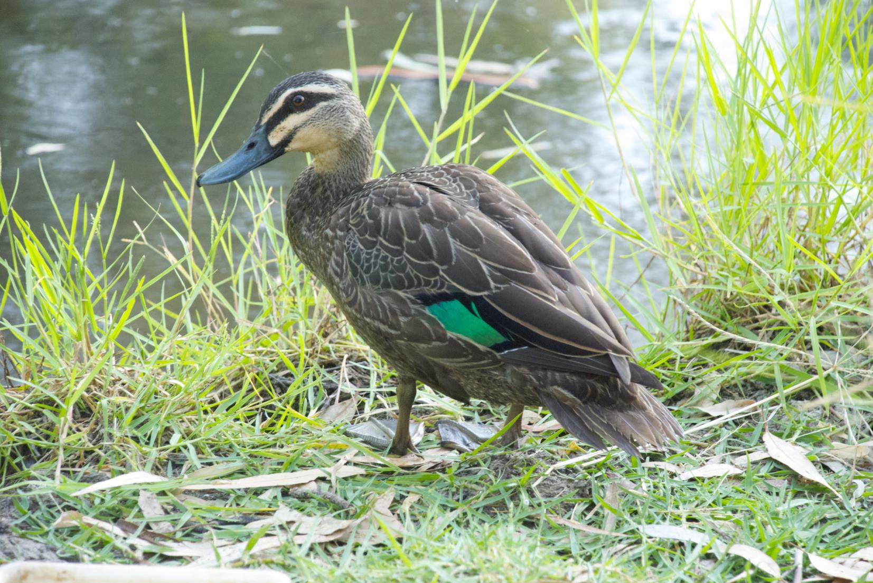




OFFICIAL

Arthur Rylah Institute for Environmental Research
Technical Report Series No. 376

Acknowledgment
We acknowledge and respect Victorian Traditional Owners as the original custodians of Victoria's land and waters, their unique ability to care for Country and deep spiritual connection to it. We honour Elders past and present whose knowledge and wisdom has ensured the continuation of culture and traditional practices.
We are committed to genuinely partner, and meaningfully engage, with Victoria's Traditional Owners and Aboriginal communities to support the protection of Country, the maintenance of spiritual and cultural practices and their broader aspirations in the 21st century and beyond.


Arthur Rylah Institute for Environmental Research Department of Energy, Environment and Climate Action PO Box 137
Heidelberg, Victoria 3084
Phone (03) 9450 8600
Website: www.ari.vic.gov.au

Citation: Ramsey, D.S.L., and Fanson, B. (2024). Abundance estimates for game ducks in Victoria: Results from the 2023 aerial and ground surveys. Arthur Rylah Institute for Environmental Research Technical Report Series No. 376. Department of Energy, Environment and Climate Action, Heidelberg, Victoria.

Front cover photo: Black Duck (Arthur Rylah Institute).

© The State of Victoria Department of Energy, Environment and Climate Action 2024

This work is licensed under a Creative Commons Attribution 3.0 Australia licence. You are free to re-use the work under that licence, on the condition that you credit the State of Victoria as author. The licence does not apply to any images, photographs or branding, including the Victorian Coat of Arms, the Victorian Government logo, the Department of Energy, Environment and Climate Action logo and the Arthur Rylah Institute logo. To view a copy of this licence, visit http://creativecommons.org/licenses/by/3.0/au/deed.en

Edited by Fox Writing Services ISSN 1835-3835 (pdf))
ISBN 978-1-76136-623-9 (pdf/online/MS word)

Disclaimer
This publication may be of assistance to you but the State of Victoria and its employees do not guarantee that the publication is without flaw of any kind or is wholly appropriate for your particular purposes and therefore disclaims all liability for any error, loss or other consequence which may arise from you relying on any information in this publication.

Accessibility
If you would like to receive this publication in an alternative format, please telephone the DEECA Customer Service Centre on 136 186, email customer.service@delwp.vic.gov.au or contact us via the National Relay Service on 133 677 or www.relayservice.com.au. This document is also available on the internet at www.deeca.vic.gov.au

Abundance estimates for game ducks in Victoria
Results from the 2023 aerial and ground surveys

David S.L. Ramsey and Ben Fanson

1Arthur Rylah Institute for Environmental Research 123 Brown Street, Heidelberg, Victoria 3084

Arthur Rylah Institute for Environmental Research
Technical Report Series No. 376

Arthur Rylah Institute for Environmental Research Department of Energy, Environment and Climate Action Heidelberg, Victoria

Acknowledgements

Aerial surveys were conducted by Ecoknowledge Pty Ltd (www.ecoknowledge.com.au). We would like to thank Mark Lethbridge of Ecoknowledge Pty Ltd for providing additional support and valuable feedback on the aerial survey data. The authors thank Simon Toop, Jason Flesch (Game Management Authority) and Jian Yen (DEECA) for providing valuable comments on a draft of this report. This work was commissioned by the Victorian Game Management Authority.

.

ii Game duck abundance in Victoria 2023

Contents
Acknowledgements ii
Summary 1
- Introduction 3
Objectives 4
- Methods 5
Estimates of surface water availability 5
Selecting the sample of waterbodies 6
Aerial and ground sampling of game ducks 6
Abundance estimation 7
    - Waterbody level estimates 7
    - Statewide abundance estimates 7
- Results 9
Survey summary 9
Surface water availability 10
    - Calibration of surface water predictions 11
Waterbody level abundance estimates 12
Statewide abundance estimates 15
    - Design-based estimates 15
    - Model-based estimates 15
    - Trends in game duck abundance 17
- Discussion 19
References 21
Appendix A 23
Appendix B 24
Appendix C 28

Tables

Table 1. Waterbodies sampled by aerial and ground surveys during 2023. The numbers of these waterbodies observed with surface water are given in parentheses 9
Table 2. Number of mapped waterbodies determined as containing surface water during the Spring 2023 period. 11
Table 3. Total counts of each species by waterbody type and size class (ha). The maximum of the two counts for each waterbody was used to calculate the total. Species codes are: GT = Grey Teal; CT = Chestnut Teal; WD = Australian Wood Duck; PBD = Pacific Black Duck; AS = Australian Shelduck; HH = Hardhead; PED = Pink-eared Duck; BWS = Australasian Shoveler. n = number of waterbodies with surface water. 13
Table 4. Total counts of each species by bioregion. The maximum of the two counts for each waterbody was used to calculate the total. Species codes are: GT = Grey Teal; CT = Chestnut Teal; WD = Australian Wood Duck; PBD = Pacific Black Duck; AS = Australian Shelduck; HH = Hardhead; PED
= Pink-eared Duck; BWS = Australasian Shoveler. n = number of waterbodies with surface water. 13

Table 5. Summary of design-based estimates of total abundance for the eight game duck species in Victoria.
SE = standard error; CV = coefficient of variation; LCL = lower 90% confidence limit; UCL = upper 90% confidence limit 16
Table 6. Summary of model-based estimates of total abundance of five game duck species in Victoria. SE = standard error; CV = coefficient of variation; LCL = lower 90% confidence limit; UCL = upper 90% confidence limit 16

Figures

Figure 1. Overview of the waterbody (A) and river/stream (B) GIS layers and processing steps used to derive estimates of the number of waterbodies, rivers and streams with surface water in Victoria. 6
Figure 2. Locations of the 865 waterbodies (dams, sewage ponds, wetlands and rivers/streams) that were subject to aerial and ground sampling during October-November 2023. Bioregion boundaries are (clockwise from top left), West, North, East and South 10
Figure 3. Temporal changes in surface water availability in wetlands and dams since 2020. 10

Figure 4a. Confusion table for observed (actual) versus predicted (Sentinel-2) surface water presence for small dams, sewage ponds, wetlands rivers/streams and storage dams. Red indicates incorrect predictions and green indicates correct predictions, with shading indicating relative (in)accuracy. White and grey indicates no data. Wet = surface water present; Dry = surface water absent 11

iv Game duck abundance in Victoria 2023

Figure 4b. Confusion table for observed (actual) versus predicted (DEA2.0) surface water presence for large dams, sewage ponds, wetlands, rivers/streams and storage dams. Red indicates incorrect predictions and green indicates correct predictions, with shading indicating relative (in)accuracy.
White and grey indicates no data. Wet = surface water present; Dry = surface water absent 12
Figure 5. Posterior predictive distributions of the counts of eight game duck species. y = observed counts (sum of both observers); yrep = average predicted count from the fit of the zero-inflated N-mixture model. The predicted and observed counts were square root transformed to aid the visibility of the small counts. The black line shows a 1:1 relationship. 14
Figure 6. Detection probabilities of game ducks from aerial and ground surveys by habitat type and waterbody size class (<6 ha; 6–50 ha; >50 ha) in the presence or absence of glare from the water surface. 15
Figure 7. Abundance of game duck species by waterbody type and size class. GT = Grey Teal; CT = Chestnut Teal; WD = Australian Wood Duck; AS = Australian Shelduck; PBD = Pacific Black Duck; HH = Hardhead; PED = Pink-eared Duck; BWS = Australasian Shoveler. 17
Figure 8. Abundance of game duck species by bioregion. GT = Grey Teal; CT = Chestnut Teal; WD = Australian Wood Duck; AS = Australian Shelduck; PBD = Pacific Black Duck; HH = Hardhead; PED
= Pink-eared Duck; BWS = Australasian Shoveler. 17
Figure 9. The trends in the abundance of the eight species of game ducks from 2021–2023. Abundance is given on the log10 scale. Estimates could not be obtained for some species in some years due to inadequate data. 18

Game duck abundance in Victoria 2023 v

Summary

Context:
In Victoria, eight species of native duck are subject to legal recreational harvest: Grey Teal (Anas gracilis), Pacific Black Duck (Anas superciliosa), Australian Wood Duck (Chenonetta jubata), Australian Shelduck (Tadorna tadornoides), Pink-eared Duck (Malacorhynchus membranaceus), Chestnut Teal (Anas castanea), Hardhead (Aythya australis), and Australasian Shoveler (Anas rhynchotis) (hereafter called game ducks), with the latter two species not able to be legally harvested in 2023. Implementation of Adaptive Harvest Management (AHM) in Victoria requires comprehensive surveys of game ducks (Ramsey et al. 2017). A survey design suitable for estimating the statewide abundance of game duck species was recently developed (Ramsey 2020), with the initial pilot survey conducted in late 2020 (Ramsey and Fanson 2021). A revised survey design incorporating recommended improvements (Prowse and Kingsford 2021) was implemented in October 2021. This report details the results of the statewide aerial and ground survey of game ducks in Victoria conducted during 2023.
Aims:
The aims of this report were to (i) estimate the amount of surface water in the major waterbody types in Victoria for the period when surveys were undertaken to define the amount of suitable habitat available for game ducks, and (ii) conduct an analysis of the monitoring data from the aerial and ground surveys of game ducks undertaken in 2023 to estimate the abundance of each game species within the main habitat types in Victoria.
Methods:
Waterbodies, selected using a stratified random sampling design, were subject to aerial surveys during October-November 2023. At each waterbody, two observers on the left side of the aircraft (one forward and one rear) independently conducted counts of game ducks at each waterbody. Ground surveys were conducted for those waterbodies that could not be surveyed from the air due to airspace or safety restrictions. Ground surveys used a similar double-observer method. The abundance of game duck species at each sampled waterbody was estimated using a zero-inflated N-mixture model and Bayesian inference.
Estimates of surface water area for waterbodies in Victoria (wetlands, dams, sewage treatment ponds, rivers and large streams) were derived from the most recent Landsat and Sentinel-2 satellite imagery at the time of the surveys to derive the number of waterbodies of each type in Victoria containing surface water. Design-based, finite sampling methods were then used to estimate total game duck abundance for each species by extrapolating abundance estimates from sampled waterbodies to the number of available waterbodies with surface water of each type across the state. Additionally, model-based procedures were also used to derive statewide abundance estimates for each species.
Results:
Surface water estimates for Victoria revealed that the amount of surface water in dams, wetlands and sewage ponds decreased by around 5% compared with surface water estimates for 2022. Calibration of surface water presence from satellite imagery with observations during surveys indicated relatively high accuracy for wetlands and sewage ponds (>90% true positive rate) but lower accuracy for river/stream segments and small farm dams (81% and 70% true positive rate, respectively).
A total of 865 waterbodies were subject to aerial (802) or ground surveys (63). Of these, 801 were observed to contain surface water, and the counts of game duck species on these were used to estimate their abundance on each waterbody using the zero-inflated N-mixture model. Record high counts of game ducks were recorded on most waterbodies, but especially in large wetlands and sewage ponds with counts sufficient to estimate the abundances for all eight game species. As a result of the record high counts, estimates of detectability of ducks by observers during aerial surveys were lower than in previous surveys.
Game duck abundance in Victoria 2023 1

Design-based estimates of the total abundance of the eight species indicated that the population of game ducks on dams, wetlands, sewage ponds, rivers and streams in Victoria was 7,120,600 (95% confidence interval: 6,035,100–8,401,400). Australian Wood Duck was the most abundant game species (c. 2.6M), followed by Pacific Black Duck (c. 1.4M), Grey Teal (c. 1.4M) and Chestnut Teal (c. 1.2M). Precision of the overall design-based estimate of abundance was good, with an 8% (0.08) coefficient of variation, within the target threshold of 15%. Model-based estimates of abundance were around 17% lower than the design-based estimates, giving an estimate of 5,905,900 game ducks. However, model-based estimates tended to be more precise than the corresponding design-based estimates.
Conclusions and implications:
Estimates of surface water on waterbodies, but especially small farm dams, could be improved by updating the relevant spatial layers and adopting the latest water detection algorithms.
The total statewide abundance of game ducks increased markedly from the previous year, with the total design-based abundance almost three times higher than the estimate from the 2022 survey (2.41M) (Ramsey and Fanson 2023). This substantial increase was most likely driven by the extensive flooding and presence of surface water driving breeding activity during 2022. Improvements in the estimates of observer detectability during surveys could be made by adopting mark-recapture approaches for counting game ducks (Roy et al. 2021).
To ensure transparency and sustainability in setting the recreational hunting seasonal arrangements, consideration should be given to adopting a proportional harvest strategy applied to the estimates of the Victorian population of game ducks as the first stage in the adoption of AHM. Guidelines on the maximum proportional harvest that can be supported by Victoria’s main game duck species are given in Prowse (2023).
Recommendations:
To strengthen the Victorian game duck survey to ensure robust estimates of abundance that will be suitable for use in Adaptive Harvest Management, it is recommended that:
- the current approach to estimating surface water for Victoria be updated to incorporate the latest spatial data products and water detection algorithms. In particular, the Victorian farm dam layer is becoming increasingly out-of-date and requires updating with the latest spatial information (e.g. Malerba et al. 2021).
- a mark-recapture monitoring protocol for the aerial and ground surveys be explored and adopted if practicable. This would involve the use of either independent or dependent double-count survey methods (e.g. Roy et al. 2021).
- the government adopt a proportional harvest strategy using the estimates of the Victorian game duck population as the first stage towards the adoption of AHM. A proportional harvest strategy could be implemented adopting a maximum proportional harvest of 10% of the pre-season abundance estimates as recommended by Prowse (2023).

2 Game duck abundance in Victoria 2023

Introduction

In Victoria, eight species of native duck are subject to legal recreational harvest: Grey Teal (Anas gracilis), Pacific Black Duck (Anas superciliosa), Australian Wood Duck (Chenonetta jubata), Australian Shelduck (Tadorna tadornoides), Pink-eared Duck (Malacorhynchus membranaceus), Chestnut Teal (Anas castanea), Hardhead (Aythya australis), and Australasian Shoveler (Anas rhynchotis) (hereafter called game ducks), with the latter two species not able to be legally harvested in 2023. The Victorian Government manages recreational duck hunting sustainably by setting seasonal daily bag limits for each species, as well as the timing of the start and end of the hunting season (i.e. season length). These arrangements can change each year, depending on the information available about the status of populations and the prevailing environmental conditions. Currently, the main source of information used to inform the setting of recreational hunting seasonal arrangements is the Interim Harvest Model (Kingsford and Klaassen 2021), which uses five indices based on current information on duck population abundance and surface water extent to set hunting bag limits for the following season (e.g. Klaassen 2023).
The Victorian Government has committed to implementing Adaptive Harvest Management (AHM) (e.g. Ramsey et al. 2010; Ramsey et al. 2017) to guide the setting of seasonal recreational harvest arrangements (https://www.premier.vic.gov.au/continuing-recreational-duck-hunting-victoria). Comprehensive surveys to estimate the statewide abundance of game duck species are vital if an adaptive harvest management framework (e.g. Nichols et al. 2007) is to be adopted for managing game ducks (Ramsey et al. 2017). Other surveys of game ducks such as the Victorian Priority Waterbird Counts (Menkhorst et al. 2019) and Eastern Australian Waterbird Survey (Kingsford and Porter 2009) have inadequate coverage and/or sampling designs for Victorian waterbodies to enable a robust estimation of absolute duck abundances across the state. In addition to undertaking surveys at a sample of waterbodies, estimation of the abundance of game ducks across the state would also require an estimate of the availability of surface water for each of the waterbody types considered to provide suitable game duck habitat during the period within which the surveys are undertaken. Surface water can now be regularly determined by applying appropriate algorithms to satellite imagery (e.g. Mueller et al. 2016; Pekel et al. 2016).
Sampling designs and survey methods suitable for estimating the abundances of games ducks on waterbodies in Victoria were identified by Ramsey (2020). Game duck habitat waterbodies were stratified into types (wetlands, dams, sewage treatment ponds), size classes (<6 ha, 6–50 ha, >50 ha) and bioregions (North, South, East, West). Following a pilot study of the survey design in 2020, an independent review of the survey design and methods was undertaken (Prowse and Kingsford 2021) which led to some improvements to aerial survey methods and analysis. Briefly, these included:
- increasing the sample size of the waterbodies, including large wetlands
- including waterways (rivers, large streams) as additional strata and adding large storage dams to the sampling design
- increasing the coverage of waterbodies throughout the state by including ground counts on waterbodies where it was not feasible to conduct aerial surveys
- including methods for obtaining separate abundance estimates for Grey and Chestnut Teal
- modification to the aerial survey methods involving partial counts of large waterbodies to ensure the main waterbody as well as edge is counted
- investigating alternative models for improving the detection probabilities of game ducks by observers.
The revised survey design was then implemented during October/November 2021, sampling approximately 750 waterbodies across the state (Ramsey and Fanson 2022). The analysis of the 2021 game duck survey recommended some further improvements to the survey design including increasing the sample size of waterways (river and stream segments). These improvements were subsequently implemented for the 2022 survey. This report summarises the results from the 2023 aerial and ground surveys of game ducks in Victoria using the revised survey design.
Game duck abundance in Victoria 2023 3

Objectives
The overall aim of this study was to conduct an analysis of the aerial and ground survey data for game ducks, undertaken during 2023, to provide estimates of the abundance of each species of game duck. The specific objectives were to:
- estimate the current amount of surface water available for use by game ducks within Victoria, using the most recent satellite imagery (LandSat and Sentinel 2) combined with vector layers of waterbodies (including farm dams and rivers/streams)
- analyse the aerial and ground survey data in conjunction with the estimates of surface water availability, to estimate the abundance and distribution of each game duck species in Victoria
- identify modifications to the survey design that would lead to improvements in the statewide estimates, if required.

4 Game duck abundance in Victoria 2023

Methods

Estimates of surface water availability
To extrapolate the estimates of abundance of game ducks at sampled waterbodies to regional or statewide estimates of abundance, an estimate was required of the surface water availability for the period within which the surveys were undertaken. Waterbodies in Victoria were stratified according to waterbody type and size class, with the number of waterbodies within each stratum containing surface water used to set the sampling frame. The sampling frame is the total number of objects that could be subject to sampling and is also the target of estimation. In other words, estimates of duck abundance obtained from each of the sampled waterbodies are then extrapolated to all waterbodies in the sampling frame to obtain an estimate of the total abundance. It follows that the sampling frame also delimits the total size of the regional duck population, which may exclude ducks residing in habitats that are outside the sampling frame and therefore not sampled. For the 2023 survey, surface water types estimated included wetlands, dams, sewage treatment ponds, rivers and large streams. Irrigation channels, estuaries and small streams were excluded from the surface water estimates. Irrigation channels were excluded as the available spatial data on the locations of channels contained too many spatial errors to be a reliable indicator of water availability, and small streams (i.e. width
< 5 m) were excluded as these could not be reliably surveyed from the helicopter. Since estimates of surface water will change each year due to prevailing environmental conditions and rainfall patterns, the sampling frame will also change each year and must be re-estimated.
Surface water estimates were derived from GIS layers to quantify the number and size of waterbodies and rivers/streams in Victoria (Figure 1). For wetlands and sewage ponds, we utilised the Digital Earth Australia (DEA) waterbody layer (‘DEA’ – https://www.dea.ga.gov.au/) derived from LandSat imagery taken every
16 days. This layer defines the wetland boundaries (waterbody’s spatial area) and uses Water Observation from Space (WOfS) (Mueller et al. 2016) to estimate water surface area over time. WOfS uses a machine learning algorithm for classifying surface water in Australia and has been shown to have good accuracy (~97%) (Mueller et al. 2016). After obtaining the waterbody polygons and surface water areas, we used an additional spatial layer (VIC_hydro - https://www.data.vic.gov.au/) to assign waterbody attributes. At this stage, this process excludes rivers and streams, which are dealt with separately.
As WOfS uses LandSat which has a ~ 30 m pixel size, it uses an area threshold of 2700 m2 (0.27ha); detection of surface water for waterbody areas below this threshold area is not reliable. However, many farm dams are below this area threshold and therefore, we used a Victorian farm dam spatial layer to obtain polygons for all farm dams present pre-2015. After removing any duplicates between the datasets, we then used Sentinel 2 (‘S2’) satellite imagery (taken every 5 days) for the polygon to assess presence of water (Figure 1A). Sentinel 2 uses a Normalised Difference Water Index – NDWI for the detection of surface water (Mueller et al. 2016). For both WOfS and S2 imagery, we obtained the most recent estimate of surface water extent for each waterbody at the time of the aerial and ground surveys as well as the average of the three most recent observations.
Finally, for rivers and streams, we used the Index of Stream Conditions (ISC) project to define the major river system (Figure 1B). This project mapped streambeds using LiDAR and hence had stream spatial areas (Quadros et al. 2011). Small streams in dense forest are missing from this dataset. For the sampling frame, we divided the river network lines into 1-km segments and then used these segments to extract out the overlapping riverbed to obtain surface area. We then use flow gauge information to assess flowing conditions in the river/stream around the time of the survey, which was supplemented by satellite imagery from S2.

Game duck abundance in Victoria 2023 5

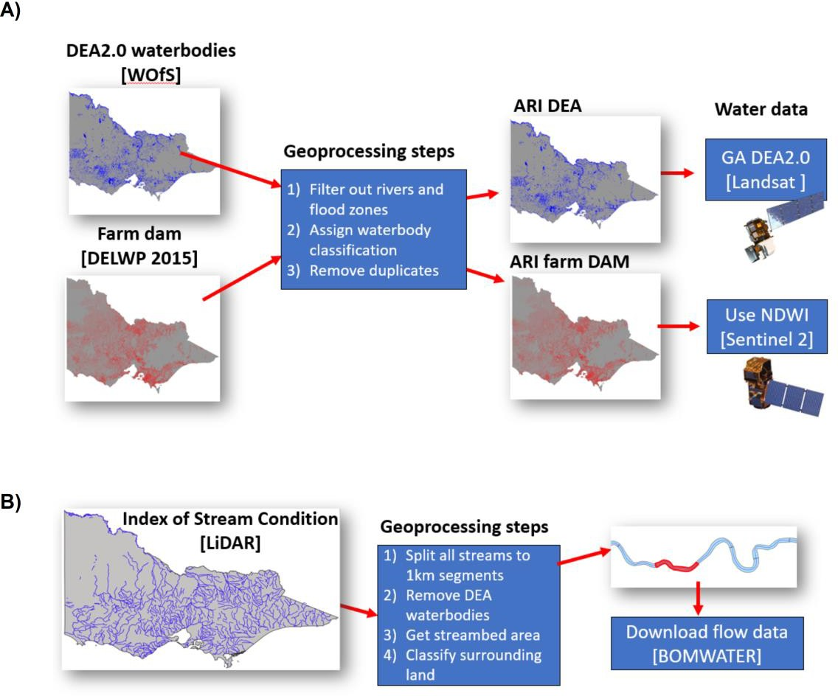

Figure 1. Overview of the waterbody (A) and river/stream (B) GIS layers and processing steps used to derive estimates of the number of waterbodies, rivers and streams with surface water in Victoria.

Selecting the sample of waterbodies
The majority of waterbodies sampled during the 2022 survey were sampled again in 2023. Strata consisted of waterbodies of different types, including wetlands, dams, sewage treatment ponds, and waterways (rivers and large streams), which were also categorised according to size class (<6 ha, 6–50 ha, >50 ha). Size classes for waterways were calculated by multiplying the segment length (1-km) by the width of the segment. Waterbodies were further stratified into four broad geographic regions in the state (North, South, East and West). Further details of the stratification of waterbodies across Victoria can be found in Ramsey and Fanson (2021).

Aerial and ground sampling of game ducks
Aerial sampling of each waterbody was undertaken from a Squirrel AS-350 helicopter. Two observers on the left side of the aircraft (one forward and one rear) conducted counts of game ducks at each waterbody independently. For smaller waterbodies and farm dams, each waterbody was approached, and counts were conducted while the aircraft completed a low circuit around the waterbody circumference at a height of around 30–50 m. For some of the largest waterbodies (>50 ha), only a portion of the waterbody, usually 50% (selected at random), was surveyed by flying inside the perimeter of the waterbody and counting towards the waterbody edge and then towards the waterbody center. This addresses the propensity of ducks to concentrate on the shoreline, sometimes in clumped aggregations, and avoids under-estimating density by only counting the shoreline. The counts for each observer for the entire surface area were then imputed using the proportion of the waterbody surveyed. Other data were also collected for each waterbody including predominant habitat type (i.e. open [little or no vegetation present], presence of reeds, presence of

6 Game duck abundance in Victoria 2023

woodland), presence of surface water, weather conditions and the presence of glare from the water surface.
Ground surveys of waterbodies that could not be sampled from the air due to airspace or other safety restrictions were undertaken using a similar double-observer methodology with two observers working independently with the aid of a spotting scope. For large wetlands subject to ground surveys, counts were obtained from multiple vantage points to maximise the coverage of the surface water of the wetland. Where coverage was incomplete, counts were again adjusted using the same imputation method as used for aerial surveys.
Since aerial surveys cannot distinguish between female Chestnut Teal and Grey Teal, ground surveys were used to estimate the ratio of male/female Chestnut Teal and this ratio was then used to adjust aerial counts of Chestnut and Grey Teal. Counts of male and female Chestnut Teal on waterbodies surveyed from the ground were used to determine the mean ratio of male/female Chestnut Teal. This ratio was subsequently used to adjust the counts of Chestnut Teal counted during aerial surveys, which only included observations of males. Only waterbodies where both Grey Teal and male Chestnut Teal were counted during aerial surveys were subject to this adjustment. The adjusted Chestnut Teal count was calculated by dividing the aerial count of male Chestnut Teal by the male/female Chestnut Teal ratio to determine the expected number of female Chestnut Teal that were likely present but included in the Grey Teal count. This expected number was then added to the Chestnut Teal count and subtracted from the Grey Teal count.

Abundance estimation

Waterbody level estimates
The two independent replicate counts of game ducks at each sampled waterbody were used to estimate the abundance of ducks at each waterbody, corrected for imperfect detection (birds missed by the observers) using a zero-inflated N-mixture model (Royle 2004; Ramsey and Fanson 2021). The standard N-mixture model has two components: an abundance component, representing the true (but unknown) number of ducks present on each waterbody at the time of the survey, and a detection component, representing the measurement (detection) error, consisting of an estimate of the fraction of birds that were present but missed by the observers. The abundance component can also be a function of the covariates likely to explain variation in abundance between waterbodies, such as waterbody type, size class, and geographic region.
Likewise, the detection component can also depend on covariates that affect the detection process, such as the presence of vegetation, or glare from the water surface. The standard N-mixture model was modified to account for the presence of excess zeros in the count data, caused by some waterbodies being unsuitable for ducks at the time of the survey, by adopting a zero-inflated Poisson (ZIP) distribution for the counts.
Hence, this model includes a component that accounts for the probability that ducks are present on the waterbody at the time of the survey. This N-mixture ZIP model was similar to that used by Ramsey and Fanson (2021).
The covariates used to potentially explain the variation in abundance of ducks were waterbody type, size class, and bioregion, with the probability of presence considered to depend on the same set of attributes. Detection probability was modelled as a function of the presence of glare from the water surface, habitat type (open, reeds or woodland), waterbody size class, survey type (aerial or ground), and the interaction of survey type with habitat and survey type with size class. The parameters for the covariates for abundance and presence probability were estimated separately for each duck species, while the parameters for the probability of detection were common to the different species of ducks. The N-mixture ZIP model was estimated in a Bayesian framework using Hamiltonian Markov chain Monte Carlo (MCMC) methods in Stan (version 2.34.1) with RStan in R (Carpenter et al. 2017). Weakly informative prior distributions were used for all parameters in the model specified as 𝑁(0, 5). A total of 3000 MCMC iterations were run for the model, using 5 chains, with the first 1000 iterations considered to be ‘warmup’ (tuning) iterations and discarded. This left a total of 10,000 samples for each parameter to form the inference.

Statewide abundance estimates
Predictions of game duck abundance for the entire sampling frame (i.e. waterbodies containing water within Victoria) were made using a design-based approach (Thompson 1992). Design-based estimates of total abundance were obtained by using predicted abundance for each sampled waterbody derived from the fitted
Game duck abundance in Victoria 2023 7

model (section 2.4.1). The predicted abundance and associated variance were then used to produce design-based estimates of the total abundance and variance of game ducks for the entire sampling frame. To account for the unequal probability sampling designs used here, total abundance of ducks was estimated using a Horvitz–Thompson type estimator (Horvitz and Thompson 1952) with inclusion probabilities for waterbodies in each stratum calculated as inversely proportional to their availability in the sampling frame.
This necessarily requires that inclusion probabilities be rescaled when the size of the sampling frame changes (i.e. due to drying and/or filling of waterbodies). Variance estimates were adjusted in a similar way (Hankin 1984; Skalski 1994). Further details of this sampling design and the estimators are provided in Appendix A.
In addition to design-based estimates, we also derived estimates of total abundance of game ducks using a model-based approach. The advantages of a model-based approach are that it can be used to predict abundance in areas outside the sampling frame and can use data collected from non-random sampling designs, which are properties that are not possible with design-based procedures. However, model-based approaches can produce biased estimates of abundance if a poor model is used for prediction. The model-based approach was undertaken by predicting the expected abundance for every waterbody in the sampling frame (i.e. both sampled and unsampled), conditional on their covariate values (waterbody attributes and region) using the fitted N-mixture ZIP model relationship for each species (section 2.4.1). The variance of the total abundance estimate was estimated using posterior predictive simulation based on the posterior distributions of the estimated parameters from the fitted model (Gelman and Hill 2007). A total of 1000 posterior estimates of total abundance were calculated for each species and used for inference.

8 Game duck abundance in Victoria 2023

Results

Survey summary
Aerial surveys of game ducks were undertaken from 16 October – 3 November 2023, with ground counts undertaken from 17 October – 6 November 2023. A total of 865 waterbodies were successfully surveyed, with 802 waterbodies surveyed from the air and a further 63 surveyed from the ground (Table 1; Figure 2). Not all the scheduled waterbodies could be sampled due to access issues (ground surveys) or the presence of obstructions impeding the safe approach of the helicopter (aerial surveys). A total of 738 of the 802 waterbodies subjected to aerial survey were observed to have surface water (92%), with the remaining either dry or not present at the identified location. No waterbody was observed to be completely dry during the ground surveys.
From the ground surveys, a total of 3336 Chestnut teal were observed from 27 waterbodies where at least one male Chestnut Teal was present. The maximum counts of male and female Chestnut Teal on these waterbodies were then used to estimate the male:female sex ratio. The mean numbers of male and female Chestnut Teal observed were 18 and 39, respectively, with an estimate of the male:female sex ratio of 0.70 (SE = 0.091). This value was subsequently used to adjust the counts of Grey and Chestnut Teal from the aerial surveys.
Table 1. Waterbodies sampled by aerial and ground surveys during 2023. The numbers of these waterbodies observed with surface water are given in parentheses.

Waterbody type | Aerial | Ground | Totals
Dams | 209 (197) | 17 (17) | 226 (214)
Sewage ponds | 5 (5) | 33 (33) | 38 (38)
Wetlands | 497 (445) | 13 (13) | 510 (458)
River/Streams | 91 (91) | 0 | 91 (91)
Total | 802 (738) | 63 (63) | 865 (801)

Game duck abundance in Victoria 2023 9

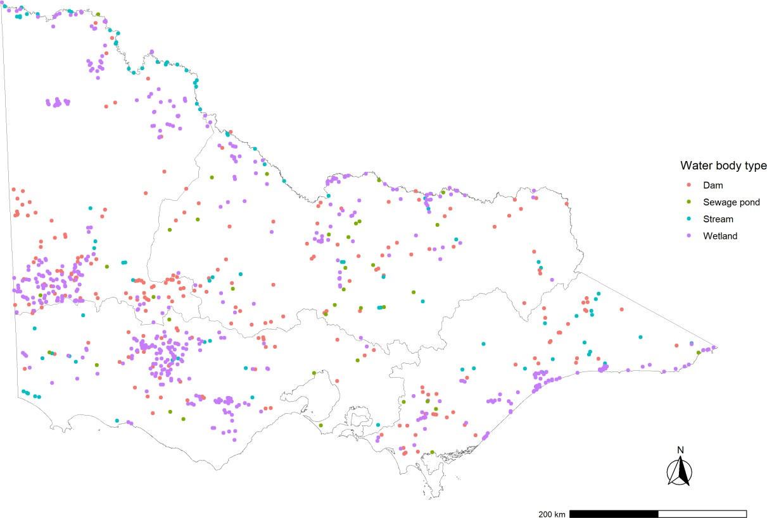

Figure 2. Locations of the 865 waterbodies (dams, sewage ponds, wetlands and rivers/streams) that were subject to aerial and ground sampling during October-November 2023. Bioregion boundaries are (clockwise from top left), West, North, East and South.

Surface water availability
The number of waterbodies (dams, sewage ponds, wetlands and rivers/streams) categorised as containing surface water following calibration of the satellite imagery was estimated at 212,045 (Table 2). This was a 16% decrease compared with the estimate for the previous survey in 2022 (251,734). Overall, surface water availability in 2023 slightly decreased by 5% compared to that in 2022, resulting in a total surface water area of 232,805 ha (Figure 3).

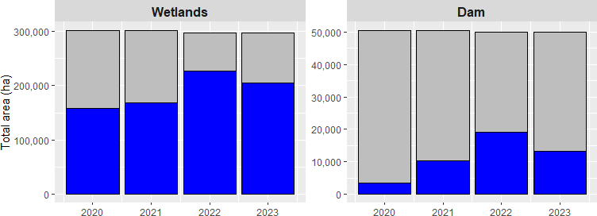

Figure 3. Temporal changes in surface water availability in wetlands and dams since 2020.

10 Game duck abundance in Victoria 2023

Table 2. Number of mapped waterbodies determined as containing surface water during the Spring 2023 period.

Waterbody type |  |  | Size class
 | <6 ha | 6–50 ha | >50 ha | Total
Dams | 191,064 | 129 | 57 | 191,250
Sewage ponds | 43 | 53 | 9 | 105
River/Streams | 11,361 | 1,929 | 0 | 13,290
Wetlands | 5,552 | 1,449 | 399 | 7,400
Total | 208,020 | 3,560 | 465 | 212,045

Calibration of surface water predictions
The results from the calibration of the Sentinel-2 satellite imagery with the observations of surface water for each sampled waterbody suggested that correct predictions of wet waterbodies were high (>90%) for wetlands and sewage ponds, and lower for river/stream segments (81%) and small dams (70%) (Figure 4a). The dam farm accuracy of 70% was the lowest recorded to date (74%-2020, 79%-2021, 88%-2022).
Exploration of mismatches identified that vegetation obscuring water was obvious in several qualitative checks of smaller waterbodies. Larger dams were correctly predicted to be wet by DEA 2.0, and classification of wetlands using DEA-2.0 was slightly lower than for Sentinel 2 (Figure 4b).
Prediction of dry wetlands was poor with 95% of dry wetlands predicted to be wet using Sentinel-2 (Figure 4a), which improved to 41% accuracy when using DEA 2.0 (Figure 4b). Further investigation
suggested that some misclassifications resulted from a mismatch in temporal alignment between helicopter and surface water measurements (i.e. some waterbodies may have had water during the helicopter survey but been dry when satellite went over), which affected classifications mainly in western Victoria. Due to cloud cover obscuring satellite images, some waterbodies may have had an observation date differing by as much as 35 days from the aerial survey date.
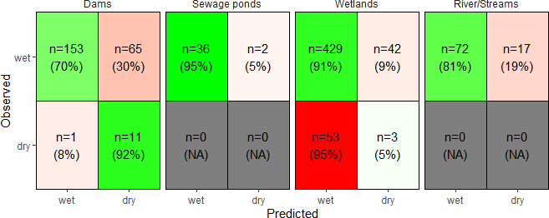

Figure 4a. Confusion table for observed (actual) versus predicted (Sentinel-2) surface water presence for small dams, sewage ponds, wetlands rivers/streams and storage dams. Red indicates incorrect predictions and green indicates correct predictions, with shading indicating relative (in)accuracy. White and grey indicates no data.
Wet = surface water present; Dry = surface water absent.

Game duck abundance in Victoria 2023 11

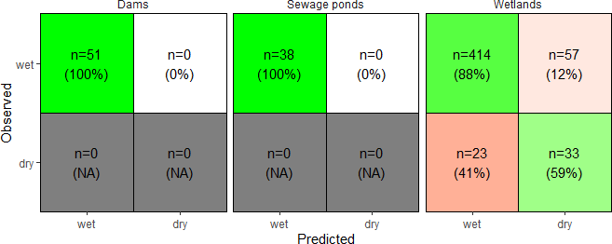

Figure 4b. Confusion table for observed (actual) versus predicted (DEA2.0) surface water presence for large dams, sewage ponds, wetlands, rivers/streams and storage dams. Red indicates incorrect predictions and green indicates correct predictions, with shading indicating relative (in)accuracy. White and grey indicates no data.
Wet = surface water present; Dry = surface water absent.

Waterbody level abundance estimates
The total counts of game ducks (based on the maximum observed in each waterbody) on the 801 waterbodies with surface water are presented in Table 4. Overall, there were more than five times as many game ducks counted on waterbodies during 2023 as there were during 2022 (121,026 versus 22,411). Grey and Chestnut Teal were the most abundant species counted, followed by Pacific Black Duck. In contrast, the least abundant species counted was the Australasian Shoveler (Table 3). Counts of most species were higher within the South and North bioregions compared with the West and East (Table 4).
The monitoring data were adequate for estimating the abundance of all eight species of game duck. The N-mixture ZIP model (section 2.4.1) appeared to be a good fit to the aerial and ground survey data for each species, with posterior predictive distributions indicating strong positive relationships (Figure 5). Bayesian R2 values (Gelman et al. 2019) were high for all species (Grey Teal (GT) = 0.92; Australian Wood Duck (WD) = 0.89; Australian Shelduck (AS) = 0.80; Pacific Black Duck (PBD) = 0.80; Chestnut Teal (CT) = 0.87; Hardhead (HH) = 0.94; Pink-eared Duck (PED) = 0.89; Australasian Shoveler (BWS) = 0.94). In particular, the fits indicated adequate prediction of the proportion of waterbodies with zero ducks, as well as of the mean duck abundance (Appendix B). However, the models generally showed some negative bias in the predicted standard deviation and maximum count, indicating some residual overdispersion that was unaccounted for in the model (Appendix B). However, attempts to add additional structure to this model by adding random effects proved to be unsuccessful due to lack of convergence of the MCMC chains.

12 Game duck abundance in Victoria 2023

Table 3. Total counts of each species by waterbody type and size class (ha). The maximum of the two counts for each waterbody was used to calculate the total. Species codes are: GT = Grey Teal; CT = Chestnut Teal; WD = Australian Wood Duck; PBD = Pacific Black Duck; AS = Australian Shelduck; HH = Hardhead; PED = Pink-eared Duck; BWS = Australasian Shoveler. n = number of waterbodies with surface water.

Waterbody type | Size class | n | GT | WD | AS | PBD | CT | HH | PED | BWS
Dams | <6 | 172 | 279 | 742 | 110 | 344 | 87 | 19 | 0 | 1
 | 6–50 | 25 | 592 | 300 | 177 | 330 | 387 | 273 | 44 | 15
 | >50 | 17 | 800 | 220 | 30 | 626 | 610 | 68 | 2 | 18
Sewage ponds | <6 | 12 | 496 | 38 | 58 | 142 | 296 | 273 | 115 | 19
Sewage ponds | 6–50 | 21 | 3,004 | 255 | 344 | 535 | 873 | 1,795 | 1,093 | 90
 | >50 | 5 | 2,966 | 515 | 185 | 165 | 368 | 1,110 | 2,297 | 85
Rivers & Streams | <6 | 59 | 142 | 802 | 41 | 556 | 167 | 11 | 0 | 4
Rivers & Streams | 6–50 | 32 | 99 | 482 | 17 | 194 | 112 | 2 | 0 | 2
Wetlands | <6 | 144 | 1,723 | 1,120 | 210 | 837 | 1,784 | 63 | 38 | 11
 | 6–50 | 170 | 7,559 | 1,132 | 1,644 | 2,165 | 11,424 | 468 | 232 | 167
 | >50 | 144 | 24,577 | 1,053 | 1,783 | 6,137 | 25,936 | 2,487 | 2,278 | 376
Total |  | 801 | 42,237 | 6,659 | 4,599 | 12,031 | 42,044 | 6,569 | 6,099 | 788

Table 4. Total counts of each species by bioregion. The maximum of the two counts for each waterbody was used to calculate the total. Species codes are: GT = Grey Teal;

CT = Chestnut Teal; WD = Australian Wood Duck; PBD = Pacific Black Duck; AS = Australian Shelduck; HH = Hardhead; PED = Pink-eared Duck; BWS = Australasian Shoveler. n = number of waterbodies with surface water.

Bioregion | n | GT | WD | AS | PBD | CT | HH | PED | BWS | Total
East | 147 | 5,957 | 534 | 549 | 1,552 | 6,649 | 751 | 78 | 49 | 16,119
North | 192 | 9,310 | 1,982 | 770 | 3,246 | 4,234 | 2,661 | 3,478 | 144 | 25,825
South | 214 | 20,152 | 757 | 2,633 | 5,115 | 27,312 | 2,513 | 2,318 | 502 | 61,302
West | 248 | 6,818 | 3,386 | 647 | 2,118 | 3,849 | 644 | 225 | 93 | 17,780

Game duck abundance in Victoria 2023 13

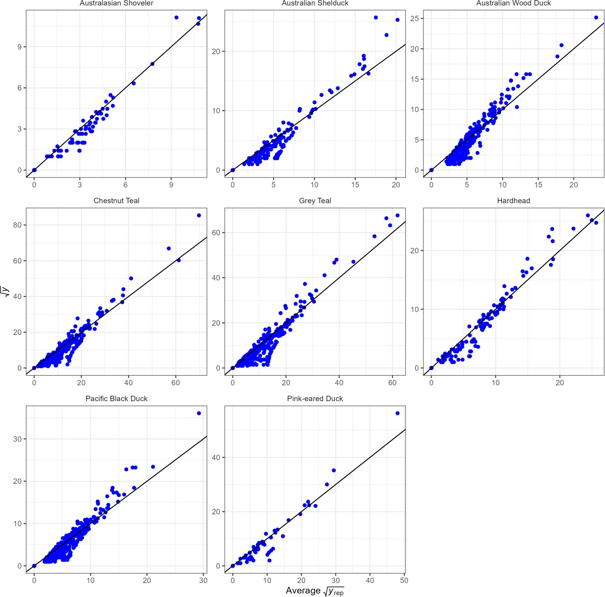

Figure 5. Posterior predictive distributions of the counts of eight game duck species. 𝒚 = observed counts (sum of both observers); 𝒚_{𝒓𝒆𝒑} = average predicted count from the fit of the zero-inflated N-mixture model. The predicted and observed counts were square root transformed to aid the visibility of the small counts. The black line shows a 1:1 relationship.

Detection probability of ducks was lower during aerial surveys compared with ground surveys, with the magnitude of the difference dependent on habitat (Figure 6). Aerial detection probability was highest in open and reed habitat (0.47–0.64) and was lowest in wooded habitat, but varied little with waterbody size class. In contrast, ground detection probability was highest in open habitat on small (<6 ha) waterbodies (0.87) and lowest in reed and wooded habitat on large (>50 ha) waterbodies (0.49–0.52) (Figure 6). Compared with habitat or waterbody size class, the presence of glare on the water surface appeared to have a relatively minor influence on detection probabilities (Figure 6).

14 Game duck abundance in Victoria 2023

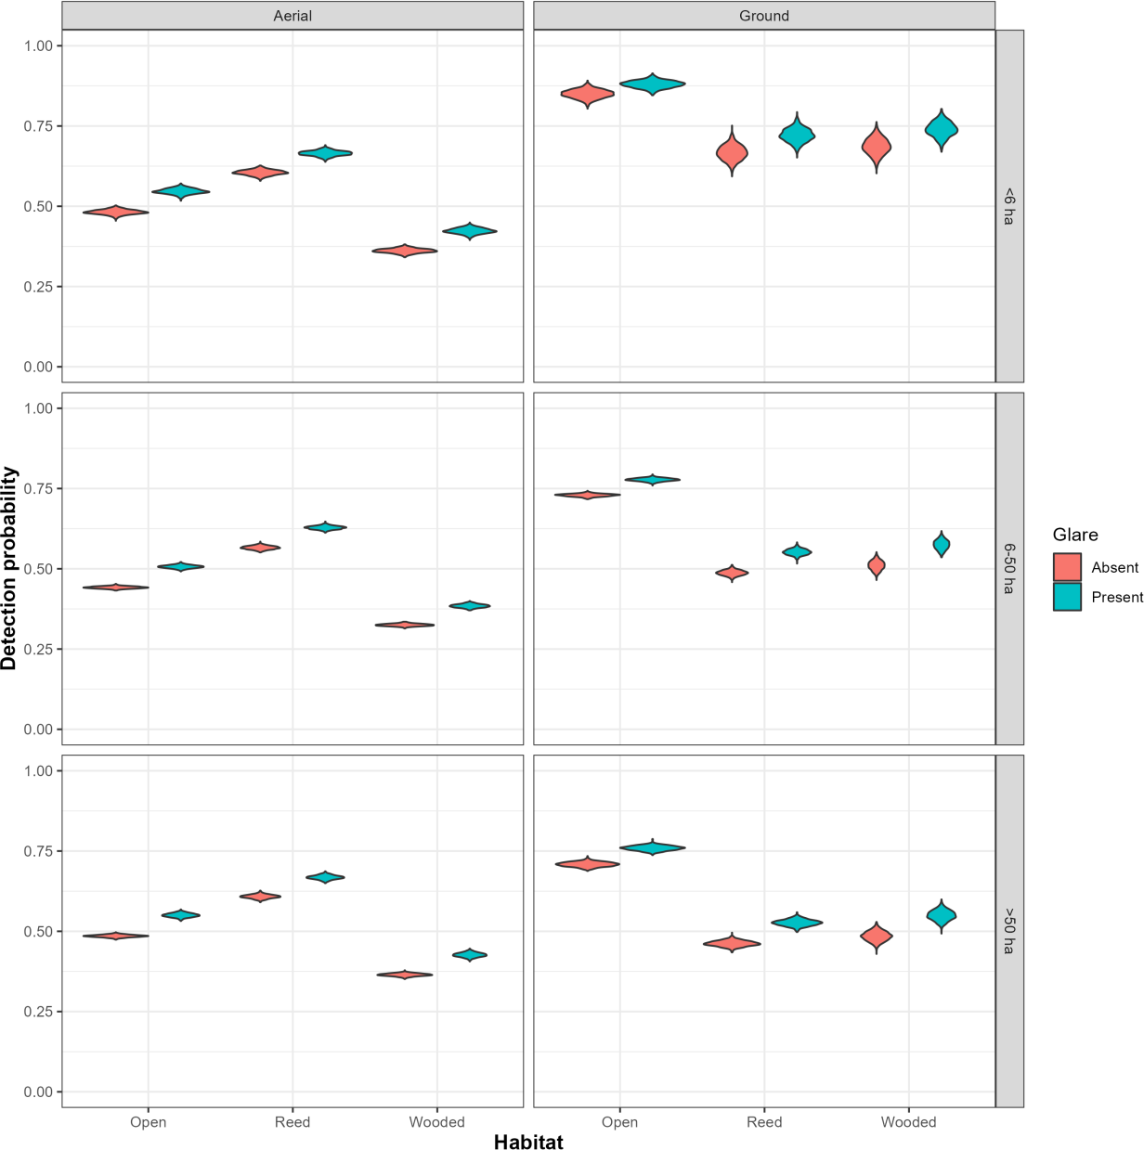

Figure 6. Detection probabilities of game ducks from aerial and ground surveys by habitat type and waterbody size class (<6 ha; 6–50 ha; >50 ha) in the presence or absence of glare from the water surface.

Statewide abundance estimates

Design-based estimates
Design-based estimates indicated that the population of game ducks on dams, sewage ponds, wetlands and streams in Victoria was approximately 7.1 M birds (Table 5). Wood Duck were the most numerous game species (~2.6 M), followed by Pacific Black Duck (~1.4 M) and Grey and Chestnut Teal (~1.4 M and 1.2 M, respectively). Precision of the overall estimate of abundance was good, with an 8% coefficient of variation, well within the target threshold of 15% identified by Ramsey and Fanson (2021) as being of adequate precision. Precision of estimates for the main individual game species was variable, ranging from 12% for Grey Teal to 23% for Black Duck (Table 5).

Model-based estimates
The estimate of the total abundance of game ducks using the model-based approach was approximately 17% lower than the design-based estimate at 5.9 M birds (Table 6). Estimates for all species, except for Pacific Black Duck, Hardhead and Australasian Shoveler, were lower than the equivalent design-based estimates (Table 6). The largest discrepancies between the design-based and model-based estimates occurred for Australian Shelduck and Australian Wood Duck, with the model-based estimates around 38%
Game duck abundance in Victoria 2023 15

and 30% lower than the design-based estimates, respectively. The precision of the overall model-based estimate of abundance was excellent, with a 4% coefficient of variation. The precision of the estimates for individual species was also good, with the precision for the main game species (Grey Teal, Chestnut Teal, Pacific Black Duck and Australian Wood Duck) all with a coefficient of variation less than 15% (Table 6).
Table 5. Summary of design-based estimates of total abundance for the eight game duck species in Victoria. SE = standard error; CV = coefficient of variation; LCL = lower 90% confidence limit; UCL = upper 90% confidence limit.

Species | Estimate | SE | CV | LCL | UCL
Australian Wood Duck | 2,567,300 | 440,600 | 0.17 | 1,838,500 | 3,585,100
Australian Shelduck | 354,400 | 92,800 | 0.26 | 213,900 | 587,100
Australasian Shoveler | 11,600 | 2,800 | 0.24 | 7,300 | 18,500
Chestnut Teal | 1,227,800 | 185,500 | 0.15 | 914,700 | 1,648,100
Grey Teal | 1,401,500 | 162,300 | 0.12 | 1,117,900 | 1,757,200
Hardhead | 156,100 | 51,400 | 0.33 | 83,300 | 292,600
Pacific Black Duck | 1,358,200 | 310,100 | 0.23 | 873,100 | 2,112,900
Pink-eared Duck | 43,600 | 9,800 | 0.23 | 28,200 | 67,500
Total | 7,120,600 | 602,000 | 0.08 | 6,035,100 | 8,401,400

Table 6. Summary of model-based estimates of total abundance of five game duck species in Victoria. SE = standard error; CV = coefficient of variation; LCL = lower 90% confidence limit; UCL = upper 90% confidence limit.

Species | Estimate | SE | CV | LCL | UCL
Australian Wood Duck | 1,797,700 | 150,200 | 0.08 | 1,524,600 | 2,139,100
Australian Shelduck | 220,100 | 38,000 | 0.17 | 157,900 | 301,600
Australasian Shoveler | 15,200 | 4,700 | 0.31 | 8,900 | 28,400
Chestnut Teal | 1,010,000 | 115,900 | 0.11 | 827,800 | 1,255,100
Grey Teal | 1,252,200 | 107,800 | 0.09 | 1,048,900 | 1,485,900
Hardhead | 164,900 | 35,500 | 0.22 | 106,300 | 249,000
Pacific Black Duck | 1,411,000 | 117,200 | 0.08 | 1,191,100 | 1,653,500
Pink-eared Duck | 34,900 | 7,600 | 0.22 | 23,600 | 273,600
Total | 5,905,900 | 253,200 | 0.04 | 5,430,100 | 6,423,400

The majority of game ducks occurred on small farm dams (<6 ha), especially Australian Wood Duck, Pacific Black Duck and Grey Teal (Figure 7). Australian Wood Duck and Pacific Black Duck also occurred in relatively large numbers on rivers and streams. In contrast, Chestnut Teal, Pink-eared Duck and Australasian Shoveler occurred predominantly on wetlands (Figure 7). Game ducks were far more numerous in the South and North bioregion and were least numerous in the East bioregion (Figure 8).

16 Game duck abundance in Victoria 2023

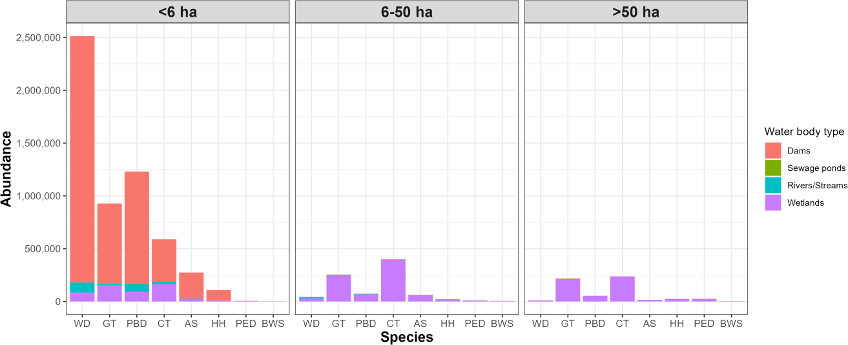

Figure 7. Abundance of game duck species by waterbody type and size class. GT = Grey Teal; CT = Chestnut Teal; WD = Australian Wood Duck; AS = Australian Shelduck; PBD = Pacific Black Duck; HH = Hardhead; PED = Pink-eared Duck; BWS = Australasian Shoveler.

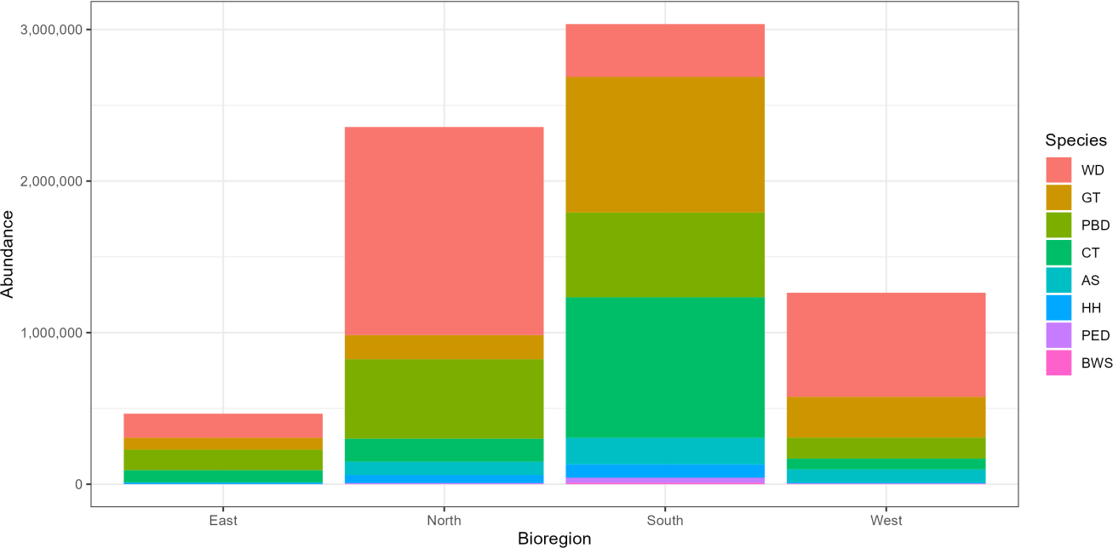

Figure 8. Abundance of game duck species by bioregion. GT = Grey Teal; CT = Chestnut Teal; WD = Australian Wood Duck; AS = Australian Shelduck; PBD = Pacific Black Duck; HH = Hardhead; PED = Pink-eared Duck; BWS = Australasian Shoveler.

Trends in game duck abundance
Trends in the abundance of each game duck species were examined from 2021–2023. Results from the 2020 pilot survey were not included, because separate estimates for Grey and Chestnut Teal were not available for that survey. The trends in the abundance revealed that the major game species, with the exception of Australian Shelduck, have increased markedly since 2021 (Figure 9). In particular, the abundance of Chestnut Teal has increased 20-fold since the 2021 survey (Figure 9).
Game duck abundance in Victoria 2023 17

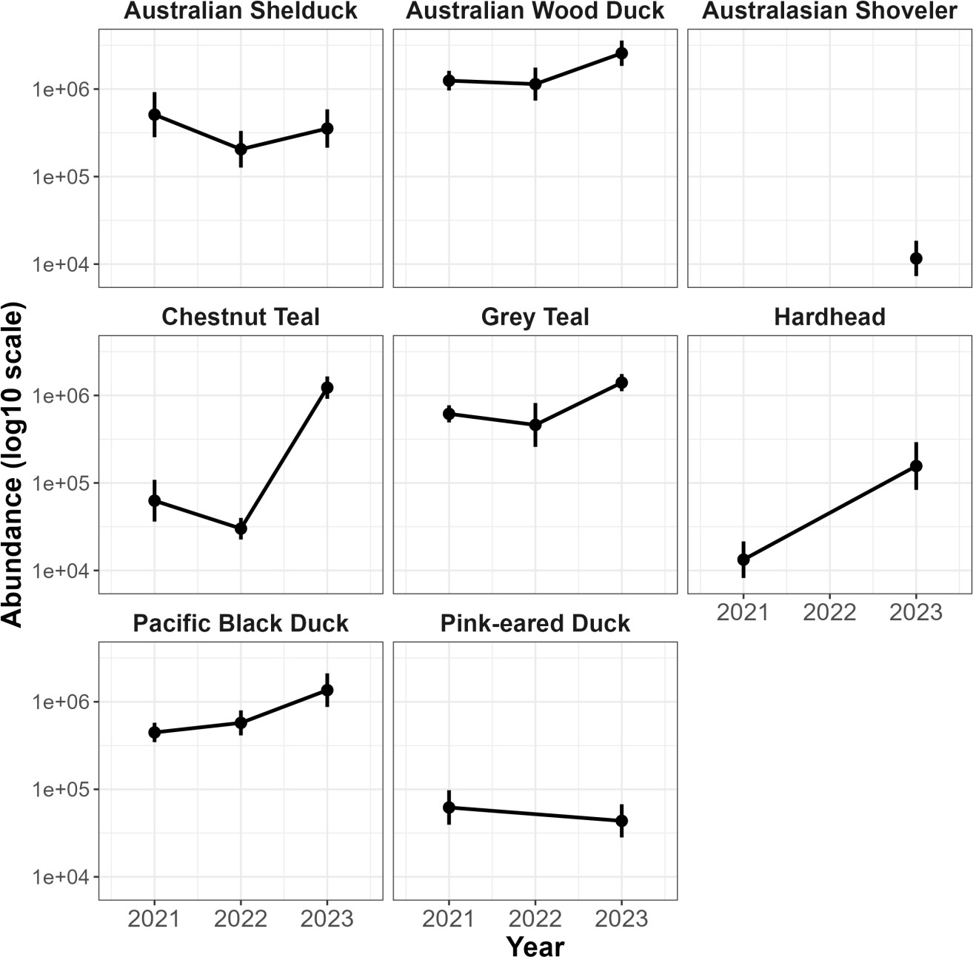

Figure 9. The trends in the abundance of the eight species of game ducks from 2021–2023. Abundance is given on the log10 scale. Estimates could not be obtained for some species in some years due to inadequate data.

18 Game duck abundance in Victoria 2023

Discussion

The total statewide abundance of game ducks has increased markedly from the previous year, with the total design-based abundance almost three times higher than the estimate from the 2022 survey (2,410,000 for the five main species of game duck) (Ramsey and Fanson 2023). This substantial increase was most likely driven by the extensive flooding and presence of surface water driving breeding activity during 2022 (Porter et al. 2023), with the abundance in 2023 reflecting recruitment from this event. The abundance estimates for all the main game species exhibited increases compared with the 2022 survey. Especially notable was the large increase in Chestnut Teal abundance, which exhibited a 20-fold increase since the 2022 survey.
Similar increases in abundance, especially for Chestnut Teal, were also noted during the Eastern Australian Waterbird Aerial Survey (Porter et al. 2023), which was conducted at a similar time of year as the current survey.
Detection probabilities of game ducks by observers during aerial surveys were relatively lower than estimated during previous surveys. In contrast, detection probabilities during ground surveys were relatively higher than those during aerial surveys, consistent with previous surveys (Ramsey and Fanson 2022; Ramsey and Fanson 2023). The main reason for the lower detection rates during aerial surveys was mainly due to the much higher counts of ducks encountered on many wetlands compared with those during previous surveys. The relatively high counts encountered meant there was a higher chance of birds being missed by either observer, especially when birds were on the wing (Mark Lethbridge – personal communication). Moving to more rigorous mark-recapture type monitoring methods, such as double-count or double-dependent-count (e.g. Roy et al. 2021) should allow detection probabilities to depend on observer and/or position in the helicopter, which should result in more robust estimates of detection probabilities.
However, the utility of mark-recapture methods of monitoring game ducks during aerial surveys needs to be explored to determine whether these methods are practical alternatives compared with the current method.
Estimates of surface water availability for the Spring period have declined from the previous highs estimated during 2022. Decreases in surface water availability compared with 2022 were also noted generally across other areas of the Murray-Darling and Lake Eyre basins (Porter et al. 2023). Calibration of surface water estimates from satellite imagery with observations from the aerial surveys revealed that estimates of larger dams and wetlands using DEA2.0 imagery was good, having an 88% true positive rate. However, classification of small farm dams using S2 imagery was less accurate, with a true positive rate of 70%. This lower accuracy was likely due to the presence of vegetation obscuring water occurrence, which was noted in several qualitative checks of smaller waterbodies. In addition, newer classification approaches for farm dams have highlighted the increasing inaccuracy of the current farm dam layer for Victoria (based on data from 2015), where it was estimated that around 11% of farm dams are missing (Malerba et al. 2021). Other classification inaccuracies were noted for some wetlands in the western bioregion, with around 41% of dry wetlands predicted to be wet from DEA2.0 imagery. This may have been caused by a lack of temporal alignment between the date of the last satellite observation and the aerial survey observation, with the waterbody becoming dry in the intervening period, which could have been as much as 35 days from the aerial survey date.
Given the reliance of the game duck abundance estimates on surface water estimates, we recommend that the current surface water approach be re-assessed to determine if improvements could be implemented.
Over the last several years, we have revised the surface water approach to incorporate new layers (e.g. a river/stream layer) and updated existing layers as new data became available (DEA1.0 to DEA2.0). The current approach relies on waterbody classification based on Victoria specific layers (VICMAP_HYDRO, FARM_DAM, ISC rivers), which are not updated regularly. Hence, it may be worthwhile investigating alternative approaches that are based on Australia-wide layers so that both regular updates can occur more seamlessly and extension of surface water estimates beyond Victoria are straightforward.
The Victorian Government has recently committed to implement Adaptive Harvest Management
(e.g. Ramsey et al. 2010; Ramsey et al. 2017) to ensure the transparency and sustainability of the seasonal recreational harvest arrangements. A key step in the transition to Adaptive Harvest Management is the use of a proportional harvest strategy to set the maximum allowable recreational harvest. Proportional harvest
Game duck abundance in Victoria 2023 19

strategies have been shown to be safe and effective for populations inhabiting fluctuating environments (Engen et al. 1997). Recent investigations of proportional harvest strategies for Victorian game ducks have shown that annual harvest fractions of 10–20% of the current Victorian abundance of a species (e.g. either Pacific Black Duck, Australian Wood Duck, Grey or Chestnut Teal) would be sustainable (Prowse 2023).
Adopting an Adaptive Harvest Management framework for Victoria requires that regular monitoring data are collected for the regions of interest. Once a sufficient time series of monitoring data are available (i.e. 5–
8 years), population models that describe how game duck populations respond to harvest arrangements and environmental conditions are fitted to the data. These models are then used to identify the optimal sustainable harvest arrangements for the following season (Nichols et al. 2007; Ramsey et al. 2017).
Adopting a proportional harvest strategy, based on the most recent abundance estimate for game ducks, will be a critical first step in the transition to Adaptive Harvest Management until sufficient monitoring data are available. Since the seasonal harvest arrangements only apply to Victoria, using the current Victorian abundance for game ducks to set a maximum proportional offtake should be sustainable, even if environmental conditions become unfavorable (Prowse 2023).
Adaptive Harvest Management offers the potential for a more rigorous scientific approach to the setting of seasonal harvest arrangements for game duck populations. As more monitoring data accumulate, it should be possible to implement the full potential of Adaptive Harvest Management to learn more about how game duck populations respond to harvest under a range of environmental conditions, which should allow greater flexibility to tailor seasonal arrangements for individual species.

20 Game duck abundance in Victoria 2023

References

Carpenter, B., Gelman, A., Hoffman, M. D., Lee, D., Goodrich, B., Betancourt, M., Brubaker, M., Guo, J., Li,
P. and Riddell, A. (2017). Stan: A probabilistic programming language. Journal of Statistical Software
76, 1–32 doi:10.18637/jss.v076.i01
Engen, S., Lande, R. and Sæther, B. E. (1997). Harvesting strategies for fluctuating populations based on uncertain population estimates. Journal of Theoretical Biology 186, 201–212 doi:10.1006/jtbi.1996.0356
Gelman, A., Goodrich, B., Gabry, J. and Vehtari, A. (2019). R-squared for Bayesian Regression Models. The American Statistician 73, 307–309 doi:10.1080/00031305.2018.1549100
Gelman, A. and Hill, J. (2007). Data Analysis Using Regression and Multilevel/Hierarchical Models. 1st ed.
Cambridge University Press, New York, USA.
Hankin, D. G. (1984). Multistage sampling designs in fisheries research: Applications in small streams.
Canadian Journal of Fisheries and Aquatic Sciences 41, 1575–1591.
Horvitz, D. G. and Thompson, D. J. (1952). A generalization of sampling without replacement from a finite universe. Journal of the American Statistical Association 47, 663–685.
Kingsford, R. and Klaassen, M. (2021). Relationships among duck population indices and abiotic drivers to guide annual duck harvest management. Unpublished report to the Game Management Authority, Victoria.
Kingsford, R. T. and Porter, J. L. (2009). Monitoring waterbird populations with aerial surveys – what have we learnt? Wildlife Research 36, 29.
Klaassen, M. (2023). Using duck proxies and surface water to inform hunting arrangements for 2024.
Unpublished report to the Game Management Authority, Victoria.
Malerba, M. E., Wright, N. and Macreadie, P. I. (2021). A continental-scale assessment of density, size, distribution and historical trends of farm dams using deep learning convolutional neural networks. Remote Sensing 13, 1–17 doi:10.3390/rs13020319
Menkhorst, P., Stamation, K. and Brown, G. (2019). Victorian Summer Waterbird Count 2019. Unpublished Client Report, Arthur Rylah Institute for Environmental Research, Heidelberg, Victoria.
Mueller, N., Lewis, A., Roberts, D., Ring, S., Melrose, R., Sixsmith, J., Lymburner, L., McIntyre, A., Tan, P., Curnow, S. and Ip, A. (2016). Water observations from space: Mapping surface water from 25 years of Landsat imagery across Australia. Remote Sensing of Environment 174, 341–352 doi:10.1016/j.rse.2015.11.003
Nichols, J. D., Runge, M. C., Johnson, F. A. and Williams, B. K. (2007). Adaptive harvest management of North American waterfowl populations: A brief history and future prospects. Journal of Ornithology 148, 343–349.
Pekel, J-F., Cottam, A., Gorelick, N. and Belward, A. S. (2016). High-resolution mapping of global surface water and its long-term changes. Nature 540, 418–422.
Porter, J., Kingsford, R., Francis, R., Brandis, K. and Ahern, A. (2023). Eastern Australian Waterbird Aerial Survey – Annual Summary Report. Department of Planning and Environment, Centre for Ecosystem Science, School of Biological, Earth and Environmental Sciences, UNSW Sydney.
Prowse, T. (2023). Conservation and Sustainable-Harvest Models for Game Duck Species. Available at: https://djsir.vic.gov.au/ data/assets/pdf_file/0010/2209942/Conservation-and-Sustainable-Harvest-Models-for-Game-Duck-Species.pdf (accessed 20 February 2024).
Prowse, T. A. A. and Kingsford, R. T. (2021). Review of Ramsey and Fanson (2021) abundance estimates for games ducks in Victoria. Unpublished report to the Game Management Authority. Available at:
Game duck abundance in Victoria 2023 21

https://www.gma.vic.gov.au/ data/assets/pdf_file/0003/819282/Game-duck-review-Kingsford-Prowse.pdf
Quadros, N., Frisina, R., Wilson, P., others (2011). Using airborne survey to map stream form and riparian vegetation characteristics across Victoria. Proceedings of the SilviLaser, Hobart, Australia 16, 19.
Ramsey, D. S. L. (2020). Design of a monitoring program for game ducks in Victoria. Arthur Rylah Institute for Environmental Research Technical Report Series No. 314. Department of Environment, Land, Water and Planning, Heidelberg, Victoria.
Ramsey, D. S. L. and Fanson, B. (2022). Abundance estimates for game ducks in Victoria: Results from the 2021 aerial and ground surveys. Arthur Rylah Institute for Environmental Research Technical Report Series No. 335, Department of Environment, Land, Water and Planning, Heidelberg, Victoria.
Ramsey, D. S. L., Fanson, B. (2023). Abundance estimates for game ducks in Victoria: Results from the 2022 aerial and ground surveys. Arthur Rylah Institute for Environmental Research Technical Report Series No. 357. Department of Energy, Environment and Climate Action, Heidelberg, Victoria.
Ramsey, D. S. L., Fanson, B. (2021). Abundance estimates of game ducks in Victoria: Results from the 2020 aerial survey. Arthur Rylah Institute for Environmental Research Technical Report Series No. 325, Department of Environment, Land, Water and Planning, Heidelberg, Victoria.
Ramsey, D. S. L., Forsyth, D., Conroy, M., Hall, G., Kingsford, R., Mitchell, G., Roshier, D., Veltman, C., Webb, G. and Wintle, B. (2010). Developing a sustainable harvest model for Victorian waterfowl. Arthur Rylah Institute for Environmental Research Technical Report Series No. 195. Department of Sustainability and Environment, Heidelberg, Victoria.
Ramsey, D. S. L., Pacioni, C., Mcleod, S. and Dundas, S. (2017). Towards the implementation of adaptive harvest management of waterfowl in south-eastern Australia. Arthur Rylah Institute for Environmental Research Technical Report Series No. 284, Department of Environment, Land, Water and Planning, Heidelberg, Victoria.
Roy, C., Gilliland, S. G. and Reed, E. T. (2021). A hierarchical dependent double-observer method for estimating waterfowl breeding pairs abundance from helicopters. Wildlife Biology e01003, 1–14 doi:10.1002/wlb3.01003
Royle, J. A. (2004). N-Mixture models for estimating population size from spatially replicated counts.
Biometrics 60, 108–115 doi:doi:10.1111/j.0006-341X.2004.00142.x
Skalski, J. R. (1994). Estimating wildlife populations based on incomplete area surveys. Wildlife Society Bulletin 22, 192–203.
Thompson, S. K. (1992). Sampling. John Wiley and Sons, New York, USA.

22 Game duck abundance in Victoria 2023

Appendix A

Design-based estimates of total abundance of game ducks

Stratified random design
For a stratified random design with unequal selection probabilities of sampling units, the total abundance of a game duck species in a particular stratum ℎ (ℎ = 1, … , 𝐻) was given by the Horvitz–Thompson estimator (Horvitz and Thompson 1952):
𝑚
𝑛̂𝑖ℎ

𝜏̂ℎ = ∑ 𝜋
(𝐸𝑞𝑢𝑎𝑡𝑖𝑜𝑛 1)

𝑖=1 ℎ
where 𝜏̂ℎ is total abundance of ducks in stratum ℎ, 𝑛̂𝑖ℎ is the best linear unbiased prediction (BLUP) estimate of the number of ducks in waterbody 𝑖 and stratum ℎ derived from the fitted N-mixture ZIP model (section 2.4.1), 𝑚 is the number of sampled waterbodies in stratum ℎ, and 𝜋ℎ is the inclusion probability for a waterbody in stratum ℎ. The variance of 𝜏̂ℎ is then given by:

𝑀 − 𝑚
𝑠2
𝑚
var(𝑛̂ )

var(𝜏̂ℎ
) = (
𝑀
) ^{ℎ} + ∑
𝑚
𝑖=1
𝜋ℎ
𝑖ℎ

where 𝑀 is the total number of waterbodies in stratum ℎ in the sampling frame, var(𝑛̂𝑖ℎ) is the variance of the BLUP estimate of 𝑛̂𝑖ℎ, and 𝑠² is given by:
ℎ
∑^{𝑚} (𝜏𝑖ℎ − 𝜏̂ℎ)²

𝑠² =
ℎ
𝑖=1
𝑚 − 1

where 𝜏𝑖ℎ is equal to 𝑚𝑛̂𝑖ℎ⁄𝜋ℎ (Thompson 1992; section 6.2). The estimate of total abundance of ducks in the sampling frame is then:

with variance:
𝐻
𝑁̂𝑇 = ∑ 𝜏̂ℎ
ℎ=1

(𝐸𝑞𝑢𝑎𝑡𝑖𝑜𝑛 2)

𝐻
var(𝑁̂𝑇 ) = ∑ var(𝜏̂ℎ)
ℎ=1

(𝐸𝑞𝑢𝑎𝑡𝑖𝑜𝑛 3)

Game duck abundance in Victoria 2023 23

Appendix B
Posterior predictive checks comparing summary statistics 𝑻 of the predicted counts for each game duck species under the model (Equation 1), with the observed counts on each waterbody. The summary statistics are the proportion of waterbodies with zero counts, the mean total count, the standard deviation of the total count, and the maximum total count. Total counts for each waterbody were calculated by summing the counts for each observer. Pale-blue histograms give the distribution of the summary statistic predicted by the model 𝑻(𝒚𝒓𝒆𝒑), and dark-blue bars give the summary statistic for the observed counts 𝑻(𝒚).
In general, the ZIP model used to estimate abundance had good correspondence between the proportion of zero counts in the data with that predicted by the model. There were small discrepancies between observed and predicted overall mean counts but larger discrepancies between the predicted and observed standard deviation and maximum counts. Despite these discrepancies, the overall fit of the model was deemed to be adequate as judged by the good correspondence between observed and predicted counts (Figure 9).
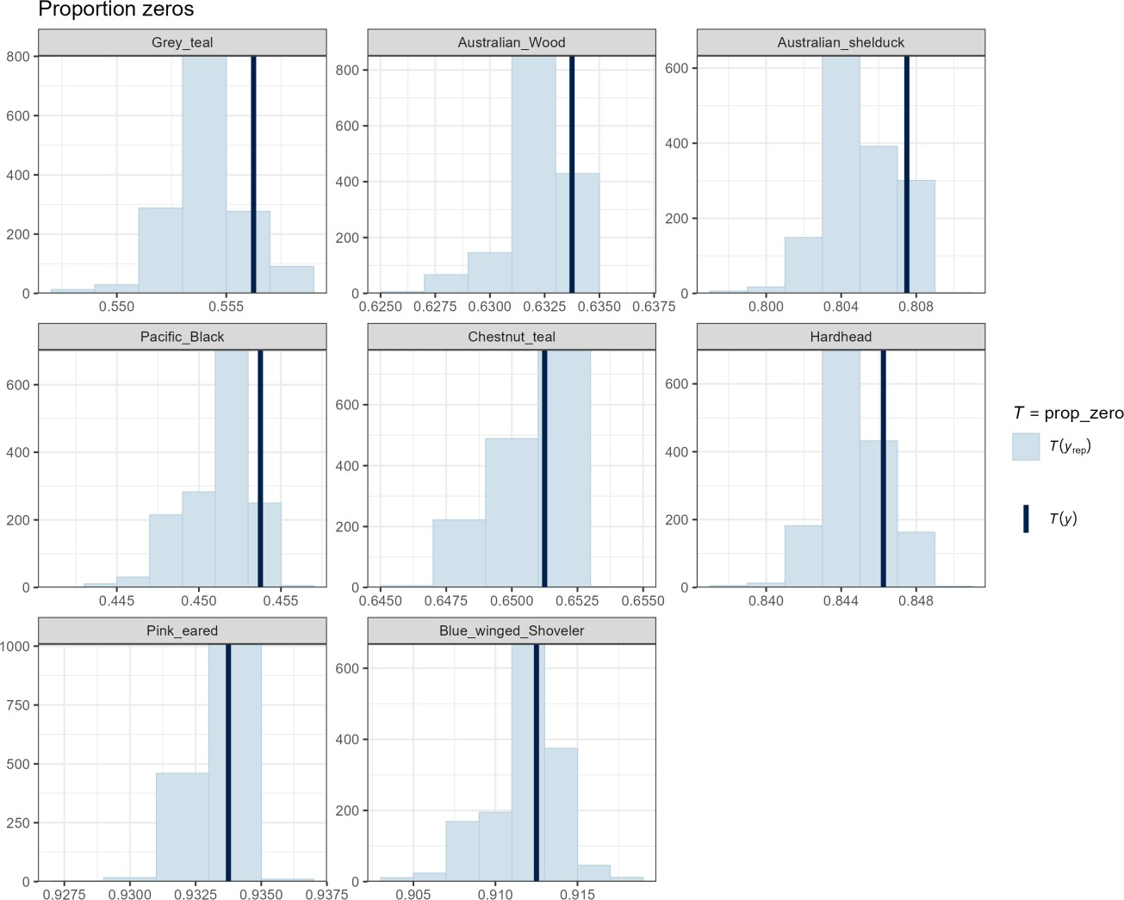

24 Game duck abundance in Victoria 2023

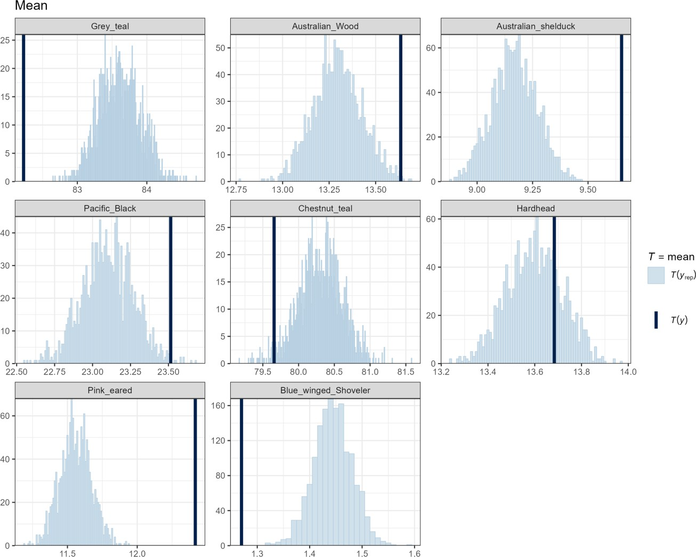

Game duck abundance in Victoria 2023 25

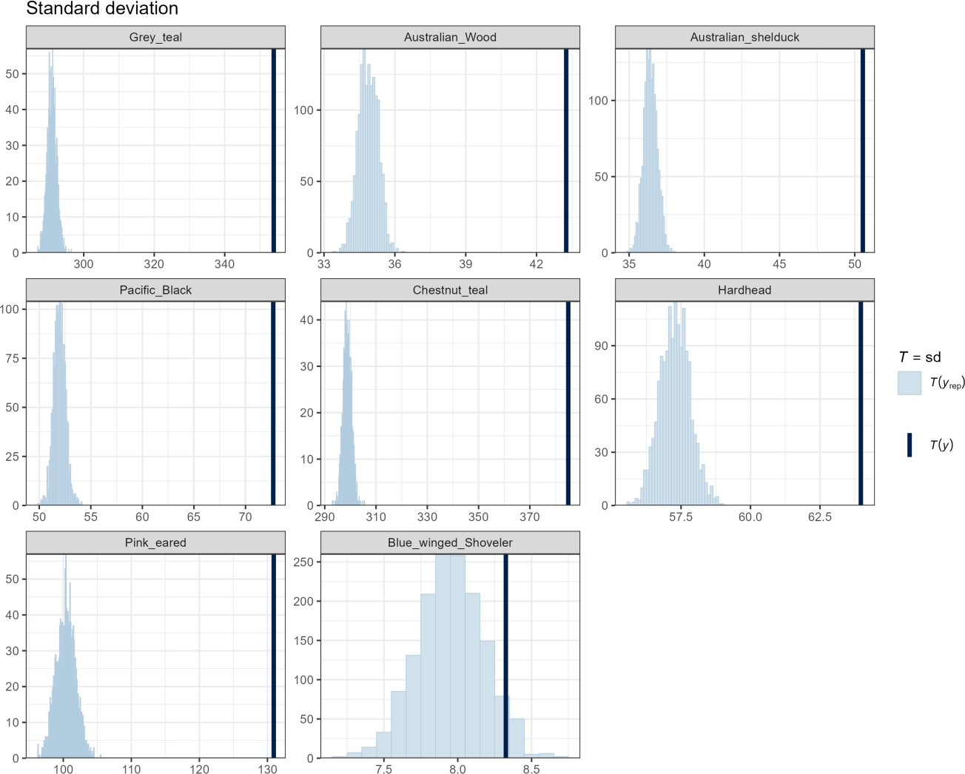

26 Game duck abundance in Victoria 2023

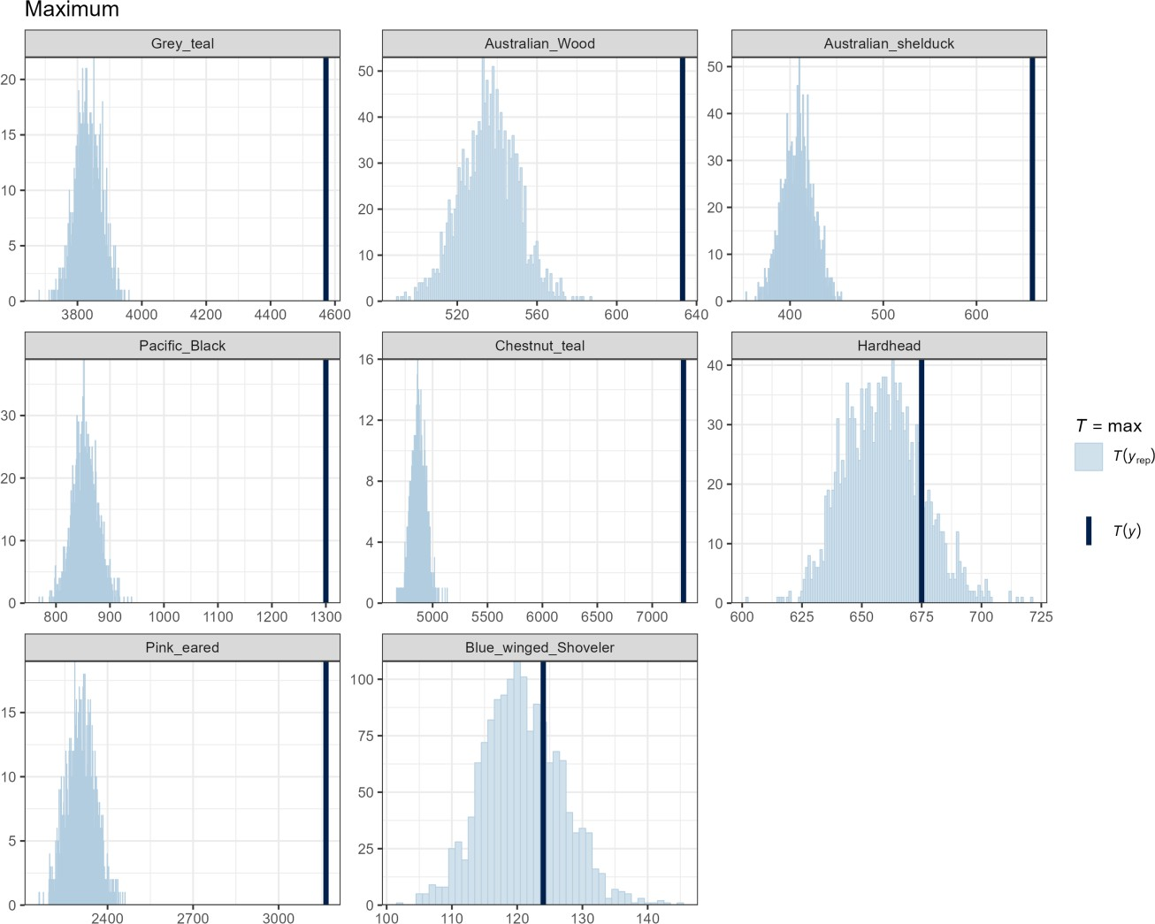

Game duck abundance in Victoria 2023 27

Appendix C

Table C1. Estimates of abundance for each species and stratum (N). SE = standard error;
CV = coefficient of variation; LCL = lower 90% confidence limit; UCL = upper 90% confidence limit;
m = number sampled; M = total number in the sampling frame.

Species | Waterbody | Size class | N | SE | CV | LCL | UCL | m | M
Grey Teal | Dam | <6 ha | 758443 | 146989 | 0.194 | 520566 | 1105021 | 172 | 191064
 | Dam | 6–50 ha | 1544 | 429 | 0.278 | 905 | 2635 | 25 | 129
 | Dam | >50 ha | 1529 | 281 | 0.184 | 1070 | 2184 | 17 | 57
 | Sewage ponds | <6 ha | 580 | 161 | 0.278 | 340 | 989 | 12 | 37
 | Sewage ponds | 6–50 ha | 4372 | 353 | 0.081 | 3734 | 5119 | 21 | 53
 | Sewage ponds | >50 ha | 3975 | 839 | 0.211 | 2640 | 5985 | 4 | 5
 | River/Stream | <6 ha | 16910 | 3772 | 0.223 | 10980 | 26043 | 59 | 11361
 | River/Stream | 6–50 ha | 1982 | 1467 | 0.74 | 543 | 7239 | 32 | 1929
 | River/Stream | >50 ha | 0 | 0 | NA | NA | NA | 0 | 0
 | Wetland | <6 ha | 151768 | 28130 | 0.185 | 105862 | 217580 | 144 | 5552
 | Wetland | 6–50 ha | 247088 | 57919 | 0.234 | 157031 | 388791 | 170 | 1449
 | Wetland | >50 ha | 213336 | 23630 | 0.111 | 171818 | 264887 | 144 | 399

Species | Waterbody | Size class | N | SE | CV | LCL | UCL | m | M
Australian Wood Duck | Dam | <6 ha | 2332379 | 440030 | 0.189 | 1616636 | 3365007 | 172 | 191064
 | Dam | 6–50 ha | 730 | 219 | 0.3 | 411 | 1297 | 25 | 129
 | Dam | >50 ha | 464 | 55 | 0.119 | 368 | 586 | 17 | 57
 | Sewage ponds | <6 ha | 54 | 19 | 0.352 | 27 | 107 | 12 | 37
 | Sewage ponds | 6–50 ha | 425 | 106 | 0.249 | 263 | 687 | 21 | 53
 | Sewage ponds | >50 ha | 636 | 147 | 0.231 | 406 | 996 | 4 | 5
 | River/Stream | <6 ha | 95741 | 13450 | 0.14 | 72795 | 125920 | 59 | 11361
 | River/Stream | 6–50 ha | 13527 | 2445 | 0.181 | 9518 | 19224 | 32 | 1929
 | River/Stream | >50 ha | 0 | 0 | NA | NA | NA | 0 | 0
 | Wetland | <6 ha | 84014 | 16759 | 0.199 | 57044 | 123736 | 144 | 5552
 | Wetland | 6–50 ha | 28649 | 5369 | 0.187 | 19905 | 41234 | 170 | 1449
 | Wetland | >50 ha | 10710 | 2074 | 0.194 | 7353 | 15599 | 144 | 399

28 Game duck abundance in Victoria 2023

Species | Waterbody | Size class | N | SE | CV | LCL | UCL | m | M
Australian Shelduck | Dam | <6 ha | 245978 | 90803 | 0.369 | 122083 | 495608 | 172 | 191064
 | Dam | 6–50 ha | 509 | 188 | 0.369 | 253 | 1026 | 25 | 129
 | Dam | >50 ha | 70 | 25 | 0.357 | 36 | 138 | 17 | 57
 | Sewage ponds | <6 ha | 74 | 29 | 0.392 | 35 | 154 | 12 | 37
 | Sewage ponds | 6–50 ha | 504 | 107 | 0.212 | 334 | 761 | 21 | 53
 | Sewage ponds | >50 ha | 193 | 84 | 0.435 | 85 | 437 | 4 | 5
 | River/Stream | <6 ha | 5003 | 4159 | 0.831 | 1209 | 20710 | 59 | 11361
 | River/Stream | 6–50 ha | 625 | 377 | 0.603 | 210 | 1860 | 32 | 1929
 | River/Stream | >50 ha | 0 | 0 | NA | NA | NA | 0 | 0
 | Wetland | <6 ha | 23376 | 6227 | 0.266 | 13992 | 39053 | 144 | 5552
 | Wetland | 6–50 ha | 63211 | 17478 | 0.277 | 37133 | 107604 | 170 | 1449
 | Wetland | >50 ha | 14846 | 2877 | 0.194 | 10190 | 21630 | 144 | 399

Species | Waterbody | Size class | N | SE | CV | LCL | UCL | m | M
Pacific Black Duck | Dam | <6 ha | 1065056 | 309687 | 0.291 | 609358 | 1861540 | 172 | 191064
 | Dam | 6–50 ha | 909 | 211 | 0.232 | 580 | 1426 | 25 | 129
 | Dam | >50 ha | 1157 | 301 | 0.26 | 700 | 1911 | 17 | 57
 | Sewage ponds | <6 ha | 170 | 50 | 0.294 | 96 | 300 | 12 | 37
 | Sewage ponds | 6–50 ha | 741 | 123 | 0.166 | 537 | 1023 | 21 | 53
 | Sewage ponds | >50 ha | 249 | 25 | 0.1 | 205 | 303 | 4 | 5
 | River/Stream | <6 ha | 72953 | 8446 | 0.116 | 58186 | 91467 | 59 | 11361
 | River/Stream | 6–50 ha | 4870 | 1325 | 0.272 | 2884 | 8224 | 32 | 1929
 | River/Stream | >50 ha | 0 | 0 | NA | NA | NA | 0 | 0
 | Wetland | <6 ha | 91523 | 10349 | 0.113 | 73382 | 114149 | 144 | 5552
 | Wetland | 6–50 ha | 67550 | 8271 | 0.122 | 53185 | 85794 | 170 | 1449
 | Wetland | >50 ha | 53063 | 5381 | 0.101 | 43521 | 64697 | 144 | 399

Species | Waterbody | Size class | N | SE | CV | LCL | UCL | m | M
Chestnut Teal | Dam | <6 ha | 401903 | 126243 | 0.314 | 220299 | 733212 | 172 | 191064
 | Dam | 6–50 ha | 1187 | 681 | 0.574 | 417 | 3376 | 25 | 129
 | Dam | >50 ha | 965 | 236 | 0.245 | 602 | 1546 | 17 | 57
 | Sewage ponds | <6 ha | 341 | 84 | 0.246 | 212 | 549 | 12 | 37
 | Sewage ponds | 6–50 ha | 1243 | 207 | 0.167 | 898 | 1720 | 21 | 53
 | Sewage ponds | >50 ha | 477 | 88 | 0.184 | 334 | 682 | 4 | 5
 | River/Stream | <6 ha | 22414 | 5387 | 0.24 | 14087 | 35663 | 59 | 11361
 | River/Stream | 6–50 ha | 2353 | 2156 | 0.916 | 509 | 10869 | 32 | 1929
 | River/Stream | >50 ha | 0 | 0 | NA | NA | NA | 0 | 0
 | Wetland | <6 ha | 164049 | 34490 | 0.21 | 109131 | 246603 | 144 | 5552
 | Wetland | 6–50 ha | 395769 | 129296 | 0.327 | 212020 | 738764 | 170 | 1449
 | Wetland | >50 ha | 237090 | 22928 | 0.097 | 196240 | 286444 | 144 | 399

Game duck abundance in Victoria 2023 29

Species | Waterbody | Size class | N | SE | CV | LCL | UCL | m | M
Hardhead | Dam | <6 ha | 98273 | 50891 | 0.518 | 37805 | 255460 | 172 | 191064
 | Dam | 6–50 ha | 846 | 326 | 0.385 | 408 | 1753 | 25 | 129
 | Dam | >50 ha | 142 | 36 | 0.254 | 87 | 233 | 17 | 57
 | Sewage ponds | <6 ha | 339 | 74 | 0.218 | 222 | 519 | 12 | 37
 | Sewage ponds | 6–50 ha | 2667 | 287 | 0.108 | 2161 | 3291 | 21 | 53
 | Sewage ponds | >50 ha | 1483 | 88 | 0.059 | 1321 | 1665 | 4 | 5
 | River/Stream | <6 ha | 858 | 489 | 0.57 | 304 | 2424 | 59 | 11361
 | River/Stream | 6–50 ha | 76 | 76 | 1 | 15 | 389 | 32 | 1929
 | River/Stream | >50 ha | 0 | 0 | NA | NA | NA | 0 | 0
 | Wetland | <6 ha | 8409 | 4078 | 0.485 | 3416 | 20699 | 144 | 5552
 | Wetland | 6–50 ha | 18811 | 4218 | 0.224 | 12187 | 29036 | 170 | 1449
 | Wetland | >50 ha | 24214 | 3620 | 0.15 | 18093 | 32407 | 144 | 399

Species | Waterbody | Size class | N | SE | CV | LCL | UCL | m | M
Pink-eared Duck | Dam | <6 ha | 0 | 23 | Inf | 0 | NA | 172 | 191064
 | Dam | 6–50 ha | 108 | 91 | 0.843 | 26 | 455 | 25 | 129
 | Dam | >50 ha | 23 | 20 | 0.87 | 5 | 103 | 17 | 57
 | Sewage ponds | <6 ha | 147 | 92 | 0.626 | 48 | 452 | 12 | 37
 | Sewage ponds | 6–50 ha | 1562 | 400 | 0.256 | 954 | 2559 | 21 | 53
 | Sewage ponds | >50 ha | 2915 | 989 | 0.339 | 1527 | 5566 | 4 | 5
 | River/Stream | <6 ha | 0 | 1 | Inf | 0 | NA | 59 | 11361
 | River/Stream | 6–50 ha | 0 | 0 | NA | 0 | NA | 32 | 1929
 | River/Stream | >50 ha | 0 | 0 | NA | NA | NA | 0 | 0
 | Wetland | <6 ha | 6004 | 5741 | 0.956 | 1237 | 29133 | 144 | 5552
 | Wetland | 6–50 ha | 10041 | 4071 | 0.405 | 4674 | 21570 | 170 | 1449
 | Wetland | >50 ha | 22840 | 6784 | 0.297 | 12918 | 40382 | 144 | 399

Species | Waterbody | Size class | N | SE | CV | LCL | UCL | m | M
Australasian Shoveler | Dam | <6 ha | 0 | 23 | Inf | 0 | NA | 172 | 191064
 | Dam | 6–50 ha | 108 | 91 | 0.843 | 26 | 455 | 25 | 129
 | Dam | >50 ha | 23 | 20 | 0.87 | 5 | 103 | 17 | 57
 | Sewage ponds | <6 ha | 147 | 92 | 0.626 | 48 | 452 | 12 | 37
 | Sewage ponds | 6–50 ha | 1562 | 400 | 0.256 | 954 | 2559 | 21 | 53
 | Sewage ponds | >50 ha | 2915 | 989 | 0.339 | 1527 | 5566 | 4 | 5
 | River/Stream | <6 ha | 0 | 1 | Inf | 0 | NA | 59 | 11361
 | River/Stream | 6–50 ha | 0 | 0 | NA | 0 | NA | 32 | 1929
 | River/Stream | >50 ha | 0 | 0 | NA | NA | NA | 0 | 0
 | Wetland | <6 ha | 6004 | 5741 | 0.956 | 1237 | 29133 | 144 | 5552
 | Wetland | 6–50 ha | 10041 | 4071 | 0.405 | 4674 | 21570 | 170 | 1449
 | Wetland | >50 ha | 22840 | 6784 | 0.297 | 12918 | 40382 | 144 | 399

30 Game duck abundance in Victoria 2023

www.deeca.vic.gov.au www.ari.vic.gov.au

