Fire impacts and survey methods for burrowing and spiny crayfish

Factsheet No. 2 December 2011

Project objectives

This project addresses a gap in knowledge on the effectiveness of survey methods for burrowing and spiny crayfish and the lack of information on the effects of fire on these genera. The objectives were to:

- Develop and trial non destructive survey methods for burrowing crayfish (Engaeus)
- Investigate detectability of spiny crayfish (Euastacus) using different sampling methods
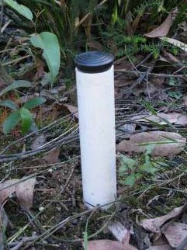
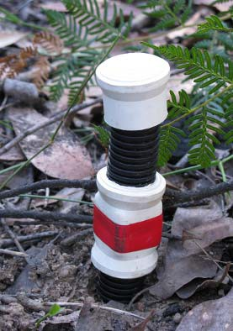
- Assess the impact of the 2009 Victorian wildfires on burrowing and spiny crayfish in the Bunyip, Latrobe and South Gippsland catchments

Capture methods for burrowing crayfish
Twelve methods were tested for effectiveness at burrowing crayfish capture. Excavation (a commonly used but destructive method) was included, however, the emphasis was on testing non‐destructive methods. These included netting, bait pump, spot lighting, baiting, electricity, carbon dioxide and one‐way trap‐
door devices such as the Norrocky trap1(Figure 1a).
These traps target crayfish as they exit the burrow entrance.

Of all methods, the trap door devices had the most captures and greatest evidence of crayfish activity. Various modifications of these traps were tested further. The modified Norrocky trap shown in Figure 1b was found to be most effective at burrowing crayfish capture (Figure 2).

Four species of burrowing crayfish were captured in the modified Norrocky trap. The traps were used in a range of habitats including the regularly inundated flats immediately adjacent to the stream and sloped bank areas beyond the streamside zone. Burrowing crayfish were captured in all of these habitats.

20

15
Capture rate (%)

10

5

0
Norrocky
trap
modified
Norrocky trap

Figure 2. Comparison of capture rate between the Norrocky and modified Norrocky traps.

Burrowing crayfish are thought to be most active at the burrow entrance during the breeding season and following wet conditions (July to December). Whilst collection of more data to confirm this is warranted, surveys should coincide with these periods to maximise crayfish detectability.

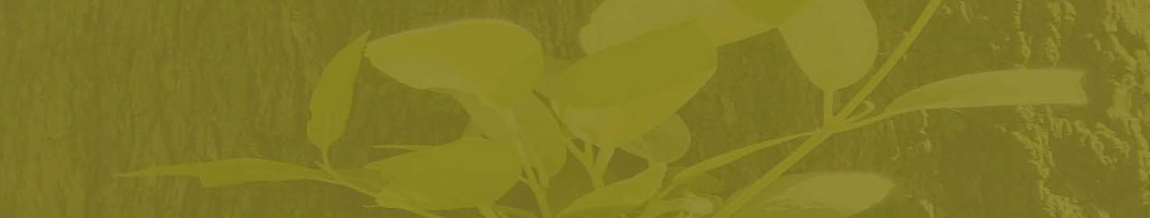


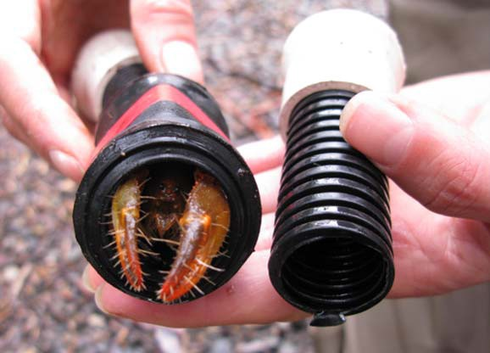
A B

Figure 3. A captured Engaeus in the modified Norrocky trap.

Figure 1(a) Norrocky trap and (b) modified Norrocky trap.



1. Norrocky M. J. (1984) Burrowing crayfish trap. Ohio Journal of Science 84:65–66

This project is funded by the Victorian and Commonwealth governments’ ‘Rebuilding Together’ Statewide Bushfire Recovery Plan launched in October 2009

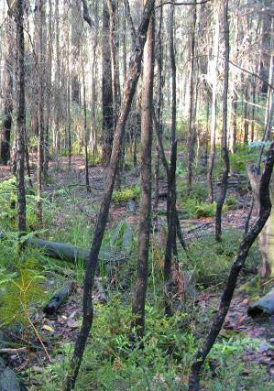
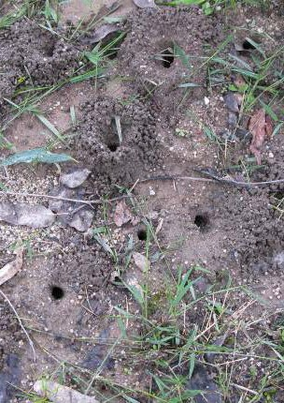
Capture methods for spiny crayfish
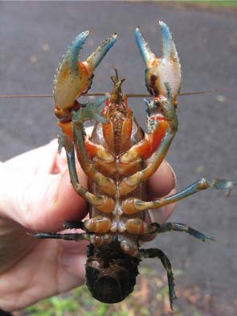
We compared the effectiveness of mesh bait traps and electrofishing for the capture of the South Gippsland Spiny Crayfish (Figure 4).

Among the ten sites surveyed, ten times as many individuals were captured by electrofishing than by bait traps. Electrofishing detected

Effects of fire
The burrowing and spiny crayfish components of this project were undertaken in the Bunyip, Latrobe and South Gippsland catchments. Sites were located within and outside the 2009 wildfire boundaries to assess the effects of the fires on these genera.

Crayfish from both genera were recorded at similar abundances in burnt and unburnt areas. Crayfish presence at fire affected sites (Figure 6) indicates they were able to either survive the fire or recolonise from nearby refuge areas. The affinity of spiny crayfish to complex in stream habitat and the subterranean habit of burrowing crayfish would offer protection against the immediate impact of

crayfish at all sites whereas
bait traps detected crayfish
at only 40% of sites.
Figure 4. South Gippsland Spiny Crayfish (Euastacus neodiversus).
fire. Additionally, the absence of significant post fire rainfall events is likely to have reduced the risk of water quality impacts known to affect spiny crayfish.

Data from multiple pass surveys (performed to indicate fishing effectiveness) showed evidence of crayfish depletion at four passes, however absolute depletion to zero catch was never achieved (Figure 5).

8

7
Mean number of crayfish captured

6

5

4

3

2

1

0
Pass 1 Pass 2 Pass 3 Pass 4

Electrofishing pass

Figure 5. Mean number of spiny crayfish collected (with standard error) in four consecutive electrofishing passes undertaken at five sites.

Up to four hours were required for four 100 m passes which may be a constraint for some surveys but two passes were considered sufficient to adequately represent the crayfish fauna at a site.

Figure 6. Recovering streamside vegetation (left) and evidence of the persistence of burrowing crayfish (right) after the fire.

For more information Refer to: Bryant, D., Crowther, D. and Papas, P. (2011). Improving survey methods and understanding the effects of fire on burrowing and spiny crayfish in the Bunyip and South Gippsland catchments. Department of Sustainability and Environment, Heidelberg, Victoria Contact: David.Bryant@dse.vic.gov.au or Phil.Papas@dse.vic.gov.au

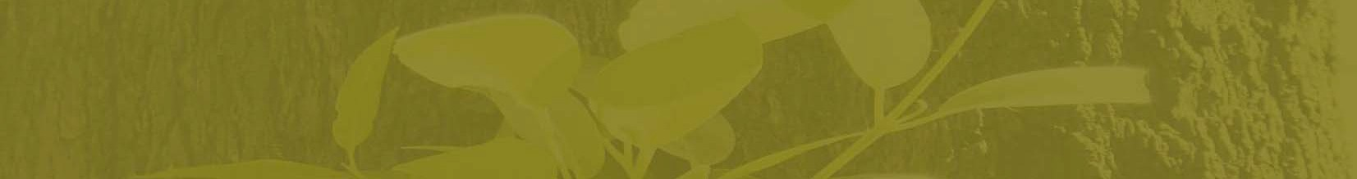

Published by the Victorian Government Department of Sustainability and Environment Melbourne, December 2011
© The State of Victoria Department of Sustainability and Environment 2010 This publication is copyright. No part may be reproduced by any process except in accordance with the provisions of the Copyright Act 1968.
Authorised by the Victorian Government, 123 Brown Street, Heidelberg. ISBN 978-1-74287-265-0 (online)
For more information contact the DSE Customer Service Centre 136 186.
Disclaimer This publication may be of assistance to you but the State of Victoria and its employees do not guarantee that the publication is without flaw of any kind or is wholly appropriate for your particular purposes and therefore disclaims all liability for any error, loss or other consequence which may arise from you relying on any information in this publication.
Accessibility If you would like to receive this publication in an accessible format, such as large print or audio, please telephone 136 186, 1800 122 969 (TTY), or email customer.service@dse.vic.gov.au This document is also available in PDF format on the Internet at www.dse.vic.gov.au

www.dse.vic.gov.au/ari

