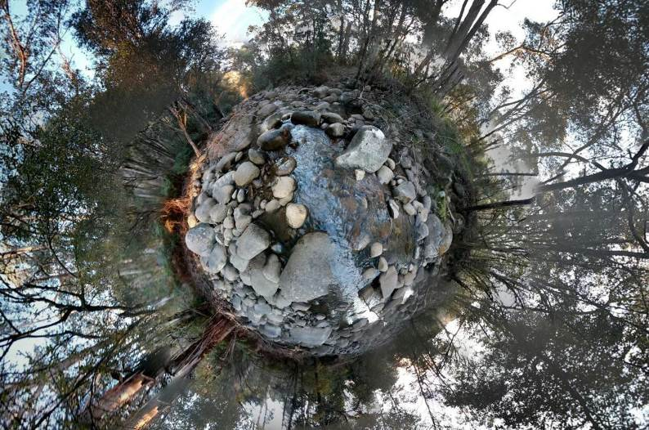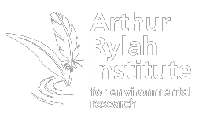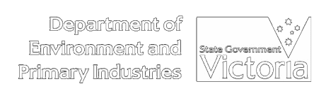A Demonstration Reach Toolbox

A Demonstration Reach Toolbox Jackson and Clunie 2014

i

Peter Jackson and Pam Clunie

2014

Arthur Rylah Institute for Environmental Research Technical Report Series No. 259

A Demonstration Reach Toolbox

Peter Jackson and Pam Clunie

Peter Jackson, consultant, Donnybrook, Queensland 4510 Pam Clunie, Arthur Rylah Institute for Environmental Research
123 Brown Street, Heidelberg, Victoria 3084

September 2014

Report produced by: Arthur Rylah Institute for Environmental Research
Department of Environment and Primary Industries PO Box 137
Heidelberg, Victoria 3084
Phone (03) 9450 8600
Website: www.depi.vic.gov.au/ari
© State of Victoria, Department of Environment and Primary Industries 2014

This publication is copyright. Apart from fair dealing for the purposes of private study, research, criticism or review as permitted under the Copyright Act 1968, no part may be reproduced, copied, transmitted in any form or by any means (electronic, mechanical or graphic) without the prior written permission of the State of Victoria, Department of Environment and Primary Industries. All requests and enquiries should be directed to the Customer Service Centre, 136 186 or email customer.service@depi.vic.gov.au

Citation: Jackson, P. and Clunie, P (2014) Demonstration Reach Toolbox. Arthur Rylah Institute for Environmental Research Technical Report No. 259. Report for Murray-Darling Basin Authority. Department of Environment and Primary Industries, Heidelberg, Victoria.

ISSN 1835-3827 (print)
ISSN 1835-3835 (online)
ISBN 978-1-74146-333-0 (print)
ISBN 978-1-74146-334-7 (online)

Disclaimer: This publication may be of assistance to you but the State of Victoria and its employees do not guarantee that the publication is without flaw of any kind or is wholly appropriate for your particular purposes and therefore disclaims all liability for any error, loss or other consequence which may arise from you relying on any information in this publication.

Accessibility:
If you would like to receive this publication in an accessible format, such as large print or audio, please telephone 136 186, or through the National Relay Service (NRS) using a modem or textphone/teletypewriter (TTY) by dialling
1800 555 677, or email customer.service@depi.vic.gov.au

This document is also available in PDF format on the internet at www.depi.vic.gov.au
Front cover photo: Fern Hames
Authorised by: Victorian Government, Melbourne

With the exception of the Commonwealth Coat of Arms, photographs, the Murray-Darling Basin Authority logo or other logos and emblems, any material protected by a trade mark, any content provided by third parties, and where otherwise noted, all material presented in this publication is provided under a Creative Commons Attribution 3.0 Australia licence.

http://creativecommons.org/licenses/by/3.0/au
© Commonwealth of Australia (Murray-Darling Basin Authority) 2014

Contents

Acknowledgements 7
Summary 8
- Introduction to demonstration reaches 9
  - Why establish a demonstration reach? 9
  - What is a demonstration reach? 10
  - Why create a demonstration reach toolbox? 11
  - How to use this demonstration reach toolbox 12
- People – Pillar 1 14
  - Identify the target audience 15
    - Lessons learnt 17
  - Establish infrastructure and governance 20
    - Prime carriage 21
    - Project manager 21
    - Succession planning 22
    - Steering committees 23
    - Community advisory group 23
    - Scientific advisory group 24
  - Identify key engagement objectives and messages 25
    - Objectives 25
    - Key Messages 26
    - Guiding principles 27
  - Identify engagement tools and actions 27
    - Written material 29
    - Promotional material 29
    - Websites and social media 30
    - Community meetings 30
    - Field days 31
    - Training days, workshops and forums 33
    - School activities 33
    - Recreational fishing activities 35
    - Indigenous community activities 36
    - Media 37
    - Linkages with complementary programs 37
  - References to Community Involvement Pillar 38
  - Appendices to Community Involvement Pillar 39
    - Appendix 2a – Terms of Reference for the Scientific Advisory Group and Community Reference Group for the Upper Murrumbidgee demonstration reach. 39
    - Appendix 2b - Examples of Community Objectives 40
    - Appendix 2c – Examples of messages 40
- Planning – Pillar 2 42
  - Site selection 42
  - Establish a vision 47
  - Whole of life plan – Implementation plan 49
  - Communication and engagement plan 51
  - Monitoring and evaluation plan 52
    - Ecological Monitoring and Evaluation Plan 52
    - Communication Monitoring and Evaluation Plan 55
  - Funding 56
  - References for Planning Pillar 58
- Onground interventions – Pillar 3 60
  - Instream habitat 61
    - Reintroducing large woody debris (snags) 61
    - Other options 64
    - Habitat for small bodied fish 66
  - Riparian rehabilitation 66
    - Where? 67
    - Protecting riparian vegetation 68
    - Rehabilitating riparian vegetation 69
  - Water quality 70
    - Is there a problem? 71
    - Rehabilitation actions that address multiple issues 72
    - Point source pollution 72
    - Large scale problems 72
  - Environmental flows 72
  - Fish passage 73
    - Identifying problem sites 74
    - Determining potential solutions and their costs 75
    - Funding 75
    - Construction 75
  - Screening of irrigation offtakes 76
    - Consultation 77
    - Determine the extent of the problem 77
    - Determine solutions 77
    - Implementing a screening program 77
    - Monitoring 77
  - Alien species management 78
    - What is the nature of the problem? 79
    - Setting priorities for management 80
    - Management techniques 80
    - Monitoring 80
  - Fish Stocking 80
    - Is there a need to stock? 81
    - Do we understand the genetic profile of the wild stock? 82
    - Quality assurance 82
    - Developing a stocking management plan 82
    - Release of the fingerlings 82
  - References for Interventions Pillar 83
  - Appendices for Intervention Pillar 87
    - Appendix 4a – Table of Interventions 87
    - Appendix 4b – Woody debris loads (snags) 88
    - Appendix 4c – Sources of woody debris 89
    - Appendix 4d – Maintaining stability of woody debris 90
    - Appendix 4e – Determining riparian rehabilitation sites 91
    - Appendix 4f – Approaches to rehabilitating riparian vegetation (e.g. natural regeneration, planting) 93
    - Appendix 4g – Water quality 94
    - Appendix 4h – Environmental flow management 95
    - Appendix 4i – Fish passage restoration 96
    - Appendix 4j– Alien species management 97
    - Appendix 4k – Fish stocking 100
- Monitoring – Pillar 4 101
  - Adaptive management 101
  - Ecological monitoring 103
    - Developing and Implementing a Monitoring and Evaluation Plan (see also Planning Pillar) 104
    - What sorts of results have been obtained so far and what can we learn? 110
  - Monitoring community engagement 112
    - Suggested steps for developing a community engagement monitoring and evaluation program 112
    - Use of surrogates 113
  - References for Monitoring Pillar 113
  - Appendices for Monitoring Pillar 115
    - Appendix 5a - Example of monitoring outcomes modifying intervention requirements – Dewfish demonstration reach 115
    - Appendix 5b - Examples of rehabilitation goals 116
    - Appendix 5c- Intervention monitoring being undertaken at each existing demonstration reach (after Boys et al. 2014) 117
    - Appendix 5d - Examples of sampling methods and environmental indicators from existing demonstration reaches 118

Acknowledgements

This project was funded by the Murray-Darling Basin Authority. The demonstration reach model has been trialed successfully at seven sites in the Murray-Darling Basin over a ten year period. Many people have been involved in their establishment and implementation during this time. Their experiences and insights have contributed significantly to the creation of this resource. The authors wish to acknowledge the role this group of people has played in the preparation of the demonstration reach toolbox. This group represents a mix of federal and state government agency staff, catchment management authority/natural resource management agency staff and community members and includes:

Murray-Darling Basin Authority – Brian Lawrence, Katie Ryan, Terry Korodaj, Heleena Bamford, Janet Pritchard, David Hohnberg, Jim Barrett (formerly of MDBA), Dean Ansell (formerly of MDBA), Melissa Morley (formerly of MDBA)

Phil Duncan (Member of the Demonstration Reach Steering Committee)

Dewfish demonstration reach – Kevin Graham, Greg Ringwood, Carl Mitchell, Andrew Norris, Francis Holt, Dan Cloonan, Gary Butler

Katfish demonstration reach – Lara Suiter, Jonathan McPhail, Kevin Smith, Mike Harper, Brenton Zampatti, Keith Rowling, Mike Harper

Namoi and Bourke to Brewarrina demonstration reach – Anthony Townsend, Sam Davis, David Cordina, Milly Hobson, Robyn Watson, Craig Boys, Andrew Hull, Anna Cronin

Ovens River and Hollands Creek demonstration reach – Fern Hames, Scott Raymond, Wayne Tennant, Mark Turner, Geoff Brennan, Peter Sacco, Steve Mitchell, Jarod Lyon, John Koehn, Anthony Wilson, Veronica Lanigan, Megan Judd, Kevin Smith, Di Farmer

Upper Murrumbidgee demonstration reach – Lisa Evans, Matt de Jongh, Mark Lintermans, Peter Saunders, Mark Jekabsons

Native Fish Strategy (NFS) Coordinators over the years have been central to the success of the demonstration reach program including: Sharon Molloy, Tony Townsend, Stephanie Challen, Maria Bavins, Greg Ringwood, Milly Hobson, Fern Hames, Jason Higham, Charlie Carruthers, Jonathan McPhail, Anthony Townsend, Natalie Baker, David Harasti and David Cordina.

From early on in the program, the need to develop some form of manual to provide guidance to practitioners was recognised. We wish to acknowledge that an earlier version of a draft manual, prepared by Dean Ansell and NFS Coordinators, has provided valuable source material for this toolbox.

Draft documents were also produced for particular rehabilitation interventions; these have also proved an important resource (Martin Mallen-Cooper - Fish passage, Bradford Sherman - Cold water pollution, Mike Braysher - Alien species, Chris Gippel – Environmental flow, Lori Gould – Native riparian vegetation, Pat Feeham – Improving water quality, Jenny Fredrickson – Snags)

Thanks also to the Steering Committee for this project (Katie Ryan, Terry Korodaj and Anthony Townsend) for their guidance and valuable insights.

Thanks to Siwan Lovett from Australian River Restoration Centre and Pat Gudhka and Curate Bee for development of Figure 2, and their efforts in creating Finbox, a web version of this resource within the Finterest website (www.finterest.com.au).

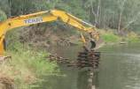

Summary

The degradation of riverine habitats across Australia has received growing attention in recent years. Rehabilitation techniques for particular problems (e.g. riparian degradation, lack of instream habitat) have been developed and trialled. However, there have been very few attempts to take a holistic approach and tackle multiple issues simultaneously. Furthermore, rehabilitation actions often lack local community involvement and ownership. As a consequence the impacts are seldom long-term and they have failed to act as catalysts for similar projects in other areas.

Over the last 10 years, the Murray-Darling Basin Authority has been trialling a new model of river rehabilitation under the auspices of its Native Fish Strategy. The “demonstration reach model” has proved very successful in rehabilitating river reaches for native fishes, achieving community ownership and adding to the knowledge base on the effectiveness of rehabilitation techniques through rigorous monitoring. As a result, this toolbox has been developed to allow other resource management practitioners to develop demonstration reaches in their local areas. The demonstration reach model encompasses four pillars – community involvement, planning, onground interventions and monitoring and evaluation. It also embraces the concept of adaptive management so that interventions can be modified as required depending on monitoring results.

The toolbox outlines how to effectively establish and implement required processes for each of the four pillars. Genuine, committed and long term engagement with the community is essential to build ownership and participation in rehabilitation of a demonstration reach. The production of planning documents is also needed to ensure the project is carried out in a properly integrated and strategic manner. Management interventions must be identified, planned and implemented following consultation with stakeholders and experts. Monitoring and evaluation of all interventions is fundamental to demonstration reaches, to assess whether they have resulted in ecological improvements, whether stakeholders are satisfied, and whether the project has been undertaken using best practice principles and represents value for money.

The toolbox provides an overview of the demonstration reach model, detail of existing reaches, the steps involved in each of the four pillars, as well as case studies, further reading and links to relevant websites. It is primarily aimed at river restoration practitioners, although is a useful resource for community groups, natural resource management groups, catchment management authorities and government agencies.

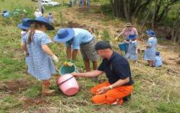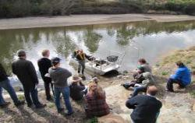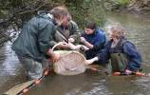Demonstration reaches have significant potential to be implemented across Australia. People identify with fish and demonstration reaches represent an effective method of harnessing community interest and participation in river rehabilitation where results are measurable and can be celebrated.

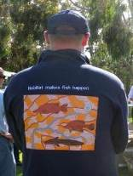

1 Introduction to demonstration reaches

Why establish a demonstration reach?
Many waterways and wetlands in Australia have become severely degraded following European settlement. While many rehabilitation programs have been initiated in recent decades, general community awareness of the plight of our aquatic ecosystems remains limited. People identify with fish and demonstration reaches use them as a “hook” to harness interest and participation of the community in broad river rehabilitation programs.

A demonstration reach is a reach of river or area of wetland where multiple management interventions are undertaken simultaneously to showcase the cumulative benefits of rehabilitation for native fish populations and river health to the broad community. It represents a coordinated approach to native fish rehabilitation on a large scale. The model has been trialed successfully at seven sites in the Murray-Darling Basin over a ten year period.

Benefits include:

    - People identify with fish and demonstration reaches represent an effective method of harnessing community interest and participation in river rehabilitation where results are measurable and can be celebrated.

    - Involving the community in all aspects of a river rehabilitation program will greatly increase awareness and help engender ownership of local issues.

    - Applying multiple interventions in rehabilitating rivers and fish communities is likely more effective than single interventions.

    - Most river rehabilitation projects are spread too thinly, potentially diluting their cost effectiveness. Concentrating efforts on specific river reaches is likely to be more effective.

    - Demonstration reaches represent long term programs, incorporating the concept of both temporal and spatial scales, and recognising interactions over time and space.

    - Inclusion of rigorous monitoring means that demonstration reaches use an evidence based approach to demonstrate outcomes – this is an appealing ‘hook’ for funding bodies which are increasingly expecting measurable outcomes.

    - The demonstration reach ‘brand’ has significant value, having operated for over ten years, with significant achievements and lessons learnt. Some have garnered substantial partnerships, investment and success, which can provide an important template.

    - There is an existing network of people who have been directly involved in demonstration reaches which represent a wealth of knowledge and experience.

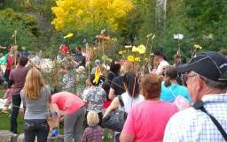

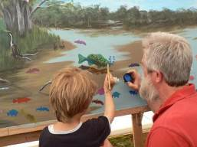

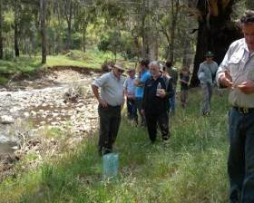

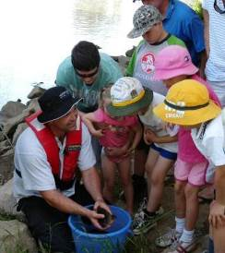People identify with fish which provides the ‘hook’ to promote broader river rehabilitation (Photos: Janet Pritchard, Fern Hames)

What is a demonstration reach?
The demonstration reach concept was developed under the Native Fish Strategy. In response to the decline in condition of river systems and native fish populations across the Murray-Darling Basin, the then Murray-Darling Basin Commission released the Native Fish Strategy (NFS) in 2003 with the aim of rehabilitating habitats and fish populations over a 50 year period (MDBC 2004). This strategy provided a long-term program to tackle key threats to native fish populations, with management decisions underpinned with good science allowing an adaptive management approach. Community engagement was a key component of the strategy and demonstration reaches were a fundamental feature of the NFS approach to genuine community engagement.

Demonstration reaches encompass four pillars - community involvement, planning, on ground interventions and rigorous monitoring (Figure 1). The demonstration reach model establishes a practical and comprehensive planning framework, involves the local community and all relevant stakeholders. It also sets up a monitoring and evaluation program to measure progress in the rehabilitation of the habitat and fish communities. The model maximizes the effectiveness of rehabilitation efforts by concentrating them on a

reach of river, wetland or both. Onground interventions can include habitat rehabilitation, management of alien species, improvement of water quality and fish passage, provision of environmental flows and fish stockings.

Rigorous monitoring is undertaken to demonstrate the benefits that can be achieved by such an integrated program. In principle, the successful rehabilitation of a reach will enhance community awareness and support for such actions, focus the attention of funding agencies, establish partnerships and boost scientific knowledge of rehabilitation techniques. Demonstrations reaches must be of sufficient size to impact on river health and rehabilitate the fish populations targeted.

It is recognized that sometimes, funding constraints limit the ability to undertake rigorous monitoring. Rehabilitation programs without such monitoring, called rehabilitation reaches, can still apply the demonstration reach model and use this toolbox. Rehabilitation reaches simply encompass three pillars – community involvement, planning and onground interventions. However, losing the monitoring component will mean that an adaptive management approach cannot be taken and the effectiveness of interventions will remain largely unknown.

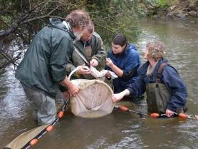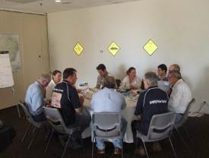

Demonstration reaches incorporate sound planning with rigorous ecological monitoring (Photos: Fern Hames)

Why create a demonstration reach toolbox?
The first demonstration reach was established in 2005 and seven have been formed across the Basin. Ten years of experience has indicated demonstration reaches provide an effective model for river rehabilitation and community engagement. Valuable insights have been gained into what is needed for successful creation and implementation of demonstration reaches, challenges you may face and how best to address these. While each site and community is different, there are commonalities.

This toolbox has been developed in response to growing interest in the demonstration reach concept and river rehabilitation in general. It is primarily aimed at river restoration practitioners. However, it can be used as a resource to guide anyone from community groups, natural resource management groups or catchment management authorities through to government agencies. The demonstration reach concept is designed to actively

engage all stakeholders in management actions, thus this toolbox has relevance to anyone interested in rehabilitating rivers and their native fish populations. It is recognized that this toolbox includes some relatively technical and detailed information. Community groups may need to seek additional specialist advice to interpret some of the content.
The Demonstration Reach Toolbox is targeted at government, natural resource management and

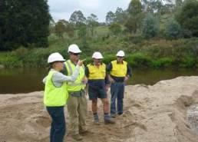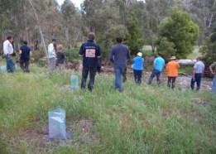
community groups involved in river restoration (Photos: Fern Hames, Mark Jekabsons)

How to use this demonstration reach toolbox
This toolbox provides an overview of the demonstration reach model, detail of existing demonstration reaches, the specific steps involved in each of the four pillars of establishment, as well as case studies, further reading and links to relevant websites.

Information is provided in varying levels of detail. While each component is summarized briefly with key lessons and points highlighted, further detail is provided in appendices and in specific recommended references. The variety of documents prepared by existing demonstration reaches can be considered as potential templates for those seeking support in establishing and implementing a demonstration reach.

Advisory Note
This toolbox is a broad introductory guide only. The approaches and techniques contained in this
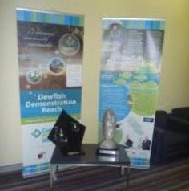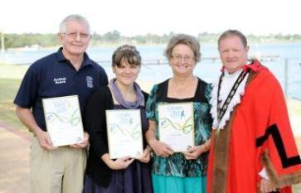document are not all-inclusive or universally applicable. Before commencing a demonstration reach project it is essential to contact all relevant jurisdictional and local government agencies to determine all policy, administrative and legislative requirements. Relevant expertise should also be sought for all specific components of the project.

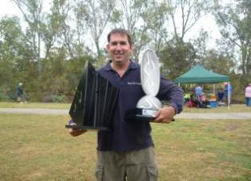
Some demonstration reaches, including the Dewfish and Katfish, have received major awards for their achievements (Photos: Greg Ringwood, Lara Suitor)

Figure 1 – The structure of the Demonstration Reach Toolbox

Demonstration Reach Toolbox

Pillar 1 People

Pillar 2 Planning

Pillar 3 Onground interventions

Pillar 4 Monitoring

Identify the target audience
Site selection
Instream habitat

Adaptive management

Establish infrastructure and governance

Establish a vision

Riparian rehabilitation

Ecological monitoring

Identify key engagement objectives and messages

Identify engagement tools and actions
Whole of Life Plan

Communication and Engagement Plan

Monitoring and Evaluation Plan
- Ecological
Water quality Environmental flows
Fish passage Screening of irrigation offtakes
Monitoring and Evaluation Plan
- Communication
Alien species

Communication monitoring

Fish stocking

2 People – Pillar 1

Genuine, direct and sustained community involvement is fundamental to the demonstration reach concept. The initial consideration of appropriate sites to select recognises the importance of community, and it is recommended they be established near significant population centres, which are accessible and visible to the public. Without positive community interest in the natural values of a site, a demonstration reach will likely struggle to garner and retain strong and ongoing community support.

The community, particularly key stakeholders, such as landholders, community groups, recreational fishers, Indigenous members and agencies, need to be involved in all steps of a demonstration reach – from initial site selection, to planning and decision making, participation in management actions and monitoring programs, and celebration of achievements. This strong involvement and an emphasis on two way communication builds ownership and long term support for the reach.

This pillar of the demonstration reach toolbox outlines approaches that will help identify target audiences, establish infrastructure and governance, identify key objectives and messages, and develop engagement tools and actions. These steps are common components of Communication and Engagement Plans.

Ten years of experience in establishing demonstration reaches across the MDB has provided valuable insights into what is needed for successful engagement, as well as challenges that may be faced and approaches to address these. Each component of the ‘People’ Pillar includes key points to consider when establishing a new demonstration reach. While each demonstration reach, its community and engagement approach will be different, there are also likely to be many commonalities.

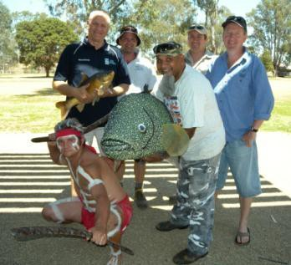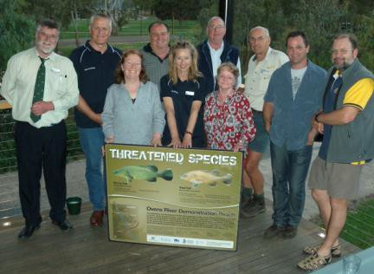

Genuine, strong and ongoing community involvement is essential to the success of a demonstration reach (Photos: Fern Hames)

14

Identify the target audience

    - Focus early on effectively identifying the range of individuals and organisations who represent the target audience for a demonstration reach. Use existing networks to identify the target audience.

    - Early engagement with community champions and long term residents in an area can help build local relationships and trust, as well as assist in community participation and ownership.

    - Consider the lessons learnt in identifying and engaging with target audiences which are outlined below. These relate to expectations and perceptions, effort and time, adaptability and flexibility, diversity and complexity, and understanding and awareness.

Demonstration reaches aim to address multiple management issues, and thus the notion of the ‘community’ is complex. The numbers and types of participants and stakeholders will depend on the size of the reach and the variety of issues that need to be addressed. The potential target audience could encompass any individual, group and organisation with a direct or indirect interest or role in management of a demonstration reach. This may include local, state and potentially federal government agencies, private landholders, Indigenous communities, fishing clubs and Landcare groups, schools, service clubs, and business, interest and industry groups. Figure 2 below highlights the potential diversity of a target audience.
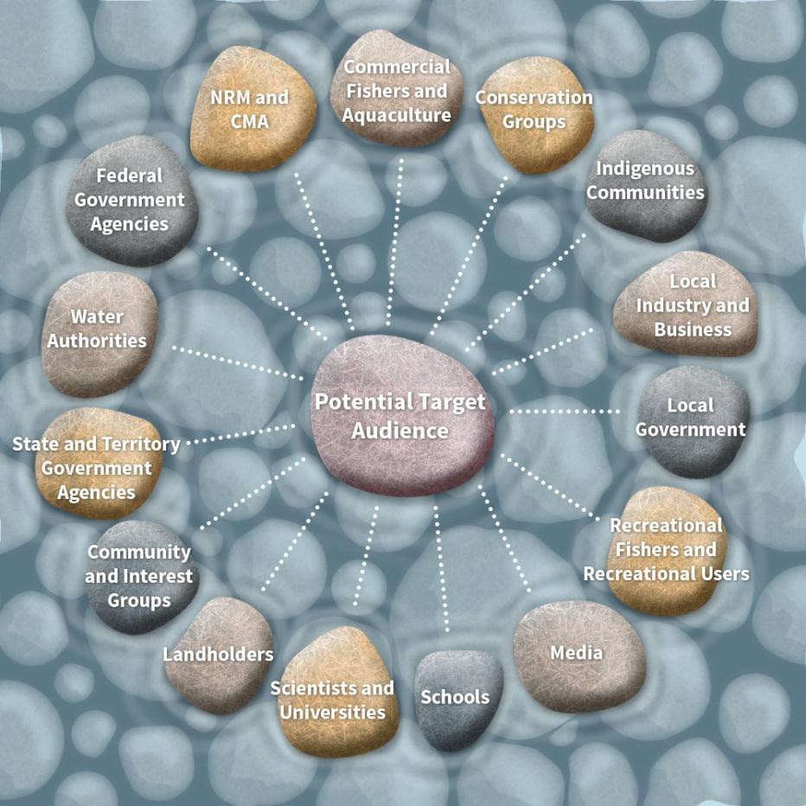

Figure 2: The potential target audience for a demonstration reach can be diverse.

It is important to recognise that members of a target audience will each have their own interests and perspectives; understanding these is an essential step in developing the most appropriate approach to communicate with them. It is critically important to identify the correct people to contact with respect to stakeholder groups, especially in Indigenous communities. Use of champions and high profile people can be valuable, increasing profile and interest. Long term landholders who have lived in an area for many generations should be involved since they will have a wealth of knowledge.

During the development of demonstration reaches, emphasis should be placed on effectively identifying the target audience by using existing networks and ensuring adequate promotion of the project in the community inviting participation from community representatives.

Strong community ownership, participation and empowerment is essential in all aspects from the development of strategies and plans, implementation of works and monitoring the outcomes. This approach helps to build community capacity and maximises the chances of empowering the community to become stewards in the long term. Broad community involvement also increases the potential to diversify funding options through partnerships with local industry, the community and government. Without this genuine, continuous and diverse involvement, a community can view a demonstration reach as a government agency driven program that they are not strongly and personally invested in.

Relationships and trust must be developed and maintained throughout the project. It is important to acknowledge that there can be a significant ‘lead in’ time to building community understanding and support for the proposed activities.

Example:

In the Dewfish demonstration reach, branding helped build community recognition and relationships. While personnel changed over time, locals recognised the Native Fish Strategy shirt and the Condamine Alliance vehicle.

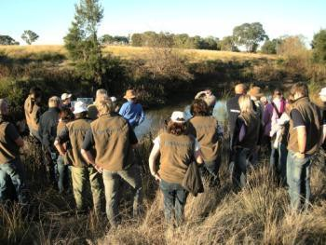

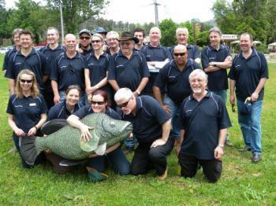Branding can help build community recognition (Photos: Janet Pritchard, Fern Hames)

The existing demonstration reaches have engaged with a great diversity of target audiences. For example, the two New South Wales reaches (Bourke to Brewarrina and the

Namoi) have engaged with 50 groups, while the Dewfish demonstration reach has over 70 partners. Smaller reaches such as Hollands Creek demonstration reach have engaged with approximately ten groups.

2.1.1 Lessons learnt
Many lessons have been learnt in the first ten years of establishing and implementing demonstration reaches, which are summarised below.

Expectations and Perceptions
- In the early stages of initiating a demonstration reach, some community members may have existing broader frustrations about river management or particular organisations. This may result in an unwillingness to participate in project activities. Be mindful that this may change as people begin to see onground works being implemented and are encouraged by the participation of others within the community. The involvement of school students in activities can often lead to subsequent participation by their parents.
- Managing expectations is essential to ensure ongoing community commitment to the project. Common areas to be aware of may include:
  - long timeframes are required to demonstrate a positive improvement in river health.
  - ecological knowledge is imperfect and this needs to be communicated honestly and openly.
  - acknowledging past mistakes (e.g. desnagging, poor practices in willow removal etc) and that NRM is a constantly evolving field.
  - highlighting that while monitoring and demonstrating ecological benefits is one aspect of demonstration reaches, other aspects such as building relationships are very important too.
  - activities need to be realistic and achievable from the outset.
  - establishing and clearly communicating a shared vision can help maintain focus and scope
  - identifying some early short term and achievable goals help in getting people and groups engaged.
- Differences in interests of stakeholder groups and perceptions that particular rehabilitation actions may have negative impacts on them, can lead to conflict and opposition. Clarity and communication are key.

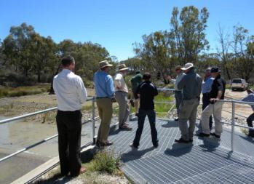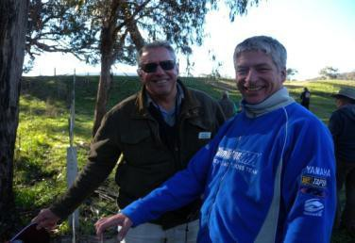
Seeing onground actions being implemented can encourage the community (Photos: Fern Hames)

Effort and Time
- Adequate resourcing and commitment to community engagement for the implementation of demonstration reaches is needed.
- Negotiations between stakeholders and the community can be lengthy, detailed and require significant effort, and sometimes require external expertise.
- Effective engagement needs to be persistent and ongoing, and is very time consuming. Community engagement often grows exponentially, starting slowly as trust and relationships are built and develop into involvement and ownership of the project. This is where dedicated staff and funding to undertake such roles is very
valuable to provide a connection to all aspects of the demonstration reach.
- Resources and investment to monitor engagement efforts also need to be included in planning and budgeting to allow for the adaptive management of community engagement.

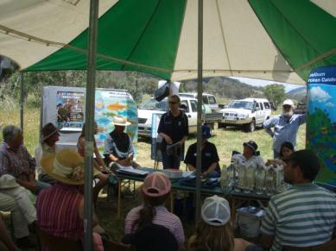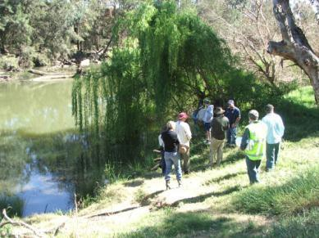

Effective community engagement takes time, effort and skill (Photos: Tony Townsend, Fern Hames)

Adaptability and Flexibility
- It is important that demonstration reaches are flexible and adaptable in their planning and implementation. Robust planning underpinned by good science is vital to guide the delivery of projects as participants can change over time, potentially leading to loss of momentum and support. Unforseen events such as drought or flood can also affect the success of onground actions and the community can lose enthusiasm, potentially becoming disillusioned with the lack of progress.
- There is also risk of burn out for some participants, especially community champions and this needs to be anticipated and managed effectively. Community champions must be supported; they are also likely to change over time and engagement approaches should remain inclusive to encourage nurturing of new, emerging champions.
- Vandalism of signage, habitat works and tracks, as well as theft can be an ongoing issue for some sites. Responses to this should consider the practical aspects (e.g. more robust signs; or less robust, cheaper, readily-replaceable signs) as well as the human aspect (e.g. analysing the causes of the vandalism and actively engaging with that sector of the community to build advocacy and ownership for the site). Within the Dewfish demonstration reach, this provided an opportunity to trial new approaches that encouraged site ownership by the local youth and school-driven community engagement.

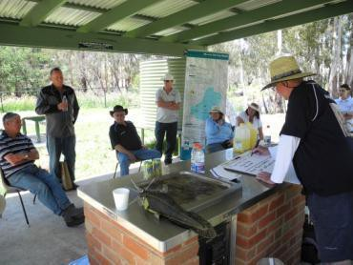

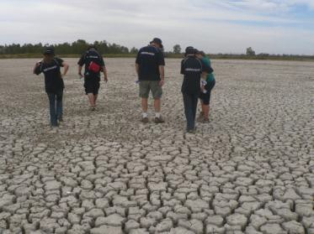Demonstration reaches must be flexible and adaptable in their planning to address events such as floods and drought (Photos: Fern Hames)

Diversity and Complexity
- All sites and communities are different and it is important to understand the variety of community issues and concerns, and how these fit into and influence management options.
- All stakeholders will have their own personal motivations, which can be complex and difficult to understand. Multiple perspectives bring great value to projects, and acknowledging and understanding these is essential.
- In divided communities, there is a risk of perceived or real ‘take over’ of events or entire projects by interest groups with a single agenda, potentially in conflict with the project’s aims. It is important to maintain focus, and regularly reflect on the agreed shared vision.

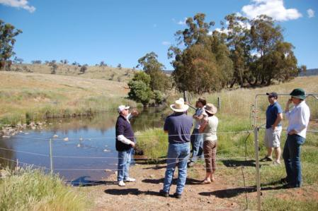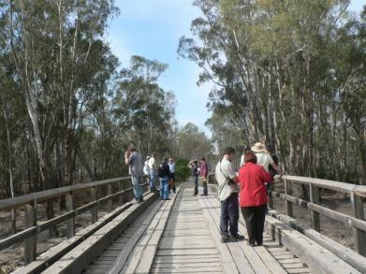
Local communities will have a variety of issues and concerns and these will influence management options for a demonstration reach (Photos: Fern Hames)

Understanding and Awareness
- Lack of understanding by some stakeholders can hamper agreement on, or support for, activities. This can include:
  - local landholders not understanding the benefits of proposed activities (e.g. willow removal, riparian fencing or resnagging), the current status of a waterway or the level of intervention required.
  - some stakeholders believing that simply adding more fish to a river by stocking will achieve a net increase in fish abundance and diversity.

- Recognising the multiple perspectives of all stakeholders and building an understanding of multiple benefits from rehabilitation actions across a range of areas including environmental, social and economic, can be powerful. For example, highlighting to a landholder that offstream watering points are good for the river and his stock.

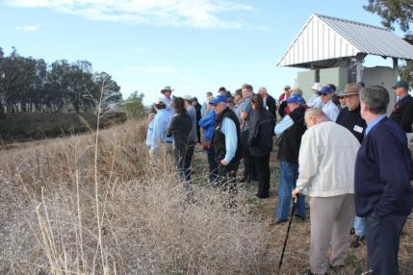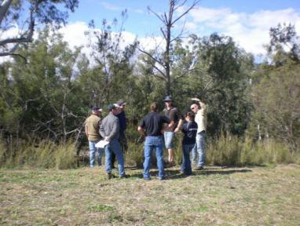
Understanding stakeholders’ perspectives and building awareness of the multiple benefits of river rehabilitation is key to successful engagement (Photos: Tony Townsend)

Establish infrastructure and governance

    - Establishing the right infrastructure and governance from the start of a demonstration reach is critical.

    - An organisation (e.g. an NRM group) must take prime carriage for the planning and implementation of the project.

    - The type of governance structure will vary between demonstration reaches and should be compatible with the existing structure and processes of the agency taking prime carriage, however it must encompass all stakeholders who will drive and participate in the demonstration reach project.

    - A project manager is vital to the short term development and long term success of a demonstration reach representing the “glue” that keeps the project together.

    - Key people who drive the establishment and implementation of demonstration reaches, particularly project managers, need sound communication skills.

    - It is recommended that key groups such as steering committees and advisory groups are established to ensure sufficient and broad stakeholder and community consultation.

    - Knowledge exchange between those involved (project managers, steering committees, advisory groups) is very important so that all the elements of the program link closely (onground works, community engagement, research).

    - Terms of Reference for committees and groups can be very useful since they help in planning of specific actions, they clarify roles and functions which can minimise the risk of future conflict when people have different perceptions of what they should be doing.

- Implement a plan for succession to minimise potential loss of corporate knowledge, connections and momentum.

Coordination is required for all aspects of a demonstration reach – from community involvement, planning, implementation of actions and monitoring. To achieve this, an appropriate organisational structure must be established, the character of which will be driven by the specific context, the scale of the site, complexity of issues, community size and funding.

For example, some large complex demonstration reaches could include steering committees, community advisory groups, working groups, expert panels and project teams. Other smaller reaches may establish small steering committees or a community advisory group and a project team. Whichever structure is established, it is essential that there is a mechanism for all stakeholders to contribute to management decisions. Developing clear terms of reference (Appendix 2a) for committees and groups can clarify their role and minimise any potential confusion or conflict. It is also important that sharing information across groups on relevant issues is effective and efficient.

    - Prime carriage
A demonstration reach project requires an organisation to take prime carriage of its implementation. Within the existing demonstration reaches, government NRM agencies (South Australia, New South Wales and ACT) or CMAs/NRM groups (Victoria and Queensland) have fulfilled this role. Given the long-term aim of demonstration reaches being ‘owned’ by a local community, the preferred model is likely for CMAs/NRM groups to drive them.

    - Project manager
Experience from existing demonstration reaches has shown that a dedicated project manager makes a significant difference to the chances of a demonstration reach being successful. This position should be fully focussed on the demonstration reach project, rather than juggling multiple other roles. This person is responsible for managing the varying and often disparate projects required to deliver the desired ecological outcomes of the demonstration reach.

Having a sole contact has also proven to alleviate community confusion about the project and whom they should contact. It would be preferable for the project manager to live within or near to the local community and the agencies involved in the onground activities. This provides an enhanced opportunity to build close relationships and to respond more easily to specific onground issues. If this is not possible, however, it must be recognised that additional effort will be required for travel and to develop strong community ties.

The tasks of a project manager are wide and varied and may include:
- prepare and coordinate the development of planning documents
- negotiate, monitor and report on the timetable for implementation of the various implementation activities to ensure integration

- advise the Steering Committee (see below) of any risks, gaps or opportunities and provide advice on how these might be dealt with
- undertake community awareness activities to encourage participation and adoption of river rehabilitation actions, including interacting with media
- liaise with an array of community members, contractors involved in implementing works, scientists guiding planning and undertaking monitoring etc
- develop project briefs and applications for external sources of funding
- prepare tenders and contracts for funded projects
- chair any associated groups formed within the project such as community advisory group, scientific advisory groups, and report back to the steering committee
- prepare milestone reports and updates and disseminate these.

To undertake these tasks effectively, a project manager must have particularly strong organisational skills. Comprehensive engagement skills are also essential to effectively communicate and understand the perspectives of a broad range of groups and individuals involved.

Depending on funding availability and scale of a demonstration reach and required works, a dedicated project team may be employed. Planning, coordination and implementation of multiple interventions at numerous locations within a reach over time, can represent a significant workload.

Experience has shown that the project manager tends to be the glue that keeps a project together, and keeps momentum going. With no project manager, dissemination of information and promotion of activities and achievements will decline, and community interest will wane. This will reduce the likely long term success of a demonstration reach.

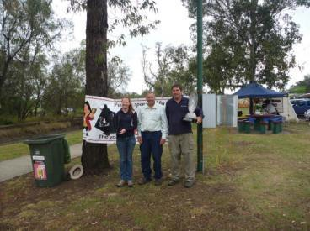

Members of the Dewfish demonstration reach team (Photo: Greg Ringwood)

    - Succession planning
Succession planning for project managers in particular is critical. Given the broad range of potential responsibilities and roles of a project manager, and the multiple established relationships involved, it is very difficult for a replacement to be able to take on these duties rapidly. During this transition phase, there is a potential for loss of momentum in a project and a failure to achieve milestones, which is magnified if a position is vacant for a period of time.

Project managers hold significant corporate knowledge associated within their reach including communities and partnerships between organisations. Emphasis must be placed on sound and comprehensive record keeping, to minimise the risk of loss of information. The creation of databases, which may include works planned and completed, key community contacts, budgets, upcoming events, ideas, concepts and potential sources of funding etc should be undertaken as part of the project management. It should also be recognised that comprehensive record keeping assists in development of milestone reports, and broader dissemination of achievements.

Branding can also play a role in minimising impacts of succession, where different staff are identifiable when they wear recognisable demonstration reach attire.

    - Steering committees
Significant and meaningful stakeholder consultation is needed right from the start. The broad community must feel directly involved in the early planning phase, including development of a vision and issues that need to be addressed. A steering committee can help achieve this, and potentially may include:

- Government representatives (Commonwealth, state and local)
- Regional NRM groups or CMAs
- Research bodies (universities, consultants etc.) – including specialist
- Indigenous community
- Community groups (Landcare, Bushcare etc.)
- Recreational fishers
- Industry and business
- Schools and educational institutes (e.g. TAFE).

The steering committee should aim to include representatives from the lead agency/group, funding bodies and jurisdiction fisheries and conservation management agencies. It should be small enough in membership to allow for efficient decision-making and ease of convening regular meetings. The frequency of meetings will depend on the tasks involved and tend to be most frequent at the development and planning stage. The committee would be responsible for all major decisions in the process and could call on technical expertise as required.

Participation of key representatives on a steering committee can strengthen linkages with other associated local programs. A steering committee which encompasses a range of skills, perspectives and experience can provide strong guidance and support for a demonstration reach.

    - Community advisory group
In addition to a steering committee, it may be valuable to establish a community advisory group to comprise members of a cross section of the local community. Such a group would strengthen the potential for community awareness and support for fish conservation and habitat rehabilitation. There must however be recognition that community members can vary in their capacity to participate in such groups.

A community advisory group can provide a more informal avenue to share information, discuss issues, priorities or concerns with the local community, and highlight linkages with specific local NRM programs. These views can then be reported to the steering committee and it is important that there is effective communication between this group and the steering committee, which can be achieved if there is overlapping membership such as the project manager.

Identifying and seeking support of local champions within the community can be valuable. The participation of those with a significant standing in the community can create momentum and promotion of the project. Ultimately, this group should be chaired by a member of the community, rather than a government or agency representative. In the early days of establishment, there may need to be a transitional arrangement, where experienced staff provide support and guidance and build capacity. The group may choose any title it desires.

Examples:

The Hollands Creek demonstration reach and Ovens River demonstration reach established community reference groups, while the Upper Murrumbidgee demonstration reach established a community network.

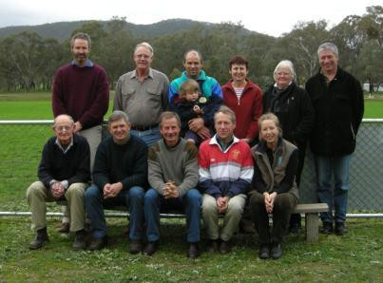

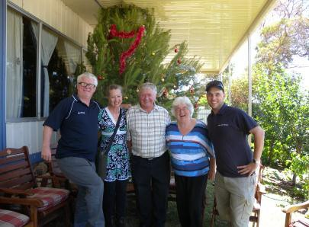The Hollands Creek Community Reference Group (Photo: Fern Hames)
The support of local champions such as Henry and Gloria Jones (third and fourth from left) has contributed significantly to riverine rehabilitation projects in South Australia (Photo: Fern Hames)

    - Scientific advisory group
Expert scientific and technical input will be needed during key stages of the demonstration reach, such as the identification and prioritisation of threats to native fish and in the planning and implementation and monitoring results of interventions. It may be valuable to establish a dedicated group comprised of aquatic ecologists as well as specialists in fields relevant to the remedial works undertaken such as geomorphologists, engineers or biometricians.

Providing knowledge on the fish community present in the reach, their current status, threats and basic ecology of fish species at the planning stage may be one of the core functions of such a group. The demonstration reach project manager would act as executive officer, thereby providing a link between other relevant groups and committees.

Given the inclusion of rigorous monitoring in demonstration reaches, scientific advisory groups would play an important role in the development and implementation of a monitoring and evaluation plan. Other approaches include contracting particular experts to provide advice and input.

Example:

The Upper Murrumbidgee demonstration reach established a specialist monitoring and evaluation subgroup to guide and review their M&E plan.

Identify key engagement objectives and messages

    - A demonstration reach project should encompass community and environmental objectives.

    - Clear community objectives can maximise chances of long term uptake and ownership of a demonstration reach.

    - Identify the most appropriate objectives for your particular situation. Objectives may be broad or very specific, long and short term. A benefit of a target oriented objective is that progress is measurable over time.

    - Identification of clear key messages is worthwhile since it provides clarify of purpose and focus for communication approaches from the start.

    - Inclusion of guiding principles, which represent statements of ‘the way we will operate’ can be valuable.

    - Objectives
Clarifying overall aims and objectives (or goals) is an important step in the establishment of a demonstration reach. Most existing demonstration reaches identify ecological and community objectives and often include recreational objectives. Identification of cultural and economic objectives may also be worthwhile to consider. These then form the basis from which specific actions are identified and implemented.

Environmental objectives specifically address the variety of threats relevant to each demonstration reach (see Whole of Life plans). Community objectives may include improving sustainable recreational use of assets, and include community education and engagement. Other objectives may also be included as part of planning, such as those used by the Upper Murrumbidgee demonstration reach which included governance objectives “to achieve a high level of integration between those involved in the management of the reach ” (ACT Government 2010).

Given that a fundamental premise of demonstration reaches is to enhance community awareness and support, it is essential to place a strong emphasis on identifying community

objectives in the early stages. Without garnering community interest, enthusiasm and input, a demonstration reach may become another government driven project that people have a limited awareness of, rather than a model that can be followed. The community needs to understand what a demonstration reach project aims to achieve, consider why it may be relevant and of interest to them, and how they can participate.

Existing demonstration reaches have followed various approaches, and used different terminology. These are detailed in different planning documents, including Whole of Life plans and Communication and Engagement plans. Most existing demonstration reaches included broad overarching objectives such as to “demonstrate to the community the cumulative benefits of applying interventions to rehabilitate native fish habitat and populations.”

Community objectives generally encompass raising community awareness, encouraging stakeholder involvement, educating stakeholders and obtaining feedback. There is significant value in including objectives which focus on building community capacity, since this will maximise the chances of a community taking ownership of a demonstration reach in the long term.

See Appendix 2b for examples of community objectives (Upper Murrumbidgee demonstration reach and Bourke to Brewarrina demonstration reach).

Examples:

The Upper Murrumbidgee demonstration reach considered timeframe within their approach, with aspiration goals, long term and short term objectives (ACT Government 2010).

The Dewfish demonstration reach distinguished between informational, attitudinal and behavioural objectives within its 2012 communication plan. It also included a target orientated objective “to restore native fish populations to 60% of pre European settlement levels by 2050” (Condamine Alliance 2012). A benefit of a target oriented objective is that progress is measurable over time.

    - Key Messages
Key messages provide the foundation for communication approaches. They represent what you want your target audience to remember about your demonstration reach project. These messages encapsulate the project, by providing clarity of purpose and focus to all involved.

When developing messages, consider who the audience includes, and ensure the messages are worded clearly and in a way people can understand and relate to. Given your audience may encompass a wide variety of groups and individuals, be mindful that the messages should adequately reflect this diversity of views and interests.

Also be mindful that a small number of clear messages is likely to be the most targeted and effective approach. Once agreed, the key messages form the foundation of

communication and should be incorporated in the variety of communication tools and actions undertaken.

Not all existing demonstration reaches specifically identified key messages, however project objectives and actions framed the content of their varied communication activities.

The Dewfish demonstration reach developed two communication plans in 2009 and 2012, which differed in their approach (Condamine Alliance 2009, 2012). The 2012 approach included a suite of key messages that focussed on background information on the reach and its location, the project’s purpose, goal and approach, as well as how to get involved, and key achievements.

See Appendix 2c for examples of messages (Bourke to Brewarrina, Namoi and Hollands Creek demonstration reaches).

    - Guiding principles
Several existing demonstration reaches also identified guiding principles, which represented statements of the ‘way we will operate’.

Examples:

The Upper Murrumbidgee demonstration reach highlighted the need to use the precautionary principle. This is described as “when an activity raises threats of harm to human health or the environment, precautionary measures should be taken even if some cause and effect relationships are not fully established scientifically” (ACT Government 2010).

The Katfish demonstration reach identified principles relating to adaptive management, the precautionary principle, the decision-making of the steering committee, the respect of Indigenous Australians, recognition of existing government obligations, and prioritisation of actions according to available resources (Katfish reach steering group 2008).

Identify engagement tools and actions

    - Use a diverse range of engagement tools and actions which appropriately cover the engagement spectrum.

    - Once all engagement tools and actions have been identified, they should be assessed for their suitability for target audiences, level of effort and time required, and feasibility within available budget constraints.

    - Engagement actions should be costed and prioritised to clarify what can realistically be achieved, and what is likely to maximise promotion of the project with specific target audiences.

    - Understand the key issues, interests and concerns of target audiences and how these may influence selection of appropriate engagement tools and actions. Identify engagement actions that people can relate to, are interested in and see the relevance of.

    - Link in with existing complementary programs and organisations wherever possible. The multiple benefits include efficient use of resources and cost savings, and developing and building relationships within the community.

    - Recognise that continuous and concerted effort will be required to effectively engage with target audiences over the long term.

    - Those undertaking engagement need to have appropriate skills and level of knowledge so that they are seen as credible by target audience. Involving a range of specialists and experts enhances this credibility.

    - Place emphasis on producing written material (e.g. plans, annual reports, summaries of achievements) that is easily accessible on websites to target audiences and the broader community. This provides a lasting legacy of a project and maximises chances of long term continuance.

    - Consider how to measure implementation of engagement tools and actions. This can include not only ways to quantify attendance and uptake, but also how to monitor social change.

Engagement tools and actions for demonstration reaches should aim to:
    - provide people with information
    - involve them in activities
    - consult them on relevant issues and
    - empower them to make well informed decisions for their reach.

This corresponds with the increasing levels of stakeholder participation identified by the International Association of Public Participation (IAP2) spectrum of engagement (i.e. inform, consult, involve, collaborate and empower).

Approaches to stakeholder engagement must cater to the differing needs, interests, perspectives and learning styles of the demonstration reach audience. Some prefer to hear about things, others like to see things and others prefer direct interactions. A wide variety of engagement tools and approaches will be required to build an understanding of the project, garner interest and ultimately participation requiring time and significant effort.

Existing demonstration reaches developed different types of Communication Plans and used varying terminology. Within these plans, many tools and actions were identified and implemented covered the levels of engagement described within the IAP2 spectrum.

Examples:

The Dewfish demonstration reach identified strategies and tactics, while the Upper Murrumbidgee demonstration reach identified communication themes and actions.

The NSW demonstration reaches described stakeholder engagement categories and actions. The Victorian demonstration reaches approach corresponded to the IAP2 spectrum of engagement.

Although each existing Demonstration Reach has distinct issues and characteristics, there are many similar tools and engagement approaches which have been undertaken. These are described below, and are also discussed in detail within the “Engaging People” component of Finterest (http://www.finterest.com.au).

    - Written material
Written material represents a key communication tool and can range in its level of detail and complexity, depending on the target audience. Newsletters and fact sheets can clearly explain relevant information briefly for a broad range of target audiences. These may also not require significant effort to prepare and distribute. For those interested in further detail, project reports, monitoring results and workshop proceedings may be appropriate and should be published and easily available. The popularity of the Fishes of the MDB book (Lintermans 2007) demonstrates how keen people are to access information on fish.

    - Promotional material
There is a vast array of promotional material that can be developed for demonstration reaches, including signs, brochures, posters, displays, stickers, drink coasters, hats and T shirts. These can help in branding of the project. Installing interpretive signage at key, accessible, popular locations, is valuable to highlight ecological values, issues and rehabilitation achievements. Creation and use of community artwork, including children’s art and Indigenous art, on interpretive signage and promotional material also strengthens community connections with a demonstration reach.
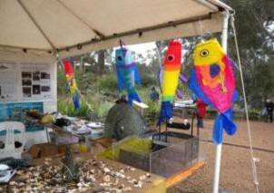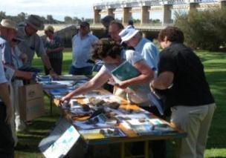

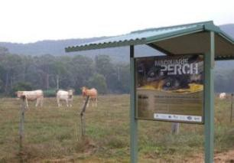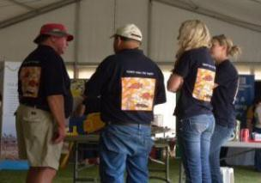

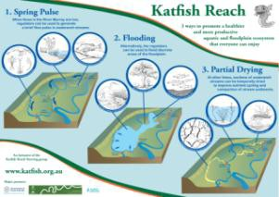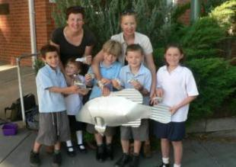
A vast array of promotional material can help with branding of a project as well as strengthen community connections (Photos: Fern Hames, Tony Townsend)

    - Websites and social media
Creation of specific websites and webpages for demonstration reaches is a key engagement portal for information to be disseminated. Such websites can provide general information, a suite of written resources and linkages to complementary projects. They also provide an opportunity to easily notify people of upcoming events. Websites are also valuable in measuring engagement, since it is easy to monitor number of visits to a site, views of particular pages and duration of visits. Establishing and maintaining a website however does take effort and funding. Websites can provide an ongoing legacy and promotion of a demonstration reach.

Examples:

Three demonstration reaches with their own specific websites:

      - Dewfish = http://www.condaminealliance.com.au/dewfish-demonstration- reach
      - Katfish = http://www.katfish.org.au/
- Upper Murrumbidgee = http://upperbidgeereach.org.au/

The rapid rise of a variety of social media platforms also presents potential opportunities to engage with some target audiences through social networking, blogs, production and sharing of videos and photographs. While existing demonstration reaches have not focussed significant effort in these approaches, there is clear potential to embrace these in the future.

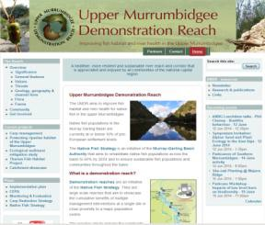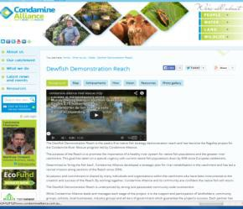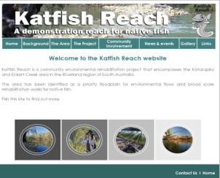

Demonstration reach websites – Katfish, Upper Murrumbidgee and Dewfish.

    - Community meetings
Undertaking community meetings provides a valuable opportunity to introduce and promote demonstration reaches, and seek local feedback on any issues, concerns and priorities. Such meetings are especially important in the early stages of a project, where local connections need to be made. These need very careful planning to consider the most appropriate location, timing, purpose, content and approach. Community meetings can often require a significant level of effort and resources. Sound preparation should include seeking the advice of local contacts, publicising the event effectively, providing catering and a point of difference to other similar meetings (e.g. fish in tanks, display material,

expert talks). This can maximise the chances of a good local attendance and creating an early favourable impression of the project with the community.

    - Field days
Field days are a fundamental component of demonstration reach engagement, since they provide the opportunity for group and individual interactions directly onsite. They provide scope to demonstrate threats and values of a site, observe on-ground rehabilitation works and techniques, celebrate achievements and thank stakeholders involved in these projects.

Direct participation of the community in activities such as tree planting, rubbish removal and water quality monitoring provides a strong local connection to the project. Involving stakeholders on field days also helps to establish them as ‘champions’ in the local community, creates ownership and a sense of pride around achievements.

Participation of local champions enables them to share information in ways that are directly relevant to their community. People often prefer to hear things from their neighbours or other landholders who live in the same region, rather than from someone outside their locality. Gradual word of mouth of neighbours, and seeing what is happening with those nearby can provide momentum.

Field days which include a variety of speakers and guest presenters can increase interest and awareness of multiple issues. Scientists and experts can discuss key values of a reach, current threats, the reasons why particular rehabilitation activities were needed, and what monitoring results are showing. Outside of such events, target audiences may rarely have the opportunity to meet scientists, or understand what they do.

Existing demonstration reach practitioners have used props to assist in engaging with people during field days, to demonstrate both simple and complex messages. Props are any object that assists the audience in understanding an issue, through linking people to a real thing. By gaining someone’s attention, this creates an opportunity to express your message. Examples include the Carp cage model and Fishway model which were used regularly at events and proved very effective.

Field days have also incorporated demonstrations of electrofishing and radiotracking, as well as seeing a fishway or fish lift work. Enabling people to see live fish, either in a tank or being released during a stocking event, can also be worthwhile. Fish must be sourced either from commercial aquariums, or from the field locally with relevant government permits. Trivia competitions have often proved a great ice breaker at field days, setting a relaxed tone, while also providing an opportunity to highlight key ecological information.

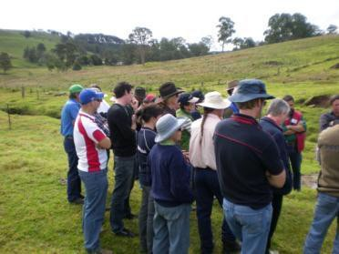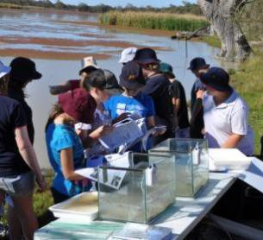

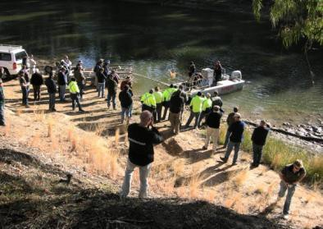

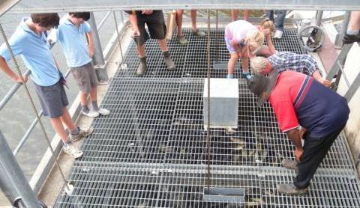

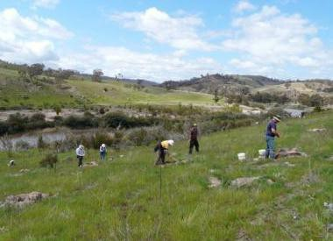

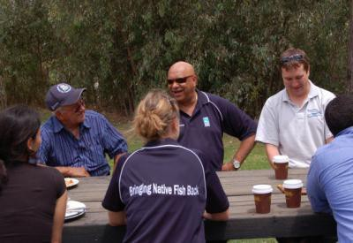Field days can help people understand onground rehabilitation activities and science, as well as encourage direct participation (Photos: Fern Hames, Tony Townsend)

    - Training days, workshops and forums
Within existing demonstration reaches, there have been examples of training days that focus on particular high priority issues. Such events achieve multiple benefits, including increasing awareness of a specific issue, increasing community capacity, building stronger relationships and attracting new participants to demonstration reaches.

The Dewfish and Namoi demonstration reaches held several Tilapia workshops to increase awareness of this pest species, stimulate discussions, and highlight the importance of early detection and rapid response. The Namoi demonstration reach also held cultural survey training days with an archaeologist, highlighting how to identify and record sites and objects of cultural significance. Several demonstration reaches have also incorporated training in water quality monitoring for local communities.

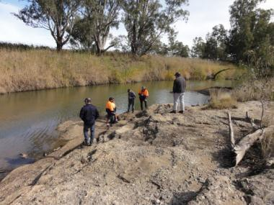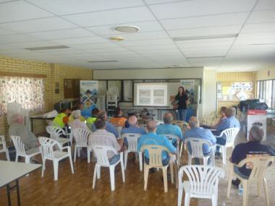

A Tilapia workshop in Queensland and a cultural survey training day along the Namoi River (Photos: Greg Ringwood and Milly Hobson)

    - School activities
All existing demonstration reaches have incorporated engagement activities specifically focussed on schools. Relationships can be built directly with school principals and teachers, to investigate the potential to incorporate aspects of the demonstration reach within the curriculum.

It can be worthwhile seeking the advice of key local community contacts on how to best engage with schools. There is often scope to give presentations within class, and involve students in onsite field visits and activities. Schools have often participated in field days, as described above, and children respond particularly well to props and direct participation.

A range of resources specifically targeted for children have been developed and used within demonstration reach events, including fish mobiles, stickers and balloons. During children’s events it is valuable to combine some active movement with more sedentary discussion and reflection time.

A variety of games have been created to highlight key ecological requirements of native fish species, the effects of particular threats and the value of rehabilitations activities.

These games can be adapted to cater to different occasions and context, as well as different age groups.

3D fish have also been created for an array of native and introduced fish species. These creative fish, which are visually very engaging, have often been used within displays and as components of games. A key benefit of these objects is that people can handle them.

The creation of the Sustaining River Life education package increased the efficiency of engaging with schools (see http://www.sustainingriverlife.org.au/). This package, which helps students develop awareness, knowledge, skills and commitment to river health, includes a variety of lesson plans and activities. There is also a MDBA Basin Champions Program for students (year 4 to 9) which offers the opportunity to link up with Murray- Darling Basin Authority experts through videoconferencing and investigate the health of a river or creek near their school (see http://www.mdba.gov.au/what-we- do/education/teachers).

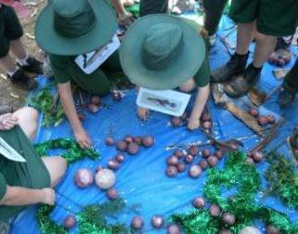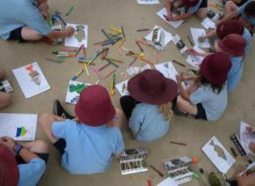
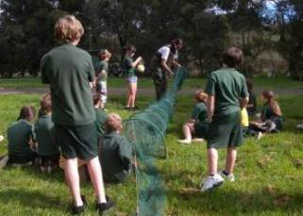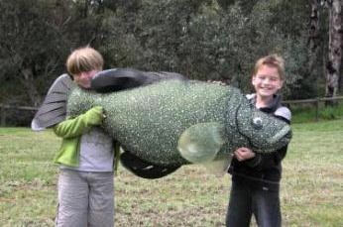

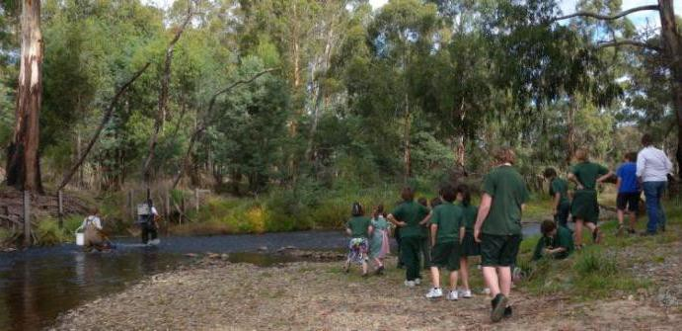

There are many ways to engage children to understand their role in river rehabilitation (Photos: Fern Hames)

    - Recreational fishing activities
Recreational fishers are seen as a key stakeholder group in all demonstration reaches. Engagement activities have included giving presentations and attending meetings with fishing clubs, writing articles in fishing magazines and involving anglers in collections of oral histories. Existing demonstration reaches have also occasionally held fishing clinics which have provided information on fish identification and fishing compliance.

Implementing Carp Musters has been a particular feature of many demonstration reaches, where a community fishing event is held to target this pest species. Local angling clubs can help support planning and implementation of such events, and local tackle shops and businesses may sponsor prizes.

Such events represent a good opportunity to build and strengthen community relationships. Developing these linkages can then flow onto involvement in other activities within a demonstration reach. Using existing networks to access resources can also represent savings in time and effort in organisation of such events. It is important to acknowledge and promote Carp Musters primarily as an awareness raising and community building exercise, with a great potential to draw strong publicity through local media.

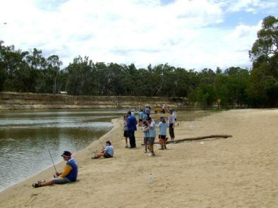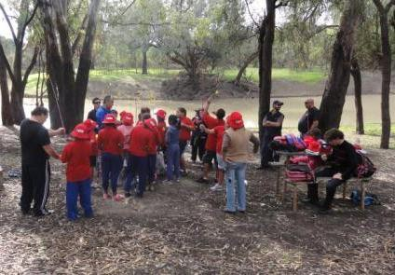

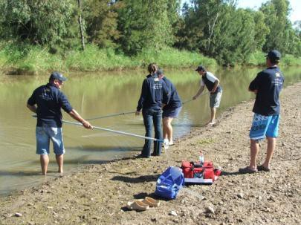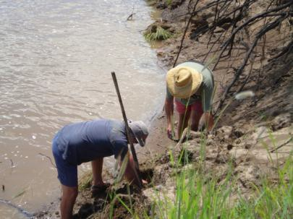

Recreational fishers are an important stakeholder group involved in many demonstration reach activities (Photos: Milly Hobson, Tony Townsend)

    - Indigenous community activities
Engagement approaches with Indigenous communities within demonstration reaches have taken many forms, with an aim of empowerment and creation of partnerships, rather than simply informing. There can be difficulties in identifying local Indigenous people to engage with, and advice should be sought from relevant local organisations.

Particular engagement activities have successfully improved connections between local Indigenous communities and others involved in demonstration reaches. A Talking Circle was built on the on the banks of Myall Creek along the Dewfish demonstration reach. The hand carved concrete seats were built by a renowned Indigenous artist Laurie Nilsen who worked with the local Indigenous community and school children to develop the carvings. This Talking Circle represents a permanent place to rest, reflect and tell stories about dewfish, this river reach and local Indigenous culture.

The Namoi demonstration reach undertook engagement activities with local Indigenous communities including cultural survey training, implementing on ground activities and building cultural awareness amongst local stakeholders. Interpretive signage using Gamilaraay language and local commissioned art also raised cultural awareness.

The Ovens River demonstration reach hosted visits from district indigenous Green Corps crews, building understanding of the value of river rehabilitation actions such as weed control and revegetation. A 2010 Native Fish Awareness Week event along the Kiewa River, involved sharing traditional knowledge, and perspectives on river values and river management. This event helped build and strengthen relationships between groups and government agencies. Elders passed on skills and knowledge of traditional activities, including demonstration of canoe cutting, weaving and spear making.

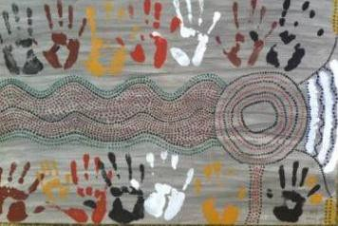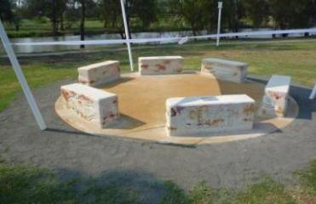

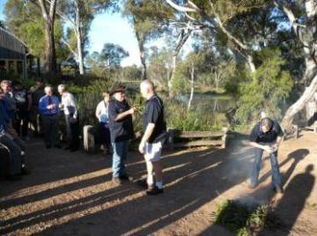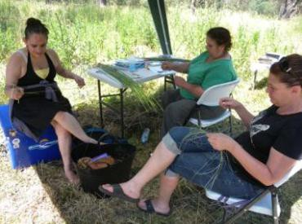
Indigenous engagement with demonstration reaches has taken many forms (Photos: Greg Ringwood, Fern Hames)

    - Media
All existing demonstration reaches recognised the need to use media to inform, engage and consult target audiences. The array of options include TV and radio interviews, contributions to newspapers, media releases, and organisation of specific media events.

Effective use of media can greatly broaden the potential audience. It is important to ensure that the appropriate level of effort is invested to reflect the desired results. Significant effort can be required to undertake comprehensive media promotion. Developing relationships with key media representatives can be very worthwhile whilst having multiple voices to speak to key messages of the demonstration reach is important to extend the reach of media in the local community.

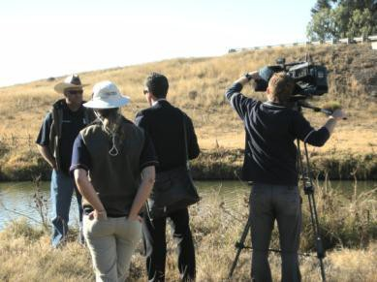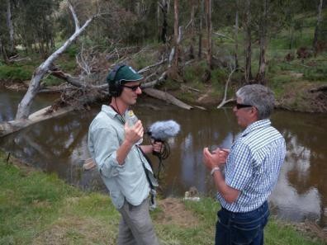
Effective use of media can increase awareness of demonstration reaches (Photos: Fern Hames)

    - Linkages with complementary programs
There is a vast array of organisations and programs involved in environmental rehabilitation that are potentially complementary to demonstration reaches. Identification of those of relevance is an important step to undertake early in a project. Piggy backing on other events, helps build trust and ensure attendance in the early stages of a demonstration reach. Establishing links and partnerships wherever possible has multiple benefits including saving on time and effort through sharing planning and organisation and building lasting relationships. Field days that involve a variety of organisations and activities can also be more likely to attract a better audience. Linking with complementary organisations and programs may also provide potential to seek collaborative funding.

There are many examples of existing demonstration reaches participating in other events and field days. These include international events such as World Rivers Day and World Wetlands Day, national programs such as National Waterweek and Clean Up Australia Day. There are also many examples of involvement in more localised state based events, such as Fish Friendly Farms, Namoi Envirobeat Youth Conference, Platypus counts, Frog Watch census and WaterWatch activities. Establishing stalls at farming expos, camping and outdoor shows and fishing competitions can also provide opportunities to link in with much larger and diverse audiences. Given the importance of riparian habitat restoration and protection for rivers, there is also obvious associations with programs run by organisations such a Greening Australia, Bush Heritage and Trust for Nature.

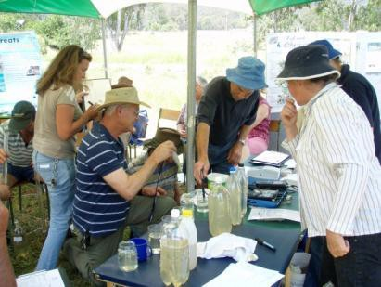
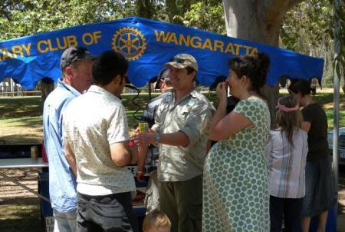There are many opportunities to link in with organisations and groups involved in environmental rehabilitation activities (Photos: Fern Hames)

References to Community Involvement Pillar

ACT Government (2010) Upper Murrumbidgee Demonstration Reach Implementation Plan . Department of Territory and Municipal Services, Canberra. Hyperlink: http://upperbidgeereach.org.au/implementation

Condamine Alliance (2009) Dewfish Demonstration Reach Communication and Engagement Plan. Hyperlink: http://www.condaminealliance.com.au/dewfish- demonstration-reach-resources

Condamine Alliance (2012) Dewfish Demonstration Reach Communication and Engagement Plan 2012-2014. Hyperlink: http://www.condaminealliance.com.au/dewfish-demonstration-reach-resources

IAP2 (2004) International Association for Public Participation. Hyperlink:
http://www.iap2.org.au/documents/item/84 2004.

Katfish Reach Steering Group (2008) Katfish Reach Implementation Plan. Hyperlink: http://www.katfish.org.au/FINAL%20PLAN%20-%20web%20copy.pdf

Lintermans, M. (2007) Fishes of the Murray-Darling Basin: An Introductory Guide.
Murray-Darling Basin Commission Publication No. 10/07, Canberra, Australia.

Appendices to Community Involvement Pillar

2.6.1 Appendix 2a – Terms of Reference for the Scientific Advisory Group and Community Reference Group for the Upper Murrumbidgee demonstration reach.

The role of the Upper Murrumbidgee demonstration reach ‘Scientific Advisory Group was to provide expert scientific advice to guide development and review of monitoring and evaluation of the UMDR project.

The group will:
    - Identify and agree on appropriate monitoring and evaluation targets to measure the progress of the UMDR project in accordance with NFS guidelines.
    - Provide advice during the development of methodology for a comprehensive monitoring and evaluation plan for the UMDR project, including data capture and analysis of techniques in-line with NFS guidelines.
    - Review the progress of monitoring and evaluation activities and make relevant recommendations for improving any aspect/s of the monitoring and evaluation activities at nominated stages.
    - Identify linkages between the on-ground NRM related rehabilitation activities and the results of monitoring and evaluation studies and provide recommendations towards future work associated with the overall UMDR project
    - Review and provide comment on any output/s and presentation of outcomes of monitoring and evaluation activities.

The roles of the Upper Murrumbidgee demonstration reach Community Reference Group were to:

    - Facilitate the exchange of knowledge and information between community based individuals, groups and organisations, with the UMDR project manager (and appropriate agency representatives as seen appropriate by the group)
    - Inform representatives of the community reference group of existing and potential future actions being undertaken toward UMDR targets.
    - Identify on-ground issues within the UMDR and continually review potential opportunities to source funding to remedy the issues.
    - Identify and continually review opportunities for community engagement opportunities, including sources of funding to assist with engagement activities, within the UMDR.
    - Provide an open forum for raising ideas for ways in which community members can play an active role in ‘championing’ the UMDR or parts thereof, within the bounds of the UMDR plans of action (Implementation, CEPA, Carp Reduction and Monitoring and Evaluation).

    - Appendix 2b - Examples of Community Objectives

The Upper Murrumbidgee demonstration reach objectives included:
    - increase awareness of activities – what is happening and what is planned in the project
    - improve community capacity to assist with management of the Reach
    - demonstrate, through education, best practice techniques for environmental rehabilitation and water use
    - improve the understanding of river ecology and fish management through communication with the community
    - develop a better understanding of the links between traditional culture and the ecology of the river and its floodplain and
    - use the site as a demonstration of river rehabilitation to the broad community so that they can learn from it in undertaking their own initiatives.

The Bourke to Brewarrina demonstration reach objectives included:
    - raise community awareness about the pressures that affect native fish species and the types of on-ground works required to alleviate these pressures
    - demonstrate the cumulative benefits of on-ground aquatic habitat rehabilitation for aquatic species and overall ecosystem health
    - rehabilitate native fish habitat in a degraded section of the Barwon- Darling River, to show a positive impact on fish populations
    - enable the community to continue improving the river environment after the project ends and
    - contribute to the Native Fish Strategy goal of rehabilitating native fish communities to 60 % of pre-European settlement levels within the next 50 years.

    - Appendix 2c – Examples of messages

The NSW demonstration reaches (Bourke to Brewarrina and Namoi) included a variety of clear messages to appeal to a variety of audiences. These are summarised below:

    - Native fish communities of the Murray-Darling Basin (Bourke to Brewarrina/Namoi) are at risk, but there are things we can do to help bring them back.
    - Carrying out a range of activities simultaneously increases the benefit to fish, aquatic habitat, and river health.
    - We can improve fish habitats, leading to healthier fish populations.
    - If we know what the problems are, we can plan how to fix them.
    - Restoring fish communities won’t happen overnight: it’s a long-term commitment.
    - Native fish need the help of everyone, especially local communities that live and work around our waterways. It doesn’t matter how small you think your contribution is.

    - Projects will also benefit landholders through improved on-farm management, leading to increased primary production and land value.

The Hollands Creek demonstration reach included the following key messages:
    - Native fish in the Murray Darling Basin have suffered serious declines in both distribution and abundance. Management interventions can slow and reverse those declines.
    - Hollands Creek has been identified as a suitable demonstration reach site, as it has several key values and should respond well to a range of river rehabilitation actions.
    - Hollands Creek is home to an important population of Macquarie perch
    - Arthur Rylah Institute (DSE Victoria) and the Goulburn Broken Catchment Management Authority (GBCMA) are committed to working with the community to ensure that the demonstration reach is developed as a partnership and involves the most appropriate works.
    - Community input will play an important role in the rehabilitation of the site.
    - The Hollands Creek demonstration reach project is designed to improve native fish populations and river health, and will not reduce visitor access.

3 Planning – Pillar 2

“ A good plan is just as crucial to good stream rehabilitation as is skill in building structures or knowledge of how streams work” Rutherford et al. 2000.

Demonstration reaches represent an integrated approach to rehabilitation through implementation of multiple interventions over a long period. A comprehensive approach to planning all aspects is essential from the start. The production of planning documents ensures that the project is carried out in a properly integrated and strategic manner. The project’s aims, approaches, targets, actions and results should all be documented and accessible to a broad audience, maximising transparency and helping engage, inform and involve the community. These documents also provide a convincing “portfolio” when addressing funding bodies or likely partners to garner support, since the proposed actions, likely benefits and priorities are clearly explained. Funding bodies increasingly expect comprehensive and clear reporting on outcomes of their investment.

Planning effort is often concentrated in the early stages of demonstration reach establishment and should be done holistically. The Whole of Life Plan, Monitoring and Evaluation Plan, and Communication and Engagement Plan should be developed in parallel and complement each other.

Once key documents are prepared, these serve as reference documents throughout the life of the project. They provide a structure which facilitates reporting on milestones and project evaluation over time. Given that demonstration reaches are long term projects, comprehensive documentation also helps in continuity, where changes in staff and community representatives can occur. Comprehensive plans can make the most of limited resources by identifying priorities, focussing effort on clear actions, and ensuring everyone is on the same page. They can also serve as valuable references and templates for other demonstration reaches.

This Pillar outlines how to select an appropriate site, establish a vision, prepare relevant planning documents and address funding issues. Ten years of experience in establishing demonstration reaches across the MDB has provided valuable insights into what planning approaches and tools are effective as well as challenges that may be faced and approaches to address these. Each component of the ‘Planning’ Pillar includes key points to consider when establishing a new demonstration reach. While each demonstration reach will require its own particular approach, there are likely to be many commonalities.

Site selection

    - Site selection will strongly influence the likely success of the demonstration reach in achieving its ecological, recreational and community objectives.

    - Selection of an appropriate site should take into account six key criteria, as a minimum. Supplementary criteria should also be considered, based on the input of the local community, scientists and relevant catchment managers.

Selection of the appropriate site represents a key step since it will strongly influence the likely success of the demonstration reach in achieving its ecological, recreational and community objectives.

In most cases, some preliminary planning will have already been undertaken to identify a potentially suitable site for a demonstration reach. In essence, establishing a Steering Committee should occur around the same time as site selection, since it is very important to involve the local community as early as possible in the process. There may well be existing community and government action along a river reach which is addressing one of more known threats to the environment. Alternatively, there may be strong community interest to initiate some rehabilitation actions at a particular site. Existing activities can play an important impetus to establish a demonstration reach. A demonstration reach which is community driven, has a high profile and a range of interested stakeholders has the strongest chances of success.

When the demonstration reach concept was first developed, a suite of generic characteristics were identified to help guide selection of an appropriate site. These original criteria still capture the essence of what a demonstration reach should encompass:

- The reach should be accessible, visible and near a significant population centre which could supply resources and strong community support and participation from a range of stakeholders as well as raising general community awareness.
  - This characteristic is one of the most important. Without being closely linked to a local community, and ensuring sites are visible and accessible, the potential for the community to embrace and ultimate take ownership of the project may be very limited.

▪
Exam

ples:

The town of Dalby, which falls within the Dewfish demonstration reach, is an area with a wide range of business and agricultural activities which provided opportunity to increase awareness and knowledge of river management across diverse industries. Several locations are accessible which provided the opportunity to have interpretive signage to support education and awareness.

The Wangaratta township lies within Ovens River demonstration reach, and the reconstruction of a fishway, establishment of interpretive signs and field days maximised the opportunities to inform the community of the project.

- The reach should contain a range of threats to river health and native fish populations that are treatable through management interventions.
  - Most rivers and streams in Australia have experienced significant
degradation, and are affected by multiple threatening processes, including changes in flow regimes, loss of riparian and instream habitat, barriers to movement, predation and competition from introduced species, reduced water quality etc. Undertaking rehabilitation works which focus on only one threat is likely to constrain the potential benefits to the ecosystem. For

example, providing fish passage to a stretch of river may achieve little if habitat conditions are not conducive to successful breeding and survival of the fish community. Alternately, a rehabilitation project may reestablish instream habitat, but if sufficient flows are not provided, this habitat will remain unavailable to fish within a river reach. Carrying out multiple interventions concurrently to address priority threats has the greatest potential to achieve effective rehabilitation goals.
  - Selection of a reach which has ‘treatable’ threats is most logical. If a reach is too degraded then successful rehabilitation may be unlikely in the long term, which raises questions of effective use of resources, limits the ability to demonstrate success as well as garner ongoing interest and support of the local community.

Example:

The Dewfish demonstration reach selected areas which, while they had varying degrees of degradation, were in general not so highly degraded since it was considered highly inefficient to invest in such sites.

- It should be suitable for trialing a range of rehabilitation techniques
with the results transferable to other rehabilitation sites.
  - Establishing a demonstration reach represents a significant investment of
time, resources and effort. Thus selecting a reach where it is feasibly to implement a range of rehabilitation techniques, with cumulative benefits, maximizes value for money. If the site characteristics are similar to other areas and if techniques and results are potentially transferable to other rehabilitation sites, this also maximizes the potential learnings.
  - Existing demonstration reaches have focused on providing examples of solutions to problems. The regular interactions between existing demonstration reach practitioners, through informal means as well as annual workshops, meant that experiences from one site could be used to inform approaches at other sites.

Examples:

Approaches to establishment of habitat for large and small fish undertaken within the Dewfish demonstration reach has been applied to additional sites along the Condamine River outside of the demonstration reach at Warwick by the Condamine Fish Stocking Association. There are also plans to establish lunkers to aid in erosion control and creation of fish habitat at Dalby.

  - Extensive promotion of rehabilitation techniques and results, through informal and formal networks, increases their potential broader use within other rehabilitation programs, whether these include rigorous monitoring or not. This could include presentations at conferences or field days, publication of reports and journal articles, provision of information on websites and use of media. Taking up the techniques and approaches trialed within demonstration reaches does not need to be limited to

government agencies, and can be relevant to community groups and large companies with an interest in habitat rehabilitation.
  - All other aspects of planning and monitoring are also transferable.

Example:

The learnings from the Dewfish demonstration reach have been applied in the planning for the newly formed Nikki Long Cod demonstration reach and Oakey restoration reach which has enabled the planning process and establishment of a steering committee to run smoothly.

- Ideally there should be untreated sites nearby that can be used as a control against which to monitor change.
  - Historically rehabilitation projects have often not been evaluated
comprehensively. This weakens scientific credibility, ongoing success and potentially community support and harnessing additional funding since outcomes can be hard to demonstrate.
  - While monitoring programs must always be tailored to a specific site, minimum standards have been identified for demonstration reach monitoring. These note that BACI type designs with replication of before, after, control and impact components are amongst the best designs for separating, with relatively high confidence, treatment effects from natural variation.
  - All existing demonstration reaches developed monitoring and evaluation plans which identified the most appropriate approaches to rigorous scientific monitoring for each intervention. All aimed to include control or ‘untreated’ sites. Plans identified monitoring methods and key indicators, the scope of which depended on the size of the project and funds available.

Example:

The Katarapko demonstration reach monitors an extensive suite of indicators including a variety of vegetation components as well as fish, frogs and waterbirds.

- The reach should be in an area where it can fit in with existing tenures and management frameworks including existing land and water programs.
  - Potential sites should be considered in the context of the broader
environment, since those which link in well with existing land and water programs have a greater chance of long term survival. There can be more options to tap into government-assisted community programs, and greater funding can result in greater potential rehabilitation benefits. If collaborators have a proven track record in an area, this can also help gain initial good will with the community.
  - Implementation of rehabilitation interventions within a demonstration reach can contribute to achieving aims and targets of other programs such as catchment management, biodiversity and water quality plans. This represents multiple benefits and cost savings.

Example:

Both the Ovens and Hollands Creek demonstration reaches were classified as high priority reaches within the existing Goulburn-Broken Regional River Health Strategy and the current conditions, values and required rehabilitation actions aligned well with the proposed demonstration reaches.

  - Given the connectivity of rivers, the quality of upstream and downstream environments can significantly influence a particular stretch of river. For example, if a significant barrier exists downstream which is not addressed, there may be a depauperate fish community within a demonstration reach which will limit rehabilitation benefits of interventions such as provision of fish passage.
  - If a site is within an area where significant works and scientific monitoring has already been undertaken, this provides a strong initial knowledge base.

Example:

Early planning for the Upper Murrumbidgee demonstration reach identified there had already been significant investment in fish and macroinvertebrate monitoring.

  - If there are significant areas of government owned and managed land within a proposed site, it can sometimes be easier to work on these tenures initially to get the ‘ball rolling’. This can then lead to greater participation of adjoining private landholders.

Example:

Much of the Katfish demonstration reach lies within the Murray River National Park (Katarapko) or on Crown Land, as well as land held by Gerard Aboriginal Reserve and a number of small private holdings.

The Upper Murrumbidgee demonstration reach within the ACT is contained within the Murrumbidgee River Corridor reserve which has assisted with the undertakings of the UMDR and co-investment in projects.

  - The Whole of Life plans which all demonstration reaches should prepare at the start, include identification of links to relevant plans and strategies.

- It should be of sufficient size but not so large that it is unmanageable. The size should reflect the scale of the threatening processes and the scale of the interventions needed to impact on river health and the fish populations that are targeted. Typically they should be between 20 and 100km long.
  - Identification of the appropriate size of a reach should take into account funding, scientific and community factors.

  - Funding - Adequate effort in implementation of rehabilitation interventions must be undertaken within available funding. If the reach is too large, the impacts of the rehabilitation measures may be too diluted. If a reach is too small, significant funds may be invested in limited environmental benefits.
  - Scientific – Determination of the most appropriate experimental design will consider the scale at which general trend analysis on key indicators can be measured. There need to be an adequate number of sampling sites to account for the spatial patchiness between different sites. If rehabilitation projects focus on small areas, this can limit the benefits to a fish community which may include species that move large distances.
  - Community - A sound understanding of the existing community and its relationship and interest in a stretch of river is also needed to determine sufficient size. If a reach is small with few relevant interest groups and landholders, overall community participation is likely to be very limited. If there is a broad diversity of groups and organisations with responsibilities and interest in an area, this strengthens potential participation.

Example:

In Queensland, input from scientists and the local community was obtained to identify five priority sites, with possible intervention activities and costings considered for each, before the Dewfish demonstration reach was established. Community demand resulted in the final Dewfish site being expanded from 28km to 110km.

These represent the minimum requirements, and input from the broad community, local catchment managers and scientists can provide supplementary criteria to consider. The ultimate decision must balance the varying interests of stakeholder groups and the potential impacts of restorative actions on some groups. For example, if there is likely to be significant conflict and opposition to actions, and it is believed that such obstacles are unlikely to be resolved, then a particular potential site may not be appropriate.

The existing demonstration reaches all considered the key criteria described above in depth prior to finalising selection of the most appropriate sites. The Whole of Life Plans provide the most effective summaries of the values and threats, linkages to relevant plans and strategies, priority actions for interventions and approaches to monitoring.

Establish a vision

    - Establishing a common vision about improving the state of a river reach should be developed early in a project, agreed upon by all those involved, and disseminated to the broader community.

    - The vision should encompass a broad, clear target which is realistic and achievable.

    - The vision must reflect the ecological condition in which the community wishes to view the reach in the future.

The vision of a demonstration reach is a statement about improving the state of the river reach into the future. Establishing a vision should occur in the early stages, and must incorporate the values of all the stakeholders involved. The process of establishing a vision can be a very valuable opportunity to comprehensively engage with key players early, setting strong foundations for ongoing interactions.

The vision is designed to guide the direction of the project as well as maintain enthusiasm for the demonstration reach amongst stakeholders for the life of the demonstration reach. If all those involved agree on and support the vision, this provides a common bond, and ensures that everyone is clear on what the project is striving to achieve.

The vision should encompass a broad target such as “a healthy and functional riverine ecosystem with a self-sustaining native fish community”, rather than one which is very specific e.g. a 50% increase in fish passage over 10 years. While it may be seen as a broad aspirational goal it must still be realistic and attainable. For example, returning a river reach to its pre European condition is impractical. Specifying an unrealistic or unattainable vision may lead to frustration and disappointment with those involved and thus may also limit the likelihood of the project persisting in the long term.

The vision must reflect the ecological condition in which the community wishes to view the reach in the future. The vision may also incorporate economic and recreational values, if desired by the community.

Examples:

“A healthier and more productive aquatic and floodplain ecosystem that everyone can enjoy” – Katarapko demonstration reach. A series of concepts, objectives and guiding principles were identified to support this vision (Katfish Reach Implementation Plan 2008- Katfish Reach Steering Group 2008).

“A healthier, more resilient and sustainable river reach and corridor that is appreciated and enjoyed by all communities of the national capital region” – Upper Murrumbidgee demonstration reach. A series of goals, long, short to medium objectives and guiding principles were identified to support the vision (Upper Murrumbidgee Demonstration Reach Implementation Plan 2010- ACT Government 2010).

“Develop, protect and expand the Reach so everyone in the community knows about it, appreciates it and wants to be involved to create a self-sustaining project which ultimately restores the health of the river and brings back the fish.” – Dewfish demonstration reach – 2012 revised vision (Condamine Alliance 2012). A series of goals, objectives, strategies and tactics were identified to support this vision.

The existing demonstration reaches in NSW did not specify visions. The Bourke to Brewarrina, and Namoi demonstration reaches (NSW) identified overall aims, objectives and actions (Industry and Investment NSW Plan 2009). For the Hollands Creek

demonstration reach, a community workshop was held at the very beginning of the project, involving community members and landholders, the local recreational fishing group, business owners, local government representatives and project partners. The workshop was formally facilitated and involved sharing and documenting the various values held for Hollands Creek, perspectives on threats to these values, and potential actions. A key component was bringing those views together into a simple, agreed shared vision for the project, for 'a healthy Hollands Creek, supporting a range of biodiversity values'. The process of developing this simple vision was hugely valuable. The Ovens River demonstration reach (Vic) identified priority rehabilitation actions.

Whole of life plan – Implementation plan

    - A Whole of Life Plan represents the core planning document to guide implementation of a demonstration reach project and should be prepared in the early stages to maximise its value, particularly to managers.

    - It is recommended that such plans include the minimum requirements identified within this toolbox.

All demonstration reach project should aim to prepare a Whole of Life or Implementation Plan early in the process. This primary document brings all the relevant information together and sets the foundation for implementation of all activities. This plan provides the background to the demonstration reach, describing its location, boundary, land tenure, assets and threats. It should place the project in a context within the broader environment and specify relevant associated programs and initiatives. It should also describe the common vision, management objectives, interventions required, as well as timing of actions, priorities and budgets. Such a document justifies the demonstration reach project, integrates and documents what needs to happen.

While such a plan covers the whole life of the project, it should be recognised as an evolving document that will require ongoing revision, as knowledge gaps are filled with the results of implementation and monitoring of interventions. Whole of Life plans should specifically incorporate the guiding principle of adaptive management where ongoing monitoring of system responses to management actions help inform implementation of actions so they can be modified as required. They can also build on the results of other associated programs as they are implemented.

Whole of Life Plans are very useful for managers with primary responsibility for the demonstration reach, since having a clearly articulated strategy allows them to pursue further funding for specific activities from a broad range of potential investors. By including timeframes for actions and identification of priorities, this greatly assists in allocation of funds year by year.

Although Whole of Life Plans provide substantial detail for a demonstration reach project, they should be seen in conjunction with other associated plans such as Communication and Engagement Plans and Monitoring and Evaluation Plans.

While the content, format and level of detail provided within Whole of Life Plans are likely to vary according to the situation and the needs of the managing agency, it is recommended that they contain the following information as a minimum:

    - Demonstration reach name
    - Lead agency and primary contacts
    - Other partners (this list will grow as the project progresses)
    - Management and governance arrangements (i.e. steering committees, advisory groups etc.)
    - Background
      - Locality
      - Land tenure
      - Description of the reach
      - Assets (i.e. description of fish community present including conservation
status, other natural values, community values e.g. recreational fishing,
other recreation activities etc.)
      - Threats and stressors
      - Links to relevant plans, strategies, programs and initiatives
    - Vision for the reach
    - Management objectives and actions, including priorities
    - Interventions to be undertaken including time frame and by whom
    - Budget requirements, current and potential sources of funding

The existing demonstration reaches developed a variety of documents, broadly known as Whole of Life Plans or Implementation Plans. While they varied in their detail and structure, they all provided overarching plans to provide a strong and lasting foundation for implementation of demonstration reaches.

Examples:
- NSW Demonstration Reaches Whole of Life Plan 2009 (Industry and Investment NSW 2009)
- Katfish Reach Implementation Plan 2008 (Katfish Reach Steering Group 2008)
- Upper Murrumbidgee Demonstration Reach Implementation Plan 2010 (ACT Government 2010)
- Dewfish Whole of Life Plan (Condamine Alliance 2008)

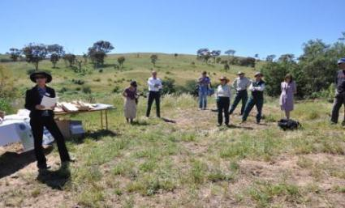

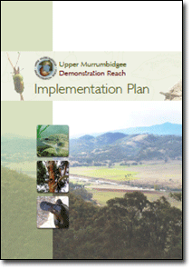Effective use of media can increase awareness of demonstration reaches (Photos: Lisa Evans)

Communication and engagement plan

    - A Communication and Engagement Plan represents a blueprint to keeping target audiences and stakeholders informed and engaged throughout the life of the demonstration reach.

    - It is recommended that such plans include the minimum requirements identified within this toolbox.

Effective and well-targeted communication is vital to keeping the community informed and engaged during the life of the demonstration reach. The preparation of a Communication and Engagement Plan plays a key role in this process, and represents a blueprint for implementation.

Such a plan should provide background context to the project, identify target audiences, messages, goals and communication actions. Inclusion of details of priorities, timeframes, responsible agents and budgets can provide a sound structure for works plans and reporting. Communication and engagement activities are sometimes overlooked or underestimated in habitat rehabilitation programs, so these plans can help emphasise their importance and the level of effort required. It is also valuable to incorporate performance indicators, targets and methods for evaluation. Identifying potential linkages to other programs can enhance connections and provide cost efficiencies with overlapping resources. Prioritisation of actions can also ensure that available resources are focussed on the most effective and important tasks. Some Communication and Engagement Plans identify potential risks and difficulties in undertaking engagement, as well as strategies to address these.

While a Communication and Engagement Plan may potentially cover the life of the project, it should be continually revised as monitoring results may indicate the need to change approaches and actions and new partners, champions and opportunities may evolve.

The content, format and level of detail within Communication and Engagement Plans are likely to vary according to the situation, the needs of the management agency and available funds.

A Communication and Engagement Plan should contain the following as a minimum requirement:
    - Demonstration reach name
    - Lead agency and primary contact
    - Partners
    - Background of the local community (demographics etc.)
    - Target audience (e.g. Government agencies, industry, recreation, landholders etc.)
    - Key messages
    - Goals and Objectives
    - Tools and actions (including time frame, priorities and responsibilities)
    - Performance indicators and evaluation

    - Budget requirements and potential sources of funding.

Further details regarding identifying target audiences, key messages, goals and objectives, and tools and actions are provided in the People Pillar.

Existing demonstration reaches have used a variety of different styles of Communication and Engagement Plans, and also used a variety of terms for different steps. They all however broadly encompassed the components outlined above.

Examples:

    - The Dewfish demonstration reach has prepared two Communication and Engagement Plans. The 2009 plan uses a CATWOE approach which represents an anagram of the letters that represent stakeholder categories (Customers, Actors, Transformation process, World view, Owner and Environmental constraints). A facilitator worked with a small working group, and the plan included a CATWOE analysis, individual stakeholder analysis, communication and engagement methods and operational considerations. A different approach was undertaken for the Dewfish Demonstration Reach Communication and Engagement Plans 2012-2014, which provided background, situation analysis, SWOT analysis, target audiences, key messages, vision, goals, strategies and tactics, evaluation and risk management.

- The Communication and Engagement Plans for the Hollands Creek and Ovens River demonstration reaches incorporated the spectrum of engagement concept (International Association of Public Participation IAP2). This recognises that differing levels of engagement are legitimate depending on the context. This spectrum ranges from the simple one-way information flow of ‘Inform’, through increasing levels of stakeholder participation in ‘Consult’ and ‘Involve’ to genuine partnerships in ‘Collaborate’ and ‘Empower’.

- The Upper Murrumbidgee demonstration reach prepared a detailed Communication, Education, Participation and Awareness Plan which identified detailed actions, priorities, key outputs, anticipated outcomes, timeframes and project partners.

Monitoring and evaluation plan

    - Ecological Monitoring and Evaluation Plan

    - An Ecological Monitoring and Evaluation Plan provides a scientifically robust and cost effective framework to guide the assessment of the ecological response to river rehabilitation.

    - An Ecological Monitoring and Evaluation Plan provides a program with a greater confidence of success, since resources can be focussed on a core number of robust evaluations.

    - This plan helps managers in their forward planning and budgeting, while also providing a framework to explain survey methodology, use of indicators and monitoring results.

    - It is recommended such plans include the minimum requirements identified within the Toolbox.

River rehabilitation programs often neglect comprehensive project evaluation. The need for standardised and scientifically robust monitoring and evaluation of the science of demonstration reaches was recognised as a core element of this approach. The development of a framework for developing and implementing ecological monitoring and evaluation of aquatic rehabilitation in demonstration reaches (Boys et al. 2008) was seen as an important step to achieve this. The framework provides a scientifically robust and cost effective guide for monitoring and evaluating ecological responses to river rehabilitation. It explains the need for ecological monitoring, describes elements of a good monitoring program and discusses different types of monitoring able to be undertaken, and how they should be applied.

This framework should be used as a guide in the development of any Monitoring and Evaluation Plan for a demonstration reach. It is sufficiently broad to be adapted to local situations and the format can be adapted to meet particular management agency needs. A Monitoring and Evaluation Plan should contain the following as a minimum requirement:
    - Demonstration reach name
    - Lead agency and primary contact
    - Partners
    - Capacity to undertake the monitoring
    - Background to the demonstration reach (including threats and goals)
    - Links between goals of the demonstration reach, interventions, hypotheses to be tested, monitoring scales and indicators to be used
    - Conceptual models and Stommel diagram (see Boys et al. 2008)
    - Experimental and statistical design
    - Methods
    - Timelines and milestones
    - Budget requirements.

The plan should include detail for both condition or reach scale monitoring (the cumulative impacts of interventions on the reach) and intervention monitoring (the impacts of individual interventions) where possible.

It should embrace a framework of adaptive rehabilitation. Their preparation can facilitate greater coordination, so that resources can be focussed on a core number of robust evaluations rather than multiple small scale and limited experiments. Clarification of the minimum evaluation requirements also helps all partners understand the need for adequate funding of these project components, as well as the implications of funding cuts.

Monitoring and Evaluation Plans help managers by explaining what needs to happen to restore fish communities, in a scientific context. This provides a program with a much greater confidence of success, which can be promoted to funders, partners and the community. Such plans can also explain why particular indicators are used in monitoring, which is useful for communication and engagement activities.

The inclusion of timelines, milestones and budget details help in forward planning, reporting and development of funding bids. These plans should be mindful of the need to demonstrate good return on investment and may consider inclusion of cost-benefit analyses to help guide investment.

Good monitoring and evaluation planning also maximises the chance of learning about ecological responses to rehabilitation, and enabling broader applicability of particular interventions. Implementation of scientifically robust monitoring and evaluation approaches increases the ability to disseminate results through publication in well regarded scientific journals.

Monitoring and Evaluation Plans should be seen in conjunction with other associated plans such as Communication and Engagement Plans and Whole of Life Plans. For example, it is important to recognise that it can take a number of years to properly assess impacts of particular interventions. This must be communicated effectively so that the expectations of partners, funders and the community are managed effectively so that they understand the potential complexity of environmental responses. There should be a focus on increasing understanding of the principles of ecological rehabilitation, and ensuring year by year monitoring results are placed in a broader context. While for some interventions, such as provision of fish passage, results of interventions may be seen quite rapidly, others such as riparian rehabilitation will likely be much longer.

Existing demonstration reaches developed a variety of Monitoring and Evaluation Plans. While they varied in the overall structure and level of detail, all broadly encompass the components identified by Boys et al. (2008).

Examples:
- Upper Murrumbidgee Demonstration Reach Monitoring and Evaluation Plan 2011 (ACT Government 2011)
- The Katfish Demonstration Reach Monitoring and Evaluation Plan 2012 (Ireland et al 2012)
- Dewfish Demonstration Reach Monitoring and Evaluation Plan 2009 and 2012 (Condamine Alliance 2009, 2012)
- Namoi Demonstration Reach Monitoring and Evaluation Plan 2010 (Industry and Investment NSW 2010a)
- Bourke to Brewarrina Demonstration Reach Monitoring and Evaluation Plan 2010 (Industry and Investment NSW 2010b)

    - Communication Monitoring and Evaluation Plan

    - A Communication Monitoring and Evaluation Plan should be developed to guide assessment of the community response of communication and engagement activities within demonstration reaches.

River rehabilitation programs also often neglect comprehensive evaluation of community engagement. While there is currently no complementary framework to that developed for biological monitoring (Boys et al. 2008), communication and engagement programs within demonstration reaches warrant a standardised and scientifically robust monitoring and evaluation approach.

Existing demonstration reaches did develop Communication and Engagement Plans, which generally included detail of actions, timelines, performance indicators and evaluation. The approach to evaluation primarily focussed on reporting and quantifying outputs e.g. number of events and activities undertaken, attendances and participation etc. This type of information helped assess whether actions were successful in achieving particular objectives, what approaches were most effective, how they could have been improved and what else needed to be undertaken. Annual reports also included detail of which types of engagement approaches and activities were appropriate for particular audiences.

There was however no comprehensive assessment of how community attitudes changed over time as demonstration reaches matured. Given that an ultimate long-term aim of demonstration reaches is that they become ‘owned’ by the local community, how well the community understands and embraces a particular reach is very important. Existing demonstration reaches did identify particular examples of where the community picked up demonstration reach activities (e.g. local schools incorporating the project into their curriculum including a school in Wangaratta removing Gambusia from local wetlands in Ovens River demonstration reach, schools in Dalby used the Dewfish demonstration reach as a case study to study features of their catchment).

Several existing demonstration reaches began to undertake more comprehensive analyses of community engagement. The Dewfish demonstration reach undertook a review of the social dimensions of engagement with the communities of practice and the economic benefits accrued (Gus Hamilton Consulting 2012). This review used a variety of methods in its assessment. It considered evidence of success for community engagement, awareness, commitment and empowerment, as well as environmental and economic impacts. It identified drivers of success and opportunities to build on the project’s success.

The Hollands Creek demonstration reach also began to monitor changes in community attitudes resulting from communication activities. A social survey was undertaken to explore public opinion on specific issues relating to the project and activities undertaken. The purpose of the questionnaire was to assist in the future design and planning of works and activities. The survey asked respondents their views on the importance of the creek, priority values, benefits of involvement in the project, awareness of threats and values of the creek and ideas of how conditions could be improved. The survey also asked about people’s awareness of the project, its works program and its ability to inform the

community. Although the report analysing the survey responses was not externally published, the results provided valuable insights for future management of the Hollands Creek demonstration reach, and the process initiated (and highlighted the value of) bringing social surveys into the broader monitoring and evaluation programs for demonstration reaches.

It is recommended that demonstration reaches develop a comprehensive evaluation framework for communication and engagement programs. Such a framework should include consideration of partners, capacity to undertake monitoring, identification of performance indicators, experimental and statistical design, timelines, milestones and budget requirements (see Monitoring Pillar for further detail).

Funding

    - Strategic forward planning is required from the start and throughout the project, to identify potential funding opportunities and partnerships, and to adapt to changing funding environments.

    - Comprehensive planning documents and established processes to assess progress maximise the appeal of the project to potential funders.

    - Emphasise the linkages between demonstration reaches and existing programs and initiatives to highlight multiple benefits.

    - If funding changes over time, be realistic and clear about what can be achieved with available funds.

    - Think laterally and focus on building strong and broad partnerships to maximise the potential to harness contributions, including fund, resources and in kind support.

Demonstration reaches represent complex, long-term projects and the resources required can be substantial. Securing long term funding can be a difficult task, particularly given that potential funding cycles of Federal and State government can be quite short-term. While funds may be obtained to establish and begin implementing a project, it is essential to plan for the future and adapt approaches to seeking funds, if options begin to decline.

Traditionally, catchment management authorities and natural resource management agencies have been key funders and partners of demonstration reaches. Demonstration reaches can be promoted as extending the activities of such organisations and represent a method of coordinating a number of existing activities into a consolidated program that uses fish as indicators of success. Building on existing initiatives and programs is better than starting from scratch, and this should be emphasised to such organisations. For example, if there are already plans to construct a fishway in a reach or mitigate cold water pollution, a demonstration reach can ‘piggy back’ on these activities and can overlay an experimental design. This represents clear value adding that is appealing to these organisations.

Funding bodies increasingly expect a clear focus on quantification and strong reporting on outcomes to demonstrate the value of their investment. This is a key point to highlight in funding bids to emphasise the value of demonstration reaches. The existence of planning documents (Whole of Life Plans, Communication and Engagement Plans, Monitoring and Evaluation Plans) as well as milestone reports can provide excellent “business plans” for seeking funding. These plans also facilitate preparation of funding bids, since relevant information is easily accessible and already collated.

A significant amount of time is often invested in developing and coordinating funding bids, potentially with little reward. It is important to consider the appropriate level of effort based on size of the potential funding opportunity. Targeting long-term regional investment should be the primary focus. However, if options are limited, short-term funding source may enable implementation of particular activities which keep a project going. Strong communication between stakeholders, sharing information and making use of participants’ knowledge, ideas and connections can help maximise investigation of options for potential funding. Thinking laterally to identify and pursue new funding sources also broadens options. Be innovative in developing options and ideas, and focus on building trust and understanding with potential partners.

Funding often tends to allocate very small amounts to monitoring, which is a weakness, and when available funds decline, monitoring can be the first thing to be cut. It is important to be clear about the minimum level of monitoring that can be undertaken to be scientifically rigorous and supportable. If monitoring is limited, those involved must have realistic expectations of what information can be obtained, and this should be communicated clearly. It should be recognised that Rehabilitation Reaches, which do not incorporate monitoring, still represent valuable rehabilitation programs.

It should be recognised that if good results are obtained during monitoring programs (i.e. improving trends in fish populations and river health), these provide an opportunity to leverage further funding. Receiving high profile awards can also increase a project’s profile, and other groups may subsequently wish to become involve.

Reduced funding can potentially restrict every aspect of a demonstration reach, including implementation of fewer onground actions and fewer staff to manage the project. The focus may need to shift to even stronger engagement with existing and potential partners to look for new opportunities. In addition to partners providing direct funds, other support such as provision of information and resources, participation in events and support by staff can represent valuable ‘in kind’ contributions.

Each existing demonstration reach has grappled with changing funding environments. Some have developed strong connections with corporate partners, with great success. When approaching potential partners, it is important to ensure they are very clear of aims of the demonstration reach, required actions, and intended outcomes. An emphasis on ongoing and strong dissemination of the project’s progress and achievements help maintain a high profile to maximise potential ongoing interest in the demonstration reach. If corporate partners view a demonstration reach as a high profile program, this has clear appeal for their own promotion. Experience has shown, not unsurprisingly, that larger reaches which have a greater community profile and involvement of multiple partners have a much greater potential to gain significant funding from external industries and businesses.

Examples:

      - Dewfish demonstration reach – detailed planning and clear direction provided impetus and a willingness for co-investment. Strong partnerships between the community, government and industry attracted $1.5 million in cash, more than $1.6 million of inkind support and more than 3000 volunteer days. There are 19 different industry partners include energy companies, engineering companies and rural farming and pastoral companies.

      - Katfish demonstration reach – partners have invested an additional $2.25 million to the project and in 2014/5 another $44 million has been committed to the project.

      - Upper Murrumbidgee demonstration reach – corporate investment has included water agencies responsible for managing the ACT water supply providing inkind input including supply and access to monitoring and evaluation data and infrastructure created by the agencies within and beyond the reach. There have been contributions to water quality and volume monitoring, including towards a new gauging station and funds to undertake fish, macroinvertebrate and riparian health monitoring.

      - Namoi demonstration reach is currently engaging with potential corporate partners such as mining companies located in the reach. They have gained in kind support including mining companies providing logs for resnagging activities as well as onground works being undertaken on land owned by such companies.

References for Planning Pillar

ACT Government (2010) Upper Murrumbidgee Demonstration Reach Implementation Plan . Department of Territory and Municipal Services, Canberra. Hyperlink: http://upperbidgeereach.org.au/implementation.

ACT Government (2010) Upper Murrumbidgee Demonstration Reach Monitoring and Evaluation Plan 2011. Department of Territory and Municipal Services, Canberra.

Upper Murrumbidgee Demonstration Reach. Hyperlink: http://upperbidgeereach.org.au/node/226

Boys, C. A., Robinson, W., Butcher, A., Zampatti, B. and Lyon, J. (2008) Framework for developing and implementing ecological monitoring and evaluation of aquatic rehabilitation in demonstration reaches. Murray-Darling Basin Commission, Canberra.

Condamine Alliance (2009) Dewfish Demonstration Reach Communication and Engagement Plan. Hyperlink: http://www.condaminealliance.com.au/dewfish- demonstration-reach-resources

Condamine Alliance (2008) Dewfish Whole of Life Plan 2008. Hyperlink: http://www.condaminealliance.com.au/dewfish-demonstration-reach-resources

Condamine Alliance (2012) Dewfish Demonstration Reach Communication and Engagement Plan 2012-2014. Hyperlink: http://www.condaminealliance.com.au/dewfish-demonstration-reach-resources

Katfish Reach Steering Group (2008) Katfish Reach Implementation Plan. Hyperlink: http://www.katfish.org.au/FINAL%20PLAN%20-%20web%20copy.pdf

Industry and Investment NSW (2010) Monitoring and Evaluation Plan for MDBA Demonstration Reaches – Bourke to Brewarrina demonstration reach. Internal report, NSW DPI Port Stephens Fisheries Institute.

Industry and Investment NSW (2010) Monitoring and Evaluation Plan for MDBA Demonstration Reaches - Namoi demonstration reach. Internal report, NSW DPI Port Stephens Fisheries Institute.

Industry and Investment NSW (2009) NSW Demonstration Reaches Whole of Life Plan 2009.

Ireland, L.J., Suitor, L., and Harper, M. (2012) Katfish Reach Monitoring Plan.
Department of Environment, Water and Natural Resources. Government of South Australia.

Gus Hamilton Consulting (2012) The Dewfish Demonstration Reach Project – A review of the social dimensions of the engagement with the communities of practice and the economic benefits accrued.

Rutherfurd, I. D., Jerie, K. and Marsh, N. (2000) A rehabilitation manual for Australian streams. Cooperative Research Centre for Catchment Hydrology.

4 Onground interventions – Pillar 3

    - The Whole of Life Plan will identify the management interventions to be undertaken.

    - Detailed design of the interventions and their placement must be done in consultation with relevant experts.

    - Consultation must occur with relevant jurisdictional government agencies to determine legislative and administrative requirements.

    - A works program should schedule the management interventions and outline the resource and funding requirements.

    - The works program and the Monitoring and Evaluation Plan must be properly coordinated.

This section provides guidance on how to undertake on ground management actions to rehabilitate ecosystem health for native fishes. It is important to involve the community in on ground management interventions such as re-snagging and riparian rehabilitation and to celebrate milestone achievements throughout the life of the demonstration reach.

The Whole of Life Plan (see Planning Pillar) should have identified the management interventions to be undertaken (e.g. riparian rehabilitation, alien fish management, fish passage restoration) and the sequence in which they are to be undertaken. Ideally all management interventions would be undertaken simultaneously throughout the demonstration reach. In reality this is not usually possible and interventions must be planned over a number of years in relation to the availability of resources and funds.

The first steps are to:

    - Undertake an assessment of the current condition of the reach and the existing threats to ecosystem health.
    - Document the necessary steps (actions) to mitigate each threat.
    - Engage the broad community and major stakeholders to identify shared goals for the reach.
    - Prioritise actions on both biological and community needs (this builds a shared ownership of the project).
    - Consult with appropriate experts to design how and where the intervention will be implemented, what the resource and cost requirements are likely to be and a cost benefit analysis.
    - Consult with jurisdictional agencies to determine the legislative and administrative constraints.

A works program can then be developed, scheduling the management actions over a period of time (e.g. 3 years) and the funds and resources required. When developing the works program it is important to be fully cognisant of all the issues that may arise including access to suitable contractors, ongoing maintenance costs, legislative requirements, contingency arrangements for delays due to e.g. flooding etc. The program

has to be realistic given the expected availability of funds and resources but the interventions must be of sufficient scale that they are likely to have a measurable impact on native fishes. It is also vital that the works program and the biological monitoring and evaluation program are planned together and properly coordinated.

There are number of management interventions that have been used to rehabilitate degraded rivers throughout Australia and a number of these, together with some new innovative approaches have been trialed at existing demonstration reaches (see examples in Appendix 4a). Broad guidelines and examples of the more common interventions are given below. However, again the reader is urged to seek expert advice on these interventions as they pertain to their particular circumstances.

Instream habitat

4.1.1 Reintroducing large woody debris (snags)

    - Local authorities must be contacted to ensure compliance with any regulatory requirements.

    - Woody debris loads should be based on the natural load for the particular river.

    - Woody debris should be native to the riparian zone but not sourced from there.

    - Logging or land clearing sites are potentially good sources of woody debris but the closer to the demonstration reach the better to avoid excessive costs.

    - Expertise should be sought in placing the woody debris to avoid danger to existing infrastructure etc., but low velocity areas on the outside or downstream of bends are preferred.

    - Anchoring may be required to achieve stability. Trunks with root wads still intact will assist in this process.

    - Heavy equipment (e.g. excavators) will be required to place woody debris in the river. Damage to the riparian zone should be avoided wherever possible.

Large woody debris consists of accumulations of woody materials (branches or whole tree trunks) that have fallen onto the stream bank or into the channel from the riparian zone. Once instream, large woody debris will become waterlogged and come to rest on the stream bed during low flow periods. They are a natural occurrence in health river systems but historically they have been considered hazards to navigation and have been wrongly thought to contribute to flooding by blocking the channel. As a consequence millions of woody debris have been removed from rivers and burnt.

More recently, the value of large woody debris to riverine ecosystems has been recognised and the re-introduction of woody material has become a major management intervention to rehabilitate degraded rivers. Large woody debris provides for:

- Habitat diversity through the development of downstream scour pools, variation in flow rates etc.

- Reduced rate of bed and bank erosion.
- Habitat for macrophytes, algae, invertebrates and microorganisms.
- Stable sites for the processing of carbon and nutrients.
- Resting areas for fish from high flows.
- Refuges from predators.
- Spawning sites for a number of native fishes (e.g. Murray cod, River blackfish).
- Territorial markers for some species (e.g. Golden perch and Murray cod).

There are a number of documents that have been produced which provide very good general guidance for restoring large woody debris in rivers. In particular, the reader is referred to Rutherfurd et al. (2000) and Brooks (2006). In the toolbox, a broad approach is documented together with examples from existing demonstration reaches.

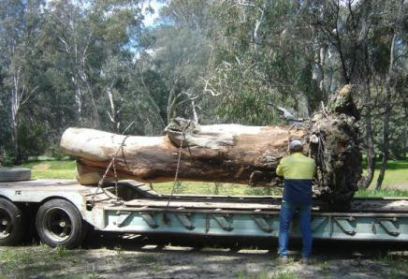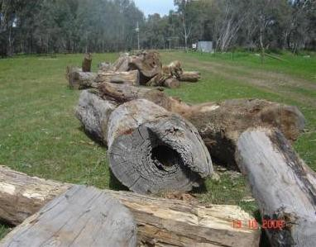

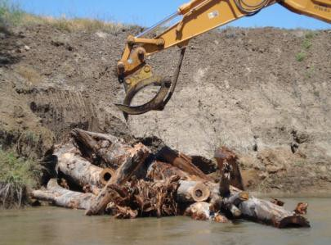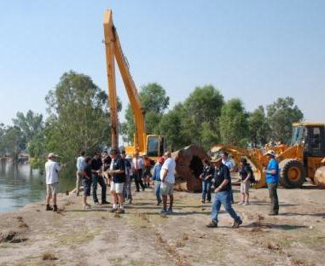

There are many practical issues to consider when reintroducing snags to a river (Photos: Tony Townsend, Scott Raymond)

      - How many?
The aim should be to restore the river to its natural large woody debris load. Natural loads are not consistent but vary from river to river depending on the biogeographical region etc.
Natural loads are best determined by direct measurements of the amounts of wood present in undegraded reaches of the river or from similar rivers nearby. Records may also be
available from local river management authorities on the number of snags removed from sections of river. More woody debris may be required in areas where the riparian zone is
degraded as there is no source of re-supply. Results from some existing demonstration

reaches have indicated that the more complex a snag pile is (e.g. five or six snags overlying each other) the higher number and diversity of fish the snag will accommodate. (see examples in Appendix 4b).

      - Type and where from?
Ideally, the woody debris used should reflect the diversity of species found naturally in the riparian zone. This way there will be a different decay rates providing a diversity of snag
types. Introduced species should not be used as they do not provide a good substrate for macro invertebrates and may decompose quickly. If possible a range of sizes should be
used. Snags should ideally have the root ball still attached and four or five large branches remaining. However, several sub optimal snags can be used in a snag pile with good
results.

Woody debris should not be sourced from the riparian zone or the floodplain as they are providing important terrestrial habitat. Waste from logging or standing (green if possible) trees from clearing agricultural land, mine sites, road realignments and industrial developments may be good sources of woody debris. The closer the site is to the demonstration reach the better, as transport costs can be prohibitive. It is likely that the introduction of woody debris will be undertaken over a number of years. If a suitable source is found it may be worthwhile stockpiling the wood if a site is available. However, termites and borers are likely to invade fallen trees within six months on the ground. The resultant snags will be lighter and harder to anchor increasing the risk of them being washed downstream during a flood (see examples in Appendix 4c).

      - Where to place woody debris?
It is very important that local authorities are contacted at an early stage and that relevant expertise is sought. Wrongly placed woody debris could lead to increased bank erosion or
could even endanger infrastructure (e.g. bridges) in flood conditions.

Woody debris should be placed in a variety of locations but generally they should be placed in low water velocity zones on the outside or downstream of bends (unless they are being specifically placed for erosion control or are hard to anchor in these positions). They can be placed at different angles to the flow in order to obtain a variety of habitats. Those placed perpendicular to the flow will be most likely to create scour pools. Snags should be placed in a variety of water depths, not just in the deepest sections, in order to benefit a broad range of fish species and size classes.

      - How to get them to the river?
Placement of woody debris in rivers requires engineering expertise and the use of heavy equipment. It should be undertaken carefully with minimum disturbance to the riparian
zone. In smaller rivers, woody debris can be placed relatively easily using excavators. In larger rivers it may be necessary to use a fixed pulley and cable system (see Nicol et al.
2004).

      - How to maintain stability?
In a healthy riparian zone, when large trees fall into the river, they usually remain partially anchored to the bank and relatively stable. Introduced woody debris are not likely to be as
stable and may need anchoring using engineering solutions such as steel cables or by

burying part of the trunk or roots (if the root ball is still intact) in the bank to mimic the natural situation. (see examples in Appendix 4d).

      - Potential Issues
There are a number of issues to consider when planning to introduce large woody debris to a reach of river. These include:

- Re-snagging is not effective in all situations. For example small numbers of logs placed in a high sediment load reach of the Murrumbidgee river were soon buried in sand. Hence engineered log jams were investigated as an alternative (see other options below).

- If woody material has to be sourced a distance away from the river, transport costs may be prohibitive.
- Is a suitable area available to stockpile the logs?
- There will be jurisdictional requirements for planning permission etc.

- Is there community support to introduce logs into the river reach; are there any recreational activities that may be impeded etc?
- Is there access to the river, are relevant landowners supportive?

- Have all the risks been determined? e.g. do the submerged logs pose a risk to other water users? Is there a risk to any infrastructure e.g. a bridge if the snags move in a flood? etc.

- Have surveys been undertaken to determine the presence of any cultural heritage sites?
- There will be a need for site rehabilitation after the snags have been put in place.

    - Other options

        - Reintroduction of woody debris is the preferred short-term option for rehabilitation of instream habitat, at least for large bodied fish.

        - There are some alternatives if the supply of woody debris is scarce or if there are specific issues such as high sediment loads etc.

        - For each example, consultation with appropriate experts is advised and jurisdictional agencies must be contacted to determine legislative and procedural requirements.

The reintroduction of woody debris is the preferred option for rehabilitating instream habitat but there will be instances where natural snags are not available. In these cases natural materials such as wood or rock should still be used whenever possible. Some options are:

        - Log Piles (Fish Hotels)

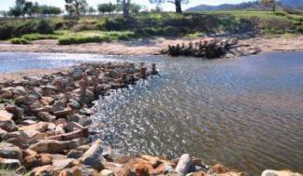
Provision of a significant number of logs constructed together in a complex array to create diverse habitat and cover for large bodied fishes such as Murray cod and Golden perch. They need to have complexity to support native fish communities.

        - LUNKERS (Little Underwater Neighbourhood Keepers Encompassing Rheotactic Salmonids)
First developed in north America they provide both bank stability and edge cover for fish. They are usually made of wood and are set into the bank. They have been
successfully trialled in the Dewfish Demonstration Reach.

        - ELJs (Engineered Log Jams)
These are purposely engineered log groyne structures, used primarily as erosion control structures and modelled on natural log jams. As such they are “soft” engineering structures that look and act more naturally in the river and also provide habitat for fish. ELJs are currently being trialled in the Upper Murrumbidgee Demonstration Reach to provide instream habitat in a stretch of river affected by a sand slug (see more details in Appendix 4d).

        - Rock Reefs
Installation of rock reefs can be used to create habitat diversity by changing water levels. They have not been trialled in existing demonstration reaches.

        - Rubble habitats
Juvenile Murray cod and Golden perch show a preference for rubble habitats (to avoid predation). These are usually located towards the head of pools in shallow water. Rubble habitats are often threatened by sedimentation and can be re- established.

        - Cod holes
Murray cod breed in hollows. The installation of hollow logs can increase breeding habitat. Natural logs are preferred as they provide habitat for invertebrates etc., and are more aesthetically appropriate but old concrete pipe culverts, constructed concrete ‘cod balls’ and plastic drums have been trialled where logs are not available or appropriate.

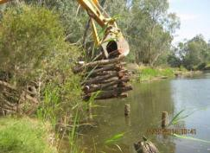The literature contains many other potential examples that could be implemented in demonstration reaches but have yet to be trialled. In the long term the goal should be to restore the riparian zone sufficiently to allow natural recruitment of woody debris and reduce sediment loads etc.

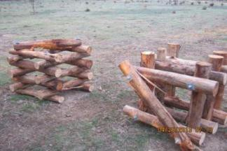

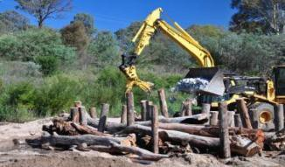

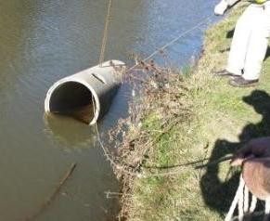
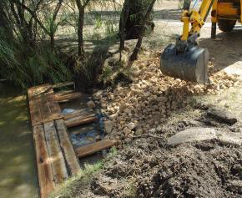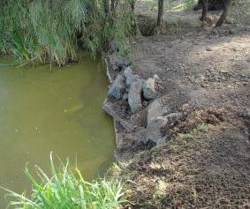Fish hotels and Engineered Log Jams (Photos: Scott Raymond, Mark Jekabsons)

A cod hole being placed instream, and a LUNKER during and after placement in stream in the Dewfish demonstration reach (Photos: Kevin Graham, Andrew Norris)

    - Habitat for small bodied fish

        - Instream habitat should also be provided for small bodied fishes and the juveniles of large bodied fishes.

        - There are a number of options but the effectiveness of these needs to be tested before widespread adoption.

Research conducted in the Dewfish Demonstration Reach has indicated that more focus is required on providing instream habitat for small bodied native fishes and the juveniles of large bodied native fishes, particularly when the river is recovering from recent floods.

Options include:

        - Re-establishment of aquatic macrophytes (may be difficult as they may be affected by other factors apart from floods).
        - Re-establishment of emergent vegetation.
        - Re-establishment of long grass within a meter of the water’s edge is important for small bodied native fish such as gudgeons.
        - Provision of rock rubble to provide shelter and habitat diversity ( ELJ’s and the associated rock groynes (particularly the rock) are providing habitat for juvenile Murray cod in the Murrumbidgee demonstration reach).

These options and others need to be investigated before widespread adoption.

Riparian rehabilitation

    - The current status of the riparian zone should be assessed to determine key sites for management.

    - All riparian management activities must be undertaken in cooperation with riparian landowners.

    - Priority should be given to protecting healthy riparian vegetation by preventing clearing, stock and vehicle access.

    - Bank stabilisation should be a priority before rehabilitation works are undertaken.

    - Rehabilitation of degraded riparian habitat may be achievable at low cost by fencing and allowing natural revegetation.

    - Active rehabilitation will involve reseeding or planting of seedlings together with weed control.

Rehabilitation of riparian vegetation is the most widespread management action undertaken in Australia to restore river health. Riparian zones have been cleared or the vegetation cover fragmented along many river systems. In agricultural land riparian vegetation is often confined to narrow strips subject to overgrazing and weed infestation. In many areas native vegetation has been replaced by introduced plants such as willows.

A healthy riparian zone provides for:

    - Reduction in bank and bed erosion.
    - Increased water quality by trapping sediments, nutrients and contaminants before they enter the river.
    - Shading and cover for aquatic organisms.
    - Reducing water temperature to limit evaporation and the occurrence of low dissolved oxygen
    - Energy input through leaf fall etc.
    - Input of woody debris into the waterway.
    - Control of noxious weeds.
    - Important habitat for terrestrial flora and fauna and landscape connectivity.

Good riparian land management is becoming widely practiced in Australia and there are a number of excellent documents that provide practical guidance. In particular the reader is referred to Rutherfurd et al. (1999) and Lovett and Price (1999 and 2007). Here the broad approach as it pertains to demonstration reaches is documented together with examples from existing demonstration reaches.

    - Where?
The first step is to assess current riparian condition in the reach and determine where protection and rehabilitation should be targeted. The highest priority should be to manage riparian vegetation that is in good condition. This is the most cost effective approach in the long term. It may also be possible to connect lengths of river with good riparian condition by rehabilitating relatively short sections of river bank.

There are a number of simple techniques that can be used to provide a broad assessment of riparian condition for example the Rapid Assessment of Riparian Condition (RARC) outlined by Jansen et al. (2005) . Aerial photographs, orthophoto maps and results of flora and fauna surveys in the area can also yield important information.

Riparian management should also be coordinated with existing natural resource management activities in the area (e.g. LandCare initiatives) and use existing networks to

work cooperatively with landholders to deliver the best results. Good riparian management on one property may provide an example for other landholders to follow. (see examples in Appendix 4e).

    - Protecting riparian vegetation
Where riparian vegetation is in a healthy condition the goals should be to:

    - Maintain the riparian zone at a width that will retain its structural integrity and effectiveness (maintaining bank stability, filtering sediment, nutrients etc). The effective width will vary depending on the position in the catchment, topography etc. but Ashley-Doran (2005) suggests a minimum of 30 to 50m as a general rule. The width of the riparian zone to be protected has to be negotiated with the landholder as it is removing land from productive use.

    - Avoid disturbance to the riparian zone. This includes working with landowners to avoid any unnecessary clearing etc. Vehicle access may also be an issue particularly along riverine recreational reserves where camping etc. may be permitted. Here it will be a matter of restricting vehicle access to the riparian zone and will involve working with the local council.

    - Restricting stock access. Continuous grazing in the riparian zone will lead to damage to riparian vegetation, reduced levels of recruitment and regeneration of riparian flora, increased levels of weed infestation, stream bank erosion and reduced water quality. Fencing of the riparian zone is the most common approach to restricting stock access. The fences must be sufficiently strong to keep cattle out and to resist flood damage.

    - Control weed infestations. Healthy riparian vegetation with restricted stock access should have limited issues with weed infestations.

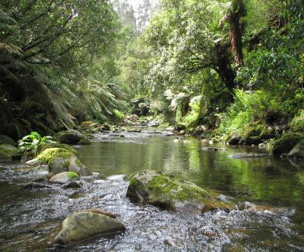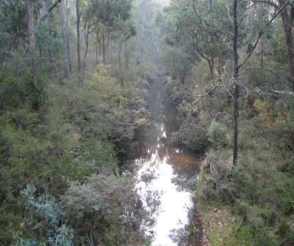

A healthy riparian zone is a key feature of a healthy river (Photos: Jason Lieschke)

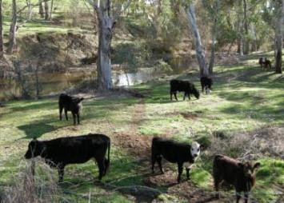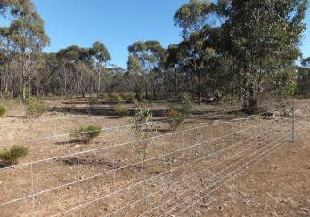
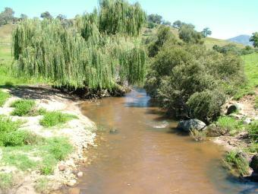

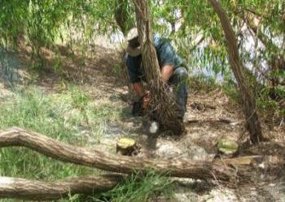

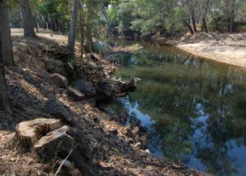

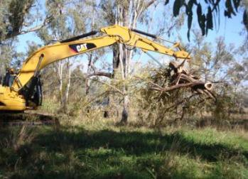Riparian zones can be damaged by clearing, weed infestations and unrestricted stock grazing. Fencing and weed control can help protect riparian zones. (Photos: Scott Raymond, Fern Hames)

    - Rehabilitating riparian vegetation
All the points listed above under “Protecting Riparian Vegetation” should also be implemented here with the additional requirement to undertake rehabilitation actions. Actions that can be undertaken will depend on the funds and other resources available. In highly degraded areas the first question to ask is are there any stream bank stability issues? If the answer is yes, these need to be addressed first before resources are directed at rehabilitating the riparian zone.

    - Natural Regeneration. Where there are limited resources, the area can be fenced off and natural regeneration allowed to occur. There will be a requirement for some initial and ongoing weed treatment.
    - Revegetation. This involves the active reintroduction of plants either through seeding or planting of seedlings. The priority should remain one of replicating nature so replanting native vegetation of local genetic provenance is essential. It is also important to plant the correct species in the right areas. For example small,

pliable species should be planted within the banks of the river so that they do not increase flooding.
(see examples in Appendix 4f).

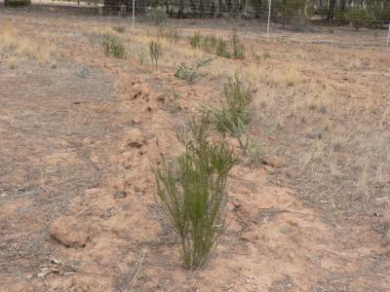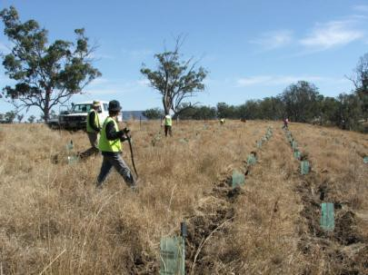

Riparian vegetation can be rehabilitated by providing suitable conditions for natural regeneration, as well as planting and direct seeding (Photos: Tony Townsend, Karly Learmonth)

Water quality

    - Event based monitoring is required to identify water quality issues and their sources.

    - Rehabilitation of riparian vegetation etc. will help protect the reach from a number of water quality problems e.g. turbidity, nutrient input, high temperatures.

    - Point source pollution will have to be tackled at the source.

    - Some large scale problems e.g. cold water pollution, salinity will be expensive to ameliorate and difficult to tackle during the life of a demonstration reach. They may be a reason for locating a demonstration reach elsewhere.

Water quality may cause significant problems in demonstration reaches. Rutherfurd et al.
(2000) lists six ecologically important categories:

      - Turbidity/fine sediments. Can impact directly on fish by clogging gills. Can also smother the bed, reducing habitat diversity, smothering fish eggs and reducing macro invertebrate numbers. Turbidity can also restrict photosynthesis and the growth of aquatic macrophytes.
      - Increased nutrient loads. Can lead to algal blooms and increased macrophyte abundance. In extreme cases it can lead to depletion in dissolved oxygen and fish kills.
      - Reduced dissolved oxygen. Can lead to fish kills through high nutrient levels and excess organic waste entering the river. Can also be caused by large lengths of unnaturally shallow water.
      - Temperature, high and low. Changes from the natural temperature regime can disrupt life cycles of fish and macro invertebrates. High temperatures may result

from removal of riparian vegetation etc, and unseasonally low temperatures may result from cold water release from dams for example.
      - Salinity. Saline intrusions to rivers due to land clearing and consequent rising water tables can significantly impact on aquatic biota. For example, River blackfish are sensitive to salinity increases as are the larvae of many fish species and some macro invertebrates.
      - Toxicants. Organic and inorganic chemicals such as pesticides and detergents etc elicit a wide range of responses depending on the particular chemical from reduced reproduction in fish and invertebrates to pathological changes in fish gills.

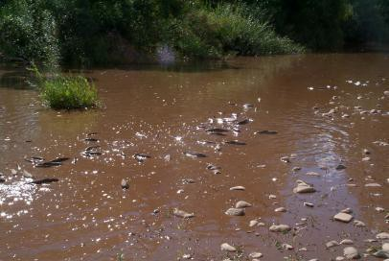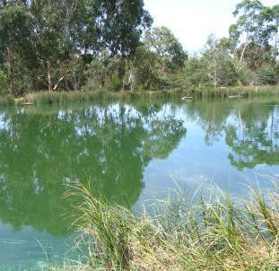

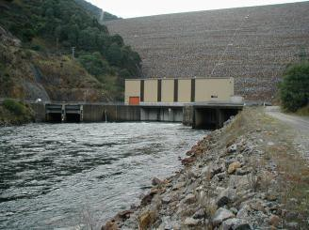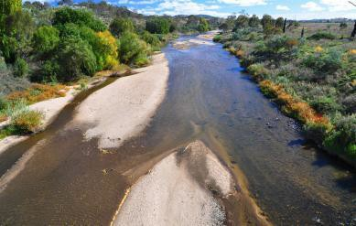

A variety of water quality issues can affect the health of a river system (Photos: Di Crowther, Jarod Lyon, Mark Jekabsons, Tom Ryan)

    - Is there a problem?

Monitoring needs to be undertaken to determine if there are water quality problems in the demonstration reach and identifying the sources of these problems. It may be possible to link in to existing monitoring programs carried out by state or local natural resource management agencies or by community driven programs such as WaterWatch. Event based monitoring will be required, for example high turbidity levels will be linked to high flow events. Once any problems have been identified and their sources located, appropriate rehabilitation actions can be undertaken.

    - Rehabilitation actions that address multiple issues
A number of the rehabilitation actions already described will assist in maintaining good water quality. For example, riparian rehabilitation will help reduce turbidity, nutrient and high water temperature problems and the introduction of large woody debris can assist with bed and bank stability. It may still be necessary to target these actions where they can be most effective, for example undertaking riparian rehabilitation next to a cattle feedlot will reduce the risk of high nutrient loads entering the river. It will also be necessary to ensure that there are no drainage lines that run through the riparian zone.

    - Point source pollution
Where toxicants are entering the river from point sources, the issue will have to be addressed at that source. (e.g. as factory).

    - Large scale problems
Some water quality problems will be difficult to address. For example, cold water pollution from a large dam can only be ameliorated by the provision of a highly expensive multilevel off take tower. In this situation in may be inappropriate to locate a demonstration reach downstream of such a structure as it would be unrealistic to expect a resolution. On the other hand, if a multilevel off take tower is under construction, there is an ideal opportunity to tie this in with a demonstration reach.

Salinity management is likely to be a large issue that needs to be planned at a catchment or even a regional scale. However, small scale salinity problems may be manageable (see example Appendix 4g). The amelioration of sediment input may in the long-term have to be addressed at the catchment scale by replanting and improved catchment management. Neither are likely to be resolved in the life span of a demonstration reach.

(see example in Appendix 4 g).

Environmental flows

    - Rehabilitating flow regimes through the provision of environmental releases is normally beyond the scope of a demonstration reach program.

    - The sites for planned environmental releases could be used to develop demonstration reaches.

Regulation of natural flow regimes and the extraction of water for consumptive use has significantly impacted on riverine fishes in the Murray-Darling Basin and throughout Australia. Regulation alters the hydraulic nature of flows often resulting in a reduction in flow diversity and hence habitat diversity. In the Basin, high volume, high velocity irrigation flows in summer are the opposite to natural low flow periods resulting in a decline in the abundance, distribution and recruitment of many native fishes. The decline in regular natural floodplain inundations has impacted on a wide variety of native fishes including floodplain wetland specialists. It has also reduced the nutrient exchange between the floodplains and the river. In the lower Murray weir pools have changed a flowing

environment into a non-flowing one disadvantaging some species. Changes in flow timing have reduced spawning and movement cues for native fishes.

Changes to legislation and policies in the Basin have led to more water being made available for the environment through the provision of environmental water allocations. Determining flow requirements (quantity and timing) for a demonstration reach requires expert input and coordination with jurisdictional and Commonwealth natural resource management agencies. Such negotiations are normally outside the scope of a demonstration reach project but where environmental flow releases are planned it could be advantageous to enhance the impact of these releases but undertaking habitat rehabilitation through the establishment of a demonstration reach. (see example in Appendix 4h).

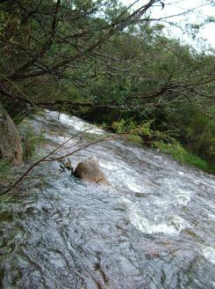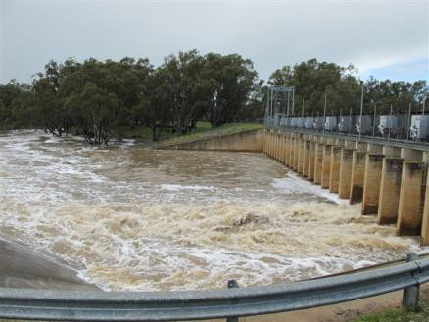

Environmental water allocations are outside the scope of demonstration reach projects, although the impacts of environmental flow releases can be enhanced by undertaking habitat rehabilitation (Photos: Jason Lieschke)

Fish passage

    - The first priority is to identify the movement requirements of the fish community in the demonstration reach.

    - The reach can then be surveyed to determine potential barriers and their likely impacts on fish passage. Engineering and fish biology expertise is required early on in the process and through to the construction and commissioning stage.

    - When sites have been prioritised, conceptual designs can be drawn up and likely costs estimated. These can be used to seek funding.

    - If funds are available, detailed designs can be drawn up followed by construction and commissioning of the fishway.

    - It is important to negotiate operational and maintenance requirements with appropriate jurisdictional and local government agencies. Well-designed fishways do not operate without specific flow allocations and ongoing maintenance will be required.

Native fishes move both within and between habitats. Movements may be meso-scale (short-term movements within the normal home range) or macro-scale (prolonged long- term, large scale movements between habitats. They may be longitudinal (up and downstream) or lateral (channel to the floodplain for example). Movements have been documented in both large bodied fish (e.g. Murray cod, Golden perch) and small-bodied species (e.g. Gudgeons and Spangled perch) and in all life history stages of species. Connectivity within and between habitats is vital to maintaining health and resilient native fish populations.

Barriers to fish movements include physical barriers ranging from large dams and weirs to gauging weirs, culverts and road crossings and may also include shallow areas of river caused by reduced flows. Behavioural barriers may also be present caused by low water temperatures (cold water pollution) and changes in flow regimes resulting in a lack of flow cues for migratory species such as Golden perch.

    - Identifying problem sites
The first step in to identify potential problem sites, these can be identified by going through the following process:

    - What fish species are present and what are their movement requirements?
Data will be available on fish species present in the demonstration reach and there is now sufficient information available in the literature to indicate the movement requirements of most species including the seasonality of that movement. The presence of any threatened species will increase the need for action.

    - Identify potential barriers
The next step is to identify potential barriers. Dams and weirs are obvious ones but other structures like small culverts and road crossings can potentially form barriers to fish movement and should be investigated.

    - Frequency of present fish passage
How much fish passage do the current structures allow? What is the drown out frequency of weirs etc? What velocities are experienced through culverts etc? Expert advice from hydrologists and fish biologists will be required.

    - Habitat area impacted
What habitat would be opened up to fish and what quality is that habitat? In a demonstration reach where habitat rehabilitation is being undertaken, consideration should be given not just to current habitat condition but expected condition of the habitat in the future.

    - Other factors
Are there factors that cannot easily be controlled within the demonstration reach? For example, is there a cold water pollution issue that cannot be addressed or are there flow regime issues etc?

If the above process reveals significant fish passage issues that can be addressed, the next step is to investigate solutions at each site and the costs of rehabilitation actions.

    - Determining potential solutions and their costs

Once sites for rehabilitation are prioritised, it is a matter of developing conceptual designs for these sites. Here both engineering and fish biology expertise relating to the design and costs of fishways are essential. Fortunately, over the last 20 years a significant amount of expertise has been built up in designing fishways for Australian conditions and for native fishes. This expertise is available in a number of jurisdictional natural resource management agencies and through consultants. At this stage it is important to involve all stakeholders to establish ownership of the project.

This conceptual design stage will enable a realistic cost estimate to be made. The type of fishway may vary from rock ramp structures, baffles in culverts to vertical slot fishways or fish locks on high structures and costs will vary accordingly. Fish passage improvements can also be undertaken when road crossings etc. are being upgraded by ensuring that fish friendly river crossings are installed (see Hyperlink: http://www.dpi.nsw.gov.au/_data/assets/pdf_file/0004/202693/Why-do-fish-need-to-
cross-the-road_booklet.pdf ).

    - Funding
Funding for fishways is highly variable but can seem prohibitive where highly engineered structures such as vertical slot fishways are required. However, funding may be available even for these structures were jurisdictional fishway programs are in place and a good case can be made. A concept design together with the logic for selecting the particular site and the likely benefits can add credibility to an application. The Whole of Life Plan indicating other complementary habitat rehabilitation actions with also support the application.

    - Construction
If funding is obtained, detailed design will then be undertaken followed by construction and commissioning of the fishway. It is important that negotiations are undertaken with both jurisdictional and local government agencies to ensure that the operational requirements of the fishway are agreed to (including watering requirements) and that a maintenance schedule is agreed to, including removal of debris after flooding etc.)

Provision of fish passage is one of the most common rehabilitation activities undertaken at existing demonstration reaches occurring at five out of seven reaches. (see examples in Appendix 4i).

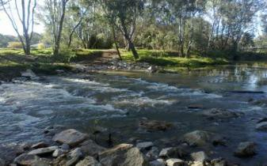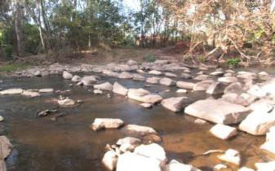
The rock ramp fishway at Wangaratta on the Ovens River demonstration reach (Photos: Scott Raymond)

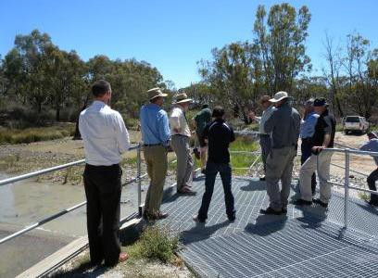

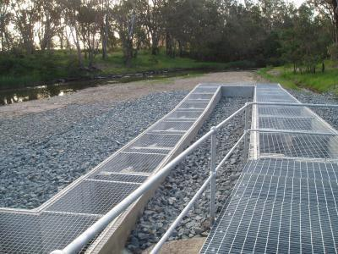Vertical slot fishways are highly engineered structures (Photos: Fern Hames, Wayne Tennant)

Screening of irrigation offtakes

    - Demonstration reaches are well placed to undertake trail screening programs for water diversions.

    - The program must be developed in consultation with all stakeholders especially irrigators.

    - Recent work by Boys et al. (2012) together with overseas literature should be used to develop design criteria for screens. Demonstration reaches provide the ideal opportunity to trial the preliminary designs used by Boys et al. (2012) on a longer- term basis.

    - Incentives may be necessary to assist irrigators in overcoming the additional costs for screening.

There is a significant amount of evidence that large numbers of native fishes are being lost to rivers through water abstraction. The scale of the impact may differ from location to location and between seasons but given the volumes of water that are diverted from Australian rivers, fish entrainment is a significant issue. It encompassed a wide range of species and sizes from large bodied species to small bodied species as well as eggs and larvae of large bodied species. Overseas, particularly in North America, fish entrainment by water abstraction is taken very seriously and specific screening programs have been set up with regional guidelines. While Australian guidelines do not exist at present, recent work by Boys et al (2012) has shed some light on the likely screen designs for native fishes. The study was undertaken in the Namoi demonstration reach. Similar work in other demonstration reaches would help “spread the message” paving the way for a Basin wide fish screening program for water diversions. The following broad guidelines are based on the recommendations of Boys et al. (2012).

    - Consultation

Consistent with all interventions in a demonstration reach it is essential to work with all stakeholders. In this instance irrigators and water user groups will be the key stakeholders.

    - Determine the extent of the problem

The next step is to take an inventory of the numbers and types of diversions present in the demonstration reach. Although more work needs to be done at specific localities to determine the extent of fish loss through specific diversion sites, there is enough evidence to suggest a precautionary approach should be taken and the loss of fish should be assumed significant.

    - Determine solutions
In the absence of Australian design criteria, Boys et al. (2012) suggest taking an evidence based approach to setting screen design and criteria for Australian species and vulnerable age classes. Their work suggests that approach velocities should not exceed 0.1m/sec and that perforated plate material is suitable for Australian species. They also point out that extensive development has already taken place in North America and this knowledge should be utilised.

    - Implementing a screening program
It is essential to work with irrigators as screening of pumps to stop fish entrainment will cost money. Incentive funding may be required to assist them. It will also be necessary to factor in ongoing maintenance costs.

    - Monitoring
The advantage of setting up a screening program in a demonstration reach is that rigorous monitoring will be undertaken and an adaptive management approach adopted. The program will contribute to the broad knowledge of screen designs to stop the loss of fish to water abstraction. Demonstration reaches have the opportunity to use the trial work and preliminary screen designs used at the Namoi demonstration reach and test them on a more permanent basis.

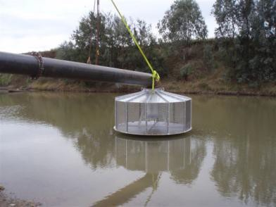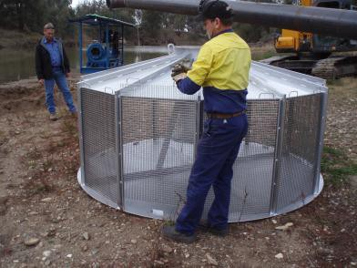

Irrigation screens being trialed along the Namoi demonstration reach (Photos: Craig Boys)

Alien species management

    - An integrated pest management approach must be taken when dealing with alien fishes including the development of a management plan.

    - The management plan should be developed in consultation with the community and have clearly stated goals.

    - The plan may involve actions to prevent incursions of new species as well as the control of established species. Control actions should be aimed at reducing the impacts of alien species to an acceptable level.

    - A range of management actions should be taken to ensure an integrated approach
(e.g. community education, removal tools – electrofishing, netting etc., screening, habitat rehabilitation etc.).

Fish assemblages in the Murray-Darling Basin are becoming increasingly dominated by alien species –that is species that originate from overseas but have become established in Australian waters (Harris 1995) or native species that have become established outside their natural range. There are 12 alien fish established in the Basin (see Lintermans 2007) of which Carp (Carassius auratus) is the most widespread and abundant. Gambusia (Gambusia holbrooki) is also widespread and has significant impacts on native fishes, particularly small bodied species. Other species such as Tilapia (Oreochromis spp.) are established in catchments close to the Basin and could be introduced in the future. Alien species have contributed to the decline of native fishes, impacting in many ways including: direct predation, competition and habitat alteration. Alien fish impede the recovery of native fish even when other threats are being addressed. Most alien fish thrive in aquatic habitats disturbed by human activities. They can significantly reduce the impact of habitat management interventions in demonstration reaches.

Some alien fish management activities are being undertaken at six of the seven existing demonstration reaches. Most of the work has concentrated on Carp management, however, there is a community driven Gambusia removal program in the Upper Murrumbidgee demonstration reach (see Appendix 4j). At most of these reaches Carp musters (community run fishing competitions) are the only activity. These musters are a very valuable community engagement, awareness and education tool but do not control Carp numbers. At the Dewfish and Upper Murrumbidgee demonstration reaches a more integrated approach has been taken using the principles outlined below. Although these principles have been chiefly used for Carp, they are equally applicable to the management of other alien fishes.

It is important to take a systematic and strategic approach to managing alien fish in a demonstration reach. This approach must be driven by first establishing the goals of the program and then working out the most cost effective actions to take given the limited

resources that are available. The reader is referred to Braysher and Barrett (2000) and Braysher and Saunders (2003) for more details but the points below outline the framework for developing an Alien Fish Management Plan for a demonstration reach:

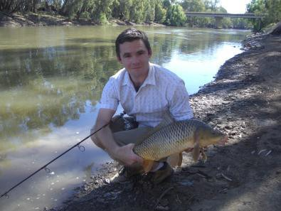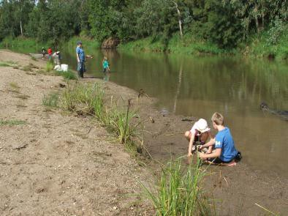
Many demonstration reaches have held Carp musters (Photos: Tony Townsend, Matt Barwick)

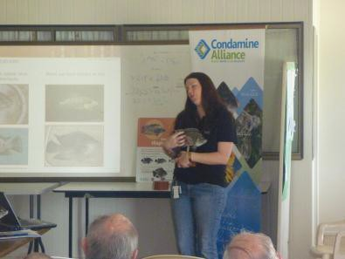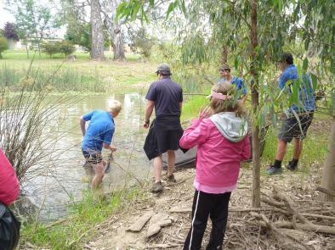

Local schools in Wangaratta have incorporated Gambusia removal from wetlands in their curriculum. (Photos: Tony Townsend). Tilapia training workshops have been held in Queensland (Photo: Greg Ringwood)

    - What is the nature of the problem?
The first thing to do is to understand the problem and to set the objectives for a management plan. This should be done in full consultation with the community to ensure local ownership.

    - Are there alien species that may become established in the demonstration reach?
For example, Tilapia are not present in the Basin but are established in south east catchments in Queensland, very close to the Dewfish demonstration reach on the Condamine. Management actions to prevent an incursion are priorities for this reach and the whole Murray-Darling Basin.

    - Are there established alien species in the demonstration reach?
Are there established alien fish populations within the reach, what impact are they having on native fishes? Are they widespread within the reach or are there isolated populations that could be contained?

    - Setting priorities for management

      - Preventing incursions of new species

For prevention, priority actions will include; a targeted education and extension program to prevent human added translocations of alien species into the reach, setting up a surveillance program to detect any incursion as soon as possible, setting up a rapid response strategy with the relevant jurisdictional agency.

      - Managing established species

This should focus on management actions that will reduce the damage caused by alien fish to an acceptable level. The demonstration reach should be broken up into management units and these can then be ranked based on the perceived threat of the alien species to native fishes. For example are there floodplain wetland areas were Carp recruitment is occurring? Are Carp threatening spawning sites of native fishes? Are there wetland areas where Gambusia populations could be removed, to protect small bodied native fishes?

    - Management techniques

There are no “silver bullets” control alien fishes but there are a range of tools available including: capture techniques (electrofishing, nets, traps etc.), Habitat manipulation (draining waterways, draw down of fish breeding areas), Fish exclusion devises (fish screens, Carp cages) etc. Rehabilitation of the habitat and native fish populations will also make the reach more resilient to alien fish disturbance. Invasive species such as Carp, Gambusia and Tilapia appear to thrive in disturbed waterways. Improving the river health in the demonstration reach should remain the overarching management technique. Management actions should be undertaken where environmental conditions maximize the outcomes.

    - Monitoring
Monitoring of alien fish management interventions should be included in the Monitoring and Evaluation Plan and be hypothesis driven. (see example in Appendix 4j).

Fish Stocking

    - Fish stocking should only be undertaken if the need had been clearly established and there are no alternatives.

    - Genetic management is vital if wild genetic diversity is to be maintained ensuring the wild population maintains the ability to adapt to environmental change, disease and competition.

    - Fingerlings must be obtained only from hatcheries where there is a quality assurance program. Stocking should only be undertaken when a five year program has been developed and funds are guaranteed over this period.

    - All hatchery released fish should be marked (e.g. tagged in some way so they can be distinguished from wild fish) so that the contribution of stocked fish to the population can be monitored.

Stocking hatchery reared fingerlings of native fish species (particularly recreational species like Murray cod and Golden perch) is widely practiced in most parts of Australia and all jurisdictions in the Basin apart from South Australia. It is a common fisheries management tool and has created recreational fisheries in artificial impoundments and has temporarily boosted fish numbers in riverine situations. There are however potential negative impacts from fish stocking. These include:

    - Impacts on wild population genetics from interbreeding with genetically inferior hatchery reared fish.
    - Introduction of disease.
    - Overstocking.
    - Translocation of non-target species (including non-desirable fish species and invertebrates).
    - Masking of underlying causes for wild stock depletion.
    - In demonstration reaches, masking the impacts of habitat rehabilitation activities on fish populations (e.g. are population increases due to stocking or habitat rehabilitation?).

Stocking is a short term fix that should only be used as a last resort for example where there is a spawning bottleneck that cannot be resolved by habitat rehabilitation. It may also be appropriate where an endangered species is being re-introduced to its native habitat.

    - Is there a need to stock?
Is there compelling evidence that wild populations are severely depleted and that other actions e.g. habitat rehabilitation, changes in fishing regulations etc., cannot be used to rehabilitate wild populations. Is there an identified bottleneck (e.g. lack of recruitment) that cannot be overcome any other way? Is it an endangered species that is being re- introduced to its native range?

If the answer to any of these questions is affirmative then stocking could be considered as a management tool. It should be undertaken with the goal of rehabilitating wild populations, not to enhance recreational fisheries. In the long-term, together with habitat rehabilitation it may well lead to enhanced recreational fisheries.

    - Do we understand the genetic profile of the wild stock?

Do we understand the genetic variability inherent in the wild population and can suitable fingerlings be produced in a hatchery? If our understanding of the wild population genetics is unclear, can sufficient broodstock be harvested from the river and used in hatchery production of the fingerlings.

    - Quality assurance
Is there a hatchery available where there is sufficient quality assurance to reduce the risks of disease transfer, translocation of non-target species etc. to an acceptable risk level (e.g. some NSW hatcheries are part of a Hatchery Quality Assurance Program).

    - Developing a stocking management plan
Stocking should occur over a five year period with sufficient numbers released to ensure the establishment of a population structure. Is the hatchery able to produce fingerlings over this time frame; are funds available to purchase the fingerlings?

    - Release of the fingerlings
All fingerlings should be marked before release so that their contribution to future sampling is known. (see example in Appendix 4k).

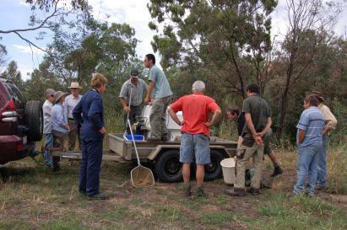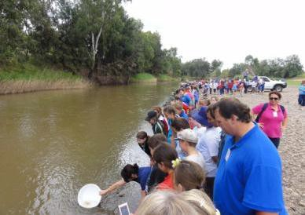

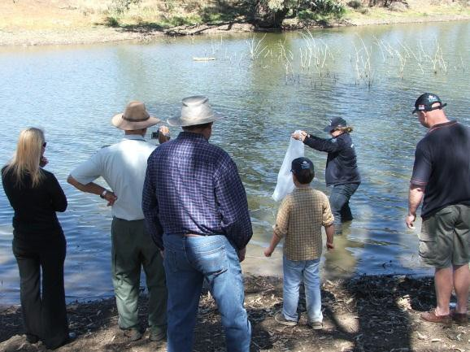
Local communities participating in the release of native fish (Photos: Tony Townsend, Scott Raymond)

References for Interventions Pillar

General

ACT Government 2010. Upper Murrumbidgee Demonstration Reach Implementation Plan. Department of Territory and Municipal Services, Canberra.

Boys, C.A., Lyon, J., Zampatti, B., Norris, A., Butcher, a., Robinson, W. and Jackson, P.
2014. Demonstration Reaches. Looking back whilst moving forward with river rehabilitation under the Native Fish Strategy. Ecological Management and Restoration,
15 (Supplement 1), 67-74.

Rutherfurd, I.D., Jerie, K. and Marsh, N. 2000. A Rehabilitation Manual for Australian Streams, Volumes 1 and 2. Land and Water resources Research and Development Corporation Cooperative research Centre for Catchment Hydrology, Melbourne. Hyperlink: http://www.rivers.gov.au

Re-introducing Large Woody Debris

Brooks, P., Abbe, T., Cohen, T., Marsh, N., Mika, S., Boulton, A., Broderick, T., Borg, D. and Rutherfurd, I. 2006. Design guideline for the reintroduction of wood into Australian streams. Land and Water Australia, Canberra.

Cottingham, P., Bunn, S., Price, P. and Lovett, S. (eds) 2003. Managing Wood in streams.
River and Riparian Land Management Technical Guidelines update No3, July 2003, Land and Water Australia, Canberra.

Erskine, W.D. and Webb, A.A. 2003. Desnagging to resnagging: New directions in river rehabilitation in southeastern Australia. River Research Applications, 19,233-249.

Marsh, N., Rutherfurd, I. and Jerie, K. 1999. Large woody debris in some Australian streams, natural loading, distribution and morphological effects. Second Australian Stream Management Conference, Adelaide, South Australia.

Nichol, S.J., Lieschke, J.A., Lyon, J.P. and Hughes, V. 2004. Restoring structural woody habitat in the River Murray. Native Fish Habitat rehabilitation and Management in the Murray Darling Basin, Albury Workshop, Murray-Darling Basin Commission, Canberra.

NSW Department of Primary Industries 2007. Threat abatement plan - Removal of large woody debris from NSW rivers and streams. NSW Department of Primary Industries, NSW.

Treadwell, S. 1999. Managing snags and large woody debris. In: Lovett, S. and Price, P. (eds). Riparian Land Management Technical Guidelines Volume Two: On-ground Management Tools and Techniques. Land and Water Resource Research and Development Corporation, Canberra.

Treadwell, S., Koehn, J. and Bunn, S. 1999. Large woody debris and other aquatic habitat. In: Lovett, S. and Price, P. (eds). Riparian Land Management Technical Guidelines, Volume One: Principles of Sound Management. Land and Water Resources Research and Development Corporation, Canberra.

Habitat for Small-bodied Fish

Norris, A., Hutchison, M., Nixon, D. and Chilcott, K. 2013. Habitat preferences of small- bodied native fish. Final Report, Agri Science Queensland, Department of Agriculture Fisheries and Forestry, Brisbane.

Riparian Rehabilitation

Lovett, S., Price, P. (eds) 1999. Riparian Land Management Technical Guidelines Volume One: Principles of Sound Management. Land and Water Resources Research and Development Corporation, Canberra.

Thorpe, J. 2011. Dewfish Demonstration Reach Revegetation Stage 1 and 2. Final Project Report by Notomys Seeds to Condamine Alliance, Queensland. Hyperlink: http://www.condaminealliance.com.au/project-final-reports-water

Webb, A.A. and Erskine, W.D. 1999. Guidelines for the rehabilitation of riparian vegetation in southeastern Australia. In: Rutherfurd, I.D. and Bartley, R. (eds), Proceedings of the Second Australian Stream Management Conference. Cooperative Research Centre for catchment Hydrology, Vol 2, 683-689, Melbourne.

Water Quality

Murray-Darling Basin Authority 2013. Fact Sheet: The River Murray Water Quality Monitoring Program. MDBA Publication No. 16/11, Murray-Darling Basin Authority, Canberra. Hyperlink: http://www.mdba.gov.au/sites/default/files/RM-2013- RMWQMP-fact-sheet.pdf

State of the Environment Victoria. 2008. Water Quality in Rivers and Streams, everyone lives in a catchment-what we do on land affects the water. State of the Environment Victoria Fact Sheet, Commissioner for Environmental Sustainability, Melbourne. Hyperlink: http://www.ces.vic.gov.au/_data/assets/pdf_file/0019/124426/factsheet13.pdf

Environmental Flows

Baumgartner, L.J., Conallin, J., Wooden, I., Campbell, B., Gee, R., Robinson, W.A. and Mallen-Cooper, M. 2013. Using flow guilds of freshwater fish in an adaptive management framework to simplify environmental flow delivery for semi-arid riverine systems. Fish and Fisheries, Blackwell Publishing.

Koehn, J.D., King, A.J., Beesley, L., Copeland, C., Zampatti, B.P. and Mallen-Cooper, M.
2014. Flows for native fish in the Murray-Darling Basin: lessons and considerations for future management. Ecological Management and Restoration, 15 (Supplement S1), 40-
50.

Fish Passage

Berghuis, A. 2013. Technical Assessment of the Loudoun Weir Fishway Improvement Works. Aquatic Biopassage services, Bundaberg, Queensland. Hyperlink: http://www.condaminealliance.com.au/project-final-reports-water

Condamine Alliance. 2006. Loudoun Weir Fishway Repair. CA Project CA06028 report to Recreational Fishing Community Grants program project R5103, Condamine Alliance, Queensland. Hyperlink: http://www.condaminealliance.com.au/project- final-reports-water

Hutchison, M., Butcher, A., Kirkwood, J., Mayer, D., Chilcott, K. and Backhouse, S.
2008. Mesoscale movements of small and medium sized fish in the Murray-Darling Basin. MDBC Publication No.41/08, Canberra.

Screening of Offtakes

Baumgartner, L.J. and Boys, C. (2012). Reducing the perversion of diversion: Applying world standard fish screening practices to the Murray-Darling Basin. Ecological Management and Restoration,13,135-143.

Boys, C., Baumgartner, L., Rampuno, B., Robinson, W., Alexander, T., Roswell, M., Fowler, T. and Lowry, M. 2012. Development of fish screening criteria for water diversions in the Murray-Darling Basin. Fisheries Final Report Series No 134, NSW Department of Primary Industries, Cronulla. Hyperlink: http://www.dpi.nsw.gov.au/research/areas/fisheries-and-ecosystems/wild- fisheries/outputs/2012/2204

King, A.J. and O’Connor, J.P. 2007. Native fish entrapment in irrigation systems: a step towards understanding the significance of the problem. Ecological Management and Restoration, 8,32-38.

Norris, A. 2012. Screening off-take pumps-Pilot program for the Dewfish Demonstration Reach. Queensland Department of Agriculture, Fisheries and Forestry, Brisbane.

Alien Species Management

Braysher, M. and Barrett, J. 2000. Ranking Areas for Action: A Guide for Carp Management Groups. Murray-Darling Basin Commission, Canberra.

Braysher, M. and Saunders, G. 2003. PESTPLAN – a guide to setting priorities and developing a management plan for pest animals. Bureau of Rural Sciences and the Natural Heritage Trust, Canberra.

Braysher, M., Stuart, I. and Higham, J. 2009. Dewfish Demonstration Reach Carp Management Plan. A sub-component of the Condamine River Rescue Program. Condamine Alliance, Queensland.

Butcher, A. and Norris, A. 2010. Integrated Carp Removal in the Dewfish Demonstration Reach: A Report to the Condamine Alliance. June 2010. Department of Employment, Economic Development and Innovation, Brisbane, Queensland. Hyperlink: http://www.condaminealliance.com.au/project-final-reports-water

Condamine Alliance 2012. Keep tilapia out: an action plan to exclude tilapia from the Northern Murray-Darling Basin 2012-2022. Condamine Alliance, Queensland

Condamine Alliance 2012. Keep tilapia out: an implementation plan to exclude tilapia from the Northern Murray-Darling Basin 2010-2014.Condamine Alliance, Queensland.

Invasive Animals Cooperative Research Centre 2012. The importance of Public Consultation for Pest Fish Management. PestSmart Toolkit Fact Sheet, Invasive Animals Cooperative Research Centre, Canberra. Hyperlink: http://www.feral.org.au/wp-content/up[loads/2012/03/PFFS3.pdf

Lintermans, M. 2007. Fishes of the Murray-Darling Basin:An introductory guide. MDBC Publication No. 10/07, Murray-Darling Basin Commission, Canberra.

Norris, A., Chilcott, K. and Hutchison, M. 2013. The Role of Fishing Competitions in Pest Fish Management. PestSmart Toolkit Publication. Invasive Animals Cooperative Research Centre, Canberra. Hyperlink: http://www.feral.org.au/fishing-competitions- in-pest-fish-management

Harris, J.H. 1995. The use of fish in ecological assessments. Australian Journal of Ecology, 20, 65-80.

Smith, B., Thwaites, L. and Conallin, A. 2009. Guidelines to inform the selection and implementation of carp management options at wetland inlets: a test case for South Australia. Report to the Invasive Animals Cooperative Research Centre by South Australia research and Development Institute, Invasive Animals CRC, Canberra. Hyperlink: http://www.feral.org.au/guidelines-to-inform-the-selection-and- implementation-of-carp-management-options-at-wetland-inlets-a-test-case-for-south- australia

Stuart, I., Higham,J., Lintermans, M., Braysher, M. and Phillips, B. 2010. Carp reduction plan for the Upper Murrumbidgee Demonstration Reach and surrounding region. Department of Territory and Municipal Services, Canberra. Hyperlink: http://upperbidgeereach.org.au/files/domain-4/UMDRcarpplan-5-7.pdf

Fish Stocking

Gillanders, B.M., Elsdon, T.S. and Munro, A.R. 2006. Impacts of native fish stocking on fish within the Murray-Darling Basin. Report to Murray-Darling Basin Commission, University of Adelaide, South Australia.

Moore, A., Ingram, B., Friend, S., Ho, H.K., Robinson, N., McCormack, R., Coughran, J. and Hayes, B., 2010. Management of Genetic Resources for Fish and Crustaceans in the Murray-Darling Basin. Bureau of Rural Sciences, Canberra.

Phillips, B.F. (ed.) 2003. Managing Fish Translocations and Stocking in the Murray- Darling Basin. Workshop held in Canberra 25-26 September 2002. Statements, Recommendations and Support Papers, WWF Australia, Sydney.

Russel, J. 2008. Towards responsible native fish stocking, identifying management concerns and appropriate research methodologies. Department of primary Industries and Fisheries and the Fisheries Research Development Corporation, Queensland.

Appendices for Intervention Pillar

    - Appendix 4a – Table of Interventions

 | B to Bre | Namoi | Dewfish | Hollands | Ovens | UM | Katfish
Instream  - Re-snag | * | * | * | * | * | *
Instream  - other |  |  | * |  |  | *
Alien | * | * | * | * | * | *
Riparian | * | * | * | * | * | *
Passage | * | * | * |  | * | * | *
Screening |  | *
Flows |  |  |  |  |  |  | *
Stocking |  | * | * | * |  | *

    - Appendix 4b – Woody debris loads (snags)

Hume Dam to Yarrawonga Resnagging Program

(see hyperlink: http://www.mdba.gov.au/sites/default/files/archived/mdba-tlm- reports/2092-Resnagging_the_River_Murray_factsheet.pdf

The program, funded under the Living Murray initiative, has resnagged 14 sites along the River Murray. A plan to identify areas for resnagging and to determine appropriate snag loads was developed in 2004. Key points were:

- A “snag assessment” collected data on existing snags including location, size, complexity, snag alignment and depths.
- Associated riparian condition and connectivity were also recorded.
- Data were also available on the number and location of snags that had been removed in the past (from “river improvement” works records).
- From this information an “instream woody habitat load” was calculated.
- Priority areas for resnagging were based on the above assessment and consideration of establishing connectivity with existing good quality instream habitat.
- Consideration was also given to practical aspects such as source of snags, transport and access to the river.

    - Appendix 4c – Sources of woody debris

Dewfish Demonstration Reach

      - Land clearing for industrial and farm use- The machinery contractors who clear the timber can often be used to install the snags in the river.
      - Road realignments.
      - Mining sites.
      - Storm damage.

Hume to Yarrawonga Resnagging Program

Only felled native hardwood trees were used and were sourced from development sites, road and bridge construction sites and approved farmland clearing. Relevant authorities such as local government, development corporations etc., to ensure that trees were stockpiled for later use in the snagging program.

    - Appendix 4d – Maintaining stability of woody debris

Dewfish Demonstration Reach

Re-snagging of sections of this demonstration reach have been very successful with great stability achieved. The results suggest that:

      - Important to select “good” snags in the first place e.g. with root ball intact and four or five good branches.
      - Select sites not in full velocity flows during floods.
      - Key the root ball into the bank.
      - Four or five branches should dig into the bed to stop movement and prevent the snag from rolling.
      - Face the trunk downstream.
      - Pin the snag with at least 250mm hardwood logs.
Logs are most likely to move within the first six months, after which they become waterlogged and hence more stable. More complex snag piles are the most stable.

Upper Murrumbidge Demonstration Reach- Tharwa Fish Habitat Project (see reports http://upperbidgereach.org.au/node/519)

Reintroduction of large woody debris to create habitat diversity can become problematic in waterways where there is high sediment loads. Widespread catchment erosion in the late 1800s and 1900s has caused areas of sand build up in the Murrumbidgee River (e.g. Tharwa). This has resulted in sections of the river that are very shallow with little or no instream habitat. Engineered Log Jams (ELJs) are being trialled to improve river channel deepness and fish habitat.

Key points are:

        - Large Woody Debris introduced in the normal way is likely to be quickly buried under shifting sand loads.
        - Well designed ELJs are a proven technique in Australia that can have positive effects on river physical and ecological functions.
        - They can be expensive if a local supply of timber is not available.
        - A community information session was held to inform stakeholders about the ELJs project.
        - The introduction of ELJs will be accompanied by other site restoration activities including riparian plantings.
        - Monitoring of the fish fauna has taken place both before and after the ELJs were constructed. So far monitoring suggests that they have improved both river channel deepness and native fish assemblages.

Hume to Yarrawonga Resnagging Program

Individual logs were embedded with electronic microchips to tag the logs to identify the extent of any movement from their original position as a result of floods.

    - Appendix 4e – Determining riparian rehabilitation sites

Dewfish Demonstration Reach –Revegetation Oakey Creek

Grazing livestock has resulted in degraded riparian vegetation including loss of key tree species and ground cover. The initial aim has been to improve vegetation condition and connectivity along a 5km stretch of the 20km reach. The rehabilitation was planned to improve connectivity between two patches of Queensland Herbarium recognised regrowth vegetation and extend the width of the current regrowth area.

Upper Murrumbidgee Demonstration Reach- Riparian Surveys

In 2013, Cooma Waterwatch undertook surveys along the entire length of the NSW section of the Murrumbidge River to assess riparian health.

The Key points are:

- Assessments were made using the RARC methodology.
- Results will be mapped and used to prioritise riparian management and will also provide a baseline upon which to measure future change.
- Willow saplings are colonising previously willow free areas including areas with good native vegetation. The results will used to prioritise willow
control activities ( see appendix 4i).

Dewfish Demonstration Reach-Revegetation of Oakey Creek (see Thorpe 2011)

The approach was to replant in degraded areas, remove the weed African boxbrush and improve the diversity of existing regrowth together with landholder supplied fencing.

Key points are:

- Compromise may have to be made regarding the width of the riparian zone.
In this case the vegetation Management Code for the Brigalow Belt Region recommends a buffer of 200m for a waterway the size of Oakey Creek.
Current agricultural use limited the width to a maximum of just over 100m from the water.
- There are however significant opportunities to increase the length of health riparian zone.
- African boxthorn was mechanically removed from within the planting sites but further control measures are required.
- Mulch was used to suppress other plant growth around the seedlings. The mulch was from locally sourced bluegrass bales. This was free of agricultural propagules and provided a native grassland seedbank.
- Timing of planting was flexible to avoid drought and flood while ensuring the appropriate amount of moisture for planting.
- Plant selection was based on species already present at the site and to include a broader range of species when planting beyond the upper bank into the floodplain. Plant species were also selected to improve habitat for the Regent Honeyeater.
- Plants were selected and placed to increase long-term success in the large ranges of microhabitats present (e.g. cleared ground, gilgais, sparse regrowth canopy etc.).
- Communication between the landholder, the fencer and the planter is essential. In this case there were occasions when the fencing wasn’t completed before the planting window and covered a larger area that required. Additionally gateways were sometimes narrower that was required by the landholder for maintenance purposes.

    - Appendix 4f – Approaches to rehabilitating riparian vegetation (e.g. natural regeneration, planting)

Upper Murrumbidge Demonstration Reach- Willow Control (see reports
http://upperbidgeereach.org.au/node/218 )

Introduced willows can dominate the riparian zone in many areas of the Basin. Willows do not provide the input of energy and woody debris that native species do and do not provide the diversity of habitat for riparian dwelling fauna. They are also prolific and “choke” shallow sections of waterways. The Upper Murrumbidgee Demonstration Reach Community Willow Control Program is funded by the NSW DPI Habitat Grant program and has the aim of controlling emergent instream willows along 45km of the demonstration reach from Bredbo to Angle Crossing.

Key points are:

- Well established willows are difficult and costly to remove. Targeting young emerging willows growing instream before they become a source of further infection is a cost effective approach.
- The project uses volunteers e.g. Willow Warriors.
- Small teams of volunteers paddle the river and remove willows along the way.
- The willow removal is carried out under the guidance of qualified professionals including trained river guides and uses best practice methods for controlling willows.
- The project also identifies high value riparian and aquatic habitat for protection against willow invasion and identifies sources of willow spread.
- Riparian Blackberry is also being mapped and the information shared with Cooma Monaro Shire Council.
- Control in high value riparian areas of the UMDR are prioritised.
- This project contributes to implement Willow control in river reaches prioritised by the UMCCC Willow Management Strategy.

    - Appendix 4g – Water quality

Katfish Demonstration Reach- Maintaining Water Quality for Murray hardyhead

The Murray hardyhead (Craterocephalus fluviatilis) is endangered under the IUCN Red List 2004, and the federal EPBC Act 1999. It can reside in habitats with a wide range of salinities, but seems to have a competitive advantage in waters with a higher salinity range. Due to numerous threats, the species has suffered a decline in distribution at both a state and basin wide scale. Numerous populations across the Murray Darling Basin are now believed to be extinct from sites where it has historically been recorded. Currently there are eight known sites within South Australia and Victoria where viable populations exist, one of these sites is the Berri Saline Water Disposal Basin, in the Riverland South Australia.

The Berri Saline Water Disposal Basin is located within the the Katfish Reach project area. In the past, the site received high volumes of saline irrigation drainage water from the Berri Irrigation Area. Between 2005 - 2010, inflows of irrigation drainage water declined significantly, through improved irrigation efficiencies due to drought conditions. This resulted in the majority of the Berri Basin drying out, forcing the Murray hardyhead population to retract into a smaller habitat area with unfavorable conditions.

Under the Katfish Reach Demonstration Reach project, the high value of this site for Murray hardyhead was identified, and a range of on-ground interventions were developed to create additional habitat for the species at the site and to upgrade existing infrastructure to achieve appropriate salinity ranges and water level variations at the site to create ideal conditions for Murray hardyhead.

During 2013 the on ground works were completed in the form of a 3km long surface channel along the western edge of the Berri Basin to corral the limited saline irrigation drainage entering the site. The salinity of the drainage water can now be diluted or increased via management of an upgraded water flow control structure which allows fresh water to enter the site from the River Murray when required. Due to these interventions, salinity and water level at the site can be managed to create and maintain ideal conditions for Murray hardyhead. Monitoring of water quality and fish populations is ongoing at the site and recent sampling of Murray hardyhead post intervention, have demonstrated a consistent significant population increase, indicating successful recruitment within the
site. Due to the recent rapid decline of Murray hardyhead throughout its range, securing the Berri Basin population was critical to ensure the long term future of this species.

    - Appendix 4h – Environmental flow management

Katfish Reach – Katarapko South Australia

The Katfish demonstration reach was established in 2007 to provide a holistic approach to the management of the health of the Katarapko anabranch system and its associated floodplain. Constructions of locks and weir structures along the Murray River have created predominately lentic habitats where there were once hydrodynamically diverse lotic systems. The Katarapko anabranch and floodplain system bypasses Lock and Weir 4 and has retained hydraulically diverse aquatic habitats. However there are barriers to fish movement and a lack of environmental flows has caused widespread ecological decline of the floodplain.

Significant funding has been secured through the Murray Futures Riverine Recovery Project and an integrated hydrological operating plan is being developed. There are six flow related management interventions being implemented:

- Improve spring/summer inundation of Eckert Island at low river flows.
- Temporarily partial dry and vary pool level of Eckert Creek anabranch system.
- Achieve fish passage and increased in-stream flow for Eckert Creek anabranch system.
- Achieve fish passage and increased in-stream flow for Katarapko Creek.
- Improve flows, Carp control and fish passage at Ngak Indau Wetland. Improve opportunities for wetland inundation frequency at a number of temporary wetlands and Katarapko Island Saline Water Disposal Basin.

    - Appendix 4i – Fish passage restoration

Loudoun Weir Fishway- Dewfish Reach-Condamine Alliance.

Loudoun Weir on the Condamine River supplies water to the town of Dalby. Originally about 4m in height it was constructed in 1959 and fitted with an ineffective pool and weir fishway. In 1995 the weir height was increased by 1.2m and a new fishway was required under state fisheries legislation. A vertical slot fishway was subsequently built but unfortunately had some design faults.

With the implementation of the Dewfish Demonstration Reach Project, the Condamine Alliance gave priority to increasing the effectiveness of the fishway. It has subsequently been upgraded in 2006 and 2012 and these upgrades together with ongoing maintenance activities have seen significant increases in native fish numbers upstream of the weir. Key points are:

- The Condamine Alliance has had to work over a long period of time with multiple stakeholders to achieve a successful result including; local, state and Commonwealth government agencies, private contractors and local communities. There has not always been agreement and the persistence of key people has been vital.
- As well as design and construction, operation and maintenance are key.
- Negotiations to achieve appropriate operating plans for the fishway have been difficult and protracted but worked through with operators. Full credit must be given to the WDRC staff that operates the fishway according to the
plan. Education of the staff and management was critical to achieving this outcome
- There is a need for ongoing maintenance particularly on a river like the Condamine where flood levels can result in high sediment and wood debris loads affecting the operation of the fishway.

    - Appendix 4j– Alien species management

Integrated Carp Management Plan-Dewfish Reach-Condamine Alliance
In 2009 an Integrated Carp Management Plan was prepared for Dewfish Reach which recognised the potential for new alien fish to become established (namely Tilapia). The objectives are to:
- minimise the risk of new alien freshwater fish establishing in the catchment.
- target reduction of Carp abundance within the reach as measured using standard techniques.
- limit Carp recruitment within the geographic area of the site, without impacting on native fish recruitment.
- limit Carp emigration and migration to the site and movement within the site, without impacting on native fish movement.
- promote community awareness & increase the involvement of community & local management agencies in Carp management & therefore other rehabilitation activities within the site.
The demonstration reach was divided into management units with a number of management actions for each (e.g. install a Williams Carp Separation Cage at Loudoun weir, establish mobile instream carp traps, promote targeted Carp removal, investigate devises to exclude Carp from emergent vegetation, provide adequate disposal facilities for captured Carp. While all the proposed action are yet to be implemented (e.g. Williams Carp Separation Cages cannot be installed under state legislation), the Condamine Alliance has developed and is implementing an Action and Implementation Plan for preventing Tilapia from entering the northern MDB and has been actively removing Carp from key sites along the demonstration reach. Carp numbers have remained low at most sites apart from below Loudoun weir. Research into improved Carp trap designs will occur in 2014. It may be possible to implement a community Carp trapping program.

Community Control of Gambusia in the Upper Murrumbidgee (see Gambusia Forum 2011, http://www.mdba.gov.au/media-pubs/publications/gambusia-forum-
2011 )

Gambusia occur in a number of habitats in the Upper Murrumbidgee including ponds and small farm dams. The primary vector for their introduction to these habitats appears to be humans. The Upper Murrumbidgee Waterwatch (UMWW) together with ACT Conservation Planning and Research (CPR) began a program in 2011 to engage the local community in removing Gambusia from urban dams and ponds. The aims are to achieve cost-effective removal of Gambusia and to educate the community about the negative consequences of spreading this species.

Key points are:

• The UMWW has used its networks to identify bodies of water that have community interest in Gambusia control.
• These water bodies have been assessed to determine their level of infestation (dip netting and visual observations), connectivity to other waterways, locality in the catchment, size and access etc. UMWW and CPR then prioritised the ponds for control.
• Removal is undertaken in winter months when fish numbers are low and the fish congregate in warmer areas. Techniques for removal are based on recommendations from Victoria..
• The UMWW is running a concurrent community education and engagement program.
• If the project is successful and Gambusia free sites are achieved, they will be considered for introductions of small bodied native fish.
• Fish are euthanized by UMWW of CPR persons under ethics approval through the ACT government. The fish are not euthanized in the presence of
children.

Upper Murrumbidgee Demonstration Reach- Carp Reduction Plan (see http://upperbidgeereach.org.au/files/domain-4/UMDRcarpplan-5-7.pdf and http://upper-bidgereach.org.au/node/1366
Carp are well established in the Murrumbidgee demonstration reach and the surrounding areas. A Carp Reduction Plan, which sits under the Implementation Plan for the demonstration reach, lists three overarching issues to be implemented:
• Promoting community engagement (e.g. “Carp out/Carp Muster” events).
• Addressing priority knowledge gaps (e.g. lack of detailed knowledge of Carp distribution, local habitat preferences, population dynamics etc.).
• Examine operating policy or regulatory ‘levers” to assist Carp control (e.g.
e.g. coarse fishing events, keeping of Koi Carp etc.)
The plan identifies three management units, two of which cover the demonstration reach and the third extends the area to Molonglo River and Lake Burley Griffin. The management plan also highlights that managing Carp cannot only be confined to the demonstration reach area. Individual actions include installing Williams Carp Separation Cages on fishways, screening off takes, surveillance and rapid response in Carp free zones etc. A rigorous monitoring program is also recommended. It is emphasised that Carp control is part of a suite of management interventions to rehabilitate the demonstration reach for native fishes.

The demonstration reach will undertake a cooperative research project with Bush Heritage Australia, NSW Department of Primary Industries, ACT Government, a Macquarie Perch researcher, Upper Murrumbidgee Waterwatch, Invasive Animals CRC, Capital region Fishing Alliance, and the University of Canberra to fill some of the knowledge gaps, specifically:
- Tracking Carp using radio telemetry to establish movement biology and microhabitat preferences.
- Trial trapping measures suitable to the Upper Murrumbidgee.
- Determine the population structure of Carp caught in the trapping trials.
- Examine ecosystem/native fish response to long term Carp removal.
- Collate community reports on Carp spawning and aggregation sites in the whole of the Upper Murrumbidgee catchment via an online portal supported
by the Invasive Animals CRC’s Feral Scan platform.
- Gather information on angling catches by working with recreational fishers.
- A regional Carp out event targeting riverine Carp in the Upper Murrumbidgee
will be held in January 2015.

    - Appendix 4k – Fish stocking

Stocking with Macquarie Perch- Hollands Creek Demonstration Reach, Victoria

Macquarie perch is an endangered species, listed both nationally and at the state level in Victoria. It occurs naturally in Hollands Creek but recently only in small numbers.

Electrofishing surveys of the demonstration reach in 2008/09 recorded only five Macquarie perch from a single pool. There were no Macquarie perch smaller than 270mm in length. Reasons for the lack of small individuals were unclear but continued inability to recruit smaller individuals would undoubtedly have a negative impact on the long-term survival of the Macquarie perch population in the demonstration reach. A recommendation was made that Macquarie perch be stocked into Hollands Creek.

In 2010/11 sampling the numbers of Macquarie perch were still small but had doubled since 2008/09 and were similar to the number recorded in 2007/08. In February 2010, 300 Macquarie perch fingerlings were stocked into Hollands Creek. They were sourced from Snob’s Creek Centre

Surveys in 2012 recorded the highest number of Macquarie perch since the project began and the geographic distribution increased from two to four sites. Flooding has changed the creek habitat improving connectivity between the bottom four sites enabling Macquarie perch to access habitat that has been unavailable to them over the last five years.

5 Monitoring – Pillar 4

Demonstration reach projects are designed to “demonstrate” the benefits to local communities that a coordinated program of river rehabilitation activities over a reach of river has on native fish, river health and stakeholder engagement. As such, monitoring and evaluation has to be a key component of all demonstration reaches.

When gauging the success of a demonstration reach project, there are three important questions that need to be asked:

- Have the rehabilitation interventions resulted in ecological improvement (in particular in relation to restoring native fish populations)?
- Has the project engaged all stakeholders, particularly the local community, and are they satisfied with the outcomes?
- Has the project been undertaken using “best practice” principles and does it represent value for money?

These questions can only be answered if the project embraces an adaptive management approach from the start and has developed and implemented monitoring and evaluation programs, to gauge both ecological and stakeholder engagement success.

Adaptive management
    - An adaptive management approach is essential if rehabilitation actions in demonstration reaches are to comply with “best management” principles.

    - Adaptive management requires rigorous monitoring to enable the success or otherwise of restoration and engagement activities to be tested.

    - Management interventions must be designed to test hypotheses and be closely linked to the monitoring program.

    - The planning and governance framework must be flexible enough to respond in a timely manner to outcomes of monitoring and evaluation (adaptive experiments) and modify management actions accordingly (adaptive governance).

    - Rigorous monitoring to demonstrate the impacts of interventions coupled with adaptive management is a core component of all Demonstration Reaches. In comparison, Rehabilitation Reaches where management interventions are undertaken without rigorous monitoring are high risk ventures as the impacts of the management activities will remain largely unknown..

Demonstration reaches are about implementing a range of on-ground actions designed to achieve strategic goals that primarily focus on aspects of rehabilitating native fish populations. An adaptive management approach is taken by implementing a rigorous monitoring and evaluation program to test that these actions are “best practice” and modifying them as necessary Similarly, a number of communication and engagement activities are implemented to involve all stakeholders in the project. These activities will

be wide ranging from field days to dissemination of posters, information pamphlets, and school visits for example. The success of these communication and engagement activities must be evaluated and modified as necessary to maximise their impacts.

It is important to recognise that there are two components to adaptive management;
adaptive governance and adaptive experimentation (see figure below).

PLAN
(adaptive governance)

IMPLEMENT

Interventions (adaptive experiments)

LEARN
(adaptive governance)

MONITOR AND EVALUATE
(adaptive experiments)

Conceptual Model of Adaptive Management (modified from Allan et al. 2007).

Management activities are designed to test hypotheses through on-ground ecological experiments. The design and implementation of river restoration management interventions (e.g. re- snagging, riparian restoration etc.) must be undertaken to test specific hypotheses and be designed in conjunction with the monitoring and evaluation plan, not separately. For example, it is not simply a matter of “piggy backing” on an existing resnagging program and then trying to design a monitoring and evaluation program around it. The snagging program has to be designed to test a particular hypothesis and the snags placed in the river in a way that allows the hypothesis to be tested.

The planning processes for a demonstration reach (see Planning Pillar) and the monitoring evaluation program must be properly coordinated and integrated. They must be flexible enough to respond to the outcomes of the monitoring and evaluation (adaptive

experiments) by modifying management actions accordingly (adaptive governance). Similarly, communication and engagement activities can be viewed as on-ground experiments (adaptive experiments) that need to be tested and the planning process must be flexible enough to respond to the results (adaptive governance).

A reach of river where a coordinated program of rehabilitation is undertaken without the monitoring and evaluation program is referred to as a Rehabilitation Reach. This toolbox can be used as a guide to setting up a Rehabilitation Reach; however potential proponents should be aware of the limitations of such an approach from the start and all stakeholders must be willing to accept the risks. Assumptions will have to be made on the likely impact of particular interventions on fish populations and reporting to stakeholders will largely be based on inputs (number of riparian trees planted, number of snags placed in the river etc.) rather that outcomes (increase in fish recruitment, adult fish numbers etc.). There will be no opportunity to take an adaptive management approach and to demonstrate best practice.

In effect, demonstration reaches and rehabilitation reaches represent two extremes i.e. rigorous monitoring and no monitoring. In the real world there will be intermediaries between these two. The amount of monitoring and evaluation that can be undertaken will depend on funding and resource availability, the hypotheses to be tested and the rigor in which they can be tested will be set within this context. What is important is to recognise what level of information a particular monitoring program can deliver right from the start. In this way there will be no unrealistic expectations amongst stakeholders and the risks
(i.e. expected lack of knowledge of outcomes in some areas) can be acknowledged and deemed acceptable or otherwise by investors etc.

Whatever funds are available, the following guidelines can be applied to the development of a monitoring and evaluation program. The steps in developing such a program are outlined below:

Ecological monitoring

Current knowledge of the responses of native fishes to a particular river restoration activity or a combination of activities remains limited; consequently learning must be a big component of such activities. Despite this, many if not most, rehabilitation projects are undertaken without any substantial monitoring taking place. Where monitoring does occur, surrogates such as physical condition, increase in woody debris, water quality etc. may be used to infer improved conditions for biota. Even within existing demonstration reaches, it has proved difficult to extrapolate results between reaches. Quite different results may be obtained depending on different geomorphology, climate, hydrology and fish faunas, and when interventions have been undertaken in slightly different ways according to local circumstances. Given our current state of knowledge of fish biology it is not possible to make direct correlations between changes in physicochemical conditions and biological values for fish. Direct measurements of fish population parameters are required.

A well planned and resourced monitoring program has significant benefits for a demonstration reach project, including:

    - Allowing an adaptive management approach to be taken. Proponents can learn from poor results (e.g. rehabilitation actions that have no beneficial impacts on fish

communities or are selective to some species only) so that these suboptimal actions are not perpetuated for the life of the project. (see examples in Appendix 5a).
    - Allowing the benefits of the rehabilitation program to be clearly demonstrated to the community, greatly assisting ongoing support and engagement.
    - The investors in the project (both financial and resources) can see the benefits from their investment and that best practice is being followed.
    - Demonstrating outcomes will assist in applications to potential funding partners.
    - The project will contribute to the overall knowledge of river rehabilitation techniques.

5.2.1 Developing and Implementing a Monitoring and Evaluation Plan (see also Planning Pillar)

    - There is an existing framework developed by the MDBA to guide monitoring and evaluation plans in demonstration reaches (see Boys, et al 2008).

    - Existing demonstration reaches have used jurisdictional natural resource management agencies (often fisheries departments) or consultants to develop and implement monitoring and evaluation plans.

    - Rehabilitation goals are generally developed through the Whole of Life Plan and should be agreed to by all stakeholders.

    - All existing demonstration reaches have undertaken both condition (responses of fish to all interventions at the reach scale) and intervention (responses of fishes to specific interventions) monitoring.

    - The development of conceptual models is key to understanding how the ecosystem may operate in relation to particular stressors and to developing hypotheses related to the impact of the interventions on the targeted fish populations; identifying appropriate indicators and sampling methods; and developing the experimental design.

    - Given the importance of the experimental design and the statistical analysis of the data, it is essential that the services of a competent biometrician are sought.

    - Implementation varies between reaches depending on the length of the reach and the particular interventions. Sampling sites normally include a number on a control reach and sampling methods depend on the location and characteristics of the reach.

    - Regular analysis and reporting of results to all stakeholders is vital. It is important to release all findings whether they represent successes or failures.

    - Given the long-term nature of fish population responses to interventions it may be necessary to use surrogates (e.g. length of river re-snagged) to “celebrate” achievements with the community in the short-term.

    - Documenting the experimental design is important to ensure integrity of the program over a long period of time (10 years or more) and to ensure consistency of methodologies.

In order to ensure a consistent approach to monitoring and evaluation across demonstration reaches, the MDBA commissioned the development of a “framework for developing and implementing ecological monitoring and evaluation of aquatic rehabilitation in demonstration reaches” (Boys et al. 2008). The reader is referred to this document for more details, but the key steps are summarised below, using experiences from existing demonstration reaches as a guide where possible.

The framework was compiled to ensure that a minimum standard of monitoring was undertaken at demonstration reaches but is flexible enough to allow the different challenges and circumstances at each demonstration reach to be taken into account.

In the development of a monitoring plan and its implementation it is important to have persons with the appropriate technical skills (e.g. qualified scientists). If these skills do not reside within the organisation leading the project it may be necessary to recruit personnel either through other agencies or via consultants.

      - Establishing rehabilitation goals

Before planning a monitoring and evaluation program it is necessary to clearly define the rehabilitation goals for the demonstration reach. These should be articulated in the Whole of Life Plan and developed at the concept stage for the project. It is here that all stakeholders must agree on the type of restoration intervention improvements that will be sought. These improvements should be realistic, degraded rivers cannot be returned to pristine states and there will be social-economic constraints as well.

(See examples of rehabilitation goals for existing demo reach whole of life plans in Appendix 5b.)

      - Choosing the types of monitoring
There are two types of monitoring that have been undertaken in existing demonstration reaches, together they allow for a good understanding on both the combined impacts of
monitoring interventions and the contributions of individual actions.

Condition monitoring

Trend or condition monitoring is used to report on broad scale patterns of river health through time. In demonstration reaches it focuses on the whole demonstration reach and how the condition of the fish community has changed over time. It will identify general trends in the reaches response to the interventions undertaken but gives no indication of the underlying mechanisms and contributions of the different interventions.

Intervention monitoring

Intervention monitoring focuses on the outcomes of particular on-ground actions, and their contribution to fish responses in the reach. The level of monitoring needed depends on the scale of the intervention being undertaken.

( see table of intervention monitoring undertaken in existing demonstration reaches in Appendix 5c)

      - Conceptual models and hypotheses
The development of monitoring and evaluation activities will be governed by the rehabilitation goals outlined in the Whole of Life Plan, and the interventions planned. To
test these goals and interventions it is important to develop stressor/response conceptual
models and hypotheses. These will bring together existing information on how the ecosystem may be expected to function and where the gaps in knowledge might be. Conceptual models can be quite simple diagrams. They are starting points gathering and developing knowledge about how the ecosystem in question may respond to the interventions and are qualitative in nature. However, they allow both the development of hypotheses to be tested and suitable indicators to be measured.

(See examples of conceptual models in Boys et al. 2008, Appendix 5, page 53 “Developing Conceptual Models”).

      - Developing environmental indicators and sampling methods
To suitably test conceptual models and hypotheses it is important to have a clear indication of what environmental indicators will be used to measure the condition and
response (physical, chemical or biological). Indicators should be developed according to
SMART criteria (Specific, Measurable, Achievable, Realistic and Time- bound). They should be measurable using existing and accepted methods (e.g. electrofishing, trapping etc.), and non-destructive to the ecosystem. Sampling of these indicators will allow for the statistical testing of the hypotheses.

(see Appendix 5d - Examples of indicators and sampling methods used by existing demonstration reaches).

      - Experimental design and statistical analysis
The choice of experimental design is crucial to the success of the monitoring program. Regardless of the resources available, a poorly designed monitoring program will not
provide useful information and can result in a waste of resources. The design has to be
tailored to the specific project, but the Boys et al. (2008) document provides very good broad guidance. Decisions about statistical analysis methods should be made before data collection starts and both the sampling design and proposed analysis should be developed with the assistance of a competent biometrician.

The experimental design for demonstration reaches needs to incorporate monitoring over different space and time scales.

Spatial

Different spatial scales will be used to evaluate demonstration reach outcomes depending on the type of monitoring. Condition Monitoring will be carried out with the whole demonstration reach as the management unit. Within the demonstration reach, sites will have to be sub- sampled at the sub-reach scale to account for spatial variability. The number and location of these sub-samples will depend on the particular indicator, its patchiness and the statistical power required.

Intervention Monitoring will require a different spatial scale depending on whether the response is expected to occur at specific sites (e.g. placement of lunkers or large woody debris) or throughout the reach (e.g. cold water pollution or Carp management). It is important to remember, particularly in short demonstration reaches, that there can be

confounding effects of multiple interventions on the impact of single interventions if interventions are undertaken too close to each other.

Temporal

Monitoring and evaluation programs associated with demonstration reaches need to be implemented over a number of years if an ecological response to interventions is to be detected. It may take 5 to 15 years to detect changes related to some on-ground activities particularly when considering natural “background” variability associated with extreme events such as floods and droughts. Depending on the indicator in question, there may be some short-term responses to interventions. For example, the placement of large woody debris in a reach may result in a relatively rapid increase in numbers of some species. This may simply be due to the woody debris acting as attraction devices, and actual increases in sustainable population numbers may take considerably longer to detect.

Likely response times will impact on the sampling regime and this needs to be made apparent to stakeholders so that there are no unrealistic expectations.

Overall Design

Although the overall monitoring designs for different demonstration reaches will vary, it is important that they include a period of before or pre-intervention monitoring as well as a period of after or post-intervention monitoring. The pre-intervention monitoring should cover a number of years if possible, to account for natural variability. Post-intervention monitoring may require sampling for a long period of time (e.g. 10 years) depending on the expected time lag for a fish population response to be detected. There should also be a control reach for comparison to ensure that the responses are due to the interventions and not natural variability. Together this will form a Before-After-Control-impact (BACI) design. (see Boys et al. 2008).

      - Implementation
In most instances, monitoring programs have been undertaken by jurisdictional natural
resource management agencies (usually Fisheries). These agencies have the necessary equipment (electrofishers, nets etc.), the permits and the expertise to use the equipment effectively.

The number of sampling sites varies from reach to reach. For example, the Ovens River Demonstration Reach (100km in length) has 10 sites within the reach (five treatment and five non-treatment sites) together with four control sites in the King River. Boat mounted electrofishers and baited traps are used to sample the fish community.

Hollands Creek Demonstration Reach (20km in length) has seven sampling sites within the reach and four control sites on Ryans Creek. Sampling is undertaken with backpack electrofishers (due to the shallow nature of the creek) and fyke nets. Sampling times vary from reach to reach but is usually undertaken annually in summer.

      - Reporting
It is important that regular monitoring reports are produced (e.g. annually) and that these are made available to the steering committee and summaries of the results to the wider
community. Both successes and failures should be reported so that an adaptive
management approach can be taken. Given the expected time lag in native fish response to most management interventions it may be appropriate to celebrate interim milestones with the community such as length of river re-snagged etc.

Given the long time frame for the monitoring program (10 years or more) it is important to maintain its integrity through a quality assurance program and to ensure ongoing data analysis and data storage.

Examples of reports, which can be used as a guide, can be found below:
        - Hollands Creek Demonstration Reach: Annual progress Report 2008/09.
www.gbcma.vic.gov.au

        - Dewfish Demonstration reach Monitoring and Evaluation report Autumn 2013.
www.condaminealliance.com.au/dewfish-demonstration-reach-resources

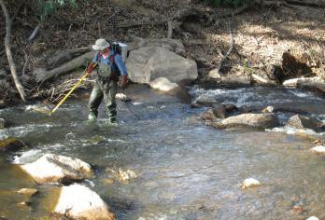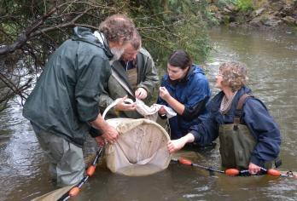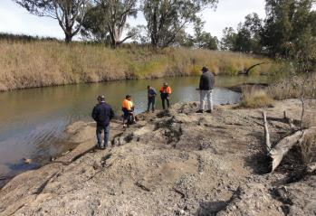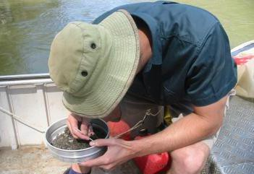
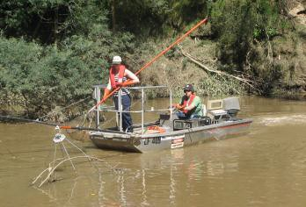

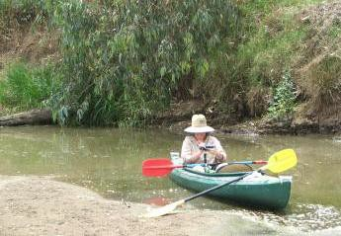

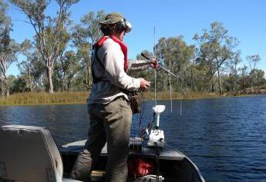

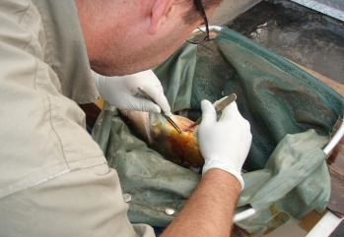

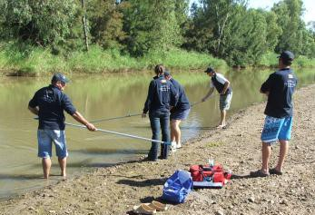
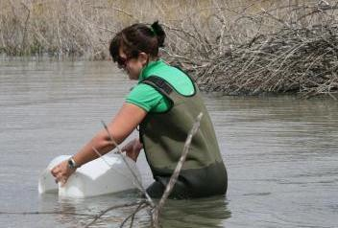Monitoring can take many forms (Photos: Jason Lieschke, Fern Hames, Scott Raymond, Tony Townsend, Milly Hobson, Lara Suiter)

5.2.2 What sorts of results have been obtained so far and what can we learn?

        - Demonstration Reaches are regarded as long-term projects and no reaches have been monitored for longer than 5 years, so results must be considered preliminary.

        - Results that have been obtained vary from no apparent response to management interventions to increase in abundance of some fish species.

        - Natural variability in climatic conditions including flooding will provide a level of background variability, in Hollands Creek demonstration reach for example, flooding has removed or relocated a number of the instream snag placements.

        - The size of the demonstration reach and the impracticality of enacting appropriately large scale rehabilitation programs is a significant issue for monitoring in demonstration reaches. When reaches are 100 to 200km long it may be impossible, at least in the short-term, to have a scale of intervention sufficient to elicit a response in the fish community.

        - Responses to particular restoration activities may vary between localities, extrapolation is dangerous.

None of the existing demonstration reaches have been monitored for long enough for all the hypotheses to be fully tested, with no post-intervention monitoring undertaken for longer than 5 years. Nevertheless it is worthwhile presenting a brief summary of some of the results obtained so far to provide an indication of how variable ecological responses can be. The following information has largely been taken from a recent review by Boys et al. (2014). The reader is referred to this paper for more information.

      - Condition monitoring
Several demonstration reaches have reported against reach scale condition targets, with varying results The Bourke to Brewarrina reach has been unable to detect any response by
native fishes to the demonstration reach. Boys et al. (2014) suggest that this may be in part
due to two factors; large inter-annual variability in fish abundance associated with floods in the Barwon-Darling River, and the relatively small scale of the interventions in relation to the large demonstration reach.

In contrast, preliminary analysis in the Ovens River demonstration reach suggests that Murray cod numbers may have increased since management interventions began. Macquarie perch numbers also appear to have increased in the Hollands Creek demonstration reach.
In the Dewfish demonstration reach the abundance of large bodied native fish, particularly Golden perch, have increased at two sites.

      - Intervention monitoring
Intervention monitoring has been carried out at most reaches with variable results. Here the results from monitoring three particular interventions are discussed to illustrate some
of the issues that may be encountered. Two of these management actions have been
implemented widely within demonstration reaches and more broadly across river

restoration in Australia. One (re-snagging) illustrates the results of directly monitored fish responses to the intervention while the second (riparian rehabilitation) discusses the use riparian condition as a surrogate. The third (alien fish management) is being implemented in a systematic way at two demonstration reaches only and the results are very preliminary.

Re-snagging (Large Woody Debris)

The most frequently implemented and evaluated management action in demonstration reaches has been re-snagging (five of the seven reaches). However, the impacts of this intervention on native fish populations have varied considerably.

In the Dewfish demonstration reach, preliminary data suggests that re-snagging has resulted in a significant increase in the numbers of Golden perch and Eel-tailed catfish, as well as a return of Murray cod individuals. Recent surveys (Norris, Hutchison and Chilcott, 2014) have confirmed that numbers of Golden perch, Murray cod, Eel-tailed catfish and Bony bream have remained much higher than before the reintroduction of large woody debris. In Oakey Creek in the Dewfish demonstration reach, few juveniles of large bodied species were captured after the 2013 summer spawning season suggesting that strong recruitment is not occurring in the area. The large woody debris may be acting as fish attractive devises only at this stage. There was no evidence that the numbers of small- bodied fish have increased due to re-snagging.

In contrast, monitoring of the impacts of re-snagging on fish populations in the Bourke to Brewarrina reach has failed to detect any significant effect on Golden perch or Murray cod numbers. Further to this, measurements of hydraulic and geomorphic indicators showed no response to the re-snagging either.

Although further monitoring is required to understand the reasons for the contrasting results for this management action, the differing results do highlight the need for monitoring even when the intervention is widely thought to be of benefit to native fishes and river health in general. It may also suggest the impact of re-snagging could be site specific and that the placement of snags may also be important.

Riparian rehabilitation

Riparian restoration is widely practiced in Australia and the links between the riparian zone and fish habitat are well documented (provision of large woody debris, input of energy via leaf litter, shading, bank stability etc.). Riparian restoration is occurring in all demonstration reaches; however monitoring of its benefit to demonstration reaches is only occurring at the Upper Murrumbidgee and Dewfish reaches. Even here, monitoring of riparian related activities only relates to riparian condition, using this as a surrogate for fish condition. The focus has been on riparian health and not the impact that this may have on fish populations. However, some inferences have been made in the Dewfish demonstration reach, where extensive and better condition riparian vegetation has protected native grasses during drought and recent flood scouring. Fish assemblages at these sites have been more stable throughout variable climate conditions than at other sites with less healthy riparian vegetation.

Alien fish management

Integrated Carp Management Plans have been developed for the Dewfish and Upper Murrumbidgee demonstration reaches. Both plans require a large number of coordinated actions to be taken to reduce Carp numbers. The Upper Murrumbidgee demonstration reach has only just started to implement the plan and at the moment on the focus is on gathering more knowledge. The Dewfish demonstration reach has been removing Carp from sections of the reach but has yet to implement all of the components of the management plan. However, Carp numbers have been kept at a low level at a number of sites. Monitoring of the impact of interventions to control Carp is complex as there will be a large number of activities that will be required in order to have a significant impact. It is most likely that combined impacts will be noticed during condition monitoring rather than intervention monitoring.

Monitoring community engagement

    - A monitoring and evaluation program is essential to ensure that communication and engagement activities are ‘best practice’ and effective.

    - To date rigorous monitoring has not been undertaken at any existing demonstration reach.

    - Surrogates can be used to give some indication of the effectiveness of communication activities but given the importance of community support for river rehabilitation and demonstration reaches, they are no substitute for direct monitoring.

    - A monitoring and evaluation framework similar to the Boys et al. (2008) document needs to be developed for monitoring community engagement.

All existing demonstration reaches were required to develop Communication and Engagement Plans, which clearly identify all stakeholders and develop strategies for engagement (see Planning Pillar). These plans all lack a comprehensive monitoring component. Although this has long been recognised as a deficiency in demonstration reaches, and most NRM activities, it has not been acted upon, largely due to funding constraints.

There are a myriad of communication activities that can be undertaken when implementing a demonstration reach (e.g. brochures, websites, school presentations, public meetings etc.) and without adequate monitoring and evaluation it is not possible to evaluate their effectiveness and ensure that resources are being allocated in the most cost effective way.

    - Suggested steps for developing a community engagement monitoring and evaluation program

The logic behind any monitoring and evaluation program for community engagement should be similar to the biological monitoring, that is:

- Establish the communication goals.

- Determine how these goals could be achieved within the stakeholder community. (Hypotheses to be tested).

- Develop the set of actions/activities to be undertaken

(The above would all be articulated in the Communication and Engagement Plan).

- Develop a monitoring and evaluation plan using appropriate expertise.

- Undertake pre-intervention monitoring of the proposed target audiences including control groups.

- Undertake regular post intervention monitoring of control and post intervention groups.

- Modify communication and engagement activities as appropriate.

Consideration must be given to choosing the appropriate indicators and sampling methods, experimental design and analysis methodology. If a monitoring and evaluation framework is developed for communication and engagement, this could identify the array of types of monitoring that could be undertaken, their pros and cons, as well as issues to be mindful of when monitoring communities.

    - Use of surrogates
In the absence of a monitoring and evaluation program, demonstration reaches have used surrogates to give an indication of the success of engagement activities. These can include number of “hits” on a website, attendance at meetings, level of involvement at demonstration reach activity days, number of newspaper articles, number of brochures used etc (see Planning Pillar). While they do provide a “feeling” for the level of community engagement and can indicate some things that may not be working (e.g. unused brochures), they do not provide the same level of feedback as a monitoring program.

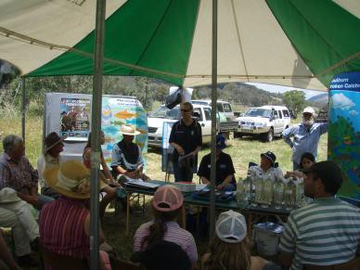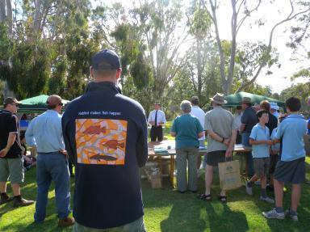

Comprehensive evaluation of community engagement is important (Photos: Fern Hames)

References for Monitoring Pillar
Allan, C. 2007. Adaptive management of natural resources. In: Wilson, A.I., Dehaan, R.I., Watts, R.I, Page, K.J., Bowmer, K.H. and Curtis, A. (eds.) Proceedings of the 5th

Australian Stream Management Conference, Australian rivers: making a difference. Charles Sturt University, Thurgoona, New South Wales.

Boys, C.A., Robinson, W., Butcher, A., Zampatti, B. and Lyon, J. 2009. Framework for developing and implementing ecological monitoring and evaluation of aquatic rehabilitation in demonstration reaches. MDBA Publication No. 43/08. Murray- Darling Basin Authority, Canberra. Hyperlink: http://www.mdba.gov.au/media- pubs/publications/framework-developing-and-implementing-ecological-monitoring- and-evaluation.

Boys,C., Alexander, T. Fowler, T. and Thieband, I. 2010. Interim monitoring report of the Namoi River Demonstration Reach 2011. M&E phase 1 report prepared for the
Murray-darling basin Authority, NSW Department of primary Industries, Port Stephens Fisheries Institute, Nelson Bay, NSW.

Boys, C.A., Southwell, M., Thoms, M.C. et al. 2013. Evaluation of Aquatic Rehabilitation in the Bourke to Brewarrina Demonstration Reach, Barwon-darling River, Australia. Fisheries Final Report Series No. 134. NSW Department of Primary Industries, Port Stephens Fisheries Institute.

Boys, C.A., Lyon, J., Zampatti, B., Norris, A., Butcher, A., Robinson, W. and Jackson, P.
2014. Demonstration reaches: Looking back whilst moving forward with river rehabilitation under the Native Fish Strategy. Ecological Management and Restoration,
15 (suppl 1), 67-74. Hyperlink:
http://onlinelibrary.wiley.com/doi/10.1111/emr2014.15.issue-s1/issuetoc

Norris, A., Hutchison, M. and Chilcott, K. 2012. Dewfish Demonstration Reach Monitoring and Evaluation Report, Autumn 2012. Department of Employment, Economic Development and Innovation, Brisbane. Hyperlink: http://www.condaminealliance.com.au/project-final-reports-water

Norris, A., Hutchison,. M. and Chilcott, K. 2012. Dewfish Demonstration Reach Monitoring and Evaluation report, Spring 2012. Department of Employment, Economic Development and Innovation, Brisbane.

Norris, A., Hutchison, M. and Chilcott, K. 2014. Dewfish Demonstration Reach Monitoring and Evaluation Report Spring 2013. Department of Agriculture, Fisheries and Forestry, Brisbane.

Raymond, S., Hames, F., Lyon, J. and Tennant, W. 2013. Hollands Creek demonstration reach. Final Report 2012/13. Arthur Rylah Institute for Environmental research. Client Report. Department of Sustainability and Environment, Heidelberg.

Raymond, S., Lyon, J., Hames, F. and Wilson, A. 2013. Ovens River demonstration Reach. Final Report 2012/13. Arthur Rylah Institute for Environmental Research Client Report, Department of Sustainability and Environment, Heidelberg.

Palmer, M.A., Bernhardt, E.s., Allan, J.D., Lake, P.S., Alexander, G., Brooks, S., Carr, J., Clayton, S., Dahm, C.N., Follstad Shah, J., Galat, D.L., Loss, G., Goodwin, P., Hart, D.D., Hasset, B., Jenkinson, R., Kondoff, G.M., Lare, R., Meyer, J.L., O’Donnell, T.K., Pyano, L. and Sudduth, E. 2005. Standards for ecologically successful river restoration. Journal of Applied Ecology, 42, 208-217.

Wilson, P.J., Gehrig, S.L., Leigh, S.J., Bice, C.M. and Zampatti, B.P. 2013. Fish and aquatic habitats in the Katarapko Anabranch system (“Katfish”Demonstration Reach):

“Before” intervention monitoring 2013. South Australian Research and Development Institute (Aquatic Sciencesa0, Adelaide, SARDI Publication No. F2012/000441-2, SARDI Research Report5 Series No.742.Hyperlink: http:www.sardi.sa.gov.au/_data/assets/pdf_file/0015/215205/Katarapko_Intervention_ Monitoring_2013_-_FINAL.pdf

Appendices for Monitoring Pillar

    - Appendix 5a - Example of monitoring outcomes modifying intervention requirements – Dewfish demonstration reach

Ongoing monitoring of the Dewfish Reach has identified two issues that need to be
addressed through additional interventions, these are:

- Decline in abundance of small bodied species.

There has been an ongoing decline of small bodied species at the tributary intervention sites probably due to the loss of macrophytes and emergent vegetation habitats (these are susceptible to flood events). As a result active reintroduction of key habitats will be targeted. This includes the installation of rock and gravel beds, finer submerged bank-side snags and re-introduction of aquatic vegetation.

- Recruitment of large bodied species has been limited.

Very few juvenile or small individuals of large bodied species have been recorded during monitoring surveys. This situation is unsustainable and needs to be addressed. The provision of spawning structures (hollow logs, pipes etc.) for Murray cod and gravel beds for nest building for Eel-tailed catfish has been recommended to start addressing this issue.

Without a comprehensive monitoring program it is unlikely that these issues would have been detected and there would have been no opportunity to undertake the necessary management interventions to address them.

    - Appendix 5b - Examples of rehabilitation goals

Demonstration Reach | Intervention | Rehabilitation Goal
Bourke to Brewarrina  (from Boys et al. 2009) | Re-snagging | - Increased hydraulic diversity in re-snagged reaches.  - Creation of deep hole habitat in re-snagged reaches.  - Increase in abundance of native fish species utilizing  treated sites.  - Trajectory improvement in native fish numbers in the whole demonstration reach.
Dewfish (from Dewfish Demonstration Reach  Final Report 2009-2011. Condamine Alliance | Multiple interventions  along length of reach  Re-snagging  Fish Passage  Integrated Carp eradication program | - Enhance aquatic habitat that supports native fish by  improving river health.  - Create increased habitat heterogeneity which can support increased abundance of native fish.  - Reinstate fish migration pathways and longitudinal habitat connectivity.  - The removal of Carp will allow populations of native fish to increase, especially key species such as Tandans

    - Appendix 5c- Intervention monitoring being undertaken at each existing demonstration reach (after Boys et al. 2014)

 | B to Bre | Namoi | Dewfish | Hollands | Ovens | M’Bge | Katfish
Re-snag | * |  | * | * | * | *
Alien |  |  | * |  |  | *
Riparian |  |  | * |  |  | *
Passage |  | * | * |  | * | *
Habitat |  |  |  | *
Screening |  | *
Flows |  |  |  |  |  |  | *
Stocking |  | * | * | * |  | *

118
    - Appendix 5d - Examples of sampling methods and environmental indicators from existing demonstration reaches

 | Demonstration Reach | Intervention | Sampling Method | Parameters Measured | Environmental Indicators
 | Hollands Creek | Reach Scale and Re- snagging | Backpack electrofisher, non-baited fyke nets.  Electrofishing using Sustainable Rivers Audit protocols – Eight 150 second shots at each site. | Species identified, all fish counted, measured total or caudal length to nearest mm. | - Total fish community  per site across  years.  - Total native fish community  per site across years.  - Total alien fish  community  per site across years.  - Total fish community within re-  snagged sites  across years.  - Total fish community  within non-  snagged sites across years.  - Individual fish species per  site across  years including  length  frequencies.
 | Condamine River (Dewfish Reach) | Reach Scale, Re-snagging, Carp removal | Boat mounted electrofisher, non-baited fyke nets.  Electrofishing undertaken in a structured fashion over a fixed area of 50m by 15m at each site with a “power on” time of 300 seconds. | Species identified and all fish counted. First 20 fish captured at each site measured (fork length) | - Total Fish community per site across  years.  - Nativeness metrics across sites across  years.  - Diversity indices across sites across years.  - Individual species  abundance  across sites across years.  - Individual species length  frequencies  across sites across years.

