Background
Carbon, Fire and Biota project
Understanding the response of biodiversity and carbon to fire August 2015
The objective of the Carbon, Fire and Biota project is to build capacity in DELWP to protect biodiversity and understand carbon storage using adaptive fire management. This will be done through research and through collaboration with fire managers (especially in DELWP fire risk landscape teams) to implement promising strategies.
The Carbon, Fire and Biota project explores the synergies and trade-offs that arise in planning fire regimes to protect biodiversity and carbon stocks. Previous work has been undertaken exploring either carbon and fire or carbon and biodiversity; and this project uses a novel approach to combine these different areas of investigation. We also have taken advantage of recent improvements in fire severity mapping, which provides important guidance for fire management planning.
Research questions
- What are the effects of different planned fire regimes on biodiversity and carbon in mixed-species eucalypt forests?
- What are the effects of different (unplanned) bushfire regimes on biodiversity and carbon in mixed-species eucalypt forests?
- What conflicts or synergies arise in planning fire regimes to protect biodiversity, carbon stocks and assets?
- What strategies can be devised to improve the balance between these management objectives? What practical strategies can be implemented through DELWP’s fire risk landscape management teams?

Study area and methods
Study area
The 80 study sites are located in the foothills forests to the north-east of Melbourne, in and adjacent to the area burnt by the 2009 Black Saturday fires (Figure 1).
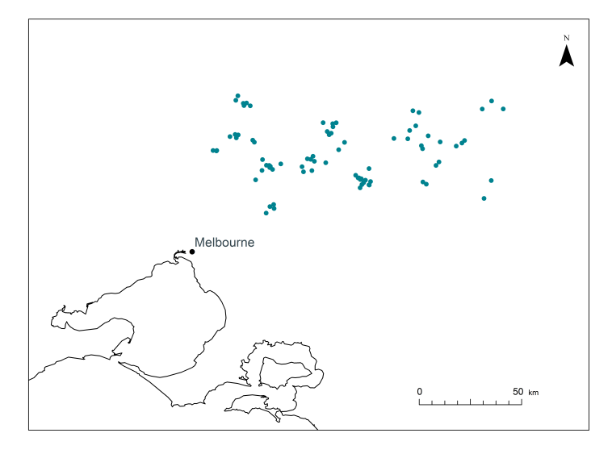
Figure 1. Location of the study sites north-east of Melbourne.
Sites were selected to be within one forest type (herb-rich foothills forest) and to have one of six fire history characteristics (Figure 2), based on 2009 fire severity and the time since the most recent fire prior to 2009:
- High severity fire in 2009 and planned burnt sometime in the 10 years prior to 2009
- High severity fire in 2009 and not burnt by any fire for 30 years prior to 2009
- Low severity fire in 2009 and planned burnt sometime in the 10 years prior to 2009
- Low severity fire in 2009 and not burnt by any fire for 30 years prior to 2009
- Not burnt in 2009 and planned burnt sometime in the 10 years prior to 2009
- Not bunt in 2009 and not burnt by any fire for 30 years prior to 2009
Components sampled
Two aspects of biodiversity were sampled; plants and birds. Plants were assigned to a functional group based on life form and reproductive response to fire (Box 1). Birds were assigned to guilds based on their feeding and nesting behaviours.
Carbon stocks were estimated for above- (trees, shrubs, stumps, logs, litter) and below-ground (soil to 30 cm depth) pools.

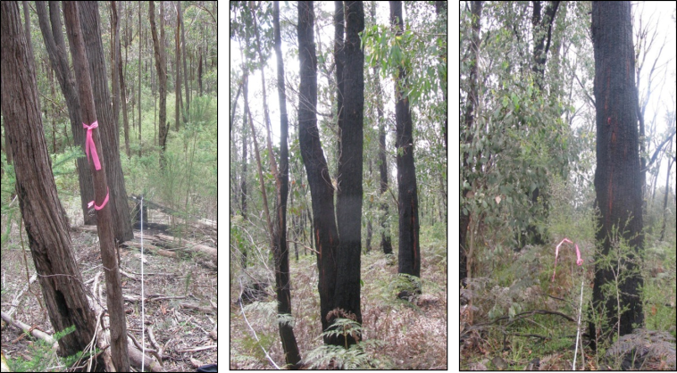
Figure 2. Examples of unburnt, low and high fire severity sites

Results
Biodiversity
Responses of plant functional groups to fire varied. In some groups, such as obligate seeder shrubs, we could not detect a response to fire. However, the presence of other groups such as resprouter trees and resprouter shrubs with a short juvenile period were positively associated with recent fire (both in and prior to 2009). By contrast, resprouter shrubs with a long juvenile period did not show a response to time since fire but were disadvantaged by a low severity bushfire in 2009 (Figure 3). Bird data will be analysed in the coming months.
Box 1. Terms used to describe plant functional groups
Obligate seeder – adults are killed by fire and regenerate from the seed bank.
Resprouter – adults survive fire and regenerate from protected buds
Juvenile period – time to reproductive maturity: <5 years = short, >5 years = long
Carbon
Bushfire severity had a larger effect on carbon stocks than time since fire. Carbon stocks in live above-ground biomass (e.g. trees and shrubs) were lower at high severity sites than low severity and unburnt sites. Decreases in live above-ground carbon stocks due to bushfire were counter-balanced by increases in dead wood and in soil particularly at low severity sites. This indicated a shift in from live to dead pools after bushfire, which could make carbon stocks more susceptible to subsequent fires.
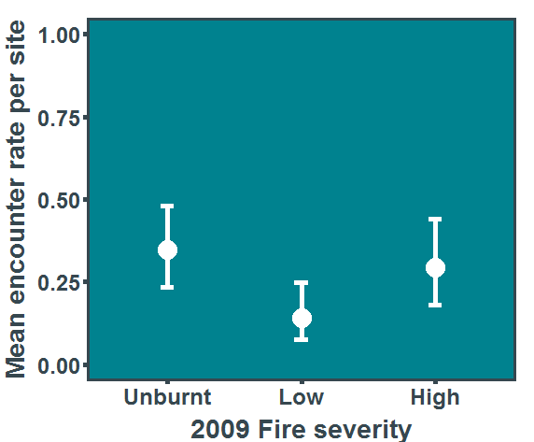
Figure 3. Response of resprouter shrubs with a long juvenile period to 2009 fire severity. There was no relationship to time since fire in this functional group.
Summary and next steps
To date the project has shown promising results, enhancing our understanding of plant biodiversity and carbon stocks to fire severity and time since fire. The next step for the project is analysis of bird data. Once this is complete we will synthesize the results and provide advice to DEWLP fire planners about how they can balance carbon and biodiversity management objectives.
For more information contact:
matthew.bruce@delwp.vic.gov.au
michele.kohout@delwp.vic.gov.au
ltb@unimelb.edu.au (Lauren Bennett)
www.delwp.vic.gov.au/ari

