|  |
| --- |
| Conservation of endemic and threatened Victorian galaxiid species |
| Biodiversity Response Planning Projects 118, 119, 120 & 121 2018–2020 |

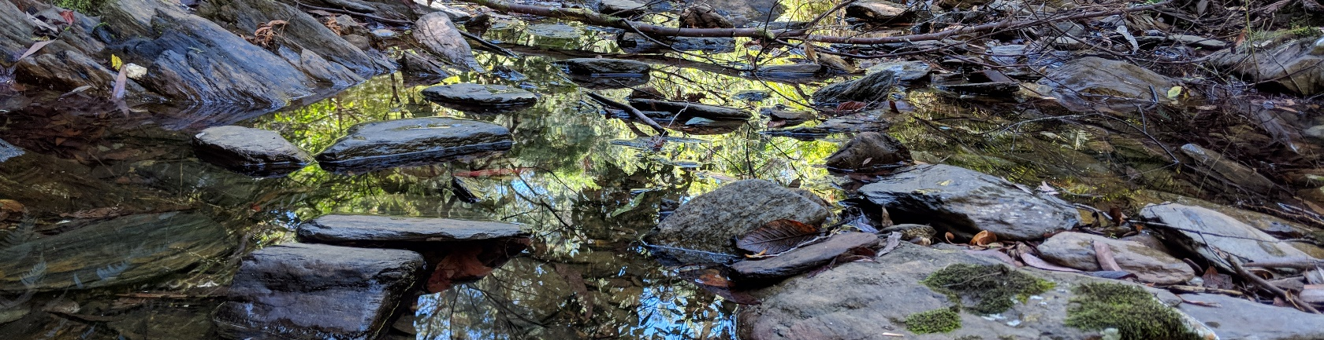

## Background

Within Victoria are small, native fishes known as galaxiids. Eleven species are highly threatened, and are now only found in small, remote, mountain streams. They occur in the upper reaches of the Goulburn River system, and various coastal river catchments across Gippsland, ranging in elevation from 200 m to over 1600 m in alpine areas.

These species have declined dramatically in number and distribution, largely due to predation by introduced trout. In short, where trout are present these species can’t persist. Most species now exist as a single, small, isolated population, which means they are further threatened by localised impacts such as fire and drought. As such, they urgently need ongoing conservation management to prevent extinction.

Staff from the Arthur Rylah Institute for Environmental Research (ARI), DELWP, have led the discovery and description of many of these species and are also working to protect them and ensure their persistence in the future.

### Species threats

The main threat to the survival of the threatened galaxiids, above all else, is predation by introduced trout. The galaxiids now only survive above barriers to trout movement, such as waterfalls. A few trout can rapidly eat a large population of galaxiids, which, for those galaxiid species remaining as a single population, means extinction. Preventing trout from moving upstream over the barriers protecting the galaxiids, or removing them immediately if they have done so, is critical to galaxiid survival.

Further, because each galaxiid species now persist in such a small area (<0.5 ha total), they are now particularly susceptible to drought that can cause their habitat to dry up. Fire can also fatally increase water temperature and increase the amount of sediment flowing into rivers during storms which clog up the streams and impact on breeding success.

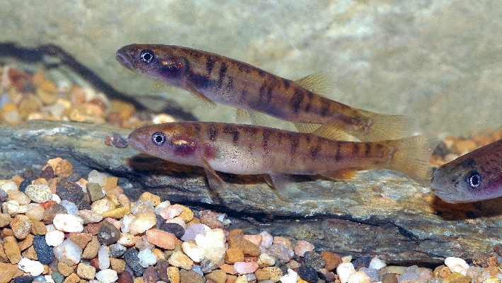

Yalmy Galaxias

Credit: Tarmo Raadik DELWP

## Project objectives

This project funded by the Victorian Government, will continue the protection of each of the following 11 threatened galaxiid species, all located in eastern Victoria:

* Barred Galaxias (*Galaxias fuscus*)
* Dargo Galaxias (*Galaxias mungahan*)
* East Gippsland Galaxias (*Galaxias aequipinnis*)
* McDowall’s Galaxias (*Galaxias mcdowalli*)
* Roundsnout Galaxias (*Galaxias terenasus*)
* Shaw Galaxias (*Galaxias gunaikurnai*)
* Tapered Galaxias (*Galaxias lanceolatus*)
* West Gippsland Galaxias (*Galaxias longifundus*)
* Moroka Galaxias (*Galaxias* n.sp.) – a recently discovered new species being formally described.
* Morwell Galaxias (*Galaxias* n.sp.) – a recently discovered new species being formally described.
* Yalmy Galaxias (*Galaxias* n.sp.) – a recently discovered new species being formally described.

The conservation management will focus on:

* Preventing rapid population decline by controlling predators (locating and then removing/relocating them) immediately below the barriers protecting the galaxiid populations, and above them if the barriers have been breached;
* Adding additional galaxiids to recently translocated populations to bolster the genetic diversity of these establishing populations (‘genetic top-up’); and,
* Continuing to search for suitable, predator free and secure sites which may be suitable as locations in which to establish additional galaxiid populations to spread extinction risk.

## Approach

These threatened galaxiids are now only found in small headwater streams in remote locations within steep and forested catchments. As such, they can only be accessed by four-wheel drive and/or by hiking into the catchments.

|  |  |
| --- | --- |
| Tarmo A. Raadik © The State of Victoria Department of Environment, Land, Water and Planning 2019  LogoThis work is licensed under a Creative Commons Attribution 4.0 International licence. You are free to re-use the work under that licence, on the condition that you credit the State of Victoria as author. The licence does not apply to any images, photographs or branding, including the Victorian Coat of Arms, the Victorian Government logo and the Department of Environment, Land, Water and Planning (DELWP) logo. To view a copy of this licence, visit http://creativecommons.org/licenses/by/4.0/  **ISBN** 978-1-76077-800-2 **(pdf/online/MS word)**  Disclaimer  This publication may be of assistance to you but the State of Victoria and its employees do not guarantee that the publication is without flaw of any kind or is wholly appropriate for your particular purposes and therefore disclaims all liability for any error, loss or other consequence which may arise from you relying on any information in this publication. | Accessibility  If you would like to receive this publication in an alternative format, please telephone the DELWP Customer Service Centre on 136186, email [customer.service@delwp.vic.gov.au](mailto:customer.service@delwp.vic.gov.au), or via the National Relay Service on 133 677 [www.relayservice.com.au](http://www.relayservice.com.au). This document is also available on the internet at [www.delwp.vic.gov.au](http://www.delwp.vic.gov.au). |

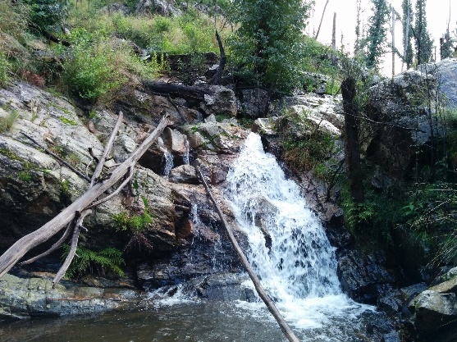

## An effective, natural trout barrier

Credit: Tarmo Raadik DELWP

Predator control (the detection and removal of trout from within galaxiid populations) will be undertaken at pre-established monitoring locations by experienced teams using electrofishing equipment and following a robust methodology developed by the ARI over 25 years of conservation work.

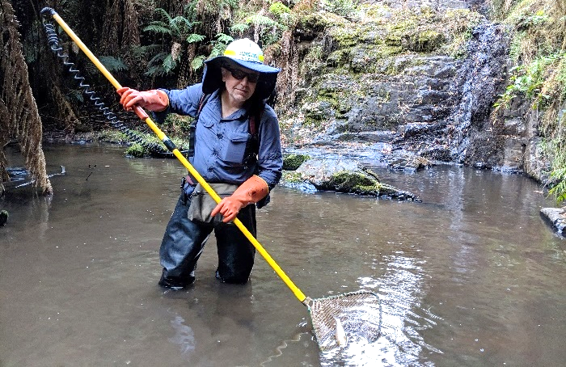

## Backpack electrofishing in the upper Morwell River

Credit: Tarmo Raadik DELWP

## Project benefits

This project will also benefit a range of additional instream aquatic biota, such as spiny crayfish and riverine frogs, where trout predation is an issue. It will also add to our knowledge of aquatic species distributions, and may further increase Australia’s biodiversity by locating additional, undescribed species.

## Contact

If you are interested in learning more about the project, please contact [Tarmo.Raadik@delwp.vic.gov.au](mailto:Tarmo.Raadik@delwp.vic.gov.au).

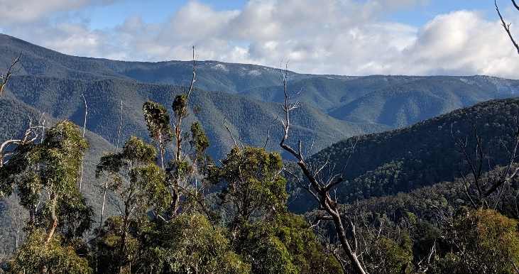

## Steep and remote alpine catchments, Mitchell River system

Credit: Tarmo Raadik DELWP