|  |
| --- |
| Recovery actions for seven endemic and threatened Victorian galaxiid species |
| Biodiversity On-ground Actions Regional Partnerships and Targeted Actions Project 2017-18 |

## Background

Ten species of highly threatened, native galaxias fish, endemic to Victoria, occur in small, remote, upland streams, with one in the upper Goulburn River system, and the rest in coastal Gippsland. Most species now exist as single, very small, populations and urgently need ongoing conservation management to prevent extinction. Many of these species were discovered in 2002, with three species only discovered since 2015.

### Threats

The main threat to the survival of the threatened galaxiids is predation by introduced trout species. The impact of trout predation is clearly demonstrated by the presence of the galaxiid species only above waterfalls where trout do not occur. Brown Trout (*Salmo trutta*) and Rainbow Trout (*Oncorhynchus mykiss*) grow much larger than the galaxiids and can eat all but the largest fish. These older fish are chased by trout and prevented from feeding, and soon die. Since a few trout can rapidly remove a large population of galaxiids in such small streams, all eleven species are highly vulnerable to the risk of extinction.

The survival of populations requires actions that prevent predation by trout, including blocking their ability to move upstream over the barriers, and immediate removal of trout if they are detected where the galaxiids occur. Management actions to conserve the threatened species in the coastal Gippsland area commenced in 2010. The extremely restricted distribution and abundance of each galaxiid species (<0.5 ha total) also means they are all at a high risk of extinction from natural disturbance (e.g. fire, drought, disease).

Fig 1: West Gippsland Galaxias (Photo: Tarmo Raadik DELWP)

## Project objectives

This project, funded by the Victorian government, represents a continuation of actions to protect the single, global population of each of the following seven of the 10 threatened galaxiid species:

* West Gippsland Galaxias (*Galaxias longifundus*)
* Tapered Galaxias (*Galaxias lanceolatus*)
* Shaw Galaxias (*Galaxias gunaikurnai*)
* McDowall’s Galaxias (*Galaxias mcdowalli*)
* East Gippsland Galaxias (*Galaxias aequipinnis*)
* Roundsnout Galaxias (*Galaxias terenasus*)
* Morwell Galaxias (*Galaxias* sp.) – a recently discovered new species being formally described.

The management goal is to reduce extinction risk for each species and relies on securing remnant populations followed by establishing additional populations. Management actions include:

* Monitoring all populations and when trout are detected, immediately removing or reducing them within and immediately below galaxiid populations;
* Bolstering the genetic diversity of recently translocated populations (‘genetic top-up’) through addition of individuals, during their establishment phase; and,
* Continuing to search for suitable, predator free and secure sites to establish additional galaxiid populations.

## Approach

The galaxiid species are now found in small, narrow, headwater streams, which are in remote locations with steep and forested terrain. Some can be reached by four-wheel drive, though many required hiking long distances into steep valleys.

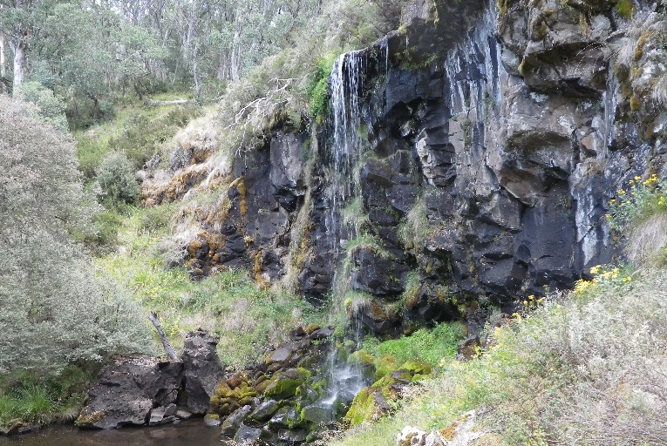

Fig 2: An effective, natural trout barrier (Photo: Tarmo Raadik DELWP)

The detection and removal of trout from within galaxiid populations will be undertaken at pre-established monitoring locations using electrofishing and following a robust methodology developed by the Arthur Rylah Institute (ARI) over 25 years of conservation work.

Usually only a few (< 10) small (<180 mm long) trout are encountered above barriers.

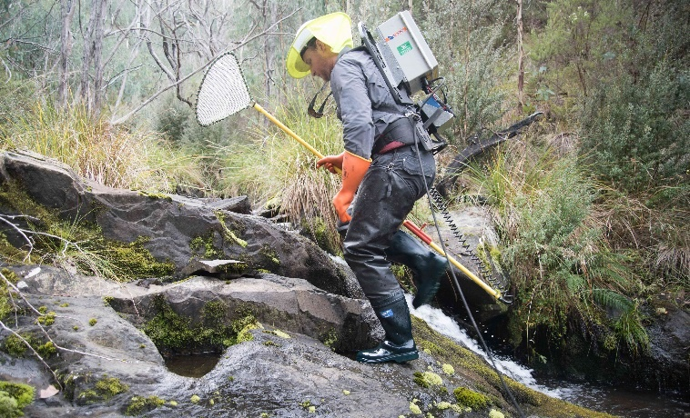

## Fig 3: Backpack electrofishing an upper Dargo River tributary

(Photo: Tarmo Raadik DELWP)

## Project benefits

This project will also benefit a range of additional instream aquatic biota, such as spiny crayfish and riverine frogs known to be affected by trout predation. It will also add to our knowledge of aquatic species distributions, and may lead to the location of additional, undescribed galaxiid species.

## Contact

If you are interested in learning more about the project, please contact [Tarmo.Raadik@delpw.vic.gov.au](mailto:Tarmo.Raadik@delpw.vic.gov.au).

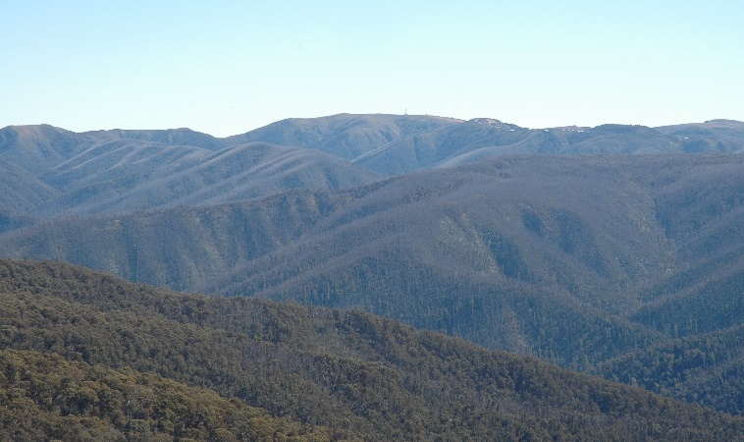

## Fig 4: Steep and remote alpine catchments

|  |  |
| --- | --- |
| Tarmo A. Raadik © The State of Victoria Department of Environment, Land, Water and Planning 2019  LogoThis work is licensed under a Creative Commons Attribution 4.0 International licence. You are free to re-use the work under that licence, on the condition that you credit the State of Victoria as author. The licence does not apply to any images, photographs or branding, including the Victorian Coat of Arms, the Victorian Government logo and the Department of Environment, Land, Water and Planning (DELWP) logo. To view a copy of this licence, visit http://creativecommons.org/licenses/by/4.0/  **ISBN** 978-1-76077-801-9 **(pdf/online/MS word)**  Disclaimer  This publication may be of assistance to you but the State of Victoria and its employees do not guarantee that the publication is without flaw of any kind or is wholly appropriate for your particular purposes and therefore disclaims all liability for any error, loss or other consequence which may arise from you relying on any information in this publication. | Accessibility  If you would like to receive this publication in an alternative format, please telephone the DELWP Customer Service Centre on 136186, email [customer.service@delwp.vic.gov.au](mailto:customer.service@delwp.vic.gov.au), or via the National Relay Service on 133 677 [www.relayservice.com.au](http://www.relayservice.com.au). This document is also available on the internet at [www.delwp.vic.gov.au](http://www.delwp.vic.gov.au). |

(Photo: Tarmo Raadik DELWP)