|  |
| --- |
| WetMAP – Victoria’s Wetland Monitoring and Assessment Program for environmental water |
| Project Update – 2019  Frog Theme |

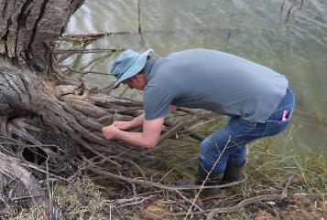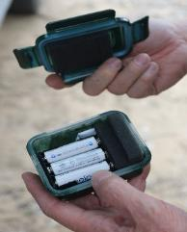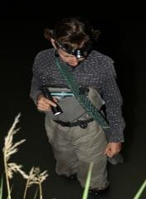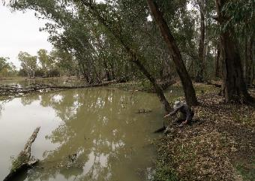

## Background

WetMAP is a state-wide monitoring program designed to assess ecological responses of vegetation, waterbirds, frogs and fish to the delivery of water for the environment in Victorian wetlands. Monitoring for the current stage of WetMAP (2016–2020) is coordinated by Arthur Rylah Institute (ARI) and funded through the Victorian government’s $222 million investment over four years to improve catchment and waterway health.

**Program Objectives**

WetMAP aims to:

* enable DELWP (Department of Environment, Land, Water and Planning) and its water delivery partners to clearly demonstrate ecological outcomes of environmental water management to the community and water industry stakeholders.
* fill knowledge gaps to enable adaptive management – improving planning, delivery and evaluation of environmental water management in rivers and wetlands across Victoria.
* identify ecosystem outcomes from environmental water to help meet Victoria’s obligations under the Murray-Darling Basin Plan.
  1. Ultimately, WetMAP seeks to inform the development of an environmental water planning tool for Catchment Management Authorities (CMAs) and the Victorian Environmental Water Holder.
  2. **Program Design**

The design of WetMAP is based on:

* conceptual models of wetland responses to environmental water delivery and natural flooding
* watering objectives defined in state and regional water management plans, and
* Key Evaluation Questions (KEQs) and indicators.

**Factors that influence the response of frogs to environmental water**

Key drivers that affect frog responses to water regimes include processes operating at both local (wetland) and landscape scales. At the local scale, factors such as water regime, water chemistry and vegetation are likely to be important, along with other variables that reflect the sites’ disturbance histories. The principal historic disturbance factors for wetlands include altered water regimes, salinity, nutrient enrichment, presence of Carp *Cyprinus carpio* and grazing by livestock. Other factors likely to affect frog occurrence at the local scale include predation and the presence of virulent pathogens, notably chytrid fungus *Batrachochytrium dendrobatidis*. At landscape scales, factors such as the number of and distance to nearby wetlands is likely to determine how many frogs can colonise watered sites.

Data collected through WetMAP will be used to answer current Key Evaluation Questions (see over) as well as to generate hypotheses predicting short- to medium-term frog responses under water regimes that vary in terms of: timing of flooding; type of habitat flooded (permanent, semi-permanent or temporary waterbodies and their structural and landscape attributes); time that water remained on flooded areas; and water quality.

**Frog Monitoring**

This component of WetMAP incorporates two elements:

1. **Local response monitoring** – wetland frog monitoring conducted by ARI.
2. **Citizen science linkage** – a collaboration to increase the amount of data collected from local response monitoring and promote wetland science within the community.

This flyer focuses on outcomes from the **local response monitoring** element for 2018-19.

Key Evaluation Questions have been developed to guide the monitoring design for the WetMAP frog theme (Table 1). Supplementary Questions have also been developed to investigate some of the specific processes that drive frog responses to environmental watering (Table 2).

**Survey Methods**

In 2018/19, frog monitoring was conducted at 16 wetlands across four catchment management authority regions. The sites represented a water regime gradient from near permanent to ephemeral (infrequently flooded) and included four permanently inundated sites and 12 temporary wetlands, all of which received environmental water. Multiple monitoring transects, each 50 m long, were established along the waterline at each study wetland, the number primarily determined by the size of the wetland.

|  |
| --- |
| **KEQs** |
| 1. Do environmental watering events increase the abundance of resident frog species in wetlands? |
| 1. Do environmental watering events increase the species richness of frogs in wetlands? |
| 1. Do environmental watering events precipitate breeding by frogs in wetlands? |

**Table 1. Key Evaluation Questions**

|  |
| --- |
| **SQs** |
| 1. What survey technique or combination of techniques is the most effective in detecting the greatest number of frog species and measures of abundance in wetlands? |
| 1. Is the composition of frog assemblages related to timing, frequency and/or duration of environmental watering or the legacies of water regime history? If so, to what extent do these flow characteristics increase or decrease frog species richness and abundance?   2a: Is the effect of an environmental water event on richness and abundance of frog species dependent on the hydrological history prior to the watering and over what antecedent period?  2b: Is the effect of an environmental water event on richness and abundance of frog species dependent on the timing, duration and/or frequency of the watering? |
| 1. Is the effect of an environmental water event on richness and abundance of frog species in a wetland dependent on water quality and/or habitat structure? |
| 1. Is the effect of an environmental water event on richness and abundance of frog species dependent on landscape complexity (especially habitat connectivity and the existence of proximate potential frog refuges)? |
| 1. What components of environmental water events (especially timing, which relates to water temperature) affect spread and persistence of chytrid fungus? |
| 1. Which hydrological regime facilitates the persistence of the Growling Grass Frog in Victorian wetlands? (What is its dispersal capacity? What is the influence of chytrid fungus?) |

**Table 2. Supplementary Questions**

Frogs were surveyed using audio-visual surveys and AudioMoth (programmable recording units) acoustic loggers. Tadpoles were surveyed using standardised sweep netting. Aquatic habitat, adjacent terrestrial habitat and water quality were also assessed. Data collection was restricted to a single visit to each wetland during spring-summer for both frog audio-visual surveys and tadpole surveys. AudioMoth acoustic loggers were installed at every transect during October-December and remained in situ for 56-84 days.

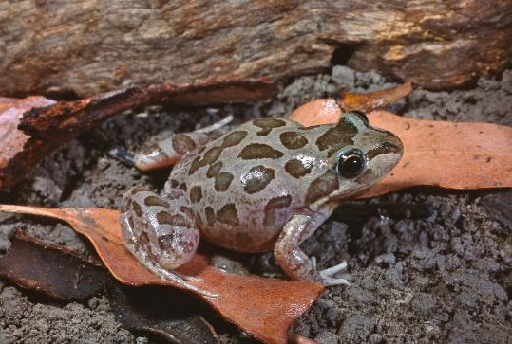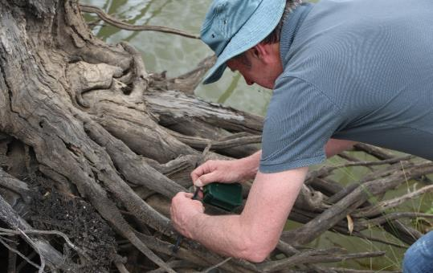

**Fig 1 - (top) Placing an AudioMoth acoustic logger in the field (Photo: ARI); (bottom) Spotted Marsh Frog was recorded from all wetlands (Photo: Geoff Heard).**

**Results and Key Observations**

Over 6300 frog recordings were made, representing eight species, four genera and three families. The most frequently recorded species were Spotted Marsh Frog *Limnodynastes tasmaniensis* (every wetland) and Peron’s Tree Frog *Litoria peronii* (all wetlands but one). Conversely, the Growling Grass Frog *Litoria raniformis* (one record) and Painted Burrowing Frog *Neobatrachus pictus* (four records) were rarely detected, and each from only a single wetland.

The number of frog species recorded during surveys varied between three and six species per wetland. The largest number of frog records came from Gaynor Swamp (n=1283) and Wallpolla Horseshoe Lagoon (n=840).

Tadpole surveys yielded few individuals, from only four study wetlands, representing four common frog species. Tadpoles in large wetlands are difficult to collect by dip-netting, so alternative approaches will be employed in future surveys.

AudioMoth data were not available for analysis at the time of preparing this fact sheet; however, they are expected to reveal a broader distribution of some frog species across transects at each study wetland, and possibly reveal additional species at some study wetlands.

There are currently too few data to identify the relationship between frog occurrence and environmental watering, yet preliminary analyses of the audio-visual dataset reveal:

* frog occurrence is influenced by water quality (e.g. salinity, turbidity).
* frog occurrence is influenced by elements of the terrestrial habitat along the waterline (e.g. cover of short herbs/grasses, bare ground, tall and short emergent vegetation).
* the responses of individual frog species are distinctive.

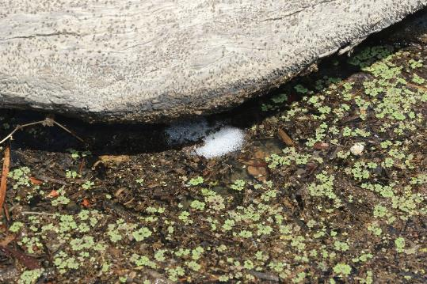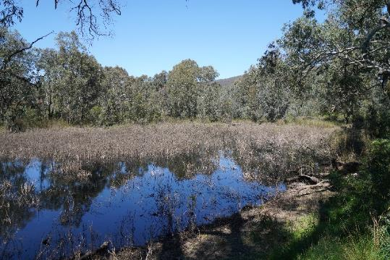

**Fig 2 - (top) Evidence of spawning; (bottom) vegetation along a wetland’s waterline can be diverse and influence frog occurrence (Photos: ARI).**

**What’s Next?**

Monitoring data collected during 2019-20 will increase the overall dataset and help answer KEQs around the impacts of environmental watering events. Further monitoring is required to assess frog responses to the broader hydrological regime.

Information on landscape context and hydrological history is being collated for each study wetland and, along with habitat and water quality data, is being used to model the drivers of frog occurrence.

Once the AudioMoth call data has been analysed, this will enlarge the data-set and together with expert advice from herpetologists and biometricians, this will clarify the most appropriate survey techniques to employ over coming years.

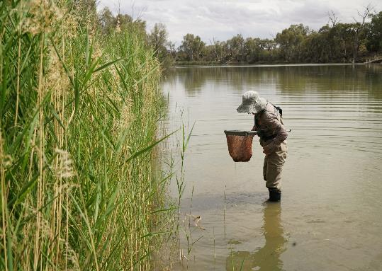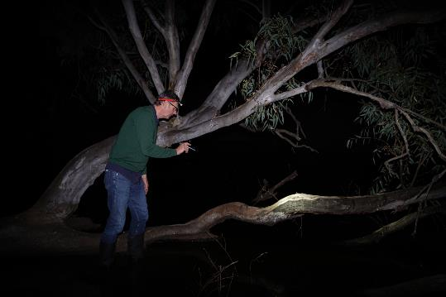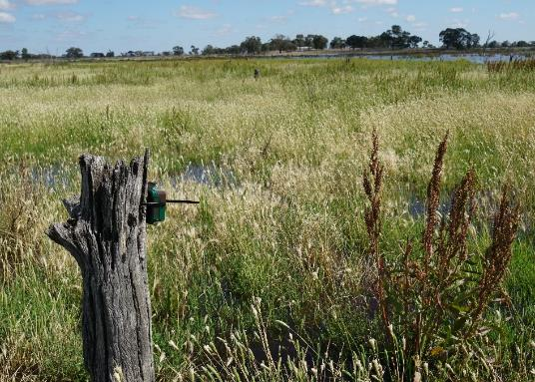

**Fig 3 - (clockwise from top left) A tadpole; nocturnal audio-visual frog survey; AudioMoth logger placed on tree stump; tadpole sweep-netting (Photos: ARI)**

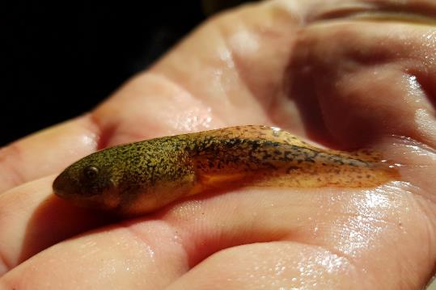

**Further information**

See [www.ari.vic.gov.au](http://www.ari.vic.gov.au) for further information on WetMAP

**Contact**

[Geoff.Brown@delwp.vic.gov.au](mailto:Geoff.Brown@delwp.vic.gov.au) (frog monitoring methods);

[Jacqueline.Brooks@delwp.vic.gov.au](mailto:Jacqueline.Brooks@delwp.vic.gov.au) (program leader).

|  |  |
| --- | --- |
| © The State of Victoria Department of Environment, Land, Water and Planning 2020  LogoThis work is licensed under a Creative Commons Attribution 4.0 International licence. You are free to re-use the work under that licence, on the condition that you credit the State of Victoria as author. The licence does not apply to any images, photographs or branding, including the Victorian Coat of Arms, the Victorian Government logo and the Department of Environment, Land, Water and Planning (DELWP) logo. To view a copy of this licence, visit http://creativecommons.org/licenses/by/4.0/  ISBN 978-1-76105-029-9 (pdf/online/MS word)  Disclaimer  This publication may be of assistance to you but the State of Victoria and its employees do not guarantee that the publication is without flaw of any kind or is wholly appropriate for your particular purposes and therefore disclaims all liability for any error, loss or other consequence which may arise from you relying on any information in this publication. | Accessibility  If you would like to receive this publication in an alternative format, please telephone the DELWP Customer Service Centre on 136186, email [customer.service@delwp.vic.gov.au](mailto:customer.service@delwp.vic.gov.au), or via the National Relay Service on 133 677 [www.relayservice.com.au](http://www.relayservice.com.au). This document is also available on the internet at <https://www.ari.vic.gov.au/research/wetlands-and-floodplains/assessing-wetland-response-to-environmental-water> |