|  |
| --- |
| Revegetation in farm landscapes  2. Practical ways to improverevegetation for birds |

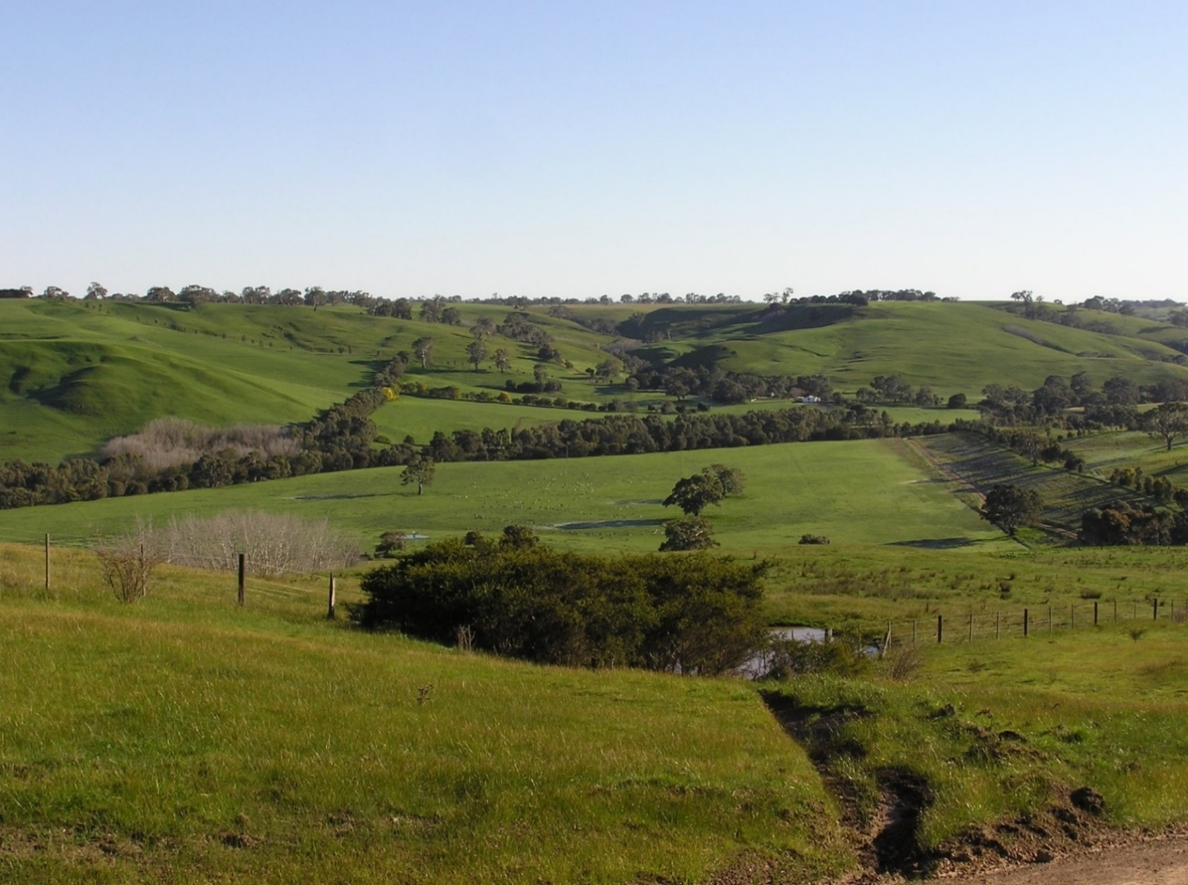

**Revegetation - valuable habitat for native birds**

Revegetation is common in rural environments in south-eastern Australia, where plantings provide a range of values such as shelter for stock, soil and water protection, and conservation. All such plantings can provide benefits for native birds and other animals.

We surveyed birds at 133 revegetation plots on farms in the Glenelg Hopkins region of Victoria. In total, 86 species of birds (excluding waterbirds) were recorded. By analysing the relationship between bird species and the features of these plantings (and their surroundings) we identified factors that made the greatest contribution to their value for native birds. Here, we summarise findings into five practical ways to increase the value of revegetation plantings for nature conservation.

**1. Plant a range of plant species**

As the number of tree and/or shrub species increases, so too does the number of bird species using the planting. Different plant species provide different resources for animals. For example, including rough-barked eucalypts in woodlots of smooth-barked species adds resources for birds that feed on insects living in the bark. Native wattles provide options for trees/shrubs that are highly variable in size and shape, and foliage and flowers. Revegetation containing a range of plant species provides resources for more animals with different habitat requirements.

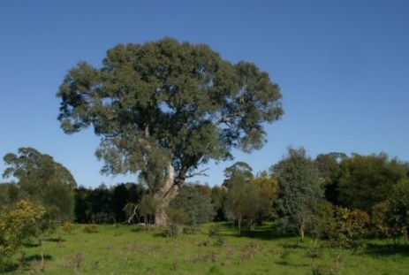

**Revegetation planting around a large remnant River Red Gum (*Eucalyptus camaldulensis*).**

Another benefit of planting multiple species, especially trees, is that natural variation in their flowering times means that flowering/nectar resources will be spread out across the year.

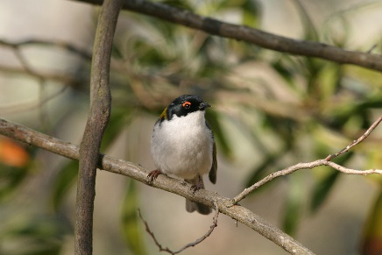 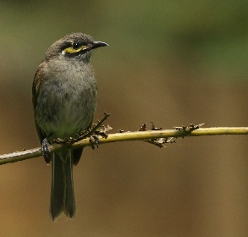

**Native honeyeaters are attracted to the floral resources provided by revegetation plantings, including the White-naped Honeyeater (*Melithreptus lunatus*) and Yellow-faced Honeyeater (*Lichenostomus chrysops*).**

**2. Locate plantings close to existing vegetation**

Revegetation plantings with a greater amount of *other* wooded vegetation nearby contain more bird species than plantings with less surrounding vegetation. This is because many birds get the resources they need, for feeding, shelter and breeding, from multiple patches of habitat. Plantings will provide greatest benefit for birds if they are positioned near to existing vegetation, and so add to the network of local habitat patches.

Particular value will be gained from revegetation that is undertaken along creeklines or streams. These are productive habitats for wildlife and they provide natural connectivity through the landscape. Streamside vegetation also plays an important role in protecting aquatic habitats and water quality.

**3. Revegetate around existing mature trees**

Mature remnant trees provide a range of benefits for birds: a greater likelihood of tree hollows for breeding, more consistent flowering events, wide canopies and big branches for foraging, perching and nesting. We found that revegetation planted around existing large trees supported more bird species than those without remnant trees. For example, Striated Pardalotes, Red-rumped Parrots and Laughing Kookaburras all preferred plantings that contained large mature trees. All three species nest in tree hollows.

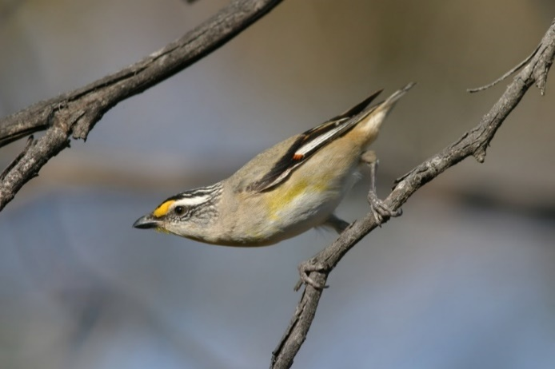

**Striated Pardalotes (*Pardalotus striatus*) are more likely to use revegetation plantings if they contain mature, remnant trees.**

**4. Fence plantings to protect them from grazing**

Plantings from which stock are excluded for all or most of the time contain, on average, three to four more woodland bird species – a 38% increase in richness – than plantings grazed by stock. Cows and sheep trample the ground layer, reducing the cover of herbs and small shrubs, and impacting leaf litter layers and logs. Fencing plantings (and leaving logs in place) will protect these important ground-layer habitat features and improve their value for birds such as the Superb Fairy-wren, that depend on them for foraging and shelter. Moving logs from farm paddocks into plantings will further increase their value for animals.

**5. Even small plantings have value**

Revegetation plantings in a range of forms – shelterbelts, creekline plantings – all benefit conservation. Even small plantings have value. Individually, they provide resources that birds use for foraging and shelter. Collectively, they contribute to the overall amount of vegetation in the landscape. And this cumulative contribution is really valuable, as more bird species occur in landscapes that contain a greater amount of wooded vegetation. Small plots of revegetation should not be dismissed as being of no value: plantings of any size enhance the resources for fauna relative to open paddocks, and can be supplemented over time to increase their size.

**Remnant native vegetation has great value!**

While the focus here is on practical ways to increase the value of revegetation plantings for native birds, with flow on benefits for other types of animals too, it is essential to remember that remnant native vegetation is important. Whether in patches, strips, or individual mature trees – it is critical for the persistence of native species in rural environments. Revegetation does not replace remnant vegetation. Remnant vegetation provides distinctive habitat in its own right (especially older trees that take decades to grow), and it also *enhances the value of* *revegetation* for birds. Scattered trees in farm paddocks also provide a range of benefits for native species. Protecting remnant vegetation in the rural landscape is a high priority for conservation.

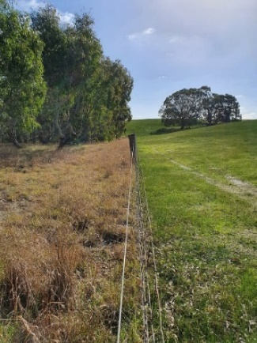 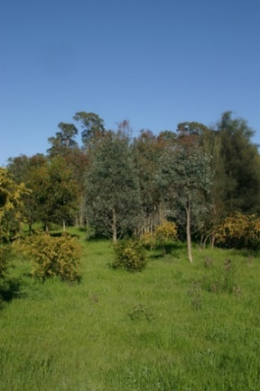

**Revegetation plantings that are fenced to exclude stock, and contain a greater range of tree and shrub species have higher value for native birds.**

## Further information

Angie Haslem [A.Haslem@latrobe.edu.au](mailto:A.Haslem@latrobe.edu.au)

[research.ari@delwp.vic.gov.au](mailto:research.ari@delwp.vic.gov.au) [**ari.vic.gov.au**](https://www.ari.vic.gov.au/)

## Acknowledgements

This project was funded with support of the Victorian Government as part of the Biodiversity On-ground Action Adaptive Learning project, undertaken as a collaboration between Arthur Rylah Institute and La Trobe University.

**Prepared by:** Angie Haslem, Andrew Bennett, Rohan Clarke, Alex Maisey, Greg Holland (July 2020)

**Photo credits:** Rohan Clarke, Meghan Lindsay, Alex Maisey

|  |  |
| --- | --- |
| © The State of Victoria Department of Environment, Land, Water and Planning 2020  LogoThis work is licensed under a Creative Commons Attribution 4.0 International licence. You are free to re-use the work under that licence, on the condition that you credit the State of Victoria as author. The licence does not apply to any images, photographs or branding, including the Victorian Coat of Arms, the Victorian Government logo and the Department of Environment, Land, Water and Planning (DELWP) logo. To view a copy of this licence, visit http://creativecommons.org/licenses/by/4.0/  **ISBN 978-1-76105-261-3**  **(pdf/online/MS word)**  Disclaimer  This publication may be of assistance to you but the State of Victoria and its employees do not guarantee that the publication is without flaw of any kind or is wholly appropriate for your particular purposes and therefore disclaims all liability for any error, loss or other consequence which may arise from you relying on any information in this publication. | Accessibility  If you would like to receive this publication in an alternative format, please telephone the DELWP Customer Service Centre on 136186, email [customer.service@delwp.vic.gov.au](mailto:customer.service@delwp.vic.gov.au), or via the National Relay Service on 133 677 [www.relayservice.com.au](http://www.relayservice.com.au). This document is also available on the internet at https://www.ari.vic.gov.au/research/ |