|  |
| --- |
| Monitoring the outcomes of revegetation |
| 2. Outcomes of a state-wide monitoring program |

## The value of monitoring revegetation outcomes

Revegetation helps to restore cleared areas, expand existing bushland, and also connect isolated patches to assist the movement of native plants and animals across the landscape. Under a changing climate, these revegetation actions are even more important to help native species to persist.

Land managers and community groups play an important role in learning how revegetated areas change over time by carrying out monitoring. Monitoring allows us to learn what actions are most effective in restoring vegetation to individual properties and whole landscapes, how well plant species survive, and the quality of habitat it provides for animals.

La Trobe University and the Arthur Rylah Institute, Department of Environment, Land, Water & Planning (DELWP) have been working with a range of land managers undertaking revegetation across the state to better understand how revegetation outcomes vary locally and regionally and what contributes to effective revegetation. The monitoring aims were to:

* assess the outcomes of revegetation, in terms of the survival of planted trees, shrubs and understory plants;
* determine the factors that affect variation in survival among different species, and different regions.

## Monitoring

In the 2019 planting season (June to October), two or more monitoring plots were established (50 m x 4 m in size) at each of the revegetation sites by land managers or community groups. Within each monitoring plot the number of each species planted, land-use history, the goal of the planting, and the site preparation undertaken were recorded. Sites were revisited after the first summer (March to April 2020) and all live plants, the average height of five plants of each species, grazing presence, cover of weeds and the cover of bare ground were recorded.

Participants were also sent a questionnaire to assess their views on the ease of using the monitoring methods, any factors that limited their ability to undertake the monitoring, and ways in which the monitoring could be improved.

**Results**

Overall, 65 sites containing 137 plots were monitored in Spring to early Summer 2019 and re-monitored in Autumn (March - April) 2020.

The average survival of plants after the first summer was 61%, with average annual rainfall and whether the plants were protected by tree guards having significant effects on plant survival.

Plots in East Gippsland, West Gippland and Port Phillip & Westernport Catchment Management Authorities (CMAs) had the highest survival (>60%), and plots in the North Central and Corangamite CMAs the lowest (<50%). Plots in East Gippsland and Port Phillip & Westernport had the highest planting densities with >4,000 plants per hectare (see Fig. 1).

**Fig 1: Average plants per hectare revegetated (winter/spring 2019) and surviving post summer (March/April 2020) in each Catchment Management Authority (CMA).**

Swamp Paperbark (*Melaleuca ericifolia*) and Hop Goodenia (*Goodenia ovata*) were some of the most commonly planted species and showed high survival over the monitoring period, as did Blackwood (*Acacia melanoxylon*), Silver Wattle (*A. dealbata*), Manna Gum (*Eucalyptus viminalis*) and Swamp Gum (*E. ovata*). Prickly and Woolly Teatree (*Leptospermum spp.*), Sweet Bursaria (*Bursaria spinosa*) and Sheoak (*Allocasuarina verticillata*) had relatively low survival after the first summer (see Fig. 2).

Of those participants who responded to the questionnaire (23 participants out of a possible 43), the majority were from Landcare groups or CMAs. Respondents found the monitoring methods generally easy to understand and undertake, with 91% stating that revegetation monitoring was important to undertake and 83% would likely use the methods in the future.

|  |  |
| --- | --- |
| © The State of Victoria Department of Environment, Land, Water and Planning 2020  LogoThis work is licensed under a Creative Commons Attribution 4.0 International licence. You are free to re-use the work under that licence, on the condition that you credit the State of Victoria as author. The licence does not apply to any images, photographs or branding, including the Victorian Coat of Arms, the Victorian Government logo and the Department of Environment, Land, Water and Planning (DELWP) logo. To view a copy of this licence, visit http://creativecommons.org/licenses/by/4.0/  ISBN 978-1-76105-264-4 (pdf/online/MS word)  Disclaimer  This publication may be of assistance to you but the State of Victoria and its employees do not guarantee that the publication is without flaw of any kind or is wholly appropriate for your particular purposes and therefore disclaims all liability for any error, loss or other consequence which may arise from you relying on any information in this publication. | Accessibility  If you would like to receive this publication in an alternative format, please telephone the DELWP Customer Service Centre on 136186, email [customer.service@delwp.vic.gov.au](mailto:customer.service@delwp.vic.gov.au), or via the National Relay Service on 133 677 [www.relayservice.com.au](http://www.relayservice.com.au). This document is also available on the internet at [www.delwp.vic.gov.au](http://www.delwp.vic.gov.au). |

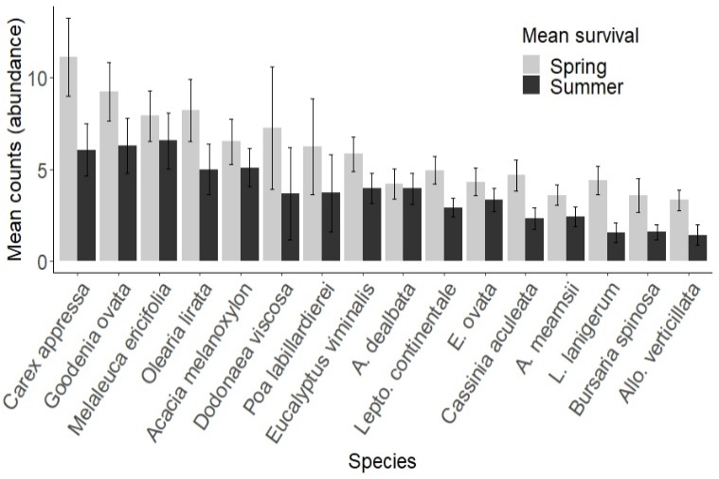

**Fig 2: The average counts (abundance at each site) of the 16 most commonly planted species in spring and after the first summer. Bars represent standard errors.** *Lepto. = Leptospermum, Allo. = Allocasuarina).*

Participants responded that they would be most likely to undertake monitoring in the future if they were provided with funding (68%), and/or a database to enter and store the data (64%).

**How can I contribute?**

Organisations and individuals undertaking revegetation in 2020 can contribute by using the standard monitoring protocol and associated guidelines. Please contact Sacha Jellinek ([sachamj@unimelb.edu.au](mailto:sachamj@unimelb.edu.au)) for more details.

**Acknowledgements**

This project was funded with support of the Victorian

Government as part of the Biodiversity On-ground Action Adaptive Learning project. It was a collaboration between Arthur Rylah Institute and LaTrobe University with support from several CMAs, Greening Australia, Landcare groups and other agencies.

Prepared by: Sacha Jellinek, Tim O’Brien, Andrew

Bennett (September 2020)