ARI Aquatic Quarterly Update – Influence Autumn-Winter 2020

About Us
The Applied Aquatic Ecology section aims to generate and share knowledge, through world-class, applied, ecological research, which supports and guides sustainable ecosystem policy and management to ensure healthy, resilient ecosystems. We work collaboratively with national, state and local agencies, research institutes, universities, interest groups and the community.
Our focus:
- To undertake high quality, relevant ecological research.
- To interpret research outcomes and communicate these effectively to key stakeholders.
- To guide and support sustainable ecosystem policy and management.

This update provides five examples of projects which help managers.

They provide:
- a strong scientific basis to implement flow management to achieve recruitment success for Murray Cod and other species with similar breeding strategies (e.g. Trout Cod, River Blackfish)
- insights regarding the risk of harvest pressure for Murray Crayfish, and recommendations on how fishing regulations could be improved to protect the species.
- a comprehensive analysis of the genetic structure of Estuary Perch populations, to help guide stocking efforts, and to provide a baseline to monitor the overall genetic health of wild populations.
- an enhanced understanding of the patterns of juvenile Australian Grayling entering rivers and the associated drivers to improve management to benefit the species, including through environmental flows.
- a compendium of easily accessible, contemporary ecological knowledge to guide management of priority native freshwater fish within the Murray-Darling Basin.

www.ari.vic.gov.au Subscribe to any of ARI’s communications at www.tiny.cc/ARIsubscribe

Managing flows to enhance recruitment of Murray Cod
Issue: Murray Cod (Maccullochella peelii), with its cultural, conservation and economic values, is a species frequently targeted by waterway restoration actions, particularly environmental flow delivery aimed at enhancing recruitment success. Unfortunately, there are still major gaps in our understanding of how best to manage river flows to benefit recruitment of Murray Cod.
Action: Hypotheses were developed about the links between recruitment and key components of the flow regime, such as flow during spring spawning period or during the summer juvenile stage. Twenty years of annual fish survey data from five rivers in the southern MDB (Murray, Goulburn, Broken, Ovens and King rivers) were then analysed to test these hypotheses. While these rivers varied in their size and habitat characteristics, all have self-sustaining populations of Murray Cod.
Results: Spring flows and their variation during spawning, as well as summer and winter flow conditions during the early juvenile period all influenced the recruitment of Murray Cod, which support our initial hypotheses. This emphasises the importance of accounting for flows that influence each of the key life stages during the recruitment process. For example, ideal elevated spring flow conditions may lead to successful spawning, but if the summer or winter flow conditions which follow are not suitable, these new juveniles may not survive or thrive.
Relationships between river discharge and the strength of Murray Cod recruitment varied across rivers; this likely reflects the differences in the river characteristics (e.g. their flows, habitats and geomorphology) and available data.
Outcome: This work has greatly improved our knowledge of how river flows influence the breeding success of Murray Cod. Our results lend support for managing rivers in accordance with the natural flow regime and provide a strong scientific basis to implement flow management to achieve recruitment success for Murray Cod and other species with similar breeding strategies such as Trout Cod and River Blackfish. Population models, a key tool used to predict long-term population outcomes from a range of flow scenarios, have also been improved by incorporating the results through this work.
Funder: DELWP Water and Catchments. This is an output of the Victorian Environmental Flows Monitoring and Assessment Program (VEFMAP). ARI contact: Zeb Tonkin
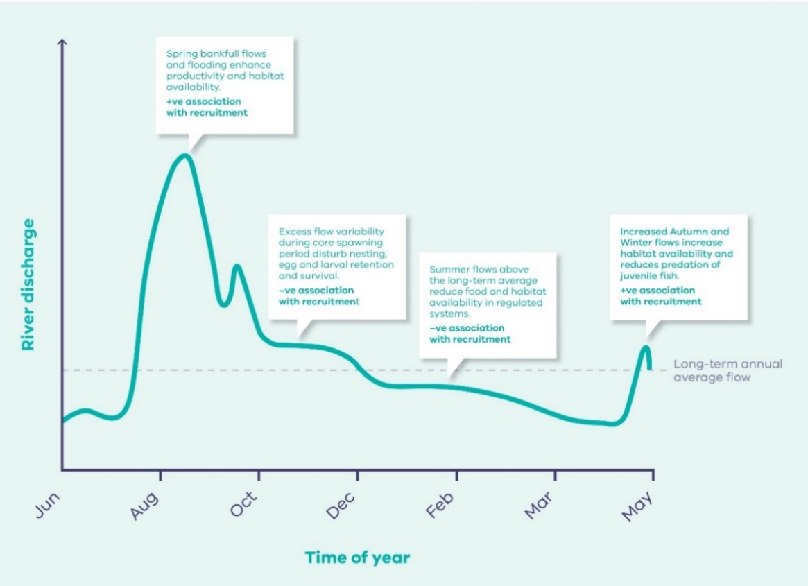
Tonkin et al. (2020) Linking flow attributes to recruitment to inform water management for an Australian freshwater fish with an equilibrium life-history strategy. Science of The Total Environment 752.
Figure 1. Conceptual model showing key flow components influencing recruitment of Murray Cod in northern Victorian rivers.

Assessing the risk of harvest pressure on the threatened Murray Crayfish
Issue: Murray Crayfish (Euastacus armatus), a species popular for recreational take, is threatened and has experienced recent declines in distribution and abundance. It is long lived (25+ years), very slow growing, has limited mobility and reproductive output, and matures at 8-9 years.
Fisheries regulations for crayfish commonly relate to size and sex-specific measures. For Murray Crayfish there is a restricted harvest season, closures for regions, a bag limit and a harvestable slot limit length (HSLL – 100 to 120 mm, Occipital Carapace Length: OCL). There is also a ban on possessing egg bearing females, to help counterbalance the possible effects of overharvesting. It has been suggested that the skewed sex ratios (toward females) that have been detected in populations are a sign of selective harvesting of males and past overharvesting pressure.
Action: A population model was developed for the species to examine the risk of harvest pressure. A new indicator was identified, called ‘size at functional reproduction’ (SFR), which is based on the relationship between size and the likelihood of presence of eggs. This indicator was then compared to the existing indicator of sexual maturity - called ‘size at onset of maturity’ (SOM).
Results: SOM underestimated the risk of harvest pressure compared to SFR. The difference in this risk also became more pronounced with increasing harvest pressure, which indicates SOM is inadequate to characterise risk. This work also found that the large discrepancy in sex ratios (2:1, females to males) in catch data may be attributed to sex-based Differential Encounter Rates, suggesting that using sex ratio as a measure of exploitation and recovery is problematic.
Outcome: This work highlights how our new indicator SFR can allow the rapid assessment of population reproductive output to help set regional harvest regulations. Several recommendations are provided on how fishing regulations could be improved to protect the Murray Crayfish. These include that the harvestable slot limit length be altered to consider the SFR results or that females be protected from take.
ARI contact: Scott Raymond
Raymond and Todd (2020) Assessing risks to threatened crayfish populations from sex-based harvesting and differential encounter rates: A new indicator for reproductive state. Ecological Indicators 118.

Understanding the genetic structure of Estuary Perch populations
Figure. 2. The modelled impact of harvest pressure (probability of capture: capture Pr) and harvest strategy on the Expected Minimum Population Size of a Murray Crayﬁsh population, using the reproductive indicators size at onset of sexual maturity (SOM) and the proposed SFR (size at functional reproduction). SFR harvest strategies include males and non-berried females (male+ nb female), males only (male only), males, non-berried females and diﬀerential rates of encounter (male+ nb female+ DER) and for males and DER (male only+ DER).
Issue: Estuary Perch (Percalates colonorum), an estuarine fish which migrates to the lower reaches of estuaries to spawn, is native to south-eastern Australia. This long-lived species (>40 years) has declined, likely as a response to fishing pressure, flow regulation and climate change. There is now increasing emphasis on stocking rivers with hatchery-reared fish to supplement wild populations. While some assessment of the population genetics of Estuary Perch has occurred, a comprehensive investigation is required, to guide optimal stocking strategies. Uninformed stocking can pose a risk to the genetic integrity of populations leading to declines in fitness and genetic differentiation between populations.
Action: An analysis of the fine-scale population genetic structure and patterns of connectivity was undertaken. This included the development of 21 novel polymorphic microsatellite markers.
Results: This work indicated there is significant genetic structure of populations of Estuary Perch throughout its range in eastern Australia. Three broad genetic clusters were identified, with populations on mainland Australia showing a pattern of isolation by distance. The only known population in Tasmania (Arthur River) is genetically and geographically isolated from mainland populations and has very low levels of genetic diversity.
Outcome: On mainland Australia, three genetic management regions have been defined for management purposes to help guide future supplementation stocking for the conservation of this important recreational fish. The genetic markers developed will enable future monitoring of both the success of supplementation stocking and the effects of supplementation on the genetics of wild populations. This study provides a baseline to monitor the overall genetic health of wild populations of Estuary Perch throughout its range in south eastern Australia.
Funder: East Gippsland Catchment Management Authority (partial funding)
ARI contact: Daniel Stoessel
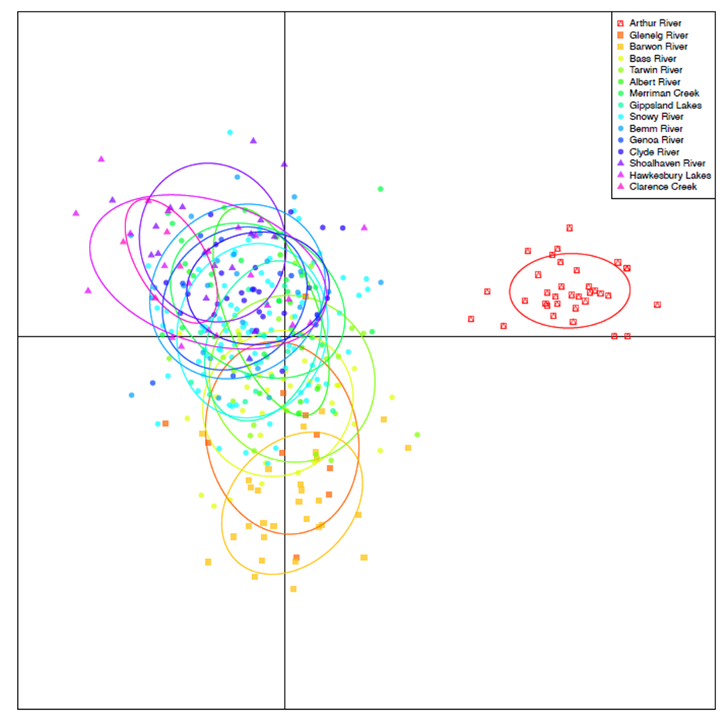
Stoessel et al. (2020) Population genetic structure of estuary perch (Percalates colonorum Gunther) in south-eastern Australia. Marine and Freshwater Research.
Figure 3. Scatter plot of the discriminant analysis of principal components (DAPC) of estuary perch across 21 microsatellite loci. The first two principle components of the DAPC, which explain the majority of the variation, are shown. Clusters are indicated by different symbols (K = 3), while different colours and inertia ellipses represent the sampled estuaries, and dots represent individuals.
Juvenile migration of Australian Grayling
Issue: The Australian Grayling (Prototroctes maraena), a nationally threatened species, is found in coastal rivers and streams in south-eastern Australia. While the species migrates between marine and freshwater habitats as part of its life cycle, the links between river flows and recruitment are poorly understood.
Action: Fish monitoring occurred in the Bunyip, Barwon and Tarwin rivers and Cardinia Creek multiple times between 2016 and 2018, using fine mesh nets and a fish trap on the Barwon Barrage fishway.
Results: Migration occurred from September to December, with peak abundances between late October and early November (mid-austral spring). Catches were also related to mean daily discharge in the preceding 7 days, with highest catches at intermediate flows (100–150 ML day¹).
Outcome: This study has improved our knowledge of the patterns of juvenile Australian grayling entering rivers and the associated drivers to improve management to benefit the species. These findings can help guide management of environmental flows to attract and facilitate the movement of juvenile Grayling into freshwater from marine nursery areas. Considering and managing flows for a range of other life history processes, such as adult spawning migrations, is also important.
Funder: DELWP Water and Catchments and Melbourne Water. This is an output of the Victorian Environmental Flows Monitoring and Assessment Program (VEFMAP).
ARI contact: Wayne Koster
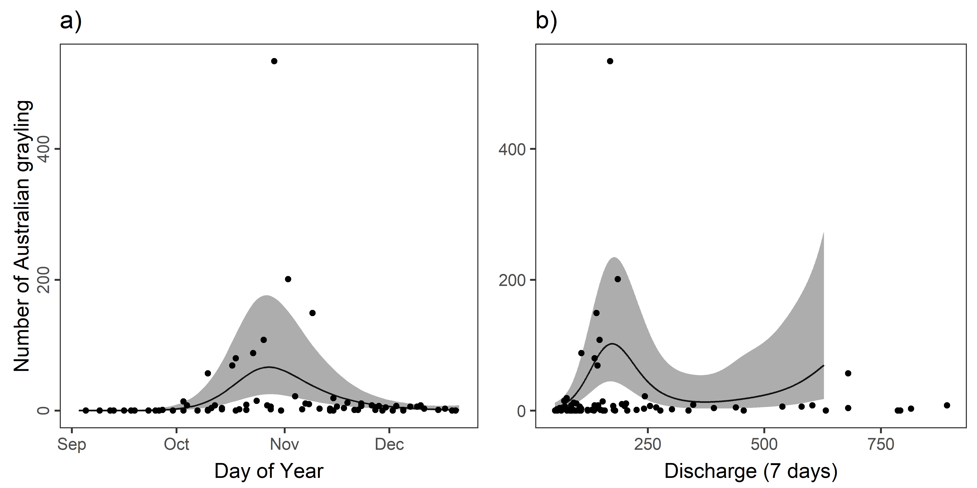
Koster et al. (2020) Environmental influences on the juvenile migration of the threatened amphidromous Australian grayling (Prototroctes maraena). Marine and Freshwater Research.
Figure 4. Predictions from the generalised additive model examining the relationship between the number of Australian Grayling caught in the Bunyip River and (a) day of year and (b) mean daily discharge (ML) in the 7 days before sampling (Discharge 7 days). In (b), model predictions are not shown above 600 ML because the upper confidence intervals were above the y-axis limit. The solid lines indicate the mean prediction and the shaded areas indicate 95% confidence intervals.
Bringing fish ecological information together
Issue: Many freshwater fishes are imperilled globally, including within Australia. There is a need for easily accessible, contemporary ecological knowledge to guide management.

Action: A compendium was prepared which collated knowledge from >600 publications and 27 expert workshops to support the restoration of nine priority native freshwater fish species. These species are representative of the range of life history strategies and values in south eastern Australia’s Murray-Darling Basin (MDB).
Ecological knowledge and threats were assessed for each species and life stage, to help prioritise future research investment and restoration actions. There is considerable new knowledge (80% of publications used were from the past 20 years), but this varied among species and life stages, with most known about adults, then egg, juvenile and larval stages (in that order).
Results: This work identified that the largest knowledge gaps concern early life stage requirements, survival, recruitment, growth rates, condition and movements. Key threats include reduced longitudinal and lateral connectivity, altered flows, loss of refugia, reductions in both flowing and slackwater riverine habitats, degradation of wetland habitats, alien species interactions and loss of aquatic vegetation.
Outcome: This compendium represents an extensive ecological evidence base for multiple species and is provided in a tabular format to assist a range of readers. It also includes examples and case studies to illustrate the application of this knowledge to underpin effective restoration management.
Funder: Murray-Darling Basin Authority and ARI
ARI contact: John Koehn

Koehn et al. (2020) A compendium of ecological knowledge for restoration of freshwater fishes in Australia’s Murray-Darling Basin. Marine and Freshwater Research.
This work is also accompanied by another paper which provides 30 priority activities urgently needed to restore MDB native fishes.
Koehn et al. (2020) What is needed to restore native fishes in Australia’s Murray-Darling Basin? Marine and Freshwater Research
Both papers have been provided as open access and so you get copies free from the Marine and Freshwater Research journal website using links above.

