|  |
| --- |
| Supporting the recovery of  the Southern Right Whale in eastern Australia  Recommendations for threat mitigation, research and stakeholder engagement |
| K. Stamation and M. Watson |
| June 2023 |

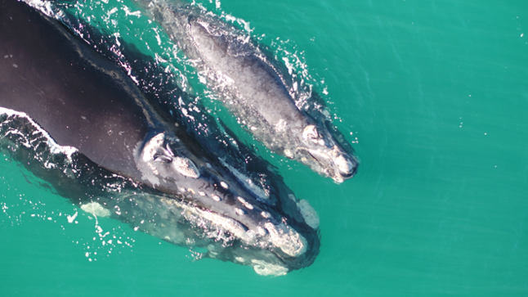

Arthur Rylah Institute for Environmental Research   
Technical Report Series No. 362



|  |
| --- |
| Acknowledgment  We acknowledge and respect Victorian Traditional Owners as the original custodians of Victoria's land and waters, their unique ability to care for Country and deep spiritual connection to it. We honour Elders past and present whose knowledge and wisdom has ensured the continuation of culture and traditional practices.  We are committed to genuinely partner, and meaningfully engage, with Victoria's Traditional Owners and Aboriginal communities to support the protection of Country, the maintenance of spiritual and cultural practices and their broader aspirations in the 21st century and beyond. |

Arthur Rylah Institute for Environmental Research  
Department of Energy, Environment and Climate Action   
PO Box 137  
Heidelberg, Victoria 3084  
Phone (03) 9450 8600  
Website: [www.ari.vic.gov.au](http://www.ari.vic.gov.au)

**Citation**: Stamation, K., and Watson, M. (2022). Supporting the recovery of the Southern Right Whale in eastern Australia: recommendations for threat mitigation, research and stakeholder engagement. Arthur Rylah Institute for Environmental Research Technical Report Series No. 362. Department of Energy, Environment and Climate Action, Heidelberg, Victoria.

**Front cover photo**: Mother and calf at Yambuk, south-west Victoria on 4 September 2018 (3FBAerworx). Taken under DELWP Wildlife Act 1975 research permit no. 10008395

Logo© The State of Victoria, Department of Energy, Environment and Climate Action 2023

This work is licensed under a Creative Commons Attribution 3.0 Australia licence. You are free to re-use the work under that licence, on the condition that you credit the State of Victoria as author. The licence does not apply to any images, photographs or branding, including the Victorian Coat of Arms, the Victorian Government logo, the Department of Energy, Environment and Climate Action logo and the Arthur Rylah Institute logo. To view a copy of this licence, visit <http://creativecommons.org/licenses/by/3.0/au/deed.en>

Edited by Dr David Meagher, Zymurgy Consulting

ISSN 1835-3827 (print)

ISSN 1835-3835 (pdf))

ISBN 978-1-76136-303-0 (print)  
ISBN 978-1-76136-304-7 (pdf/online/MS word)

**Disclaimer**This publication may be of assistance to you but the State of Victoria and its employees do not guarantee that the publication is without flaw of any kind or is wholly appropriate for your particular purposes and therefore disclaims all liability for any error, loss or other consequence which may arise from you relying on any information in this publication.

Accessibility

If you would like to receive this publication in an alternative format, please telephone the DEECA Customer Service Centre on 136 186, email [customer.service@delwp.vic.gov.au](mailto:customer.service@delwp.vic.gov.au) or contact us via the National Relay Service on 133 677 or [www.relayservice.com.au](http://www.relayservice.com.au). This document is also available on the internet at [www.deeca.vic.gov.au](http://www.delwp.vic.gov.au)

Supporting the recovery of the Southern Right Whale in eastern Australia.

Recommendations for threat mitigation, research and stakeholder engagement.

Kasey Stamation1 and Mandy Watson2

1 Arthur Rylah Institute for Environmental Research   
 123 Brown Street, Heidelberg, Victoria 3084

2 Department of Energy, Environment and Climate Action  
 Barwon South West Region,  
 30–30 Little Malop Street, Geelong 3220

Date

Arthur Rylah Institute for Environmental Research  
Technical Report Series No. 362

# Acknowledgements

We gratefully acknowledge the advice and feedback provided by our colleagues on earlier drafts of this report, in particular Peter Menkhorst, Andy Geschke, Rob Hale, Rachel Leihy and Diane Crowther. This work was funded through the Icon Species program, DEECA.

Contents

Acknowledgements ii

Summary v

1 Introduction 1

2 Priority threats 5

2.1 Entanglement 5

2.2 Vessel strike 8

2.3 Anthropogenic noise 10

3 Priority actions 13

3.1 Entanglement mitigation 13

3.2 Vessel strike mitigation 16

3.3 Anthropogenic noise mitigation 17

3.4 Addressing knowledge gaps 17

3.5 Research priorities 18

4 Stakeholder engagement 26

5 Conclusion 32

References 33

Tables

Table 1. List of research priorities to address key knowledge gaps and their applicability to State or Commonwealth waters. 22

Table 2. List of methods to address key knowledge gaps. 25

Table 3. Key considerations for development of a Stakeholder Engagement Plan. 27

Figures

Figure 1 (a) The location of Southern Right Whale cow–calf pair sightings and historical high use areas in south-eastern Australia. (b) The number of Southern Right Whale cow–calf records per site location in Victoria. (c) Detail from map (b) showing the historically important south-western Victorian area. 3

Figure 2. A female Southern Right Whale (with calf) showing scars, injury, and poor health as the result of an entanglement. Sealers Cove, Wilsons Promontory, Victoria, August 2014. 6

Figure 3 (a) The number of whale entanglement reports in Victorian waters between 2003 and 2021. (b) Victorian entanglements reports between 2003 and 2021 broken down by species and entanglement type. 7

Figure 4. Southern Right Whale (nicknamed ‘Tangles’) caught in rock lobster fishing gear near Portland in August 2018.This whale was successfully disentangled on 12 August 2018 after a four-day emergency operation. 8

Figure 5. Vessel traffic for the month of August 2022 and all Southern Right Whale cow–calf pair sightings in Victoria. 10

Figure 6. Estimated benefit of management scenarios to persistence anywhere in eastern Australia under RCP 4.5 climate change scenario (top graph) and RCP 8.5 climate change scenario (bottom graph). 15

# Summary

### Context:

The Southern Right Whale (*Eubalaena australis*) is listed as endangered in Victoria; the eastern Australian population is estimated to be less than 300 individuals. The recovery from commercial whaling has been more protracted for this species than it has been for the Humpback Whale (*Megaptera novaeangliae*) in eastern Australia, and is thought to be constrained by the Southern Right Whale’s strong site fidelity and migratory culture and its relatively long calving cycle.

A Specific Needs Assessment for Southern Right Whales was undertaken by the Victorian Government in 2021. This expert elicitation process predicts the probability of persistence of the eastern Australian population under a range of management scenarios and two climate change scenarios. The assessment concluded that, even under best-case climate change scenarios, reducing the risk of premature deaths due to anthropogenic threats and protecting coastal breeding habitat are vital for ensuring the persistence of the eastern Southern Right Whale population.

While acknowledging that conservation efforts are needed throughout the species’ range and that reducing effects of climate change is crucial, this report focuses on actions to reduce the risk of mortality and habitat displacement from three key threats in Victorian waters: entanglement, vessel strike and anthropogenic noise. This report also addresses the existing critical knowledge gaps and the need for long-term monitoring and rigorous scientific data to successfully manage this endangered population.

### Aims:

* Use the outcomes of the Specific Needs Assessment to investigate threat mitigation tools relevant to Victorian waters.
* Develop recommendations for practical actions that will support the recovery of the Southern Right Whale in Victorian waters.
* Identify key considerations to support the development of a stakeholder engagement plan to support the successful implementation of recommended threat mitigation actions for the protection of the Southern Right Whale in Victorian waters.
* Identify research priorities to support the development of a research plan aimed at filling critical knowledge gaps to support the recovery of the Southern Right Whale in eastern Australia.

### Findings and recommendations:

The risk assessments undertaken for the Draft National Southern Right Whale Recovery Plan (DCCEEW, 2023) and the Victorian Specific Needs Assessment have helped to determine priority actions that can be implemented in Victorian waters to mitigate the key threats of entanglement, vessel strike and anthropogenic noise. These recommendations are:

1. Build partnerships and meaningful engagement between government agencies (DEECA and VFA) and Victorian Rock Lobster fishers.
2. Develop and test practical solutions to reduce the whale entanglement risk from the Victorian Rock Lobster Fishery.
3. Support and promote the application of the [Rock Lobster Fishery Code of Practice](https://delwpvicgovau.sharepoint.com/sites/ecm_93/BioDiv/IconSpecies-SRW/(https:/www.siv.com.au/uploads/9/8/7/7/98771034/siv_rock_lobster_code_of_conduct_-_final_printing_artwork.pdff) by commercial Rock Lobster fishers in Victoria.
4. Create engaging communications material to promote awareness and increase reporting rates and near- to real-time reporting.
5. Continue investment in disentanglement training and emergency response for Victorian government staff and partner agencies.
6. Identify areas where there is a high risk of vessel strike.
7. Legislate additional vessel exclusion zones in high-risk areas for cow–calf pairs (i.e. areas where cow–calf pairs are likely to overlap with high vessel traffic).
8. Test the feasibility of vessel speed restriction measures around cow-calf pairs and/or within reproduction biologically important areas (BIAs)
9. Test the feasibility of dynamic vessel exclusion zones to protect cow–calf pairs as they move around the coast during the breeding season or reside in otherwise unprotected habitat.
10. Test the feasibility of dynamic speed zones triggered by Southern Right Whale sightings.
11. Develop and evaluate targeted efforts to raise awareness of Southern Right Whale regulations and other mitigation strategies (e.g., seasonal signage at boat ramps, provision of information on popular boating websites).
12. Increase seasonal compliance monitoring and prosecution efforts.
13. Investigate ways to improve reporting of vessel-whale interactions and processes for data management.
14. Trial the use of automated whale detection systems in high-risk areas where cow–calf pairs are likely to overlap with shipping traffic, such as Portland.
15. Improve industry–regulator–research and research–regulator–industry consultation processes.
16. Support research into characterising the underwater soundscape of important Southern Right Whale habitat areas and the potential impacts (including cumulative effects) of different noise on Southern Right Whales.

Critical knowledge gaps for this population still exist, and research efforts need to concentrate on those that help fill these gaps and provide practical information that will help manage and support the recovery of the eastern Australian Southern Right Whale population. Long-term standardised baseline monitoring and studies that test new and existing threat-reduction methods are required. A summary of ten priority knowledge gaps and associated methods to address them is provided.

An effective stakeholder engagement plan is also required to help guide and develop current and future mitigation strategies. Key considerations for an effective engagement plan to support the recovery of Southern Right Whales in Victoria are provided. This includes consulting with behavioural change experts to tailor communication tools based on the key messages, key actions and potential perceived barriers for each of the key stakeholder groups. An engagement plan should also include an evaluation component to measure the success of the communication strategies.

1. Introduction

Southern Right Whales (*Eubalaena australis*) were targeted for commercial hunting between 1790 and 1980, and at least 150,000 were killed globally (Jackson et al., 2008). In New Zealand and south-eastern Australian waters alone, over 58,000 Southern Right Whales were killed, including approximately 19,000 in south-eastern Australian waters (Carroll et al. 2014). Southern Right Whale populations are structured by their preferences for winter calving areas and summer foraging grounds. These preferences typically seem to be driven by strong site fidelity and ‘cultural memory’ (Valenzuela et al. 2009; Carroll et al. 2015, 2016, 2020a; Harcourt 2019), although individuals are also capable (at least in more recent times) of sudden shifts in location (Harcourt 2019; Weir and Stanworth 2019; Carroll et al. 2020a; Watson et al. 2021). The high degree of philopatry, strong migratory culture and relatively long calving cycle have constrained the recovery of right whale populations around the world (Valenzuela et al. 2009; Carroll et al. 2015, 2016, 2020a; Harcourt 2019), resulting in a much slower return in comparison to other species, such as the Humpback Whale (Zerbini et al. 2010; Noad et al. 2019). Two genetically distinct populations of Southern Right Whales winter in Australian waters: a western Australian population that calves in South Australian and Western Australian waters, and an eastern Australian population whose breeding range includes Victorian, Tasmanian, New South Wales and southern Queensland waters. The eastern population is estimated to comprise less than 300 individuals, including 68 breeding females; the western population is estimated at more than 2,500 individuals. Both populations are increasing at a rate of about 5% p.a. (Stamation et al. 2020; Smith et al. 2021).

Although breeding females have been observed with young calves in multiple locations along the eastern coast of Australia, the only currently established calving area in eastern Australia is at Logans Beach, near Warrnambool in Victoria (see Watson et al. 2021). It is possible that this was the only calving site in eastern Australia where all females familiar with this site were not killed during the whaling era (pre-1980), so that the cultural memory for that site was retained. At least 15 different breeding females use Logans Beach (Watson et al. 2021). An average of 2 to 3 calves are born here each year, and there has been no significant change in this calving rate over the past 30 years (Stamation et al. 2020). In recent years there has been an increasing number of observations of cow–calf pairs over-wintering in locations that correspond with historically important areas, such as southern New South Wales and other parts of south-western Victoria, as well as new areas across the coast of Victoria (Figure 1). Some of these historically important areas overlap with high levels of shipping, including Portland in western Victoria.

Cetaceans are often considered flagship species and indicators of ecosystem health (Nelms et al. 2021; Parsons et al. 2015), and are essential to the functioning of marine ecosystems (Visser 2007; Lavery et al. 2014; Roman et al. 2014; Doughty et al. 2016). However, at least 25% are globally threatened (IUCN 2022). Nelms et al. (2021) outlined the key threats facing marine mammals globally and highlighted the need for setting evidence-based priorities for research and conservation. They summarised the key threats as:

* **Climate change** and its potential impacts on prey and critical habitat availability. It is predicted that reduced prey from warming oceans and interspecific competition will lead to dramatic declines and even extinction of some baleen whale populations (Tulloch et al. 2019).
* **Fisheries,** where direct impacts include incidental capture and entanglement, as well as competition for food resources.
* **Industrial development,** including the construction of ports, dams, facilities related to industry and marine renewable energy installations.
* **Exploitation** for consumption.
* **Pollution,** including underwater noise from a variety of sources, plastics that can be ingested or entrap individuals, and chemical contaminants.

**a**

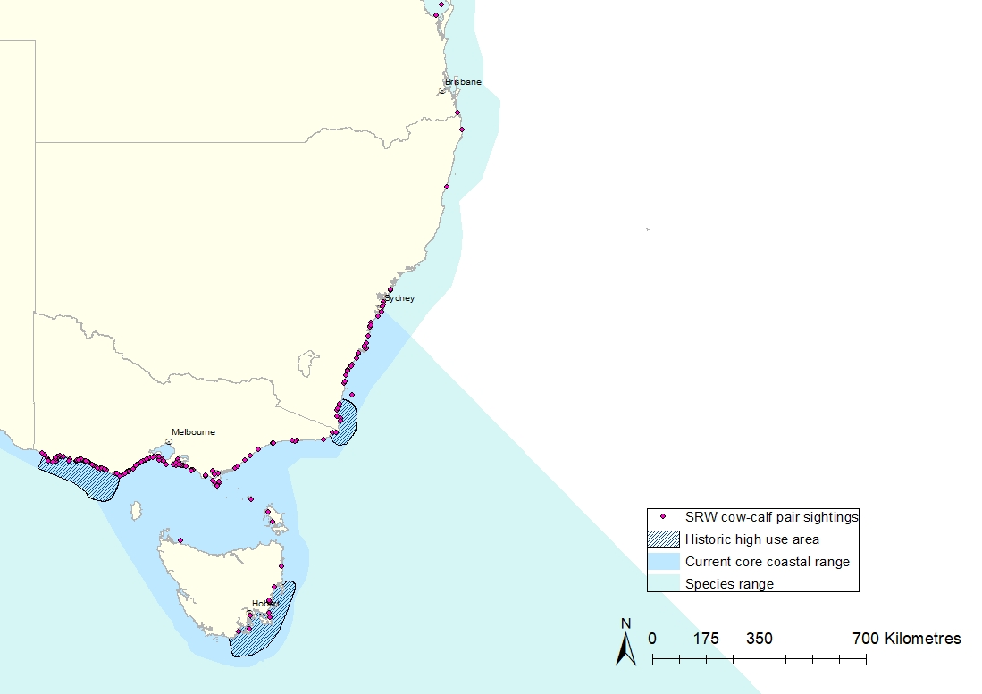

**b**

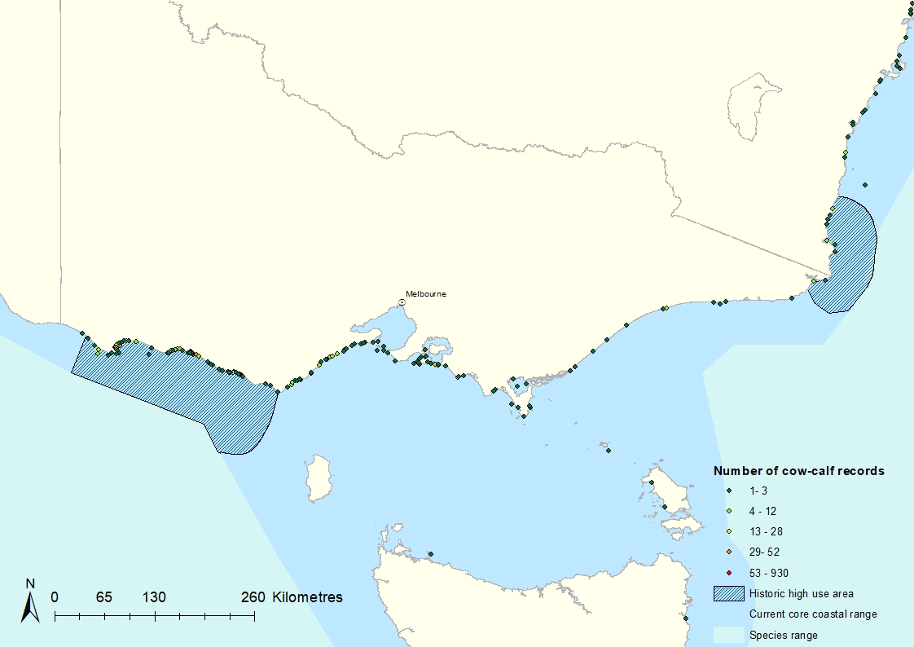

**c**

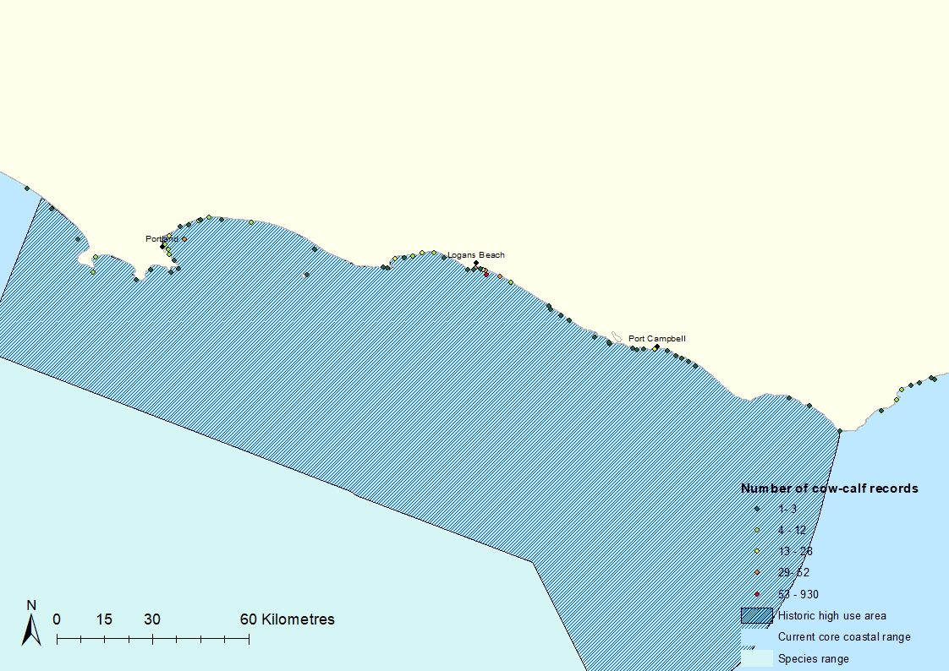

Figure 1 (a) The location of Southern Right Whale cow–calf pair sightings and historical high use areas in south-eastern Australia. (b) The number of Southern Right Whale cow–calf records per site location in Victoria. (c) Detail from map (b) showing the historically important south-western Victorian area.

Data expands from 1971 to 2022. Records are grouped by location and date, so only one record is counted per site and date. ‘Historical use’ refers to areas inhabited by significant numbers of Southern Right Whales in pre-whaling times. Historical use areas and species ranges are adapted from DSEWPC (2012).

Excluding direct exploitation, Southern Right Whales in the eastern Australian population are exposed to all the threats listed above. Like other migratory cetacean species, they are vulnerable to anthropogenic threats throughout most of their range, including in coastal waters where they breed, and offshore environments they use for transiting and foraging. The national Southern Right Whale Conservation Management Plan states that the long-term recovery objective is to minimise anthropogenic threats, to allow the conservation status of the Southern Right Whale to improve so that it can be removed from the threatened species list under the EPBC Act (DSEWPC 2012). The current plan and new draft recovery plan (DCCEEW 2023) recognise the need to reduce cumulative impacts of underwater noise, entanglement in fishing gear, habitat modification, and vessel disturbance. These plans (as well as the wider research community) recognise the need to address significant knowledge gaps to better understand the species needs (including the location of foraging grounds, migratory pathways and coastal habitat use) and the scale of the impacts of climate change and other anthropogenic threats on the health and recovery of Southern Right Whale populations (Harcourt et al. 2019; Carroll et al. 2020b).

The Southern Right Whale is listed as endangered in Victoria under the *Flora and Fauna Guarantee Act 1988* (Vic.). A Specific Needs Assessment for the Southern Right Whale was completed in 2021. This was an expert elicitation process that focused on predicting the probability of persistence of the eastern Australian population under a range of species-specific management scenarios and two climate change scenarios. The measure of persistence was focused on the probability of breeding habitat being used by breeding females 100 years into the future. The project reported on here used the outcomes of the Specific Needs Assessment to investigate threat mitigation tools relevant to Victorian waters and to develop recommendations for practical on ground actions that support the recovery of the eastern Australian Southern Right Whale population. We present a stakeholder engagement plan (Section 5) that identifies relevant stakeholders, appropriate methods for engagement, and timelines to support the implementation of the recommended actions. This report also brings into focus the priorities for Southern Right Whale research in Victoria, with the development of a research plan that incorporates new and existing technology to collect robust data to inform the ongoing management and conservation of the species in Victorian waters.

1. Priority threats

Concern over anthropogenic impacts on the recovery of populations of all three right whale species (North Atlantic *Eubalaena glacialis*, North Pacific *Eubalaena japonica* and Southern *Eubalaena australis*) is well documented (see Harcourt et al. 2019). Indirect impacts of climate change and habitat modification on health and reproduction are not well understood, but are predicted to have significant consequences for right whale populations (Leaper et al. 2006; Seyboth et al. 2016; Tulloch et al. 2019; Agrelo et al. 2021). A recent study at Península Valdés in Argentina found a marked increase in Southern Right Whale mortality rates following El Niño events (Agrelo et al. 2021). The authors hypothesised that the impact is greatest for females that need to replenish their energy stores following weaning of a calf. Lengthening of calving intervals observed in several right whale populations in recent years could be linked to food availability and changes in sea surface temperatures (Rolland et al. 2016; Charlton 2017; Brandão et al. 2018; Meyer-Gutbrod and Greene 2018; Vermeulen et al. 2018; Record et al. 2019). Myer-Gutbrod et al. (2021) demonstrated a direct link between birth rates of North Atlantic Right Whalesand the abundance of a key copepod prey. North Atlantic Right Whales and Southern Right Whales are also becoming smaller (Stewart et al. 2021; Vermeulen et al. 2023). A recent study reported a 23% reduction in the maternal body condition of Southern Right Whales in South Africa over a 43-year monitoring period (Vermeulen et al. 2023). In Northern Atlantic Right Whales body length has been correlated to calf production and calving intervals (Stewart et al. 2022). The effects of habitat modification, including noise from industry, construction and recreation, are additional stressors that could displace individuals from important habitat, deplete energy reserves, cause injury, and interfere with important communication and other biological functions (Cunningham and Mountain 2014; Tenessen and Parks 2016; Erbe et al. 2019; Quintana-Rizzo et al. 2021; Morrette 2022).

Direct human-induced whale mortality such as entanglement and vessel strike are somewhat more quantifiable, although the availability of data can be severely limited by the lack of reporting and the challenges of locating individual whales that have been impacted. For some right whale species, the impacts are stark, none more so than the critically endangered North Atlantic Right Whale. Between 2014 and 2018, the annual detected human-caused mortality and serious injury to right whales from entanglement and vessel strike averaged 8.15 (Hayes et al. 2021) and an analysis of all non-calf right whale carcasses between 2003 and 2018 found that all mortality (where cause of death could be determined) was human induced (Sharp et al. 2019).

A conclusion of the first expert workshop for the Southern Right Whale Specific Needs Assessment was that, even under best case climate change scenarios, reducing the risk of premature deaths due to anthropogenic threats and protecting coastal breeding habitat are vital for ensuring the persistence of the eastern Southern Right Whale population.

While acknowledging that conservation efforts are needed throughout the species’ range, and that reducing climate change impacts are crucial, this report focuses on prioritising actions to reduce the risk of mortality and displacement from habitat due to three key threats in Victorian waters: entanglement, vessel strike and anthropogenic noise. Reducing the impacts of these threats could help improve the resilience of the population to the impacts of climate change.

This report also addresses the existing critical knowledge gaps and the need for long-term monitoring and rigorous scientific data to successful management this endangered population.

* 1. Entanglement

The incidental capture or entanglement of animals in fishing gear is a long-standing global concern, yet continues to have devastating effects on marine mammal populations (see Nelms et al. 2021 for a review). For right whales the problem is most serious in the North Atlantic Right Whale: fewer than 400 individuals survive, 83% of the population shows evidence of entanglement, and the rate of serious injury that is likely to be fatal is more than 6 individuals per year (Hayes et al. 2021). The long-term health and reproductive implications of non-lethal entanglements in this population includes increased stress levels, high energetic costs, restricted growth rates and lower reproductive output (Knowlton et al. 2012; Hunt et al. 2016; Rolland et al. 2016; Pettis et al. 2017; Rolland et al. 2017; Lysiak et al. 2018; Stewart et al. 2021; Stewart et al. 2022). In small populations such as the North Atlantic Right Whale and the eastern Australian Southern Right Whale, losing even a very small number of breeding females can significantly impede population recovery (Pace et al. 2017; Stamation et al. 2020).

There are limited data available on the rates of whale entanglement in Australia, and it is likely that many incidents go unreported. Evidence of entanglement scarring has not been quantified for the eastern Southern Right Whale population, but preliminary data suggests the rate is approximately 1%. Some clear examples of scarring, injury and poor health (likely the result of entanglement) are available in the South-Eastern Australian Southern Right Whale Photo Identification Catalogue (SEA SRW PIC). For example, the whale shown in Figure 1 appears to have a curvature of the spine and scaring on the keel of the tailstock that is likely the result of a previous entanglement. This individual is emaciated and has a high load of orange cyamids (*Cyamus erraticus),* a whale louse that you typically only see in high numbers on new born calves or unhealthy adult Southern Right Whales (Kaliszewska et al. 2005). It is accompanied by a calf that appears undersized of for its age (estimated as 2-3 months old, based on the timing of the photo).

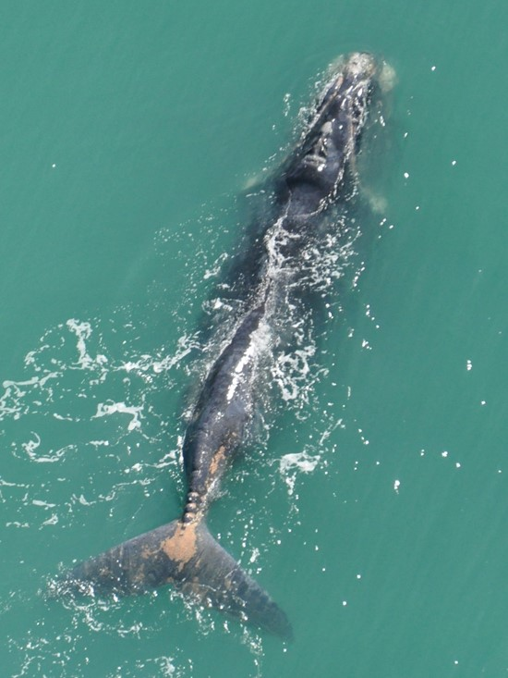

Figure 2. A female Southern Right Whale (with calf) showing scars, injury, and poor health as the result of an entanglement. Sealers Cove, Wilsons Promontory, Victoria, August 2014.

Photo: Ian Westhorpe.

A review of historical records for Australian waters revealed 28 documented whale entanglement incidents between 1887 and 2016, 14 of those involving Southern Right Whales (Tulloch et al. 2020). This assessment revealed the highest risk of entanglement for Southern Right Whales was from traps and ropes used in commercial fishing. Over the last 10 years (2012 to 2021) 325 entangled whales have been reported in Australian waters, including six Southern Right Whales in eastern Australian waters (IWC 2021).

Since Victorian entanglement records began in 2003, DEECA has received 26 confirmed reports, an average of more than one per year (Figure 3a). Seven of those reports were of Southern Right Whales, and—as in the national assessment of Tulloch et al. (2020)—by far the most common entanglement type was rock lobster fishing gear (Figure 3b). The seven Southern Right Whale entanglement reports occurred in different areas: four in the south-west (Cape Bridgewater to Marengo), two near Phillip Island, and one off East Gippsland. Although data is limited, it does suggest an increase in the entanglement rate of Southern Right Whales in Victoria in recent years; three of the seven entanglements (recorded over a 20 year period) occurred in the last five seasons (2018–2022).

Moorings such as those associated with floating offshore renewable energy facilities, oil and gas platforms, wave and tidal energy systems and coastal infrastructure pose a moderate entanglement risk (Benjamins et al. 2014; Farr et al. 2021). The degree of risk depends on the design of the mooring (e.g., the number and placement of lines) and how much tension is in the line, with slack lines posing the greatest risk (Benjamins et al. 2014). Moorings in areas where baleen whales are foraging are thought to pose the greatest risk of entanglement. There have been no reported entanglements of Southern Right Whale at moorings in Australia, but there was a recent report of a Humpback Whale entangled in a mooring line off the Western Australian coast in 2019 (IWC 2021). As the demand for renewable energy increases it is expected that moorings associated with wind and wave energy facilities will become more prevalent in the marine landscape.

**a**

**b**

Figure 3 (a) The number of whale entanglement reports in Victorian waters between 2003 and 2021. (b) Victorian entanglements reports between 2003 and 2021 broken down by species and entanglement type.

RL = Rock Lobster. Data is based on DEECA records, and only confirmed reports have been included. Records directly from the industry were not sourced for this report.

Cetacean entanglement is a declared emergency in Victoria. The Victorian Department of Energy, Environment and Climate Action (DEECA) is the lead agency responsible for response to cetacean entanglements including incident management, expert advice, planning support and on-water response (Victorian Cetacean Emergency Plan 2018). DEECA also provides specialised whale-disentanglement training for department and support agency staff nationally (Victorian Cetacean Emergency Plan 2018). Disentanglement operations are inherently dangerous, involving large, stressed animals capable of sudden, unpredictable and aggressive behaviour. Success depends on locating and tracking a highly mobile whale in an adverse ocean environment. Southern Right Whales can be highly elusive and can travel long distances, even while dragging heavy ropes and other fishing gear. Only 3 out of 19 incident responses have so far resulted in the successful removal of an entanglement, largely because of difficulties relocating whales and the unsafe sea conditions. Reporting is often delayed, which can further hinder rescue efforts.

A successful disentanglement operation not only relies on a fast response, but on other factors like favourable sea conditions and location. The successful rescue of a Southern Right Whale near Portland (Figure 4) can be attributed largely to the fact that the whale stayed close to a populated coastline long enough for crews to wait for sea conditions that were safe enough to mount a response. Aircraft and community observers were helpful in relaying location information to disentanglement crews. The dangerous nature and low success rate of disentanglement on the southern Australian coastline highlights the need for preventative actions.

The Victorian Southern Rock Lobster Fishery has developed a voluntary [Rock Lobster Fishery Code of Practice](https://delwpvicgovau.sharepoint.com/sites/ecm_93/BioDiv/IconSpecies-SRW/(https:/www.siv.com.au/uploads/9/8/7/7/98771034/siv_rock_lobster_code_of_conduct_-_final_printing_artwork.pdf) (CoP) that outlines best practice for the commercial sector. The intent is for the code to be reviewed every five years in consultation with the industry, RockLobster and Giant Crab Resource Assessment Group (RAG), Seafood Industry Victoria (SIV) and SeaNet. The most recent review was in 2022. The code includes several measures aimed at reducing the level of whale entanglement. These include avoiding excessive slack in pots by adjusting ropes to a length appropriate to the depth and strength of the tide at the site being worked; regularly checking pots; and not leaving pots in the water for prolonged periods. The code also details reporting procedures for interactions with whales. Neither the effectiveness of the measures outlined in the CoP or the level of uptake by the industry has been formally evaluated, but whale entanglements have continued to occur during the decade that the CoP has been in place.

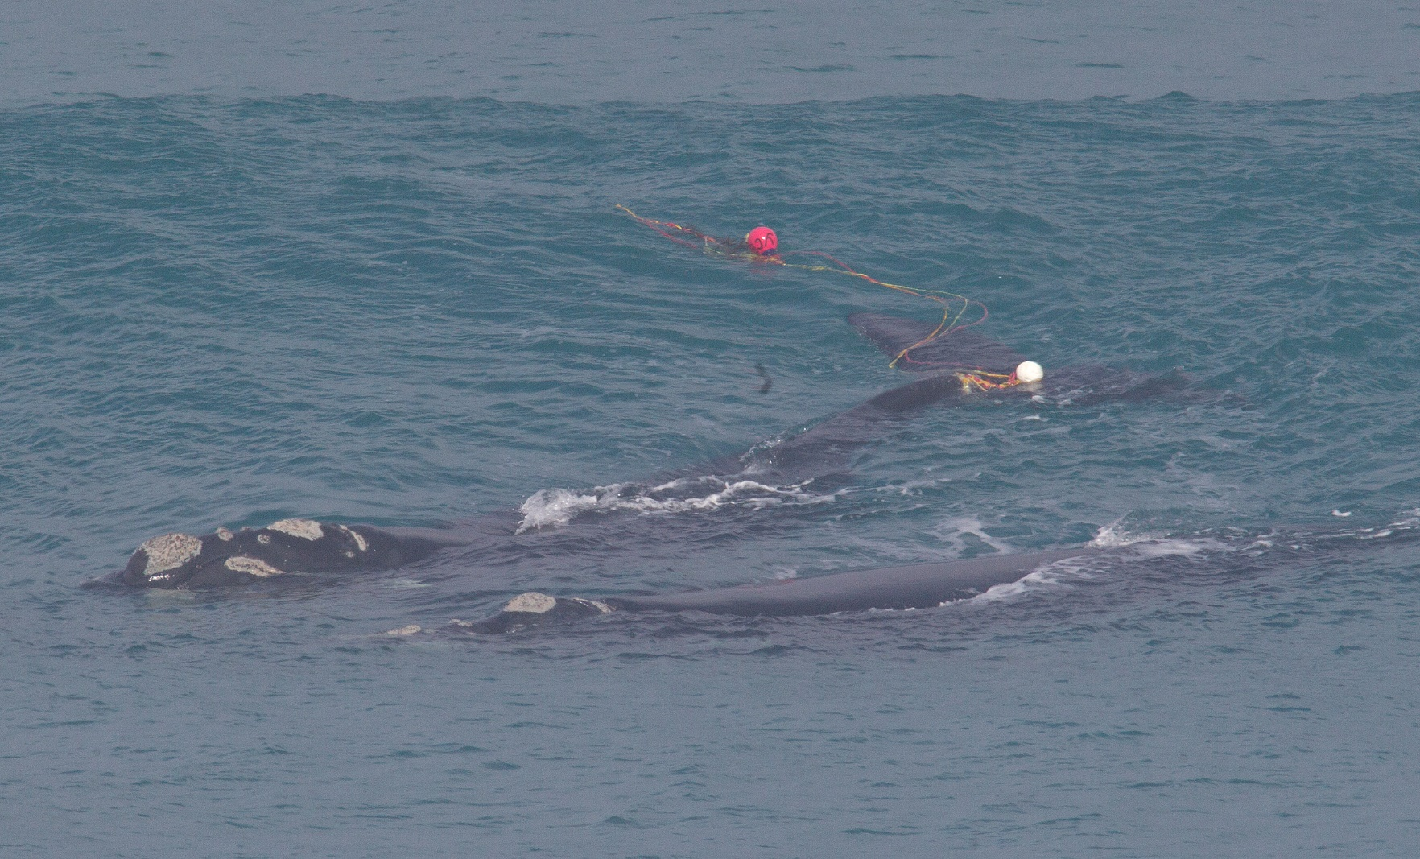

Figure 4. Southern Right Whale (nicknamed ‘Tangles’) caught in rock lobster fishing gear near Portland in August 2018.This whale was successfully disentangled on 12 August 2018 after a four-day emergency operation.

Photo Credit: Bob McPherson

* 1. Vessel strike

Vessel strike is recognised globally as a leading cause of direct human-induced whale mortalities (Cates et al. 2017; Peel et al. 2018; Nelms et al. 2021). It is both an animal welfare issue and one that has the potential to threaten smaller vulnerable whale populations (Peel et al. 2018; Harcourt et al. 2019). Furthermore, it poses a risk to human safety, human fatalities have occurred in Australian waters as the result of whale-vessel collisions (Peel et al. 2018). The potential for vessel collision continues to increase with a global increase in maritime traffic, military shipping and offshore industries (Cates et al. 2017; Peel et al. 2018; Nelms et al. 2021). The issue is of such concern that it prompted the International Whaling Commission to develop a strategic plan to reduce the threat of ship strikes on cetaceans (Cates et al. 2017). The plan highlights the importance of identifying and managing high risk areas, where areas with high vessel traffic, such as shipping lanes and ports, overlap critical whale habitat used for feeding, breeding or migration.

Southern Right Whales are particularly vulnerable to vessel strike from recreational and commercial vessels because they spend much time close to shore, during their calving period, often resting just below the surface—a behaviour known as logging. Their dark skin and lack of a dorsal fin also make them very difficult to see. In Australia, Southern Right Whale distribution overlaps with major shipping areas (Peel et al. 2018), and it is not surprising that the timing of most vessel strike reports corresponds with the species’ winter breeding migration. There appears to have been a significant increase in Southern Right Whale ship strikes in the last decade. A review of historical vessel strike records (Peel et al. 2018) found 137 documented collisions in Australian waters between 1877 and 2015, of which 10 involved Southern Right Whales (0.7 strikes per decade). Over the 10 years between 2012 and 2021 there were 38 reports of whales being struck by vessels in Australian waters, which included four Southern Right Whales in eastern Australian (Kemper et al. 2008; IWC 2021). At least one of these incidents involved a cow–calf pair struck by a ferry in Moreton Bay in 2014 (Lanyon and Janetzki, 2016).

There are few confirmed cases of vessel strikes on whales in Victorian waters, and none for Southern Right Whales, but it is likely that most interactions go unreported and might not even be detected by larger vessels (Peel et al. 2018; Ritter and Panigada 2019). Most of the data on cetacean vessel strikes comes via stranding incidents. In Victoria a whale stranding is classed as a wildlife emergency and is managed in accordance with the Victorian Cetacean Emergency Plan (VCEP). Between 1991 and 2019 there were 14 fatal strandings (9 dolphins and 5 large whales) in which collision with a vessel was the suspected cause (DEECA, unpublished data). Often the exact cause of death and the type of vessel that might have caused the injury cannot be confirmed due the condition of the carcass, and retrieval of the carcass for expert post-mortem examination is often not feasible.

In Victoria there are several areas where Southern Right Whale distribution overlaps shipping lanes and high vessel traffic (Figure 5). There are four major commercial ports in Victoria (Melbourne, Geelong, Hastings and Portland), all within the coastal distribution of the eastern Southern Right Whale population. These ports play a significant role in Victoria’s economy and are the conduit for approximately $26 billion worth of exports (<https://transport.vic.gov.au/ports-and-freight/commercial-ports>, accessed July 2022). <https://transport.vic.gov.au/ports-and-freight/commercial-ports>, accessed July 2022). Vessel traffic is expected to continue to increase, with freight volumes predicted to more than double over the next 30 years (<https://transport.vic.gov.au/ports-and-freight/commercial-ports>, accessed July 2022). Recreational boating also continues to be a popular activity in Victoria, with an estimated 696,000 adults participating in 6.6 million trips in Victorian waters in the 2018–19 financial year (Ernst and Young 2020). The coastal areas in the Port Phillip, South West and Gippsland regions were the most popular. This report estimated that by 2037–38 there will be close to 950,000 recreational boaters making 8.7 million trips per year (Ernst and Young 2020).

Marine mammal interactions with vessels in Victorian Waters are regulated under the Wildlife (Marine Mammal) Regulations 2019 (<https://www.legislation.vic.gov.au/in-force/statutory-rules/wildlife-marine-mammals-regulations-2019/001>, accessed May 2022). The regulations state that boats must not approach within 100 m of a dolphin and 200 m of a whale. Jet-skis are not permitted within 300 m of a whale or dolphin. There is also a vessel exclusion zone (specified in the regulations) at the Southern Right Whale calving ground off Logans Beach, near Warrnambool. It is in effect from 1 June to 31 October each year and excludes all powered vessels from entering the area, which extends approximately two nautical miles along the coast and out to one nautical mile offshore.

The waters around Portland in south-western Victoria (where there is high vessel traffic) are of particular concern. This section of coastline is mapped as a biologically important area (BIA) for the eastern population (DCCEEW 2023). The consequences of vessel strike for the eastern Australian population are considered to be major, given that even a low-level anthropogenic mortality has the potential to impede the recovery of such a small population (DCCEEW 2023).

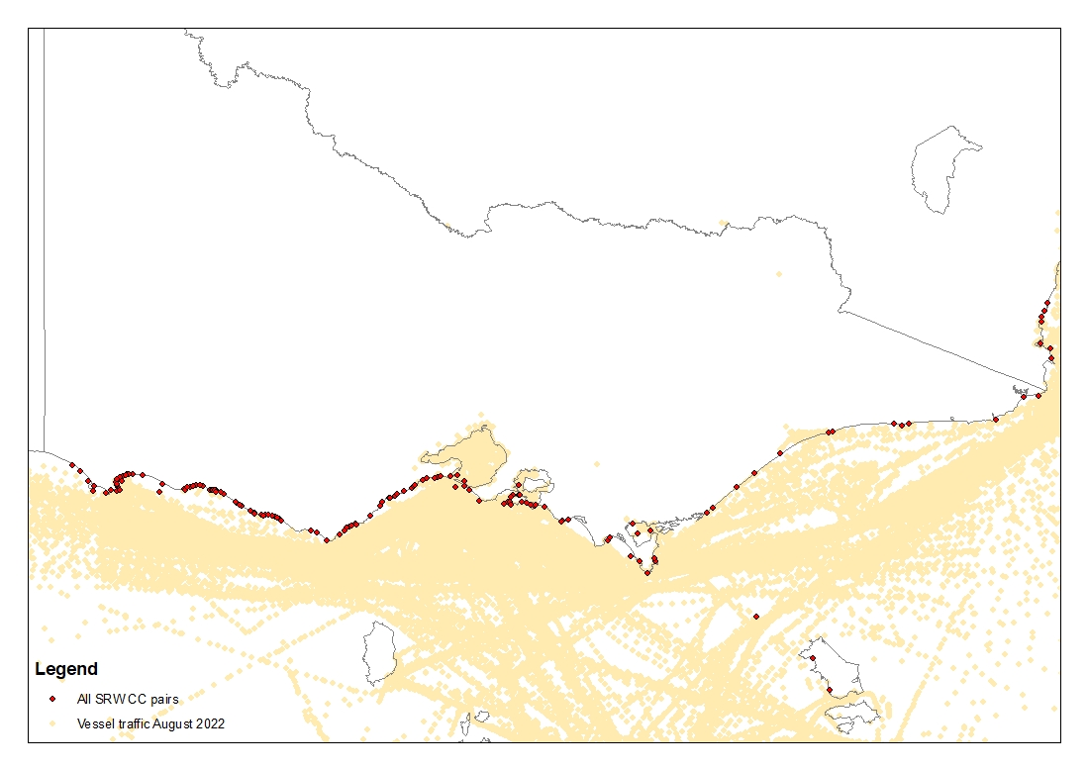

Figure 5. Vessel traffic for the month of August 2022 and all Southern Right Whale cow–calf pair sightings in Victoria.

Vessel traffic data sourced from AMSA Craft Tracking System records. [Digital Data (amsa.gov.au)](https://www.operations.amsa.gov.au/Spatial/DataServices/DigitalData)

* 1. Anthropogenic noise

Baleen whales are particularly sensitive to underwater noise, relying on producing and receiving sound for communication, navigation, and predator avoidance. Large baleen whales produce low-frequency sounds designed to travel large distances (e.g. for long-range communication) or very soft low-amplitude sound intended for discrete short-range communication. For example, nursing females frequently use quiet calls, thought to be an acoustic crypsis strategy to minimise detection by predators or conspecifics (Nielsen et al. 2019, Parks et al. 2019; Zeh 2022). As marine environments become increasingly noisy (Erbe et al. 2019), concern is growing about anthropogenic noise interfering with important biological functions of baleen whales (Erbe et al. 2019). Effects such as auditory masking from anthropogenic sources, changes in species acoustic behaviour and individual stress responses have all been noted, although the biological significance of these effects is still unclear (Cunningham and Mountain 2014; Erbe et al. 2019; Marotte et al. 2022). There are several sources of anthropogenic noise within the range of the eastern Australian Southern Right Whale population and within BIAs (DCCEEW 2023). These include impulsive noise from industry (such as pile driving, dredging, and seismic airgun surveys) and non-impulsive sources such as vessels, wind farms and gas wells. Sound produced from all these sources are known to overlap the hearing of right whales (Marotte et al. 2022). However, data on noise levels in critical coastal habitat and offshore migratory corridors of the eastern Australian Southern Right Whale population is lacking.

Shipping noise is a dominant source of anthropogenic noise in ocean environments, and marine traffic continues to increase (Madsen et al. 2006; Erbe 2019). Despite this, consistent, and accurate measurements of noise from commercial vessels is lacking globally (Erbe et al. 2019; Marotte et al. 2022). Studies have shown, however, that that low frequency noise from large ships (20–200 Hz) overlaps acoustic signals used by right whales (Hatch et al. 2012). Although there is limited data available on noise levels and their impacts on cetaceans in Australian waters, recent modelling has flagged the south-eastern seaboard of Victoria and New South Wales as areas of high shipping noise, above natural noise levels (Peel et al. 2021).

Most of our understanding of the effects of shipping noise on right whales comes from studies of North Atlantic Right Whales. Alarmingly, this species has shown no behavioural response to approaching ship noises in areas where vessel strike is prevalent (Nowacek et al. 2004), although hormone levels in faecal samples reveal that noise from large vessels may increase stress levels in North Atlantic Right Whales (Rolland et al. 2012). Some important communication calls in right whales (i.e., upcalls and gunshot calls which may serve socialisation and threat functions) are particularly susceptible to masking by shipping noise (Cunningham and Mountain 2014; Tenessen and Parks 2016). In response, North Atlantic Right Whales have shown shifts in vocalisation frequency and duration, producing louder upcalls in order to maintain communication with conspecifics (Parks et al. 2011).

In coastal habitats, both recreational and commercial vessels contribute to the soundscape. The effects would vary depending on the number of vessels, existing ambient noise levels and the acoustic properties of the habitat. There have been no studies of the effect of vessel noise in important coastal habitat of Southern Right Whales in eastern Australia. However, a recent study in Encounter Bay, South Australia, reported a reduction in resting of cow-calf pairs after vessel approaches (Sprogis et al. 2023). The authors hypothesised that the increase in vessel speed when departing (and consequent increase in noise) may have disrupted resting in these cow-calf pairs. Noise levels may also affect other important behaviours in cow-calf pairs. Southern Right Whale mothers communicate with their calves using use quiet calls, which likely play an important survival function (Nielsen et al. 2019, Parks et al. 2019; Zeh 2022). Because vessels can impact the communication space of cow–calf pairs (Tenessen and Parks 2016) further research on the impacts of vessel noise is needed.

Offshore wind turbines also contribute non-impulsive (and continuous) noise in the marine landscape. Offshore wind energy demand is growing quickly as the world looks for renewable energy alternatives. This has ignited concerns about the impacts of these developments on marine mammals. One of the largest offshore wind energy facilities in the USA is to be built in important migratory and feeding habitat of the critically endangered North Atlantic Right Whale, leading to a call for increased monitoring and the implementation of strategies to mitigate impacts (Quintana-Rizzo et al. 2021). Although there are currently no wind energy facilities within the migratory range of the eastern Australian Southern Right Whale, the offshore renewable energy industry is expected to grow rapidly in the coming years. The Victorian government is committed to reaching a target of 4 GW of offshore wind capacity by 2035 and 9 GW by 2040 (Engage Victoria 2022). There are plans for significant investment in pre-construction and feasibility works for facilities in Gippsland and Bass Coast, and the Portland West area has been flagged as a key area for future developments (Engage Victoria 2022). There is also a large windfarm project proposed off the north-eastern coast of Tasmania (Tasmanian Government 2022) but none as yet for New South Wales.

As with shipping noise, sound from operating wind turbines overlaps in frequency with the communication range of right whales (Marotte et al. 2022) although source levels are much lower (i.e., by at least 10 dB) than shipping noise (Madsen et al. 2006; Tougaard et al. 2020). Where there is already high ambient noise the sound from turbines may be masked, so turbine noise is likely to be most significant in low noise environments (Madsen et al. 2006; Tougaard et al. 2020). Madsen et al. (2006) hypothesised that in quiet habitats, right whales may respond to noise from operating turbines at ranges up to a few kilometres. More recent work indicates that the degree of noise contributions will be influenced by the size, type and number of turbines, therefore combined, and cumulative impacts of the entire wind farm must be considered (Tougaard et al. 2020; Stober and Thomsen et al. 2021).

Concern is not just for the ongoing noise of the operating wind turbines but also for the noise associated with construction and maintenance of windfarm developments, the alteration of oceanographic habitat conditions and the associated increase in vessel and air traffic (Farr et al. 2021; Quintana-Rizzo et al. 2021). These concerns are echoed for all large offshore and coastal developments including oil and gas platforms, processing facilities, marinas and ports. Pile driving, drilling, trenching and dredging are often associated with both offshore and coastal developments and can include the use of explosives and sonar. The construction phase of offshore developments is considered to have the greatest potential for impact on marine mammals (Quintana-Rizzo et al. 2021; Stober and Thomsen 2021). Pile-driving is of particular concern as it creates high-intensity, low-frequency sound (Hilderbrand 2009). Although there are no studies on the effects of pile driving on right whales, seismic airguns have a similar noise profile and so can be used as a proxy to predict impacts (Marotte et al. 2022). Studies have shown active avoidance by both right whales and bowhead whales to these kind of impulsive sounds (see Quintana-Rizzo et al. 2021).

Seismic exploration activities in which sound is used to survey the seafloor for oil and gas exploration are another potential noise threat operating within the range of the Southern Right Whale population in eastern Australia. There is a proposal for seismic testing in a 7.7 million ha area of Bass Strait (ABC 2022). These surveys use airgun arrays towed behind ships, producing powerful low-frequency sound waves typically repeated at approximately 10-second intervals, and can present a greater risk to whales than most continuous sounds (Hilderbrand 2009; DCCEEW 2023). The level of received sound for individual whales can be difficult to measure and can vary with habitat conditions. At lower received levels, behavioural changes and displacement can occur and at higher received levels physical injury such as hearing loss is possible (see Marotte 2022). Seismic surveys also have the potential to disrupt zooplankton communities and so could have indirect impacts in the Southern Right Whale foraging zones (McCauley et al. 2017; Erbe et al. 2019). The *EPBC Act Policy Statement 2.1 — Interaction between offshore seismic exploration and whales* (DCCEEW 2021) includes several measures to mitigate these impacts in Australian waters, including advising against seismic activities in declared BIAs. However, information on the location and extent of important foraging and migration habitat is lacking for the Australian populations of Southern Right Whale, as is data on the appropriate source distances and impact zones.

1. Priority actions

A threat risk assessment for the eastern Australian population was recently undertaken as part of the preparation of the updated National Southern Right Whale Recovery Plan (DCCEEW 2023). Underwater noise, infrastructure development (coastal and offshore), vessel strike, entanglement and climate change were all rated as moderate to major threats. Accordingly, several national actions have been drafted. These will help guide the recommended actions for Victorian waters.

The other assessment helping to guide the management actions in this report is the Southern Right Whale Specific Needs Assessment. This expert elicitation process revealed, that the most benefit to persistence would be a broad management package. This was true for both the best (RCP 4.5) and the worst (RCP 8.5) climate change scenarios (Figure 6). The broad management package included the ‘status quo’ of the Logans Beach Exclusion Zone and the Victorian state department’s disentanglement response, as well as all the proposed actions defined in the Specific Needs Assessment. The benefits of individual actions relating to reducing entanglement ranked highly (i.e. prohibiting wild trap fisheries or mandating change in wild trap fishery technology), as did protecting foraging areas and limiting anthropogenic noise and vessel strike risk. The large range in upper and lower benefit estimates reflect a high degree of uncertainty among experts. This uncertainty is partly a result of the large knowledge gaps that exist for this population.

This report is focused on priority actions that can be implemented in Victorian waters to mitigate key threats to support the recovery of the Southern Right Whale. The key threats for this project identified in the Specific Needs Assessment were entanglement, vessel strike and anthropogenic noise. Actions aimed at locating, describing, and protecting foraging areas outside Victorian waters are additional priorities that will be addressed nationally through the National Recovery Plan for Southern Right Whales (DCCEEW 2023) and are not considered further in the priority actions section of this report. However, the lack of knowledge around dietary requirements and important foraging grounds is highlighted as an area for future research in the Priority Research Section of this report.

* 1. Entanglement mitigation

The leading source of whale entanglements in Victoria is the Victorian Rock Lobster Fishery (DEECA, unpublished data). Several potential mitigation measures to reduce the risk of entanglement currently exist, however, few have been trialled for their application or effectiveness in the Victorian Rock Lobster fishery. Measures trialled elsewhere include seasonal closures during whale season, trap limits, reduced soak times, sinking ground lines, weak breaking points inserted into vertical buoy lines and ropeless fishing gear (Myers et al. 2019; How et al. 2021). The Western Australian Department of Fisheries has introduced several protocols for their rock lobster industry including restricting the use of surface rope and the requirement for weighted rope in water depths greater than 18 fathoms. It is believed that these measures have led to at least a 25% reduction in entanglements (How et al. 2021). Fishers in NSW have been trialling the use of submerged head gear including a galvanic time release and sub-surface horizontal rope that could be retrieved by grappling (Warren and Wooden 2021; <https://www.oceanwatch.org.au/whale-entanglement-mitigation/>). There have been huge efforts in trialling and developing solutions to minimise interactions between North Atlantic Right Whales and the large pot/trap fisheries in America and Canada. It has been concluded by the National Oceanic and Atmospheric Administration (NOAA) that, in the North American context, on-demand (or ropeless fishing gear) offers the best solution by allowing fishing to still occur with minimal risk of entanglement (NOAA 2022a).

Current ropeless gear technology uses a remote retrieval system to trigger the release of an inflatable lift bag or buoyant spool to allow fishers to retrieve their gear on demand. In response to the continued and significant mortality of North Atlantic Right Whales from entanglements, NOAA has recently released a draft Ropeless Roadmap that outlines the path for increasing adoption of this technology (NOAA 2022a). Whilst the parallels between the North Atlantic Right Whale population and the eastern Australian Southern Right Whale population are clear, the scale of the impact, the scale of fishery operations and environmental conditions vary greatly between the two areas and location- and fishery-specific solutions need to be found.

In November 2022, funding from the 2022 Victorian Icon Species program allowed KS to lead a trial of an underwater acoustic release retrieval system (FioBouy AC100, see <https://fiomarine.com/>) with three Victorian rock lobster fishers (one from the eastern zone and two from the western zone). Representatives of VFA and Fiomarine also attended the trial. Whilst the deployment and retrieval of the Fiobouy (and fishing gear it was attached to) was successful, there were still some significant concerns from fishers over the practicality of this type of system in the Victorian rock lobster fishery setting. It was concluded that an ideal pot retrieval system would be simple to use and easy to program; be integrated with current vessel computer hardware; include an automatic winder that quickly coils rope onto a spool; be easy to see when it rises to the surface; be light enough to not pose significant occupational health and safety concerns when deploying multiple pots per day; be robust enough to withstand the harsh environmental conditions; have a very low risk of failure; not increase the drag of the pot significantly more than the current gear; and be cost effective. Currently, a system meeting all these criteria does not exist, but there was agreement that significant advances could be made if fishers and gear designers/manufacturers worked together to develop a solution tailored to the industry’s needs.

Five recommended actions to help reduce the threat of entanglement are provided below. These all align with the objectives of the Draft Southern Right Whale Recovery Plan (DCCEEW 2023).

**1. Build partnerships and meaningful engagement between government agencies (DEECA and VFA) and the Victorian Rock Lobster fishers.**

This may be in the form of formal industry / management meetings and workshops, working groups, informal discussions, and research trials. These partnerships should include managers, fishers and species experts, who should work together in setting objectives for reducing entanglements and vessel strike risk.

**2. Further develop and test practical solutions to reduce the whale entanglement risk from the Victorian Rock Lobster Fishery.**

This should focus on testing current technologies as well as looking for new or improved solutions that are effective and practical in the Victorian Rock Lobster fishery context such as temporal or spatial closures. This requires working relationships between fishers testing the gear, gear manufactures/developers, researchers, and mangers to find a solution that is safe and practical for use in the Victorian Rock Lobster Fishery.

**3. Support and promote the application of the Rock Lobster Fishery Code of Practice (CoP).**

Periodic reviews and improvements to the CoP should continue to include all fishers, species experts, DEECA and VFA managers. These reviews should consider more accessible formats for fishers to access the CoP (e.g., a mobile app may improve its reach and impact). An interactive version of the CoP could incorporate functions to report lost gear, retrieval of gear, whale entanglements and other interactions. It could also include easy to access guidelines and interactive species information and a mechanism to report a Southern Right Whale sighting. An evaluation component should be incorporated into the review process to measure the effectiveness of the CoP and the level of support of the CoP amongst fishers.

**4. Create engaging communications material to promote awareness and increase reporting rates and near- to real-time reporting.**

Creative communication tools should be developed (in consultation with behavioural change experts) to deliver messaging to fishers of the impacts of entanglement. The importance of collaborative partnerships and solutions should also be stressed (See Table 3 for specific messaging for the Victorian Rock Lobster Industry).

**5. Continue investment in disentanglement training and emergency response**

DEECA and supporting agencies should continue their commitment to investing in on-going training for specialist disentanglement teams and co-ordinated emergency responses to entanglement incidences (as outlined in the VCEP).

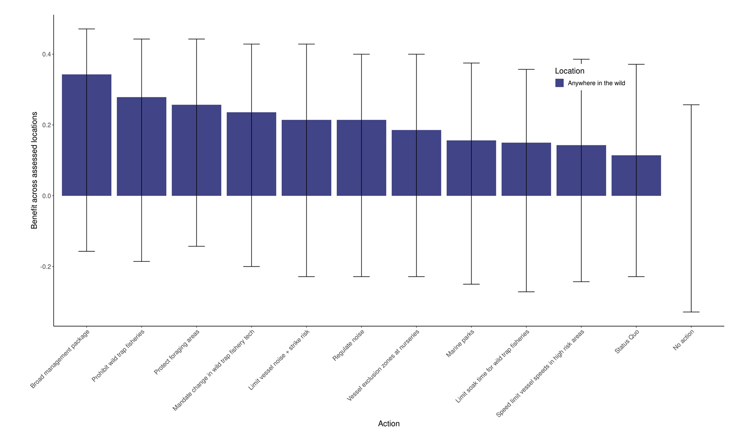

Figure 6. Estimated benefit of management scenarios to persistence anywhere in eastern Australia under RCP 4.5 climate change scenario (top graph) and RCP 8.5 climate change scenario (bottom graph).

From DEECA Specific Needs Assessment (Pritchard in prep.). ‘Benefit’ is the difference in mean estimated probability of persistence compared to the No Action scenario, i.e. No Action is set to zero. Error bars represent the mean upper and mean lower benefit estimates of participants, and therefore expert uncertainty.

* 1. Vessel strike mitigation

Reducing vessel speed has proven to be an effective mitigation strategy to lessen the risk of lethal collisions with large shipping vessels. A speed limit of 10 knots for vessels 19.8 metres or more in length transiting through North Atlantic Right Whale Seasonal Management Areas (SMAs) was introduced in 2008. A recent evaluation of the effectiveness of this rule revealed that it had resulted in a reduction of serious injuries and death from vessels since the rule was implemented (NMFS 2020). NOAA is now proposing changes to include all vessels over 10.7 m. Dynamic speed zones where vessels are required to slow down when three or more whales are known to be present in SMAs are also used. Visual and acoustic surveys, including the use of aircraft and underwater gliders, are used to detect whales and trigger the dynamic management zones. Dynamic zones remain in effect for 15 days from the date whales were sighted. NOAA has now proposed to extend this rule outside SMAs (NOAA 2022b). For a similar mitigation strategy to be considered for the south-east coast of Australia, we would first need to understand more about the current movement and distribution patterns of Southern Right Whales to identify and quantify high risk collision areas. We would also need to commit to monitoring to detect the presence of whales in shipping areas.

Recreational vessel movements are often much more variable and harder to quantify than industry vessels. Whilst smaller and generally quieter, their spatial footprint in coastal areas is often larger, they are less predictable in their movements and they commonly travel at higher speeds (Cope et al. 2021). Victoria’s Wildlife (Marine Mammals) Regulations 2019 require vessels to maintain a constant speed of no more than 5 knots (8 km/h) when within 300 metres of a whale and to not approach closer than 100 m. For these regulations to be effective in mitigating vessel strikes, the vessel operator needs to have seen the whale and then be willing and able to comply with the regulations. Seeing a Southern Right Whale can be difficult (see section 2.2). Detection is unlikely when a vessel is travelling at speed, or if the vessel operator is not looking out for Southern Right Whales or does not know the visual signs of Southern Right Whale presence. The vessel exclusion zone at Logans Beach provides protection in a small area of coastal waters (approximately 1 km shore length x 2 nautical miles out to sea), where the highest density of cow-calf pairs is known to occur. Recently, cow–calf pairs are being sighted more regularly in other areas of the south-east Australian coastline (see Figure 1) with some potentially emerging as important nursery areas (Stamation et al. 2020; Watson et al. 2021; recent unpublished monitoring data).

Eight recommended actions to help reduce the threat of vessel strike are provided below. These all align with the objectives of the Draft Southern Right Whale Recovery Plan (DCCEEW 2023).

**1. Identify high-risk vessel strike areas.** Use existing sighting data to better understand coastal Southern Right Whale distribution and use BIA information and vessel traffic data to identify high risk areas for vessel strike.

**2. Legislate additional vessel exclusion zones in high-risk areas for cow-calf pairs.** These areas should be periodically reviewed to test alignment with current distribution patterns.

**3. Test the feasibility of dynamic vessel exclusion zones for cow**–**calf pairs that are triggered by sightings** with the aim of legislating in the longer term if deemed necessary, effective and practical.

**4. Test the feasibility of dynamic speed zones triggered by the Southern Right Whale sightings** with the aim of legislating in the longer term if deemed necessary, effective and practical.

**5. Develop and evaluate targeted efforts to raise awareness of Southern Right Whale, existing regulations and other mitigation strategies (e.g., seasonal signage at boat ramps, provision of communications material on popular boating websites).** Messages and platforms should be targeted to the specific audience and informed by behavioural change science.

**6. Increase seasonal vessel-whale interaction compliance monitoring and prosecution efforts (May to October annually).**

**7. Investigate ways to improve reporting of vessel-whale interactions and data management processes**, including a streamlined process for migrating data from Victorian databases to the National Ship Strike Database.

**8. Trial the use of automated whale detection systems for commercial vessels in high-risk areas, such as Portland where cow**–**calf pairs are likely to overlap with shipping traffic.**

* 1. Anthropogenic noise mitigation

Many of the mitigation measures for reducing vessel strike (detailed above) are also applicable to reducing impacts of vessel noise. To reduce disturbance from coastal and offshore industry exploration, construction and operation, a range of measures need to be considered. At a minimum they should include modelling of the potential noise levels propagated by the specific noise source and collecting real-time data on the presence of Southern Right Whales in the area during operations. The appropriate platforms for collection of whale presence data, such as vessel, aircraft, passive acoustic monitoring or a mixture of platforms, would depend on the temporal and spatial scale of operations as well as the location and type of activity. Current management practices to protect whales from injury include the *EPBC Act Policy Statement 2.1 — Interaction between offshore seismic exploration and whales* (DCCEEW 2021) and the National Anthropogenic Underwater Noise Guidelines (currently being finalised). The underwater noise guidelines will provide exposure criteria that identify levels at which effects are likely to occur and will be based on existing scientific evidence. A technical background report, to be developed alongside the national underwater noise guidelines, will provide advice on appropriate standards for monitoring noise levels in the marine landscape. Setting appropriate indicators and measures to protect Southern Right Whales from permanent and temporary hearing impairment requires a high level of understanding of the distribution and habitat needs of Southern Right Whales, as well as the potential areas of impact which could extend far beyond the immediate vicinity of the proposed activity (Thomsen et al. 2006). The consequences of cumulative exposure should also be considered. Given the current lack of knowledge and uncertainty around impacts from noise and other habitat modifiers, a precautionary approach must be adopted, and mitigation strategies need to be continually evaluated and revised based on best available science.

As well as the first six recommendations listed in section 3.2, three other actions to help reduce the threat from anthropogenic noise are provided below. These align with the objectives of the Draft Southern Right Whale Recovery Plan (DCCEEW 2023).

**9. Test the feasibility of vessel speed restriction measures around cow**–**calf pairs and/or within reproduction BIAs** with the aim of legislating such measures if deemed necessary, effective and practical.An example of a vessel speed restriction measure would be that recommended by Sprogis et al. (2023) – that vessels maintain a slow speed <10 kn within 1 km of a whale.

**10. Improve industry-regulator-research consultation processes** by ensuring that eastern Australian Southern Right Whale experts are consulted when conducting offshore industry development impact assessments. The Commonwealth Government’s BIA maps and anthropogenic noise guidelines should also be consulted. Further, research methods and data (including knowledge gaps) should be published or publicly available through decision support tools, such as the Victorian Government’s CoastKit and FeAST tools, <https://dev.mapshare.vic.gov.au/coastkit/>, with regular reviews to incorporate updated knowledge.

**11. Support research into characterising the underwater soundscape of important Southern Right Whale habitat areas and the potential impacts (including cumulative) of noise on Southern Right Whales.** These studies should incorporate appropriate national standards set by technical experts with proven experience in monitoring marine soundscapes and passive acoustic detection of Southern Right Whales**.**

* 1. Addressing knowledge gaps

Significant knowledge gaps exist for the eastern Australian Southern Right Whale population (see Table 1) which limits the ability to effectively manage threats and support the species recovery. A commitment to long-term investment in robust scientific surveys, community science programs, and trialling and developing new impact mitigation technology and scientific tools for collecting and analysing data is needed across the entire distribution range of the eastern population. See section 4 for further details on research priorities.

The overarching recommendation for addressing knowledge gaps is:

**Facilitate and support long-term investment in robust scientific surveys, community science programs, and trialling/developing new scientific tools for collecting and analysing data** **(as outlined in section 4).**

This requires collaboration between DEECA researchers and managers, state partner organisations, the Commonwealth government, universities, non-government organisations and industry. This investment needs to extend beyond political timeframes to collect enough data to determine meaningful trends, especially given that the Southern Right Whale is long-lived (80+ years), takes a long time to mature (6–10 years), has long calving intervals (about 3–5 years), and lives in a dynamic environment with changing climatic conditions and anthropogenic stressors.

* 1. Research priorities

Priority research projects are those that help fill critical knowledge gaps and provide practical information that will assist with managing and supporting the recovery of the eastern Australian Southern Right Whale population. A summary of the current knowledge gaps against the data required and potential methods to fill them is provided in Table 1. Some progress has already been made in recent years against some of these knowledge gaps, for example population estimates (see Stamation et al. 2020) and population dynamics (see Watson et al. 2021, however, continued data collection and improved methodologies are still required.

There are several methods currently available to collect the data required (see Table 2). Some of these have already been tested in Victoria (fixed wing aerial flights, RPAS, Citizen Science, DNA biopsies), while others have been proven to work elsewhere (passive acoustic monitoring [PAM], satellite tagging, stable isotopes) or are still in development with potential for future application (eDNA, high-resolution satellite imagery and fixed-wing RPAS for aerial surveys). Some methods have the potential to serve the dual purpose of direct mitigation and research tools (e.g., PAM and eDNA). Further details on the current use of each method and the potential for future application in Victoria is provided below.

#### Fixed-wing aerial surveys

Systematic fixed-wing aerial surveys are a well-tested method for collecting long-term data on population dynamics, distribution, and movement in right whales (e.g., Rowntree et al. 2001; Crowe et al. 2021; Smith et al. 2021). Aerial surveys of Southern Right Whales have been undertaken annually off the south-western Australian coast since 1993, between Cape Leeuwin in Western Australia and Ceduna in South Australia (Smith et al. 2021). These types of repeatable surveys offer the most robust way to monitor long-term trends in population abundance. The methodology was successfully tested in eastern Australia in 2013 and 2014 (Watson et al. 2015) and annual flights should be conducted until the population has recovered to pre-harvesting levels. Consideration should also be given to incorporating new and emerging technologies to improve efficiency in data capture and analysis through automated techniques like belly cam (e.g. Willoughby et al. 2021), fixed-wing RPAS (e.g. Hodgson et al. 2017) and artificial intelligence (e.g. Araújo et al. 2022)

#### Citizen science

Citizen science is fast becoming a valuable data source for the conservation of cetacean species classified as threatened or data deficient (Cranswick et al. 2022). Data collected by the community has been an integral component of the Victorian Southern Right Whale Monitoring program since it began in the mid-1980s, and has been used in population estimate models and assessments of reproductive and movement patterns (Stamation et al. 2020; Watson et al. 2021). In recent years it has developed into a formalised citizen science program with the establishment of an online platform, WhaleFace (<https://www.swifft.net.au/whaleface/>) for facilitating increased data collection and information sharing between researchers and the community. In 2021, the whale-watching community contributed sightings of 39 individuals to the catalogue which included 11 new breeding females.

Although incidental sighting data can have limited use in the assessment of population trends, it provides valuable data on individual movements, local residency patterns, fine-scale habitat usage, reproductive rates, and behavioural patterns. Ongoing investment is needed to foster continued engagement and to expand the reach of the program to the entire Victorian coastal community. Improving and extending community led scientific monitoring at aggregation areas for rigorous data on occupancy rates, residency patterns is also required.

#### Remotely piloted aircraft systems (RPAS) imagery

RPAS is now a tested tool for cetacean research and has proved to be low impact and cost effective (e.g. Christiansen et al. 2016a & b, 2020a; Nowacek 2016). There is a growing body of research showing that cetaceans do not respond to RPAS flying at low altitudes (<10 m) above cetaceans (e.g. Acevedo-Whitehouse et al. 2010; Durban et al. 2015; Koski et al. 2015 ; Christiansen et al. 2016, 2020a). RPAS is useful in understanding juvenile recruitment and site fidelity because it can capture high-resolution photo-identification data for calves aged between 2 and 3 months (Stamation and Watson unpublished data). Since 2017, seven new breeding females, four sub-adults and at least fourteen calves have been added to SEA SRW PIC from RPAS imagery. Given that Southern Right Whales do not start breeding until 6–10 years of age, any study of population dynamics and life history requires consistent long-term monitoring and data. RPAS is a low impact and relatively easy way of collecting these long-term data.

RPAS imagery can also be used to assess the health of Southern Right Whale populations by providing high quality imagery for qualitative visual heath assessments (Charlton et al. 2021) as well as quantitative assessments of body condition and growth rates, where body volume is estimated from body length and width measurements (Christiansen et al. 2018, 2020b; Vermeulen et al. 2023).

#### Passive acoustic monitoring (PAM)

Passive acoustic monitoring has been used successfully in the study of North Atlantic Right Whales (Davis et al. 2017), North Pacific right whales (Zerbini et al. 2015), and Southern Right Whales (Childerhouse et al. 2010; Mate et al. 2011; Zerbini et al. 2016) for many years. Used in conjunction with visual surveys, PAM can provide huge insights into understanding the distribution and movement of right whales (Davis et al. 2017; Baumgartner 2014; Baumgartner 2020; Wright et al. 2019) and can also be used to monitor the ambient noise levels in coastal aggregation and marine protected areas (e.g. Kilne et al. 2020). In 2022 an acoustic logger was installed at the Encounter Bay aggregation area (Claire Charlton pers comm.) Passive acoustic monitoring can be via fixed arrays (e.g. Davis et al. 2017) or mobile autonomous platforms like underwater gliders and surface drifters, capable of ranging thousands of kilometres (Wiggins et al. 2010; Baumgartner et al. 2020; Kowarski et al. 2020). Automated acoustic buoys and gliders can provide near real time detection and have been used in risk management and mitigation strategies for the North Atlantic Right Whale throughout the northwestern Atlantic Ocean (Van Parijs et al. 2009; Baumgartner et al. 2019; Baumgartner et al. 2020; Kowarski et al. 2020).

There are still several challenges with autonomous gliders including operational noise and limitations in computing and data transfer capabilities (see Kowarski et al. 2020). Their feasibility in the high energy Victorian coastal environment would need to be investigated. With the rapid development of offshore renewable energy, it is becoming increasingly important to understand the offshore distribution and movement of Southern Right Whales (and other cetaceans) in these previously understudied environments. PAM offers an effective albeit costly, way to sample for the presence of cetacean species and requires a collaborative investment between state and Commonwealth governments, the energy sector, universities, and other research agencies. Technical experts (with proven experience in monitoring marine soundscapes and passive acoustic detection of Southern Right Whales) should be consulted in the design and implementation of an acoustic monitoring program for Southern Right Whales in eastern Australia, and national and global monitoring standards for acoustic monitoring should be adopted to maximise scientific outcomes.

#### Suction cup biologging tags

Biologging tags such as DTAGs are short-term suction cup tags that monitor sound and movement (Johnson and Tyack 2003). Biologging tags deployed on Southern Right Whales in south-east Australia would offer the ability to collect fine-scale movement and habitat preference data as well as cow-calf vocalisation patterns. Acoustic tags attached directly to the animal increase the detection of low-amplitude signals and new call signals, including those used exclusively by lactating females, which have been detected in right whales via DTAGs in south-eastern USA waters (Parks et al. 2019). If attached to pregnant females, biologging tags may lead to the discovery of preferred birthing locations. Calving locations are yet to be identified for this population. Recently suction cup biologging tags have been attached to fin whales and blue whales in the Gulf of California using a RPAS deployment method (<https://whale.org/tagging/>). This provides a less invasive (and safer) deployment method and its application to Southern Right Whales in eastern Australia should be explored.

#### Satellite tagging

Satellite telemetry systems have been used to track large whales globally for decades (e.g. Mate et al. 1992, 1997, 2011; Andrews et al. 2008; Childerhouse et al. 2010; Zerbini et al. 2016, 2018). Deep implantable tags offer the opportunity to collect valuable data on migration and movement patterns, population structuring and can lead to the identification of important biological areas. Recent satellite tagging work in New Zealand and south-west Australia is identifying new offshore feeding sites and areas of potential exposure to anthropogenic threats (Mackay et al. 2020; Tohora Voyages 2021).

Although tag technologies continue to advance, it remains a highly invasive methodology. A risk-benefit assessment that considers the health and welfare impacts on individuals against the potential knowledge gained would need to be undertaken before satellite tagging was considered for the eastern Australian population.

#### Skin/blubber biopsy

Mitochondrial DNA (mtDNA) and genetic microsatellite data has been used successfully to understand genetic diversity, population connectivity and structuring of Southern Right Whales, including the delineation of the western and eastern Australian populations (Carroll et al. 2011, 2015). However, there are still questions over the degree of connectivity between the eastern and western Australian populations and between the eastern and New Zealand populations (Carroll et al. 2015; Stamation et al. 2020; Watson et al. 2021; Kemper et al. 2022). Further sampling and analysis of existing samples is required in all three of these populations and is an action in the draft Southern Right Whale Recovery Plan (DCCEEW 2023).

DNA and stable Isotope sampling has also been used for health assessment of large whales around the world (e.g. Pirotta et al. 2017; Alves et al. 2020) and to understand changes in foraging distribution (e.g., Derville et al. 2023). By taking skin samples from whales on wintering grounds, stable isotope analysis can reveal information on where whales were foraging 2–3 months prior (Marón et al. 2020; van den Berg et al. 2020; Derville et al. 2023). Stable isotope studies have recently been conducted on 46 samples taken from the eastern Australian population between 2001 and 2013 (Derville et al. 2023). This work found a small increase in the use of high-latitude feeding grounds for the eastern Australian population over the past three decades which coincides with increase in krill density in these areas. However ongoing sampling is required, in combination with satellite tracking data, to ensure findings are representative of current trends in foraging habitat use in a rapidly changing climate. Linking genetic data with photo identification data is important to provide context around known site fidelity, residency patterns and demography of individuals and allows individuals in the catalogue to be sexed. This could help fill important demographic data gaps that might exist for some individuals in photo-identification catalogues (Carroll et al. 2020b).

#### Satellite imagery

Very high resolution (VHR) satellite imagery (15–31 cm spatial resolution) has been used to successfully detect Southern Right Whales off Peninsula Valdes (Cubaynes et al. 2019) and North Atlantic Right Whales in Cape Cod Bay (Hodul et al. 2022) Currently limitations of this method include the cost of commercial imagery, time involved in manual processing, high wind and or cloud cover during image capture, and lack of image contrast between whales and water. Imagery costs can be significantly reduced by using archived images and taking advantage of research institute rates offered under the sustainability goals of Maxar (commercial provider). Manual processing may be reduced by machine learning and deep learning techniques, and algorithms are currently being developed (Cubaynes et al. 2022; Pisano and Worm 2022).

The white callosities of Southern Right Whales may help detect whales in otherwise low contrast images. The feasibility of using VHR satellite imagery to detect Southern Right Whales has not been tested in offshore environments or in inshore areas around the eastern coast of Australia. It was agreed by participants at the 2019 1WC-SORP workshop in Barcelonathat it is worth exploring this method further to determine its usefulness in detecting high use areas of Southern Right Whales on the poorly surveyed south-east coast of Australia and in offshore environments (Carroll et al. 2020b).

#### Offshore Industry sightings data

Sightings data for Southern Right Whales in Australian offshore waters is scant despite there being several commercial fisheries and extensive oil and gas exploration within Bass Strait. Collaborating with the energy industry fishers to collect sightings data could help with identifying potential migration corridors and high use areas which could then allow for more targeted research programs to answer questions relating to movement patterns, habitat use and population structure and dynamics. A simple, easy-to-use mobile platform or a program that is integrated with existing tools used by the fisheries could facilitate this. Improvements to industry standards from Marine Mammal Observer (MMO) data collection and reporting, and sharing of information, are also required.

#### Environmental DNA (eDNA)

Environmental DNA (eDNA) is a new and rapidly emerging technology that might be able to replace traditional dart biopsy methods for understanding population structure, population dynamics and health. Some eDNA studies on cetaceans have commenced with varying success (Baker et al 2018; Pinfield et al. 2019; Alter et al. 2022; Suarez-Bregua et al. 2022), but it has been shown as an effective technique that could replace biopsy for whale sharks in Australian waters (Dugal et al. 2021). Considerable investment in developing sampling kits and testing eDNA sampling and analysis methods against traditional methods would be required before this could be considered an effective research tool for Southern Right Whale in eastern Australian waters.

Table 1. List of research priorities to address key knowledge gaps and their applicability to State or Commonwealth waters.

| No. | Key knowledge gaps | Data required | Potential Methods | Waters | |
| --- | --- | --- | --- | --- | --- |
| State | Comm |
| 1. | Population estimates and trends | 1. Count of individual breeding females (Cow-Calf pairs) each year. Based on Southern Right Whale breeding cycles would require 3-5 years to sample one entire cohort. 2. Imagery capable of identifying individuals via callosity patterns. | 1. Annual systematic survey using fixed-wing aircraft over a long term 2. Incidental photo-id data of Cow-Calf pairs from a range of sources incl. citizen science programs 3. Mark-recapture models updated every 3-5 years | ü |  |
| 2. | Coastal movement & habitat usage patterns | 1. Accurate spatial data 2. Age/sex class 3. Imagery capable of identifying individuals via callosity patterns. 4. Individual movements/occupancy rates | 1. Aerial survey comprising multiple flights by fixed-wing aircraft, covering the entire coast 2. as above using Remote Piloted Aircraft Systems (RPAS) 3. Citizen science program photo-id data (including incidental records and systematic surveys) 4. PAM: Ocean gliders, fixed arrays, acoustic buoys etc. 5. DTAGs (short-term suction cup tags, deployed by vessel or drone) 6. Satellite tagging | ü |  |
| 3. | Population dynamics | 1. Age/sex class 2. Calving rates 3. Site selection/fidelity 4. DNA 5. Imagery capable of identifying individuals via callosity patterns | 1. Multiple flights by RPAS (during breeding season) 2. Multiple flights by fixed-wing aircraft (during breeding season and over multiple years) 3. DNA sampling – biopsy 4. Citizen science program (including incidental records and systematic surveys) | ü |  |
| 4. | Population health | 1. Imagery of whole body of whale (flat orientation parallel to the water surface) taken at known altitude 2. Body length measurements 3. Presence of scars/wounds/lesions/cyamids 4. Body condition 5. Individual calving rates and calving intervals 6. physiological heath indicators e.g. glucocorticoid, carbon and nitrogen isotopes, presence of bacteria. | 1. RPAS fitted with laser altimeter 2. RPAS collection of breath samples 3. Aerial photogrammetry analysis for body measurements 4. Visual health assessment 5. Photo-identification from citizen science and systematic surveys 6. Biopsy | ü |  |
| 5. | Offshore distribution patterns | 1. Accurate spatial data 2. Age/sex class 3. Imagery capable of identifying species and individuals via callosity patterns (when possible) | 1. Fixed wing aerial flights (multiple per year, all seasons over multiple years) 2. PAM: Ocean gliders, fixed arrays, acoustic buoys etc. 3. Records from offshore fishing fleets, other industry vessels (Marine Mammal Observer data) and marine research vessels 4. Satellite tagging 5. High-resolution satellite imagery |  | ü |
| 6. | Impacts of noise and other habitat modifiers | 1. Ambient noise levels in important habitat | 1. PAM: Ocean gliders, fixed arrays/acoustic loggers 2. DTAGs (deployed by vessel or drone) | ü | ü |
| 7. | Birthing habitat | 1. Accurate spatial data 2. Imagery capable of identifying species and individuals via callosity patterns 3. Movement patterns of pregnant females | 1. DTAGs (deployed by vessel or drone) 2. Satellite tagging 3. Incidental sightings (citizen science, fixed-wing flights, RPAS) | ü |  |
| 8. | Identifying foraging habitat and important prey species | 1. Stable isotope 2. DNA 3. Imagery capable of identifying species 4. Accurate spatial data | 1. Satellite tagging 2. Stable isotope analysis 3. High resolution satellite imagery 4. Records from offshore fishing fleets, other industry vessels (Marine Mammal Observer data) and marine research vessels 5. PAM: Ocean gliders, fixed arrays, acoustic buoys etc. |  | ü |
| 9. | Location of non-breeding whales (BIAs for this group) | 1. Accurate spatial data (coastal and offshore) 2. Age/sex class   Imagery capable of identifying species and individuals via callosity patterns (when possible) | 1. Fixed wing aircraft flights (multiple per year, all seasons over multiple years) 2. PAM: Ocean gliders, fixed arrays, acoustic buoys etc. 3. Records from offshore fishing fleets, other industry vessels (Marine Mammal Observer data) and marine research vessels 4. Satellite tagging 5. High-resolution satellite imagery | ü | ü |
| 10. | Impacts of climate change | 1. All of the above   Climate change indicators (e.g., Sea Surface Temperature, Southern Annular Mode, Southern Oscillation Index and  Indian Ocean Dipole | 1. Models of population and other biological data against climate change variables | ü | ü |
| 11. | Identification of high-risk areas, where high level threats overlap with Southern Right Whale distribution | 1. Distribution data (coastal and offshore) 2. Vessel density and movement data 3. Soundscape data 4. Fisheries 5. Offshore renewable energy, oil and gas sightings data | 1. As per 2,5 & 8 | ü | ü |
| 12. | Cumulative impacts of exposure to stressors | 1. All of the above | 1. Cumulative impact risk assessments and models | ü | ü |

Table 2. List of methods to address key knowledge gaps.

|  |  |  |  |  |  |  |  |  |  |  |  |  |  |  |  |  |  |  |  |  |  |  |  |  |  |  |
| --- | --- | --- | --- | --- | --- | --- | --- | --- | --- | --- | --- | --- | --- | --- | --- | --- | --- | --- | --- | --- | --- | --- | --- | --- | --- | --- |
|  | Potential Method | Tested | | | Knowledge Gap (as per Table 1) | | | | | | | | | | | | | | | | | | | | |  |
|  | Vic | Australia | | 1 | 2 | | 3 | | 4 | | 5 | | 6 | | 7 | | 8 | | 9 | | 10 | | 11 | | 12 |
| 1. | Systematic fixed-wing aircraft surveys | ü | | ü | ü | | ü | | ü | | ü | | ü | |  | | ü | |  | | ü | | ü | | ü | ü |
| 2. | Citizen science sightings and images | ü | | ü | ü | | ü | | ü | | ü | |  | |  | | ü | |  | |  | | ü | | ü | ü |
| 3. | RPAS imagery | ü | | ü |  | | ü | | ü | | ü | |  | |  | |  | |  | |  | | ü | | ü | ü |
| 4. | PAM (various platforms) |  | | ü |  | | ü | |  | |  | | ü | | ü | |  | | ü | | ü | | ü | | ü | ü |
| 5. | DTAGs |  | |  |  | | ü | |  | |  | |  | | ü | | ü | |  | |  | | ü | |  | ü |
| 6. | Satellite tagging* | ü | | ü |  | | ü | |  | |  | | ü | |  | | ü | | ü | | ü | | ü | | ü | ü |
| 7. | Skin/blubber biopsy | ü | | ü |  | |  | | ü | | ü | |  | |  | |  | | ü | |  | | ü | | ü | ü |
| 8. | Satellite imagery* |  | | |  | |  | |  | |  | | ü | |  | |  | | ü | | ü | | ü | | ü | ü |
| 9. | Offshore sighting data (industry) |  | | |  | |  | |  | |  | | ü | |  | |  | | ü | | ü | | ü | |  | ü |
| 10 | eDNA* |  | | |  | |  | |  | |  | |  | |  | |  | |  | |  | | ü | |  | ü |

*Currently, significant limitations exist for implementation in eastern Australia (as discussed above).

1. Stakeholder engagement

Effective stakeholder engagement is critical to the success of any threatened species threat mitigation strategy. Key stakeholders required to support the recovery of Southern Right Whales in Victoria have been identified below (Table 3). All have a role to play in helping guide the development and implementation of current and future threat mitigation strategies. Stakeholders will differ in their motivations, knowledge, interests, and values. Understanding these drivers and potential barriers will influence what engagement tools are required to influence change and achieve the desired action. Key messages need to be well defined and will also influence the communication tools needed for each audience. Table 3 outlines the key considerations that an engagement strategy (to support the recovery of Southern Right Whales in Australia) should address. This is not an exhaustive list and will need to re-assessed and refined regularly during the stakeholder engagement process which should include evaluating stakeholder motivations, attitudes and behaviours.

It is recommended that behavioural change experts are consulted to develop a detailed stakeholder engagement plan that outlines recommendations for communication methods to suit each audience. It should also provide recommendations for evaluation to measure the success of the communication strategies. Some potential tools that may be considered include community talks, industry meetings/workshops, deep listening/yarns, participation in cultural ceremonies/storytelling, wheelhouse stickers, infographics, cartoons, fact sheets, videos, industry and community champions, mobile apps (e.g. the Rock Lobster Fishery Code of Practice in an app form to make information more accessible and reporting easier), interpretive signage and mobile electronic signage (e.g. warnings for boaters when whales are in the area).

Table 3. Key considerations for development of a Stakeholder Engagement Plan.

| Stakeholder | Key Messages | Key Action | Potential Perceived Barriers |
| --- | --- | --- | --- |
| Rock Lobster fishers | * Partnership is important * Need to find solutions together that reduce entanglement risk and provide benefits to fishers * May not be an ideal technical solution now, but can help develop one by working together with regulators, fishers and gear companies * The code of practice includes practical measures to reduce the risk of whale entanglement and needs to be adhered to * Social licence is important - there is a growing community of whale watchers on the coastline – they have growing connections (often to individual whales) and take an interest in threatening processes | Reduce whale entanglement | Implications to business/livelihood: cost/time/safety  No practical solutions (in a Victorian fishery context) currently exist Conservationists/managers don’t understand industry needs |
|  | * Whale entanglement risk is increasing as populations recover * Southern Right Whales are different to Humpback Whales (slower recovery/fewer individuals/ breed on our coastline). Entanglements can have implications for recovery of SRWs * SRWs have been entangled in Victoria * Lost Rock Lobster gear does pose a threat * SRW (Koontapool in Gundijimara language) hold great significance to Traditional Owner groups | Raise Awareness of SRW and threats | Lower perception of risk and consequence of whale entanglement – the problem is not with them, rather its other fishers (e.g., I lose little gear, no whales are entangled in my area) |
|  | * State wildlife emergency response teams need to know when a whale has been entangled ASAP. Chance of disentanglement success increases with timely reporting. * Reporting of lost gear is important to help assess risk and mitigation strategies | Increase reporting | Fear of prosecution and reputational risk  Not sure how to report  Not easy to report |
| Department and support agencies | * Extension of exclusion zones (including dynamic ones) may be needed as population recovers * Increased on-water patrols and investment in compliance/enforcement is needed * Several threats exist that government agencies have a responsibility to mitigate * Significant knowledge gaps exist and increased investment in long-term coastal monitoring is needed * There is a growing community of whale watchers on the coastline – they report potential breaches and take an interest in threatening processes and expect action | Reduce risk to Southern Right Whales via threat mitigation  Increase enforcement and compliance  Increase coastal monitoring | Perceived low impact by government  Budget constraints/competing priorities  Govt. funding cycles do not align with long-term data needs |
|  | * SRW are endangered and breed in Victorian waters. Recovery is slow. * Increased investment in stakeholder engagement and community education is needed * SRW (Koontapool in Gundijimara language) hold great significance to Traditional Owner groups | Raise awareness of SRW and threats  Increase and improve stakeholder relationships | Budget constraints/competing priorities |
| Recreational boat users | * SRW sit low in the water and can be hard to see * Slowing down and looking out for them will give you a better chance of seeing whales * Regulations specific minimum approach distances and ways to approach whales to minimise disturbance | Reduce Vessel Strike | Don’t know what they are looking for  Don’t know how to access info on regulations  Don’t know where they are likely to encounter SRWs  Enjoy travelling at speed/feel there is a need to travel at speed |
|  | * SRW need quiet places to raise calf and avoid detection from predators. Boats can interfere with communication between cow-calf pairs. * SRW need to conserve energy. Females do not eat while in Victorian waters (a period of 3-4 months). If they waste energy avoiding vessels it could compromise their health and that of their calf | Reduce disturbance |  |
| Traditional Owners | * Need to understand and incorporate Traditional Owner knowledge assertations, knowledge and deep connections to Sea Country and SRW (Koontapool in Gundijimara language) into research and management decisions * Storytelling and knowledge sharing is important, and we need to work together to facilitate multiple ways of knowing | Increase and improve stakeholder relationships  Raise awareness of SRW and threats | Lack of understanding of TO assertations with respect to Southern Right Whales  Loss of some TO knowledge  High demand on TO engagement and lack of adequate resources |
| Whale watchers / general community | * SRW are endangered and breed in Victorian waters. Recovery is slow * Several threats exist to SRW exist * Significant advances have been made in SRW monitoring in Victoria, but funding is always a constraint. * SRW (Koontapool in Gundijimara language) hold great significance to traditional owner groups * Acknowledgement that govt is responsible for threat mitigation and is working towards improvements in this area | Raise awareness of SRW and threats  Increase and improve stakeholder relationships | Lack of interest/reach within general community  Lack of trust of government agencies to carry out appropriate mitigation actions  Confusion over who is responsible |
|  | * Significant knowledge gaps exist and long-term coastal monitoring is needed. Community can help with this * Citizen science complements other scientific surveys, not instead of (need both) * Individual SRWs can be identified by patterns on their head. Important for monitoring * Photos and sightings of SRWs can be submitted to WhaleFace and contribute to research * There may be future opportunities for dedicated whale watchers to be involved in systematic surveying of coastal areas | Increased coastal monitoring | Confusion over where to send data  Too much effort  Not technologically savvy  Don’t see value or how their data is being used  Worried about IP or images  Think their data is being dismissed (not considered) when scientists conduct their surveys (e.g. drone images vs WhaleFace images). |
| Funders / collaborators  (includes govt, industry, universities and NGOs) | * Long-term data is required. Long-lived animal takes a long time to mature and breeds only every 3-4 years. * Short term funding sources with EOFY deadlines don’t align well with whale season and so need flexibility in delivery timelines * Critical knowledge gaps exist but require significant investment to address. Cetacean research methods are expensive. * Multi-agency/university collaborations will achieve more. * Little data exists to effectively predict impacts or recommend appropriate mitigation actions from coastal and offshore developments | Fill knowledge gaps to help with mitigation actions | Significant time/planning required for initiating partnerships, but often unfunded with uncertainty about leadership  Lack of clarity on what is state and what is federal responsibility.  Conflicts of interest between govt agencies and industry funders (e.g., oil/gas, renewable energy).  Poor industry standards around data collection, reporting and storage and issues around data sharing (IP).  Budget constraints/competing priorities |

1. Conclusion

Multiple stressors are currently operating on Southern Right Whales in eastern Australia. These stressors have the potential to threaten the recovery and persistence of this small population by displacing individuals from critical habitat and directly threatening their survival. This report should be used to guide investment in research and conservation for the endangered Southern Right Whale in Victoria. It is hoped that the actions recommended can be implemented to alleviate key threats caused by human activity in Victorian waters and support the long-term recovery of this endangered population. There is a need for continued support and investment in ongoing systematic monitoring and the testing of new and existing technologies with the aim of reducing knowledge gaps and the threats of entanglement, vessel strike and anthropogenic noise in and around biologically important areas. Effective community engagement and ongoing stakeholder collaboration will also play a crucial role in the successful management of this population.

# References

ABC (2022). [Proposed seismic testing in the Bass Strait could emit blasts almost two times louder than a rock concert](https://www.abc.net.au/news/2022-08-25/bass-strait-seismic-testing-plan-gas-exploration-fears/101367052), accessed November 2022.

Acevedo-Whitehouse, K., Rocha-Gosselin, A. and Gendron, D. (2010). A novel non-invasive tool for disease surveillance of free-ranging whales and its relevance to conservation programs. *Animal Conservation* **13**, 217–225. doi:10.1111/j.1469-1795.2009.00326.x

Agrelo, M., Daura-Jorge, F.G., Rowntree, V.J., Sironi,M., Hammond, P.S., Ingram and others (2021). Ocean warming threatens southern right whale population recovery. *Science Advances* **7**, 1–8.

Alter, S.E., King, C.D., Chou, E., Chin, S.C., Rekdahl, M. and Rosenbaum, H.C. (2022). Using Environmental DNA to Detect Whales and Dolphins in the New York Bight. *Frontiers in Conservation Science* **3**, 820377. doi: 10.3389/fcosc.2022.820377.

Alves, F., Dromby, M., Baptista, V., Ferreira, R., Correia, A.M., Weyn, M. and others (2020). Ecophysiological traits of highly mobile large marine predators inferred from nucleic acid derived indices. *Scientific Reports* **10**, 4752. https://doi.org/10.1038/s41598-020-61769-7

Andrews, R.D., Pitman, R.L., Balance, L.T. (2008). Satellite tracking reveals distinct movement patterns for Type B and Type C killer whales in the southern Ross Sea, Antarctica. *Polar Biology* **31**,1461–8.

Araújo V.M., Shukla A., Chion C., Gambs S. and Michaud R. (2022). Machine-learning approach for automatic detection of wild Beluga Whales from hand-held camera pictures. *Sensors* **22** (11), 4107. https://doi.org/10.3390/s22114107.

Baker, C.S., Steel, D., Nieukirk, S. and Klinck, H. (2018). Environmental DNA (eDNA) from the wake of whales: Droplet digital PCR for detection and species identification. *Frontiers in Marine Science* **5**, 133. doi: 10.3389/fmars.2018.00133.

Baumgartner, M.F., Bonnell, J., Van Parijs, S.M., Corkeron, P.J., Hotchkin, C. and others (2019). Persistent near real-time passive acoustic monitoring for baleen whales from a moored buoy: system description and evaluation. *Methods in Ecology and Evolution* **10**, 1476–1489. doi: 10.1111/2041-210X.13244.

Baumgartner, M.F., Bonnell, J., Corkeron, P.J., Van Parijs, S.M., Hotchkin, C., Hodges B.A., Thornton J.B., Mensi., B.L. and Bruner, S.M. (2020). Slocum gliders provide accurate near real-time estimates of baleen whale presence from human-reviewed passive acoustic detection information. *Frontiers in Marine Science* **7**, <https://doi.org/10.3389/fmars.2020.00100>.

Benjamins, S., Harnois, V., Smith, H.C.M., Johanning, L., Greenhill, L., Carter, C. and Wilson, B. (2014). Understanding the potential for marine megafauna entanglement risk from renewable marine energy developments. Scottish Natural Heritage Commissioned Report No. 791.

Brandão, A., Vermeulen, E., Ross-Gillespie, A., Findlay, K. and Butterworth, D.S. (2018). Updated application of a photo-identification based assessment model to Southern Right Whales in South African waters, focussing on inferences to be drawn from a series of appreciably lower counts of calving females over 2015 to 2017. Ulsan: International Whaling Commission.

Carroll, E.L, Patenaude, N., Alexander, A., Steel, D. and others (2011). Population structure and individual movement of southern right whales around New Zealand and Australia. *Marine Ecology Progress Series* **432**, 257−268.

Carroll, E.L., Jackson, J.A., Paton, D. and Smith, T.D. (2014). Two intense decades of 19th century whaling precipitated rapid decline of right whales around New Zealand and east Australia. *PLOS ONE* **9**, e93789.

Carroll E.L., Baker, C.S., Watson, M., Alderman, R. and others (2015). Cultural traditions across a migratory network shape the genetic structure of southern right whales around Australia and New Zealand. *Scientific Report* **5**, 16182.

Carroll E.L., Fewster, R.M., Childerhouse, S.J., Patenaude, N.J., Boren, L. and Baker, C.S. (2016). First direct evidence for natal wintering ground fidelity and estimate of juvenile survival in the New Zealand southern right whale *Eubalaena australis*. *PLOS ONE* **11**, e0146590.

Carroll, E.L., Ott, P.H., McMillan,L.F., Galletti Vernazzani, B., Neveceralova, P. and others (2020a). Genetic diversity and connectivity of Southern Right Whales (*Eubalaena australis*) found in the Brazil and Chile–Peru wintering grounds and the South Georgia (Islas Georgias del Sur) feeding ground. *Journal of Heredity*, 263–276 doi:10.1093/jhered/esaa010.

Carroll, E, Charlton, C., Vermeulen, E., Jackson, J. and Clarke, P. (2020b). Roadmap to success for the International Whaling Commission - Southern Ocean. Research partnership (IWC-SORP) theme 6 - the right sentinel for climate change: Linking southern right whale foraging ecology to demographics, health and climate. Report on the southern right whale workshop held at the World Marine Mammal Conference, Barcelona, Spain, in December 2019.

Cates, K., DeMaster, D.P., Brownell, R.L. Jr., Silber, G., Gende, S., Leaper, R. and others (2017). Strategic Plan to Mitigate the Impacts of Ship Strikes on Cetacean Populations: 2017-2020. International Whaling Commission. Available online at: <https://iwc.int/ship-strikes>.

Charlton, C.M. (2017). Population demographics of southern right whales (*Eubalaena australis*) in Southern Australia. PhD dissertation, Curtin University, Bentley, Western Australia.

Charlton, C., Vermeulen E., Hörbst, S., Gregory, E. and Christiansen, F. (2021). Global, standardised southern right whale qualitative visual health assessment protocol. Report SC/68C/SH/21 presented to the Scientific Committee of the International Whaling Commission. Cambridge (UK): Scientific Committee of the IWC. Available from: <https://iwc.int/home>

Childerhouse, S., Double, M. and Gales, N. (2010). Satellite tracking of southern right whales (*Eubalaena australis*) at the Auckland Islands, New Zealand. Paper SC/62/BRG19 presented to the Scientific Committee of the International Whaling Commission, Agadir, Morocco.

Christiansen, F., Rojano-Doñate, L., Madsen, P.T. and Bejder, L. (2016a). Noise levels of multi-rotor unmanned aerial vehicles with implications for potential underwater impacts on marine mammals. *Frontiers in Marine Science* 3, 277. doi: 10.3389/fmars.2016.00277

Christiansen, F., Dujon, A.M., Sprogis, K.R., Arnould, J.P.Y. and Bejder. L. (2016b). Noninvasive unmanned aerial vehicle provides estimates of the energetic cost of reproduction in humpback whales. *Ecosphere* **7** (10), e01468.10.1002/ecs2.1468

Christiansen, F., Vivier, F., Charlton, C., Ward, R., Amerson, A., Burnell, S. and Bejder, L. (2018). Maternal body size and condition determine calf growth rates in southern right whales. *Marine Ecology Progress Series* **592**, 267-281. <https://doi.org/10.3354/meps12522>

Christiansen, F., Nielsen, M.L.K., Charlton, C., Bejder, L. and Madsen, P.T. (2020a). Southern right whales show no behavioral response to low noise levels from a nearby unmanned aerial vehicle. *Marine Mammal Science* 2020 **36**, 953–963. <https://doi.org/10.1111/mms.12699>

Christiansen F., Dawson, S.M., Durban, J.W., Fearnbach, H. and others (2020b). Population comparison of right whale body condition reveals poor state of the North Atlantic right whale. *Marine Ecology* *Progress Series* **640**,1-16. <https://doi.org/10.3354/meps13299>

Cope, S., Hines, E., Bland, R., Davis, J.D., Tougher, B. and Zetterlind, V. (2021). Multi-sensor integration for an assessment of underwater radiated noise from common vessels in San Francisco Bay. The *Journal of the Acoustical Society of America* **149**, 2451. doi/10.1121/10.0003963.

Cranswick, A.S., Constantine, R., Hendriks,H. and Carroll, E. L. (2022). Social media and citizen science records are important for the management of rarely sighted whales. *Ocean & Coastal Management* **226**, 106271. https://doi.org/10.1016/j.ocecoaman.2022.106271.

Crowe, L.M., Brown, M.W., Corkeron, P.J., Hamilton, P.K. and others (2021). In plane sight: a mark-recapture analysis of North Atlantic right whales in the Gulf of St. Lawrence. *Endangered Species Research* **46**, 227-251. <https://doi.org/10.3354/esr01156>.

Cubaynes, H.C., Fretwell, P.T., Bamford, C., Gerrish, L. and Jackson, J.A. (2019). Whales from space: Four mysticete species described using new VHR satellite imagery. *Marine Mammal Science* **35**, 466-491. <https://doi.org/10.1111/mms.12544>

Cubaynes, H.C., and Fretwell, P.T. (2022). Whales from space dataset, an annotated satellite image dataset of whales for training machine learning models. *Scientific Data* **9** (245), 1-7. https://doi.org/10.1038/s41597-022-01377-4

Cunningham, K.A. and Mountain, D.C. (2014). Simulated masking of right whale sounds by shipping noise: Incorporating a model of the auditory periphery. *The Journal of the Acoustical Society of America* **135**, 1632–1640. <https://doi.org/10.1121/1.4864470>.

Davis, G.E., Baumgartner, M.F., Bonnell, J.M., Bell, J., Berchok, C., Thorton, J.B. and others (2017). Long-term passive acoustic recordings track the changing distribution of North Atlantic right whales (*Eubalaena glacialis*) from 2004 to 2014. *Scientific Reports* **7**, 13460. https://doi.org/10.1038/s41598-017-13359-3

DCCEEW (2021). EPBC Act Policy Statement 2.1 — Interaction between offshore seismic exploration and whales: industry guidelines. <https://www.dcceew.gov.au/environment/epbc/publications/epbc-act-policy-statement-21-interaction-between-offshore-seismic-exploration-and-whales>, accessed November 2022.

DCCEEW (2023). Draft National Recovery Plan for the Southern Right Whale (*Eubalaena australis*). Department of Agriculture, Water and the Environment, Canberra. [https://www.dcceew.gov.au/environment/biodiversity/threatened/recovery-plans/comment/draft-recovery-plan-southern-right-whale-2023](https://urldefense.com/v3/__https:/aus01.safelinks.protection.outlook.com/?url=https*3A*2F*2Fwww.dcceew.gov.au*2Fenvironment*2Fbiodiversity*2Fthreatened*2Frecovery-plans*2Fcomment*2Fdraft-recovery-plan-southern-right-whale-2023&data=05*7C01*7CBelinda.Harding*40dcceew.gov.au*7C500a0bfe5f6f4cb58db308daee0a5814*7C2be67eb7400c4b3fa5a11258c0da0696*7C0*7C0*7C638084025435457926*7CUnknown*7CTWFpbGZsb3d8eyJWIjoiMC4wLjAwMDAiLCJQIjoiV2luMzIiLCJBTiI6Ik1haWwiLCJXVCI6Mn0*3D*7C3000*7C*7C*7C&sdata=LqIMwXIqqrWWg*2Fwh*2FjAwukHKRFQ85xGX86CykDt80fk*3D&reserved=0__;JSUlJSUlJSUlJSUlJSUlJSUlJSUlJSUlJSUl!!C5rN6bSF!HFlSk1TLTDLWD8vM2bRJ9Tyk9Ikyjm7KHvD77TVliLR2jnv7ns0m_V5CxxWc0QWMUVp1tztSwp88tELpNK8CF7ZGO8-QRtxeZbrRVbXDmA$).

Derville, S., Torres, L.G., Newsome, S.D., Somes, C.J., Valenzuela, L.O., Vander Zanden, H.B. and others (2023). Long-term stability in the circumpolar foraging range of a Southern Ocean predator between the eras of whaling and rapid climate change. *Ecology* **120** (10), e2214035120. https://doi.org/10.1073/pnas.2214035120.

DSEWPC (2012). Conservation management plan for the southern right whale: A recovery plan under the *Environment Protection and Biodiversity Conservation Act 1999* 2011−2021. Department of Sustainability, Environment, Water, Population and Communities, Canberra.

Doughty, C.E., Roman, J., Faurby, S., Wolf, A., Haque, A., Bakker, E.S., Malhi, Y., Dunning, J.B. and Svenning, J.C. (2016). Global nutrient transport in a world of giants. *Proceedings of the National Academy of Sciences U.S.A.* **113,** 868–873.

Dugal, L., Thomas, L., Jensen, M.R., Sigsgaard, E.E., Simpson, T., Jarman, S., Thomsen, P.F. and Meekan, M. (2022). Individual haplotyping of whale sharks from seawater environmental DNA. *Molecular Ecology Resources* 22, 56– 65. <https://doi.org/10.1111/1755-0998.13451>.

Durban, J.W., Fearnbach, H., Barrett-Lennard, L.G., Perryman,W. L. and Leroi, D.J. (2015).Photogrammetry of killer whales using a small hexacopter launched at sea. *Journal of Unmanned Vehicle Systems* 3: 131–135. doi:10.1139/juvs-2015-0020

Engage Victoria (2022). [Victoria’s Offshore Wind Policy Directions Paper | Engage Victoria](https://engage.vic.gov.au/victorias-offshore-wind-policy-directions-paper-developing-the-offshore-wind-sector), accessed July 2022).

Erbe, C., Dähne, M., Gordon, J., Herata, H., Houser, D.S., Koschinski, S. and others (2019). Managing the effects of noise from ship traffic, seismic surveying and construction on marine mammals in Antarctica. *Frontiers in Marine Science* **6**. 1-21.  
doi: https://www.frontiersin.org/article/10.3389/fmars.2019.00647.

Ernst and Young (2020). The economic value of recreational boating in Victoria. Better Boating Victoria, Victorian Fisheries Authority, Final Report December 2020. <https://vfa.vic.gov.au/__data/assets/pdf_file/0003/629256/The-economic-value-of-recreational-boating-in-Victoria-2020-Ernst-and-Young-Report.pdf>.

Farr, H. Ruttenberg, B., Walter, R.K., Wang, Y. and White, C. (2021). Potential environmental effects of deepwater floating offshore wind energy facilities. *Ocean and Coastal Management* **207,** 1-16. https://doi.org/10.1016/j.ocecoaman.2021.105611.

Harcourt R., van der Hoop J., Kraus S. and Carroll E.L. (2019). Future Directions in *Eubalaena* spp.: Comparative Research to Inform Conservation. *Frontiers in Marine Science* **5**, 530. doi: 10.3389/fmars.2018.00530.

Hatch L.T., Clark C.W., Van Parijs S.M., Frankel A.S., Ponirakis D.W. (2012). Quantifying loss of acoustic communication space for right whales in and around a US national marine sanctuary. *Conservation Biology* 26, 983−994.

Hayes, S.A., Josephson, E., Maze-Foley, K., Rosel, P.E. and Turek, J. (2021). US Atlantic and Gulf of Mexico Marine Mammal Stock Assessments – 2020. NOAA Technical Memorandum NMFS-NE 271. Silver Spring, Maryland, USA.

Hildebrand, J.A. (2009). Anthropogenic and natural sources of ambient noise in the ocean. *Marine Ecology Progress Series*, **395**, 5–20.

Hodgson, A., Peel, D. and Kelly, N. (2017). Unmanned aerial vehicles for surveying marine fauna: Assessing detection probability. *Ecological Applications* **27** (4), 1253–1267. https://doi.org/10.1002/eap.1519.

Hodul, M., Knudby, A., McKenna, B., James, A., Mayo, C., Brown, M., Durette-Morin, D. and Bird, S. (2022). Individual North Atlantic right whales identified from space. *Marine Mammal Science* **39**, 1–12. <https://doi.org/10.1111/mms.12971>.

How, J.R., de la Mare, W.K., Coughran, D.K., Double, M.C. and de Lestang, S. (2021). Gear modifications reduced humpback whale entanglements in a commercial rock lobster fishery. *Marine Mammal Science,* **37** (3), 782–806. doi: https://doi.org/10.1111/mms.12774.

Hunt, K.E., Lysiak, N.S., Moore, M.J. and Rolland, R.M. (2016). Longitudinal progesterone profiles in baleen from female North Atlantic right whales (*Eubalaena glacialis*) match known calving history. *Conservation Physiology* **4**,1-9. cow014. doi: 10.1093/conphys/cow014.

IWC (2021). [International Whaling Commission: Portal (iwc.int)](https://portal.iwc.int/), accessed May 2021.

Jackson J.A., Patenaude N.J., Carroll E. L. and Baker C.S. (2008). How few whales were there after whaling? Inference from contemporary mtDNA diversity. *Molecular Ecology* **17**, 236−251.

Johnson M.P. and Tyack P.L. (2003). A digital acoustic recording tag for measuring the response of wild marine mammals to sound. *IEEE Journal of Oceanic Engineering* 28 (1), 3–12.

Kemper, C., Coughran, D., Warneke, R., Pirzl, R., Watson, M., Gales, R. and Gibbs, S. (2008). Southern right whale (*Eubalaena australis*) mortalities and human interactions in Australia, 1950–2006. *Journal of Cetacean Research Management* **10** (1), 1–8.

Kemper, C.M., Steele-Collins, E. Al-Humaidhi, A., Segawa Fellowes, T., Marsh O. and Charlton, C. (2022). Encounter Bay, South Australia, an important aggregation and nursery area for the southern right whale, *Eubalaena australis* (Balaenidae: Cetacea). *Transactions of the Royal Society of South Australia* **146** (2), 207-227, DOI: [10.1080/03721426.2021.2018759](https://doi.org/10.1080/03721426.2021.2018759).

Kline,L.R., DeAngelis, A.I., McBride, C., Rodgers, G.G., Rowell, T.J., Smith, J. and others (2020). Sleuthing with sound: Understanding vessel activity in marine protected areas using passive acoustic monitoring. *Marine Policy* **120,** 1-13. <https://doi.org/10.1016/j.marpol.2020.104138>.

Knowlton, A.R., Hamilton, P.K. and Pettis, H.M. (2012). Status of reproductive females in the North Atlantic Right Whale population and impacts of human activities on their reproductive success. Silver Spring, Maryland, USA: NOAA, 41.

Koski, W.R., Gamage,G., Davis, A.R., Mathews,T., Leblanc, B. and Ferguson,S.H. (2015). Evaluation of UAS for photographic re-identification of bowhead whales, *Balaena mysticetus*. *Journal of Unmanned Vehicle Systems* **3**, 22–29. doi:10.1139/juvs-2014-0014

[Kowarski](https://asa.scitation.org/author/Kowarski%2C+Katie+A), K.A., [Gaudet](https://asa.scitation.org/author/Gaudet%2C+Briand+J), [B.J., Cole](https://asa.scitation.org/author/Cole%2C+Arthur+J), A.J., [Maxner](https://asa.scitation.org/author/Maxner%2C+Emily+E), [E.E., Turner](https://asa.scitation.org/author/Turner%2C+Stephen+P), S.P., Martin, S.B., [Johnson](https://asa.scitation.org/author/Johnson%2C+Hansen+D) H.D, and [Moloney](https://asa.scitation.org/author/Moloney%2C+John+E), J.E. (2020). Near real-time marine mammal monitoring from gliders: Practical challenges, system development, and management implications. *The Journal of the Acoustical Society of America* **148**, 1215, <https://doi.org/10.1121/10.0001811>

Lanyon, J.M. and Janetzki, H. (2016). Mortalities of Southern right whales (*Eubalaena australis*) in a subtropical wintering ground, Southeast Queensland. *Aquatic Mammals* 42, **470**.   
doi: 10.1578/AM.42.4.2016.470

Lavery, T.J., Roudnew, B., Seymour, J., Mitchell, J.G., Smetacek, V. and Nicol, S. (2014). Whales sustain fisheries: Blue whales stimulate primary production in the Southern Ocean. *Marine Mammal Science* **30**, 888–904.

Leaper, R., Cooke, J., Trathan, P., Reid, K., Rowntree, V. and Payne, R. (2006). Global climate drives southern right whale (*Eubalaena australis*) population dynamics. *Biology Letters* **2**, 289–292. <https://doi/10.1098/rsbl.2005.0431>

Lysiak, N.S.J., Trumble, S.J., Knowlton, A.R. and Moore, M.J. (2018). Characterizing the duration and severity of fishing gear entanglement on a North Atlantic right whale (*Eubalaena glacialis*) using stable isotopes, steroid and thyroid hormones in baleen. *Fronteirs of Marine Science* **5**,168. doi: 10.3389/fmars.2018.00168

Mackay, A.I., Bailleu, l.F., Carroll, E.L., Andrews-Goff, V., Baker, C.S. and others (2020). Correction: Satellite derived offshore migratory movements of southern right whales (*Eubalaena australis*) from Australian and New Zealand wintering grounds. *PLOS ONE* **15** (6), e0235186. <https://doi.org/10.1371/journal.pone.0235186>.

Marón, C.F., Budge, S.M., Ward, R.E., Valenzuela, L.O. and others (2020). Fatty acids and stable isotopes (δ13C, δ15N) in southern right whale *Eubalaena australis* calves in relation to age and mortality at Península Valdés, Argentina. *Marine Ecology Progress Series* **646**, 189–200. <https://doi.org/10.3354/meps13387>.

Madsen, P.T., Wahlberg, M., Tougaard, J., Lucke, K. and Tyack, P.L. (2006). Wind turbine underwater noise and marine mammals: Implications of current knowledge and data needs. *Marine Ecology Progress Series* **309**, 279–295.

Marotte E., Wright A.J., Breeze H., Wingfield J., Matthews L.P. and others (2022). Recommended metrics for quantifying underwater noise impacts on North Atlantic right whales. *Marine Pollution Bulletin* **175**, doi: 10.1016/j.marpolbul.2022.113361.

Mate, B.R., Best, P.B., Lagerquist, B.A. and Winsor, M.H. (2011). Coastal, offshore, and migratory movements of South African right whales revealed by satellite telemetry. *Marine Mammal Science*, **27**, 455-476. <https://doi.org/10.1111/j.1748-7692.2010.00412.x>

McCauley, R.D., Day, R.D., Swadling, K.M., Fitzgibbon, Q.P., Watson, R.A. and Semmens, J.M. (2017). Widely used marine seismic survey air gun operations negatively impact zooplankton. *Nature Ecology & Evolution* **1** (7), 0195. doi: https://doi.org/10.1038/s41559-017-0195.

Meyer-Gutbrod, E.L. and Greene, C.H. (2018). Uncertain recovery of the North Atlantic right whale in a changing ocean. *Global Change Biology* **24**, 455–464. doi: 10.1111/gcb.13929.

Meyer-Gutbrod, E.L., Greene, C.H., Davies, K.T.A. and Johns D.G. (2021). Ocean regime shift is driving collapse of the North Atlantic right whale population. *Oceanography* (Wash DC) **34**, 22−31.

Myers, H.J., Moore, M.J., Baumgartner, M.F., Brillant, S.W., Katona, S.K., Knowlton, A.R., Morissette, L., Pettis, H.M., Shester, G. and Werner, T.B. (2019). Ropeless fishing to prevent large whale entanglements: Ropeless Consortium report. *Marine Policy* **107**, p.103587.

NMFS 2020. North Atlantic Right Whale (*Eubalaena glacialis*) Vessel Speed Rule Assessment. National Marine Fisheries Service, Office of Protected Resources, Silver Spring, Maryland, USA.

Nelms, S.E., Alfaro-Shigueto J., Arnould J.P.Y., Avila I.C. and others (2021). Marine mammal conservation: over the horizon. *Endangered Species Research* **44**, 291-325. <https://doi.org/10.3354/esr01115>.

Nielsen, M.L., Bejder, L., Videsen, S.K., Christiansen, F. and Madsen, P.T. (2019). Acoustic crypsis in Southern Right Whale mother–calf pairs: infrequent, low-output calls to avoid predation? *Journal of Experimental Biology* **222**, jeb190728. ([doi:10.1242/jeb.190728](http://dx.doi.org/10.1242/jeb.190728)) [Crossref](https://royalsocietypublishing.org/servlet/linkout?suffix=e_1_3_7_16_2&dbid=16&doi=10.1098%2Frsbl.2019.0485&key=10.1242%2Fjeb.190728), [PubMed](https://royalsocietypublishing.org/servlet/linkout?suffix=e_1_3_7_16_2&dbid=8&doi=10.1098%2Frsbl.2019.0485&key=31296536), [ISI](https://royalsocietypublishing.org/servlet/linkout?suffix=e_1_3_7_16_2&dbid=128&doi=10.1098%2Frsbl.2019.0485&key=000475480100001), [Google Scholar](http://scholar.google.com/scholar_lookup?hl=en&volume=222&publication_year=2019&pages=jeb190728&journal=J.+Exp.+Biol.&author=ML+Nielsen&author=L+Bejder&author=SK+Videsen&author=F+Christiansen&author=PT+Madsen&title=Acoustic+crypsis+in+southern+right+whale+mother%E2%80%93calf+pairs%3A+infrequent%2C+low-output+calls+to+avoid+predation%3F) ([doi:10.1242/jeb.190728](http://dx.doi.org/10.1242/jeb.190728)) [Crossref](https://royalsocietypublishing.org/servlet/linkout?suffix=e_1_3_7_16_2&dbid=16&doi=10.1098%2Frsbl.2019.0485&key=10.1242%2Fjeb.190728), [PubMed](https://royalsocietypublishing.org/servlet/linkout?suffix=e_1_3_7_16_2&dbid=8&doi=10.1098%2Frsbl.2019.0485&key=31296536), [ISI](https://royalsocietypublishing.org/servlet/linkout?suffix=e_1_3_7_16_2&dbid=128&doi=10.1098%2Frsbl.2019.0485&key=000475480100001), [Google Scholar](http://scholar.google.com/scholar_lookup?hl=en&volume=222&publication_year=2019&pages=jeb190728&journal=J.+Exp.+Biol.&author=ML+Nielsen&author=L+Bejder&author=SK+Videsen&author=F+Christiansen&author=PT+Madsen&title=Acoustic+crypsis+in+southern+right+whale+mother%E2%80%93calf+pairs%3A+infrequent%2C+low-output+calls+to+avoid+predation%3F).

NOAA (2022a). Draft Ropeless Roadmap: A strategy to develop on-demand fishing available for public input. https://www.fisheries.noaa.gov/bulletin/draft-ropeless-roadmap-strategy-develop-demand-fishing-available-public-input, accessed November 2022.

NOAA (2022b). Amendments to the North Atlantic Right Whale vessel strike reduction rule. (<https://www.federalregister.gov/documents/2022/08/01/2022-16211/amendments-to-the-north-atlantic-right-whale-vessel-strike-reduction-rule>), accessed November 2022.

Noad, M.J., Kniest, E. and Dunlop, R.A. (2019).  Boom to bust? Implications for the continued rapid growth of the eastern Australian humpback whale population despite recovery. *Population Ecology* **61**,198– 209. <https://doi.org/10.1002/1438-390X.1014>.

Nowacek, D.P., Johnson, M.P. and Tyack, P.L. (2004). North Atlantic Right Whales (*Eubalaena glacialis*) ignore ships but respond to alerting stimuli. *Proceedings: Biological Sciences* **271** (1536), 227–231. <http://www.jstor.org/stable/4142629>

Nowacek, D.P., Christiansen, F., Bejder, L., Goldbogen, J.A. and Friedlaender, A.S. (2016). Studying cetacean behaviour new technological approaches and conservation applications. *Animal Behaviour* **120**, 235–244. doi:10.1016/j.anbehav.2016.07.019

Pace, R.M. III, Corkeron, P.J. and Kraus, S.D. (2017). State-space mark-recapture estimates reveal a recent decline in abundance of North Atlantic right whales. *Ecology and Evolution* **7**, 8730–8741. doi: 10.1002/ece3.3406

Parks, S., Johnson, M., Nowacek, D. and Tyack, P. (2011). Individual right whales call louder in increased environmental noise. *Biology letters* **7**, 33-35. 10.1098/rsbl.2010.0451.

Parks, S.E., Cusano, D.A., Van Parijs, S.M. and Nowacek, D.P. (2019). Acoustic crypsis in communication by North Atlantic Right Whale mother–calf pairs on the calving grounds. *Biology Letters* **15** (10), 20190485. doi: <https://doi.org/10.1098/rsbl.2019.0485>.

Parsons, E.C.M., Baulch, S., Bechshoft, T., Bellazzi, G. and others (2015). Key research questions of global importance for cetacean conservation. *Endangered Species Research* **27**, 113−118.

Peel, D., Smith, J.N. and Childerhouse, S. (2018). Vessel strike of whales in Australia: The challenges of analysis of historical incident data. *Frontiers in Marine Science* **5**, 69. doi: 10.3389/fmars.2018.00069.

Pettis, H.M., Rolland, R.M., Hamilton, P.K., Knowlton, A.R., Burgess, E.A. and Kraus, S.D. (2017). Body condition changes arising from natural factors and fishing gear entanglements in North Atlantic right whales *Eubalaena glacialis*. *Endangered Species Research* **32**, 237-249.  <https://doi.org/10.3354/esr00800>

Pinfield, R., Dillane, E., Runge, A.K.W. and others (2019). False-negative detections from environmental DNA collected in the presence of large numbers of killer whales (*Orcinus orca*). *Environmental DNA* **1**, 316– 328. <https://doi.org/10.1002/edn3.32>

Pirotta, V., Smith, A., Ostrowski, M., Russell, D., Jonsen, I.D., Grech, A. and Harcourt, R. (2017). An economical custom-built drone for assessing whale health. *Frontiers in Marine Science* **4**, 425. doi: 10.3389/fmars.2017.00425

Pisano, O.M. and Worm, B. (2022). Automated detection of whales in the Atlantic Northwast. Conference presentation. 24th Biennial Conference on the Biology of Marine Mammals. Palm Beach Florida.

Pritchard, R. (in prep.), Southern Right Whale Specific Needs Assessment Report. Department of Energy, Environment and Climate Action, Victoria.

Quintana-Rizzo, E., Leiter, S., Cole, T.V.N., Hagbloom, M.N., Knowlton, A.R., Nagelkirk, P. and others (2021). Residency, demographics and movement patterns of North Atlantic right whales *Eubalaena glacialis* in an offshore wind energy development area in southern New England, USA. *Engangered Species Research* **45**, 251-268. https://doi.org/10.3354/esr01137

Record, N.R., Runge J.A., Pendleton D.E., Balch W.M. and others (2019). Rapid climate-driven circulation changes threaten conservation of endangered North Atlantic right whales. *Oceanography* **32**, 162−169.

Ritter, F. and Panigada, S. (2019). Collisions of Vessels With Cetaceans—The Underestimated Threat. In: Sheppard, C. (ed.) World Seas: an Environmental Evaluation (Second Edition). Academic Press.

Rolland, R.M., Parks, S.E., Hunt, K.E., Costellote, M., Corkeron, P.J, Nowecek, D.P. and others (2012). [Evidence that ship noise increases stress in right whales](https://royalsocietypublishing.org/doi/abs/10.1098/rspb.2011.2429). *Proceedings of the Royal Society B Biological Sciences* **279**, 2363–2368. https://royalsocietypublishing.org/doi/full/10.1098/rspb.2011.2429

Rolland, R.M., Schick, R.S., Pettis, H.M., Knowlton, A.R., Hamilton, P.K., Clark, J.S. and others (2016). Health of North Atlantic right whales *Eubalaena glacialis* over three decades: from individual health to demographic and population health trends. *Marine Ecology Progress Series* **542**, 265–282. doi: 10.3354/meps11547.

Rolland, R.M., McLellan, W.A., Moore, M.J., Harms, C.A., Burgess, E.A. and Hunt, K.E. (2017). Fecal glucocorticoids and anthropogenic injury and mortality in North Atlantic right whales *Eubalaena glacialis*. *Endangered Species Research* **34**, 417–429. doi: 10.3354/esr00866.

Roman, J., Estes, J. A., Morissette, L., Smith, C., Costa, D., McCarthy, J., Nation, J. B., Nicol, S., Pershing, A. and Smetacek, V. (2014). Whales as marine ecosystem engineers. *Frontiers in Ecology and the Environment*. **12**, 377–385.

Rowntree, V.J., Payne, R.S. and Schell, D. (2001). Changing patterns of habitat use by southern right whales (*Eubalaena australis*) on their nursery ground at Península Valdés, Argentina, and in their long-range movements. *Journal of Cetacean Research and Management* **2**, 133–143.

Seyboth, E., Groch, K.R., Dalla Rosa, L., Reid, K., PaC, F. and Secchi, E.R. (2016). Southern right whale (*Eubalaena australis*) reproductive success is influenced by krill (*Euphausia superba*) density and climate. *Scientific Reports* **6**, 28205. <https://doi.org/10.1038/srep28205>

Sharp, S.M., McLellan, W.A., Rotstein, D.S., Costidis, A.M., Barco, S.G., Durham, K. and Pitchford, T.D. (2019). Gross and histopathologic diagnoses from North Atlantic right whale *Eubalaena glacialis* mortalities between 2003 and 2018. *Diseases of Aquatic Organisms* **135**, 1– 31.

Smith J.N., Jones D., Travouillon K., Kelly N., Double M. and Bannister, J.L. (2021). Monitoring Population Dynamics of ‘Western’ Right Whales off Southern Australia 2018-2021 — Final Report on activities for 2020. Report to the National Environmental Science Program, Marine Biodiversity Hub. Western Australian Museum (lead organisation).

Sprogis, K.R., Holman D., Arranz, P. and Christiansen, F. (2023). Effects of whale-watching activities on southern right whales in Encounter Bay, South Australia. *Marine Policy* **150**, 105525 https://doi.org/10.1016/j.marpol.2023.105525

Stamation, K., Watson, M., Moloney, P., Charlton, C. and Bannister, J. (2020). Population estimate and rate of increase of Southern Right Whales *Eubalaena australis* in south-eastern Australia. *Endangered Species Research* **41**, 373-383. <https://doi.org/10.3354/esr01031>.

Stewart, J.D., Durban, J.W., Knowlton, A.R., Lynn, M.S., Fearnbach, H., Barbaro, J., Perryman, W.L., Miller, C.A. and Moore, M.J. (2021). Decreasing body lengths in North Atlantic Right Whales. *Current Biology* **31** (14), 3174-3179.e3173. doi: <https://doi.org/10.1016/j.cub.2021.04.067>.

Stewart, J.D., Durban, J.W., Europe, H., Fearnbach, H., Hamilton, P.K., Knowlton, A.R., Lynn, M.S., Miller C.A., Perryman W.L., Tao, B.W.H. and Moore, M.J. (2022). Larger females have more calves: Influence of maternal body length on fecundity in North Atlantic Right Whales. *Marine Ecology Progress Series* **689**, 179–189. doi: <https://doi.org/10.3354/meps14040>.

Stöber, U. and Thomsen, F. (2021). How could operational underwater sound from future offshore wind turbines impact marine life? *The Journal of the Acoustical Society of America* **149** (3), 1791-1795. https://doi.org/10.1121/10.0003760

Suarez-Bregua, P., Álvarez-González, M., Parsons, K.M., Rotllant, J., Pierce, G.J. and Saavedra, C. (2022). Environmental DNA (eDNA) for monitoring marine mammals: Challenges and opportunities. *Frontiers in Marine Science* **9**, 1-9. <https://doi.org/10.3389/fmars.2022.987774>.

Tasmanian Government (2022). [Next step in the development of Tasmania’s offshore wind energy potential](https://www.premier.tas.gov.au/site_resources_2015/additional_releases/next-step-in-the-development-of-tasmanias-offshore-wind-energy-potential), accessed November 2022.

Tennessen, J.B. and Parks, S.E. (2016). Acoustic propagation modeling indicates vocal compensation in noise improves communication range for North Atlantic Right Whales. *Endangered Species Research* **30**, 225-237. doi, [https://www.int-res.com/abstracts/esr/v30/p225- 237/](https://www.int-res.com/abstracts/esr/v30/p225-%20237/).

Thomsen, F., Ludemann, K., Kafemann, R. and Piper, W. (2006). Effects of offshore wind farm noise on marine mammals and fish. Biola, Hamburg, on behalf of COWRIE.

Tohora Voyages (2021). <https://tohoravoyages.ac.nz/meet-the-2021/>, accessed Nov 2022.

Tougaard, J., Hermannsen, L. and Madsen, P.T. (2020). How loud is the underwater noise from operating offshore wind turbines? *The Journal of the Acoustical Society of America* **148** (5), 2885-2893. https://doi.org/10.1121/10.0002453

Tulloch, V.J.D., Plagányi, É.E., Brown, C., Richardson, A.J. and Matear, R. (2019). Future recovery of baleen whales is imperiled by climate change. *Global Change Biology* **25** (4), 1263–1281. <https://doi.org/10.1111/gcb.14573>.

Tulloch, V., Pirotta V., Grech A., Crocetti S., Double M., How J., Kemper C., Meager J., Peddemors V., Waples K., Watson M. and Harcourt R. (2020). Long-term trends and a risk analysis of cetacean entanglements and bycatch in fisheries gear in Australian waters. *Biodiversity and Conservation* **29**, 251-282. doi: https://doi.org/10.1007/s10531-019-01881-x.

van den Berg, G.L., Vermeulen, E., Valenzuela, L.O. and others (2021). Decadal shift in foraging strategy of a migratory southern ocean predator. *Global Change Biology* **27**,1052–1067. <https://doi.org/10.1111/gcb.15465>.

Van Parijs, S.M., Clark, C.W., Sousa-Lima, R.S., Parks, S.E., Rankin, S., Risch, D. and others (2009). Management and research applications of real-time and archival passive acoustic sensors over varying temporal and spatial scales. *Marine Ecology Progress Series* **395**, 21–36. doi: 10.3354/meps08123.

Vermeulen, E., Wilkinson, C., Thornton, M. and others (2018). Report on the Mammal Research Institute Whale Unit southern right whale survey. Report SC/67B/SH/01 presented to the Scientific Committee of the International Whaling Commission, Cambridge, UK. Available from [www.iwc.int](http://www.iwc.int/). Accessed July 2022.

Vermeulen, E., Thavar, T., Glarou, M., Ganswindt, A. and Christiansen, F. (2023). Decadal decline in maternal body condition of a Southern Ocean capital breeder. *Scientific Reports* **13**, 3228. https://doi.org/10.1038/s41598-023-30238-2

Valenzuela, L.O., Sironi, M., Rowntree, V.J. and Seger, J.O.N. (2009). Isotopic and genetic evidence for culturally inherited site fidelity to feeding grounds in Southern Right Whales (*Eubalaena australis*). *Molecular Ecology* **18** (5), 782-791. doi: https://doi.org/10.1111/j.1365-294X.2008.04069.x.

Visser, A.W. (2007). Biomixing of the oceans? *Science* 316, 838–839.

Ward, R. (2020). Southern right whale vocalisations, and the “spot” call in Australian waters: characteristics; spatial and temporal patterns; and a potential source — the Southern Right Whale. PhD thesis, School of Earth and Planetary Sciences, Centre for Marine Science and Technology, Curtin University, Perth. <http://hdl.handle.net/20.500.11937/80625>.

Warren, B. and Wooden, M. (2021). East Coast Whale Entanglement Mitigation Project. Final Report, 31 December 2020. https://www.oceanwatch.org.au/wp-content/uploads/2021/03/East-Coast-Whale-Entanglement-Mitigation-Project-Final-report-.pdf.

Watson M., Westhorpe I., Bannister J., Harcourt R. and Hedley S. (2015). Australian marine mammal centre grants program final report for project 13/29: Assessment of numbers and distribution of southern right whales in south-east Australia—Year 2. The Australian Marine Mammal Centre, Hobart.

Watson, M., Stamation, K., Charlton, C. and Bannister, J. (2021). Calving rates, long-range movements and site fidelity of Southern Right Whales (*Eubalaena australis*) in south-eastern Australia. *Journal of* *Cetacean Research and Management* **22**, 17–27. <https://doi.org/10.47536/jcrm.v22i1.210>.

Weir, C.R. and Stanworth, A. 2019. The Falkland Islands (Malvinas) as sub-Antarctic foraging, migratory and wintering habitat for southern right whales. *Journal of the Marine Biolology Association of the United Kingdom* 100, 1–11. doi:10.1017/S0025315419001024.

Wiggins, S., Manley, J., Brager, E. and Woolhiser, B. (2010). Monitoring marine mammal acoustics using wave glider. <https://www.cetus.ucsd.edu/docs/publications/WigginsIEEE2010.pdf>

Willoughby, A., Ferguson, M., Hou, B., Accardo, C. and others (2021). Belly port camera imagery collected to address cetacean perception bias during aerial line-transect surveys: Methods and sighting summaries. US Department of Commerce, NOAA Technical Memorandum NMFS-AFSC-427.

Wright, D.L., Berchok, C.L., Crance, J.L. and Clapham, P.J. (2019). Acoustic detection of the critically endangered North Pacific right whale in the northern Bering Sea. *Marine Mammal Science* **35** (1), 311- 326 doi 10.1111/mms.12521.

Zeh, J.M., Dombroski, J.R.G. and Parks, S.E. (2022). Preferred shallow-water nursery sites provide acoustic crypsis to Southern Right Whale mother–calf pairs. *Royal Society Open Science* **9**, 220241. https://doi.org/10.1098/rsos.220241.

Zerbini, A.N., Clapham, P. and Wade, P. (2010). Assessing plausible rates of population growth in humpback whales from life-history data. *Marine Biology* **157**, 1225–1236.

Zerbini, A.N., Baumgartner, M.F., Kennedy, A.S., Rone, B.K., Wade, P.R. and Clapham, P.J. (2015). Space use patterns of the endangered North Pacific right whale *Eubalaena japonica* in the Bering Sea. *Marine Ecology Progress Series* **532**, 269–281. doi: 10.3354/meps11366.

Zerbini, A.N., Mendez, M., Rosenbaum, H., Sucunza, F., Andriolo, A., Harris, G., Clapham, P., Sironi, M. and Uhart, M. (2016). Tracking southern right whales through the southwest Atlantic: new insights into migratory routes and feeding grounds. Report SC/66b/BRG26 presented to the Scientific Committee of the International Whaling Commission, Cambridge (UK): Scientific Committee of the IWC. Available from: <https://iwc.int/home>

Zerbini, A.N., Ajó, A.F., Andriolo, A., Clapham, P.J., Crespo, E., González, R., Harris, G., Mendez, M., Rosenbaum, H., Sironi, M. and others (2018). Satellite tracking of Southern right whales (*Eubalaena australis*) from Golfo San Matías, Rio Negro Province, Argentina. Report SC/67B/CMP17 to the Scientific Committee of the International Whaling Commission, Cambridge (UK): Scientific Committee of the IWC. Available from: https://iwc.int/home

www.deeca.vic.gov.au

www.ari.vic.gov.au