# Brolga breeding habitat suitability model

Predicting suitable breeding habitat for Brolgas in Victoria to inform strategic wind energy project planning and conservation decisions

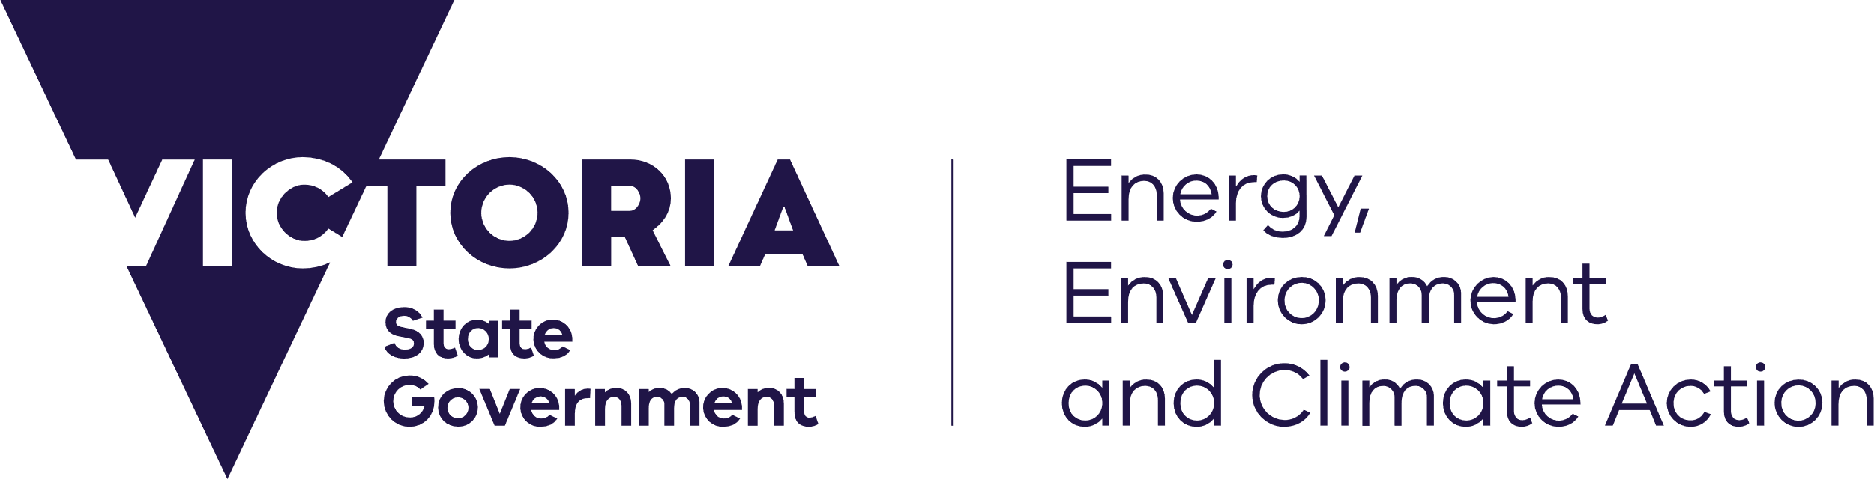



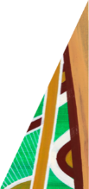

January 2025

## Key Messages

* Ecological modelling can predict suitable breeding habitat for Brolgas across Victoria.
* Our model identified potentially suitable breeding habitat that was previously unknown and additional to recognised breeding sites.
* The state-wide Brolga breeding habitat model helps guide evidence-based decision making for strategic conservation and renewable energy siting in Victoria.

[deeca.vic.gov.au](https://delwpvicgovau.sharepoint.com/Users/fionadurante/Downloads/deeca.vic.gov.au)

## PROJECT CONTEXT

* The Victorian Government has set net-zero emissions targets to be achieved by 2045 in its transition to renewable energy.
* Brolga is considered a species of concern due to potential impacts of disturbance and collision from wind energy facility infrastructure.
* Brolga breeding habitat in Victoria overlaps with an area of interest for wind energy project development.
* Under current government guidelines, known breeding sites require a habitat buffer to avoid and minimise potential disturbance and collision impacts.
* Unknown breeding sites (where Brolga breed but it hasn’t been observed or recorded) present a challenge for conservation and management of these sites when planning and assessing wind energy projects.
* Due to limited knowledge on Brolga breeding site locations a state-wide strategic approach to identify suitable breeding habitat is required to inform the development of policy for renewable energy planning.
* Ecological models can assist in identifying modelled suitable habitat where we have imperfect knowledge on the location of such habitat.
* This fact sheet outlines a project undertaken to predict the locations of suitable Brolga breeding habitat in Victoria to inform DEECA policy guidance for wind energy project development.

Credit: Bob McPherson

## Ecological model for Brolga breeding habitat

Many wetlands important for Brolga breeding occur on land that is infrequently or rarely visited by bird observers and the extent of private land surveyed is limited. As a result, it is likely that many wetlands across Victoria provide suitable habitat for regular, infrequent or future Brolga breeding, but have been poorly documented. Creating a model that extrapolates from the characteristics of wetlands where Brolgas are known to breed to the wider landscape is an important first step in identifying high value habitat that could be prioritised for protection and conservation.

## Brolga breeding habitat requirements

Features that characterise breeding wetlands include:

* Shallow freshwater 30-50 cm deep that flood for 2-6 months of the year (Herring 2001). This allows for nest building (~30 days), incubation (~30 days) and fledging of chicks (11-14 weeks) (Marchant and Higgins 1993).
* Emergent vegetation approximately 90 cm tall (Herring 2001) (Figure 1, Figure 2), which pairs use for both nest building and protecting chicks from predators.
* Pairs of adults with chicks use wetland and surrounding non-wetland habitats for foraging (Veltheim et al. 2019), and wetlands for roosting at night and during the day.
* Proximity and connectivity of nesting wetlands to other shallow vegetated wetlands is important and is likely to influence breeding success. If a nesting wetland dries before chicks fledge, the breeding pair will typically relocate chicks to suitable inundated wetlands within 2 km.

Size and context of wetlands where brolgas breed is highly variable:

* In Victoria nesting wetland size can vary and can be as small as 0.2 hectares or as large as 1000 hectares.
* Wetlands used by Brolgas for breeding may be surrounded by woody vegetation, or they may be in open and agricultural settings.

Figure 1: Brolga nest in an *Eleocharis* dominated wetland

Credit: Matt Herring, Murray Wildlife Pty Ltd

Brolga nest

Figure 2: Aerial view of Brolga breeding wetland habitat with a Brolga on a nest (nest located in the lower left-hand corner, surrounded by emergent vegetation)

## Modelling approach

### Brolga observation data

Brolga breeding wetland habitat was identified using published and unpublished breeding records sourced from databases and experts.

The process of compiling the model input dataset included two main steps. Firstly, selection of breeding records, and secondly, plotting and selecting breeding records to identify breeding wetlands.

#### Selecting breeding records

Field observation records were selected for use in the modelling if they:

1. were in southeast (SE) Australia, including Victoria, southern New South Wales and South Australia;
2. included details of breeding, eggs, nests and/or chicks;
3. had notes on breeding recorded (as listed above under point 2) and occurred between June and February (when Brolgas are known to nest);
4. were pairs with no notes on breeding and occurred between June and January;
5. occurred post-1970; and
6. were reliably plotted.

#### Plotting and selecting breeding records to identify breeding wetlands

Database records have inherent locational inaccuracies arising from:

* where the sighting location point was recorded in relation to the actual location of the birds or nest;
* datum and projection errors; and
* collection date.

For example, observers may log a point location on a road or a high-point such as a hill (i.e. where they were standing), rather than the nest or bird in a wetland. Additionally, data collected prior to GPS-enabled devices can be inaccurate and unreliable for identifying the actual or most likely location of a sighting record. These inaccuracies lead to a portion of records being plotted outside wetlands.

As the aim was to model suitable breeding wetland habitat, all records used in the model input dataset had to be located within a wetland. The data was plotted and visually inspected to select records that fell within existing wetlands. Expert knowledge was used to decide whether records located less than 500 m from known wetlands were moved into a wetland for inclusion in the model.

### Linking observations to environmental variables

Modelling breeding habitat involved the interaction of Brolga breeding observation data (the ‘dependent’ data) (as described above) and a set of mapped environmental variables or characteristics (the ‘independent’ data) that are relevant for discriminating ‘suitable’ from unsuitable breeding wetland habitat.

The environmental data used included:

* vegetation and wetland types derived from satellite imagery since the mid-1980s;
* earth observation data including the frequency of water observation and radar back-scatter; and
* landscape variables describing physiographic and geological context.

See Figures 3-5 for examples of environmental data included in the modelling.

Observations of Brolgas in public and Government datasets typically include varying amounts of information on breeding behaviour. Occasionally observation data is associated with notes relating to breeding such as ‘nest’ / ‘nesting’, ‘egg/s’ or ‘chick/s’. For a limited portion of the breeding observation data, ‘fledging’ was recorded.

Records of adult pairs in June-January were considered indicative of potential breeding interest.

Selected Brolga data was annotated for modelling purposes using the following categories, representing decreasing certainty of successful breeding (defined as chicks fledging, i.e. surviving to an age when they can fly):

1. dates and locations of successful fledging of young across SE Australia;
2. dates and locations of breeding attempts (with notes of ‘nest’, ‘egg/s’ or ‘chick/s’, which may or may not have ultimately been successful) across SE Australia;
3. dates and locations of pairs of adult Brolgas with or without young observed during the June to January breeding season (known nesting period) across SE Australia.

These observation records of Brolgas were combined with randomly selected locations across Australia (~360,000 points) to represent the absence or ‘pseudo-absence’ of Brolga breeding. This is done because we cannot be confident that an apparent absence of an observation on any given date conclusively means that there was no Brolga breeding for that year at that site.

We used a regression-tree modelling method, where we simultaneously attempted to predict:

1. known breeding success (observations of fledging events associated with a wetland);
2. known breeding attempts (nesting observations associated with a wetland);
3. likely breeding behaviour (i.e. pairs observed on a potentially suitable wetland during the breeding season);
4. a model of wetland suitability for Brolga breeding where we weighted the observation of birds during the breeding season, observations of birds ‘attempting’ to breed, and where successful fledging of young was observed.

To assess the model’s accuracy for predicting wetland suitability for Brolga breeding and its ability to generalise, we conducted a validation procedure. We first trained the model using a random subset of 70% of the breeding data and withheld the remaining 30% for testing purposes. The results of this analysis were encouraging, suggesting that more that 73% of the variation within the input data was explained by the model. The remining uncertainty is likely due to the idiosyncrasies and ancestral preferences of the birds and our current lack of understanding of landscape-level hydrological patterns.

#### Examples of input variables included in the Brolga breeding suitability model

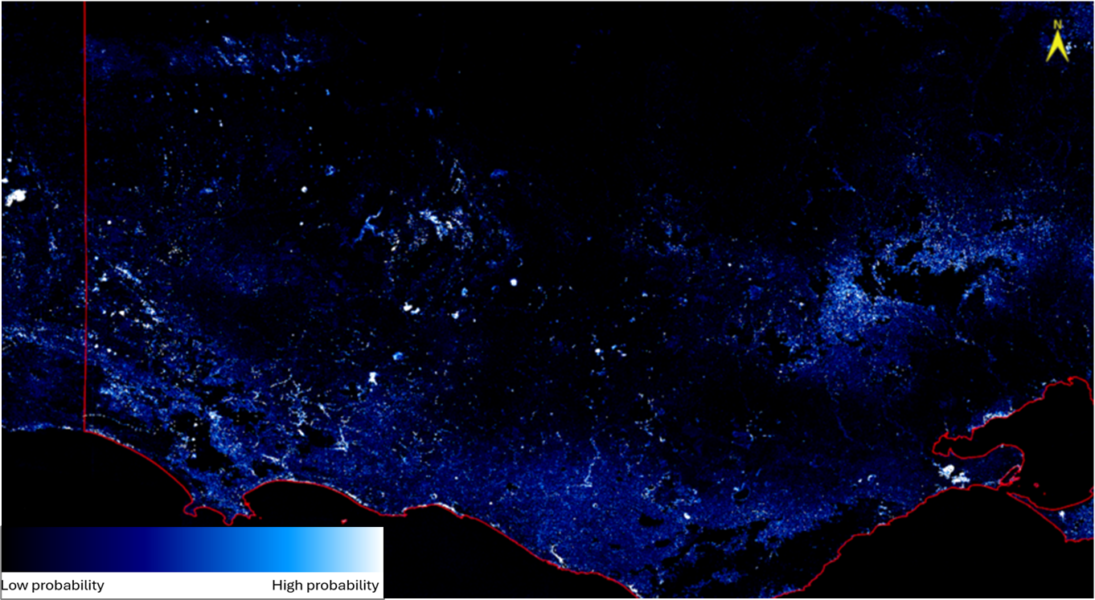Figure 3: Average perennial wetland vegetation cover, 1986-2019. Black regions denote places that have low probability of supporting perennial wetland vegetation, whereas white regions denote places that have a high probability of supporting perennial wetland vegetation.

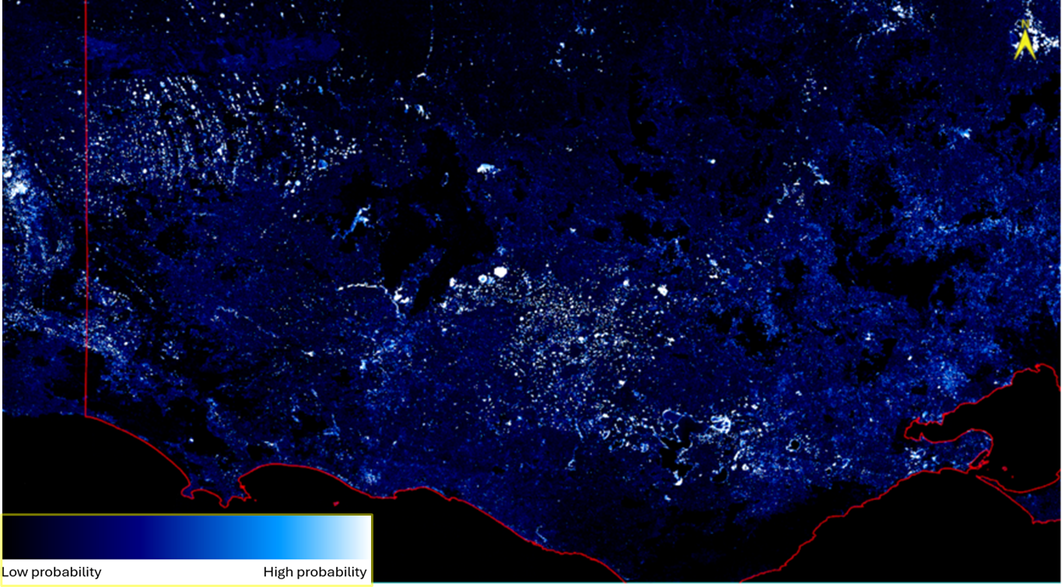Figure 4: Average seasonal wetland vegetation cover, 1986-2019. Black regions denote places that have low probability of supporting seasonal wetland vegetation, whereas white regions denote places that have a high probability of supporting seasonal wetland vegetation.

Figure 5: Vertical elevation above known wetlands and streams. Purple regions are vertically ‘close’ to wetlands and streams through to red regions which are vertically ‘distant’ from wetlands and streams.

## Results and implications

* The model provides a map of predicted suitable Brolga breeding habitat in Victoria (see Figure 6).
* The model is useful for identifying wetlands that are ostensibly suitable for breeding with 73% of the data variation explained. The model tended to marginally over-predict the utility for Brolga breeding in some wetlands. This was anticipated, as Brolga breeding habitat preferences are – in part – based on ancestral breeding choices and subtle hydrological characteristics and water chemistry that were unknown to the modelling process. Experts with local knowledge were engaged to exclude these unsuitable wetlands from the final product.
* The model will assist in prioritising areas for protection and enhancement of Brolga breeding habitat. As new and reliable field observation data are accumulated, they will be used to refine future modelling.

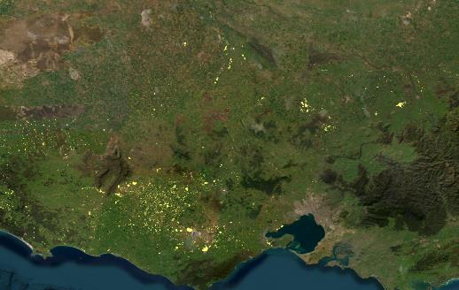

Figure 6: Brolga breeding habitat model output applied to mapped wetlands across Victoria. Yellow wetlands support both known and modelled suitable habitat for Brolga breeding.

## Further reading

Herring, M. W. (2001). *The brolga (*Grus rubicunda*) in the New South Wales and Victorian Riverina: distribution, breeding habitat and potential role as an umbrella species*. Honours thesis, Faculty of Science and Agriculture, School of Environmental and Information Sciences. Charles Sturt University Albury-Wodonga, Australia.

Marchant, S. and Higgins, P. J. (Eds) (1993). *Handbook of Australian, New Zealand and Antarctic Birds. Volume 2: Raptors to Lapwings*. Oxford University Press, Melbourne.

Accessibility

If you would like to receive this publication in an alternative format, please telephone the DEECA Customer Service Centre on 136186, email [customer.service@delwp.vic.gov.au](mailto:customer.service@delwp.vic.gov.au), or via the National Relay Service on 133 677 [www.relayservice.com.au](http://www.relayservice.com.au).

Veltheim, I., Cook, S., Palmer, G. C., Hill, F. A. R. and McCarthy, M. A. (2019). Breeding home range movements of pre-fledged brolga chicks, *Antigone rubicunda* (Gruidae). *Global Ecology and Conservation* **20,** e00703.

**For further information contact** [renewables.biodiversity@deeca.vic.gov.au](mailto:renewables.biodiversity@deeca.vic.gov.au)



We acknowledge Victorian Traditional Owners and their Elders past and present as the original custodians of Victoria’s land and waters and commit to genuinely partnering with them and Victoria’s Aboriginal community to progress their aspirations.

ISBN 978-1-76176-060-0 (pdf/online/MS word)

© The State of Victoria Department of Energy, Environment and Climate Action Month 2023

Logo

ISBN xxx-x-xxxxx-xxx-xx (pdf)

Accessibility

If you would like to receive this publication in an alternative format, please telephone the DEECA Customer Service Centre on 136186, email [customer.service@delwp.vic.gov.au](mailto:customer.service@delwp.vic.gov.au), or via the National Relay Service on 133 677 [www.relayservice.com.au](http://www.relayservice.com.au).

This work is licensed under a Creative Commons Attribution 4.0 International

licence. To view a copy of this licence, visit

creative commons.org/licenses/by/4.0/