|  |
| --- |
| Victorian Riparian Research and Monitoring |
| Overview – May 2017 |

Using monitoring and research to evaluate and improve the effectiveness and efficiency of riparian management

## Background

## In Victoria, agencies including the Department of Environment Land Water and Planning (DELWP), Catchment Management Authorities (CMAs) and Melbourne Water invest significant resources in riparian management interventions along waterways. These interventions aim to improve vegetation condition and manage bank erosion and contribute to long-term improvements in the condition of our waterways. While it is expected that these management interventions will achieve these aims, long-term monitoring is needed to:

* Demonstrate the environmental benefits of riparian management
* Improve understanding of riparian responses to management
* Assess if responses to management vary across the state
* Inform management standards and best management guidelines for riparian land
* Link outcomes of riparian management to broader waterway health program objectives and condition change
* Allow more accurate and specific management targets to be established
* Support riparian monitoring requirements for large-scale priority waterways projects and the *Regional Riparian Action Plan* (RRAP)

## To support these aims the Victorian Riparian Monitoring and Research Program is using a mix of approaches.

## 1. Riparian Intervention Monitoring Program -

The Riparian Intervention Monitoring Program (RIMP) is a state-wide, long-term intervention monitoring program which aims to evaluate and demonstrate responses of riparian land to weed control, revegetation and livestock exclusion. The program began in 2014 and is being delivered in partnership with CMAs.

The core component of the RIMP is to monitor responses of riparian attributes to management at paired intervention and control (unmanaged) sites before and after management is applied. The program aims to assess at least five pairs of intervention and control sites in each CMA. This will provide a range of environmental conditions to inform if and why responses to management vary across the state.

The monitoring methods used in the program are designed to quantify changes in a range of riparian attributes including:

* invasive vegetation cover
* native vegetation cover and composition
* cover of bare ground
* vegetation structure
* recruitment of native plants
* native vegetation extent and continuity
* bank stability

A range of complementary approaches have also been developed to enhance the core program (see RIMP Fact Sheet1).

## 2. Riparian monitoring at large-scale priority waterway projects - 36 priority waterways in Victoria will be targeted for concentrated riparian management over the next 25 years. One high priority waterway in each region will be the focus of long-term monitoring to track progress and report back to communities. At these sites, monitoring and research will focus on:

* Providing evidence of progress toward management outcomes targets
* Informing critical knowledge gaps to support management decisions and planning
* Improving understanding or riparian responses to management

## 3. Measuring rates of change in woody vegetation - To support CMAs in setting long-term woody vegetation objectives, models are being developed that predict expected rates of change in selected riparian woody vegetation attributes (e.g. tree and shrub cover).

Figure 1. Aerial images (A)(B) of the same site over time are used to measure rates of change in the cover of woody vegetation after management by assigning a vegetation cover type to 100s of georeferenced points (yellow points in C.).

**4. Tracking progress towards riparian management objectives -** Riparian attributes were measured with remote sensing (LiDAR; Light Detection and Ranging and aerial imagery) in 2009/10 by the Index of Stream Condition program. This data willl be collected again at priority waterways to track riparian responses to management. Riparian attributes requiring field based monitoring will be assessed using RIMP or other suitable methods.

## 

## 5. Strategic research - DELWP will continue to support strategic riparian related research to improve understanding of the relationships between management interventions and outcomes and underlying processes.

## 6. Informing management decisions - The program sits within a broader adaptive management framework where new learning will inform target setting, update our assumptions and improve management practice standards.

## Who is involved and what is their role?

The program involves strong collaborations:

* **DELWP -** the program leader, liaise with CMA staff to identify suitable sites, engage botanists to monitor the sites, analyse results and use learnings to inform adaptive management.

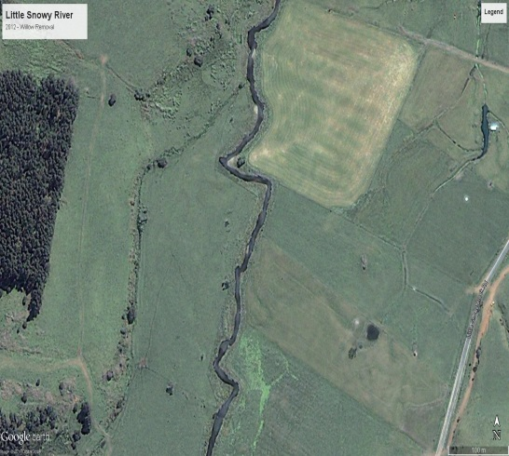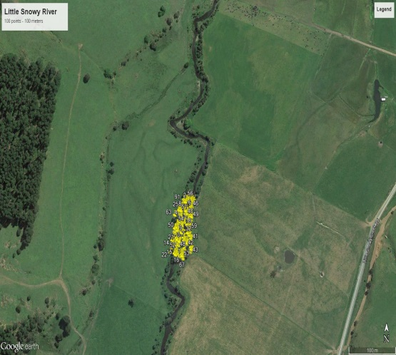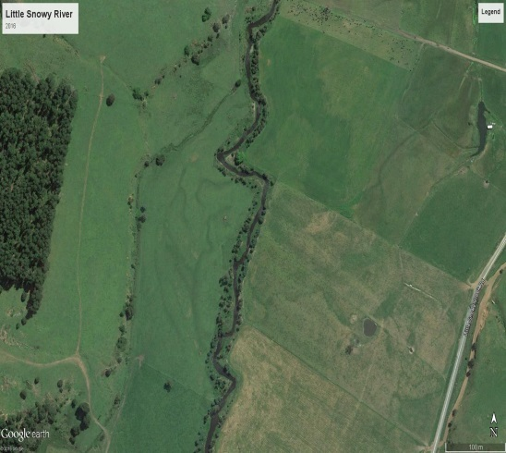

**A.**

**B.**

**C.**

**2012**

**2016**

**2016**

* **CMAs** - identify suitable sites across Victoria, liaise and work with landholders to implement management interventions.
* **Landholders** - work with CMAs to implement management interventions, and allow access to their land for botanists to carry out monitoring.

This program is part of a $222 million investment by the Victorian Government announced in the Water Plan, *Water for Victoria,* to improve the health of waterways and catchments. This funding will support an accelerated riparian works program across regional Victoria delivered though the *Regional Riparian Action Plan*. This program will play an important role in demonstrating outcomes of the Action Plan and will support the government’s commitment to improving knowledge and information about waterways and providing better reporting back to communities.

## 1 DELWP (2017) Riparian Intervention Monitoring Program Overview May 2017. Fact Sheet, Department of Land Water and Environment.

## Contacts

## paul.reich[@delwp.vic.gov.au](mailto:Kay.Morris@delwp.vic.gov.au) (DELWP, Program lead), [kaylene.morris@delwp.vic.gov.au](mailto:kaylene.morris@delwp.vic.gov.au) (Arthur Rylah Institute, Program delivery)

|  |  |
| --- | --- |
| © The State of Victoria Department of Environment, Land, Water and Planning 2017  LogoThis work is licensed under a Creative Commons Attribution 4.0 International licence. You are free to re-use the work under that licence, on the condition that you credit the State of Victoria as author. The licence does not apply to any images, photographs or branding, including the Victorian Coat of Arms, the Victorian Government logo and the Department of Environment, Land, Water and Planning (DELWP) logo. To view a copy of this licence, visit <http://creativecommons.org/licenses/by/4.0/>  ISBN 978-1-76047-603-8 (Print) ISBN 978-1-76047-604-5 (pdf/online)  Disclaimer  This publication may be of assistance to you but the State of Victoria and its employees do not guarantee that the publication is without flaw of any kind or is wholly appropriate for your particular purposes and therefore disclaims all liability for any error, loss or other consequence which may arise from you relying on any information in this publication. | Accessibility  If you would like to receive this publication in an alternative format, please telephone the DELWP Customer Service Centre on 136186, email [customer.service@delwp.vic.gov.au](mailto:customer.service@delwp.vic.gov.au), or via the National Relay Service on 133 677 [www.relayservice.com.au](http://www.relayservice.com.au). This document is also available on the internet at [www.delwp.vic.gov.au](http://www.delwp.vic.gov.au). |