www.delwp.vic.gov.au

ARI Technical Report Series No. 280

Design of an aerial survey to estimate the abundance of kangaroos in Victoria

 | 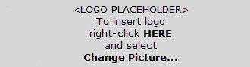

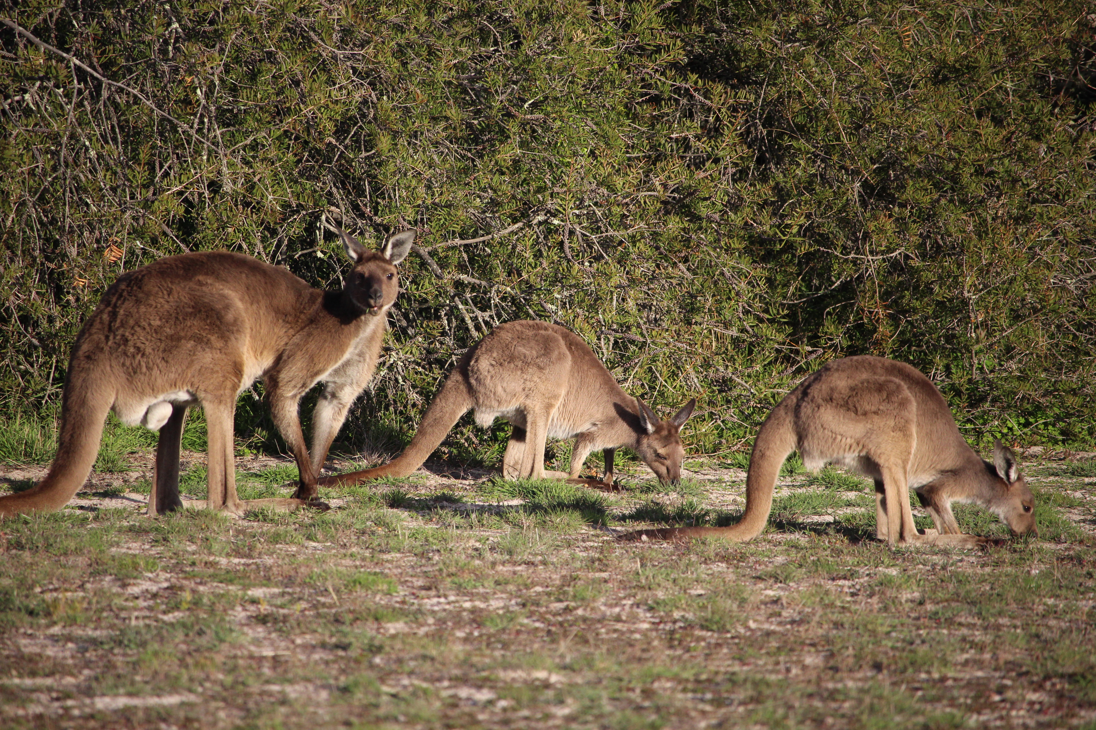

Report produced by: Arthur Rylah Institute for Environmental Research
Department of Environment, Land, Water and Planning
PO Box 137
Heidelberg, Victoria 3084
Phone (03) 9450 8600
Website: www.delwp.vic.gov.au
Acknowledgements

We thank David Forsyth, Naomi Davis and Graeme Coulson, who provided us with density estimates for Eastern Grey Kangaroos. They had previously collated these data from a variety of published and unpublished sources. We thank Graeme Coulson, Tony Pople and Kirsty Greengrass for some very useful comments on an earlier draft of this report.
Authors
This report was prepared by: Michael Scroggie, Paul Moloney and David Ramsey
Photo credit
Western Grey Kangaroos. Photo: Jemma Cripps.
© The State of Victoria Department of Environment, Land, Water and Planning 2017

This work is licensed under a Creative Commons Attribution 4.0 International licence. You are free to re-use the work under that licence, on the condition that you credit the State of Victoria as author. The licence does not apply to any images, photographs or branding, including the Victorian Coat of Arms, the Victorian Government logo and the Department of Environment, Land, Water and Planning (DELWP) logo. To view a copy of this licence, visit http://creativecommons.org/licenses/by/4.0/

ISSN 1835-3827 (print)
ISSN 1835-3835 (pdf))
ISBN 978-1-76047-641-0 (print)
ISBN 978-1-76047-642-7 (pdf/online)
Disclaimer
This publication may be of assistance to you but the State of Victoria and its employees do not guarantee that the publication is without flaw of any kind or is wholly appropriate for your particular purposes and therefore disclaims all liability for any error, loss or other consequence which may arise from you relying on any information in this publication.
Accessibility
If you would like to receive this publication in an alternative format, please telephone the DELWP Customer Service Centre on 136186, email customer.service@delwp.vic.gov.au, or via the National Relay Service on 133 677 www.relayservice.com.au. This document is also available on the internet at www.delwp.vic.gov.au.
Citation
Scroggie, M.P., Moloney, P.D. and Ramsey, D.S.L. (2017). Design of an aerial survey to estimate the abundance of kangaroos in Victoria. Arthur Rylah Institute for Environmental Research Technical Report No. 280. Department of Environment, Land, Water and Planning, Heidelberg, Victoria.
August 2017
Editor
Jeanette Birtles, Organic Editing

Contents
Executive summary 1
1 Introduction 2
1.1 Background 2
2 Methods 4
2.1 Broad distributions of the three species in the state 4
2.2 Study area and stratification 5
2.3 Aerial transect survey methodologies 6
2.4 Distance-sampling designs for estimating kangaroo abundance 6
2.5 Simulation study 8
2.6 Obtaining separate estimates of abundance for Eastern and Western Grey Kangaroos 9
2.7 Determining sampling requirements for ground surveys in the grey kangaroo overlap zone 10
3 Results 11
3.1 Results of the distance-sampling simulation study 11
3.2 Analysis of the grey kangaroo overlap zone 17
3.3 Results of the simulation study of driven transect sampling of the overlap zone 20
4 Discussion 21
4.1 Comments on the analysis of the grey kangaroo overlap zone 22
4.2 Recommended survey specifications 22
4.3 General principles and recommendations for a future survey 23
References 24
Appendix 1. Sources of assumed kangaroo density estimates used in the simulations 25
Red Kangaroos 25
Grey kangaroos 25
Appendix 2. Sources of assumed distance-detection parameters used in the simulations 25
Appendix 3. Examples of road transects across the grey kangaroo overlap zone 26

Figures
Figure 1: Distribution of three kangaroo species in Victoria. 4
Figure 2: Map of proposed stratification scheme for statewide kangaroo surveys 6
Figure 3: Assumed distance-detection relationship for the distance-sampling simulation study 8
Figure 4: Simulation results for low-density kangaroo populations (2.0 kangaroo km^{–2}) 12
Figure 5: Simulation results for medium-density kangaroo populations (5.0 kangaroo km^{–2}) 13
Figure 6: Simulation results for high-density kangaroo populations (10.0 kangaroo km^{–2}) 14
Figure 7: Representative arrangements of transect lines allocated to each stratum in order to achieve total survey efforts of 1000, 1500 and 2000 km statewide 18
Figure 8: The study area, with records of Eastern Grey Kangaroos from the Atlas of Living Australia overlaid 19
Figure 9: The modelled probability that a Grey Kangaroo detected at a given location in Victoria is an Eastern Grey Kangaroo, based on a Generalised Additive Model (GAM) fitted to sighting data from the Atlas of Living Australia 19
Figure 10: The average span (upper bound subtract lower bound of the 95% confidence interval) under each scenario, and the distance travelled 20
Figure 11: The average span (upper bound subtract lower bound of the 95% confidence interval) under each scenario, and the distance travelled 21
Figure A3-1. The road transect from Tyrendarra to Strathdownie (via Greenwald) is approximately a 140-km transect in a north-westerly direction, covering the Glenelg LGA, the southern-most part of the GKOZ 27
Figure A3-2. The road transect from Nareeb to Dorodong (via Konongwootong) is approximately a 190-km transect in a west-north-westerly direction, covering the Southern Grampians and West Wimmera LGAs. 27
Figure A3-3. The road transect from Streatham to Glenora (via Tooan) is approximately a 300-km transect in a north-westerly direction, covering the Ararat, Southern Grampians and West Wimmera LGAs 27
Figure A3-4. The road transect from Waubra to Rainbow (via Marnoo) is approximately a 320-km transect in a north-westerly direction, covering the Pyrenees, Northern Grampians, Yarriambiack and Hindmarsh LGAs 28
Figure A3-5. The road transect from Newbridge to Patchewollock (via Birchip) is approximately a 270-km transect in a north-westerly direction, covering the Loddon, Buloke and Yarriambiack LGAs 28
Figure A3-6. The road transect from Mitiamo to Bannerton (via Chinkapook) is approximately a 270-km transect in a north-north-westerly direction, covering the Loddon, Gannawarra and Swan Hill LGAs, the northernmost part of the GKOZ 28

Executive summary
- Currently, limited culling of kangaroos is conducted in Victoria, under the Authority to Control Wildlife (ATCW) provisions of the Wildlife Act 1975 (Victoria). To date, there has been a lack of state-wide kangaroo population data to inform ATCW assessment and decision making. The Department of Environment, Land, Water and Planning (DELWP) is undertaking a statewide kangaroo population survey, the results of which will help to ensure that any authorised kangaroo management activities undertaken in Victoria are sustainable.
- In parts of Victoria, some limited utilisation of the resulting carcasses of kangaroo culling currently occurs under the Kangaroo Pet Food Trial, in the form of processing into pet food and export of the skins overseas. The trial is due to conclude on 31 March 2018. The results from the kangaroo population survey will assist in the evaluation of the trial and will be considered as part of a decision on future arrangements.
- Accordingly, the Arthur Rylah Institute for Environmental Research (ARI) has been engaged to determine an appropriate methodology for estimating the abundance of Red (Osphranter rufus), Eastern Grey (Macropus giganteus) and Western Grey (M. fuliginosus) Kangaroos in Victoria. Based on an examination of experiences in other Australian jurisdictions where state- or regional-scale kangaroo surveys are conducted, aerial surveys were identified as the only practical means of determining the abundance of kangaroos in Victoria.
- Using a simulation approach, we examined the relationship between the precision of population estimates derived from aerial distance-sampling surveys under several assumed densities of kangaroos. The results of these simulations demonstrated that at least 1000 km of aerial transects would need to be conducted in order to determine state- and regional-level population sizes with acceptable precision.
- As Eastern and Western Grey Kangaroos cannot be reliably distinguished from the air, deriving separate state and regional population estimates for these species requires the collection of additional data on ratio of abundances of the two species in the parts of the state where they overlap. We devised a program of road vehicle transects that can be used to determine the ratio of Eastern to Western Grey kangaroos in their overlap zone. These estimates can then be used to apportion the total abundance estimates for Grey Kangaroos obtained from the aerial surveys to the two species. The recommended program of vehicle surveys involves driving approximately 800–1000 km of road transect within the areas of overlap of the two species.
- Further recommendations are made about the design and execution of the aerial and road surveys to ensure that the data collected will be of high quality, and suited to the aims of the proposed survey program.

1 Introduction

1.1 Background
Three species of kangaroos [Eastern Grey Kangaroo (Macropus giganteus), Western Grey Kangaroo (M. fuliginosus) and Red Kangaroo (Osphranter rufus)] are subject to legal culling in Victoria, under the Authority to Control Wildlife (ATCW) provisions of the Wildlife Act 1975 (Victoria), for damage mitigation purposes. To date, there has been a lack of state-wide kangaroo population data to inform ATCW assessment and decision making. The Department of Environment, Land, Water and Planning (DELWP) is undertaking a statewide kangaroo population survey and the analysis of the results will be used to ensure that any authorised kangaroo management activities undertaken in Victoria are sustainable for its kangaroo populations.
In recent years, under the Kangaroo Pet Food Trial, the carcasses of some kangaroos culled under ATCW provisions have been utilised in the pet food trade and the skins have been exported overseas under Commonwealth approval. The Kangaroo Pet Food Trial is due to conclude on the 31 March 2018. The trail is currently being evaluated and a decision will be made in early 2018 as to its future beyond March 2018. The results from the kangaroo population survey will assist with informing the evaluation of the trial and will also inform the decision about whether the trial will continue in some shape or form beyond March 2018.
Should the trial continue beyond 31 March 2018, there will also be a requirement to comply with national wildlife trade legislation [the Environment Protection and Biodiversity Conservation Act 1999 (EPBC)] and international wildlife trade conventions [the Convention on International Trade in Endangered Species of Wild Fauna and Flora (CITES)]. In particular, Victoria may need to demonstrate whether any authorised kangaroo management activities under current and future ATCW provisions in Victoria are ecologically sustainable.
Accordingly, the Arthur Rylah Institute for Environmental Research (ARI) has been engaged to design a program of surveys that will allow the populations of the three kangaroo species to be estimated with sufficient precision for effective assessment of the sustainability of any kangaroo management activities in Victoria.
Should the export of wildlife products such as kangaroo skins continue following the completion of the Kangaroo Pet Food Trial, there is a requirement to develop, and have approved by the Federal Environment Minister, a Wildlife Trade Management Plan (WTMP). WTMPs are documents prepared under the provisions of section 303FO of the Commonwealth’s EPBC. Other Australian jurisdictions have successfully gained ministerial approval for WTMPs to allow commercial harvesting and export of kangaroo products [Department of Environment and Heritage Protection (Qld) 2013, Department of Environment, Water and Natural Resources (SA) 2013, Office of Environment and Heritage (NSW) 2017]. These WTMPs provide a useful model and background.
Section 303FO of the EPBC sets out in considerable detail the requirements that such a WTMP must satisfy before being approved by the Commonwealth Minister for the Environment. Several of these requirements are of particular relevance to the current report, and have been addressed in detail in the WTMPs developed in other Australian states:
- Assessment of the status of the affected species in the wild, including the extent of its habitat, threats, and the impact of the activities covered by the WTMP.
- Identification of management controls to ensure that the impacts of the proposed activities are ecologically sustainable, and
- Measures to mitigate and minimise environmental impacts of the activities covered by the plan, and to monitor these impacts.
Based on these legislative requirements, should Victoria move to a future program after the Kangaroo Pet Food Trial, Victoria may need to undertake a rigorous and defensible assessment of the status of kangaroo populations of a quality similar to those that have been undertaken in other states where kangaroo products are commercially harvested, in order to support the development and approval of a WTMP.
The population assessment methodologies used in other states provide a model for meeting the requirements here in Victoria, so it is worth briefly noting the population survey assessment methods used in other states as points of reference, though it will of course be necessary to adapt any methods to Victorian conditions and requirements.
Kangaroo population surveys are regularly undertaken in other Australian states, using a variety of different sampling methodologies. Where population estimates are required at large geographic scales for setting harvest quotas, or for monitoring population status at state or regional scales, it has been found that aerial surveys (sometimes supplemented with limited on-ground surveys), are the only practical approach.
In New South Wales, populations of Red and Grey Kangaroos (both species), and Euros (Macropus robustus) are subject to commercial harvesting [Office of Environment and Heritage (NSW) 2017]. Population monitoring in inland parts of NSW is carried out using annual surveys from fixed-wing aircraft. On the Western slopes of the Great Dividing Range, and the Northern Tablelands of NSW, helicopter surveys are used instead, supplemented with walked transects in heavily timbered or topographically difficult terrain [Office of Environment and Heritage (NSW) 2008].
Kangaroo populations in Queensland are also subject to extensive commercial harvesting. To monitor population status, and to support the setting of sustainable quotas, helicopter-based aerial surveys are conducted annually across the inland pastoral zone of the state, where most commercial harvesting is conducted [Department of Environment and Heritage Protection (Qld) 2013]. The transects, each approximately 50–90 km long, are grouped into 22 distinct clusters, to reduce the amount of time spent ferrying aircraft between transects [Department of Environment and Heritage Protection (Qld) 2013]. Monitoring of kangaroo populations in South Australia is carried out using aerial surveys from fixed-wing aircraft. Walked transects are used to supplement these data in some parts of the state where the topography does not permit use of fixed-wing aircraft for aerial surveys [Department of Environment, Water and Natural Resources (SA) 2013].
In Western Australia, fixed-wing aircraft are also used to conduct aerial surveys for Red Kangaroos and Western Grey Kangaroos [Department of Parks and Wildlife (WA) 2014]. Surveys are conducted triennially in the arid interior of the state, and annually in the mesic zone of the south-west of the state [Department of Parks and Wildlife (WA) 2014]. These surveys are used to set quotas for the commercial harvest of Red Kangaroos and Western Grey Kangaroos.
Currently, there is no commercial utilisation of kangaroos in Tasmania, the Australian Capital Territory, or the Northern Territory, although limited localised culling occurs in these jurisdictions (Government of the Australian Capital Territory 2000, Tanner and Hocking 2000, Neave 2008). Consequently, there has been no requirement to develop a means of assessing kangaroo abundance at the scale of an entire state or territory in these jurisdictions.
Given the large geographic area to be covered, an aerial survey is the only feasible method of estimating population sizes for kangaroo species in Victoria. Aerial surveys have been the cornerstone of population survey and monitoring efforts in other states that have required state- or regional-scale population estimates for management or regulatory purposes (see above). Aerial surveys have already been used on a limited basis to estimate kangaroo abundance in some parts of Victoria for management purposes (see, for example, Moloney and Forsyth 2013). Other means of survey are unlikely to be suitable or economically feasible at broad spatial scales, given the need to sample representative habitat across a range of land tenures, including remote, poorly roaded parts of the state, and private property in agricultural areas.
It is intended that the survey method should be adequate for estimating abundances of kangaroos at the scale of Local Government Areas (LGAs). Although decisions regarding ATCW permits are made on a case-by-case basis, these decisions should ideally be informed by knowledge of the status of kangaroo populations at a somewhat larger spatial scale, to avoid negative impacts on populations due to excessive localised culling. Additionally, if Victoria were to ultimately move to a harvest model of kangaroo population management, surveys at the scale of LGAs could also be used to set regional quotas if this was deemed to be desirable.
In this report, we present the results of a simulation study that we have conducted to determine the likely precision of statewide and LGA-level estimates of kangaroo populations that result from aerial line-transect survey programs with varying degrees of effort across the non-forested, non-metropolitan portions of the state. Recommendations regarding required effort are made for estimating abundance for all three species with a target precision (expressed as a coefficient of variation, CV) of 20%.
We also consider the problem of deriving separate counts for Eastern and Western Grey kangaroos within the broad area of overlap between these two species in Western Victoria. We consider the possibility of using existing Atlas data, drawn from the Atlas of Living Australia (www.ala.org.au) to construct spatial models of the two species’ distributions, and using these models to apportion the counts. We also explore an alternative approach, by devising a program of driven ground transects to allow direct estimation of the proportional representation of Eastern and Western Grey Kangaroos within the overlap zone.
There are a large number of unknown quantities that need to be considered in any assessment of the performance of alternative sampling designs. In particular, the assessment of any specified survey design requires that assumptions are made about the likely abundance of each species of kangaroo in each spatial unit for which an estimate of abundance is desired. It is also necessary to make assumptions about the likely performance of the line-transect survey method. To examine the performance of the proposed program of ground surveys of grey kangaroos in the overlap zone, it was necessary to make assumptions about kangaroo density, and sightability from vehicles.
As each of these quantities are not known with any certainty, it was necessary to make numerous simplifying assumptions, informed wherever possible by results obtained from published and unpublished studies, and also based on the authors’ own judgements. It should be acknowledged at the outset that these assumptions are a starting point for consideration. As actual survey data is collected, it will be advisable to revise the initial sampling designs. Improved understanding of the actual distribution and abundance of kangaroos in different parts of the state, and an understanding of the performance of the survey methods will both allow refinement of the survey methodology in any subsequent survey. Therefore, it is considered highly likely that the initial survey designs described here will require revision as more informative data come to hand.

2 Methods

2.1 Broad distributions of the three species in the state
Atlas data were obtained from the Atlas of Living Australia database, which provided locations of the known spatially referenced records for all three species across the entire state (Figure 1). The Atlas of Living Australia data includes data from the Victorian Biodiversity Atlas (DELWP), due to a data-sharing arrangement between the administrators of these two databases.
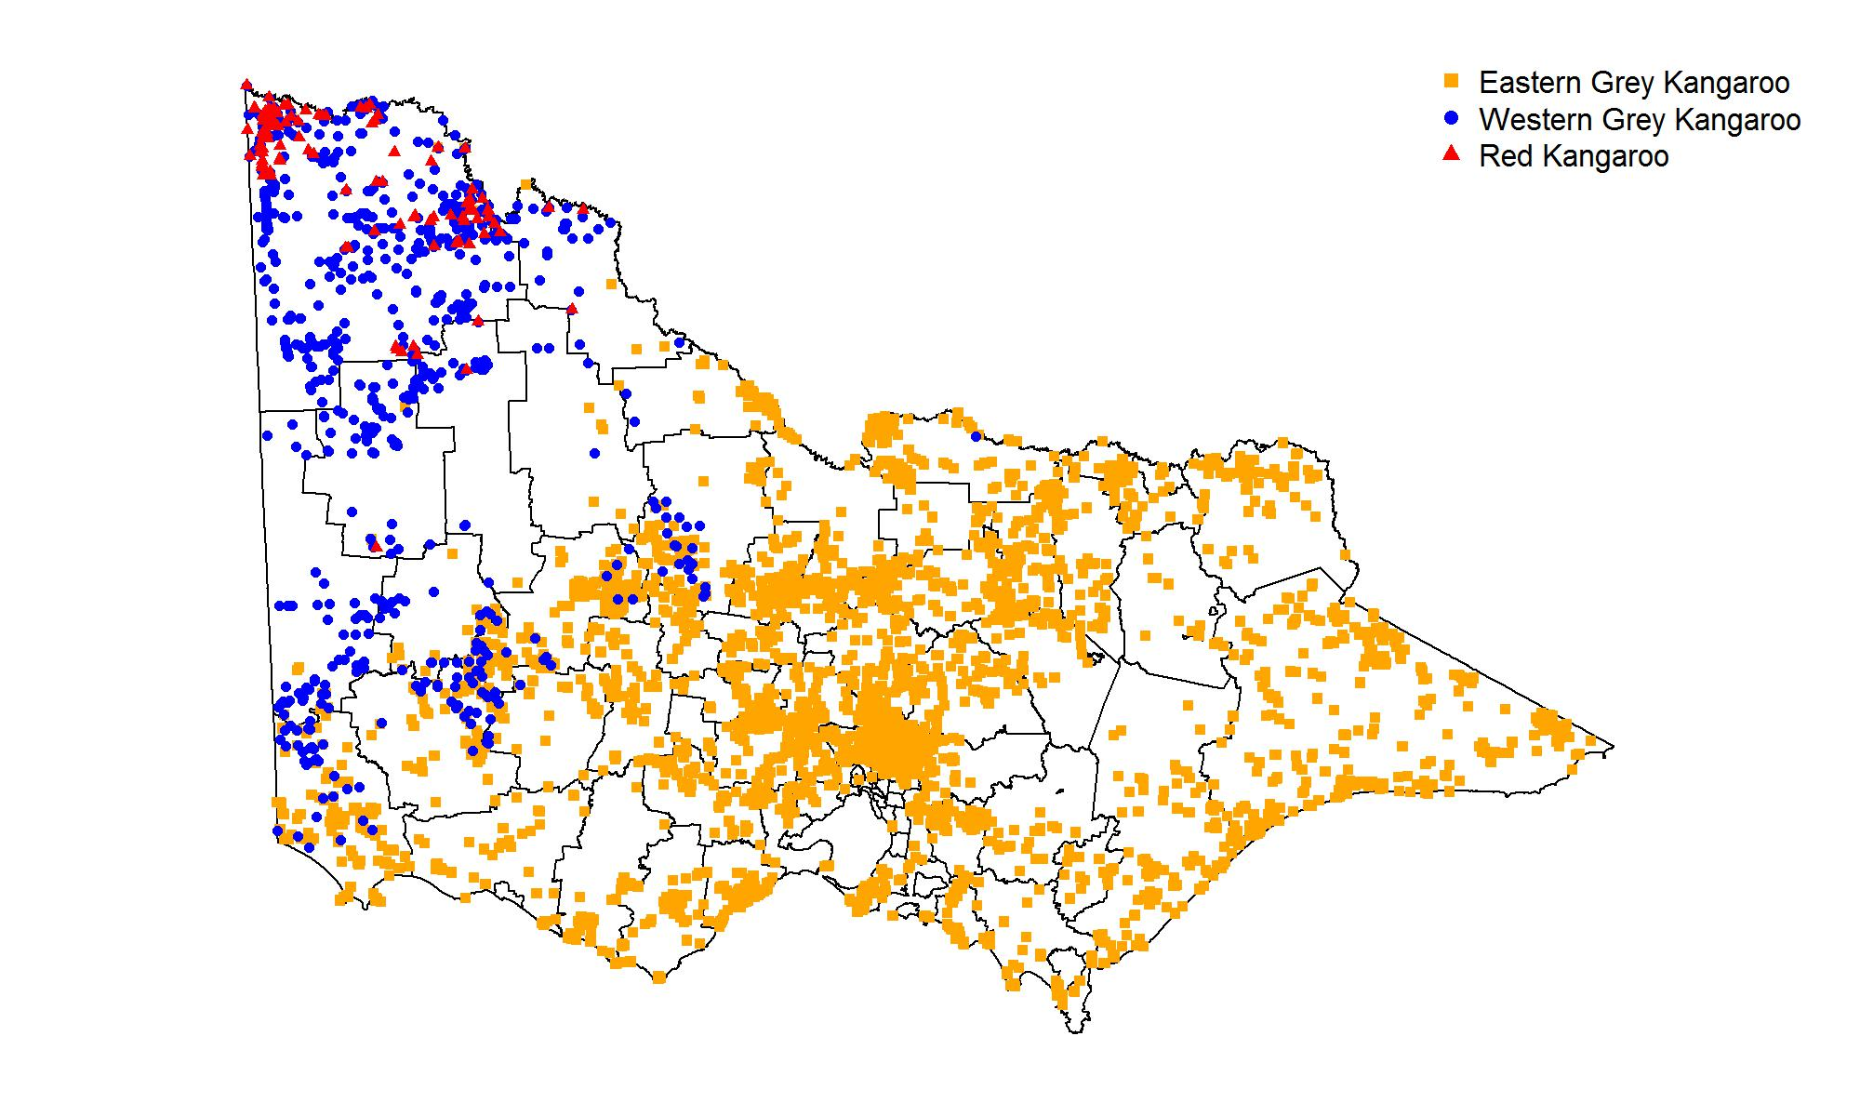
Figure 1: Distribution of three kangaroo species in Victoria. Data were obtained from the Atlas of Living Australia (only includes records since 1980).
Red kangaroos (hereafter RK) are largely confined to the far NW of the state, with almost all known records occurring within the confines of the Mildura Shire LGA (Figure 1). Accordingly, it will only be necessary to estimate the abundance of this species within the Mildura Shire. The proportion of the state’s population occurring outside the Mildura shire is judged to be negligible, but if sufficient sightings are recorded in adjacent shires during the surveys proposed here, this data can be readily incorporated into our analyses.
Western Grey Kangaroos (hereafter WGK) are confined to the west of the state, with a few outlying records in central Victoria (Figure 1). LGAs with a significant number of records for this species are: Buloke, Glenelg, Hindmarsh, Horsham, Loddon, Mildura, Northern Grampians, Southern Grampians, Swan Hill, West Wimmera and Yarriambiack LGAs.
Eastern Grey Kangaroos (hereafter EGK) are widespread throughout the east of the state. In the far Northwest, EGK also have a limited distribution in the immediate vicinity of the Murray River (Figure 1). The range of the WGK overlaps with that of the EGK in a broad band across the west of the state (Caughley et al. 1984), including in the previously listed LGAs, plus in the Ararat and Gannawarra LGAs.

2.2 Study area and stratification
For the purposes of survey design, the entire state was subdivided into seven strata by amalgamating adjacent, ecologically similar LGAs (Figure 2). This was done using an ad hoc approach, and other approaches to stratification would certainly be feasible. The desire to obtain defensible estimates of abundance at the level of LGAs prompted this approach to stratification. We also sought to include the majority of the overlap zone between EGK and WGK within only two strata (see below), so as to limit the geographic scale over which it would be necessary to apportion aggregated aerial count data for the two grey kangaroo species into separate assessments for EGK and WGK.
Several parts of the state were excised from consideration in our aerial survey design. First, we excluded LGAs that were entirely (or almost entirely) contained within highly urbanised parts of the Melbourne metropolitan area, given the likely very low abundance of kangaroos in most of these areas, and the regulatory and practical difficulties inherent in conducting aerial surveys at low altitude over urban areas. Urban-fringe municipalities containing significant rural or semi-rural land use, such as Wyndham, Hume, Nillumbik and Casey, were however included (see Figure 2), as these municipalities are known to support significant populations of EGK.
Parts of the state covered by dense forest cannot practically be surveyed for kangaroos from the air, as kangaroos cannot be reliably detected from the air in thickly forested habitat. We did, however, include areas with mallee vegetation in the area encompassed by our surveys, as experience both in Victoria and in other states has demonstrated the feasibility of conducting aerial surveys for kangaroos in mallee vegetation, given the low canopy height and density of this vegetation type.
We considered that the exclusion of heavily forested habitat was justifiable for the purposes of population assessment for harvest regulation purposes for two reasons. First, as densities of kangaroos in forested country are generally low, the overall proportion of kangaroos excluded from survey will be small, relative to the overall size of the state’s kangaroo population. Second, the presence of unsurveyed kangaroos in forested habitat means that the overall population estimates derived from the proposed survey designs presented here will be biased low. The presence of additional kangaroos in the unsurveyed portion of the state will add an additional margin of safety to the sustainability of any future population control operations.
We used the TREE100 GIS layer to excise forested areas (other than mallee) from the seven survey strata (Figure 2). We retained in our surveyed area patches of forested habitat that were less than or equal to 100 ha in size—such fragments of forest typically exist as small islands of forest in larger areas of treeless or lightly timbered vegetation, and their exclusion from the survey area was therefore not considered desirable or necessary. Finally, we excluded from further consideration French and Phillip Islands, and other small offshore islands lacking extant kangaroo populations (Figure 2).
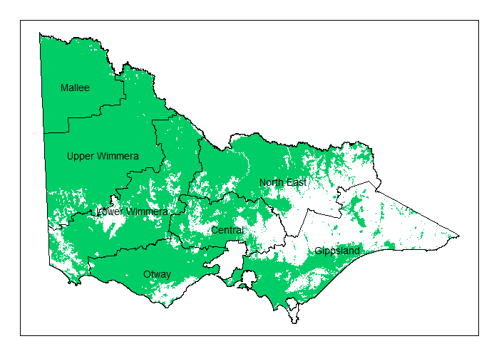
Figure 2: Map of proposed stratification scheme for statewide kangaroo surveys. Shaded green areas are non-forested and mallee vegetation types, and are to be included in the survey. Unshaded areas are forested, highly urbanised or located on kangaroo-free offshore islands and therefore excluded from survey.

2.3 Aerial transect survey methodologies
Aerial surveys have been widely used in Australia and other countries for determining densities and abundances of wildlife. Placing transect lines randomly or systematically in a landscape of interest, and counting numbers of animals within a defined distance of the transect line (assuming no counting errors, i.e. that all animals within a specified distance of the transect line are certain to be detected), is equivalent to the process of counting animals within randomly placed quadrats. However, in practice, it has been found that as the distances of animals from the transect line increase, their probabilities of detection decrease. A specialised statistical methodology has been developed to deal with this problem of imperfect distance-limited detection around linear transects, called distance-sampling (Buckland et al. 2001). This methodology (and various elaborations of it) have been widely used in the analysis of wildlife survey data collected from aerial surveys (Buckland et al. 2001, Thomas et al. 2010) and in a variety of other contexts.

2.4 Distance-sampling designs for estimating kangaroo abundance
Designing an aerial survey for kangaroos in Victoria involves making choices about the total length of the transects to be flown, and the spatial distribution of the transect lines across the seven strata we have defined. As the total length of transect flown increases, it can be expected that increasingly precise estimates of population density (and by extension total abundance) will be possible. The relationship between survey effort (expressed as total transect length) and precision of the resulting density estimate (expressed as a CV) depends on the underlying (but currently unknown) average density of kangaroos in the state. At higher densities, it is possible to achieve a desired level of precision with a smaller survey effort, but at lower densities, greater effort will be required to achieve the same level of precision (Buckland et al. 2001).
In order to examine the relationship between survey effort (total transect length) and precision of abundance estimates, it was necessary to make assumptions about the actual likely densities of kangaroos in Victoria. Many of the available estimates of kangaroo abundance in Victoria are based on studies conducted in small geographic areas, and the associated measures of density are likely to be atypical of density across the entire state. Accordingly, we based our assessments on densities that we considered to represent likely low, medium and high densities, obtained from a non-exhaustive examination of literature regarding observed densities of kangaroos both in Victoria and elsewhere, and from the authors’ own judgements about likely kangaroo densities. The three densities we considered were: low = 2 kangaroos km^{–2}, medium = 5 kangaroos km^{–2} and high = 10 kangaroos km^{–2}. We assessed the likely precision of estimates of abundance that would result from surveys where these three true densities applied throughout Victoria (for both grey kangaroo species combined) or for the Mallee Stratum, consisting only of the Mildura Shire LGA (for Red Kangaroos), using a simulation approach (Thomas et al. 2010).
Under these three kangaroo density assumptions, we simulated the process of allocating varying total lengths of aerial transect survey effort. We considered a range of total effort of between 400 km and 2000 km statewide, increasing in 200 km increments.
Following aerial survey methodologies that have previously been used for aerial kangaroo surveys in Victoria, and in other states (see for example Moloney and Forsyth 2013, Cairns et al. 2015), we simulated the process of flying randomly placed transects and observing kangaroos from a helicopter. While fixed-wing aircraft could be employed, and are less expensive to operate per hour, they may be unsuitable for the survey proposed here. First, helicopters are capable of much slower flight, and this is expected to result in better kangaroo detection by human observers. Second, fixed-wing aircraft are less flexible to operate, requiring access to runways that may not be located in close proximity to the transects, whereas helicopters can be operated from a wide variety of locations, including the multiple DELWP premises across the state that have helipads and refuelling facilities. Third, helicopters are much better at maintaining constant velocity and altitude at low level, leading to greater survey consistency. Finally, in hilly country, helicopters are better able to access topographically difficult parts of the landscape that may be impossible or less safe for fixed-wing aircraft.
Following Moloney and Forsyth (2013), and Cairns et al. (2015), we assumed that the helicopter flew at an altitude of 250 feet and a speed of 50 knots while on a transect and surveying. While transiting between transects, higher speeds and altitudes can be employed. We assumed that one observer was assigned to each side of the aircraft, recording sightings of all kangaroos seen on each side of the aircraft’s flight path, out to a maximum distance exceeding 150 m. All kangaroo sightings were recorded (Reds and Greys recorded separately), and the distance of each kangaroo from the transect line was approximated using a calibrated sighting bar affixed to each side of the helicopter. Distances were rounded into bins, defined by coloured markings placed at intervals on the sighting bar. Previous surveys in Victoria (Moloney and Forsyth 2013) have used a sighting bar calibrated to distance bins of 0–20, 20–40, 40–70, 70–100 and 100–150 m from the transect line, so we followed that practice in our simulations.
From the accumulated sighting and distance data, abundances of kangaroos can be estimated, using the distance-sampling approach (Buckland et al. 2001). Under distance-sampling, it is assumed that kangaroos located at zero distance from the transect line are detected with certainty, but that the probability of being detected declines with increasing distance from the transect line. The shape of this decline is estimated by fitting a detection function, $g(x)$ to the observed distribution of distance, $x$, assuming $g(0)=1$, using the method of maximum likelihood. A variety of different detection functions can be used, including half-normal and hazard-rate functions. In practice, the most appropriate model for the detection process is inferred from the data, using information-theoretic approaches (Buckland et al. 2001). For the purposes of our simulations, we assumed a half-normal detection function, with standard deviation $σ=40$ meters This figure was based on examination of distance functions, estimated by Moloney and Forsyth (2013) and Cairns et al. (2015) for helicopter surveys conducted in north-western Victoria and south-eastern New South Wales, respectively (see Appendix 2). The assumed relationship between distance and detection probability is shown in Figure 3 below.
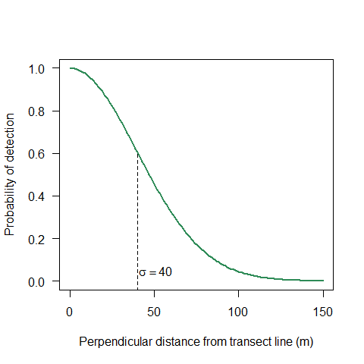
Figure 3: Assumed distance-detection relationship for the distance-sampling simulation study. The dashed vertical line denotes the assumed value of the standard deviation parameter sigma for the half-normal detection function.
Analysis of the number of kangaroos actually detected during a specified transect length, along with fitting of the detection function to the observed transect-distances, allows the statistical estimation of the overall density of kangaroos in the area sampled by the aerial transect. Provided the locations of the aerial transects are a representative sample drawn from the broader area of interest, it is straightforward to then estimate the overall abundance of kangaroos for the entire study area, and to generate associated statistical estimates of uncertainty (standard errors, confidence intervals and coefficients of variation).

2.5 Simulation study
In the absence of any better information, as a starting point for decision-making, we considered simulations of distance-sampling surveys with three densities of kangaroos judged to be representative of low, medium and high densities in the state. These were set at 2.0, 5.0 and 10.0 kangaroos km^{–2}. For grey kangaroos (both species combined), it was assumed that density was approximately uniform across the surveyed (non-forested) portion of the state, while red kangaroos were considered to be wholly confined to the Mildura Shire (Mallee Stratum in our analysis), and had zero density elsewhere in the state.
Our simulations have all made the simplifying assumption that kangaroos are distributed entirely at random within each stratum. While it is certain that within each stratum prevailing densities will vary spatially, without additional survey data it is difficult to make defensible predictions regarding the likely patterns of small- to medium-scale spatial variation in density within each stratum. Provided that placement of transects within the strata provides a representative sample of prevailing densities, within-strata variation in density should have a limited effect on the accuracy or precision of density estimates.
We considered survey designs in which between 400 and 2000 km of transects were flown, increasing in 200 km increments. These total amounts of effort were allocated among the strata in proportion to strata areas, rounded (for convenience) to the nearest 5 km of transect length in each stratum.
In each stratum, the lengths of transect required for achieving the overall target transect length were arranged randomly across each stratum to provide spatial coverage. Each transect was 25 km long, though transects that by chance intersected the boundary of a stratum, or an area of unsurveyed forested habitat, were truncated at these boundaries. For simplicity, all transects ran in an east–west orientation. As aerial surveys for kangaroos are typically conducted around dawn and dusk, an east–west orientation means that the observers will be facing to the north and south, and therefore will not have to observe kangaroos while facing into the glare of the rising or setting sun.
We generated simulated distributions of grey kangaroos (both species combined, see below) and Red Kangaroos for all strata, based on the low, medium and high assumed densities. Simulated transects were flown, and the process of detecting kangaroos under the assumed detection model was simulated.
We conducted the simulations in R (R Core Team 2016), using the package Distance (Miller 2016) to fit the distance-sampling models, and derived estimates of the stratum-specific and statewide abundances for each replicate simulation. For each iteration, the resulting precision of the abundance estimates was expressed as a coefficient of variation (CV). Each simulated abundance scenario (low, medium and high) was simulated 100 times, and the resulting population estimates and CVs were retained to examine the relationship between total effort and precision (expressed as a CV).

2.6 Obtaining separate estimates of abundance for Eastern and Western Grey Kangaroos
While Red Kangaroos are readily distinguished from grey kangaroos during aerial surveys, the two species of grey kangaroos are morphologically very similar, and cannot be reliably distinguished from the air (Caughley et al. 1984). Accordingly, aerial surveys conducted in the strata where both species of grey kangaroos co-occur (Lower and Upper Wimmera) will only provide an estimate of abundance for the two grey kangaroo species combined. Partitioning these estimates into separate estimates for Eastern and Western Greys will require additional data that provide information on the proportions of the two species present within the relevant strata.
Two approaches were explored here that could achieve this aim. First, spatially referenced wildlife atlas data from the Victorian Biodiversity Atlas (DELWP) or the Atlas of Living Australia could be used to estimate the prevailing proportions of the two species occurring in the relevant strata. This approach would be straightforward and low-cost, but would rely on the assumption that atlas records for the two species accrue for a given area in proportion to the local ratio of abundances of the two species. This is a rather strong and difficult to test assumption. It is also likely that older Atlas data will reflect the prevailing proportions of EGK and WGK in the overlap zone in the past, but not necessarily be representative of current proportions, as the range boundaries may have shifted over time in response to changes in habitat, climatic conditions, or other unknown ecological factors.
We examined the proportional representation of Eastern and Western Grey Kangaroo records in a large collection of location records obtained from the Atlas of Living Australia. Records were plotted, and the proportions of records for each species from each LGA in the state were computed and mapped. Using the location of each grey kangaroo record from the Atlas of Living Australia, a generalised additive model (GAM) was constructed using the package mgcv (Wood 2006) within R (R Core Team 2016). The spatial coordinates of the grey kangaroo records were used as the only explanatory variable, and a 2-dimensional thin-plate regression spline was fitted to the data (Wood 2003).
As an alternative to relying on Atlas data to provide information about the relative proportions of the two species in the grey kangaroo overlap zone (hereafter GKOZ), a program of vehicle-based ground surveys could be conducted to directly estimate the relative abundances of the two species at a sample of locations within the GKOZ. This data could then be used to infer the expected proportions of the two species across the entire GKOZ, and hence to apportion the estimated total abundance of grey kangaroos to the two species. The proposed methodology would be for an observer to drive road transects, and when a grey kangaroo was spotted, to stop and use binoculars and/or a spotting scope to identify kangaroos to species. Caughley et al. (1984) considered differentiation between EGK and WGK to be readily achievable if the kangaroo is within 300 m, in good lighting. We would caution though that, as surveys would ideally be done close to dawn and dusk (when kangaroos are most active and observable), reliable identification may in practice be more difficult than Caughley et al. (1984) suggest. Use of a high-quality spotting scope and photography through a powerful telephoto lens could make identification in the field easier and more reliable, as could the use of observers with experience differentiating these two similar species in the field.
We propose that the current structure of the GKOZ be investigated by driving transects over the entire region. When a grey kangaroo is observed (either alive or dead), the vehicle should stop to confirm the species (EGK or WGK), using binoculars if necessary. The number of each species observed should be recorded, as well as the GPS coordinates and time of the sighting. Ideally, road transects should meet the following requirements:
- Be oriented to roughly north-west or south-east directions, in line with the observed gradient from one species to the other.
- Be confined to minor roads or tracks where driving slowly and stopping frequently will not be a road safety concern.
- Be carried out in the early morning and late afternoon, when kangaroos are most active and observable.
- Cover the region of interest (GKOZ) in a representative fashion.
Surveys only need to be conducted in the two strata (Lower and Upper Wimmera) that coincide with the GKOZ, as discussed previously and shown in Figure 2. The ratio of EGK to WGK needs to be estimated over the entire overlap zone, and partitioned by strata and LGAs to determine estimates of the ratios of EGK to WGK in each stratum.
We have prepared a set of example road transects that meet the above requirements, and these are presented in Appendix 3. Other transect sampling designs could certainly be used, provided they were generally representative of the overlap zone and met the requirements specified above.
In addition to an organised program of road transects, it may be possible to utilise incidental observations by suitably experienced DELWP staff who may be travelling across the overlap zone for work purposes. Enlisting the assistance of such staff in collecting supplementary data could be a useful means of increasing the amount of data available for inferring the species compositions within the GKOZ. Staff would need to follow the same observation protocol as described above, as proper identification of species and accurate recording of locations are very important if the data are to be used for modelling. In particular, it is essential that data are recorded for all kangaroos encountered while surveying, to ensure that the resulting estimates of species composition are unbiased.

2.7 Determining sampling requirements for ground surveys in the grey kangaroo overlap zone
In order to determine the extent of ground surveys required to determine the relative proportions of WGK and EGK occurring in the GKOZ, we conducted a simulation study.
The total length of driven transects required will depend on several factors: the density of grey kangaroos in the area; the proportions of EGK and WGK present; and the level of precision required for the estimate of proportions. The following assumptions were used in the simulations:
- Grey kangaroo density is uniform (consistent) across the region.
- The density is between 0.1 and 5 grey kangaroos km^{–2}.
- One hundred percent of grey kangaroos at the south-eastern edge of the transect are EGK.
- One hundred percent of grey kangaroos at the north-western edge of the transect are WGK.
- Grey kangaroos located within 250 m of the driven transect will be able to be positively identified.
- Each group of grey kangaroos encountered is of only one species.
The simulation effectively sampled 2.5 km² quadrats for grey kangaroos, i.e. a 500 m wide, 2 km long survey strip, with perfect detection, both in terms of observing any grey kangaroos present in the quadrat, and determining their species. The number of each species of grey kangaroo within each quadrat was randomly generated from a Bernoulli distribution, dependent on the probability of that quadrat being occupied with EGK. The number of grey kangaroos in a quadrat was randomly generated from a Poisson distribution, dependent on the prevailing density of kangaroos.
One consequence of these assumptions is that the overall percentage of EGK and WGK in our simulated surveys is 50%. In general, when the expected proportion being estimated is 0.5, then a larger sampling effort is required for a given precision. Should the actual proportion of EGK be closer to zero or one in the overlap zone, then a smaller sampling effort will suffice to achieve the same precision.
The process of driving transects across the zone at specified prevailing kangaroo densities was simulated in R. Each simulation was repeated 1000 times, recording the width (‘span’) of the resulting 95% confidence interval on the estimate of the proportion of EGK in the population as a measure of the uncertainty in the estimation of the ratio of EGK to WGK in the zone.

3 Results

3.1 Results of the distance-sampling simulation study
The relationships between overall aerial survey effort and the precision of the resulting estimates of kangaroo abundances are given in Figures 4–6. These figures present the results obtained under assumed low, medium and high densities, respectively.
Under the lowest assumed density (2.0 kangaroos km^{–2}), most strata were likely to meet the target precision of <20%, when the total survey effort exceeded 1000 km (Figure 4). However, it was found that the Otway, Central and Gippsland strata would likely produce abundance estimates with coefficients of variation greater than 20%, unless the overall statewide survey effort approached 1600 km.
At medium densities (5.0 kangaroos km^{–2}), the target precision of <20% could be expected to be achieved in all strata for survey designs with at least 800 km of transect effort allocated across the entire state (Figure 5).
At high densities (10.0 kangaroos km^{–2}), the simulations showed all strata achieving precisions of <20%, even for designs with only 400 km of transect effort (Figure 6).
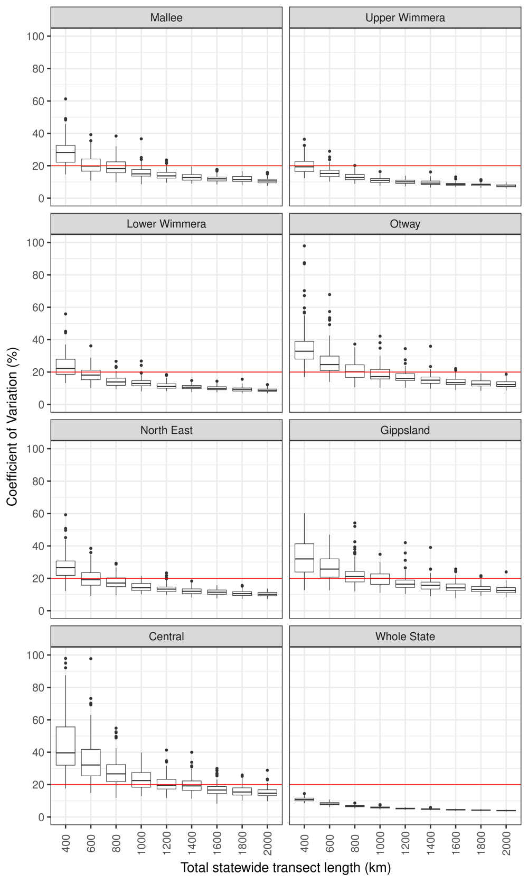
Figure 4: Simulation results for low-density kangaroo populations (2.0 kangaroo km^{–2}). The horizontal axis denotes the total statewide transect length in km; the vertical axis denotes the expected coefficient of variation of the kangaroo abundance estimates; the horizontal red line denotes the target CV of 20%. Results are based on 100 simulations of each total survey effort level.

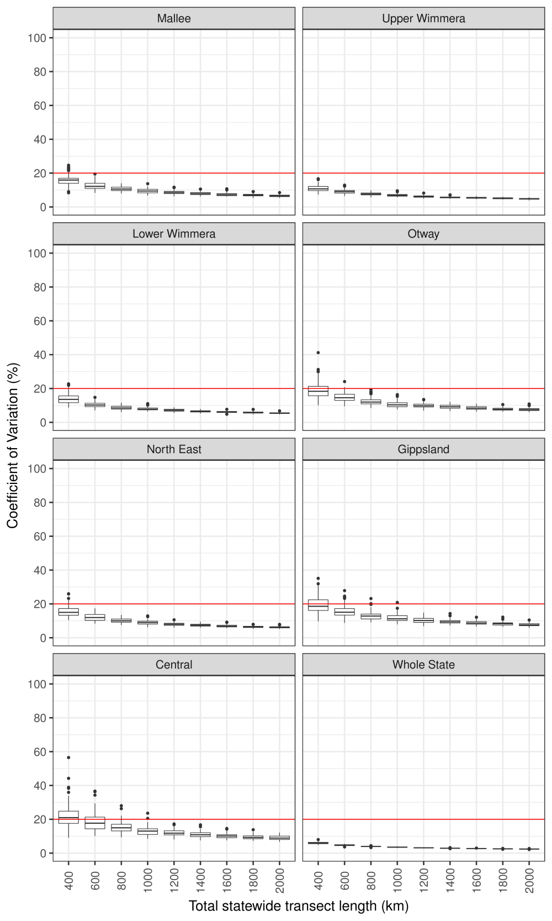
Figure 5: Simulation results for medium-density kangaroo populations (5.0 kangaroo km^{–2}). The horizontal axis denotes the total statewide transect length in km; the vertical axis denotes the expected coefficient of variation of the kangaroo abundance estimates; the horizontal red line denotes the target CV of 20%. Results are based on 100 simulations of each total survey effort level.

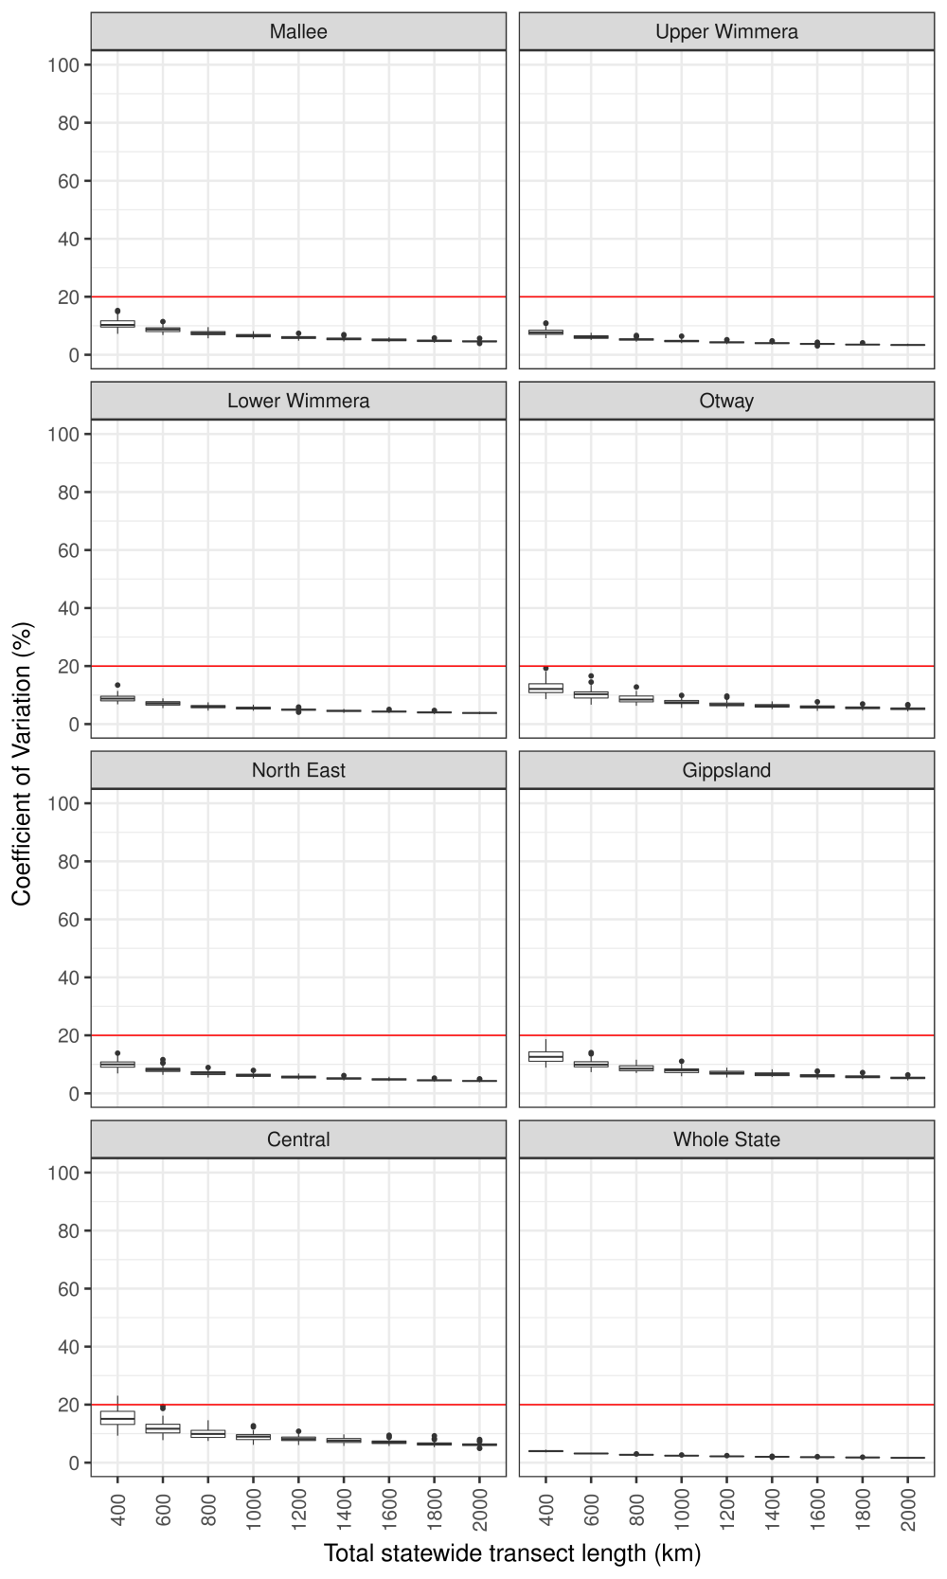
Figure 6: Simulation results for high-density kangaroo populations (10.0 kangaroo km^{–2}). The horizontal axis denotes the total statewide transect length in km; the vertical axis denotes the expected coefficient of variation of the kangaroo abundance estimates; the horizontal red line denotes the target CV of 20%. Results are based on 100 simulations of each total survey effort level.

Based on the cautious assumption that between 1000 and 1600 km of helicopter transects will be required statewide, we have prepared example survey designs with total transect lengths of 1000, 1500 and 2000 km to illustrate what such survey designs would look like in practice. This was done by laying out east–west oriented, 25-km-long transects in each stratum, with a spacing between lines of 10 km. The transects were arranged from east to west in a 25-km-on, 10-km-off pattern. A random sample of the resulting grid of 25-km transect lines was then chosen until sufficient 25-km transects had been selected to meet the required proportional allocation of survey effort to each stratum on the basis of its total area. At the edges of strata, and where forest was encountered, the 25-km transects were truncated, meaning that most strata contained at least some transects of less than 25 km in length.
The above method of choosing samples of 25-km transects was employed to serve several sampling principles. First, constructing a grid of candidate transects distributed systematically across each stratum, ensures that the transects will be spatially representative of each stratum. Second, the spacing between transect lines ensures that no part of any two transects will be located within 10 km of the other, ensuring a measure of statistical independence between transects located within the same stratum. Finally, by randomly selecting transects from the systematic grid, a representative random sample of habitats within each stratum will be surveyed.
Maps of representative sampling designs with total statewide allocations of 1000, 1500 and 2000 km are given in Figure 7. These each represent one random realisation of a sampling design chosen using the above rules. If desired, it would be straightforward to generate additional realisations of the design by running the sample generation code again with a different random seed. This would be useful (for example) if one or more of the selected transects could not be flown due to any unforeseen logistic difficulty or regulatory or safety restrictions on aircraft operation in a specific area.
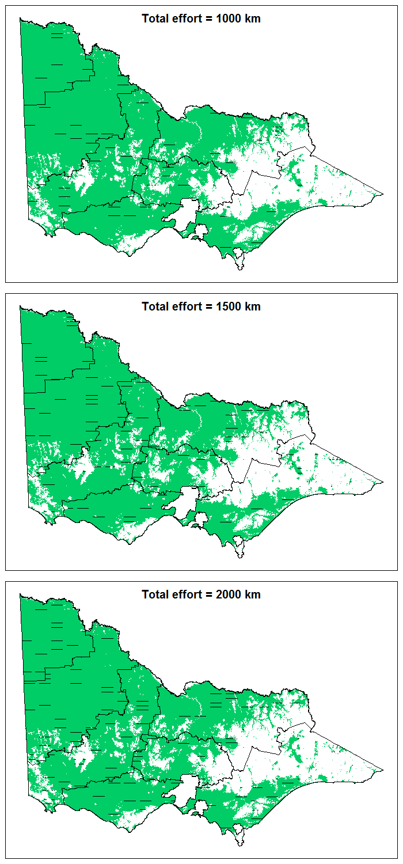
Figure 7: Representative arrangements of transect lines allocated to each stratum in order to achieve total survey efforts of 1000, 1500 and 2000 km statewide. The shaded green areas are untreed habitat potentially to be included in the survey; the black lines are boundaries between strata; the short, black, horizontal lines are the subsample of transect lines randomly sampled from each stratum’s regular grid of transect lines in order to meet the target level of survey effort.

The target allocations of effort among strata are listed in Table 1. These targets are based on the proportional allocation of total survey effort, rounded to the nearest 5 km, for simplicity.

Table 1: Allocation of transect lengths (km of aerial transects) to strata to achieve total statewide efforts of 1000, 1500 and 2000 km. Allocation of transect lengths is in proportion to stratum area, and is rounded to the nearest 5 km, for simplicity.
Stratum name | Stratum area (km²) | 1000 | 1500 | 2000
Mallee | 21,875 | 135 | 200 | 270
Upper Wimmera | 40,633 | 250 | 375 | 500
Lower Wimmera | 31,241 | 190 | 285 | 385
Otway | 16,838 | 105 | 155 | 205
North East | 24,702 | 150 | 225 | 305
Gippsland | 15,836 | 95 | 145 | 195
Central | 12,150 | 75 | 110 | 150

3.2 Analysis of the grey kangaroo overlap zone
The results of fitting the spatial GAM to data from the Atlas of Living Australia (Figure 9) revealed the likely extent of the GKOZ within Victoria. It should be noted, however, that there are large areas with very few records of grey kangaroos in the Atlas of Living Australia (Figures 8 and 9, and Table 2). Notably, Buloke Shire has only 11 records of grey kangaroos and is entirely in the GKOZ, and only four LGAs have more than 100 records of grey kangaroo. Thus, the location and breadth of the overlap zone in this part of the state is rather uncertain, and many parts of the prediction surface are derived largely from extrapolation from neighbouring areas.

Table 2: Percentages of atlas records for grey kangaroos that were identified as Eastern Grey Kangaroos for LGAs in and around the overlap zone.
LGA | Total records | Proportion EGK
Ararat | 74 | 93.2%
Buloke | 11 | 63.6%
Central Goldfields¹ | 41 | 100.0%
Gannawarra | 54 | 96.3%
Glenelg | 334 | 89.5%
Hindmarsh | 68 | 2.9%
Horsham | 44 | 56.8%
Loddon | 160 | 85.0%
Mildura² | 636 | 0.8%
Northern Grampians | 290 | 89.0%
Pyrenees¹ | 53 | 100.0%
Southern Grampians | 99 | 65.7%
Swan Hill | 71 | 5.6%
West Wimmera | 80 | 22.5%
Yarriambiack | 68 | 1.5%
¹Denotes an LGA with no records of WGK, but which may be within the overlap zone. ²Denotes the presence of a small number of records of EGK in the immediate vicinity of the Murray River in the Mildura Shire.

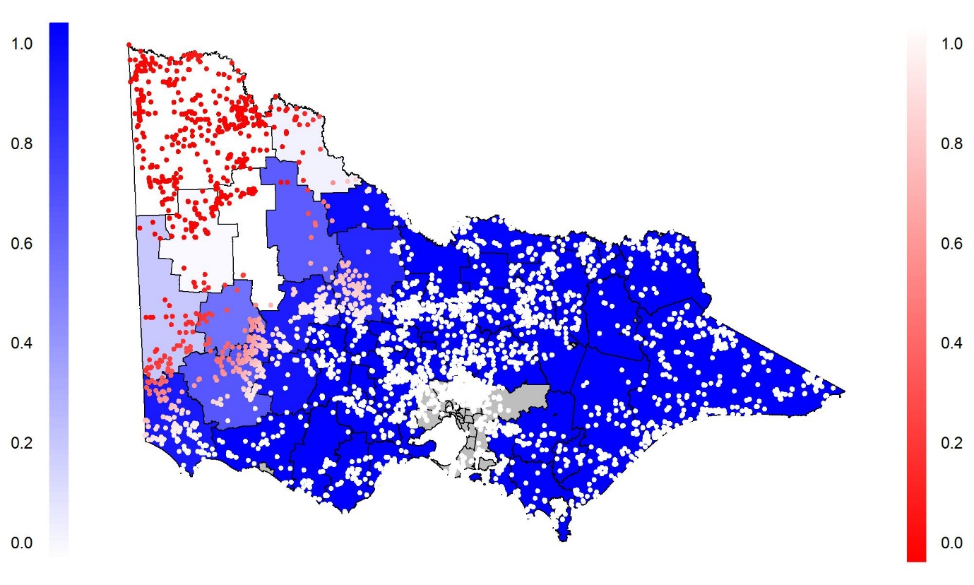
Figure 8: The study area, with point records of Grey Kangaroos from the Atlas of Living Australia overlaid. Each local government area (LGA) is shaded blue relative to the proportion of grey kangaroos recorded in the Atlas of Living Australia from that LGA that were Eastern Grey Kangaroos (EGK). The map only includes atlas records since 1980. The shade of red of the points is relative to the modelled probability that a grey kangaroo recorded at that location would be an EGK. Grey shaded LGAs indicate the melborne metropolitan area.

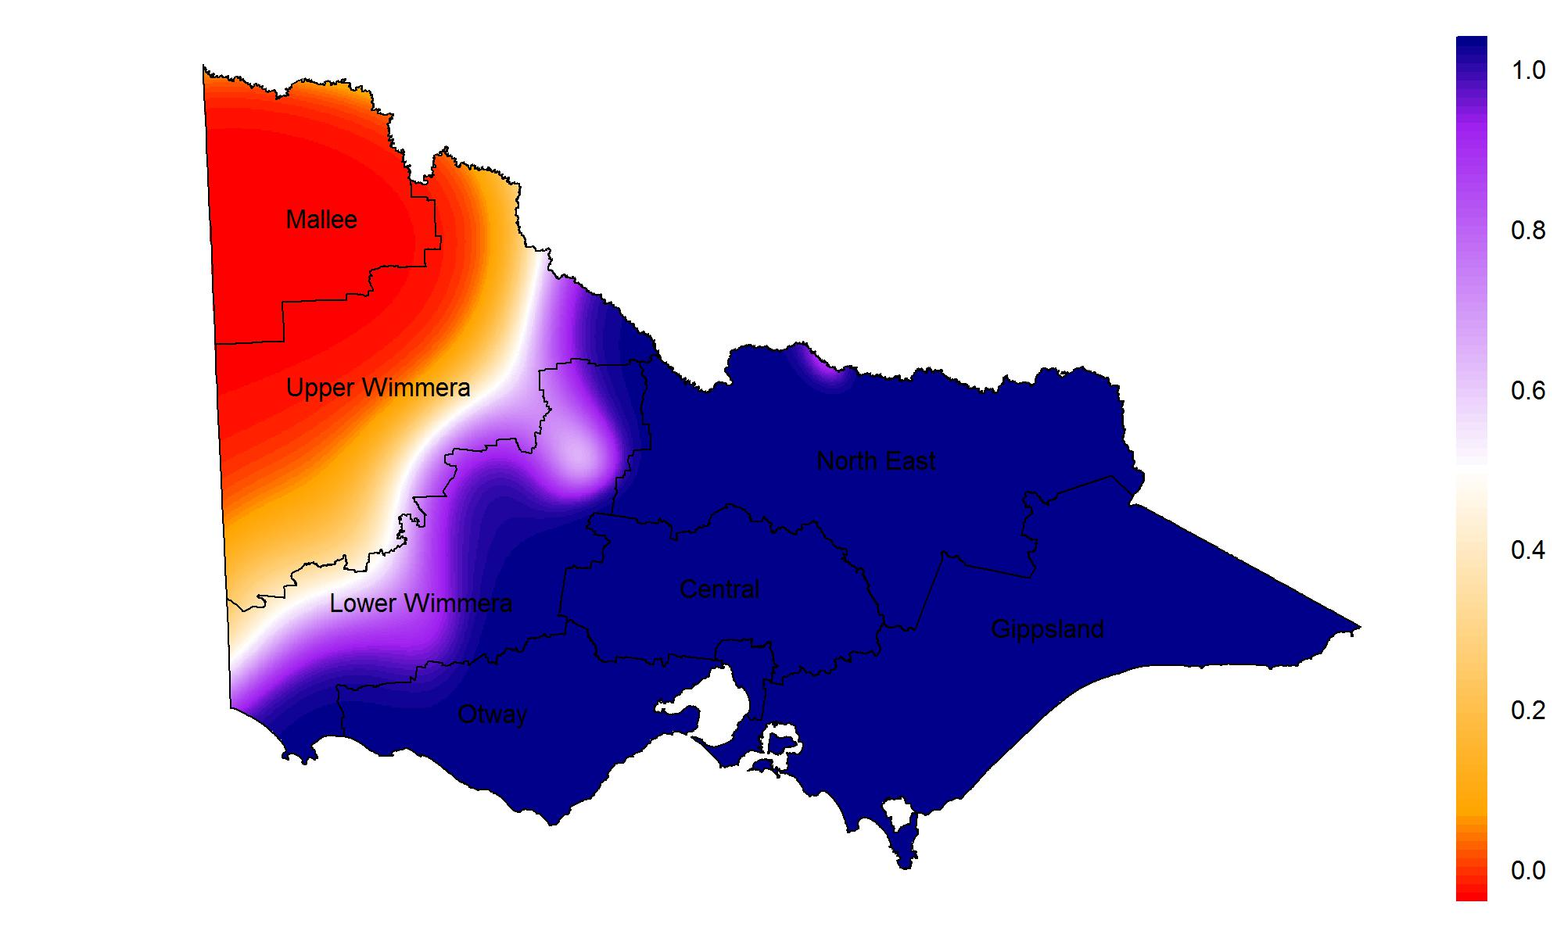
Figure 9: The modelled probability that a Grey Kangaroo detected at a given location in Victoria is an Eastern Grey Kangaroo, based on a Generalised Additive Model (GAM) fitted to sighting data from the Atlas of Living Australia. The borders included are for the local government areas (LGAs). The scale bar on the right shows the predicted probability that a randomly sampled grey kangaroo is an EGK.

3.3 Results of the simulation study of driven transect sampling of the overlap zone
Scenarios with six different prevailing kangaroo densities were considered. The estimated density and its 95% confidence interval was recorded for each simulation. The precision of the estimate was measured using the span of the confidence interval (upper bound subtract lower bound). The smaller the span, the higher the precision of the estimate of the proportion of EGK in the population. Imprecision in the estimated percentage of Eastern and Western Grey Kangaroos affects the precision of the separate density estimate for each species.
As the distance driven increased, the span decreased (Figure 10). At low densities (less than 1.0 grey kangaroo km^{–2}), it is estimated that a total transect distance of over 1000 km would be required in order to estimate the proportion of EGK with a span of less than 10%. If the density is somewhat high (greater than 2 grey kangaroo km^{–2}), it is estimated that a total transect length of approximately 500 km would result in an estimate with a similar span. The example transects in Appendix 3 cover approximately 1600 km. If these transects (or an equivalent set with similar representative coverage of the overlap zone) were surveyed, then we would expect that as long as the density of grey kangaroos is at least 0.5 km^{–2}, then the width of the 95% confidence interval of the resulting estimate of the proportion of EGKs should be less than 0.1.

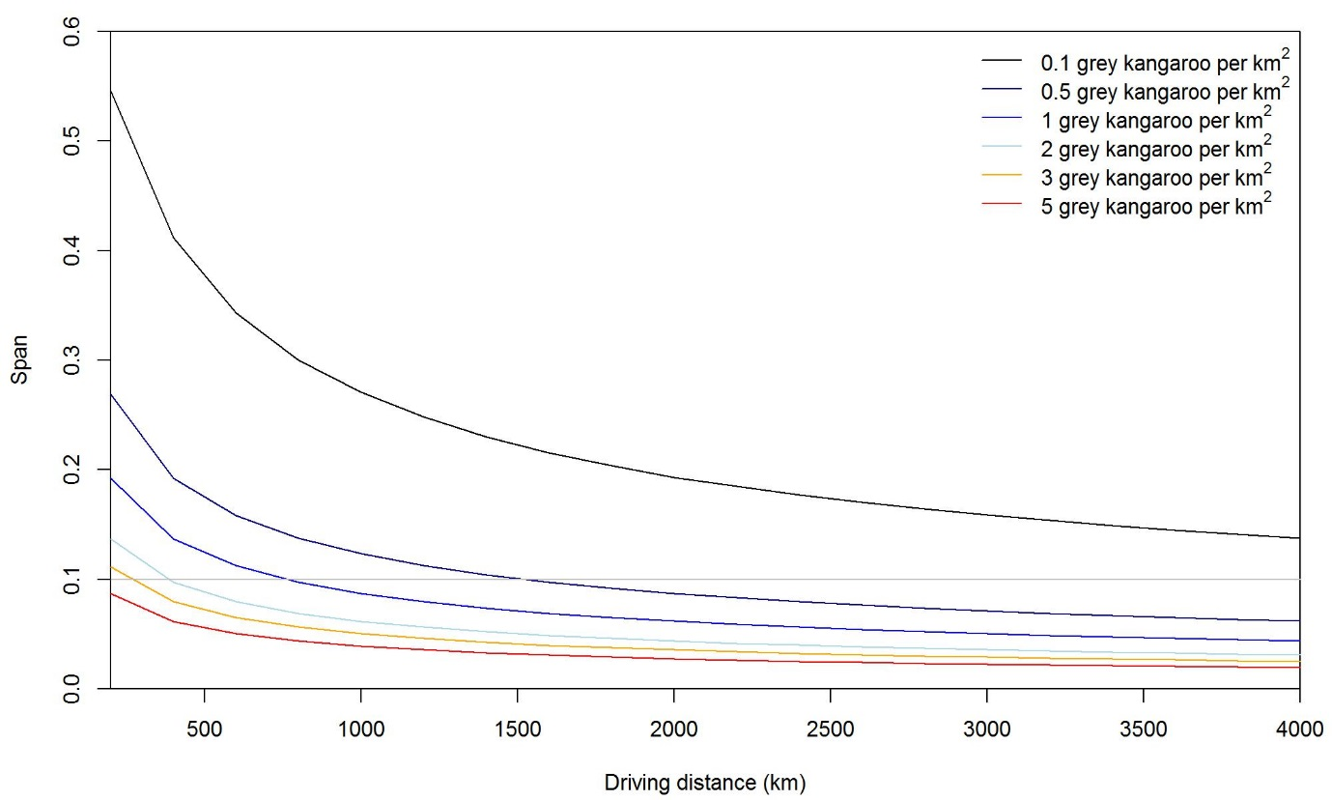
Figure 10: The average span (upper bound subtract lower bound of the 95% confidence interval) under each scenario, and the distance travelled. The grey horizontal line shows a 10% span, or ~±5% margin of error.

An alternative way of thinking about the effort required is the total number of grey kangaroos observed in the GKOZ. As the total number increases, the span between the upper and lower bounds of the estimated percentage of EGK in the GKOZ decreases (Figure 11). These results show that observing more than 400 grey kangaroos at a representative sample of locations across the overlap zone will be necessary in order to estimate the proportion of EGK with a confidence interval span of less than 0.1. It is reasonable to conclude that once the span is within the desired precision, no more surveying needs to occur. The caveat on this result is that the observations (or at least attempted observations) must be representative of the entire GKOZ.
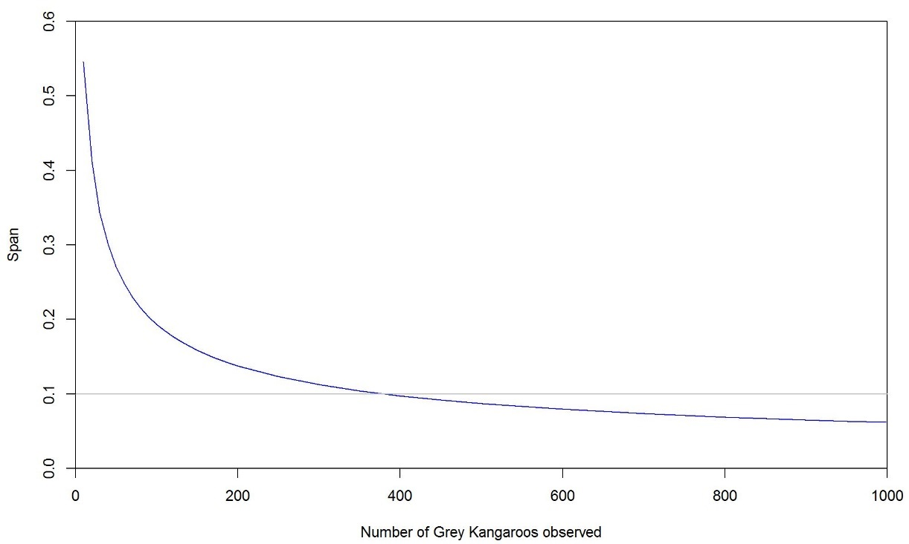
Figure 11: The average span (upper bound subtract lower bound of the 95% confidence interval) under each scenario, and the distance travelled. The grey horizontal line shows a 10% span, or ~±5% margin of error.

The ground surveys described above provide a reasonable basis for apportioning total aerial estimates of grey kangaroo abundance between the two species. As the overlap zone is largely confined to the Lower and Upper Wimmera stratums (see Figure 1), it is anticipated that only the total counts of grey kangaroos within these stratums will require apportioning between the two species. As the estimate of total abundance from aerial surveys, and the estimates of proportions of grey kangaroo species in the overlap zone from ground surveys, are derived from two independent data sources, these two quantities can be treated as statistically independent. On this basis, it is then straightforward to apportion the total abundance estimate into separate estimates for the two species by multiplication. The uncertainty in the apportionment can be derived from the standard errors of the abundance and proportion estimates, using the delta method (see Powell 2007) to combine the uncertainties in the two originally estimated quantities.

4 Discussion
The results of the simulation study of distance-sampling effort suggest that unless kangaroo densities are rather low (≤2 kangaroos km^{–2}), an overall survey effort in the range of 1000–1600 km of helicopter transects is likely to be adequate for obtaining estimates of abundance for each of the seven strata with coefficients of variation consistently and reliably less than 20%.
We would tend to favour density estimates at the lower level of our three assumed densities for any decision-making about required effort for any planned surveys in Victoria. This is because estimating abundance to a specified level of precision using distance-sampling requires greater survey effort when densities are lower (Buckland et al. 2001). Our simulations will overestimate the survey effort required to achieve a specified level of precision in the abundance estimates if the actual prevailing abundances prove to be higher than those assumed in the simulations. If the surveys find that abundances are higher than projected in our simulations, then the resulting precisions of the abundance estimates will be better than predicted by the simulations. Conversely, if prevailing densities prove to be lower than 2 kangaroos km^{–2}, the survey may fail to achieve the required target precision.
Provided that kangaroo densities in all strata are not less than 2.0 kangaroo km^{–2}, a design with an overall effort of 1600 km should be capable of providing estimates of abundance with coefficients of variation less than the target of 20%, for all strata, subject to the following caveats.
- The simulations assumed a rather simple model for the distance data, with no allowance for observer effects, and only partial allowance for effects of habitat on detection probabilities (this was partially achieved by allowing for estimation of separate distance-detection functions for each stratum in the fitted model). In real surveys, effects of observer, survey conditions (e.g. weather, time of day) and habitat type (e.g. farmland, mallee, etc.) can and should be included in the models of distance-detection relationships to improve the fit of the model. However, this comes at the cost of estimating additional parameters in the model, which requires more data, and may thus lead to somewhat lower precision for a given amount of survey effort.
- It is also assumed that the usual assumptions associated with distance-sampling will be met. This can generally be achieved in practice by using reliable, experienced observers to collect the data.
There may be various reasons why the simulation study of distance-sampling presented here may tend to underestimate the required effort for estimating abundances. For this reason, it is recommended that our conclusions about required effort are interpreted cautiously and conservatively. Without collecting real data, it is difficult to assess the likely importance of the various reasons for why the estimates of required effort may be too low, but it is worth noting them here for further consideration when choosing a level of effort.
In brief, the following factors could lead to lower precision for a given level of effort than would be predicted by our simulation study of distance-sampling designs:
- There is more spatial heterogeneity than envisaged in the simulation studies.
- Detection curves are worse than experienced elsewhere (lower sightability, smaller effective area surveyed per km of transect).
- There are data collection problems, leading to some of the collected data being discarded.
- There is a need to account for habitat-, survey- and observer-specific covariates in analysis using post-stratification. Estimating these additional parameters may reduce the precision of the resulting estimates of abundance.
- There is violation of the $g(0)=1$ assumption (i.e. kangaroos at zero-distance from the flightline are not detected with certainty), necessitating the use of more complex line-transect statistical models, such as mark–recapture distance sampling, which will result in a lower level of precision for a given level of transect effort, and negative bias in the density estimates, if not addressed.

4.1 Comments on the analysis of the grey kangaroo overlap zone
If we pessimistically assume a prevailing density of 1.0 grey kangaroo km^{–2} in the GKOZ, then the results of the simulation study of driven transects suggests that somewhere in the vicinity of 1000 km of driven transect should be adequate for estimating the proportion of EGK and WGK in the overlap zone, with adequate precision. If prevailing densities are lower, or kangaroos are less sightable than the simulation has assumed, then a greater length of transect is likely to be necessary. Without attempting collection of some data, it is difficult to provide recommendations that are guaranteed to result in adequate precision of the resulting estimates. Regardless of the prevailing density, observations of approximately 400 grey kangaroos at a representative sample of locations in the GKOZ would be necessary in order to obtain a precise estimate of the ratio of EGK to WGK in the GKOZ.
If conducting road transects to assess proportions of EGK and WGK in the overlap zone is not desired, then reliance on atlas sighting data to inform the likely proportions of EGK and WGK in the overlap zone will be necessary. This would be straightforward in practice, and involve using the fitted spatial GAM model presented in Figure 9 to infer the likely proportions of EGK and WGK in the overlap stratum, and thus apportion the population estimate of grey kangaroo species combined between the two species. While this approach would be straightforward, there would be several pitfalls. First, much of the Atlas data is rather old, and may represent the structure of the overlap zone in the past, rather than the present, leading to bias. Second, it is likely that aberrant records outside the usual range of EGK and WGK may be more likely to be reported as Atlas records, due to their novelty and notability. This may also lead to bias in the model’s assessment of the location and width of the overlap zone. Finally, it is unknown to what extent records of EGK and WGK in the Atlas are the result of occasional misidentification of the two grey kangaroo species by contributors of data.

4.2 Recommended survey specifications
Based on our consideration of the results presented in this report, we recommend the following design specifications and procedures for carrying out the proposed program of aerial surveys and ground surveys:
- At least 1000 km of aerial helicopter transects in total, with effort allocated among strata in proportion to area, as described in this report.
- Helicopter transect surveys should be conducted early in the morning or later in the afternoon, within 2–3 hours of sunrise/sunset, to coincide with the daily activity period of kangaroos.
- Use 25 km transects, selected randomly from a systematic grid of transects within each stratum, with transects oriented east–west. Morning transects should be flown in a westerly direction, and evening transects in an easterly direction, to avoid the pilot having to fly at low level into the glare of the rising/setting sun.
- Seasonal timing of surveys is flexible, but a Spring survey (September–November) may be preferable. The availability of abundant green grass at this time of year across much of Victoria means that kangaroos are likely to be more evenly spread in the landscape, minimising the possibility that sampling errors may mean that by chance the transects may coincide with areas that are less used during other seasons when food resources may be less widespread. Kangaroo surveys have been conducted with success during Spring in Queensland (e.g. Clancy et al. 1997) and NSW (e.g. Cairns et al. 2015).
- For ground surveys to determine the ratio and distributions of grey kangaroo species in the overlap zone, we would recommend that approximately 1000 km of road transect be surveyed. The example transects presented in Appendix 3 would provide a good basis for this. While the simulation analysis suggested that somewhat less effort may lead to an adequately precise estimate of the ratio of Eastern to Western Grey Kangaroos in the overlap zone, we are rather uncertain about many of the assumptions used in the simulations. Accordingly, we would recommend the precautionary approach of undertaking a level of survey effort greater than is expected to be necessary, in case the assumptions are unreasonably optimistic. Providing high ground-survey effort will also ensure that we gain a good understanding of the current spatial structure of the overlap zone, which will be very useful for refining the survey design of both the aerial and ground surveys in future years.

4.3 General principles and recommendations for a future survey
It is strongly recommended that competent, experienced contractors are engaged to fly the transects and collect the aerial survey data. Previous experience has shown that inexperienced observers require practice and training in order to collect reliable, usable aerial survey data. Inexperienced observers may in some cases collect faulty data that must be discarded, resulting in costly wasted aircraft hours, and compromised survey results with poor precision. Similarly, for the ground surveys of the GKOZ, observers with experience in identifying the two species in the field should be employed. Erroneous field identifications could lead to significant errors in any apportionment of aerial density estimates to the two grey kangaroo species.
Is is likely that the experience obtained in undertaking an initial survey could be used to update the survey design to make it more efficient for future surveys. In particular, assumptions made in the present study about distance-detection curves and prevailing densities of kangaroos may diverge significantly from what actually transpires during the first survey. Analysis of the first survey will provide a solid basis for checking these assumptions. It is strongly recommended that the designs presented here be updated in light of the results of the first survey, with the intention of improving the efficiency, precision and accuracy of the survey design.
The proposed sampling program, being conducted on a statewide scale, presents a unique opportunity for acquiring data on the abundance of wildlife species on a large scale. While the survey has been designed chiefly to collect data on kangaroos, it is likely that distance data on other large herbivores, such as feral goats, feral pigs, deer and emus could be collected simultaneously for future use. This data could potentially be used to obtain density estimates for these species, which may be of use to land managers, including DELWP and Parks Victoria.

References
Atlas of Living Australia. National Research Infrastructure for Australia. An Australian Government Initiative. htto://www.ala.org.au/. Data downloaded 5 April 2017.
Buckland, S.T., Anderson, D.R., Burnham, K.P., Laake, J.L., Borchers, D.L. and Thomas, L. (2001). Introduction to Distance Sampling: Estimating Abundance of Biological Populations. Oxford University Press, UK.
Cairns, S., Bearup, D. and Lollback, G. (2015). Design and analysis of helicopter surveys of kangaroo populations in the South East NSW Kangaroo Management Zone 2015. NSW Office of Environment and Heritage, Sydney.
Caughley, G., Brown, B., Dostine, P. and Grice, D. (1984). The grey kangaroo overlap zone. Wildlife Research 11, 1–10.
Clancy, T., Pople, A. and Gibson, L. (1997). Comparison of helicopter line transects with walked line transects for estimating densities of kangaroos. Wildlife Research 24, 397–409.
Coulson, G., Cripps, J.K. and Wilson, M.E. (2014). Hopping down the main street: Eastern Grey Kangaroos at home in an urban matrix. Animals 4, 272–291.
Department of Environment and Heritage Protection (Qld). (2013). Queensland Wildlife Trade Management Plan for Export of Commercially Harvested Macropods 2013–17. Queensland Department of Environment and Heritage Protection, Brisbane.
Department of Environment, Water and Natural Resources (SA). (2013). South Australian Kangaroo Management Plan 2013–2017. Department of Environment, Water and Natural Resources, Adelaide.
Department of Parks and Wildlife (WA). (2014). Management Plan for the Commercial Harvest of Kangaroos in Western Australia 2014–2018. Western Australia Department of Parks and Widlife, Perth.
Government of the Australian Capital Territory. (2000). ACT Kangaroo Management Plan. Government of the Australian Capital Territory, Canberra.
Heathcote, C. (1987). Grouping of Eastern Grey Kangaroos in open habitat. Wildlife Research 14, 343–348.
Miller, D.L. (2016) Distance: Distance Sampling Detection Function and Abundance Estimation. R package version 0.9.6.
Moloney, P. and Forsyth, D. (2013). North West Mallee parks kangaroo analysis 2013. Arthur Rylah Institute for Environmental Research, Heidelberg.
Neave, H. (2008). Assessment of the conservation and management of the Red Kangaroo Macropus rufus and Euro Macropus robustus in the Northern Territory. Northern Territory Parks and Wildlife Service, Darwin.
Office of Environment and Heritage (NSW). (2008). Population monitoring methods for the NSW Kangaroo Management Program. Office of Environment and Heritage, Sydney.
Office of Environment and Heritage (NSW). (2017). New South Wales Commercial Kangaroo Harvest Management Plan 2017–2021. Office of Environment and Heritage, Sydney.
Powell, L.A. (2007). Approximating variance of demographic parameters using the delta method: a reference for avian biologists. Condor 109, 949–954.
R Core Team. (2016). R: A Language and Environment for Statistical Computing. R Foundation for Statistical Computing, Vienna, Austria.
Ramp, D. and Coulson, G. (2002). Density dependence in foraging habitat preference of Eastern Grey Kangaroos. Oikos 98, 393–402.
Short, J. and Grigg, G.C. (1982). The abundance of kangaroos in suboptimal habitats: wheat, intensive pastoral, and mallee. Wildlife Research 9, 221–227.
Tanner, Z. and Hocking, G. (2000). Status and Management of the Forester Kangaroo in Tasmania. Department of Primary Industries, Water and Environment, Hobart.
Thomas, L., Buckland, S.T., Rexstad E.A., Laake, J.L., Strindberg, S., Hedley,S.L., Bishop, J.R., Marques, T.A. and Burnham, K.P. (2010). Distance software: design and analysis of distance sampling surveys for estimating population size. Journal of Applied Ecology 47, 5–14.
Department of Environment, Land, Water and Planning (DELWP). Victorian Biodiversity Atlas. http://www.depi.vic.gov.au/environment-and-wildlife/biodiversity/victorian-biodiversity-atlasVictorian Biodiversity Atlas
Wood, S. (2006). Generalized Additive Models: an Introduction with R. Chapman and Hall/CRC Press.
Wood, S.N. (2003). Thin plate regression splines. Journal of the Royal Statistical Society: Series B (Statistical Methodology) 65, 95–114.

Appendix 1. Sources of assumed kangaroo density estimates used in the simulations

Red Kangaroos
There are rather few published estimates of the density of Red Kangaroos in the north-west of Victoria. Moloney and Forsyth (2013) reported densities of between 2.8 and 11.45 kangaroos km^{–2} for various areas of the Parks Victoria estate in north-western Victoria, assessed using either walked transects or helicopter transects (Murray–Sunset, Hattah–Kulkyne and Wyperfeld national parks). Non-park parts of the Mallee Stratum were not surveyed during this study. Importantly, surveys of some parts of the study area considered by Moloney and Forsyth (2013) did not result in the detection of any RK, and therefore density estimates could not be obtained for those areas, which presumably supports rather low densities of RK.
Short and Grigg (1982) reported densities of Red Kangaroos for north-western Victoria and adjacent parts of South Australia of between 0 and 0.21 kangaroos km^{–2}, based on a program of aerial surveys. The same study reported densities in national parks in north-western Victoria of between 0 and 0.77 kangaroos km^{–2}.
For the purposes of the simulations presented in this report, we have taken the conservative approach of assuming densities of Red Kangaroos of between 1 and 5 kangaroos km^{–2}.

Grey kangaroos
There are many published estimates of density for grey kangaroos (mainly EGK, but also WGK) for Victoria—too numerous to present or fully review here. Importantly, it should be noted that many of these studies are of relatively small areas, and include studies of kangaroo populations that are at high density, and therefore a source of concern due to their impacts on biodiversity values of protected areas, or due to other reasons. Therefore, treating these estimates as being typical of broader areas of the state is likely to be very misleading. We present a few of these estimates here, with some commentary to give a sense of the range of values encountered in some studies.
For the same survey regions as they considered for RK, Moloney and Forsyth (2013) also estimated densities of WGK and EGK. For WGK, estimated densities varied between 6.93 and 27.55 kangaroos km^{–2} for areas sampled using walked transects, whereas for areas surveyed by helicopter, estimated densities varied between 0.23 and 6.61 kangaroos km^{–2}. For the purposes of our simulation study, we have favoured the estimates obtained from the helicopter surveys, as these were conducted over larger, and presumably more representative areas of the Mallee.
Heathcote (1987) reported a mean density of 40 EGK km^{–2} in an isolated population located on a grazing property at Quamby East, north of Warrnambool in western Victoria.
Coulson et al. (2014) reported densities of EGK at between 200 and 400 km^{–2} on the Anglesea golf course. These densities are probably artificially high, and not broadly representative of the Otway stratum.
Ramp and Coulson (2002) reported densities of EGK of 100–178 km^{–2} in a population at the Yan Yean reservoir, in central Victoria.
Short and Grigg (1982) reported densities of WGK in western Victoria and adjacent parts of South Australia, based on broad-scale aerial surveys. Densities varied between 0 and 2.38 kangaroos km^{–2}.

Appendix 2. Sources of assumed distance-detection parameters used in the simulations
Moloney and Forsyth (2013) analysed helicopter surveys of kangaroos (Red and grey) in Mallee parks. Visual inspection of the fitted detection function (half-normal with cosine adjustment) in Figure 5 of Moloney and Forsyth (2013) suggests a distance-detection function with standard deviation $σ≈70 m$.
Cairns et al. (2015) analysed helicopter surveys of grey kangaroos in south-eastern New South Wales. Separate estimates of detection functions were computed for different spatial units during this survey, as detection seemed to differ between habitats. Visual inspection of figures in Appendix 2 of Cairns et al. (2015) suggests $σ≈40 m$, for most regions, although hazard-rate functions with a stronger ‘shoulder’ were favoured in some units, which would result in higher detection probabilities at close distances to the track-line than would result from a half-normal detection function as used in the simulations presented in this report.
We favoured a conservative approach in the simulations presented in this report, by assuming a value of $σ=40 m$. If the actual value of $σ$ during surveys in Victoria proves to be higher, then we would expect that the resulting distance-sampling estimates of density and abundance of kangaroos would have better precision than the simulations presented in this report would suggest.

Appendix 3. Examples of road transects across the grey kangaroo overlap zone
The following are examples of suitable transects that could be driven to collect data on the relative abundances of the two species of grey kangaroos within the overlap zone. These are intended as examples, as other sampling designs would be suitable, provided that the transects were representative of habitat within the overlap zone.
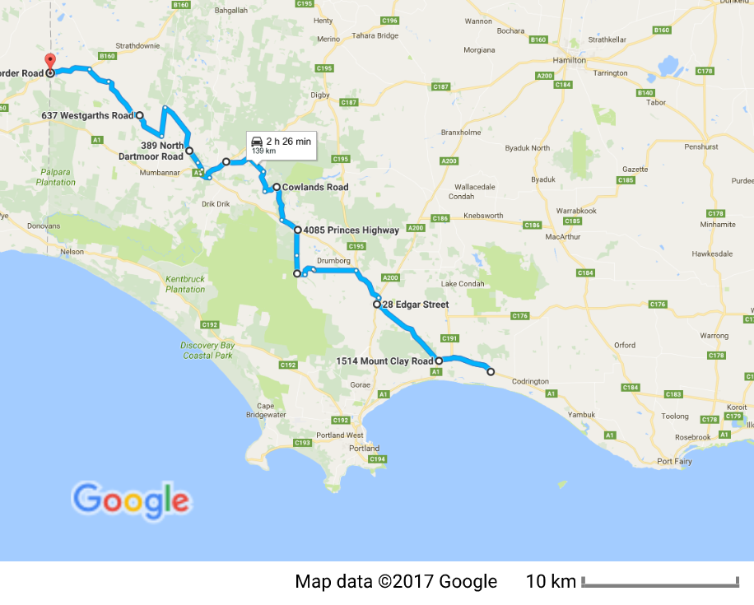
Figure A3-1. The road transect from Tyrendarra to Strathdownie (via Greenwald) is approximately a 140-km transect in a north-westerly direction, covering the Glenelg LGA, the southern-most part of the GKOZ.
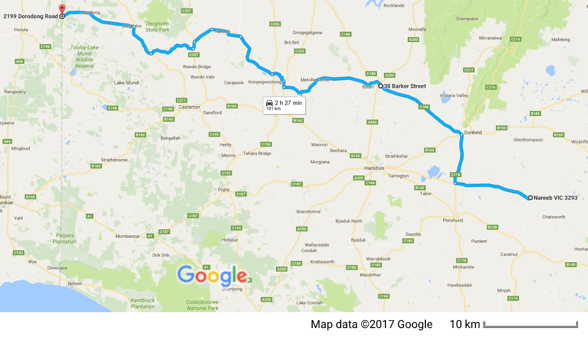
Figure A3-2. The road transect from Nareeb to Dorodong (via Konongwootong) is approximately a 190-km transect in a west-north-westerly direction, covering the Southern Grampians and West Wimmera LGAs.
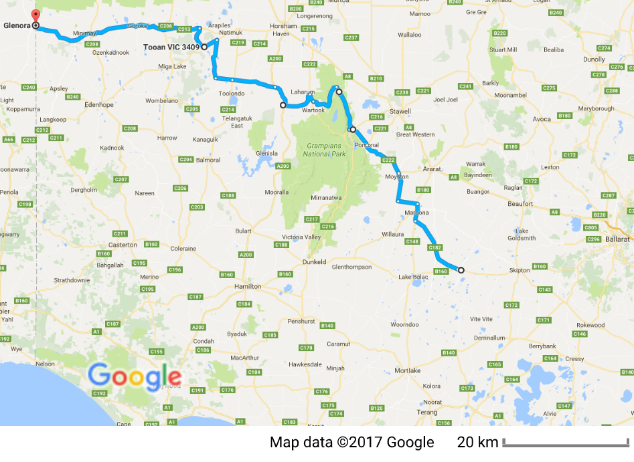
Figure A3-3. The road transect from Streatham to Glenora (via Tooan) is approximately a 300-km transect in a north-westerly direction, covering the Ararat, Southern Grampians and West Wimmera LGAs.
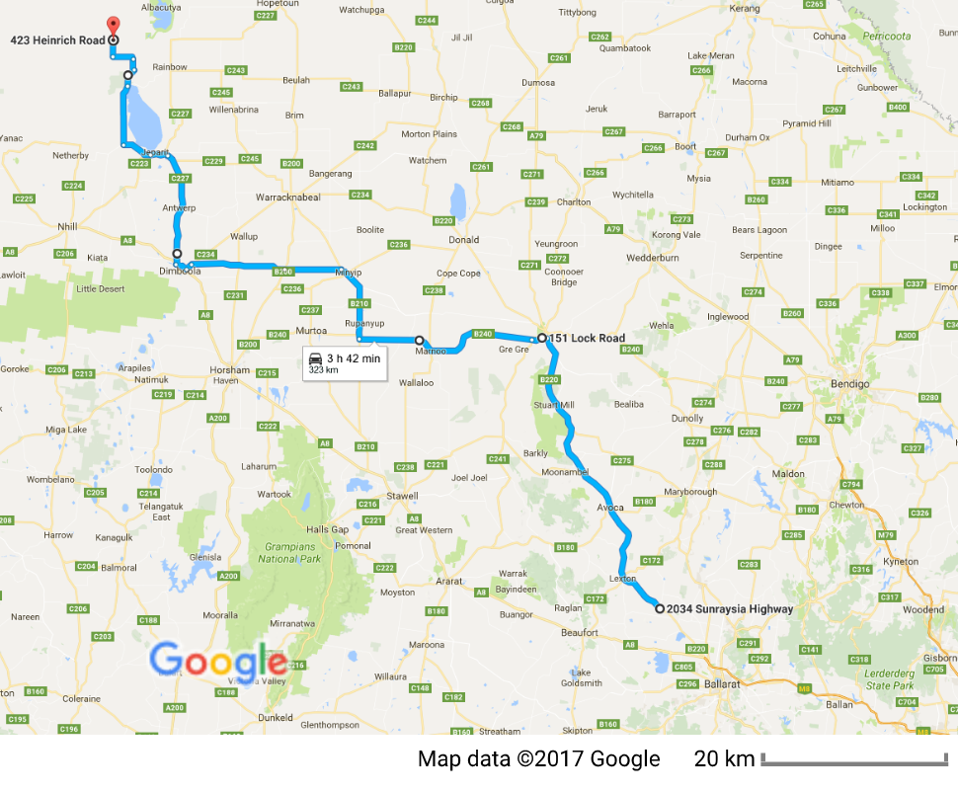
Figure A3-4. The road transect from Waubra to Rainbow (via Marnoo) is approximately a 320-km transect in a north-westerly direction, covering the Pyrenees, Northern Grampians, Yarriambiack and Hindmarsh LGAs.
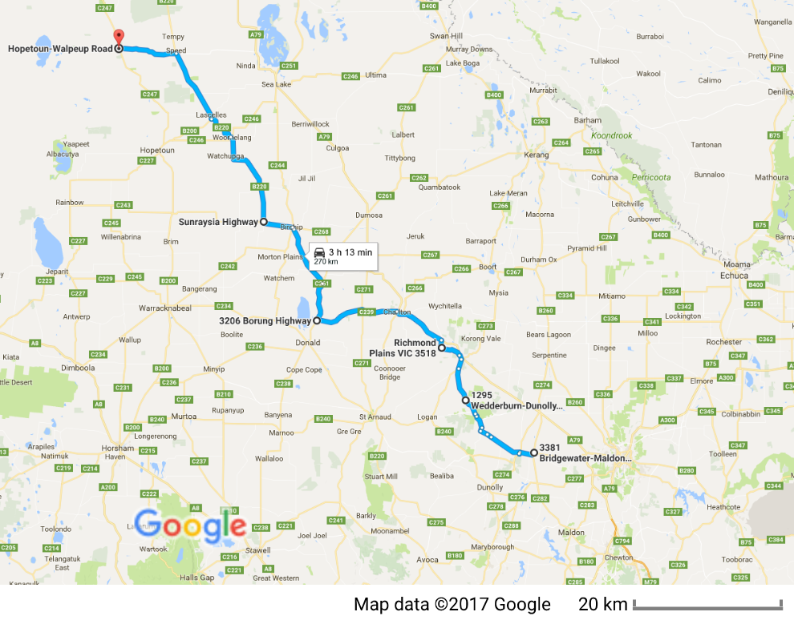
Figure A3-5. The road transect from Newbridge to Patchewollock (via Birchip) is approximately a 270-km transect in a north-westerly direction, covering the Loddon, Buloke and Yarriambiack LGAs.

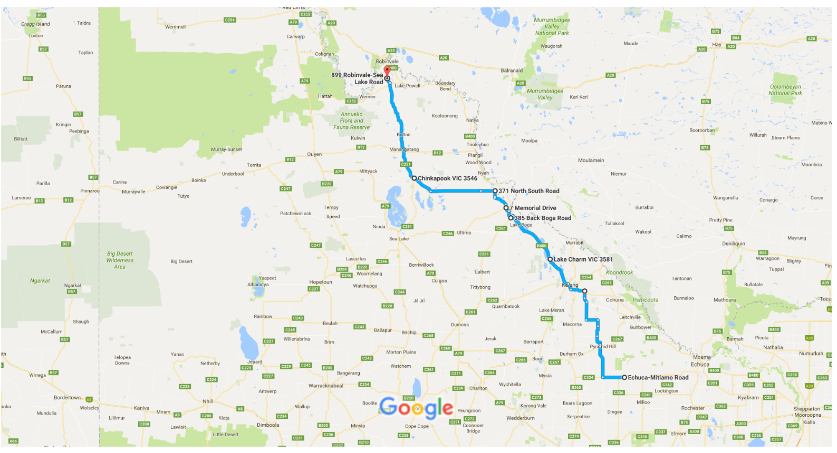
Figure A3-6. The road transect from Mitiamo to Bannerton (via Chinkapook) is approximately a 270-km transect in a north-north-westerly direction, covering the Loddon, Gannawarra and Swan Hill LGAs, the northernmost part of the GKOZ.

delwp.vic.gov.au
delwp.vic.gov.au

