|  |
| --- |
| Use of nest boxes – general guide |

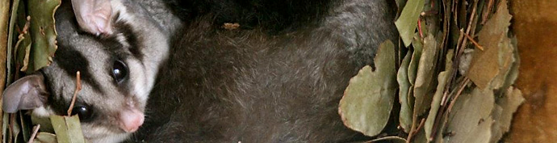

This fact sheet provides an overview of the use of nest boxes for conservation purposes. It includes design, installation, monitoring and maintenance guidelines. This information should be considered by those planning to apply for funding under the Department of Environment, Land, Water and Planning (DELWP) Community & Volunteer Action Grants.

## Hollows as wildlife habitat

Many species of wildlife rely on natural tree hollows for nesting, breeding and shelter. Hollows provide a safe home away from the weather and predators. In eucalypt trees, small hollows may take over 70 years to develop and large hollows many decades longer. The range of hollow sizes and types is matched by the range of wildlife able to use them – small species such as the Feathertail Glider use small hollows, large parrots such as the Sulphur-crested Cockatoo use large, deep hollows. Not all natural hollows are occupied. This can be because the hollow is unsuitable. It can also be because, when not breeding, most species will move frequently between a number of hollows.

## The role and limitations of nest boxes

Loss of natural tree hollows is a major concern for the protection of Victoria’s hollow-dependent wildlife. Nest boxes have been proposed as a potential solution to this problem in some situations, particularly where natural hollows have been depleted by humans.

A number of studies have contributed to our knowledge of nest box design, use by wildlife and contribution to conservation outcomes but there remains a great deal to learn. Hence, it is difficult to be definitive about many aspects of nest box design and their use as a management tool.

Nest boxes are not a long-term substitute for natural hollows. They typically last around ten years compared to a tree hollow that may exist for over 100 years.

Nest boxes have been shown to be a useful technique for surveying some species, such as Brush-tailed Phascogale and Feathertail Glider, but not others.

## Your objectives

Before deciding on the use of nest boxes clarify your objective. What species (single or multiple) are you trying to target and why?

For example:

* Provide additional habitat for hollow-dependent fauna in areas where hollows are absent or in short supply
* Support the persistence or reintroduction of a species

Knowing something about the habitat preferences and hollow-use of the species you are hoping to benefit will be essential for decisions about box design and placement.

A knowledge of the history of the location where nest boxes are to be installed is also useful. Does it contain natural hollows? Have hollows been depleted, such as through previous logging or fires? Are other essential habitat resources, such as food plants, present?

These issues may affect the success of your nest box project. For example, if food and water requirements are not present in the surrounding environment, a nest box may remain unoccupied.

Before nest boxes are installed, it is useful to discuss when to end the project. What is the useful life of the boxes? Will they be removed if there is a lack of occupancy or an ongoing problem with pest animals? Who will be responsible for their removal?

## Nest box design and construction

Nest boxes are available commercially or can be built by anyone with basic woodworking knowledge and tools. Recommended nest box dimensions are available on the internet and in relevant publications (see Further information).

The following points need to be considered when choosing or making a nest box:

* **The species you wish to attract** – each species will prefer a design suited to its needs.
* **Entrance size** – is very important. The entrance hole should be just large enough for the animal to enter through. This is to avoid entry by larger predators and potential competitors. A few millimetres can make a difference.
* **Depth** – some species, such as Kookaburras and Black Ducks, prefer gently-sloping hollows for breeding whilst others, such as large Cockatoos prefer deep, vertical hollows. Young animals must be able to exit the hollow. A rough surface inside can assist them.
* **Cavity space** – is dependent on the species and the likely number of occupants. Leadbeater’s Possums live communally with as many as eight individuals denning together. Brush-tailed Phascogales are solitary for much of the year and may move between hollows nightly. They may share a breeding hollow with up to 6-8 young
* **Nesting material** – some species will line the cavity with nesting material such as bark strips, leaves, feathers or fur. Parrots do not supply their own nesting material and will benefit from the addition of wood shavings, to mimic natural hollow decay.

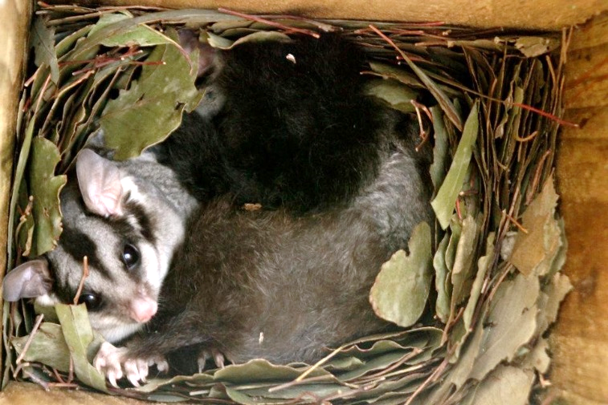

A Sugar Glider in a nest box curled up in a typical bowl-shaped nest made from eucalypt leaves (Photo: Jess Lawton)

* **Insulation and colour** – is important. Use of thick wood and suitable insulation material, and avoiding gaps and drafts will help reduce temperature fluctuations. Temperature extremes (hot and cold) are to be avoided. While also affected by box placement (see under Orientation and shading), heat absorption is influenced by the colour of the box, with light colours reflecting more heat. However, camouflage colours may help to prevent predators and vandals from locating nest boxes.
* **Ventilation** - can primarily be achieved through the entrance hole. Ensure that it is not obstructed. Additional ventilation may be required in some box designs and in regions that experience extremely hot weather.
* **Access** - a rough external box surface can assist animals to reach the entrance. A hinged lid opening will allow for cleaning and the occasional inspection.
* **Durability** – is influenced by the choice of materials, protective coatings and potential for damage by other organisms such as cockatoos and termites. Metal strips on lid edges may deter attack by cockatoos.
* **Toxicity** – boxes should be made from non-toxic wood and paint.
* **Weather protection** – preventing entry by rain, wind and snow. A nest box lid that extends over the entrance is helpful.
* **Labelling** – nest boxes should be individually labelled with the box number and contact details.

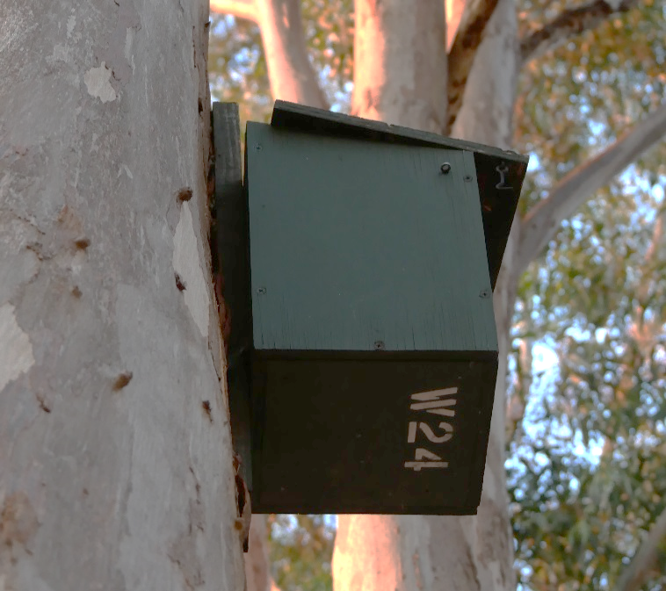

This nest box is clearly labelled, and can be easily seen from the ground. Note the lid looks crooked, and may need fixing (Photo: Fern Hames)

## Location, position and attachment

* **Location** – the extent of surrounding suitable habitat and connectivity to native vegetation, the presence of feed trees, such as eucalypts and wattles will influence the success of nest boxes to attract animals.
* **Height** – place at a height that deters dogs and foxes, and human vandals. Generally, anything over 3 meters is appropriate. Potential predators include goannas, cats, foxes, snakes, pythons, sugar gliders and birds such as butcherbirds.
* **Orientation and shading** – the box opening should face the direction that minimises exposure to wind and rain. Positioning the box on the south side of the host tree will reduce the amount of direct sunlight it receives during the day. Water entry or too much heat can kill young.
* **Attachment** – make sure the nest box is secure and allow for host tree growth to avoid damage to tree and box. A wire threaded through a section of hose (to protect the tree) which includes a section of spring can be used. Screws, e.g. coach screw (galvanised will last longer), can also be used for attachment, with some designs recommending adding a spacer between the box and tree. Trees can grow around the spacers, or slowly break them, rather than pushing against the box and causing damage. Any method of attachment will need to be regularly checked to make sure materials haven’t deteriorated, the tree isn’t being damaged and the nest box is still secure.

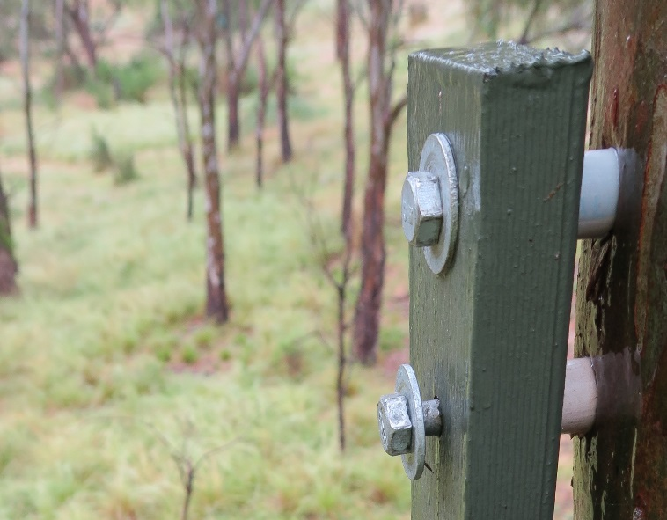

Nest box attachment using PVC spacers. Spacers minimise damage to the tree and box by helping allow for tree growth and bark shedding, and creating space between the box and tree to reduce the likelihood of rotting (Photo: Steve Griffiths)

## Safety

Installing and checking nest boxes is a potentially hazardous activity involving working at height and lifting heavy items. Assess your capacity to safely undertake these tasks. A qualified arborist may be needed. Dangerous animals can occupy nest boxes, for example, bees, wasps, spiders, snakes and biting native animals. Avoid working alone, wear protective clothing, carry first aid and maintain communication.

## Ethics and permits

Wildlife should be able to live free of unnecessary interference by humans, particularly if there is a risk to wildlife safety or health, or a risk of pain or suffering.

The placement of nest boxes on your private land does not normally require a permit. On other land, the permission of the landholder or land manager should first be sought.

Natural hollows should not be taken from the environment and converted to nest boxes. They are in short supply and are likely to already have an occupant. In some cases, natural hollows may be used if salvaged e.g. from timber harvesting, or routine pruning of amenity trees, where they would normally be destroyed.

## Monitoring, recordkeeping and reporting

Be aware that it may take months or years before a nest box is occupied. Activity can be seasonal with greater activity in spring when breeding occurs.

* **Keep internal inspection** of nest boxes to a minimum to avoid disturbing resident animals. Consider the use of a ground-based inspection camera on an extension pole. Remote cameras or observations from the ground can be also used to record nest box activity with little or no disturbance.

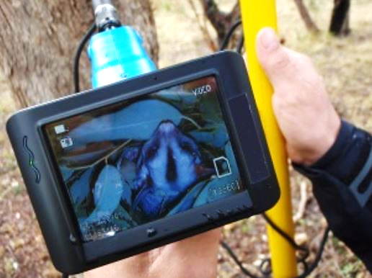

A pole mounted camera with a separate screen which allows ground-based nest box inspection (Photo: Treetec)

* **Regular inspection** of the condition of the box and presence of pest animals is essential. Nest box materials can deteriorate over time, and parts such as lids may become damaged. Maintenance may be needed to keep nest boxes in a usable condition. The security of attachment of the nest box should also be checked regularly. Pests, such as Common Myna and feral bee, may need to be controlled if they occupy the nest box. It is recommended that such inspections take place from the outside to avoid disturbing animals that are using the box.

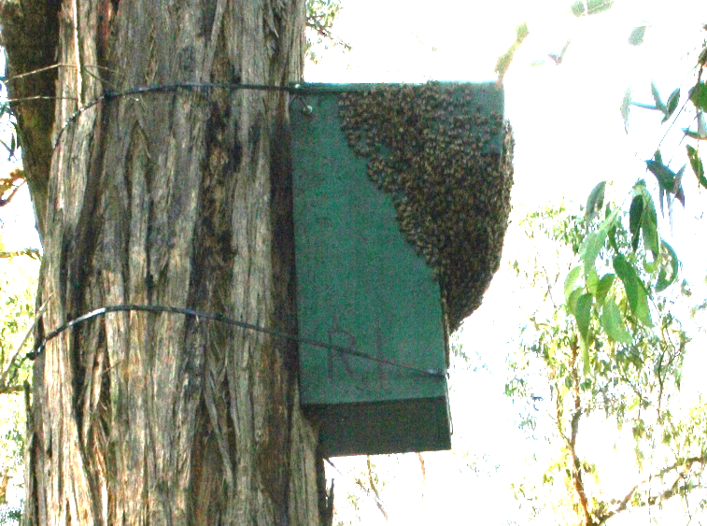

This rosella nest box (above) has become infested by feral bees; the view inside (below) (Photos: Friends of Glenfern Valley Bushlands)

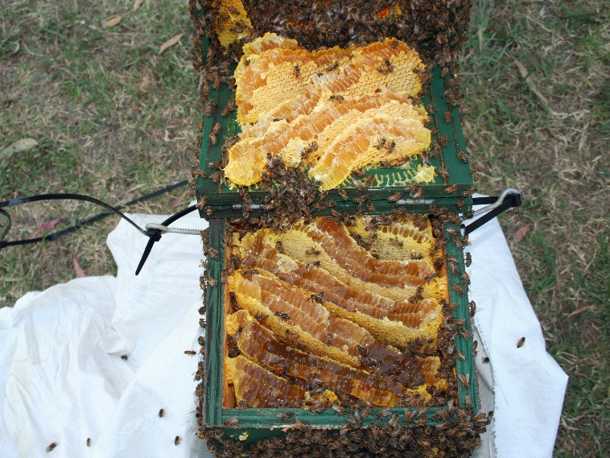

* **Data collected** about nest box use can be used to help conserve wildlife and guide better use of nest boxes. It is essential that the data is accurate and comprehensive. Useful data includes nest box label, location coordinates, date of installation, target species, box characteristics, date of inspection, species using the box and how they are using it.

If you are a DELWP grant recipient, you will be required to record details of your nest boxes and contribute data to understanding more about their role in nature conservation by using an online nest box data entry tool.

Further information

The internet contains a wide range of resources on nest box purchase, design and construction as well as commercial suppliers of nest boxes. Suggested search terms are: ‘Nest boxes for wildlife’, ‘Nest boxes Australia’ ‘Nest Box Design for [species]’, ‘How to build a nest box’. Research papers on nest boxes can be found via Google Scholar. Some relevant publications include:

Alan and Stacey Franks (2003). Nest boxes for wildlife: a practical guide. Bloomings Books, Melbourne

Phillip Gibbons and David Lindenmayer (2002). Tree hollows and wildlife conservation in Australia. CSIRO, Collingwood

Learning from nest boxes – monitoring and storing data fact sheet, DELWP:

https://www.ari.vic.gov.au/__data/assets/pdf_file/0026/328193/Nest-box-fact-sheet-monitoring-data.pdf

Boxes for Bats fact sheet, Australasian Bat Society:

http://ausbats.org.au/download/i/mark_dl/u/4008973680/4634168299/Boxes%20for%20bats_high%20res.pdf

Birds in Backyards nest box plans, BirdLife Australia:

<http://www.birdsinbackyards.net/Nest-Box-Plans>

<http://www.birdlife.org.au/images/uploads/education_sheets/INFO-Nestbox-technical_0.pdf>

Nest Boxes for Wildlife, Tweed-Byron Bush Futures Project:

<https://www.tweed.nsw.gov.au/Documents/Environment/Bush%20Futures/TSC01135_Nest_Box_Manual.pdf>

Building and Installing a Nest Box, Wildlife Preservation Society of Queensland:

<http://wildlife.org.au/wp-content/uploads/2015/11/nestbox_instructions.pdf>

|  |  |
| --- | --- |
| © The State of Victoria Department of Environment, Land, Water and Planning 2018  LogoThis work is licensed under a Creative Commons Attribution 4.0 International licence. You are free to re-use the work under that licence, on the condition that you credit the State of Victoria as author. The licence does not apply to any images, photographs or branding, including the Victorian Coat of Arms, the Victorian Government logo and the Department of Environment, Land, Water and Planning (DELWP) logo. To view a copy of this licence, visit http://creativecommons.org/licenses/by/4.0/  ISBN 978-1-76077-154-6 (print)  ISBN 978-1-76077-138-6 (pdf/online/MS word)  Disclaimer  This publication may be of assistance to you but the State of Victoria and its employees do not guarantee that the publication is without flaw of any kind or is wholly appropriate for your particular purposes and therefore disclaims all liability for any error, loss or other consequence which may arise from you relying on any information in this publication. | Accessibility  If you would like to receive this publication in an alternative format, please telephone the DELWP Customer Service Centre on 136186, email [customer.service@delwp.vic.gov.au](mailto:customer.service@delwp.vic.gov.au), or via the National Relay Service on 133 677 [www.relayservice.com.au](http://www.relayservice.com.au). This document is also available on the internet at [www.delwp.vic.gov.au](http://www.delwp.vic.gov.au) |

Compiled by: Phoebe Macak (Arthur Rylah Institute for Environmental Research) and Stephen Platt

Header image: Sugar Glider in a nest box (Photo: Jess Lawton)