|  |
| --- |
| Victorian Environmental Flows Monitoring and Assessment Program (VEFMAP) Stage 6 |
| Project Update – 2019  Southern Victorian Rivers - Fish |

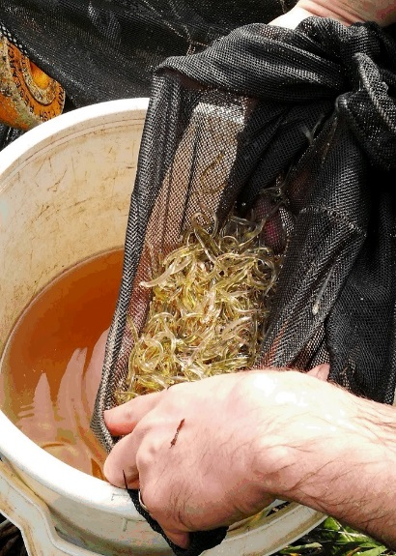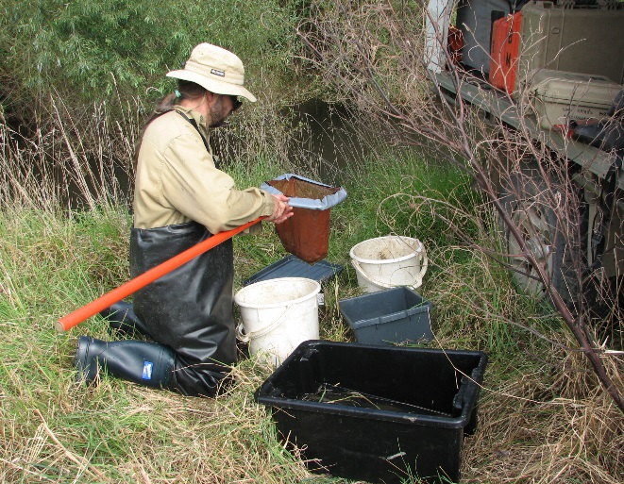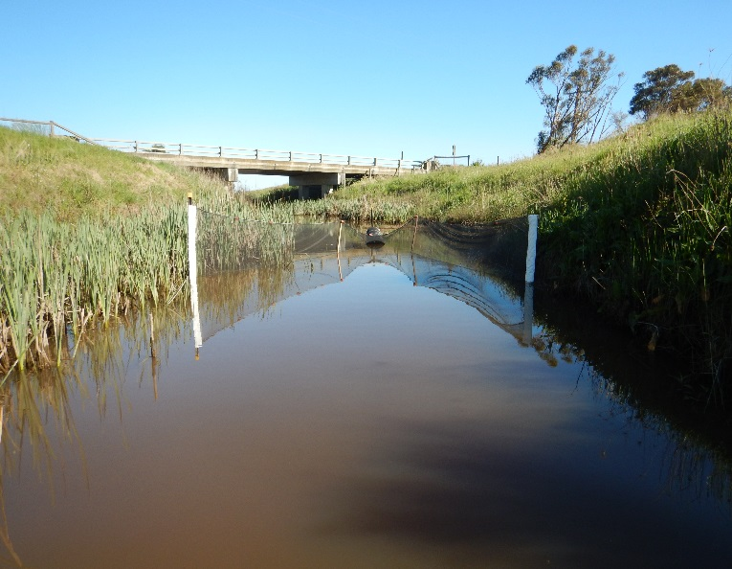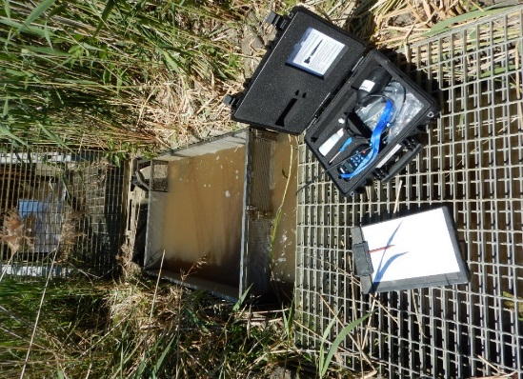

**Background**

The Victorian Environmental Flows Monitoring and Assessment Program (VEFMAP) was established by the Victorian Government in 2005 to monitor and assess ecosystem responses to environmental watering in priority rivers across Victoria. Its results help inform decisions for environmental watering by Victoria’s Catchment Management Authorities (CMAs), Melbourne Water and the Victorian Environmental Water Holder (VEWH). VEFMAP Stage 6 (2016-20) includes a strong focus on “intervention” or “flow event” type questions, for vegetation and fish.

**Fish Monitoring - Southern Victorian Rivers**

The core objective for fish monitoring in VEFMAP Stage 6 for coastal rivers is to examine the importance of environmental flows in promoting immigration, dispersal and subsequent recruitment of diadromous (migratory between fresh and salt water) fishes.

There are two key evaluation questions for fish in coastal Victorian rivers, which were developed in collaboration with CMAs.

KEQ 1 Do environmental flows enhance *immigration* of diadromous fishes into coastal streams?

KEQ 2 Do environmental flows enhance *dispersal, distribution and recruitment* of diadromous fishes in coastal streams?

**Survey Sites and Timing**

Surveys were undertaken to investigate processes associated with KEQ 1 and 2 in the following sites:

* ***Immigration*** - the lower freshwater reaches of the Barwon, Werribee, Bunyip and Tarwin rivers and Cardinia Creek.
* ***Dispersal*** - the Glenelg, Moorabool and Macalister rivers.
* ***Distribution and recruitment*** - the Glenelg and Thomson rivers.

**Methods**

Different survey methods were used for each component of the study:

***Immigration***

* *Fyke netting* – undertaken weekly (Oct-Dec) in the Glenelg, Tarwin and Werribee rivers and Cardinia Creek. The Bunyip River was sampled as part of a study by Melbourne Water (Sept-Dec) (2016-2018).
* *Fishway trapping* – undertaken weekly at the vertical-slot fishway in the Barwon River at the Barwon Barrage (Sept-Dec) (2016-2018).

***Dispersal***

* *Fyke netting –* in the Glenelg River system annually for three years (2017-2019); the Moorabool system (2018); and the Macalister system (2019). Netting occurred immediately before a summer fresh release, and during the peak of the release.

***Distribution and recruitment***

* *Electrofishing –* Annual bank-mounted electrofishing was used to sample abundance, size structure and distribution of fish species in the Thomson (2005–2019) and Glenelg (2009–2019) rivers each summer/autumn.

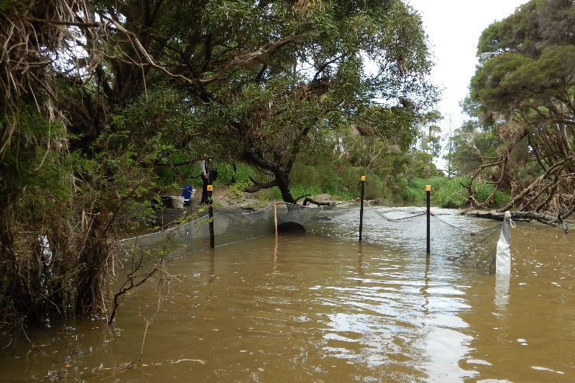

**Fig 1. A double winged fyke net in the Tarwin River (Photos: ARI)**

**Results and Key Observations**

***Environmental flow delivery***

There were environmental flow releases in spring in the Werribee (2016 and 2017) and natural flows in the remaining four rivers. Environmental water was delivered in summer/autumn as within-channel pulses or ‘freshes’ (i.e. small flow events that exceed the baseflow and last up to several weeks) in the Glenelg (2017-2019), Moorabool (2018) and Macalister (2019) rivers.

***Immigration***

The number of young-of-year (YOY) galaxiids *Galaxias* spp. immigrating into rivers from marine environments is significantly higher in rivers with higher spring discharge. To date, there is also early evidence that spring environmental flow releases in the Werribee River increased the movement of Common Galaxias *Galaxias maculatus* into freshwater reaches.

***Dispersal***

Summer/early autumn fresh releases (a short period of elevated river discharge) stimulated the upstream movement of YOY Common Galaxias in the Glenelg River and juvenile Short-finned Eels *Anguilla australis* in the Moorabool River.

There is evidence to support the release of summer/early autumn freshes that may also stimulate the upstream movement of YOY Tupong *Pseudaphritis urvilli*. This species may also avoid migrating into areas where lower flow rates occur.

Barriers to fish movement can be a confounding factor when using environmental flow releases to stimulate migration (i.e. barriers may continue to preclude fish passage during elevated flows).

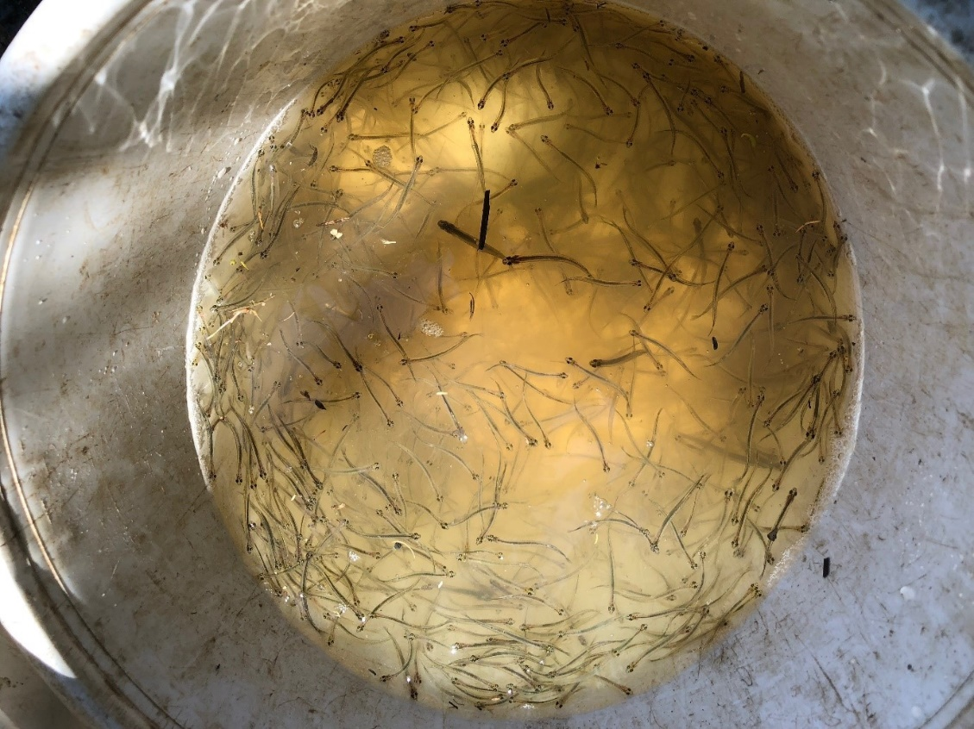

**Fig 2. Juvenile galaxiids collected during a survey of the Tarwin River (Photo: ARI)**

***Distribution and recruitment***

The long-term population surveys in the Thomson and Glenelg rivers show important links between river flows and recruitment, abundance and distribution of a number of species. For example, results indicate that the use of environmental water to maintain sufficient river base flows provides for successful upstream dispersal (over 100 km) and the maintenance of population structure of Common Galaxias and Tupong.

Variable recruitment rates have been identified for Tupong, which can be modelled against flow related factors to investigate potential causes.

The CPUE of Common Galaxias and Tupong in 2019 was the highest observed during the 11-year history of VEFMAP monitoring in the Glenelg River (Fig 3).



Tupong



Common Galaxias

CPUE

Year

**Fig 3. Mean electrofishing catch-per-unit-effort (solid circles; CPUE – fish h-1) of Tupong and Common Galaxias captured at sites sampled consistently in the Glenelg River, 2009-2019. Open circles represent the raw data for each site; sampling was incomplete in 2011.**

**Flow Recommendations to Support Managers**

While the results and analyses to date are preliminary, some of the emerging patterns enable the following flow recommendations for the 2019/20 period:

* Given that high discharge rates in early spring increases the number of galaxiids in rivers, spring environmental flow releases are not expected to provide detectable benefits at the population scale within rivers when a large natural flow pulse has already occurred during spring. These environmental flow releases are best used in years with relatively low spring discharge (e.g. Werribee River in 2017).
* To provide conditions for upstream dispersal, instream habitat and survival of galaxiids and Tupong, maintain recent base flow targets that have been shown to provide enough depth for the upstream migration and sustain suitable water quality for galaxiids and Tupong.
* Consider prioritising summer or early autumn freshes to provide connectivity for large-bodied species or, during high recruitment years (e.g. years with high spring flows for galaxiids), to enhance the upstream dispersal of juvenile diadromous fishes. However, sufficient base flows are considered a priority.

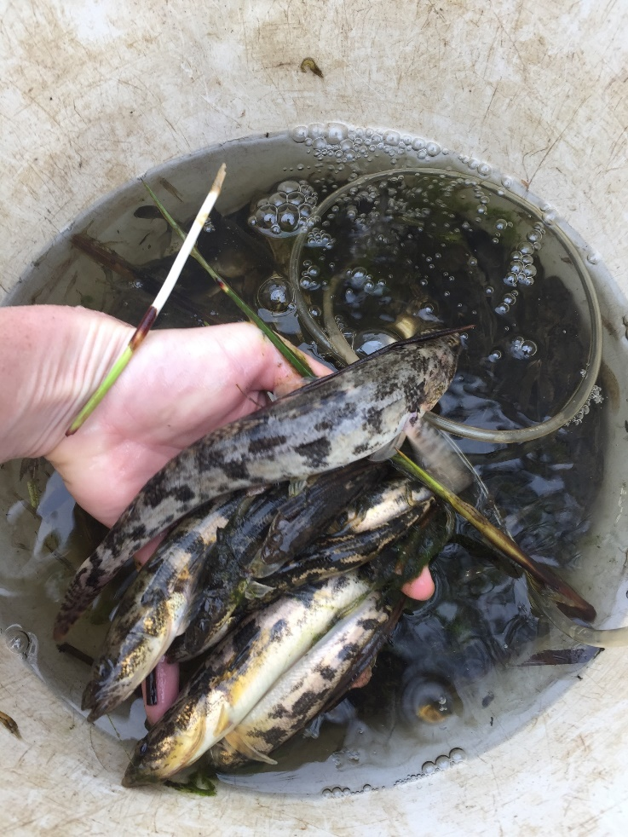Environmental base flows and fresh releases will not benefit upstream dispersal of diadromous fishes in rivers where barriers (natural or artificial) prevent their movement.

**Fig 4. A catch of Tupong from the Glenelg River (Photo: ARI)**

**Science Supporting Management**

The VEFMAP Stage 6 approach to combine both event-based intervention monitoring, and condition monitoring has provided a link between patterns in population processes and population demographics.

The findings from this project so far provide important information for waterway managers, demonstrating how environmental water can be used to improve benefits to diadromous fish communities. If any step within the fish recruitment process fails, this will limit successful recruitment, population structure and survival of fish species in rivers with modified flow environments

Extensive information has been collected on immigration of juvenile diadromous fishes including the abundance, timing and discharge conditions for nine species, two being of conservation significance. This information is highly beneficial to waterway managers, providing them with knowledge on how to improve the benefits of environmental water releases to stimulate immigration of a range of fish species into coastal rivers.

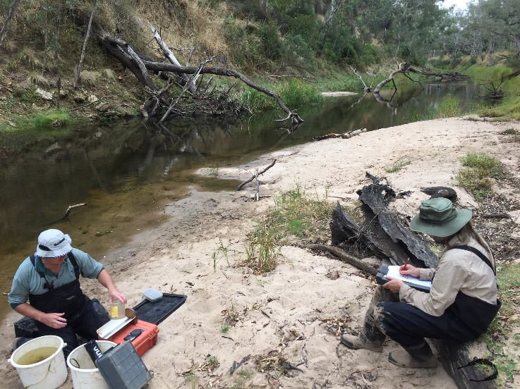A highlight to date has been the strong collaboration between program managers and waterway managers. Regular and active interactions have been integral to the effective program delivery and the communication of outcomes. This has enabled the inclusion of local advice on the timing and location of monitoring, provided opportunities for input and feedback on the program, and facilitated discussion to modify environmental water management plans.

**Fig 5. VEFMAP team record details of their fish samples (Photo: ARI)**

**What’s Next?**

Monitoring methods tested to date are encouraging, producing several positive results. Based on findings to date and project team discussions, maintaining the long-term population monitoring component of the program is proposed for 2019/20. Collection and interrogation of data will continue to further clarify how flows can be managed to increase benefits to native fish communities.

**Further Details**

See DELWP (2019) VEFMAP Stage 6: Do environmental flows enhance immigration and dispersal of diadromous fishes in Victorian coastal rivers? 2018/19 survey results. A client report to Water and Catchments of the Department of Environment, Land, Water and Planning (DELWP).

**Acknowledgements**

Most of this work was funded by DELWP Water and Catchments, as part of the Victorian Government’s $222 million investment to improve catchment and waterway health across regional Victoria. Melbourne Water provided funding for work in the Bunyip River as part of another project.

**Contact**

[Frank.Amtstaetter@delwp.vic.gov.au](mailto:Frank.Amtstaetter@delwp.vic.gov.au), [Zeb.Tonkin@delwp.vic.gov.au](mailto:Zeb.Tonkin@delwp.vic.gov.au), [Wayne.Koster@delwp.vic.gov.au](mailto:Wayne.Koster@delwp.vic.gov.au) (Bunyip River surveys)

|  |  |
| --- | --- |
| © The State of Victoria Department of Environment, Land, Water and Planning 2020  LogoThis work is licensed under a Creative Commons Attribution 4.0 International licence. You are free to re-use the work under that licence, on the condition that you credit the State of Victoria as author. The licence does not apply to any images, photographs or branding, including the Victorian Coat of Arms, the Victorian Government logo and the Department of Environment, Land, Water and Planning (DELWP) logo. To view a copy of this licence, visit http://creativecommons.org/licenses/by/4.0/  ISBN 978-1-76077-902-3 (pdf/online)  Disclaimer  This publication may be of assistance to you but the State of Victoria and its employees do not guarantee that the publication is without flaw of any kind or is wholly appropriate for your particular purposes and therefore disclaims all liability for any error, loss or other consequence which may arise from you relying on any information in this publication. | Accessibility  If you would like to receive this publication in an alternative format, please telephone the DELWP Customer Service Centre on 136186, email [customer.service@delwp.vic.gov.au](mailto:customer.service@delwp.vic.gov.au), or via the National Relay Service on 133 677 [www.relayservice.com.au](http://www.relayservice.com.au). https://www.ari.vic.gov.au/research/rivers-and-estuaries/assessing-benefits-of-environmental-watering |

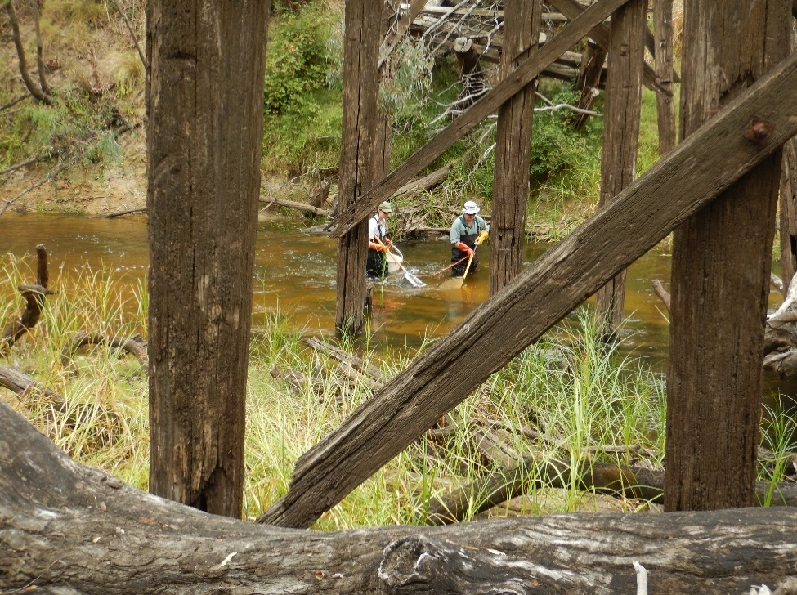

**Fig 6. Bank-mounted electrofishing survey (Photo: ARI)**