|  |
| --- |
| Victorian Environmental Flows Monitoring and Assessment Program (VEFMAP) Stage 6 |
| Vegetation Project Update – 2019  Monitoring of Aquatic and River Bank Vegetation:  **Glenelg and Wannon Rivers** |

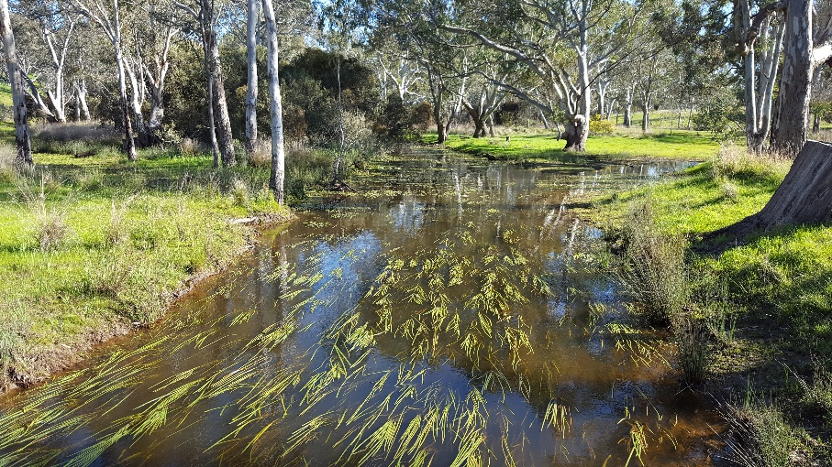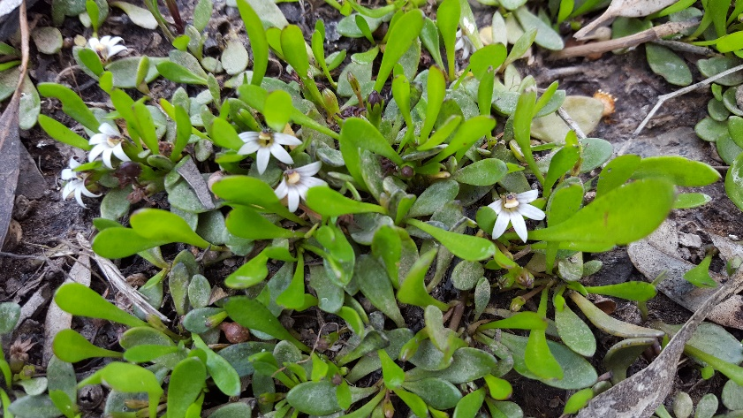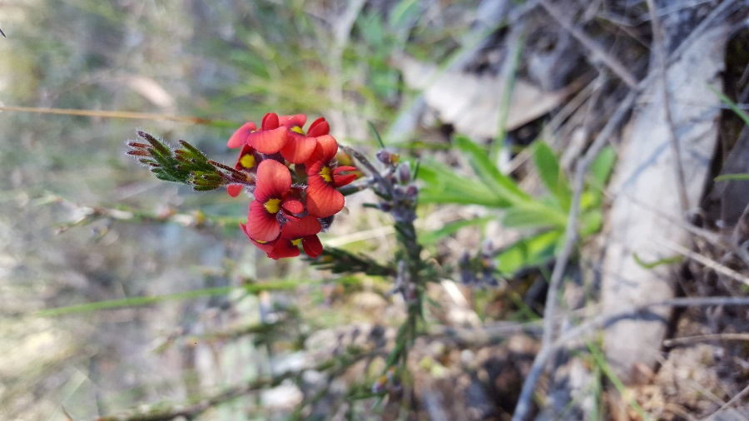

* 1. **VEFMAP Stage 6**

The Victorian Environmental Flows Monitoring and Assessment Program (VEFMAP) is now in its sixth stage of delivery. VEFMAP Stage 6 focusses on ‘intervention’ or ‘event-based’ monitoring of fish and vegetation responses to flows. The program is funded through the Victorian government’s $222 million investment in waterway and catchment health.

## Stage 6 – Vegetation Objectives

Stage 6 vegetation objectives aim to identify vegetation responses to environmental flows. The monitoring approach has been substantially modified from previous stages of the program and is focussed on individual flow events in waterways to detect short-term responses of native and exotic plant species to environmental water delivery. A longer-term understanding will be gained from repeated short-term assessments and by using data from previous stages of VEFMAP to create longer-term datasets. Importantly, these responses will be considered in relation to other factors that may influence flow responses, such as grazing, rainfall, soil properties and season (see program overview for details, DELWP 2017a).

## 2018/19 Monitoring on the Glenelg and Wannon Rivers

2018/2019 is the first year of surveys along the Glenelg and Wannon Rivers. Surveys were conducted at six sites, five on the regulated Glenelg River and one on the unregulated Wannon River (Figure 1).

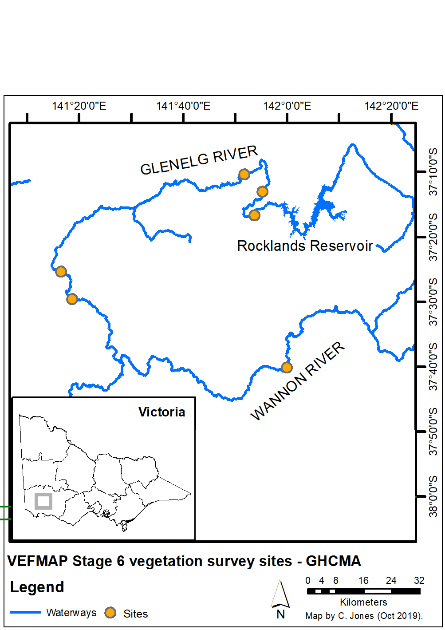

**Figure 1: Map of survey sites on the Glenelg and Wannon Rivers.**

## Survey timing and hydrology

Timing for the VEFMAP surveys considers rainfall and managed flow deliveries. The sampling design recommends surveys occur before a planned flow delivery and two to 12 weeks after the event, depending on the flow regime (to provide adequate time for vegetation to respond and for germinants to emerge). Timing is altered if rainfall increases the flow prior to a planned survey.

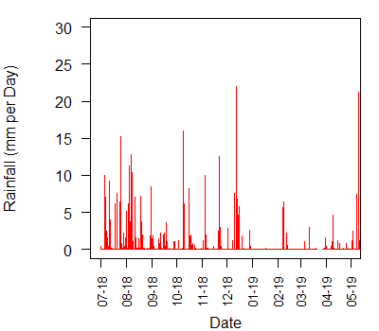

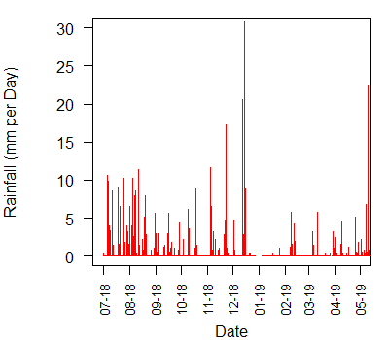

**Figure 2: Daily rainfall in the upper Glenelg area at Kanagulk near Rocklands Reservoir (top) and near the Wannon River at Hamilton airport (bottom) in 2018/19.**

On the Glenelg River, a natural late winter fresh occurred in August 2018 that was fed by consistent rain through July and August (Figure 2). This was followed by a period of low flow, with base flows provided by environmental water (Figure 3). Three small summer environmental flows were delivered, the first coinciding with a rainfall event in early December.

As in the Glenelg River, winter rainfall resulted in a large winter flow event in the Wannon River, peaking at over 3000 ML per day in August 2018 (Figure 3). The December rainfall-driven flow provided a small natural fresh in the Wannon River but there were few subsequent variations in flow after that period and a period of cease-to-flow in Jan-March.

For both rivers, the first survey was conducted after the August fresh in September 2018, followed by a second survey three months later in January after the small rainfall pulse. A third survey was conducted in April 2019.

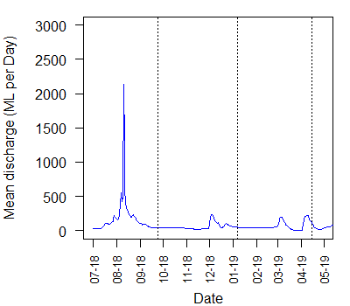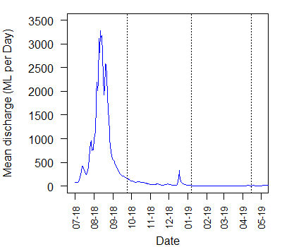

**Figure 3: Glenelg River flow discharge at Fulham Bridge near Rocklands reservoir (top) and Wannon River flow at Henty (bottom) in 2018/19 and vegetation survey timing for the three full surveys (dotted lines).**

## Methods

Survey methods are outlined in detail in VEFMAP Stage 6 Part B: Monitoring design and sampling methods (DELWP 2017b). The surveys include a wide range of methods: fine-scale vegetation measurements, broad-scale mapping, tree canopy assessments and hydrology assessments.

## Survey observations

The abundance of **instream vegetation** was high at all three upstream sites on the Glenelg River (Figure 4), which corresponds with observed broader state-wide trends (Jones and Vivian 2019). These instream vegetation populations are likely to remain stable through time unless there are significant increases in cattle access or reductions in flow. In contrast, the two downstream sites on the Glenelg River had higher water turbidity and less instream vegetation, particularly where livestock grazing was present. The unregulated flows of the Wannon River promoted a naturally patchy distribution of instream species.

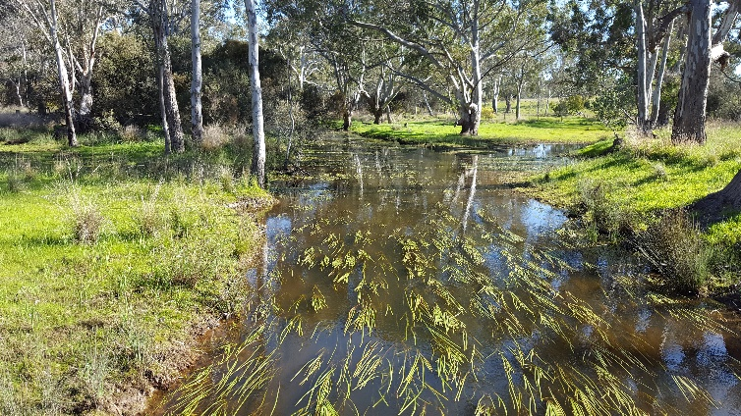

**Figure 4: High cover of instream vegetation on the Glenelg River.**

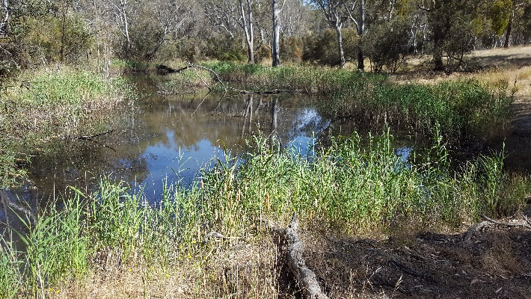**Emergent vegetation** occurs throughout all sites in this system, but the species and abundance vary. For example, tall emergent macrophytes such as *Phragmites* were dominant on the bank at some sites (Figure 5) but absent from others. At all sites the channel profile and flow conditions prevent emergent species from occupying the deepest parts.

**Figure 5: An extensive band of *Phragmites australis* along the margin of the upper Glenelg River.**

**Fringing vegetation** was generally in good condition at all ungrazed sites. Exotic vegetation cover was high at all sites, but well-timed flow deliveries can help to reduce encroachment of terrestrial exotic species into riparian areas.

Where sites had high levels of livestock grazer access, the fringing and emergent vegetation was severely degraded (e.g. Figure 6). The negative impacts were consistent throughout sites in all areas that were accessible to stock. Environmental water is unable to provide any benefits to riparian vegetation when livestock impacts are so high.

Some upstream sites have large infestations of exotic iris species (e.g. Crocosmia/Montbretia), which pose a high threat and are difficult to control.

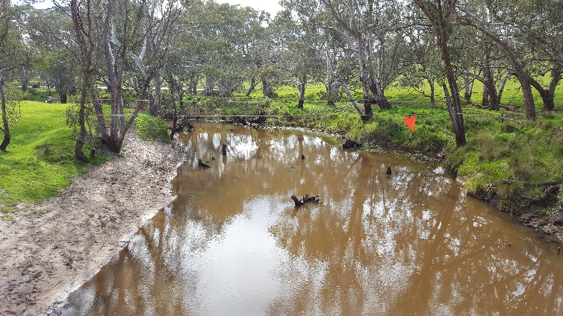

**Figure 6: Growth of fringing vegetation (right) and the lack of vegetation when livestock grazing is present (left).**

**Vegetation recruitment** was observed during spring surveys but the subsequent very dry conditions in summer meant survival was low for some species. The only summer recruitment occurred on the water margin in bare protected areas.

Recruitment was limited in sites with livestock grazing or where large resident numbers of waterfowl occur (waterfowl are known to deliberately keep previously disturbed banks clear, presumably so there are fewer hiding places for potential predators; Figure 7).

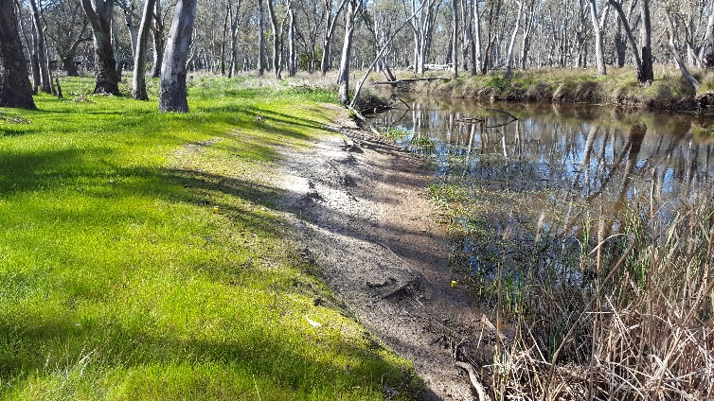

**Figure 7: A previously cleared river bank kept bare by waterfowl.**

## Grazing Exclosures

Livestock grazing occurs at various intensities within the surveyed sites on the Glenelg River. Upstream at a site within private property, the survey site was separated into two distinct sections – one heavily grazed and one lighter grazed. A single grazing exclosure was installed in each of these sections in late 2018, each with a paired unfenced control (Figure 8).

As expected over this short time period and with low rainfall and no large inundation events, the differences in vegetation change in the month after exclusion were small. However, by the April survey there were already signs of plant expansion in the upper elevations and colonisation of the bank on the water margin within the fenced areas. The grazing exclosures will continue to be surveyed throughout 2019/20.

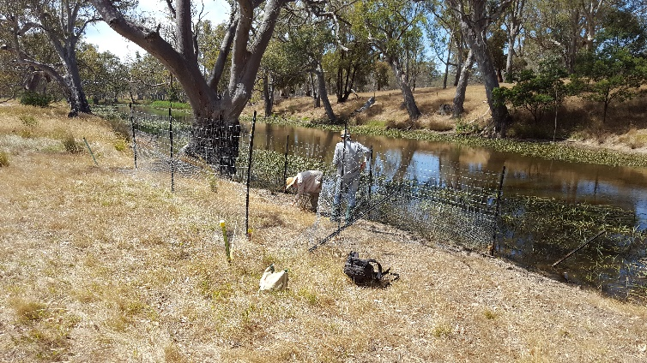

**Figure 8: The grazing exclosure installed in the more heavily grazed section of the site, with vegetation colonisation occurring at the water margin by January 2019.**

## Summary

Environmental flows are being delivered on the Glenelg River to deliver benefits to vegetation and a wide range of fauna. Waterway managers are working closely with researchers, waterway authorities and a range of other stakeholders to manage flow deliveries as effectively as possible for the environment and other users.

The observations summarised here form part of a larger story relating to vegetation responses to environmental water. Further information on the other systems surveyed and research projects is also available.

## Key Outcomes

* Spring freshes were observed to encourage the growth of both exotic and native fringing and emergent species and appear to be effectively limiting terrestrial species encroachment on the lowest bank margins.
* Recruitment of native riparian species triggered by rainfall and environmental flows was observed at all sites, but survival was limited due to dry summer conditions and grazing.
* Instream vegetation cover and diversity was relatively high upstream but declined substantially further downstream as water depth and turbidity increased. Instream plant populations tend to be relatively stable unless grazed or the river ceases to flow for extended periods.
* If crash grazing of exotic-dominated riparian zones can be restricted to higher bank elevations (top of bank), this could dramatically reduce the negative impacts of livestock access on native vegetation.

## Next Steps

In the final year of VEFMAP Stage 6 (2019/20), the data collected during the first three years of the program will be processed and analysed, and the findings reported in a series of reports and publications. Some additional targeted data collection will also continue, including additional vegetation surveys and monitoring of the grazing exclosures at various sites.

## References

DELWP (2017a and b) VEFMAP Stage 6 Part A: Program context and rationale and VEFMAP Stage 6 Part B: Program design and monitoring methods. Reports by Arthur Rylah Institute for Environmental Research and Integrated Water and Catchments Division, Department of Environment, Land, Water and Planning.

Jones C. and Vivian L. 2019. VEFMAP Stage 6: Monitoring vegetation response to environmental flow delivery in Victoria 2018/19. Arthur Rylah Institute report to the Department of Environment, Land, Water and Planning, Melbourne.

## Contact [Chris.Jones@delwp.vic.gov.au](mailto:Chris.Jones@delwp.vic.gov.au)

## Stephen Ryan (s.ryan@ghcma.vic.gov.au)

|  |  |
| --- | --- |
| © The State of Victoria Department of Environment, Land, Water and Planning 2020  LogoThis work is licensed under a Creative Commons Attribution 4.0 International licence. You are free to re-use the work under that licence, on the condition that you credit the State of Victoria as author. The licence does not apply to any images, photographs or branding, including the Victorian Coat of Arms, the Victorian Government logo and the Department of Environment, Land, Water and Planning (DELWP) logo. To view a copy of this licence, visit http://creativecommons.org/licenses/by/4.0/  ISBN 978-1-76077-162-1 (pdf/online/MS word)  Disclaimer  This publication may be of assistance to you but the State of Victoria and its employees do not guarantee that the publication is without flaw of any kind or is wholly appropriate for your particular purposes and therefore disclaims all liability for any error, loss or other consequence which may arise from you relying on any information in this publication. | Accessibility  If you would like to receive this publication in an alternative format, please telephone the DELWP Customer Service Centre on 136186, email [customer.service@delwp.vic.gov.au](mailto:customer.service@delwp.vic.gov.au), or via the National Relay Service on 133 677 [www.relayservice.com.au](http://www.relayservice.com.au). This document is also available on the internet at https://www.ari.vic.gov.au/research/rivers-and-estuaries/assessing-benefits-of-environmental-watering |