|  |
| --- |
| Revegetation in farm landscapes  4. The value of revegetation changes over time |

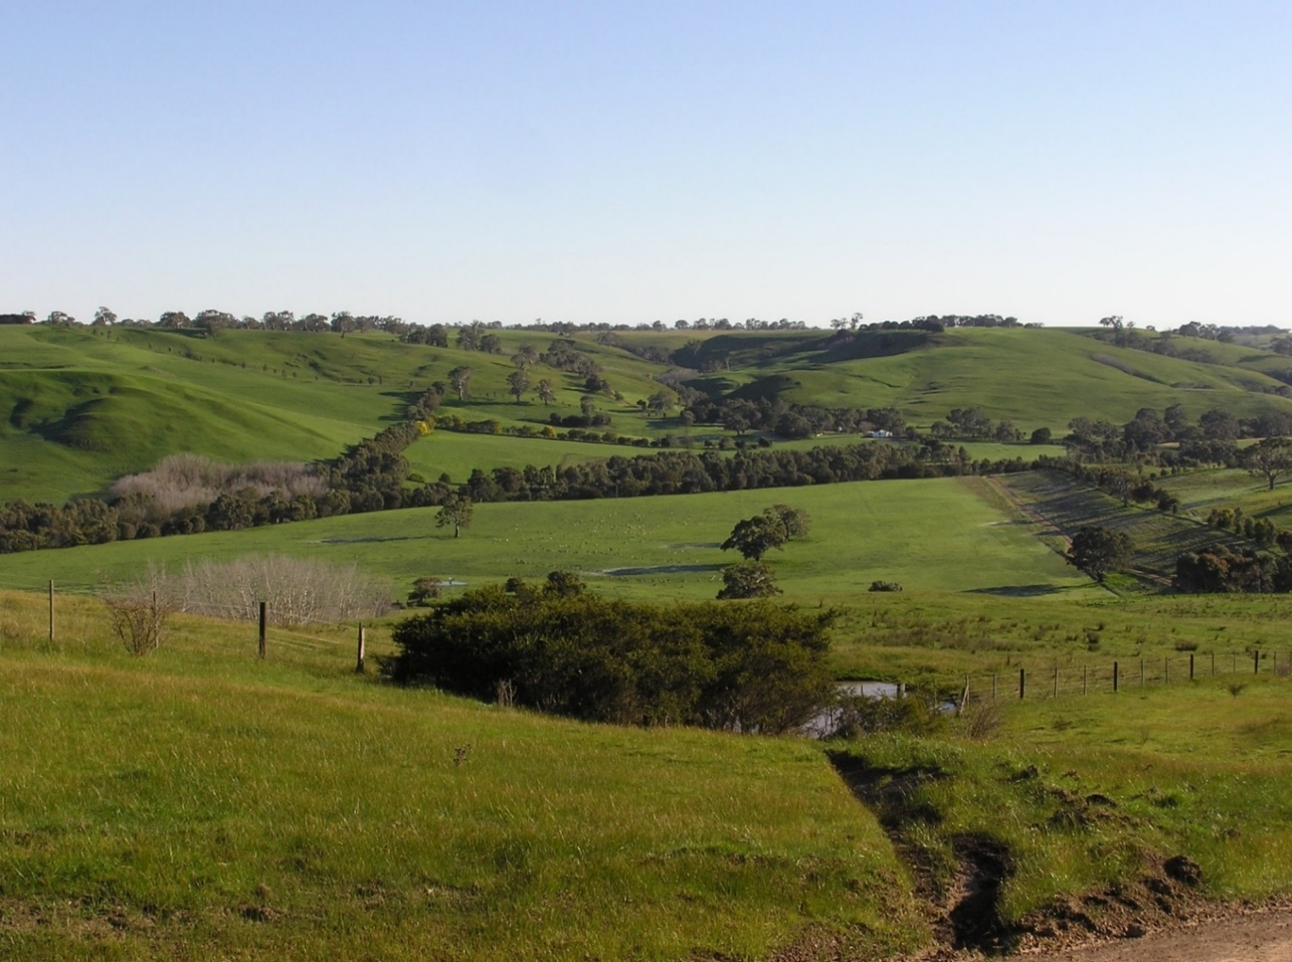

**Revegetation plantings change over time, with consequences for native animals**

From the time of planting, as seedlings grow into dense stands of saplings, and then into taller, more open plantings, important changes to the habitat that revegetation provides for native animals – for foraging, shelter, nesting and refuge – occurs.

We investigated how the value of plantings for birds changes over time by surveying revegetation on farms in the Glenelg Hopkins region, Victoria. We used two approaches:

1. comparing the birds occurring in revegetation plantings aged between 2 and 52 years old, and
2. directly tracking changes over time, by resampling birds at sites first surveyed 12 years earlier (in 2006/07 and in 2019).

Both approaches confirmed the strong effect of age on the use of revegetation by birds. Here we summarise some of the ways planting age affects its value for animals.

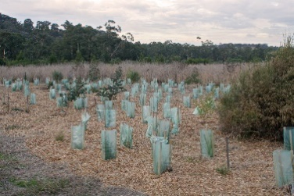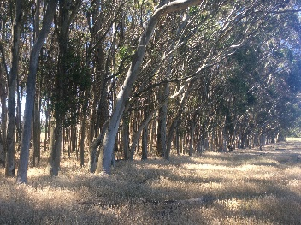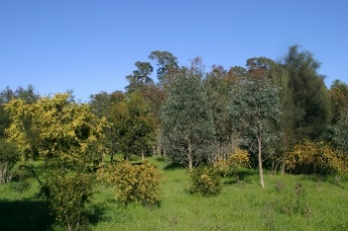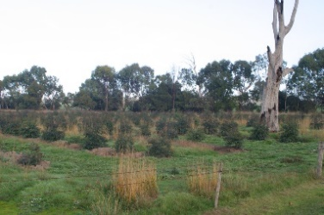

**Revegetation plantings undergo clear patterns of change as plants grow and mature, resulting in differing resources and habitat opportunities for animals over time.**

**Young plantings show rapid improvement for wildlife**

As plantings age, the number of bird species they support increases. Largest gains in the number of species occur in the first 10-20 years after planting, as trees and shrubs increase in height and structural complexity. Resampling sites over time showed that young plantings (<10 years old when first surveyed) contained two to three times the number of species when surveyed 12 years later. Less increase through time was seen in sites that were older when first surveyed.

Not only does the *number* of species increase rapidly in young plantings, the *composition* of bird communities (the mix of different species present) also shows greatest change in the first decade after planting. Woodlots, shelterbelts and other plantings amongst farmland all showed most rapid change in early years, whereas riparian plantings along creeks and streams supported more stable bird communities from a young age.

**Older plantings continue to develop critical resources for animals**

Revegetation plantings continue to change beyond 20 years of age. As trees mature and develop wide canopies, large branches and tree hollows, the range of habitat resources they provide for animals increases further. These resources continue to develop well beyond the age of plantings sampled in this study (52 years). Older trees flower more regularly and profusely than younger trees, providing food for a large number of nectar-feeding birds (and insects, which in turn provide food for different bird species). Tree hollows are another critical habitat resource, present only in older trees: they can take a century or more to develop, and are essential for breeding in many bird species.

Importantly, birds recorded more frequently in older revegetation often included species that forage in tall shrubs and the bark and canopy layers of mature trees. For example, the White-throated Treecreeper, White-winged Triller, Crested Shrike-tit and Horsfield’s Bronze-Cuckoo.

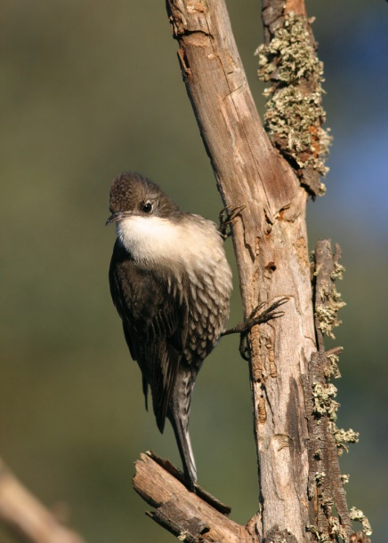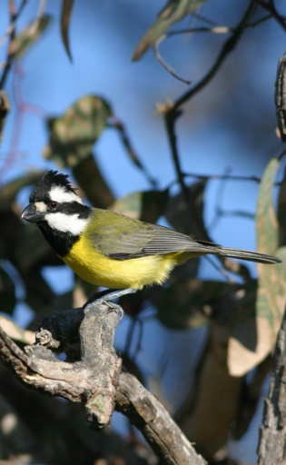

**White-throated Treecreepers (*Cormobates leucophaeus*) and Crested Shrike-tits (*Falcunculus frontatus*) feed on insects found under the bark of mature trees.**

**The benefits of revegetation for nature conservation take time to be realised**

Other important changes in the value of revegetation, at local and broader scales, were shown by resampling study sites over time (comparing 2006 and 2019).

In 2006/07, surveys showed that adding increased amounts of revegetation across larger areas (i.e. 800 ha study ‘landscapes’) serves to return more woodland bird species to farm landscapes. However, for the same amount of tree cover, landscapes dominated by revegetation had fewer species than those dominated by remnant vegetation (see Factsheet 3).

By 2019, with the increased age of plantings, the number of species returned to revegetation landscapes, for a given amount of tree cover, equalled the number recorded in landscapes with remnant vegetation.

This is an important result because it shows that revegetation has value for wildlife at a range of scales. At the local scale it provides specific resources for animals (e.g. shelter, nest sites, foraging), while at broader scales it adds to the overall availability of habitat in rural landscapes.

Over time, the types of native birds using revegetation plantings (and landscapes) become *more similar* to those found in remnant vegetation. These findings are promising because they suggest revegetation may increasingly replicate native habitats as the plantings age and mature. They also show that revegetation provides *complementary* habitat to remnant native vegetation, as it supports bird communities that are distinctly different from those of remnant vegetation (e.g. species that favour shrubby vegetation such as Brown Thornbill, and New Holland Honeyeater).

Rapid increases in numbers of bird species in the first decade or so after planting confirm the relatively quick biodiversity return for revegetation effort. Revegetation also represents a powerful long-term conservation investment, by facilitating the return of birds and other species to farm landscapes.

## Further information

Angie Haslem [A.Haslem@latrobe.edu.au](mailto:A.Haslem@latrobe.edu.au)

[research.ari@delwp.vic.gov.au](mailto:research.ari@delwp.vic.gov.au) [**ari.vic.gov.au**](https://www.ari.vic.gov.au/)

## Acknowledgements

This project was funded with support of the Victorian Government as part of the Biodiversity On-ground Action Adaptive Learning project, undertaken as a collaboration between Arthur Rylah Institute and La Trobe University.

**Prepared by:** Angie Haslem, Andrew Bennett, Rohan Clarke, Alex Maisey, Greg Holland (July 2020)

**Photo credits:** Rohan Clarke, Alex Maisey

|  |  |
| --- | --- |
| © The State of Victoria Department of Environment, Land, Water and Planning 2020  LogoThis work is licensed under a Creative Commons Attribution 4.0 International licence. You are free to re-use the work under that licence, on the condition that you credit the State of Victoria as author. The licence does not apply to any images, photographs or branding, including the Victorian Coat of Arms, the Victorian Government logo and the Department of Environment, Land, Water and Planning (DELWP) logo. To view a copy of this licence, visit http://creativecommons.org/licenses/by/4.0/  ISBN 978-1-76105-259-0 (pdf/online/MS word)  Disclaimer  This publication may be of assistance to you but the State of Victoria and its employees do not guarantee that the publication is without flaw of any kind or is wholly appropriate for your particular purposes and therefore disclaims all liability for any error, loss or other consequence which may arise from you relying on any information in this publication. | Accessibility  If you would like to receive this publication in an alternative format, please telephone the DELWP Customer Service Centre on 136186, email [customer.service@delwp.vic.gov.au](mailto:customer.service@delwp.vic.gov.au), or via the National Relay Service on 133 677 [www.relayservice.com.au](http://www.relayservice.com.au). This document is also available on the internet at <https://www.ari.vic.gov.au/research/> |