|  |
| --- |
| Environmental Water Benefits Black Box |
| Environmental watering at Hattah Lakes Icon Site improves Black Box woodlands (recruitment and population structure) |

**Key Points:**

* Environmental watering improves tree recruitment and population structure in Black Box woodlands.
* Land managers can be confident that environmental watering at the Hattah Lakes Icon Site will improve in Black Box woodlands.

Sustainable woodlands

A sustainable tree population is reliant on a balance of healthy individuals across a range of age classes. It requires healthy adults that can reproduce to provide sufficient juveniles, which in turn survive long enough to replace the stand as the old trees senesce and die.

The Arthur Rylah Institute (ARI, DELWP), in partnership with several organisations, established a multi-faceted research program to evaluate the effectiveness of environmental watering in maintaining or improving Black Box tree populations.

At the Hattah Lakes Icon site, two Black Box woodlands research projects investigated the role of flooding in improving:

* tree population structure
* recruitment

# Improved population structure

Environmental watering at Hattah Lakes has led to improved structure of Black Box populations.

Watered sites had fewer adult trees but more large (> 40 cm diameter) old Black Box trees, compared to unwatered sites. In contrast, unwatered sites had more senescent and/or dead trees compared to watered sites (Figure 1).

Sapling recruitment from watering in a Black Box woodland.

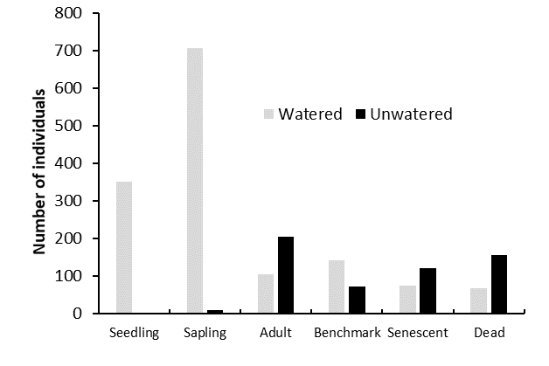

Figure 1. Tree life stage distribution at unwatered and watered sites

Seedling Sapling Adult Old Senescent Dead

# Recruitment

Environmental watering at Hattah Lakes has improved Black Box recruitment. Experimental sites that received environmental water had more Black Box seedlings and saplings compared to unwatered sites. At unwatered sites no seedlings and only a limited number of saplings were recorded.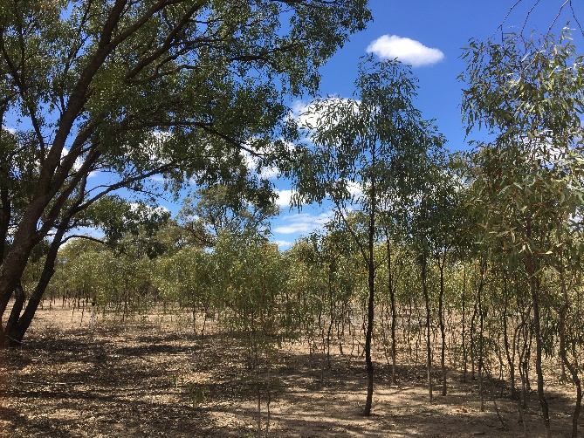

**Knowledge Gap:**

Will seedlings survive to become adults?



# Why apply environmental water?

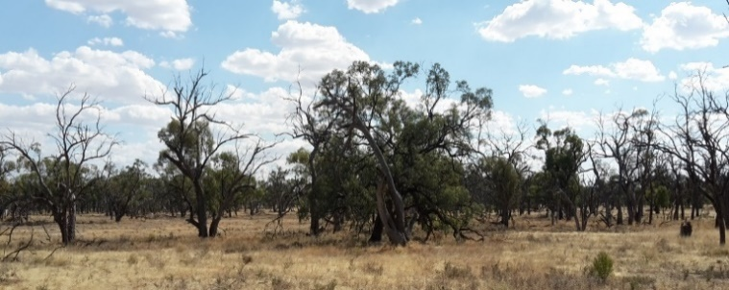Floodplain trees across the Murray-Darling Basin are declining in condition. Changed flooding regimes (frequency, duration, extent) due to water regulation and drought, is largely the cause of this decline. These populations are now often composed of unhealthy adults with limited recruitment (for example, few seedlings or saplings).

Unwatered poor condition Black Box woodland.

The Living Murray initiative is designed to improve the health of the Murray River and its floodplain through targeted environmental watering events (managed flooding). The Hattah Lakes Icon Site was selected to be part of the program due to its significant cultural, recreational, heritage and ecological values, including floodplain trees.

To effectively deliver environmental water, a clear understanding of how plants, animals and ecosystems respond to watering events is needed. Monitoring can provide this information and be used to refine future watering events and management actions.

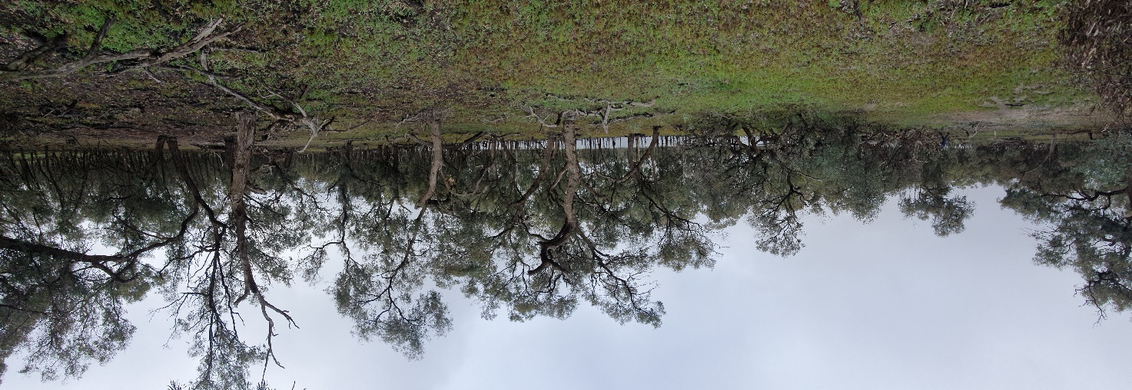

Watered good condition Black Box woodland.

# Lessons for managers

Land managers can be confident that environmental watering at the Hattah Lakes Icon Site can be used to produce improvements in Black Box tree condition, recruitment and population structure.

This research highlights the value and effectiveness of using environmental watering to improve floodplain tree condition. It provides an evidence-base on which land managers can reliably report management outcomes and refine future decision-making.

Watered good condition Black Box woodland with recruitment.

# Acknowledgements

This research program was funded by DELWP, the Joint Ventures Monitoring and Evaluation Committee through the Murray-Darling Basin Authority, and the Mallee Catchment Management Authority through The Living Murray initiative. The Living Murray is a joint initiative funded by the New South Wales, Victorian, South Australian, Australian Capital Territory and Commonwealth governments, coordinated by the Murray-Darling Basin Authority.

# Further information

For more information about this project, please contact [research.ari@delwp.vic.gov.au](mailto:research.ari@delwp.vic.gov.au)

**Report:** Moxham C., Kenny S. and Moloney P. (2019) Improving evaluation and reporting on woody vegetation condition outcomes, at regional and Basin scales: 2021 case study report: Victoria. Unpublished client report. Arthur Rylah Institute for Environmental Research, Department of Environment, Land, Water and Planning, Heidelberg, Victoria.

|  |
| --- |
| © The State of Victoria Department of Environment, Land, Water and Planning 2021Logo.  This work is licensed under a Creative Commons Attribution 4.0 International licence. To view a copy of this licence, visit http://creativecommons.org/licenses/by/4.0/  **ISBN** 978-1-76105-505-8 **(pdf/online/MS word)**  Citation: Moxham C., Kenny S. and Moloney P. (2021) Environmental water benefits Black Box. Environmental watering at Hattah Lakes Icon sites improves Black Box woodlands (recruitment and population structure). Fact Sheet. Arthur Rylah Institute for Environmental Research, Department of Environment, Land, Water and Planning, Heidelberg, Victoria. |