ARI Aquatic Quarterly Update – Influence Summer 2020-21

About Us
The Applied Aquatic Ecology section aims to generate and share knowledge, through world-class, applied, ecological research, which supports and guides sustainable ecosystem policy and management to ensure healthy, resilient ecosystems. We work collaboratively with national, state and local agencies, research institutes, universities, interest groups and the community.
Our focus:
- To undertake high quality, relevant ecological research.
- To interpret research outcomes and communicate these effectively to key stakeholders.
- To guide and support sustainable ecosystem policy and management.

This update provides three examples of projects which help managers.

They provide:
- a Carp estimate to help managers prioritise national and local control strategies, set appropriate objectives and track river recovery.
- evidence to support refinement and application of targeted restoration efforts including environmental flows, to help manage and conserve Silver Perch.
- evidence that environmental flows can stimulate the upstream movement of juvenile diadromous fish species; this management intervention can assist in population persistence and recovery through increased recruitment, distribution, and habitat use.

www.ari.vic.gov.au Subscribe to any of ARI’s communications at www.tiny.cc/ARIsubscribe

Carp estimates in Australia provide an invaluable tool for managers
Issue: Carp (Cyprinus carpio) are now the most abundant large freshwater fish in south east Australia, causing substantial social, environmental and economic impacts. Even at low abundances Carp can negatively impact water quality, aquatic plants, and native fish.
The National Carp Control Plan (NCCP) has undertaken a suite of projects regarding the assessment of the feasibility of using Cyprinid herpesvirus 3 (CyHV-3), a naturally occurring strain of Carp herpesvirus, as a biological control agent for this pest. These projects cover issues around potential use of carp biocontrol, ranging from virus epidemiology, to clean-up strategies and social dynamics. ARI contributed to the research that underpinned the NCCP by undertaking a five-state collaborative project with La Trobe University.
Action: This project used a cutting-edge model-based approach to estimate Carp density (number/ha) and biomass density (kg/ha) at river reach/waterbody, basin and continental scales. A spatial layer of rivers and waterbodies was built, aquatic habitats classified and the area of each throughout the range of Carp in Australia calculated. A national database of fishery-independent electrofishing catch-per-unit-effort (CPUE) for habitat types was developed, containing catch information for 574,145 Carp caught at 4831 sites over the last 20 years. Additional field experiments were also undertaken to establish relationships between relative and absolute abundances. Continental estimates were generated by scaling up site-based estimates to habitat types.
Results: This work estimated that across Australia there are 199.2 million Carp (and biomass of 205,774 tonnes) in an 'average' year and 357.5 million Carp (and biomass of 368,357 tonnes) in a 'wet' year. Up to 96% of Carp biomass occur on the east coast where they occupy over 54% of wetlands and 97% of large rivers.
Outcome: This work provides a first quantitative understanding of the location and magnitude of Carp populations across the Australian continent at a range of scales. These findings will help managers prioritise national and local Carp control strategies, set appropriate objectives and track river recovery. Modelling efforts continue, which will help to build our ability to predict Carp biomass over different hydrological scenarios.
Funder: Fisheries Research and Development Corporation (FRDC)
ARI contact: Ivor Stuart
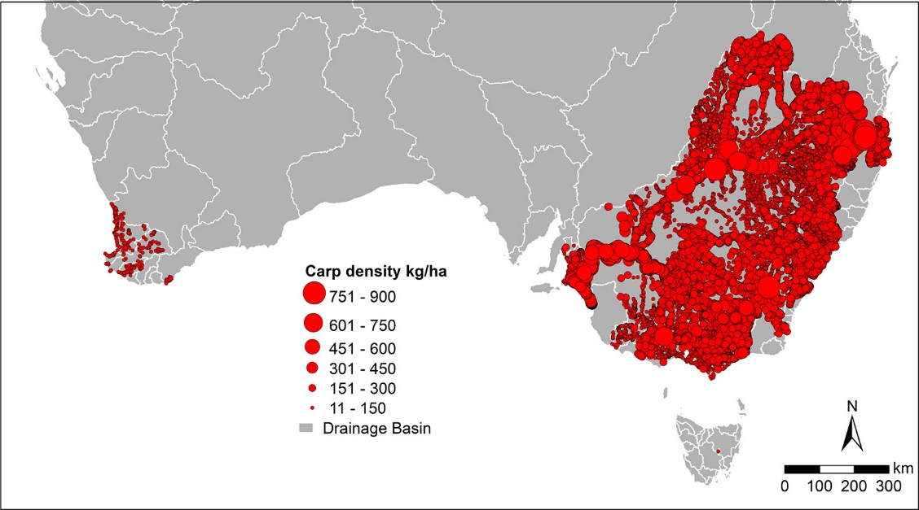
Stuart et al. (2021) Continental threat: How many common carp (Cyprinus carpio) are there in Australia? Biological Conservation 254.
Figure 1. Distribution and predicted density of Carp on the Australian continent

Insights into the movement of Silver Perch can help its recovery
Issue: The nationally threatened Silver Perch (Bidyanus bidyanus) is a native freshwater fish found in lowland reaches of the Murray–Darling Basin (MDB). The species has suffered substantial declines in abundance and range, particularly due to altered flow regimes, loss of long (i.e. >500 km) flowing river reaches and barriers to movement. Information on the movement ecology of Silver Perch is limited.
Action: A total of 203 Silver Perch (including juvenile, subadult and adult fish) in the Murray River were fitted with acoustic tags and their movement between habitats and river reaches monitored.
Results: Silver Perch occupied extended reaches of river (hundreds of kilometres) and multiple habitats throughout the river network, ranging from a large mainstem river to inflowing tributaries, anabranches and floodplain habitats. Movements were linked with aspects of the flow regime, such as small to moderate mainstem discharge rises and elevated tributary discharge. These results highlight the need to manage Silver Perch populations within an integrated riverscape context rather than only focusing on reach/river scales.
Outcome: The inter-relationship between Silver Perch movement and river discharge highlights the species’ ongoing susceptibility to river regulation. The improved understanding on the migratory behaviour of Silver Perch now provides evidence to support refinement and application of targeted restoration efforts including environmental flows, to help manage and conserve this threatened species. For example, providing flow conditions to achieve higher tributary discharge relative to the Murray River could contribute to population recovery in tributaries by promoting dispersal of Silver Perch into these habitats.
Funder: DELWP, Murray-Darling Basin Authority, Goulburn-Broken Catchment Management Authority and Victorian Environmental Water Holder
ARI contact: Wayne Koster
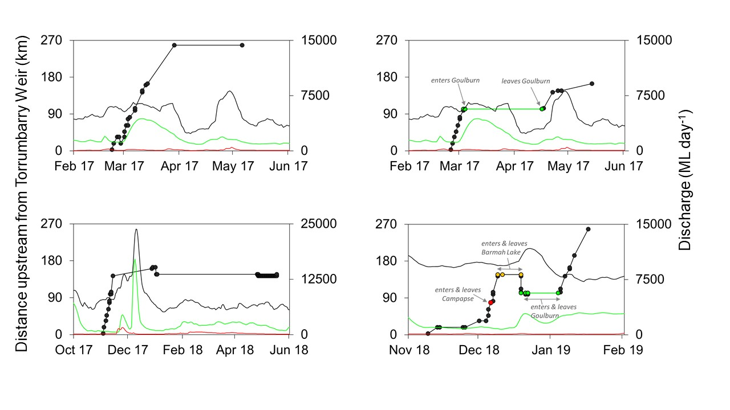
Koster et al. (2020). Environmental influences on migration patterns and pathways of a threatened potamodromous fish in a regulated lowland river network. Ecohydrology

Environmental flows enhance upstream movement of juvenile fish species
Figure 2. Examples of movement patterns of silver perch. Circles show detections of tagged fish on the listening stations in the Murray River (•), Campaspe River (•), Goulburn River (•) and Barmah Lake (•). Discharge also shown for Murray (−), Campaspe (−) and Goulburn (−) rivers
Issue: River regulation and instream barriers have been detrimental to fish communities and the effects can be pronounced for those species that migrate between fresh and salt water during their lifecycle (diadromous species). These species’ life history processes can depend on flow conditions, to provide cues for adult migration and spawning, attract recruits into coastal rivers and promote upstream dispersal. Environmental flows are used to mitigate the effects of river regulation and instream barriers, and an understanding their effectiveness is needed to improve management practices.

Action: This study examined the effects of targeted environmental flows on the upstream juvenile dispersal of three diadromous/catadromous* fish species; Common Galaxias (Galaxias maculatus), Tupong (Pseudaphritis urvillii) and Short-finned Eel (Anguilla australis). Fyke netting was used to capture juvenile fish moving upstream before and during environmental flows in summer and autumn in two coastal rivers (the Glenelg and Moorabool rivers).
Results: Significant increases in the catch of young-of-the-year (YOY) Common Galaxias (6-fold higher) and juvenile Short-finned Eel (26-fold higher) relative to control sites were recorded during environmental flow pulses compared with stable, regulated base-flow conditions. Although a significant result was not detected for Tupong, a 39% increase in movement was observed.
Outcome: These results demonstrate that environmental flows can stimulate the upstream movement of juvenile diadromous fish species to potentially promote population persistence and recovery through increased recruitment, distribution, and habitat use. An analysis of long-term fish monitoring data in the Glenelg River supports this link between environmental flows and population changes; the abundance of Tupong and Common Galaxias have both increased in response to increases in summer/early autumn environmental flow releases.
The findings provide managers with evidence of use of environmental flows to support fish populations. It is important to note that other limiting factors such as instream barriers and water availability can influence the effectiveness of environmental flows to benefit fish.

Funder: DELWP. This work was part of the Victorian Environmental Flows Monitoring and Assessment Program (VEFMAP)
ARI contact: Frank Amtstaetter Amtstaetter et al. (2021) Environmental flows stimulate the upstream movement of juvenile diadromous fishes. Marine and Freshwater Research.
* catadromous – fish migrating down rivers to the sea to spawn
Figure 3. Mean catches of young-of-the-year (YOY) Common Galaxias per 24-h fyke net set at each site in the Glenelg (impact) and Stokes (control) rivers before and during summer or early autumn environmental flows in the Glenelg River, 2017–19.

