Goulburn River 2021
Goulburn Broken region

This report card summarises the 2021 Native Fish Report Card (NFRC) survey in the Goulburn River
Sites 11, Electrofishing

Fish found in Goulburn River for NFRC
Target species
Golden Perch
Murray Cod
Silver Perch
Trout Cod

Non-target species captured since 2017*
Large-bodied native species
Bony Bream
River Blackfish

Small-bodied native species
Australian Smelt
Flatheaded Gudgeon
Carp Gudgeon sp.
Murray-Darling Rainbowfish
Unspecked Hardyhead

Exotic species
Common Carp
Eastern Gambusia
Goldfish
Oriental Weatherloach
Redfin

* These non-target species were incidentally captured during NFRC surveys since 2017 but not measured as for target species

LOGOS – ARI, DELWP

Goulburn River 2021
Fish Community

NFRC target species
The NFRC Program began in 2017, with a focus on targeting the monitoring of population dynamics of key iconic fish species that have high recreational and/or conservation values, in large rivers across Victoria. In the Goulburn River, the target species are Murray Cod, Golden Perch, Silver Perch and Trout Cod. Surveys occur in April/May each year, at 11 sites from just downstream of Lake Nagambie (Goulburn Weir) to upstream of the junction with the Murray River (River Bend Caravan Park - Sun Valley). The timing of the surveys coincides with reduced flows immediately following the irrigation season, when the target species are most easily captured. The equipment and habitats surveyed are focused on these species, which are measured to determine population structures. Other fish species that are incidentally captured are recorded, but not measured to determine their population structures.

Summary of key health indicators for target species in 2021
Species | Key Health Indicators
 | Recent recruitment | Multiple size classes | Mature fish present
Golden Perch | No | Yes | Yes
Murray Cod | Yes | Yes | Yes
Silver Perch | - | - | -
Trout Cod | Yes | Yes | Yes

Recent recruitment means young-of-year fish
*- cannot be determined due to low abundances

Both Silver Perch and Trout Cod were historically abundant in the lower and mid Goulburn River, with Silver Perch historically abundant up to the Nagambie area and Trout Cod present upstream of the Lake Eildon confluence. These species have experienced dramatic declines across their range. The status of both species has now improved, with Trout Cod now having a self-sustaining population downstream of Lake Nagambie and Silver Perch present, although in lower densities. Overall, the Goulburn River appears to be maintaining healthy populations of Golden Perch, Murray Cod and Trout Cod. The following pages have more detail about the population structures of each target species.

Non-target species
The non-target fish species that have been incidentally recorded in the Goulburn River during NFRC surveys since 2017 are:

Large-bodied native species
Other large-bodied native fish species recorded in fish surveys are Bony Bream and River Blackfish. Bony Bream are a lowland species only expected to be found in the lower Goulburn River. The species is recorded in lowland rivers across the Murray-Darling Basin and is intolerant of cold water. River Blackfish are a lowland species, generally found at altitudes below 200 metres. This species has suffered a decline in distribution and abundance across the State. It has low abundance in this section of the Goulburn River, but was captured in 2019 and 2020 during NFRC surveys.

Small-bodied native species
The small-bodied species Australian Smelt, Carp Gudgeon, Flatheaded Gudgeon and Unspecked Hardyhead are common and are expected to be widespread throughout the Goulburn River and more broadly within the Murray-Darling Basin. Murray-Darling Rainbowfish were historically present to 130 m altitude in the Goulburn River system. While once widespread in the Murray-Darling Basin, its range has become more restricted. The species now has a patchy distribution and is listed as threatened in Victoria.
Exotic fish species
Common Carp, Goldfish and Redfin are widely distributed across the Goulburn River, with Eastern Gambusia more common in the slower flowing waters. Oriental Weatherloach are increasing in distribution and abundance and are found in slower flowing areas, often in silt substrate. Weatherloach often disperse during floods.

Other native fish species known from the Goulburn River
Some fish species known to occur in the Goulburn system have never been recorded during NFRC surveys. For example, no Freshwater Catfish, Flatheaded Galaxias, Obscure Galaxias or Southern Pygmy Perch have been detected in the surveys. The two galaxiid species are hard to detect using the NFRC sampling method. Flatheaded Galaxias, Freshwater Catfish and Southern Pygmy Perch are common in offstream habitats such as billabongs, wetlands and lagoons within the Goulburn system. As the section surveyed is downstream of the cooler trout waters, it is not unexpected that trout have not been detected in the NFRC surveys.
Other notable species
NFRC surveys have also recorded Murray Crayfish, Yabbies and Turtle species.

Environmental and Management Context

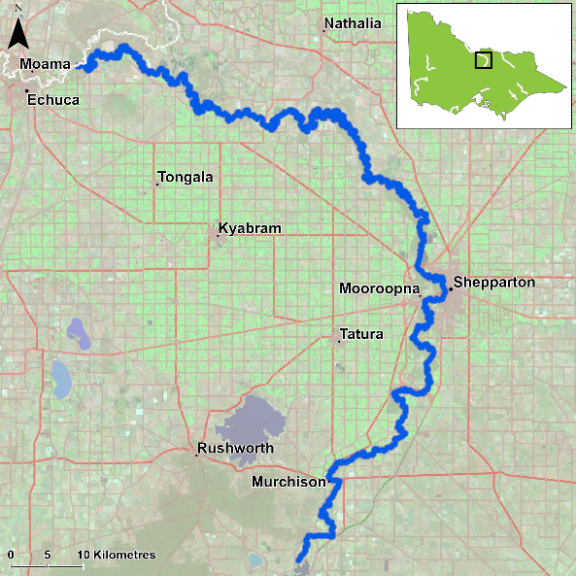
Figure 1. Map showing the section of Goulburn River where NFRC sampling occurs

Environment
Stream flow was marginally higher in 2018, 2020 and 2021 compared to 2017 and 2019, due to water management (i.e. Inter Valley Transfers) and this may have decreased electrofishing efficiency in those three years. During 2020 and 2021 surveys there was elevated turbidity following earlier flooding, which also further decreased electrofishing efficiency for all species.

River rehabilitation efforts in the Goulburn River
Many rehabilitation actions have occurred, and are underway, to improve the health of the Goulburn River and its fish community. These include revegetation, weed control and fencing of riparian areas, reintroduction of instream woody habitat, allocations of water for the environment and fish stockings. Regular monitoring of the fish community has occurred for over 10 years. Current research and monitoring programs include the Victorian Environmental Flows Monitoring and Assessment Program (VEFMAP) and Flow-MER (fish theme). Recent work has focused on the role of flows for spawning of Golden Perch and Silver Perch using drift net surveys, as well as links between flows and movements of these species using telemetry techniques. The Goulburn-Broken Catchment Management Authority, DELWP, and VFA support rehabilitation and management of the Goulburn River and its fish community.
The NFRC program, and related monitoring initiatives, provide improved understanding of the structure of fish communities and how rivers can be best managed.
PHOTOS
LOGOS – ARI, DELWP, NFRC
Golden Perch

Goulburn River, Goulburn Broken region

Key Health Indicators
Recent recruitment No
Multiple size classes Yes
Mature fish present Yes

Monitoring Results
Total number of fish caught 40
Fish per 1km of waterway 2.77
Largest fish by length (cm) 51.9
Largest fish by weight (kg) 2.14
% of the catch that is legal size 77.5

The abundance of Golden Perch (Macquaria ambigua) was consistent from 2017 to 2019, but slightly lower in 2020 and 2021. This was likely owing, at least partly, to high flows and associated high turbidity reducing the likelihood of capturing fish in 2020 and 2021. A large proportion of Golden Perch collected are adults (87% over the five-year sampling period) (Figure 2). Recruits of this species are difficult to catch using the NFRC survey method and none have been detected in all five years of sampling (Figure 2; Figure 3). It is worth noting that other surveys have shown that Golden Perch recruitment is low or often zero in the Goulburn River, with only 17% spawned locally¹. This indicates that natural immigration of adults as well as stocking is maintaining the Golden Perch population within the Goulburn River. Fish surveys from 2014 to 2016, just prior to initial NFRC surveys, showed that over 60 % of Golden Perch were stocked and 20% were migrants into the system¹.

Stocking
Fifty-thousand Golden Perch were stocked in 2016; 44,000 in late 2017; 59,000 in early 2018; 89,950 in 2019; 61,000 in 2020; and 115,000 in early 2021 (including 60,000 in January and 55,000 in late April). These fish were released downstream of Lake Nagambie (where NFRC surveys occur).
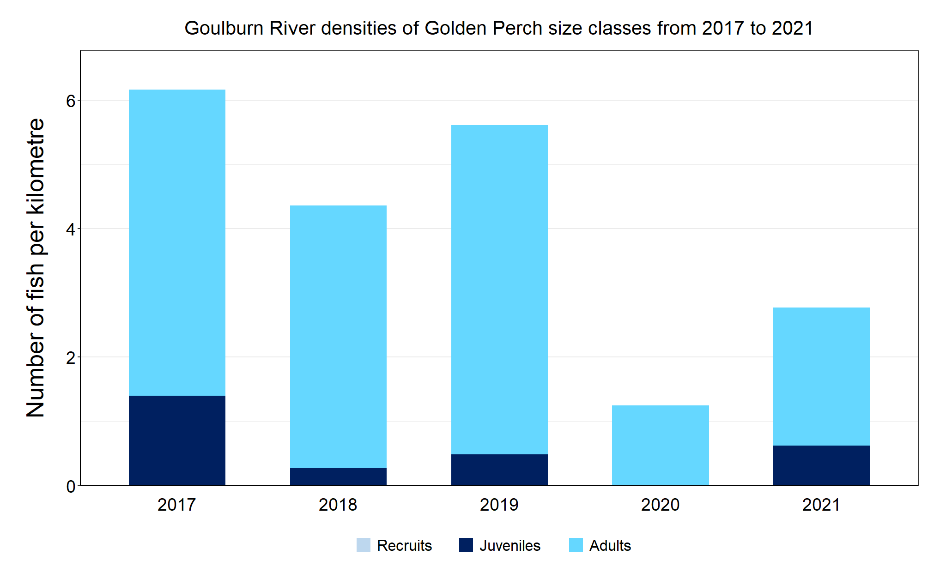
Figure 2. The densities of recruits, juveniles and adult Golden Perch for NFRC surveys in the Goulburn River from 2017 to 2021

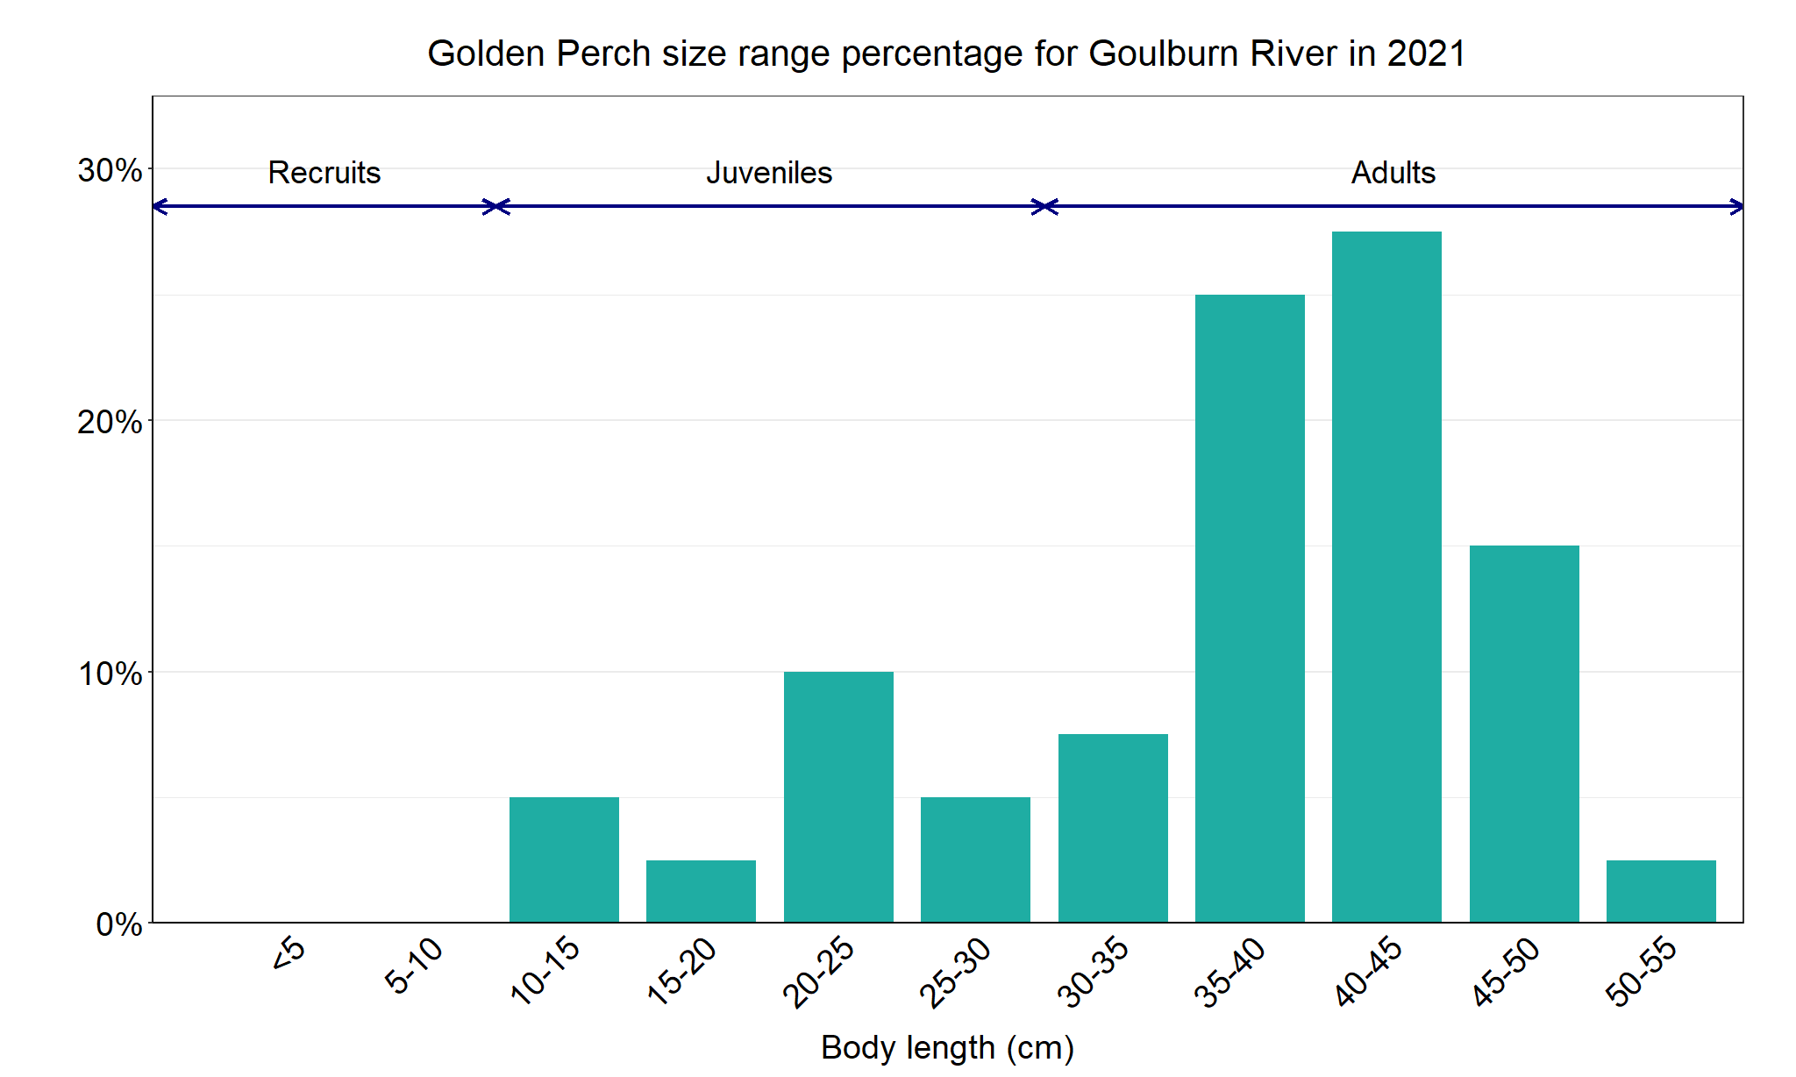
Figure 3. The size range percentage of Golden Perch measured from the Goulburn River during NFRC surveys in 2021.

1. Tonkin, Z., Kitchingman, A., Ingram, B., Lieschke, J., Koster, W., Lyon, J., Lutz, M. and Pavlova, A. (2019). Smarter stocking: a synthesis of existing data to assess native fish stocking success in Victorian rivers. Unpublished Client Report for the Victorian Fisheries Authority. Arthur Rylah Institute for Environmental Research, Department of Environment, Land, Water and Planning, Heidelberg, Victoria.

Murray Cod

Goulburn River, Goulburn Broken region

Key Health Indicators
Recent recruitment Yes
Multiple size classes Yes
Mature fish present Yes

Monitoring Results
Total number of fish caught 64
Fish per 1km of waterway 4.43
Largest fish by length (cm) 99.0
Largest fish by weight (kg) 14.5
% of the catch that is legal size 9.4

Fewer Murray Cod (Maccullochella peelii) were captured in 2020 and 2021 with captures marginally higher in 2018 compared to 2017 and 2019 (Figure 4). The lower abundances correlate with higher flows and associated high turbidity reducing the likelihood of capturing fish, particularly in 2020 and 2021. Multiple size classes including mature and young-of-year fish were caught in all five years. There were however small numbers of legal-size fish, which may indicate high fishing pressure (Figure 4; Figure 5). A large proportion of Murray Cod in the Goulburn River are from wild spawnings. An otolith* study showed that Murray Cod from year classes 2016/17 and 2017/18 were all assigned as wild spawned, with fish from the 2018/19 year class still dominated by wild spawned individuals (65%)². Similarly, Murray Cod collected from the Goulburn River for the Long-Term Intervention Monitoring (LTIM) project (otoliths collected in 2016 and 2017) showed most were wild fish (ARI, unpublished data). This indicates that stocked Murray Cod are making a very small contribution to the Murray Cod population in the Goulburn River.

Stocking
In 2016, 54,000 Murray Cod were stocked; 102,000 in early 2017; 50,000 in late 2017; 40,000 in 2018; 21,000 in 2019; 96,000 in 2020 and 17,000 in January 2021. These stockings occurred below Lake Nagambie (where NFRC surveys occur).

*Otoliths are fish earbones

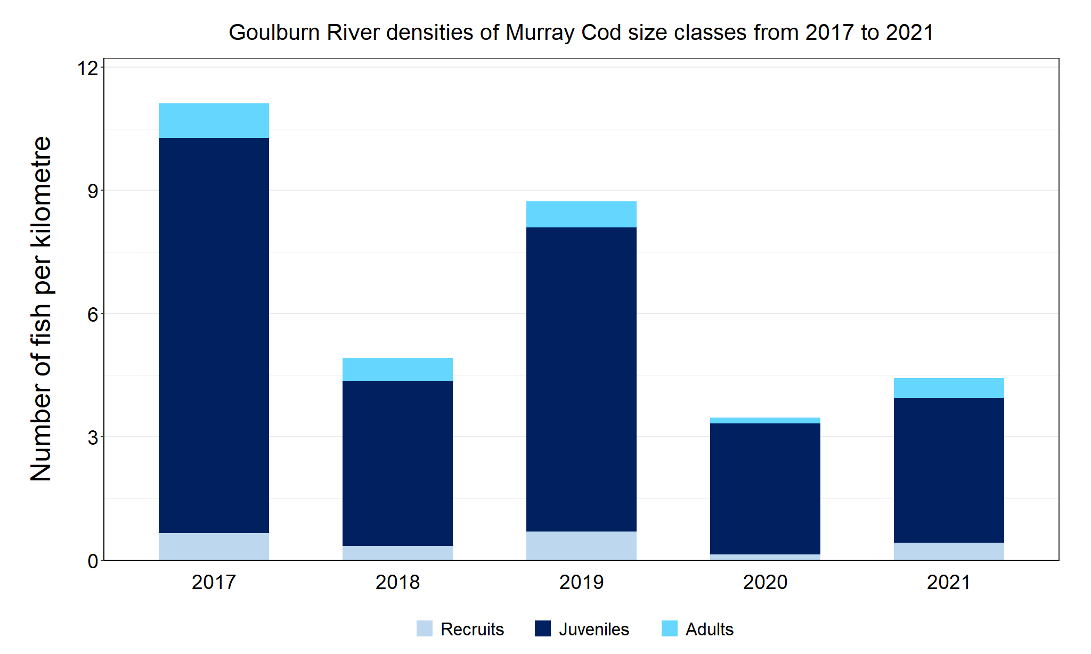
Figure 4. The densities of recruits, juveniles and adult Murray Cod in the Goulburn River from 2017 to 2021.
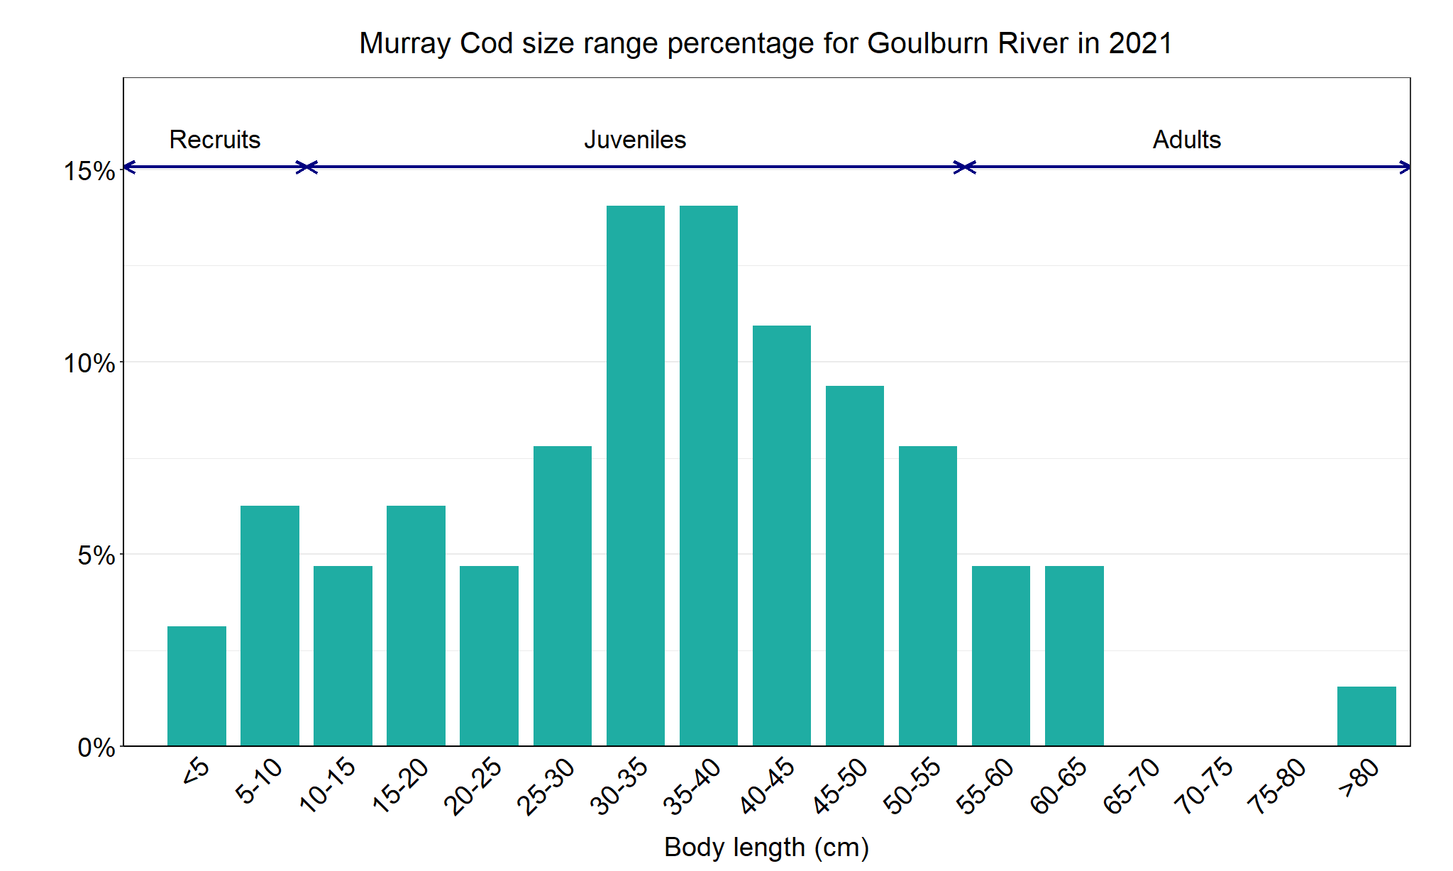
Figure 5. The size range percentage of Murray Cod in the Goulburn River in 2021.

2. Harris, A., Tonkin, Z., Moloney, P., and Woodhead, J. (2020). Using Otolith Microchemistry to Assign Natal Origin to Juvenile Murray Cod. Unpublished Client Report for Water and Catchments, Department of Environment, Land, Water and Planning. Arthur Rylah Institute for Environmental Research, Department of Environment, Land, Water and Planning, Heidelberg, Victoria.

Silver Perch

Goulburn River, Goulburn Broken region

Key Health Indicators
Recent recruitment Cannot be determined
Multiple size classes Cannot be determined
Mature fish present Cannot be determined

Monitoring Results
Total number of fish caught 2
Fish per 1km of waterway 0.14
Largest fish by length (cm) 38.5
Largest fish by weight (kg) 0.79
% of the catch that is legal size NA

The natural range of Silver Perch (Bidyanus bidyanus) includes most of the Murray-Darling Basin, excluding the cool, higher altitude upper reaches of streams. Within the Goulburn River, Silver Perch were historically abundant to the Nagambie area. Cold water pollution, river regulation and barriers are all factors that have impacted Silver Perch populations, and all of these are relevant to the Goulburn River. The NFRC does not expect to capture enough Silver Perch to measure key health indictors. However, by collecting data for non-recreational species including threatened species such as Silver Perch, it will allow a greater understanding of the current status of the populations providing essential information to the management on these species. Low abundances of Silver Perch have been detected in all five years (Figure 6). The Silver Perch detected are mainly adults with only adults collected in 2021 (Figure 7). Recruits of this species are difficult to catch using the sampling method used by NFRC and none have been detected in all five years of sampling. Silver Perch recruitment is low or often zero in the Goulburn River, with 90% of the population classified as migrants (ARI, unpublished data).

Stocking
No stocking has occurred.
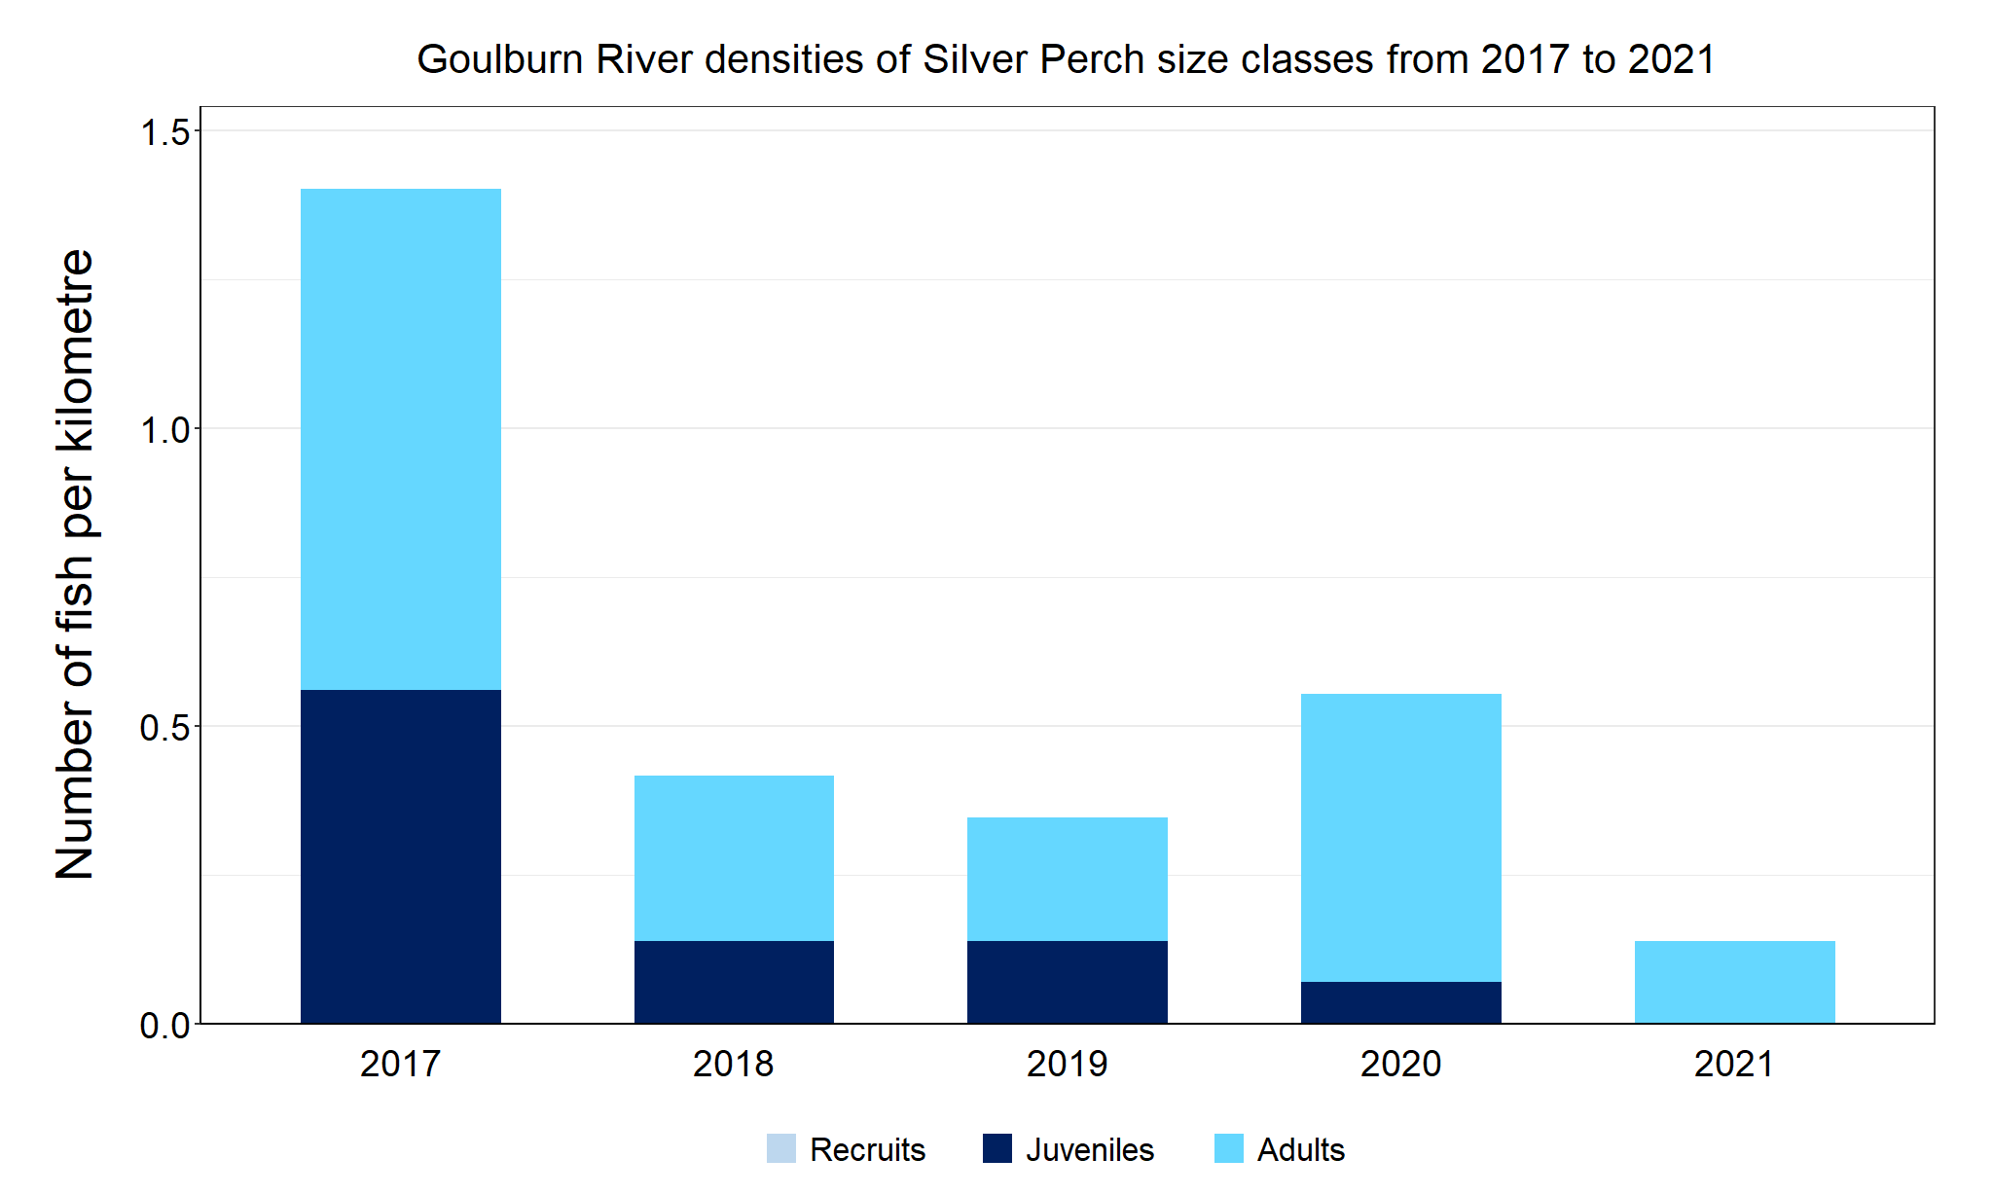
Figure 6. The densities of recruits, juveniles and adult Silver Perch in the Goulburn River from 2017 to 2021.

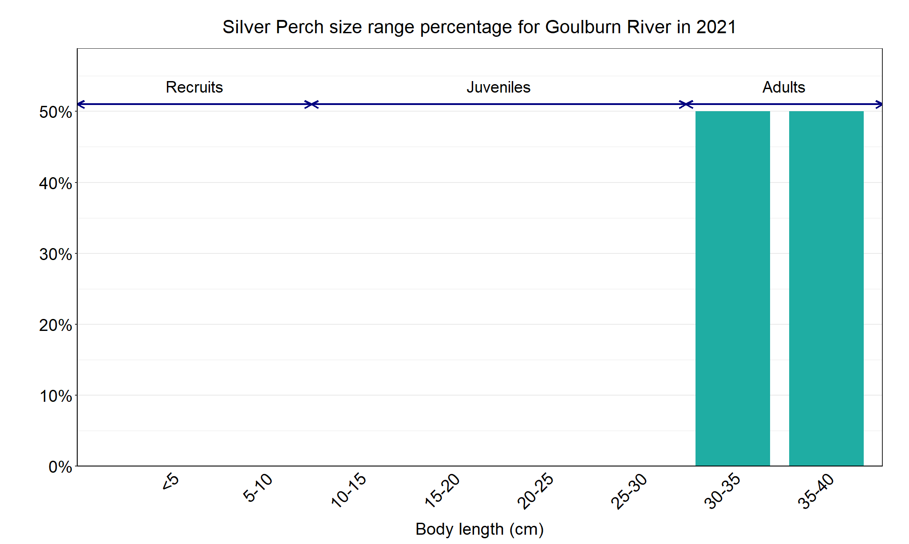
Figure 7. The size range percentage of Silver Perch in the Goulburn River in 2021.

Trout Cod

Goulburn River, Goulburn Broken region

Key Health Indicators
Recent recruitment Yes
Multiple size classes Yes
Mature fish present Yes

Monitoring Results
Total number of fish caught 19
Fish per 1km of waterway 1.32
Largest fish by length (cm) 36.5
Largest fish by weight (kg) 0.53
% of the catch that is legal size NA

The abundance of Trout Cod (Maccullochella macquariensis) has been low downstream of Lake Nagambie for 20 plus years compared to historical abundances. The abundances of Trout Cod recorded by NFRC in 2018, 2020 and 2021 were lower compared to 2017 and 2019. This was likely owing, at least partly, to high flows and associated high turbidity reducing the likelihood of capturing fish, particularly in 2020 and 2021. Multiple size classes of fish including young-of-year/1+ old fish and mature fish were caught in 2021 (Figure 8) with these size classes captured in all five years of NFRC sampling (Figure 9). This indicates that Trout Cod persistence is high in this section of Goulburn River. However, very few Trout Cod have been caught downstream of Shepparton, indicating a restricted distribution between Shepparton and Lake Nagambie. This is consistent with other research, including the Long-Term Intervention Monitoring program.

Stocking
There has been no stocking below Lake Nagambie (where NFRC surveys occur) since 1997. Between 1993 and 1997, a total of 58,500 fish were stocked below Lake Nagambie.

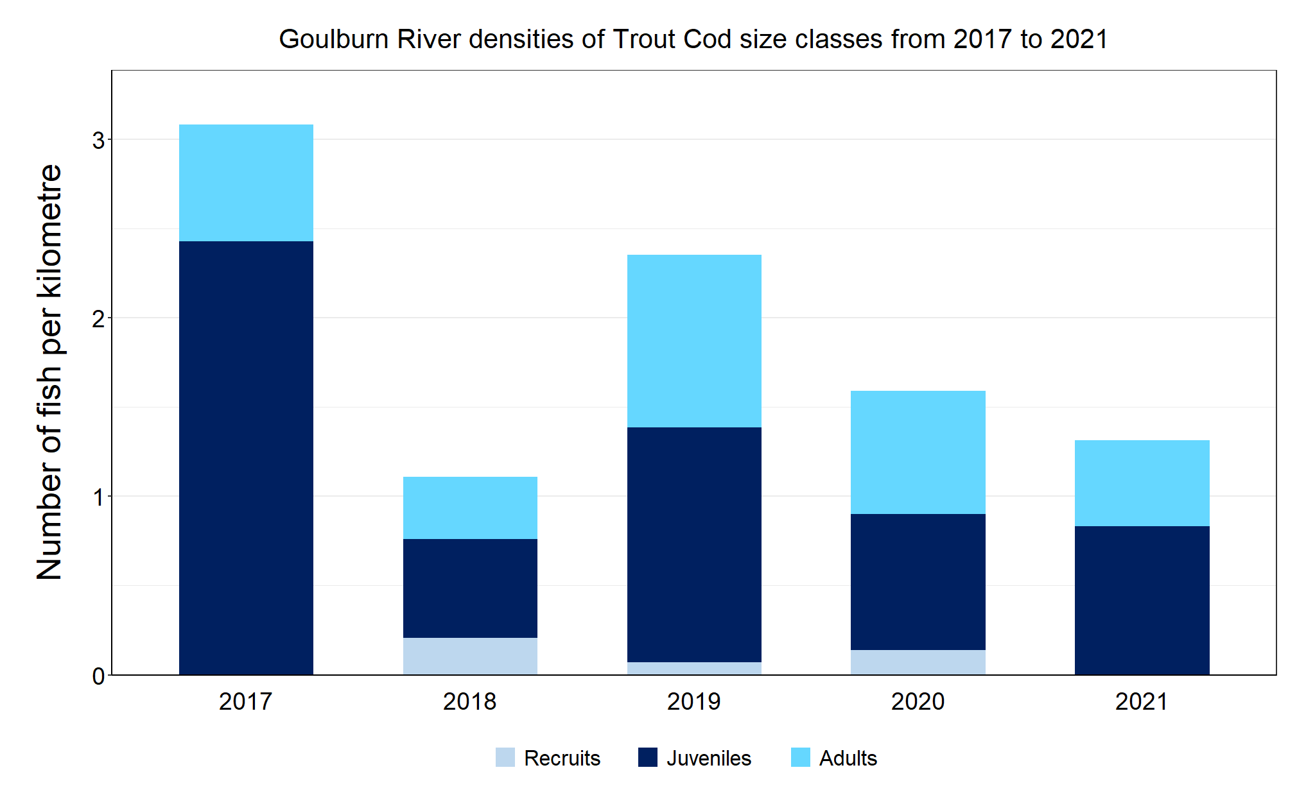
Figure 8. The densities of recruits, juveniles and adult Trout Cod in the Goulburn River from 2017 to 2021.

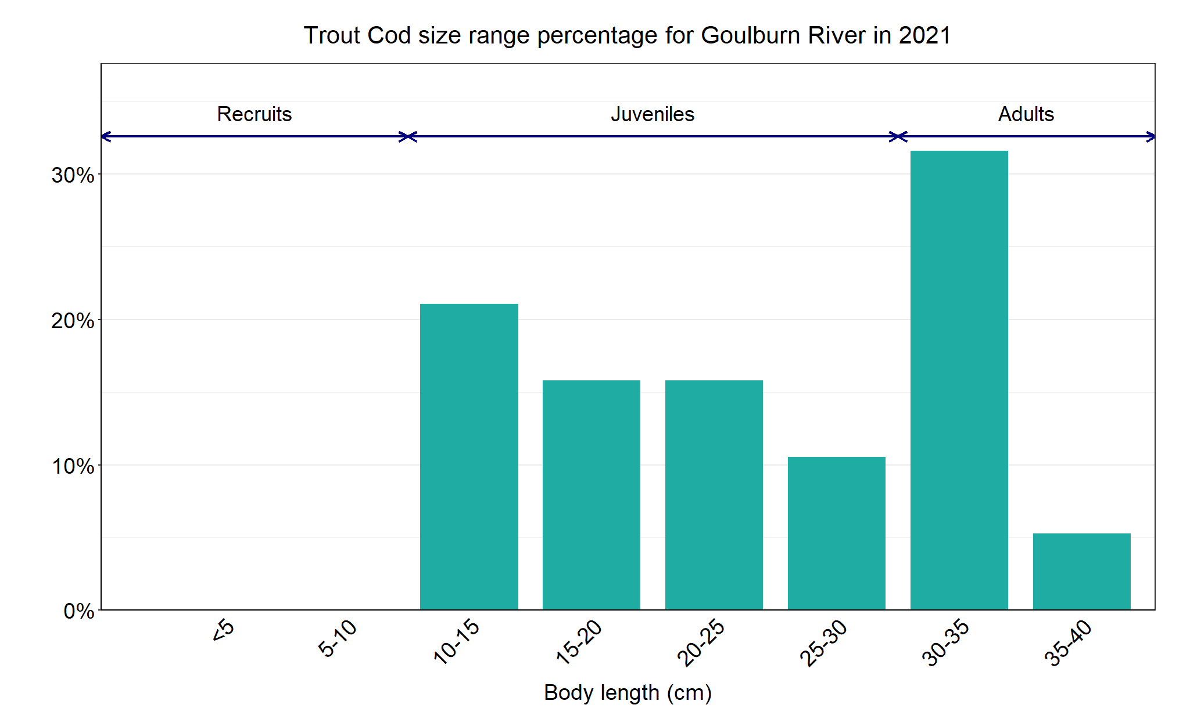
Figure 9. The size range percentage of Trout Cod in the Goulburn River in 2021.

