# Comparison of pre- and post-construction survey results for birds and bats at Victorian wind energy facilities

Do pre-construction risk assessments predict post-construction mortalities?

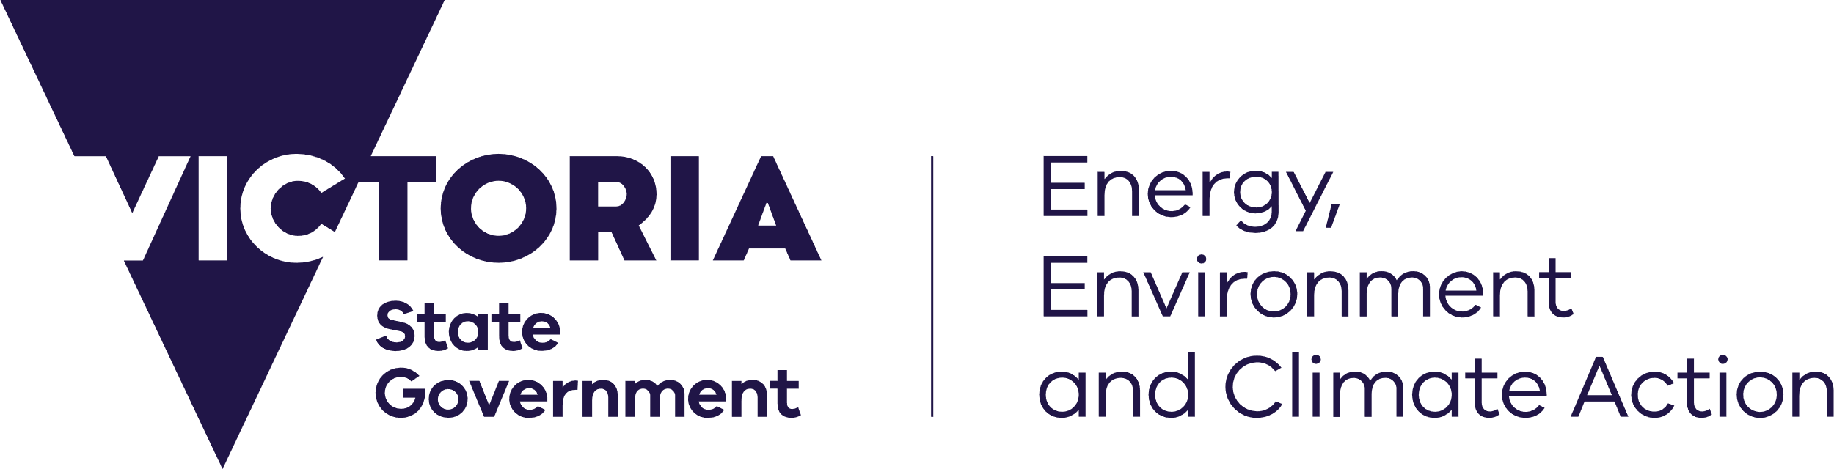



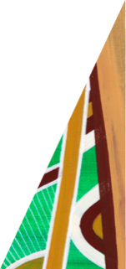

## Overview

* Extensive surveys for bats and birds have been undertaken pre-construction at Victorian wind energy facilities. However, these data have not been compared with corresponding post-construction mortality estimates to assess how effectively the pre-construction surveys predict collision risk. Even internationally, these comparisons are rarely conducted.
* This study aimed to compare pre-construction survey and assessment results with post-construction mortality estimates at Victorian wind energy facilities to inform guidelines aimed at improving these assessments.
* Pre-construction assessment reports were difficult to access and collate for analysis, and this limited the number of wind energy facilities that could be included in this study. A central repository for reports and associated data, with standardised formatting, would help address this problem.
* Pre-construction survey effort for bats and birds varied markedly between wind energy facilities, and the results and assessments were presented in different ways. Guidelines outlining best-practice approaches to surveys and risk assessments, the survey effort required, and how the data should be presented (including standard metrics), would facilitate greater consistency between assessments, and enable comparisons to be made between sites.
* The species predicted to occur at proposed sites, based either on surveys or distribution maps, identified many of the non-threatened species subsequently found in post-construction mortality monitoring, but were less accurate in predicting the likely occurrence of threatened species (e.g. Grey-headed Flying-fox, White-throated Needletail).
* Wind energy facility pre-construction risk assessments included in this study lacked consistency and clarity. Most wind energy facilities did not use a formal risk evaluation matrix model factoring in the likelihood of collisions with turbine blades and the consequences of this impact. In the absence of a risk evaluation matrix, wind energy facilities described risk assessment outcomes in the body of the report, often in multiple places and using vague and inconsistent terminology, and it was often unclear how the level of risk had been determined.
* The relationship between pre-construction survey results and assessed risk was often unclear, with almost all assessments stating that risk was ‘low’ or ‘minimal’.
* Mortalities of the Critically Endangered Southern Bent-wing Bat were recorded at three wind energy facilities included in this study. An examination of the pre-construction survey effort undertaken at these sites suggests that neither the ground-based or ‘at height’ surveys that were conducted were adequate for predicting collision risk for this species.
* The findings of this study suggest that there is currently not a clear relationship between pre-construction surveys and risk assessments, and post-construction mortality risk. Comprehensive, detailed guidance is required to improve the consistency and rigour of pre-construction assessments, as well as further investigations of approaches for more accurately predicting the risk of collisions.
* The implication of it being difficult to predict risk up-front highlights the importance of undertaking rigorous post-construction mortality monitoring, over a sufficient period of time, to fully understand the magnitude of collision impacts.

May 2025

deeca.vic.gov.au

## Background

The approval process for proposed wind energy facilities includes fauna assessments to evaluate the potential impacts of collisions with wind turbines. However, the relationship between the impacts predicted based on pre-construction assessments and the mortalities of bats and birds recorded after construction has not been thoroughly investigated in Victoria. This information has important implications for determining how pre-construction assessments should be undertaken, especially for Species of Concern, which are threatened species at risk of population-level impacts from turbine collisions in Victoria (DEECA 2024).

Pre-construction utilisation surveys for birds usually consist of observations made on-site using point count surveys, while for insectivorous bats, acoustic detectors are used to record bat echolocation calls to document species presence and relative activity.

## Aims

This study aimed to:

1. Investigate if pre- and post-construction data available from operating wind energy facilities in Victoria is suitable for rigorous quantitative analysis.
2. Compare pre-construction bat survey and bird utilisation data and assessments with subsequent mortality rates at wind energy facilities, based on:

* the species identified as likely to occur in the area
* the level of activity recorded compared to estimates of annual mortality rates
* the level of risk identified in risk assessments, and approaches used to assess this risk.

1. Identify areas for improvement in pre-construction bird and bat surveys and risk assessments, and areas for further investigation.

## Methods

### Data collation

This study initially aimed to collate data from the pre-construction assessments for 23 wind energy facilities for which post-construction mortality estimates were concurrently being calculated. Ideally, all of the data from wind energy facilities on which the risk assessments were based would have been available in spreadsheets or databases, to enable efficient, quantitative comparisons with the mortality estimates. However, DEECA does not hold this data, and so the information had to be extracted from consultants’ assessment reports, many of which were difficult to access or were not available. Within the time available, it was only possible to collate the pre-construction data for 10 of the 23 wind energy facilities with post-construction data.

The consultants’ reports were mostly available as pdf documents, which were often password protected (preventing tables of data from being copied), making the transcription, collation and summarising of data time consuming. In addition, information was often difficult to find within the reports, with data being presented in different ways, described in the text in multiple sections, and using different metrics or approaches.

## Results

### Survey effort

Pre-construction survey effort varied markedly between wind energy facilities. Formal bird utilisation surveys were undertaken at eight of the 10 examined facilities, with these surveys varying considerably with respect to the number of days, seasons and years surveyed, the number of sites, and the number of times sites were surveyed per season. The remaining two wind energy facilities only undertook informal bird observations across the site. Excluding Brolga (for which targeted surveys are usually undertaken), collision risk modelling was not conducted at any of the 10 facilities, and only one facility included counts of the number of flights of diurnal birds on a per-species basis during surveys, which is the metric required for collision risk modelling.

Similarly for bats, survey effort was highly variable making it difficult to find consistent metrics to compare to the post-construction data. For example, the number of detector nights (number of sites × nights) ranged from 2–406 per season. In summary, there was variation in bat survey effort in:

* the number of sites surveyed (as a proportion of the number of proposed turbines)
* how often they were surveyed, and the number of nights sampled within a sampling period
* which seasons were surveyed
* the number of years over which sites were surveyed
* the number of sites that were situated within areas characterised in the reports as ‘non-turbine’ sites (e.g. treed areas, or areas near waterbodies) and how these data were presented
* how the echolocation calls were analysed and species complexes considered, and
* how the data were presented, i.e. sometimes this was aggregated over space and time while sometimes it was presented separately for each survey.

Half of the wind energy facilities included monitoring at height, by attaching bat detectors to meteorological masts, as well as at ground level. These surveys were undertaken at fewer sites within the facility boundary and usually over fewer nights, resulting in lower overall survey effort.

For a number of the wind energy facilities included in this study, some of the pre-construction surveys were undertaken years ago, for example in the mid-2000s, many years before the turbines were installed. Since this time there have been significant changes in technology (especially for bats), survey approaches, and expected survey effort. This has contributed to the variability in the quality and quantity of data available, and its applicability for predicting post-construction risk many years later.

### Pre-construction assessments compared to post-construction mortality

Due to the limitations of the data and how it was presented, it was not possible to undertake detailed analyses comparing pre-construction activity levels and post-construction mortality rates as the project had originally intended. At a more basic level, however, it was possible to consider the species that were identified in post-construction mortality monitoring and determine whether those species were identified as occurring on-site pre-construction, and whether a risk assessment had been undertaken.

The species recorded as occurring on-site from the surveys, or were predicted to occur based on distribution maps, identified many of the non-threatened species subsequently found in mortality monitoring. However, these were less accurate in predicting the likely occurrence of threatened species, including Species of Concern. For example, the Grey-headed Flying-fox was not identified as likely to occur on the site during the pre-construction assessments at any of the three wind energy facilities where mortalities have subsequently been recorded. Similarly, the White-throated Needletail and Black Falcon were not identified as potentially occurring at some facilities where mortalities have since occurred. This may have been due to insufficient survey effort to detect rare species (e.g. Black Falcon), insufficient surveys at the right time of the year for migratory species (e.g. White-throated Needletail), changes in species distributions between the initial surveys and turbine construction, or a lack of surveys being conducted at night (e.g. Grey-headed Flying-fox).

Knowledge of the ecology, habitat requirements and movement patterns of species may also have been limited at the time of the surveys and risk assessments. For example, at one wind energy facility no bat surveys were undertaken during the pre-construction phase ‘as no suitable habitat for bats were recognised’. However, this prediction has not been borne out in the post-construction monitoring, with mortality estimates at this facility revealing that 12.7 bats are being killed per turbine per year. This estimate, which is higher than the average across all the 23 wind energy facilities assessed, equates to almost 300 bats being killed each year, or approximately 1,400 mortalities since this facility commenced operating. It is therefore clear that bats are using this site.

While it was not possible to quantifiably compare pre- and post-construction data for most species, a case study for the Southern Bent-wing Bat is presented below, where data was more readily extractable. This reveals that the pre-construction surveys undertaken at these sites were not effective in predicting the post-construction mortality rates for this Species of Concern.

### Risk assessments

Few wind energy facilities presented risk assessments that included a clearly defined process. Two wind energy facilities used a risk evaluation matrix model based on the likelihood of collisions with turbine blades and the consequences should this occur. In the absence of a risk evaluation matrix, risk assessment outcomes were described in the body of the reports, often in multiple places and using vague and internally inconsistent wording. The risk rating applied to a species was often unclear as it was not specified or defined. This made it difficult to summarise and compare across wind energy facilities. The vast majority of species were assessed to be at ‘low risk’ of impacts. The relationship between pre-construction survey results and risk assessments was often unclear.

Of the species found during post-construction mortality monitoring at the facilities, 0–5 had been assessed for risk during the pre-construction phase, including both threatened and non-threatened species. The Critically Endangered Southern Bent-wing Bat and the non-threatened Wedge-tailed Eagle were species commonly assessed for risk.

For birds, four Species of Concern were reported as mortalities at these facilities. Black Falcons were not included on the pre-construction lists or risk assessments of the facilities with subsequent mortalities. Brolga were detected during surveys and assessed for risk. Little Eagles were recorded during pre-construction surveys, but not specifically included in risk assessments, except for a general assessment of ‘raptors’, which were assessed to be ‘moderate’ risk of collision, with impacts at the population level ‘unlikely’ due to them being ‘widespread and common’. White-throated Needletails were not detected during pre-construction surveys, and the species was identified as being at low risk of collision at one facility, with the assessment that ‘the loss of a small number of individuals each year is unlikely to have a significant impact on the species or contribute to the species continuing decline’. The second facility that recorded White-throated Needletail mortality did not identify the species in pre-construction lists or undertake a risk assessment for the species.

## Case study: Southern Bent-wing Bat

Mortalities of the Critically Endangered Southern Bent-wing Bat *Miniopterus orianae bassanii* have been recorded at three of the 10 wind energy facilities included in this study. At two of these facilities, the species had been identified as occurring on the site in pre-construction surveys (Table 1). At the third facility, the Southern Bent-wing Bat was only identified in three calls as part of a ‘species-complex’. Calls are sometimes assigned to a species-complex due to overlapping call characteristics with other species. The Southern Bent-wing Bat (or species-complex) was not detected within the proposed rotor swept height at any of the three facilities during their pre-construction surveys. However, given that there have been mortalities at these sites, individuals must be flying within the rotor swept area of turbines at times, suggesting that these surveys were inadequate to detect the species at these heights. Detector surveys undertaken at height often contain interference from noise due to the windy conditions, and this was identified as a limitation in one of the assessments.

The relationship between Southern Bent-wing Bat pre-construction survey results and post-construction mortality is unclear, and suggests that a precautionary approach to assessments is likely required for this species. The sites with the highest estimated annual mortalities post-construction were the ones with the fewest detections in pre-construction assessments (Table 1). Low survey effort was undertaken at one of these sites, suggesting that greater survey effort may be needed to inform impact assessments. However, it was unclear in many of the assessments in this study whether a higher number of detections would have had any bearing on the assessed risk classification, and if so, at what level a higher risk rating would have been applied. In addition, based on knowledge from other studies of the species’ abundance and movements patterns in this area, the number of Southern Bent-wing Bat calls identified at these facilities during the pre-construction assessments is likely to have been significantly underestimated, with a much higher number of calls expected to have been recorded.

Table 1: Comparisons of pre-construction survey and risk assessment results, and post-construction mortality estimates, for the Southern Bent-wing Bat at three Victorian wind energy facilities (based on the data available in 2024). SBWB = Southern Bent-wing Bat, GL = ground level, Detector nights = sites × nights surveyed, RSH = rotor swept height above the ground. Note that the number of detector nights undertaken at height has not been included in the table as this detail was unclear in the reports. Annual post-construction mortality is an estimate of the number of individual Southern Bent-wing Bats likely killed per year (with 95%CI), factoring in survey effort, persistence rates, searcher efficiency, and the number of turbines. ‘Mortality estimates since construction’ factors in the number of years that the wind energy facility has been operating, assuming this estimate is an average representation across all years.

| Wind energy facility | SBWB calls (GL) | Species-complex calls (GL) | Detector nights (GL) | Heights surveyed | SBWB calls detected at height | Assigned risk pre-construction | Annual post-construction mortality across the facility (95%CI) | Mortality estimates since construction (95%CI) |
| --- | --- | --- | --- | --- | --- | --- | --- | --- |
| 1 | 21 | 111 | 676 | 25m, 50m | Six species-complex calls at 25m (below RSH) | Moderate | 7.8 (7.0–8.6) | 23.3 (21.1–25.8) |
| 2 | 9 | 21 | 935 | 45m | 0 | Likely to be minimal | 37.1  (32.3–43.1) | 445.6 (387.5–517.6) |
| 3 | 0 | 3 | 10 | 50m | 0 | Likely to be minimal | 11.5 (7.8–17.0) | 68.7 (46.8–102.1) |

## 

**Southern Bent-wing Bat**. Photo: Lindy Lumsden

## Conclusions and recommendations

* Pre-construction bat activity and bird utilisation data were unable to be quantitatively analysed against post-construction mortality rates in this study. This was due to the data not being readily available, and the considerable variability in the survey methods, the amount of survey effort undertaken, and how it was reported.
* It is recommended that consideration is given to how pre-construction assessment reports are obtained and managed by DEECA, so they are more readily accessible (e.g. a central repository with a standard file structure). The raw data used in these reports should also be submitted to DEECA, and stored in a standardised way, to better inform future analyses.
* Comprehensive guidelines for bat and bird pre-construction surveys and assessments would ensure greater consistency between wind energy facilities and enable comparisons to be made between sites. This includes guidance on how the surveys should be undertaken, the level of survey effort required, how the information should be reported and supplied (e.g. using standard metrics), and a clear process for risk assessments using defined risk ratings.
* No collision risk models, or population viability analyses were conducted for the wind energy facilities included in this study. Where there is sufficient data, and the models are rigorously constructed, these can be useful tools for assessing risk.
* A case study of assessments for the Southern Bent-wing Bat suggests that a precautionary approach to assessments is required, including considering species-complex calls and assuming that some Southern Bent-wing Bats fly at rotor swept height, even if they have not been detected during at height surveys.
* The apparent inability to adequately predict mortalities up-front highlights the importance of robust post-construction mortality monitoring (i.e. ensuring that it is conducted thoroughly, and over a sufficient number of years) to fully understand risk. For example, at one of the facilities where mortalities of Southern Bent-wing Bats are currently being recorded, the risk was considered low based on the pre-construction survey effort, and no Southern Bent-wing Bats were found during the first three years of post-construction mortality monitoring. However, carcasses have been found each year in the subsequent three years of monitoring. Had the post-construction mortality monitoring ended after two or three years (as is the standard for many facilities), the current mortalities of Southern Bent-wing Bats at this site would be going undetected.
* There are three components influencing the finding of no clear relationship between pre- and post-construction assessments in this study, each with different potential solutions.
  + Firstly, the data were not readily available or accessible, limiting the number of potential comparisons that could be made. A centralised repository of the reports and their underlying data is needed to resolve this issue.
  + Secondly, the data that were available were highly variable with respect to quantity, quality and adequacy. This could be resolved by the release, and adherence to, comprehensive, detailed guidelines.
  + Thirdly, even if adequate, well-documented and accessible data were available, there may not actually be clear relationships. There have been few quantitative studies conducted internationally on this topic, but most of those that have been undertaken have found that pre-construction assessments were not effective in predicting post-construction mortalities. In addition to data quality issues, it is possible that birds and bats behave differently once the turbines are constructed and operating. This is especially the case for insectivorous bats, as a number of international studies have shown that individuals may be attracted to the turbines, with higher levels of activity recorded after operation than before, leading to greater numbers of mortalities than predicted. In addition, as many of the assessments at the Victorian wind energy facilities were undertaken decade/s prior to construction, there may have been changes to the habitat available on-site, or to the distribution and abundance of the species in the intervening periods.
* Further investigations are required to more fully understand the relationship between pre-construction activity and collision risk at Victorian wind energy facilities, including exploring approaches for more accurately predicting the risk of collisions, to more fully inform guidelines to improve pre-construction risk assessments methods and practices.
* The implications of it being difficult to predict the risk upfront are twofold. Firstly, a precautionary approach should be taken in relation to pre-construction assessment findings. Secondly, it is even more important to undertake rigorous post-construction mortality monitoring over a sufficient period of time to fully understand the magnitude of collision impacts.

## Further reading

DEECA (2024). Updated Species of Concern list for Victoria, relevant to onshore wind energy facilities. Department of Energy, Environment and Climate Action, Victoria.

**For further information contact:** [renewables.biodiversity@deeca.vic.gov.au](mailto:renewables.biodiversity@deeca.vic.gov.au)



We acknowledge Victorian Traditional Owners and their Elders past and present as the original custodians of Victoria’s land and waters and commit to genuinely partnering with them and Victoria’s Aboriginal community to progress their aspirations.

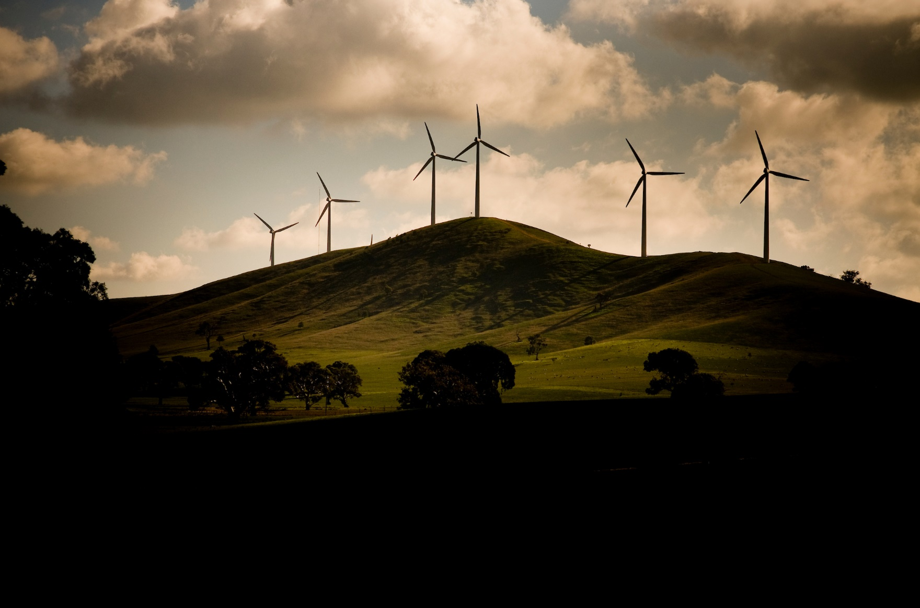

Photo: DEECA

© The State of Victoria Department of Energy, Environment and Climate Action May 2025

Logo

**ISBN** 978-1-76176-267-3 **(pdf/online/MS word)**

Accessibility

If you would like to receive this publication in an alternative format, please telephone the DEECA Customer Service Centre on 136186, email [customer.service@delwp.vic.gov.au](mailto:customer.service@delwp.vic.gov.au), or via the National Relay Service on 133 677 [www.relayservice.com.au](http://www.relayservice.com.au).

This work is licensed under a Creative Commons Attribution 4.0 International

licence. To view a copy of this licence, visit

creative commons.org/licenses/by/4.0/

© The State of Victoria Department of Energy, Environment and Climate Action May 2025

Logo

ISBN xxx-x-xxxxx-xxx-xx (pdf)

Accessibility

If you would like to receive this publication in an alternative format, please telephone the DEECA Customer Service Centre on 136186, email [customer.service@delwp.vic.gov.au](mailto:customer.service@delwp.vic.gov.au), or via the National Relay Service on 133 677 [www.relayservice.com.au](http://www.relayservice.com.au).

This work is licensed under a Creative Commons Attribution 4.0 International

licence. To view a copy of this licence, visit

creative commons.org/licenses/by/4.0/