|  |
| --- |
| Wetland Intervention Monitoring Program |
| Phase I: Understanding responses of wetlands to changes in grazing management |

Understanding how wetlands respond to management interventions will improve the efficiency, effectiveness and long-term benefits of wetland management in Victoria.

## Wetland Intervention Monitoring Program

* 1. The Wetland Intervention Monitoring Program (WIMP) is a state-wide, long-term program developed by the Department of Environment, Land, Water and Planning (DELWP). The project is part of a $222 million investment by the Victorian Government under *Water for Victoria* to improve the health of waterways and catchments.
  2. The program will assess the effectiveness of management interventions commonly applied in wetlands. Phase I of WIMP commenced in 2017 and will run until 2020. The aim of Phase I is to understand how changes to grazing management affect wetland vegetation.

## Background

* 1. About 80% of Victoria’s wetlands are on private land. Many of these, especially wetlands that fill seasonally, are located in agricultural landscapes. These wetlands provide significant habitat for plants, frogs and birds.
  2. Fencing to manage livestock access is one of the most common management actions undertaken in Victoria’s privately owned wetlands.
  3. Livestock grazing is often detrimental to wetland condition, but can be beneficial in some cases if managed carefully. Many factors can influence the response of wetland vegetation to grazing, including the:
* type of vegetation (e.g. treed or herbaceous)
* overall condition of the wetland
* water regime of the wetland
* grazing management practice (type of animal, intensity, duration, season, frequency)

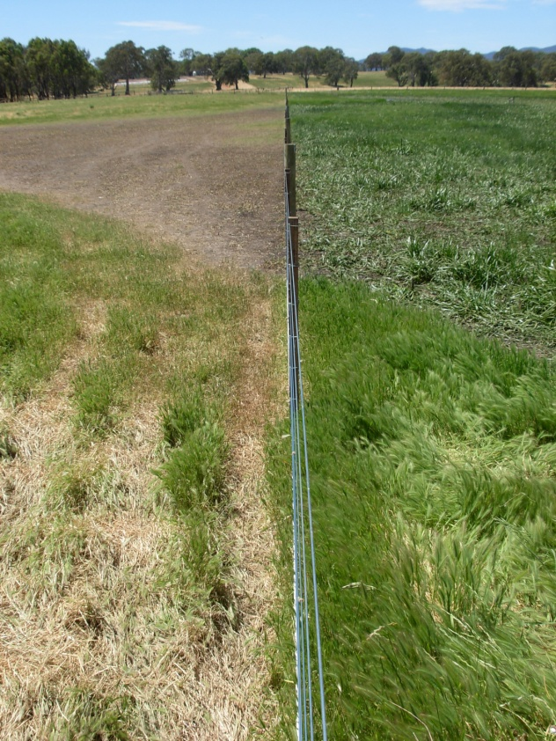

Grazed and ungrazed wetland areas separated by fencing (western Victoria). Photo: Michelle Casanova

## WIMP Phase I

* 1. In Phase I, WIMP will assess how grazing management changes influence the vegetation of seasonal or temporary freshwater wetlands. Phase I will also assess whether responses differ between wetlands that are treed or only have herbaceous plants.
  2. WIMP will monitor multiple wetlands in different regions of Victoria to understand how differences in climate, flooding pattern and soil type influence wetland responses to changes in grazing management.
  3. This understanding will help identify ways we can improve grazing management guidance and better target future management investments.

The program involves an assessment of vegetation condition at intervention sites, where a change in grazing management is planned, and at similar control sites, where the current grazing management will continue.

Comparing changes that occur at intervention sites with those that occur at control sites will tell us how much change is due to the management intervention (Figure 1).

Without control sites it is difficult to know if the changes at intervention sites are a result of the grazing management changes, or changes in environmental conditions such as rainfall.

Figure 1. Possible changes in vegetation condition at control and intervention sites over time - the difference between sites represents the change due to management.

**Vegetation condition**

**Control Site**

**Intervention Site**

**Condition change**

**Time**

## Who is involved and what is their role?

WIMP is a collaboration between organisations and landowners. The success of the project relies on the following contributions:

* **DELWP** – lead the program, work with Catchment Management Authorities (CMAs) to identify suitable sites, monitor the sites, analyse results and use learnings to inform adaptive management.
* **CMAs** – identify intervention and control sites across Victoria and work with landholders to implement grazing management.
* **Landholders** – work with CMAs to implement grazing management.
* **Botanists** – undertake field monitoring, work with landholders and CMAs.

## We need landholders to volunteer

We are looking for landowners to participate in the program to help us to improve the effectiveness of wetland management in Victoria.

Pairs of intervention and control sites are needed so that rigorous comparisons can be made between wetland vegetation responses where grazing management has and has not changed. These sites can be within the same wetland and separated by a fence, or be two similar wetlands with the same management history.

## What would I need to do?

* 1. **Intervention sites** are sites where a change to the existing grazing management is being planned, such as removing stock or grazing at certain times only.
  2. These sites will already be subject to a land management agreement between a landholder and CMA.
  3. The only additional requirement for landowners is to agree to the site being monitored before the grazing management changes and several times afterwards. This will allow assessment over time of vegetation responses during the wet and dry phases of the wetland.
  4. **Control sites** are sites where no change to grazing management is planned (or has been recently undertaken). These sites do not require a project agreement with a CMA, but landowners need to agree that:
* current land management practices are intended to continue for at least three years
* the site can be monitored at the start of the project and subsequently during drying and wetting phases.

## About the monitoring

Monitoring involves a botanist and an assistant undertaking wetland vegetation surveys along transects and plots in each wetland. Transects are marked with a star picket or wooden stake. Surveys take up to one day to complete in each wetland and cause no disturbance other than walking through the property.

All site visits will be approved by the landowner before being undertaken.

## More information

|  |  |
| --- | --- |
| © The State of Victoria Department of Environment, Land, Water and Planning 2017  LogoThis work is licensed under a Creative Commons Attribution 4.0 International licence. You are free to re-use the work under that licence, on the condition that you credit the State of Victoria as author. The licence does not apply to any images, photographs or branding, including the Victorian Coat of Arms, the Victorian Government logo and the Department of Environment, Land, Water and Planning (DELWP) logo. To view a copy of this licence, visit http://creativecommons.org/licenses/by/4.0/  ISBN 978-1-76047-820-9 (Print) ISBN 978-1-76047-821-6 (pdf/online)  **Disclaimer**  This publication may be of assistance to you but the State of Victoria and its employees do not guarantee that the publication is without flaw of any kind or is wholly appropriate for your particular purposes and therefore disclaims all liability for any error, loss or other consequence which may arise from you relying on any information in this publication. | Accessibility  If you would like to receive this publication in an alternative format, please telephone the DELWP Customer Service Centre on 136186, email [customer.service@delwp.vic.gov.au](mailto:customer.service@delwp.vic.gov.au) or via the National Relay Service on 133 677 [www.relayservice.com.au](http://www.relayservice.com.au). This document is also available on the internet at [www.delwp.vic.gov.au](http://www.delwp.vic.gov.au). |

To learn more or participate, contact your local CMA or Dr Kay Morris, Arthur Rylah Institute for Environmental Research:  
Email: [kaylene.morris@delwp.vic.gov.au](mailto:kaylene.morris@delwp.vic.gov.au)  
Phone: 03 9450 8600