|  |
| --- |
| Victorian Environmental Flows Monitoring and Assessment Program (VEFMAP) Stage 6 |
| Project Update – 2017  Fish Study – Southern Victorian Rivers |

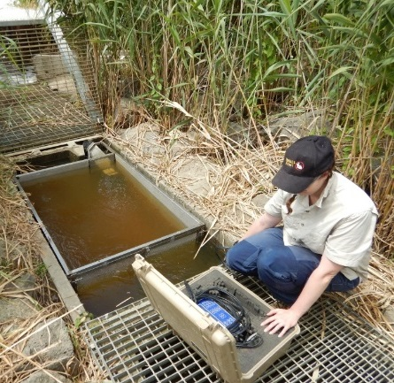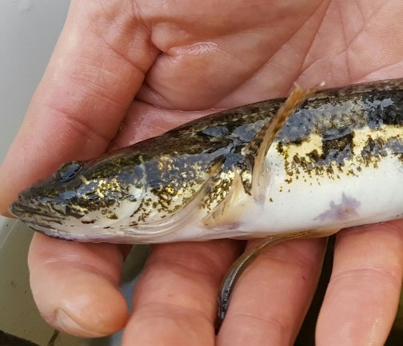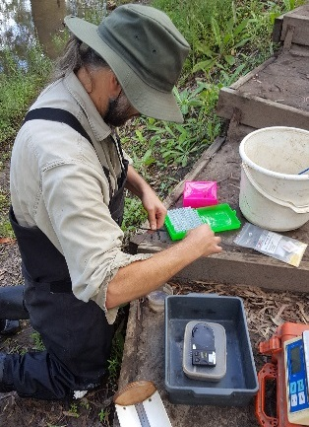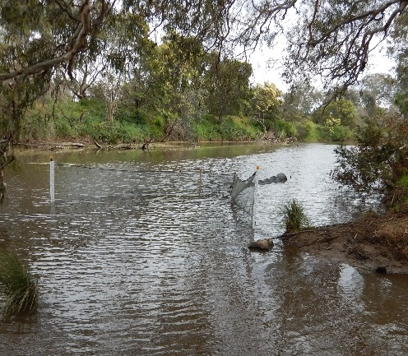

## Background

The Victorian Environmental Flows Monitoring and Assessment Program (VEFMAP) was established by the Victorian Government in 2005 to monitor and assess ecosystem responses to environmental watering in priority rivers across Victoria. The program’s results help inform decisions for environmental watering by Victoria’s Catchment Management Authorities (CMAs), Melbourne Water and the Victorian Environmental Water Holder (VEWH). Over the past 12 years, the information collected through VEFMAP has provided valuable data and informed significant changes to the program. VEFMAP is now in its sixth stage of delivery and includes a strong focus on “intervention” or “flow event” type questions, for vegetation and fish.

## Fish Monitoring - Southern Victorian Rivers

The core objective for fish monitoring in VEFMAP Stage 6 for coastal rivers is to examine the importance of environmental flows in promoting immigration, dispersal and subsequent recruitment of diadromous fish.

There are two key evaluation questions for fish in coastal Victorian rivers, which were developed in collaboration with CMAs:

KEQ 1 Do environmental flows enhance *immigration* of diadromous fishes in coastal streams?

KEQ 2 Do environmental flows enhance *dispersal, distribution and recruitment* of diadromous fishes in coastal streams?

## 2016/17 Survey Sites and Timing

In 2016/17, surveys were undertaken to investigate KEQ 1 and 2 processes in the following sites:

* ***Immigration*** - the lower reaches of the Barwon, Werribee, Bunyip and Tarwin rivers and Cardinia Creek (Oct-Dec 2016).
* ***Dispersal*** - the Glenelg River (Jan-Mar 2017).
* ***Distribution and recruitment*** - the Glenelg and Thomson rivers (Feb-Mar 2017).

The Barwon, Werribee, Bunyip, Glenelg and Thomson rivers and Cardinia Creek are regulated. These provide response data on environmental flow releases, and to natural fluctuations in discharge. Cardinia Creek is regulated, but does not have a seasonal watering plan or environmental flow targets. The Tarwin River is unregulated and has been included in the study to provide response data on natural fluctuations in freshwater discharge that may attract juvenile diadromous fish from marine into freshwater environments.

## Methods

Different survey methods were used for each component of the study:

***Immigration***

* *Fyke netting* – undertaken weekly (dependent on water levels) (Oct-Dec 2016) at one site in each of the Werribee, Bunyip and Tarwin rivers and Cardinia Creek. Additional sampling was completed during an environmental flow release in the Werribee River (three events in one week). Given that the Werribee and Barwon rivers were being sampled simultaneously, extra sampling was completed in the Barwon River as well.
* *Fishway trapping* – undertaken weekly at the vertical-slot fishway in the Barwon River at the Barwon Barrage (Oct-Dec 2016). Additional sampling was undertaken during an environmental flow release (three events in one week).

All fish were identified to species, counted and a subsample of 50 fish/species measured for length. Large-bodied fish were weighed.

* *Discharge data* – were obtained from monitoring gauges closest to the fyke netting and trapping sites.

***Dispersal***

* *Fyke netting –* undertaken over three nights (late Feb-early Mar 2017), before a summer fresh release, and over four nights in mid Mar 2017 during the peak of the release in the Glenelg River. Netting was conducted at six ‘treatment’ sites on the lower Glenelg River and at three control sites on the Stokes River.

All fish were identified to species, counted and a subsample of 20 fish/species measured for length.

* *Acoustic telemetry* – bankmounted electrofishing was undertaken at 11 sites in the Glenelg River (Jan 2017) to capture Tupong *Pseudaphritis urvilli*. Thirty-three fish were implanted with acoustic transmitters (most fish were >200 mm and probably mature).
* *Discharge data* – were obtained from the monitoring gauge closest to the majority of the sampling sites.

***Distribution and Recruitment***

* *Electrofishing –* bankmounted electrofishing was undertaken at 14 sites in the Thomson River (Feb 2017) and at nine sites in the Glenelg River (Mar 2017). This included some of the same sites monitored during previous VEFMAP stages.

All fish were identified to species, counted and a subsample of 50 fish/species measured for length. Large-bodied fish and Tupong were weighed.

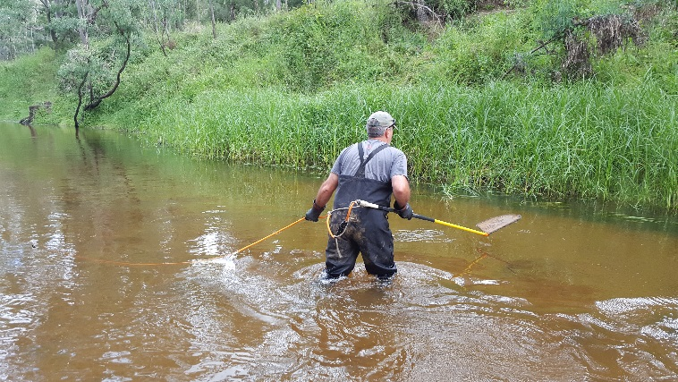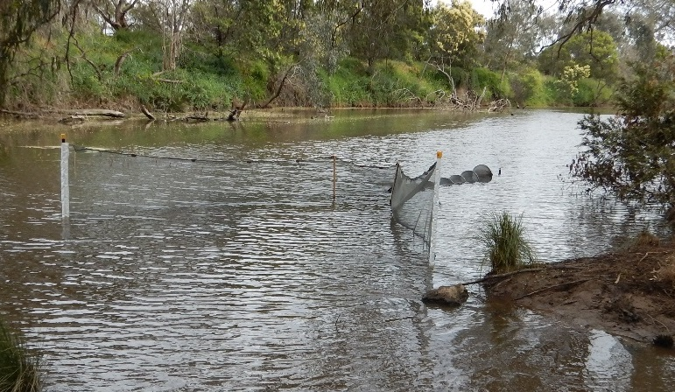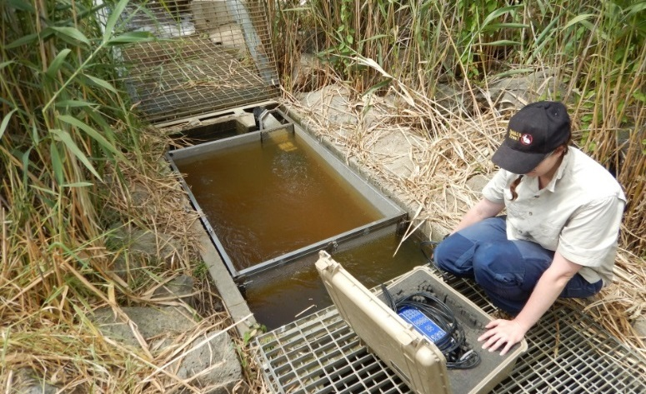

**Figure 1-3 (from top) – A double winged fyke net, a fishway trap used to capture fish in the Barwon River fishway, bankmounted electrofishing.**

## Results

***Hydrology and environmental flow delivery***

Rain events occurred from September to December 2016, resulting in a number of natural flow peaks in all rivers. An environmental flow release occurred in the Werribee River in late 2016. In the Glenelg River, discharge during the summer of 2017 was driven by rainfall events and base flow environmental flow releases. A summer fresh environmental flow release resulted in a discharge peak in mid-March 2017.

***Immigration***

Over 130,000 fish were captured in the five streams. Juvenile diadromous galaxiids comprised the bulk of the catch (~95%). Two threatened diadromous species, Australian Grayling *Prototroctes maraena* and Australian Mudfish *Neochanna cleaveri* were collected. Other diadromous species collected were Tupong and Short-finned Eels *Anguilla australis*.

***Dispersal***

A total of 99 Tupong and 383 Common Galaxias *Galaxias maculatu*s were captured during the fyke netting survey. A total of 20 Tupong with transmittters were detected between January and May 2017, with most close to their initial tagging location.

***Distribution and Recruitment***

In the Thomson River, a total of 1531 fish of 14 species (10 native and four exotic) were captured, including five diadromous species: Short-finned Eels (n=69), Long-finned Eels *Anguilla reinhardti* (n=14), Australian Bass *Macquaria novemaculeata* (n=36), Australian Grayling (n=18) and Tupong (n=174). Australian Smelt *Retropinna* *semoni* and Gambusia *Gambusia affinis* were the most abundant species.

In the Glenelg River, a total of 1000 fish of 12 species (nine native and three exotic) were captured, including two diadromous species: Common Galaxias (n=19) and Tupong (n=71). Flat-headed Gudgeon *Philypnodon grandiceps* and Gambusia were the most abundant species.

## Progress to Date

***Immigration***

The highest catch rates of galaxiids in Cardinia Creek and the Bunyip and Werribee rivers occurred early in the spring sampling period following multiple, relatively large natural discharge pulses. Whether this was due to higher volumes of water or time-of-year will be investigated over the next two years.

In the Werribee River, an increase in young-of-year (YOY) galaxiids occurred during the peak of an environmental flow release, providing evidence that it was effective in attracting fish from the estuary into freshwater.

***Dispersal***

At five of the six Glenelg River sites, higher catch rates occurred during the peak of the summer fresh release, providing evidence that these flows may stimulate Common Galaxias and Tupong to disperse upstream. This pattern was not observed in any of the Stokes River control sites.

No tagged Tupong migrated upstream, although because few were sub-adults, there was a limited ability to assess the role of environmental flows in promoting dispersal of sub-adults upstream. Two large adults moved downstream on a large discharge pulse in late April, which is expected as part of their autumn/winter spawning migration.

***Distribution and Recruitment***

The high catch rate of YOY Tupong in the Thomson River indicated strong recruitment for the 2016/17 season (the highest observed in 13 years of VEFMAP sampling in this river). The 2007, 2011 and 2012 year classes of Tupong were also detected, indicating a combination of successful spawning, immigration into freshwater and dispersal upstream.

No trend in year classes for Australian Grayling was detected, but this may be the result of low abundance and low detectability in the Thomson River.

In the Glenelg River, small Tupong dispersed as far as 40 km upstream of Dartmoor. Some of this movement may have been stimulated by the summer fresh release. Environmental water was used to maintain river connectivity during summer 2017, allowing fish to migrate throughout the summer. Strong year classes for Tupong for 2012 and 2016 were detected.

## Highlights

The 2016/17 surveys have provided valuable evidence regarding the links between river discharge, including environmental flow releases, and the life history processes of diadromous fish in Victoria. The results provide the basis for refining future monitoring and environmental flow delivery in coastal rivers.

There has been strong collaboration between program managers and key stakeholders. Regular and active communication has supported the effective delivery of the program and the communication of outcomes. This has provided opportunities for input and feedback on the program, and facilitated discussion to modify environmental water management plans.

## What’s next?

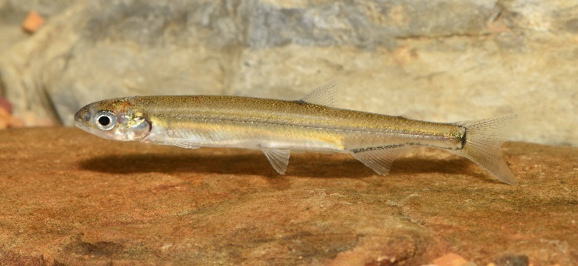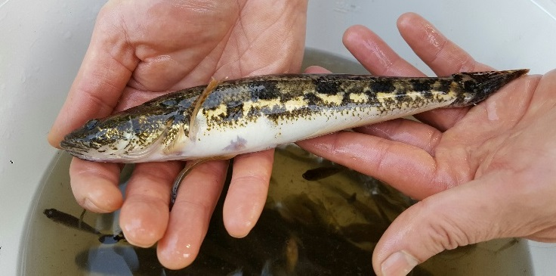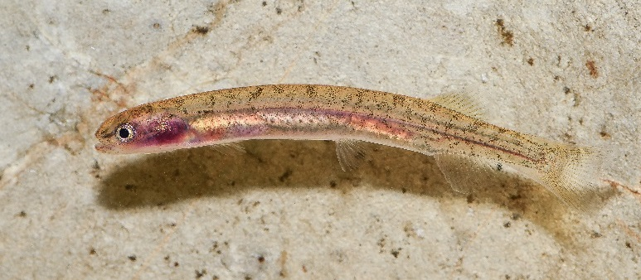

***Surveys***

* Conduct further sampling in the Barwon, Werribee, Bunyip and Tarwin rivers and Cardinia Creek during spring 2017.
* Repeat the event-based netting investigating upstream movement in the Glenelg River, and add another river to increase spatial coverage and statistical power.
* Continue the electrofishing in the Thomson and Glenelg rivers investigating diadromous fish distribution, abundance and year-class strength, and add another river to increase spatial coverage and statistical power.

***Further analysis of data***

* Use existing data to develop a statistical model to investigate the effect of winter and spring discharge characteristics on Tupong year-class strength.
* Verify the size classification for YOY Tupong, for use in analyses.

## Further details:

See DELWP (2017) VEFMAP Stage 6: Do environmental flows enhance immigration and dispersal of diadromous fishes in Victorian coastal rivers? 2016/17 survey results. A client report to Water and Catchments of the Department of Environment, Land, Water and Planning (DELWP).

## Acknowledgements:

Most of this work was funded by DELWP Water and Catchments, as part of the Victorian Government’s $222 million investment over the next four years to improve catchment and waterway health across regional Victoria. Melbourne Water provided funding for work in the Bunyip River as part of another project.

**Figure 4 – 6 (from top) – A juvenile Australian Mudfish, a juvenile Australian Grayling, a Tupong.**

## Contact:

## [Zeb.Tonkin@delwp.vic.gov.au](mailto:Zeb.Tonkin@delwp.vic.gov.au) (fish program leader)

## [Frank.Amtstaetter@delwp. vic.gov.au](mailto:Frank.Amtstaetter@delwp.%20vic.gov.au)

Wayne.Koster@delwp. vic.gov.au(Bunyip River surveys)

|  |  |
| --- | --- |
| © The State of Victoria Department of Environment, Land, Water and Planning 2017  LogoThis work is licensed under a Creative Commons Attribution 4.0 International licence. You are free to re-use the work under that licence, on the condition that you credit the State of Victoria as author. The licence does not apply to any images, photographs or branding, including the Victorian Coat of Arms, the Victorian Government logo and the Department of Environment, Land, Water and Planning (DELWP) logo. To view a copy of this licence, visit http://creativecommons.org/licenses/by/4.0/  ISBN 978-1-76047-795-0 (print), 978-1-76047-796-7 (pdf/online)  Disclaimer  This publication may be of assistance to you but the State of Victoria and its employees do not guarantee that the publication is without flaw of any kind or is wholly appropriate for your particular purposes and therefore disclaims all liability for any error, loss or other consequence which may arise from you relying on any information in this publication. | Accessibility  If you would like to receive this publication in an alternative format, please telephone the DELWP Customer Service Centre on 136186, email [customer.service@delwp.vic.gov.au](mailto:customer.service@delwp.vic.gov.au), or via the National Relay Service on 133 677 [www.relayservice.com.au](http://www.relayservice.com.au). This document is also available on the internet at [www.delwp.vic.gov.au](http://www.delwp.vic.gov.au). |