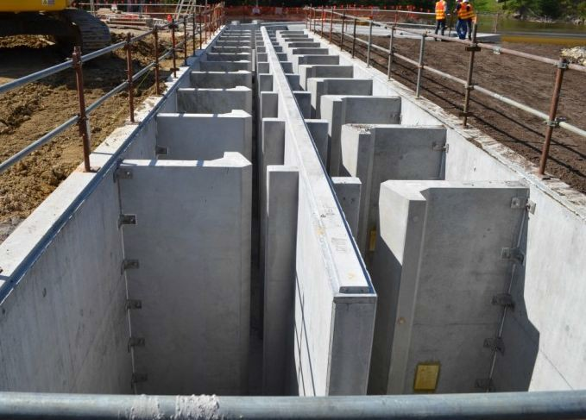Guidelines for the design,
approval and construction of
fishways

J. O’Connor, I. Stuart, M. Jones

November 2017

Arthur Rylah Institute for Environmental Research Technical Report Series Number 274

Acknowledgements
The Water and Catchments Group (Department of Environment, Land, Water and Planning) funded this project. The authors would like to thank Greg Woodward and Joel Rawlinson from the Water and Catchments Group for managing the project and participating in many useful discussions. Thanks also to Dennis Lovric and Mark Turner, who were members of the Steering Committee. Tim Marsden and Joel Rawlinson provided useful comments on an earlier version of this document.

Authors
J. O’Connor, I. Stuart and M. Jones
Arthur Rylah Institute for Environmental Research, Department of Environment, Land, Water and Planning, 123 Brown Street, Heidelberg, Victoria 3084

Citation
O’Connor, J., Stuart, I. and Jones, M. (2017). Guidelines for the design, approval and construction of fishways. Arthur Rylah Institute for Environmental Research. Technical Report Series No. 274. Department of Environment, Land, Water and Planning, Heidelberg, Victoria.

Photo credit
Front cover: Dights Falls vertical-slot fishway (Justin O’Connor).

© The State of Victoria, Department of Environment, Land, Water and Planning, August 2017

This work is licensed under a Creative Commons Attribution 4.0 International licence. You are free to re-use the work under that licence, on the condition that you credit the State of Victoria as author. The licence does not apply to any images, photographs or branding, including the Victorian Coat of Arms, the Victorian Government logo and the Department of Environment, Land, Water and Planning (DELWP) logo and the Arthur Rylah Institute logo. To view a copy of this licence, visit http://creativecommons.org/licenses/by/3.0/au/deed.en
ISSN 978-1-76047-206-1 (print)
ISSN 978-1-76047-207-8 (pdf)
ISSN 1835-3827 (print)
ISSN 1835-3835 (pdf)

Disclaimer
This publication may be of assistance to you but the State of Victoria and its employees do not guarantee that the publication is without flaw of any kind or is wholly appropriate for your particular purposes and therefore disclaims all liability for any error, loss or other consequence which may arise from you relying on any information in this publication.

Accessibility
If you would like to receive this publication in an alternative format, please telephone the DELWP Customer Service Centre on 136186, email customer.service@delwp.vic.gov.au, or via the National Relay Service on 133 677 www.relayservice.com.au. This document is also available on the internet at ari.vic.gov.au.

Contents

Summary 1

1 Introduction 3
1.1 Objectives of the guidelines 4
  - The design process 7
    - Stakeholder engagement 9
    - Elements of fishway design 11
    - Intervention and fish passage objectives 11
    - Budget 12
  - Site characteristics 12
    - Stream discharge 12
  - Local fish community 13
  - Fishway design attributes 15
    - Fishway type 15
    - The fishway entrance 17
    - Passage through the fishway 20
    - The fishway exit 25
  - Recommended fishway design parameters 26
  - Quality control 33
    - Fishway modelling 33
- Fishway approval 35
  - Construction of new in-stream structures—legislation and policy to protect
fish passage 35
    - Water Act 1989 (Vic.) 35
    - Conservation, Forests and Lands Act 1987 (Vic.) 35
3.1.3 Flora and Fauna Guarantee Act 1988 (Vic.) 35
    - Fisheries Act 1995 (Vic.) 35
    - Environment Effects Act 1978 (Vic.) 36
    - Environment Protection and Biodiversity Conservation Act 1999 (Cwlth) 36
    - Victorian River Health Strategy (2002) 36
    - Guideline documents 36
    - Legislation and policy effectiveness 36
- Fishway construction 38
  - General 38
  - Concrete fishways 38
  - Rock fishways 39
  - Fishway commissioning 40
    - Dry commissioning process 40
    - Wet commissioning process 40
  - Fishway design life 42
    - Concrete structures 42
    - Rock-ramp structures 42
  - Problematic designs 42
    - Rock chutes: problematic fish passage designs 42
  - Fishway maintenance 43
References 44
Appendices 47
Appendix 1 Common fishway passage options/designs 47
Appendix 2 Victorian fish species and their primary location 57
Appendix 3 Guidelines from DSE to Water Authorities 58
Appendix 4 Sample of CMA permit for Works on Waterways 59

Figures
Figure 1.1: The implementation of VWMS Action 11.6 and how this fits with Policies 11.7
and 11.10 6
Figure 2.1: The logical steps of fishway construction and the role of Action 11.6 for
considering all parameters. Action 11.8 is also linked in the process 8
Figure 2.2: Engaging with stakeholders at the Barwon River barrage 9
Figure 2.3 Swimming locations—e.g. pelagic for species such as the Australian Grayling (Prototroctes maraena, top), versus stream bottoms for species such as the Tupong
(Pseudaphritis urvillii, bottom)—can be indicative of swimming ability 15
Figure 2.4: Two vertical-slot fishways with a low-flow entrance channel extending into the tailwater pool (left), and a higher channel wall and entrance slot for high tailwater
conditions (right). (photos: A. Berghuis and I. Stuart) 18
Figure 2.5: Auxiliary water systems for providing extra fish-attracting water adjacent to a fishway entrance: overfall weir (top left); small culvert (bottom left); and twin vertical
diffusers (right). (photos: I. Stuart) 19
Figure 2.6: Turbulence at Dights Falls, Yarra River 22
Figure 2.7: Details of a standard vertical-slot baffle for a coastal fishway. The slot width
shown is 0.15 m (from Mallen-Cooper 1993) 22
Figure 2.8: Details of a standard vertical-slot baffle for a Murray–Darling Basin fishway. The
slot width shown is 0.3 m (from Mallen-Cooper 1993) 23
Figure 2.9: Concept of a vertical-slot fishway with middle sill block-outs, which reduce pool discharge and turbulence for optimal ascent of abundant numbers of small-bodied fish
(e.g. 15+ mm long). (drawing by M. Mallen-Cooper) 23
Figure 2.10: A vertical slot with a modified key-hole sill installed to reduce discharge and
pass large fish at the bottom and small fish at the top 24
Figure 2.11: A fishway turning pool with (left) the slot aligned to the outside of the channel wall, which causes water to ‘short-circuit’, creating uneven hydraulics, and (right) the slot aligned on the inside of the channel to guide water into the far corner of the turning pool. The black triangle represents a flow-guiding device that may also have
hydraulic merit. (concept: S. Slarke, Jacobs) 25
Figure 2.12 Exit of the Dights Falls fishway 26
Figure 2.13: Example of a physical model. (photo: M. Mallen-Cooper) 33
Figure 2.14: Example of a computational fluid dynamics model showing velocity gradients of
a physical model 34
Figure 4.1: Fishway entrance flow (blue arrow), showing high integrity of flow and low
recirculation within 0.5 m of the entrance (photo: M. Mallen-Cooper) 41
Figure 4.2: Diagram of a recirculation remedied by adding rock. (illustrations: M. Mallen-
Cooper) 42

Figure 4.3: Example of a vertical-slot fishway without a maintenance schedule. The outcome can alter cell volume and hydraulics, thus reducing functionality of the fishway and so
fish passage 43
Figure A1.1: Barrier removal, Barwon River 47
Figure A1.3: Full-width rock-ramp fishways 50
Figure A1.4: Two lateral-ridge-rock fishways: a full-river-width design at Pollocksford Weir on the coastal Barwon River (top) and a partial-width design on Sugarloaf Creek near
Puckapunyal (bottom). (photos: I. Stuart) 51
Figure A1.5: Ascending hopper lift on Tallowa Dam, Shoalhaven River 52
Figure A1.6: Denil fishway 53
Figure A1.7: Natural bypass fishway on Cardinia Creek, Melbourne 54
Figure A1.8: A cone fishway in Queensland 55
Figure A1.9: A trapezoidal weir 56
Tables
Table 2.1: Stakeholder engagement and communication plan 10
Table 2.2: Advantages and disadvantages of fishway types in use in Victoria 16
Table 2.3: Hydraulic design standards for fishway entrance and exit. 27
(modified from Mallen-Cooper 2000a) 27
Table 2.4: Hydraulic design standards for passage through fishways 28
(modified from Mallen-Cooper 2000a) 28
Table 2.5: Physical design standards for passage through fishways 30
(modified from Mallen-Cooper 2000a) 30
Table 2.6: Recommended physical and hydraulic standards for vertical-slot and rock-ramp
fishways 31
Table 4.1: Design tolerances for vertical-slot, cone and rock-ramp fishways 39

Summary

The information presented in this document is intended to support waterway and asset managers, engineers, fishway designers, researchers and consultants, who together collectively manage, design and assess new and existing fish passage structures. This document addresses Action 11.6 of the Victorian Waterway Management Strategy (DEPI 2013), which is to ‘Develop best practice guidelines for the appropriate design, approval and construction of fishways and other fish passage works’. This document outlines contemporary fishway designs, and approval and construction processes for promoting consistent procedures, protocols and standards in fishway design in Victoria.

The specific objectives of these guidelines are to outline:

      - A recommended design process

      - Common fishway design attributes

      - Recommended standards for different design parameters and fishway types

      - The fishway approvals process

      - The fishway construction and commissioning process.

The first step towards a thorough fishway design process includes stakeholder engagement, considering elements of fishway design, formulating intervention and fish passage objectives and budget considerations.

Site characteristics also need to be considered including topography of the site (including bends and flow pathways), site geology (e.g. including the presence of bedrock), river depth and width, stream discharge and velocity of water over the barrier. These site characteristics will influence the type, location and complexity of the fishway design.

A major factor influencing the design of a fishway is the range of fish species it is intended to pass. There are many characteristics specific to individual species of fish that affect fishway design and these include swimming ability, size of migratory fishes (juvenile or adults), seasonal biomass or abundance of migrating fishes, specific life-history traits and swimming behaviours.

Before designing specific physical and hydraulic parameters of the fishway the appropriate fishway design type needs to be determined and there are various design options to restore fish passage at in-stream barriers.

Once stakeholder engagement has commenced and information on site characteristics, elements of fishway design, local fish community, intervention and ecological objectives and fishway type have been established, the fishway design attributes, including the physical and hydraulic parameters of the fishway need to be determined. There are three main areas to consider when designing the physical and hydraulic parameters of a fishway; the fishway entrance, passage through the fishway and the fishway exit. Each of these will have unique physical and hydraulic design parameters and these will largely be determined by the target fish species.

At the fishway entrance operational range, fishway discharge and auxiliary water all need to be considered. For passage within the fishway velocity and turbulence parameters (controlled by slope of the fishway, head loss and pool volume) need to be designed around the target fish community. Other considerations include fishway length, turning pools and resting areas. Finally, the design of the fishway exit needs to consider flow vectors which are controlled by location and orientation of the exit with respect to river flow. Trash racks also need to be included in the fishway exit design. Recommended fishway design standards are provided for these parameters. Quality control throughout the process is governed by regular review, input of expert advice, potential fishway modelling followed by a thorough ecological evaluation.

The fishways approval process is regulated by numerous legislation, strategies, guidelines and policy documents which are also summarized in this document. Finally, the fishway construction process is addressed including protocols for planning (including personnel, materials, etc.) auditing and fishway commissioning.

Introduction

The construction of dams, weirs and other artificial stream structures has had an overwhelming impact on the abundance and diversity of native fish in Australia (Cadwallader 1978; Mallen-Cooper 1996; Mallen-Cooper and Brand 2007). Dams and weirs have fragmented rivers and disrupted longitudinal and lateral connectivity for many species (Thorncraft and Harris 2000; O’Connor et al. 2005; Stuart et al. 2008; Koster et al. 2014).

Artificial barriers impact fish by restricting access to spawning grounds and preferred habitats, and preventing dispersal and recolonisation (Barrett and Mallen-Cooper 2006; Baumgartner et al. 2010). Barriers also interrupt the migrations of freshwater fish, an essential step for various life history stages (Reynolds 1983; Mallen-Cooper and Brand 2007; Mallen-Cooper 1996; Baumgartner et al. 2010).

The presence of barriers to fish migration has major detrimental impacts on fish in Victorian streams, because large sections of aquatic habitat are obstructed by barriers (Koehn and O’Connor 1990). Native fish populations in the Murray–Darling Basin (MDB), for example, are at 10% of their pre-European levels (MDBC 2004). Numerous human-induced factors have contributed to this decline, including in-stream barriers, and connectivity of river habitats is recognised as important for maintaining and restoring native fish populations. Given the potential impacts on fish assemblages as a result of restricted movement around weirs and dams, water managers are increasingly required to provide fish passage around these structures.

Australia’s fish passage history began in the early 1900s, where 44 fishways were built in New South Wales between 1913 and 1985 (Thorncraft and Harris 2000). These fishways were based on American designs for salmonids, but performed very poorly for Australian native fish (Mallen-Cooper 1996). In 1982, Australian scientists engaged George Eicher, an eminent North American fishway ecologist, to advise on a fishway design program. A report developed from Eicher’s visit outlined the problems with the existing fishway designs, suggested some alternatives (such as the vertical-slot type) and set out future research priorities (Thorncraft and Harris 2000), which included baseline research into the swimming abilities of a number of Australian native fish species (Mallen-Cooper 1992, 1994).

The data from this research were used to inform the design of the first vertical-slot fishway at Torrumbarry Weir on the Murray River in the early 1990s. Monitoring of that fishway demonstrated the passage of a broad range of fish species, while also providing insights into the movement behaviour of species within the Murray–Darling Basin (Mallen-Cooper 1996). The Torrumbarry experience helped revitalise interest in fishways and has led to several hundred fishways being constructed, mostly in eastern Australia but also in the south-west of Western Australia. The learnings from the Torrumbarry Weir fishway experience were applied more recently (2000–2013) to the Sea to Hume fishways construction project, which restored passage along more than 2200 km
of the Murray River and included 14 new fishways (Barrett and Mallen-Cooper 2006; Baumgartner et al. 2010).

During the Sea to Hume project, monitoring of the new fishways by the Murray River Fishway Assessment Program (MRFAP) found that significant numbers of small fish (< 50 mm long) were trying to migrate through the fishways; this was a new ecological insight (Stuart et al. 2008). From these new data and a desire to achieve a more cost-effective fish passage solution, dual fishway and fish-lock designs were constructed at several sites in order to improve the overall passage efficiency for both small and large fish (20–1400 mm long).

The evolution of Australian fishway designs has been an adaptive learning process involving researchers, waterway managers, structure owners and civil engineers. A major lesson learnt (from both successful and unsuccessful fishways) is that designs should be generated from the local site

hydrology and fish ecology. Fishways are now being constructed with quantitative ecological and hydrological data underpinning their design, to the point where fishways can be tailored to pass whole fish communities, target species or size ranges, and operate over a broad range of river conditions.

The challenge now is to establish consistency in Victorian fishway design (O’Brien et al. 2010), but this is not always easily achieved. Given that each has its own unique design characteristics because of stream topography and hydrology and other factors, fishways do not lend themselves to standard designs; however, a standard design process and some standard design principles should be in place.
In other words, each fishway site is unique, but the steps and considerations for remediation are not. Unfortunately fishways continue to be designed and constructed without a collaborative team
(i.e. engineers, fishway biologists and river managers) and without the unique site hydrology and ecology driving the fishway design process. The guidelines in this document should ensure that fishways always successfully achieve their functional, ecological and hydraulic performance standards.

Victoria has sufficient legislation to protect fish passage during the construction of in-stream structures, but contemporary knowledge on fish passage design is required to improve the standard, and a more consistent approval process is required. The Victorian Waterway Management Strategy (VWMS) (DEPI 2013) provides an opportunity to mitigate the risks to river channel condition posed by in-stream structures by providing guidelines on contemporary fishway design at a statewide level. Improving passage for native fish is one objective of the VWMS, and preventing further loss of connectivity is recognised as a critical aspect of maintaining and improving the viability of fish populations (DEPI 2013).

1.1 Objectives of the guidelines

The guidelines will support waterway and asset managers, engineers, fishway designers, researchers and consultants, who together collectively manage, design and assess new and existing fish passage structures. The specific objectives of the guidelines are to outline:

- a recommended design process

- common fishway design attributes

- recommended standards for different design parameters and fishway types

- the fishway approvals process

- the fishway construction and commissioning process.

The development of this document is a policy action of the VWMS, which was designed to provide the framework for government, in partnership with the community, for maintaining or improving the condition of rivers, estuaries and wetlands so that they can continue to provide environmental, social, cultural and economic values. The strategy outlines the Victorian Government’s policy on regional decision-making, investment, management activities and specific management issues for waterways.

Policies 11.7 and 11.10 of the VWMS have led to the development of these guidelines which address Action 11.6 of the strategy, which is to ‘Develop best practice guidelines for the appropriate design, approval and construction of fishways and other fish passage works’ (Figure 1.1). This action outlines contemporary fishway designs, recommended standards, and approval and construction processes in order to promote consistent procedures, protocols and standards in fishway management in Victoria. The VWMS also included the following actions specific to fishways:

- Action 11.7: Develop a suite of fish passage design guidelines for use at small-scale structures.

- Action 11.8: Develop and implement a statewide program for monitoring the performance of fishways and fish passage works.

- Action 11.9: Develop Performance, Operation and Maintenance Guidelines for fishways and fish passage works.

O’Connor et al. (2015) provided detailed guidelines on performance standards, operation and maintenance of fishways (Action 11.9), which identified at what level a fishway should perform to achieve its ecological objectives. Jones and O’Connor (2016) outlined standard monitoring guidelines and protocols (Action 11.8) and O’Connor et al. (2016) outlined the approach to remediation of fish passage at small weirs and road crossings, which have unique design requirements specific to these structures (Action 11.7).

The guidelines presented here complement the information provided in O’Connor et al. (2015) by providing potential designs solutions capable of meeting the performance objectives defined in that document.

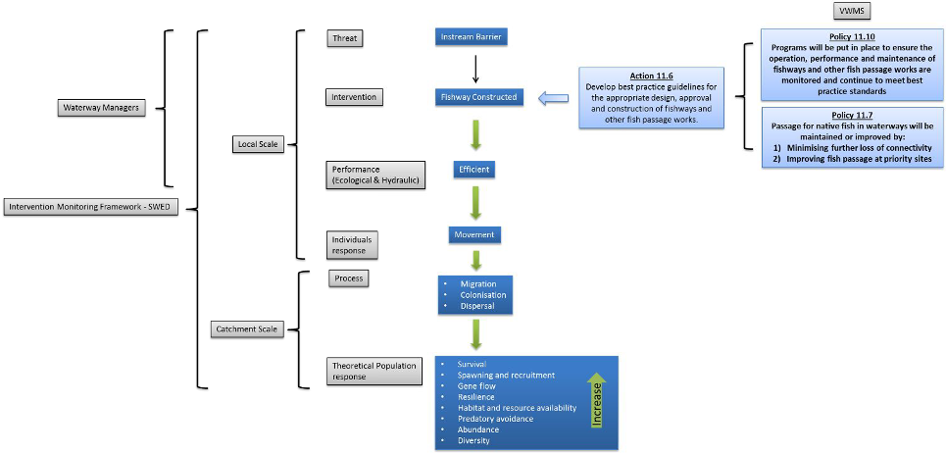

Figure 1.1: The implementation of VWMS Action 11.6 and how this fits with Policies 11.7 and 11.10.

Fishway design

2.1 The design process

The fishway design process consists of a series of logical steps (Figure 2.1). Central to its success is the identification and engagement of stakeholders and clarity about the ownership of structures. Equally important is considering information relevant to the requirements of the fishway, including ecological and hydraulic parameters, advances in technology and alternative design solutions.

Fish passage objectives should be developed in consultation with stakeholders, and should include discussions about the functionality of the in-stream structure; for example, it might provide hydraulic head for irrigation, a swimming pool for the local community, water storage, or for a stream-gauging station. The fish passage objectives should also take into account the fish species
present, their life history, and site characteristics such as topography, geology and stream hydrology.

Each fishway site will have unique requirements and various possible design solutions, and all fishway attributes need consideration. Some of the more important aspects of a design include the location of the fishway entrance (appropriateness for target species), hydraulic conditions (such as turbulence and water velocity in relation to the ability of the fish species to negotiate them) and the range of stream discharges over which the structure will be required to provide passage.

The functionality of the fishway should always drive design. There are many cases where a preselected fishway concept gathers design momentum but can never meet the local ecological and hydrological objectives because it was the wrong initial concept. Because each fishway is unique, the local fish ecology and site hydrology must, without exception, set the functional fishway objectives and therefore guide the fishway design process.

Concept design reviews are important for identifying major oversights and for adjusting the design to suit the scope of the project or the fish passage objectives. Concept designs may undergo numerous iterations before a consensus is reached, and hydraulic modelling may be an important part of this process. The final design may undergo similar reviews, but most of the design issues and stakeholder concerns should be dealt with during the concept phase.

The Victorian Government requires that fish passage is protected during works on waterways. Victoria’s approval process takes into account legislation, strategies and guidelines to protect fish passage during the installation of in-stream structures. The construction of a fishway is therefore considered a significant step towards a positive outcome. The first steps towards a thorough fishway design process include consideration of:

  - stakeholder engagement

  - elements of fishway design

  - intervention and fish passage objectives

  - budget constraints.

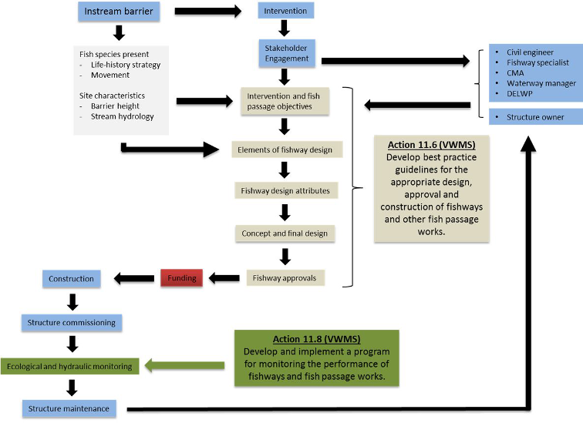

Figure 2.1: The logical steps of fishway construction and the role of Action 11.6 for considering all parameters. Action 11.8 is also linked in the process.

VWMS = Victorian Waterway Management Strategy, CMA = Catchment Management Authority, DELWP = Department of Environment, Land, Water and Planning.

    - Stakeholder engagement

Good fishway planning should engage all stakeholders from the beginning of the project so that their objectives, expectations and concerns can be considered (Figure 2.2). Stakeholders include owners
of the structure, water authorities, land managers, irrigators, anglers and the public. Stakeholder objectives need to be understood and achievable, and clear communication between stakeholders must be maintained throughout the process. Furthermore an expert design team needs to be established which includes experienced engineers, scientists, asset owner/manager and local water authority. Finally, a project manager is required to oversee the design and implementation process including gathering relevant information, delegation of tasks, communication between design team and communication with stakeholders. A suggested engagement and communication strategy is outlined in Table 2.1.

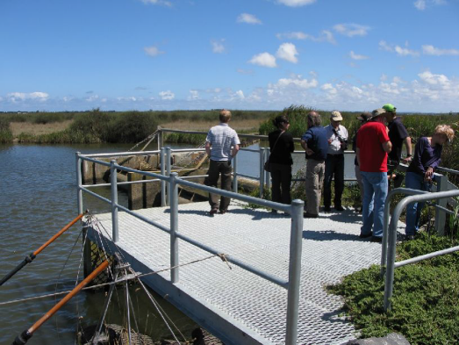

Figure 2.2: Engaging with stakeholders at the Barwon River barrage.

Table 2.1: Stakeholder engagement and communication plan.

Process |  | Outcomes | Responsibility
1. Initial data  gathering | Collate site data (fish assemblages), daily hydrological data and  summary hydrological data (flow duration curves, exceedance data, flow event curves, environmental flow arrangements) and asset/barrier data (this will depend on whether the barrier is existing or proposed).  Assess fish habitat at the site and upstream and downstream of  the site.  Engage/communicate with stakeholders |  | Project  manager
2. First meeting | Establish an expert design team (experienced engineers,  scientists, asset owner/manager and local water officer).  Identify who will document the design discussions, issues and  resolutions throughout the design process and how issues will be captured, worked through and ticked off.  Collate existing ecological, hydrological and operational information, e.g. flow curves, water extraction and releases, tidal range, proposed weir and fishway operational strategy, impoundment/headwater and tailwater levels.  Identify data gaps.  Set dates for additional data collection and dissemination, and identify the design team members who will be responsible for these tasks.  Set date for site inspection. Engage/communicate with stakeholders |  | Project  manager/ Design team
3. Site meeting | Inspect site and check catchment for other barriers.  Develop fishway concepts on-site (not before): entrance location, fishway type, operational range, weir operations.  Determine access arrangements for maintenance and monitoring.  Set date for workshop. Engage/communicate with stakeholders |  | Project  manager/ Design team
4. Initial design  workshop | Collate site data and fishway concepts.  Identify potential problems/constraints, important factors/considerations (upstream and downstream passage, passage at temporary structures or gauges).  Agree on fishway type and concept design and disseminate to stakeholders.  Discuss fishway modelling (physical and/or computer-generated). Engage/communicate with stakeholders |  | Project  manager/ Design team
5. Ongoing input  (period for review) | Submit for approval to design team any changes made to the  design. |  | Project  manager
6. Final design  workshop | Discuss final design, operation, maintenance, and rectification  and monitoring program.  Obtain in-principle agreement among design team.  Obtain agreement among design team s’ on final fishway design. Apply for permit from relevant authority (if required).  Obtain permit to proceed. Engage/communicate with stakeholders |  | Project  manager/ Design team

    - Elements of fishway design

Numerous variables need to be considered when designing a fishway. A well-structured design process leads to improved fish passage outcomes. The first step towards creating a consistent fishway design, approval and construction process is the development of a set of functional design principles. These principles should include overarching criteria that focus on the ecological and hydrological objectives of the fishway. The following set of key principles should be considered for all new fishways in order to ensure that a best practice approach is being used:

- Fishways should be suitable for all native fish that move through the site.

- Fishways should be designed to provide year-round passage for fish over the full range of headwater and tailwater levels and stream discharges or, as a minimum, ensure passage when fish are migrating.

- Fishways should provide both upstream and downstream fish passage.

- All releases and flows should, in the first and last instance, be diverted down the fishway, i.e. the fishway should be the first point of release of flow and the last to be turned off.

- All infrastructure (including raceways, aprons, plunge pool and baffles) should be designed to minimise fish injury.

- Flows should be directed adjacent to the fishway entrance to facilitate fish attraction.

- Appropriate lighting and resting habitat should be provided within the fishway.

    - Intervention and fish passage objectives

Setting realistic and contemporary objectives for the fishway during the design process will help ensure its success. An essential component of fishway design is applying the ecological objectives to set the performance criteria for the fishway, and hence the basis by which the design and the fishways effectiveness can be assessed. (Complementary information on performance criteria can be found in O’Connor et al. 2015.)

The first step is to specify the target fish community. Then the minimum and maximum size of the fish which the fishway is required to pass. The next step is to specify the range of river flows over which these fishes are expected to move, and in what direction. If the operational range is below 100%, then the ecological objectives and priorities need to be developed with this in mind. Once these ecological objectives are clear, ‘ecological windows’ of optimum fishway operation (rather than a linear range of operation) can be selected to optimise function and reduce cost.

Many ecological objectives for fish passage are driven by policy. These are usually broad-level objectives for the ecosystem, or in some cases relate to particular species (e.g. species that are threatened or recorded as having declined). Ecological objectives are mostly generic, such as ‘restore fish distribution and abundance’, and apply to almost all fishway projects, but they can also be specific if a particular ecological issue has been identified. Other objectives, such as hydrology, will also be site specific. Therefore, objectives for each new fishway should be developed in close consultation with stakeholders, including fishway design engineers, fish ecologists and the
structure’s owner and operators. For example, the hydrological objectives for a stream-gauging station that requires updating and incorporation of a fishway might include:

- Provide accurate stream gauge information over the known range of stream discharges.

- Achieve fish passage objectives; for example —

  - pass all fish species present downstream of the structure

  - pass fish of size range 40–700 mm

  - provide passage for fishes for the full range of the headwater and tailwater levels and stream discharges within which they migrate

  - provide fish passage in both upstream and downstream directions.

Objectives that are not well considered or documented may result in a fishway with less than optimal functionality and operation. More information on setting fish passage objectives can be found in O’Connor et al. (2015).

    - Budget

The primary aim in any fish passage intervention is to design an efficient structure that allows effective fish passage of the target species and size class. However, cost is a crucial factor and must be discussed with stakeholders during the design phase. Costs of fishways can vary widely depending on the site, but a general rule is that per metre height (head differential) vertical-slot fishways may range in cost from AU$250 000 to AU$1 million, and rock-ramp fishways from AU$20 000 to AU$1 million (Mallen-Cooper 2014). Any compromises around budget and design must be guided by the objectives of the fishway.

Site characteristics

The important starting point in any fishway design process is an initial site visit to identify the unique site characteristics. These will include topography (including bends and flow pathways), geology (e.g. including the presence of bedrock), river depth and width, and discharge and velocity of water over the barrier. These site characteristics will influence the type, location and complexity of the fishway design.

The location of the fishway entrance is crucial because it has a significant effect on the ability to attract fish to the fishway. Often there are natural movement pathways that fish use to move upstream, and it essential to utilise these in fishway design so that the entrance of the fishway is ideally located; this may require some initial monitoring to identify the pathways. The size and width of the barrier will influence the position and size of the fishway entrance and therefore the ability of fish to find the entrance. In a wide stream or river, a poorly designed or located fishway entrance may greatly reduce the efficiency of the fishway in moving fish upstream. In smaller streams a full- width rock-ramp fishway is ideal in that fish are not required to locate an entrance at all, thus removing the uncertainty around fishway entrance location and design.

The location of the fishway will also be determined by site access. Although this has important implications for cost, the optimum location of the fishway should always be governed by its potential for maximum passage efficiency of fish.

    - Stream discharge

One key design aspect of any fishway is the stream discharge, and therefore the headwater and tailwater levels over which it will be required to operate (head differential). The target species of fish will determine the timing of migrations. From that, predictions about the volume and duration of discharge likely to be encountered during key migration periodscan be determined. Flow duration curves and flow frequency analysis can also predict the type of flows over which the fishway may need to operate. Depending on the range of flows, specific design aspects such as multiple fishway entrances and exits may need to be considered. High flows that occur for only a small percentage of the time often can be particularly important because certain life-history traits such as spawning and dispersal may be closely associated with these events.

Each site will be unique in its maximum stream discharge and therefore maximum head differential. This has major implications for selecting the appropriate fishway type and for the fishway design and performance. The head differential needs to be accurately calculated from historical upstream and

downstream water levels, so that the appropriate ‘operational range’ for the fishway can be determined (see section 2.4.2). The greater the difference between the historical headwater and tailwater levels, the greater the fishways operational range will need to be.

Local fish community

A major factor influencing the design of a fishway is the fish species it is intended to pass. There are many characteristics specific to individual species of fish that affect fishway design, including:

- swimming ability

- size of migratory fishes

- seasonal biomass or abundance of migrating fishes

- life-history traits

- swimming behaviours.

    - Swimming ability

It is important to understand the swimming ability of the fish that will be using the fishway. Swimming ability is directly related to body size, and smaller fish are generally weaker swimmers. Data on swimming ability lead to specific water velocities and turbulence criteria that are used in fishway design (Mallen-Cooper 1994; Silva et al. 2011). Swimming ability also includes other aspects such as climbing ability e.g. juvenile eels (elvers). Some climbing species, such as Broad-finned Galaxias, use the boundary layers where the velocity of edges of flowing water slows adjacent to rough surfaces. These are useful characteristics for attempting to pass fish upstream, and vary between species and life stages.

    - Size of migratory fishes

Knowledge of migration ecology is used to determine two key related criteria: the ‘maximum size of fish utilising the fishway’, which determines the amount of space and depth needed in the fishway, and the ‘minimum size of fish utilising the fishway’, which relates to fish with the weakest swimming ability and determines the maximum water velocity and turbulence.

    - Seasonal biomass or abundance of migrating fishes

Migratory population and biomass (including the number of fish migrating, the size of the fish migrating, and the spread of the timing of the migration) are factors that influence fish passage design and can be used in developing fish passage objectives.

    - Life-history traits

The life history of the target fish species will dictate the reasons for migration, which are important in determining the timing and magnitude of the flows over which the fishway will be required to
operate, and it can also help determine acceptable levels of delay (and hence operational range). For example, the ecological consequences of a delay to a spawning migration may be more detrimental than a delay to a juvenile dispersal migration.

Life history traits of coastal diadromous fish species (see Appendix 2) include movement from marine environments into freshwater as a mandatory requirement to complete their life cycle. About 70% of native fish species in Victoria’s coastal drainages are diadromous and undertake migrations between fresh and estuarine or marine environments (Harris 1984). In-stream barriers that never drown out can result in a complete absence of diadromous fish upstream. Where barriers are periodically drowned out, upstream fish populations can range from completely absent to the absence of various age classes, depending on whether a diadromous migration corresponded with a

high-flow barrier drown-out event. Within coastal streams, the upstream passage of juvenile (under 1 year old) diadromous fish migrating from the sea represents a large proportion of the fish passage required and is the major driver of coastal fishway design. However, coastal barriers can also have detrimental impacts on adult return-spawning migrations of Australian Grayling (Prototroctes maraena), which can be stranded downstream following annual spawning migrations and require passage back upstream (Koster et al. 2014; Amtstaetter et al. 2015a).

In the Murray–Darling Basin (inland systems), which is the most regulated river system in Australia (McNee 1999), some of the greatest threats to native fish populations result from the presence of barriers to fish movement. The freshwater reaches of the Murray–Darling Basin are dominated by potamodromous fish species, which are species that migrate wholly within freshwater (see Appendix 2). These migrations play an important role in a fish species’ life cycle, but barriers can restrict access to spawning grounds and preferred habitats, and prevent dispersal and recolonisation (O’Connor et al. 2005; Koehn et al. 2009). The impacts of reduced connectivity within the Murray–Darling Basin can also often be masked by large-scale fish-stocking programs, e.g. for species such as Golden Perch (Macquaria ambigua) and Murray Cod (Maccullochella peelii).

    - Swimming behaviours

Some species move and migrate only during the day, and this will need to be accounted for in the length of the fishway (see resting pools in Section 2.4.3). Other species are pelagic swimmers or bottom dwellers (Figure 2.3), and may require innovative designs such as lining the bottom of concrete fishways with rock to create a diversity of flows that enable the fish to move upstream.

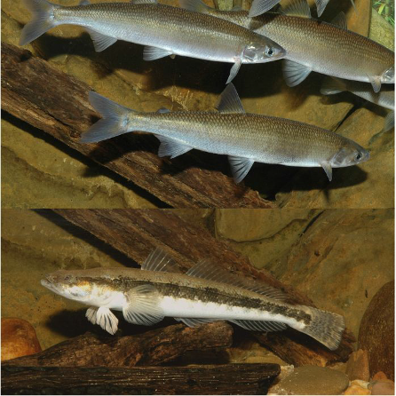

Figure 2.3 Swimming locations—e.g. pelagic for species such as the Australian Grayling (Prototroctes maraena, top), versus stream bottoms for species such as the Tupong (Pseudaphritis urvillii, bottom)—can be indicative of swimming ability.

Fishway design attributes

    - Fishway type

Before designing specific physical and hydraulic parameters of the fishway, the appropriate fishway design type needs to be determined. There are various design options to restore fish passage at in- stream barriers. Detailed descriptions of fishway types in use in Victoria are provided in Appendix 1, and their advantages and disadvantages are summarised in Table 2.2. Generally rock-ramp, Denil, bypass, cone and trapezoidal fishways are suitable for restoring fish passage where the head differential is up to 3 metres. Vertical-slot fishways can be suitable for up to 6 metres of head differential, while mechanical fishways (e.g. fish locks or lifts) are required for structures higher than this.

Table 2.2: Advantages and disadvantages of fishway types in use in Victoria.

Fishway type | Advantages | Disadvantages
Vertical-slot | Operate over a wide range of river flow  conditions.  Pass a broad size range of fish. | Expensive.
Rock-ramp (random or  lateral ridge) | Relatively inexpensive.  Operate over a wide range of river levels. Fish can easily find the fishway entrance  (full width). | Require regular  maintenance  Need to be properly engineered and constructed.  Operation can be limited by variable headwater.
Mechanical (fish lock and  fish lift) | Pass a broad size range of fish.  Suited to medium/large barriers (e.g. 5– 14 m). | Expensive.  Require power and computer control.  High maintenance fishways.
Denil | Can be built on steeper slopes compared  with vertical-slot fishways. Pass bottom dwelling species. | The design tends to favour  fish longer than 40– 60 mm.  Poor passage has been reported for some surface- dwelling species.
Natural bypass | Looks like a natural stream (aesthetic  value).  Pass a broad size range of fish. | Expensive.  Can require large area to build.  Operation can be limited by variable headwater.  Require high discharge.
Cone | Will pass small fish at low flows, while  larger fish pass at high flows. Relatively inexpensive.  Short construction time. | Unproven for medium and large fish (e.g. more than  300 mm long).
Trapezoidal | Relatively inexpensive.  Pass small-bodied fish by producing low water velocities and turbulence. | Not proven for all Victorian  fish species.

Once information on site characteristics, local fish community, intervention and ecological objectives and fishway type have been established, the fishway design attributes, including physical and hydraulic parameters, need to be determined. There are three main areas to consider when designing the physical and hydraulic parameters of a fishway:

- The fishway entrance;

- Passage through the fishway and;

- The fishway exit.

Each of these will have unique physical and hydraulic design parameters, and these will be determined largely by the target fish species.

    - The fishway entrance

The most crucial design component that influences the success of a fishway is its entrance, and generally it is considered one of the more challenging exercises in fishway design. Efficiently attracting migrating fish to the fishway entrance without undue delay is a major performance goal for successful fishways (Larinier 2002). If the entrance does not attract fish from the river, then the fishway will not function efficiently. In the case of building a new weir, attracting fish to the fishway entrance has implications for the total weir design as it can have an impact on the weir axis, abutment alignment, gate design, spillway design, stilling basin hydraulics, riverbank protection, outlet works and daily weir operations. Hence, the fishway is an integral part of the total weir design, not a discrete ‘add-on’ component. In the case of retrofitting a fishway to an existing weir, unique site attributes are crucial in deciding where to place the fishway for maximum attraction efficiency.

A number of parameters need to be considered when designing the fishway entrance, including:

- operational range

- fishway discharge

- auxiliary water

- location.

Operational range
The operational range is the range of flows over which it has been determined the fishway will be required to operate. The flows at which the target species are migrating are used to determine the operational range. Operational range will influence the design and location of the entrance of the fishway and more than one entrance may be required to cater for the full range of flows over which the fishway is required to operate. For example, a low-flow entrance is often located close to the weir crest, whereas a high-flow entrance location is more complex (Figure 2.4).

No single criterion (e.g. 95% of flows) can be used to preselect the operational range of a fishway. This is because during peak flows (i.e. < 5% of flows), large numbers of fish such as Golden Perch can migrate. Simple flow percentages (such as 95%) are even less useful in rivers with a ‘peaky’ hydrology. The key strategy is to match the hydrology to the ecological objectives and then overlay the cost component. We recommend that average recurrence interval (the average or expected value of the periods between exceedances of a given discharge accumulated over a given duration) be used to determine the optimum fishway operational range. This information can then be used to balance the fishway operation against the weir ‘drown-out’ level.

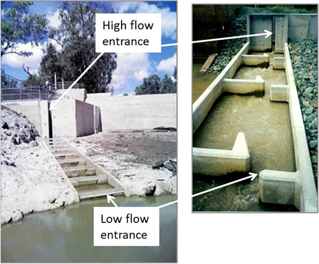

Figure 2.4: Two vertical-slot fishways with a low-flow entrance channel extending into the tailwater pool (left), and a higher channel wall and entrance slot for high tailwater conditions (right). (photos: A. Berghuis and I. Stuart)

Fishway discharge
Fishway discharge is a function of the geometry and the water velocity. Fishway discharge influences fish attraction at the entrance, and also the ability of the fishway to operate at low flows. A strong discharge of water from a fishway is a key factor in attracting fish, but many fishways (especially vertical-slot, fish lock and partial-river-width rock-ramp fishways) discharge only a small percentage of river flow; for example, most Murray River fishways would discharge less than 1% of the water flowing past the weir. Therefore, for these types of fishways there is also a need to specify a minimum head loss (velocity) at the entrance, where fish enter the fishway at the downstream end, to ensure there is acceptable attraction of fish at high tailwater (see Tables 2.3 and 2.6 for design standards for fishway entrances). This is because at high tailwater (caused by a high tide or high river flow) the water velocity at the entrance is reduced as water backs up through the fishway, and this reduces the attraction of the entrance to migrating fish. Integrating auxiliary water into the
minimum head loss criterion is also recommended.

Unlike vertical-slot, fish lock and partial rock-ramp fishways, full-river-width rock-ramp fishways discharge 100% of water in small to medium rivers, so they have excellent fish attraction and the fish entrance location can be anywhere across the river channel.

All fishways require water to operate, and this needs to be considered in the design phase. Once again, flow duration curves can be used to design a fishway that uses the amount of water that is available in the system. In regulated rivers, fishway watering requirements need to be incorporated into environmental flow recommendations and all releases (including irrigation releases) should be

first directed down the fishway until it reaches its design discharge volume, after which the flow should be directed towards optimal fishway attraction (see O’Connor et al. 2015 for details on optimising fishway attraction).

Auxiliary water
Auxiliary water is the introduction of additional water to enhance fish attraction to the entrance of the fishway. Auxiliary water is supplied through a delivery system such as pipes, culverts, diffusers or overfall weirs, and these are usually located within the fishway entrance area, in the walls or floor (Figure 2.5). The extra water must be introduced at low velocity, turbulence and aeration. Auxiliary water systems have recently been included on several Victorian fishways (e.g. Dights Falls and the Barwon River barrage vertical-slot fishways). It is important that the auxiliary water is high-quality water sourced from near the surface of the headwater.

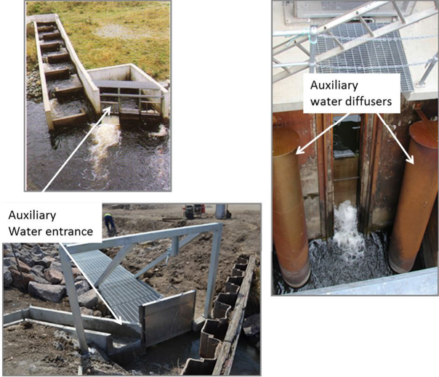
Figure 2.5: Auxiliary water systems for providing extra fish-attracting water adjacent to a fishway entrance: overfall weir (top left); small culvert (bottom left); and twin vertical diffusers (right). (photos: I. Stuart)

Location
To efficiently attract fish to the fishway entrance, it must be located at the ‘upstream limit of migration’ for upstream migrants or ‘downstream limit of migration’ for downstream migrants, confirmed by flow vectors, water velocity and observations of zones of intense turbulence. The fishway entrance is also generally located on the bank because fish tend to migrate along the banks. The location of the fishway entrance should also ensure that its orientation does not create flow vectors no more than 90° from centreline of stream, i.e. no recirculation or eddies (see Table 2.3 (Section 2.5) for design standards for fishway entrances).

Summary of key entrance criteria

- The fishway entrance must be accessible under all flows.

- The fishway entrance must be at the ‘upstream limit of migration’.

- The fishway entrance is generally located at the bank, because fish tend to migrate along the banks.

- For rock-ramp fishways, a full-river-width fishway provides optimal entrance efficiency.

- In very wide rivers, a second fishway can be considered so that there are fishways on both banks.

- The integrity of the fishway entrance flow needs to be maintained (e.g. fish are not attracted to flow over the spillway).

- There should be no hydraulic barriers downstream of the fishway entrance.

- The fishway entrance should not be within a recirculation eddy or reverse flow area.

- Attraction flows should be appropriate for all sizes of fish.

- Attraction water should be sourced from high-quality surface water.

- Auxiliary water (attraction flow) can be useful for increasing fish attraction towards the entrance of the fishway.

    - Passage through the fishway

Water velocity
Water velocity is a fundamental performance standard of fish passage and is determined by the swimming ability of the target fish species. Within fishways, maximum water velocity is a common measure. It can be measured in the field using the difference in adjacent water levels, or head loss. This parameter is an important design input and is determined by the slope of the fishway. (Refer to Tables 2.4 and 2.6 in Section 2.5 for guidance on maximum and minimum velocities for passage through fishways.)

Slope of the fishway
The slope of the fishway, also called the gradient or inclination, determines the velocities of water within the fishway and needs to be suitable for the swimming ability of the target fish species. Many Australian fishways built in the last decade have a gradient of 1 m vertical rise for every 25 m of horizontal length (1v : 25h), or even lower slopes of 1v : 30h. Fishway slope can be calculated by dividing the head loss per pool into the pool length. For example, on the Murray River the Torrumbarry fishway has a 0.165 m head loss per pool and a pool length of 3 m, so the slope is
1v : 18h. (Alternatively, this may be expressed as percentage slope, i.e. 100/18 = 5.5%). Lock 8
fishway, also on the Murray River, has a more conservative slope of 3.1% (1v : 32h). (Refer to Tables
2.4 and 2.6 in Section 2.5 for fishway slope design standards.)

Head loss
Head loss refers to the difference in water level (step height) between two adjacent pools of a fishway; it is important because it determines the maximum water velocity in the fishway (Mallen-

Cooper 2000b). The head loss between adjacent pools will relate to the velocity of water moving between pools of the fishway. This velocity, combined with turbulence (see below), will be a major factor governing the ascent of fish. Determining the swimming ability of the target species and the size classes of the fish are important at design stages in order to determine what the maximum velocity should be. Head loss between pools is typically 0.1 m for inland vertical-slot fishways where there are small fish, 0.12–0.15 m for inland rivers with large fish, and 0.05–0.07 m for coastal systems with very small fish. Head loss is not a generic design element but a unique site-specific design decision based on the local fish assemblage. Specifications regarding head loss for rock ramp fishways are broadly similar to those for vertical-slot fishways, but rock-ramp fishways can have far more hydraulic diversity because of their complex nature. (Refer to Tables 2.4 and 2.6 in Section 2.5 for head loss design standards.)

Turbulence
Turbulence is another key parameter in fishway design. Turbulence is the haphazard secondary motion caused by eddies within a moving fluid; a stretch of turbulent water in a river occurs when one current flows into or across another current. Turbulence (Figure 2.6) is now recognised as an important factor for fish ascending fishways, particularly for small fish (Mallen-Cooper et al. 2008). Within the fishway turbulence is the measure of the energy dissipation from water flowing into a fishway pool and is related to the pool volume and the head loss (water velocity) of each pool. The volume of the pool is determined by the dimensions (length, width and depth), and the energy is determined by the discharge (Q) (see Box 1) of water into each pool (determined by head loss and slot width). High turbulence can be a barrier to fish passage because quiet-water resting areas are effectively eliminated.

In Australia before 1995, it was recommended that Murray–Darling Basin fishways to have a turbulence level of 105 W/m3 (measured in Watts per cubic metre; W/m3), but two decades later this was reduced to 25 W/m3 for small fish (Mallen-Cooper et al. 2008; Stuart et al. 2008). It is important to note that the turbulence equation results in a single number that is an average and thus overestimates the turbulence in the quiet zones of a fishway pool (i.e. behind the baffle) and underestimates it in the high-energy areas (i.e. the impact zone on the channel wall immediately downstream of the slot). The average turbulence figure is simply a convention and broadly reflects fishway pool hydraulics determined by the swimming ability of the weakest of the target fish species. Turbulence affects the swimming ability of fish (particularly small fish), and current data indicate that average turbulence must be very conservative (i.e. <30W/m3) to pass small fish in a vertical-slot fishway (O’Connor et al. 2015). (Refer to Tables 2.4 and 2.6 in Section 2.5 for guidance on turbulence design standards.)

Box 1. Discharge equation
Discharge is often expressed by engineers in cumecs (cubic metres per second or m3/s), but many fish biologists work in ML/day; the conversion is 1 cumec = 86.4 ML/day. The fishway discharge equation is:
Q = Cd × (V × A) where:
Q = discharge (ML/d)
Cd = coefficient of discharge (usually 0.7)
V = water velocity (m/s)
A = slot area.
For a vertical-slot fishway with 1.4 m/s water velocity, 0.3 m–wide slots, 1 m pool depth, the discharge is:
Q = 0.7 × (1.4 × 0.3) = 0.294 m3/s = 25.4 ML/d (i.e. 0.294 × 86.4).
When citing discharge (Q) and turbulence, it is an important convention to define the coefficient of discharge (Cd)—which is a measure of the drag (or resistance) of water in a fishway. For most vertical-slot fishways Cd will be close to 0.7.

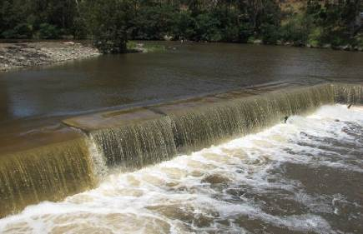

Figure 2.6: Turbulence at Dights Falls, Yarra River.

Slot design
Slot configuration is used to manipulate the two major hydraulic characteristics used in the design of vertical-slot fishways: turbulence in the fishway pool and the maximum water velocity in the slot between each pool. These two parameters directly influence the gradient, length and cost of these fishways (Mallen-Cooper et al. 2008). In Victorian coastal streams the slot width is generally 150 mm wide to accommodate the size range of species in these systems (Figure 2.7). In the Murray–Darling Basin the slot width is 300 mm wide to accommodate the larger fish in these systems (Figure 2.8).

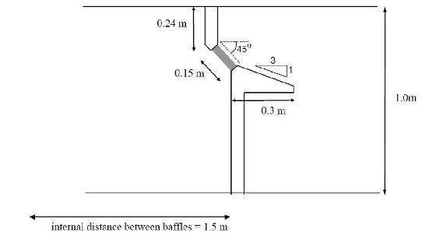
Figure 2.7: Details of a standard vertical-slot baffle for a coastal fishway. The slot width shown is 0.15 m (from Mallen-Cooper 1993).

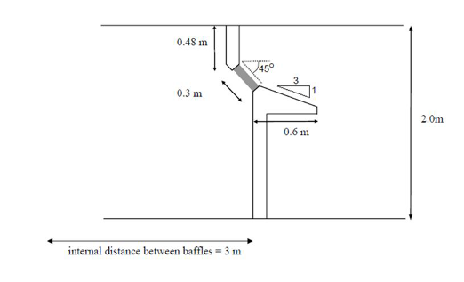

Figure 2.8: Details of a standard vertical-slot baffle for a Murray–Darling Basin fishway. The slot width shown is 0.3 m (from Mallen-Cooper 1993).

Fishway sills
A sill can be incorporated into a slot design and can be used to adjust the discharge and functionality of fishway. Sills have only recently been incorporated into fishway design and practice in Victoria. Adding middle sills can increase passage of small-bodied fish 6 to 13 times compared with an unmodified fishway (Mallen Cooper 2008). However, sills have the disadvantage of reducing fishway discharge and therefore attraction of fish to the entrance.

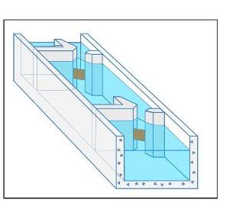

Figure 2.9: Concept of a vertical-slot fishway with middle sill block-outs, which reduce pool discharge and turbulence for optimal ascent of abundant numbers of small-bodied fish (e.g. 15+ mm long). (drawing by M. Mallen-Cooper)

Key-hole slot design
New key-hole slot designs are now preferable to the traditional rectangular designs because they can pass a greater range of fish sizes (Figure 2.10). For example, a slot size of up to 250 mm can pass fish up to about 650 mm long, while a slot size of 150 mm can pass fish as small as 40 mm long.

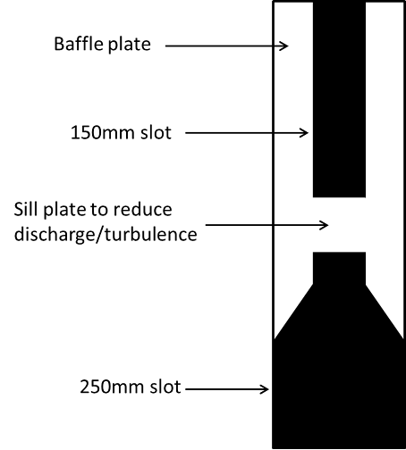

Figure 2.10: A vertical slot with a modified key-hole sill installed to reduce discharge and pass large fish at the bottom and small fish at the top.

Fishway pool size and capacity
The dimensions of the pools of the fishway, apart from controlling for turbulence, must also be large enough for the species to physically fit within the pool and still be capable of swimming or resting. The depth of the pool should also provide some protection against predation from birds, etc. Another consideration is ‘capacity’ or ‘run size’, where large numbers of fish migrate over a short time-span. High biomass events where fish may ‘bottleneck’ in fishways are rare in Victoria, but may be an issue in tidal fishways where fish access is restricted to a few hours at high tide, or when fish are escaping blackwater, or when a large number of schooling fish such as Common Carp are seasonally migrating (Conallin et al. 2012).

Turning pools

In vertical-slot and Denil fishways (see Appendix 1) there are often corners and bends where the fishway channel turns through 90° or 180° as it ascends from the entrance to the exit. Hydraulically, this means that the water must also turn, and this alters the hydraulics of a standard pool. To ensure that the hydraulic function of a turning pool is adequate for fish passage, there are two criteria that need to be observed: (i) a 90° bend needs 1.5 times the standard pool volume of the fishway, and (ii) a 180° bend needs 2.5 times the standard pool volume. In low headloss fishways (e.g. 50 mm drop per pool) the turning pool hydraulics appear to be less sensitive than for higher head loss fishways
(e.g. 150 mm drop per pool). In addition, the slot arrangement can also affect the turning pool hydraulics. The optimal arrangement is shown in Figure 2.11.

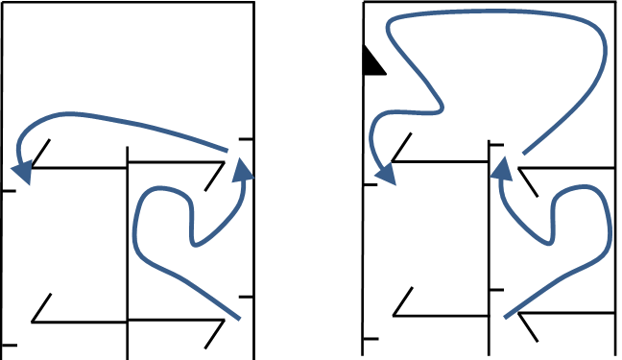

Figure 2.11: A fishway turning pool with (left) the slot aligned to the outside of the channel wall, which causes water to ‘short-circuit’, creating uneven hydraulics, and (right) the slot aligned on the inside of the channel to guide water into the far corner of the turning pool. The black triangle represents a flow-guiding device that may also have hydraulic merit. (concept:
S. Slarke, Jacobs)

Resting pools
There is no definitive study on the maximum length of a fishway for Australian fish, but research has demonstrated that in long fishways some fishes (e.g. juvenile galaxias and Bony Herring, Nematalosa erebi) may not complete their ascent during daylight, and may descend the fishway when the light fades (Mallen-Cooper 1999; Amtstaetter et al. 2015b). Large resting pools may enable fish to remain overnight in a long fishway, but more data are required to confirm whether this behaviour occurs. Very small fish require quiet resting areas before completing their ascent of a long fishway. For example, Torrumbarry fishway is 130 m long, and small fish can take six hours to ascend.

Resting pools have four times the volume of standard pools and are often included in vertical-slot, Denil, rock-ramp and bypass fishways. They allow fish to rest in quiet water as they make their way through a long fishway, instead of returning downstream. There are no strict rules for the inclusion of a resting pool, especially in coastal rivers, as there are few field evaluations. However, a preliminary criterion is that a resting pool should be used for every 1 m rise in vertical elevation. The slot configuration and flow guides can be the same as those used in turning pools.

2.4.4 The fishway exit

At the exit of the fishway, it is important to ensure fish are not swept back downstream because of the orientation of the exit with respect to the upstream flow pathways. Flow vectors should not vary more than 90° from the centreline of the stream, i.e. no recirculation or eddies. It is also recommended that maximum water velocity at the exit in the weirpool or impoundment is 0.05 m/s for small fish (20–100 mm), 0.15 for medium fish (100-200 mm) and 0.30 m/s for medium and large fish (200–1400 mm). (Refer to Table 2.3 in Section 2.5 for design standards for fishway exits.)

Other factors to consider in the design of the fishway exit are that the exit should be placed near and orientated towards the bank (because fish tend to move along banks), the depth of the exit must be the same as the depth of the fishway, and the exit location must not be adjacent to the spillway or turbine intakes. Managing these considerations will allow fish to quickly orientate themselves upstream without being swept back downstream in the fishway, over the spillway or through turbines.

Fishway trash racks
The fishway exit should also have a trash rack installed to avoid a build-up of debris within the fishway which could lead to blockages. Fishway exit screens (trash racks) are essential for minimising the amount of floating debris entering the fishway (Figure 2.12). Debris can also block the slots between pools, altering the hydraulic conditions throughout the fishway. When a partial blockage is present, the headwater rises upstream of the blockage, resulting in a larger head loss in the downstream pool. This can alter the performance of the fishway and prevent smaller fish from being able to successfully ascend. Cleaning the trash racks is essential for ensuring that the functionality of the fishway is maintained, and is typically undertaken by the structure owner or the water authority.

Trash racks should have a 45–52° slope, to allow debris to rise to the surface, and constitute three times the area of the fishway channel to maximise the surface area filtered. The design of the trash rack can vary; however, vertical bars tend to self-clean. Floating booms can also be used to deflect large debris in waterways with high velocities. Floating booms should be angled at 45° to deflect debris, and be positioned in the headwaters.

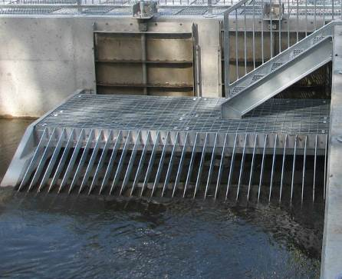
Figure 2.12 Exit of the Dights Falls fishway.

Recommended fishway design parameters

Fishway designers should endeavour to follow the fishway design standards outlined in this section. These standards should be used for effective fish passage and are formulated from contemporary information and the experience of fishway experts. Tables 2.3–2.5 outline design standards for fishway entrance, passage through the fishway and the exit. Table 2.6 provides recommended contemporary guideline standards, which have been developed over a number of years from various studies, monitoring programs and expert opinion. Each fishway will have a unique set of parameters and site conditions to work with, but generic design principles can be applied.

Table 2.3: Hydraulic design standards for fishway entrance and exit.

(modified from Mallen-Cooper 2000a)

Performance criteria | Hydraulic performance standard
Attraction  (For both upstream- and downstream- migrating fish)  Fish locate fishway entrance over operational flow range  Fish enter fishway | For upstream- and downstream-migrating fish:  - Flow vectors do not vary more than 90° from the centreline of stream,  i.e. no recirculation or eddies (see Figure 3.10c in Section 3).  - ntrance is at the ‘upstream limit of migration’ for upstream migrants or ‘downstream limit of migration’ for downstream migrants (confirmed by flow vectors, water velocity and observations of zones of intense turbulence).  - inimum depth leading to entrance is:  0.3 m depth for small fish (20–100 mm)  1.0 m depth for medium and large fish (100–1400 mm). For upstream-migrating fish:  - ntrance discharge is not masked by other flows, i.e. ‘integrity of fishway flow’ is maintained.  - Minimum head loss at entrance is maintained: 20 mm for small fish (20–100 mm)  80 mm for medium and large fish (100–1400 mm).  (vi) Maximum head loss at entrance does not exceed: 100 mm for small fish (20–100 mm)  150 mm for medium and large fish (100–1400 mm).
Exit  Fish leave fishway and continue migrating upstream or downstream | For upstream- and downstream-migrating fish:  - Flow vectors do not vary more than 90° from the centreline of the stream, i.e. no recirculation or eddies.  - inimum depth leading from exit is:  0.3 m for small fish (20–100 mm)  1.0 m depth for medium and large fish (100–1400 mm). For upstream-migrating fish:  (iii) The maximum water velocity at the exit in the weirpool/impoundment is:  0.05 m/s for small fish (20–100 mm)  0.30 m/s for medium and large fish (100–1400 mm).  (iv) There is less than 20 mm head loss across trash racks.

Table 2.4: Hydraulic design standards for passage through fishways.

(modified from Mallen-Cooper 2000a)

Hydraulic Hydraulic performance standard performance
criteria
Minimum depth in fishway | Vertical-slot fishways, fish locks:  0.40 m minimum depth (0.5 m desirable) for small fish (20–100 mm)  0.75 m minimum depth (1.0 m desirable) for medium fish (100–650 mm)  1.0 m minimum depth (1.5 m desirable) for large fish (650–1400 mm). Rock-ramp fishways:  Criteria are presently being refined for rock-ramp fishways. Preliminary standards for the ‘ridge design’, which is a series of pools and ridges, include: Minimum depth of 0.3 m for 50% of the pool surface area, for small to medium fish (20–150 mm)  Minimum depth of 0.5 m for 50% of the pool surface area, for medium fish (150–400 mm)  Same minimum depths above and below 50% of gaps in ridge rocks Same minimum depth, providing a continuous path between ridges Minimum depth of 0.15 m for 50% of ridge-rock gaps, for small fish (20– 100 mm)  Minimum depth of 0.3 m for 50% of ridge-rock gaps, for medium fish (20– 400 mm).  Preliminary standards for the ‘random-rock design’ (like a roughened channel without discrete pools) include:  A minimum depth of 0.3 m for a minimum 2 m of channel width, for small fish (20–100 mm)  A minimum depth of 0.4 m for a minimum 3 m of channel width, for medium fish (100–400 mm)  Providing a continuous path of the minimum depth from top to bottom of the ramp.  Note: there are little data available concerning the minimum depth in rock fishways for large fish (> 400 mm).

(continued on next page)

Table 2.4 (continued)

Hydraulic Hydraulic performance standard performance
criteria
Maximum water velocity | Determined using head loss between baffles or pools and needs to be interpreted together with turbulence.  Vertical-slot fishways, fishlock entrance or exit. Head loss:  0.075 ± 0.015 m for small fish (30–50 mm)  0.100 ± 0.020 m for small fish (40–100 mm)  0.165 ± 0.035 m for medium and large fish (100–1400 mm). Rock-ramp fishways: ridge design  0.075 ± 0.015 m for very small fish (15–40 mm)  0.100 ± 0.02 m for small fish (40–100 mm). Connecting channels  Head loss is not applicable and direct measurement of velocity is used:  < 0.03 m/s for small fish > 20 mm  < 0.10 m/s for medium fish > 100 mm  < 0.30 m/s for medium fish > 300 mm.
Turbulence | Not directly measured on site, but calculated from head loss and pool volume (see Appendix 1):  Vertical-slot fishways  < 30 W/m3 (using Cd = 0.7) for small-bodied fish >25 mm  < 60 W/m3 for medium fish > 90 mm  < 90 W/m3 for medium fish > 150 mm. Rock-ramp fishways (ridge-rock design)  < 30 W/m3 in pools.  Denil fishways  < 10 W/m3 in resting pools. Fish locks  < 20 W/m3 in lock chamber.
Hydraulic gradient | Denil fishways, rock-ramp fishways: random-rock design  Headwater depth entering fishway channel ≤ tailwater depth leaving fishway channel, within specified operating range of fishway.
Downstream passage | Regulator gates overshot, not undershot (the latter causes mortality of larvae and juveniles).  For weirs, the plunge pool downstream of the crest provides a depth that is  > 40% of the difference between the upstream and downstream water levels  (i.e. the head differential).  For large dams, spilling water at the base of the dam has a gradual deceleration of 1.5 m/s2 per metre distance.  No dissipaters or structures on the downstream apron that could impact fish. (Note: these are criteria developed in the last 5 years, and many weirs may not comply).

Table 2.5: Physical design standards for passage through fishways.

(modified from Mallen-Cooper 2000a)

Performance criteria Physical performance standard
Minimum space | Pool size (internal measurements)  1.5 m long ⋅ 1.1 m wide, maximum fish length of 150 mm  2.0 m long ⋅ 1.5 m wide, maximum fish length of 500 mm  3.0 m long ⋅ 2.0 m wide, maximum fish length of 1200 mm  3.5 m long ⋅ 2.0 m wide, maximum fish length of 1400 mm. Slot width of baffle, or gap in ridge rocks of rock-ramp fishways  0.10 m, maximum fish length of 150 mm  0.15 m, maximum fish length of 450 mm  0.25 m, maximum fish length of 650 mm  0.30 m, maximum fish length of 1000 mm 0.35–0.40 m, maximum fish length of 1400 mm. Denil channel width (internal)  0.325 m, maximum fish length of 600 mm  0.400 m, maximum fish length of 1200 mm. Length – will vary depending on the species
Light | >200 lux

Table 2.6: Recommended physical and hydraulic standards for vertical-slot and rock-ramp fishways.

Vertical-slot fishway (generally suitable for up to 6 m head differential)

Fish length (mm) | Target depth (m) | Min pool volume (L) | Min slot width (mm) | Target turbulence (Wm3) (Cd  of 0.7) | Max slot water velocity (ms-1) | Slope | Pool to pool head loss (mm) | Min head loss @ entrance (mm) | Max water velocity  @ fishway exit channel (ms-1) | Entrance and exit flow vectors (degrees  from stream centreline) | Head loss @ trash racks (mm) | Min plunge  pool depth of weir for DS  migrants | Weir style for DS migrants | Location of entrance and exit, respectively
20– | > 0.5 | 825 (i.e. | 100 | <25 | <1.20 | >1:30 | <75 | 45 | 0.05 | <900 from | <20 | 40% of | Overshot | U/S or D/S
100 |  | 1.5 x 1.1 m) |  |  |  |  |  |  |  | stream |  | max head |  | of
 |  |  |  |  |  |  |  |  |  | centreline, |  | differential |  | migration
 |  |  |  |  |  |  |  |  |  | no |  |  |  | limit
 |  |  |  |  |  |  |  |  |  | recirculation
100– | > 0.75 | 2800 (i.e. | 150 | <30 | <1.40 | >1:30 | <100 | 60 | 0.15 | <900 from | <20 | 40% of | Overshot | U/S or D/S
200 |  | 2.5 x 1.5 m) |  |  |  |  |  |  |  | stream |  | max head |  | of
 |  |  |  |  |  |  |  |  |  | centreline, |  | differential |  | migration
 |  |  |  |  |  |  |  |  |  | no |  |  |  | limit
 |  |  |  |  |  |  |  |  |  | recirculation
200– | > 1.0 | 5000 (i.e. | 250 | <50 | <1.6 | >1:25 | <120 | 72 | 0.3 | <900 from | <20 | 40% of | Overshot | U/S or D/S
700 |  | 2.5 x 2 m) |  |  |  |  |  |  |  | stream |  | max head |  | of
 |  |  |  |  |  |  |  |  |  | centreline, |  | differential |  | migration
 |  |  |  |  |  |  |  |  |  | no |  |  |  | limit
 |  |  |  |  |  |  |  |  |  | recirculation
700+ | > 1.5 | 10500 (i.e.  3.5 × 2 m) | 350 | <50 | <1.8 | >1:20 | <165 | 100 | 0.3 | <900 from stream | <20 | 50% of max head | Overshot | U/S or D/S of
 |  |  |  |  |  |  |  |  |  | centreline, |  | differential |  | migration
 |  |  |  |  |  |  |  |  |  | no |  |  |  | limit
 |  |  |  |  |  |  |  |  |  | recirculation

Min = minimum, max = maximum, US = upstream, DS = downstream.

Guidelines for the design, approval and construction of fishways 31

Table 2.6 cont.: Rock-ramp fishway (generally suitable for up to 3 m head differential)

Fish length | Target depth | Min. pool volume (L) | Min. slot | Target turbulence | Max. slot water | Slope | Pool to | Min. head | Max. water | Entrance  and exit flow | Lateral ridge | Min plunge pool depth | Weir style for | Location of | entrance
(mm) | (m) |  | width | (W/m3) | velocity |  | pool | loss at | velocity | vectors | slope | of weir for | DS
 |  |  | (mm) | (Cd = 0.7) | (ms-1) |  | head | entrance | at fishway | (degrees | (site- | DS migrants | migrants
 |  |  |  |  |  |  | loss | (mm) | exit (ms-1) | from stream | specific | (partial | (partial
 |  |  |  |  |  |  | (mm) |  |  | centreline) | decision) | width) | width)
20– | > 0.3 | 1500 (i.e. | 100 | < 25 | < 1.20 | > 1:3 | < 75 | 45 | 0.05 | < 90° from | > 1:6 | 40% of | Overshot | US/DS of | US of
100 |  | 2.5 × 2 m) |  |  |  | 0 |  |  |  | stream |  | max. head |  | migration | migration
 |  |  |  |  |  |  |  |  |  | centreline, |  | differential |  | limit | limit
 |  |  |  |  |  |  |  |  |  | no
 |  |  |  |  |  |  |  |  |  | recirculation
100– | > 0.5 | 2500 (i.e. | 150 | < 30 | < 1.4 | > 1:3 | < 100 | 60 | 0.15 | < 90° from | > 1:6 | 40% of | Overshot | US/DS of | US of
200 |  | 2.5 × 2 m) |  |  |  | 0 |  |  |  | stream |  | max. head |  | migration | migration
 |  |  |  |  |  |  |  |  |  | centreline, |  | differential |  | limit | limit
 |  |  |  |  |  |  |  |  |  | no
 |  |  |  |  |  |  |  |  |  | recirculation
200– | > 0.6 | 6000 (i.e. | 250 | < 50 | < 1.6 | > 1:2 | < 120 | 72 | 0.3 | < 90° from | > 1:6 | 40% of | Overshot | US/DS of | US of
700 |  | 4.5 × 2 m) |  |  |  | 5 |  |  |  | stream |  | max. head |  | migration | migration
 |  |  |  |  |  |  |  |  |  | centreline, |  | differential |  | limit | limit
 |  |  |  |  |  |  |  |  |  | no
 |  |  |  |  |  |  |  |  |  | recirculation
700+ | > 1.0 | 10,000 | 350 | < 50 | < 1.8 | > 1:2 | < 120 | 90 | 0.3 | < 90° from | > 1:6 | 50% of | Overshot | US/DS of | US of
 |  | (i.e. |  |  |  | 0 |  |  |  | stream |  | max. head |  | migration | migration
 |  | 4 × 2.5 m) |  |  |  |  |  |  |  | centreline, |  | differential |  | limit | limit
 |  |  |  |  |  |  |  |  |  | no
 |  |  |  |  |  |  |  |  |  | recirculation
US = upstream, DS = downstream

Quality control

There are several ways to ensure a fishway design meets current best practice. These include:

- peer review

- continuity of designers

- fishway modelling (see below)

- dry and wet commissioning (see Section 4.4)

- ecological evaluation (see Jones and O’Connor 2017).

We recommend that the collaborative design team conducts regular reviews of the concept and detailed designs, with independent peer review highly recommended, especially where there are ecologically sensitive species and where there is significant capital expenditure.

2.6.1 Fishway modelling

During the fishway design process, consideration should also be given to fishway modelling. Hydraulic modelling provides a convenient and cost-effective means to characterise and predict the behaviours of environmental systems (Karisch and Power 1994). For structures that are large and likely to be expensive to build, or are complex (with multiple interactions with other structures, e.g. dams or hydroelectricity plants), physical models (e.g. Figure 2.13) or 2D and 3D computer-based models (e.g. Figure 2.14) can be used to inform the decision-making process. Modelling allows hydraulic parameters such as turbulence and velocity to be accurately predicted with respect to the design. Fishway entrance conditions can be difficult to predict because of the range of interacting factors, and physical and computer-based models can be used optimise each design element to ensure suitable fishway attraction conditions. Modelling hydraulic conditions around the design minimises the chances of a major oversight and therefore poor fish passage outcomes. Modelling can often result in significant design modifications, and it is important to identify at what stage in the design process it is best to undertake modelling, especially for entrance conditions,
location of the fishway, etc. Timing of modelling is also likely to differ depending on whether the barrier is a new structure or the fishway is being retrofitted.

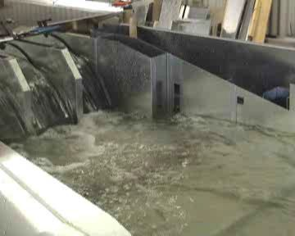

Figure 2.13: Example of a physical model. (photo: M. Mallen-Cooper)

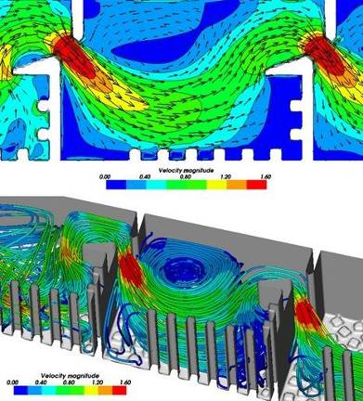

Figure 2.14: Example of a computational fluid dynamics model showing velocity gradients of a physical model.

Fishway approval

Construction of new in-stream structures—legislation and policy to protect fish passage

Victoria has significant legislation and guidelines to protect fish passage during the installation of in-stream structures. Legislation includes the Water Act 1989, the Conservation, Forests and Lands Act 1987, the Crown Land (Reserves) Act 1978 and the Flora and Fauna Guarantee Act 1988. Policy guidelines include the Victorian Waterway Management Strategy (DEPI 2013), the Victorian River Health Strategy 2002, the various catchment management authority (CMA) Regional Catchment Strategies, the Melbourne Water Community Environment Public Health Assessment (CEPHA) checklist (Melbourne Water Corporation 2008) and the Murray–Darling Basin Native Fish Strategy 2003–2013 (MDBC 2004). Practical guidelines include the Technical Guidelines for Waterway Management (DSE 2007), the Guidelines for Assessment of Applications for Permits and Licences for Works on Waterways (SKM 2001) and Performance, Operation and Maintenance Guidelines for Fishways and Fish Passage Works (O’Connor et al. 2015).

    - Water Act 1989 (Vic.)

The Water Act 1989 stipulates that works on waterways such as the construction of dams, weirs and erosion control structures should be licensed. The responsibility for the regulation of works in waterways has been entrusted to the relevant CMAs. The CMAs develop and implement river protection and restoration programs in accordance with the priorities of Government, Regional Catchment Strategies and River Health Strategies and in partnership with local communities. The authorisation of works by CMAs is generally by the Authority’s Waterways Protection By-law. The Water Act also stipulates that water authorities cannot abandon major works on waterways without the approval of the Minister. The social, economic and environmental impacts need to be considered in the submission, including the potential positive environmental benefits of increasing fish passage. The Water Act states that Ministerial approval is required when ownership of a structure and the water entitlement (Licence to Take and Use Water or Licence for In-stream Use of Water) is to be transferred. Under these provisions the transfer can be rejected, or additional conditions can be stipulated for the transfer (such as the provision of fish passage).

    - Conservation, Forests and Lands Act 1987 (Vic.)

The Conservation, Forests and Lands Act 1987 requires all public authorities to submit plans of works to the Secretary of DELWP for comment, where works involve ‘construction of dams, weirs or other structures in or across watercourses which potentially interfere with the movement of fish, or the quality of aquatic habitat’. Under the Conservation, Forests and Lands Act and the Crown Land (Reserves) Act 1978, DELWP needs to consider whether the in-stream structure is on a waterway that may be on Crown or freehold land. If the works are on Crown land, the application process requires exposure to a wide cross-section of community viewpoints. DELWP has limited control over activities on freehold land.

    - Flora and Fauna Guarantee Act 1988 (Vic.)

The Flora and Fauna Guarantee Act 1988 provides specific protection of fish passage by noting that the ‘prevention of passage of aquatic biota as a result of the presence of in-stream structures’ is a potentially threatening process and that ‘there should be no further preventable decline in the viability of any rare species’.

    - Fisheries Act 1995 (Vic.)

The Fisheries Act 1995 provides protection of aquatic habitat through two provisions relating to maintaining fish habitat and protection of specific fish species. The Fisheries Act has regulatory powers to prevent blockage of fish passage by a net or other material that causes an obstruction within a bay, inlet, intertidal flat, river or creek.

The River Murray Act 2003 (South Australian Government, 2009) protects catchments in the part of the Murray–Darling Basin that is in South Australia. This Act contains river health objectives, including avoiding and overcoming ‘barriers to the migration of native species within the River Murray system’ and ensuring that the Murray River mouth is ‘kept open in order to maintain navigation and the passage of fish in the area’.

    - Environment Effects Act 1978 (Vic.)

The Environment Effects Act 1978 may also trigger relevant fish passage issues during local planning applications. This Act provides the necessary legislation for the state ministers, local government and statutory authorities to make informed decisions about whether a project with potentially significant environmental effects should proceed. If the Minister for Planning decides that there is potential environmental impact, an Environment Effects Statement (EES) must be provided to the public and relevant government departments and authorities for comment. Drainage, waterways and surface water quality and flows are considered to be relevant environmental assets requiring consideration under the guidelines of this process (administered by the Department of Planning and Community Development). In those cases where an EES is not required, an assessment of environmental impacts may still be required under the Planning and Environment Act 1987 (Victoria) or the Environment Protection Act 1970 (Victoria).

    - Environment Protection and Biodiversity Conservation Act 1999 (Cwlth)

The Commonwealth Environment Protection and Biodiversity Conservation Act 1999 may require assessment and approval where a significant impact on a specified matter of national environmental significance could occur. A Cultural Heritage Management Plan is also mandatory under the provisions of the Aboriginal Heritage Act 2006 (Victoria).

    - Victorian River Health Strategy (2002)

The Victorian River Health Strategy (DSE 2002) states that CMAs, Melbourne Water, and Southern Rural Water will only give approval for works on waterways if they maintain or improve the environmental value of the site and surrounds, and new structures must include provision for fish passage.

    - Guideline documents

Implementation guidelines for Water Authorities to assist in compliance with the legislative requirements were issued by the DSE Secretary in 2005. These stipulate that ‘Water Authorities shall, when constructing, renewing or refurbishing a dam or existing structure on a waterway ensure that works are undertaken in accordance with current environmental practice, including any requirements to better provide the Environmental Water Reserve (EWR) and fish passage’. The guidelines outline the fish passage objectives that will be taken into account on a case-by-case basis before any exemption from these guidelines is approved.

Works on Waterways permits are required for a number of in-stream activities, including river crossings (bridges, culverts, fords), river deviations (realignments), sediment extractions, erosion control and bank stabilisation, vegetation removal, and other major works (including stormwater, drop structures and service crossings) (NECMA 2009). The CMAs are responsible for site inspections, ensuring compliance with legislation and guidelines, and issuing permits. A sample CMA permit, including standard conditions such as not impeding fish passage is provided in Appendix 4. Critical fish passage permit conditions include ‘any works in the bed of the waterway should be designed and constructed so as not to impede fish passage’ and ‘works shall always be maintained in good order.’

    - Legislation and policy effectiveness

While there appears to be sufficient legislation and policy guidelines to mitigate the impacts on fish passage during the construction of new in-stream structures, there is a lack of consistency in how different organisations obtain approvals, assess works and implement fish passage requirements. Victoria is not in a large dam-building phase at present, but other structures such as stream gauges, road crossings and flow regulators have been built recently. In some cases these appear to have been constructed without referral and often without a consistent and current ‘best practice’ approach to fish passage. Unfortunately it is

difficult to quantify the number of new structures constructed in Victoria each year. There is no central register of in-stream structures, apart from the asset records maintained for hazardous or large dams and the stream gauging network managed by DELWP. Advice from some CMAs is that the Works on Waterways process is not applied consistently for works, including for temporary stream gauges, repair works and road crossings. A centralised system for documenting all new in-stream structures and any associated permits or exemptions from fish passage obligations should therefore be established. The lack of clarity and consistency regarding the application of existing legislation would be significantly improved by the development of a comprehensive Statement of Obligations for Water Authorities and other owners and managers of in-stream structures. These obligations should outline responsibilities for all aspects of fish passage, including the design, construction, operation and maintenance of fishways to current best practice standards.

The legislation most relevant to the provision of fish passage in Victoria includes the Water Act, the Conservation, Forests and Lands Act and the Flora and Fauna Guarantee Act. The Water Act stipulates that major works on waterways, such as the construction of dams and weirs, must be licensed, and that all possible social, economic and environmental impacts, including fish passage, must be considered. The Conservation, Forests and Lands Act requires all public authorities to submit plans of works to the Secretary of DELWP for comment where works involve ‘construction of dams, weirs or other structures in or across watercourses which potentially interfere with the movement of fish, or the quality of aquatic habitat’. The Flora and Fauna Guarantee Act provides specific protection of fish passage by noting that the ‘prevention of passage of aquatic biota as a result of the presence of in-stream structures’ is a ‘potentially threatening process’ and that ‘there should be no further preventable decline in the viability of any rare species’.

There are also a number of strategies supporting fish passage, such as the Victorian River Health Strategy, CMA Regional Catchment Strategies, Melbourne Water’s Community Environment Public Health Assessment (CEPHA) checklist and the Murray–Darling Basin Native Fish Strategy 2003–2013, as well as guidelines from DELWP such as Technical Guidelines for Waterway Management and Guidelines for Assessment of Applications for Permits and Licences for Works on Waterways. These strategies and guidelines have been developed as best management practices in Victoria’s catchments. But while collectively they are extensive, there is a lack of consistency in how the various organisations obtain approval, assess works and implement fish passage requirements. Advice from policy staff indicates that, apart from some dam safety improvement works, few referrals for fish passage exemption are made, indicating that new structures are either fully compliant with fish passage requirements through the Works on Waterways permit, or that (as anecdotally reported) some works such as new stream gauges, road crossings and flow regulators have been constructed without sufficient referral or consultation.

Fishway construction

General

4.1.2 Fishway type

There are numerous fishway designs (Appendix 1), and each of these has their own unique construction challenges. But there are some generic principles that can be applied to most designs to ensure a streamlined process and enhanced outcomes. This section deals only with non-mechanical fishways (those with no moving parts, e.g. vertical slot, cone, Denil, trapezoidal and rock-ramp fishways). Mechanical fishways (those with moving parts, e.g. fish lifts and fish locks) are not discussed because these also have specialised construction challenges that are beyond the scope of this document.

2.1.3 Personnel

The construction of an effective fishway involves many skills. The inclusion of an experienced and multi- skilled team will reduce the risk of the project failing. This extends to the construction team; previous experience is particularly valuable for rock-ramp construction, where the optimum placement of rocks is critical. Multi-skilled teams include engineers, public representation, geomorphologists, biologists, hydrologists and Indigenous representation. Once again, clear, achievable objectives with a strong communication strategy among the expert team will ensure a good outcome.

Concrete fishways

Concrete fishways discussed here include vertical slot, cone, Denil and trapezoidal designs. Accurate construction is a key component of a successful fishway, and poor techniques can lead to partial failure of the fishway in meeting its ecological objectives. In some cases, poor construction techniques have led to considerable variation in for example vertical-slot widths, and in a few cases there has been poor adherence to the design invert for the slots. Either of these errors can lead to excessive head loss between pools, poor local hydraulics, and compromising of fish passage.

    - Concrete fishway construction protocols

To ensure each fishway meets consistent standards, a fishway construction protocol is provided below. Oversight by a fishway biologist is critical to determine how on-ground adjustments to a fishway design may affect fish behaviour and fish passage.

Construction planning and oversight

Ensure standard project management procedures are implemented during construction. Ensure the ‘for construction’ fishway designs are used.
Ensure strict adherence to the design specification, with small margins of tolerance (Table 4.1).

Any changes in design or dimensions are to be authorised by the design team (including a fish biologist) prior to implementation.

Auditing during construction

Regular site inspections are to be undertaken by the fishway biologist and/or design engineer at critical stages in construction. These should be at the beginning (outset), middle and pre-completion phases.
Ensure that any proposed design changes are approved by the fishway biologist and the design engineer. Ensure any alterations to the riverbed downstream of the weir do not affect the attraction ability of the
fishway entrance.

Final audit

While the fishway is dewatered, ensure all dimensions of the fishway are as per the ‘for construction’ design and within acceptable tolerances (i.e. dry commissioning).

While the fishway is dewatered, complete an ‘as-built’ feature survey of the fishway, slot inverts, rock control points, toe rocks, headwater and tailwater for quality control and for future reference.

Restore flow to the fishway, inspect, and adjust all hydraulic aspects as part of the wet commissioning. Make minor alterations, as required, to improve the functioning of the fishway.
Give final approval of the fishway, and implement the operations and maintenance plan.

Table 4.1: Design tolerances for vertical-slot, cone and rock-ramp fishways.

Design item Vertical-slot & cone tolerance Rock-ramp tolerance

Invert of hydraulic control point
±2 mm from design. ±5 mm from design.

Variation in slot width ±1.5% for adjacent baffles.
±3% along full length of fishway.
Match cross-sectional area of flow pathways throughout the fishway.

Hydraulic head loss ±5% from design per baffle. No head loss is to exceed 20% of design
(e.g. no head loss > 120 mm in a fishway designed for 100 mm).

Gridmesh Meets required standard.

Baffle and rock angle Angle of water jet conforms to design
standard without water jet turning directly downward, creating ‘carryover’ water velocity at next slot.

In lateral-ridge-rock fishways, the rocks in adjacent pools should not be aligned to limit carryover water velocity.

Rock fishways

Rock fishways discussed here include rock ramp (partial and full width) and natural bypass designs. In all of these designs it is important that ridge rocks, toe rocks and fill rocks are inspected and selected at the quarry before delivery to the site. Rocks should be high quality, square rather than round, and free from cleavage planes. More information is provided below.

    - Rock fishway construction protocols

- Full-river-width rock ramp fishways are the optimal design for low barriers (up to 1 m height) on most river systems.

- Fishways can have either random-rock style placement or lateral-ridge design.

- Rock-ramp fishways < 1.5 m high provide for high fish passage functionality.

- There should be a minimum longitudinal gradient (slope) of 1v : 25h.

- A lateral (bank-to-bank) gradient may be incorporated to increase the functional headwater range (gradient is a site-specific decision).

- Rocks must protrude from the water surface within the design operational range.

- Rock size is a site-specific decision, but generally 1.2 m diameter rocks embedded to 50–60% of their diameter into the fill rock are required.

- Rocks should be angular (not round), clean, sound, hard, of uniform quality and free from cleavage plane.

- Large-diameter rocks should protrude 0.3 m above the water surface.

- Larger fill rocks (e.g. 0.6 m diameter) are to be placed carefully to support the protruding rocks.

- Large protruding rocks should be spaced two diameters apart in a random-rock design.

- The rock-ramp fishway depth should be maximised (e.g. 0.3 m).

- In a lateral-ridge fishway, there should be a low (e.g. 80 mm) head drop between pools.

- Low pool turbulence (e.g. no white water) is to be achieved by using large (e.g. 2 m) pools.

- The toe (downstream footing of the fishway) is to be secured with two rows of large rocks at 1v : 3h grade for ramp stability, which should be large (e.g. 1.5–1.8 m diameter), buried to 1 m below bed level and buried into batters.

- Rocks and ridges are to extend the total width of the crest into the batters/banks.

- The fill rock size is to be determined by engineers, but should not be less than nominal D50 300 mm (range 0.1–0.3 m).

- The fill rock depth is to be determined by engineers, but should not be less than 0.5 m.

- Mixed media fill is to be augmented with fines (40 mm minus) to fill interstitial spaces.

- Use of geo-fabric to retain fines and surface flow is to be decided on a site-by-site basis.

- The site is to be revegetated as per local agency requirements.

Fishway commissioning

All fishways need to be commissioned. Adjustments are required due to unexpected site-specific issues, minor construction faults, and because the design process can never completely predict field conditions. Usually commissioning involves only minor structural or operational changes, but this ‘fine-tuning’ process can ensure a well-functioning fishway. Fishways should be both dry and wet commissioned, and adjusted at the pre-completion stage before the construction team leaves the site.

    - Dry commissioning process

- Confirm all levels, especially the invert of vertical slots and the control points of rock and cone fishways, are to design specification.

- Confirm all baffle angles are to design specification.

- Check rock-ridge fishways have unaligned ridge rocks between rows.

- Check stability of all rocks and the toe.

    - Wet commissioning process

Wet commissioning of the fishway comprises measuring the:

- head loss (difference between upstream and downstream water level) at each ridge in a rock ramp or natural by-pass fishway or baffle in a vertical slot, cone or trapezoidal fishway

- depths in the pools

- width and depth of the concrete structure and low-flow gap in rock fishways.

In rock fishways the irregular shapes of the rocks provide varying gaps between the ridges, and these can create differing cross-sectional areas through which the water can pass, which can in turn create high head losses, with high water velocities that prevent fish passage. Commissioning involves measuring the head losses, depths and low-flow slots at each ridge, identifying where these are outside the design parameters, and adjusting or adding rocks.

Wet commissioning, like the ecological assessment of fishways, has two main sections:

1. Attraction to the fishway entrance, which involves the flow patterns and turbulence below the weir and the fishway, and

2. Passage through the fishway, which involves the internal hydraulics of the fishway, such as depth, head loss and internal turbulence.

Attraction
The three principles for fish attraction that guide assessment and wet commissioning are:

1. The fishway entrance needs to be at the upstream limit of migration. This can be determined by adjusting the zone of intense turbulence (i.e. the region not negotiable by fish) from the regulator gates.

- The fishway entrance needs to have integrity of fishway flow; i.e. flows from the fishway are not masked by other flows (Figure 4.1).

- Gates need to be adjusted to minimise recirculation locally (near the fishway) and broadly (across the channel). Fish follow flow vectors, and recirculation can lead them away from the fishway (Figure 4.2).

The fundamental assumptions during most design processes are that: the location of the entrance in relation to the gates is at the upstream limit of migration and will attract fish, and that wet commissioning of the gates will be able to produce effective attraction flows.

Passage through the fishway
  - Check all water levels, and measure and record pool heights above and below each slot/ridge.

  - Calculate the head drops at each baffle or rock ridge and check them against the design.

  - Ensure equal numbers and approximately equal areas of ‘slots’ in each ridge throughout the length in a lateral-rock-ridge fishway.

  - Check the water (pool) depth throughout the fishway.

  - Adjust weir gate settings for optimal fish attraction.

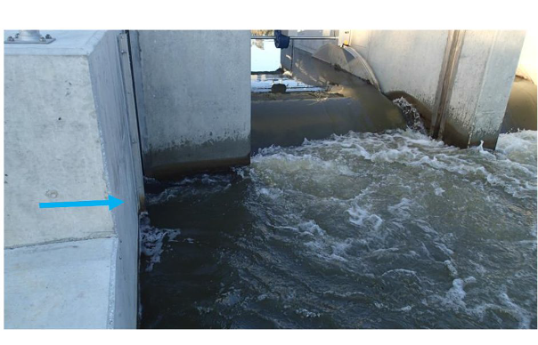
Figure 4.1: Fishway entrance flow (blue arrow), showing high integrity of flow and low recirculation within 0.5 m of the entrance (photo: M. Mallen-Cooper)

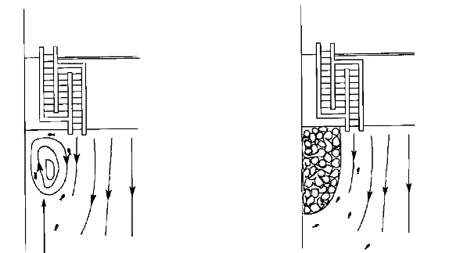

Figure 4.2: Diagram of a recirculation remedied by adding rock. (illustrations: M. Mallen-Cooper)

Fishway design life

    - Concrete structures

The design life of a fishway has a major bearing on the total capital cost. Design life is generally a site-by- site decision, but as an area of cost sensitivity it can have a significant bearing on the overall fishway capital cost.

For many fishways the design life is a decision for the asset owner, in line with standard agency requirements. For example, the Murray River fishways have a design life of 100 years, which was a requirement of the owners. Elsewhere, sheet-pile fishways may have a 50-year design life, which is consistent with the design life of the low-head weir structure.

    - Rock-ramp structures

There is no standard design life for rock fishways; fishways constructed before 2000 tended to have a 10– 15 year design life before a major re-work was required.

Problematic designs

    - Rock chutes: problematic fish passage designs

Rock chutes are a simple way to build a bed control structure and are usually relatively cheap to construct. However, chutes rarely provide for ecologically acceptable fish passage and are the least stable of the rock- ramp construction techniques. Chutes require regular extensive maintenance, they have a relatively short design life, and they rarely provide optimal fish passage. In summary, chutes can suffer from fish passage functional failure for a number of reasons:

- Rock chutes are often too steep and water velocities too fast for fish ascent.

- Chutes use a loose rock design, where rocks are often dumped at a steep gradient.

- Floods can shift even large rocks within a loose rock structure, and rocks lost from the weir crest create a hydraulic step that fish cannot negotiate.

- In chutes, increasing river flow simply increases water velocity, especially towards the toe of the chute; hence, stream energy is often directed undissipated towards the base of the chute.

- A scour pool often forms at the toe of the chute and causes loss of rocks and collapse of the bottom of the chute, with a major head loss that fish cannot negotiate.

- Rocks are placed loosely and on a steep gradient, with no retention at the downstream end.

- Chutes rarely incorporate large-diameter stabilising/retention rocks at the toe, or large rocks keyed in to the bed or banks to help support the structure.

- Mixed media to fill interstitial spaces are rarely used, which creates potential failure points.

- Rock chutes are designed to quickly drown out, but fish require emergent rocks for successful fish passage.

- Where rocks move, head loss becomes highly variable and can quickly exceed fish passage criteria.

- Rocks in chutes are often too small and consequently move during high flows, causing ongoing erosion and structural stability issues.

- Where there is infrequent maintenance, rock chutes rarely provide fish passage.

Fishway maintenance

Regular maintenance is essential to preserve the functionality of a fishway. All fishways collect debris,
which readily blocks the slots, altering the hydraulic conditions throughout the fishway (Figure 4.3). Altering the hydraulics may in turn result in a physical or behavioural barrier for fish movement. O’Connor et al. (2015) recommend that each fishway should be inspected, checked hydraulically, and undergo an annual dewatering event to check for blockages. A debris management device may also be fitted to remove or manage the volume of debris entering the fishway. For a comprehensive discussion on fishway maintenance, refer to O’Connor et al. (2015).

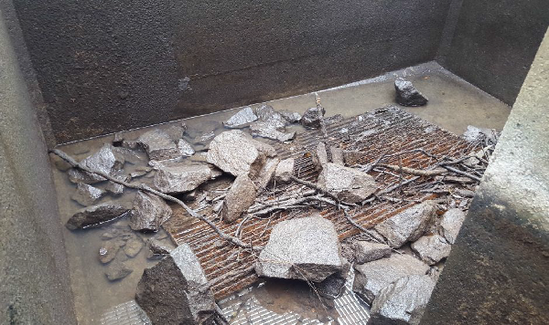

Figure 4.3: Example of a vertical-slot fishway without a maintenance schedule. The outcome can alter cell volume and hydraulics, thus reducing functionality of the fishway and so fish passage.

References

Amtstaetter, F., O'Connor, J. and Pickworth, A. (2015a). Environmental flow releases trigger spawning migrations by Australian grayling Prototroctes mraena, a threatened, diadromous fish. Aquatic Conservation: Marine and Freshwater Ecosystems. DOI: 10.1002/aqc.2570

Amtstaetter, F., O’Connor, J., Borg D., Stuart I. and Moloney, P. (2015b). Remediation of upstream passage for migrating Galaxias (Family: Galaxiidae) through a pipe culvert. Fisheries Management and Ecology. [DOI: 10.1111/fme.12211]

Barrett, J. and Mallen-Cooper, M. (2006). The Murray River's ‘Sea to Hume Dam’ fish passage program: progress to date and lessons learned. Ecological Management and Restoration 7(3), 173–183.

Baumgartner, L.J., Boys, C.A., Stuart, I.G. and Zampatti, B.P. (2010). Evaluating migratory fish behaviour and fishway performance: testing a combined assessment methodology. Australian Journal of Zoology 58, 154–164.

Cadwallader, P.L. 1978. Some causes of the decline in range and abundance of native fish in the Murray- Darling River system. Proceedings of the Royal Society of Victoria 90, 211–224.

Clay, C.H. (1995). Design of fishways and other fish facilities, 2nd edn. Department of Fisheries of Canada, Ottawa.

Conallin, A., Smith, B., Thwaites, L. Walker, K. and Gillanders, B. (2012). Environmental water allocations in regulated lowland rivers may encourage offstream movements and spawning by common carp, cyprinus carpio: implications for wetland rehabilitation. Marine and Freshwater Research 63, 865– 877.

Denil, G. (1909). Les échelles à poissons et leur application aux barrages de Meuse et d’Orthe. Goemaere, Bruxelles.

DEPI (2013). Victorian Waterway Management Strategy. Department of Environment and Primary Industries, East Melbourne, Victoria.

DSE (2002). Healthy Rivers Healthy Communities & Regional Growth: Victorian River Health Strategy.
Department of Natural Resources and Environment, August 2002.

DSE (2007). Technical Guidelines for Waterway Management. Developed for the Department of Sustainability and Environment (DSE) by a steering committee comprising representatives of the DSE, Waterway Managers Forum of Catchment Management Authorities (CMAs) and Alluvium Consulting Pty Ltd.

Harris, J. (1984). Impoundments of coastal drainages of south-eastern Australia and a review of its relevance to fish migrations. Australian Zoologist, 21, 235–250.

Jones, M.J. and O’Connor, J.P. (2016). Monitoring the performance of fishways and fish passage works.
Arthur Rylah Institute for Environmental Research Technical report No. 257. Department of Environment, Land, Water and Planning, Heidelberg, Victoria.

Karisch, S. and Power, M (1994). A simulation study of fishway design: An example of simulation in environmental problem solving. Journal of Environmental Management. 41(1). 67–77.

Koehn, J.D., McKenzie, J.A., O’Mahony, D.J., Nicol, S.J., O’Connor, J.P. and O’Connor, W.G. (2009).
Movements of Murray cod (Maccullochella peelii peelii) in a large Australian lowland river. Ecology of Freshwater Fish 18(4), 594–602.

Koehn, J.D. and O’Connor, W.G. (1990). Biological information for management of freshwater fish in Victoria. Arthur Rylah Institute for Environmental Research, Department of Conservation & environment, Heidelberg, Victoria.

Koster, W., Dawson, D. and Crook, D. (2013). Downstream spawning migration by the amphidromous Australian grayling (Prototroctes maraena) n a coastal river in south-eastern Australia. Marine and Freshwater Research, 64, 31–41

Koster, W., Dawson, D., O’Mahony, D., Moloney, P. and Crook, D. (2014). Timing, frequency and environmental conditions associated with mainstem–tributary movement by a lowland river fish, Golden Perch (Macquaria ambigua). PLoS ONE 9(5), e96044. doi:10.1371/journal.pone.0096044

Larinier, M. (2002). Pool fishways, pre-barrages and natural bypass channels. In: Larinier, M., Travade, F. and Porcher, J.P. (Eds) Fishways: Biological Basis, Design Criteria and Monitoring, pp. 54–82. Bulletin Francais de la Peche et de la Pisciculture 364 supplement, 54–82.

Mallen-Cooper, M. (1992). The swimming ability of juvenile Australian bass, Macquaria novemaculeata and juvenile barramundi, Lates calcarifer in an experimental verticall vertical slot fishway. Australian Journal of Marine and Freshwater Research 43, 823–834.

Mallen-Cooper, M. (1994). Swimming ability of adult Golden perch (Macquria ambigua) and adult Silver perch (Bidyanus bidyanus) in an experimental vertical slot fishway. Australian Journal of Marine and Freshwater Research 45, 191–198.

Mallen-Cooper, M. (1996). Fishways and freshwater fish migration in south-eastern Australia. PhD thesis.
University of Technology, Sydney, Faculty of Science (unpublished).

Mallen-Cooper, M. (1999). Developing fishways for non-salmonid fishes: a case study from the Murray
River in Australia. In: Odeh, M. (ed.) Innovations in Fish Passage Technology, pp. 173–195. American Fisheries Society, Bethesda, Maryland, USA.

Mallen-Cooper, M. (2000a). Taking the mystery out of migration. In: Hancock, D.A., Smith, D.C. and Koehn,
J.D. (Eds) Proceedings of the 1999 Annual Workshop of the Australian Society for Fish Biology, Bendigo, Victoria, pp. 101–111. Australian Society for Fish Biology, Sydney, NSW.

Mallen-Cooper, M. (2000b). Review of fish passage in NSW. Report to NSW Fisheries by Fishway Consulting Services, Bruce, ACT.

Mallen-Cooper, M. (2014). Fishway design process. Unpublished presentation to ANCOLD Conference.
Canberra Convention Centre, 21–22 October, 2014.

Mallen-Cooper, M. and D. A. Brand. 2007. Non-salmonids in a salmonid fishway: what do 50 years of data tell us about past and future fish passage? Fisheries Management and Ecology 14, 319–332.

Mallen-Cooper, M., Zampatti, B., Stuart, I. and Baumgartner, L. (2008). Innovative fishways – manipulating turbulence in the vertical-slot design to improve performance and reduce cost. Produced for Murray–Darling Basin Commission. Fishway Consulting Services.

McNee, A. (1999). Fish passage in the Murray-Darling Basin: current developments and future options.
Murray Darling Basin Commission, Canberra, ACT.

MDBC. (2004). Native Fish Strategy for the Murray–Darling Basin 2003–2013. Murray–Darling Basin Ministerial Council, Canberra, ACT.

Melbourne Water Corporation (2008). Community Environment Public Health Assessment checklist (CEPHA). Melbourne Water Corporation, Melbourne, Victoria.

NECMA (2009). Works on Waterways Background information and permits. North East Catchment Management Authority website [www.necma.vic.gov.au/About-Us/Programs- Initiatives/Undertake-Works-on-Waterways], accessed July 2017.

O’Brien, T., Ryan, T., Stuart, I. and Saddlier, S. (2010). Review of fishways in Victoria 1996–2009. Arthur Rylah Institute for Environmental Research Client Report No. 2010/84 for the Sustainable Water Environments Division. Department of Sustainability and Environment, Heidelberg, Victoria.

O’Connor, J., Mallen-Cooper, M. and Stuart, I. (2015). Performance, operation and maintenance guidelines for fishways and fish passage works. Arthur Rylah Institute for Environmental Research Technical

Report No. 262 for the Water and Catchments Group, Department of Environment, Land, Water and Planning. Arthur Rylah Institute for Environmental Research, Department of Environment, Land, Water and Planning, Heidelberg, Victoria.

O’Connor, J., Stuart, I. and Campbell-Beschorner, R. (2016). Guidelines for passage at small structures.
Arthur Rylah Institute for Environmental Research. Technical Report Series No. XXX. Department of Environment, Land, Water and Planning, Heidelberg, Victoria.

O’Connor, J.P., O’Mahony, D.J. and O’Mahony, J.M. (2005). Movements of Macquaria ambigua, in the Murray River, south-eastern Australia. Journal of Fish Biology 66, 392–403.

Rajaratnam N. & Katopodis C. (1984) Hydraulics of Denil fishways. Journal of Hydraulic Engineering 110, 1219–1233.

Reynolds, L.F. (1983). Migration patterns of five fish species in the Murray–Darling river system. Australian Journal of Marine and Freshwater Research 34, 857–871.

Silva, A., Santos, J., Ferreira, M., Pinheiro, A. and Katopodis, C. (2011). Effects of water velocity and turbulence on the behaviour of Iberian barbell (Luciobarbus bocagei) in an experimental pool type fishway. River Research and Applications. 27: 360–373

SKM (2001). Guidelines for Assessment of Applications for Permits and Licences for Works on Waterways.
Produced for the Victorian Waterway Managers Group.

South Australian Government (2009). River Murray Act 2003. South Australian Legislation website [https://www.legislation.sa.gov.au/LZ/C/A/RIVER%20MURRAY%20ACT%202003.aspx], accessed July 2017.

Stuart, I., Zampatti, B. and Baumgartner, L. (2008). Can a low-gradient vertical-slot fishway provide passage for a lowland river fish community? Marine and Freshwater Research 59, 332–46.

Thorncraft, G. and Harris, J. (2000). Fish passage and fishways in New South Wales: a status report.
Cooperative Research Centre for Freshwater Ecology Technical Report 1/2000. CRCFE, Canberra, ACT.

Appendices

Appendix 1 Common fishway passage options/designs

A1.1 Barrier removal

Barrier removal should always be the first consideration in any remediation (Figure A1.1). Barrier removal involves either removing or modifying in-stream structures such as dams, weirs, stream gauges and road crossings that are known to block fish passage. Barrier removal can involve the complete or partial removal of redundant structures, or the replacement of culverts with free span crossings (such as bridges). All fishway designs involve some compromise in performance (such as for small species or at certain times of the year), and full barrier removal, where practical, is generally the most effective method of enabling fish passage.

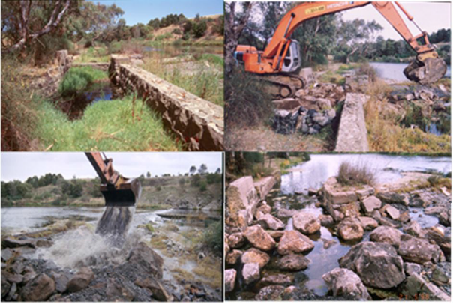
Figure A1.1: Barrier removal, Barwon River.

A1.2 Pool-type fishways (including vertical-slot fishways)

Pool-type fishways consist of a series of pools interconnected by narrow slots designed to maintain water velocities at levels below the swimming ability of the target fish species, therefore allowing fish to bypass a barrier (Figure A1.2). A number of pool-type fishways have been installed in Australia, but the vertical-slot design has proved most effective for passing native fish. These fishways provide consistent within-fishway flow conditions over a wide range of river flow conditions and can be designed for a broad range of fish sizes or to target a particular subset of the migratory fish community.

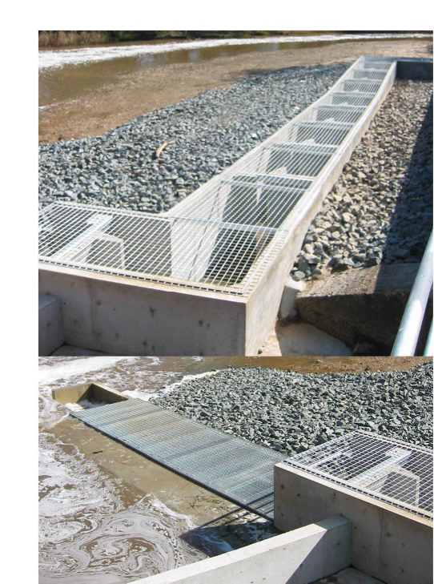
Figure A1.2: Vertical-slot fishway, Broken River.

A1.3 Rock-ramp fishway

Rock-ramp fishway design has improved substantially in the last five years, and there are many successful rock-ramp fishways in Victoria (Figures A1.3 and A1.4). These fishways are rocky channels that simulate rocky stream riffles, enabling fish to bypass the structure by swimming between pools separated by faster- flowing rock ridges. In narrow streams, rock-ramp fishways that span the entire stream width have the advantages of operating over a wide range of river levels and enabling fish to find the fishway entrance easily. Rock-ramp fishways are usually cheaper than technical fishways such as vertical-slot or locks, but must be carefully designed and constructed to avoid loss of depth due to seepage of water under the rocks. Regular maintenance, including removal of debris, encroachment of weeds, and movement of rocks, particularly after high flows, is also required. Rock-ramp fishways simulate the structure of a riffle or rocky creek. There are two main groups of rock-ramp fishways: they either occupy the full width of the stream (Figures A1.3 and A1.4, top) or a partial width of the stream (Figure A1.4, bottom). Partial-width rock-ramp fishways commonly have the downstream entrance at the base of the weir, with most of the fishway channel downstream of the weir (the upstream limit of fish migration) and the exit near the weir abutment.

Rock-ramp fishways need to be well engineered. Some significant design points are:

- The rock needs to be sized to withstand flood events and high water velocities at the site.

- The preferred building technique is to have keyed-in boulders, where the friction and stability of the boulders increases with high velocity flooding.

- The rock-ramp channel often needs to be lined with geotextile, and at low-flow sites a layer of impermeable material (e.g. Bentofix) is needed to prevent percolation of water directly through the rock ramp.

The rocks in a rock-ramp fishway provide roughness that creates zones of low water velocity. Roughness is decreased when the large rocks in the fishway become submerged; the effective operating range is considered to be when the rocks are breaking the surface of the water.

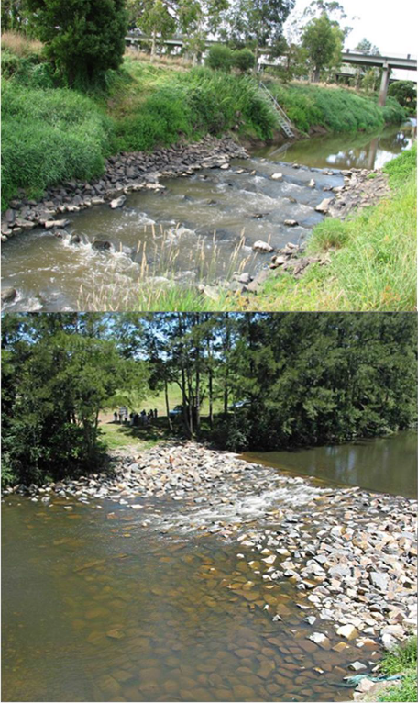

Figure A1.3: Full-width rock-ramp fishways.

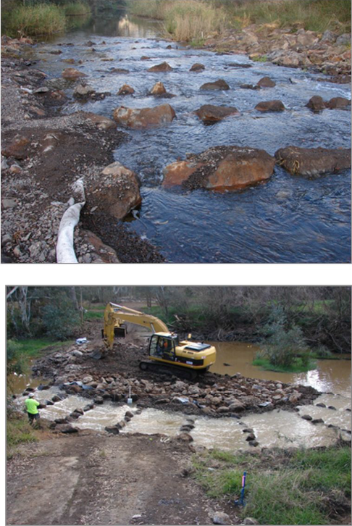

Figure A1.4: Two lateral-ridge-rock fishways: a full-river-width design at Pollocksford Weir on the coastal Barwon River (top) and a partial-width design on Sugarloaf Creek near Puckapunyal (bottom). (photos: I. Stuart)

A1.4 Fish lock and fish lift

Fish locks have traditionally been most suited to medium to large barriers (e.g. 5–14 m), but they have also been used at low head (e.g. 3 m) structures. Fish locks consist of a lock chamber, upstream and downstream gates, and valves to fill and drain the lock. The valves and gates are usually controlled by a programmable logic controller (PLC), and level sensors are used to provide data to the PLC. Fish locks operate by attracting fish through a gated entrance similar to that of a pool-type fishway and into a holding chamber at the base of the lock. The holding chamber gate is then sealed and water fills the lock to the same level as water upstream of the barrier. Fish are then able to swim out of the lock exit gate. To encourage fish to move through the lock, a combination of attraction flows, cycling times and crowding screens can be used. Yarrawonga Weir on the Murray River, Hipwell Road Weir on Gunbower Creek and Box Creek Weir on Pyramid Creek are examples of operational fish locks near or in Victorian waters, and several others exist within the Murray–Darling Basin and in Queensland.

Fish locks can be applied to low-level weirs such as Hipwell Road Weir, where recent evaluation has shown the passage of large numbers of small-bodied native fish. Fish locks require power, computer control and moving parts, and for those reasons they are considered high-maintenance fishways. Although improvements have been made to their reliability, they still require a high degree of operator input.

A fish lift operates like an elevator. Fish are attracted up an entrance channel, through a gate and into a hopper. After a specified period of time the gate closes, and the hopper is then lifted over the wall and lowered into the water upstream of the dam. Fish are then released from the hopper and are able to resume upstream migrations. Two large fish lifts operate in Australia: one at Paradise Dam on the Burnett River near Biggenden in Queensland, and one at the Tallowa Dam on the Shoalhaven River near Nowra in New South Wales (Figure A1.5).

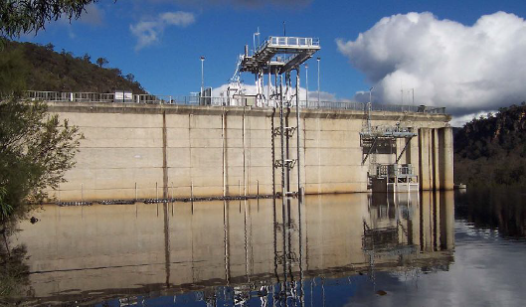
Figure A1.5: Ascending hopper lift on Tallowa Dam, Shoalhaven River.

A1.5 Denil fishway

The Denil fishway was invented in 1909 by Belgian engineer Gustave Denil (Denil 1909). It uses a series of symmetrical close-spaced baffles in a channel to redirect the flow of water, allowing fish to swim around the barrier (Figure A1.6). Examples of Denil fishways can be seen on the Murray River at Euston Weir, at Lock 10 at Wentworth, and at the Koondrook–Pericoota floodplain inlet structure off the Torrumbarry weir pool.

Denil fishways are systematically roughened channels. Rather than separate pools as in pool-type fishways, they have closely-spaced U-shaped baffles (Figure A1.6, bottom). The flow turns upon itself at the base of the baffle, and this creates a low-velocity zone that the fish use to ascend. The main advantage of Denil fishways is that they can be built on steeper slopes (e.g. 1v : 12h) compared with pool-type fishways like the vertical-slot design.

Denil fishways are widely used in North America and Europe for the passage of adult herring and salmon. In Australia, research has indicated the potential of Denil fishways for native fish and they have been used at a few sites. The design tends to favour fish greater than 40–60 mm in length, and bottom-dwelling and mid- water dwelling species. Poor passage has been reported for some surface-dwelling species (Rajaratnam & Katopodis 1984).

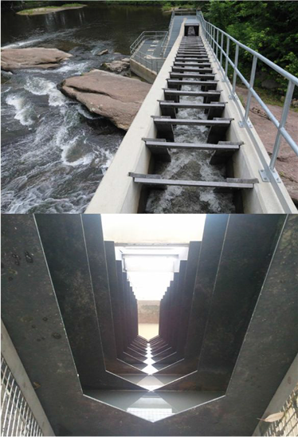

Figure A1.6: Denil fishway.

A1.6 Natural bypass fishways

This fishway design looks much like a natural stream and has the ability to move all species when properly designed. A stream channel using natural materials is designed to bypass a barrier (Figure A1.7). It can provide replacement stream habitat and can be used on any size of river, but the gradient is usually
1v : 50h. This conservative slope requires a larger footprint than most other designs. The operation of bypass fishways can be limited by variable headwater, and on small systems by their inherently high discharge. Few fish bypasses have been constructed in south-eastern Australia, but in Melbourne there is one on Cardinia Creek, another on Merri Creek at Coburg Lake, and a more recent example built in 2012 on a tidal barrage on the lower Patterson River.

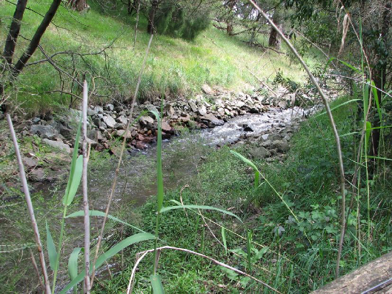

Figure A1.7: Natural bypass fishway on Cardinia Creek, Melbourne.

A1.7 Cone fishway

Cone fishways are designed to pass a broad size range of fish. The cone-shaped baffles form a series of ridges through which fish pass. They are designed to have conservative hydraulics (low velocities and turbulence levels) at low discharge to allow small-bodied fish to pass, while at higher flows the velocity and turbulence levels increase, along with the physical dimensions of the gaps within the fishway, therefore allowing larger fish to pass.

Cone fishways were first developed in Queensland and are simply pre-cast baffles that are fitted to a concrete channel (Figure A1.8). The advantage of these fishways is that they can often be built on a slightly steeper gradient than vertical-slot fishways. Cone fishways appear to be excellent for small fish, but are largely unproven for medium and large fish (e.g. > 300 mm long).

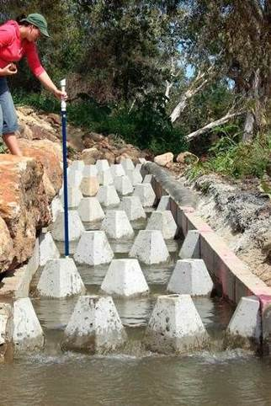

Figure A1.8: A cone fishway in Queensland.

A1.8 Trapezoidal fishway

Trapezoidal fishways are designed to safely enable the passage of small-bodied fish by producing low water velocities and turbulence. There are currently no trapezoidal fishways in Victoria. Trapezoidal weirs have been used for fish passage in North America, and recently in New South Wales and South Australia (Figure A1.9), following extensive physical and computational fluid dynamics modelling. A trapezoidal fishway is similar to a pool-type fishway, with a straight channel divided into pools with weirs. The shape of the weirs provides for the passage of high flows down the middle of the channel, while maintaining fish passage along the sides; small fish are attracted to the greater flow and high velocity in the middle of the fishway, and there are low velocity passages along each side. Pre-cast box culverts can be used, and most debris appears to pass down the middle of the channel.

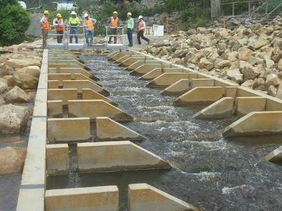

Figure A1.9: A trapezoidal weir.

Appendix 2 Victorian fish species and their primary location

 | Common name | Scientific name | Migratory strategy | Conservation
Coastal species | Short-finned Eel | Anguilla australis | Diadromous
 | Long-finned Eel | Anguilla reinhardtii | Diadromous
 | Common Galaxias | Galaxias maculatus | Diadromous
 | Spotted Galaxias | Galaxias truttaceus | Diadromous
 | Dwarf Galaxias | Galaxiella pusilla | Local | EPBC, FFG
 | Pouched Lamprey | Geotria australis | Diadromous
 | Striped Gudgeon | Gobiomorphus australis
 | Cox’s Gudgeon | Gobiomorphus coxii |  | FFG
 | Empire Gudgeon | Hypseleotris compressa |  | FFG
 | Australian Whitebait | Lovettia sealii |  | FFG
 | Australian Bass | Macquaria novemaculeata | Diadromous
 | Short-headed Lamprey | Mordacia mordax | Diadromous
 | Flinders Pygmy Perch | Nannoperca sp.
 | Variegated Pygmy Perch | Nannoperca variegata | Local | EPBC, FFG
 | Australian Mudfish | Neochanna cleaveri | Local | FFG
 | Freshwater Herring | Potamalosa richmondia |  | FFG
 | Australian Grayling | Prototroctes maraena | Diadromous | EPBC, FFG
 | Tupong | Pseudaphritis bursinus | Diadromous
 | Broad-finned Galaxias | Galaxias brevipinnis | Diadromous
 | Obscure Galaxias | Galaxias oliros | Local
 | Southern Pygmy Perch | Nannoperca australis | Local
 | Yarra Pygmy Perch | Nannoperca obscura | Local | EPBC, FFG
 | Flat-headed Gudgeon | Philypnodon grandiceps | Migratory
 | Dwarf Flat-headed Gudgeon | Philypnodon macrostomus | Local
 | Australian Smelt | Retropinna semoni | Migratory, diadromous, local
 | River Blackfish | Gadopsis marmoratus | Local
 | Mountain Galaxias | Galaxias olidus | Local
Inland species | Silver Perch | Bidyanus bidyanus | Potamodromous | EPBC, FFG
 | Murray Hardyhead | Craterocephalus fluviatilis |  | EPBC, FFG
 | Unspecked Hardyhead | Craterocephalus fulvus | Potamodromous | FFG
 | Two-spined Blackfish | Gadopsis bispinosus | Local
 | Barred Galaxias | Galaxias fuscus | Local | EPBC, FFG
 | Riffle Galaxias | Galaxias arcanus | Local
 | Western Carp Gudgeon | Hypseleotris klunzingeri | Potamodromous
 | Trout Cod | Maccullochella macquariensis | Potamodromous | EPBC, FFG
 | Murray Cod | Maccullochella peelii | Potamodromous | EPBC, FFG
 | Golden Perch | Macquaria ambigua | Potamodromous
 | Macquarie Perch | Macquaria australasica | Potamodromous | EPBC, FFG
 | Murray–Darling Rainbowfish | Melanotaenia fluviatilis | Potamodromous | FFG
 | Southern Purple-spotted Gudgeon | Mogurnda adspersa
 | Bony Herring | Nematalosa erebi | Potamodromous
 | Freshwater Catfish | Tandanus tandanus | Local | FFG
 | Broad-finned Galaxias | Galaxias brevipinnis | Diadromous
 | Obscure Galaxias | Galaxias oliros | Local
 | Southern Pygmy Perch | Nannoperca australis | Local
 | Yarra Pygmy Perch | Nannoperca obscura | Local | EPBC, FFG
 | Flat-headed Gudgeon | Philypnodon grandiceps | Migratory
 | Dwarf Flat-headed Gudgeon | Philypnodon macrostomus | Local
 | Australian Smelt | Retropinna semoni | Migratory, diadromous, local
 | River Blackfish | Gadopsis marmoratus | Local
 | Mountain Galaxias | Galaxias olidus | Local
EPBC = listing under the Australian Environment Protection and Biodiversity Conservation Act 1999

FFG = listing under the Victorian Flora and Fauna Guarantee Act 1988.

Appendix 3 Guidelines from DSE to water authorities

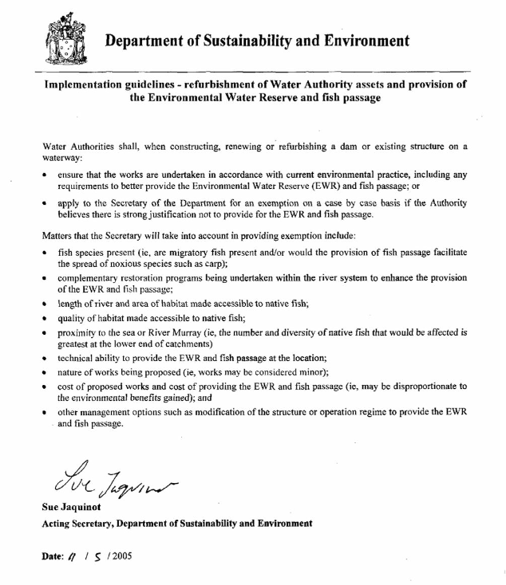

Appendix 4 Sample of CMA permit for Works on Waterways

WORKS1.DOC FORM: PERMIT WORKS

................................. Catchment Management Authority

Insert (address of CMA): …………………………………………………………………………………………………………………………. (Telephone, fax number, email of CMA) ………………………………………………………………………………………………….

WATER ACT 1989 (Sections 160, 161 and 219)

Permit No: ......................... (issued under Bylaw No.: ..........................)

Subject to the conditions listed overleaf, the..............Catchment Management Authority authorises:

(insert name and address of applicant) …………………………………………………………………………………………….…………. to construct and operate the following works (insert a description of works):
……………………………………………………………………………………………………………………………………………………………………..

on the following waterway at a site in, or adjacent to, the land described below.

Waterway: State Waterway No.: …………………………………. Lot(s): Plan of Subdivision No.: …………………………….. Allotment(s): Section: ………………………………………………….. Parish/Township: ………………………………………………...

NOTE

- The works identified above must be completed within 12 months of the date of issue of this permit. If these works are not completed within that period, this permit shall expire 12 months from the date of issue of this permit. Any renewed permit, if granted, may be subject to renewed conditions.

- The Authority accepts no responsibility for any claims, suits or actions, arising from injury, loss, damage or death, to any person or property which may arise from the construction, maintenance, existence or use of the works.

- The extent of the review by the Authority of the works identified above, has been confined to a limited evaluation of the effect of the works on erosion in the waterway and flooding of adjacent lands and in particular has not included an evaluation of the structural soundness of the works.

Authorising Officer: …………………………………………………… Date of Issue: …………………………………………………….

Permit Conditions

- The works shall be constructed in accordance with the plans attached.

- The waterway shall not be deviated in any manner for construction purposes except with the specific approval of the Authority. If necessary, the flow shall be pumped around the construction site or construction undertaken in stages with flow confined to one portion of the waterway.

- Disturbance of the bed and banks of the waterway and the use of construction plant and equipment is to be kept to a minimum during construction. Removal, destruction or lopping of native vegetation is also to be kept to a minimum. Suitable conservation measures are to be implemented to prevent vegetation, silt, chemicals and spillage from construction activities either entering the waterway or moving downstream. No discharge/dumping of wastewater or other materials to the waterway is permitted, unless specifically authorised by the Authority.

- All disturbed bank areas shall be graded to remove humps and hollows and top soiled and planted with locally occurring native species of grasses and shrubs.

- Vegetation that has been cleared for construction purposes and any heaps of excavated soil remaining after the completion of the works shall be removed from site. No material of any sort shall be pushed into the waterway or left in a manner where it can slip or be moved by floodwaters, into the waterway.

- Any works in the bed of the waterway should be designed and constructed so as not to impede fish passage.

- Logs and boulders removed from the waterway as a result of construction activity should be returned to the waterway and randomly distributed.

- The works shall always be maintained in good order.

- It is the responsibility of the person issued with this permit to obtain the necessary approval of the works before their commencement:

- from the relevant planning authority;

- rom the Department of Natural Resources and Environment in relation to the Land Act 1958, the Forests Act 1958, the Flora and Fauna Guarantee Act 1988, the Conservation, Forests and Land Act 1987 and the Catchment and Land Protection Act 1994.

ari.vic.gov.au

