|  |
| --- |
| VEFMAP Stage 6  Angler Citizen Scientists – A Pilot Project |
| Fishers fishing for fish ear bones |

**The Victorian Environmental Flows Monitoring and Assessment Program (VEFMAP) Stage 6**

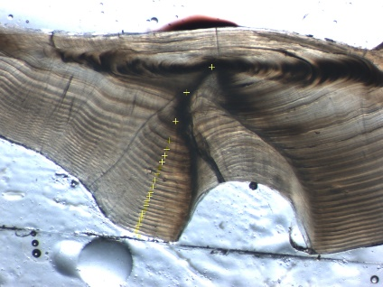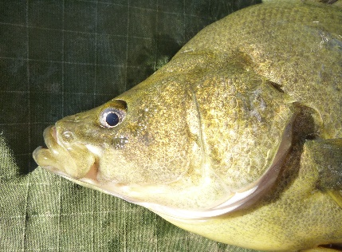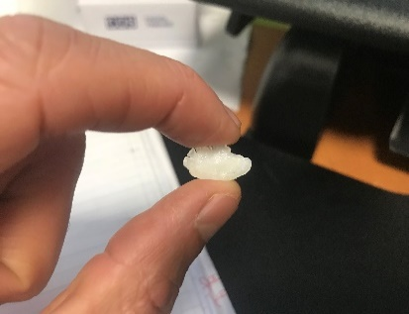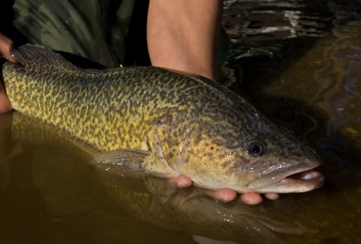

Angler Citizen Science – A Pilot Project

VEFMAP Stage 6 used a range of methods to monitor fish in northern Victorian rivers, including the collection and analysis of fish ear bones (otoliths). Analysis of otoliths can provide many insights into a fish’s life including its age, growth rate, whether it bred naturally in the river or was stocked, and which rivers it has spent time in. Such information can provide insights into the links between flow events in rivers and fish movement, breeding and survival. While otoliths were collected for Golden Perch and Murray Cod as part of the routine VEFMAP monitoring, there was also an opportunity to increase the sample size by working alongside anglers who were catching these species to keep and eat.

**Aims**

This project included three key aims:

* To obtain supplementary otolith samples to those obtained through conventional monitoring, to provide a greater sample size for analysis.
* To provide a successful, meaningful and satisfying citizen science program for anglers.
* To increase angler and broader community awareness of the benefits of water for the environment, VEFMAP, and the information used to guide management of water for the environment.

Scientists and anglers working together also provides an opportunity to build strong relationships, leading to an improved understanding of each other’s perspectives and interests.

**Approach**

In early 2018, angling clubs in northern Victoria were contacted to gauge their interest in taking part. There was also promotion through presentations at angling club meetings, relevant regional events and forums, the [ARI website](https://www.ari.vic.gov.au/research/people-and-nature/fishers-fishing-for-fish-ear-bones) and through other collaborators. A [video](https://www.youtube.com/watch?v=VDbnxX0337I&feature=emb_logo) was developed outlining how to extract an otolith and a training day was held near Elmore in late 2018. Angler Scientist Kits were sent to participants, which provided background information, instructions and tools to extract and record the otolith details. For those who did not wish to extract the otoliths themselves, there was an option to freeze the fish for collection. The project lead liaised with participants regularly via email.

**Results**

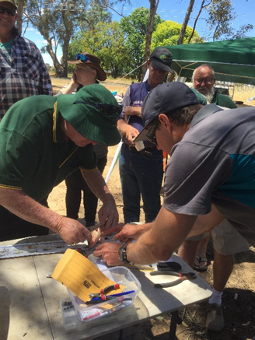Eighty-four Golden Perch and 25 Murray Cod otoliths were collected from 12 rivers, creeks and lakes in northern Victoria, up until June 2019. Once the samples were analysed, participants were provided with fish profiles for each of their fish which outlined the fish’s age, where it was born, and if it was captured in a river, where it had moved from. The fish profiles also included additional information and hyperlinks to the VEFMAP fish monitoring results so far, how water for the environment is managed in Victoria, and graphs of Golden Perch and Murray Cod growth vs age (from a large dataset collected over the last 10 years across northern Victoria).

**Highlights**

Otoliths collected from rivers have provided valuable additional information to help us assess the benefits of water for the environment. Highlights include:

* Three Golden Perch born in the lower Darling/Murray junction were caught near Cobram East (> 1000kms).

**Fig 1 – ARI’s Zeb Tonkin training anglers to extract ear bones during a field day near Elmore.**

* Two Golden Perch born in the lower Darling/Murray junction region were caught near Piambie (>400kms).
* A natural recruit of Murray Cod within the Campaspe River.
* Insights into the growth and survival of stocked Golden Perch in the Campaspe River.
* Strong engagement and knowledge transfer between scientists and anglers.

These large-scale movements of Golden Perch, which have been observed in other monitoring studies, emphasise the need to manage and coordinate river flows for this species at large spatial scales. The evidence of natural recruitment of Murray Cod and strong growth of stocked Golden Perch are encouraging signs in support of the flow management within the Campaspe River. Many participants have expressed strong interest in finding out about their fish, including their growth rates and learning more about how fish respond to water for the environment. The field day and other presentations during the project provided valuable opportunities for scientists and anglers to connect and share information.

This project has been a collaboration between DELWP, numerous angling clubs and other interested anglers, as well as the North Central CMA, the Goulburn Broken CMA, and the Victorian Fisheries Authority.

**Evaluation** Participants were encouraged to complete an initial survey, to assess their awareness of water management, fish ecology and participation in citizen science projects. At the end of the project, once VEFMAP Stage 6 findings have been shared further, a second survey will be sent to participants. Informal feedback is also being gathered.

|  |  |
| --- | --- |
| © The State of Victoria Department of Environment, Land, Water and Planning 2020  LogoThis work is licensed under a Creative Commons Attribution 4.0 International licence. You are free to re-use the work under that licence, on the condition that you credit the State of Victoria as author. The licence does not apply to any images, photographs or branding, including the Victorian Coat of Arms, the Victorian Government logo and the Department of Environment, Land, Water and Planning (DELWP) logo. To view a copy of this licence, visit http://creativecommons.org/licenses/by/4.0/  ISBN 978-1-76105-150-0 (pdf/online/MS word)  Disclaimer  This publication may be of assistance to you but the State of Victoria and its employees do not guarantee that the publication is without flaw of any kind or is wholly appropriate for your particular purposes and therefore disclaims all liability for any error, loss or other consequence which may arise from you relying on any information in this publication. | Accessibility  If you would like to receive this publication in an alternative format, please telephone the DELWP Customer Service Centre on 136186, email [customer.service@delwp.vic.gov.au](mailto:customer.service@delwp.vic.gov.au), or via the National Relay Service on 133 677 [www.relayservice.com.au](http://www.relayservice.com.au). This document is also available on the internet at https://www.ari.vic.gov.au/publications. |

**What’s Next?** Planning for VEFMAP Stage 7 will include an assessment of how this pilot project could continue, to obtain further ear bones for analysis, as well as work collaboratively with interested anglers.