|  |
| --- |
| Investigating Black Box Regeneration |
| Browsing has a high impact on Black Box seedling survival |

**Key points:**

* Field trial examining Black Box regeneration is underway.
* Long-term monitoring will determine seedling survival, growth rates and time to maturity.

Black Box

Black Box *(Eucalyptus largiflorens)* is a dominant floodplain tree at the Hattah-Kulkyne Lakes Ramsar site. Changes in flooding regimes have reduced tree condition and regeneration. To mitigate this threat, environmental watering has been implemented since 2014. However, many Black Box populations remain in poor health with limited regeneration.

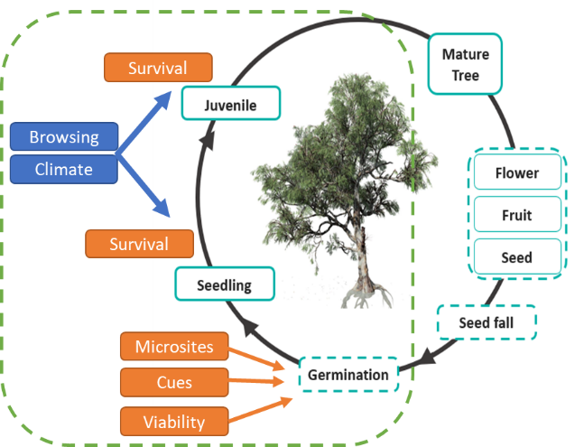Investigating Regeneration

A key knowledge gap is understanding factors that influence seed germination, seedling survival, juvenile growth rates and time to maturity. A field trial has been established to better understand the recruitment niche (green hashed lines) of the Black Box life cycle at Hattah Lakes (Figure 1).

The trial investigates the effectiveness of different management treatment options (natural regeneration, direct seeding, tube stock planting and browsing control) in supporting improved regeneration outcomes.

A trial plot has been established (April 2021) in an area where very little natural regeneration has occurred. The plot contains 25 treatment cells, and one of four treatments was randomly applied to each cell, leaving a central blank cell (Figure 2).

Figure 1. Simplified overview of Black Box regeneration showing the basic life cycle. The recruitment niche (green) highlights the phase of the cycle that this project investigates. Shown are factors that may block the cycle (blue), facilitate (orange), life cycle processes (hashed) and life stages (aqua).

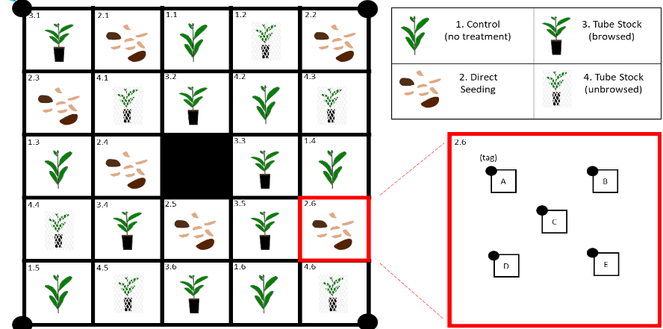

Figure 2. Conceptual diagram of the trial design (with six replicates of each of the four treatments). The red box shows within cell replication (e.g. depending on treatment either five tube stock or direct seeding subcells).

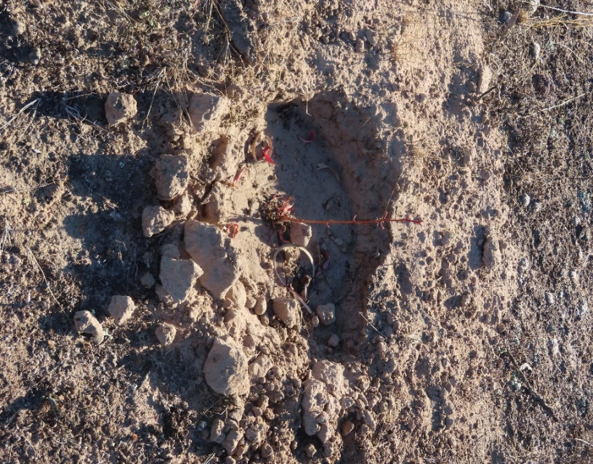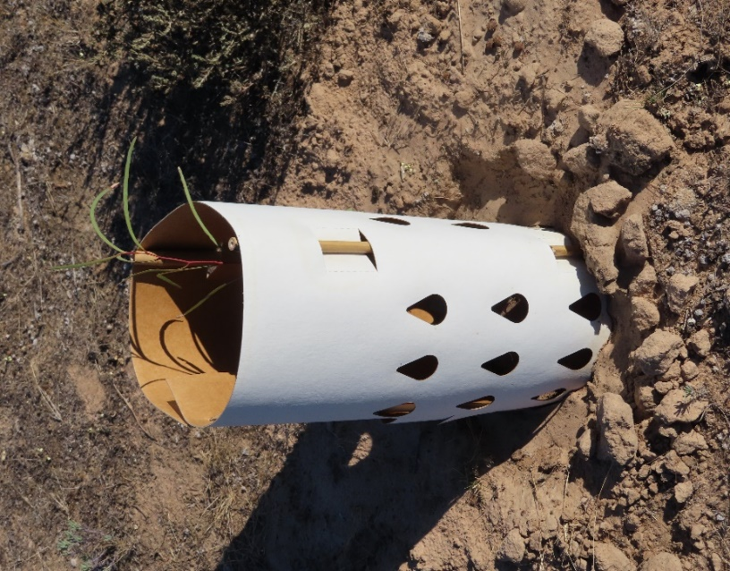

Initial Trends

Initial monitoring of the trial has been completed. One month after establishment:

* No germination of seed was observed from either the natural regeneration or direct seeding treatments.
* 93% of tube stock plants (no tree guards) were browsed and 20% were dead (Figure 3).
* Tube stock (with tree guards) and existing natural regeneration seedlings were all unbrowsed and alive.

Initial Outcomes

Initial trends provide evidence that browsing (either native herbivores or rabbits) is having a high impact on Black Box seedling survival at Hattah Lakes.

Browsing impacts on Black Box regeneration and subsequent population viability needs to be considered when developing management options for this species.

|  |
| --- |
| © The State of Victoria Department of Environment, Land, Water and Planning 2021Logo.  This work is licensed under a Creative Commons Attribution 4.0 International licence. To view a copy of this licence, visit http://creativecommons.org/licenses/by/4.0/  **ISBN** XXXXXXXXXXXXXXXXXXXX **(pdf/online/MS word)** |

Continued monitoring of the surviving seedlings will provide longer-term impacts of browsing, seedling growth rates and time to maturity.

## Acknowledgements

This project is supported by the Mallee Catchment authority, through funding from the Australian Government’s National Landcare Program

delwp.vic.gov.au

ari.vic.gov.au

Figure 3. Browsed tube stock (left) and tree guarded unbrowsed tube stock (right), one month after planting.

## Further information

For more information about this project, please contact [research.ari@delwp.vic.gov.au](mailto:research.ari@delwp.vic.gov.au)

**Report:** Moxham, C. and Duncan, M. (2021). Black Box regeneration trial management plan: Version 3. Unpublished Report for the Mallee Catchment Management Authority. Arthur Rylah Institute for Environmental Research, Department of Environment, Land, Water and Planning, Heidelberg, Victoria.