Thomson and Macalister Rivers 2021
West Gippsland region

This report card summarises the 2021 Native Fish Report Card (NFRC) survey in the Thomson and Macalister rivers
Sites 9, WGCMA, Electrofishing

Fish found in Thomson and Macalister Rivers for NFRC
Target species
Australian Bass
Australian Grayling

Non-target species captured since 2017*
Large-bodied native species
Golden Perch
Long-finned Eel
Short-finned Eel
Tupong
And a further five fish species which are estuarine (see following pages)

Small-bodied native species
Australian Anchovy
Australian Smelt
Common Galaxias
Flatheaded Gudgeon
Flinders Pygmy Perch

Exotic species
Brown Trout
Eastern Gambusia
Common Carp
Goldfish
Rainbow Trout
Redfin

* These non-target species were incidentally captured during NFRC surveys since 2017 but not measured as for target species

LOGOS – ARI, DELWP
Thomson and Macalister Rivers 2021
Fish Community

NFRC target species
The NFRC Program began in 2017, with a focus on targeting the monitoring of population dynamics of key iconic fish species that have high recreational and/or conservation values, in large rivers across Victoria. In the Thomson and Macalister rivers, the target species are Australian Bass and Australian Grayling. Surveys occur in March each year, at nine sites from the junction with the Latrobe River to Lake Glenmaggie on the Macalister River, and to Denison on the Thomson River. The site at Denison on the Thomson River just downstream Rainbow Creek junction was shifted to the Rainbow Creek just upstream the Thomson River junction in 2021 due to access logistics. The Thomson and Macalister river surveys use boat electrofishing. The equipment and habitats surveyed are focused on these species, which are measured to determine population structures. Other fish species that are incidentally captured are recorded, but not measured to determine their population structures.

Summary of key health indicators for target species in 2021
Species | Key Health Indicators
 | Recent recruitment | Multiple size classes | Mature fish present
Australian Bass | Yes | Yes | Yes
Australian Grayling | - | - | -

Recent recruitment means young-of-year fish
*- cannot be determined due to low abundances

Australian Bass in the Thomson and Macalister river systems are at the outermost extent of their natural range. Historically they occurred no further west than Wilsons Promontory. Australian Bass are an important recreational species in the Thomson and Macalister rivers. The population is aided by stockings. Australian Grayling were once widespread throughout coastal Victoria, including the Thomson and Macalister river system. Changes to flow regimes and barriers impact this species. The detection of Australian Grayling in four of the five years indicates that management measures such as environmental flows are benefiting the population.

Non-target species
The non-target fish species that have been incidentally recorded in the Thomson and Macalister rivers during NFRC surveys since 2017 are:

Large-bodied native species
Other large-bodied species recorded in surveys are Black Bream, Estuary Perch, Golden Perch, Long-finned Eel, River Garfish, Sea Mullet, Short-finned Eel, Tupong and Yellow-eye Mullet. Five of these species (Black Bream, Estuary perch, River Garfish, Sea Mullet and Yellow-eye Mullet) are considered as estuarine species. Long-finned and Short-finned Eel and Tupong are diadromous species found throughout coastal Victoria. Golden Perch are considered a translocated species in the Thomson and Macalister rivers and have been detected in the lower Thomson River in three of the five years.

Small-bodied native species
Australian Smelt and Flatheaded Gudgeon are common species distributed across all of Victoria. The Common Galaxias is a diadromous species found across coastal Victoria. Flinders Pygmy Perch (listed as vulnerable in Victoria under the Flora and Fauna Guarantee Act 1988) are common in offstream habitats such as billabongs, wetlands and lagoons. Australian Anchovy are an estuarine species and are only expected to be detected at the lowest site/s (i.e. closest to the estuary).

Exotic fish species
Six exotic species have been recorded during NFRC surveys: Brown Trout, Rainbow Trout, Eastern Gambusia, Common Carp, Goldfish and Redfin. Common Carp and Redfin have been detected in all sampling years and are widespread throughout the Thomson and Macalister rivers. Brown Trout and Rainbow Trout are restricted to the upper sites in the Macalister River. Goldfish are present in both rivers, albeit in low abundances. Eastern Gambusia were detected in Rainbow Creek in 2021 and are often found in slower flowing waters.

Other fish species known from the Thomson and Macalister rivers
Some fish species known to occur in the Thomson and Macalister rivers have never been recorded during NFRC surveys. For example, no Climbing Galaxias, Mountain Galaxias, Spotted Galaxias, Pouched Lamprey, Short-headed Lamprey or River Blackfish have been detected in the surveys. The Climbing Galaxias, Spotted Galaxias, Pouched Lamprey and Short-headed Lamprey are diadromous species in coastal Victoria. The Climbing Galaxias and Spotted Galaxias have patchy distributions and are found in lowland areas but are hard to detect using NFRC sampling methodology. The Pouched Lamprey and Short-headed Lamprey were considered widespread but in recent times adults are rarely seen and are usually nocturnal. The Mountain Galaxias is found both sides of the divide from Melbourne eastwards in Victoria. In the Thomson and Macalister rivers they were patchy and relatively uncommon in the lower areas but were more common in higher altitudes and are hard to detect using the NFRC sampling methodology. The River Blackfish are a lowland species, generally found at altitudes below 200 metres. This species has suffered a decline in distribution and abundance across the State and was historically considered relatively widespread throughout the Thomson basin¹. This species is still present in the Thomson River, though upstream of NFRC sampling sites.

Other notable species
Surveys have also recorded Eastern Long Necked Turtle.

LOGOS – ARI, DELWP, NFRC

1. Lieschke, J.A., Dodd, L., Stoessel, D., Raadik, T.A., Steelcable A., Kitchingman, A. and Ramsey, D.
(2013). The status of fish populations in Victorian rivers 2004–2011 – Part A. Arthur Rylah Institute for
Environmental Research Technical Report Series No. 246. Department of Environment and Primary
Industries, Heidelberg, Victoria.

Thomson and Macalister Rivers 2021
Environmental and Management Context

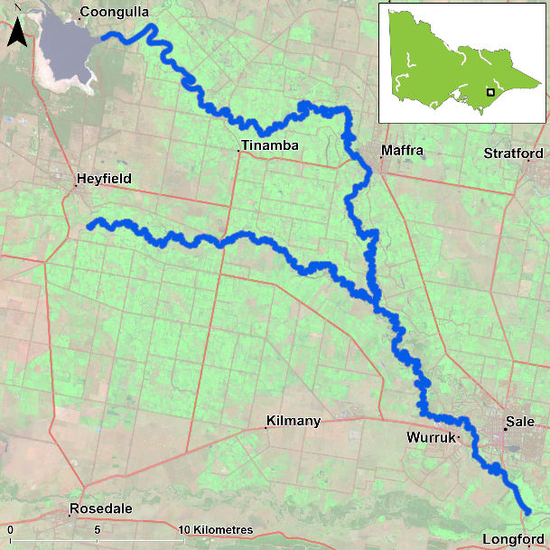
Figure 1. Map showing the section of Thomson and Macalister rivers where NFRC sampling occurs

Environment
Low flow conditions were present in all five sampling seasons, albeit slightly higher in 2021.

River rehabilitation efforts in the Thomson and Macalister rivers
Many rehabilitation actions have occurred and are underway to improve the health of the Thomson and Macalister rivers. These are informed by the West Gippsland Waterway Strategy 2014-2022. Efforts include revegetation, weed control and fencing of riparian areas and floodplain wetlands, allocations and delivery of water for the environment and removal of migration barriers and erosion control. Some monitoring of the fish community occurs, including related to management efforts above. This includes the Victorian Environmental Flow Monitoring and Assessment Program (VEFMAP). The West Gippsland Catchment Management Authority, DELWP and VFA support rehabilitation and management of the Thomson and Macalister rivers.

PHOTOS
LOGOS – ARI, DELWP, NFRC

Australian Bass

Thomson and Macalister Rivers, West Gippsland region

Key Health Indicators
Recent recruitment Yes
Multiple size classes Yes
Mature fish present Yes

Monitoring Results
Total number of fish caught 53
Fish per 1km of waterway 9.57
Largest fish by length (cm) 41.1
Largest fish by weight (kg) 1
% of the catch that is legal size 35.8

Australian Bass (Percalates novemaculeata) - formerly Macquaria novemaculeata - are a targeted recreational fishing species in the Thomson and Macalister rivers. Recruits, juveniles and adults have been collected in 2017, 2018 and 2021, with recruits absent in 2019 and 2020 (Figure 2). The 2017 and 2021 population abundances appear to be higher, but this is due to the increase of recruits detected, which are likely from stockings. The absence of recruits in 2019 and 2020 is possibly due to stocking occurring away from NFRC sites, rather than the recruits not surviving. Despite abundances being dominated by recruits in 2021, there was a wide range of sizes detected including large adult fish (Figure 3).

Stocking
Nine thousand Australian Bass were stocked in late 2016; 28,500 fish in late 2017; 10,000 in 2018 and 2019; and 25,000 in 2020.
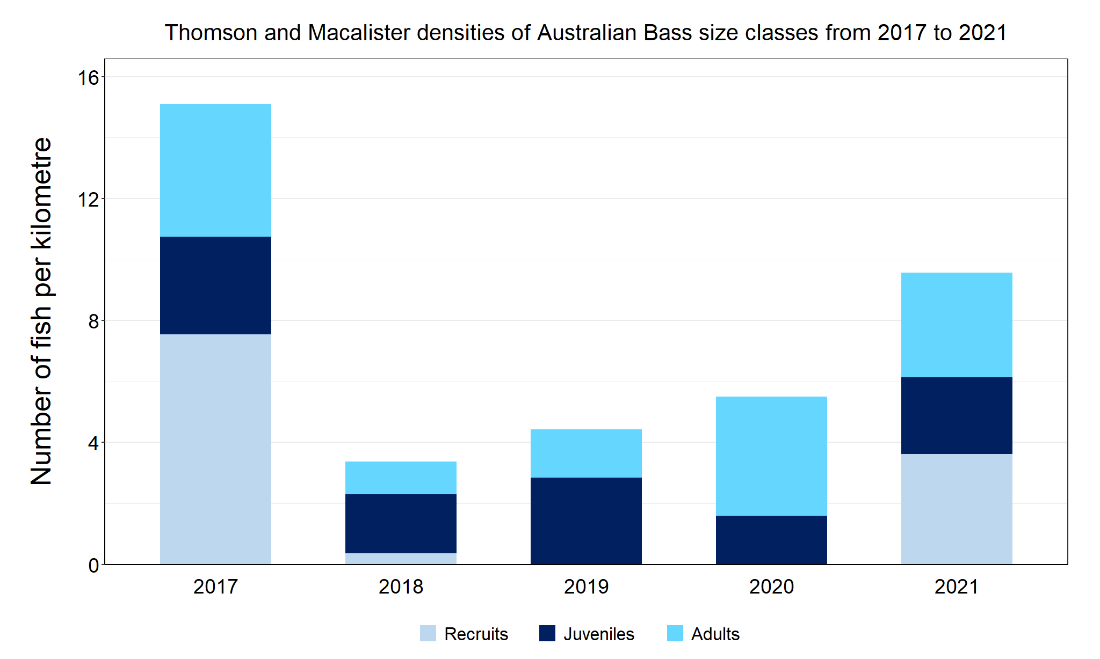
Figure 2. The densities of recruits, juveniles and adult Australian Bass in the Thomson and Macalister rivers from 2017 to 2021.

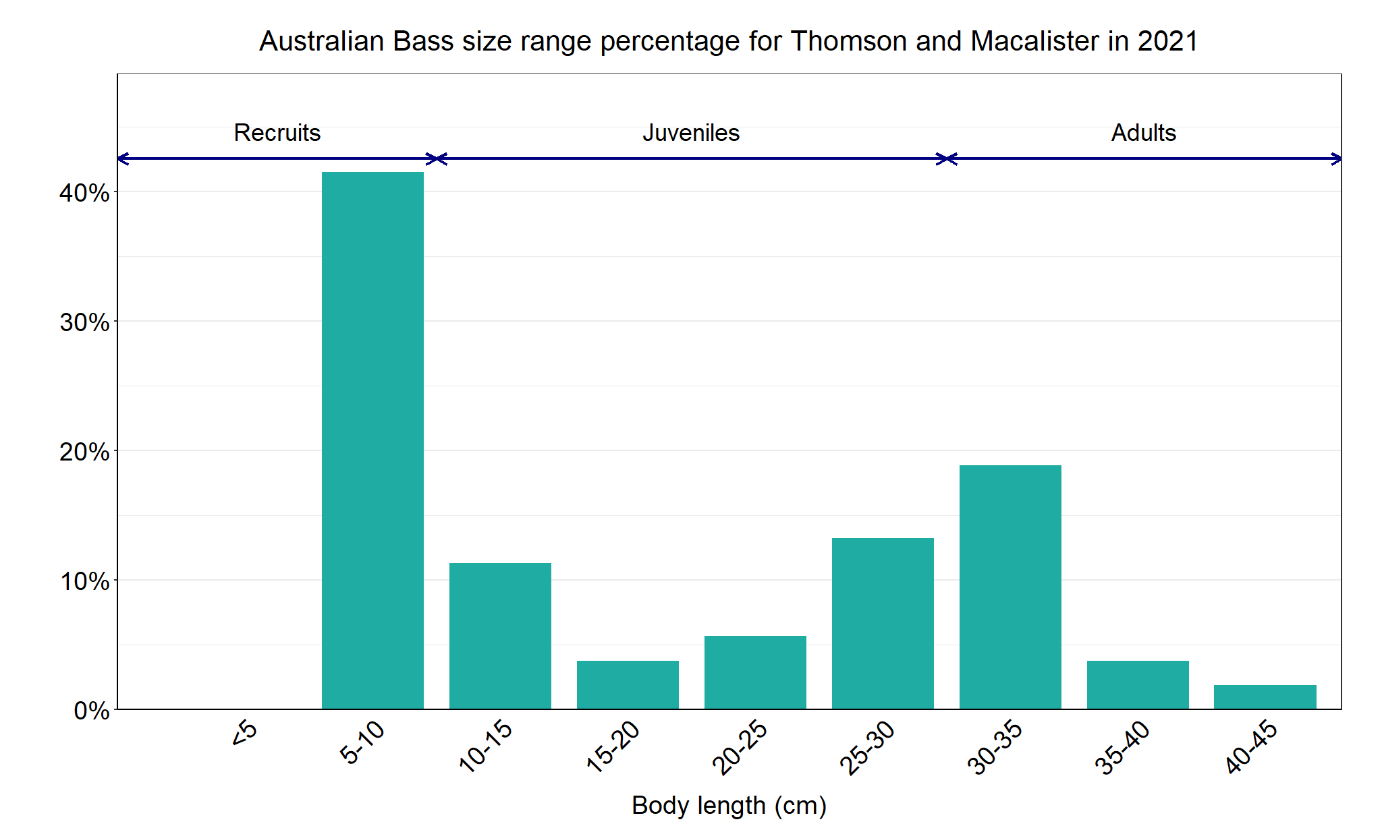
Figure 3. The size range percentage of Australian Bass in the Thomson and Macalister rivers in 2021.

Australian Grayling

Thomson and Macalister Rivers, West Gippsland region

Key Health Indicators
Recent recruitment Cannot be determined
Multiple size classes Cannot be determined
Mature fish present Cannot be determined

Monitoring Results
Total number of fish caught 1
Fish per 1km of waterway 0.18
Largest fish by length (cm) 13.7
Largest fish by weight (kg) 0.03
% of the catch that is legal size NA

Australian Grayling (Prototroctes maraena) are a diadromous species that has undergone declines in distribution and abundance across its range. Australian Grayling are listed as endangered in Victoria (Flora and Fauna Guarantee Act 1988) and nationally (Environment Protection and Biodiversity Conservation Act 1992). While NFRC expects to only capture low numbers of this species, the monitoring can provide a greater understanding of the current status of the populations which is essential to inform management of these species. Due to the low abundances of Australian Grayling collected during NFRC the key health indicators cannot be determined. However, low abundances of adults have been captured in 2017, 2018 and 2020 with juveniles also detected in 2020 and 2021 (Figure 4). No Australian Grayling were detected in 2019. The presence of juveniles in 2020 and 2021 (Figure 4, Figure 5) points towards successful recent recruitment. This indicates stream conditions were suitable for recruits to be attracted into the system in 2019 and 2020.

Stocking
No stocking has occurred.
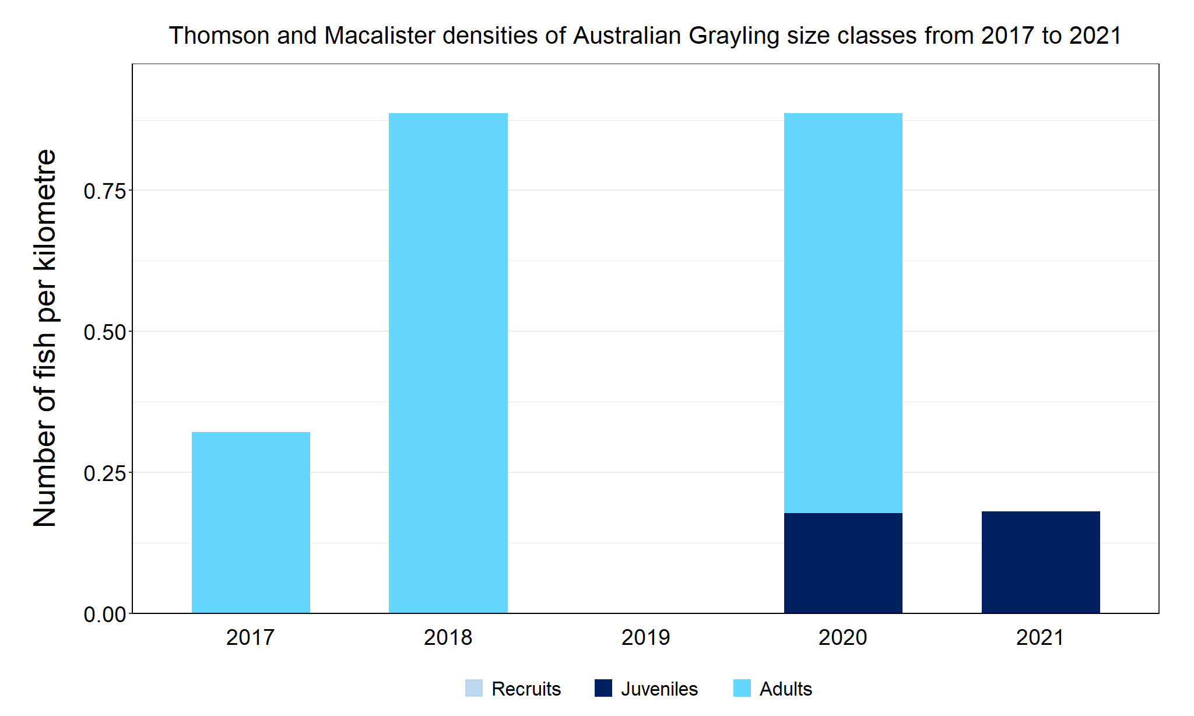
Figure 4. The densities of recruits, juveniles and adult Australian Grayling in the Thomson and Macalister rivers from 2017 to 2021.

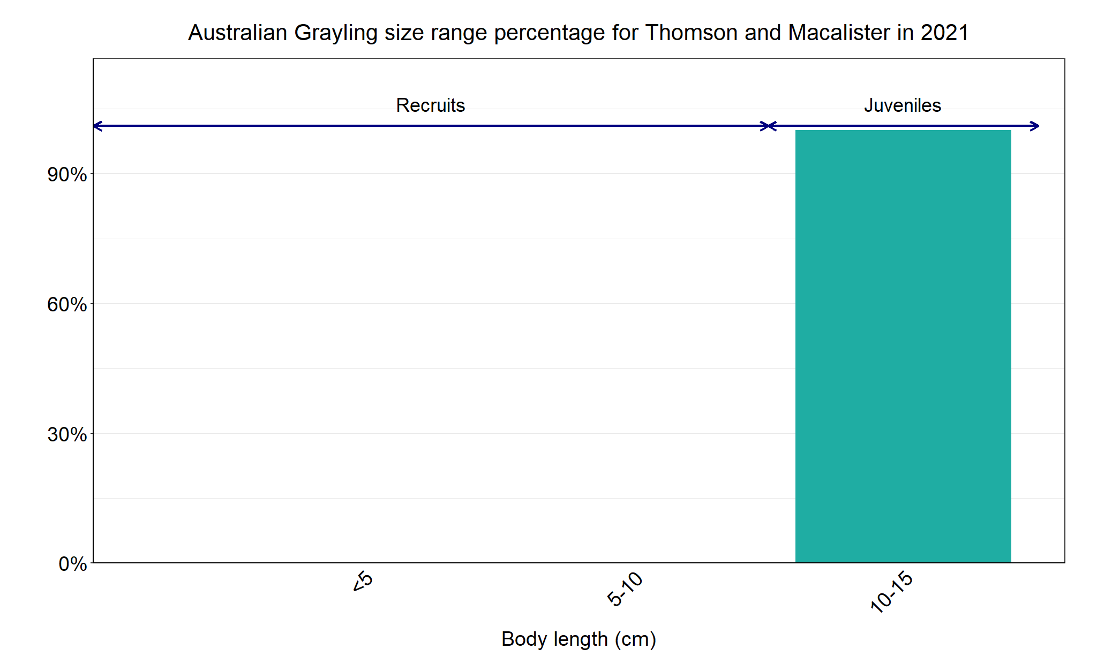
Figure 5. The size range percentage of Australian Grayling in the Thomson and Macalister rivers in 2021.

