|  |
| --- |
| Benefits of environmental water - Migration of Australian Grayling in four coastal rivers  Fact sheet 2 – Migration of Australian Grayling to spawn |

Investigating how to use environmental water to protect and restore environmental values within rivers, floodplains, wetlands and estuaries.

Background

Australian Grayling (*Prototroctes maraena*) is a nationally threatened fish that lives in coastal rivers in south-eastern Australia. The species is amphidromous, meaning adults spawn in the lower freshwater reaches, larvae then drift downstream to the sea, and juveniles migrate back upstream into freshwater. There has been a dramatic decline in abundance and distribution of Australian Grayling, due largely to altered flow regimes and stream barriers, which block fish migration.

Managing environmental water releases

In Victoria, many agencies work to implement environmental watering programs. West Gippsland Catchment Management Authority and Melbourne Water have develop seasonal watering proposals which include key flow objectives to deliver within channel flow pulses, known as 'freshes', to specifically trigger downstream migration and spawning of Australian Grayling. Every June, the Victorian Environmental Water Holder collates and summarises these seasonal watering proposals into a seasonal watering plan which previews all potential environmental watering across Victoria for the coming water year under each planning scenario.

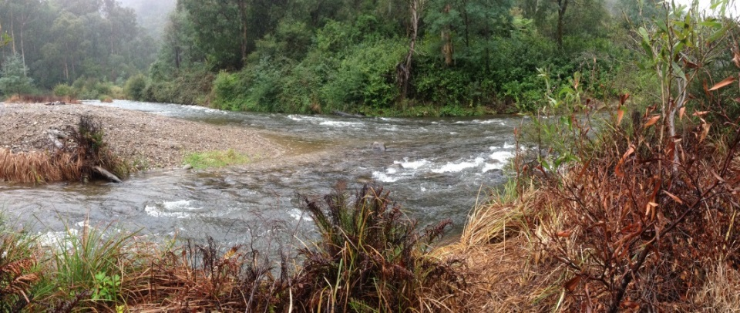

*The Thomson River during a release of environmental water*

Studying Australian Grayling

From 2008 to 2015, the Arthur Rylah Institute (ARI) investigated the effects of flows on migration and spawning of Australian Grayling. The objective was to identify key components of the flow regime (hydrograph) that could be provided annually to stimulate downstream spawning migrations.

Monitoring the migration of Australian Grayling

Australian Grayling from the Tarago, Bunyip and Thomson rivers were tagged with acoustic transmitters and their movements were monitored. Australian Grayling in the Tarwin River were monitored using PIT (Passive Integrated Transponder) tags.

Key findings

*Tarago-Bunyip rivers*

* Downstream spawning migrations coincided with within-channel flow pulses or ‘freshes’.
* Most fish migrated downstream (up to 45 km) to spawn in the lower reaches of the Bunyip River, from late March to late April. This is important knowledge for management for implementing longer duration flows that encompass the downstream travel time for fish.
* 80% of fish began migration during a natural flow pulse driven by rainfall runoff in early April.
* 20% of fish began migration during a managed, within-channel flow pulse in late April.
* The managed within-channel flow pulses:
  + **triggered** downstream migration of some fish, and
  + **enhanced** migration of other fish that had ceased moving after the earlier natural flow event.

*Thomson River*

* Rapid, downstream fish movements occurred in late April and early May, coinciding with the within-channel flow pulses.
* Fish migrated long distances (62 to 140 km) downstream on flow pulses.

*Tarwin River*

* 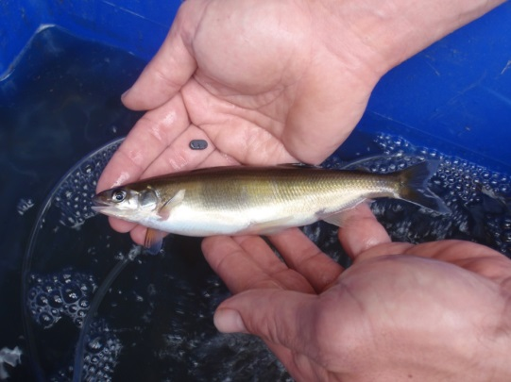Downstream fish movements coincided with a natural within-channel flow pulse in April.
* During the spring/summer non-spawning period, fish movement was limited to <5 km.

What does this mean for management?

Environmental flows to trigger or enhance spawning migrations of Australian Grayling need to include autumn freshes of sufficient duration (> 7 days) to enable adults to migrate long distances from the upper reaches of rivers to spawning areas in the lower reaches. This work has clarified that the magnitude of these freshes can be within-channel.

Figure: Example of the movement pattern of an Australian Grayling tagged in the Tarago River in 2015.

* Dark blue lines (daily discharge in Tarago River at Drouin West)
* Shaded blue area (environmental flow fresh)
* Light blue line (daily discharge in Bunyip River at Iona gauge)
* Red dashed line (daily water temperature in Tarago River at Drouin West).
* Grey line – movement pattern of fish

50

40

30

20

10

0

0

100

200

300

400

Distance upstream from Bunyip River mouth (km)

Discharge (ML d-1)

Water temperature (°C)

30

15

0

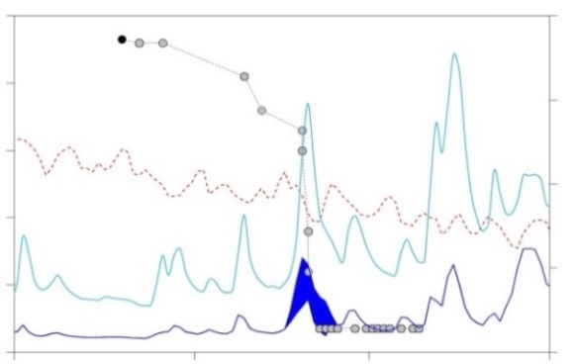

March April May

Related work

See Fact sheet 3 for further results of studies on spawning of Australian Grayling.

Contact: [Wayne.Koster@delwp.vic.gov.au](mailto:Wayne.Koster@delwp.vic.gov.au) (Monitoring in Bunyip and Tarago rivers)

[Frank.Amtstaetter@delwp.vic.gov.au](mailto:Frank.Amtstaetter@delwp.vic.gov.au) (Monitoring in the Thomson and Tarwin rivers)

*An Australian Grayling with an acoustic transmitter*

**Funding:** This research was funded by Melbourne Water, West Gippsland Catchment Management Authority and DELWP (Victorian Environmental Flows Monitoring and Assessment Program, in partnership with the University of Melbourne).