Glenelg Ark—2020 monitoring and evaluation update

A. Robley, P.D. Moloney and E. Le Duc

July 2022


Arthur Rylah Institute for Environmental Research
Technical Report Series No. 340


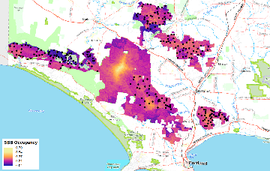
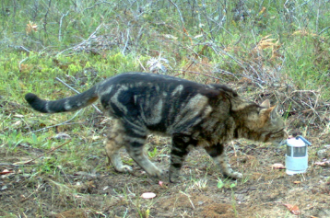
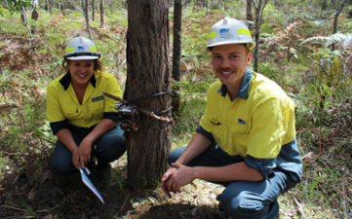
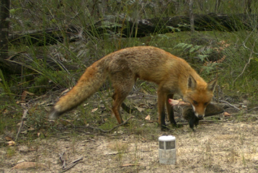



Acknowledgement
We acknowledge and respect Victorian Traditional Owners as the original custodians of Victoria's land and waters, their unique ability to care for Country, and their deep spiritual connection to it. We honour Elders past and present, whose knowledge and wisdom have ensured the continuation of culture and traditional practices.
We are committed to genuinely partnering, and meaningfully engaging, with Victoria’s Traditional Owners and Aboriginal communities to support the protection of Country, the maintenance of spiritual and cultural practices, and their broader aspirations in the 21st century and beyond.
Arthur Rylah Institute for Environmental Research
Department of Environment, Land, Water and Planning
P.O. Box 137
Heidelberg, Victoria 3084
Phone (03) 9450 8600
Website: www.ari.vic.gov.au
Citation: Robley, A., Moloney, P.D. and Le Duc, E. (2022). Glenelg Ark—2020 monitoring and evaluation update. Arthur Rylah Institute for Environmental Research Technical Report Series No. 340. Department of Environment, Land, Water and Planning, Heidelberg, Victoria.
Front cover photos: (a) Red Fox with native prey; (b) feral Cat inspecting lure; (c) monitoring native species response (photographer: DELWP); (d) predicted occupancy of Southern Brown Bandicoots.

© The State of Victoria Department of Environment, Land, Water and Planning 2022

This work is licensed under a Creative Commons Attribution 3.0 Australia licence. You are free to re-use the work under that licence on the condition that you credit the State of Victoria as the author. The licence does not apply to any images, photographs or branding, including the Victorian Coat of Arms, the Victorian Government logo, the Department of Environment, Land, Water and Planning logo and the Arthur Rylah Institute logo. To view a copy of this licence, visit http://creativecommons.org/licenses/by/3.0/au/deed.en
Printed by DELWP, Melbourne
Edited by Jeanette Birtles, Organic Editing
ISSN 1835-3827 (print)
ISSN 1835-3835 (pdf))
ISBN 978-1-76136-034-3 (pdf/online/MS word)

Disclaimer
This publication may be of assistance to you, but the State of Victoria and its employees do not guarantee that the publication is without flaw of any kind or is wholly appropriate for your particular purposes and therefore disclaims all liability for any error, loss or other consequence which may arise from you relying on any information in this publication.
Accessibility
If you would like to receive this publication in an alternative format, please telephone the DELWP Customer Service Centre on 136 186, email customer.service@delwp.vic.gov.au or contact us via the National Relay Service on 133 677 or www.relayservice.com.au. This document is also available on the internet at www.delwp.vic.gov.au

Glenelg Ark—2020 monitoring and evaluation update

Alan Robley¹, Paul D. Moloney¹ and Ethan Le Duc²

¹Arthur Rylah Institute for Environmental Research,
Department of Environment, Land, Water and Planning
123 Brown Street, Heidelberg, Victoria 3084
²Barwon South West Forest, Fire and Regions
Department of Environment, Land, Water and Planning
12 Murray Street, Heywood, Victoria 3304

Arthur Rylah Institute for Environmental Research
Technical Report Series No. 340

Arthur Rylah Institute for Environmental Research
Department of Environment, Land, Water and Planning
Heidelberg, Victoria

Acknowledgements
Data analysis and reporting were funded by the Weeds and Pests on Public Land program of the Department of Environment, Land, Water and Planning (DELWP) through the Glenelg Ark project, and Parks Victoria. Members of the Glenelg Ark Working Group provided guidance and input throughout.
Members of the works crew at the Heywood and Dartmoor Depots undertook invaluable project support activities, including baiting and camera set-up (Tyler Britten, Beau Dixon, Jess Greenwood, James Grey, Chris Johansson, Tom McKinnon, Michael Murrell, Samantha Sheppard, Dylan Thomas, Sharlee Trigg and Rhys Weber). Baiting for the control of foxes was also undertaken by Ray Albert, Megan Andrews, Michael Bowd, Tim Hiscock and Kenny Scott.
Camera trapping and other field activities were performed under Research Permit Number 1007449 and AEC Permit Number AEC 19-003.
Lachlan Francis (ARI) undertook the FoxNet modelling.
Matthew Rees (University of Melbourne PhD candidate) undertook the feral cat density estimation analysis.
Building of the reproducible raster stack of spatial layers for Glenelg to enable the prediction of species distribution models was undertaken by David Uribe-Rivera (University of Melbourne).
Lindy Lumsden, Phoebe Macak and David Ramsey provided comments that improved this report.

Contents
Acknowledgements ii
Summary 1
Context: 1
Methods: 1
Results: 1
Conclusions and implications: 2
1 Introduction 4
2 Methods 5
2.1 Glenelg Ark operations area 5
2.2 Monitoring and evaluation design 5
2.3 The difference in fox density between treatment and non-treatment monitoring locations 6
2.3.1 Calculating changes in fox density 7
2.4 Measuring the response in native mammal species 7
2.5 Species occupancy 9
2.5.1 Spatial predictions of occupancy 11
3 Results 12
3.1 Fox density 12
3.2 Feral cat density 13
3.3 The influence of site-level covariates on colonisation, persistence, and growth rates between locations with and without fox control 14
3.3.1 Common Brushtail Possum 14
3.3.2 Long-nosed Potoroo 16
3.3.3 Southern Brown Bandicoot 17
3.4 Areas of potential additional monitoring for Long-nosed Potoroo and Southern Brown Bandicoot 21
3.4.1 Spatial predictions of occupancy 22
4 Conclusions and implications 25
References 28
Appendix 32

Tables
Table 1. Camera level covariates used in the multiseason occupancy models 10
Table 2. Parameters and their definitions used in the multiseason occupancy model 11
Table 3. Modelled predictions of fox density at treatment and non-treatment monitoring locations at 10 years after baiting commenced, i.e. in 2015 13
Table 4. Estimated feral cat densities at locations with and without fox control 14
Table 5. Results from the Common Brushtail Possum occupancy model 15
Table 6. Results from the Long-nosed Potoroo occupancy model 17
Table 7. Results from the Southern Brown Bandicoot model that relates to the covariates 20

Figures
Figure 1. Glenelg Ark operations area. Green - Glenelg Ark operational areas. Red dots indicate poison bait stations. Pale grey – other public land. 6
Figure 2. Monitoring sites in the treatment monitoring locations (TMLs; dark tan areas) and non-treatment monitoring locations (NTMLs; pale tan areas) for Glenelg Ark are indicated by purple dots. LGNP = Lower Glenelg National Park. 8
Figure 3. The layout of the nine hair-tubes and possible location (A, B, C or D) of the single digital camera at a monitoring site 9
Figure 4. The modelled fox densities for the Glenelg Ark program—locations with fox control (aqua) and locations without fox control (red). Fortnightly baiting commenced in model year 11, as per the project description, and ran for the duration of the model. 12
Figure 5. Modelled spatial reduction in modelled fox densities for the Glenelg Ark program 13
Figure 6. Estimated persistence rate for Common Brushtail Possum in relation to distance to non-native vegetation 14
Figure 7. The difference in growth rates (percentage difference between sites with and without fox control) for Common Brushtail Possum over time. The dot is the median, and the lines represent the 95% credible interval. 15
Figure 9. Estimated persistence rate for Long-nosed Potoroo in relation to distance to non-native vegetation, separated by fox control status 16
Figure 10. The difference in growth rates (percentage difference between sites with and without fox control) for Long-nosed Potoroo over time. The dot is the median, and the lines represent the 95% high-density interval. 17
Figure 11. (A) Persistence rates for Southern Brown Bandicoot across different topographic wetness indices, separated by fox control status, given all other covariates are held at their mean value. (B) Persistence rates for Southern Brown Bandicoot across different times since fire, separated by fox control status, given all other covariates are held at their mean value. The line is the median, and the shaded area represents the 95% credible interval. 18
Figure 12. Estimated local colonisation rate for Southern Brown Bandicoot in relation to distance to non-native vegetation, separated by fox control status 19
Figure 13. The difference in growth rates (percentage difference between sites with and without fox control) for Southern Brown Bandicoot over time. The dot is the median, and the lines represent the 95% high-density interval. 20
Figure 14. Counts of camera sites and raster cell values for model covariates used in current occupancy modelling, and three additional covariates. DTNV = distance to non-native vegetation; DTW = Distance to Water; EVC = Ecological Vegetation Class; NDVI = Normalised Difference Vegetation Index; TSF = time since fire; TWI = topographic wetness index. 22
Figure 15. Predicted occupancy of Long-nosed Potoroo across the Glenelg Ark landscape. Black dots are the location of existing camera-trap monitoring stations. 23
Figure 16. Predicted occupancy of Southern Brown Bandicoots across the Glenelg Ark landscape. Black dots are the location of camera-trap monitoring stations. 24

Summary

Context:
The Glenelg Ark project was initiated in 2005 to facilitate the recovery of selected native mammal species considered at risk from Red Fox (Vulpes vulpes; hereafter ‘fox’) predation: in that year, continuous landscape-scale fox baiting was established across 90,000 ha of state forest and national park in south-western Victoria. Three native mammal species found within the project area at the time were selected for monitoring because they were in low numbers, had patchy distributions, and were considered at risk from fox predation: Common Brushtail Possum (Trichosurus vulpecula), Long-nosed Potoroo (Potorous tridactylus) and Southern Brown Bandicoot (Isoodon obesulus). This twelfth Glenelg Ark report is an update on the progress made in achieving biodiversity benefits from ongoing reduction of the threat posed by fox predation by the Glenelg Ark project since it began in 2005.
Aims:
The aims of this report are:
- to update information on the outcomes of the fox control operation and the responses of targeted native species as of 2020
- to aid land managers and policy groups in decision-making regarding the project's future directions.

Methods:
Changes in fox population density over the past 15 years in response to baiting were predicted using a spatially explicit, individually based population model, ‘FoxNet’. FoxNet incorporates parameters on dispersal and home ranges as a function of resource availability and customises survival and reproductive parameters for south-eastern Australia.
Species detection/non-detection data from 240 monitoring sites across three monitoring locations with fox control and three monitoring locations without fox control were used in Bayesian multi-season occupancy models to estimate the occupancy, colonisation, persistence, and occupancy growth rate of the target native mammal species at these locations. A range of plausible covariates were included in these models to predict the current occupancy across the Glenelg Ark operations area.
Foxes not only impact the numbers of prey species, but potentially the numbers of other predators, which may increase or change their behaviour as fox numbers decline. Data on the changes in feral Cat (Felis catus; hereafter ‘cat’) density across four of the six locations were provided by Matt Rees (University of Melbourne PhD candidate) and for two locations from a Biodiversity Response Planning project funded by the Department of Environment, Land, Water and Planning (DELWP).

Results:
Fox density
FoxNet modelling showed a reduction in fox density of 73% 10 years after implementing model fox control. At that time (in 2015), the mean fox density across the treatment monitoring locations was 0.46/km² (min–max: 0.38–0.54), with fox density reduced by >65% over 43% of locations with fox control. Even one year after model fox baiting began, fox densities at locations with baiting became significantly different from fox densities at locations without baiting.
Cat density
Cat densities at locations with fox control were higher (0.47/km² 95% CL 0.31–0.70) than at locations without fox control (0.20/km² 95% CL 0.13–0.34). Note that these estimates are for cat density from 2020. Note, also, that it cannot be assumed that fox density is the only parameter affecting cat density.
Common Brushtail Possum
Persistence of Common Brushtail Possums was greater at locations with fox control than at locations without fox control; in addition, persistence decreased as distance to non-native vegetation increased, regardless of the fox control status. The odds of an occupied location remaining occupied (i.e. persisting from one year to the next) were greater by 43% (95% credible interval 20–72%) at a location with fox control compared with at the equivalent location without fox control. The only covariate that influenced colonisation rates was the presence of fox control. At locations with fox control, the odds of an unoccupied site becoming occupied (i.e. colonised) were greater by 35% (95% credible interval 1–79%) compared with at the equivalent location without fox control.
Since 2009, the occupancy growth rate for Common Brushtail Possum has been very close to zero across all locations, suggesting that most available suitable habitat has been occupied since then. The number of occupied sites has reached a plateau at each location.
Long-nosed Potoroo
Locations with fox control tended to have higher Long-nosed Potoroo persistence rates than locations without fox control, but the difference reduced as the topographic wetness index increased. The odds of an occupied location remaining occupied were 103% greater (95% credible interval 8–276%) at a site with fox control than at the equivalent site without fox control.
Fox control influenced colonisation. At locations with fox control, the odds of an unoccupied site becoming occupied were 239% greater (95% credible interval 120–469%) than at the equivalent site without fox control.
The growth rate in Long-nosed Potoroo occupancy since 2005 at locations with fox control has been consistently greater than at locations without fox control.
Southern Brown Bandicoot
Persistence of Southern Brown Bandicoots at locations without fox control was influenced by topographic wetness index or time since fire, increasing with an increase in topographic wetness index and decreasing with an increase in time since fire. However, these variables did not affect their persistence at locations with fox control.
The colonisation rate of Southern Brown Bandicoots increased (since 2005) with an increase in distance to non-native vegetation at locations with and without fox control, but locations with fox control had higher colonisation rates.
The growth rate of Southern Brown Bandicoot occupancy at locations with fox control since 2005 has been consistently greater than at locations without fox control.

Conclusions and implications:
This analysis has shown that, for Long-nosed Potoroo and Southern Brown Bandicoot, fox control has made a substantial positive difference in site occupancy. Both colonisation and persistence rates for Long-nosed Potoroo and Southern Brown Bandicoot were higher at fox control locations than at locations without fox control. This has resulted in growth (new sites becoming occupied over time), and this has been consistently higher at locations with fox control. The colonisation and persistence rates of Common Brushtail Possums were less influenced by fox control, although it was an important factor, with rates being higher at locations with fox control.
Some of the evidence reported here supports the niche expansion hypothesis, i.e. that a release from predation pressure would relax the stringency of the ecosystem requirements of those native species at risk from predation: the need for shelter and for proximity of food would be less restrictive, and this would permit expansion of the realised niche. In the presence of foxes, the persistence rate of Southern Brown Bandicoots increased with increase in topographic wetness index and decreased with time since fire, while at locations with significantly reduced fox presence, the modelled habitat characteristics did not influence the persistence of Southern Brown Bandicoots. This suggests they can occupy a broader range of habitat in the absence of foxes.
Overall, these results highlight the benefit of ongoing fox control for three native species at risk from fox predation. We suggest future directions for the monitoring and evaluation of Glenelg Ark so that land managers, policymakers and the community can continue to make informed, evidence-based assessments of the success of this broadscale mainland fox control operation and have the information necessary for decision-making about future directions.
We recommend the following next steps in the monitoring program.
- Add additional monitoring at locations of high predicted occupancy and/or at locations with covariate values underrepresented in the occupancy model to improve model predictions and inferences about the role of fox control in native species occupancy.
- Include the additional variables Normalised Difference Vegetation Index, Distance to Water, Ecological Vegetation Class, mean annual rainfall, and mean annual temperature in the next round of analysis to strengthen the model predictions.
- Consider the collection and analysis of fox monitoring data from Lower Glenelg – South and Lower Glenelg – North to complete the assessment of fox density across Glenelg and confirm FoxNet model predictions.
- If recommendation three is implemented and both LiDAR and fox density data is available from the University of Melbourne project, incorporate this data directly into the occupancy model.
- Commence planning for the integration of feral cat control in the financial year 2023/24. A possible design of the rollout for feral cat control is provided in Robley et al. (2019). This approach would continue to add to the current long-term monitoring dataset but allow for the integration of feral cat control.
- Introduction
This is the twelfth annual report on the progress of Glenelg Ark, and it updates the achievements to date of this project concerning (i) managing the threat posed by foxes and (ii) the response of three native species at risk from fox predation.
The Glenelg Ark project has involved the implementation of continuous, landscape-scale Red Fox (Vulpes vulpes; hereafter ‘fox’) baiting across 90,000 ha of state forest and national park in south-western Victoria since 2005. The monitoring and evaluation component of Glenelg Ark has assessed the outcomes of the fox control activities in terms of (i) modelled changes in fox density and (ii) occupancy rates of the three selected native species considered to be at risk from fox predation. Glenelg Ark must demonstrate benefits to biodiversity in Victoria to justify government commitment and community support.
Three native mammal species found within the project area at the time of project commencement were selected for monitoring because they were in low numbers (Robley et al. 2011), had patchy distributions (Menkhorst 1995), and were considered at risk from fox predation: Common Brushtail Possum (Trichosurus vulpecula), Long-nosed Potoroo (Potorous tridactylus) and Southern Brown Bandicoot (Isoodon obesulus). All three species were known to be preyed upon by foxes (Seebeck 1978) and to have responded positively to a reduction in foxes (Kinnear et al. 2002; Arthur et al. 2012).
We suggest that, in the presence of predators such as foxes, it is probable that populations can only persist in refugia that may be quite atypical of a species’ actual niche requirements. In terms of the Hutchinson (1978) concept of the niche (also see Kinnear et al. 1988), fox predation affects the dimensions of a species’ realised niche (i.e. where the species actually lives) by exaggerating their requirements for protective shelter and their need for food to be nearby. Niche theory predicts that a release from predation would relax the requirements for shelter and the proximity of food and thus permit the expansion of the realised niche, as observed by Kinnear et al. (1988) for Black-flanked Rock-wallabies (Petrogale lateralis) when foxes were controlled. Over time, this relaxation may present in several metrics of occupancy.
Environmental factors such as historical land use or fire regimes can influence species distribution (MacKenzie et al. 2017). To account for the possible effect of factors other than predation on species occupancy, we incorporated several possible explanatory variables in dynamic spatial occupancy models (Royle and Kéry 2007) to assess the response of the selected native species to fox control.
We used a spatially explicit individually based population model (FoxNet; Hradsky et al. 2019; Francis et al. 2020) to model the differences in the relative abundance of foxes at locations with ongoing and continuous fox control with locations with no history of fox control. We assessed outcome success (whether fox control has resulted in a positive benefit to the target native species) by investigating four population parameters: (i) the rate of occupancy, (ii) the rate of colonisation (i.e. the rate at which new sites are occupied each year), (iii) the rate of persistence (i.e. the rate at which previously occupied sites remain occupied) and (iv) the rate of growth (i.e. the rate at which occupied sites increase over time), comparing the data for locations with and without ongoing fox control.
It was predicted that if fox control has been effective at Glenelg Ark, the three target species should exhibit niche expansion, which would be indicated if:
- Colonisation rates are positively associated with fox control: if a species’ niche is limited by predation, reduced predation pressure should result in individuals occupying new sites as the population expands.
- Persistence rates are positively associated with fox control: if a specie niche is limited by predation, reduced predation pressure should result in higher persistence rates at locations with fewer foxes than at locations with more foxes.
- The above rates are greater at locations sites with fox control than at locations without fox control.
This report updates the previous monitoring and evaluation report (Robley et al. 2019) by incorporating new data on the outcomes of the fox control operation as of 2020, including data from monitoring of the target native species. A revised occupancy modelling approach has been implemented (including a set of plausible environmental variables for exploring drivers of the response of target species to a changed level of predation risk). Finally, in this report, future directions for the monitoring and evaluation of Glenelg Ark have been suggested. The outcome is that land managers, policymakers and the community can now make informed, evidence-based assessments of the success of this broadscale mainland fox control operation and have the information necessary for decision-making about future directions.

- Methods
  - Glenelg Ark operations area
The Glenelg Ark operations area is in far south-western Victoria, near the township of Heywood (38°07'50"S, 147°37'45"E), and covers 90,000 ha of public land (Figure 1).
Fox control was consolidated in the southern half of the overall operations area to achieve a broadscale reduction in the abundance of foxes across the public land areas. Ideally, fox control would have been randomly allocated across the available public land blocks. This would have increased the strength of any assessment of the impact of fox control (the treatment) on the response (change in native species).
Fox baiting using commercial shelf stable bait containing either sodium fluoroacetate (known as 1080) or para-aminopropiophenone (known as PAPP) is undertaken by burying a single bait in a bait station (Figure 1). Baits stations are checked every fortnight and taken baits replaced year-round.
  - Monitoring and evaluation design
Three treatment monitoring locations (TMLs) (i.e. locations with fox control) and three non-treatment monitoring locations (NTMLs) (i.e. locations without fox control) (Figure 1) were used to assess the benefits of fox control to native species. These areas were matched as best as possible for EVCs and fire history. There had been little fox control in the TMLs and NTMLs before 2005.
The main Ecological Vegetation Classes (EVCs) across all six locations are Heathy Woodland, Lowland Forest, Herb-rich Woodland, and Wet Heathland. The area receives an average annual rainfall of 700 mm, and the average minimum and maximum temperatures are 8.1°C and 17.6°C, respectively.

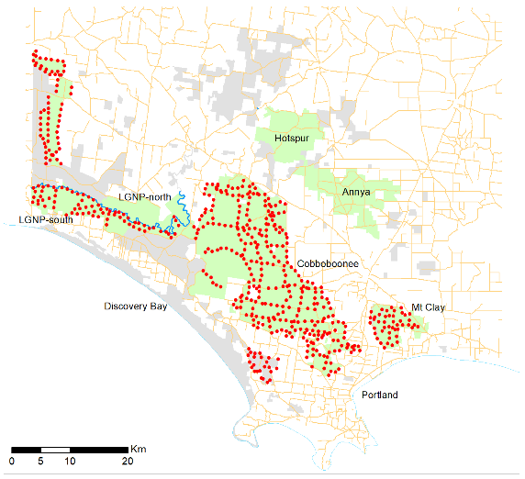
Figure 1. Glenelg Ark operations area. Green - Glenelg Ark operational areas. Red dots indicate poison bait stations. Pale grey – other public land.
The six monitoring locations were:
- Annya State Forest (NTML; 8520 ha)
- Hotspur State Forest (NTML; 6940 ha).
- Lower Glenelg National Park – North (LGNP-north; NTML; 4659 ha) (separated from LGNP-south by the Glenelg River)
- Cobboboonee National Park (TML; 9750 ha)
- Lower Glenelg National Park – South (LGNP-south; TML; 8954 ha)
- Mount Clay State Forest (TML; 4703 ha)
The aim of this design was to identify any patterns of association between a reduction in foxes and an increase in targeted native species.
  - The difference in fox density between treatment and non-treatment monitoring locations
In the absence of data on the density of foxes in the TML and NTML we used a spatially explicit, individually based population model, ‘FoxNet’, to predict the difference in fox population density and responses to baiting. FoxNet incorporates parameters on dispersal and home ranges as a function of resource availability (Hradsky et al. 2019) and customises survival and reproductive parameters for south-eastern Australia (see Hradsky 2022 for detail of model parameters).
FoxNet models foxes as mobile individuals whose behaviour is determined by age, sex, status, and the time of year. Within the model, ‘alpha’ foxes seek to join or start their fox families, establishing and maintaining a territory. Each fox family must contain at least one alpha fox and may also include the alpha’s mate, cubs and subordinate offspring, who share the territory. Fox families can be characterised by a description of the family members, their territory (habitat-cells) and the productivity of their territory.
The landscape in FoxNet is divided into habitat cells, which we defined as 1 ha in size. Each habitat cell has a set of parameters that affect how fox families and individual foxes behave.
We updated our model processes at 1-week intervals (time steps). A series of operations occur consecutively at each time step, and key seasonal events [e.g. dispersal (March–April) and mating (July–September)] are linked to weeks of the year (9–21 and 27–40, respectively).
At each time step, foxes age; if old enough, they disperse between March and May of each year. Within fox families, an alpha male or female that dies (either by natural causes or baiting) is replaced by an age- and sex-appropriate subordinate from that family if a suitable individual is available. Otherwise, the position remains vacant for a disperser to join the fox family. Fox families check their territories; if productivity is insufficient, adults and subordinates disperse, and cubs die. This checking also enables fox families to expand and contract their territory size in response to landscape productivity.
Baits are deployed at bait stations (according to the defined Glenelg Ark management strategy). Foxes whose territories overlap with one or more bait stations are exposed to these baits and risk dying, with the level of risk based on the number of baits, the size of their territory and the number of foxes in the fox family. All baits that are not ‘eaten’ by foxes are removed after each model time step (1 week). Although baits may be available to foxes for longer than a week, degradation of 1080 may render baits non-lethal 2 weeks after deployment (Saunders et al. 2000).
Models were run for 40 iterations to capture the underlying variance in fox responses. Adult fox densities were recorded and updated at each time step and were averaged across all model iterations. Models were run with a buffer of ~30 km around the locations to capture >96% of dispersing female foxes and >93% of dispersing male foxes that might reach the location.
Fox density was modelled for 10 years before the commencement of baiting (to allow the population to stabilise) and for 10 years following the beginning of baiting across each TML.
    - Calculating changes in fox density
The difference in mean fox density between baited and unbaited models was used to assess the success of the control strategy. For each of the 40 model iterations, fox densities within a location were averaged over 13 × 13 1-ha cells, or 1.69 km², approximately 80% of the area of a fox’s home range. This produced an average fox density (number per km²) for both baited and unbaited locations, which was analysed to determine the percentage reduction in density [R package ‘raster’ (Hijmans 2015)]. This assessment was taken in week 23 of model year 20 to coincide with the midpoint between population peaks (cub independence).
A snapshot in time of the spatial effect of baiting on fox density was also produced; this ‘density map’ was also calculated for week 23 of model year 20 to coincide with the midpoint between population peaks (cub independence), and it illustrates the areas with spatial reductions in fox density of between 50 and 65% and >65%. Spatial reduction calculations contrasted the unbaited and baited scenario spatial density outputs.
FoxNet was built and run in the open-source software Netlogo (v. 6.0.4, Wilensky 1999), and models were executed using R v. 3.5.3 (R Core Team 2021) and the ‘RNetLogo’ package (Thiele et al. 2012; Thiele 2014). Landscapes were built using ArcMap 10.3.1 (ESRI 2015) using Victorian Government GIS datasets (PLM25). A detailed model overview and description of FoxNet following the Overview, Design, Details protocol is provided in Hradsky et al. (2019).
  - Measuring the response in native mammal species
Occupancy by the three target native mammal species (Long-nosed Potoroo, Southern Brown Bandicoot and Common Brushtail Possum) was monitored annually at 40 camera trap sites established within each TML and NTML (Figure 2). The placement of the monitoring sites was chosen based on descriptions of the habitat preferred by the target native mammal species (Menkhorst 1995) and aligned with EVCs; the number of sites within a EVC was proportional to the size of the preferred habitat within each TML and NTML. The position of the monitoring sites within locations was randomly assigned but constrained to be within 50 m of tracks. A site was assumed to sample the area potentially occupied by the target species, with home ranges for Southern Brown Bandicoot and Long-nosed Potoroo ranging from 2 to 4 ha (Bennett 1987; Scott et al. 1999; Ricciardello 2006; McGregor et al. 2013).
Monitoring before the commencement of poison baiting was conducted in winter 2005, then usually undertaken in spring (2005, 2008–2020). In 2006, sampling was conducted in late winter, and the spring 2007 samplings at Mount Clay and Hotspur were delayed, with monitoring undertaken in the 2007–2008 summer.
From 2005 to 2012, at each monitoring site, nine ‘Handiglaze’ hair-tubes (Murray 2005; Figure 3) baited with peanut butter, rolled oats, and golden syrup were set and checked daily for four consecutive days, with tapes being replaced each day. These daily tape replacements represented four repeat surveys of the monitoring site per sampling period. Beginning in spring 2013, hair-tubing was discontinued, and a single digital camera (Reconyx RapidFire HC600, Reconyx, LLP Wisconsin, USA) was set at one of four possible locations within a hair-tube grid at each monitoring site (Figure 3). A series of coin tosses determined the camera’s location within the grid. Cameras were attached to the nearest tree 20–30 cm above the ground. A lure of truffle oil, peanut butter, rolled oats, and golden syrup was secured to the ground in a small, ventilated container 2 m in front of the camera. Cameras were set to take five images per trigger and operated for a minimum of 30 days, with each day representing a repeat survey of the monitoring site per sampling period.
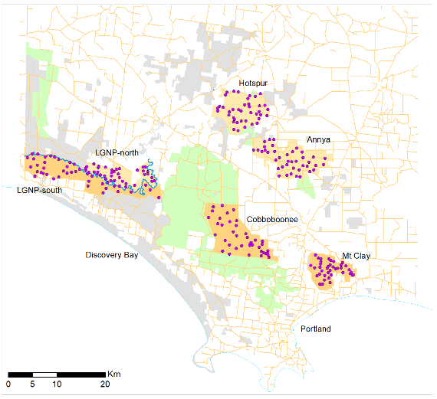
Figure 2. Monitoring sites in the treatment monitoring locations (TMLs; dark tan areas) and non-treatment monitoring locations (NTMLs; pale tan areas) for Glenelg Ark are indicated by purple dots. LGNP = Lower Glenelg National Park.

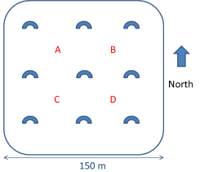
Figure 3. The layout of the nine hair-tubes and possible location (A, B, C or D) of the single digital camera at a monitoring site
  - Species occupancy
A multiseason occupancy model was used to estimate the occupancy ($ψ$), detection ($p$), local colonisation $(γ$, the probability that an unoccupied site in season, $γ-t$ is occupied in season $γ-(t+1))$ and local persistence ($η$, the probability that an unoccupied site site season $η-t$ remains occupied in season $η-(t+1)$) (MacKenzie et al. 2006, 2017). The model was constructed in a Bayesian framework, using a space–state formulation (Royle and Kéry 2007). Separate models were built for each species of interest: CBP, LNP and SBB. Each model allowed for a parameter difference at each of the six locations: Annya State Forest, Hotspur State Forest, and Lower Glenelg National Park – North (no fox control); Cobboboonee National Park, Mount Clay State Forest, and Lower Glenelg National Park – South (fox control). Models were constructed that included several camera level covariates individually for local persistence, and local colonisation rates (Table 1).
Distance to non-native vegetation (DTNV). Invasive predators are well documented to prefer edges between forest and cleared land, because they facilitate efficient movement and hunting (e.g. McGregor et al. 2014; Hradsky et al. 2017; Nichols et al. 2019). We modelled the effect of the minimum distance from each camera trap site to the nearest substantial area of non-native vegetation. We calculated this by inverting the extent of native vegetation (Department of Environment, Land, Water and Planning 2019) and removing cleared areas smaller than 30 ha, as per Geary et al. (2020).
Terrain ruggedness and wetness. High topographic complexity (i.e. ‘ruggedness’) can limit predator movement and predation rates, benefiting prey (Hohnen et al. 2016; McDonald et al. 2017; Stobo-Wilson et al. 2020). Soil moisture (estimated by the topographic wetness index) impacts vegetation and the availability of subterranean invertebrates and fungi—key food sources for Long-nosed Potoroo and Southern Brown Bandicoot (Lobert 1990; Nuske et al. 2017).
We extracted each site’s elevation above sea level (metres) using a 10-m-resolution digital elevation model (Department of Environment, Land, Water and Planning 2020). We also used this elevation layer to calculate the median terrain ruggedness index (TRI, which calculates the difference in elevation between a central cell and eight adjacent cells (Riley et al. 1999), taking the median value in a 30-m radius around each camera trap site. We also took the median topographic wetness index in a 30-m radius around each camera-trap site, derived from a 30-m resolution layer (Gallant and Austin 2012). The topographic wetness index estimates where water will accumulate by accounting for topographic influences on hydrological processes (Beven and Kirkby 1979).
Time since fire (TSF). We derived the time since the last fire (in years) for each camera trap deployment, using coarse fire scar mapping provided DELWP dating back to 1939, when large wildfires burnt the region extensively.
Treatment. To allow for covariate effects to vary between locations with and without fox control, we included a binary variable for treatment representing fox control (1) and no fox control (0).

Table 1. Camera level covariates used in the multiseason occupancy models
Covariate | Description
Distance to non-native vegetation (DTNV) patches of >30 ha | Distance in metres to the nearest patch (>30 ha) of non-native vegetation, e.g. pine plantation, open pasture
Terrain Ruggedness Index (TRI) | A measure of the difference in elevation between a centre cell and the eight cells directly surrounding it. The eight elevation differences are squared and averaged. The square root of this average result is a TRI measurement for the centre cell.
Time since fire (TSF) | Time (in years) since the camera site was last recorded as being burnt
Topographic Wetness Index (TWI) | A quantitative measure of the terrain-driven variation in soil moisture. Topographic Wetness Index (TWI) is calculated as log_e(specific catchment area / slope) and estimates the relative wetness within a catchment.
Treatment | A binary variable that indicates whether a location received fox control or not. 0 = no fox control, 1= fox control

A random effect was included in the local persistence and colonisation rate to account for annual variation. If there was evidence that the covariate was important (the 95% high-density interval/credible interval excluded 0), then that covariate was included in a combined model for that rate. Only the final combined model is reported (see Appendix 2 for a list of all models). The ecological fire group (EFG) was initially considered for inclusion, but once the data was compiled, it was clear that the dominant EFG was aligned with the location and would therefore be confounded. Since there were very limited EFGs outside the dominant ones, we decided to use location rather than EFG as an explanatory variable.
The general form of the model took the form:
$$\begin{matrix}\text{logit}(ψ_{i,t}) & =Z_{i,t-1}×η_{i,t}+(1-Z_{i,t-1})×γ_{i,t} \\ \text{logit}(γ_{i,t}) & =α_{Location_{i}}+α_{1}×x_{i,t,h}+α_{2}×y_{i,t}×Control_{Location_{i}}+ε_{C,t} \\ \text{logit}(η_{i,t}) & =β_{Location_{i}}+β_{1}×x_{i,t,h}+β_{2}×y_{i,t}×Control_{Location_{i}}+ε_{S,t} \\ Y_{i,t,j} & ∼\text{bern}(p_{D_{j}}×Z_{i,t}) \\ Z_{i,0} & ∼\text{bern}(ψ_{0}) \\ Z_{i,t} & ∼\text{bern}(ψ_{i,t}),t>0 \\ ε_{C,t} & ∼\text{N}(0,σ_{C}^{2}) \\ ε_{S,t} & ∼\text{N}(0,σ_{S}^{2})\end{matrix}$$

Table 2. Parameters and their definitions used in the multiseason occupancy model
Parameter | Definition
$$t$$ | The survey period since the initial survey in 2005
$$X_{i,t,j}$$ | Observation status of a species at site $i$ in period $t$ on the $j$ observation: 1 (detected), 0 (otherwise)
$$Z_{i,t}$$ | True occupancy status of a species at site $i$ in period $t$: 1 (occupied), 0 (otherwise)
$$ψ_{i,t}$$ | The occupancy rate for a species at site $i$ in period $t$
$$p_{D_{j}}$$ | The daily detection rate of a species depending on the device $D$ used on day $j$ at a site, given the site is occupied
$$x_{i,t,h}$$ | Variable of interest $h$ at site $i$ in period $t$
$$γ_{i,t}$$ | Colonisation rate at site $i$ in period $t$
$$η_{i,t}$$ | Persistence rate at site $i$ in period $t$
$$ε_{C,t}$$ | Random variation in colonisation rates in period $t$
$$ε_{S,t}$$ | Random variation in persistence rates in period $t$
$$σ_{C}$$ | Standard deviation in the random variation in colonisation rates between periods
$$σ_{S}$$ | Standard deviation in the random variation in persistence rates between periods

The models also allowed for differences in daily detection rates based on whether a hair-tube or camera was used for detection. Additionally, hair-tube detection of Long-nosed Potoroos and Southern Brown Bandicoots was allowed to differ depending on whether Common Brushtail Possums were detected at the site. The reasoning for this was that the hair-tubes could be swamped with Common Brushtail Possum hairs, making it difficult for hair from other species to be collected by the hair tubes; therefore, Long-nosed Potoroos and Southern Brown Bandicoots could be underreported.
We then derived the growth rate from the posterior distributions for the number of occupied sites. The growth rate is a comparison of the current occupancy rate with the previous season’s occupancy rate, i.e.
$${\text{Growth}}_{t}=\frac{ψ_{t}}{ψ_{t-1}}$$
Growth rates of >1 imply increasing occupancy, whereas growth rates of <1 show that occupancy is decreasing; a growth rate of 1 shows no occupancy change. As a measure of the impact fox control had on the growth rate, we calculated the percentage difference in growth rate between locations with and without fox control.
    - Spatial predictions of occupancy
We used predictions from the occupancy models for Long-nosed Potoroos and Southern Brown Bandicoots to generate spatial maps of the occupancy probability across the Glenelg Ark operations landscape. These surfaces can help visualise predicted occupancy for the current monitoring locations and for locations outside the monitored areas, aiding with decision-making regarding the placement of additional monitoring sites.
Predictions for each location, which including both sampled and unsampled locations, were conditional on the values of all covariates at these locations used in the model fitting process. These spatial maps were designed to help land managers evaluate the current camera trap placement and consider where to place new cameras to help increase our understanding of the relationship between the explanatory variables, fox control and occupancy by Long-nosed Potoroos and Southern Brown Bandicoots. Some of the predicted locations had values for explanatory variables that were outside the range of those included in the models. Predictions at those locations are extrapolations and assume the relationships are linear (on the logit scale) for those values, which may not be the case.
The models were constructed in JAGS (Plummer 2003) via R (R Core Team 2021) using the package R2jags (Su and Yajima 2015. Model chains were run until the chains converged. Convergence was defined when the Gelman and Rubin’s convergence diagnostic (scale reduction factor) was <1.05 for all parameters (Gelman et al. 2004). The model selection was performed by running a model with each variable separately and then including that variable in the final model if there was evidence it was important (95% CI excluded 0).

- Results
  - Fox density
FoxNet modelling showed a reduction in fox density of 73% at 10 years after implementing model fox control (Figure 4). Fox densities at locations with baiting became significantly different from fox densities at locations without baiting 1 year after baiting began, and the mean fox density across TMLs was 0.46/km² (min–max: 0.38–0.54).
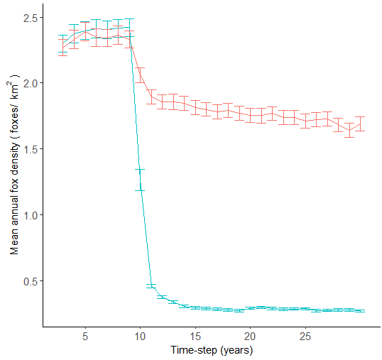
Figure 4. The modelled fox densities for the Glenelg Ark program—locations with fox control (aqua) and locations without fox control (red). Fortnightly baiting commenced in model year 11, as per the project description, and ran for the duration of the model.
The modelled fox density was reduced by >65% over 43% of the TMLs by June in model year 20 (Figure 5). Table 3 shows the average modelled density of foxes for each monitoring area in the spring 10 years after baiting commenced.
Table 3. Modelled predictions of fox density at treatment and non-treatment monitoring locations at 10 years after baiting commenced, i.e. in 2015
Treatment | Monitoring location | Modelled fox density (min–max)  (/km²)
No fox control | Annya | 1.20 (0.99–1.5)
No fox control | Hotspur | 1.25 (0.94–1.7)
No fox control | Lower Glenelg – North | 0.54 (0.34–0.70)
Fox control | Mount Clay | 0.22 (0.11–0.38)
Fox control | Cobboboonee | 0.09 (0.02–0.18)
Fox control | Lower Glenelg – South | 0.22 (0.16–0.34)

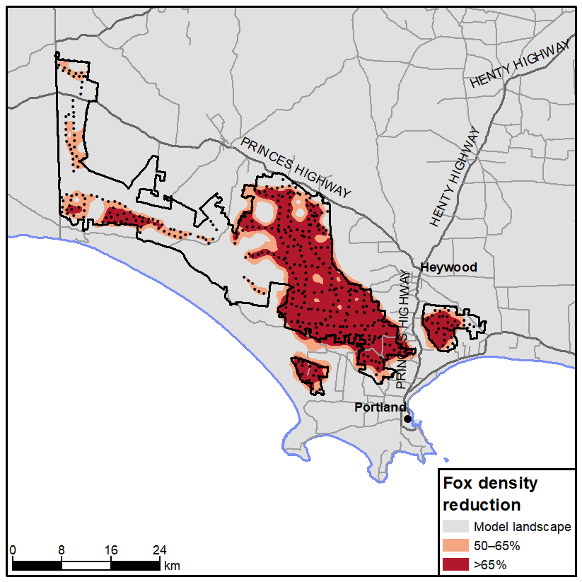
Figure 5. Modelled spatial reduction in modelled fox densities for the Glenelg Ark program
  - Feral cat density
Camera trap data collected by the Glenelg Ark team as part of the Feral Cat project funded through the Biodiversity Response Planning program was added to the data compiled and then analysed by University of Melbourne PhD candidate Matthew Rees. Results from this analysis show that, on average, the feral cat density at locations with fox control was higher (0.47/km² 95% CL 0.31–0.70) than at locations without fox control (0.20/km² 95% CL 0.13–0.34) (Table 4). Note that these estimates are for cat density from a single year (2021) year. The underlying density of feral cats may differ between these locations, regardless of fox control.
Table 4. Estimated feral cat densities at locations with and without fox control
Landscape | Estimate  (/km²) | Lower 95% CL  (/km²) | Upper 95% CL  (/km²) | Treatment | Replicate
Annya | 0.24 | 0.17 | 0.34 | NFC | 1
Hotspur | 0.22 | 0.14 | 0.33 | NFC | 2
LGNP-N | 0.15 | 0.07 | 0.35 | NFC | 3
Cobboboonee | 0.60 | 0.40 | 0.88 | FC | 1
Mount Clay | 0.24 | 0.18 | 0.31 | FC | 2
LGNP-S | 0.56 | 0.34 | 0.90 | FC | 3
CL = confidence limit; FC = fox control; LGNP-N = Lower Glenelg National Park – North; LGNP-S = Lower Glenelg National Park – South; NFC = no fox control,
  - The influence of site-level covariates on colonisation, persistence, and growth rates between locations with and without fox control
    - Common Brushtail Possum

Persistence
The persistence rates for Common Brushtail Possums were higher at locations with fox control, while persistence tended to decline as distance to non-native vegetation increased, regardless of fox control status (Figure 6) (Table 4).
The odds of an occupied site remaining occupied by Common Brushtail Possums (i.e. persisting from one year to the next) were greater by 43% (95% CI 20–72%) than at the equivalent site without fox control.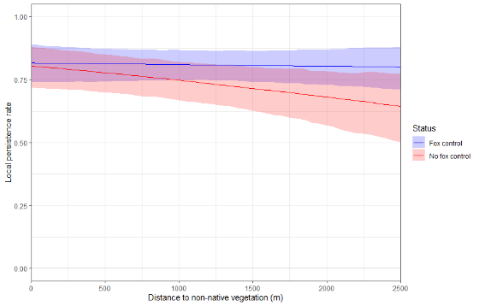
Figure 6. Estimated persistence rate for Common Brushtail Possum in relation to distance to non-native vegetation

Colonisation
The only covariate that influenced colonisation rates was the presence of fox control (Table 5). At sites with fox control, the odds of an unoccupied site becoming occupied by Common Brushtail Possums were greater by 35% (95% CI 1–79%) than at the equivalent site without fox control.
Table 5. Results from the Common Brushtail Possum occupancy model
Component | Parameter | Median | L.B. | U.B.
Persistence | Distance to non-native vegetation | –0.326 | –0.630 | –0.015
Persistence | Distance to non-native vegetation with fox control status | 0.285 | –0.118 | 0.712
Persistence | Fox control area | 0.360 | 0.182 | 0.542
Colonisation | Fox control area | 0.303 | 0.014 | 0.585
Rows in bold type are significant results. L.B. and U.B. are the lower and upper bounds from the 95% credible interval, respectively. All estimates are on the logit scale.
Growth rate
Since 2009, the difference in occupancy growth rate for Common Brushtail Possums has been very close to zero across all locations, suggesting that the most suitable habitat has become and remains occupied since then. Hence, there was a slight decline in the difference in growth rate (as a percentage change) with fox control (Figure 7).
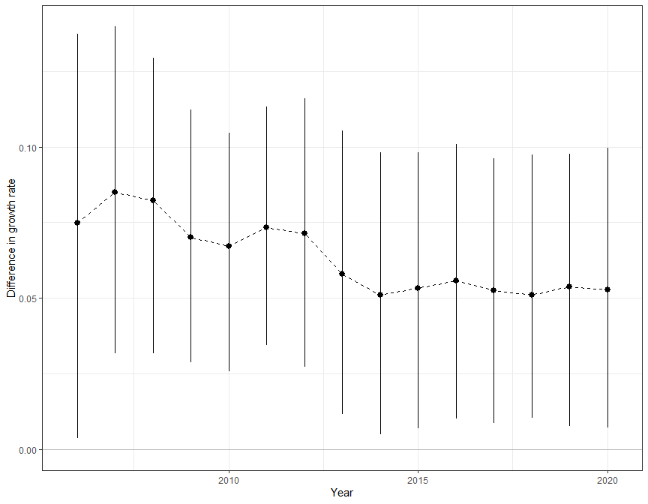
Figure 7. The difference in growth rates (percentage difference between sites with and without fox control) for Common Brushtail Possum over time. The dot is the median, and the lines represent the 95% credible interval.

    - Long-nosed Potoroo

Persistence
The covariates influencing Long-nosed Potoroo persistence rates were the presence of fox control and the topographic wetness index (Table 6). Sites with fox control tended to have higher persistence rates than sites without fox control, but this difference ceased as topographic wetness increased above a TWI of 9. (Figure 9).
The odds of an occupied site remaining occupied were 103% greater (95% CI 8–276%) than for the equivalent site without fox control.
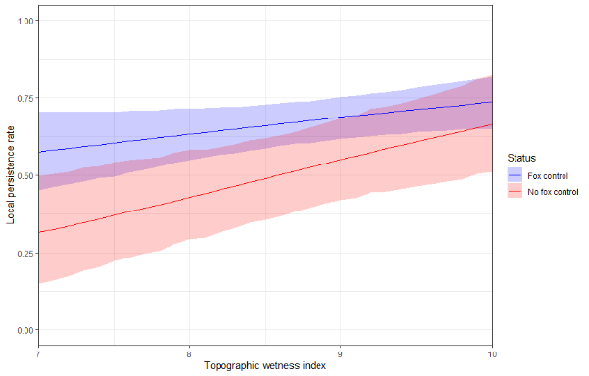
Figure 9. Estimated persistence rate for Long-nosed Potoroo in relation to distance to non-native vegetation, separated by fox control status

Colonisation
The covariate that influenced Long-nosed Potoroo colonisation rates was the presence of fox control (Table 6). At sites with fox control, the odds of an unoccupied site becoming occupied by Long-nosed Potoroo were 239% greater (95% CI 120–469%) than for the equivalent site without fox control.
Table 6. Results from the Long-nosed Potoroo occupancy model
Component | Parameter | Median | L.B. | U.B.
Persistence | Topographic wetness index | 0.960 | 0.249 | 1.796
Persistence | Topographic wetness index with fox control status | –0.476 | –1.399 | 0.432
Persistence | Fox control area | 0.706 | 0.079 | 1.324
Colonisation | Fox control area | 1.222 | 0.789 | 1.739
Rows in bold are significant results. L.B. and U.B. are the lower and upper bounds from the 95% credible interval, respectively. All estimates are on the logit scale.
Growth rate
The difference in growth rate at locations with fox control has been consistently greater than at locations without fox control (Figure 10).
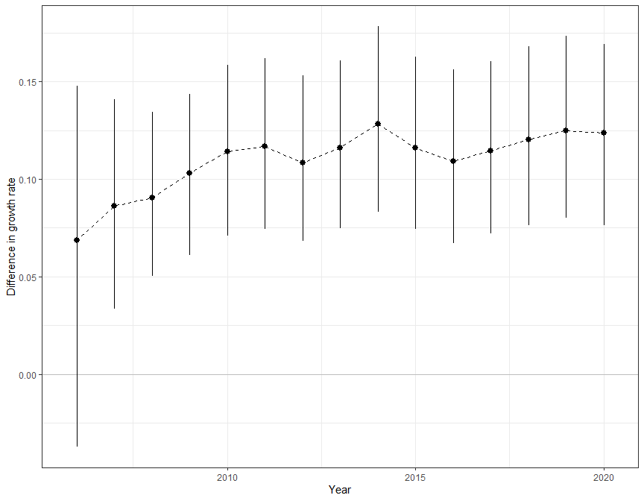
Figure 10. The difference in growth rates (percentage difference between sites with and without fox control) for Long-nosed Potoroo over time. The dot is the median, and the lines represent the 95% high-density interval.

    - Southern Brown Bandicoot

Persistence
The covariates influencing persistence of Southern Brown Bandicoots were the presence of fox control, the topographic wetness index, and the time since fire (Table 7). At sites without fox control, the Southern Brown Bandicoot persistence rate increased with an increase in topographic wetness index (Figure 11a), while at sites with fox control, there was little evidence that the topographic wetness index influenced persistence.
At sites without fox control, the local persistence rate of Southern Brown Bandicoots decreased with increasing time since fire (Figure 11b), while at sites with fox control, the local persistence rate did not seem to be influenced by time since fire.
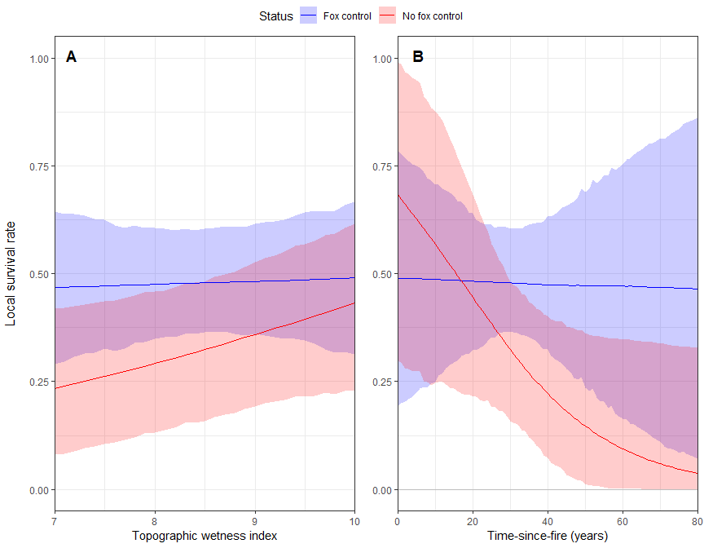
Local persistence rate
Figure 11. (A) Persistence rates for Southern Brown Bandicoot across different topographic wetness indices, separated by fox control status, given all other covariates are held at their mean value. (B) Persistence rates for Southern Brown Bandicoot across different times since fire, separated by fox control status, given all other covariates are held at their mean value. The line is the median, and the shaded area represents the 95% credible interval.

Colonisation
The covariates influencing local colonisation rates of Southern Brown Bandicoots were the presence of fox control and the distance to non-native vegetation (Table 7). The colonisation rate increased with increasing distance to native vegetation at sites with and without fox control, although sites with fox control had higher colonisation rates (Figure 12).
The odds of an unoccupied site becoming occupied were 190% greater (95% CI 85–357%) than at the equivalent site without fox control.
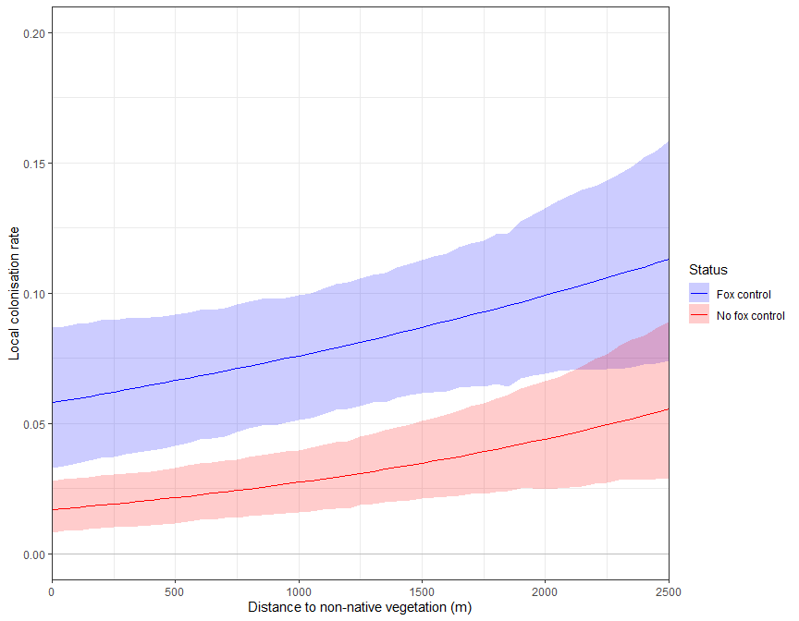
Figure 12. Estimated local colonisation rate for Southern Brown Bandicoot in relation to distance to non-native vegetation, separated by fox control status
Growth rate
The difference in occupancy growth rate of Southern Brown Bandicoots at locations with fox control has been consistently greater than at locations without fox control (Figure 13).
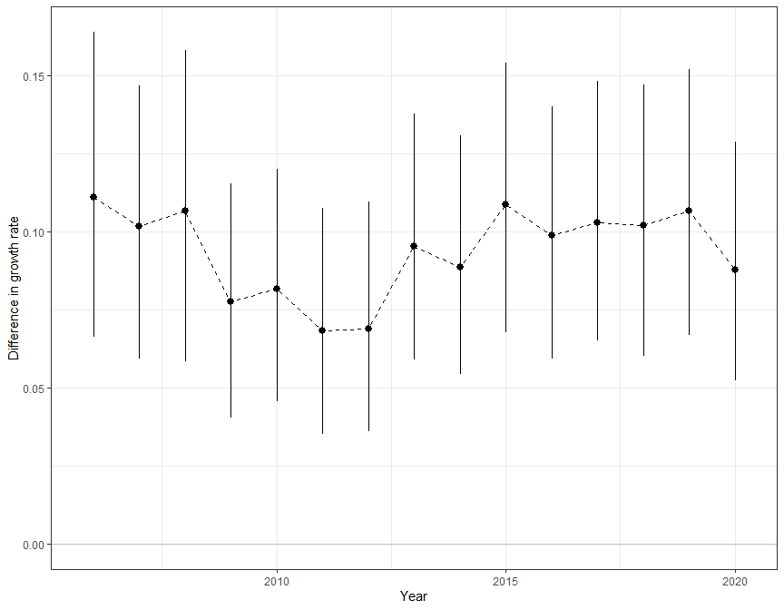
Figure 13. The difference in growth rates (percentage difference between sites with and without fox control) for Southern Brown Bandicoot over time. The dot is the median, and the lines represent the 95% high-density interval.
Table 7. Results from the Southern Brown Bandicoot model that relates to the covariates
Component | Parameter | Median | L.B. | U.B.
Persistence | Topographic wetness index | 0.609 | –0.057 | 1.309
Persistence | Time since fire | –0.546 | –0.966 | –0.145
Persistence | Topographic wetness index with fox control status | –0.967 | –1.797 | –0.066
Persistence | Time since fire with fox control status | 0.049 | –0.552 | 0.616
Persistence | Fox control area | 0.651 | –0.143 | 1.465
Colonisation | Distance to non-native vegetation | 0.490 | 0.195 | 0.795
Colonisation | Distance to non-native vegetation with fox control status | –0.200 | –0.602 | 0.193
Colonisation | Fox control area | 1.065 | 0.617 | 1.519
Rows in bold are significant results. L.B. and U.B. are the lower and upper bounds from the 95% credible interval, respectively. All estimates are on the logit scale.

  - Areas of potential additional monitoring for Long-nosed Potoroo and Southern Brown Bandicoot
We plotted the counts of the current monitoring sites for each predictor variable and included Normalised Difference Vegetation Index (NDVI), EVC, and Distance to Water (distance to a water course) as possible variables to include in the next update (Figure 14). Other suggestions for inclusion in the next update are the mean annual temperature, the mean annual precipitation, and the mean moisture index of the highest quarter.
Inspection of Figure 14a–l indicates that the distribution of camera sites is roughly proportional to the availability of locations for each covariate, with some of the more extreme values being slightly less well represented in the current monitoring design.
Visual inspection of the model outputs indicates that a distance of >2500 m from non-native vegetation was an important variable for Southern Brown Bandicoot colonisation. Approximately 5% of camera sites are, on average, >2500 m from non-native vegetation (Figure 14a), while the predicted surface indicates that approximately 13% of occupied sites are >2500 m from non-native vegetation (Figure 14b). From the current camera monitoring, approximately 18% of sites were >2500m from non-native vegetation across both locations, and approximately 22% of predicted sites were available in the landscape (Figure 14d). Similarly, a topographic wetness index above a value of 9 increased the persistence of Southern Brown Bandicoot at locations without fox control, and the current monitoring sampled around 33% of these sites—with approximately 41% of predicted sites available for monitoring (Figure 14e–f). Time since fire of less than around 20 years appeared to an important criterion for Southern Brown Bandicoot persistence at locations without fox control.
The proposed new covariates (NDVI and Distance to Water) are also well represented by the current monitoring array (Figure 14g–j). Monitoring a representative range of EVCs presents some challenges. Most of the camera sites and the predicted landscape are represented by EVC 8 (Figure14k–l). One solution may be to include ‘EVC 8’ and ‘other EVC’ as categories in the next modelling round.
Before potential new monitoring sites are allocated, it will be necessary to separate locations with and without fox control. This may be particularly useful, as time since fire and topographic wetness index were important only at locations without fox control for Southern Brown Bandicoots.
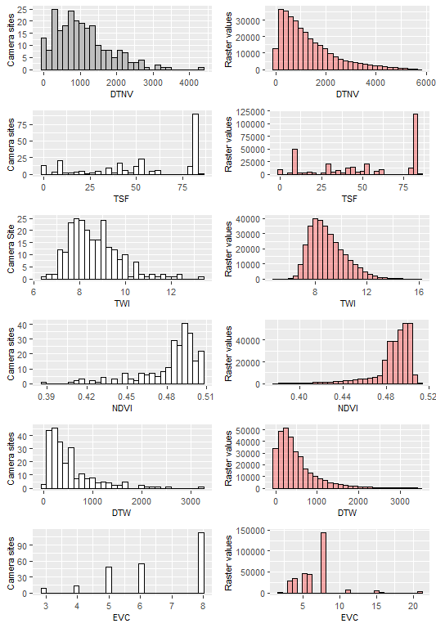
Figure 14. Counts of camera sites and raster cell values for model covariates used in current occupancy modelling, and three additional covariates. DTNV = distance to non-native vegetation; DTW = Distance to Water; EVC = Ecological Vegetation Class; NDVI = Normalised Difference Vegetation Index; TSF = time since fire; TWI = topographic wetness index.

    - Spatial predictions of occupancy
Based on the ‘best model’, we also generated predictive occupancy maps across the study region for Long-nosed Potoroo (Figure 15) and Southern Brown Bandicoot (Figure 16). Rather than predict occupancy by each species throughout the entire south-west, we limited our predictions to the core public land areas of Glenelg Ark, because predicting occupancy well outside the sampled environmental domain introduces a large amount of uncertainty into the predictions and would be unreliable.
The predicative occupancy maps (particularly for Southern Brown Bandicoot) indicate that the extreme values for the important covariates strongly influence the predicted occupancy outside the current monitoring area. It is in these locations that additional monitoring should be focused. Adding monitoring data from these locations and the proposed additional covariates from across the monitoring landscape should significantly improve model predictions and strengthen our ability to make inferences about the role of fox control in the occupancy of the three target native mammal species.
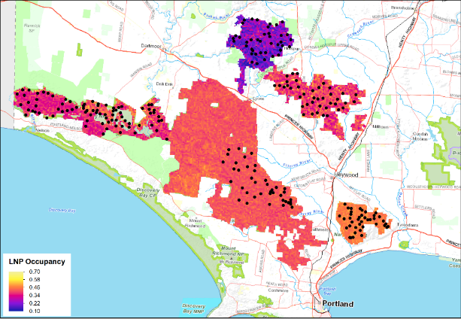
Figure 15. Predicted occupancy of Long-nosed Potoroo across the Glenelg Ark landscape. Black dots are the location of existing camera-trap monitoring stations.

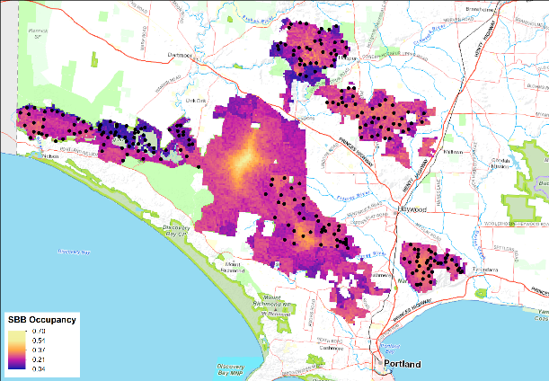
Figure 16. Predicted occupancy of Southern Brown Bandicoots across the Glenelg Ark landscape. Black dots are the location of camera-trap monitoring stations.
- Conclusions and implications
We found that fox control has a strong positive effect on both Long-nosed Potoroos and Southern Brown Bandicoots, and a lesser but still positive effect on Common Brushtail Possums over Glenelg Ark. Long-nosed Potoroos occupied new sites and remained at current sites more often at locations with fox control. As topographic wetness (a surrogate for soil moisture and vegetation composition) increases, so does the probability that a site remains occupied by Long-nosed Potoroos, regardless of fox control status. Southern Brown Bandicoots had a higher probability of persisting at wetter sites and sites that had been unburnt for longer at locations without fox control, while they had a higher probability of occupying new sites as distance to non-native vegetation increased, regardless of fox control status; this difference, however, became less important above 2250m elevation. The weaker (but still positive) response by possums may have been because, since 2009, most available suitable habitat has become and remains occupied, resulting in a growth rate near zero.
The higher growth rates indicate that growth in occupied sites was consistently greater at locations with fox control compared with locations without fox control. While our results indicate that Long-nosed Potoroos and Southern Brown Bandicoots are doing better at locations with fox control, the magnitude of their responses is relatively small. Long-nosed Potoroo and Southern Brown Bandicoot occupancy rates are only 10% (6–14%) and 9% (6–13%), respectively, greater at locations with fox control compared with those without fox control.
FoxNet modelling indicates that fox density is likely to have been significantly reduced after 1 year of baiting and held at <0.25 foxes/km² after 5 years of baiting. Interestingly, for Southern Brown Bandicoots at locations without fox control, the topographic wetness index and the time since fire were influential in driving persistence; this was not the case, however, at locations with fox control. One possible interpretation is that Southern Brown Bandicoots can occupy sites that encompass a more comprehensive set of characteristics (i.e. broaden their realised niche) at locations where the predation risk has been substantially reduced. This is in line with the predictions of the expanding niche hypothesis of Hutchinson (1978) and observations for Brush-tailed Rock-wallabies in Western Australia (Kinnear et al. 1988), where not only did the population of Brush-tailed Rock-wallabies increase, but they also increased their use of the habitat.
We believe that the ecology of the surviving populations of small-to-medium-sized mammals at Glenelg Ark is atypical because of fox predation. Probably, populations can only currently persist in refugia, which may be quite atypical of a species' niche requirements in the absence of introduced predators. Bennett (1993) investigated microhabitat use by the Long-nosed Potoroo in remnant forest vegetation in south-western Victoria. He found that the Long-nosed Potoroo, throughout its geographic range, is consistently associated with dense vegetation in the ground and shrub strata. Bennett (1993) concluded that the dense vegetation cover provided diurnal shelter and protection from predators, but that food resources were most abundant in the adjacent, more open areas. Bennett (1993) also suggested that a key characteristic of potoroo habitat selection is the presence of vegetation mosaics or ecotones that contain different microhabitats in temperate environments. Arthur et al. (2012) observed that bandicoot populations (Isoodon obesulus and Perameles nasuta combined) declined at a rate faster than the rate of decreasing shrub cover, and that in contrast Long-nosed Potoroos increased with closing tree canopy (10 years post-fire) and had a negative association with the presence of foxes. Both studies were undertaken in the presence of foxes (and most likely feral cats), thus representing conditions of possible niche restriction.
The Hutchinson (1978) concept of the niche posits that fox predation affects the dimensions of a species' realised niche by exaggerating the requirements for protective shelter and the need for food to be nearby. Niche theory predicts that a release from predation would relax the requirements for shelter and the proximity of food and thus permit the expansion of the realised niche, which is possibly what was observed in Southern Brown Bandicoots at Glenelg Ark (i.e. less stringent habitat requirements in areas with fox control), and to a lesser degree in Long-nosed Potoroos.
There is uncertainty regarding niche expansion in the current study, which may be related to the covariates in our models not fully describing the finer-scale differences when comparing the habitat use by Southern Brown Bandicoots and Long-nosed Potoroos at locations with and without fox control. Selecting the most informative predictors for species distribution and habitat modelling is challenging. Ideally, we would select factors that directly influence population growth (colonisation), survival (persistence), distribution (occupancy), or, if these are not identified or available, proxies that reflect biotic or abiotic processes relevant to the target species (Phillips et al. 2006). While the variables in this analysis were selected with this in mind, in future they will be reviewed and additional variables added that may clarify the differences in habitat use between locations with and without fox control, e.g. annual mean NDVI for the period January 2001 – December 2020. NDVI is a measure of surface reflectance and gives a quantitative estimation of vegetation growth and biomass change over time. A suitable NDVI layer for each year was not available at the time of this analysis. Other possible variables not available at the time of the study that might be considered include annual mean temperature for 2005–2022, mean annual precipitation for 2005–2022, mean moisture index of highest quarter for 2005–2022, Distance to Water, and light detection and ranging imagery (LiDAR) to assess vegetation structure at multiple levels (a commonly used metric in animal distribution studies, Simonson et al. 2014).
The model predictions for occupancy were used to map the likely occurrence of Long-nosed Potoroos and Southern Brown Bandicoots, so that land managers can use these outputs in planning future monitoring activities, adding to the current monitoring sites and relocating current sites if necessary, depending on available capacity and resources. We recommend adding to the current monitoring locations, using the predicted surfaces to identify areas in which the present covariates are under sampled and where new sites are needed.
FoxNet has been run on fox projects with known outcomes (changes in density) to validate the modelling (Hradsky et al. 2019), and it has proven to be a reliable representation of changes in fox populations following control actions. FoxNet model predictions for Glenelg Ark indicate that fox densities at locations with fox control are significantly lower than at locations without fox control. Data on the actual density of foxes are required to validate the predicted fox densities. These data are already being sought as part of a University of Melbourne project at Annya, Hotspur, Mount Clay and Cobboboonee and will soon be available. It would be beneficial for Glenelg Ark monitoring to include collection and analysis of density data from Lower Glenelg National Park – South and Lower Glenelg National Park – North to complete the assessment.
What is unclear is the precise fox density at which prey species are released from limitation in growth by predation. This notion of a threshold density, a point at which predator density is so low that native species are no longer limited by predation, has long been sought after. FoxNet modelling was incorporated into occupancy models investigating the impact of the 2019–2020 bushfires in Gippsland (Robley et al. 2022). Fox density was found to be a significant variable affecting the occurrence of Long-footed Potoroo, with the probability of Long-footed Potoroos occurring at a site being zero when fox density was higher than 0.5/km². In a series of introduction experiments into 14-km² fenced areas, Moseby et al. (2019) found that during a trial of 66 Burrowing Bettong (Bettongia lesuerii) releases into a large, fenced paddock, one fox, at a density of 0.027/km², drove the bettong population extinct within 12 months. These results indicate that fox density needs to be reduced and maintained at very low levels for Burrowing Bettongs to persist. However, it is likely that, even at low densities, habitat structure and diversity will remain important factors affecting the survival of species such as bandicoots and potoroos.
It needs to be noted, however, that predator–prey dynamics are complex. Predators can interact with one another and with prey to influence mortality among prey via interference, competition, or cooperative predation (Delong and Vasseur 2013; Stallings and Dingeldein 2012). In addition to the number of predators, the availability of refugia can influence prey mortality rates. Refugia, should lead to reduced predator–prey interaction rates (Sih 1987). Prey may alter their foraging behaviour to avoid predators if refugia are available, leading to a lower mortality rate (Luttbeg and Kerby 2005; Searle et al. 2008). The amount of habitat refugia also shifts as land managers alter habitat through actions like planned burning. Recent studies have indicated that foxes and feral cats can increase their activity around recently burnt landscapes (McGregor et al. 2017).
Feral cats are regularly detected on cameras across all the Glenelg Ark monitoring areas. Data supplied by University of Melbourne PhD candidate Matthew Rees and the Biodiversity Response Planning project shows that, on average, feral cat density at locations with fox control was higher (0.47/km² 95% CI 0.31–0.70) than at locations without fox control (0.20/km² 95% CI 0.13–0.34). Note that these estimates are for cat density from a single year and the underlying feral cat density may higher at these locations, regardless of fox control. Over the past few decades, robust evidence has emerged demonstrating the significant impact of feral cats on native wildlife through direct predation (Nogales et al. 2004; Marlow et al. 2015; Jones et al. 2016). It has been shown that feral cats preferentially select small mammals as prey (Kutt 2012) and that some individual feral cats can be disproportionately responsible for predation on populations of native species (Moseby et al. 2015). Predation by feral cats has been identified as the main contributing factor in the failure of several reintroduction programs (Moseby et al. 2011, 2015; Hardman et al. 2016). Feral cats have also been demonstrated to be the main predator of medium-sized mammals at locations where there has been sustained control of foxes (Marlow et al. 2015). There is little doubt that feral cats will be impacting native wildlife values in the Glenelg Ark operations area.
Until recently, the tools available to land managers for the control of feral cats have been limited to confinement traps and shooting. With the declaration of feral cats as an established pest animal on specified Crown land in Victoria under the Catchment and Land Protection Act 1994, and the registration of Curiosity feral cat bait in 2020, landscape scale control of feral cats is now a possibility. We would recommend that planning for feral cat control be undertaken, commencing in 2023. A possible design of the rollout for feral cat control is provided in Robley et al. (2019). This approach would continue the current long-term monitoring dataset but allow for the integration of feral cat control.
The Glenelg Ark monitoring program has provided information to DELWP and Parks Victoria land managers and policy groups, highlighting the positive response of Southern Brown Bandicoots and Long-nosed Potoroos to the reduction in foxes, and the complexity of predator–prey responses to fox control. It has involved new approaches to monitoring and is providing insights into additional factors that may contribute to the long-term sustainability of the target species and other ecosystem components. Glenelg Ark is in a solid position to adapt its focus in the light of these insights. In addition, the project provides a framework and the infrastructure through which other management-focused research questions could be addressed (e.g. the response of other small mammals, and the impact of possible unintended consequences, such as changes in the feral cat population). Currently, investigations into these issues are happening in a largely ad hoc fashion. A refocus of the direction and purpose of the project, including development of a project-specific strategic plan, within an adaptive management framework, would provide guidance for prioritisation and future funding.

Recommendations
Here we provide some recommendations on possible next steps in the monitoring program.
- Add additional monitoring at locations of high predicted occupancy and/or at locations with covariate values underrepresented in the occupancy model to improve model predictions and inferences about the role of fox control in native species occupancy.
- Include the additional variables Normalised Difference Vegetation Index, Distance to Water, Ecological Vegetation Class, mean annual rainfall, and mean annual temperature in the next round of analysis to strengthen the model predictions.
- Consider the collection and analysis of fox monitoring data from Lower Glenelg – South and Lower Glenelg – North to complete the assessment of fox density across Glenelg and confirm FoxNet model predictions.
- If recommendation three is implemented and both LiDAR and fox density data is available from the University of Melbourne project, incorporate this data directly into the occupancy model.
- Commence planning for the integration of feral cat control in the financial year 2023/24. A possible design of the rollout for feral cat control is provided in Robley et al. (2019). This approach would continue to add to the current long-term monitoring dataset but allow for the integration of feral cat control.

References
Arthur, A.D., Catling, P.C. and Reid, A. (2012). Relative influence of habitat structure, species interactions and rainfall on the post-fire population dynamics of ground-dwelling vertebrates. Austral Ecology 37, 958–970 doi:10.1111/j.1442-9993.2011.02355.x.
Bennett, A.F. (1987). Conservation of mammals within a fragmented forest environment: the contributions of insular biogeography and autecology. In: Saunders, D.A., Arnold, G.W., Burbidge, A.A. and Hopkins, A.J.M. (Eds). Nature Conservation: The Role of Remnants of Native Vegetation, pp. 41–52. Surrey Beatty & Sons, Chipping Norton, NSW.
Bennett, A.F., (1993). Microhabitat use by the long-nosed potoroo, Potorous tridactylus, and other small mammals in remnant forest vegetation, south-western Victoria. Wildlife Research 20, 267-285. https://doi.org/10.1071/WR9930267 (acccessed MArch 2022).
Beven, K.J. and Kirkby, M.J. (1979). A physically based, variable contributing area model of basin hydrology. Hydrological Sciences Journal 24, 43–69.
Department of Environment, Land, Water and Planning. (2019). Native vegetation – modelled 2005 ecological vegetation classes (with bioregional conservation status), http://services.land.vic.gov.au/catalogue/metadata?anzlicId=ANZVI0803003495&publicId=guest&extractionProviderId=1 (accessed June 2022).
Department of Environment, Land, Water and Planning. (2020). Vicmap elevation DEM 10m, https://www.land.vic.gov.au/maps-and-spatial/spatial-data/vicmap-catalogue/vicmap-elevation (accessed June 2022).
ESRI (2015). ArcGIS Desktop: Release 10. Redlands, CA: Environmental Systems Research Institute.
Francis, L., Robley, A. and Hradsky, B. (2020). Evaluating fox management strategies using a spatially explicit population model. Arthur Rylah Institute for Environmental Research Technical Report Series No. 304. Department of Environment, Land, Water and Planning, Heidelberg, Victoria.
Gallant, J. and Austin, J. (2012). Topographic Wetness Index derived from 1” SRTM DEM-H. V2. 11 CSIRO. Data Collection.
Geary, W.L., Hradsky, B.A., Robley, A. and Wintle, B.A. (2020). Predators, fire or resources: what drives the distribution of herbivores in fragmented mesic forests? Austral Ecology 45, 329–339.
Gelman, A.B., Carlin, J.S., Stern, H.S. and Rubin, D.B. (2004). Bayesian Data Analysis, 2nd edn. Chapman and Hall/CRC, Boca Raton, Florida, USA.
Hardman, B., Moro, D. and Calver, M. (2016). Direct evidence indicates feral cat predation as the primary cause of failure of a mammal reintroduction programme. Ecological Management and Restoration 17, 152–158.
Hijmans, R.J. (2015). Raster: Geographic Data Analysis and Modeling. R Package Version 2.4-15.
http://CRAN.R-project.org/package=rasterHohnen, R., Tuft, K., McGregor, H.W., Legge, S., Radford, I.J. and Johnson, C.N. (2016). Occupancy of the invasive feral cat varies with habitat complexity. PLoS One 11, e0152520.
Hradsky, B.A. (2022). FoxNet User Guide V2.020. Uantitative and Applied ecology, University of Melbourne, Melbourne.
Hradsky, B.A., Kelly, L.T., Robley, A. and Wintle, B.A. (2019). FoxNet: an individual-based model framework to support the management of an invasive predator, the red fox. Journal of Applied Ecology 56, 1460–1470. doi: 10.1111/1365-2664.13374.
Hradsky, B.A., Robley, A., Alexander, R., Ritchie, E.G., York, A. and Di Stefano, J. (2017). Human-modified habitats facilitate forest-dwelling populations of an invasive predator (Vulpes vulpes). Scientific Reports 7, 1–12.
Hutchinson, G.E. (1978). An Introduction to Population Ecology. Yale University Press, New Haven, USA.
Jones, H.P., Holmes, N.D., Butchart, S.H.M., Tershy, B.R., Kappes, P.J., Corkery, I., Aguirre-Munoz. A., Armstrong, D.P., Bonnaud, E., Burbridge, A.A., Campbell, K., Courchamp, F., Cowan, P.E., Cuthbert, R.J., Ebbert, S., Genovesi, P., Howald, G.R., Keitt, B.S., Kress, S.W., Miskelly, C.M., Oppel, S., Poncet, S., Rauzon, M.J., Rocamora, G., Russell, J.C., Samaniego-Herrera, A., Seddon, P.J., Spatz, D.R., Towns, D.R. and Croll, D.A. (2016). Invasive mammal eradication on islands results in substantial conservation gains. Proceedings of the National Academy of Sciences of the United States of America 113, 4033–4038.
Kinnear, J.E., Onus, M.L. and Bromilow, R.N. (1988). Fox control and rock-wallaby population dynamics. Wildlife Research 15, 435–450.
Kinnear, J.E., Sumner, N.R., and Onus, M.L. (2002). The red fox in Australia – An exotic predator turned biocontrol agent. Biological Conservation 108, 335-359.
Kutt, A.S. (2012). Feral cat (Felis catus) prey size and selectivity in north-eastern Australia: implications for mammal conservation. Journal of Zoology 287, 292–300.
Lobert, B. (1990). Home range and activity period of the Southern Brown Bandicoot (Isoodon obesulus) in a Victorian heathland. In: Seebeck, J.H., Brown, P.R., Wallis, R.L. and Kemper, C.M. (Eds) Bandicoots and Bilbies, pp. 319–325. Surrey Beatty & Sons/The Australian Mammal Society, Chipping Norton, New South Wales.
Luttbeg, B. and Kerby, J.L. (2005). Are scared prey as good as dead? Trends in Ecology & Evolution 20, 416–418.
MacKenzie, D.I., Nicols, J.D., Royle, J.A., Pollock, K.H., Bailey, L.L. and Hines, J.E. (2006). Occupancy Estimation and Modeling. Elsevier Academic Press, Amsterdam, The Netherlands.
MacKenzie, D.I., Nicols, J.D., Royle, J.A., Pollock, K.H., Bailey, L.L. and Hines, J.E. (2017). Occupancy estimation and modeling. Inferring patterns and dynamics of species occurrence. Elsevier, San Diego, California, USA.
Marlow, N., Thomas, N.D., Williams, A.E., Macmahon, B., Lawson, J., Hitchen, Y., Angus, J. and Berry, O. (2015). Cats (Felis catus) are more abundant and are the dominant predator of woylies (Bettongia penicillata) after sustained fox (Vulpes vulpes) control. Australian Journal of Zoology 63, 18–27.
McDonald, P.J., Nano, C.E.M., Ward, S.J., Stewart, A., Pavey, C.R., Luck, G.W. and Dickman, C.R. (2017). Habitat as a mediator of mesopredator-driven mammal extinction. Conservation Biology 31, 1183–1191.
McGregor, C.I., Wood, J.T., Dexter, N. and Lindenmayer, D. (2013). Home range size and use by long-nosed bandicoot (Perameles nasuta) following fire. Australian Mammalogy 56, 206–216.
McGregor, H.W., Legge, S., Jones, M.E. and Johnson, C.N. (2014). Landscape management of fire and grazing regimes alters the fine-scale habitat utilisation by feral cats. PloS One 9, e109097. (accessed June 2022).
McGregor, H.W., Hannah, B.C., and Kanowski, J. (2017). Habityat prefernce for fire sars by fral cats in Capr York Peninsula, Australia. Wildlife Research 43, 623-633.
Menkhorst, P. (Ed.) (1995). Mammals of Victoria. Distribution, Ecology and Conservation. Oxford University Press, South Melbourne, Victoria.
Moseby, K.E., Letnic, M., Blumstein, D.T. and West, R. (2019). Understanding predator densities for successful co-existence of alien predators and threatened prey. Austral Ecology 44, 409–419. https://doi.org/10.1111/aec.12697 (accessed May 2022).
Moseby, K.E., Peacock, D.E. and Read, J.L. (2015). Catastrophic cat predation: a call for predator profiling in wildlife protection programs. Biological Conservation 191, 331–340.
Moseby, K.E., Read, J.L., Paton, D.C., Copley, P., Hill, B.M. and Crisp, H.M. (2011). Predation determines the outcome of 10 reintroduction attempts in arid Australia. Journal of Biological Conservation 144, 2863–2872.
Murray, A. (2005). A new low-cost hair-tube design for the detection of the spotted-tailed quoll Dasyurus maculatus in south-eastern Australia. Australian Mammalogy 27, 81–84.
Nichols, M., Ross, J., Glen, A.S. and Paterson, A.M. (2019). An evaluation of systematic versus strategically-placed camera traps for monitoring feral cats in New Zealand. Animals (Basel) 9, 687.
Nogales, M., Martin, A., Tershy, B.R., Donlan, C.J., Veitch, D., Puerta, N., Wood, B. and Alonso, J. (2004). A review of feral cat eradication on islands. Conservation Biology 18, 310–319.
Nuske, S., Vernes, K., May, T., Claridge, A., Congdon, B., Krockenberger, A. and Abell, S. (2017). Redundancy among mammalian fungal dispersers and the importance of declining specialists. Fungal Ecology 27, 1–13.
Phillips, S.J., Anderson, R.P. and Schapire, R.E. (2006). Maximum entropy modeling of species geographic distributions. Ecological Modelling 190, 231-259.
Plummer, M. (2003). JAGS: a program for analysis of Bayesian graphical models using Gibbs sampling. In: Hornik, K., Leisch, F. and Zeileis, A. (Eds). Proceedings of the 3rd International Workshop on Distributed Statistical Computing (DSC 2003), Vienna, Austria, 20–22 March 2003. http://www.R-project.org/conferences/DSC-2003/ (accessed June 2022).
R Core Team. (2021). R: A Language and Environment for Statistical Computing (Version 4.2.1). R Foundation for Statistical Computing, Vienna, Austria. http://www.R-project.org. (accessed June 2022)
Ricciardello, J. (2006). Home range, habitat selection and microhabitat selection of the Long-nosed Potoroo (Potorous tridactylus tridactylus) in an area of intensive long-term fox control. BEnvSc Honours thesis, Deakin University.
Riley, S.J., DeGloria, S.D. and Elliot, R. (1999). A terrain ruggedness that quantifies topographic heterogeneity. Intermountain Journal of Sciences 5, 23–27.
Robley, A., Gormley A., Albert, R., Bowd, M., Hatfield, C., McDonald, A., Thorpe, C., Scroggie, M., Smith, A. and Warton, F. (2011). Glenelg Ark 2005–2010: evidence of sustained control of foxes and benefits for native mammals. Arthur Rylah Institute for Environmental Research Technical Report Series No. 226. Department of Sustainability and Environment, Heidelberg, Victoria.
Robley, A., Stringer, L. and Hale, R. (2019). Glenelg Ark 2005–2018: long-term predator and native mammal response to predator control. Arthur Rylah Institute for Environmental Research Technical Report Series No. 297. Department of Environment, Land, Water and Planning, Heidelberg, Victoria.
Robley, A., Cally, J.G., Murray, A., Bluff, L., Collyer, A., Borg, N. and Phillips, L. (2022). The response of native species to the 2019–20 bushfires and introduced predators in far East Gippsland. Arthur Rylah Institute for Environmental Research Technical Report Series No. 329. Department of Environment, Land, Water and Planning, Heidelberg, Victoria.
Royle, J.A. and Kéry, M. (2007). A Bayesian state–space formulation of dynamic occupancy models. Ecology 88(7), 1813–1823.
Saunders, G., McLeod, S. and Kay, B. (2000). Degradation of sodium monofluoroacetate (1080) in buried fox baits. Wildlife Research 27, 129-135.
Searle, K.R., Stokes, C.J. and Gordon, I.J. (2008). When foraging and fear meet: using foraging hierarchies to inform assessments of landscapes of fear. Behavioral Ecology 19, 475–482.
Scott, L.K., Hume, I.D. and Dickman, C.R. (1999). Ecology and population biology of long-nosed bandicoots (Perameles nasuta) at North Head, Sydney Harbour National Park. Wildlife Research 26, 805–821).
Seebeck, J.H. (1978). Diet of the fox Vulpes vulpes in a western Victorian forest. Australian Journal of Ecology 3, 105-108. https://doi.org/10.1111/j.1442-9993.1978.tb00856.x (accessed March 2022).
Sih, A. (1987). Prey refuges and predator–prey stability. Theoretical Population Biology 31, 1–12.
Simonson, W.D., Allen, H.D. and Coomes, D.A. (2014). Applications of airborne lidar for the assessment of animal species diversity. Methods in Ecology and Evolution, 5, 719–729. https://doi.org/10.1111/2041-210X.12219 (accessed May 2020).
Stallings, C.D. and Dingeldein, A.L. (2012). Intraspecific cooperation facilitates synergistic predation. Bulletin of Marine Science 88, 317–318.
Stobo-Wilson, A.M., Stokeld, D., Einoder, L.D., Davies, H.F., Fisher, A., Hill, B.M., Mahney, T., Murphy, B.P., Stevens, A., Woinarski, J.C.Z., Rangers, B., Rangers, W. and Gillespie, G.R. (2020). Habitat structural complexity explains patterns of feral cat and dingo occurrence in monsoonal Australia. Diversity and Distributions 26, 832–842.
Su, Y.S. and Yajima, M. (2015). R2jags: using R to Run ‘JAGS’. R package version 0.7-1. https://CRAN.R-project.org/package=R2jags (accessed June 2022).

Appendix
Table A1. Occupancy model output for all species. Parameters of interest in bold were significant in that model
Sp. | Parameter of interest | Model | Parameter | Estimate | Lower bound | Upper bound
CBP | Distance to non-native vegetation | Persistence rate | DNNV | –0.441 | –0.818 | –0.085
CBP | Distance to non-native vegetation | Persistence rate | DNNV:Bait | 0.394 | –0.080 | 0.897
CBP | Distance to non-native vegetation | Persistence rate | Bait | 8.491 | 5.379 | 9.841
CBP | Distance to non-native vegetation | Colonisation rate | DNNV | –0.119 | –0.348 | 0.105
CBP | Distance to non-native vegetation | Colonisation rate | DNNV:Bait | –0.271 | –0.620 | 0.064
CBP | Distance to non-native vegetation | Colonisation rate | Bait | –4.160 | –7.082 | 0.309
CBP | Time-since-fire | Persistence rate | TSF non-baited | –0.016 | –0.222 | 0.190
CBP | Time-since-fire | Persistence rate | TSF baited | 0.206 | –0.096 | 0.521
CBP | Time-since-fire | Colonisation rate | TSF non-baited | –0.031 | –0.190 | 0.134
CBP | Time-since-fire | Colonisation rate | TSF baited | 0.175 | –0.077 | 0.422
CBP | Terrain wetness index | Persistence rate | TWI | 0.122 | –0.287 | 0.552
CBP | Terrain wetness index | Persistence rate | TWI:Bait | 0.027 | –0.577 | 0.607
CBP | Terrain wetness index | Persistence rate | Bait | 8.034 | 3.232 | 9.317
CBP | Terrain wetness index | Colonisation rate | TWI | –0.153 | –0.466 | 0.151
CBP | Terrain wetness index | Colonisation rate | TWI:Bait | –0.053 | –0.558 | 0.446
CBP | Terrain wetness index | Colonisation rate | Bait | –4.047 | –7.064 | 0.928
CBP | Terrain ruggedness index | Persistence rate | TRI | 0.105 | –0.237 | 0.463
CBP | Terrain ruggedness index | Persistence rate | TRI:Bait | 0.677 | –0.075 | 1.485
CBP | Terrain ruggedness index | Persistence rate | Bait | 8.034 | 3.232 | 9.317
CBP | Terrain ruggedness index | Colonisation rate | TRI | 0.309 | 0.053 | 0.587
CBP | Terrain ruggedness index | Colonisation rate | TRI:Bait | 0.730 | 0.022 | 1.468
CBP | Terrain ruggedness index | Colonisation rate | Bait | –4.047 | –7.064 | 0.928
LNP | Distance to non-native vegetation | Persistence rate | DNNV | –1.679 | –3.634 | 0.240
LNP | Distance to non-native vegetation | Persistence rate | DNNV:Bait | 1.834 | –0.154 | 3.845
LNP | Distance to non-native vegetation | Persistence rate | Bait | 4.522 | 0.715 | 7.564
LNP | Distance to non-native vegetation | Colonisation rate | DNNV | 0.283 | –0.186 | 0.751
LNP | Distance to non-native vegetation | Colonisation rate | DNNV:Bait | 0.327 | –0.235 | 0.901
LNP | Distance to non-native vegetation | Colonisation rate | Bait | –9.473 | –9.982 | –7.302
LNP | Terrain wetness index | Persistence rate | TWI | 2.595 | 0.696 | 4.340
LNP | Terrain wetness index | Persistence rate | TWI:Bait | –2.239 | –4.093 | –0.210
LNP | Terrain wetness index | Persistence rate | Bait | 4.170 | 0.306 | 6.949
LNP | Terrain wetness index | Colonisation rate | TWI | –0.162 | –1.154 | 0.604
LNP | Terrain wetness index | Colonisation rate | TWI:Bait | 0.268 | –0.591 | 1.311
LNP | Terrain wetness index | Colonisation rate | Bait | –9.465 | –9.979 | –7.254
LNP | Terrain ruggedness index | Persistence rate | TRI | 0.873 | –2.087 | 3.891
LNP | Terrain ruggedness index | Persistence rate | TRI:Bait | –1.103 | –4.367 | 2.148
LNP | Terrain ruggedness index | Persistence rate | Bait | 4.170 | 0.306 | 6.949
LNP | Terrain ruggedness index | Colonisation rate | TRI | 0.031 | –0.782 | 0.594
LNP | Terrain ruggedness index | Colonisation rate | TRI:Bait | –0.998 | –1.948 | 0.019
LNP | Terrain ruggedness index | Colonisation rate | Bait | –9.465 | –9.979 | –7.254
LNP | Time-since-fire | Persistence rate | TSF non-baited | 0.953 | 0.248 | 1.797
LNP | Time-since-fire | Persistence rate | TSF baited | –0.471 | –1.434 | 0.409
LNP | Time-since-fire | Colonisation rate | TSF non-baited | 1.223 | 0.769 | 1.730
LNP | Time-since-fire | Colonisation rate | TSF baited | 0.701 | 0.077 | 1.337
SBB | Distance to non-native vegetation | Persistence rate | DNNV | 0.090 | –0.678 | 0.852
SBB | Distance to non-native vegetation | Persistence rate | DNNV:Bait | 0.660 | –0.364 | 1.690
SBB | Distance to non-native vegetation | Persistence rate | Bait | 3.332 | –0.605 | 6.570
SBB | Distance to non-native vegetation | Colonisation rate | DNNV | 0.474 | 0.170 | 0.801
SBB | Distance to non-native vegetation | Colonisation rate | DNNV:Bait | –0.231 | –0.688 | 0.200
SBB | Distance to non-native vegetation | Colonisation rate | Bait | –9.077 | –9.943 | –6.618
SBB | Terrain wetness index | Persistence rate | TWI | 0.768 | –0.327 | 1.987
SBB | Terrain wetness index | Persistence rate | TWI:Bait | –1.434 | –2.867 | –0.096
SBB | Terrain wetness index | Persistence rate | Bait | 3.550 | 0.014 | 6.551
SBB | Terrain wetness index | Colonisation rate | TWI | 0.055 | –0.378 | 0.467
SBB | Terrain wetness index | Colonisation rate | TWI:Bait | –0.106 | –0.664 | 0.454
SBB | Terrain wetness index | Colonisation rate | Bait | –9.259 | –9.962 | –6.814
SBB | Terrain ruggedness index | Persistence rate | TRI | –0.927 | –3.033 | 0.819
SBB | Terrain ruggedness index | Persistence rate | TRI:Bait | 0.707 | –1.308 | 2.952
SBB | Terrain ruggedness index | Persistence rate | Bait | 3.550 | 0.014 | 6.551
SBB | Terrain ruggedness index | Colonisation rate | TRI | –0.157 | –0.612 | 0.229
SBB | Terrain ruggedness index | Colonisation rate | TRI:Bait | 0.442 | –0.208 | 1.097
SBB | Terrain ruggedness index | Colonisation rate | Bait | –9.259 | –9.962 | –6.814
SBB | Time-since-fire | Persistence rate | TSF non–baited | –0.652 | –1.113 | –0.232
SBB | Time-since-fire | Persistence rate | TSF baited | –0.533 | –0.952 | –0.144
SBB | Time-since-fire | Colonisation rate | TSF non-baited | –0.030 | –0.291 | 0.236
SBB | Time-since-fire | Colonisation rate | TSF baited | –0.262 | –0.508 | –0.027

CBP = Common Brushtail Possum; DNNV = distance to non-native vegetation; LGNP = Lower Glenelg National Park; LNP = Long-nosed Potoroo; SBB = Southern Brown Bandicoot; TRI = terrain ruggedness index; TSF = time since fire; TWI = terrain wetness index.

www.delwp.vic.gov.au

www.ari.vic.gov.au

