State-wide abundance of kangaroos in Victoria, 2022

Results from the 2022 aerial survey

P.D. Moloney, D.S.L. Ramsey and M.P. Scroggie

February 2023

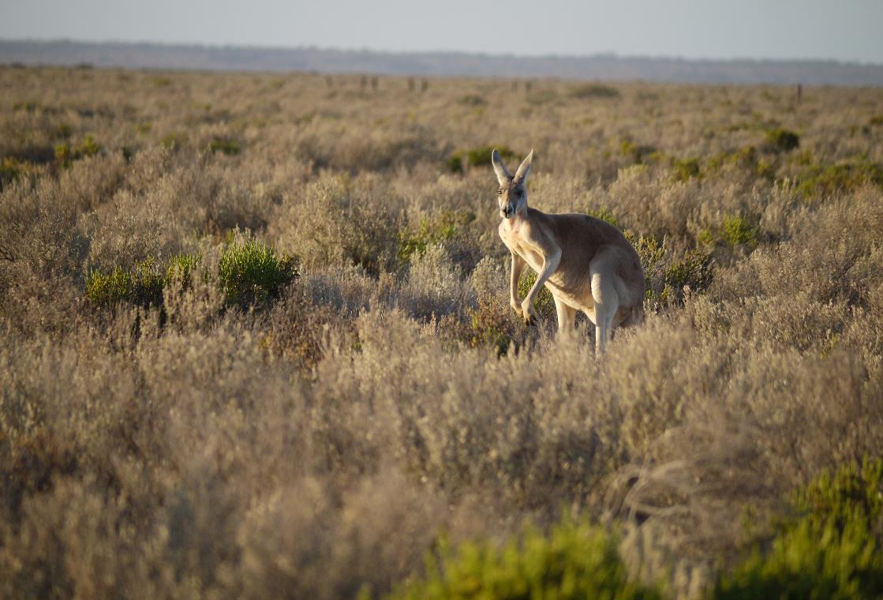

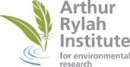

Arthur Rylah Institute for Environmental Research
Technical Report Series No. 356
Arthur Rylah Institute for Environmental Research
Department of Energy, Environment and Climate Action
PO Box 137
Heidelberg, Victoria 3084
Phone (03) 9450 8600
Website: www.ari.vic.gov.au
Citation: Moloney, P.D., Ramsey, D.S.L., and Scroggie, M.P. (2023). State-wide abundance of kangaroos in Victoria: Results from the 2022 aerial survey. Arthur Rylah Institute for Environmental Research Technical Report Series No. 356. Department of Energy, Environment and Climate Action, Heidelberg, Victoria.
Front cover photo: Red Kangaroo (Geoff Brown, Arthur Rylah Institute).

© The State of Victoria Department of Energy, Environment and Climate Action 2023

This work is licensed under a Creative Commons Attribution 3.0 Australia licence. You are free to re-use the work under that licence, on the condition that you credit the State of Victoria as author. The licence does not apply to any images, photographs or branding, including the Victorian Coat of Arms, the Victorian Government logo, the Department of Energy, Environment and Climate Action logo and the Arthur Rylah Institute logo. To view a copy of this licence, visit http://creativecommons.org/licenses/by/3.0/au/deed.en
ISSN 1835-3827 (print)
ISSN 1835-3835 (pdf))
ISBN 978-1-76136-204-17 (pdf/online/MS word)
Disclaimer
This publication may be of assistance to you but the State of Victoria and its employees do not guarantee that the publication is without flaw of any kind or is wholly appropriate for your particular purposes and therefore disclaims all liability for any error, loss or other consequence which may arise from you relying on any information in this publication.

Accessibility
If you would like to receive this publication in an alternative format, please telephone the DEECA Customer Service Centre on 136 186, email customer.service@delwp.vic.gov.au or contact us via the National Relay Service on 133 677 or www.relayservice.com.au. This document is also available on the internet at www.deeca.vic.gov.au


Acknowledgment
We acknowledge and respect Victorian Traditional Owners as the original custodians of Victoria's land and waters, their unique ability to care for Country and deep spiritual connection to it. We honour Elders past and present whose knowledge and wisdom has ensured the continuation of culture and traditional practices.
We are committed to genuinely partner, and meaningfully engage, with Victoria's Traditional Owners and Aboriginal communities to support the protection of Country, the maintenance of spiritual and cultural practices and their broader aspirations in the 21st century and beyond.

State-wide abundance of kangaroos in Victoria, 2022

Results from the 2022 aerial survey

P.D. Moloney, D.S.L. Ramsey and M.P. Scroggie

Arthur Rylah Institute for Environmental Research
123 Brown Street, Heidelberg, Victoria 3084

Date

Arthur Rylah Institute for Environmental Research
Technical Report Series No. 356

Acknowledgements
This report was commissioned by the Biodiversity Regulatory Reform Branch, Biodiversity Division, of the Department of Environment, Land, Water and Planning (now part of the Department of Energy, Environment and Climate Action). Aerial surveys were conducted by Terrestrial Ecosystem Services Pty Ltd (www.ecoknowledge.com.au). We thank Rob Hale and Lindy Lumsden who provided valuable feedback on drafts of this report.

Contents
Acknowledgements ii
Contents iii
Summary 1
1 Introduction 3
2 Methods 4
2.1 Species distribution, study area and stratification 4
2.2 Aerial surveys 5
2.3 Proportions of Eastern and Western Grey kangaroos in the overlap zone 6
2.4 Kangaroo abundance estimates for each harvest zone 7
3 Results 8
3.1 Kangaroo density estimates for each harvest zone 8
3.2 Kangaroo abundance estimates for each harvest zone 10
4 Discussion 12
4.1 Recommendations 13
5 References 14
Appendix 16

Tables
Table 1. Kangaroo estimates (in thousands) for non-heavily forested areas of Victoria in 2022. SE = standard error; lower and upper bounds = 95% confidence interval. 1
Table 2. Local government areas and harvest zones included in the survey and estimates 4
Table 3. Estimated proportions of EGK in each harvest zone within the GKOZ during 2022, along with corresponding estimates of uncertainty. 7
Table 4. Kangaroo density (kangaroos/km²) estimates by harvest zone for grey (GK) and red (RK) kangaroos. SE = standard error; CV = coefficient of variation; lower and upper bound = 95% confidence interval. 9
Table 5a. Abundance estimates for Eastern Grey Kangaroo by harvest zone, in thousands 10
Table 5b. Abundance estimates for Western Grey Kangaroo by harvest zone, in thousands 10
Table 5c. Abundance estimate for Red Kangaroo by harvest zone, in thousands 10
Table 5d. Total abundance estimate for Victoria, in thousands for all species combined 10
Table A1. Akaike’s Information Criterion (AIC) for detection function models considered in the analysis of the distance sampling data. 16
Table A2. Relative precision (coefficient of variation %) of kangaroo abundance estimates as a percentage for various populations of kangaroos across Victoria in 2017, 2018, 2020 and 2021. 16

Figures
Figure 1. Map of the stratification scheme used for the state-wide kangaroo survey to define harvest zones 5
Figure 2. Map of transects flown in the 2022 kangaroo aerial survey 6
Figure 3. Estimated probability of detection of kangaroos with distance from the transect during the 2022 kangaroo aerial survey. 8
Figure 4. Comparison of harvest zone density estimates (kangaroos/km²) from aerial surveys conducted from 2017–2022. 9
Figure 5. Comparison of Victorian-wide abundance estimates for the three species of kangaroos between 2017 and 2022. 11

Summary
Context:
The Kangaroo Harvest Management Plan 2021–2023 (KHMP) is recognised under section 28A(1)(h) of the Wildlife Act 1975 (Victoria) as a wildlife management plan. The KHMP permits ecologically sustainable commercial harvesting of wild grey kangaroo (Eastern Grey Kangaroo, Macropus giganteus and Western Grey Kangaroo, M. fuliginosus) populations in the state. In addition, both species of grey kangaroo and the Red Kangaroo (Osphranter rufus) are subject to legal control under the Authority to Control Wildlife (ATCW) provisions of the Wildlife Act. To determine whether the total offtake of kangaroos through both regulatory systems is ecologically sustainable, the State of Victoria conducts periodic state-wide aerial population surveys of these three species of kangaroo.
Aims:
To estimate the abundance of the three species of kangaroo in the non-forested regions of Victoria.
Methods:
Aerial surveys conducted in September and October 2022 were used to estimate kangaroo abundance within seven harvest management zones. These surveys update population estimates derived from earlier surveys conducted in 2017, 2018 and 2020. Heavily forested areas were excluded from kangaroo abundance estimates as these could not be reliably monitored using aerial surveys. As Eastern and Western Grey kangaroos cannot be reliably distinguished from aerial surveys, the relative proportions of these two species within areas of Victoria where they overlap was estimated using a spatial model of the relative occurrence of each species, based on ground survey data and biodiversity atlas records.
Results:
Based on an analysis of the aerial survey data, the total population of kangaroos in the non-heavily forested areas of Victoria was estimated to be 2,418,000 (Table 1). After applying the predicted occurrence of each grey kangaroo species using the spatial model from Moloney et al. (2021), there were an estimated 2,146,000 Eastern Grey Kangaroos (EGK), accounting for the majority (89%) of Victorian kangaroos. The remaining kangaroo population comprised an estimated 218,000 Western Grey Kangaroos (WGK) and 54,000 Red Kangaroos (RK) (Table 1).
The Central harvest zone had the highest density of EGK (67.5 kangaroos/km²), much greater than the next highest density in the Lower Wimmera harvest zone (16.1 kangaroos/km²). The Mallee and Upper Wimmera harvest zones had the lowest densities of kangaroos (5.0 and 5.2 kangaroos/km² of all species combined, respectively).
Table 1. Kangaroo estimates (in thousands) for non-heavily forested areas of Victoria in 2022. SE = standard error; lower and upper bounds = 95% confidence interval.
Kangaroo species | Estimate | SE | Lower bound | Upper bound
Eastern Grey Kangaroo | 2,146 | 261 | 1,693 | 2,720
Western Grey Kangaroo | 218 | 45 | 147 | 325
Red Kangaroo | 54 | 20 | 25 | 115
Total | 2,418 | 284 | 1,916 | 3,051

Conclusions:
The results from the 2022 aerial survey indicate that Victoria’s kangaroo population has increased significantly since 2018 [an increase of 0.98 M from 2017 (95% CI: 0.21 M–1.74 M) and 0.99 M from 2018 (95% CI: 0.28 M–1.70 M)]. Compared to estimates from 2020, the estimated kangaroo population has increased, but the differences were not statistically significant (an increase of 0.47 M, 95% CI: -0.26 M–1.21 M). The majority of these increases relate to grey kangaroos, especially in the Central harvest zone. The estimated RK population has remained consistent over the surveys. The precision of all estimates was similar to that obtained from the 2018 and 2020 surveys for most harvest zones, with the estimates obtained from the North East and Otway harvest zones having much lower precision than the other zones.

Recommendations:
- Continuation of the current survey frequency of once every two years is recommended.
- Consideration should be given to repeating ground surveys of EGK and WGK during the next two years to update the spatial model of the occurrence of each species within and around the Grey Kangaroo Overlap Zone (GKOZ).
- Introduction
In Victoria, culling of wild kangaroos is permitted under two regulatory systems. The first mechanism is the Authority to Control Wildlife (ATCW) provisions of the Wildlife Act 1975 (Victoria), which allows legal culling of wildlife, including three species of kangaroo — Eastern Grey Kangaroo (Macropus giganteus, EGK), Western Grey Kangaroo (M. fuliginosus, WGK) and Red Kangaroo (Osphranter rufus, RK). The second is a commercial harvest of EGK and WGK (also through the Wildlife Act) where annually determined quotas allow for ecologically sustainable commercial use of meat and skins from both species of grey kangaroo. Collectively, the culling and harvest of kangaroos is termed ‘offtake’.
To determine the overall level of offtake (under both regulatory systems) that is ecologically sustainable, the Victorian Government has been conducting state-wide aerial population surveys of these three species of kangaroo since 2017. Ecological sustainability can be defined in terms of the maximum proportional offtake that can be sustained in the long-term, while ensuring a low risk of declines in kangaroo populations and their respective conservation status. Sustainable rates of offtake of kangaroos are usually based on a fixed proportion of the estimated population size, with proportions of 10–20% of the population generally considered to be ecologically sustainable (Caughley et al. 1987; Hacker et al. 2004; McLeod et al. 2004; Scroggie and Ramsey 2020). Periodic statewide surveys also serve to provide a means of assessing whether kangaroo populations have increased or decreased at both statewide and regional scales, providing early warning of increases or declines in abundance, and allowing managers to adjust harvest quotas up or down in response.
Aerial surveys have been used to guide the management of kangaroo populations since the 1960s (Caughley et al. 1976) and in combination with line transect sampling, provide accurate estimates of population density and abundance of kangaroos (Fewster and Pople 2008; Tracey et al. 2008). The first comprehensive aerial and ground survey of Victoria’s kangaroo population was conducted in 2017 (Moloney et al. 2017), which estimated Victoria’s kangaroo population to be 1,442,000, with an overall relative precision (coefficient of variation, CV) of 19%. The CV is defined as the standard error of the estimate divided by the mean, which gives an estimate of how much variation there is between values compared to the mean value. Because the precision of the population estimates for some zones were large (up to 67%) and judged to be inadequate for management purposes, improvements to the survey design were recommended prior to the next survey (Moloney et al. 2018). These recommendations sought to establish the minimum survey effort required to estimate the population abundance of kangaroos within each of seven harvest zones, with a CV of 20% or less, to minimise the risk to the population from imprecise estimates (Pople 2008). The seven harvest zones were chosen by amalgamating local government areas to reflect the likely regional variation in the density of Victoria’s kangaroo populations.
Because of the difficulty in distinguishing Eastern and Western Grey kangaroos during aerial surveys, ground surveys have previously been undertaken to estimate the relative proportions of each species across the overlap zone where they co-occur (mainly in the Lower and Upper Wimmera zones). These proportions are then used to derive separate estimates of the abundances of the two grey kangaroo species within the overlap zone from the overall estimates of grey kangaroo abundance derived from the aerial survey.
In this report, we present the results of the fourth state-wide aerial survey of kangaroo populations in Victoria, based on aerial surveys conducted during 2022. Updated abundance estimates (and their precision) are provided for each zone. Comparisons are made between the results from this updated survey and the previous surveys in 2017, 2018 and 2020 (Moloney et al., 2017, 2019, 2021).

- Methods
  - Species distribution, study area and stratification
Aerial surveys, using the method outlined in Moloney et al. (2018) were conducted (with slight variation) in September and October 2022 to estimate the kangaroo population in seven harvest management zones (Figure 1). The survey used the same 150 aerial transects flown in 2020, comprising a total of 3234 km. The survey and estimates excluded local government areas (LGAs) that are entirely (or almost entirely) within highly urbanised parts of the Melbourne metropolitan area. Estimates also excluded heavily forested areas (Figure 1) because of the unreliability of kangaroo detection from the air in those areas. The survey and the resulting population estimates were therefore restricted to 58 rural and semi-rural LGAs within the kangaroo harvest zones, which are listed in Table 2.
Table 2. Local government areas and harvest zones included in the survey and estimates
Harvest zone | LGA | Harvest zone | LGA
Central | Ballarat | North East | Alpine
 | Brimbank |  | Benalla
 | Hepburn |  | Campaspe
 | Hume |  | Greater Bendigo
 | Macedon Ranges |  | Greater Shepparton
 | Melton |  | Indigo
 | Mitchell |  | Mansfield
 | Moorabool |  | Moira
 | Mount Alexander |  | Strathbogie
 | Murrindindi |  | Towong
 | Nillumbik |  | Wangaratta
 | Whittlesea |  | Wodonga
 | Yarra Ranges | Otway | Colac Otway
Gippsland | Bass Coast |  | Corangamite
 | Baw Baw |  | Golden Plains
 | Cardinia |  | Greater Geelong
 | Casey |  | Hobsons Bay
 | East Gippsland |  | Moyne
 | Latrobe |  | Surf Coast
 | Mornington Peninsula |  | Warrnambool
 | South Gippsland |  | Wyndham
 | Wellington | Upper Wimmera | Buloke
Lower Wimmera | Ararat |  | Hindmarsh
 | Central Goldfields |  | Horsham
 | Gannawarra |  | Swan Hill
 | Glenelg |  | West Wimmera
 | Loddon |  | Yarriambiack
 | Northern Grampians | Mallee | Mildura
 | Pyrenees
 | Southern Grampians
Kangaroos are widely distributed over most parts of Victoria. RK are restricted to the far north-west of the state. EGK inhabit most of the state, apart from the far north-west. WGK inhabit only the west and north-west. The range of EGK and WGK overlap in a broad band across the west of the state, known as the Grey Kangaroo Overlap Zone, GKOZ (Caughley et al. 1984), which mostly coincides with the Lower and Upper Wimmera harvest zones.

Figure 1. Map of the stratification scheme used for the state-wide kangaroo survey to define harvest zones
Each harvest zone was formed by aggregating several ecologically similar and geographically proximate LGAs. Green shading corresponds to open or lightly forested areas and mallee vegetation types that are included in the survey and estimates. Unshaded areas are heavily forested, highly urbanised, or kangaroo-free areas that were excluded from survey and estimates.
  - Aerial surveys
Aerial surveys and line-transect distance sampling (Buckland et al. 1993) were used to estimate kangaroo densities across Victoria. Aerial surveys were conducted by Helifarm Pty Ltd. in September and October 2022 using a Bell LongRanger helicopter, using methods similar to those used in previous surveys (Lethbridge and Stead 2017). Each transect was flown within three hours of sunrise or sunset in an easterly or westerly direction (flying away from the sun) at a height of 200 feet (about 60 m) above ground level, and a speed of 50 knots (about 90 km/h) (Figure 2). A five-zone survey pole was used on either side of the aircraft, allowing observed kangaroos to be placed into one of five distance classes (0–20 m, 20–40 m, 40–70 m, 70–100 m and 100–150 m from the transect line). The species, size (number of kangaroos) and distance class of the first observation of each group of kangaroos was recorded. Because of difficulties in accurately determining the difference between EGK and WGK from the air, only RK and an aggregated ‘grey kangaroo’ (GK) (representing both EGK and WGK combined) were recorded. For further details of the aerial surveys methodology, see Lethbridge and Stead (2017).
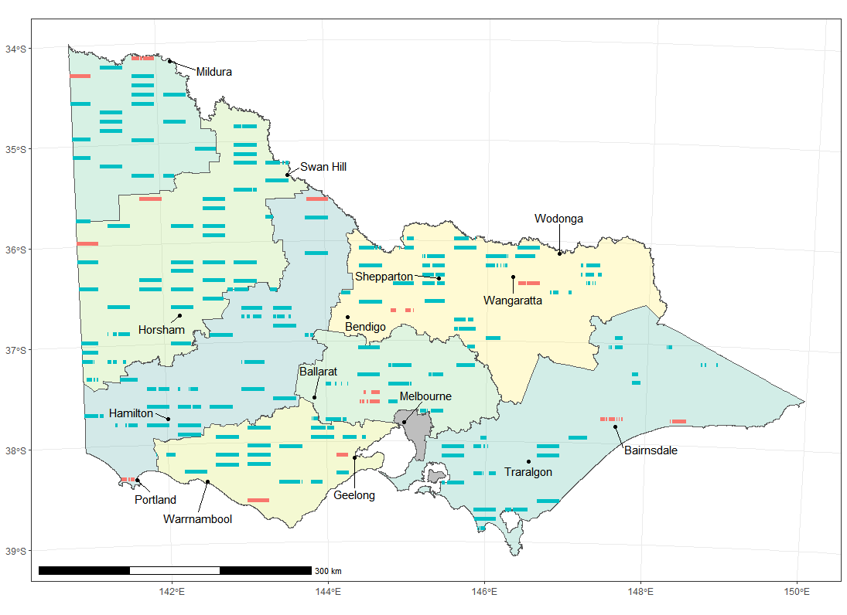
Figure 2. Map of transects flown in the 2022 kangaroo aerial survey
Priority transects (blue) were surveyed with contingency transects (red) substituted in the event that priority transects could not be safely flown. Shading indicates the different harvest zones.

  - Proportions of Eastern and Western Grey kangaroos in the overlap zone
To enable effective management of EGK and WGK, separate population estimates were required for the two species. In zones occupied only by EGK (North East, Central, Otway, and Gippsland), the estimates of total GK abundance equated to the number of EGK. However, in the GKOZ, it was necessary to apportion the total population estimate between the two species based on an analysis of available distributional data for the species’ (including data derived from targeted ground surveys across the GKOZ (Moloney et al. 2021)).
Since no ground surveys were conducted in 2022, the geographical variation in the proportions of Eastern and Western Grey kangaroos was based on the spatial model of the relative occurrence of the two species developed from the most recent ground surveys (Moloney et al. 2021). The fitted model coincided well with our existing knowledge of the current position and extent of the GKOZ and showed minimal change in recent years, so the 2020 predictions were used for the 2022 estimate. Estimated proportions of EGK in the Upper Wimmera and Lower Wimmera zones ranged from 38–83% (Table 3). These estimates were used to apportion the total estimates of GK abundance between the two species in the two harvest zones spanning the Victorian portion of the GKOZ.

Table 3. Estimated proportions of EGK in each harvest zone within the GKOZ during 2022, along with corresponding estimates of uncertainty.
Proportions are derived from the predictions of the spatial model of relative occurrence of the two species (Moloney et al. 2021). SE = standard error; lower and upper bounds = 95% confidence interval.
Harvest zone | Estimate | SE | Lower bound | Upper bound
Upper Wimmera | 0.377 | 0.024 | 0.331 | 0.423
Lower Wimmera | 0.838 | 0.021 | 0.791 | 0.870
  - Kangaroo abundance estimates for each harvest zone
The density of GK and RK (kangaroos/km²) was estimated for each zone using standard line-transect distance sampling techniques (Buckland et al. 1993). Half-normal and hazard-rate detection functions with potential second and third order cosine adjustment terms were considered, with the model with the lowest Akaike’s Information Criterion (AIC; Burnham and Anderson 2002) used for the final inferences. In harvest zones outside the GKOZ, GK could be assumed to be either EGK or WGK and densities could be estimated directly from the distance sampling model. However, within the GKOZ, the density of GK needed to be assigned to EGK and WGK. This was done by multiplying the relevant density estimates by the modelled proportion of GK in that harvest zone that were EGK and WGK, respectively (Table 3). Bootstrapping, based on 10,000 replicate samples, was used to estimate the standard error and confidence intervals of the EGK and WGK densities within the GKOZ (Efron and Tibshirani 1993). The analysis was carried out using the statistical program R (R Core Team 2022), with the Distance package (Miller 2017) used to estimate the distance sampling model.
- Results
  - Kangaroo density estimates for each harvest zone
A total of 5947 GK and 140 RK were observed along the 3234 km of transects during the aerial survey. Studies have shown that at least 80 distance observations are required to provide a reasonable estimate of the detection function, which is necessary to estimate density with acceptable precision and accuracy (Buckland et al. 1993). While there were 89 RK clusters observed (i.e. the minimum threshold for distance observations for the RK individuals was exceeded), a single detection function was fitted for all kangaroos as the separate RK detection function fitted the data very poorly and showed signs of non-monotonicity. Hence, it was assumed that the distance detection function for GK and RK was identical. A half-normal detection function with second and third order cosine adjustments was selected after comparing the fit of the half-normal and hazard rate distance functions, with up to fourth order cosine adjustments (Table A1). The monotonicity assumption was not violated in the combined detection function, with the estimated detection function decreasing as distance from the transect increased (Figure 3). The goodness-of-fit test for the model was adequate (p-value = 0.192).
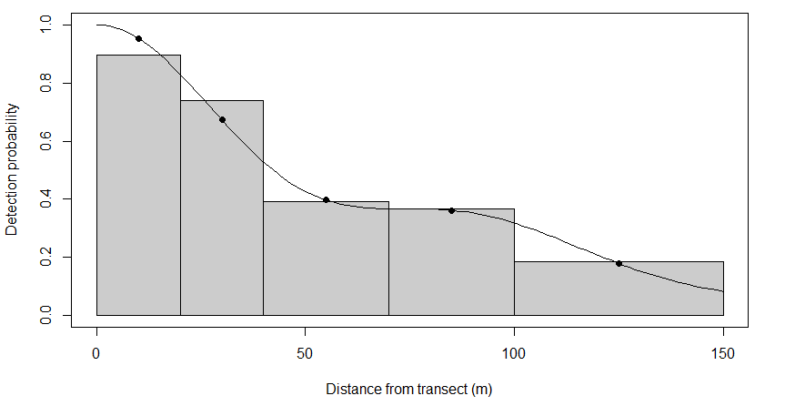
Figure 3. Estimated probability of detection of kangaroos with distance from the transect during the 2022 kangaroo aerial survey.
The line and dots represent the estimated probability. Bars indicate the relative number of kangaroos observed in that distance category. The horizontal axis denotes distance from the helicopter flight line.

The distance sampling model was used to estimate the density of GK and RK (kangaroos/km²) for each of the seven kangaroo harvest zones (Table 4). The highest density was estimated to be for GK in the Central zone (67.5/km², 95% confidence interval (CI): 49.6–91.9), and this density was more than triple the density of the next highest zone, Lower Wimmera (17.8/km², 95% CI: 10.6–30.0). The harvest zones in the north-west of Victoria (Mallee and Upper Wimmera) had the lowest densities of GK. Because all but one of the observed RK were in the Mallee zone, RK density and abundance estimates were provided only for that zone.
The estimated densities of grey kangaroos in the Mallee and North East harvest zones were consistent from 2017 to 2022, while in the Gippsland and Otway zones the estimated densities were lower only in 2018 and 2017, respectively (Figure 4). However, in the Lower Wimmera and Upper Wimmera zones, the estimated density showed a positive trend from 2017 to 2022, while in the Central zone, the estimated density trended higher except for in 2018 (Figure 4). The density of RK in the Mallee zone varied over the surveys with no clear trend, with the 2022 density estimate being the highest one to date (Figure 4). In most harvest zones, the precision of GK density estimates was acceptable. However, it was low for the North East and Otway zones, with CV’s greater than 0.40 (Table 4 and Figure 4). Large aggregations of kangaroos on some transects most likely led to the lower precision of estimates for these zones. For example, 473 kangaroos were observed on transect NE09 in the North East, between Mount Samaria State Park and Mansfield, which accounted for 38% of all kangaroos detected in that zone. In the Otway zone, 171 kangaroos were observed on transect OT12, between Dunkeld and Mortlake, which accounted for 33% of all kangaroos detected in that zone, while no kangaroos were observed on a quarter (4 out of 16) of Otway zone transects. More generally, the precision of density estimates for most harvest zones for the 2022 survey were fairly consistent with the corresponding estimates for 2018 and 2020 (Table A2).
Table 4. Kangaroo density (kangaroos/km²) estimates by harvest zone for grey (GK) and red (RK) kangaroos. SE = standard error; CV = coefficient of variation; lower and upper bound = 95% confidence interval.
Species | Harvest zone | Estimate | SE | CV | Lower bound | Upper bound
GK | Mallee | 2.55 | 0.61 | 0.24 | 1.55 | 4.20
 | Upper Wimmera | 5.16 | 1.64 | 0.32 | 2.74 | 9.70
 | Lower Wimmera | 17.80 | 4.57 | 0.26 | 10.57 | 29.98
 | Otway | 11.24 | 4.83 | 0.43 | 4.68 | 26.99
 | Central | 67.54 | 9.46 | 0.14 | 49.62 | 91.92
 | North East | 14.41 | 6.63 | 0.46 | 5.85 | 35.49
 | Gippsland | 11.15 | 2.75 | 0.25 | 6.69 | 18.57
RK | Mallee | 2.47 | 0.92 | 0.37 | 2.74 | 9.70

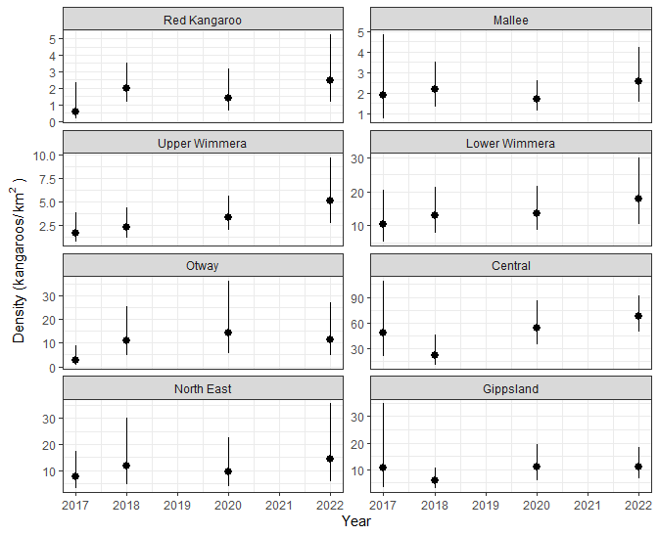
Figure 4. Comparison of harvest zone density estimates (kangaroos/km²) from aerial surveys conducted from 2017–2022.
The estimates for Red Kangaroo are only for the Mallee harvest zone. All other harvest zone estimates are for both species of grey kangaroo combined. Error bars are 95% confidence intervals. Note the density scale (y axis) differs among harvest zones.

  - Kangaroo abundance estimates for each harvest zone
Based on the density estimates for each zone derived from the distance sampling analysis, and the known surveyable areas of each zone, estimates of the number of EGK, WGK and RK in each harvest zone were estimated using standard design-based, finite sampling methods (Thompson 1992). The Central harvest zone had the greatest number of EGK in Victoria (Table 5a), while the Mallee zone had the greatest number of WGK in Victoria (Table 5b). The estimated abundance of RK in the Mallee zone was 54,000 (Table 5c). The overall kangaroo population for Victoria (all harvest zones and species combined, excluding the heavily forested areas) amounted to 2,418,000 kangaroos (Table 5d).
Table 5a. Abundance estimates for Eastern Grey Kangaroo by harvest zone, in thousands
SE = standard error; lower and upper bounds = 95% confidence intervals.
Harvest zone | Estimate | SE | Lower bound | Upper bound
Central | 821 | 115 | 603 | 1,117
Gippsland | 177 | 43 | 106 | 294
Lower Wimmera | 504 | 135 | 304 | 828
North East | 356 | 164 | 145 | 877
Otway | 189 | 81 | 79 | 454
Upper Wimmera | 99 | 35 | 53 | 189

Table 5b. Abundance estimates for Western Grey Kangaroo by harvest zone, in thousands
SE = standard error; lower and upper bounds = 95% confidence intervals.
Harvest zone | Estimate | SE | Lower bound | Upper bound
Lower Wimmera | 52 | 19 | 26 | 97
Mallee | 56 | 13 | 34 | 92
Upper Wimmera | 111 | 38 | 59 | 210

Table 5c. Abundance estimate for Red Kangaroo by harvest zone, in thousands
SE = standard error; lower and upper bounds = 95% confidence intervals.
Harvest zone | Estimate | SE | Lower bound | Upper bound
Mallee | 54 | 20 | 25 | 115

Table 5d. Total abundance estimate for Victoria, in thousands for all species combined
SE = standard error; lower and upper bounds = 95% confidence intervals.
Kangaroo species | Estimate | SE | Lower bound | Upper bound
Eastern Grey Kangaroo | 2,146 | 261 | 1,693 | 2,720
Western Grey Kangaroo | 218 | 45 | 147 | 325
Red Kangaroo | 54 | 20 | 25 | 115
Total | 2,418 | 284 | 1,916 | 3,051

The estimate of the Victorian kangaroo population for 2022 of 2.4 M was a 68% increase from the 2017 and 2018 estimates of 1.4 M kangaroos and a 24% increase from the 2020 estimate of 1.9 M kangaroos (Moloney et al., 2017, 2019, 2021) (Figure 5). The increase was statistically significant compared with 2017 (0.98 M, 95% CI: 0.21 M–1.74 M) and 2018 (0.99 M, 95% CI: 0.28 M–1.70 M). However, the increase was not statistically significant compared with 2020 (0.47 M, 95% CI: -0.26 M–1.21 M). The main driver for this change was an increase in GK abundance, as RK abundance had not significantly changed over that time.

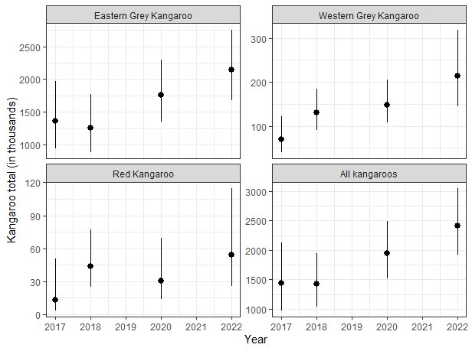
Figure 5. Comparison of Victorian-wide abundance estimates for the three species of kangaroos between 2017 and 2022.
Scales are in thousands of kangaroos. Error bars are 95% confidence intervals.
- Discussion
Based on our analysis of the aerial survey data, we estimated that the overall kangaroo population in Victoria in September and October 2022 was 2,418,000 (95% confidence interval: 1,916,000–3,051,000). There were an estimated 2,146,000 (1,693,000–2,720,000) Eastern Grey Kangaroos, accounting for the overwhelming majority (89%) of Victorian kangaroos. The remaining portion of the total kangaroo population comprised of an estimated 218,000 (147,000–325,000) Western Grey Kangaroos and 54,000 (25,000–115,000) Red Kangaroos. The overall kangaroo population estimate for 2022 was larger than the estimates from the 2017, 2018 and 2020 surveys. The changes in overall abundance from 2017 and 2018 to 2022 represent statistically significant increases, while the change since the 2020 survey was not statistically significantly different to any other survey. The increase in estimated abundance has been primarily driven by an increase in the GK population, as estimates for RK have not shown strong statistical evidence of increases since surveys began in 2017.
The Victorian estimate of the kangaroo population met the precision goal, having a relative precision (expressed as the coefficient of variation, CV) of 11.8%, which was less than the target CV of 20% identified in the sampling design (Moloney et al. 2018). The precision of abundance estimates for each kangaroo species has been consistent since the 2018 survey (Table A2), when the extra transects were added following the initial survey in 2017. The precision of abundance estimates for individual zones ranged from 14.0% (Central zone for EGK) to 46.0% (North East zone for EGK). While the precision of the abundance estimates for individual zones had generally improved since the 2017 survey, the precision in some zones remained low. The main reason for these instances of low precision was the high level of aggregation of kangaroos within some zones. Transects in the North East and Otway zones were subject to the chance sampling of large numbers of kangaroos on a small number of transects. The numbers along these transects formed a large proportion of the total numbers of kangaroos seen in these zones, with the remaining transects recording low numbers of kangaroos. Large aggregations of kangaroos inflate the transect-level variance for the zone, leading to decreased precision. Population estimates with a relative precision over 50% can increase the risks of over-harvesting (Pople 2008). The risk of overharvesting can be mitigated by adopting a conservative approach to setting of harvest rates and by regularly updating population estimates and reductions in harvest quotas in response to any observed declines. The CVs for EGK for the North East and Otway zones were marginally below this 50% CV threshold, but the CVs for all other zones were clearly below the 50% threshold. The relative precision of the statewide estimate was good (CV < 20%), and the relative precision in each harvest zone was acceptable (CV < 50%). Since the overall sustainable offtake of GK is calculated based on the statewide estimate, the levels of precision reached for the estimates from the 2022 survey are considered to be suitable for the setting of sustainable harvest quotas.
While we assumed that all GK were WGK in the Mallee harvest zone, it was estimated that a very small proportion (<3%) of the GK were EGK (Moloney et al. 2021). These estimates were based on a relatively small number of observations of EGK in and around the Mallee zone. It would be prudent to collect additional ground survey data on the distribution and abundance of EGK within the Mallee zone, as the size of the EGK population in this zone is relatively small and therefore vulnerable to overharvesting.
The results from the 2022 aerial survey indicate that, since 2018, there has been a statistically significant increase in Victoria’s kangaroo population. However, the increase since 2020 was not statistically significant. That means that while we can be confident that the increase in the estimate from 2018 to 2022 is a result of the kangaroo population increasing (rather than natural variation in the survey), we cannot be certain this is the case from 2020 to 2022. Uncertainty in the successive estimates of abundance means that the size of the relative change between years is uncertain. Although high levels of kangaroo aggregation in some zones continue to hamper the precise estimation of density and abundance for individual harvest zones, the level of overall precision can be considered adequate for the setting of sustainable harvest quotas. Alternatively, given the high level of kangaroo aggregation observed during the aerial surveys, consideration could be given to using a model-based distance sampling approach (Camp et al. 2020). This would allow the data from all current and future surveys to be included in a single model that could account for fine scale (e.g. 5–10 km) habitat-driven variability in abundance across the landscape as well as temporal trends in abundance. Model-based approaches (where densities would be related to geographical and environmental conditions) may provide increased precision compared with the existing design-based approach (where densities are assumed consistent across a zone), with the trade-off that estimates may have increased bias. A preliminary model-based approach applied to the 2018 aerial survey data (Scroggie and Ramsey 2020) indicated that this approach has merit, and could be further investigated now that four years of aerial survey data have been accumulated. Furthermore, a model-based distance sampling approach could also incorporate distance sampling data from other sources, such as the ground-based line-transect kangaroo surveys undertaken in the Mallee by Parks Victoria (Mackenzie 2017).
Given the level of precision achieved with the current survey, and the need to use the resulting estimates in the setting of sustainable harvest quotas, it is advised that the current survey frequency of once every two years be continued. Although studies have shown that surveys every three years greatly reduce the long-term survey costs without substantially increasing the risk of over-harvesting or inappropriate control measures (Pople 2008), more frequent surveys are recommended here. This is because of the relatively small number of surveys that have been undertaken in Victoria to date. Regular, more frequent surveys will allow the trends in kangaroo abundance over time to be more accurately established. This, in turn, will allow the impacts of various level of kangaroo offtake or the impacts of floods, droughts or other events that may substantially impact kangaroo populations to be more accurately assessed. More frequent and more precise surveys of abundance are also prudent if higher overall rates of harvest are contemplated, as risks of overharvesting and subsequent population decline will be exacerbated if uncertain population estimates inadvertently result in higher than intended rates of harvesting.
  - Recommendations
- The current survey frequency of once every two years should be continued.
- Consideration should be given to repeating ground surveys of EGK and WGK during the next two years to update the spatial model of the occurrence of each species within and around the GKOZ.
- References
Buckland, S. T., Anderson, D. R., Burnham, K. P. and Laake, J. (1993). Distance Sampling: Estimating Abundance of Biological Populations. Chapman and Hall, London, UK.
Burnham, K. P. and Anderson, D. R. (2002). Model Selection and Multimodel Inference: A Practical Information-Theoretic Approach. Springer-Verlag, New York, USA.
Camp, R. J., Miller, D. L., Thomas, L., Buckland, S. T. and Kendall, S. J. (2020). Using density surface models to estimate spatio-temporal changes in population densities and trend. Ecography 43, 1079–1089 https://doi.org/10.1111/ecog.04859
Caughley, G., Brown, B., Dostine, P. and Grice, D. (1984). The grey kangaroo overlap zone. Wildlife Research 11, 1–10.
Caughley, G., Shepherd, N. and Short, G. (1987). Kangaroos, their Ecology and Management in the Sheep Rangelands of Australia. Cambridge University Press, Melbourne, Victoria.
Caughley, G., Sinclair, R. and Scott-Kemmis, D. (1976). Experiments in aerial survey. The Journal of Wildlife Management 40, 290–300 https://doi.org/10.2307/3800428
Efron, B. and Tibshirani, R. J. (1993). An introduction to the bootstrap. In Monographs on Statistics and Applied Probability (Vol. 57). Chapman and Hall, New York, USA.
Fewster, R. M. and Pople, A. R. (2008). A comparison of mark-recapture distance-sampling methods applied to aerial surveys of eastern grey kangaroos. Wildlife Research 35, 320–330.
Hacker, R., Mcleod, S., Druhan, J., Tenhumberg, B. and Pradhan, U. (2004). Kangaroo management options in the Murray-Darling Basin. Murray-Darling Basin Commission, Canberra, ACT.
Lethbridge, M. and Stead, M. (2017). Victorian aerial kangaroo population survey: Insights and learnings from Victoria’s first state-wide kangaroo aerial survey. Report to the Department of Environment, Land, Water and Planning, Melbourne, Victoria.
Mackenzie, D. I. (2017). Distance analysis of Mallee parks kangaroo census data 2017. Report for Parks Victoria, Proteus Client report 1.
McLeod, S. R., Hacker, R. B. and Druhan, J. P. (2004). Managing the commercial harvest of kangaroos in the Murray-Darling Basin. Australian Mammalogy 26, 9–22.
Miller, D. L. (2017). Distance: Distance Sampling Detection Function and Abundance Estimation. https://cran.r-project.org/package=Distance.
Moloney, P. D., Ramsey, D. S. L. and Scroggie, M. P. (2017). A state-wide aerial survey of kangaroos in Victoria. Arthur Rylah Institute for Environmental Research Technical Report Series No. 286. Department of Environment, Land, Water and Planning, Heidelberg, Victoria.
Moloney, P. D., Ramsey, D. S. L. and Scroggie, M. P. (2019). State-wide abundance of kangaroos in Victoria: Results from the 2018 aerial survey. Arthur Rylah Institute for Environmental Research Technical Report Series No. 296. Department of Environment, Land, Water and Planning, Heidelberg, Victoria.
Moloney, P. D., Ramsey, D. S. L., and Scroggie, M. P. (2021). State-wide abundance of kangaroos in Victoria: Results from the 2020 aerial survey. Arthur Rylah Institute for Environmental Research Technical Report Series No. 324. Department of Environment, Land, Water and Planning, Heidelberg, Victoria.
Moloney, P. D., Scroggie, M. P. and Ramsey, D. S. L. (2018). Revisiting the Victorian kangaroo aerial survey design. Unpublished Client Report. Arthur Rylah Institute for Environmental Research, Department of Environment, Land, Water and Planning, Heidelberg, Victoria.
Pople, A. R. (2008). Frequency and precision of aerial surveys for kangaroo management. Wildlife Research 35, 340–348 https://doi.org/10.1071/WR07066
R Core Team. (2022). R: A Language and Environment for Statistical Computing (4.2.1). R Foundation for Statistical Computing.
Scroggie, M. P. and Ramsey, D. S. L. (2020). A Spatial Harvest Model for Kangaroo Populations in Victoria. Arthur Rylah Institute for Environmental Research Technical Report Series No. 315. Department of Environment, Land, Water and Planning, Heidelberg, Victoria.
Skalski, J. R. and Millspaugh, J. J. (2002). Generic variance expressions, precision, and sampling optimization for the sex-age-kill model of population reconstruction. Journal of Wildlife Management 66, 1308–1316.
Thompson, S. K. (1992). Sampling. John Wiley and Sons, New York, USA.
Tracey, J. P., Fleming, P. J. S. and Melville, G. J. (2008). Accuracy of some aerial survey estimators: Contrasts with known numbers. Wildlife Research 35, 377–384 https://doi.org/10.1071/WR07105

Appendix
Table A1. Akaike’s Information Criterion (AIC) for detection function models considered in the analysis of the distance sampling data.
Models with lower AIC values (ΔAIC) are better supported by the data.
Model | AIC | ΔAIC
Half-normal with second and third order cosine adjustments | 5136.1
Hazard-rate (no adjustment terms) | 5148.9 | 12.8
Half-normal with second order cosine adjustments | 5151.2 | 15.1
Half-normal with second to fourth order cosine adjustments | 5153.4 | 17.3
Hazard-rate with second order cosine adjustments | 5157.1 | 21.0
Half-normal (no adjustment terms) | 5186.9 | 50.8

Table A2. Relative precision (coefficient of variation %) of kangaroo abundance estimates as a percentage for various populations of kangaroos across Victoria in 2017, 2018, 2020 and 2021.
Lower values indicate more precise population estimates. Precision under the 20% CV threshold are coloured green, between thresholds (20–50% CV) are coloured yellow, and over the 50% CV threshold are coloured red.
 |  | Coefficient of variation (%)
Region | Species | 2017 | 2018 | 2020 | 2022
Mallee | RK | 67 | 25.9 | 40.9 | 37.3
Mallee | GK | 43 | 23.4 | 20.2 | 24.1
Upper Wimmera | GK | 39 | 32.8 | 25.2 | 31.8
Lower Wimmera | GK | 32 | 24.9 | 22.6 | 25.7
Otway | EGK | 54 | 41.2 | 46.7 | 43.0
Central | EGK | 35 | 31.4 | 20.7 | 14.0
North East | EGK | 40 | 48.2 | 43.0 | 46.0
Gippsland | EGK | 53 | 30.2 | 28.8 | 24.6
Victoria-wide | EGK | 19.6 | 17.6 | 13.6 | 12.8
Victoria-wide | WGK | 28.8 | 18.2 | 17.1 | 20.5
Victoria-wide | RK | 67.0 | 25.9 | 40.9 | 37.3
Victoria-wide | All species | 18.8 | 15.7 | 12.5 | 11.8

www.delwp.vic.gov.au

www.ari.vic.gov.au

The main difference between the surveys was that seven of the 150 aerial transects could not be flown in 2020, but could be flown in 2022, while four other aerial transects could not be flown in 2022 that were flown in 2020. The reason for not flying a transect in a given survey is usually due to operational and safety requirements, for example poor weather.
Based on the relatively stable distribution of the two GK species in the first three surveys, Moloney et al. (2021) advised that the ground surveys to assess the distribution within the GKOZ would only need to be assessed every second aerial survey to provide robust estimates.

