Native Fish Report Card 2024

**Ovens River**

**North East Region**



**This report card summarises the 2024 Native Fish Report Card (NFRC) survey in the Ovens River**

**Sites 12, NECMA, Electrofishing**

**Fish found in Ovens River for NFRC**

**Target species**

Golden Perch

Macquarie Perch

Murray Cod

Trout Cod

**Non-target species captured since 2017\***

**Large-bodied native species**

Bony Bream

River Blackfish

Two-spined Blackfish

**Small-bodied native species**

Australian Smelt

Carp Gudgeon

Flatheaded Gudgeon

Obscure Galaxias

Southern Pygmy Perch

Unspecked Hardyhead

**Exotic species**

Brown Trout

Common Carp

Eastern Gambusia

Goldfish

Oriental Weatherloach

Redfin

Rainbow Trout

* These non-target species were incidentally captured during NFRC surveys since 2017 but not measured as for target species

**Ovens River 2024**

**Fish Community**

**NFRC target species**

**The NFRC Program began in 2017** **to monitor population dynamics of key iconic fish species that have high recreational and/or conservation values, in large rivers across Victoria. In the Ovens River, the target species are Golden Perch, Macquarie Perch, Murray Cod and Trout Cod. Surveys occur in March/April each year, at 12 sites from** **just downstream of Porepunkah to the junction with Lake Mulwala (Boorhaman North). The equipment used and habitats surveyed target these species, which are measured to determine their population structures. Other fish species that are incidentally captured are counted, but not measured.**

**Summary of key health indicators for target species in 2024**

|  |  |  |  |
| --- | --- | --- | --- |
| **Species** | **Key Health Indicators** | | |
|  | Recent recruitment | Multiple size classes | Mature fish present |
| Golden Perch | No | No | Yes |
| Macquarie Perch | Yes | Yes | Yes |
| Murray Cod | Yes | Yes | Yes |
| Trout Cod | Yes | Yes | Yes |

Both Macquarie Perch and Trout Cod were historically abundant in the lower and mid Ovens River, but experienced dramatic declines until they were considered locally extinct. The status of both species has improved in recent times. Overall, the Ovens River appears to be maintaining healthy Murray Cod and Trout Cod populations. Golden Perch are historically rare upstream of Wangaratta, while low numbers of adults are consistently found downstream. An integrated program for the recovery of Macquarie Perch is showing encouraging results. As the section surveyed is downstream of the cooler waters preferred by trout, large abundances of trout species are not expected in the NFRC surveys.

**Non-target species**

The non-target fish species that have been incidentally recorded in the Ovens River during NFRC surveys since 2017 are:

**Large-bodied native species**

Bony Bream was recorded in 2024 at two sites (near Wangaratta), the first time since NFRC surveys began. This is the first Bony Bream record in the Ovens system since 2012, with Yarrawonga Weir generally restricting their upstream migrations. Bony Bream is a lowland species across the Murray-Darling Basin which is intolerant of cold water. Other large-bodied species recorded in 2024 are River Blackfish and Two-spined Blackfish, with River Blackfish recorded every year during NFRC surveys. River Blackfish is more frequently recorded upstream of Wangaratta and is a lowland species, generally found at altitudes below 200m. It is rarely recorded at the top site towards Porepunkah. This species has declined in distribution and abundance across Victoria1.

Two-spined Blackfish is only found at the top few sites monitored in the Ovens River. The species typically occurs above 200m altitude, with few records down to 180m altitude (this correlates to around Whorouly in the Ovens system).

**Small-bodied native species**

Southern Pygmy Perch was recorded for the first time in 2024. It is often more common in offstream habitats such as billabongs, wetlands and lagoons. Other species recorded in 2024 are Australian Smelt, recorded in all eight NFRC surveys, and Unspecked Hardyhead, recorded in six of the eight years. Unspecked Hardyhead is a lowland species only found in the lower regions of tributaries of the Murray River and is not expected to be found at the upper sites. Flatheaded Gudgeon and Carp Gudgeon have also been previously recorded in five NFRC surveys. Flatheaded Gudgeon and Australian Smelt are common and widespread throughout the Murray-Darling Basin. Carp Gudgeon is a lowland species and not expected to be recorded above 200 m altitude. The species is more common in slower flowing habitats, especially downstream of Wangaratta. The Obscure Galaxias has been recorded twice during NFRC surveys and is normally found in lowland areas up to 260m altitude.

**Exotic fish species**

Common Carp and Goldfish were the only exotic species recorded in the 2024 survey. Common Carp has been recorded every year during NFRC surveys, and is widely distributed across sampling sites, though lower in abundances towards Porepunkah. Goldfish, recorded five times and Eastern Gambusia, recorded four times, are more common in the slower flowing waters. Redfin, recorded three times, are also distributed throughout, but in lower abundances. Brown Trout, Oriental Weatherloach and Rainbow Trout have only been recorded once each. Oriental Weatherloach is increasing in distribution and abundance and found in slower flowing areas, often in silt substrate. This species often disperses during floods. Brown Trout and Rainbow Trout are cool water species and have only been detected upstream Wangaratta. This is not unexpected after the cool and wet spring summers of 2021/2 and 2022/3.

**Other native fish species known from the Ovens River**

Some fish species known to occur in the Ovens River have never been recorded during NFRC surveys and for some species this is likely due to the habitats they live in not being surveyed. For example, no Flatheaded Galaxias or Silver Perch have been recorded. Flatheaded Galaxias is often more common in offstream habitats such as billabongs, wetlands and lagoons. Silver Perch have been historically recorded to up to 140m altitude and has experienced dramatic declines across their range.

**Other notable species**

Surveys have also recorded Murray Crayfish, Yabbies, Eastern Long-necked Turtles and Platypus.

1 Hammer et al. (2014) A multi-gene molecular assessment of cryptic biodiversity in the iconic freshwater blackfishes (Teleosti: Perchichthyidae: Gadopsis) of south-eastern Australia. Biological journal of the Linnean Society.

**Ovens River 2024**

**Environmental and Management Context**

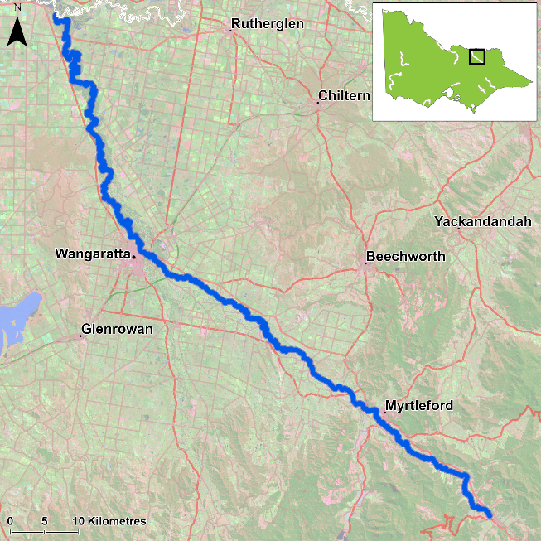

Figure 1. Map showing the section of Ovens River where NFRC sampling occurs

**Environment**

In 2024, river flows were low and similar to 2017-19, with higher flows encountered in the 2020-23 sampling events. The higher flows present in 2020-23 impacted the sampling efficiency, especially for small-bodied species or small individuals of large-bodied species. The 2020-23 survey results are therefore likely lower than comparable sampling conditions in 2017-19 and 2024.

**Waterway and fisheries management efforts in the Ovens River**

Many rehabilitation actions have occurred, and are underway, to improve the health of the Ovens River and its suite of large-bodied native fish species including Murray Cod, Trout Cod, Golden Perch and Macquarie Perch. These are informed by the North East Waterway Strategy 2014-22. In particular, since 2008, there has been a large scale coordinated effort by many government agencies and the community to protect and plant native streamside vegetation, install instream woody habitat and fishways to improve fish passage, and remove Carp. These efforts include the Demonstration Reach program and targeted monitoring for Macquarie Perch and Trout Cod, as well as reintroduction and recovery efforts. The [North East Catchment Management Authority](https://www.necma.vic.gov.au/), DEECA and VFA support rehabilitation and management of the Ovens River and its fish community.

**Golden Perch**

**Ovens River, North East region**

**Key Health Indicators**

Recent recruitment No

Multiple size classes No

Mature fish present Yes

**Monitoring Results**

Total number of fish caught 27

Fish per 1km of waterway 4.24

Largest fish by length (cm) 53.7

Largest fish by weight (kg) 2.8

% of the catch that is legal size 100

**Low abundances of Golden Perch (*Macquaria ambigua*) were recorded each year during NFRC surveys, although abundances in 2023 and 2024 were over double the next highest year (2021) (Figure 2). In 2024, Golden Perch were generally evenly distributed between the eight most downstream sites between Tarrawingee and Boorhaman North. No Golden Perch have been recorded upstream of the Tarrawingee site.**

**Only adults were recorded in 2024 with recruits and juveniles absent from catches (Figure 2; Figure 3). The fate of Golden Perch stocked in recent years is unclear. Recruits of this species are difficult to catch using this sampling methodology of electrofishing and none have been detected during the eight years of sampling (Figure 2; Figure 3). Adult Golden Perch have only been recorded upstream of Wangaratta in 2021–24. The large flooding of 2022 may have led to fish immigrating into and dispersing up the system from the Murray River and Lake Mulwala.**

**Stocking**

In 2016 no Golden Perch were stocked; 30,000 were stocked in 2017; 50,293 in 2018; 51,000 in 2019; 54,000 in 2020; 50,000 in 2021; 54,000 in 2022; 50,000 in 2023; and 31,900 in 2024 (after NFRC surveys).

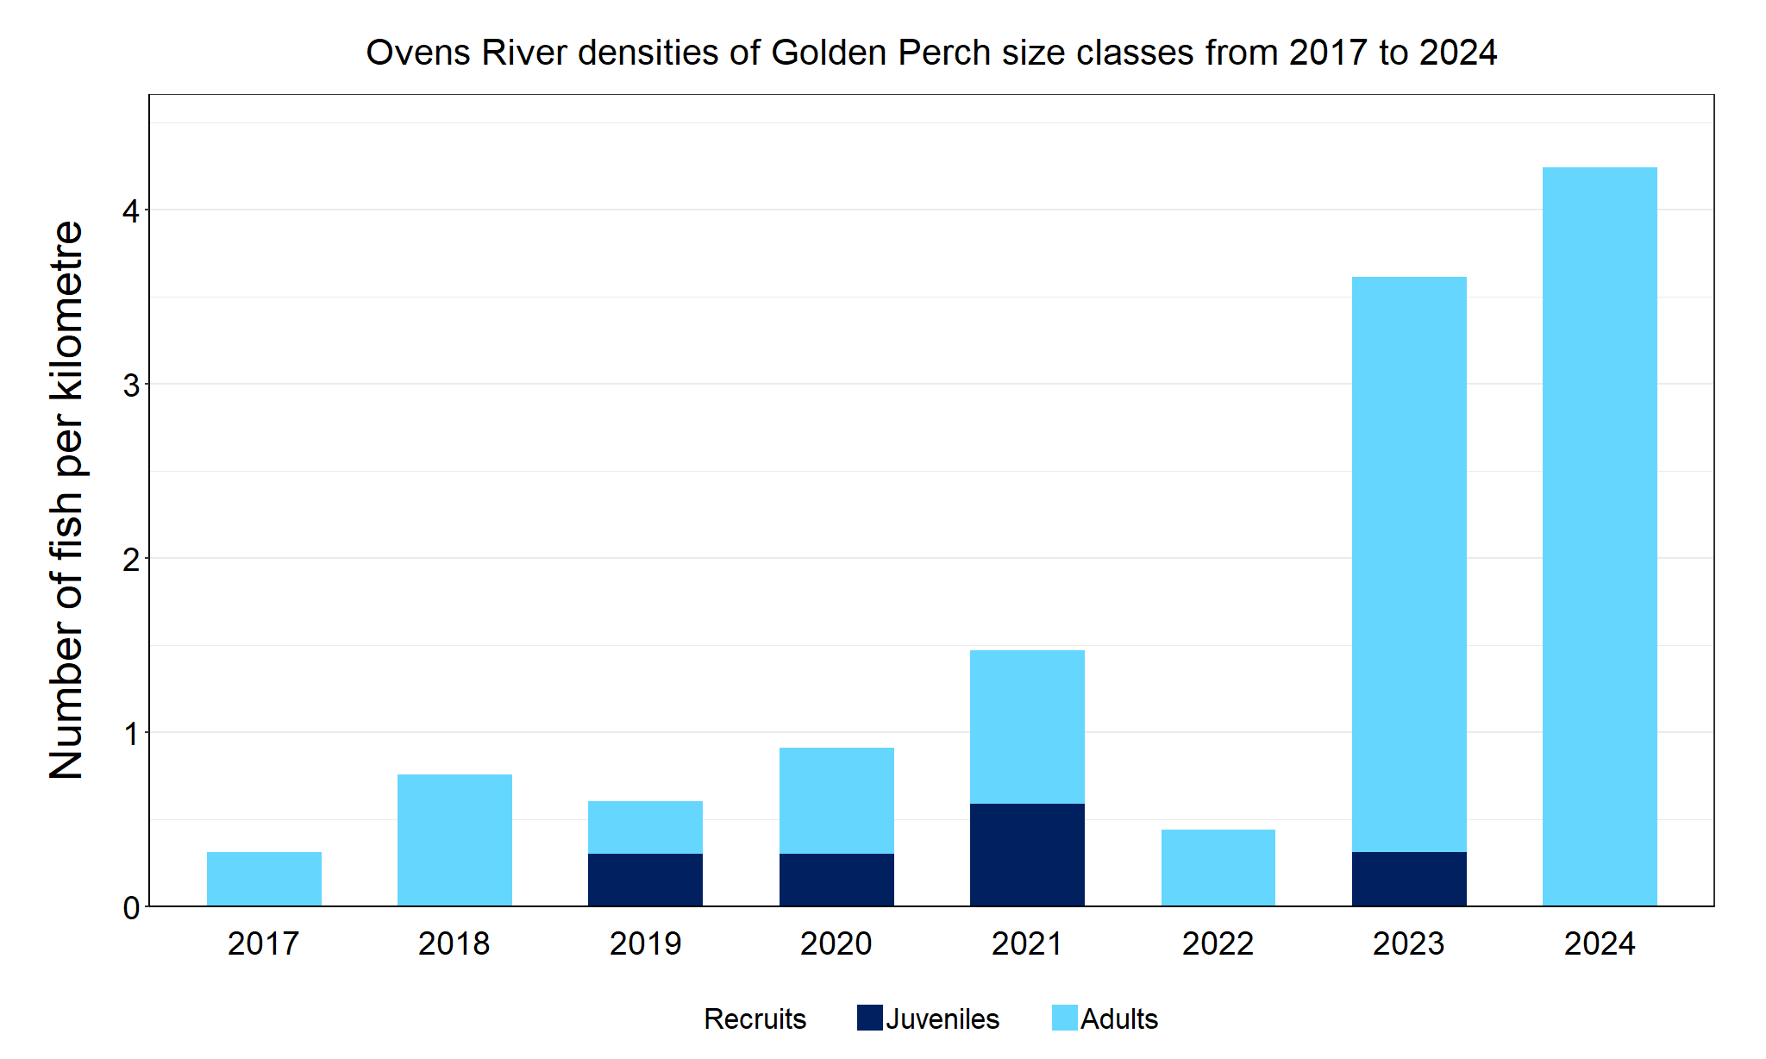

Figure 2. The densities of recruits, juveniles and adult Golden Perch in the Ovens River from 2017 to 2024

Figure 3. The size range percentage of Golden Perch in the Ovens River in 2024

|  |
| --- |
|  |

**Macquarie Perch**

**Ovens River, North East region**

**Key Health Indicators**

Recent recruitment Yes

Multiple size classes Yes

Mature fish present Yes

**Monitoring Results**

Total number of fish caught 108

Fish per 1km of waterway 16.95

Largest fish by length (cm) 38.4

Largest fish by weight (kg) 0.89

% of the catch that is legal size NA#

# *This species is a Protected Freshwater Species and taking or possessing is prohibited (Victorian Recreational Fishing Guide 2023-2024)*

**Most Macquarie Perch (*Macquaria australasica*) recorded during each year of NFRC surveys were juveniles (Figure 4; Figure 5), with recruitment recorded in all years except 2021. A large increase of adult** **fish was detected in 2023 and 2024, indicating the fish are surviving to maturity (Figure 4). The highest abundances of juveniles were detected in 2024, but it is unknown if these are stocked fish or from wild breeding. Genetic samples were taken from Macquarie Perch recruits for later analysis.**

**In 2024, Macquarie Perch were collected from all seven sites from Murtaugh upstream of Wangaratta to Porepunkah. No Macquarie Perch were detected downstream of Murtaugh. In 2023 the first detections of Macquarie Perch were recorded downstream of Wangaratta; two juveniles and one recruit were recorded from three separate sites. Future monitoring will establish if Macquarie Perch continues to extend its range downstream and if past management actions in establishing a population with natural recruitment was successful and continues into the future. Given the species is long-lived and has undergone population crashes shortly after establishment in other areas2, continued monitoring is critical to track the success of the establishment of this species in the Ovens system.**

**Stocking**

Stocking of fingerlings started in the Ovens River in 2011, and translocations from Lake Dartmouth started in 2014. Stockings relevant to NFRC survey areas include: 6400 fingerlings and 62 adult fish (ex-broodfish) into the Ovens River in 2016; 8300 fingerlings and 675 translocated fish in 2017; 15,000 fingerlings, 10 adult broodfish and 474 translocated fish in 2018 (following NFRC surveys); 7500 fingerlings in 2019; 700 fingerlings in 2020; 32,000 fingerlings in 2021; 40,000 fingerlings in 2022; 10,500 in 2023; and 10,000 in January 2024. In addition, 15,300 Macquarie Perch fingerlings have been stocked into the King River in 2022; 4950 in 2023; and 25,050 in January and February 2024. All translocations involved a range of sizes from young-of-year to adults.

Lintermans et al. (2013) The rise and fall of a translocated population of the endangered Macquarie Perch *Macquaria australasica* in south-eastern Australia. Marine and Freshwater Research 64(9): 838.

Figure 4. The densities of recruits, juveniles and adult Macquarie Perch in the Ovens River from 2017 to 2024

Figure 5. The size range percentage of Macquarie Perch in the Ovens River in 2024

**Murray Cod**

**Ovens River, North East region**

**Key Health Indicators**

Recent recruitment Yes

Multiple size classes Yes

Mature fish present Yes

**Monitoring Results**

Total number of fish caught 200

Fish per 1km of waterway 31.4

Largest fish by length (cm) 98.0

Largest fish by weight (kg) 17.0

% of the catch that is legal size 26

**Multiple size classes of Murray Cod (*Maccullochella peelii*), including adults, juveniles and recruits have been caught during each year of NFRC surveys (Figure 6). An increase in Murray Cod recruits (5-10cm) captured in 2024 (Figure 7) could possibly be linked to lower river flows at the time of sampling resulting in greater fishing efficiency for smaller size classes. Murray Cod were detected at every site surveyed in 2024. As no Murray Cod stocking occurs in the Ovens River, it is likely that a large proportion of Murray Cod recorded are from natural recruitment. The abundances of Murray Cod, evidence of annual recruitment, and wide range of size classes including large adult fish indicate that the Murray Cod population is healthy in the system. This is supported by the fact that the Ovens River had the highest number of fish per kilometre surveyed compared to the other NFRC rivers that targeted Murray Cod (Goulburn, Gunbower and Lindsay-Mullaroo).**

**Stocking**

No stocking has occurred in the area surveyed post 1990.

Figure 6. The densities of recruits, juveniles and adult Murray Cod in the Ovens River from 2017 to 2024

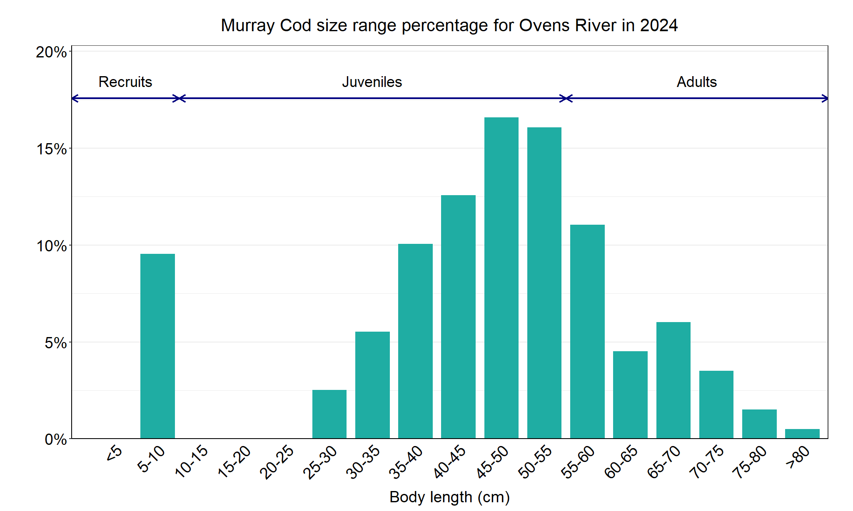

Figure 7. The size range percentage of Murray Cod in the Ovens River in 2024

**Trout Cod**

**Ovens River, North East region**

**Key Health Indicators**

Recent recruitment Yes

Multiple size classes Yes

Mature fish present Yes

**Monitoring Results**

Total number of fish caught 75

Fish per 1km of waterway 11.8

Largest fish by length (cm) 66.4

Largest fish by weight (kg) 4.25

% of the catch that is legal size NA#

# *This species is a Protected Freshwater Species and taking or possessing is prohibited (Victorian Recreational Fishing Guide 2023-2024)*

**Abundances of Trout Cod (*Maccullochella macquariensis*) across all eight years of NFRC surveys have generally remained high, with 2024 slightly higher than other years (Figure 8). A wide size range of fish was recorded in 2024 with most fish representing either late juvenile stages or early adulthood (Figure 9). The lower abundance of fish recorded in 2020 correlates with higher flows and associated high turbidity which would have reduced the likelihood of capturing fish. The wide size range and detection of recruits (six of eight years), juveniles (all eight years) and adults (all eight years) indicate that conditions in the Ovens River are supporting the recruitment and survival of this species throughout its lifecycle.**

**Stocking**

No Trout Cod stocking has occurred in the Ovens River system since 2006, however 15,000 fingerlings were stocked into the King River in 2024.

Figure 8. The densities of recruits, juveniles and adult Trout Cod in the Ovens River from 2017 to 2024

Figure 9. The size range percentage of Trout Cod in the Ovens River in 2024

We acknowledge and respect Victorian Traditional Owners as the original custodians of Victoria’s land and waters, their unique ability to care for Country and deep spiritual connection to it. We honour Elders past and present whose knowledge and wisdom has ensured the continuation of culture and traditional practices.

Logo*© The State of Victoria Department of Energy, Environment and Climate Action 2024. This work is licensed under a Creative Commons Attribution 4.0 International licence. To view a copy of this licence, visit creativecommons.org/licenses/by/4.0/ ISSN 2981-9075 Online (pdf/word)*