Victoria demonstrates that river rehabilitation works for native fish

What is a Demonstration Reach?
Rehabilitation activities (2008 – 2014):

Approximately 90% of native fish populations within the Murray-Darling Basin have declined since European settlement. This decline is largely attributed to in-stream habitat removal, degraded riparian vegetation, un-regulated stock access to rivers, river bank deterioration, barriers to fish passage and introduced fish. To mitigate impact from these threats and improve native fish resilience, the Murray-Darling Basin Authority’s Native Fish Strategy developed the Demonstration Reach concept. Demonstration Reaches are stretches of river where we demonstrate the cumulative benefits of multiple river rehabilitation actions to enhance native fish populations.

Ovens River

305 logs added willow control (18 km) fencing (5.5 km)
fishway re-constructed 25 fish hotels added 200 Carp removed

Target fish species

Holland’s Creek

126 logs added willow control (29 km) fencing (24 km)
19 rock-seeds

Rock-bar constructed 3,200 shrubs planted

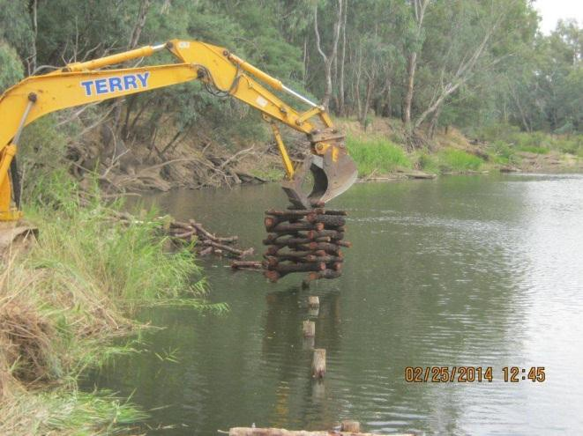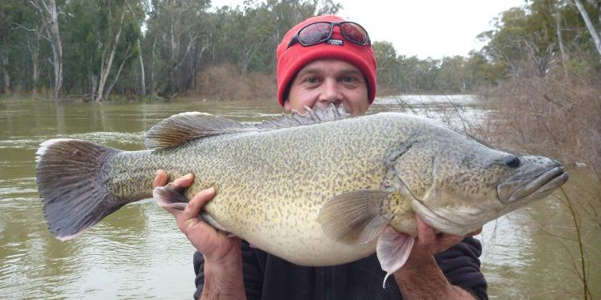Murray Cod (Maccullochella peelii) and the nationally endangered Trout Cod (Maccullochella macquariensis) are the target species in the Oven’s River Demonstration Reach (ORDR) while the nationally endangered Macquarie Perch (Macquaria australasica) is the target species for the Hollands Creek Demonstration Reach (HCDR).

Placing fish hotels (structural habitat) into the Ovens River. Photo: A. Wilson

Victorian Demonstration Reaches and rehabilitation

Victoria has two Demonstration Reaches; one on the Ovens River (from Wangaratta to Myrtleford) and one on Hollands Creek, near Benalla (from Tatong to Spring Creek). These Demonstration Reach projects were initiated in 2008 and have continued to 2014. Both projects involved a range of rehabilitation actions aimed at improving the resident native fish populations, including installing logs to provide fish habitat, fencing to reduce stock access to the river, and weed and ‘pest’ fish control .

Success: a 450% increase in Murray Cod abundance in the Ovens River over the life of the project. Photo: G. Hackett
These large-bodied native fish species were historically abundant and widespread. However, their distribution and abundance dramatically declined in the last century.

Victoria demonstrates that river rehabilitation works for native fish

Is it working?

Over the life of the Victorian Demonstration Reach projects, annual fish surveys in the Ovens River have revealed

a 450% increase in the Murray cod population
and
a 270% increase in the Trout cod population.
Similarly, spectacular results from Hollands Creek were recorded with

a 1200% increase in Macquarie perch,

a 1500% increase in Two-spined blackfish and a 400% increase in River blackfish.
The impressive increase in the number of large-bodied native fish within the Ovens River and Hollands Creek suggests that conditions within treatment Demonstration Reaches have improved compared with control reaches, where no works were undertaken. These improved conditions are likely to be related to the reduction of threats to fish within treatment reaches, as a result of our rehabilitation actions.

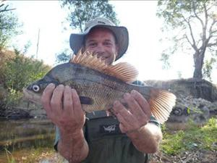Populations of large-bodied native fish have not only increased in abundance, but have also been strengthened by an increase in distribution and a wider range of size classes; indicating that the populations have been successfully
breeding and/or recruiting individuals.

Macquarie Perch numbers in Hollands Creek increased by 1200% since the project started. photo: J. Kearns_

Murray Cod from the Wangaratta fishway. Photo: S. Raymond

Project partnerships

Partnering with relevant stakeholders was essential to foster project ownership, effectively improve river health, and demonstrate the value of collaboration. Community Reference Groups included local landholders, representatives from local clubs and government agencies. Regular engagement events were held, including field days with local school students and program partners, information stands at local fishing shows, and conducting annual fish survey demonstrations. Information signs were installed and project updates were communicated during meetings, in distributed reports, through dedicated Demonstration Reach agency webpages, in local media, and at research conferences.

Project partners;
- Murray-Darling Basin Authority (MDBA)
- Department of Environment and Primary Industries (DEPI)
- North East Catchment Management Authority (NECMA)
- Goulburn Broken Catchment Management Authority (GBCMA)
- Rural City of Wangaratta
- Rural City of Benalla
For more information on this project contact:

Dr. Scott Raymond: scott.raymond@depi.vic.gov.au Anthony Wilson: anthony.wilson@necma.vic.gov.au Mark Turner: markt@gbcma.vic.gov.au

Published by the Victorian Government Department of Environment and Primary Industries Melbourne, June 2014
© The State of Victoria Department of Environment and Primary Industries Melbourne 2014
This publication is copyright. No part may be reproduced by any process except in accordance with the provisions of the Copyright Act 1968.
Print managed by Finsbury Green (June 2014)
ISBN 978-1-74146-016-2 (Print) ISBN 978-1-74146-017-9 (pdf)
Accessibility
If you would like to receive this publication in an alternative format, please telephone DEPI Customer Service Centre 136 186, email customer.service@dse.vic.gov.au (or relevant address), via the National Relay Service on 133 677 www.relayservice.com.au This document is also available in on the internet at www.depi.vic.gov.au
Disclaimer
This publication may be of assistance to you but the State of Victoria and its employees do not guarantee that the publication is without flaw of any kind or is wholly appropriate for your particular purposes and therefore disclaims all liability for any error, loss or other consequence which may arise from you relying on any information in this publication.

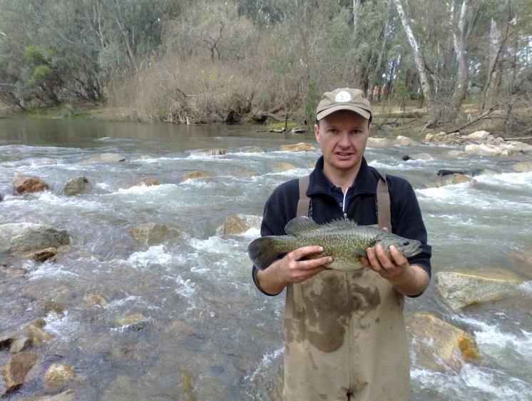

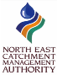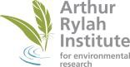www.depi.vic.gov.au

