|  |
| --- |
| Victorian Environmental Flows Monitoring and Assessment Program (VEFMAP) Stage 6 |
| Vegetation Project Update – 2019  Monitoring of Aquatic and River Bank Vegetation:  **Thomson and Macalister Rivers** |

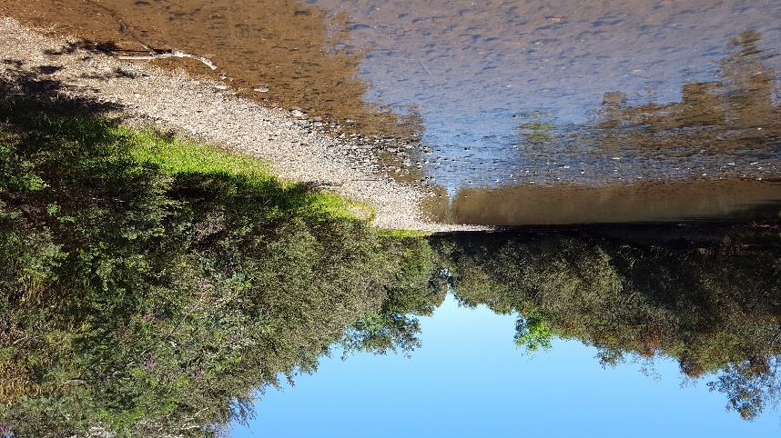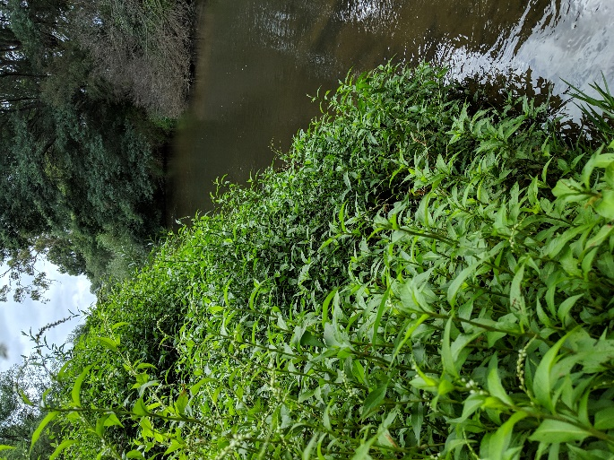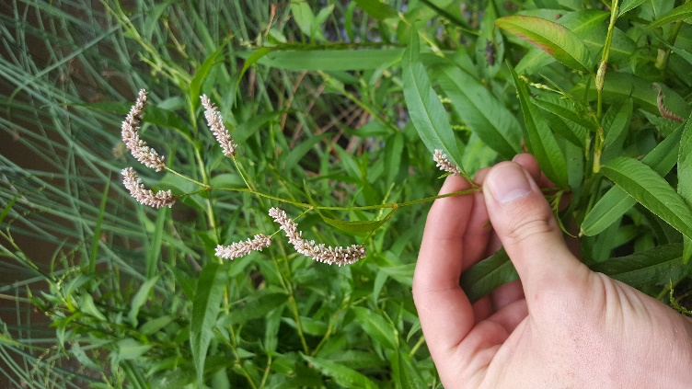

* 1. **VEFMAP Stage 6**

The Victorian Environmental Flows Monitoring and Assessment Program (VEFMAP) is now in its sixth stage of delivery. VEFMAP Stage 6 focusses on ‘intervention’ or ‘event-based’ monitoring of fish and vegetation responses to flows. The program is funded through the Victorian government’s $222 million investment in waterway and catchment health.

## Stage 6 – Vegetation Objectives

Stage 6 vegetation objectives aim to identify vegetation responses to environmental flows. The monitoring approach has been substantially modified from previous stages of the program and is focussed on individual flow events in waterways to detect short-term responses of native and exotic plant species to environmental water delivery. A longer-term understanding will be gained from repeated short-term assessments and by using data from previous stages of VEFMAP to create longer-term datasets. Importantly, these responses will be considered in relation to other factors that may influence flow responses, such as grazing, rainfall, soil properties and season (see program overview for details, DELWP 2017a).

## 2018/19 Monitoring in the WGCMA

Monitoring in the Thomson and Macalister Rivers commenced in 2018/2019. Surveys were conducted at three sites on the Thomson River and three sites on the Macalister River to investigate changes through time and in response to different flow events (Figure 1).

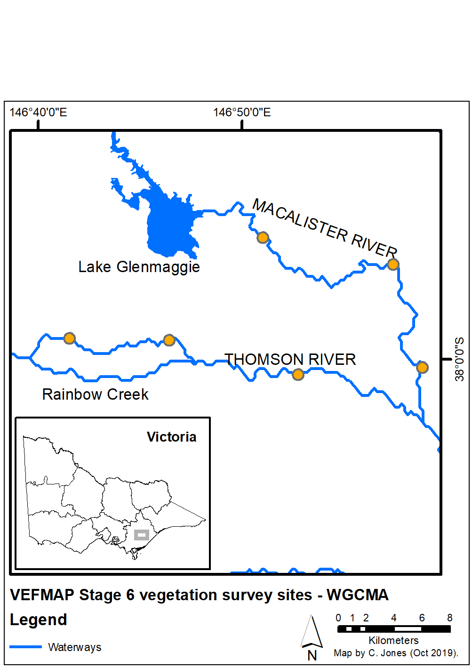

**Figure 1: Map of survey sites on the Thomson and Macalister Rivers.**

## Survey timing and hydrology

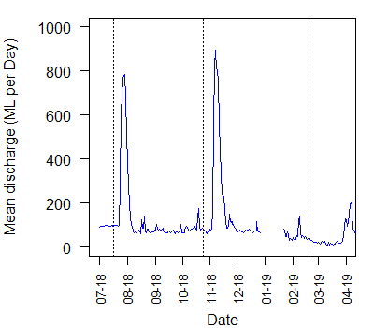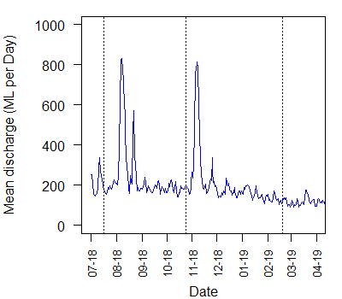

Timing for the VEFMAP surveys considers rainfall and managed flow deliveries. The sampling design recommends that surveys occur before a planned flow delivery and two to 12 weeks after the event, depending on the flow regime, to provide adequate time for vegetation to respond and for germinants to emerge. Timing is altered if rainfall increases the flow prior to a planned survey.

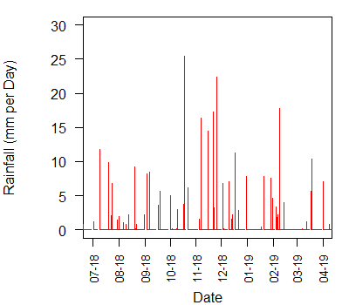

**Figure 2: Daily rainfall recorded at Maffra in 2018/19.**

Rainfall recorded near the survey sites in Maffra was relatively consistent throughout 2018/19 (Figure 2) but was lower than average.

In the Thomson River, flow discharge remained relatively high throughout 2018/19, with no periods of very low flow (Figure 3), due to regulated releases. Two environmental flows occurred on the Thomson River in August and November 2018. Short-term flow variability resulted in small-scale variation in flow height and depth throughout the year. In the Macalister River, flow discharge was very similar to the Thomson River, with two large environmental flows released in August and November over relatively consistent baseflows. The lowest flow levels occurred in March 2019.

Surveys in both rivers were conducted in July and October 2018 and February 2019, to capture vegetation attributes before and after each of the significant flow periods.

## Methods

Survey methods are outlined in detail in VEFMAP Stage 6 Part B: Monitoring design and sampling methods (DELWP 2017b). The surveys include a wide range of methods: fine-scale vegetation measurements, broad-scale mapping, tree canopy assessments and hydrology assessments.

**Figure 3: River flow recorded on the Thomson River (top) and Macalister River (bottom) in 2018/19.**

## Survey observations

All six of the survey sites contained a mix of native and exotic plant species. The **fringing vegetation** in particular often supported a high cover of exotic inundation-tolerant species such as *Rubus anglocandicans* (Blackberry), *Phalaris arundinacea* (Reed Canary Grass), *Cenchrus clandestinus* (Kikuyu), *Tradescantia fluminensis* (Wandering Trad) and *Vinca major* (Blue Periwinkle). These are common and often dominant weeds along many Victorian waterways where rainfall is relatively high. The two spring freshes were neither sufficiently long nor deep to negatively impact these species. Instead, the spring freshes were observed to encourage the growth of both exotic and native fringing and emergent species at sites on both rivers (Figure 4).

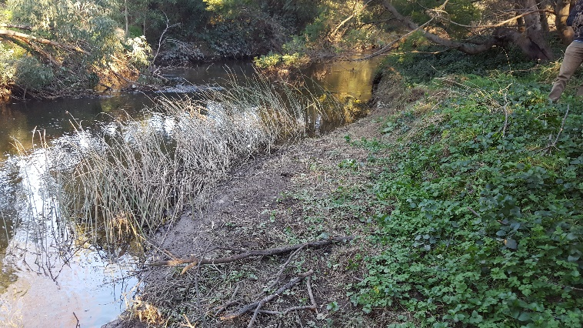

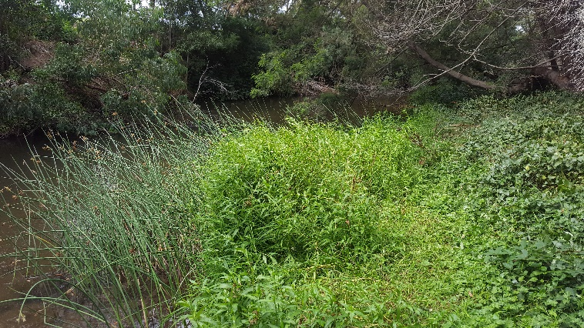

**Figure 4: Fringing vegetation on the Thomson River at Cowwarr in July 2018 (top photo) prior to the spring freshes, and again in February 2019 (lower photo), showing the growth of both native (e.g. Knotweed and native sedges) and exotic (e.g. Blue Periwinkle) inundation-tolerant fringing vegetation.**

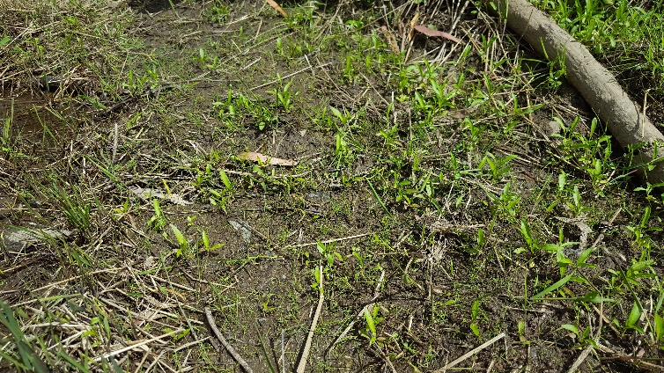

**Figure 5: Recruitment of native and exotic seedlings, including *Acacia* spp. (Wattles) and *Cyperus eragrostis* (Drain Flat-sedge) along the Thomson River in October 2018.**

River flows are an important part **of plant dispersal and recruitment**, so well-timed flows can help to encourage plant growth and diversity (Jones and Vivian 2019). Recruitment in and around waterways typically occurs at the end of autumn (when rainfall increases after summer) and in spring (when high flow levels decline and expose the soil). Spring is therefore a great time to observe the recruitment that has occurred within these two periods and appears as a combination of new germinants and seedlings (Figure 5). During 2018/19, in both the Thomson and Macalister Rivers, recruitment of native riparian species was observed at most sites but was limited at sites where the bank was dominated by perennial species (often exotic). It will be very difficult for native species to colonise and recruit into places with high perennial exotic plant cover.

**Instream vegetation** was present at four of the six survey sites (Jones and Vivian 2019), and was generally associated with lower-energy, shallow reaches, with not too much shading from adjacent vegetation (Figure 6). During the 2018/19 monitoring period there was no observed evidence of short-term increases or decreases in extent or abundance of instream vegetation in response to changes in flow in either river. Longer-term monitoring is most likely required to detect any large changes in instream vegetation.

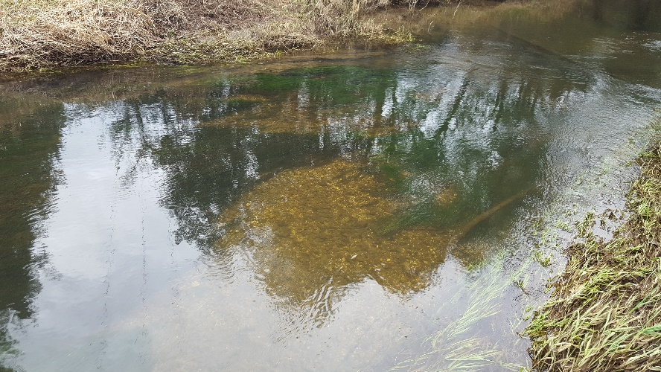

**Figure 6: Submerged instream vegetation in the fast-flowing but shallow Thomson River.**

**Emergent vegetation** cover was generally high across the survey sites, including species such as *Schoenoplectus tabernaemontani* (River Club-sedge) and *Bolboschoenus medianus* (Marsh Club-rush). As a result of the high tolerance of emergent species to small flow variations, and the typical seasonal growth of these species, there was little change in emergent vegetation distribution observed during the during the 2018/19 surveys in response to flow.

## Grazing

Currently, there is little livestock grazing at the surveyed sites on the Thomson and Macalister rivers, although many sites show clear signs of extensive historical clearing, grazing and exotic vegetation dominance. One site on the Macalister River is occasionally crash grazed in accessible locations. This can remove exotic plants, but it also removes native riparian plants (Figure 7).

While crash grazing can be an effective method for exotic vegetation management on the higher bank slopes, there are almost always corresponding negative impacts on the lower banks. If crash grazing of exotic-dominated riparian zones can be restricted to higher bank elevations, then this could dramatically reduce the negative impacts of livestock access.

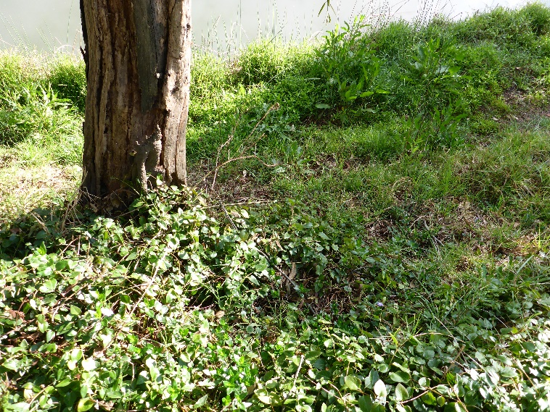

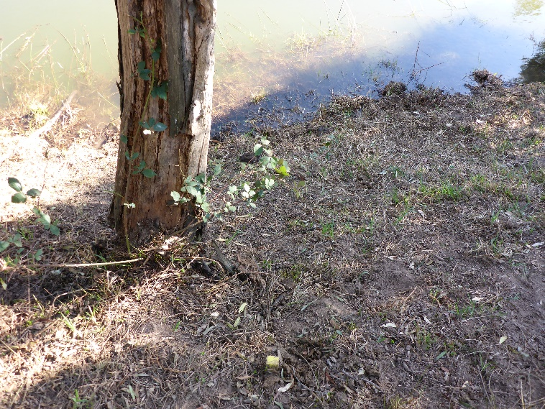

**Figure 7: Livestock grazing (cattle) on the Macalister River. Vegetation cover of exotic and native species present in October 2018 (top photo) was severely reduced by grazing prior to surveys in February 2019 (lower photo).**

## Key Outcomes

* Spring freshes were observed to encourage the growth of both exotic and native fringing and emergent species at sites on both rivers. Inundation-tolerant exotic species are a significant problem that requires additional management actions for removal.
* Recruitment of native riparian species was observed at most sites but was limited at sites where the bank was dominated by perennial species (often exotic).
* Instream vegetation was more prevalent on the Thomson River and was generally associated with lower-energy, shallow reaches, with not too much shading from adjacent vegetation.
* The extent and abundance of instream and emergent vegetation is not highly sensitive to changes in river flow from environmental water.
* If crash grazing of exotic-dominated riparian zones can be restricted to higher bank elevations, this could dramatically reduce the negative impacts of livestock access on native vegetation and banks.

## Summary

Environmental flows are being delivered on the Thomson and Macalister Rivers to deliver benefits to vegetation and a wide range of fauna. Waterway managers are working closely with researchers, waterway authorities and a range of other stakeholders to manage flow deliveries as effectively as possible for the environment and other users.

The observations summarised here form part of a larger story relating to vegetation responses to environmental water. Further information on the other systems surveyed and research projects is also available.

## Next Steps

In the final year of VEFMAP Stage 6 (2019/20), the data collected during the first three years of the program will be processed and analysed, and the findings reported in a series of reports and publications.

## References

DELWP (2017a and b) VEFMAP Stage 6 Part A: Program context and rationale and VEFMAP Stage 6 Part B: Program design and monitoring methods. Reports by Arthur Rylah Institute for Environmental Research and Integrated Water and Catchments Division, Department of Environment, Land, Water and Planning.

Jones C. and Vivian L. 2019. VEFMAP Stage 6: Monitoring vegetation response to environmental flow delivery in Victoria 2018/19. Arthur Rylah Institute report to the Department of Environment, Land, Water and Planning, Melbourne.

## Contact [Chris.Jones@delwp.vic.gov.au](mailto:Chris.Jones@delwp.vic.gov.au)

## jemimam@wgcma.vic.gov.au

|  |  |
| --- | --- |
| © The State of Victoria Department of Environment, Land, Water and Planning 2020  LogoThis work is licensed under a Creative Commons Attribution 4.0 International licence. You are free to re-use the work under that licence, on the condition that you credit the State of Victoria as author. The licence does not apply to any images, photographs or branding, including the Victorian Coat of Arms, the Victorian Government logo and the Department of Environment, Land, Water and Planning (DELWP) logo. To view a copy of this licence, visit http://creativecommons.org/licenses/by/4.0/  ISBN 978-1-76077-160-7 (pdf/online/MS word)  Disclaimer  This publication may be of assistance to you but the State of Victoria and its employees do not guarantee that the publication is without flaw of any kind or is wholly appropriate for your particular purposes and therefore disclaims all liability for any error, loss or other consequence which may arise from you relying on any information in this publication. | Accessibility  If you would like to receive this publication in an alternative format, please telephone the DELWP Customer Service Centre on 136186, email [customer.service@delwp.vic.gov.au](mailto:customer.service@delwp.vic.gov.au), or via the National Relay Service on 133 677 [www.relayservice.com.au](http://www.relayservice.com.au). This document is also available on the internet at https://www.ari.vic.gov.au/research/rivers-and-estuaries/assessing-benefits-of-environmental-watering |