|  |
| --- |
| Revegetation in farm landscapes  3. How does it contribute to landscape restoration? |

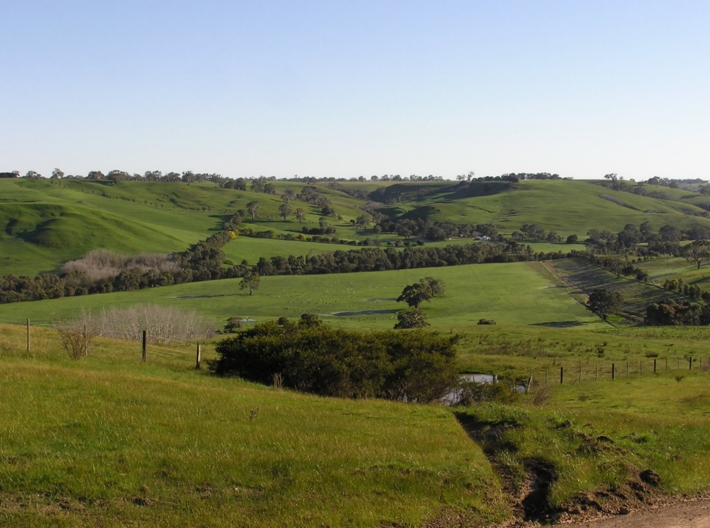

**Whole of landscape restoration**

Revegetation plantings along creeks, as shelterbelts or woodlots each have value as individual habitats for birds and other species (see Factsheet 2). It’s also important to understand how they contribute to conservation values at the broader scale – for the overall farm landscape. For example, does restoration through revegetation reverse the effects of the loss of native vegetation from rural landscapes? Does revegetation in cleared farmland ‘bring back’ species to the landscape, or simply provide additional habitat for species already present? And, how much revegetation is required in farm landscapes to enhance nature conservation?

To answer these questions, we selected landscapes (each 800 ha) in the Glenelg Hopkins region that represented three categories:

a) wooded vegetation dominated by remnant native vegetation, ranging from ~20% cover (160 ha) down to ~1% (8 ha) cover (i.e. a gradient of *loss* of vegetation);

b) wooded vegetation dominated by revegetation, ranging from ~1% up to ~18% cover (i.e. a gradient of *restoration* of otherwise cleared farmland)

c) landscapes with a mix of both remnant and revegetation (~1% to 18% cover).

Landscapes were also selected so that some included scattered paddock trees, and some did not.

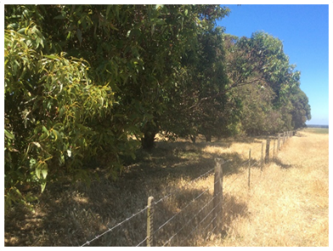

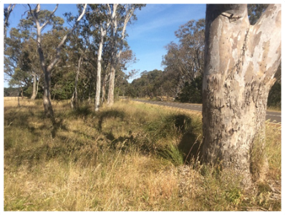

**Figure 1. Remnant native vegetation (left) along a roadside; and revegetation planting (right) in the form of a shelterbelt.**

**Birds in different types of farm landscapes**

Birds were surveyed at 12 sites (1 ha plots) in each landscape, in each season across one year (2006/07). In total, 122 bird species (excluding waterbirds) were recorded, including 60 ‘woodland-dependent’ species. The number of woodland species ranged from 9 – 36 species per landscape, and 80% of them were recorded in revegetation plots.

The number of woodland bird species increases with the total amount of vegetation in the landscape (Fig. 2). As landscapes with **remnant native vegetation** (brown line in Fig. 2) become more cleared and vegetation decreases, there is a loss of bird species. In contrast, as the overall area of **revegetation** in landscapes (green line in Fig. 2) increases, the number of bird species increases.

For a given amount of vegetation, landscapes with remnant native vegetation supported more woodland bird species than revegetated landscapes (Fig. 2).

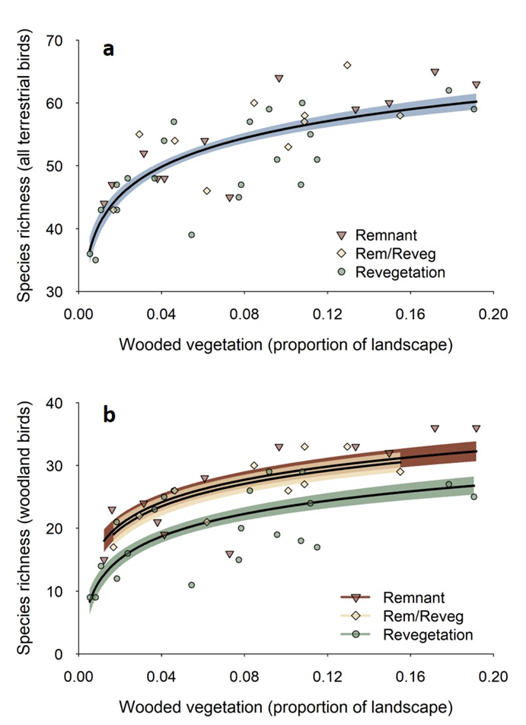

**Figure 2. The relationship between the number of woodland bird species and the amount of wooded vegetation in the landscape for those mostly comprised remnant vegetation (brown line), revegetation (green line) and a mix of both (buff line).**

**What influences woodland birds?**

The number of woodland bird species in these rural landscapes is determined by four main factors.

a) With more vegetation, whether remnant patches or revegetation, more species will be present.

b) The number of woodland bird species increases with increasing cover of scattered trees. These trees provide habitat in their own right and are important for helping birds move through the landscape.

c) Landscapes in the higher rainfall areas in the south tended to have more species.

d) Adding revegetation has the greatest impact in largely cleared landscapes (<5% initial cover). In landscapes with more remnant vegetation, revegetation had less immediate impact on bird species richness but does provide long-term benefit.

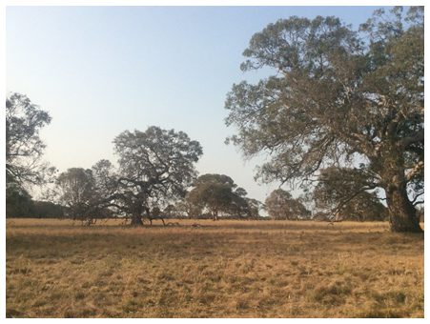

**Figure 3. Scattered trees in farmland have a strong positive influence on the number of woodland bird species in farm landscapes.**

**Differences in bird communities**

Restoring farm landscapes with revegetation plantings helps to ‘bring back’ species to otherwise cleared farmland. However, the composition of the bird community (i.e. the mix of species) differs between revegetated and remnant landscapes. Revegetated landscapes tend to have higher occurrence of species associated with shrubby vegetation, such as the Superb Fairy-wren, Brown Thornbill and New Holland Honeyeater. They are less likely to have species that typically use mature trees for foraging or nesting, such as the Crimson Rosella, Tree Martin, White-throated Treecreeper and Crested Shrike-tit. These species occur more frequently in remnant landscapes where large old trees are common.

|  |  |
| --- | --- |
| © The State of Victoria Department of Environment, Land, Water and Planning 2020  LogoThis work is licensed under a Creative Commons Attribution 4.0 International licence. You are free to re-use the work under that licence, on the condition that you credit the State of Victoria as author. The licence does not apply to any images, photographs or branding, including the Victorian Coat of Arms, the Victorian Government logo and the Department of Environment, Land, Water and Planning (DELWP) logo. To view a copy of this licence, visit http://creativecommons.org/licenses/by/4.0/  ISBN 978-1-76105-260-6 (pdf/online/MS word) Disclaimer  This publication may be of assistance to you but the State of Victoria and its employees do not guarantee that the publication is without flaw of any kind or is wholly appropriate for your particular purposes and therefore disclaims all liability for any error, loss or other consequence which may arise from you relying on any information in this publication. | Accessibility  If you would like to receive this publication in an alternative format, please telephone the DELWP Customer Service Centre on 136186, email [customer.service@delwp.vic.gov.au](mailto:customer.service@delwp.vic.gov.au), or via the National Relay Service on 133 677 [www.relayservice.com.au](http://www.relayservice.com.au). This document is also available on the internet at https://www.ari.vic.gov.au/research/ |

**Key messages**

* Revegetation in farm landscapes benefits a wide range of bird species, including woodland birds. It acts to ‘bring species back’ to cleared farmland; more restored vegetation leads to more species.
* Scattered trees across farm paddocks have a critical role in the value of the overall landscape for birds.
* Revegetated landscapes are not identical to those with remnants: for a given amount of vegetation they support fewer species and have a distinct bird community.
* Restoration of farmland has long-term benefits. The value of the planted vegetation will increase over time as the vegetation matures (see Factsheet 4).
* The individual contributions of landholders, LandCare groups and agencies all make a difference: they ‘add together’ for greater cumulative benefits over broad areas.

## Further information

Angie Haslem [A.Haslem@latrobe.edu.au](mailto:A.Haslem@latrobe.edu.au)

[research.ari@delwp.vic.gov.au](mailto:research.ari@delwp.vic.gov.au) [**ari.vic.gov.au**](https://www.ari.vic.gov.au/)

## Acknowledgements

This project was funded with support of the Victorian Government as part of the Biodiversity On-ground Action Adaptive Learning project, undertaken as a collaboration between Arthur Rylah Institute and La Trobe University.

**Prepared by:** Andrew Bennett, Greg Holland, Angie Haslem and Rohan Clarke (July 2020)

**Photo credits:** Rohan Clarke, Alex Maisey