|  |
| --- |
| Revegetation in farm landscapes  5. Butterflies and revegetation |
|  |

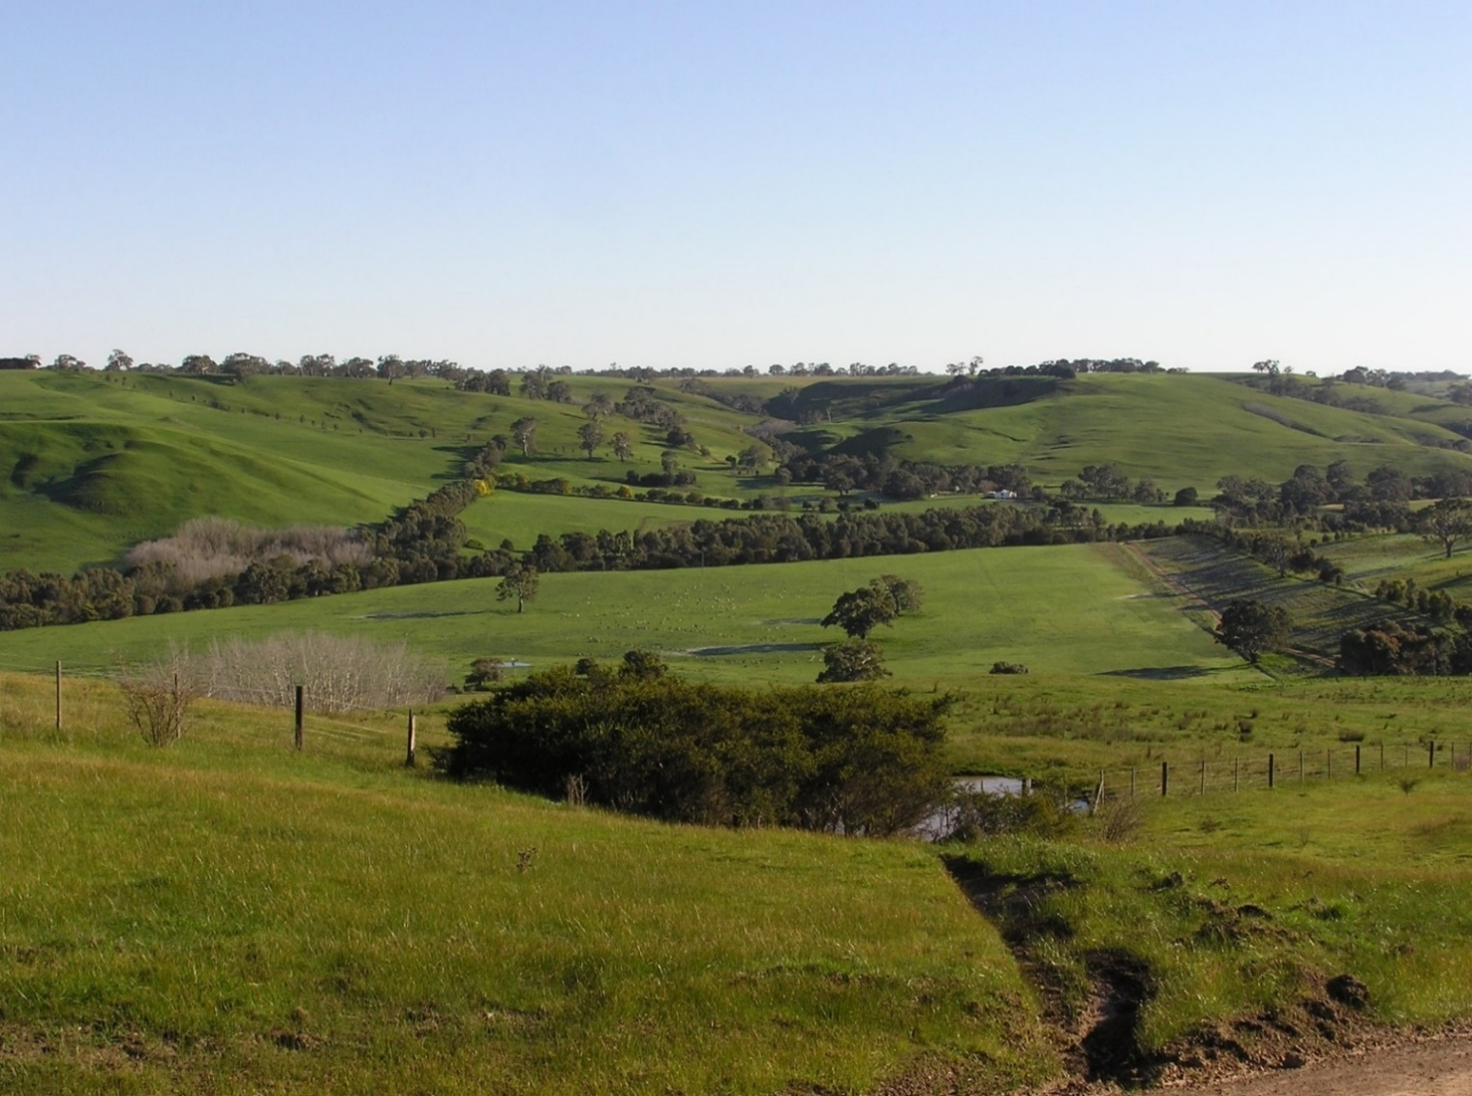

**Butterflies**

Butterflies are among the most well-known insects. Revegetation in rural landscapes is rarely undertaken with insects in mind, but understanding its value for groups such as butterflies, moths and native bees helps provide a broader measure of the success of restoration. Such insects strongly rely on vegetation because they feed on plants (e.g. nectar and pollen from flowers) and depend on host plants for reproduction. Insects interact with plants and animals in many ways which affect the health of an ecosystem (e.g. pollination, pest regulation) and they are food for many animals, including birds, mammals, reptiles and spiders. In many countries, butterflies are used as indicators of healthy ecosystems.

Butterflies, together with moths, make up the Family Lepidoptera. There are 408 species of butterflies known to occur in Australia, of which almost half are unique to Australia. Butterflies occur in all environments, from deserts to rainforests, in cities and on farms. They are most numerous in the rainforests of tropical northern Australia.

**Caper White *Belenois java***

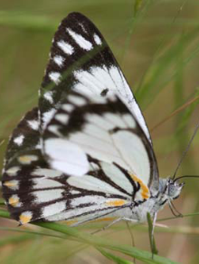

Butterflies have four stages in their life cycle; eggs, larva, pupa, and adult butterfly. Eggs are usually laid on the foliage of a suitable ‘host plant’ by an adult female. These hatch into larvae (caterpillars), which spend their time feeding on the host plant leaves. The pupa (also known as the chrysalis) is a non-feeding stage when the body system and organs of the caterpillar are transformed into those of the familiar adult butterfly.

The adult stage is concerned mainly with reproduction and dispersal. Males search for females, either around larval host plants, at feeding sites (e.g. flowering plants where they feed on nectar) or at landmarks such as hill tops, riverbanks, forest edges, sunny clearings and prominent trees. After courtship and mating, females spend much of their time searching for suitable larval host plants on which to lay their eggs.

**Does revegetation benefit butterflies?**

To answer this question, we carried out butterfly surveys in western Victoria; in 8 landscapes (each 200 ha) containing revegetation, and 8 landscapes containing remnant native vegetation as a comparison. In both types of landscape, the amount of vegetation ranged from 1 – 34% of the 200 ha area. In each landscape, butterfly surveys were carried out along a 1500 m transect, made up of fifteen 100-m sections that passed through different types of vegetation (revegetation, remnant vegetation, scattered trees in farmland, open pasture). Plant surveys were also conducted.

Butterfly surveys were undertaken on four occasions, from November 2007 to February 2008, in sunny conditions.

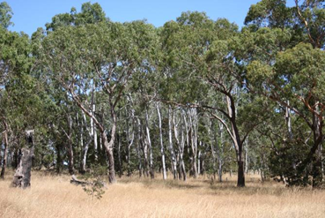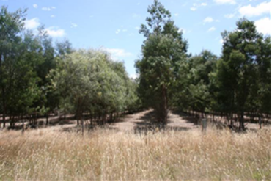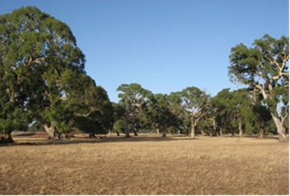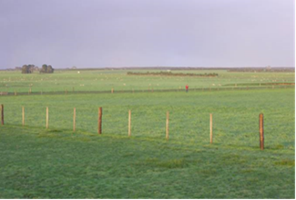

**Examples of different vegetation types: clockwise from top left: remnant vegetation, revegetation, open farmland, scattered trees.**

**The butterfly community**

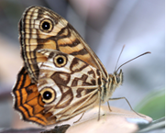

A total of 1683 butterflies from 11 species was recorded during the surveys. Four species were very common, together making up 98% of all records: Common Grass-blue *Zizina otis labradus* (n=768 observations), Common Brown *Heteronympha merope* (520), Australian Painted Lady *Vanessa kershawi* (161) and the exotic species Cabbage White *Pieris rapae* (197). Four species were much rarer, only being recorded once: Caper White *Belenois java,* Chequered Copper *Lucia limbaria,* Yellow Admiral *Vanessa itea* and Ringed Xenica *Geitoneura acantha.*

**How do butterflies use revegetation?**

Butterflies were more common in wooded parts of the landscape - in the remnant vegetation and revegetation - and less common among scattered trees and open pasture. Remnants and revegetation supported similar numbers of *different* *species*, but the number of *individual butterflies* (overall abundance) was greater in remnant vegetation.

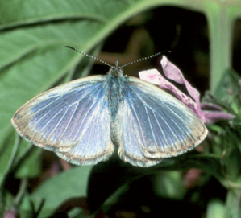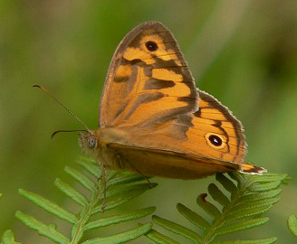

**Common Brown Common Grass-blue**

Different species show preferences for different habitats. The Common Brown occurred most often in patches of remnant vegetation and revegetation, but was rare among scattered trees in farmland and never recorded in pasture. Likewise, the Common Grass-blue and Cabbage White occurred in similar abundance in remnants, revegetation and among scattered trees but less commonly in open pasture.

The Australian Painted Lady was widespread, but most common among scattered trees. One species, Satin Azure *Ogyris amaryllis*, has a specialised requirement for mistletoes as a host for its larvae, and occurred only in remnant vegetation where mistletoes were present.

Clearly, revegetation is creating new wooded habitat

in these farm landscapes for butterflies.

**Ringed Xenica**

In all vegetation types, the ground layer was disturbed and dominated by exotic plants; most observations of butterflies feeding on nectar (78%) were from exotic plants. The absence of suitable native host plants for the larval stage of particular species likely contributed to a number of species ‘missing’ from the area.

|  |  |
| --- | --- |
| © The State of Victoria Department of Environment, Land, Water and Planning 2020  This work is licensed under a Creative Commons Attribution 4.0 International licence. You are free to re-use the work under that licence, on the condition that you credit the State of Victoria as author. The licence does not apply to any images, photographs or branding, including the Victorian Coat of Arms, the Victorian Government logo and the Department of Environment, Land, Water and Planning (DELWP) logo. To view a copy of this licence, visit http://creativecommons.org/licenses/by/4.0/  ISBN 978-1-76105-258-3 (pdf/online/MS word)  Disclaimer  This publication may be of assistance to you but the State of Victoria and its employees do not guarantee that the publication is without flaw of any kind or is wholly appropriate for your particular purposes and therefore disclaims all liability for any error, loss or other consequence which may arise from you relying on any information in this publication. | Accessibility  If you would like to receive this publication in an alternative format, please telephone the DELWP Customer Service Centre on 136186, email [customer.service@delwp.vic.gov.au](mailto:customer.service@delwp.vic.gov.au), or via the National Relay Service on 133 677 [www.relayservice.com.au](http://www.relayservice.com.au). This document is also available on the internet at https://www.ari.vic.gov.au/research/ |

**Conclusions**

* Revegetation plantings in rural landscapes create new wooded habitats that butterflies can use.
* Plantings supplement the habitat provided by remnants of native vegetation, at least for common species of butterflies.
* Native vegetation is important to protect; it supports a greater abundance of butterflies than revegetation and has specialised habitats, such as mistletoes.
* Revegetation practices typically focus on planting trees. There will be higher value for butterflies if restoration includes food plants for adult butterflies (e.g. flowering shrubs) and larval host plants (including native grasses), particularly for the less common species not able to use exotic plants.

**Further information**

Angie Haslem [A.Haslem@latrobe.edu.au](mailto:A.Haslem@latrobe.edu.au)

[research.ari@delwp.vic.gov.au](mailto:research.ari@delwp.vic.gov.au) [**ari.vic.gov.au**](https://www.ari.vic.gov.au/)

**Acknowledgements:** This project was funded with support of the Victorian Government as part of the Adaptive Learning Project, undertaken as a collaboration between Arthur Rylah Institute and La Trobe University.

A. Ouin was supported by INP de Toulouse (France). We thank the farmers who kindly gave access to their land.

**Prepared by:** Andrew Bennett, Annie Ouin, Angie Haslem, Rohan Clarke (July 2020).

**Photos:** Rohan Clarke, Alistair Stewart, Annie Ouin.