Gunbower Creek 2021
North Central region

This report card summarises the 2021 Native Fish Report Card (NFRC) survey in the Gunbower Creek
Sites 11, Electrofishing

Fish found in Gunbower Creek for NFRC
Target species
Golden Perch
Murray Cod
Silver Perch
Trout Cod

Non-target species captured since 2017*
Large-bodied native species
Bony Bream

Small-bodied native species
Australian Smelt
Carp Gudgeon sp.
Flatheaded Gudgeon
Murray-Darling Rainbowfish
Unspecked Hardyhead

Exotic species
Common Carp
Eastern Gambusia
Goldfish
Oriental Weatherloach
Redfin

* These non-target species were incidentally captured during NFRC surveys since 2017 but not measured as for target species

LOGOS – ARI, DELWP

Gunbower Creek 2021
Fish Community

NFRC target species
The NFRC Program began in 2017, with a focus on targeting the monitoring of population dynamics of key iconic fish species that have high recreational and/or conservation values, in large rivers across Victoria. In the Gunbower Creek, the target species are Golden Perch, Murray Cod, Silver Perch and Trout Cod. Surveys occur in April/May each year, at 11 sites from the offtake with the Murray River upstream of Torrumbarry to the junction of the Murray River at Koondrook. The equipment and habitats surveyed are focused on these species, which are measured to determine population structures. Other fish species that are incidentally captured are recorded, but not measured to determine their population structures.

Summary of key health indicators for target species in 2021
Species | Key Health Indicators
 | Recent recruitment | Multiple size classes | Mature fish present
Golden Perch | No | Yes | Yes
Murray Cod | Yes | Yes | Yes
Silver Perch | - | - | -
Trout Cod | - | - | -

Recent recruitment means young-of-year fish
*- cannot be determined due to low abundances

Silver Perch were historically abundant throughout Gunbower Creek, while Trout Cod were rare this far down the Murray River system. Both of these species have experienced dramatic declines across their range. The Yarrawonga population of Trout Cod was shown to have extended downstream from Barmah to Gunbower Island in 2012¹. Trout Cod were then captured in 2014, with NFRC sampling detecting this species in four of the five sampling years from 2017, although in low densities. Silver Perch are also present in low densities. Overall, the Gunbower Creek appears to be maintaining healthy populations of Golden Perch and particularly Murray Cod.

Non-target species
The non-target fish species that have been incidentally recorded in the Goulburn River during NFRC surveys since 2017 are:

Large-bodied native species
Other large-bodied species recorded in fish surveys include Bony Bream. Bony Bream are a lowland species across the Murray-Darling Basin which are intolerant of cold water and likely to be restricted to the lower Gunbower Creek (downstream Koondrook). It is unlikely this species would be detected upstream of the barrier at Koondrook, although a new fishway being installed in 2021 may assist fish passage.

Small-bodied native species
The small-bodied species Australian Smelt, Carp Gudgeon, Flatheaded Gudgeon, and Unspecked Hardyhead are common and are expected to be widespread throughout the Gunbower Creek and more broadly within the Murray-Darling Basin. Murray-Darling Rainbowfish are common and widespread in the Gunbower Creek. Once widespread in the Murray-Darling Basin, this species now has a patchy distribution and a restricted range and is considered threatened in Victoria.

Exotic fish species
Common Carp and Goldfish are widely distributed across sampling sites, with Eastern Gambusia more common in the slower flowing waters. Redfin are also distributed throughout, but in lower abundances. Weatherloach are increasing in distribution and abundance and are found in slower flowing areas, often in silt substrate. Weatherloach often disperse during floods.

Other native species known from Gunbower Creek
Some fish species known to occur in the Gunbower Creek system have never been recorded during NFRC surveys. For example, no Flatheaded Galaxias or Freshwater Catfish have been detected in the surveys, but these species are more common in offstream habitats (such as billabongs, lagoons and wetlands), with Freshwater Catfish detected in permanent offstream habitats regularly by The Living Murray surveys. No Obscure Galaxias have been recorded during the surveys. No Southern Pygmy Perch have been recorded during the NFRC surveys and this species has been absent from the Gunbower Creek system for over 30 years. These species outlined above are hard to detect using the NFRC sampling methodology.

Other notable species
Surveys have also recorded Rakali, Yabbies and Turtle species.

LOGOS – ARI, DELWP, NFRC

1. Douglas, J, Hunt, T and Trueman, W. (2012). Confirmed records of the endangered Trout Cod Maccullochella macquariensis from the Murray River at Gunbower Island, Victoria. Victorian Naturalist 129(4):152-155.

Gunbower Creek 2021
Environmental and Management Context

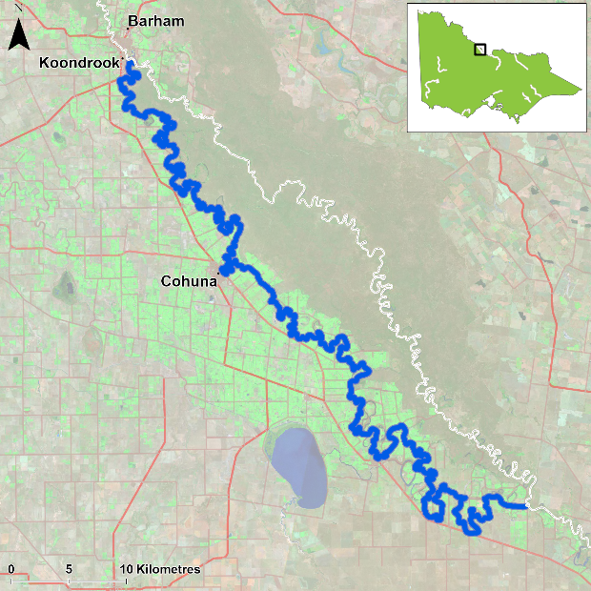
Figure 1. Map showing the section of Gunbower Creek where NFRC sampling occurs

Environment
Stream flow was consistent for the majority of Gunbower Creek from 2017 to 2021. However, the two sites downstream of Koondrook, had fluctuating heights, with heights particularly low in 2018, 2019 and 2020. In 2018 and 2021, these sites were fished later in autumn, when water levels had increased slightly.

River rehabilitation efforts in the Gunbower Creek
Many rehabilitation actions have occurred, and are underway, to improve the health of the Gunbower Creek and its fish community. These are informed in particular by the Native Fish Recovery Plan – Gunbower and lower Loddon. Actions include allocations of water for the environment, increasing connectivity by establishing fishways at Koondrook and Cohuna to improve fish passage, channel screening to prevent loss of fish to irrigation channels, protection and revegetation of riparian areas, investigating options to control Carp, and reintroduction of threatened species including Southern Pygmy Perch into two wetlands (Black Charlie and Reedy lagoons). There are a range of fish monitoring efforts related to the rehabilitation efforts above. These include the Victorian Environmental Flow Monitoring and Assessment Program (VEFMAP) and The Living Murray program. The North Central Catchment Management Authority, DELWP and VFA support rehabilitation and management of the Gunbower Creek and its fish community.

PHOTOS
LOGOS – ARI, DELWP, NFRC

Golden Perch

Gunbower Creek, North Central Region

Key Health Indicators
Recent recruitment No
Multiple size classes Yes
Mature fish present Yes

Monitoring Results
Total number of fish caught 32
Fish per 1km of waterway 2.12
Largest fish by length (cm) 57.5
Largest fish by weight (kg) 3.28
% of the catch that is legal size 96.9

The abundance of Golden Perch (Macquaria ambigua) was consistent from 2018 to 2020, albeit lower than 2017 and 2021. The increased abundances in 2017 were due to more fish captured at the two sites downstream Koondrook Weir compared to the following years when water levels were exceptionally low at these sites. A large proportion of Golden Perch collected were adults (Figure 2) with 97% of the catch being adults in 2021 (Figure 3). This indicates conditions in the system are suitable for maintaining adult Golden Perch populations. Juveniles have been present in all years, with recruits only detected in 2019 (Figure 2). It is unlikely that these are natural recruits, as the creek has many barriers which would limit spawning opportunities and egg/larval survival.

Stocking
Twenty thousand Golden Perch were stocked in 2016; 40,500 in 2017; 200,000 in early 2018; and 70,000 in 2019; 70,000 in 2020 and 70,000 in January 2021. Golden Perch were stocked into Gunbower Creek for the first time in 2016.
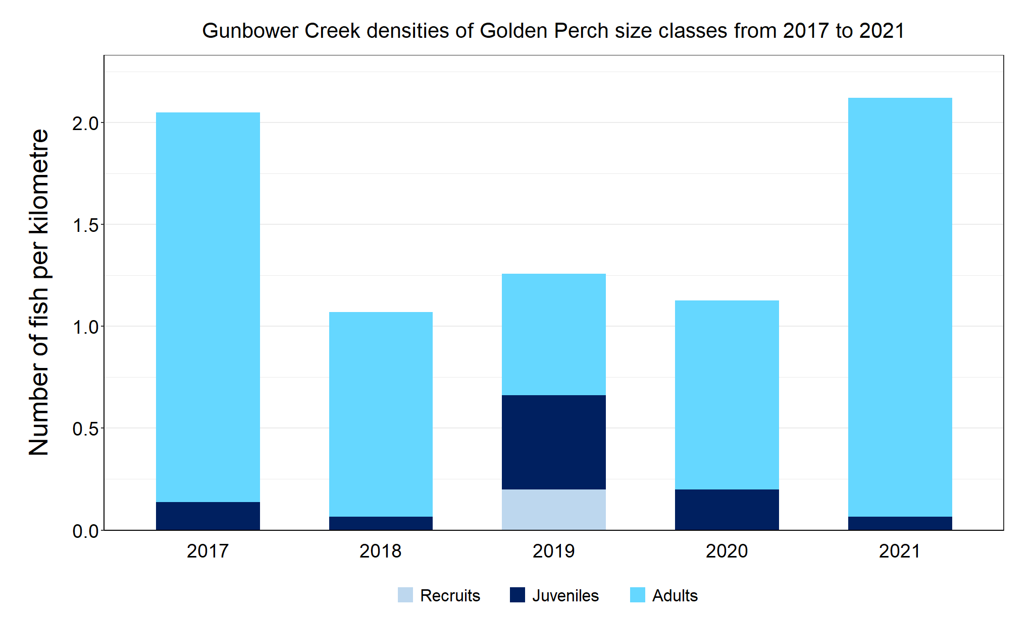
Figure 2. The densities of recruits, juveniles and adult Golden Perch in Gunbower Creek from 2017 to 2021

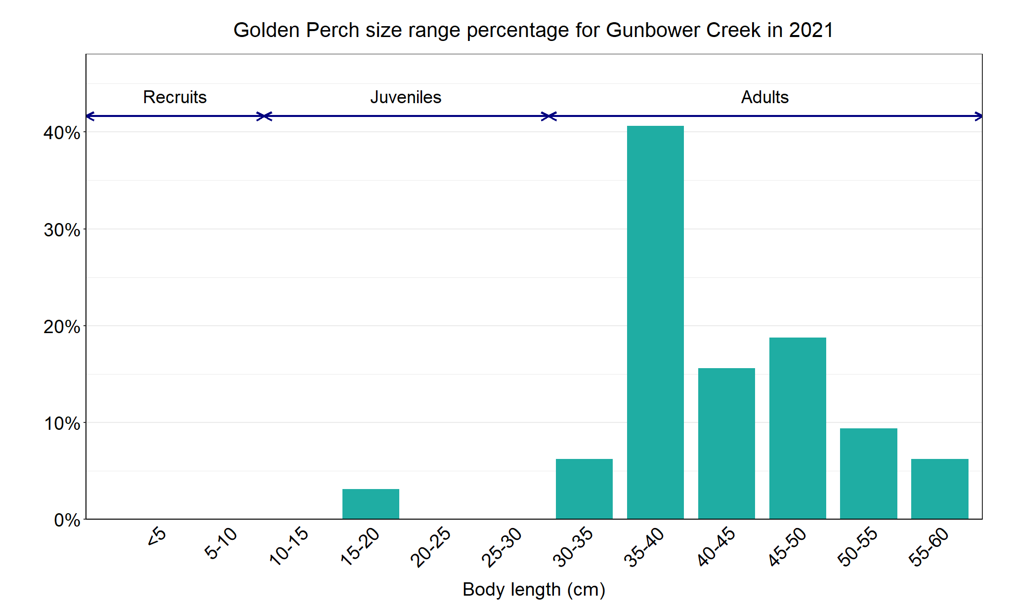
Figure 3. The size range percentage of Golden Perch in Gunbower Creek in 2021.

Murray Cod

Gunbower Creek, North Central region

Key Health Indicators
Recent recruitment Yes
Multiple size classes Yes
Mature fish present Yes

Monitoring Results
Total number of fish caught 82
Fish per 1km of waterway 4.43
Largest fish by length (cm) 88.0
Largest fish by weight (kg) 10.25
% of the catch that is legal size 15.9

The Murray Cod (Maccullochella peelii) population appears to be increasing (Figure 4.) Multiple size classes including mature and young-of-year fish were caught in all five years, with a wide size range collected in 2021 (Figure 5). A ‘Murray Cod hydrograph’ was created to use environmental water to reduce water level fluctuations by filling the gaps in flows caused by irrigation demand within the creek and also to maintain winter base flows ². The ‘Murray Cod hydrograph’ is enhancing the survival of young-of-year fish, irrespective of them being stocked or being from natural recruitment.

Stocking
Twenty thousand Murray Cod were stocked in 2016; 55,000 in 2017; 100,000 in early 2018 and 50,000 in late 2018; and 115,690 in 2020 (of which 65,000 were in December). Murray Cod stocking started in 2001, with 20,000 stocked in most years until 2016. The exceptions to this are: 120,000 in 2012 and 80,000 in 2014. No Murray Cod were stocked in 2019.

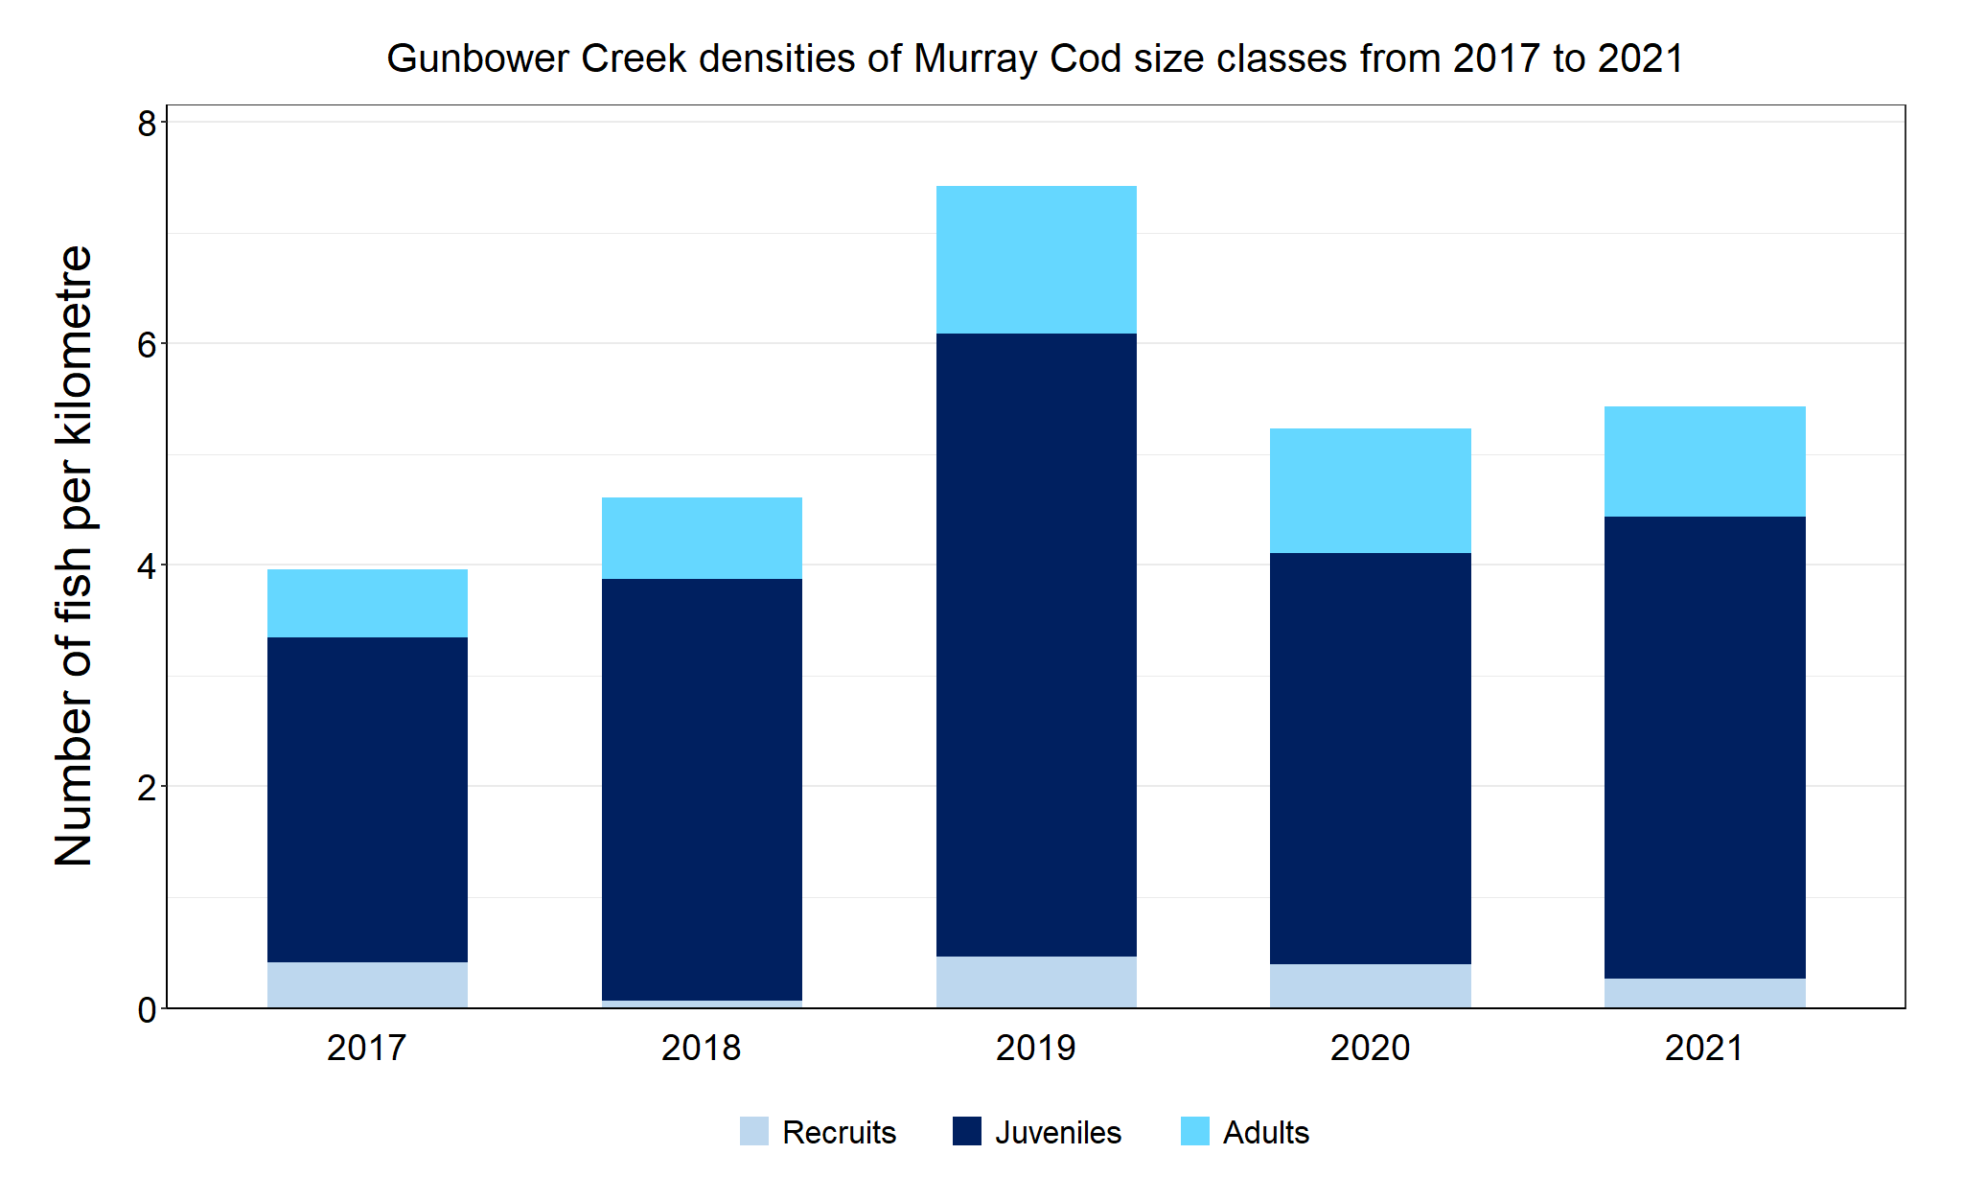
Figure 4. The densities of recruits, juveniles and adult Murray Cod in Gunbower Creek from 2017 to 2021.

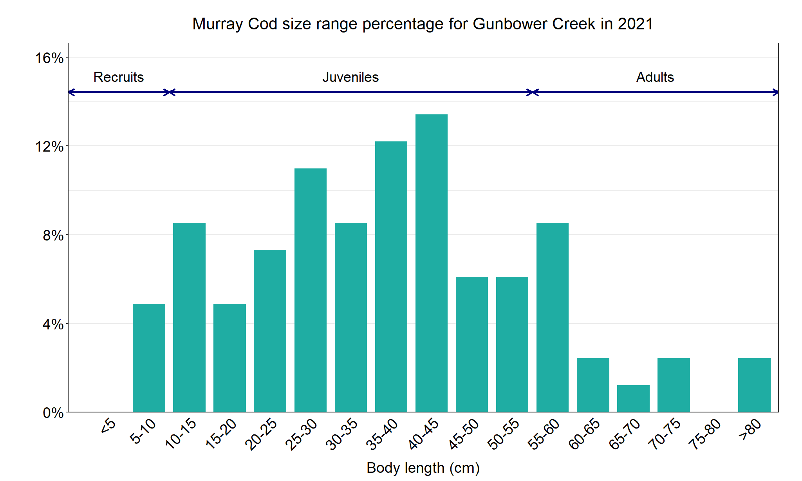
Figure 5. The size range percentage of Murray Cod in Gunbower Creek in 2021.

2. Ivor Stuart, Clayton Sharpe, Kathryn Stanislawski, Anna Parker and Martin Mallen-Cooper (2019). From an irrigation system to an ecological asset: adding environmental flows establishes recovery of a threatened fish species. Marine and Freshwater Research: 70 (9), 1295-1306.

Silver Perch

Gunbower Creek, North Central region

Key Health Indicators
Recent recruitment Cannot be determined
Multiple size classes Cannot be determined
Mature fish present Cannot be determined

Monitoring Results
Total number of fish caught 2
Fish per 1km of waterway 0.13
Largest fish by length (cm) 44.3
Largest fish by weight (kg) 1.31
% of the catch that is legal size NA

The natural range of Silver Perch (Bidyanus bidyanus) includes most of the Murray-Darling Basin, excluding the cool, higher altitude upper reaches of streams. River regulation and barriers have all impacted Silver Perch populations, with these prevalent in Gunbower Creek. The NFRC does not expect to capture enough Silver Perch to measure key health indictors. However, by collecting data for non-recreational species including threatened species such as Silver Perch, it will allow a greater understanding of the current status of the populations providing essential information to the management on these species. Due to the low abundances of Silver Perch collected during NFRC the key health indicators cannot be measured. However, low abundances of Silver Perch have been detected in all five years (Figure 6). The Silver Perch detected are predominantly adults with only adults collected in 2018 to 2021 (Figure 6, Figure 7). Juveniles were detected in 2017 only. Recruits of this species are difficult to catch using this sampling methodology and none have been detected in all five years of sampling. Silver Perch are unlikely to have a successful spawning in Gunbower Creek due to the many barriers.

Stocking
No stocking has occurred.
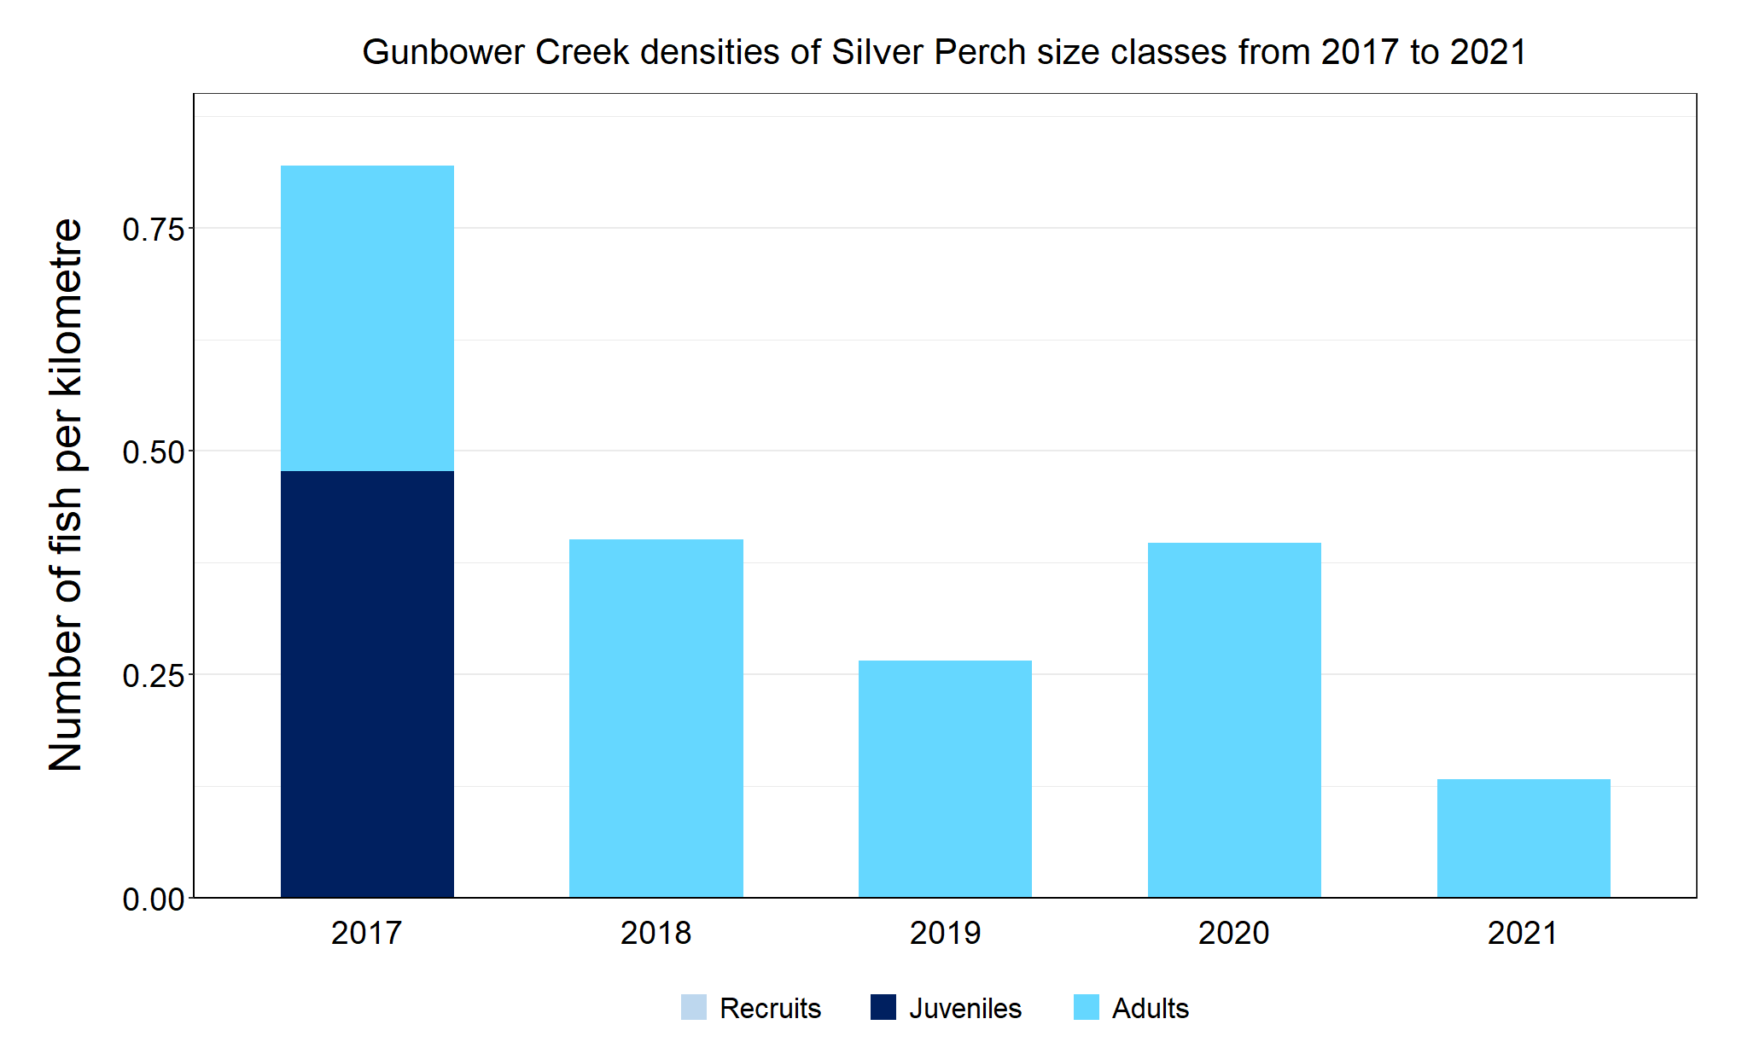
Figure 6. The densities of recruits, juveniles and adult Silver Perch in Gunbower Creek from 2017 to 2021.

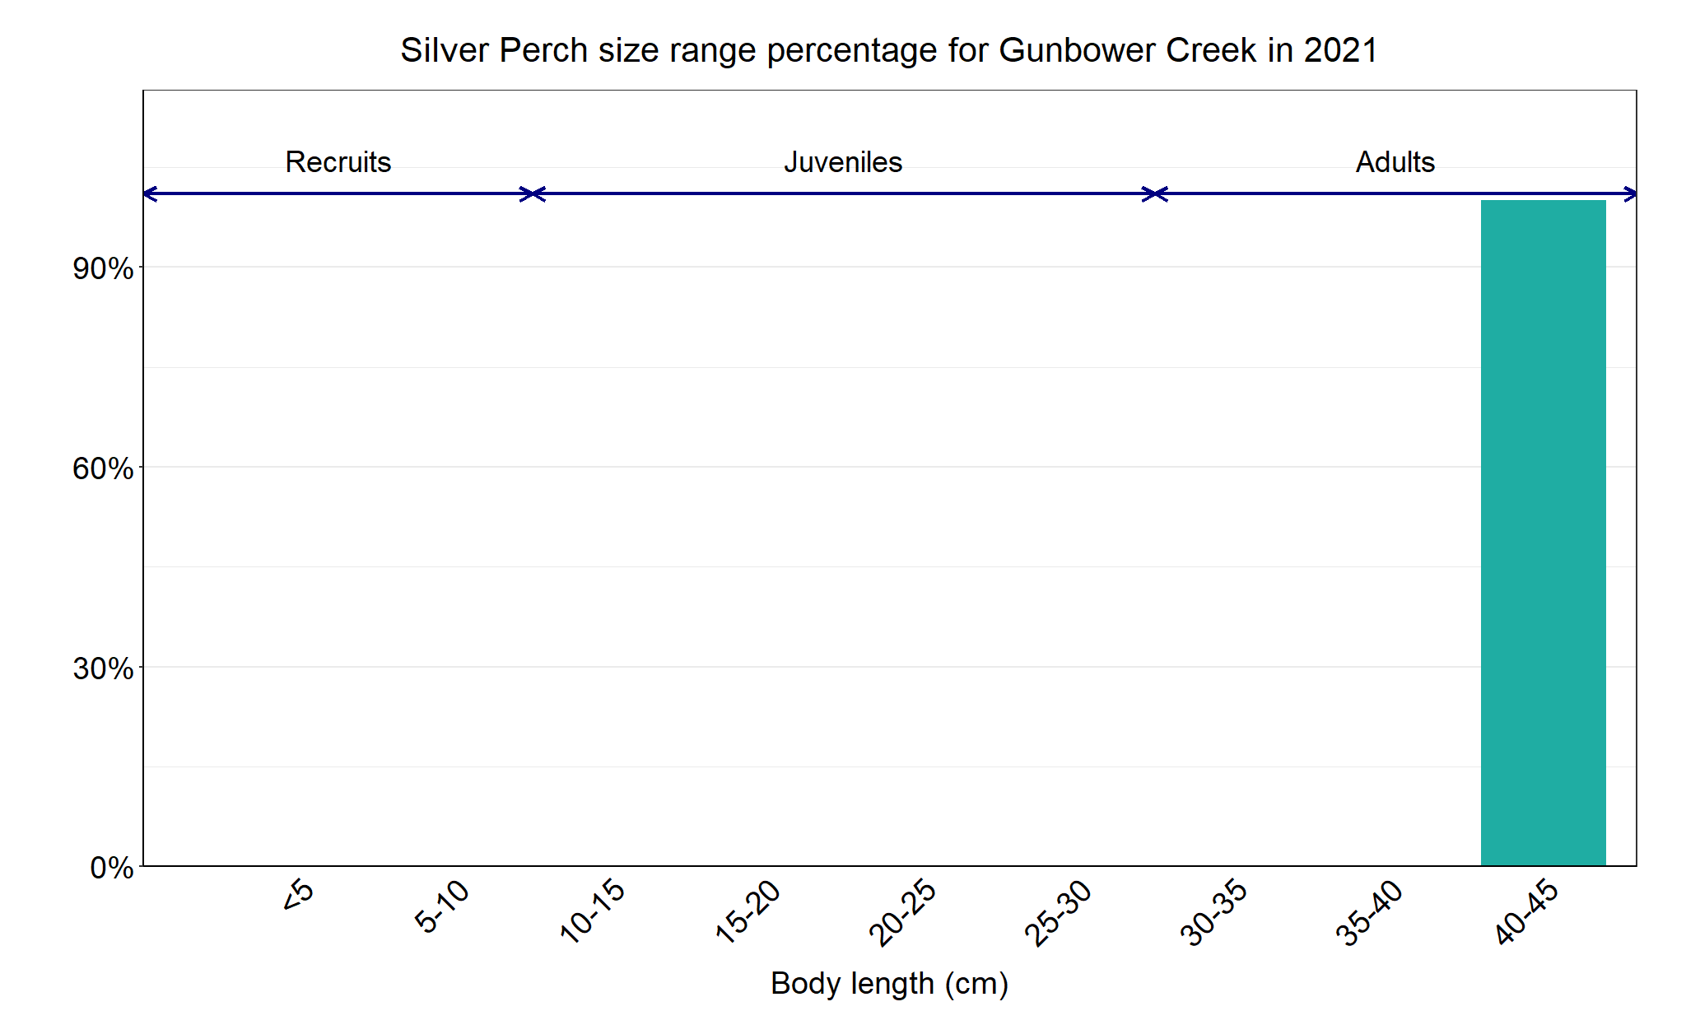
Figure 7. The size range percentage of Golden Perch in Gunbower Creek in 2021.

Trout Cod

Gunbower Creek, North Central region

Key Health Indicators
Recent recruitment Cannot be determined
Multiple size classes Cannot be determined
Mature fish present Cannot be determined

Monitoring Results
Total number of fish caught 2
Fish per 1km of waterway 0.13
Largest fish by length (cm) 47.8
Largest fish by weight (kg) 1.47
% of the catch that is legal size NA

The natural range of Trout Cod included Gunbower Creek, but the species was absent in this area from the 1980s. The NFRC does not expect to capture enough Trout Cod to measure key health indictors. However, by collecting data for non-recreational species including threatened species such as Trout Cod, it will allow a greater understanding of the current status of the populations providing essential information to the management on these species. Due to the low abundances of Trout Cod collected during NFRC the key health indicators cannot be measured. Trout Cod was first detected again in Gunbower Creek¹ in 2012 and have regularly been recorded since then, albeit in low abundances. Trout Cod have been recorded in four of the five years of NFRC sampling (Figure 8). No recruits have been detected in NFRC sampling, with only two individuals (one juvenile and one adult) recorded in 2021 (Figure 9). This indicates that Trout Cod are persisting in Gunbower Creek, but it is uncertain if they are breeding. It is possible that larvae or recruits enter the system via the national channel inlet upstream Torrumbarry Weir.

Stocking
No stocking has occurred.

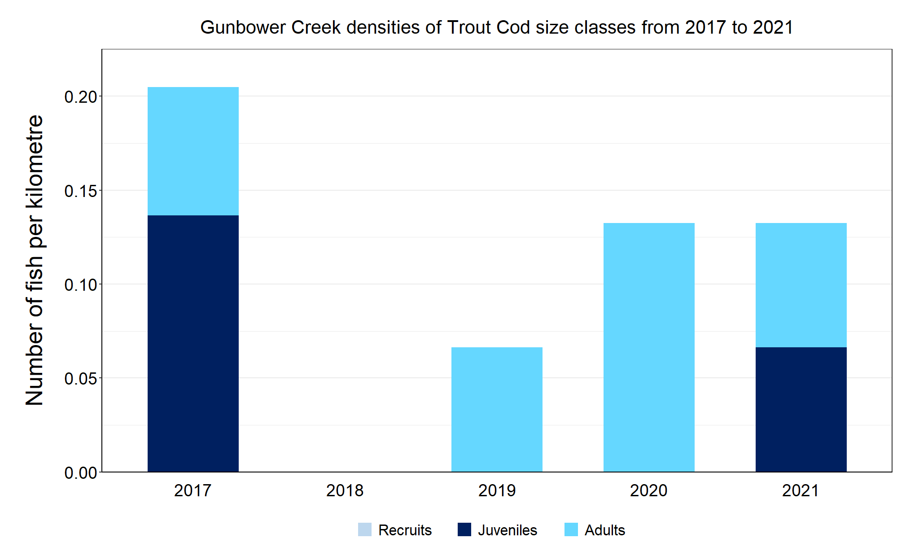
Figure 8. The densities of recruits, juveniles and adult Trout Cod in Gunbower Creek from 2017 to 2021.

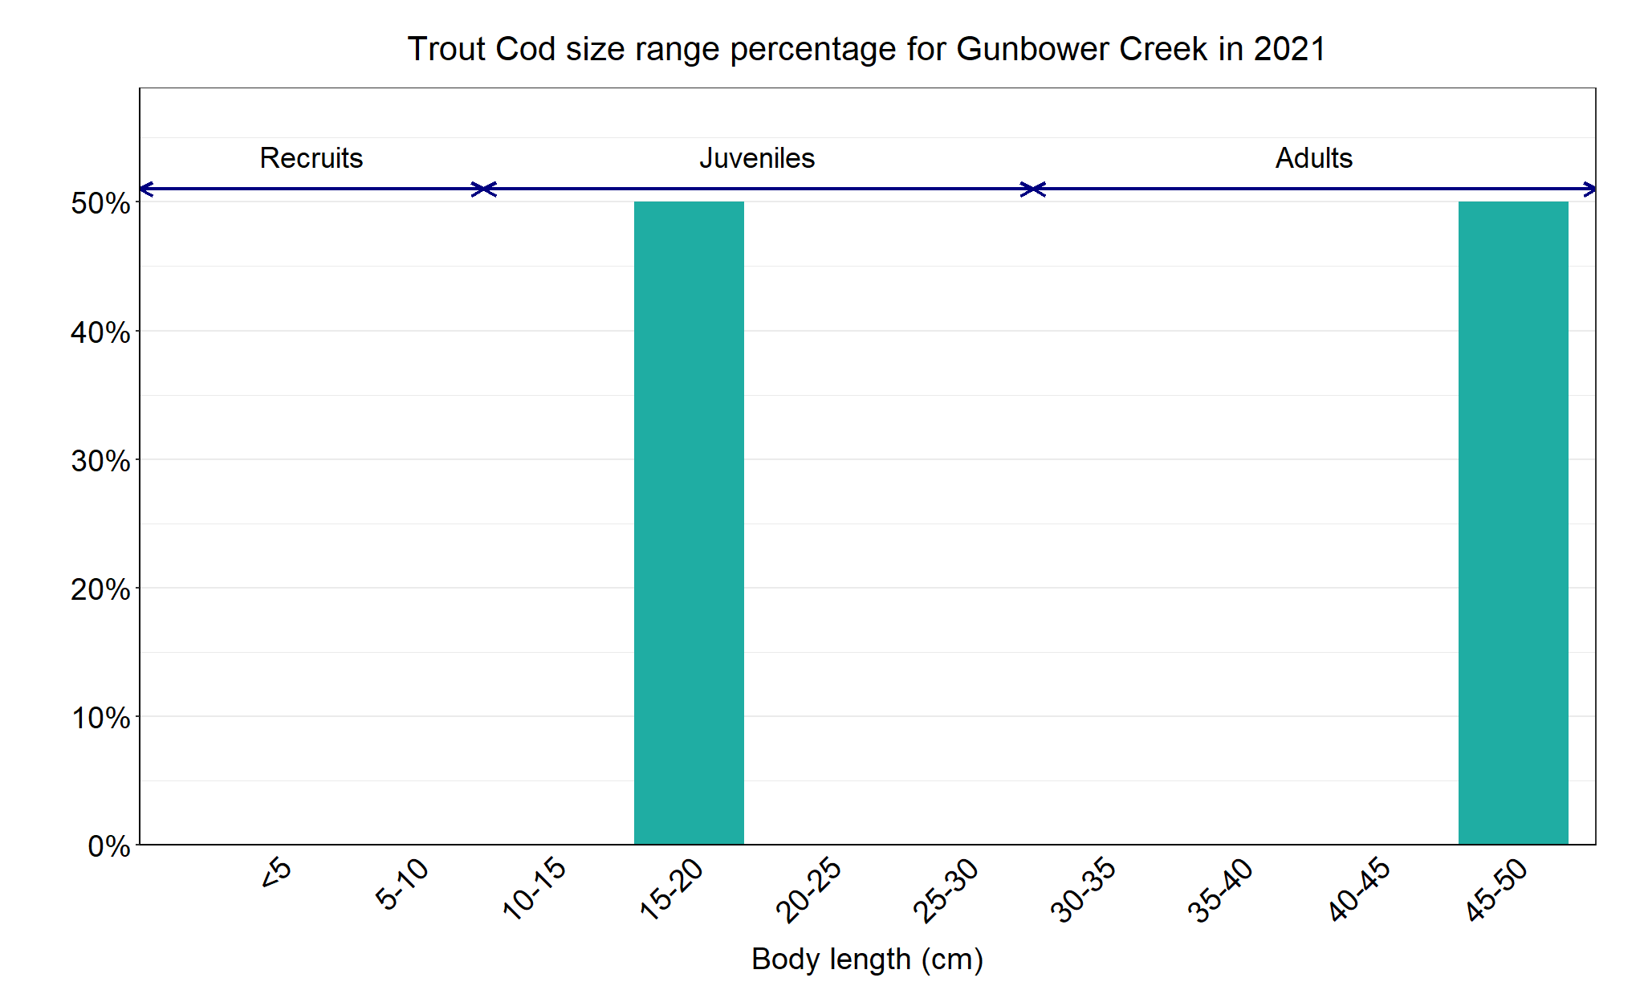
Figure 9. The size range percentage of Trout Cod in Gunbower Creek in 2021.

