Benefits of environmental water – Spawning of Australian Grayling in four coastal rivers
Fact sheet 3 - Spawning success of Australian Grayling
Investigating how to use environmental water to protect and restore environmental values within rivers, floodplains, wetlands and estuaries.

Background
Australian Grayling (Prototroctes maraena) is a nationally threatened fish that lives in coastal rivers in south-eastern Australia. The species is amphidromous, meaning adults spawn in the lower freshwater reaches, larvae then drift downstream to the sea, and juveniles migrate back upstream into freshwater. There has been a dramatic decline in abundance and distribution of Australian Grayling, due largely to altered flow regimes and stream barriers, which block fish migration.

Managing environmental water releases
In Victoria, many agencies work to implement environmental watering programs. West Gippsland Catchment Management Authority and Melbourne Water have develop seasonal watering proposals which include key flow objectives to deliver within channel flow pulses, known as 'freshes', to specifically trigger downstream migration and spawning of Australian Grayling. Every June, the Victorian Environmental Water Holder collates and summarises these seasonal watering proposals into a seasonal watering plan which previews all potential environmental watering across Victoria for the coming water year under each planning scenario.
An Australian Grayling with an acoustic transmitter

Studying Australian Grayling
From 2008 to 2015, the Arthur Rylah Institute (ARI) studied the effects of flows on spawning of Australian Grayling. The objective was to identify key components of the flow regime (hydrograph) that could be provided annually to stimulate downstream spawning migrations from March to May.

Monitoring spawning success
Eggs and larvae of Australian Grayling were collected in the lower Bunyip and Yarra rivers annually from 2008 to 2015 using drift nets. This represents an important continuous dataset to analyse flow patterns and the ecology of a nationally threatened species. Eggs and larvae were collected in the Thomson River from 2013 to 2015 and in the Tarwin River in 2012.

Monitoring results
Bunyip River
- The peak abundances of eggs and larvae (about 70%) coincided with a within-channel flow pulse in late April.
- A smaller spawning response was detected with a second larger flow in mid-May.
Yarra River
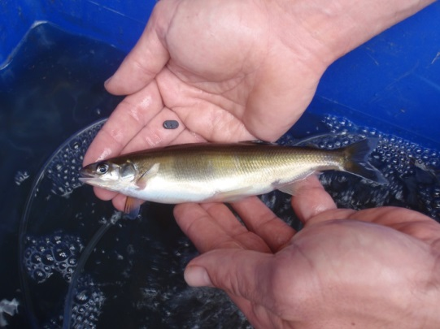
- Peak egg abundance also coincided with a within-channel flow pulse in May.
- The Dights Falls Weir on the lower Yarra River has significantly affected Australian Grayling movements and spawning potential. In 2012, a vertical-slot fishway was installed to assist upstream movement of juvenile Australian Grayling, which is likely to improve future spawning success in the Yarra River.
Thomson River
- Eggs were captured during within-channel flow pulses in 2013.
- The peak egg densities coincided with within-channel flow pulses during late April and mid-May.
Tarwin River
- After Australian Grayling had migrated to the lower river reaches, eggs were detected in newly identified spawning areas.
Water temperature
- Significant numbers of eggs have been recorded at water temperatures as high as 16-18ºC. Previously, 10-12ºC was assumed to be needed to trigger spawning.

What does this mean for management?
- This research has confirmed that an increase in flow triggers downstream migration and spawning of Australian Grayling.
Figure: Adjusted total density of Australian Grayling eggs and larvae per 1000m³ of water collected in drift nets in the (a) Bunyip River during 2015. Dark blue lines (daily discharge in Tarago River at Drouin West, shaded blue area (environmental flow fresh), light blue line (daily discharge in Bunyip River at Iona), red dashed line (daily water temperature in Tarago River at Drouin West).
- The greatest egg concentrations occur during moderate flow events, contained within the river banks.
- Extended duration flow events (e.g. >5 days), with smaller peaks enable long distance migration by adults to downstream spawning areas.
- Maximum spawning occurs when flows increase from a prevailing period of steady or low flows.
- Even modest (e.g. 50 ML/d) amounts of water, added to a low river for >5 days, can result in migration and spawning. This finding opens up greater management opportunities and immediate applications for improving Australian Grayling populations.
- A broader seasonal range of flows can now be implemented to cue an ecological spawning response.

Related work: See Fact sheet 2 for the results of studies on migration of Australian Grayling.

Contact: Wayne.Koster@delwp.vic.gov.au (Monitoring in Bunyip and Tarago rivers), Frank.Amtstaetter@delwp.vic.gov.au (Monitoring in Thomson and Tarwin rivers)
Funding: Surveys were funded by Melbourne Water, West Gippsland Catchment Management Authority and DELWP (Victorian Environmental Flows Monitoring and Assessment Program, in partnership with the University of Melbourne).

