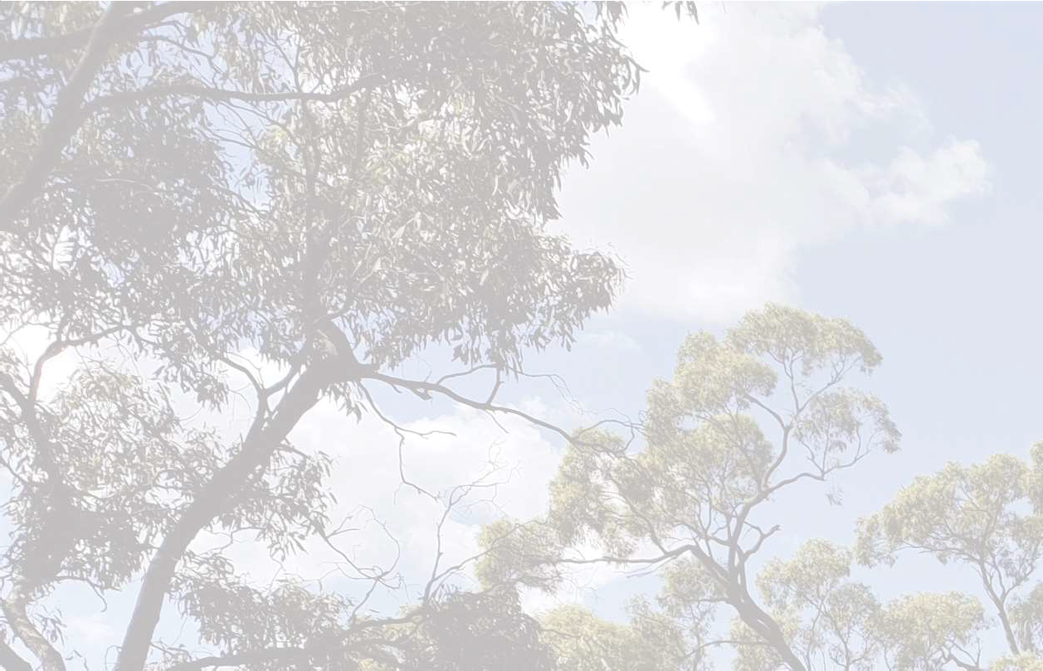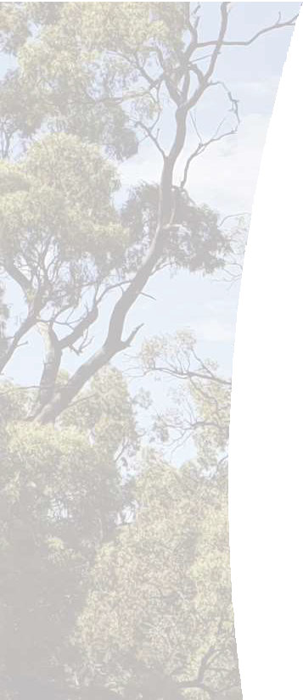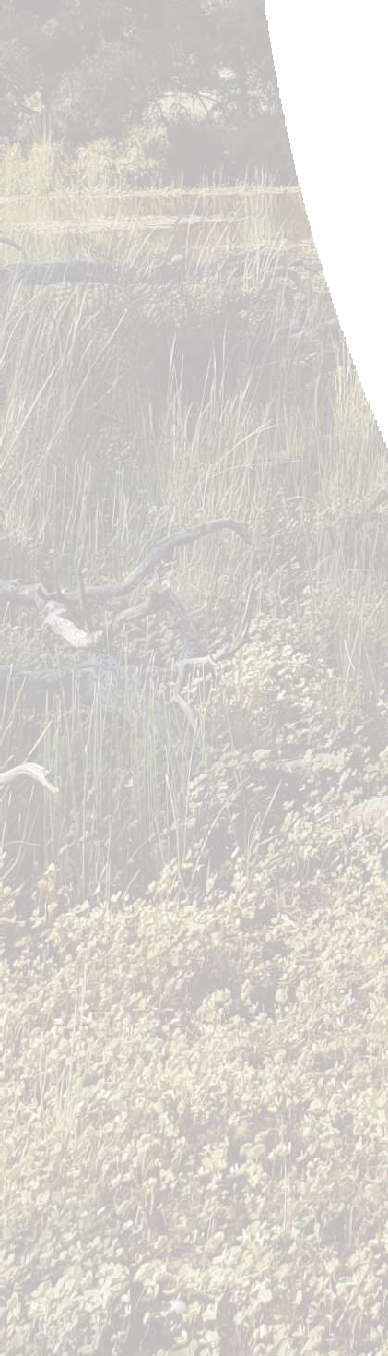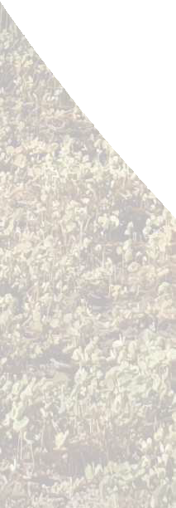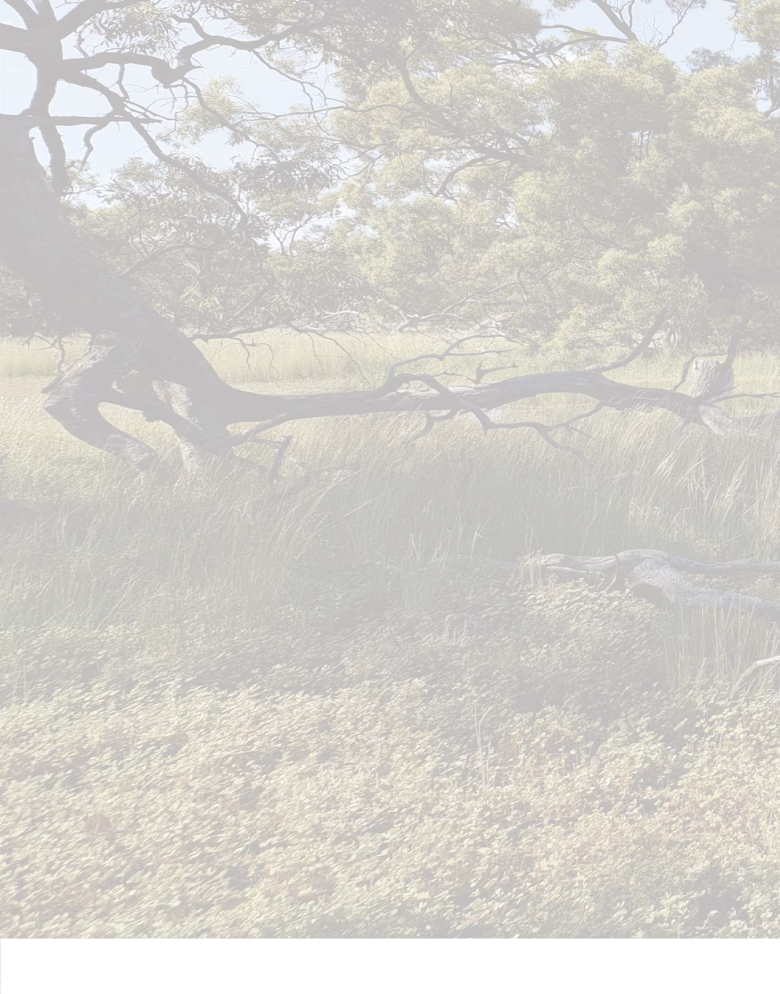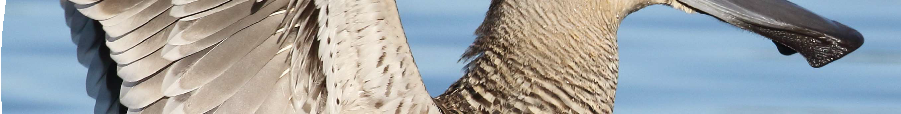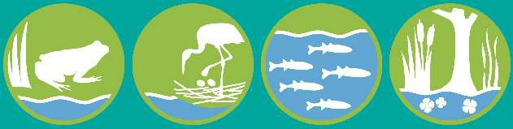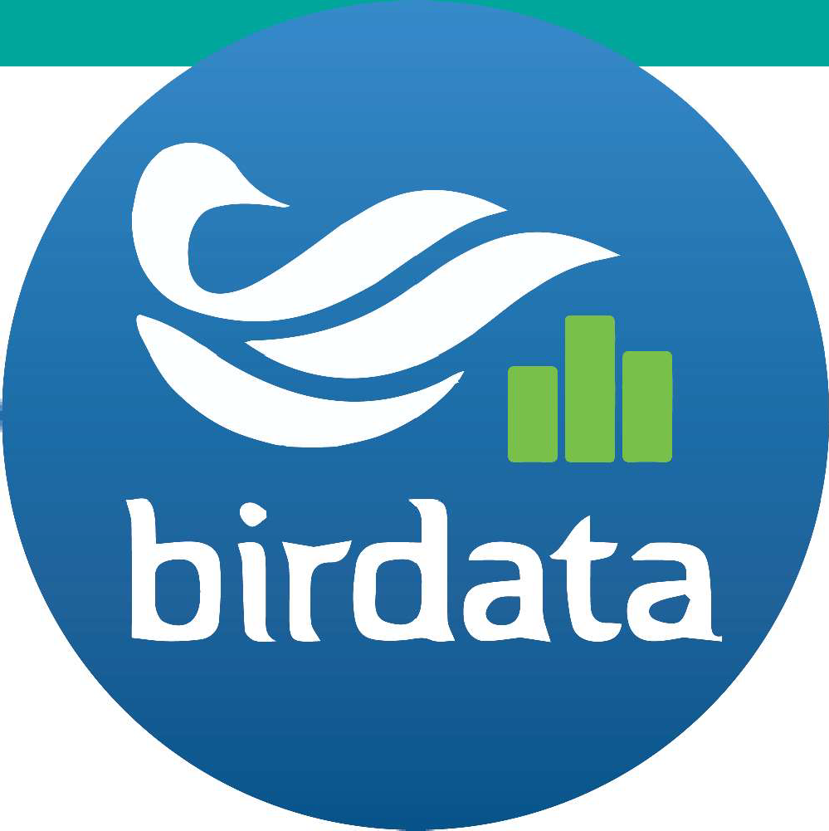WetMAP

Waterbird Citizen Science Project

Birding is better when we work together!

Join our flock as a waterbird citizen scientist

Visit wetlands across the Goulburn Broken Catchment and use the Birdata app
to count birds. You’ll be contributing to valuable scientific research.
Photo: Andrew Silcocks

Download Birdata & help us find out how birds respond to watering of wetlands

The Wetland Monitoring Assessment Program (WetMAP) is tracking the health of our wetlands to better understand how plants and animals respond to the delivery of water for the environment.

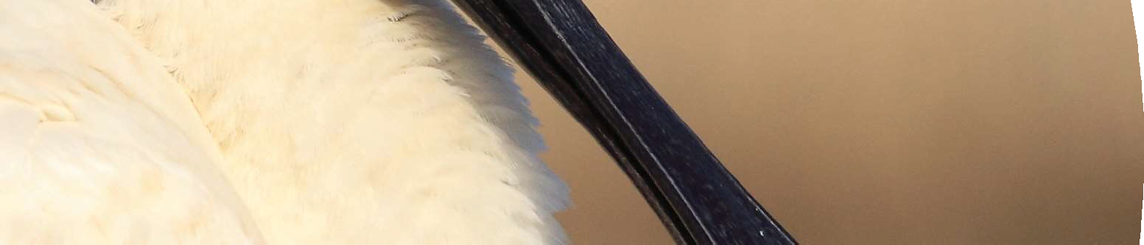For more information, visit:
www.birdlife.org.au
or email bradley.clarke-wood@birdlife.or u
g.a

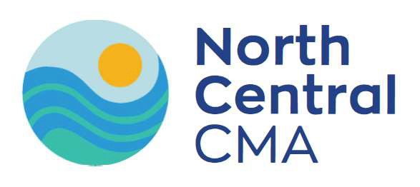

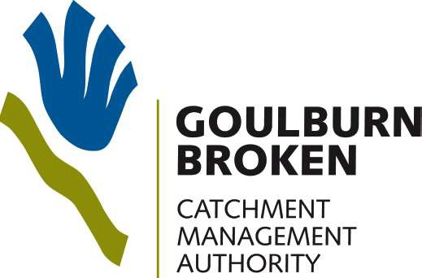
Photo: Andrew Silcocks
facebook.com/ BirdLifeAustralia

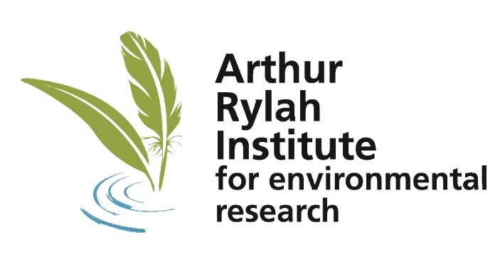
@BirdlifeOZ
