ARI Aquatic Quarterly Update – Influence Autumn 2021
Influencing the management of environmental water through targeted monitoring and research

About Us
The Applied Aquatic Ecology section aims to generate and share knowledge, through world-class, applied, ecological research, which supports and guides sustainable ecosystem policy and management to ensure healthy, resilient ecosystems. We work collaboratively with national, state and local agencies, research institutes, universities, interest groups and the community.
Our focus:
- To undertake high quality, relevant ecological research.
- To interpret research outcomes and communicate these effectively to key stakeholders.
- To guide and support sustainable ecosystem policy and management.

This update provides three examples of projects which help managers.

They provide:
- an example of how long-term monitoring has contributed to improve management of the lower Mitta Mitta River to benefit Murray Cod. The work clarified the conditions required by this species to successfully spawn and recruit in the river.
- insights into how underlying trends in fish population can confound the short-term effects of river discharge. This work also highlights the importance of large data sets and long-term monitoring when assessing the effects of management interventions, both in the short and long-term.
- evidence of how juvenile diadromous fish species respond to higher levels of river discharge. This work also provides specific guidance for water managers regarding the targeted use of environmental flows to promote immigration of these juvenile fish.

www.ari.vic.gov.au Subscribe to any of ARI’s communications at www.tiny.cc/ARIsubscribe
The right conditions allow Murray Cod to thrive in the lower Mitta Mitta River
Issue: Native fish populations in the lower reaches of the Mitta Mitta River declined after the construction and operation of Dartmouth Dam in the late 1970s. Murray Cod are a species that showed dramatic decreases in abundance, with the release of unseasonal cold water during their breeding period thought to be a major factor in this decline. Surprisingly, their numbers have increased considerably in recent years. Understanding why these increases occurred will help the MDBA develop river operations approaches to enhance the population further, in association with complementary river restoration efforts.

Action: The migration patterns and population demography of the Murray Cod population in the lower Mitta Mitta River have been studied since 2013. This work has enhanced our understanding of the role of river flow on movement behaviour, recruitment strength and subsequent population dynamics.
Cold water pollution has been detrimental to Murray Cod, particularly for young fish. The survival of juvenile Murray Cod is enhanced during years of warmer summer water temperatures that result when only small volumes of water were transferred from Lake Dartmouth. Between 2013 and 2019, the natural spring water temperatures required for successful spawning have never been recorded, and no natural recruitment has been detected. Management advice has included recommending, when feasible, minimal summer flows to enhance the survival of stocked fish, as well as assist potential natural recruitment.
The 2020/21 season provided an excellent example of proactive management by multiple agencies. The early notice of minimal cold-water releases from Lake Dartmouth in spring and early summer suggested that fish may experience more suitable environmental conditions and provided an opportunity to test the recommendations of the previous work. A survey in autumn 2021 monitored the population and included an assessment of the natal origin of juvenile fish.
Results: The flow and temperature regime for the 2020/21 season was much more reflective of natural conditions suited to both spawning and recruitment of Murray Cod. There was a clear increase in the number of young-of-year (YOY) Murray Cod in the lower Mitta Mitta River. The YOY fish included both stocked fish and natural recruits. To our knowledge, this represents the first confirmed natural recruitment of Murray Cod in the lower Mitta Mitta River since construction of the dam.
Outcome: This long-term monitoring has significantly contributed to improving river operations to benefit Murray Cod. It has clarified the conditions required for the species to successfully spawn and recruit in the lower Mitta Mitta River.
Funder: MDBA ARI contact: Zeb Tonkin
Figure 1. Length Frequency (%) of all Murray Cod captured during electrofishing surveys in the lower Mitta Mitta River from 2011–2021. The presence of young-of-year fish (<100 mm length) are highlighted.

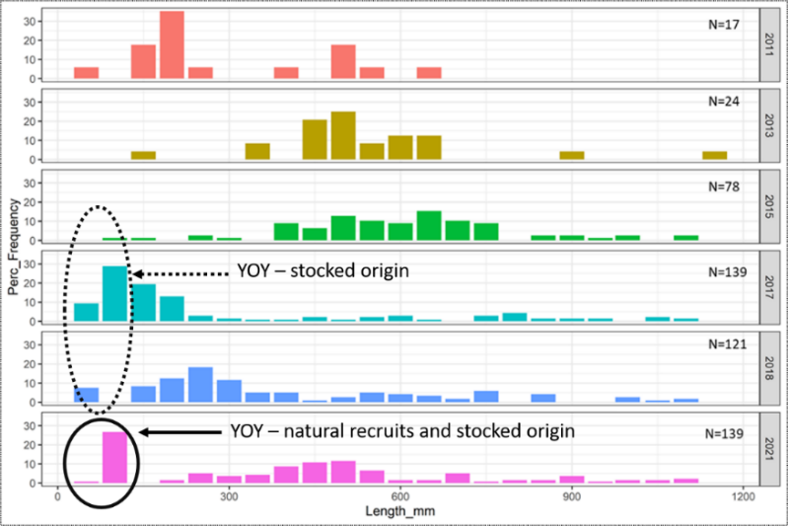
Underlying factors can influence how fish populations respond to river discharge

Issue: Changes to river flows and water extraction have caused declines in riverine systems worldwide. Targeted water releases (environmental flows) are often used as one tool to maintain biodiversity values. Monitoring short-term responses to environmental flow releases can often identify positive outcomes such as fish spawning and recruitment. It is however hard to directly credit broader fish population trends to environmental flows, due to the disconnect between individual flow events and population outcomes, which operate over much longer time scales.
Action: The effects on fish populations of annual variation in river discharge and water temperature were investigated, after considering underlying population trends. Data was analysed for five native and one non-native fish species (Figure 2), collected over 7–20 years in 15 reaches of seven rivers in the Murray-Darling Basin, south-eastern Australia.

Results: Population trends explained 3.4%–24.6% of the total variation in abundance and biomass of the six species, while discharge and water temperature explained a further 1.2%–11.4% of this variation. Population trends masked the effects of discharge and water temperature, which suggests that the effects of annual river discharge may depend on past conditions and key population factors (e.g. age structure). Failing to account for population trends led to a combination of plausible and implausible links with river discharge and water temperature. Plausible associations included positive associations with the magnitude of spring discharge and negative associations with the number of days where discharge was below the long-term 10th percentile. Determining whether estimated associations are accurate requires a greater focus on the processes that underpin population trends over multiple years.
Outcome: These results highlight the potential for underlying trends in fish populations to confound the short-term effects of river discharge. Therefore, it is important that assessments of responses of fish populations to river discharge, over both the short and long term, are considered in the context of broader environmental conditions. Broadly, these results reinforce the importance of large data sets and long-term monitoring, even when assessing the short-term effects of management interventions.
Funder: Murray-Darling Basin Authority, Commonwealth Environmental Water Office (Long-Term Intervention Monitoring Project) and DELWP (VEFMAP - Victorian Environmental Flow Monitoring and Assessment)
ARI contact: Jian Yen
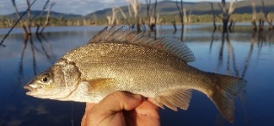
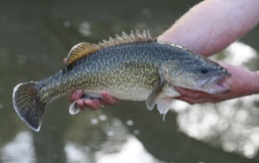
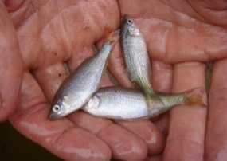
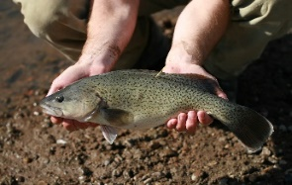
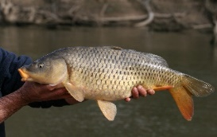
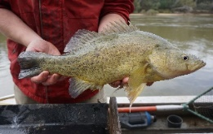
Yen et al. (2021) Underlying trends confound estimates of fish population responses to river discharge. Freshwater Biology
Figure 2. Data was analysed for the following five native species (Murray Cod, Trout Cod, Golden Perch, Silver Perch, Murray-Darling Rainbowfish) and one non-native species (Common Carp).

Elevated river discharge helps juvenile fish move into rivers
Issue: Changes to river flow regimes threaten freshwater biodiversity globally. Diadromous fish, which migrate between salt and fresh water during their life cycle, are potentially disproportionally affected by these changes. These species rely on flow cues to trigger key life history processes such as migration. An improved understanding of the relationship between river discharge and the immigration of juvenile diadromous fishes into rivers is needed, to understand threats associated with lower discharge rates and potential mitigation actions.

Action: The influence of river discharge on the abundance of juvenile fish of four diadromous species moving into rivers was investigated (Common Galaxias, Spotted Galaxias, Climbing Galaxias and the nationally threatened Australian Grayling). Fyke netting or fishway trapping was carried out to catch juvenile fish moving from estuaries into freshwater in five coastal waterways in south-eastern Australia during the spring migratory period. This included the Barwon, Bunyip, Werribee and Tarwin rivers and Cardinia Creek.

Results: There was a positive relationship between the probability of high catch rates of juvenile fish and mean river discharge in September. A positive relationship was also detected between river discharge and the number of fish recruits captured 22–30 days later in a flow stressed system.
The day-of-year also strongly influenced catch rates, with the peak abundance of juveniles for three species most likely to occur midway through the sampling period (Spotted Galaxias in October, Climbing Galaxias in late October and Australian Grayling in late October and early November).

Outcome: This study demonstrated that higher magnitudes of river discharge were associated with increased catches of juvenile diadromous fishes.
The findings provide valuable guidance for water managers regarding how to use environmental flows in a targeted way. In waterways or years when river discharge is low or stable, environmental flows can seek to maintain small amounts of immigration into freshwater populations. When there are natural, large river discharge volumes and relatively large numbers of juvenile fish are expected to enter coastal waterways, environmental flows may not be required to promote immigration. This provides opportunities for water savings.

Funder: DELWP Water and Catchments. VEFMAP
ARI contact: Frank Amtstaetter (currently seconded to DELWP Water and Catchments)
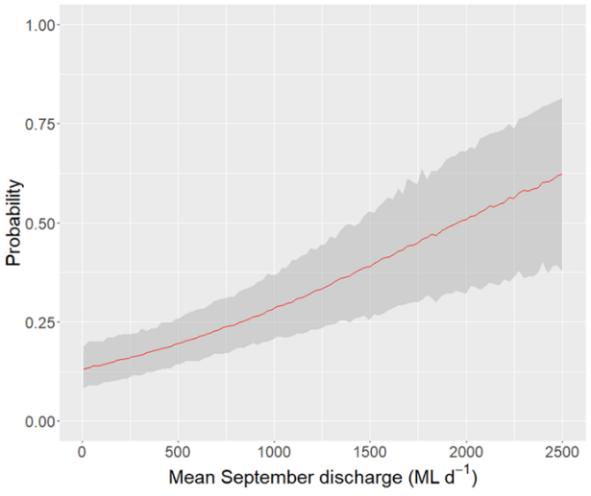
Amtstaetter et al. (2021) Elevated river discharge enhances the immigration of juvenile catadromous and amphidromous fish in temperate coastal rivers. Journal of Fish Biology

Figure 3. Probability of high catches of juvenile catadromous and amphidromous fish representing four species in the lower freshwater reaches of five costal waterways during the spring and early summer migration period, against mean September discharge. The shaded areas indicate 95% confidence limits.

