Ovens cod love river rehabilitation

River rehabilitation activities benefit native fish

What is a Demonstration Reach?

It is estimated that 90% of native fish populations within the Murray-Darling Basin (MDB) have declined since European settlement. This decline is largely attributed to in-stream habitat removal, degraded riparian vegetation, un-regulated stock access to rivers, river bank deterioration, barriers to fish passage and introduced fish species. To mitigate impacts from these threats and improve native fish resilience, the Murray-Darling Basin Authority’s Native Fish Strategy (NFS) developed the Demonstration Reach concept. Demonstration reaches are stretches of river where we demonstrate the cumulative benefits of multiple river rehabilitation actions to enhance native fish populations.
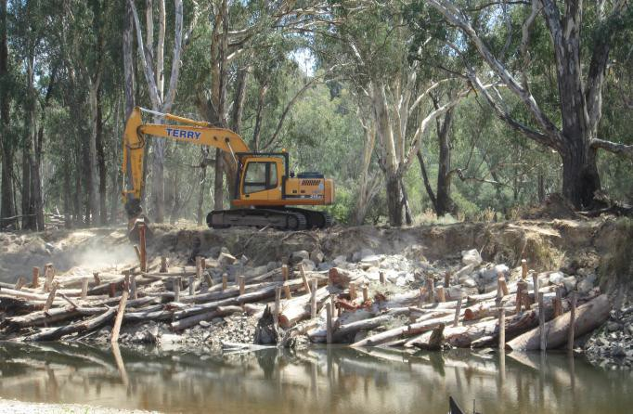
Using wood to protect banks on the Ovens River Photo: S. Raymond

The Ovens River and rehabilitation for fish

In the Ovens River, multiple river rehabilitation actions have been applied to address threats to river health and improve native fish populations in the river. Local, state and federal government agencies along with community groups have invested in a works and community education program to increase native fish numbers and build knowledge. The works program has provided additional habitat for native fish in the form of logs and ‘fish hotels’, removed river bank weeds, fenced off stock access to the river, improved river connectivity, removed barriers to fish migration, removed introduced fish species and stocked the reach with native fish.
Rehabilitation works undertaken in the Ovens River (2008-2014) include:

- 305 habitat snags inserted
- 25 fish hotels placed in river
- 18 km of willows removed
- 6 km of fencing installed
- New fishway constructed (Wangaratta)
- 250 kg of Carp removed
- 10,000 Macquarie perch stocked in 2014

Ovens River fish community

The Ovens River is home to the iconic Murray Cod Maccullochella peelii and the nationally endangered Trout Cod Maccullochella macquariensis; both large-bodied native fish species historically abundant and widespread in the lower and mid Ovens River. However, their distribution and abundance dramatically declined in the last century, culminating in the local extinction of the Ovens River Trout Cod population in the 1980’s. A successful re-stocking program initiated in the 1990’s resulted in the return of a self- sustaining population of Trout Cod within the mid Ovens River by 2010. These cod fish species are most likely to benefit from the rehabilitation works undertaken in the Ovens River over the last eight years.
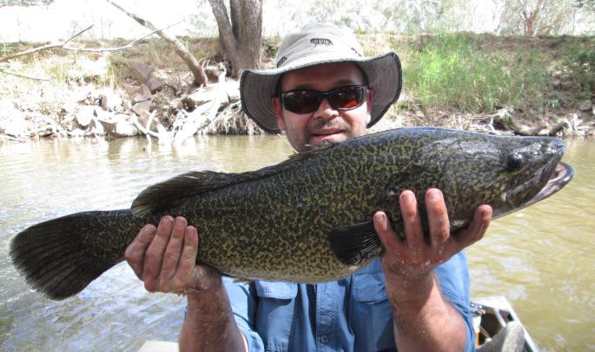
Murray cod - a priority fish species expected to benefit from river rehabilitation activities. Photo: G. Hackett

Ovens cod love river rehabilitation

Is it working?

Annual electrofishing surveys have been undertaken in the Ovens and King rivers since 2008 to monitor the response of native fish to rehabilitation efforts in the Ovens River. Results have been dramatic, with a

450% increase in the Murray cod population and
a 270% increase in Trout cod numbers

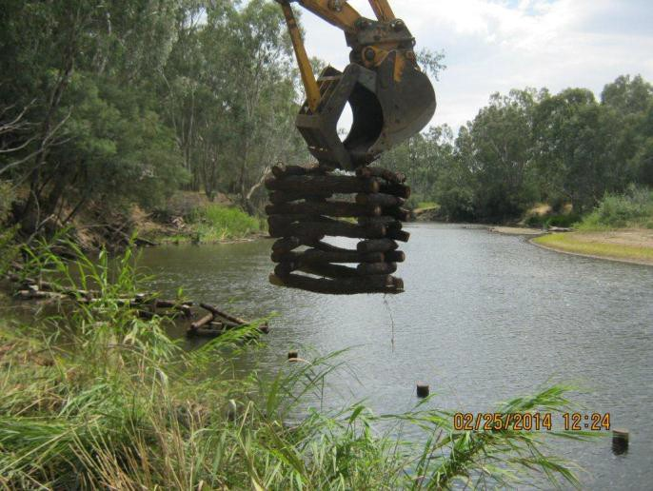since the project began. In addition to the increases in abundance, populations of both cod species have also been strengthened by increases in distribution and size classes, indicating improvements to natural recruitment. These improvements to cod populations were not as pronounced in the nearby King River, strengthening the case for the success of river rehabilitation actions.

Inserting fish hotels into the Ovens River to increase native fish habitat. Photo:
- Wilson

Program partnerships

Partnering with relevant stakeholders was essential to foster ownership of the project, effectively improve river health and demonstrate the value of collaboration. Partners included landholders, representatives from local clubs (including Landcare groups, Rotary, fishing clubs), schools and

_
Ovens River Community engagement. Photo: F. Hames

government agencies. Regular engagement events were held, including on-site meetings and field days with local school students and program partners, information stands at local fishing and camping shows, and conducting annual fish survey demonstrations. Information signs were installed and project updates were communicated during meetings, in distributed reports, through Demonstration Reach agency webpages, in local media, and at research conferences.

Project partners;
  - Murray-Darling Basin Authority (MDBA)
  - Department of Environment and Primary Industries (DEPI)
  - DEPI Arthur Rylah Institute
  - DEPI Fisheries Victoria
  - North East Catchment Management Authority (NECMA)
  - Rural City of Wangaratta
  - Wangaratta Sustainability Network and Restoring Our Waterways
  - Wangaratta Rotary Club
  - And the many landowners and interested community members who participated in field work, provided assistance with river access and advice, supported
rehabilitation activities on their properties, and continue to advocate for a healthy Ovens River.

For more information on this project contact:

Dr. Scott Raymond: scott.raymond@depi.vic.gov.au

Anthony Wilson: anthony.wilson@necma.vic.gov.au

Published by the Victorian Government Department of Environment and Primary Industries Melbourne, June 2014
© The State of Victoria Department of Environment and Primary Industries Melbourne 2014
This publication is copyright. No part may be reproduced by any process except in accordance with the provisions of the Copyright Act 1968.
Print managed by Finsbury Green (June 2014)
ISBN 978-1-74326-993-0 (Print) ISBN 978-1-74326-994-7 (pdf)
Accessibility
If you would like to receive this publication in an alternative format, please telephone DEPI Customer Service Centre 136 186, email customer.service@dse.vic.gov.au (or relevant address), via the National Relay Service on 133 677 www.relayservice.com.au This document is also available in on the internet at www.depi.vic.gov.au
Disclaimer
This publication may be of assistance to you but the State of Victoria and its employees do not guarantee that the publication is without flaw of any kind or is wholly appropriate for your particular purposes and therefore disclaims all liability for any error, loss or other consequence which may arise from you relying on any information in this publication.

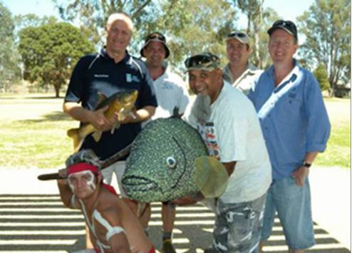

www.depi.vic.gov.au

