|  |
| --- |
| Victorian Environmental Flows Monitoring and Assessment Program (VEFMAP) Stage 6 |
| Vegetation Project Update – 2018  Monitoring of Aquatic and River Bank Vegetation: **Loddon River** |

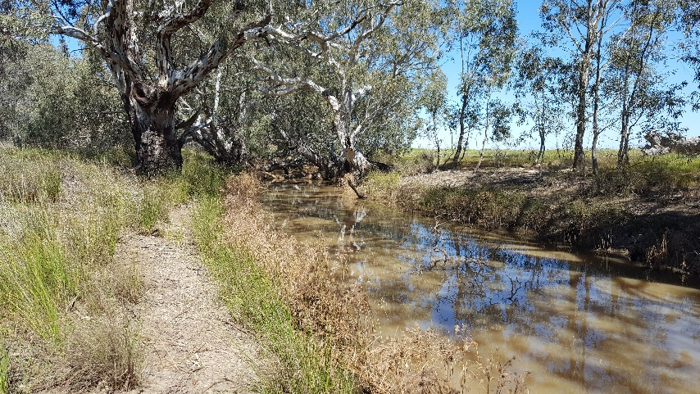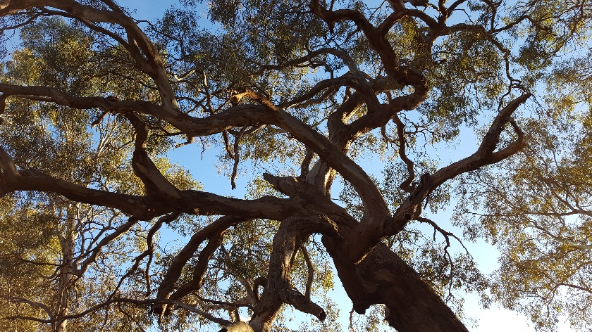

* 1. **VEFMAP Stage 6**

The Victorian Environmental Flows Monitoring and Assessment Program (VEFMAP) is now in its sixth stage of delivery. VEFMAP Stage 6 will run from 2016 to 2020, funded through the Victorian government’s $222 million investment in waterway and catchment health. VEFMAP Stage 6 focusses on ‘intervention’ or ‘event-based’ monitoring of fish and vegetation responses to flows and incorporates data from previous VEFMAP stages.

## Stage 6 – Vegetation Objectives

Stage 6 vegetation objectives aim to measure vegetation responses to environmental flows. The monitoring approach has been substantially modified from previous stages of the program and is initially focussing on individual flow events in individual waterways to detect short-term responses of native and exotic plant species to environmental water delivery. A longer-term understanding will be gained through repeated short-term assessments and by using data from previous stages of VEFMAP to create longer-term datasets. Importantly, these responses will be considered in relation to other factors that may influence flow responses, such as grazing, rainfall, soil properties and season (see program overview for details, DELWP 2017a).

## 2017/18 Monitoring on the Loddon River

The Loddon River was one of three river systems to be added to the vegetation monitoring program in 2017/18 (other rivers monitoring incuded the Campaspe, Moorabool and tributaries of the Wimmera). Surveys on the Loddon River were conducted at six sites across three waterways (Figure 1). Two sites were located on the Tullaroop Ck, two on the 12 Mile Creek, and two on the Loddon River (west arm of Canary Island).

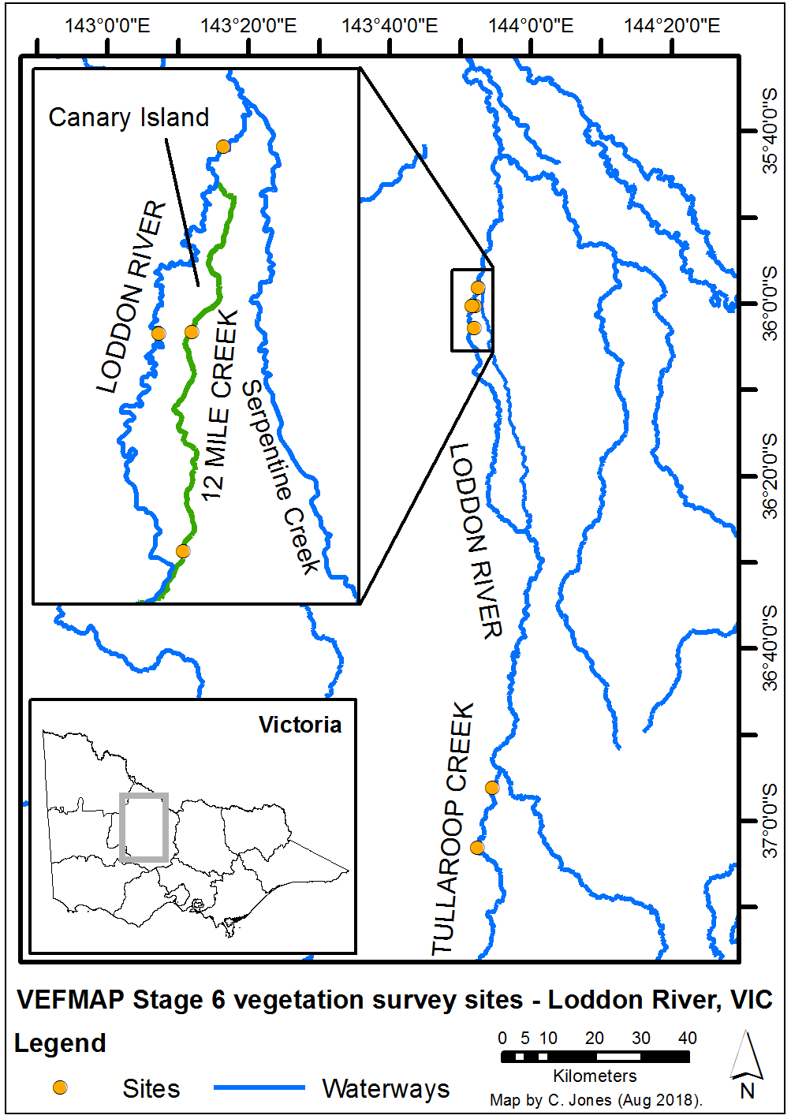

**Figure 1 – Map of survey sites on the Loddon River system.**

## Survey timing and hydrology

Timing for the VEFMAP surveys considers rainfall and managed flow deliveries. The sampling design recommends surveys occur before a planned flow delivery and two to 12 weeks after the event, depending on the flow regime (to provide adequate time for vegetation to respond and for germinants to emerge). Timing is altered if rainfall increases the flow prior to a planned survey.

Rainfall in the upper Loddon River and the Tullaroop Creek was more consistent than further north, but there were few large peaks of daily rainfall. Total rainfall in Maryborough for the 2017/18 period was 435 ml (Figure 2) compared to 312 ml at Kerang (Figure 3; data from the Bureau of Meteorology).

Rainfall on the lower Loddon River, measured in Kerang, did not result in large changes to the river flow outside of the managed flow events (Figure 4), apart from increased flow levels in November following a larger managed flow release.

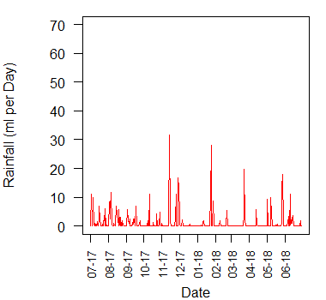

**Figure 2 – Daily rainfall recorded at Maryborough in 2017/18.**

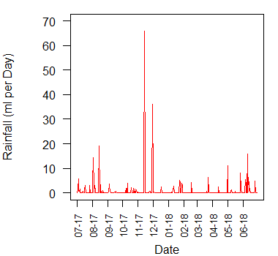

**Figure 3 – Daily rainfall recorded at Kerang in 2017/18.**

This resulted in the first survey occurring in September prior to a spring fresh in October, a second survey in January following the elevated flows, and a third survey after the commencement of a series of small flow pulses (Figure 4).

The first spring flow peak last three days, while the second flow peak lasted six days. The long summer high flow was a consumptive delivery, not an environmental delivery, and lasted a considerable time through the hottest part of the year.

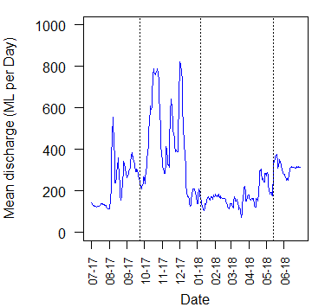

**Figure 4 – River flow discharge recorded at Kerang in 2017/18 and VEFMAP vegetation survey timing for the three surveys (dotted lines).**

## Methods

Survey methods are outlined in detail in VEFMAP Stage 6 Part B: Monitoring design and sampling methods (DELWP 2017b). The surveys include a wide range of methods: fine-scale vegetation measurements, broad-scale mapping, tree canopy assessments and hydrology assessments.

## Survey observations

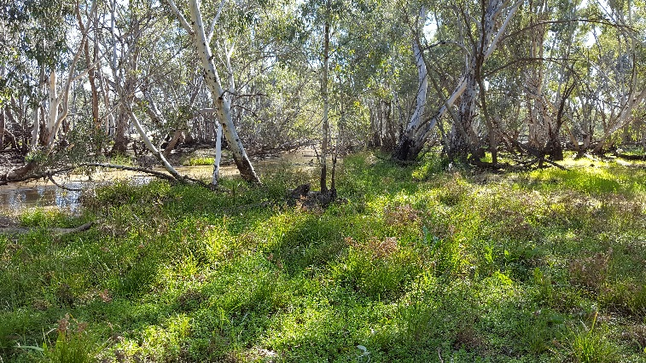The Loddon River is a long and variable watercourse and the North Central Catchment Management Authority (NCCMA) has a range of objectives for the different reaches. The VEFMAP Stage 6 monitoring sites were selected to enable two key comparisons between different features of the Loddon: (i) comparison between the upstream headwaters (Tullaroop Creek) and lower reaches, and (ii) comparison between two lower reach sections with different channel form and flows (Loddon River and 12 Mile Creek that form Canary Island).

*Tullaroop Creek*

Typically, reaches further upstream in a system have lower flow velocities, better water quality and a greater abundance of instream vegetation. While the water in the Tullaroop Creek is much less turbid than the on the lower Loddon River, the instream vegetation was sparse at the surveyed sites. However, instream emergent plant growth (Cumbungi and Phragmites) in summer, after senescence in winter, was particularly abundant in the Tullaroop Creek.

*Canary Island*

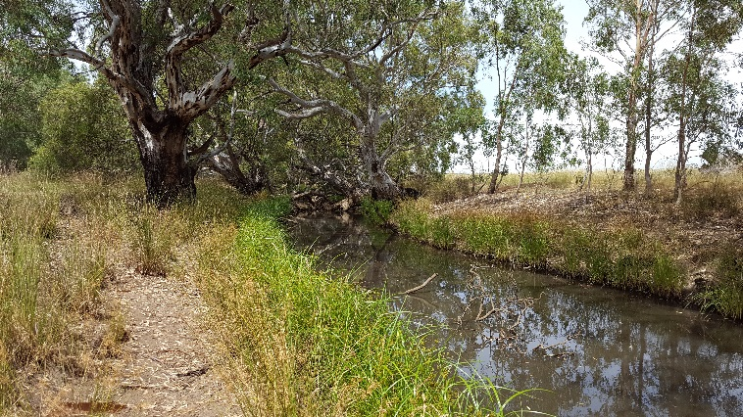Spring and summer growth of fringing vegetation on the Loddon River at Canary Island occurs as a distinct line of sedges growing at the consistent water level, which senesce each year (Figure 5). Stability of flows within this channel may reduce the value of individual environmental flow events, compared to systems with more variable flows, due to the rapid drying of soils after a flow. The banks above the water line are very dry in the downstream reaches of the Loddon River, making it difficult for plants to establish.

**Figure 5 – Stratified vegetation on the bank of the Loddon River.**

Given that the 12 Mile Creek is a much younger channel than the Loddon River, there are a number of structural differences between the two channels around Canary Island. The 12 Mile Creek has a flatter (lower) bank, so there are many areas where flows can spill out over the bank, supporting fringing inundation-tolerant species further from the main channel (e.g. Figure 6).

Patches of Water Ribbons(*Cycnogeton procerum*) were doing well in the 12 Mile Creek despite the turbid water and grazing pressure (Figure 7a). The shallow profile of the stream is a likely driver of this, because water levels are usually too deep for germination in stable/regulated systems, where the level doesn’t drop to allow germination in autumn. Unfortunately, most of the Water Ribbons were trampled by cattle by May as the cattle moved into the stream in late summer (Figure 7b).

*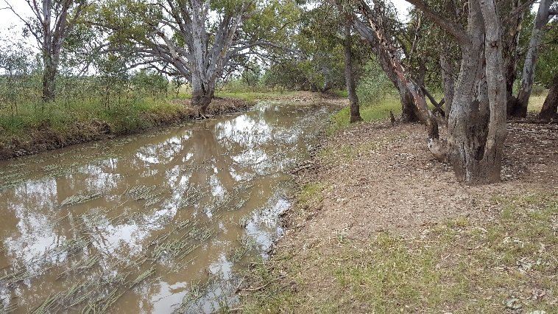***Figure 6 – Growth of fringing (inundation tolerant) understorey vegetation growing well away from the channel of the 12 Mile Creek due to the lower bank level.**

**Figure 7 – Extensive growth of Water Ribbons in the channel of the 12 Mile Creek in January 2018, but much of this was trampled by cattle in the subsequent months.**

## Grazing

One site on the Tullaroop Creek and one site on the 12 Mile Creek were both heavily grazed throughout the year. The Tullaroop Creek site has light cattle grazing on one side, with substantial pugging damaging the instream habitat. The other side is grazed heavily by sheep, which have removed the majority of vegetation on the stream bank (Figure 8).

Cattle Grazing on the 12 Mile Creek has greatly reduced the vegetation cover on the bank and instream. The vegetation remaining is dominated by species that are tolerant to heavy grazing disturbance.

Typically, sheep cause less damage to both the bank (e.g. pugging) and instream vegetation because of their smaller size compared to cows, and their tendency to not enter water as commonly as cows. However, sheep can cause significant damage where they are in high abundance or when they graze for long periods.

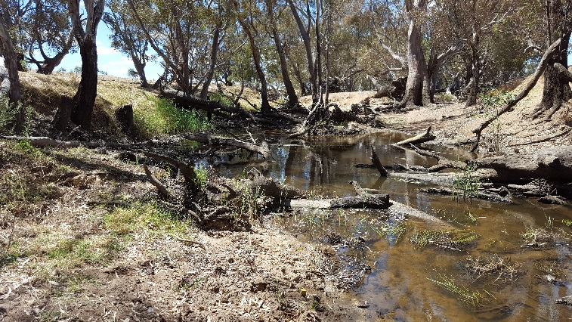In order to realise any benefits of environmental water for native vegetation, it will be important to continue to manage the level of grazing at all sites with livestock access.

**Figure 8 – Cattle grazing and pugging on the left bank of the Tullaroop Creek, and sheep grazing on the right bank.**

## Summary

Using multiple methods and surveying at regular intervals to directly address the VEFMAP Stage 6 monitoring objectives, the program has so far been successful in evaluating vegetation responses to flows. The observations summarised here form part of a larger story relating to vegetation responses to environmental water, which will continue to unfold in the coming years. Further information on the other systems surveyed and research projects is also available.

Environmental flows are being delivered on the Loddon River to deliver benefits to vegetation and a wide range of fauna. Waterway managers are working closely with researchers, waterway authorities and a range of other stakeholders to manage flow deliveries as effectively as possible for the environment and other water users. Flows delivered at the right time, magnitude and duration can be beneficial to vegetation on the river banks, in the channel, and beyond the channel. Flows delivered at non-ideal times or sizes may have detrimental effects on vegetation, but the native riparian vegetation is mostly very tolerant of variable flow conditions.

## Collaboration

VEFMAP Stage 6 includes many collaborations between DELWP staff, waterway managers and authorities, academics (internal and external) and students.

## References

DELWP (2017a) VEFMAP Stage 6 Part A: Program context and rationale. A report by Arthur Rylah Institute for Environmental Research and Integrated Water and Catchments Division, Department of Environment, Land, Water and Planning.

DELWP (2017b) VEFMAP Stage 6 Part B: Program design and monitoring methods. A report by Arthur Rylah Institute for Environmental Research and Integrated Water and Catchments Division, Department of Environment, Land, Water and Planning, Victoria.Department of Environment, Land, Water and Planning.

## Contact [Chris.Jones@delwp.vic.gov.au](mailto:Chris.Jones@delwp.vic.gov.au)

Philip.Slessar@nccma.vic.gov.au

|  |  |
| --- | --- |
| © The State of Victoria Department of Environment, Land, Water and Planning 2018  LogoThis work is licensed under a Creative Commons Attribution 4.0 International licence. You are free to re-use the work under that licence, on the condition that you credit the State of Victoria as author. The licence does not apply to any images, photographs or branding, including the Victorian Coat of Arms, the Victorian Government logo and the Department of Environment, Land, Water and Planning (DELWP) logo. To view a copy of this licence, visit http://creativecommons.org/licenses/by/4.0/  ISBN 978-1-76077-352-6 (print) 978-1-76077-353-3 (pdf/online/MS word)  Disclaimer  This publication may be of assistance to you but the State of Victoria and its employees do not guarantee that the publication is without flaw of any kind or is wholly appropriate for your particular purposes and therefore disclaims all liability for any error, loss or other consequence which may arise from you relying on any information in this publication. | Accessibility  If you would like to receive this publication in an alternative format, please telephone the DELWP Customer Service Centre on 136186, email [customer.service@delwp.vic.gov.au](mailto:customer.service@delwp.vic.gov.au), or via the National Relay Service on 133 677 [www.relayservice.com.au](http://www.relayservice.com.au). This document is also available on the internet at https://www.ari.vic.gov.au/research/rivers-and-estuaries/assessing-benefits-of-environmental-watering |