- To undertake high quality, relevant ecological research.
How these project outputs help managers? They provide:
- evidence for the need for multi-year flow plans for freshwater fish populations, such as Silver Perch.
- insights into Mulloway movement and the significant angling pressure on the species in the Glenelg River estuary.
- great confidence to river managers that installing woody habitat really does help native fish populations thrive.

- To interpret research outcomes and communicate these effectively to key stakeholders.
- To guide and support sustainable ecosystem policy and management.

Understanding Silver Perch recruitment
Issue: Lack of quantitative studies linking hydrology and hydraulics to key aspects of the lifecycle of the critically endangered Silver Perch.
Action: Collection of a multidecadal age-structured dataset from a locally abundant Silver Perch population (mid Murray River) and compilation of a complementary database of environmental variables.
Result: The strongest year classes were associated with a combination of low to average river discharge and high water temperatures over the peak spawning period, followed in the next year by extended high flows and widespread flooding that promoted survival of age-1+ juveniles.
Outcome: New understanding of the role of river hydrology and temperature in influencing recruitment strength and subsequent population dynamics of Silver Perch. Conditions influencing growth and dispersal of juvenile fish, in addition to the spawning period, are critical in governing recruitment dynamics of Silver Perch. Results highlight the need for multi-year flow plans for population recovery.
Funder: Murray-Darling Basin Authority ARI contact: Zeb Tonkin
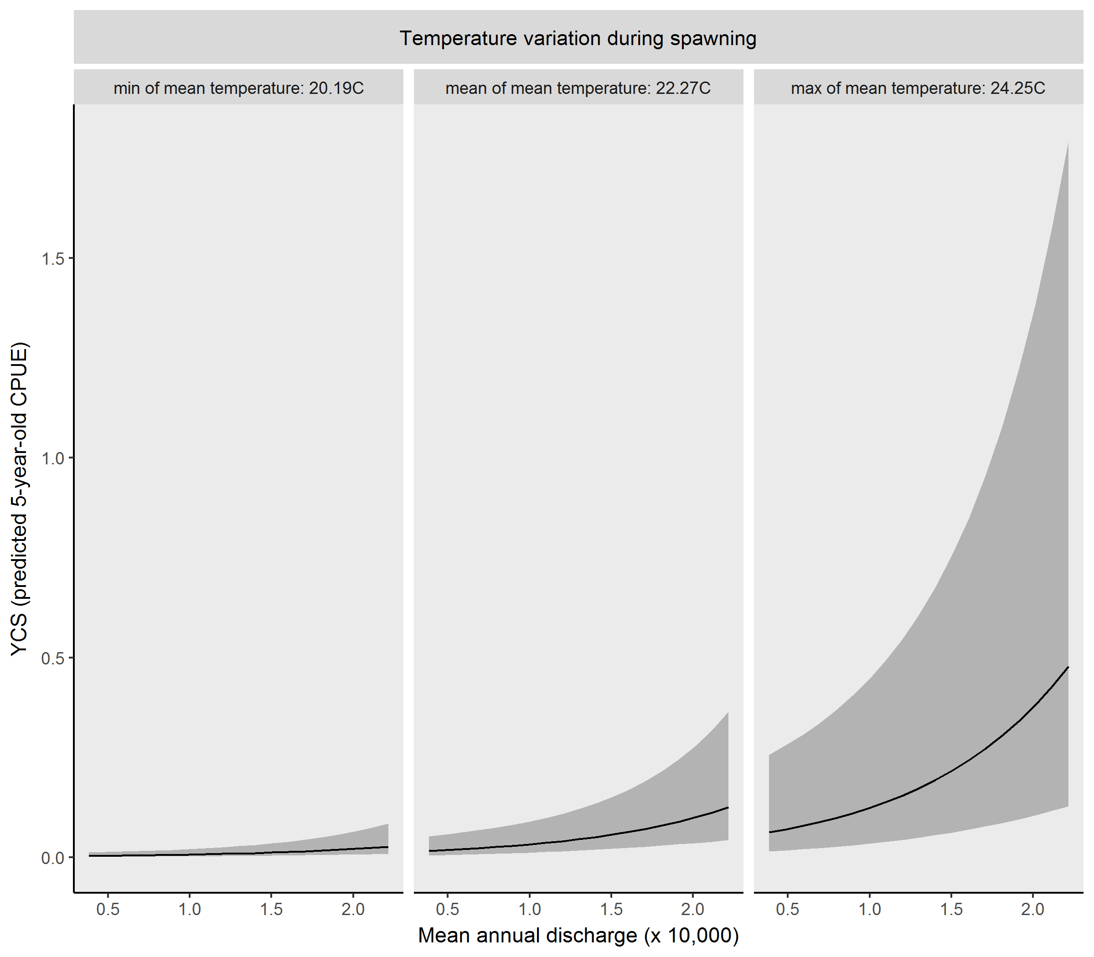
Tonkin et al. (2019)
Fig 1. Predicted year-class strength (YCS: +/- 95% confidence intervals) conditional on catch per unit effort (CPUE) for age-5 at capture, under average daily flows during Nov and Dec (spawning flows), minimum, mean and maximum daily temperature during Nov and Dec (spawning temperature) and varying daily discharge the year following the first year of life (juvenile flows; x-axis) over the ranges present during the study.

Studying Mulloway habitat and movement
Issue: Mulloway is an important fish for people, both recreationally and commercially. An improved understanding of its habitat preferences and movement between estuaries and open ocean is needed.
Action: Twenty-four juvenile to sub-adult mulloway were captured in the Glenelg River, acoustically tagged and tracked for three years.
Result: Over 90% of fish that exited the estuary, exited between November and January. Fish showed a habitat preference for the downstream end of the estuary, rarely moving more than 50 km upstream except during low flows.
Thirteen Mulloway (54%) were captured and kept by anglers, indicating a high intensity of angling pressure. Four fish that exited were subsequently detected > 450 km away, at or near the Coorong (Murray River mouth, South Australia), a known breeding area.
Outcome: This study provides generalised movement patterns for Mulloway. It highlights the difficulties for tagging studies where high angling pressure exists.
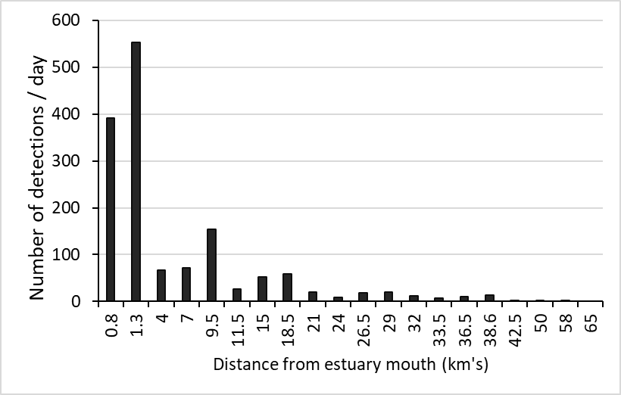
ARI contact: Jason Lieschke Lieschke (2019)

Estimated population size
(no. fish >200mm)

Fig 3. Estimated population size of Golden Perch and Murray Cod (estimated total number of fish >200mm in sampling sites). Error bars are 95% credible intervals, blue lines indicate linear trends over the course of the study, with non-random correlations highlighted in boldface type (P<0.05).

Fig 2. Average number of detections per day at each receiver. Note lower detections at mouth (0.8km). Although this receiver went missing after a few months, its records were included due to the number of tags available for detections and as it was also an important movement time.

Fish populations increase after resnagging
Figure. xx
Issue: Lack of long-term studies to assess the effectiveness of river restoration which capture large-scale mechanisms (e.g. completion of life-history processes, changes in system productivity, time lags of ecosystem responses).
Action: Monitoring of fish in sites with (intervention) and without (control) restoration of structural wood habitat (SWH). A total of 4450 pieces of SWH were reintroduced over 110km stretch of river. Between 2007 and 2013, annual electrofishing surveys recorded catch, effort, length and tagging data for Murray Cod and Golden Perch. Modelling estimated changes in fish population parameters.
Result: A three-fold increase in abundance of Murray Cod and a two-fold increase of Golden Perch within intervention reach. Fish abundance in adjacent sites remained stable, indicating that fish numbers across the whole study area increased, rather than just the same fish moving around.
Outcome: Evidence that adding structural woody habitat to rivers can increase the abundance of fish at a population scale in a large, lowland river.
Funder: MDBA The Living Murray Program ARI contact: Jarod Lyon:
Lyon et al. (2019)
Year

