|  |
| --- |
| Victorian Environmental Flows Monitoring and Assessment Program (VEFMAP) Stage 6 |
| Project Fact Sheet – 2019  Monitoring of Aquatic and River Bank Vegetation:  **Wimmera River tributaries** |

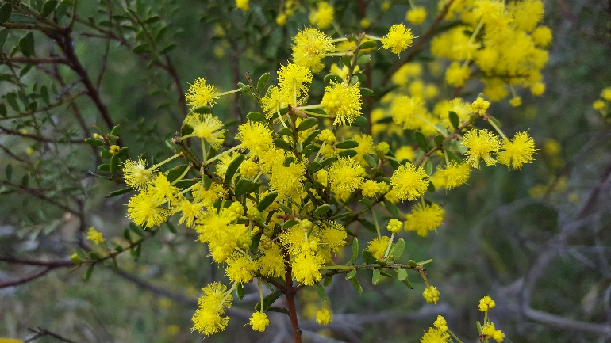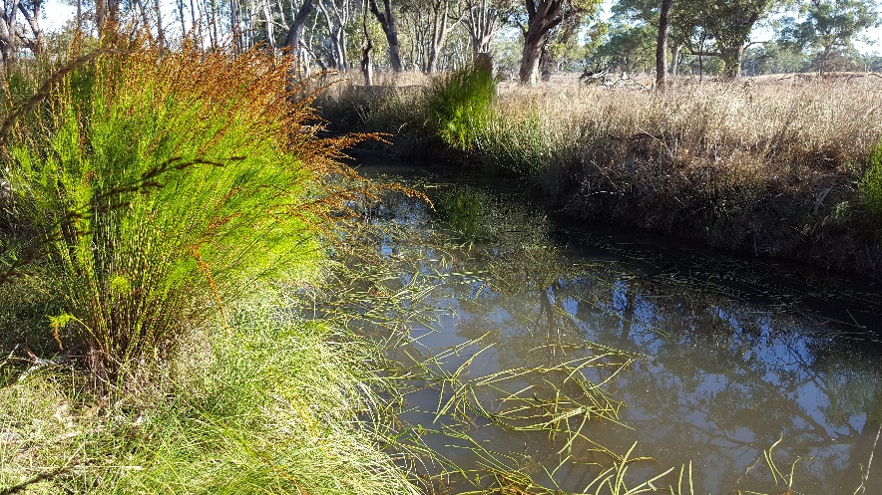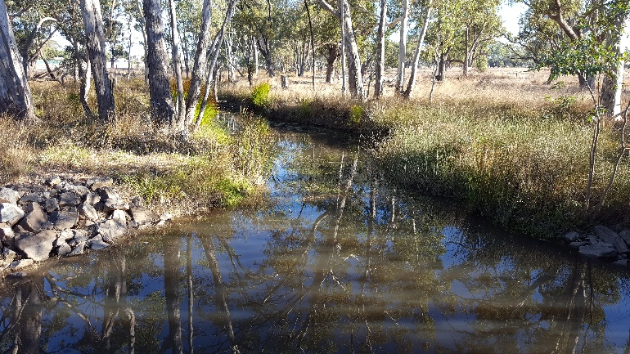

* 1. **VEFMAP Stage 6**

The Victorian Environmental Flows Monitoring and Assessment Program (VEFMAP) is now in its sixth stage of delivery. VEFMAP Stage 6 focusses on ‘intervention’ or ‘event-based’ monitoring of fish and vegetation responses to flows and incorporates data from previous VEFMAP stages. VEFMAP is funded through the Victorian government’s $222 million investment in waterway and catchment health.

* 1. **Vegetation Objectives**

The vegetation objectives aim to identify vegetation responses to environmental flows. The monitoring approach has been substantially modified from previous stages of the program and is focussed on individual flow events in waterways to detect short-term responses to environmental water delivery. A longer-term understanding will be gained from repeated short-term assessments and by using data from previous stages of VEFMAP. Importantly, these vegetation responses will be considered in relation to other factors that may influence flow responses, such as grazing, rainfall, soil properties and season (see program overview for details, DELWP 2017a).

* 1. **2018/19 Monitoring in the Wimmera**

Surveys were conducted for the second consecutive year on three Wimmera River tributaries: MacKenzie River, Burnt Creek and Mount William Creek (Figure 1). These waterways are regulated and occur below water storage reservoirs in the Grampians area at Lake Lonsdale and Wartook Reservoir. The waterways have different channel forms and flow regimes, but similar climatic conditions.

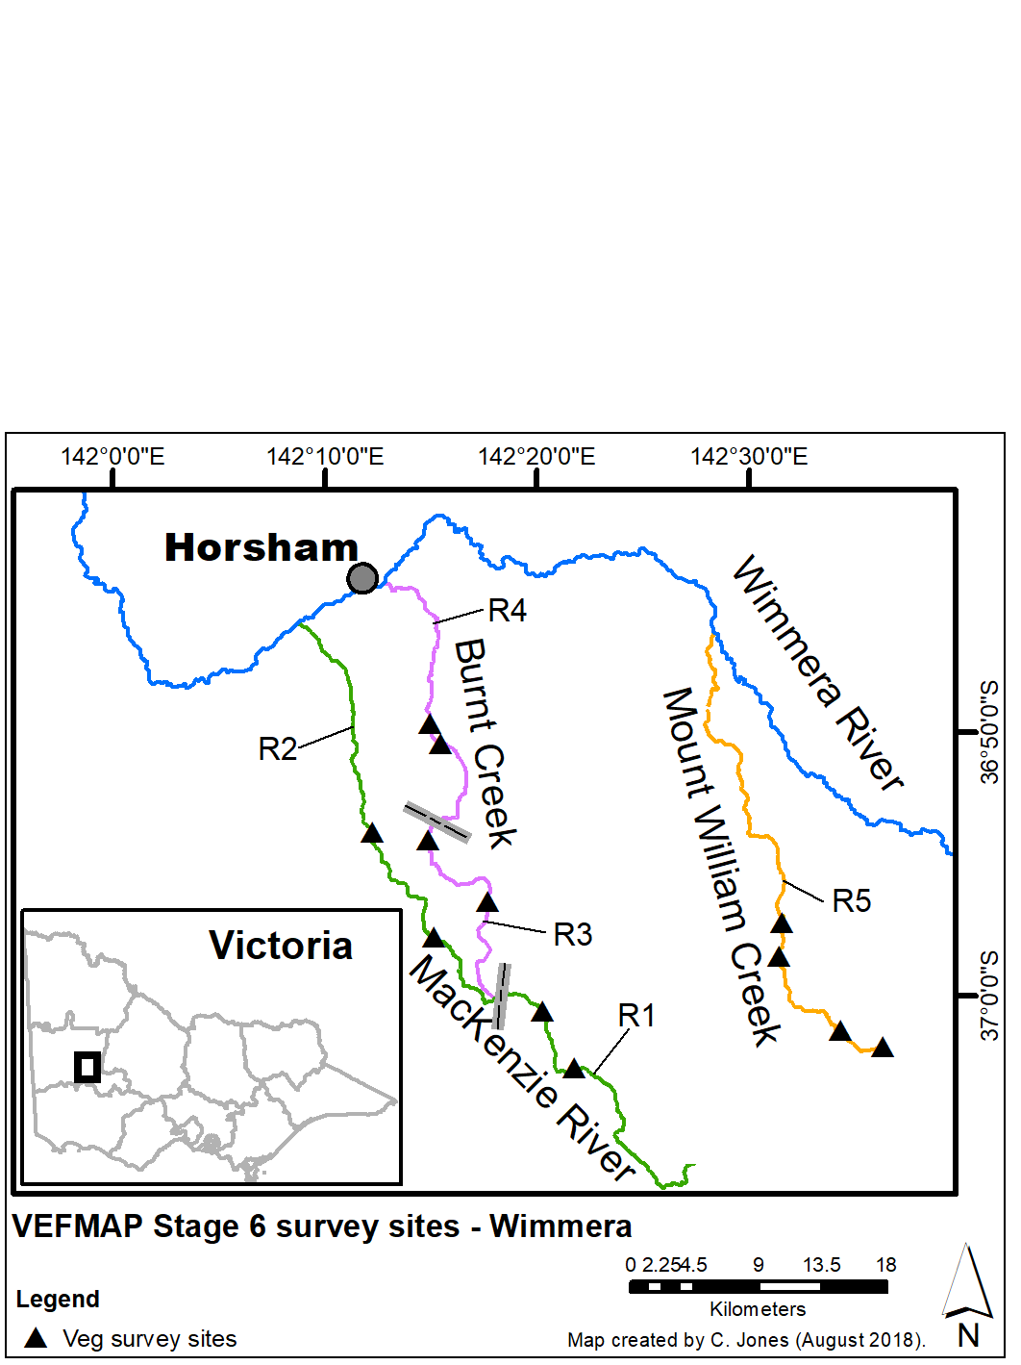

**Figure 1: Map of survey sites on the MacKenzie River, Burnt Creek and Mount William Creek. Reaches are labelled R1-5 and are separated by grey lines.**

The MacKenzie River and Burnt Creek have two distinct reaches: upper and lower (separated by weirs), while the Mount William Creek is more uniform. Twelve sites were surveyed, with four on each waterway (Figure 1).

* 1. **Survey timing and hydrology**

Timing for the VEFMAP surveys considers rainfall and managed flow deliveries. The sampling design recommends surveys occur before a planned flow delivery and two to 12 weeks after the event, depending on the flow regime, to provide adequate time for vegetation to respond and for germinants to emerge. Timing is altered if rainfall increases the flow prior to a planned survey.

Rainfall in the Horsham region near the Wimmera River tributaries included relatively low but consistent rainfall in winter, followed by intermittent rainfall (2018/19; Figure 2). Rainfall in late summer and early autumn was low with few rainfall contributions to waterway flows. Discharge in each of the three surveyed waterways varies from upper to lower reaches due to water diversions and structures, but overall the flow was low and sporadic, and in each waterway, flows were punctuated by periods of cease-to-flow.

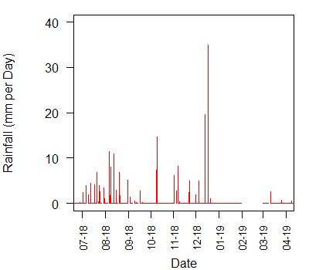

**Figure 2: Daily rainfall recorded at Horsham in 2018/19.**

In all three waterways, most spring flow was provided through reservoir releases of environmental water (Figure 3). The lower MacKenzie River had a series of flow releases of similar magnitude in the winter and spring but little flow in summer and early autumn. The Burnt Creek had elevated flow discharge in late winter, followed by small flow variation through the remainder of the year. In contrast, there were no late winter/early spring flows in the upper Mount William Creek, but there was an elevated flow release in late spring followed by three small summer and autumn flows.

* 1. Surveys were conducted in September (after peak natural flows from rainfall), December (after peak environmental flow releases) and March (at the end of the season).
  2. **Methods**

Survey methods are outlined in detail in VEFMAP Stage 6 Part B (DELWP 2017b). The surveys include a wide range of methods: fine-scale vegetation measurements, broad-scale mapping, tree canopy assessments and hydrology assessments.

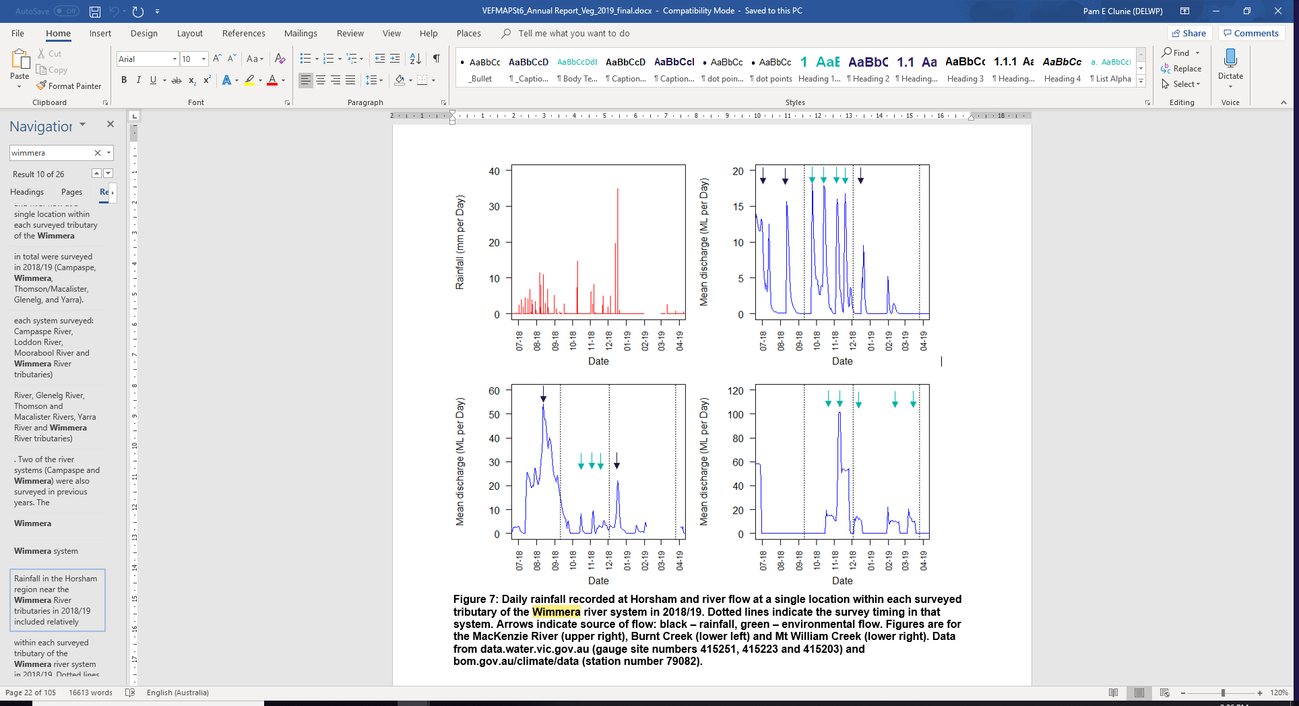

**Figure 3: River flow in 2018/19 within the MacKenzie River (top), Burnt Creek (middle) and Mt William Creek (bottom). Dotted lines indicate timing of surveys. Arrows indicate source of flow (black: rainfall, green: environmental flow).**

* 1. **Survey observations**

**Instream aquatic vegetation** cover was relatively high across most of the survey sites, as the channels of the Wimmera tributaries are generally low energy, with shallow complexes and pools, with not too much shading or flow (Figure 4).

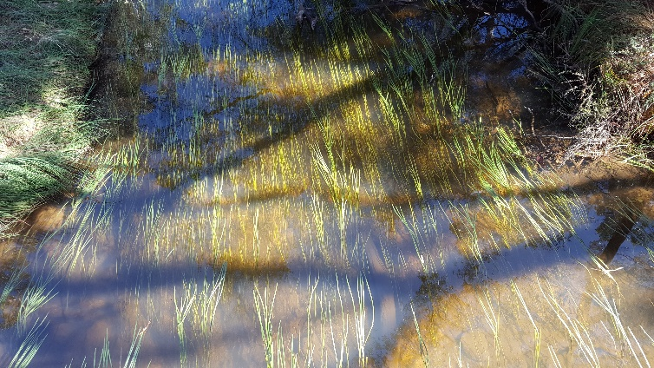**Figure 4: Abundant instream aquatic plants in the Mackenzie River in early autumn 2019.**

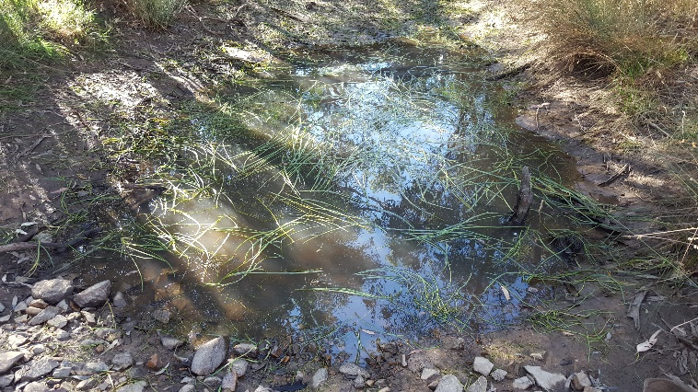However, very low cover of instream vegetation was recorded in four of the 12 sites, likely because of too much water (i.e. too deep in pools) or too little water (cease to flow). A key objective and opportunity for environmental flows in these systems is to provide sufficient water for instream species to persist when flows cease in summer. Many instream aquatic species can grow without water, so long as the soil remains damp. If the soil becomes too dry, the plants die back and may regrow from underground parts the following season, but this process is slow and means that cover will be low compared to places where the plants have persisted and can grow much larger. Brief summer/autumn flow pulses at the right time can be enough to keep these plants alive and ready for the next year (Figure 5).

**Figure 5: Example of instream aquatic plants persisting in a shallow pool in early autumn 2019.**

**Emergent and fringing vegetation** that occurs on the water edge and on the stream bank is an important component of the riparian system and is highly influenced by flow regime. Emergent species such as *Typha* spp. (cumbungi) and *Phragmites australis* (common reed) have relatively low abundance throughout these systems; however, at some sites the functional role of emergent plants appears to be provided by fringing species such as *Carex gaudichaudiana* (Fen Sedge), which are rooted at higher elevations but have leaves that hang into the water (Figure 6). These plants provide structural habitat in the water and a vector from water to the air or bank.

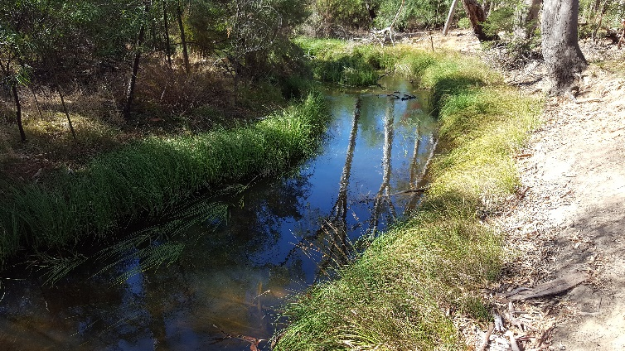

**Figure 6: Fringing/emergent vegetation providing aquatic habitat and a connection between the land and water.**

In contrast to the low-bank elevation emergent species, the fringing species that occur at higher elevations such as *Carex* spp., *Juncus* spp., and *Baloskion* are relatively abundant in these systems. These species are typically tolerant of dry summer periods, so long as they have good winter-spring water access. In reaches where the water regime is perennial (e.g. the upper Burnt Creek and upper Mackenzie River), riparian vegetation can remain green and vigorous right through the summer, providing a valuable resource for flora and fauna.

However, these systems are not naturally perennial and permanent high-water levels have implications for water quality, nutrient cycling and fish, and vegetation composition. Having reaches with different flow regimes can be valuable to promote higher biodiversity throughout the landscape.

* 1. **Soil moisture and hydrology**

Six soil moisture recording probes were installed in 2017, with two on each of the three tributaries. The lower Burnt Creek has the least flow of the surveyed reaches, retreating to few refuge pools in summer. Monitoring showed that soil moisture remained high until the refuge pools dried, with rapid declines until the pools were refilled by either flow releases or rainfall.

When refilling occurs from flow releases, such as in April 2018, the deeper soil layers are wetted first, and the shallow layers are wetted later, or not much at all (Figure 7). In comparison, the soil moisture survey site on the lower Mackenzie River has slightly more continuous flow. Here, the soil moisture in the deeper soil layers remains damper for longer and dries more slowly (see full annual report: Jones and Vivian 2019).

In both waterways, the surface soil (~5cm) is mostly influenced by rainfall, even at the lower probe locations, because flow heights are typically very low in these lower reaches.

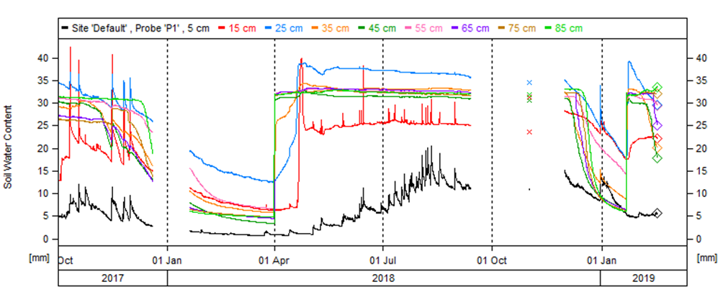

Figure 7: Soil moisture probe data output from various depths at the lower Burnt Creek monitoring site. Graph shows data from the lower part of the bank (near low-flow water edge).

Drying

Wetting

Drying

* 1. **Key Outcomes**
* Brief summer/autumn flow pulses at the right time can be enough to keep instream aquatic vegetation alive and ready for the next year in intermittent streams where flows cease in summer.
* In reaches where the water regime is largely perennial (e.g. the upper Burnt Creek and upper Mackenzie River), riparian vegetation can remain green and vigorous right through the summer, providing a valuable resource for flora and fauna.
* Permanent high water levels have implications for water quality, nutrient cycling, fish, and vegetation composition. Having reaches with different flow regimes can be valuable to promote higher biodiversity throughout the landscape.
  1. **Summary**

Environmental flows are being delivered in the Wimmera River tributaries to deliver benefits to vegetation and a wide range of fauna. Waterway managers are working closely with researchers, waterway authorities and a range of other stakeholders to manage flow deliveries as effectively as possible for the environment and other users. The observations summarised here form part of a larger story relating to vegetation responses to environmental water. Further information on the other systems surveyed and research projects is also available.

* 1. **Next Steps**

In the final year of VEFMAP Stage 6 (2019/20), the data collected during the program will be processed and analysed, and the findings reported in a set of publications. Some additional targeted data collection will also continue, including soil moisture monitoring.

* 1. **References**

DELWP (2017a and b) VEFMAP Stage 6 Part A: Program context and rationale and VEFMAP Stage 6 Part B: Program design and monitoring methods. Reports by Arthur Rylah Institute for Environmental Research and Integrated Water and Catchments Division, Department of Environment, Land, Water and Planning.

Jones C. and Vivian L. 2019. VEFMAP Stage 6: Monitoring vegetation response to environmental flow delivery in Victoria 2018/19. Arthur Rylah Institute report to the Department of Environment, Land, Water and Planning, Melbourne.

## Contact Chris.Jones@delwp.vic.gov.au

FletcherG@wcma.vic.gov.au (WCMA)

|  |  |
| --- | --- |
| © The State of Victoria Department of Environment, Land, Water and Planning 2020  LogoThis work is licensed under a Creative Commons Attribution 4.0 International licence. You are free to re-use the work under that licence, on the condition that you credit the State of Victoria as author. The licence does not apply to any images, photographs or branding, including the Victorian Coat of Arms, the Victorian Government logo and the Department of Environment, Land, Water and Planning (DELWP) logo. To view a copy of this licence, visit http://creativecommons.org/licenses/by/4.0/  ISBN 978-1-76077-159-1 (pdf/online/MS word)  Disclaimer  This publication may be of assistance to you but the State of Victoria and its employees do not guarantee that the publication is without flaw of any kind or is wholly appropriate for your particular purposes and therefore disclaims all liability for any error, loss or other consequence which may arise from you relying on any information in this publication. | Accessibility  If you would like to receive this publication in an alternative format, please telephone the DELWP Customer Service Centre on 136186, email [customer.service@delwp.vic.gov.au](mailto:customer.service@delwp.vic.gov.au), or via the National Relay Service on 133 677 [www.relayservice.com.au](http://www.relayservice.com.au). This document is also available on the internet at https://www.ari.vic.gov.au/research/rivers-and-estuaries/assessing-benefits-of-environmental-watering |