|  |
| --- |
| Revegetation in farm landscapes  1. What is the value of revegetation for nature conservation? |

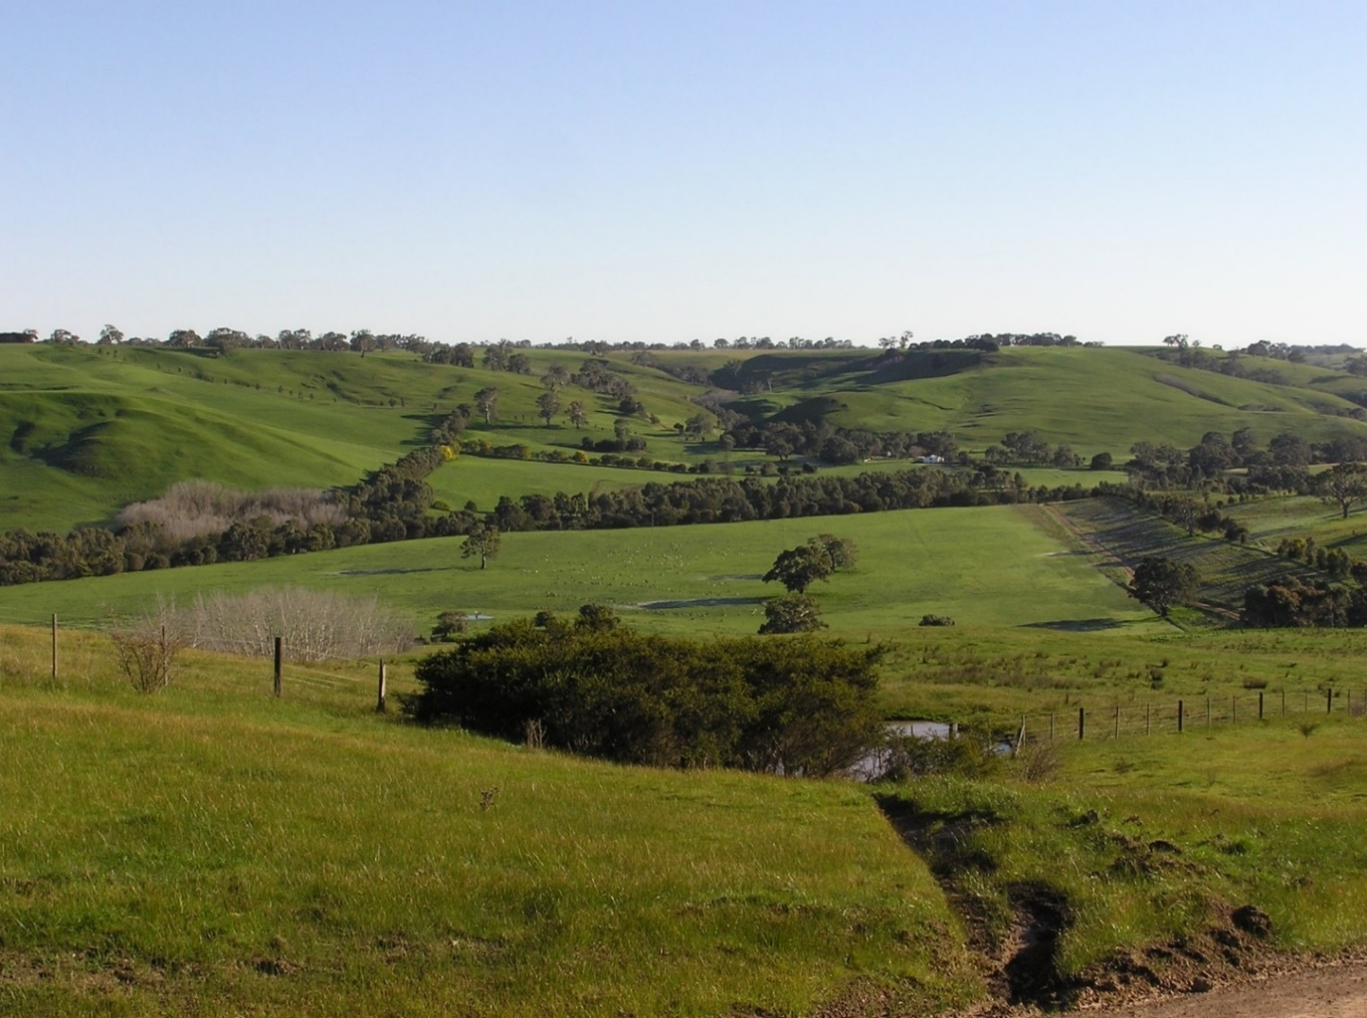

Across Australia, landholders, community groups and government agencies are actively carrying out revegetation in farm landscapes. Revegetation plantings in the form of shelterbelts, woodlots and plantings along creeks are being added to farms to provide shelter for stock, to counteract salinity, reduce erosion and help nature conservation. Such revegetation plantings can provide habitat for native plants and animals, particularly in landscapes that have otherwise been heavily cleared.

To understand how revegetation plantings contribute to nature conservation, we ask:

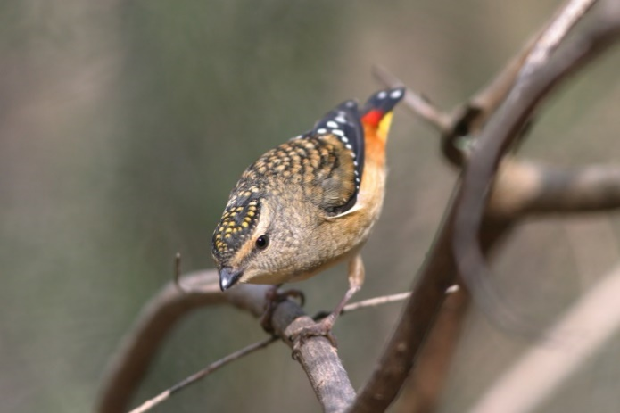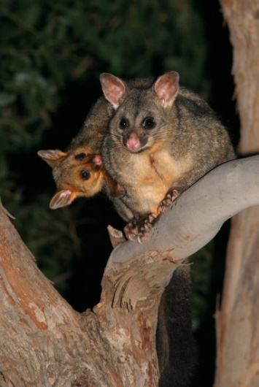

**Spotted Pardalotes (*[Pardalotus punctatus](http://www.birdsinbackyards.net/Passeriformes/Pardalotidae/Pardalotus/Pardalotus-punctatus)*) and Common Brushtail Possums (*Trichosurus vulpecula*) have been recorded in revegetation plantings**

* *What are the features of revegetation plantings that most increase their value for animals?*
* *Which species benefit most from revegetation in rural landscapes?*
* *Does the conservation value of revegetation change over time as plantings age and mature?*

This factsheet is the first in a series of publications from the Adaptive Learning project, which is examining the value of revegetation for birds and butterflies. Here, we summarise some ways the features of revegetation plantings can influence their value for animals.

**Revegetation comes in different forms**

Revegetation plantings vary greatly in their size, shape, the number of plant species, and their position in the landscape. For example, agroforestry plots or farm woodlots are often monocultures of a single tree species that will be harvested in the future. Shelterbelts are typically planted in linear strips along fence lines. Revegetation plantings along creeks and drainage lines often include shrubs and may be placed around existing mature trees, or connected to existing patches of native vegetation. These differences influence their use by native animals. Knowledge of such relationships will provide opportunities to increase the conservation value of future plantings.

**Revegetation provides habitat for fauna**

Revegetation plantings benefit native animals in a range of ways. For example, patches or strips of revegetation can provide habitat resources such as shelter, food and nesting sites. This will depend on the features of the planting itself. Does it include a shrubby understorey? Or leaf litter and logs on the ground? It also depends on the habitat requirements of individual animal species – for example, Spotted Pardalotes forage for invertebrates that occur in dense tree foliage.

Revegetation plantings can also provide habitat at broader scales by increasing the overall amount of vegetation in the landscape. This is important because single patches of habitat (revegetation or remnant vegetation) are rarely enough to support viable populations of native animals in the long term. Also, many species move between different parts of the landscape for different purposes (e.g. to feed or to nest), or at different times of the year.

Less is known about factors that enhance the value of revegetation plantings for animals at the landscape (‘whole-farm’, or larger) scale. However, as land managers generally make decisions about revegetation plantings at this scale, such knowledge will assist with guidelines for future revegetation.

**Revegetation habitats change over time**

As plants mature, the habitat resources they provide changes. For example, trees develop a larger and wider canopy over time, and as shrubs grow they provide greater cover and shelter. Older trees develop hollows, and large limbs fall and become logs on the ground.

Different types of revegetation will follow different patterns of change over time and therefore have differing values for native fauna in coming years and decades. The best way to understand such changes is to survey revegetation sites and their fauna over a period of time, but this is rarely done.

**Key questions about the value of revegetation**

|  |  |
| --- | --- |
| © The State of Victoria Department of Environment, Land, Water and Planning 2020  LogoThis work is licensed under a Creative Commons Attribution 4.0 International licence. You are free to re-use the work under that licence, on the condition that you credit the State of Victoria as author. The licence does not apply to any images, photographs or branding, including the Victorian Coat of Arms, the Victorian Government logo and the Department of Environment, Land, Water and Planning (DELWP) logo. To view a copy of this licence, visit http://creativecommons.org/licenses/by/4.0/  ISBN 978-1-76105-262-0 (pdf/online/MS word)  Disclaimer  This publication may be of assistance to you but the State of Victoria and its employees do not guarantee that the publication is without flaw of any kind or is wholly appropriate for your particular purposes and therefore disclaims all liability for any error, loss or other consequence which may arise from you relying on any information in this publication. | Accessibility  If you would like to receive this publication in an alternative format, please telephone the DELWP Customer Service Centre on 136186, email [customer.service@delwp.vic.gov.au](mailto:customer.service@delwp.vic.gov.au), or via the National Relay Service on 133 677 [www.relayservice.com.au](http://www.relayservice.com.au). This document is also available on the internet at https://www.ari.vic.gov.au/research/ |

* *What is the value of different types of plantings for native animals?*
* *Is the value of plantings for animals influenced by how much native vegetation is nearby?*
* *Which aspects of a revegetation planting (e.g. variety of species planted, structure) most influence their value for animals?*
* *How does the age of a planting influence the number and types of species that use it?*
* *At the landscape scale, does revegetation attract new species back into farm landscapes?*

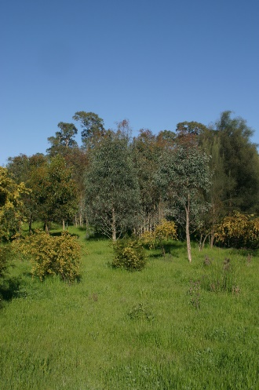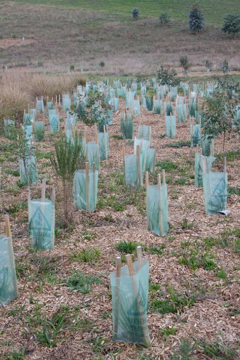

**As plants mature, the habitat they provide changes**

**Future work exploring the value of revegetation for nature conservation**

These questions, and more, were examined in a large field study undertaken in Glenelg Hopkins region of western Victoria during 2019 and 2020. The study repeated bird and habitat surveys at a large number (>250) of sites that were established in 2006/07. These sites were selected to survey revegetation patches of different types, ages and amounts of surrounding vegetation, as well as nearby remnant vegetation.

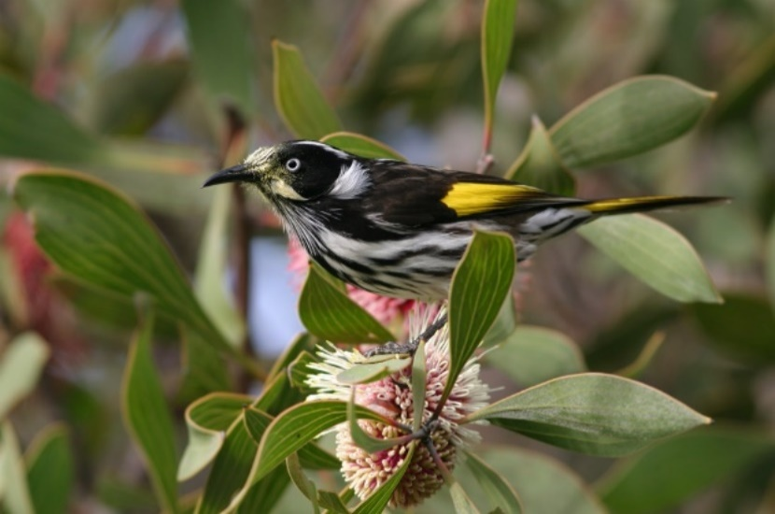

**Flowering shrubs provide food resources for nectar-feeding species such as the New Holland Honeyeater (*[Phylidonyris novaehollandiae](http://www.birdsinbackyards.net/Passeriformes/Meliphagidae/Phylidonyris/Phylidonyris-novaehollandiae)*)**

Comparison of bird records made in 2019 with those in 2006/07 provided an understanding of how the value of revegetation for birds has changed over time.

## Further information

Angie Haslem [A.Haslem@latrobe.edu.au](mailto:A.Haslem@latrobe.edu.au)

[research.ari@delwp.vic.gov.au](mailto:research.ari@delwp.vic.gov.au) [**ari.vic.gov.au**](https://www.ari.vic.gov.au/)

## Acknowledgements

This project was funded with support of the Victorian Government as part of the Biodiversity On-ground Action Adaptive Learning project, undertaken as a collaboration between Arthur Rylah Institute and La Trobe University.

**Prepared by:** Angie Haslem, Andrew Bennett, Rohan Clarke, Alex Maisey, Greg Holland (July 2020)

**Photo credits:** Rohan Clarke, Alistair Stewart