

**The importance of revegetation**

Across much of south-eastern Australia, landscapes have been extensively cleared for farming, as well as for cities, towns and industry. This loss of native vegetation in many regions has had a range of negative consequences – for native plants and animals, and for sustainable land-use in rural environments.

Revegetation with native vegetation can help to restore landscapes. It can increase areas of native bushland for animals to live and thrive, as well as provide corridors to connect isolated bushland areas. It can contribute to more sustainable rural landscapes by reducing soil loss, providing shelter for stock, capturing and storing carbon, and along gullies and creeks, revegetation can help protect water quality by filtering run-off from the surroundings. Revegetation also provides social benefits, as it contributes to aesthetic values and an attractive environment in urban and agricultural landscapes.

Many groups are involved in revegetation activities, including Catchment Management Authorities (CMAs), Landcare groups, non-government organisations such as Greening Australia, and individuals. Much has been learned about techniques and approaches for effective revegetation, and knowledge continues to grow about the values of revegetation for native fauna.

One area where a better understanding is required relates to the outcomes of planting, particularly the survival of plants and why this varies between the species planted and between planting sites.

**Adaptive Learning - Revegetation monitoring**

This factsheet provides an overview and initial results for the revegetation monitoring component of DELWP’s Adaptive Learning Project.

Further revegetation monitoring outputs will be provided as findings become available. The aim is to:

* Assess the outcomes of revegetation, in terms of the survival of planted trees, shrubs and understory plants
* Determine the factors that affect variation in survival among different species, and different regions
* Develop a monitoring protocol that agencies and community groups can use to collect information in a standard way to monitor planting outcomes.



**Fig 1. Monitoring plant survival after revegetation**

An initial trial has been undertaken to develop a simple monitoring protocol (attached). The next stage is to use this monitoring procedure across a range of revegetation sites in Victoria.

There is an opportunity for CMAs, Landcare groups and other organisations to gather this information on the outcomes of their revegetation activities. Through the participation of many groups and individuals, we will gain a better understanding of how planting success varies between plant species, how it varies between sites, the factors that influence planting success, and how revegetation might be more effective in the future.

**What monitoring has occurred?**

In 2018/19, a trial was undertaken at 11 sites (involving 30 monitoring plots) across five CMAs in Victoria. Monitoring plots were established directly after planting at each site (June to October). This was done by setting-up at least two permanent survey plots (50 m x 4 m area) per site. These were assessed by recording (counting) all native plants and species that were planted. Information on land-use history, site preparation and planting technique were also recorded (Fig 1).

These surveys were repeated after the first summer (in March - approximately 9 months after planting). All native plants and species (previously planted) that were alive were recorded.

This trial monitoring showed that after this first summer, the overall number of individual plants that survived was 55% of those planted. Survival was highest in the CMA areas in the south, with higher rainfall.

Survival across the species commonly planted was highly variable, with 68% of the species diversity that were planted surviving. For example, Blackwood (*Acacia melanoxylon* - 8 sites), Swamp Gum (*Eucalyptus ovata* - 6 sites) and Manna Gum (*E. viminalis -* 7 sites) survival averaged >70%, while Spiky Teatree (*Leptospermum continentale -* 10 sites), Sweet Bursaria (*Bursaria spinosa -* 10 sites) and Drooping Sheoak (*Allocasuarina verticillata -* 7 sites) survival averaged <35% across the sites that were planted (Fig 2).

Broad factors that influenced survival included where planting occurred (CMA area) and whether the planting area was grazed (especially by livestock).

**How can I contribute?**

Organisations and individuals who are undertaking revegetation activities this year are invited to contribute to this monitoring. An ability to identify the plants to species level is necessary to undertake the monitoring effectively. This involves using the standard monitoring protocol and associated guidelines (attached) to:

* Mark two or more monitoring plots within a planting site
* Record all plants that are planted within the plot area directly after planting
* Note information on the land-use history, a description of the landscape being planted, the site preparation undertaken and the planting techniques
* Revisit these sites after the first summer and record plants that are alive in the monitoring plots and their approximate height.

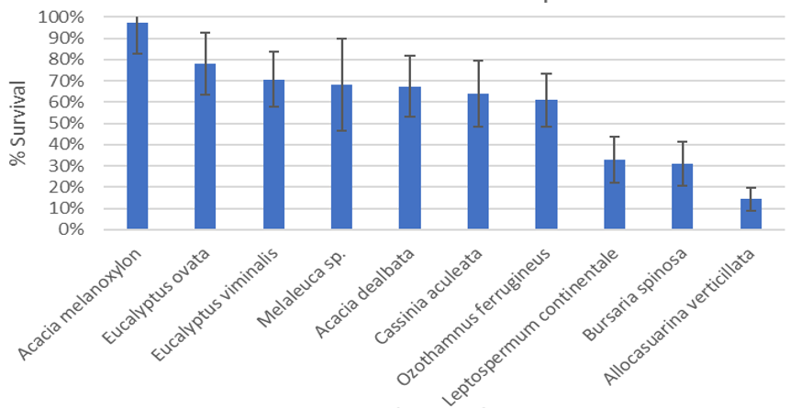

**Fig 2. Post-summer survival of commonly planted species**

## Further information

If you would like further information or to monitor the outcomes of your revegetation project, please contact:

Sacha Jellinek: [Sacha.Jellinek@gmail.com](mailto:Sacha.Jellinek@gmail.com)

[research.ari@delwp.vic.gov.au](mailto:research.ari@delwp.vic.gov.au) [ari.vic.gov.au](https://www.ari.vic.gov.au/)

## Acknowledgements

This project was funded with support of the Victorian Government as part of the Biodiversity On-ground Action Adaptive Learning project. It was undertaken as a collaboration between Arthur Rylah Institute and La Trobe University with support from several CMAs, Greening Australia, Landcare groups and other agencies.

**Prepared by:** Sacha Jellinek, Tim O’Brien, Andrew Bennett (May 2019)

**Photo credit:** Sacha Jellinek

**Background**

The aim of this project is to develop a quick and simple monitoring method for revegetation projects, to better understand how well plants survive after planting, and what influences their survival and growth.  
To do this, it is necessary to record how many plants or seed of each species are planted, and their survival after the first summer (i.e. in the following Autumn).

Important information to collect includes land-use history, the type of planting (e.g. windbreaks, patches), the site location (e.g. paddock, near bushland) and landscape topography (e.g. flats, slope, floodplain, etc).

**Data Collection**

To collect the most relevant information, three data sheets are provided:

1. To record your project and site information;
2. To undertake initial monitoring after planting; and
3. Follow-up monitoring after the first summer (Autumn).

These data sheets are as follows:

1. **Project & Site Information**

This sheet is to record initial information about the project and site, including the purpose of the revegetation, the previous land-use history at the site, and details about site preparation.

1. **Initial Monitoring** (30 min - 1 hour per plot)

This sheet provides details about how to set-up a monitoring plot during, or shortly after, planting; and how to survey it to record the species planted and other relevant information. We recommend plots are 50m X 4m in size for Tubestock Plantings (Figure 1), and 20m X 20m in size for Direct Seeding sites, and that you set-up 2 - 3 plots per site. If the site is larger than 1 ha, do more.

1. **Follow-Up Monitoring - Autumn** (15 - 30 min per plot)

This sheet is to record follow-up monitoring data; i.e., to record which plants have survived after the first summer (Autumn monitoring: 7 - 9 months after planting), and then in subsequent years in Autumn. It would also be valuable to initially monitor sites 1 - 2 months after planting (i.e. Spring).

Plants Survey

50 m long

4 m wide

*Figure 1: An example of the monitoring plot used to assess plant survival in Tubestock plantings.*

**Please send completed datasheets and enquires to:** [**sacha.jellinek@gmail.com**](mailto:sacha.jellinek@gmail.com)

|  |  |  |
| --- | --- | --- |
| 1. **Project & Site Information**   **General Information** | | |
| Date: | | |
| Site name: | Landholder name: |
| Location (nearest road name & town): | | |
| Site entry coordinates (for future access): | | |
| Easting (GPS): | Northing (GPS): |
| Assessor name: | Assessor organisation: |
| Funding body (select one) & project name: *Local Government (DELWP*) *Local Council*  *Federal*  *Other…………………………………* | | |
| Purpose of revegetation (select one or more):  *Conservation*  *Shelterbelt*  *Land Stabilisation*  *Other………………………...............* | | |
|
| Revegetation goal (vegetation type/target EVC) - if known: | | |
|  | | |
| **Site Details** (please record details for the whole of the planting area) | | |
| Land-use before planting (select one or more): *Grazing*  *Cropping*  *Horticulture*  *Plantation*  *Other*…………………………………... | | |
| Main vegetation at time of planting (select one): None (*bare ground*)   *Pasture Grass*  *Scattered Trees*  *Remnant Bush*  *Other*…………………………………... | | |
| Soil type (select one or more): *Gravel*  *Sand*  *Loam*  *Clay*  *Other*…………………………………... | | |
| Site topography (select one or more): *Floodplain*  *Slope*  *Ridge*  *Dune*  *Flats*  *Other*…………………………………... | | |
| Planting area (size - ha): | | |
| Previously planted: *Yes*  *No*  *Unsure* | If Yes, when: |
|  | | |
| **Site Preparation Details** | | |
| Was weed control done (select one): *No*  *Spot Spray*  *Strip Spray*  *Whole Paddock*  *Other*…………………………………... | | |
| Other site preparation(select one or more): *Fenced to Exclude Animals*  *Ripping*  *Scalping*  *Animal Control*  *Burning*  *Other*…………………………………... | | |
| Notes: | | |

1. **Initial Monitoring**

**How to Set-up and Survey a Monitoring Plot**

1. Select an area that is representative of the planting site and set-up a plot. At each corner of the plot, permanently mark with a star picket:
   1. For **Tubestock Plantings** set-up a **200 m2 area** (e.g. 50m X 4m recommended size, although size/shape can vary). In the centre of the two long sides of the plot add a stake
   2. For **Direct Seeding** set-up a **400 m2 area** (e.g. 20m X 20m recommended size, although size/shape can vary).
2. Record the GPS coordinates (use WGS84 map datum with Eastings and Northings) for the start and end of the plot, and give the plot a unique Site Name and Monitoring Plot Number.
3. Take a picture of the plants in the plot (photopoint) - (i) Sit a camera or phone (landscape) on the star picket in the north-west corner of the plot and take a photo towards the opposite end, (ii) download the photo, naming it with the site name, monitoring plot number and date (e.g. Walker01_17082019).
4. Tubestock Planting - Walk within the plot area and record (count) all the native species that were planted and any pre-existing native plants. Take the average height of the first five plants for each planted species, using the categories provided. Estimate weed cover and cover of bare ground.
5. Direct Seeding - Record the kilograms (kg) of seed used per hectare (ha) for each species sown. Initial monitoring not required for direct seeding.

|  |  |  |  |
| --- | --- | --- | --- |
| **Monitoring Plot Details** | | | |
| Site name: | Date: | | |
| Assessor name: | Assessor organisation: | | |
| Monitoring plot location: Start Easting (GPS): End Easting (GPS):  Start Northing (GPS): End Northing (GPS): | | | |
| Plot size (select one): *50m * 4m*  *Other*…………………………………... | | | |
| Plot position (select one):  *Floodplain*  *Slope*  *Ridge*  *Dune*  *Flats*   *Other*………………………………….. | | | |
| Planting dates: | Initial survey date: | | |
| Planted by (select one or more): *Contractor*  *Volunteers*  *Landholder*  *Other*…………………………………... | | | |
| Planting type (select one or more): *Tubestock*  *Direct Seeding*  *Other*…………………………………... | | | |
| Source of plants (nursery?): | Seed provenance: | | |
| Were any of these agents used (select one or more): *Wetting Agent*  *Fertiliser*  *Pest Repellent*  *Other*…………………………………... | | | |
| Plants guarded: *Yes*  *No* | | | |
| Guard type (select one): *Cardboard*  *Mesh*  *Hard Plastic*  *Soft Plastic* | | | |
| Plants watered during planting: *Yes*  *No* | After planting: *Yes*  *No* | | |
| **Monitoring Plot Survey Records (Initial)** *-* print one datasheet for each plot  *Record (count) all the native species that were planted and any pre-existing native plants, or if direct seeded, the kg of seed used per hectare for each species.*  *Plant height categories: <0.5m, 0.5 - 1m, 1 - 1.5m, 1.5 - 2m, >2m* | | | |
| Monitoring plot number: | Photopoint number: | | |
| Evidence of grazing animals: *Rabbits*  *Hares*  *Kangaroos*  *Deer*  *Livestock*  *Other*……………………… | | | |
| **Species Name (planted or direct seeded)** | | **Number of plants or Kg seed per ha (by species)** | **Average height of first five plants for  each species** |
|  | |  |  |
|  | |  |  |
|  | |  |  |
|  | |  |  |
|  | |  |  |
|  | |  |  |
|  | |  |  |
|  | |  |  |
|  | |  |  |
|  | |  |  |
|  | |  |  |
|  | |  |  |
|  | |  |  |
|  | |  |  |
|  | |  |  |
| Pre-existing Trees and Shrubs: | |  |  |
|  | |  |  |
|  | |  |  |
| Estimated Weed Cover in the Plot (select one): *<5 %*  *5 - 25 %*  *25-50 %*  *>50 %* | | | |
| Estimated Bare Ground in the Plot (select one): *<5 %*  *5 - 25 %*  *25-50 %*  *>50 %* | | | |
| Notes: | | | |
|

1. **Follow-Up Monitoring - Autumn**

**Methods**

1. Return to the monitoring plot in Autumn (after summer). If possible, use the same assessor who initially monitored the site.
2. Take a photopoint of the plot using the information in Section 2 C.
3. Walk within the plot area and count and record all the alive native species that were planted or direct seeded, any pre-existing native or naturally recruiting plants, and note whether any plant species are flowering or producing seed. Take the average height of the first five plants for each planted species, using the categories provided. Estimate weed cover and cover of bare ground.

|  |  |
| --- | --- |
| **Monitoring Plot Details** | |
| Site name: | Date: |
| Assessor name: | Assessor organisation: |

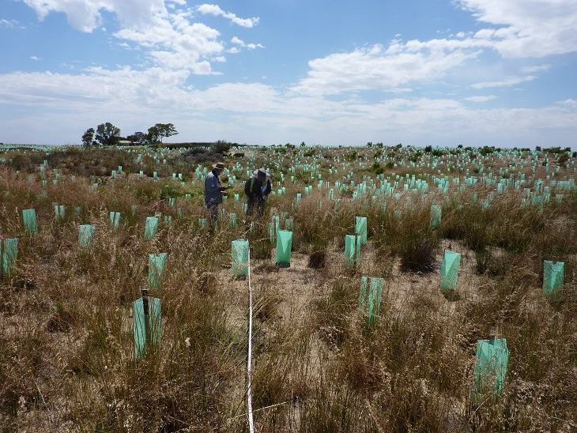

|  |  |  |  |  |
| --- | --- | --- | --- | --- |
| **Monitoring Plot Survey Records (Autumn)** *-* print one datasheet for each plot  *Count and record each of the planted and/or direct seeded plants and existing trees and shrubs in the plot.*  *Plant height categories: <0.5m, 0.5 - 1m, 1 - 1.5m, 1.5 - 2m, >2m* | | | | |
| Monitoring plot number: | | Photopoint number: | | |
| Evidence of grazing animals: *Rabbits*  *Hares*  *Kangaroos*  *Deer*  *Livestock*  *Other*……………………… | | | | |
| **Species Name (planted or direct seeded)** | **Number of plants alive** (plants partially or  wholly green) | | **Average height of first five plants for each species** | **Producing Seed** (Y/N) **Flowering** (Y/N) |
|  |  | |  |  |
|  |  | |  |  |
|  |  | |  |  |
|  |  | |  |  |
|  |  | |  |  |
|  |  | |  |  |
|  |  | |  |  |
|  |  | |  |  |
|  |  | |  |  |
|  |  | |  |  |
|  |  | |  |  |
|  |  | |  |  |
|  |  | |  |  |
|  |  | |  |  |
|  |  | |  |  |
| Pre-existing Trees and Shrubs: |  | |  |  |
|  |  | |  |  |
|  |  | |  |  |
| Naturally Regenerating Species: |  | |  |  |
|  |  | |  |  |
|  |  | |  |  |
| Estimated Weed Cover in the Plot (select one): *<5 %*  *5 - 25 %*  *25-50 %*  *>50 %*  Estimated Bare Ground in the Plot (select one): *<5 %*  *5 - 25 %*  *25-50 %*  *>50 %* | | | | |
| Notes: | | | | |

**Please send completed datasheets and enquires to:** [**sacha.jellinek@gmail.com**](mailto:sacha.jellinek@gmail.com)