|  |
| --- |
| Managing the impacts of large weirs as barriers to platypus dispersal  Current knowledge and recommended actions |
| M. Serena, D. Crowther and A.M. Kitchingman |
| May 2023 |

Arthur Rylah Institute for Environmental Research   
Technical Report Series No. 361

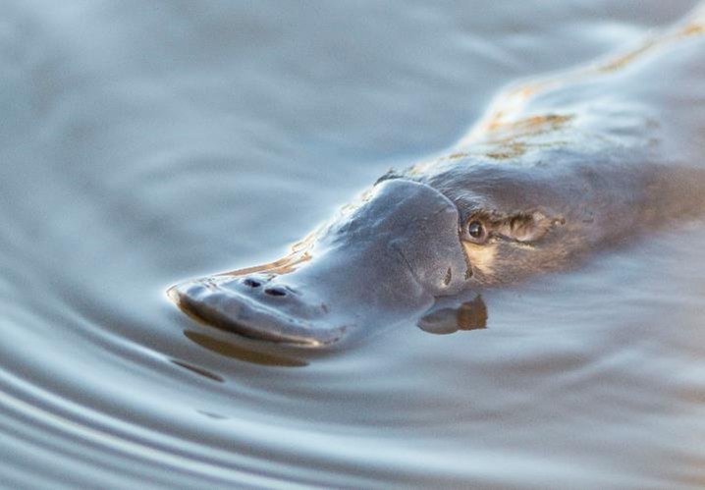

|  |
| --- |
| Acknowledgement  We acknowledge and respect Victorian Traditional Owners as the original custodians of Victoria’s land and waters, their unique ability to care for Country and deep spiritual connection to it. We honour Elders past and present, whose knowledge and wisdom has ensured the continuation of culture and traditional practices.  We are committed to genuinely partner, and meaningfully engage, with Victoria's Traditional Owners and Aboriginal communities to support the protection of Country, the maintenance of spiritual and cultural practices and their broader aspirations in the 21st century and beyond. |

Report produced by:

Australian Platypus Conservancy

PO Box 115

Campbells Creek, Victoria 3451  
and  
Arthur Rylah Institute for Environmental Research  
Department of Energy, Environment and Climate Action  
PO Box 137  
Heidelberg, Victoria 3084  
Phone (03) 9450 8600  
Website: [www.ari.vic.gov.au](http://www.ari.vic.gov.au)

**Citation**: Serena, M., Crowther, D. and Kitchingman, A.M. (2023). *Managing the impacts of large weirs as barriers to platypus dispersal: current knowledge and recommended actions*. Arthur Rylah Institute for Environmental Research Technical Report Series No. 361. Department of Energy, Environment and Climate Action, Heidelberg, Victoria.

**Front cover photo**: Platypus (credit: Barry Baker)

Logo© The State of Victoria Department of Energy, Environment and Climate Action 2023

This work is licensed under a Creative Commons Attribution 3.0 Australia licence. You are free to re-use the work under that licence, on the condition that you credit the State of Victoria as author. The licence does not apply to any images, photographs or branding, including the Victorian Coat of Arms, the Victorian Government logo, the Department of Energy, Environment and Climate Action logo and the Arthur Rylah Institute logo. To view a copy of this licence, visit <http://creativecommons.org/licenses/by/3.0/au/deed.en>

Edited by Jeanette Birtles, Organic Editing

ISSN 1835-3827 (print)

ISSN 1835-3835 (pdf))

ISBN 978-1-76136-283-5 (pdf/online/MS word)

**Disclaimer**This publication may be of assistance to you but the State of Victoria and its employees do not guarantee that the publication is without flaw of any kind or is wholly appropriate for your particular purposes and therefore disclaims all liability for any error, loss or other consequence which may arise from you relying on any information in this publication.

Accessibility

If you would like to receive this publication in an alternative format, please telephone the DEECA Customer Service Centre on 136 186, email [customer.service@delwp.vic.gov.au](mailto:customer.service@delwp.vic.gov.au) or contact us via the National Relay Service on 133 677 or [www.relayservice.com.au](http://www.relayservice.com.au). This document is also available on the internet at [www.deeca.vic.gov.au](http://www.delwp.vic.gov.au)

Managing the impacts of large weirs as barriers to platypus dispersal

Current knowledge and recommended actions

Melody Serena1, Diane Crowther2 and Adrian M. Kitchingman2

1 Australian Platypus Conservancy  
PO Box 115, Campbells Creek, Victoria 3451

2 Arthur Rylah Institute for Environmental Research   
123 Brown Street, Heidelberg, Victoria 3084

Date

Arthur Rylah Institute for Environmental Research  
Technical Report Series No. 361

# Acknowledgements

This project received grant funding from the Australian Government through the Regional Bushfire Recovery for Multiregional Species and Strategic Projects Program.

We thank Mark Taylor (Southern Rural Water) for facilitating our detailed inspection of the weir at Pykes Creek Reservoir, Anne Musser and Tom Grant for sharing unpublished information from their platypus studies at the Jenolan Karst Conservation Reserve in New South Wales, Jessica Thomas (Healesville Sanctuary) for providing unpublished details about platypus behaviour, Rosemary Booth for sharing her knowledge about predator-inflicted injuries, and Rachael Beecham (Corangamite CMA), Tom Scarborough (Barwon Water), Chris Solum (Glenelg Hopkins CMA) and Bruce Jackson (Otway Eco Tours) for sharing information pertaining to the platypus’s distribution in western and south-western Victoria.

We thank Alistair Danger (Melbourne Water) for granting permission to use Melbourne Water spatial data for barriers and fishways.

We also thank Ashley Sparrow and Jarod Lyon (both from Arthur Rylah Institute, DEECA) for their very helpful input into earlier drafts of this report.

Contents

Acknowledgements ii

Summary 1

Context: 1

Aims: 1

Methods: 1

Results: 1

Conclusions and implications: 1

1 Introduction 3

2 Background information: movements and dispersal, behaviour at barriers, use of weir pools, and weir-related risks 5

2.1 Adult platypus home range size and daily foraging area 5

2.2 Juvenile platypus dispersal 5

2.3 Movement past barriers 6

2.3.1 Natural waterfalls 6

2.3.2 Weir walls 6

2.3.3 Fishways 8

2.4 Use of weir pools 9

2.5 Barrier-related risks to platypus 9

2.5.1 Increased mortality 10

2.5.2 Genetic considerations: effects of fragmentation and inbreeding 10

2.6 Predicted impact of weirs on rakali movements and dispersal 11

3 Effect of weir features on platypus movement, and suggested mitigation actions 12

3.1 Introduction 12

3.2 Identifying and mitigating structural features that can impede platypus dispersal 12

3.2.1. Problematic features of spillways 12

3.3 Attracting flows 21

3.4 Summary of recommended actions to encourage and facilitate platypus travel past a weir 21

3.5 The use of platypus translocation to address weir-related impacts 22

4. The location of large Victorian weirs in relation to known platypus populations 23

4.1 Introduction 23

4.2 Methods 23

4.2.1. Location of large dams in relation to platypus distributional records 23

4.2.2 Other information pertaining to weir-related fragmentation of platypus populations 24

4.3 Results 24

4.3.1. Identification of Victorian weirs deemed most likely to contribute to platypus population fragmentation based on their location 24

4.3.2. Weir-related attributes relating to fragmentation of platypus populations: catchment location and platypus use of weir pools 28

4.3.3. Weir-related attributes relating to fragmentation of platypus populations: weir height and occurrence of at least two large weirs on a given watercourse 29

5. Knowledge gaps and priority research areas 32

5.1 Introduction 32

5.2 High-priority management questions 32

5.2.1 How can existing weir spillways be modified to most effectively facilitate platypus movement along their length and thereby improve population connectivity? 32

5.2.2 Can platypus be directed to consistently use a relatively protected terrestrial route to travel around a weir and thereby improve population connectivity? 32

5.2.3 What is the potential for weir pools to provide platypus habitat and thus serve as drought or post-bushfire refuges under future climate change? 33

5.2.4 To what extent do small instream structures (such as weir walls less than 2 metres high and road culverts) contribute to platypus mortality risk? 33

5.3 Medium-priority management questions 33

5.3.1 What is the current size and status of platypus subpopulations presumed to be isolated by the presence of a weir? 33

5.3.2 How does platypus usage of fishways vary with their design or the way they are operated (e.g., flow rate)? 34

References 35

.Appendix 1 Platypus movement through culverts and pipes 39

Appendix 2 Study methodology used to rate weirs as platypus barriers 42

Appendix 3 Case studies of selected dams 45

Tables

Table 1. Evidence for platypus occurrence in water bodies located within the same subcatchment and upstream of ANCOLD-listed Victorian weirs 26

Table 2. Strahler stream order and platypus use of weir pools at 35 ANCOLD-listed Victorian weirs located between likely platypus populations 28

Table 3. Wall height of 35 ANCOLD-listed Victorian weirs located between likely platypus populations, and occurrence of two or more such weirs on a given watercourse 30

Table A1. Definitions of the five categories used in this study to rate the relative likely impact of a given weir on platypus movements and dispersal 42

Figures

Figure 1. Mackenzie Falls in the Grampians (Gariwerd) National Park, Victoria 6

Figure 2. The Belgrave Lake weir wall in Melbourne’s outer-eastern suburbs 8

Figure 3. A vertical-slot fishway designed for movement of medium- to large-sized fish presumably should also be navigable by a platypus 9

Figure 4. A rakali about to enter a stormwater drain near Melbourne 11

Figure 5. Lake Eppalock spillway crest, viewed from the weir pool end 14

Figure 6. Stepped spillway at Upper Coliban Reservoir, viewed from the downstream end 15

Figure 7. Steeply sloping spillway surface at Gong Gong Reservoir, viewed from the downstream end 16

Figure 8. Water being released from Cairn Curran Reservoir via a controlled (gated) spillway 17

Figure 9. Flat rocks next to the vertical spillway surface at Newlyn Reservoir 18

Figure 10. A slope that could be readily traversed by a platypus at Pykes Creek Reservoir 19

Figure 11. The outer edge of the spillway wall at Tullaroop Reservoir 20

Figure 12. A fence bisecting the route a platypus would likely follow to bypass Laanecoorie Reservoir 21

Figure 13. Distribution of major ANCOLD-listed dams in Victoria in relation to known platypus occurrence 25

Figure A1. A piped culvert in central Victoria 41

Figure A2. The best-fit linear relationship (dotted line) between weir height (from 10 to 52 metres) and its associated platypus barrier rating 43

Figure A3. Melton Dam in high flow in September 2022, showing stepped wall and spillway 46

Figure A4. Melton Dam showing stepped wall with surrounding extensive concreted areas 47

Figure A5. Aerial view of Melton Dam under low flow, showing exposed spillway 47

Figure A6. Aerial view of Kelynack Dam, with steep, lawned slope down to the Plenty River highlighted (red circle) 49

Figure A7. Kelynack Dam, showing steep, lawned slope down to the Plenty River (refer to red circle in Figure A6 as reference point) 49

Figure A8. Culvert emerging from lower end of Kelynack Dam, showing some water pooling near the outlet 50

Figure A9. Fencing around Kelynack Dam (left), showing animal path evident under one fence (right) 50

Figure A10. Aerial view of Yan Yean Dam 52

Figure A11. Yan Yean Dam showing paved spillway, surrounding fencing, and nearby recreation reserve 52

Figure A12. View of paved spillway just downstream of Yan Yean Dam 53

Figure A13. View of narrow area of open spillway downstream of Yan Yean Dam, showing vehicle parking and recreation use 53

# Summary

### Context:

Instream barriers can impact aquatic fauna in many ways, notably by increasing the risk that isolated populations will become extinct following events such as drought or severe post-fire siltation. Unlike most other freshwater species, a platypus (*Ornithorhynchus anatinus*) can exit the water to walk around an instream barrier, and there are reliable records of individuals bypassing large natural waterfalls and weirs measuring up to 10 metres in height. However, genetic differentiation of platypus populations on either side of large weir walls has been shown to occur, indicating that these structures can contribute to potentially threatening population fragmentation. In addition, travel by a platypus across land to bypass barriers is predicted to increase predation risk at any spatial scale.

### Aims:

In the absence of previous studies investigating how platypus population fragmentation is likely to be affected by a weir’s structural features and location, this report aims to: (1) summarise relevant information about platypus movements, dispersal, and behaviour at barriers, and how population fitness is affected by isolation and inbreeding, (2) discuss how structural features of large weirs are predicted to impede platypus movement, (3) describe actions that can be taken to encourage platypus movement past weirs, (4) identify which weirs in Victoria are most likely to contribute to platypus population fragmentation, based on their location, and (5) identify major knowledge gaps and priority areas for future research to counter population fragmentation, thereby augmenting the species’ resilience to deal with extreme weather-related events such as fire and drought.

### Methods:

The Australian National Committee on Large Dams (ANCOLD) maintains a comprehensive database of sizable weirs (≥10 metres in height) found across Australia. We inspected a broadly representative group of 28 large Victorian weirs (including 26 ANCOLD-listed structures) to trace the most obvious route that would be taken by a platypus seeking to bypass the structure, identify features that would impede or complicate the route from a platypus’s point of view, and determine how these problems could potentially be mitigated. We also collated platypus live-trapping records, eDNA records, and/or sighting records obtained since 2000 in the river systems where Victorian ANCOLD-listed weirs occur, to determine which of these weirs are potentially contributing to platypus population fragmentation based on their location within catchments. We also collated additional relevant information pertaining to such weirs, including wall height, the Strahler stream order of the associated watercourse, whether platypus sightings have been recorded in the weir pool, and the distances to neighbouring large weirs located on the same watercourse.

### Results:

The available evidence indicates that platypus currently occur both upstream and downstream of 35 large Victorian weirs registered by ANCOLD, distributed across 16 river basins. Platypus have been recorded since 2000 in 60% of the associated weir pools. In many cases, a platypus is expected to first try travelling past a weir using the spillway but will be barred by associated gated control structures or vertical concrete steps and drop structures. The animal’s only option will then be to find a terrestrial route to bypass the weir wall. A number of actions may contribute to making it easier for a platypus to move past a weir:adding appropriately engineered ramps to enable a platypus to negotiate vertical steps within a spillway, improving traction on steeply sloping spillway surfaces, releasing a small amount of water down a spillway as an attracting flow, or (if the only realistic option is to encourage animals to bypass the weir across land) providing a protected route for animals to follow from the water to the top of the weir bank and back down to the water.

### Conclusions and implications:

More can and should be done to facilitate platypus passage around large weirs located at sites where populations occur both upstream and downstream. This is particularly but not exclusively to improve the resilience of the populations when they are challenged by prolonged drought or other extreme weather-related events such as fires and floods. To provide a solid empirical basis for modifying weir infrastructure in the most cost-effective manner, additional field work is needed to learn more about how a platypus responds behaviourally to different types of structural features, and to test the efficacy of design modifications through appropriately designed monitoring. Other recommended lines of research include evaluating the potential for weir pools to serve as platypus drought refuges, assessing the status of platypus populations deemed to be at increased risk of extinction due to being isolated by weirs, and evaluating the cumulative impact of minor instream barriers on platypus mortality risk.

1 Introduction

Instream barriers can adversely affect aquatic fauna by fragmenting populations and interfering with migratory movements or dispersal. In the case of Australian freshwater fishes, a diverse range of instream structures are potentially problematic, including small culverts, gauging weirs, low-level road crossings, and larger weir walls (O’Connor et al. 2017a). Instream structures can also impede the movement of other freshwater taxa, including mussels (Benson et al. 2018) and other benthic invertebrates (Rawer-Jost et al. 1998).

Unlike most other freshwater species, a platypus (*Ornithorhynchus anatinus*) can leave the water to walk around an instream barrier. Reliable records exist of individuals bypassing large natural waterfalls (Griffiths and Weeks 2010), and evidence of longer-distance overland travel has been obtained from genetic studies. For example, a genetic analysis of platypus occupying two neighbouring but spatially independent river systems in New South Wales indicated that 11% of a sample of 120 individuals were first-generation migrants that had moved across land between the two systems (Kolomyjec et al. 2009). In addition, populations inhabiting river systems on different sides of the Great Dividing Range have been found to be genetically similar, implying that gene flow via successful dispersal is occurring across the Divide (Furlan et al. 2013).

Although a platypus may routinely bypass weirs measuring up to 10 metres in height (A. Musser and T. Grant, pers. comm.), movement across land will inevitably increase the risk of mortality due to predation (Grant 2007) or being hit by a motor vehicle (Tyson 1980; Taylor et al. 1991; Connolly et al. 1998; Otley and Le Mar 1998; Mooney and Spencer 2000; Magnus et al. 2004; Serena and Williams 2010).

Large weir walls can contribute to fragmentation of platypus populations, presumably by restricting longitudinal travel along a creek or river. For example, genetic differentiation of platypus populations located on either side of major weir walls (typically measuring more than 70 metres in height) has been recorded in studies conducted in Victoria and New South Wales (Kolomyjec 2010; Furlan et al. 2013; Mijangos etal. 2022). Insofar as weirs constrain movement, they will also plausibly increase the risk that platypus populations contract in size or become extinct following extreme weather events, by limiting access to refuge habitats (Serena et al. 2023) and restricting how many migrants are available to colonise depleted habitats.

To manage the impact of instream barriers on platypus populations, reliable answers are needed to a range of questions:

* How is a platypus’s willingness and ability to bypass a barrier affected by the object’s size and structure?
* What can be done to improve the likelihood that a platypus safely bypasses instream barriers?
* How are instream barriers distributed in relation to where platypus populations occur?

To date, none of these questions have been formally addressed, other than as scattered and mainly anecdotal information relating to platypus movement around waterfalls and weirs of various sizes.

This report has been designed to help fill this gap in knowledge by (1) identifying the features of major weirs that are most likely to impede platypus passage, (2) recommending strategies to mitigate these problematic features, and (3) identifying the subset of large weirs in Victoria that (based on their locations) have the greatest potential to contribute to platypus population fragmentation. More specifically:

* Section 2 summarises current knowledge about platypus movements and dispersal, the species’ ability to negotiate barriers (natural waterfalls, weirs walls, and fishways), platypus usage of weir pools, and the scope for instream barriers to contribute to increased platypus mortality or loss of genetic diversity. For the sake of completeness, it also briefly considers the potential for weirs to serve as barriers to Victoria’s other semi-aquatic mammal species, the Australian water-rat or rakali (*Hydromys chrysogaster*).
* Section 3 discusses how specific structural features are expected to discourage platypus travel around a weir and outlines possible mitigating actions to encourage a platypus to bypass a weir wall safely.
* Section 4 identifies the large weirs in Victoria that are deemed to be most likely to contribute to platypus population fragmentation, based on their locations relative to where this species is known to occur, and presents information related to the size of these weirs, the Strahler stream order of the adjoining watercourse, and whether platypus sightings have been recorded in their respective weir pools.
* Section 5 lists priority knowledge gaps and future research options, particularly identifying the information needed to test cost-effective strategies to counter platypus population fragmentation and thereby promote the resilience needed for coping with severe drought or other extreme weather events.

2 Background information: movements and dispersal, behaviour at barriers, use of weir pools, and weir-related risks

2.1 Adult platypus home range size and daily foraging area

Long-term platypus mark–recapture studies (conducted near Melbourne and in the Wimmera River system in Victoria) and acoustic-tag tracking studies (conducted in the Severn River system in New South Wales) have indicated that adult males move on average around three times farther than adult females over time scales ranging from a few weeks to more than a year (Serena and Williams 2013; Bino et al. 2018). The greatest lengths of home ranges described to date are 18.8 kilometres for a male platypus (Bino et al. 2018) and 6.0 kilometres for a female platypus (Griffiths et al*.* 2014b), with several other studies reporting that adult male and female home ranges can, respectively, extend ≥7 kilometres (Gardner and Serena 1995b; Serena et al. 1998; Serena and Williams 2013) and ≥4 kilometres (Serena et al. 1998; Serena and Williams 2013). Most adults appear to show strong site fidelity over time, occupying stable home ranges over intervals of at least several years (Serena and Williams 2013).

The size of platypus foraging areas may vary substantially in different places, presumably at least partly due to differential availability of food resources, particularly benthic insects (Faragher et al. 1979; McLachlan-Troup et al. 2010; Marchant and Grant 2015; Hawke et al. 2022). For example, daily foraging areas of adult platypus occupying a subalpine Tasmanian lake (Lake Lea) encompassed 3–35 hectares in the case of males and 2–58 hectares for females (Otley et al*.* 2000). In contrast, daily foraging areas for platypus occupying a small stream in the upper Yarra (Birrarung) catchment (Badger Creek) comprised 0.4 hectares on average, with each individual using 24–70% of his or her total known home range in a given foraging session (Serena 1994).

2.2 Juvenile platypus dispersal

Platypus mating behaviour has been recorded in Victoria from August to November (De-La-Warr and Serena 1999; Holland and Jackson 2002; Easton et al. 2008; Thomas et al*.* 2018), with most juveniles first emerging from their natal burrow in late January or February (Williams et al. 2013).

In favourable years, the number of juveniles produced by a healthy platypus population (up to 1.5 juveniles per breeding age female: Serena and Grant 2017) will far exceed the number needed to compensate for annual adult mortality (around 12–17% of resident animals: Serena et al. 2014; Serena and Grant 2017). It is, therefore, plausible that many surplus juveniles will disperse from their natal population, contributing to gene flow and helping to populate vacant home ranges or newly created habitat. As mentioned earlier in this report, genetic studies indicate that this may contribute to substantial movement of animals between river systems:

* Kolomyjec et al. (2009) concluded that 11% of a sample of 120 animals from two neighbouring river systems in New South Wales were first-generation migrants that had moved overland between the two catchments.
* Populations in river systems on different sides of the Great Dividing Range remain genetically similar, presumably due to gene flow occurring across the Divide (Furlan et al. 2013).

Many aspects of platypus dispersal remain poorly understood. Young males travel farther from their natal range than young females do, with spatial displacements of more than 40 kilometres having been documented (Serena and Williams 2013). In contrast, young females are more likely to settle and potentially breed within their natal range (Grant 2004a; Furlan et al. 2013; Serena et al. 2014). The number of juveniles captured in Victorian netting surveys drops quite sharply in May, suggesting that many first-year animals disperse in late autumn (Serena and Williams 2012). A radio-tagged juvenile female apparently dispersed in mid-May from her natal home range in a creek east of Melbourne by swimming steadily downstream for 2.3 kilometres, reaching the Yarra River in about 1 hour; she was not detected in the creek thereafter (Serena 1994).

In New South Wales, McLeod (1993) reported that a radio-tagged juvenile male captured at the end of April in a weir on the Duckmaloi River was recorded a month later about 6 kilometres upstream of the weir. Subsequent searches extending up to 12 kilometres from the weir failed to find him, presumably because he had dispersed farther (or his radio tag had failed).

2.3 Movement past barriers

2.3.1 Natural waterfalls

In a study conducted in the Grampians (Gariwerd) National Park, the only two platypus (adult males) that were captured upstream of Mackenzie Falls and entered nets on more than one occasion were also recorded downstream of the Falls (Griffiths and Weeks 2010). Mackenzie Falls is over 30 metres high, implying that natural waterfalls are unlikely to prevent a platypus from moving around them if the animal can exit the water and climb the adjoining slope on at least one side of the falls (Figure 1).

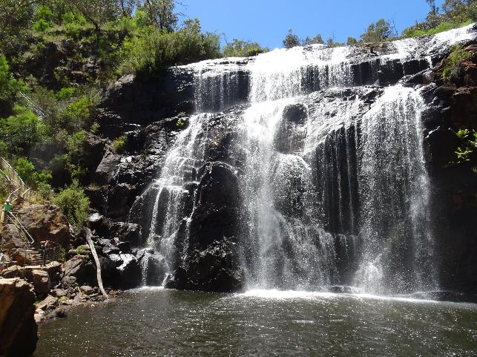

Figure . Mackenzie Falls in the Grampians (Gariwerd) National Park, Victoria

Credit: Australian Platypus Conservancy

2.3.2 Weir walls

A platypus can ascend a vertical or nearly vertical concrete or metal surface only by standing up on its hind legs and using its front legs to lever itself up, which means that a 30-centimetre-high vertical step can serve as a significant barrier (Otley and Le Mar 1998). This means that weir walls and instream vertical concrete drop structures often obstruct platypus movements. Alternatively, a platypus can choose to exit the water to walk around a vertical or nearly vertical surface. The propensity of a platypus to travel around vertical or nearly vertical weir walls is illustrated by the three examples described below. In each case, the degree of difficulty experienced by a platypus when bypassing the weir is expected to be similar to that experienced by a platypus bypassing a natural waterfall of comparable size.

Badger Creek, Healesville Sanctuary, Victoria: Serena (1994) found that longitudinal travel by platypus in Badger Creek was not restricted by a series of three small weir walls, each measuring <2 metres high. When tracked at night, animals characteristically bypassed the weirs by walking around them, re-entering the water within a minute or two. More recently, radio-tracking studies conducted in the same part of Badger Creek found that both young juveniles and adults sometimes occupied burrows located in the creek banks on different sides of a weir on consecutive days, indicating that the animals bypassed the weir during the intervening night (Jessica Thomas, Healesville Sanctuary, pers. comm.). Both studies also found that a platypus will make use of shallow vegetated drainage lines and small gaps under chain-link fencing to travel between the creek and the Healesville Sanctuary display ponds.

Belgrave Lake, Victoria: This small lake, located in Melbourne’s outer-eastern suburbs, has a steep concrete weir wall that is just under 6 metres high (Figure 2). Mark–recapture studies conducted over a 12-year period have confirmed that platypus commonly travel around the weir wall, which is bounded on both sides by vegetated slopes. A total of 31 animals (11 adult or subadult males, 13 adult or subadult females, and 7 juveniles) were captured within 3 kilometres of the weir on two or more occasions within the study period (unpublished data, Australian Platypus Conservancy). Of these, 45% of adult/subadult males and 23% of adult/subadult females were documented to have travelled past the weir wall on at least one occasion.

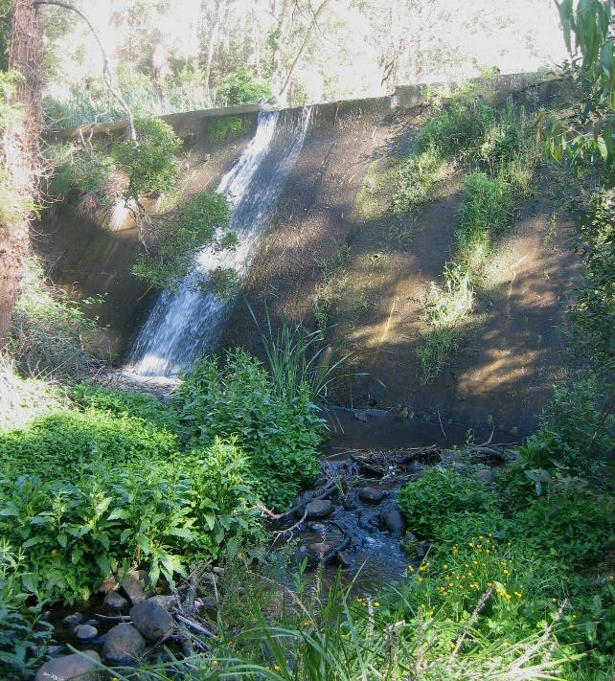

Figure . The Belgrave Lake weir wall in Melbourne’s outer-eastern suburbs

Credit: Australian Platypus Conservancy

Blue Lake, Jenolan Karst Conservation Reserve, New South Wales: A recent study of platypus behaviour, using detailed visual observations and camera technology, found that animals routinely exited the water to travel both upstream and downstream around the steep 10-metre-high concrete weir wall of Blue Lake (Anne Musser and Tom Grant, pers. comm.).

2.3.3 Fishways

The relative advantages and disadvantages of various fishway designs (including rock-ramp, Denil, natural bypass, cone, trapezoidal, and vertical-slot fishways, as well as mechanical fish locks and fish lifts) are discussed in detail by O’Connor et al. (2017b). With the likely exception of fish locks and fish lifts, these designs are predicted to support platypus usage if the design standards recommended by O’Connor et al. (2017b) to promote passage by medium- to large-sized fish are followed, such as adopting a maximum water velocity of 0.3 metres/second (Figure 3). By comparison, a platypus swims most efficiently at a speed of 0.4 metres/second (Bethge et al. 2001).

Mechanical fish locks and fish lifts have mainly been developed for use at large dams. Unfortunately, we predict that a platypus will typically remain within a lock/lift box for only a short period (possibly even less than a minute) before it concludes that there is no way to circumvent the barrier from inside the box, at which point it will leave the box to search elsewhere.

This presumably will greatly reduce the likelihood that a platypus is inside the box when the door shuts and movement is initiated up the weir face. It is important to note that no studies have so far been conducted to investigate how a platypus interacts with *any* type of fishway. More research is needed (see Section 5.3.2) to identify the optimum design criteria and to develop performance indicators and standards for platypus (as recommended for fish by O’Connor et al. 2022).

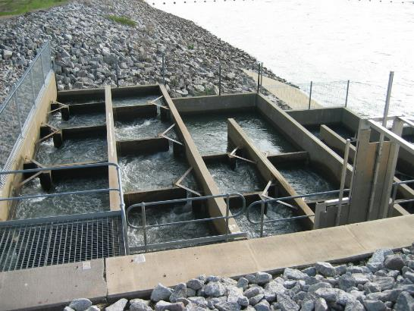

Figure 3. A vertical-slot fishway designed for movement of medium- to large-sized fish presumably should also be navigable by a platypus

Credit: Australian Platypus Conservancy

2.4 Use of weir pools

Platypus occupy both natural lakes and artificial impoundments that have a suitable depth profile. Although a platypus has been recorded diving nearly 9 metres deep while feeding, most foraging activity occurs at a depth of less than 3 metres (McLeod 1993; Bethge et al. 2003; Grant 2004b). An analysis of the spatial distribution of platypus records in New South Wales in the late 1980s revealed that most (88%) of the records associated with 34 large artificial water storage facilities occurred in relatively shallow water in their upper reaches (Grant 2007).

2.5 Barrier-related risks to platypus

2.5.1 Increased mortality

A platypus becomes more vulnerable to predators if it is forced to leave the water and travel across land (Grant 2007). Most of the recent cases of platypus predation in Victoria have been ascribed to foxes (Serena and Williams 2010). Other known predators include the dingo (*Canis lupus dingo*) and the domesticated dog (*Canis lupus familiaris*) (Brown and Triggs 1990; Connolly et al. 1998), the spotted-tail quoll (*Dasyurus maculatus*) (Dawson et al. 2007), and raptors such as the white-bellied sea eagle (*Haliaeetus leucogaster*) (Seale 2008), the wedge-tailed eagle (*Aquila audax*) (Rakick et al. 2001) and the grey goshawk (*Accipiter novaehollandiae*) (Richards 1986). Severe platypus injuries likely to have been caused by a feral or domesticated cat (*Felis catus*) are also occasionally reported (Rosemary Booth, wildlife veterinarian, pers. comm.).

Predation is likely to be a particularly important factor affecting the outcomes of juvenile dispersal. Due to their small size and lack of experience, juveniles are more vulnerable to predators than are older individuals (with juveniles comprising 63% of 16 mortalities due to predation, mainly by foxes: Serena and Williams 2010). Accordingly, the frequency of successful juvenile dispersal is expected to improve if the amount of time spent on land while circumventing instream barriers is minimised.

Motor vehicles can also contribute to platypus mortality, particularly at locations where animals are forced to cross a road to bypass a culvert (Tyson 1980; Taylor et al. 1991; Otley and Le Mar 1998; Mooney and Spencer 2000; Magnus et al. 2004; Serena and Williams 2010). The species may also become entrapped and/or drown in narrow pipes, or in apertures such as gaps in channel gateways (Serena and Williams 2010). Information relating to factors affecting a platypus’s ability to travel through culverts and pipes (associated with weirs or found elsewhere) is presented in Appendix 1.

2.5.2 Genetic considerations: effects of fragmentation and inbreeding

Genetic differentiation of platypus populations located on either side of a major weir wall has been documented in studies of the Nepean Dam (85 metres high) in New South Wales (Kolomyjec 2010), the Lillydale Lake dam wall (440 metres long) in Victoria (Furlan et al. 2013), and five dams ranging in height from 72 to 180 metres (including the Nepean Dam) in New South Wales and Victoria (Mijangos et al. 2022).

In the most comprehensive study to date, Mijangos et al. (2022) found that genetic differentiation on either side of a given weir was, on average, about six times greater than that found across a similar-sized stretch of a matched but undammed river. The amount of genetic differentiation associated with a dam was also found to increase significantly with the length of time since it had been constructed (ranging from 43 to 87 years). However, actual deleterious genetic outcomes of reduced gene flow were not observed: allelic abundance, heterozygosity, and inbreeding of platypus populations located upstream and downstream of a major dam did not differ from their counterparts in undammed rivers.

Even if inbreeding occurs, other genetic studies suggest that impacts on platypus population viability will not necessarily be evident in the short to medium term, i.e. until there is a need to adapt to challenges such as a new disease or novel climatic conditions. For example, Furlan et al. (2012) found that genetic diversity in the small platypus population on King Island in Bass Strait (which has been isolated from Victorian and Tasmanian populations for an estimated 12,000 years) is among the lowest ever recorded in a natural vertebrate population. However, neither physical abnormalities nor poor physical condition were recorded, and the species is now widespread and abundant in all perennial watercourses on the island (Ondrea Richards, King Island Rambles, pers. comm.).

Similarly, Furlan et al. (2012) reported that the platypus population on Kangaroo Island, descended from 16 founders translocated from Victoria in the 1940s, seems to be saturating all available habitat, despite having an effective population size (*N*e, the estimated number of breeding adults contributing genetically to the next generation) of just 10–11 animals. Kangaroo Island platypus are again characterised by normal physical features, and population densities in Breakneck and Rocky rivers are like those reported for creeks of comparable size on the Victorian mainland (Serena and Williams 1997).

Close inbreeding may occur routinely in wild platypus populations (Martin et al. 2018), presumably as an outcome of the species’ polygamous breeding system and longevity of up to 21 years in the wild (Grant 2004a). This in turn provides a plausible mechanism explaining the King Island and Kangaroo Island findings—namely that the platypus genome has been selected over time to reduce the frequency of defective or otherwise poorly adapted progeny when mating occurs between long-lived close relatives. Gradual purging of deleterious alleles has been shown to reduce inbreeding depression in laboratory populations of fruit flies (Swindell and Bouzat 2006), and the same process has been posited to contribute to other species (such as albatrosses) thriving in the wild despite extremely low genetic diversity (Milot et al. 2007).

2.6 Predicted impact of weirs on rakali movements and dispersal

The Australian water-rat or rakali is a much more terrestrial species than the platypus, with individuals known to travel across land for distances of several hundred metres (Gardner and Serena 1995a) or even several kilometres (Vernes 1998) to access offstream impoundments. Rakali have also been heard foraging inside hollow trees (Woollard et al. 1978) and can climb nearly vertical concrete surfaces (Figure 4). Although rakali are at risk of being killed by predators such as foxes or dogs while on land (Gardner and Serena 1995a), large instream structures are unlikely to impede dispersal or otherwise contribute to significant population fragmentation.

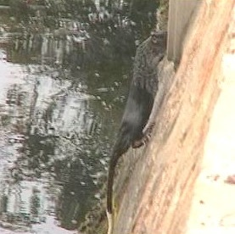

Figure 4. A rakali about to enter a stormwater drain near Melbourne

Credit: Australian Platypus Conservancy

3 Effect of weir features on platypus movement, and suggested mitigation actions

## 3.1 Introduction

A platypus can bypass natural waterfalls more than 30 metres in height and will exit the water to circumvent 10-metre-high weirs (see Sections 2.3 and 2.4). However, direct knowledge of how a platypus behaves when confronted with weirs exceeding 10 metres in wall height and with different design characteristics is scant. Our assessment of how animals interact with specific structural features when moving upstream or downstream has, therefore, been largely informed by what is known or can be inferred from relevant aspects of platypus biology.

As outlined in more detail in Section 2 and Appendix 1, it is *known* that:

* A platypus must stand on a solid surface to reach up to any significant extent while swimming.
* Vertical steps are unlikely to be easily surmounted by a platypus (particularly small dispersing juveniles) if the steps are more than approximately 15 centimetres high.
* Very forceful water flow will hinder or preclude upstream travel by a platypus, particularly if features providing added traction aren’t available.
* A platypus should normally be able to find a place to pass under a fence provided the bottom is raised ≥5 centimetres above the ground, but a buried chain link fence will require a mesh size of more than 70 × 70 millimetres to permit passage by large individuals (Grant et al. 2004).

It is also *inferred* that:

* Dispersing juveniles will be highly motivated to bypass instream barriers.
* Dispersing juveniles may encounter a weir wall while travelling either upstream or downstream.
* A platypus’s first choice will be to move past a weir using a spillway that contains some flow (increasing its confidence that this will lead to surface water in a natural channel), followed by using a dry spillway, followed by travelling across adjoining terrestrial habitats if travel via a spillway is not possible.
* A platypus will seek to avoid travelling through terrestrial habitats offering little protective cover (such as closely mown lawns) to reduce predation risk.
* A platypus will avoid travelling through an area dominated by contiguous large, tumbled rocks (rip rap) if an easier (i.e., less challenging and time-consuming) route is available.

## 3.2 Identifying and mitigating structural features that can impede platypus dispersal

Dams and weirs across Victoria often contain structural features that are expected to impede platypus dispersal. Some problematic structural features of dams and weirs under different flow levels (spilling and not spilling) and suggested mitigation strategies are provided in the examples given below. A total of 28 dams [representing around one-quarter of the large Victorian dams listed by the Australian National Committee on Large Dams (ANCOLD)] were visually assessed to identify structural barriers to platypus movement.

### 3.2.1. Problematic features of spillways

Spillways are defined as structures designed to facilitate the safe release of surplus water from a weir or dam. They are broadly divided into controlled spillways (which are fitted with gates to control how much water is released) and uncontrolled spillways (which release water automatically when water height in the weir pool exceeds the elevation of the spillway crest). Although uncontrolled spillways can take a variety of forms, most are variants of open concrete channels that also incorporate steps or drops to convey water quickly downhill.

Of the 109 large dams located in Victoria or contiguous parts of the Murray River and listed by ANCOLD ([www.ancold.org.au](http://www.ancold.org.au)), as of July 2022:

* 85% (*n* = 93) have uncontrolled spillways
* 8% (*n* = 9) have spillways controlled by gates [e.g., Cairn Curran Reservoir (Figure 8), Lake Glenmaggie, Goulburn Weir].
* 2% (*n* = 2) have combined controlled and uncontrolled spillways (Merrimu Reservoir and Melton Reservoir, Appendix 3, case study 1).
* 5% (*n* = 5) apparently have no spillway (e.g., Kelynack Dam in Melbourne’s north-east, Appendix 3, case study 2).

Structural features that will impede or preclude platypus usage of a spillway to bypass a weir wall include:

* vertical concrete surfaces located at an uncontrolled spillway’s upstream end (see example A, Lake Eppalock)
* vertical concrete surfaces located along the length of a spillway and/or at its downstream end (see example B, Upper Coliban Reservoir)
* steeply sloping spillway surfaces bounded by vertical walls (see example C, Gong Gong Reservoir)
* spillways fitted with flow control gates (see example D, Cairn Curran Reservoir).

Example A. Lake Eppalock, Victoria, has an uncontrolled spillway contained within concrete walls (Figure 5). When the dam is not spilling, the vertical nature of the spillway’s upstream surface and its adjoining boundary walls will prevent a platypus from moving downstream. To rectify this, the most straightforward strategy would be to add or attach an appropriately engineered ramped structure to the vertical spillway surface (either fixed in place or floating, and not necessarily much wider than a platypus) that would allow a platypus to exit the water and climb to the top of the spillway. The sloping distal surface of this spillway crest would allow a platypus to walk down the far side without assistance and continue travel.

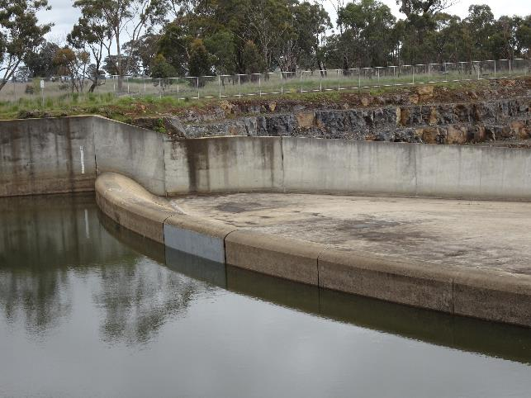

Figure 5. Lake Eppalock spillway crest, viewed from the weir pool end

Credit: Australian Platypus Conservancy

Example B. Vertical to near-vertical concrete surfaces that extend more than approximately 15 centimetres high across the entire width of a spillway and are contained within vertical walls will prevent a platypus from moving upstream and may (depending on step height) discourage or preclude movement downstream. This is well illustrated by the multiple vertical barriers of varying height found along the spillway at Upper Coliban Reservoir (Figure 6). The simplest solution will be *either* to provide appropriately engineered ramps within the spillway (so a platypus can ascend and descend each step safely) *or* to provide ramps at suitable points at the edge of the spillway (so a platypus can exit the spillway and walk up or down the adjoining vegetated slope to bypass the internal barriers).

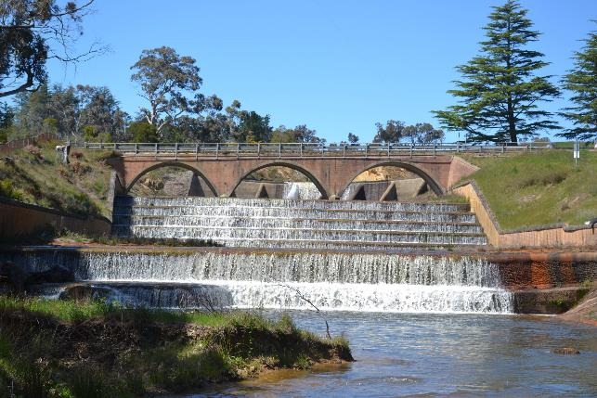

Figure 6. Stepped spillway at Upper Coliban Reservoir, viewed from the downstream end

Credit: Australian Platypus Conservancy

Example C. If the opposing water flow is not too substantial, a platypus could probably scramble up the steep but sloping spillway face located at the downstream end of the uncontrolled spillway at Gong Gong Reservoir (Figure 7). To create a more platypus-friendly structure that encourages movement across a wider range of discharge, consideration could be given to improving traction in the spillway surface (e.g., by scoring horizontal grooves in the concrete to provide footholds). Improving traction would also facilitate downstream travel by a platypus when the spillway is dry. Under the flow scenario shown here, the slanted nature of the drop face, along with the presence of reasonably deep water below the drop, should enable a platypus to move safely downstream.

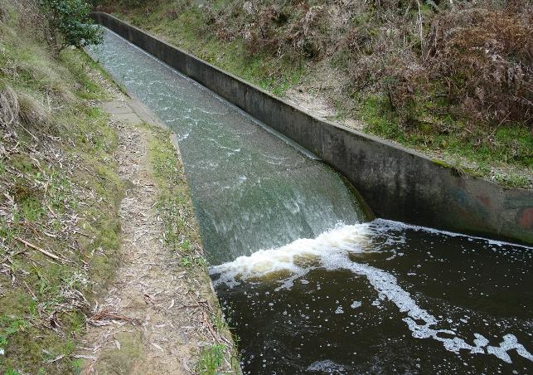

Figure 7. Steeply sloping spillway surface at Gong Gong Reservoir, viewed from the downstream end

Credit: Australian Platypus Conservancy

Example D. There is no obvious structural solution that would allow a platypus to directly utilise a controlled spillway to travel past a weir wall. As shown in the case of Cairn Curran Reservoir (Figure 8), the very forceful and turbulent flow emerging from any opening in the gate that is likely to be wide enough to accommodate a platypus will preclude an animal from moving safely through the opening. Water depth at the inner weir face is also likely to exceed the maximum depth to which a platypus normally descends (see Section 2.4).

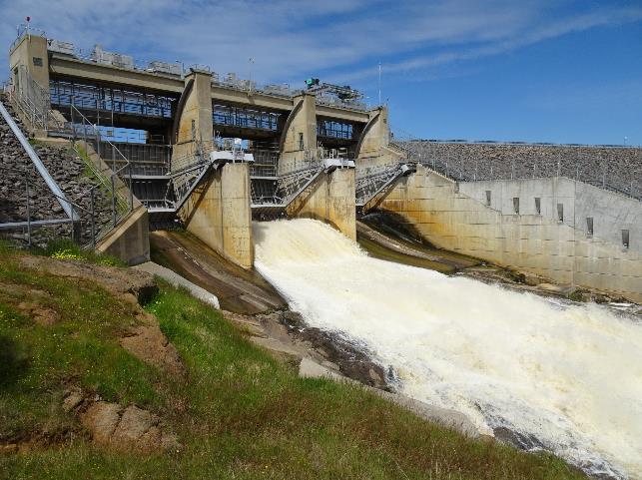

Figure 8. Water being released from Cairn Curran Reservoir via a controlled (gated) spillway

Credit: Australian Platypus Conservancy

**3.2.2. Facilitating platypus movement across land**

If a spillway can’t be used by a platypus to move past a weir wall, the animal’s only option will be to find a terrestrial route to bypass the barrier. Actions that will make it easier for a platypus to travel across land around a weir wall are as follows:

* Provide an inviting place for a platypus to exit the water close to where it encounters a barrier [see examples E and F (Newlyn Reservoir and Pykes Creek Reservoir)].
* Provide adequate cover for a platypus travelling across land (see example G, Tullaroop Reservoir).
* Cater for platypus requirements when installing infrastructure near weirs (see example H, Laanecoorie Reservoir).

Example E. Flat rock surfaces next to the vertical spillway steps at Newlyn Reservoir (Figure 9) provide an easy place for a platypus to enter and exit the water.

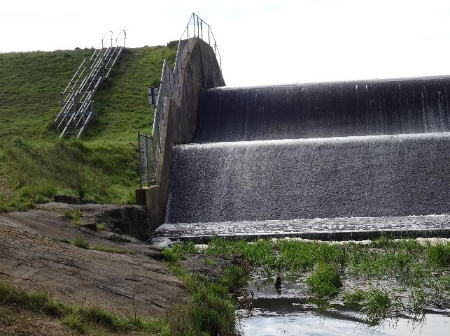

Figure 9. Flat rocks next to the vertical spillway surface at Newlyn Reservoir

Credit: Australian Platypus Conservancy

Example F. The moderately inclined slope at the end of Pykes Creek Reservoir (Figure 10) contains many embedded small rocks and open gravel patches through which a platypus could readily pick a path. This slope doesn’t provide much protective cover, so could be further improved from a platypus’s perspective by allowing some low-growing vegetation to develop.

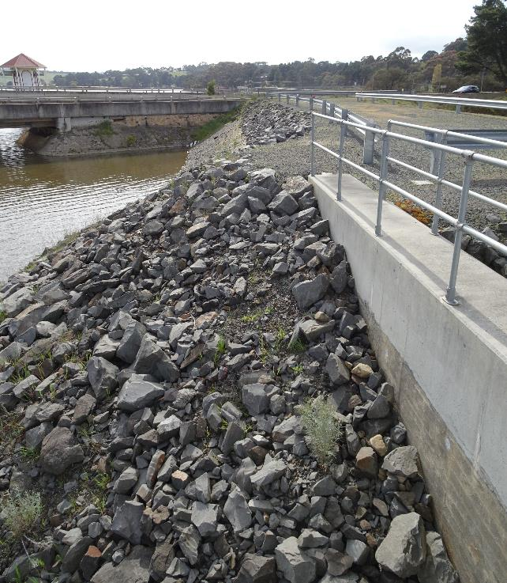

Figure 10. A slope that could be readily traversed by a platypus at Pykes Creek Reservoir

Credit: Australian Platypus Conservancy

Example G. If a platypus must travel a substantial distance across land to bypass an instream barrier, adequate cover in the form of low-to-medium shrubs, grass tussocks, rocks, and logs is essential to provide protection from predators such as foxes and birds of prey. Cover is likely to be of most benefit if it is located where animals are likely to first leave the water. For example, a rock-strewn gutter along the spillway wall at Tullaroop Reservoir (Figure 11) could be improved by encouraging the growth of hardy, low-growing native shrubs along the spillway edge.

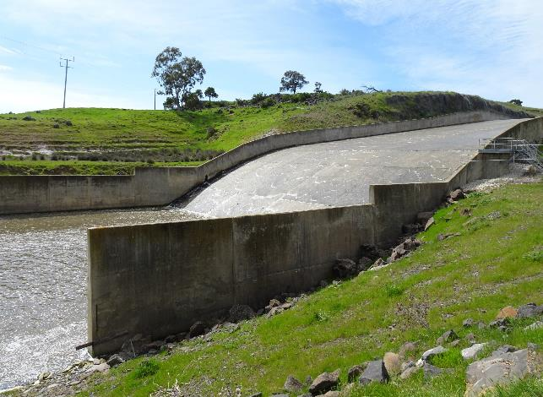

Figure 11. The outer edge of the spillway wall at Tullaroop Reservoir

Credit: Australian Platypus Conservancy

Example H. The fence line at Laanecoorie Weir is designed to exclude humans from accessing a steep bank located just downstream of the weir wall (Figure 12). The bottom of the wire mesh runs just above the ground, and there are (at best) limited opportunities for a platypus to squeeze underneath. Ensuring that gaps (at least 5 centimetres high × 15 centimetres wide) are available at regular intervals below such a fence should make it simpler and faster for a platypus to move around a weir.

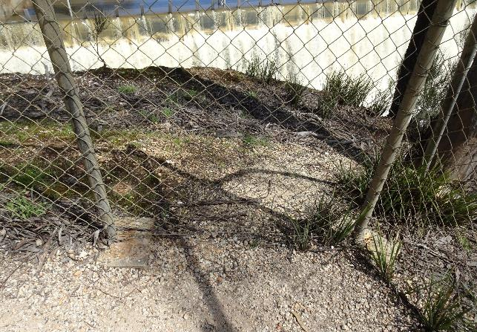

Figure 12. A fence bisecting the route a platypus would likely follow to bypass Laanecoorie Reservoir

Credit: Australian Platypus Conservancy

## 3.3 Attracting flows

No studies have been conducted to confirm that a dispersing platypus will be encouraged to follow a small attracting flow carried by a spillway. However, anecdotal evidence suggests that platypus are motivated to investigate any source of flow. For example, a radio-tracking study conducted approximately 10–11 months after the Hull Road Wetlands (near Melbourne) were built found that tagged platypus occupying the neighbouring creek did not enter the wetlands *except* when a tagged adult male spent approximately 30 minutes there. Rain had fallen on the previous day after a long dry period, prompting some water to start spilling down the wetland’s outlet into the creek. Researchers hypothesised that the new trickle of water had stimulated the male to follow the water to its source (Serena and Williams 2000).

## 3.4 Summary of recommended actions to encourage and facilitate platypus travel past a weir

Other than for mechanical fish locks and lifts, it can be safely assumed that fishways designed to attract and accommodate passage by medium- to large-sized fish are also likely to provide a safe and effective route for platypus movement past a weir (see Section 2.3.3). Having said that, research has not to date been conducted to assess the use of fishways by platypus, and investigation is needed to identify features that will promote platypus usage (see Section 5.3.2).

If a fishway hasn’t been installed at a weir and is unlikely to be built in the foreseeable future, consideration should be given to modifying the weir’s spillway to enable a platypus to travel upstream or downstream during as much of the year as possible (unless the spillway is controlled by gates or is otherwise inherently unsuited to serving as a platypus pathway). The following spillway modification options are suggested:

* Install appropriately engineered ramps or steps to enable a platypus to travel past vertical or near-vertical surfaces along its length (with each riser measuring ≤15 centimetres in height, to facilitate use by dispersing juveniles).
* Improve traction on sloping surfaces within the spillway to assist the ease and efficiency of platypus movement, particularly but not exclusively in the upstream direction.
* Release a small volume of discharge down the spillway as an attracting flow for the species (particularly in autumn and winter, when juvenile platypus dispersal is most likely to occur).

In cases where it is not feasible to facilitate platypus movement along a spillway, provide a reasonably direct and safe route for a platypus to bypass the weir on land:

* Ensure that accessible exit/entry points from/to the water are located both upstream and downstream of the weir, close to where a platypus is likely to seek to leave the water after encountering an intractable barrier in the channel.
* Provide a protected terrestrial route for a platypus to follow that extends from the most likely exit point from the water to the top of the weir slope and then back down the far slope to the water. For example, this could take the form of a ditch or trench that is deep enough to hide a platypus from the view of a nearby fox, with additional cover in the form of overhanging tussock grasses or low shrubs (see Section 2.3.2).
* If a wall or fence bisects a likely platypus route to bypass a weir, incorporate gaps that are large enough for a platypus to pass through or under the barrier (see Sections 3.1 and 3.2.2).

## 3.5 The use of platypus translocation to address weir-related impacts

It is not clear that artificially supporting platypus gene flow via translocation will make a meaningful contribution to platypus population survival at any scale. As discussed in Section 2.5.2, a small platypus population will likely be more vulnerable to extinction as a result of demographic or environmental stochasticity, rather than inbreeding, particularly in the short to medium term. Translocation is, therefore, more likely to be needed to restore platypus populations that have been extirpated or badly depleted by events such as drought or severe fire-related siltation, as opposed to contributing to genetic rescue.

Protocols for platypus translocations have been trialled successfully in recent decades at Warrawong Wildlife Sanctuary in South Australia and at Cardinia Creek in Victoria (Serena and Williams 2004, 2005, 2006, 2007, 2008a). A third translocation project at the Royal National Park near Sydney is due to commence in autumn 2023 and is to be undertaken by researchers from the University of New South Wales.

4. The location of large Victorian weirs in relation to known platypus populations

## 4.1 Introduction

As noted in Section 1, weirs can contribute to platypus mortality by increasing predation risk when individuals are forced to leave the water to bypass weir walls, and by reducing their ability to move to suitable refuge habitats (to cope with catastrophic environmental change due to events such as drought or severe post-fire siltation). Populations that have become fragmented by large weir walls may also become more vulnerable to extinction if population size drops below the number needed for long-term viability (Shaffer 1981), particularly if this is coupled with a low or non-existent frequency of incoming juvenile migrants. In the case of weirs located on a large watercourse in which many animals occur both upstream and downstream, the main impact is most likely to be at the metapopulation scale. Although the risk of local population extinction may not increase much, or at all, in the river system where the weir is located, reduced juvenile migrant movement due to the weir may both impede restocking of other water bodies depleted by adverse events and restrict useful genetic exchange.

To evaluate the degree of impact of a given weir in terms of platypus population fragmentation and extinction risk, information is needed about where the weir is located in relation to where platypus populations occur.

Evidence exists that weir walls measuring up to 6–10 metres in height may be routinely circumvented by a platypus (see Section 2.3.2). We focus here on identifying which of the large Victorian weirs listed in the ANCOLD database (≥10 metres in height, see below) have platypus populations located upstream and downstream and thus may substantially impede population exchange (depending on their design and associated features, see Section 3).

We acknowledge that this approach may miss some substantial structures that, while not meeting the ANCOLD criteria for listing, may nonetheless contribute to platypus population fragmentation (e.g., the Lillydale Lake weir wall in Melbourne’s eastern suburbs: Furlan et al. 2013). The list of dams below is, therefore, best regarded as a reasonably comprehensive starting point for future research and improved management, to be updated as more information becomes available.

As well as identifying which of the ANCOLD-listed weirs in Victoria are currently likely to have platypus populations located upstream and downstream, we summarise other attributes relating to their likely degree of impact as platypus barriers, including weir wall height, the Strahler stream order of the adjoining waterway, whether platypus sightings have been recorded in recent decades on the weir pool, and whether other ANCOLD-listed weirs occur on the same waterway.

## 4.2 Methods

### 4.2.1. Location of large dams in relation to platypus distributional records

ANCOLD maintains a comprehensive database of large dams in Australia, most recently updated in January 2022 (<https://www.ancold.org.au>). The list includes all dams with a structural wall height of >15 metres and dams with a structural wall height of 10–15 metres that also comply with at least one of the following criteria:

* length of crest = ≥500 metres
* reservoir capacity = ≥1 million cubic metres (≥1000 megalitres)
* maximum flood discharge capacity = ≥2000 cubic metres per second.

Excluding dams in the Murray River along the Victorian border (which are managed by New South Wales) and some technically independent but functionally subsidiary structures directly associated with Cardinia Reservoir, the ANCOLD list of dams for Victoria currently comprises 98 structures. To identify which of these dams are currently likely to be associated with a platypus population, we searched for evidence of platypus occurrence [in the form of live-trapping records, eDNA records, or sighting records held by the Atlas of Living Australia (ALA) and/or the Australian Platypus Conservancy (APC)] upstream and/or downstream of each structure since 2000.

Due to the limited number of platypus records available for many rivers across the platypus’s range, we assumed that records were indicative of the species’ occurrence if they originated *either* in the watercourse on which a dam is located *or* one of its directly adjoining tributaries.

For the same reason, we also deemed a dam to be associated with an upstream or downstream platypus population if a second ANCOLD dam is located on the same watercourse and recent platypus records are available for sites on or beyond the second dam, even if they do not exist for the section of channel between the two structures.

In cases for which evidence of platypus occurrence was available in one direction but not the other, and a lack of sightings was plausibly explained by restricted opportunities for human access, we consulted maps (google.com/maps) and other sources of information [including staff employed by water authorities, catchment management authorities (CMAs) and wildlife tour companies] to determine whether reliable platypus habitat is likely to be present and potentially occupied by the species. In this way, we designated three weirs as being likely to have a platypus population located upstream on the grounds that at least two knowledgeable persons independently reported that extensive suitable platypus habitat exists upstream, and they would expect the species to be found there.

Given the sparse nature of both historical and current platypus distributional records, we acknowledge that some ANCOLD-listed dams may have been excluded from our list that do support platypus populations both upstream and downstream (false negatives). We also acknowledge that platypus may have disappeared upstream of some weirs after they were constructed, and that local extinctions may even have occurred in the years since nearby sightings were recorded (false positives).

In particular, we note that the occurrence of platypus upstream of Rocklands Reservoir in the Glenelg River catchment is mainly predicated on a single sighting recorded about 10 years ago at Cherrypool (⁓4 kilometres above the impoundment). Upstream of Cherrypool, the Glenelg becomes a braided channel that is fed by small creeks; it held permanent pools until the early 2000s, but now dries up entirely or almost entirely in summer (Chris Solum, Glenelg Hopkins CMA, pers. comm.). However, Rocklands Reservoir is also connected to the Wimmera River catchment via constructed channels that, in theory, could provide a pathway for population exchange between these two catchments. Accordingly, we consider it appropriate to regard Rocklands Reservoir as a potential barrier to platypus migration, even if very few (or possibly no) animals now routinely reside above the reservoir.

### 4.2.2 Other information pertaining to weir-related fragmentation of platypus populations

Four additional weir-related attributes that are relevant to assessing the risk of local platypus population fragmentation are summarised in this report:

* structural wall height (downloaded from the ANCOLD website in December 2022)
* stream order (Strahler 1957) of the waterway on which a given weir is located [extracted from the database developed by Chee and Elith (2012)]
* platypus sightings on specific weir pools (compiled from records in the Atlas of Living Australia and unpublished records contained on the Australian Platypus Conservancy platypus sightings database)
* occurrence of at least two ANCOLD-listed weirs on a given waterway (determined by the authors, using Google Maps; the distance between neighbouring weirs was estimated using the Google Maps measuring tool).

## 4.3 Results

### 4.3.1. Identification of Victorian weirs deemed most likely to contribute to platypus population fragmentation based on their location

Weirs that are located on a constructed channel or on a river system where platypus populations are not normally found are likely to have minimal or no impact as a platypus barrier.

The same generalisation will generally apply to weirs located high in a catchment and where little or no perennial aquatic habitat occurs farther upstream to support a resident platypus population.

Following on from the analysis outlined in Section 4.2.1, platypus populations are currently deemed likely to occur both upstream and downstream of 35 large Victorian weirs (approximately one-third of those currently listed by ANCOLD), indicating that these are the most likely candidate structures to be acting as barriers to platypus population exchange (Figure 13).

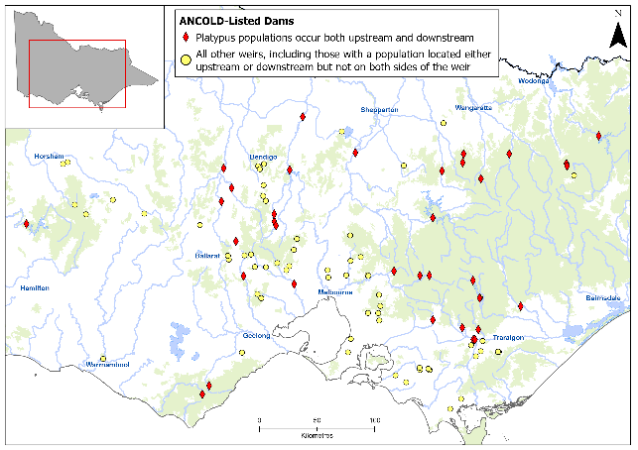

Figure 13. Distribution of major ANCOLD-listed dams in Victoria in relation to known platypus occurrence

See text below and Table 1 for details of how platypus occurrence in association with a given dam was identified.

In the case of 32 weirs, this was based on factual records obtained both upstream and downstream of the structure since 2000. For the remaining 3 weirs (McCall Say, West Barwon and O’Shannassy), platypus occurrence was confirmed downstream but only inferred (though with reasonable confidence) based on habitat availability upstream. In all cases, substantially more platypus distributional records were available for habitats located downstream as opposed to upstream of a weir, so details are only specified for the latter in Table 1.

In terms of their spatial distribution, the Victorian weirs that are deemed to potentially contribute to platypus population fragmentation as an outcome of their location are found in 16 river basins.

Nine river basins contain two or more such weirs: Campaspe (5 weirs), Latrobe (4), Loddon (4), Broken (3), Thomson (3, though the Swingler and Thomson Saddle weirs effectively form one contiguous weir pool), Yarra (3), Goulburn (2), Kiewa (2) and Ovens (2).

Seven river basins contain one potentially problematic weir each (Barwon, Bunyip, Glenelg, Moorabool, Otway Coast, Upper Murray and Werribee).

Table 1. Evidence for platypus occurrence in water bodies located within the same subcatchment and upstream of ANCOLD-listed Victorian weirs

| Catchment | Weir name | Evidence for platypus occurrence upstream of a weir since 2000 | Source |
| --- | --- | --- | --- |
| Barwon | West Barwon | ? | – |
|  | Loombah | 5 animals seen in McCall Say Reservoir on one occasion in 2019 | ALA |
|  | McCall Say | ? | – |
|  | Nillahcootie | 2 sightings (Broken River) in 2005 | ALA |
| Bunyip | Tarago | 10 animals captured (Tarago River) in 2009–2013 | Griffiths et al. 2014a |
| Campaspe | Lauriston | ? (Coliban River between Lauriston Reservoir and Upper Coliban Reservoir) | – |
|  | Upper Coliban | 2 sightings (Coliban River) in 2006, 2013 (ALA); 2 positive eDNA records ⁓2 km upstream in 2017 and 2019, respectively (Coliban River) | Griffiths et al. 2020 |
|  | Malmsbury | 7 sightings (Coliban River) 2004–2020 (ALA); 1 positive eDNA record (Coliban River between Malmsbury and Lauriston weirs) in 2019 | Griffiths et al. 2020 |
|  | Eppalock | 1 positive eDNA record (Campaspe River) in 2017; numerous animals captured in and downstream of Malmsbury (Coliban River) in 2001, 2010 and 2020–2021 | Griffiths et al. 2020; Serena and Williams 2020; Williams and Serena 2021 |
|  | Campaspe | 14 sightings (Campaspe River between Campaspe Weir and Eppalock) from 2002 to 2021 | ALA |
| Glenelg | Rocklands | Sighting recorded ⁓10 years ago at Cherrypool | C. Solum, GHCMA, pers. comm. |
|  | Eildon | Populations known to occupy both the mainstem and upstream tributaries | – |
| Goulburn | Goulburn | Populations known to occupy both the mainstem and upstream tributaries | – |
| Kiewa | Junction | 4 sightings (Rocky Valley Creek) in 2002–2021 | ALA |
|  | Clover | 3 sightings on Clover Dam in 2022 | B. Lacey, AGL Hydro, pers. comm. |
| Latrobe | Blue Rock | 5 sightings (Tanjil River) in 2000–2008 | ALA |
|  | Moondarra | 5 sightings (Tyers River, unnamed tributaries) in 2004–2020 | ALA |
|  | Yallourn Storage | Populations known to occupy both the mainstem and tributaries upstream | – |
|  | Yallourn Weir | 1 sighting (La Trobe River between Yallourn Weir and Yallourn Storage) in 2003 | ALA |
| Loddon | Newlyn | 4 sightings ⁓9 km upstream (at Dean Reservoir) in 2001–2022 | ALA |
|  | Cairn Curran | Populations known to occupy both the mainstem and tributaries upstream | – |
|  | Tullaroop | 2 sightings in Tullaroop Creek near reservoir (2021, 2022); 3 sightings farther upstream (Tullaroop Creek) in 2005–2010; 3 sightings in/near Clunes (Creswick Creek) in 2010–2018 | ALA |
|  | Laanecoorie | 9 sightings (Eddington to 1 km downstream of Baringhup) in 2002–2020; routine sightings at Baringhup since 2019 | ALA; R. Huxley, pers. comm. |
| Moorabool | Bungal/Lal Lal | 1 sighting ⁓0.5 km upstream (at a gauging weir pool) in 2014; several sightings also reported at same site from approximately 2004 to 2009 | ALA; APC, unpublished data |
| Otway Coast | West Gellibrand | 1 sighting ⁓1 km upstream (West Gellibrand River) in 2005 | ALA |
| Ovens | William Hovell | 1 sighting ⁓20 km upstream (King River) in 2016 | ALA |
|  | Buffalo | Numerous captures recorded (Buffalo River) in surveys 2018–2021 | Serena et al. 2022 |
| Thomson | Swingler | 2 sightings (upper Thomson River) in 2005 and 2009 | ALA |
|  | Thomson Saddle | 1 sighting recorded on Thomson Reservoir in 2022 | ALA |
|  | Glenmaggie | 10 animals captured in 2008 in Barkly River and Mount Skene Creek (Serena and Williams 2008c); 13 sightings (Macalister River) in 2004–2022 (ALA) | Serena and Williams 2008c; ALA |
| Upper Murray | Dartmouth | Captures recorded upstream and downstream (Mitta Mitta River) in 2018 | Hawke et al. 2021 |
| Werribee | Melton | 4 animals captured in/near Bacchus Marsh (Werribee River) in 2022 | Serena et al. 2022 |
| Yarra | Maroondah | 3 animals captured 0.2–3 km upstream (Watts River and Contentment Creek) in 2009 | Armistead and Weeks 2009 |
|  | O’Shannassy | ? | – |
|  | Upper Yarra | 1 sighting (Aldermans Creek headwaters) in 2021 | ALA |

In each case, substantial factual evidence exists for the occurrence of platypus farther downstream. ‘?’ indicates that occurrence was inferred based on suitable habitat being present. ‘Populations known to occupy both the mainstem and tributaries upstream’ indicates that multiple platypus sightings or other records exist for watercourses located upstream of the weir since 2000. Sightings are not necessarily detailed if live-trapping records exist. ALA: Atlas of Living Australia; APC: Australian Platypus Conservancy.

### 4.3.2. Weir-related attributes relating to fragmentation of platypus populations: catchment location and platypus use of weir pools

Strahler stream order provides a simple way to gauge the relative location of a weir within a river catchment: the smallest unbranched tributaries at the extreme upper end of a catchment are designated as order 1, with stream order rising by one whenever two watercourses of the same order merge (e.g., a stream segment formed by the merging of two order 4 streams is designated as order 5). In practice, orders 1 to 3 watercourses are generally considered to be headwater streams that are expected to flow intermittently, orders 4 to 6 watercourses are considered to be medium streams that are perennial in most or all years, and order 7 (or higher) watercourses are considered to be rivers. In the context of this report, water bodies are progressively more likely to comprise areas of reliable platypus habitat and hence be capable of supporting viable platypus populations as order number increases. They are also less likely to be subject to reduced platypus carrying capacity caused by adverse climatic conditions or extreme weather events.

Table 2 specifies the Strahler stream order for the watercourses on which the weirs listed in Table 1 are located, and whether platypus activity has been recorded in a given weir pool since 2000. For the reader’s convenience, the nature of the evidence supporting the occurrence of a platypus population upstream of the weir is also briefly described.

The main findings of interest are:

* Platypus sightings have been reported since 2000 in more than half (60%) of the weir pools in Table 2.
* Platypus sightings have been reported in two of the three weir pools for which local knowledge judged a population likely to be present upstream, supporting the predictions of platypus occurrence there.
* Among the weirs where platypus occurrence was inferred upstream, 66% were contiguous with watercourses characterised by a stream order of 4–6 (‘medium streams’); 34% were associated with watercourses characterised by a stream order of ≥7 (‘rivers’).

Table 2. Strahler stream order and platypus use of weir pools at 35 ANCOLD-listed Victorian weirs located between likely platypus populations

| Catchment | Weir name | Watercourse | Stream order | Platypus seen on weir | Platypus presence upstream |
| --- | --- | --- | --- | --- | --- |
| Barwon | West Barwon | West Barwon River | 4 | Yes | ? |
|  | Loombah | Ryans Creek | 4 | Yes | S+ |
|  | McCall Say | Ryans Creek | 4 | Yes | ? |
|  | Nillahcootie | Broken River | 4 |  | S+ |
| Bunyip | Tarago | Tarago River | 5 | Yes | A |
| Campaspe | Lauriston | Coliban River | 5 | Yes | S+ |
|  | Upper Coliban | Coliban River | 5 | Yes | S+, E |
|  | Malmsbury | Coliban River | 6 | Yes | S+, E |
|  | Eppalock | Campaspe River | 7 |  | A, E |
|  | Campaspe | Campaspe River | 10 | Yes | S+ |
| Glenelg | Rocklands | Glenelg River | 7 |  | S |
| Goulburn | Eildon | Goulburn River | 8 | Yes | S+ |
|  | Goulburn | Goulburn River | 16 | Yes | S+ |
| Kiewa | Junction | East Kiewa River | 4 | Yes | S+ |
|  | Clover | East Kiewa River | 6 | Yes | S+ |
| Latrobe | Blue Rock | Tanjil River | 6 | Yes | S+ |
|  | Moondarra | Tyers River | 6 |  | S+ |
|  | Yallourn Storage | Latrobe River | 8 | Yes | S+ |
|  | Yallourn Weir | Latrobe River | 8 |  | S |
| Loddon | Newlyn | Bullarook Creek | 5 | Yes | S+ |
|  | Cairn Curran | Loddon River | 6 | Yes | S+ |
|  | Tullaroop | Tullaroop Creek | 6 |  | S+ |
|  | Laanecoorie | Loddon River | 11 | Yes | S+ |
| Moorabool | Bungal/Lal Lal | West Moorabool River | 5 |  | S+ |
| Otway Coast | West Gellibrand | West Gellibrand River | 4 |  | S |
| Ovens | William Hovell | King River | 5 |  | S |
|  | Buffalo | Buffalo River | 7 |  | A |
| Thomson | Swingler | Thomson River | 6 | Yes | S+ |
|  | Thomson Saddle | Thomson River | 6 | Yes | N.A. |
|  | Glenmaggie | Macalister River | 8 | Yes | S+, A |
| Upper Murray | Dartmouth | Mitta Mitta River | 8 |  | S+ |
| Werribee | Melton | Werribee River | 8 |  | A |
| Yarra | Maroondah | Watts River | 5 | Yes | A |
|  | O'Shannassy | O'Shannassy Creek | 5 |  | ? |
|  | Upper Yarra | Yarra River | 6 |  | S+ |

Yes: ≥1 sighting in the associated weir pool has been recorded since 2000. Presence upstream: S: 1 sighting recorded; S+: ≥2 sightings recorded; A: ≥1 platypus captured in surveys; E: ≥1 positive eDNA record; ?: presence inferred from habitat availability. N.A.: not applicable. Sightings are not necessarily referenced if other data are available. Swingler and Thomson Saddle Weirs comprise contiguous reservoirs, so status upstream is characterised for Swingler only.

### 4.3.3. Weir-related attributes relating to fragmentation of platypus populations: weir height and occurrence of at least two large weirs on a given watercourse

A significant positive relationship has been found to exist between weir height and the likely degree of challenge it presents to a dispersing platypus (see Appendix 2). Similarly, the occurrence of two or more weirs along the same river potentially has implications for platypus population fragmentation, particularly when the amount of channel between the structures is too limited to support a self-sustaining platypus population.

Assuming (reasonably) that connectivity is reduced in an additive or even multiplicative manner across neighbouring structures, improving platypus travel past any given weir may be of limited value unless issues impacting longitudinal movement are also addressed at neighbouring structures.

Table 3 presents the structural wall heights of the 35 ANCOLD-listed weirs located between known or presumed platypus populations in Victoria and identifies which of these structures are associated with other such weirs on the same watercourse.

The main findings of interest are:

* The structural height of ANCOLD-listed weir walls located between known or presumed platypus populations in Victoria ranges from 12 to 180 metres, with 40% measuring <30 metres, 49% measuring 30–69 metres, and 11% measuring 70 metres or more. The last of these categories corresponds to the weir heights that Mijangos et al. (2022) found to be associated with significant genetic differentiation of the platypus populations developing on either side (over periods ranging from 43 to 87 years).
* Two or more ANCOLD-listed weirs are located between platypus populations on eight watercourses in Victoria: Ryans Creek, Coliban River, Campaspe River, Goulburn River, East Kiewa River, Latrobe River, Loddon River, and Thomson River.
* Pairs of weirs separated by a distance corresponding to less than five consecutive adult male home ranges (estimated to be in the order of 35 kilometres, see Section 2.1) include Loombah and McCall Say, Lauriston and Upper Coliban, Lauriston and Malmsbury, Junction and Clover, Yallourn Storage and Yallourn Weir, Cairn Curran and Laanecoorie, and Swingler and Thomson Saddle (which are effectively contiguous).

Table 3. Wall height of 35 ANCOLD-listed Victorian weirs located between likely platypus populations, and occurrence of two or more such weirs on a given watercourse

| Catchment | Weir name | Watercourse | Weir height (m) | Other ANCOLD weir(s) on the same watercourse? | Location |
| --- | --- | --- | --- | --- | --- |
| Barwon | West Barwon | West Barwon River | 43 |  |  |
|  | Loombah | Ryans Creek | 14 | Yes (⁓8 km) | D |
|  | McCall Say | Ryans Creek | 23 | Yes (⁓8 km) | U |
|  | Nillahcootie | Broken River | 34 |  |  |
| Bunyip | Tarago | Tarago River | 34 |  |  |
| Campaspe | Lauriston | Coliban River | 33 | Yes (⁓1.5 km, ⁓8 km) | D, U |
|  | Upper Coliban | Coliban River | 30 | Yes (⁓1.5 km) | U |
|  | Malmsbury | Coliban River | 24 | Yes (⁓8 km, ⁓50 km) | D, U |
|  | Eppalock | Campaspe River | 45 | Yes (⁓50 km, ⁓70 km) | D, U |
|  | Campaspe | Campaspe River | 13 | Yes (⁓70 km) | D |
| Glenelg | Rocklands | Glenelg River | 24 |  |  |
| Goulburn | Eildon | Goulburn River | 83 | Yes (⁓180 km) | U |
|  | Goulburn | Goulburn River | 15 | Yes (⁓180 km) | D |
| Kiewa | Junction | East Kiewa River | 26 | Yes (⁓3 km) | U |
|  | Clover | East Kiewa River | 20 | Yes (⁓3 km) | D |
| Latrobe | Blue Rock | Tanjil River | 72 |  |  |
|  | Moondarra | Tyers River | 41 |  |  |
|  | Yallourn Storage | Latrobe River | 21 | Yes (⁓3 km) | U |
|  | Yallourn Weir | Latrobe River | 12 | Yes (⁓3 km) | D |
| Loddon | Newlyn | Bullarook Creek | 12 |  |  |
|  | Cairn Curran | Loddon River | 44 | Yes (⁓27 km) | U |
|  | Tullaroop | Tullaroop Creek | 41 |  |  |
|  | Laanecoorie | Loddon River | 22 | Yes (⁓27 km) | D |
| Moorabool | Bungal/Lal Lal | West Moorabool River | 49 |  |  |
| Otway Coast | West Gellibrand | West Gellibrand River | 23 |  |  |
| Ovens | William Hovell | King River | 35 |  |  |
|  | Buffalo | Buffalo River | 31 |  |  |
| Thomson | Swingler | Thomson River | 18 | Yes (contiguous) | U |
|  | Thomson Saddle | Thomson River | 36 | Yes (contiguous) | D |
|  | Glenmaggie | Macalister River | 37 |  |  |
| Upper Murray | Dartmouth | Mitta Mitta River | 180 |  |  |
| Werribee | Melton | Werribee River | 35 |  |  |
| Yarra | Maroondah | Watts River | 41 |  |  |
|  | O'Shannassy | O'Shannassy Creek | 34 |  |  |
|  | Upper Yarra | Yarra River | 89 |  |  |

‘Yes’ indicates there are at least two ANCOLD weirs on the same named watercourse (the distance between them is in parentheses). U: the named weir is upstream of an ANCOLD weir on the same (named) watercourse; D: the named weir is downstream of an ANCOLD weir on the same (named) watercourse).

5. Knowledge gaps and priority research areas

## 5.1 Introduction

As articulated elsewhere in this report, very little is currently known (apart from anecdotal and opportunistic observations) about platypus behaviour at instream barriers. Similarly, little is known about how specific management actions will contribute to maintaining platypus population connectivity and thereby promote population resilience, particularly, though not exclusively, when challenged by climate change and extreme weather-related events such as fire and drought.

To help address this situation, in this section we seek to:

* identify key management-related questions concerning the impact of barriers on platypus dispersal
* broadly rate the relative importance of these questions in the context of platypus management
* outline the nature of the research that is likely to be most effective in answering these questions.

## 5.2 High-priority management questions

### 5.2.1 How can existing weir spillways be modified to most effectively facilitate platypus movement along their length and thereby improve population connectivity?

Answering this question will ultimately require both biological input (*How is a platypus’s ability to climb or descend steps or ramps limited by physical factors such as step height and width or ramp texture, length and steepness?*) and engineering input (*What is the most practical design solution to ensure that a given spillway is navigable by a dispersing platypus under a range of discharge scenarios?*).

Suggested research approach: To provide the baseline biological parameters required by spillway designers to take the platypus’s needs into account, one possible approach will be to investigate how a platypus uses steps or ramps in a controlled captive setting, e.g., by introducing a range of structures into the platypus holding facilities at Healesville Sanctuary and using video surveillance to monitor how animals respond. This will ideally test the species’ willingness and ability to scale and descend steps and ramps when they are effectively dry, as well as in situations where an opposing flow is present (e.g., from a hose positioned at the top of the structures).

### 5.2.2 Can platypus be directed to consistently use a relatively protected terrestrial route to travel around a weir and thereby improve population connectivity?

In some cases, it may not be feasible to facilitate platypus travel along the spillway of a dam or weir. Apart from building a fishway (a relatively expensive option), the best alternative may be to provide a reasonably safe route across land that animals can and will adopt to bypass the barrier. As described in Section 2.3, a platypus will leave the water to travel around both natural and constructed barriers, with distinct runways or paths sometimes developing where this routinely occurs (Taylor et al. 1991). Observations of radio-tagged wild platypus suggest that animals preferentially adopt routes across land that reduce their visibility to predators, as exemplified by their use of vegetated ditches and low-lying drainage lines (see Section 2.3.2). However, more information is needed about the best way to encourage a platypus to bypass a weir safely, e.g., by testing strategies through appropriately designed field trials.

Suggested research approach: Camera technology has been successfully used to monitor platypus movement around a weir wall at the Jenolan Karst Conservation Reserve in New South Wales (see Section 2.3.2) and to document platypus activity along a Tasmanian Creek (Simon Roberts and M. Serena, unpublished data), with machine-learning programs increasingly being used to screen footage for relevant images (Hilton et al. 2022). Equipment would ideally be deployed in the first instance at several relatively small weirs where platypus routinely make use of the weir pool and are also known or highly likely to occupy the watercourse found immediately downstream.

### 5.2.3 What is the potential for weir pools to provide platypus habitat and thus serve as drought or post-bushfire refuges under future climate change?

As described in Section 2.4, weir pools may serve as important platypus foraging areas if the depth profile is suitable for use by this species. For example, it has been estimated that Toorourrong Reservoir near Melbourne (surface area ⁓12 hectares, water depth at weir wall ⁓2.3 metres) supported a population of 20–25 animals in the early 2000s, though some animals also made use of adjoining creeks (Easton et al. 2008; Serena and Williams 2008b).

Suggested research approach: In general, the platypus feeds in water that is less than approximately 5–6 metres deep and ideally approximately 1.5–3 metres deep (McLeod 1993; Bethge et al*.* 2003; Grant 2004b). Though water bodies impounded by relatively low weir walls are likely to be most suitable for platypus use, larger weirs may also be used, especially along inlets or where extensive slow-moving water backs up along an incoming creek. Table 3 identifies which of the 35 large Victorian weirs deemed most likely to be associated with platypus populations upstream and downstream have had platypus sightings recorded in the weir pool since 2000. To provide a more detailed assessment of which Victorian weirs are potentially best suited to supporting regular and substantial platypus usage, a desk-top study should be conducted that takes the following points into consideration:

* Do recent reliable reports exist of platypus sightings at a given weir? If so, where have the animals been spotted, e.g., only in the weir’s upstream reaches, near the weir wall, or at a range of locations?
* How much of the surface area of a candidate weir pool and/or its adjoining water course are reliably inundated to a depth of 1.5–6 metres?
* How often is a weir pool likely to be drained or almost drained for management reasons, e.g., to provide flow farther downstream?
* Does a potential platypus source population exist within 5–10 kilometres upstream or downstream of the weir pool?
* If a platypus source population is believed to exist only downstream, to what extent is the weir wall likely to interfere with dispersing individuals being able to access the weir pool? If the weir wall is likely to act as a significant barrier, how easily could this be rectified by modifying the spillway structure or providing a protected route to encourage platypus travel around the weir?

### 5.2.4 To what extent do small instream structures (such as weir walls less than 2 metres high and road culverts) contribute to platypus mortality risk?

Comprehensive databases detailing the locations and many other features of small instream structures have been compiled for many Victorian river catchments. However, there is only limited anecdotal evidence concerning how often a platypus is forced to leave the water to bypass these small instream structures. The distance and time required to bypass a structure are important factors that need to be estimated reliably to assess associated mortality risk.

Suggested research approach: One possible approach is to use time-lapse camera technology (see Section 5.2.2) to record platypus behaviour at a variety of small instream structures and, in cases where an animal leaves the water to bypass a structure, quantify how long it remains out of the water and how far it travels on land. The knowledge gained through camera monitoring could then be used to estimate the amount of time that a platypus is subject to increased predation risk in a representative range of water courses, given the known duration of platypus foraging bouts and length of foraging areas.

## 5.3 Medium-priority management questions

### 5.3.1 What is the current size and status of platypus subpopulations presumed to be isolated by the presence of a weir?

The rate at which genetic diversity declines due to inbreeding and genetic drift in an isolated population is strongly affected by population size, with larger populations being more resistant to loss of alleles than smaller populations (reviewed in Hoffman et al. 2017). In addition, smaller populations are more vulnerable to extirpation due to random environmental variation, natural or anthropogenic catastrophes, or stochastic variation in demographic attributes, such as the adult sex ratio (Shaffer 1981). However, in the case of the platypus, the desirability of assessing the status of small populations located upstream of large weirs must be weighed up against the cost and difficulty of conducting suitable studies (ideally based mainly or exclusively on live-trapping, given that eDNA studies only yield presence-absence data). The likely level of difficulty will be particularly high for waterways with limited road access, as is often the situation upstream of water-supply reservoirs.

Suggested research approach: Based on the above, we believe that a carefully targeted approach to assessing platypus population status upstream of weirs is warranted, with the highest priority being awarded to baseline studies conducted in the lead-up to a weir being modified substantially to facilitate platypus passage.

### 5.3.2 How does platypus usage of fishways vary with their design or the way they are operated (e.g., flow rate)?

Although it can reasonably be assumed that a platypus will be physically capable of travelling along fishways designed to accommodate use by medium- to large-sized fish, platypus behaviour when approaching and using a fishway has never been studied.

Suggested research approach: One possible approach is to use time-lapse camera technology (see Section 5.2.2) to record platypus activity at a representative range of fishways. Enough cameras should be deployed at a given structure (1) to determine how long it takes animals to move through a fishway, (2) to identify whether there are specific features that may promote or inhibit usage, and (3) to potentially provide some insight about the range of flow conditions associated with platypus passage through fishways, particularly when moving upstream.

# References

Armistead, R. and Weeks, A. (2010). *The distribution of platypuses in waterways from greater Melbourne: spring 2008 and autumn 2009 survey results*. Report for Melbourne Water. Cesar, Parkville, Victoria.

Atlas of Living Australia. National Research Infrastructure for Australia. An Australian Government Initiative. <http://www.ala.org.au/> (accessed July 2022).

Australian National Committee on Large Dams (ANCOLD). Reigster of Large Dams Australia – update as at January 2022. [www.ancold.org.au](http://www.ancold.org.au) (accessed July 2022)

Benson, J.A., Close, P.G., Stewart, B.A. and Lymbery, A. (2018). Upstream recolonisation by freshwater mussels (Unionoida: Hyriidae) following installation of a fishway. *Aquatic Conservation: Marine and Freshwater Ecosystems* **28**, 512–517.

Bethge, P., Munks, S. and Nicol, S. (2001). Energetics of foraging and locomotion in the platypus *Ornithorhynchus anatinus*. *Journal of Comparative Physiology B* **171**, 497–506.

Bethge, P., Munks, S., Otley, H. and Nicol, S. (2003). Diving behaviour, dive cycles and aerobic dive limit in the platypus *Ornithorhynchus anatinus*. *Comparative Biochemistry and Physiology A* **136**, 799–809.

Bino, G., Kingsford, R.T., Grant, T., Taylor, M.D. and Vogelnest, L. (2018). Use of implanted acoustic tags to assess platypus movement behaviour across spatial and temporal scales. *Scientific Reports* **8**, 5117.

Brown, G.W. and Triggs, B.E. (1990). Diets of wild canids and foxes in East Gippsland 1983–1987, using predator scat analysis. *Australian Mammalogy* **13**, 209–213.

Chee, Y.E. and Elith, J. (2012). Spatial data for modelling and management of freshwater ecosystems. *International Journal of Geographical Information Science* **26**, 2123–2140.

Connolly, J.H., Obendorf, D.L., Whittington, R.J. and Muir, D.B. (1998). Causes of morbidity and mortality in platypus (*Ornithorhynchus anatinus*) from Tasmania, with particular reference to *Mucor amphibiorum* infection. *Australian Mammalogy* **20**, 177–187.

Dawson, J.P., Claridge, A.W., Triggs, B. and Paull, D.J. (2007). Diet of a native carnivore, the spotted-tail quoll (*Dasyurus maculatus*), before and after an intense wildfire. *Wildlife Research* **34**, 342–351.

De-La-Warr, M. and Serena, M. (1999). Observations of platypus *Ornithorhynchus anatinus* mating behaviour. *The Victorian Naturalist* **116**, 172–174.

Easton, L., Williams, G. and Serena, M. (2008). Monthly variation in observed activity of the platypus *Ornithorhynchus anatinus*. *The Victorian Naturalist* **125**, 104–109.

Faragher, R.A., Grant, T.R. and Carrick, F.N. (1979). Food of the platypus (*Ornithorhynchus anatinus*) with notes on the food of the brown trout (*Salmo trutta*) in the Shoalhaven River, N.S.W. *Australian Journal of Ecology* **4**, 171–179.

Furlan, E.M., Griffiths, J., Gust, N., Handasyde, K.A., Grant, T.R., Gruber, B. and Weeks, A.R. (2013). Dispersal patterns and population structuring among platypuses, *Ornithorhynchus anatinus*, throughout south-eastern Australia. *Conservation Genetics* **14**, 837–853.

Furlan, E., Stoklosa, J., Griffiths, J., Gust, N., Ellis, R., Huggins, R.M. and Weeks, A.R. (2012). Small population size and extremely low levels of genetic diversity in island populations of the platypus, *Ornithorhynchus anatinus*. *Ecology and Evolution* **2**, 844–857*.*

Gardner, J.L. and Serena, M. (1995a). Observations on activity patterns, population and den characteristics of the water rat *Hydromys chrysogaster* along Badger Creek, Victoria. *Australian Mammalogy* **18**, 71–75.

Gardner, J.L. and Serena, M. (1995b). Spatial organisation and movement patterns of adult male platypus, *Ornithorhynchus anatinus* (Monotremata: Ornithorhynchidae). *Australian Journal of Zoology* **43**, 91–103.

Grant, T.R. (2004a). Captures, capture mortality, age and sex ratios of platypuses, *Ornithorhynchus anatinus*, during studies over 30 years in the upper Shoalhaven River in New South Wales. *Proceedings of the Linnean Society of New South Wales* **125**, 217–226.

Grant, T.R. (2004b). Depth and substrate selection by platypuses, *Ornithorhynchus anatinus*, in the lower Hastings River, New South Wales. *Proceedings of the Linnean Society of New South Wales* **125**, 235–241.

Grant, T.R. (2007). *Platypus*, 4th edn. CSIRO Publishing, Collingwood, Victoria.

Grant, T.R., Lowry, M.B., Pease, B., Walford, T.R. and Graham, K. (2004). Reducing the by-catch of platypuses (*Ornithorhynchus anatinus*) in commercial and recreational fishing gear in New South Wales. *Proceedings of the Linnean Society of New South Wales* **125**, 259–272.

Griffiths, J., Kelly, T., van Rooyen, A. and Weeks, A. (2014a). *Distribution and relative abundance of platypuses in the greater Melbourne area: survey results 2013/14.* Report for Melbourne Water. Cesar, Parkville, Victoria.

Griffiths, J., Kelly, T. and Weeks, A. (2014b). *Impacts of high flows on platypus movements and habitat use in an urban stream*. Report to Melbourne Water. Cesar, Parkville, Victoria.

Griffiths, J., Licul, S. and Weeks, A. (2020). *Mapping the distribution of platypuses and blackfish in the upper Campaspe region using citizen scientist and environmental DNA*. Report to Upper Campaspe Landcare Network. EnviroDNA, Parkville, Victoria.

Griffiths, J. and Weeks, A. (2010). Distribution and status of platypuses in the MacKenzie River, autumn 2010. Report to Wimmera CMA by Cesar Consultants, Parkville Victoria.

Hawke, T., Bino, G. and Kingsford, R.T. (2021). Damming insights: variable impacts and implications of river regulation on platypus populations. *Aquatic Conservation: Marine and Freshwater Ecosystems* **31**, 504–519.

Hawke, T., Bino, G., Shackleton, M.E., Ross, A.K. and Kingsford, R.T. (2022). Using DNA metabarcoding as a novel approach for analysis of platypus diet. *Scientific Reports* **12**, 2247.

Hilton, M.L., Goessling, J.M., Knezevish, L.M. and Downer, J.M. (2022). Utility of machine learning for segmenting camera trap time-lapse recordings. *Wildlife Society Bulletin* **46**, e1342.

Hoffman, J.R., Willoughby, J.R., Swanson, B.J., Pangle, K.L. and Zanatta, D.T. (2017). Detection of barriers to dispersal is masked by long lifespans and large population sizes. *Ecology and Evolution* **7**, 9613–9623.

Holland, N. and Jackson, S.M. (2002). Reproductive behaviour and food consumption associated with the captive breeding of platypus (*Ornithorhynchus anatinus*). *Journal of Zoology* **256**, 279–288.

Kolomyjec, S.H. (2010). *The history and relationships of northern platypus (Ornithorhynchus anatinus) populations: a molecular approach*. PhD Thesis, School of Marine and Tropical Biology, James Cook University, Townsville, Queensland.

Kolomyjec, S., Chong, J., Gongora, J., Grant, T., Johnson, C. and Moran, C. (2009). Population genetics of the platypus (*Ornithorhynchus anatinus*): a fine scale look at adjacent river systems. *Australian Journal of Zoology* **57**, 225–234.

Magnus, A., Kriwoken, L.K., Mooney, N.J. and Jones, M.E. (2004). Culvert avoidance by platypuses and subsequent road deaths: workshop aims and outcomes. In: Cooper, C., De Lacy, T. and Jago, L. (Eds). *Reducing the Incidence of Roadkill: Improving the Visitor Experience in Tasmania*. Cooperative Research Centre for Sustainable Tourism, Southport, Queensland.

Marchant, R. and Grant, T.R. (2015). The productivity of the macroinvertebrate prey of the platypus in the upper Shoalhaven River, New South Wales. *Marine and Freshwater Research* **66**, 1128–1137.

Martin, H.C., Batty, E.M., Hussin, J., Westall, P., Daish, T., Kolomyjec, S., Piazza, P., Bowden, R., Hawkins, M., Grant, T., Moritz, C., Grutzner, F., Gongora, J. and Donnelly, P. (2018). Insights into platypus population structure and history from whole-genome sequencing. *Molecular Biology and Evolution* **5**, 1238–1252.

McLachlan-Troup, T.A., Dickman, C.R. and Grant, T.R. (2010). Diet and dietary selectivity of the platypus in relation to season, sex and macroinvertebrate assemblages. *Journal of Zoology* **280**, 237–246.

McLeod, A.L. (1993). *Movement, home range, burrow usage, diel activity and juvenile dispersal of platypuses, Ornithorhynchus anatinus, on the Duckmaloi Weir, N.S.W.* Honours Thesis, Charles Sturt University, Bathurst, NSW.

Mijangos, J., Bino, G., Hawke, T., Kolomyjec, S., Kingsford, R., Sidhu, H., Grant, T., Day, J., Dias, K., Gongora, J. and Sherwin, W. (2022). Fragmentation by major dams and implications for the future viability of platypus populations. *Communications Biology* **5**, 1127.

Milot, E., Weimerskirch, H., Duchesne, P. and Bernatchez, L. (2007). Surviving with low genetic diversity: the case of albatrosses. *Proceedings of the Royal Society B* **274**, 779–787.

Mooney, N. and Spencer, C. (2000). Why did the platypus cross the road? *Australian Mammalogy* **21**, 264.

O’Connor, J., Hale, R., Mallen-Cooper, M., Cooke, S.J. and Stuart, I. (2022). Developing performance standards in fish passage: integrating ecology, engineering and socio-economics. *Ecological Engineering* **182**, 186732.

O’Connor, J., Stuart, I. and Campbell-Beschorner, R. (2017a). *Guidelines for fish passage at small structures*. Arthur Rylah Institute for Environmental Research Technical Report Series No. 276. Department of Environment, Land, Water and Planning, Heidelberg, Victoria.

O’Connor, J., Stuart, I. and Jones, M. (2017b). *Guidelines for the design, approval and construction of fishways*. Arthur Rylah Institute for Environmental Research Technical Report Series No. 274. Department of Environment, Land, Water and Planning, Heidelberg, Victoria.

Otley, H.M. and Le Mar, K. (1998). Observation on avoidance of culverts by platypus. *The Tasmanian Naturalist* **120**, 48–50.

Otley, H.M., Munks, S.A. and Hindell, M.A. (2000). Activity patterns, movements and burrows of platypuses (*Ornithorhynchus anatinus*) in a sub-alpine Tasmanian lake. *Australian Journal of Zoology* **48**, 701–713.

Rakick, R., Rakick, B., Cook, L. and Munks, S. (2001). Observations of a platypus foraging in the sea and hunting of a platypus by a wedge-tailed eagle. *The Tasmanian Naturalist* **123**, 2–4.

Rawer-Jost, C., Kappus, B., Böhmer, J., Jansen, W. and Rahmann, H. (1998). Upstream movements of benthic macroinvertebrates in two different types of fishways in southwestern Germany. *Hydrobiologia* **391**, 47–61.

Richards, G.C. (1986). Predation on a platypus, *Ornithorhynchus anatinus* (Monotremata: Ornithorhynchidae), by a goshawk. *Australian Mammalogy* **9**, 67.

Seale, J. (2008). Sea-eagle take platypus. *Boobook* **25**, 6.

Serena, M. (1994). Use of time and space by platypus (*Ornithorhynchus anatinus*: Monotremata) along a Victorian stream. *Journal of Zoology* **232**, 117–131.

Serena, M., Bloink, C. and Williams, G. (2022). *Werribee River platypus surveys at Bacchus Marsh and Werribee township: summer 2022*. Report for Bacchus Marsh Platypus Alliance and Werribee River Association. Ecology Australia, Fairfield, Victoria.

Serena, M. and Grant, T.R. (2017). Effect of flow on platypus (*Ornithorhynchus anatinus*) reproduction and related population processes in the upper Shoalhaven River. *Australian Journal of Zoology* **65**, 130–139.

Serena, M., Lyon, J.P., Tonkin, Z.D., Lieschke, J. and Williams, G.A. (2023). Differential impacts of a wildfire and post-fire sedimentation event on platypus and fish populations in a Victorian upland river. *Marine and Freshwater Research* **74**, 86–94.

Serena, M., Thomas, J.L., Williams, G.A. and Officer, R.C.E. (1998). Use of stream and river habitats by the platypus, *Ornithorhynchus anatinus*, in an urban fringe environment. *Australian Journal of Zoology* **46**, 267–282.

Serena, M. and Williams, G.A. (1997). Population attributes of platypus (*Ornithorhynchus anatinus*) in Flinders Chase National Park. *The* *South Australian Naturalist* **72**, 28–34.

Serena, M. and Williams, G.A. (2000). *Effects of substantial channel works on platypus behaviour along Olinda Creek (Yarra River catchment): post-works monitoring, summer 2000*. Report to Melbourne Water. Australian Platypus Conservancy, Whittlesea, Victoria.

Serena, M. and Williams, G.A. (2004). *An experimental reintroduction of platypus (Ornithorhynchus anatinus) to Cardinia Creek (April–June 2004).* Report to Melbourne Water. Australian Platypus Conservancy, Whittlesea, Victoria.

Serena, M. and Williams, G.A. (2005). *Reintroduction of platypus (Ornithorhynchus anatinus) to Cardinia Creek: post-release findings (April–May 2005)*. Report to Melbourne Water. Australian Platypus Conservancy, Whittlesea, Victoria.

Serena, M. and Williams, G.A. (2006). *Reintroduction of platypus (Ornithorhynchus anatinus) to Cardinia Creek: post-release findings (March–May 2006)*. Report to Melbourne Water. Australian Platypus Conservancy, Whittlesea, Victoria.

Serena, M. and Williams, G.A. (2007). *Reintroduction of platypus (Ornithorhynchus anatinus) to Cardinia Creek: post-release findings (October 2006–May 2007)*. Report to Melbourne Water. Australian Platypus Conservancy, Whittlesea, Victoria.

Serena, M. and Williams, G.A. (2008a). *Reintroduction of platypus (Ornithorhynchus anatinus) to Cardinia Creek: post-release findings (September 2007–March 2008).* Report to Melbourne Water. Australian Platypus Conservancy, Whittlesea, Victoria.

Serena, M. and Williams, G.A. (2008b). *Distribution and management of platypus in the greater Melbourne region*. Report to Melbourne Water. Australian Platypus Conservancy, Wiseleigh, Victoria.

Serena, M. and Williams, G.A. (2008c). *The status of platypus in flood- and fire-affected catchments in Gippsland, 2008*. Report for Department of Sustainability and Environment and Parks Victoria. Australian Platypus Conservancy, Wiseleigh, Victoria.

Serena, M. and Williams, G.A. (2010). Factors contributing to platypus mortality in Victoria. *The Victorian Naturalist* **127**, 178–183.

Serena, M. and Williams, G.A. (2012). Effect of sex and age on temporal variation in the frequency and direction of platypus (*Ornithorhynchus anatinus*) captures in fyke nets. *Australian Mammalogy* **34**, 75–82.

Serena, M. and Williams, G.A. (2013). Movements and cumulative range size of the platypus (*Ornithorhynchus anatinus*) inferred from mark–recapture studies. *Australian Journal of Zoology* **60**, 352–359.

Serena, M. and Williams, G.A. (2020). *Results of a platypus live-trapping survey along the Coliban River, Malmsbury October 2020*. Report for Malmsbury Landcare Group. Australian Platypus Conservancy, Campbells Creek, Victoria.

Serena, M., Williams, G., Thomas, J. and Worley, M. (1999). Effect of a flood retarding basin culvert on movements by platypus *Ornithorhynchus anatinus*. *The Victorian Naturalist* **116**, 54–57.

Serena, M., Williams, G.A., Weeks, A.R. and Griffiths, J. (2014). Variation in platypus (*Ornithorhynchus anatinus*) life history attributes and population trajectories in urban streams. *Australian Journal of Zoology* **62**, 223–234.

Shaffer, M.L. (1981). Minimum population sizes for species conservation. *BioScience* **31**, 131–134.

Strahler, A.N. (1957). Quantitative analysis of watershed morphology. *Transactions American Geophysical Union* **38**, 913–920. doi:10.1029/TR038i006p00913

Swindell, W.R. and Bouzat, J.L. (2006). Reduced inbreeding depression due to historical inbreeding in *Drosophila melanogaster*: evidence for purging. *Journal of Evolutionary Biology* **19**, 1257–1264.

Taylor, R., Mooney, N. and Lange, K. (1991). Observation on platypus. *The Tasmanian Naturalist* **105**, 1–3.

Thomas, J.L., Parrott, M.L., Handasyde, K.A. and Temple-Smith, P. (2018). Female control of reproductive behaviour in the platypus (*Ornithorhynchus anatinus*), with notes on female competition for mating. *Behaviour* **155**, 27–53.

Tyson, R.M. (1980). Road killed platypus*. The Tasmanian Naturalist* **60**, 8.

Vernes, K. (1998). Observation of a long-range overland movement event by an adult common water rat, *Hydromys chrysogaster*. *Australian Mammalogy* **20**, 409–410.

Williams, G.A. and Serena, M. (2021). *Results of a platypus live-trapping survey along the Coliban River at Malmsbury: March 2021*. Report for North Central CMA and Malmsbury Landcare Group. Australian Platypus Conservancy, Campbells Creek, Victoria.

Williams, G.A., Serena, M. and Grant, T.R. (2013). Age-related change in spurs and spur sheaths of the platypus (*Ornithorhynchus anatinus*). *Australian Mammalogy* **35**, 107–114.

WiIliams, G., Serena, M. and Thomas, J. (1997). *Report on platypus trapping surveys: Ferny Creek (Gilmour Park area), November 1996–January 1997*. Report to Knox City Council. Australian Platypus Conservancy, Whittlesea, Victoria.

Woollard, P., Vestjens, W.J.M. and MacLean, L. (1978). The ecology of the eastern water rat *Hydromys* *chrysogaster* at Griffith, N.S.W.: food and feeding habits. *Australian Wildlife Research* **5**, 59–73.

.Appendix 1 Platypus movement through culverts and pipes

A platypus spends much of its time in underground burrows, so it is not surprising that the animals will enter pipes and culverts. However, usage may be constrained by several factors, including internal width and length, occurrence of overhangs or vertical drop structures at the entrance, and water velocity (especially for animals swimming upstream).

Minimum suitable width. A platypus will enter a PVC pipe that is as little as 10 centimetres in diameter, though animals are apparently unable to back up or turn around in such a confined space and hence may die if the far end is blocked (Taylor et al*.* 1991). To enable a platypus to easily turn around within pipes, we recommend that these should have a minimum internal diameter of 25 centimetres in any place where these are likely to be accessible to the species.

Maximum suitable length (when an air space is available). Based on mark–recapture studies conducted over 3 years, Serena et al. (1999) documented that one-third of a sample of 15 adult or subadult males moved on at least one occasion through a 45-metre-long concrete culvert (1.3 metres in diameter, grade = 1.1%, water depth generally <0.25 metres) carrying creek water through an embankment. In contrast, none of 9 tagged females (which generally have smaller home ranges than males, see Section 2.1) were found to have travelled through the culvert in the same period. Though the culvert did not preclude movement in either the upstream or downstream direction, concurrent radio-tracking studies indicated that animals typically did not enter this structure during routine foraging. In a second case study, the capture of an old male platypus with very worn spurs (but no other individuals) on two occasions in upper Ferny Creek near Melbourne prompted speculation that a small population had become isolated in the creek’s upper reaches after the channel downstream was replaced by a concrete-lined underground tunnel, approximately 2 kilometres in length, in the 1970s. The population presumably dwindled over time as animals died and were not replaced until the male encountered in late 1996 and early 1997 was the sole survivor (Williams et al. 1997). Later surveys in this area failed to capture any animals, not even the old male, indicating that the population was extinct (Serena and Williams 2008b).

Maximum suitable length (when filled). The longest interval that a platypus has been known to hold its breath in an unforced dive is 138 seconds (Bethge et al. 2003), although up to 156 seconds has been recorded in an experimental study (Grant et al. 2004). Though the platypus swims most efficiently at 0.4 metres per second (or 1.4 kilometres per hour) in a captive setting (Bethge et al. 2001), animals in the wild have been recorded swimming at up to 2.4 kilometres per hour (Gardner and Serena 1995b). Assuming that forward progress isn’t reduced unduly by a strong current, the farthest that a platypus should be able to swim in 138 seconds will be around 55 metres (at a speed of 1.4 kilometres per hour) to 83 metres (at a speed of 2.4 kilometres per hour). Accordingly, a platypus may well be at risk of drowning in any structure that is filled with water and more than around 50–80 metres long (and quite possibly much less in the case of young juveniles or animals that are swimming upstream against a current). If a long pipe or culvert is likely to be used routinely by a platypus and may often be filled with water, consideration should be given to incorporating one or more vertical breathing bays along its length.

Maximum suitable water velocity inside a pipe or culvert. A platypus has been observed swimming upstream for a short distance against a current flowing at approximately 1.0 metres per second (3.6 kilometres per hour) in both a fishway and in a natural riffle (Grant 2007), and possibly as fast as 2.4 metres per second (8.6 kilometres per hour) when passing through a culvert (Magnus et al. 2004). Animals should therefore cope quite easily with a maximum water velocity of 0.3 metres per second, as has been recommended for promotion of passage through culverts by medium- to large-sized fish (fish lengths of >100 millimetres) (O’Connor et al. 2017a).

To improve traction for a platypus moving upstream during high post-storm flows, consideration should be given to providing a textured or uneven surface in culverts where possible. In Tasmania, a platypus has been seen using a series of baffles (provided to assist fish passage) as ‘handles’ to help it move upstream, and scratch marks have been noted inside culverts where animals have apparently struggled to progress against the current (Magnus et al. 2004).

Other structural considerations. Otley and Le Mar (1998) concluded that the key feature precluding platypus use of a Tasmanian road culvert was the fact that the culvert pipe protruded 30 centimetres from the road embankment, with a vertical gap of 20 centimetres separating the culvert from the pool below.

Similarly, Mooney and Spencer (2000) found that platypus usage of road culverts in north-central Tasmania was not affected by culvert length, diameter, gradient, internal water depth, or permanency. Instead, usage was mainly limited by accessibility: animals bypassed culverts when entry points were difficult to reach from the adjoining terrain, leading to a greater frequency of road kills.

Accordingly, we agree with O’Connor et al. (2017a) that scouring or perching at culvert entrances should be avoided through appropriate design and maintenance. To promote platypus access (including by small juveniles), drop structures at culvert entrances should feature steps that project less than 15°cm vertically from the adjoining solid horizontal surface and/or have a slanted face (ideally at an angle of less than 30°). For example, the central portion of the concrete step shown in Figure A1 is unlikely to be accessible to a platypus seeking to move upstream, because the adjoining channel is too deep for a platypus to be able to stand up and then reach to the top of the step. However, animals seeking to travel upstream could easily do so by first exiting the water at the left side of the culvert. They should also be able to move downstream quite easily at any point along the step.

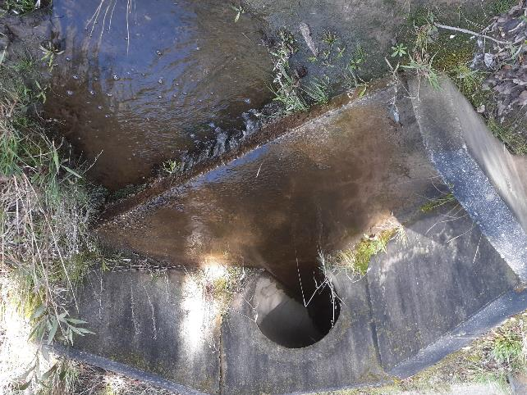

Figure A1. A piped culvert in central Victoria

Credit: Australian Platypus Conservancy

Appendix 2 Study methodology used to rate weirs as platypus barriers

As part of the current study, we developed an ordinal (5-point) platypus barrier rating system for weirs and a weir description form to provide a standardised framework for visualising and predicting the collective impact of weir features in obstructing platypus movements and dispersal. It is important to note that our weighting of various features was necessarily somewhat subjective, given the limited knowledge available about platypus behaviour at weirs, and further research is needed to confirm the system’s underlying assumptions and general validity (see Sections 5.2.1 and 5.2.2).

The five categories used in our barrier rating system are defined in Table A1. The weir description form used in this study is available at the end of this appendix.

Table A1. Definitions of the five categories used in this study to rate the relative likely impact of a given weir on platypus movements and dispersal

|  |  |
| --- | --- |
| Impact category | Definition |
| 1 | A short and easy route to bypass the weir using a spillway is available throughout the year |
| 2 | Travel across land is required at least some of the time; animal is unlikely to get lost + low additional cost/risk |
| 3 | Travel across land is required at least some of the time; small risk that an animal gets lost + moderate additional cost/risk |
| 4 | Travel across land is required at least some of the time; moderate risk that an animal gets lost + substantial additional cost/risk |
| 5 | Travel across land is required at least some of the time; high risk that an animal gets lost, turns back or is possibly killed |

Twenty-eight (28) weirs were inspected by the authors in October 2022, when most were spilling after recent high to very high spring rainfall. All but two are listed in the register of large dams maintained by the Australian National Committee on Large Dams (ANCOLD). The two exceptions, Hepburn Lagoon and Ord Hill Reservoir, were included due to their geographic proximity to a larger weir. Weirs were selected to provide representative information for a broad range of structures in the greater Melbourne area and regional Victoria. All were characterised using the form provided at the end of this appendix, and the relative degree of dispersal-related difficulty/risk for upstream and downstream travel was assessed based on the rating system described in Table A1. The main findings are as follows:

* The rating system was in most cases easy to apply, with pairs of researchers readily agreeing on the most appropriate value for a given structure. In a few cases, it was concluded that either of two consecutive values might potentially apply (in which case the mean of the two values was assigned).
* Barrier ratings at some weirs differed depending on the direction of platypus travel. For example, a steep sloping step in a spillway was sometimes deemed likely to obstruct movement by an animal travelling upstream but not downstream (see Figure 7).
* Barrier ratings were in some cases predicted to vary with the volume of water discharged down a spillway. Most typically, dispersal was deemed to be straightforward in at least one direction if the reservoir was on the verge of spilling (or spilling to a modest extent) but not otherwise (see Figure 8).
* A highly significant linear relationship was found to exist between weir height and barrier rating. For example, in the case of 22 weirs for which upstream and downstream ratings were the same and wall height was known, linear regression revealed that 38% of the variability in the barrier rating dataset was ascribable to height (*F* = 13.755, *P* = 0.001, adjusted *R*2 = 0.378). The relationship between weir height and barrier rating remained highly significant when the two largest dams included in the dataset (both 89 metres high and identified as having unduly large leverage on the statistical outcome) were removed from the analysis (linear regression, *F* = 13.091, *P* = 0.002, adjusted *R*2 = 0.389) (Figure A2).

Figure A2. The best-fit linear relationship (dotted line) between weir height (from 10 to 52 metres) and its associated platypus barrier rating

See Table A1 for how barrier ratings were defined.

It is not surprising that a positive relationship was found to exist between weir height and the presumed degree of challenge it presents to a dispersing platypus. Taller weirs tend to have longer spillways incorporating sizeable steps that in turn block platypus passage. Terrestrial routes to bypass taller weirs also tend to be longer and more complex, adding to the risk that a dispersing platypus ends up in a cul-de-sac, starts heading in the wrong direction, or encounters a predator. At the same time, it is important to note that some relatively low weirs were assigned a high platypus barrier rating in our study, whereas some relatively high weirs were assigned a moderate rating. In other words, the specific suite of structural details associated with a given weir, along with the outflow volume, can have a substantial impact on a platypus’s presumed ability to bypass a weir.

**THE WEIR ASSESSMENT FORM USED IN THIS STUDY:**

Weir name _________________________________________ Date _______________________

Which end of the weir is described on this page? North South East West

Is a lateral spillway present? YES NO If YES, can it be navigated by a platypus? YES MAYBE NO

If YES, how long is the spillway (to nearest 10 metres)? ____________________

If NO/MAYBE, describe the nature of any problematic structures along the spillway:

Is the weir currently spilling? NO YES (discharge is low–moderate) YES (discharge is high–very high)

If a spillway is NOT present or cannot be navigated, what is the minimum distance from the weir wall to where a platypus is likely to enter/exit the water **on the reservoir side** (to the nearest 10 metres)? ___________________

Describe the most likely route from the water to the bank top as a series of consecutive segments (estimate length if possible) of the following substrates: LTR = large tumbled rock, FR = flat rocks set into soil/concrete, ROAD = paved roadway/carpark, HOG = other hard surface or gravel/bare soil, LAWN = mown grass, VEG = non-lawn vegetation providing >20% cover):

What is the overall estimated degree of slope?

SHALLOW MODERATE STEEP VERTICAL/NEARLY SO

If a spillway is NOT present or cannot be navigated, what is the minimum distance from the weir wall to where a platypus is likely to enter/exit the water **on the downstream side** (to the nearest 10 metres)? ____________________

Describe the most likely route from the water to the bank top as a series of consecutive segments (estimate length if possible) of the following substrates: LTR = large tumbled rock, FR = formed rock set into soil/concrete, ROAD = paved roadway/carpark, HOG = other hard surface or gravel/bare soil, LAWN = mown grass, VEG = non-lawn vegetation providing >20% cover):

What is the overall estimated degree of slope?

SHALLOW MODERATE STEEP VERTICAL/NEARLY SO

PLATYPUS BARRIER RATING: for an animal moving upstream______________

for an animal moving downstream_______________

*(Scale* = *1–5, where 1* = *easy/fairly short spillway route, 2* = *animal cannot really get lost while on land + low additional cost/risk, 3* = *small risk that animal gets lost on land + moderate additional cost/risk, 4* = *moderate risk that animal gets lost on land + substantial additional cost/risk, 5* = *high risk that animal gets lost/turns back/dies)*

**Are there any structural/management changes that could readily be made to reduce the barrier rating?**

Appendix 3 Case studies of selected dams

Several case studies have been selected to illustrate the variety of weirs and dams that occur across Victoria and the different risk ratings that were applied at the time of site visits (see Appendix 2). Various descriptors are provided for these case studies, including the function of the dam, the location of the dam in relation to a river, the presence of platypus populations upstream and downstream of the structures, and other features to provide context for the application of risk ratings and potential mitigation strategies. Dimensions and other dam details have been sourced from the ANCOLD database (ANCOLD 2022).

**Case study 1: Melton Dam**

Melton Dam is located on the Werribee River. The dam was assessed under high-flow conditions, so some additional imagery was sourced to provide further information on the features of the dam wall, spillway, and surrounding areas under low-flow conditions.

Location of dam: onstream (Werribee River)

Primary function of dam: water storage for irrigation

Storage capacity: 17 gigalitres

Dimensions of dam wall: structural height = 35 metres; crest length = 181 metres

Description of dam: The dam has a long, lateral ungated spillway located at the edge of a steep, stepped dam wall with steep upstream and downstream banks on both sides (Figures A3 and A4). Banks have limited vegetative cover, with much of the area concreted on both sides of the dam (Figures A3, A4 and A5).

Significance for platypus management: small platypus populations are present both upstream and downstream of Melton Reservoir, so this weir may both impede dispersal and contribute to population fragmentation.

Assessment of platypus movement:

* Obstacles to a platypus moving downstream along the spillway

*It is unlikely that a platypus could navigate the spillway in the downstream direction when outflow is high due to the volume of water. Navigation may be possible when flow is low to moderate; in the absence of any outflow, animals will probably not be able to ascend the concrete lip at the start of the spillway.*

* Obstacles to a platypus moving upstream along the spillway

*It is unlikely a platypus could navigate the spillway in the upstream direction when outflow is high due to the excessive volume of water.*

*Upstream navigation may be possible when flow is low to moderate but would require some climbing of instream rocks and concrete surfaces, some of which may prove too steep.*

*When the spillway is dry, upstream navigation may be possible, though animals may be discouraged from doing so by the long, exposed nature of the route (Figure A5), which will also contribute to mortality risk due to predation.*

* Challenges associated with a platypus moving across land to bypass the weir

*The downstream end of the reservoir is bounded on either side by steep, bare concrete surfaces, which will discourage platypus movement either upstream or downstream.*

*It is possible a platypus could travel across land to bypass the spillway and the dam wall via the central area between the edge of the weir wall and the spillway (Figure A3).*

Barrier rating: 5 (very problematic) for a platypus moving either upstream or downstream

Recommendations for facilitating platypus movement:

Improve vegetation cover between the edge of the dam wall and the spillway to promote use of this route and increase the animals’ safety while they are on land. Due to the scale of the dam infrastructure, e.g. extensive walls and concreted areas, it is unlikely that an engineering solution could further facilitate platypus movement; however, this could be confirmed with further investigation when the dam is not spilling.

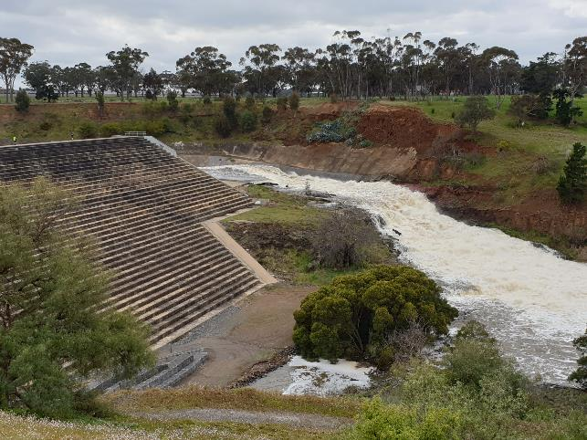

Figure A3. Melton Dam in high flow in September 2022, showing stepped wall and spillway

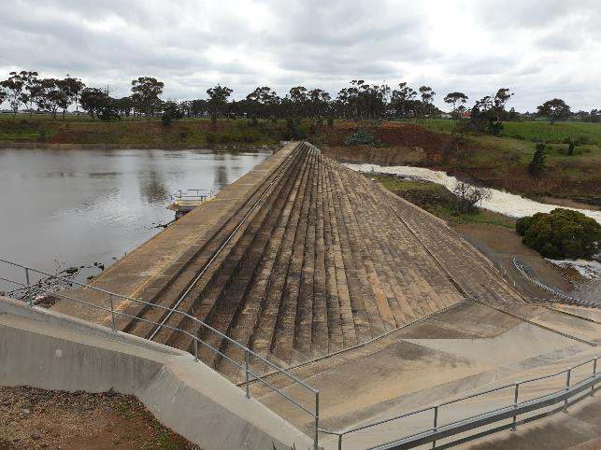

Figure A4. Melton Dam showing stepped wall with surrounding extensive concreted areas

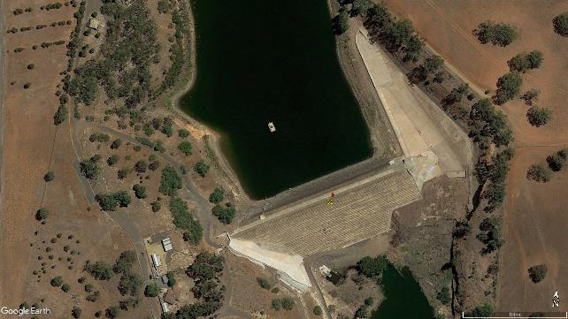

Figure A5. Aerial view of Melton Dam under low flow, showing exposed spillway

**Case study 2: Kelynack Dam**

Kelynack Dam is located near the middle reaches of the Plenty River in a reserve northeast of Melbourne.

Location of dam: onstream (tributary of Plenty River)

Primary function of dam: flood control/management of urban runoff (not specified)

Storage capacity: 0.15 gigalitres

Dimensions of dam wall: structural height = 35 metres; crest length = 200 metres

Description of dam: This off-stream embankment dam lacks a spillway and is separated from the Plenty River by a long, steep, lawned slope approximately 100 metres long (Figures A6 and A7). At the upper end of the dam, there is an associated road and a short, steep lawned slope. A small culvert drain is present at the lower end of the dam, which was mostly dry at the time of the assessment, apart from some water pooling near the outlet (Figure A8). The dam area is fenced, with evidence of animal incursion underneath fencing observed (Figure A9).

Significance for platypus management: The adjoining Plenty Gorge Parklands supported a breeding platypus population up until at least the early years of the Millennium Drought, with females comprising half of animals captured in surveys from 1995 to 2002 (Serena and Williams 2008b). Though the population has apparently since declined, recent sightings indicate that it is still extant and could potentially benefit from the provision of additional foraging habitat in a weir pool if this was readily accessible.

Assessment of platypus movement:

* Obstacles to a platypus travelling via a spillway

*Not applicable—this is an embankment dam and is not fitted with a spillway.*

* Challenges associated with moving across land to access the weir

*The occurrence of steep, mown slopes between the weir and the river mean that a platypus is unlikely to find the weir in the absence of an attracting flow.*

*The lack of vegetative cover in the form of tall grass tussocks or shrubs on the slopes would expose any platypus moving between the river and the weir to predators and the risk of other misadventure.*

*The dam area is fenced and generally lacks sufficient gaps to facilitate platypus passage.*

Barrier rating: 5 (very problematic) in relation to the difficulty of the weir being successfully located by a platypus; 4 (moderate risk, substantial energy cost) in relation to routine usage

Recommendations for facilitating platypus movement:

Action is needed both to draw the attention of platypus to the weir’s existence (via a seasonal attracting flow) and to improve safe access by leaving a small gap underneath fencing around the dam and providing an appropriate route with significantly enhanced cover for animals to move between the river and the weir. A small culvert located at the bottom of the dam (Figure A8) could be used by platypus to enter the dam but may be reliant on the presence of surface water in the channel to encourage movement.

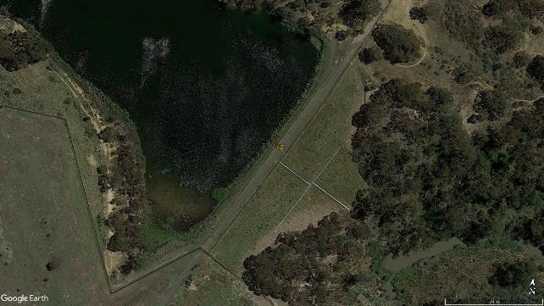

Figure A6. Aerial view of Kelynack Dam, with steep, lawned slope down to the Plenty River highlighted (red circle)

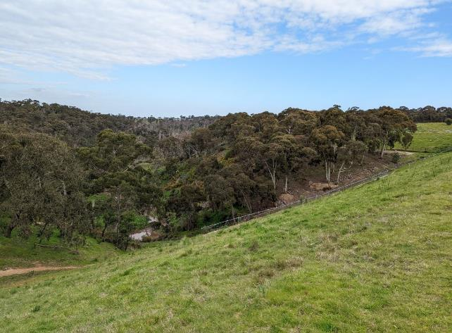

Figure A7. Kelynack Dam, showing steep, lawned slope down to the Plenty River (refer to red circle in Figure A6 as reference point)

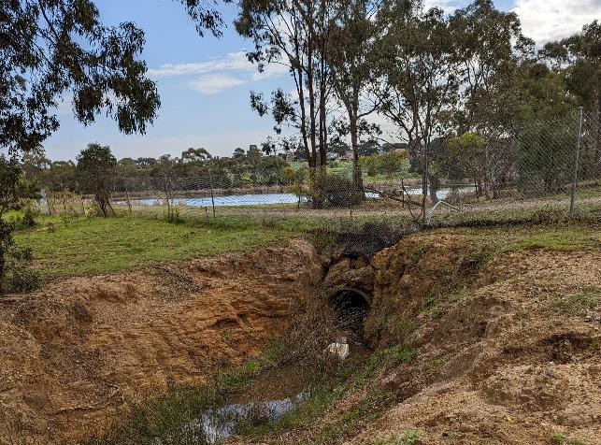

Figure A8. Culvert emerging from lower end of Kelynack Dam, showing some water pooling near the outlet

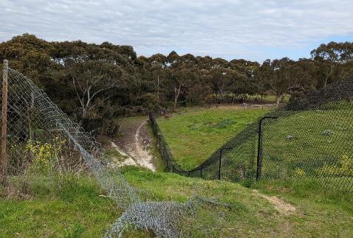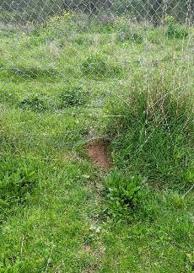

Figure A9. Fencing around Kelynack Dam (left), showing animal path evident under one fence (right)

**Case study 3: Yan Yean Dam**

Yan Yean Dam is a large, offstream dam located north-east of Melbourne.

Location of dam: offstream

Primary function of dam: water supply

Storage capacity: 33 gigalitres

Dimensions of dam wall: structural height = 10 metres high; crest length = 963 metres

Description of dam: Yan Yean Dam is a sizeable structure largely surrounded by forest, with some open and agricultural areas present on the western side (Figure A10). A long, open, paved spillway (~250 metres) is located at its southern end (Figures A11 and A12). The spillway narrows into a channel formation further downstream (Figure A13). The dam is fenced to exclude visitors using an adjoining recreation reserve (Figures A11, A12 and A13).

Significance for platypus management: Yan Yean Reservoir is located upstream of Plenty Gorge Parklands, with nearby parts of the Plenty River frequently ceasing to flow in summer. Although local platypus numbers are too low to support routine movement between the Plenty River and Yan Yean Reservoir, the possibility that Yan Yean Reservoir might potentially support a small resident platypus population will depend in part on identifying a suitable route to enable surplus juveniles to disperse from this dam to the broader Yarra catchment via Plenty River.

Assessment of platypus movement:

* Obstacles to a platypus moving downstream along the spillway

*It is likely a platypus could navigate the spillway in the downstream direction with relatively low risk to the animal when some flow is present in the channel—at most, animals would have to venture along just a few metres on land to bypass structures at the start of the spillway.*

* Obstacles to a platypus moving upstream along the spillway

*It is likely a platypus could navigate the spillway in the upstream direction with relatively low risk to the animal when some flow is present in the channel—at most, animals would have to venture along just a few metres of land to bypass structures at the start of the spillway.*

* Challenges associated with moving across land to bypass the weir

*Minimal difficulties are likely to arise (Figure A11).*

Barrier rating: 2 (low risk) for a platypus moving either upstream or downstream when the dam is spilling. Mortality risk will be higher when the spillway is dry, due to the absence of overhanging vegetation or other protective cover in or along the spillway margins.

Recommendations for facilitating platypus movement:

Establish overhanging vegetation cover, in the form of grasses and shrubs, along the spillway to provide more cover for platypus moving upstream and downstream, thereby reducing predation risk.

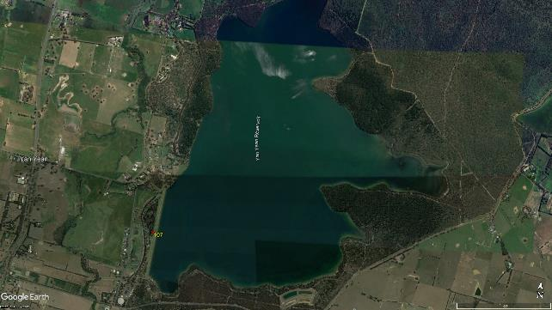

Figure A10. Aerial view of Yan Yean Dam

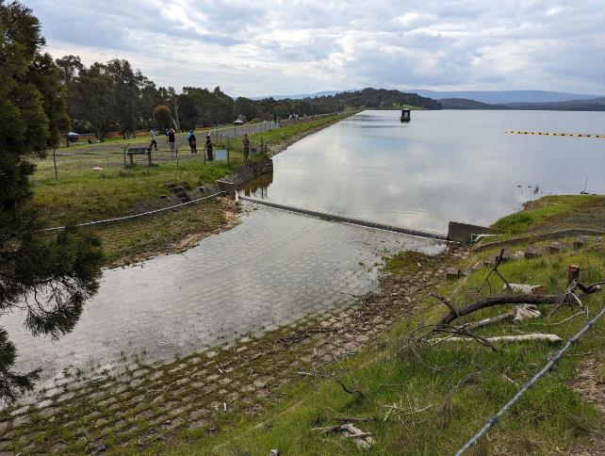

Figure A11. Yan Yean Dam showing paved spillway, surrounding fencing, and nearby recreation reserve

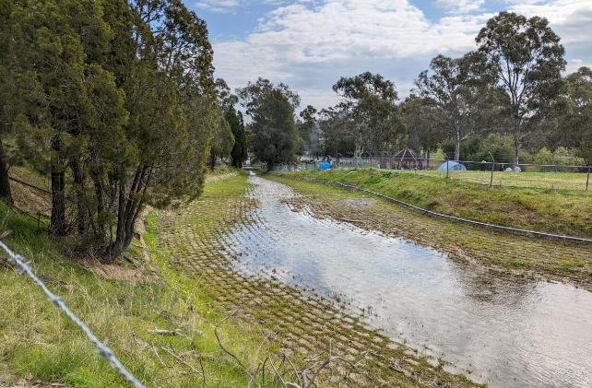

Figure A12. View of paved spillway just downstream of Yan Yean Dam

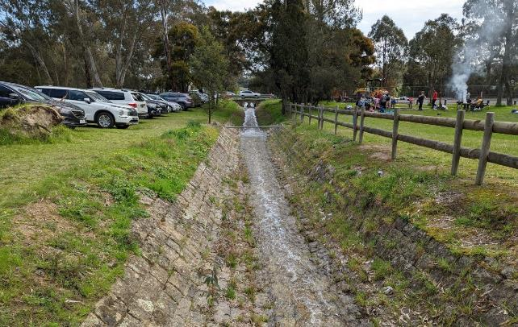

Figure A13. View of narrow area of open spillway downstream of Yan Yean Dam, showing vehicle parking and recreation use

# 

www.deeca.vic.gov.au

www.ari.vic.gov.au