VEFMAP Stage 6

Part A: Program context and rationale

October 2017

Arthur Rylah Institute for Environmental Research

and

Integrated Water and Catchments Division, DELWP

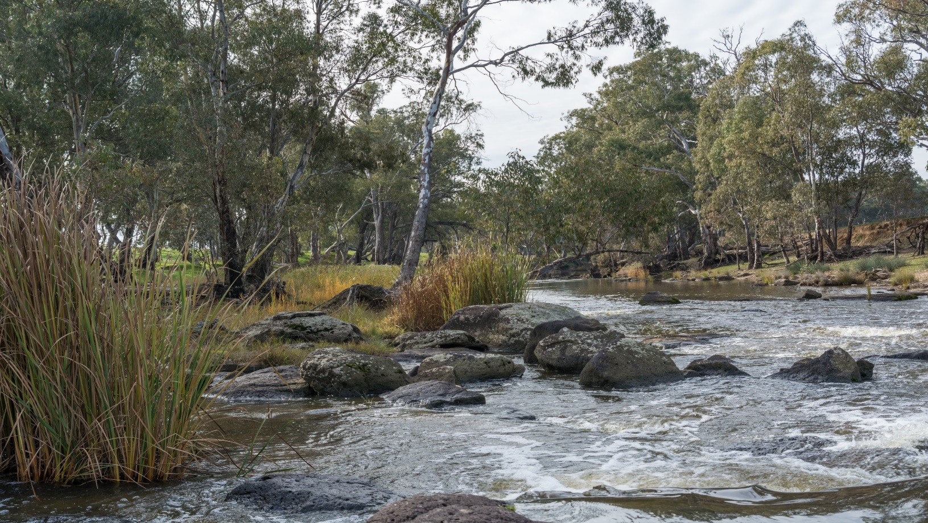

**VEFMAP Stage 6 Part A: Program context and rationale**

**Report produced by:** Arthur Rylah Institute for Environmental Research  
Department of Environment, Land, Water and Planning  
PO Box 137  
Heidelberg, Victoria 3084

**and**

Integrated Water and Catchments Division  
Department of Environment, Land, Water and Planning  
8 Nicholson Street, East Melbourne, Victoria 3002

Website: [www.delwp.vic.gov.au](http://www.delwp.vic.gov.au)

With assistance from

Peter Cottingham, Peter Cottingham and Associates

|  |
| --- |
| © The State of Victoria Department of Environment, Land, Water and Planning 2017  LogoThis work is licensed under a Creative Commons Attribution 4.0 International licence. You are free to re-use the work under that licence, on the condition that you credit the State of Victoria as author. The licence does not apply to any images, photographs or branding, including the Victorian Coat of Arms, the Victorian Government logo and the Department of Environment, Land, Water and Planning (DELWP) logo. To view a copy of this licence, visit <http://creativecommons.org/licenses/by/4.0/>  ISBN 978-1-76047-922-0 (print)  ISBN 978-1-76047-923-7 (pdf)  **Disclaimer**  This publication may be of assistance to you but the State of Victoria and its employees do not guarantee that the publication is without flaw of any kind or is wholly appropriate for your particular purposes and therefore disclaims all liability for any error, loss or other consequence which may arise from you relying on any information in this publication.  **Accessibility**  If you would like to receive this publication in an alternative format, please telephone the DELWP Customer Service Centre on 136186, email [customer.service@delwp.vic.gov.au](mailto:customer.service@delwp.vic.gov.au), or via the National Relay Service on 133 677 [www.relayservice.com.au](http://www.relayservice.com.au). This document is also available on the internet at [www.delwp.vic.gov.au](http://www.delwp.vic.gov.au). |

**Citation**: DELWP (2017) VEFMAP Stage 6 Part A: Program context and rationale. A report by Arthur Rylah Institute for Environmental Research and Integrated Water and Catchments Division, Department of Environment, Land, Water and Planning, Victoria.

**Contents**

Summary 1

1 Purpose of this document 2

2 VEFMAP Stage 6 objectives 3

3 Context 4

3.1 VEFMAP in the Victorian monitoring and reporting context 5

3.2 Key learnings from previous VEFMAP stages 7

3.3 Scoping VEFMAP Stage 6 7

4 Key Evaluation Themes 9

4.1 Native Fish Theme 9

4.2 Aquatic and River Bank Vegetation Theme 14

5 Sampling sites and program design 23

5.1 Sampling sites 23

5.2 Monitoring design 23

6 Program management 25

6.1 Governance 25

6.2 Health and Safety 26

7 Program review and evaluation 27

8 Communication and Reporting 28

9 Data and information management 30

9.1 Quality assurance and quality control 30

9.2 Data handling and storage 30

9.3 Audit procedures 31

10 Adaptive management 32

10.1 Benefits of an adaptive management framework 32

10.2 Reporting and ongoing engagement with CMAs 33

11 References 34

Appendix 1: Conceptual model of habitat processes and flows developed by Chee et al. (2006) (WQ = water quality) 36

Appendix 2: Conceptual model for fish spawning and recruitment into the juvenile population (developed by Chee et al. 2006) 37

Appendix 3: Example of native fish conceptual models 38

Appendix 4: Summary of native fish objectives for each river system 44

Appendix 5: Full list of potential VEFMAP Stage 6 fish questions 46

Appendix 6: Multi-Criteria Analysis tool 51

Appendix 7: MCA ranked priority fish questions 52

Appendix 8: Native vegetation conceptual models 55

Appendix 9: Vegetation monitoring objectives and potential evaluation questions for each river system 58

Appendix10: Summarised vegetation objectives for each river system 60

Appendix 11: Proposed complementary vegetation research questions 63

**Figures**

Figure 1: Timeline for VEFMAP stages 1-6 5

Figure 2: The adaptive management cycle underpinning the Victorian Waterway Management Strategy (DEPI 2013) 6

Figure 3: Overarching conceptual model underpinning the key drivers and modifiers of fish life-history processes and subsequent population outcomes 10

Figure 4: Conceptual model underpinning the relationship between environmental flows and vegetation response developed in Stage 2 of VEFMAP, reproduced from Chee *et al*. (2006) 17

Figure 5: Overarching conceptual model underpinning the relationship between environmental flows and vegetation response. 18

Figure 6: Conceptual approach to sampling environmetal flow events 24

Figure 7: Components of the VEFMAP data management solution showing flow of data… 31

**Tables**

Table 1: Indicators to address native fish KEQs. 12

Table 2: Types of environmental flows. 14

Table 3: Vegetation types occurring within a river channel. 15

Table 4: Expected termporal responses of aquatic and riparian vegetation to environmental flows. 15

Table 5: List of vegetation KEQs and relevant details for VEFMAP Stage 6. 21

Table 6: Summary of reporting requirements for VEFMAP Stage 6. 29

**Summary**

The Department of Environment, Land, Water and Planning (DELWP) established the Victorian Environmental Flows Monitoring and Assessment Program (VEFMAP) in 2005 and Stages 1-5 were completed in mid-2016. VEFMAP Stage 6 includes a refocus on ‘intervention’ or ‘flow-event’ style questions to help demonstrate the ecological value of water for the environment at catchment, regional and state-wide scales.

The scope and detail of Stage 6 has been compiled in two volumes:

* Part A: Program context and rationale
* Part B: Program design and monitoring methods.

Part A outlines the scope of VEFMAP Stage 6, which will include three years of monitoring and evaluation from 2016/17 until 2019/20, followed by a full analysis and program evaluation in 2020.

The planning for Stage 6 has been based on a strong collaboration between members of DELWP’s Environmental Water team, the Arthur Rylah Institute (ARI), Victorian Catchment Management Authorities (CMAs), the University of Melbourne (UoM) and other key stakeholders.

The environmental flow objectives and evaluation questions related to native fish and vegetation responses included in VEFMAP Stage 6 were developed based on Seasonal Watering Plans (SWPs) (VEWH 2016), Environmental Water Management Plans (EWMPs), and the latest conceptual understanding of native fish and aquatic and riparian vegetation responses to managed water regimes. A shortlist of evaluation questions was ranked in order of their importance using agreed criteria and distributed to CMAs for comment. The project team then worked through the feedback from CMAs and developed a set of refined key evaluation questions (KEQs) for Stage 6 that have high transferability among river reaches and catchments.

KEQs for Stage 6 are directly aimed at demonstrating ecological responses associated with environmental flow events. The combination of clear objectives and consolidated conceptual understanding that underpin the KEQs has also been used to identify indicators (monitoring end points) that will be measured during Stage 6. Details of the study design and sampling methods are provided in *VEFMAP Stage 6 Part B: Program design and monitoring methods* (DELWP 2017).

Earlier stages of VEFMAP have highlighted the importance of good data collection and management practices. VEFMAP Stage 6 will use a refined data management system including QA/QC checks to ensure data collected is accurate, adequate and up-to-date. Stage 6 will also include an updated and comprehensive Communication and Engagement Strategy that will detail clear roles and responsibilities for reporting to ensure effective communication and accountability throughout the life of the program.

VEFMAP Stage 6 represents an exciting way forward for Victoria’s state-wide monitoring of environmental water; the program will operate on a strong foundation of communication and collaboration with CMAs, scientists and other key stakeholders.

# **Purpose of this document**

This document has been compiled for the following purposes:

* To provide an Independent Review Panel (IRP) and internal reviewers from the Department of Environment, Land, Water and Planning (DELWP) with adequate information to assess the suitability of the proposed program design for meeting the stated program objectives.
* To provide a summary of the context and rationale for VEFMAP Stage 6 for Victorian Catchment Management Authorities (CMAs) and other interested stakeholders.
* To provide a source and summary of information for use in briefing DELWP Managers, Directors, Executive Directors and the Minister, Water.
* To provide a source and summary of information for use in preparing contracts to complete the monitoring.

The scope and detail of VEFMAP Stage 6 have been compiled into two volumes:

* Part A: Program context and rationale, and
* Part B: Program design and monitoring methods.

# **VEFMAP Stage 6 objectives**

1. Enable DELWP and its water delivery partners to clearly demonstrate the ecological value of environmental water management to the community and water industry stakeholders.
2. Fill knowledge gaps to improve planning, delivery and evaluation of environmental water management in rivers across Victoria.
3. Identify ecosystem outcomes from environmental water to help meet Victoria’s obligations under the Murray-Darling Basin Plan (Schedule 12, Matter 8).

VEFMAP Stage 6 includes three years of monitoring and evaluation, from 2016/17 to 2019/20, followed by a full analysis and program evaluation in 2020.

# **Context**

The acquisition and delivery of environmental water by the Victorian and Commonwealth Governments represents a significant investment in aquatic ecosystem health and rehabilitation. The Victorian Environmental Water Holder (VEWH) currently holds approximately 634 GL of environmental water in Victoria (long-term average), while the Commonwealth Environmental Water Holder (CEWH) holds an additional 543 GL.

Maximising the efficiency and effectiveness of environmental water use requires clear ecological objectives and an adaptive management framework that builds on evidence and key learnings from environmental watering outcomes.

With this in mind, the Victorian Environmental Flows Monitoring and Assessment Program (VEFMAP) was established to investigate ecosystem responses to environmental flows and to provide new information that can adaptively support flow-management decisions.

Following Stage 1 development in 2005, VEFMAP was refined in 2006 (Stage 2). Monitoring commenced in 2007 in eight regulated rivers across Victoria (Stage 3; 2007-2016). In 2010, staff at the University of Melbourne (UoM) secured an Australian Research Council (ARC) linkage grant to complete a detailed analysis of VEFMAP data (Stage 4; Miller *et al*. 2014). The most recent phase of VEFMAP (Stage 5; 2015-2016) has involved further analysis and reporting of VEFMAP data and results to date, along with development of the scope and monitoring design for Stage 6 (Figure 1). A Stage 5 report is currently being finalised by the Arthur Rylah Institute (ARI) (ARI 2017; in prep.).

Based on the combined experience of implementing VEFMAP over many years, and particularly in light of the Stage 5 outcomes, ARI and the UoM recommended that VEFMAP Stage 6 include the following:

* Revision of the VEFMAP approach by developing a series of regional and system-specific objectives and hypotheses with stakeholder input.
* The use of best-available knowledge to develop testable regional flow-ecology hypotheses.
* Selection of key indicators to evaluate the responses of fish and vegetation, focussing on those flow parameters (hydrology and hydraulics) and ecological processes (e.g. spawning, recruitment, movement) that govern fish and vegetation communities.
* Development of regionally appropriate methods, such as flow-event based monitoring, to measure fish and vegetation responses to support the hypotheses.
* Continued analysis and evaluation of existing data to confirm flow-biota relationships to inform more effective delivery of environmental flows and future monitoring programs.
* Clear and comprehensive stakeholder communication and engagement.

The proposed approach to VEFMAP Stage 6 has closely followed these recommendations and is strongly aligned with DELWP’s intervention monitoring approach (section 3.1).

Monitoring for VEFMAP Stage 6 is intended to run from late 2016 to early 2020 under EC4. The three main components of the VEFMAP Stage 6 monitoring phase will include:

* Intervention monitoring with refined hypothesis testing for native fish and aquatic and river bank vegetation outcomes.
* Adaptive management to inform operational watering decisions.
* Clear and comprehensive stakeholder communication and engagement.

Stage 6 monitoring outcomes will also contribute to reporting for Matter 8, Schedule 12 of the Murray-Darling Basin Plan and address significant knowledge gaps in our understanding of ecosystem and population responses to environmental flows.

Stage 1

**2005**

Outline of the framework for VEFMAP and its objectives

Stage 2

**2006-2007**

Development of general conceptual models of flow ecology relationships

Development of river specific monitoring programs.

Stage 4

**2010-2014**

(ARC Linkage Project)

Selection of end points for analysis

Development of a detailed conceptual model for each end point

State wide analysis of flow ecology relationships

Stage 5

**2015**

Continued analysis

Simplified conceptual models

Evidence consolidation

Formalise broader framework

Scope Stage 6

Stage 3

**2007-2016**

Collection of monitoring data on all rivers

Analysis of short term data by CMAs to inform short-term decision making

Funded by EC3

Stage 6

**2016+**

*This Project:*

Adaptive management of environmental water delivery in Victoria.

Funded by EC4 and Murray-Darling Basin Plan

Figure 1: Timeline for VEFMAP stages 1-6.

## VEFMAP in the Victorian monitoring and reporting context

VEFMAP Stage 6 is consistent with the adaptive management framework identified in the Victorian Waterway Management Strategy (DEPI 2013, Figure 2). The program has been designed on the proviso that aspects of the monitoring design may change depending on outcomes of sampling undertaken throughout the life of the program. The program itself will be continuously monitored and improved to ensure it is meeting objectives in an efficient and demonstrable manner.

Additionally, the proposed approach to VEFMAP Stage 6 aligns strongly with the intervention monitoring approach supported by DELWP’s Integrated Water and Catchments’ (IWC) Waterways Branch.

There is common agreement amongst waterway researchers and managers on the need to evaluate environmental responses to waterway management using three approaches: research, long-term condition monitoring and intervention monitoring (short- to long-term programs). DELWP currently oversees a number of state-wide long-term condition monitoring programs including the Index of Stream Condition and the Index of Wetland Condition; an Index of Estuary Condition is currently under development, with the first benchmark of Victorian estuaries to be measured in 2019/20.

VEFMAP Stage 6 is one of a set of intervention monitoring programs overseen by DELWP. Riparian and Wetland Intervention Monitoring Programs (RIMP and WIMP) are in implementation and development phases, respectively. These long-term programs aim to evaluate the effectiveness of riparian and wetland management and will demonstrate responses to different management approaches. DELWP is also currently implementing a state-wide wetland monitoring and assessment program for environmental watering (WetMAP). WetMAP represents a short-to-medium term intervention approach and will monitor a subset of Victoria’s wetlands, from each CMA region, before and after environmental water delivery.

The focus of VEFMAP Stage 6 is primarily short-to-medium term intervention-based monitoring. Long-term condition data will be collected annually at each of the target rivers to provide necessary supplementary information to support the intervention-based monitoring. Additionally, some research-based questions will be included where appropriate.

VEFMAP Stage 6 will complement other monitoring programs and research currently underway across Victoria and throughout the Murray-Darling Basin (e.g. the CEWH’s Long-term Intervention Monitoring Program and Environmental Water Knowledge and Research program; Victoria’s Fisheries Report Card monitoring; and the Murray-Darling Basin Authority’s The Living Murray program). Data provided through VEFMAP Stage 6 will also be used as part of DELWP’s Flagship Waterways program. Other opportunities for collaboration with other agencies and/or programs will be explored as projects are developed and synergies identified.

VEFMAP data will be analysed annually and results will be provided to CMA waterway managers and the Victorian Environmental Water Holder (VEWH) to help guide decisions regarding environmental water delivery. Workshops and regular discussions between the DELWP Program Management team, the project team at ARI, CMAs and the VEWH will help managers to correctly interpret results and ensure well-informed adaptive management.

Clearly communicating the benefits of environmental water to the broader community is an important goal for VEFMAP Stage 6. To this end, a program-specific Communication and Engagement Plan was developed early in 2017; the Waterway Health branch was consulted during this development phase to ensure a consistent approach to communication between branches of DELWP’s IWC. Socio-economic and shared benefits from environmental watering will provide an important part of the message to Victorian communities.



Figure 2: The adaptive management cycle underpinning the Victorian Waterway Management Strategy (DEPI 2013).

## Key learnings from previous VEFMAP stages

Environmental outcomes demonstrated from the VEFMAP Stage 3 monitoring phase are outlined in Miller *et al*. (2014).

In summary, analysis of data from VEFMAP Stage 3 showed system-scale, condition-style monitoring has limited ability to detect outcomes from environmental watering for short-to-medium term data sets. It is now more broadly recognised that this approach to monitoring may yield results if data sets span 10+ years; however, directly attributing ecological responses to environmental flows is still likely to be difficult if relying only on this approach.

A complete review of the program at the end of VEFMAP Stage 4 (see Cottingham *et al*. 2014) recommended that future monitoring should focus on the monitoring and analysis of native fish and riparian vegetation responses to environmental flows. The focus on these attributes was considered appropriate, given that native fish and riparian vegetation are key ecosystem components and are of direct interest to environmental water managers.

Complementary projects conducted during Stage 5 used an intervention-style approach, examining fish spawning responses before, during and after environmental water delivery. Results from these projects provided sound evidence for a response by fish to environmental flows (e.g. Amtstaetter *et al*. 2016). Stage 5 also involved the refinement of conceptual models to develop testable, regional, flow-ecology hypotheses for native fish and riparian vegetation (see section 4.2, this volume; and section 2, *VEFMAP Stage 6 Part B,* DELWP 2017).

As a result of this work, the focus of VEFMAP Stage 6 is to conduct intervention-based monitoring that will enable improved understanding of responses in the short-to-medium term, while continuing data collection that will allow long-term evaluation. Data collection will focus on the two key evaluation themes: native fish and aquatic and river bank vegetation, recommended from the Stage 4 review. Population demographic data will be collected annually to provide necessary supplementary information to support the intervention-based monitoring. The locations of this condition-style monitoring will focus on specific sites and river reaches of relevance to the intervention-based monitoring and KEQs. Data from this annual condition monitoring (along with other complementary programs such as Victoria’s Fisheries Report Card) will continue to build the VEFMAP Stage 3 long-term data set, which is a widely valued as a means of informing changes in fish population demographics over time.

## Scoping VEFMAP Stage 6

Stage 6 planning involved a strong collaboration between DELWP’s Environmental Water team, ARI, CMAs, UoM and other key stakeholders.

During Stage 5, representatives from DELWP, ARI, CMAs, UoM and other key agencies attended workshops and responded to questionnaires to plan the way forward and provide suggestions for monitoring questions for VEFMAP Stage 6 (see Cottingham *et al*. 2014; Miller *et al*. 2014; Sharpe 2014). This input was essential for understanding CMA needs and areas of interest.

Based on this consultation process, and in conjunction with the latest scientific understanding of ecological responses to changes in flow regimes, ARI and UoM developed a shortlist of potential key evaluation questions (KEQs) for native fish and vegetation. These questions were further refined through workshops, individual meetings with CMAs, and independent expert advice.

Particular care was taken to ensure all suggestions for monitoring questions were based on state-wide and regional objectives for environmental water delivery outlined in Seasonal Watering Plans (SWPs; VEWH 2016), Environmental Water Management Plans (EWMPs) and MDBP Long-Term Watering Plans (LTWPs).

This process ensured that VEFMAP Stage 6 focuses on both state-wide and regionally relevant KEQs that are explicitly linked to Victoria’s current objectives for environmental water.

In summary, key tasks completed during the Stage 6 scoping phase included:

* Development of a series of regional and system-specific objectives and evaluation questions.
* Selection of key indicators to evaluate the responses of fish and vegetation, focussing on flow parameters (hydrology and hydraulics) and ecological processes (spawning, recruitment, movement) that govern fish and vegetation communities.
* Development of regionally appropriate methods, such as flow-event based monitoring, to measure fish and vegetation responses.
* Continued analysis and evaluation of existing data to confirm flow-biota relationships, to inform more effective delivery of environmental flows and future monitoring programs.
* Development of KEQs that are:
  + regionally focused and relevant to CMAs;
  + highly transferable, where possible, among rivers in order to maximise the benefits at broad geographic scales (notwithstanding the point above);
  + realistically answerable and able to demonstrate the value of environmental water for engaging local, regional and potentially state-wide stakeholders;
  + based on the latest conceptual understanding of ecological responses to flow; and
  + weighted toward flow-driven population processes (e.g. dispersal, spawning, recruitment, vegetation cover).

# **Key Evaluation Themes**

## Native Fish Theme

To assist the development of KEQs relating native fish population responses to environmental watering, conceptual models were developed using best-available scientific information. Detailed conceptual models were developed in Stage 2 of VEFMAP (Chee *et al*. 2006; Appendix 1 and 2). Although some progress has been made towards understanding these links already, the generalised nature of these models (which were not system or species specific), substantial knowledge gaps and the uncertainties of some links mean many of the responses require further examination. As such, a general conceptual model has been developed (Figure 3), which incorporates more recent understanding of links between fish populations and system drivers at a broad level (e.g. MDFRC 2013) along with a compilation of recent species-specific information to consolidate the current scientific understanding of the life cycle of target native fish species and their response to different water regimes (developed as part of several expert panel workshops (Koehn *et al*. in prep; see Appendix 3 for example). A series of diagrammatic conceptual models to represent specific processes being investigated for each KEQ was also developed (see section 2, *VEFMAP Stage 6 Part B,* DELWP 2017). Together, this information provided a sound scientific base for developing evaluation questions that could be addressed through the Stage 6 VEFMAP program.

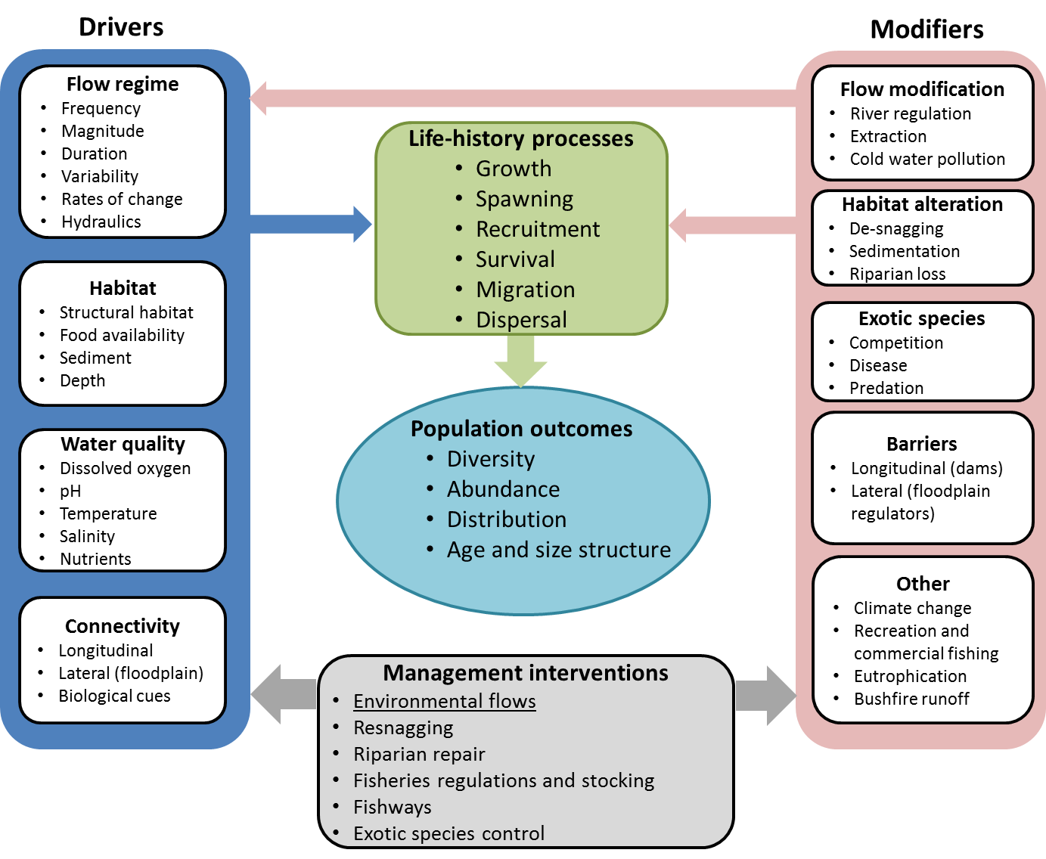

Figure 3: Overarching conceptual model underpinning the key drivers (dark blue) and modifiers (pink) of fish life-history processes (green) and subsequent population outcomes. Example of management interventions (including environmental flows) influencing these drivers and modifiers also included. Important attributes of each driver, modifier, life-history process, population outcome and interventions provided as bullet points.

Objectives and KEQs

Broadly, objectives for native fish monitoring in VEFMAP Stage 6 focus on:

1. the importance of environmental flows to promote immigration, dispersal and subsequent recruitment of diadromous fish in Victorian coastal rivers, and
2. the importance of environmental flows to promote population growth via immigration, dispersal, recruitment and survival in northern Victorian rivers.

As mentioned, objectives for native fish outcomes were based on SWPs, EWMPs, LTWPs, CMA specific objectives for priority rivers, and the current scientific conceptual understanding of native fish responses to flow. A summary of native fish objectives for each river system can be found in Appendix 4.

Based on this information, a shortlist of 12 native fish evaluation questions were identified (Appendix 5). A multi-criteria analysis (MCA) ranked the importance of the 12 questions against a range of criteria (Appendix 6), which then provided a baseline for stakeholder discussion and expert review. As a result, a list of four high priority KEQs were selected for native fish.

|  |  |  |
| --- | --- | --- |
| **Coastal Catchments** | **KEQ 1** | Do environmental flows promote immigration by diadromous fishes in southern Victorian coastal rivers? |
|  | **KEQ 2** | Do environmental flows enhance dispersal, distribution and recruitment of diadromous fishes in southern Victorian coastal rivers? |
| **Northern Catchments** | **KEQ 3** | Do environmental flows support immigration of native fish into, and dispersal throughout, northern Victorian rivers? |
|  | **KEQ 4** | Does environmental flow management used for large-bodied species enhance: (i) survival and recruitment, (ii) abundance, and (iii) distribution? |

The selected questions (and subsequent methods) were deemed likely to have high transferability among reaches, catchments and potentially fish species. Detailed information against each of the 12 previously short-listed questions, including CMA feedback, can be found in Appendix 5 and 7.

Scale of assessment and indicators for monitoring

The scale of assessment and indicators that will be measured to evaluate the four selected native fish KEQs are summarised in Table 1, below.

Variability and modifiers

Complementary monitoring data will be collected to aid KEQ analysis, including:

* site specific hydrology and hydraulic details (hydrographs, channel form, flow depth, duration and velocity);
* catch effort (electrofishing seconds, CPUE);
* geo-located site start and finish positions/sample area and location;
* wetted area of depth/structural habitat availability across all study reaches.

Full details of the monitoring methods and sampling locations for VEFMAP Stage 6 are provided in *VEFMAP Stage 6 Part B* (DELWP 2017). Sampling sites and data collected as part of VEFMAP Stage 3 will also be adopted or used, where appropriate, to complement the data collected as part of Stage 6.

**Table 1: Indicators and relevant details to address native fish KEQs**

|  |  |  |  |
| --- | --- | --- | --- |
| Key Evaluation Question | Indicators | Spatial Scale | Logic |
| Coastal Catchments | | |  |
| **KEQ 1.** Do environmental flows promote immigration by diadromous fishes in southern Victorian coastal rivers? | * Post larvae abundance * Distribution * Native species richness | Multiple rivers (coastal)  Reach | Several CMAs are releasing water to estuaries to enhance diadromous fish outcomes but attraction of young-of-year (YOY) has not been formally tested. Data from Dights Falls suggests that marine residency time is influenced by freshwater flows to estuaries. Hence, recruitment of YOY in coastal rivers can potentially be enhanced with freshwater flow cues. |
| **KEQ 2.** Do environmental flows enhance dispersal, distribution and recruitment of diadromous fishes in southern Victorian coastal rivers? | * Post larvae abundance * Distribution * Native species richness | Multiple rivers (coastal)  Reach | Several CMAs have reported that upstream dispersal of diadromous fish occurs during/after flow events. Examples are Estuary perch/tupong in Glenelg, tupong/grayling in Bunyip, galaxiids in the Werribee and several spp in the Macalister. By restoring flows and complementary actions (e.g. fish passage) there is potential to restore diadromous fish populations in the middle and upper freshwater reaches of coastal rivers. |
| Northern Catchments |  |  |  |
| **KEQ 3.** Do environmental flows support immigration of native fish into, and dispersal throughout, northern Victorian rivers? | * Post larvae abundance * Post larvae age * Post larvae length * Post larvae weight * Fish condition * Distribution * Genetic fingerprint (adults) * Larvae abundance | Multiple MDB rivers  Reach | In most summers, large numbers of 1-year old golden perch and silver perch migrate from downstream nursery habitats upstream along the Murray adjacent to the Vic/NSW tributaries. These fish then appear to disperse into the upper Murray and NSW/Vic tributaries. Synchronising a small summer rise in Vic. tribs with this summer fish migration may attract fish into Vic tribs and contribute to demonstrable re-colonisation. Initial proof-of-concept has already been demonstrated in the Gunbower and Pyramid systems. |
| **KEQ 4.** Does environmental flow management used for large-bodied species enhance:  (i) survival and recruitment: (ii) abundance and; (iii) distribution? | * Post larvae abundance (CPUE) * Post larvae age * Post larvae length * Post larvae weight * Fish condition * Fish distribution * Genetic fingerprint (adults) * Larval abundance * Native species richness | Multiple MDB rivers  Regional River Reach | With many of Murray-Darling Basin large-bodied fish species being classified as ‘flow generalists’ in terms of their reproductive strategy, the major influence of river flows in governing population trajectories is likely to be around its role in governing survival and recruitment, particularly at early life stages (eggs – juveniles).Indeed, the provision of baseflows and freshes is to maintain aquatic habitat for fish (and other taxa) by maintaining water quality, habitat availability and avoiding stratification in pools within the river.  Several CMAs have prioritised provision of winter flows to maintain connectivity and water quality. There is some evidence that annual winter cease-to-flow events are major recruitment bottlenecks for young native fish. Evaluation of the benefits of winter flows has some merit. |

Constraints to Stage 6 fish monitoring

The following constraints may influence whether monitoring objectives can be achieved:

* dry year scenarios (including drought) can influence important factors such as habitat availability and survival;
* low abundance (current status) of spawning stocks may limit the extent of spawning detected;
* winter shut-down of river systems may lead to low carrying capacity;
* cold water releases from dams during summer-autumn may limit spawning (Koehn *et al*. 2014);
* barriers to fish movement in the Murray-Darling Basin could lead to recruitment failure (Agostinho *et al.* 2008);
* mortality of large bodied fish such as Murray cod through undershot weirs (Baumgartner *et al*. 2006);
* larger in-channel flow peaks, including small floods (5,000-10,000 ML/d), have declined by half in the Murray River over the past 50 years (Maheshwari *et al*. 1995) – these act as migration and spawning cues;
* large numbers of larvae, juvenile and adult fish moving into irrigation channels (Gilligan and Schiller 2003 and Koehn and Harrington 2005);
* reversal of the flow regime in the Murray River (Maheshwari *et al*. 1995); and
* low winter flows in the Murray River increase risk to fish through increased predation, competition, habitat loss, drying, poor water quality, lower egg and larval survival rates and potential lack of flow cues and gonad development in larger fish (Koehn *et al*. 2014).

Limiting or constraining factors have been noted and accounted for, where possible, when designing monitoring projects to assess each KEQ.

## Aquatic and River Bank Vegetation Theme

To assist the development of KEQs relating vegetation to environmental watering, conceptual models were developed using best-available scientific information. Detailed conceptual models were developed in Stage 2 of VEFMAP (Chee *et al*. 2006) and these have been built on and further developed for VEFMAP Stage 6. Vegetation-based conceptual models for environmental flows are largely based on four major components: flow types, vegetation types, channel components and response types.

Flow types

There are many different types of flows within a stream, ranging from no flow to overbank flows (Table 2). Managing environmental flows requires control of the full set or regime of flows in the short and long term. Different flows will influence different parts of the channel and therefore cause different vegetation responses. The specific vegetation response is also likely to vary depending on the time of year.

**Table 2: Types of environmental flows**

|  |  |
| --- | --- |
| Environmental flow type | Details |
| Passing flow | Where a percentage of natural rain-fed inflows to a weir or storage (dam) is allowed to pass straight through, while the rest is retained for storage. |
| Low/Base flow | These generally provide just enough flow to provide a continuous flow through the channel (i.e. no gaps in the stream). |
| Fresh (freshening flow) | A short pulse of water, usually for a few days but up to a month, with water levels above base flows. The height of the flow, the duration, and the speed of build-up and draw-down cause different environmental responses. |
| High flow | A persistent increase in the base flow with water volumes and levels well above that needed to create continuous flow, but not outside the channel, i.e. not overbank flows. |
| Bankfull or overbank flows | Flows that deliberately reach (bankfull) or exceed (overbank) the top of the river bank. Overbank flows will spill out onto the surrounding floodplain. Rarely do environmental flows ever reach bankfull or overbank height. |
| Cease to flow | Where flows are deliberately stopped for a short period of time (typically summer/autumn) to mimic natural flow regimes. |

Vegetation types

River channels contain a spectrum of conditions from very wet to dry, as you move from the centre of the channel to outside the bankfull margin. Brock and Casanova (1997) categorise the vegetation within a channel into distinct groups depending on their preference for inundation and germination triggers. The three main groups from dry-loving to wet-loving are: ‘terrestrial’, ‘amphibious’ and ‘submerged’. The first two groups are further separated into a number of subgroups based on specific characteristics (Table 3).

Each of these different vegetation types will generally occur within a particular part of the river channel that corresponds to the hydrological conditions the plants prefer (Casanova and Brock 2000). The different parts of the channel are commonly divided into three zones: within the water margins during baseflow (Zone A), the lower ‘fringing’ part of the stream bank (Zone B) and the upper part of the bank (Zone C). Zones A and B are the parts of the channel most frequently influenced by river flows and fluctuations in water depth and are therefore the focus of vegetation surveys in Stage 6.

Table 3: Vegetation types occurring within a river channel

|  |  |
| --- | --- |
| Vegetation type | Channel location |
| Terrestrial: | Zone C and B |
| * Dry | Typically Zone C, where plants prefer dryer soils |
| * Damp | Typically Zone B, where plants prefer the fringing damp soils |
| Amphibious: | Zone B and A |
| * Fluctuation responder | Plants grow in response to changes in water level |
| * Fluctuation tolerator | Plants grow in spite of changing water level |
| Submerged: | Zone A, plants grow and reproduce below the water surface |

Response types

Different types of environmental flows result in different vegetation responses; some responses are rapid, while others may not be realised for many months or years after a particular flow event. Table 4 summarises the approximate timing of expected vegetation responses to typical flow events. The ultimate aim of environmental flow management is to support healthy, productive waterways in the long term – but small steps are required to achieve this long-term objective. Understanding the short-term responses and how they accumulate to provide long-term benefits is the key to successful waterway management.

Table 4: Expected temporal responses of aquatic and riparian vegetation to environmental flows

|  |  |  |  |
| --- | --- | --- | --- |
| Time since flow event (e.g. fresh) | Winter/Spring event | Summer/Autumn event | Other key drivers |
| Immediate response (during event) | * Potential damage to existing plants through scouring or drowning. * Distribution of propagules. * Germination trigger for propagules. | * Potential damage to existing plants through scouring or drowning. * Distribution of propagules. * Germination trigger for propagules. * Reduce in-stream salinity. | * Propagule availability * Flow variables inc. turbidity |
| Short-term response (0-3 months) | * Soil wetting provides water for plant growth and reproduction. * Germination of propagules resulting in increased species distribution and/or richness. | * Soil wetting provides water for plant growth, reproduction and survival of juvenile plants. * Germination of propagules resulting in increased species distribution and/or richness. | * Previous and subsequent flow events * Rainfall * Grazing * Plant competition * Soil properties |
| Medium-term response (3-12 months) | * Soil moisture effect ended? * Germinated plants mature resulting in increased cover of specific species. * Increased functional output (food, habitat, soil stability). * Adult plants improved reproductive output. | * Soil moisture effect ended? * Germinated plants mature resulting in increased cover of specific species. * Increased functional output (food, habitat, soil stability). * Adult plants improved reproductive output. | * Subsequent flow events * Rainfall * Grazing * Plant competition * Soil properties |
| Long-term response (12+ months) | * Greater species distribution/richness/cover allow for greater functional output, greater propagule availability, greater resilience against threats | * Greater species distribution/richness/cover allow for greater functional output, greater propagule availability, greater resilience against threats | * Subsequent flow events * Rainfall * Grazing * Plant competition * Soil properties |

Conceptual model summary

A summarised conceptual model for vegetation responses to different flow types was produced in the VEFMAP Stage 2 reports for each focus waterway (Chee *et al*. 2006, Figure 4). Although some progress has been made towards understanding these responses already, many of the responses are still uncertain and require further examination. The proposed monitoring approach for Stage 6 is designed to focus specifically on the parts of the model highlighted in red in Figure 4. In addition to the original conceptual links shown in Figure 4, we are exploring the role of spring freshes in negatively influencing the presence and abundance of terrestrial dry species (particularly exotic species), as shown by the blue arrow and box in Figure 4.

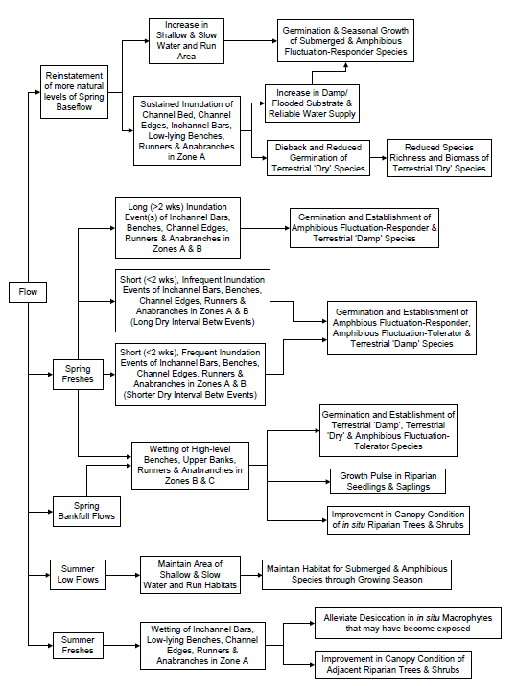

Figure 4: Conceptual model underpinning the relationship between environmental flows and vegetation response developed in Stage 2 of VEFMAP, reproduced from Chee *et al*. (2006). Responses that remain a focus of VEFMAP in Stage 6 are highlighted in red, while new links that are being tested are highlighted in blue.

Figure 5 summarises the bulk of this information diagrammatically and depicts the relationships that will be explored in VEFMAP Stage 6. The model focuses on specific flow events (freshes and high flows) and vegetation occurring on specific parts of the bank (submerged and fringing: zones A and B). This model is still simplistic and ignores a range of additional non-flow variables that will be influential, but it portrays the key drivers and responses that need to be considered and evaluated in order to confirm the potential benefits of environmental flows on vegetation. It is important that flows can be seen as potentially beneficial as well as detrimental to vegetation, depending on their attributes. Manipulation of the total discharge volume as well as the timing and rate of discharge will be important to maximise the beneficial outcomes.

Vegetation responses to flows can occur at a range of organisational levels, from individual plants to species, communities and ‘vegscapes’. Individual drivers will influence each level differently; for example, grazing impacts plants directly at the local scale (plant consumption and trampling) and indirectly at the vegscape scale (reduced propagule availability to downstream reaches).

VEFMAP monitoring aims to determine how environmental flows can be used to influence whether or not the aquatic and riverbank vegetation at a given location will become healthier or degraded through time. Degraded vegetation indicators include decreases in native vegetation cover, distribution or diversity, increases in exotic vegetation cover, distribution or diversity, reduced plant health, reproductive output and resilience. Monitoring programs can be designed to survey any one or more of these indicators that best reflect the desired outcomes of the intervention.

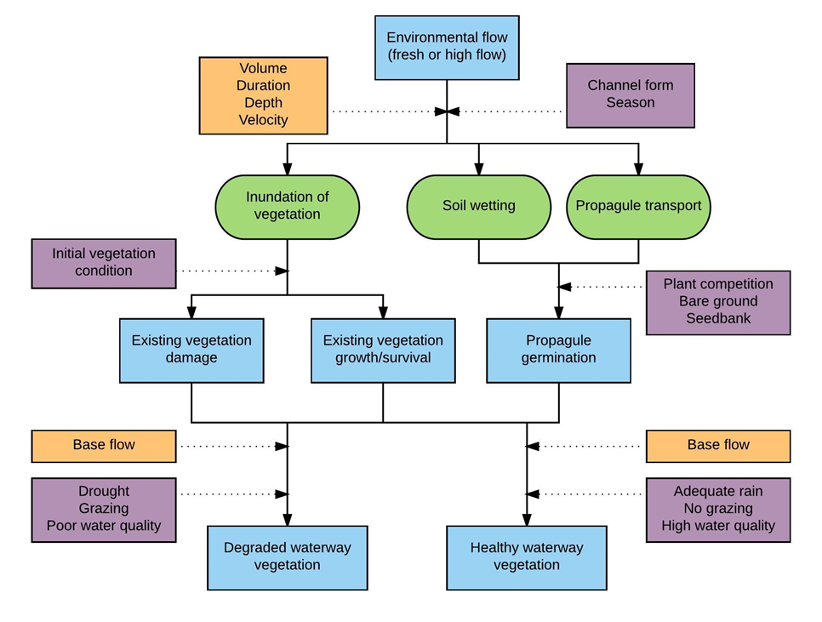

Figure 5: Overarching conceptual model underpinning the relationship between environmental flows and submerged and fringing vegetation response. Environmental flows primarily influence vegetation via three direct mechanisms (green). These mechanisms aim to trigger three key vegetation responses (e.g. propagule germination), that ultimately result in a degraded or healthy vegetation community depending a series of flow attributes (yellow) and non-flow drivers (purple).

It is critical to the full understanding of the impact of environmental flows that conceptual models consider the spatial and temporal scale over which the responses are likely to occur. The conceptual model in Figure 5 relates to a range of spatial scales, from a transect location to an entire river. However, given the variability in site conditions along a river, it is very difficult to use dispersed sampling locations to determine how an entire reach or river is responding to flows. Due to this limitation, the focus of Stage 6 is to examine change at a local scale and then use this in conjunction with existing data to suggest broader scale responses.

There is likely to be a very strong temporal influence of vegetation responses to individual flow events, and successive flow events. A summary of the expected temporal response of vegetation was shown previously in Table 4. The immediate response during an individual flow event is generally considered the most likely moment for plant damage to occur. Following the event, the flow influence continues through persistent soil moisture and vegetation responses, such as growth. The influence of an individual flow event will decrease through time, but it is unclear how long the influence will last and in what situations it lasts longest or is most effective. Isolating the impacts of individual flow events is extremely difficult, due to additional factors such as rainfall and season, as well as other flow events before and after the target event. Intervention monitoring around individual events gives us the clearest picture of vegetation response to flows, but it makes it difficult to determine delayed responses. A detailed description of the methods used to address these challenges is provided in *VEFMAP Stage 6 Part B* (DELWP 2017).

In addition to the model depicted in Figure 5, a series of high-level graphical conceptual models have been prepared that summarise the relationship between environmental flows and vegetation responses (Appendix 8). These conceptual models, along with the developing body of information relating the response of Australian native vegetation to different components of flow, have provided a strong scientific basis for objectives and KEQ development.

Objectives and KEQs

The broad objective for vegetation monitoring in VEFMAP Stage 6 is to:

* Evaluate the effectiveness of implementing flow delivery plans (i.e. EWMPs, SWPs) in achieving vegetation objectives over the three year sampling time frame.

Supplementary objectives include:

* Identify if vegetation responses to flow management vary within or among rivers or regions.
* Assess if vegetation responses to flow management are dependent on or enhanced by complementary management interventions (e.g. livestock exclusion).

Vegetation objectives were based on SWPs, EWMPs, LTWPs, CMA specific objectives for priority rivers, and the current scientific conceptual understanding of vegetation responses to flow. A summary of vegetation objectives for each river system can be found in Appendix 9 and 10.

During the scoping of Stage 6, seven KEQs were initially developed for rivers where environmental water is being delivered to achieve a particular vegetation objective. These questions were identified and subsequently refined through close collaboration between DELWP’s Environmental Water team, ARI, CMAs and UoM. After an external independent review, it was recommended that these KEQs be further refined, and the final five KEQs are listed below.

|  |  |
| --- | --- |
| **KEQ 1** | How does environmental flow discharge influence the spatial distribution, foliage cover and species diversity of in-stream semi-emergent and submerged vegetation at a sub-reach scale? |
| **KEQ 2** | How does environmental flow discharge influence the spatial distribution, foliage cover and species diversity of fringing emergent vegetation at a sub-reach scale? |
| **KEQ 3** | How does environmental flow discharge influence the spatial distribution, foliage cover and species diversity of fringing herbaceous vegetation at a sub-reach scale? |
| **KEQ 4** | How does environmental flow discharge influence the recruitment and establishment of fringing emergent, herbaceous, and woody vegetation at a sub-reach scale? |
| **KEQ 5** | How are vegetation responses to environmental flow discharge influenced by additional factors such as grazing, rainfall, soil properties, and season? |

These KEQs are focused around two broad questions of riverine vegetation response to environmental flows:

* How does existing vegetation change as a result of flows?
* Do flows help create new vegetation populations?

Both questions have high transferability among reaches, rivers and catchments.

Scale of assessment and indicators for monitoring

The scale of assessment and indicators that will be measured to evaluate the five vegetation KEQs are summarised in Table 5.

Table 5: List of vegetation KEQs and relevant details for VEFMAP Stage 6.

| **Monitoring**  **Key Evaluation Questions** | **Proposed characterisation of flow** | **Region** | **Species example** | **Indicators** | **Spatial scale** | **Possible constraints to answering question** | **Logic** |
| --- | --- | --- | --- | --- | --- | --- | --- |
| KEQ 1. How does environmental flow discharge influence the spatial distribution, foliage cover and species diversity of *in-stream* semi-emergent and submerged vegetation at a sub-reach scale? | * River discharge between sampling intervals * Maximum river height and duration | GBCMA  NCCMA  WCMA  WGCMA  GHCMA | *Triglochin* sp  *Myriophyllum* sp  *Potamogeton* sp  *Vallisneria* sp | * Foliage cover * Species richness * Presence of flow dependent species * Spatial extent of stand, within and across survey areas | Plot, sub-reach | * Water depth & clarity. * Measurable only during low flow * Response time and magnitude | * Flow improves water quality, but excessive depth or velocity detrimental |
| KEQ 2. How does environmental flow discharge influence the spatial distribution, foliage cover and species diversity of *fringing* emergent vegetation at a sub-reach scale? | * River discharge between sampling intervals * Depth and duration of inundation | GBCMA, NCCMA  WCMA  WGCMA GHCMA | *Cyperus* spp  *Juncus* spp  *Phragmites sp* | * Foliage cover * Species richness * Presence of flow dependent species * Spatial extent of stand, within and across survey areas | Plot, sub-reach | * Measurable only during low flow * Response time and magnitude | * Brief inundation tolerable/ beneficial, excessive depth or duration detrimental |
| KEQ 3. How does environmental flow discharge influence the spatial distribution, foliage cover and species diversity of *fringing* herbaceous vegetation at a sub-reach scale? | * River discharge between sampling intervals * Depth and duration of inundation | GBCMA | *Alternanthera* sp  *Persicaria* sp  *Centipeda* sp | * Foliage cover * Species richness * Presence of flow dependent species * Spatial extent of stand, within and across survey areas | Plot, sub-reach | * Measurable only during low flow * Response time and magnitude | * Brief inundation tolerable/ beneficial, excessive depth or duration detrimental |
| KEQ 4. How does environmental flow discharge influence the recruitment and establishment of *fringing* emergent, herbaceous, and woody vegetation at a sub-reach scale? | * River discharge between sampling intervals * Depth and duration of inundation * Proximity to propagule source | GBCMA  NCCMA  WCMA  WGCMA  GHCMA | All | * Foliage cover * Species richness * Presence of flow dependent species * Spatial extent of stand, within and across survey areas * Plant height | Plot, sub-reach | * Measurable only during low flow * Detectability and identity of recruits * Early grazing of recruits * Germination response time | * Flow influences propagule dispersal, plant regeneration and survival |
| KEQ 5. How are vegetation responses to environmental flow discharge influenced by additional factors such as grazing, rainfall, soil properties, season? | * River discharge between sampling intervals * Depth and duration of inundation * Bank height change and bank wetting from rainfall | All | Various: palatable species in particular | * Foliage cover * Species richness * Presence of grazing sensitive species * Plant height | Plot, sub-reach | * Response time and magnitude | * Germinants grazed before establishment * Rainfall required for survival * Soil differences require different flows * Responses different in different seasons |

Variability and modifiers

Complementary data collection and investigations to aid KEQ analysis will include the following:

* site specific hydrology and hydraulic details (hydrographs, channel form, flow depth, duration and velocity) will be collected by UoM;
* effects of grazing on the regeneration or new growth of particular species/lifeforms will be examined using grazing exclosures;
* soil moisture probes will be installed to examine the relationship between soil moisture levels, environmental conditions, bank attributes and different flow regimes; and
* a mix of experiments, analysis of existing data and literature reviews will be used to examine effects of water quality on vegetation responses to flow.

See Appendix 11 for a full list of complementary vegetation research questions.

Full details of the monitoring methods and sampling locations for VEFMAP Stage 6 are provided in *VEFMAP Stage 6 Part B* (DELWP 2017). Sampling sites and data collected as part of previous VEFMAP stages will also be adopted or used, where appropriate, to complement the data collected as part of Stage 6.

Constraints to Stage 6 vegetation monitoring

During development of the priority vegetation KEQs for VEFMAP Stage 6 it was recognised that other factors may be present that limit responses of vegetation to environmental water, such as poor water quality or the presence of carp or livestock (e.g. deep and/or turbid water make it difficult to assess submerged vegetation).

These factors have been considered in detail when developing the study design and monitoring methods presented in *VEFMAP Stage 6 Part B* (DELWP 2017). While some of these factors are directly measurable (e.g. water quality) or can be accounted for in the study design (e.g. grazing exclosures to evaluate grazing influences), others may not be possible to address and will therefore need to be considered during evaluation of the program. One of the challenging factors is the delayed response of vegetation to flows; that is, although a flow event may enable increased plant growth soon after the event, the influence on reproductive output and therefore germination response may be realised the following year. In some cases, we will be able to use existing data to try and evaluate these delayed impacts; in other cases, the same site will be surveyed in consecutive years.

# **Sampling sites and program design**

## Sampling sites

Potential rivers for monitoring in VEFMAP Stage 6 include all regulated rivers that receive environmental water throughout Victoria, plus a subset of unregulated rivers that experience high flow variability and have comparable fish species to the state’s regulated rivers (e.g. Cardinia Creek, the Tarwin River).

Specific sites selected to examine each native fish and vegetation KEQ are listed in the relevant sections of *VEFMAP Stage 6 Part B* (DELWP 2017).

## Monitoring design

Three commonly used sampling designs have been identified as suitable for evaluating the outcomes from environmental water management (listed here in decreasing evidentiary strength): the Before-After-Control Intervention (BACI) design, the Single-Site, Multiple Interventions (SSMI) design and the Before-After-Intervention (BAI) design (see Downes *et al*. 2002 for full details).

For VEFMAP Stage 6, intervention monitoring for native fish and vegetation will involve both before-after comparisons for environmental flow events (the BAI design) and full BACI designs, using control sites (same as the intervention sites but without environmental flows), where available. Where possible, the sampling regime adopted will aim to isolate particular environmental flow types and capture multiple before and after sampling events (SSMI; Figure 6).

Refer to *VEFMAP Stage 6 Part B* (DELWP 2017) for details of the complete monitoring program designs used to address each KEQ.

Figure 6: Conceptual approach to sampling environmental flow events.

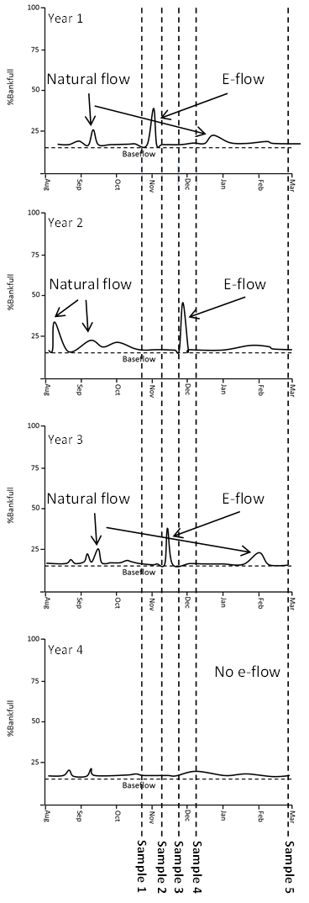

# **Program management**

## Governance

VEFMAP Stage 6 will operate using the following centralised governance model.

**Independent Review Panel (IRP)**

*Independent and external*

**Program Owner**

Manager Environmental Water

DELWP Water

& Catchments

**Project Steering Committee (PSC)**

*Program advice and decisions*

• DELWP Program Manager

• VEWH

• CMA representatives

**Project Team**

*Lead project delivery and coordination, advise PSC*

• Fish theme lead

• Vegetation theme lead

*Coordinated by*

• DELWP Program Manager

**Field work**

*Complete site selection, field sampling, data collection and data entry*

• ARI

• CMAs

• Contractors

**Analysis & Reporting**

*Central analysis, annual reporting, multi-year reporting, manage QA/QC*

• ARI

**Communications &**

**Engagement**

*Manage communications strategy and key messages*

• ARI

**CMAs**

*Ewater delivery and site information input*

• EWROs from all CMAs

VEFMAP Stage 6 will be funded and managed by DELWP to meet state objectives, and DELWP will be the custodian and authoritative source of all VEFMAP data.

DELWP will:

* provide a central repository to consolidate and securely house all VEFMAP monitoring data;
* provide and manage access to VEFMAP data by data users;
* enforce robust quality assurance and quality control to ensure data is of a high standard that can be trusted; and
* audit data supply by data providers to ensure data is current and complete.

Data providers will:

* conduct the field monitoring and collate the monitoring data;
* ensure collected data is high quality and complete; and
* provide monitoring data to DELWP via the online VEFMAP database in a timely manner after collection.

A strong partnership approach between DELWP, CMAs and research providers will ensure:

* Timeliness: prompt delivery of information and advice.
* Robustness: scientifically sound ecological data and assessments.
* Transferability: processes that ensure a framework by which to share data and inform works and measures.
* Accountability and transparency: well designed and scientifically defensible program that enables clear reporting.
* Pragmatism: clarifies and justifies a selection of the most suitable and effective waterway management strategies, outlining existing constraints.
* Improved understanding of ecological links to flow. This information will be available for waterway managers to inform future development of environmental flow recommendations aimed into the future.

## Health and Safety

Each organisation undertaking VEFMAP must complete a health, safety and environmental plan (HSEP). This can be in accordance with the organisation’s own health and safety procedures and practices, but at a minimum must include:

* **Job Safety and Environment Assessment (JSEA)** – details the potential hazards associated with work activities and the controls in place to minimise risks.
* **First Aid Training** - the requirements for First Aid training and qualification of staff.
* **Emergency Response** – the procedures to be followed in the event of an emergency.
* **Incident Reporting** – incident reporting procedures.
* **Enquires and Complaints** – procedures relating to public complaints and media enquiries.

# **Program review and evaluation**

Regular program evaluation is critical to ensure the monitoring design proposed for VEFMAP Stage 6 meets its objectives and that program objectives and KEQs remain relevant over time.

The first program evaluation will occur in 2017-2018, after the initial year of field monitoring, to maximise the opportunity for adaptive management, improve program implementation, evaluate the effectiveness of the proposed governance model and examine opportunities to update/improve program methods. This “internal” evaluation will examine the first year of data to:

* Check that field protocols are delivering useful, high quality data.
* Assess levels of variance in response indicators (using power analysis) and confirm the appropriateness of proposed methods and design.
* Examine and confirm the appropriateness of the scope of rivers and sites included in the first year of monitoring.

Review by the VEFMAP Stage 6 Independent Review Panel will provide the opportunity to identify improvements to program governance, objectives, design and monitoring methods.

# **Communication and Reporting**

Maintaining ongoing engagement with CMAs is an essential element of the adaptive management framework in which VEFMAP sits. A Communication and Engagement Plan has been developed for Stage 6, to help guide reporting and communication activities associated with VEFMAP implementation. Ongoing engagement with CMAs will be fostered by consistent annual reporting of VEFMAP results via established networks (e.g. Environmental Water Reserve Officer meetings and an annual VEFMAP stakeholder meeting). Collected data and information will be made available to the CMAs so that they have access to best-available data as inputs to their own activities (e.g. planning, program/project implementation, monitoring). Information collected annually will be presented in easily understandable language.

Reporting conducted throughout the project will include:

* annual reports for the first three years of the program;
* a final report covering the entire Stage 6 program;
* individual summary reports on all additional research activities;
* research publications; and
* summaries/flyers to CMAs/stakeholders for distribution to stakeholders and the public.

There will also be a range of discussions, meetings and presentations to a range of relevant stakeholders throughout the program. This will include presentations and ongoing discussions with the environmental water officers from each of the CMAs.

A summary of the reporting requirements for Stage 6 are presented in Table 6, below.

Table 6: Summary of reporting requirements for VEFMAP Stage 6

|  |  |  |  |  |  |
| --- | --- | --- | --- | --- | --- |
| Report type | Purpose | Timing | Commencing | Frequency | Who |
| Interim regional monitoring report | Summary of activities and data collected; brief reporting only | Within 2 months of post event sampling | Year 1 | Per sampling season | Service provider report to CMA |
| Annual regional monitoring report | To inform management and identify any modifications to protocols and or conceptual models | End of watering year | Year 1 | Annually | Service provider report to DELWP and CMAs |
| Annual progress report/fact sheet | To inform community and stakeholders on progress of VEFMAP Stage 6 | End of watering year | Year 1 | Annually | Service provider and DELWP |
| Presentation and workshop | VEFMAP workshop/presentation of activities and outcomes to inform all CMAs of emerging issues | End of watering year | Year 1 | Annually or biannually | DELWP and Service provider |
| Interim Stage 6 report | Governance and implementation review – includes analysis of early results | Mid Stage 6 | End of year 2 | Once off | DELWP |
| Mid-term VEFMAP program review | Governance and implementation review | Mid Stage 6 | End of year 2 | Once off | Independent Reviewer Panel |
| Final Stage 6 monitoring report | Summary of three years of monitoring activities | End of Stage 6 | Year 4 | Once off | Service provider and DELWP |
| Stage 6 evaluation report | Assessment against primary objective of demonstrating effectiveness of environmental water management. Data analysis report and recommendations for future monitoring | Within 12 months of end of Stage 6 monitoring activities | Year 4 | Once off | DELWP |
| Stage 6 program review | Stage 6 monitoring and evaluation review | Post Stage 6 evaluation report | End of year 4 | Once off | Independent Review Panel |

# **Data and information management**

## Quality assurance and quality control

The success of VEFMAP Stage 6 relies on collection of data that are high quality, complete and fit-for-purpose to meet reporting and evaluation needs.

Quality assurance is provided by procedures that produce monitoring data that are fit-for-purpose. This includes training for contractors, data standards and accepted methods for data capture, chain of custody and traceability of data and auditing to ensure data providers are adhering to designated protocols. Quality control procedures include checks for calibration of equipment and review of the monitoring data to check for consistency, accuracy and completeness, and to identify errors or highlight data anomalies (e.g. outliers) that require further investigation or correction.

Both QA and QC have the intent of ensuring VEFMAP Stage 6 data are of the highest quality and can be used to evaluate KEQs with high levels of confidence.

Quality assurance will be improved by an adaptive management process, where the methods are reviewed annually.

## Data handling and storage

All VEFMAP data (old and new) will be stored in a Microsoft SQL Server relational database. The database has in-built quality assurance measures to ensure consistency in the data entered. A user-friendly database interface will allow CMA staff to view and extract data summaries relevant to their area, but will not allow external users to input or change data.

The data management platform follows the principles and technology outlined in Figure 7.

Data providers can input their data via one of two methods, depending on which best suits their needs:

1) Via a custom built excel template. This template has been designed to capture the data in a standardised format. Data from this template is then imported, by the data curator, to a Microsoft Access database. This database has been set up to mirror the format of the SQL Server database and the two databases are linked. Both databases have several inbuilt QA/QC controls. Once all checks are complete, the data is imported (by the curator) from the MS Access database to the SQL server database, via automated append queries.

2) Via direct entry to the SQL server database. Data entry forms are currently being designed to mirror the format of the field data sheets. Data providers will be able to enter their data directly into these forms via the MS Access database front end. The data tables of the SQL database will be automatically populated as the data is entered. Data providers will only have access to the front-end forms. The existing data in the back-end of the database will be protected, and only accessible via the curator. The existing back-end QA/QC control measures will prevent data that does not pass the required standard from being entered.

Data for reporting purposes can be extracted by the curator, in consultation with the data users. The curator works closely with the research team to develop data queries that meet ongoing reporting needs. During the reporting phase, if any anomalies in the data are detected they can be investigated and rectified where appropriate.

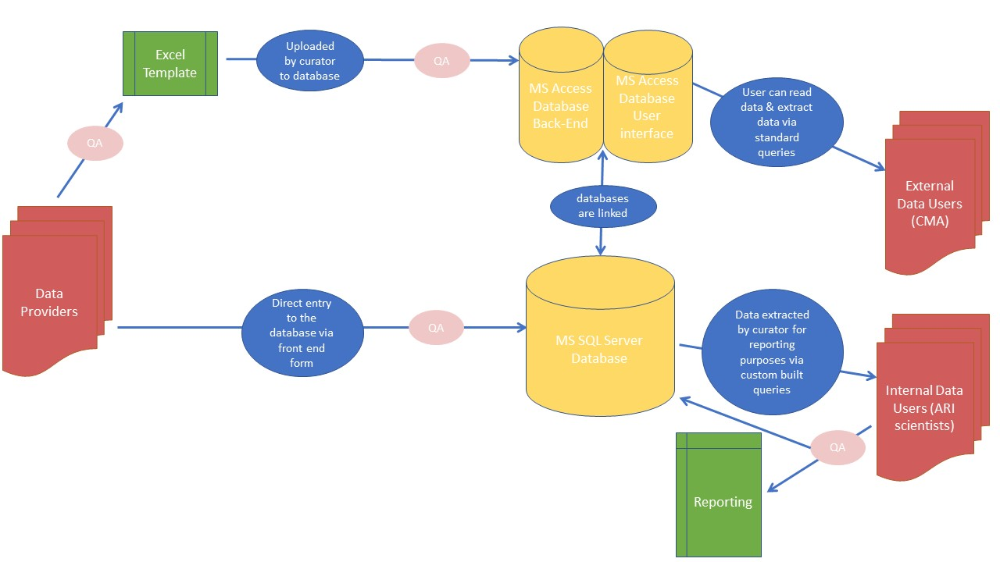

Figure 7: Components of the VEFMAP data management solution showing flow of data.

.

## Audit procedures

VEFMAP Stage 6 will be audited by DELWP’s Environmental Water team. This will include audits of both field and desktop assessments to ensure consistency with the written methods and that appropriate protocols have been implemented. The audit will assess compliance with the written methods and identify:

* exceptions to the VEFMAP Stage 6 methods and procedures,
* improvements required, and
* recommendations for modifications to procedures and methods.

Those audited will be provided with a set period to respond to the audit and address audit findings.

# **Adaptive management**

## Benefits of an adaptive management framework

Adaptive management is a commonly suggested management approach, but capturing new information and applying it effectively and transparently to future decisions is a significant endeavour. There are many benefits to applying VEFMAP within an adaptive management framework - these are summarised below. Strictly speaking, VEFMAP has limited ability to manipulate environmental flow management approaches in order to learn how alternative methods compare, so that the better outcomes can be pursued – as per conventional adaptive management. However, there are many cases where outcomes from monitoring have and will be used to directly alter flow delivery to contribute to improvements in management outcomes or learnings. VEFMAP will also be used to inform adaptive monitoring, whereby alternative methods or approaches are used to monitor and the most effective methods are selected to continue.

Improving data collection and monitoring design

Opportunities may exist to improve VEFMAP, either through implementation of new procedures (e.g. improving standardisation of data collection), or though changes to the monitoring design (e.g. site selection criteria, indicators) to improve resolution of emerging threats or novel outcomes. Such opportunities could be considered at the 1-year progress review and 4-year evaluation of Stage 6. In some cases, the learning process is truly adaptive and alternative approaches are implemented and compared before the most appropriate is selected for continued use (and potential further comparisons). In other cases, the methods will be evaluated on their own and updates and refinements will be made if considered necessary.

This will allow consideration of such features as how well the methods are working and whether the correct data are being generated to answer the KEQs. The monitoring methods and data management arrangements can then be adjusted, if necessary, to ensure the sampling undertaken in subsequent years is based on the best-available science and according to fit-for-purpose methods.

Improving Conceptual Models

The VEFMAP Stage 6 conceptual models summarise relationships between environmental water and management outcomes. Updating the conceptual models is a fundamental process towards improving future management decisions. Specific improvements may include:

* improving estimates of magnitudes of effects;
* improving estimates of rates of change;
* refining predicted outcomes from the works implemented;
* refining impacts of modifiers;
* addition of new/emerging issues or threats;
* changing the structure of models to improve interpretation;
* development of new models to incorporate novel management approaches or to provide alternative models for different contexts; and
* improving links with other DELWP models and management frameworks (e.g. condition reporting for the Index of Stream Condition).

Improving environmental water delivery

Predicting outcomes, quantifying magnitudes and rates of change and identifying unexpected consequences will improve the effectiveness of the intervention design and implementation. Improved understanding of the influence of modifiers will be used to update conceptual models, with flow on to strategic planning, prioritisation, implementation and resource allocation. Regular communication between water managers, ARI, DELWP Environmental Water and other relevant stakeholders will allow for direct input of this information into the decision-making process for environmental flow deliveries.

Improving DELWP environmental water target setting

Quantifying magnitudes and rates of change in ecosystem and species response to environmental water management will facilitate the setting of realistic objectives and targets for regional waterway strategies and other programs such as the Murray-Darling Basin long term watering strategies.

## Reporting and ongoing engagement with CMAs

Maintaining ongoing engagement with CMAs is an essential element of the adaptive management framework and will be fostered by annual reporting of VEFMAP results via established environmental water networks. Collected data and information will be made available to the CMAs as soon as possible, so they have access to best-available data as inputs to their own activities (e.g. planning, program/project implementation, monitoring). Information collected annually will be presented in easily understandable language.

# **References**

Agostinho A., Pelicice F. and Gomes L. (2008). Dams and the fish fauna of the Neotropical region: impacts and management related to diversity and fisheries. *Brazilian Journal of Biology,* 68, pp. 1119–1132.

Amtstaetter, F., O’Connor, J. and Pickworth, A. (2016). Environmental flow releases trigger spawning migrations by Australian grayling *Prototroctes maraena*, a threatened, diadromous fish. Aquatic Conservation: Marine and Freshwater Ecosystems 26, 35–43.

Arthur Rylah Institute (2017). VEFMAP Stage 5. Arthur Rylah Institute and University of Melbourne report to the Department of Environment, Land, Water and Planning, Melbourne. In prep.

Baumgartner L. J., Reynoldson N. and Gilligan D. M. (2006). Mortality of larval Murray Cod (*Maccullochella peelii peelii*) and golden perch (*Macquaria ambigua*) associated with passage through two types of low-head weirs. Marine and Freshwater Research, 57, pp. 187–191.

Brock, M. A. and Casanova, M. T. (1997) Plant life at the edge of wetlands: ecological responses to wetting and drying patterns. In Frontiers in Ecology. Klomp, N. and Lunt, I., (Ed.). Elsevier Science Ltd., Oxford. pp. 181-192.

Casanova, M. T. and Brock, M. A. (2000) How do depth, duration and frequency of flooding influence the establishment of wetland plant communities? Plant Ecology, 147, 237-250.

Chee, Y., Webb, A., Stewardson, M. and Cottingham, P. (2006) Victorian Environmental Flows Monitoring and Assessment Program: Monitoring and assessing environmental flow releases in the Glenelg River. Report prepared for the Glenelg-Hopkins Catchment Management Authority and the Department of Sustainability and Environment. e-Water Cooperative Research Centre, Melbourne.

Cottingham P., Spruzen F. and Wickson S. (eds) (2014). Victorian environmental flows monitoring and assessment program: Stage 5 future directions workshop report. Report prepared for the Department of Environment, Land, Water and Planning by Peter Cottingham & Associates, December 2014.

DELWP (2017). VEFMAP Stage 6 Part B: Program design and monitoring methods. Department of Environment, Land, Water and Planning.

DEPI (2013). Improving Our Waterways: Victorian Waterway Management Strategy, State of Victoria, Department of Environment and Primary Industries. <http://www.depi.vic.gov.au/__data/assets/pdf_file/0015/200373/VWMS_Part1.pdf>

Downes, B.J., Barmuta, L.A., Fairweather, P.G., Faith, D.P., Keough, M.J., Lake, P.S., Mapstone, B.D., and Quinn, G. 2002. Monitoring ecological impacts: concepts and practice in flowing waters. Cambridge University Press, Cambridge, UK ; New York, NY, USA.

Gilligan, D. and Schiller, C. (2003). Downstream transport of larval and juvenile fish in the Murray River. Cronulla, NSW Fisheries Final Report Series No 50.

Koehn J.D. and Harrington D.J. (2005). Collection and distribution of the early life stages of the Murray cod (*Maccullochella peelii peelii*) in a regulated river. *Australian Journal of Zoology*, 53, pp. 137–144.

Koehn J., I. Stuart, H. Bamford, C. Bice, K. Hodges, P. Jackson, J. Lieschke, S. Lovett, M. Mallen-Cooper, T. Raadik, J. Thiem, C. Todd, Z. Tonkin, B. Zampatti. (2014). Quantifiable Environmental Outcomes for Fish. Arthur Rylah Institute for Environmental Research Unpublished Client Report for the Murray Darling Basin Authority, Department of Environment and Primary Industries, Heidelberg, Victoria.

Koehn, J.D., Todd, C., Raymond, S., Balcombe, S., Zampatti, B., Bamford, H., Ingram, B.A., Bice, C., Burndred, K., Butler, G., Baumgartner, L., Clunie, P., Ellis, I., Forbes, J., Hutchison, M., Koster, W., Lintermans, M., Mallen-Cooper, M., McLellan, M., Pearce, L., Ryall, J., Sharpe, C., Stuart, I., Thiem, J., Tonkin, Z., Townsend, A., Ye, Q. (in prep) A compendium of ecological knowledge for key fish species to assist environmental flow delivery and population restoration in the Murray–Darling Basin. For Submission to Marine and Freshwater Research.

Maheshwari, B.L., Walker, K.F., & McMahon, T.A. (1995), Effects of flow regulation on the flow regime of the River Murray, Australia. *Regulated Rivers: Research & Management*, 10, pp. 15-38.

MDFRC (2013) Long-term Intervention Monitoring - Generic Cause and Effect Diagrams Final Report prepared for the Commonwealth Environmental Water Office by The Murray-Darling Freshwater Research Centre, MDFRC Publication 01/2013, May, 163pp.

Miller K.A., Webb, J.A.., de Little, S.C., Stewardson, M.J. and Rutherfurd, I.D. (2014). How effective are environmental flows? Analyses of flow-ecology relationships in the Victorian Environmental Flow Monitoring and Assessment Program (VEFMAP) from 2011-2014. Report prepared for the Department of Environment and Primary Industries.

Sharpe, A. (2014). VEFMAP next steps. How CMAs use VEFMAP data. Jacobs report to DEPI.

VEWH (2016). Seasonal Watering Plan 2016-17. http://www.vewh.vic.gov.au/watering-program/seasonal-watering-plan/seasonal-watering-plan-2016-17.

# Appendix 1: Conceptual model of habitat processes and flows developed by Chee *et al*. (2006) (WQ = water quality)

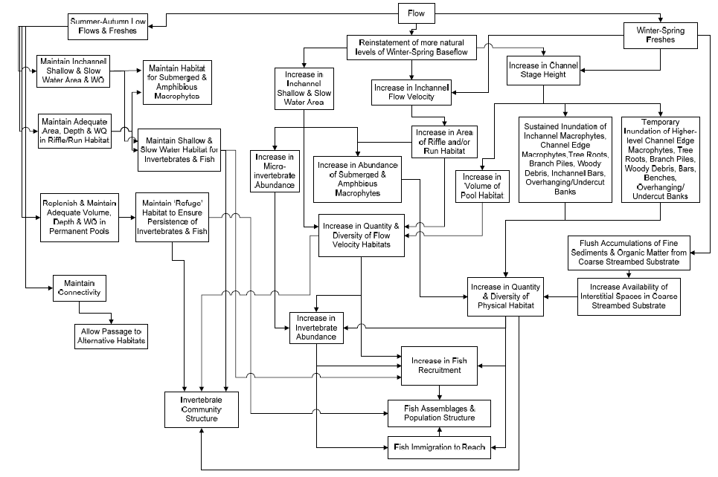

# Appendix 2: Conceptual model for fish spawning and recruitment into the juvenile population (developed by Chee *et al*. 2006)

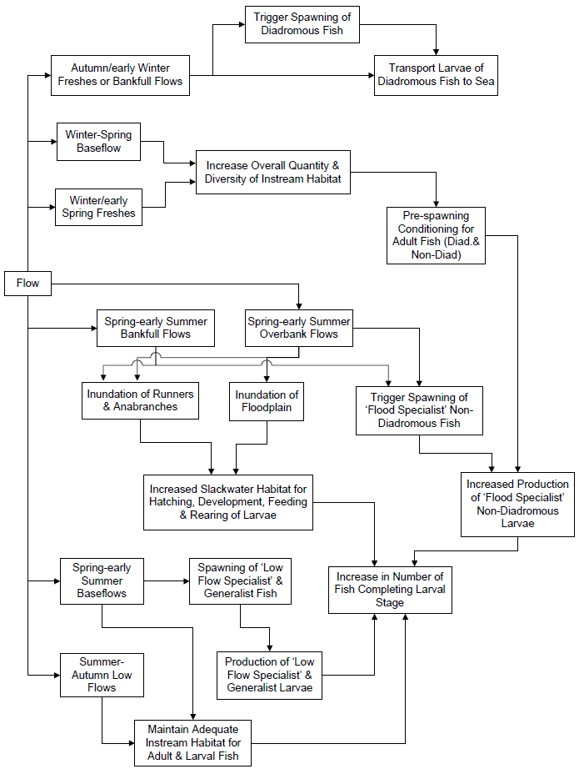

# Appendix 3: Example of native fish conceptual models

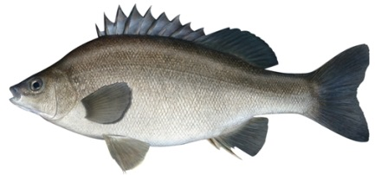**Silver perch *(From Koehn et al. in prep, Draft April 2017)***

***Southern Murray-Darling Basin***

**General description**

A large bodied, long-lived, omnivorous, schooling, river channel specialist that has drifting eggs and larvae stages (Rowland 2009). Silver perch continues to be a popular angling species and is also regarded as a good table fish. As such the species is widely cultured in hatcheries (Rowland 1994, 2004, 2009), both for the restaurant trade and conservation/recreational purposes. The latter has resulted fish stocked throughout the MDB as well as outside it’s natural range. Categorised as having a mode 2 life history (Humphries *et al*. 1999) and is classified as a flow dependant specialist (Baumgartner *et al*. 2014).

**Distribution and status**

Once widespread over most lowland reaches of the MDB, it has suffered serious declines in abundance and range (Lintermans 2007: Trueman 2012). The greatest concentration of fish in the MDB is centred in the mid-Murray River (Yarrawonga to Euston), with lower numbers of fish occupying the Edward-Wakool, Lower Darling, Murrumbidgee, Warrago/Condamine, Victorian tributaries (Loddon, Campaspe, Goulburn, Ovens) with low numbers present in SA. Catches in the mid-Murray have declined considerably (by 94% at Euston) over a 50-year period (Mallen-Cooper and Brand 2007) and the species is now rare in the NMDB. Listed as critically endangered nationally, endangered in the ACT, vulnerable in Victoria (DSE 2013), New South Wales and SA (DEE 2017). Concern has been expressed over the status of this species for several decades with a recovery plan and supporting document written in 2001 (Clunie and Koehn 2001).

**Taxonomy and similar species**

There are low levels of genetic variation in wild populations of silver perch across the MDB (Keenan *et al*. 1996). Of the species considered in this paper, Silver perch is closest ecologically to golden perch.

**Age, length, weight, growth, maturity**

Maximum TL is 500 mm and weight around 8 kg (Trueman 2012); although more commonly up to 450 mm and 1.5 kg (Lintermans 2007). Long-lived; to 17 years in rivers (27 years in dam) and show variable growth, (Mallen-Cooper and Stuart 2003). In rivers, however, fish over age 8 are now relatively uncommon.

**Habitat use**

An obligate river channel specialist that occupies a range of habitats from large, faster flowing river reaches to the slow flowing, turbid waters of lower reaches and impoundments (Clunie and Koehn 2001; Rowland 1995). They appear to prefer open waters devoid of snags (Cadwallader and Backhouse 1983), although strong ordinations with river habitat occur (Raymond *et al*. 2014). Often found in mid-channel, rather than along the banks (EO). Were once more commonly found in lakes, but this is now rarely so; exceptions include Menindee (NSW) and Lake Boga (Nthn Vic).

**Fecundity and spawning**

A sexually dimorphic species: males maturing at 3 years (250 mm) and females at 4-5 years (300 mm) (Mallen-Cooper *et al*. 1995; Mallen-Cooper and Stuart 2003; Lintermans 2007). In hatcheries, males mature at 2 years and females at 3 years (Rowland 2004). Fecundity high, up to 500 000 for a 2 kg fish (Lake 1967d) or 139 286 eggs/kg (Rowland 2004). Females remain highly fecund up to 10 years of age (Rowland 2009. Communal broad cast spawners with no parental care that seek flowing water (e.g. > 0.3 m/s) in river channel habitats in which to spawn, presumably to facilitate egg and larval drift downstream and maintain aeration (of eggs). As an aggregate spawning species, large schools form around a known spawning period, following upstream migration (Lintermans 2007; Koehn and O’Connor 1990; Clunie and Koehn 2001). Spawning occurs on multiple, separate, trigger events. These are needed for females to release all their eggs at once (CS), otherwise egg reabsorption may occur.

Temperature plays a significant role in the onset of gonadal development, maturation and spawning (Bye 1984). Spawning occurs over a protracted period from spring to late summer (mid-October to mid-February) in the SMDB (King et al. 2005; King *et al*. 2009a; Raymond *et al*. 2014) and October to March in the NMDB. In the mid-Murray River, spawning occurs in most years except during a severe blackwater event, even under more stable low flows (albeit in reduced numbers; Harris and Gehrke 1994; Humphries *et al* 1999; Gilligan and Schiller 2003; King *et al* 2005; King *et al*. 2016). Whilst spawning has previously been thought to be stimulated by changes (often small) in river levels during the aforementioned spawning period (Mallen-Cooper and Stuart 2003; King et al. 2009) In the mid Murray River, spawning is largely temperature cued, commencing in spring when water temperatures > 18°C (Gilligan and Schiller 2003; Koehn and Harrington 2005; Tonkin *et al*. 2007; King *et al*. 2009) with > 20% of predicted maximum spawning occurring between 20 and 25°C (King *et al*. 2016). King *et al*. (2016) also found the occurrence and abundance of silver perch eggs in the Murray River was positively associated with discharge and weekly temperature change and a negative association with increasing number of flood days in preceding 3 months. The species can spawn and recruit in non-flowing water such as hatchery ponds (G. Butler, NSW DEPI, pers. comm.).

Eggs are small (mean 1.2 mm diameter, range 0.7–1.3 mm; then 2.5-3.0 mm water hardened; Lake 1967b, Rowland 1984), non-adhesive, semi-pelagic (Merrick and Schmida 1984; Merrick 1996; Rowland 2009) and sink in the absence of current (Lake 1967). Specifically, Lake (1967b) reported that the fine mat-like chorion of silver perch eggs, readily collect small clay particles, causing eggs to have increased negative buoyancy and causing settling to the bottom in slow and still water. Indeed, Tonkin *et al*. (2007) recorded the greatest concentration of drifting eggs in the Murray River occuring close to shore and near the bottom - suggesting either increased spawning in these microhabitats, or more likely, a gradual settling of eggs in areas of lower water velocities. Eggs hatch within 30 to 36 hours, and have a two week larval stage (NSW DPI 2006). Induced fertilization rates of 84.5% and hatch rates of 76.8% have been recorded in hatcheries (Rowland 2004). Larvae commence feeding at yolk-sac absorption, 5-6 days after hatch (Rowland *et al* 1983). There is no evidence of direct use ephemeral floodplains for spawning or recruitment (King *et al* 2007; King *et al.* 2008).

**Recruitment**

Drifting egg (about 2 days) and larval phase is considered to be up to 15 days; NSW DPI 2006). Eggs and larvae deposited in weir pools and diversion channels are considered to have high mortalities (almost 100%) and no recruitment following drift into highly unproductive lakes (B. Zampatti, SARDI, pers. comm.). In the mid-Murray River, recruitment occurs in all years (Mallen-Cooper and Stuart 2003; Tonkin *et al*. unpublished data), presumably due to the spatial scale of lotic conditions during the spawning period whereby in most years (both dry and flood) water velocities exceed 0.4 m/s. Conversely, recruitment in the lower Murray River and Lower Darling River is episodic, and linked to high flow years which generate lotic conditions similar to those in the mid Murray River (B. Zampattii SARDI pers. comm.).

Dominant year classes have been associated with high flows in spring or summer that inundate floodplains and produce food for larvae (Lake 1967; Reynolds 1983; Gehrke 1992; Harris and Gehrke 1994), Nevertheless, a recent assessment of year class strength in the mid Murray River has highlighted that the strongest year classes within the mid Murray River are those which spawned during relatively stable in-channel flows (as per Mallen-Cooper and Stuart 2003; Clayton Sharpe pers. comm.) followed by large overbank flows (Tonkin *et al*. unpublished data). ). There appears to be no recruitment in impoundments (LB). Recruitment of silver perch into northern Victorian rivers appear heavily reliant on connectivity with the mid Murray River to facilitate immigration of fish, particularly juveniles (B. Zampattii SARDI unpublished data). Survival rates from 40-80 mm is guestimated to be about 20%. Although widely stocked, there is little evidence of this being successful in rivers.

**Movement, migration and dispersal**

Regarded as a mobile species with good swimming abilities, but as there is limited information on movements; often assumed to be similar to golden perch. They do move large distances and most silver perch tagged in the lower Murray River moved upstream; one individual moved 570 km in 19 months (Reynolds 1983). Most movements for both adults and juveniles occur over a broad timeframe (October to April). Adult movements in spring are presumed to be associated with spawning (Mallen-Cooper ~1995). Juvenile movement, whereby tens of thousands of one year old fish have been recorded moving through fishways (Mallen-Cooper and Stuart 2003; Baumgartner *et al*. 2011; 2014), is thought to be an important dispersal mechanism. For example, a large number of silver perch recently found occupying Lake Boga in Northern Victoria were found to have colonised the Lake from the mid Murray River as one year old fish during the large flood event in 2010/2011 (Z. Tonkin and B. Zampatti unpublished data). Movements appear to be stimulated by very sensitive to small increases in flows (e.g. +0.15m/24h) (Mallen-Cooper and Stuart 2003: J. Thiem, NSW DPI pers. comm.) and movements decline as flows reduce (Baumgartner *et al*. 2011; 2014). Recolonization form isolated refuge water holes is critical in the NMDB, otherwise there is no evidence to suggest movement patterns would be different between SMDB and NMDB (LB).

**Key threats**

River regulation and associated infrastructure is thought to be the main threatening process for silver perch populations. Weirs and dams restrict juvenile and adult movement, particularly those associated with dispersal and recolonization, creating highly fragmented metapopulations (i.e. tributaries of the Murray River). High densities of regulating structures severely reduce the availability of suitable habitat required for frequent spawning and recruitment. For example, the creation of a large number of weir pools in the lower Murray River have severely depleted the hydrodynamic conditions required for regular recruitment of the species, with episodic recruitment associated with years when these structures are inundated and the hydraulics of the systems under relatively unregulated conditions is restored (B. Zampatti unpublished data).

Water diversions mean large numbers of eggs, larvae and juveniles and adults are lost into irrigation channels (Gilligan and Schiller 2003; Koehn and Harrington 2005) as eggs and larvae can be trapped-causing them to settle and die (Clunie and Koehn 2001; Baumgartner et al 2014) and undershot weirs can kill >90% of larvae (Boys *et al*. 2010). Floodplain regulation structures can also strand juvenile and adult fish (Jones and Stuart 2008). Current low densities and severely fragmented populations may heighten the risk from extended recruitment failure in the future. Loss of submergent macrophytes may reduce nursery areas for juveniles. Negative impacts of blackwater events on spawning (Raymond *et al*. 2016). This loss may be compounded by carp; although the impacts of carp are not considered to be large. Thermal pollution will limit spawning below weirs and possibly increase larval survivorship below many impoundments. There is susceptibility to several diseases including EHNV (Langdon 1989). Silver perch is considered to have low vulnerability to the impacts climate change (Chessman 2013).

**Knowledge gaps and data limitations**

* Recruitment dynamics and life stages survival rates.
* Causal links between silver perch life stages and flows.
* Location of YOY silver perch.
* Eggs and larval drift distances and their survivorship in weir pools.
* Downstream movements of silver perch.
* Recolonisation rates- where do all the 1+ fish that move through Torrumbarry go?
* Percentage of females breeding under specific flow and temperature triggers throughout the season.
* Specific flow links with movement, particularly juvenile fish.
* Dietary / trophic overlap with exotic species, particularly carp.
* Genetic structure.

**Key directions for environmental flows and rehabilitation**

Landscape scale planning is required for management and to maximise population outcomes and providing fish passage to increase connectivity is an essential rehabilitation measure. Flow events appear critical and protecting the integrity of flows and flow components over large spatial scales (e.g. 300-500 km) through co-ordinated management is required to enhance populations dynamics (Koehn *et al*. 2014). Increased small short-term flow variability (1-2 days, height changes up to 0.2m) to 50% of those flows occurring naturally to stimulate juvenile movements in late summer and early autumn. Dispersalflows implemented in Murray tributaries in early summer (e.g. January-March) can attract upstream migrating juvenile fish into the in the Echuca-Yarrawonga reach, especially if synchronised with rising flows in the Murray River (Sharpe 2011; Stuart and Sharpe 2015). Spawning flows can be implemented as annual in-channel events with strong variability, and should be based on the natural hydrograph in spring/early summer. Delivery of a flood or high within-channel flow pulse a minimum of 2 in every 5 years will assist recruitment. Habitat improvements can be made by increasing hydrodynamic diversity, through weir pool lowering used in conjunction with environmental flows (Ye *et al*. 2008). For example, an increase in flow rate through weir pools to > 0.3m/s, can be achieved via increased flow delivery (20,000 ML/d) or through physical lowering of weir (flows of 10,000 ML/d) to achieve same ecological output. Low winter flows increase risk of fish through predation, competition, habitat loss, drying, poor water quality and lower egg and larval survival rates and mitigating low winter flows (to more natural winter flows) could improve fish condition and have flow on benefits for recruitment (Koehn *et al*. 2014).

**References**

Agostinho A., Pelicice F. and Gomes L. (2008). Dams and the fish fauna of the Neotropical region: impacts and management related to diversity and fisheries. *Brazilian Journal of Biology* 68, 1119–1132.

Anderson, J.R., Morison, A.K. and Ray, D.J. (1992). Validation of the use of thin-sectioned otoliths for determining the age and growth of golden perch, *Macquaria ambigua*, in the lower MDB. *Marine and Freshwater Research*43, 1103-1128.

Baumgartner, L., Zampatti, B., Jones, M., Stuart, I. and Mallen-Cooper, M. (2014). Fish passage in the Murray-Darling Basin: not just an uphill battle. *Ecological Management and Restoration* 15, 28-39.

Boys, C., Baumgartner, L., Robinson, W., Giddings, G. and Lay, C. (2010). Protecting migrating fish at in-stream structures: downstream mortality at weirs and screening water diversions. 2010 Native Fish Forum — Abstracts. Murray-Darling Basin Authority, Canberra. Online at: http://www.mdba.gov.au/system/files/NFS-2010-fish-forum-abstracts_Final.pdf Accessed: 8 November 2011.

Bye, V. (1984). The role of environmental factors in the timing of reproductive cycles. Pp. 187-205 in Fish Reproduction: Strategies and Tactics, G. W. Potts and R. J. Wootton, eds. Academic Press, London.

Cadwallader, P. and Backhouse, G.N. (1983). A Guide to the Freshwater Fish of Victoria. Government Printer, Melbourne.

Clunie, P. E. and Koehn, J. D. (2001). Silver Perch: A Recovery Plan. Final report for project R8002 to Murray-Darling Basin Commission: Canberra. Department of Natural Resources and Environment, Victoria.

Conservation Advice *Bidyanus bidyanus* (Silver Perch). (2013). <http://www.environment.gov.au/biodiversity/threatened/species/pubs/76155-conservation-advice.pdf>

Davies, P.E., Stewartson, M.J., Hillman, T.J., Roberts, J. R. and Thoms, M. C. (2012). ‘Sustainable Rivers Audit 2: The ecological health of rivers in the Murray–Darling Basin after the Millennium Drought (2008-2010)’, Vol. 1, Murray–Darling Basin Authority, Canberra.

Gilligan, D. and Schiller, C. (2003). Downstream transport of larval and juvenile fish in the Murray River. Cronulla, NSW Fisheries Final Report Series No 50.

Harris, J.H. and Gehrke, P.C. (1994). Modelling the relationship between streamflow and population recruitment to manage freshwater fisheries. *Aust. Fish*. 6: 28–30.

Harris J. H. and Gehrke P. C. (1997) Fish and Rivers in Stress: the NSW Rivers Survey. NSW Fisheries Office of Conservation and CRC for freshwater Ecology, Sydney 298 pp.

Humphries, P., King, A. and Koehn, J. (1999). Fish, flows and flood plains: links between freshwater fishes and their environment in the Murray-Darling River system, Australia. *Environmental Biology of Fishes* 56: 129–151, 1999.

Humphries, P., Serafini, L.G. and King, A.J. (2002), ‘River regulation and fish larvae: variation through space and time’, *Freshwater Biology*, vol. 47, pp. 1307–1331.

Jones, M.J. and Stuart, I. G. (2008). Regulated floodplains – a trap for unwary fish. *Fisheries Management and Ecology* 15: 71–79.

Keenan, C., Watts, R. and Serafini, L. (1996). Population genetics of golden perch, silver perch and eel-tailed catfish within the Murray-Darling Basin. Pages 17-25 *in* J.R. Banes and R. Lehane (eds.) Proceedings 1995 Riverine Environment Research Forum. Murray-Darling Basin Committee, Canberra, Australia.

King, A.J., Crook, D.A., Koster, W.M., Mahoney, J., and Tonkin, Z. (2005). Comparison of larval fish drift in the lower-Goulburn and mid-Murray Rivers. *Environmental Management & Restoration* 6(2): 136-138.

King, A.J. and O’Connor, J.P. (2007) Native fish entrapment in irrigation systems: A step towards understanding the significance of the problem. *Ecological Management and Restoration* 8(1): 32-37

King, A., Tonkin, Z. and Mahoney, J. (2009a). Environmental flow enhances native fish spawning and recruitment in the Murray River, Australia. *River Research and Applications*25, 1205-1218.

King, A.J., Ramsey, D., Baumgartner, L., Humphries, P., Jones, M., Koehn, J., Lyon, J., Mallen-Cooper, M., Meredith, S., Vilizzi, L., Ye, Q. and Zampatti, B. (2009). *Environmental requirements for managing successful fish recruitment in the Murray River Valley – Review of existing knowledge*, Arthur Rylah Institute for Environmental Research Technical Report Series No. 197, Department of Sustainabilityand Environment, Heidelberg.

Koehn J.D. & Harrington D.J. (2005) Collection and distribution of the early life stages of the Murray cod (Maccullochella peelii peelii) in a regulated river. *Australian Journal of Zoology* 53: 137–144.

Koehn, J.D., and O’Connor, W.G. (1990). *Biological Information for Management of Native Freshwater Fish in Victoria*. Department of Conservation and Environment, Freshwater Fish Management Branch, Arthur Rylah Institute for Environmental Research. Government Printer, Melbourne.

J. Koehn, I. Stuart, H. Bamford, C. Bice, K. Hodges, P. Jackson, J. Lieschke, S. Lovett, M. Mallen-Cooper, T. Raadik, J. Thiem, C. Todd, Z. Tonkin, B. Zampatti. (2014). Quantifiable Environmental Outcomes for Fish. Arthur Rylah Institute for Environmental Research Unpublished Client Report for the Murray Darling Basin Authority, Department of Environment and Primary Industries, Heidelberg, Victoria.

Lake, J.S. 1967. Rearing experiments with five species of Australian freshwater fishes. I. Inducement to spawning. *Aust. J. Mar. Freshw. Res*. 18: 137–153.

Langdon, J.S. (1989). Experimental transmission and pathogenicity of epizootic haematopoietic necrosis virus (EHNV) in redfin perch, *Perca fluviatilis* L., and 11 other teleosts. *J. Fish Dis*., 12: 295–310.

Lintermans M (2007) 'Fishes of the Murray-Darling Basin: An introductory guide.' (Murray-Darling Basin Commission, Canberra)

Lucas M. C. and Baras E. (2000) Methods for studying spatial behaviour of freshwater fishes in the natural environment. *Fish and Fisheries* 1, 283–316.

Lucas M. C., Baras E., Thom T. J., Duncan A. and Slavik O. (2001) Migration of Freshwater Fishes. Blackwell Science Ltd, London, UK.

Lyon, J., Kearns, J., Bird, T., Tonkin, Z, O’Mahony, J., Nicol, S., Hackett, G., Raymond, S., Todd, C. and Kitchingman, A. (2014). Monitoring of Resnagging between Lake Hume and Yarrawonga: Final Report 2014. Arthur Rylah Institute for Environmental Research Unpublished Client Report for the Murray-Darling Basin Authority, The Living Murray Program, Department of Environment and Primary Industries, Heidelberg, Victoria.

Maheshwari, B.L., Walker, K.F., & McMahon, T.A. (1995), Effects of flow regulation on the flow regime of the River Murray, Australia. *Regulated Rivers: Research & Management*, 10: 15-38.

Mallen-Cooper M., Stuart, I.G., Hides-Pearson, F. and Harris, J.H. (1995). Fish migration in the Murray River and assessment of the Torrumbarry fishway. Final report for Natural Resources Management Strategy Project. NSW Fisheries, Sydney, Australia.

Mallen-Cooper, M., and Stuart, I. (2003) Age, growth and non-flood recruitment of two potamodromous fishes in a large semi-arid/temperate river system. *River Research and Applications* 19: 697-719.

Mallen-Cooper M. and Brand D. M. (2007) Non salmonids in a salmonid fishway: what do 50 years of data tell us about past and future fish passage? *Fisheries Management and Ecology* 14, 319–332.

Mallen-Cooper, M., and Zampatti, B. (2015). Background paper: use of life-history conceptual models of fish in flow management in the Murray-Darling Basin. Murray-Darling Basin Authority, Canberra.

Merrick JR 1996. Freshwater grunters or perches, Family Terapontidae. Chapter 26. Silver perch. Pp. 164-166 in: Freshwater fishes of south-eastern Australia. [Ed. McDowall R.]. Reed Books, NSW.

Merrick, J.R. and Schmida, G.E. (1984). Australian freshwater fishes: biology and management. Griffin Press Ltd., South Australia. 409 p.

NSW Department of Primary Industries. (2006). Silver perch *Bidyanus bidyanus*: NSW Recovery Plan. Port Stephens NSW.

Raymond, S., Duncan, M., Robinson, W. and Tonkin, Z. (2014). Barmah-Millewa Fish Condition Monitoring: 2006 to 2014. Arthur Rylah Institute for Environmental Research Unpublished Client Report for the Murray Darling Basin Authority. Department of Environment and Primary Industries, Heidelberg, Victoria.

Reynolds, L.F. (1983). Migration patterns of five fish species in the Murray-Darling river system. *Aust. J. Mar. Freshw. Res*. 34: 857–871.

Rowland, S.J. (1995). The silver perch and its potential for aquaculture. Pp. 9-11 in: Proceedings of Silver Perch Aquaculture Workshops, Grafton and Narrandera, April 1994. NSW Fisheries.

Rowland, S.J. (2004). Domestication of Silver perch, *Bidyanus bidyanus*, Broodfish. *Journal of Applied Aquaculture*, 16: 1, 75-83.

Rowland, S.J. (2009). Review of Aquaculture research and development of the Australian freshwater fish silver perch, *Bidyanus bidyanus*. *Journal of the World Aquaculture Society* 40(3): 291-323

Sharpe, C., Stuart, I. and Mallen-Cooper, M. (2015). Monitoring of fish spawning in response to variable flow releases in the lower Darling River 2013/14. A summary of findings report to MDBA by CPS Enviro.

Sharpe, C. (2011). Fish surveys in Gunbower Creek downstream of Koondrook Weir in association with Environmental Flows, December 2011. pp. 15.

Tonkin Z, King A, Mahoney J and Morrongiello J (2007). Diel and spatial drifting patterns of silver perch *Bidyanus bidyanus* eggs in an Australian lowland river. *Journal of Fish Biology* 70: 313–317.

Walker, K.F. (1981). Effects of weirs on the environment of the Lower River Murray. *South Australian Fishing Industry Council Newsletter* 5(6): 26-29.

Ye, Q., Cheshire, K. and Fleer, D. (2008). Recruitment of golden perch and selected large-bodied fish species following the weir pool manipulation in the River Murray, South Australia. SARDI Aquatic Sciences report.

# Appendix 4: Summary of native fish objectives for each river system

Where qualitative targets are expressed in seasonal watering objectives they are indicated in the table by the following codes: M = maintain; Mo = movement; ↑ = increase, improve or restore; ↓ = reduce; A= abundance; S = spawning behaviour; ↑* indicates that the objective was general in nature (i.e. restore or improve).

|  | **Diadromous native fish** | **Northern tributaries large bodied fish** |
| --- | --- | --- |
| **North East** |  |  |
| Ovens River |  | Mo |
| **Goulburn Broken** |  |  |
| Broken and Nine Mile |  | ↑A |
| Broken River |  | M & Mo |
| Goulburn River |  | Mo & S & ↑A |
| **North Central** |  |  |
| Birch Creek |  | ↑A & ↑D & M |
| Campaspe River |  | ↑A & Mo |
| Coliban River |  | Mo & ↑A |
| Gunbower Creek |  | M & Mo |
| Loddon River - Lower |  | Mo & ↑A & S |
| **Mallee** |  |  |
| Lock 6-10 |  | ↑* (Murray cod) |
| Murrumbidgee Junction |  | ↑* |
| Yarriambiack Creek (Mallee) |  | M |
| **Wimmera** |  |  |
| Bungallally Creek |  | ↑* |
| Burnt Creek |  | Mo & ↑A |
| MacKenzie River |  | Mo & S & ↑A |
| Mount William Creek |  | Mo & S & ↑A |
| Wimmera River |  | Mo & S & ↑A |
| **Glenelg Hopkins** |  |  |
| Glenelg River | Mo & S & ↑A |  |
| **Central** |  |  |
| Yarra | ↑A |  |
| Tarago | ↑A & S |  |
| Werribee | Mo & S & ↑A |  |
| Moorabool | Mo & S & ↑A |  |
| Barwon | Mo & S |  |
| **West Gippsland** |  |  |
| LaTrobe River | ↑* |  |
| LaTrobe River Estuary | ↑A |  |
| Thompson | Mo & S & ↑A |  |
| Macalister | Mo & S & ↑A |  |
| **East Gippsland** |  |  |
| Snowy (NSW) | ↑* |  |

# Appendix 5: Full list of potential VEFMAP Stage 6 fish questions

Shortlisted VEFMAP Stage 6 fish questions as developed by ARI, UoM, CMAs and DELWP.

| **Question (can be refined by CMAs)** | **Proposed characterisation of flow** | **Condition or intervention monitoring** | **Relevant catchment** | **Species** | **Proposed measurement endpoint/s** | **Question posed by?** | **Possible constraints to answering question** | **Scale** | **Value add/cost sharing** | **Logic** |
| --- | --- | --- | --- | --- | --- | --- | --- | --- | --- | --- |
| 1. Does environmental flow management trigger post-larval and YOY diadromous (*fish that move between freshwater & the sea*) fish to enter rivers from estuarine/marine environments? | Spring fresh flow with 14-day duration and 50% exceedance flow  Quantify hydraulic cues (water velocity, turbulence) | Intervention | Bunyip  Yarra  Thomson  Cardinia  Glenelg  Werribee  Barham  Tyers/  La Trobe  Barwon/  Moorabool | Grayling  Tupong  Australian bass  Galaxiids?  Estuary perch | Otolith analysis  Hydraulics  Fishway trapping  Distribution |  | Stream barriers  Where possible align with areas where there is stream barrier remediation | Catchment  & Regional | MW  CMAs | Several CMAs are releasing water to estuaries to enhance diadromous fish outcomes but attraction of Young-Of-Year (YOY) has not been formally tested. Data from Dights Falls suggests that marine residency time is influenced by freshwater flows to estuaries. Hence, recruitment of YOY in coastal rivers can potentially be enhanced with freshwater flow cues. |
| 2. Does environmental flow management improve the spatial distribution of diadromous fish in coastal rivers? | Spring/summer fresh flow with two 10+ day duration events and 50% exceedance flow  Quantify hydraulic cues (water velocity, turbulence) | Intervention | Glenelg  Thomson  Cardinia  Yarra  Barwon/  Moorabool  Macalister Werribee  Barham?  Tyers/La Trobe | Grayling  Tupong  Eels  Australian bass  Galaxiids?  Lampreys?  Estuary perch | CPUE  Movement  Fishway trapping  Marked fish  Distribution |  | Steam barriers | Catchment  &Regional | MW  CMAs | Several CMAs have reported that upstream dispersal of diadromous fish occurs during/after flow events. Examples are Estuary perch/tupong in Glenelg, tupong/grayling in Bunyip, galaxiids in the Werribee and several spp in the Macalister. By restoring flows and complementary actions (e.g. fish passage) there is potential to restore diadromous fish populations in the middle and upper freshwater reaches of coastal rivers. |
| 3. Can the hydraulic cues (e.g. water velocity) that influence key fish life-history processes (e.g. spawning, dispersal) be quantified during an e-flow and used to predict fish outcomes in other reaches and rivers? | Quantify hydraulic cues (water velocity, turbulence, depth, distribution)  with transect application of Acoustic Doppler Current Profiler (ADCP) | Intervention | Bunyip & Barwon/  Moorabool  Goulburn  Glenelg  Campaspe  Loddon | Grayling  Golden perch  Silver perch  Murray cod  Tupong  Eels  Australian bass  Estuary perch | Hydraulics  Spawning |  |  | Regional & Statewide | MW  CMAs  VEWH?  MDBA and other jurisdictions are interested in this initiative. | The life cycles of freshwater fish are intimately linked to hydrological regimes and hydraulic complexity (fast and slow flowing water). Identification of the hydraulic drivers (e.g. water velocity; rather than ML/d) of key life-history events (e.g. spawning) is important for transferring hydraulic recommendations among catchments (as simple ML/d discharge metrics are not transferrable among reaches/catchments). *This question could likely be answered as a sub-component of others.* |
| 4. Does environmental flow management enhance survival and movement of a stocked diadromous fish? | Winter and spring fresh events with 7-10-day duration and 50% exceedance flow.  Quantify hydraulic cues (water velocity, turbulence) | Intervention | Thomson  Macalister | Australian bass | Age structure  Distribution |  |  | Catchment | CMAs  FV | FV are stocking bass into some coastal catchments. Some parts of bass life-history (spawning & movement) are mediated by flow events. Monitoring potential re-establishment of populations via flow event based monitoring - could be a value add to similar monitoring for grayling/tupong. |
| 5. Does environmental flow management enhance survival and movement of a stocked freshwater fish? | Small spring fresh (e.g. to 80% bankfull) with low variation (10-14-day duration) to enhance movement and spawning of nest building native fish | Intervention | Wimmera  Gunbower  Loddon  Campaspe  Goulburn/  Broken | Golden perch  Catfish  Murray cod? | Migration  Age structure  Growth / survival  Distribution |  |  | Catchment | CMAs  FV | The Wimmera and several other northern tributaries have considerable annual stocking effort. Determining how flows support stocked fish populations in terms of movement and survival has some merit. |
| 6. Can environmental flows be used to increase populations of target species in Victorian Tributaries of the Murray through the use of attraction flows (summer /autumn juvenile emigration flows or spring adult flows)? | Summer/autumn (Jan/Feb) fresh of 10+ days duration to rise at least 0.3 m above ‘normal’ summer level. Must be integrated with Murray River rise (e.g. >8,000 ML/d at Torrumbarry) | Intervention | Loddon/  Pyramid  Campaspe  Goulburn/  Broken  Gunbower | Golden perch  Silver perch | Hydraulics  Migration  Age structure  CPUE?  Distribution |  | Synchronising flows with Murray River | Catchment  & Regional | CMAs  FV  MDBA | In most summers, large numbers of 1-year old golden perch and silver perch migrate from downstream nursery habitats upstream along the Murray adjacent to the Vic/NSW tributaries. These fish then appear to disperse into the upper Murray and NSW/Vic tributaries. Synchronising a small summer rise in Vic. tribs with this summer fish migration may attract fish into Vic tribs and contribute to demonstrable re-colonisation. Initial proof-of-concept has already been demonstrated in the Gunbower and Pyramid systems. |
| 7. Does environmental flow management used for Murray cod and other native species result in higher survival? | Late winter/early spring rise to 80-100% bankfull and hold for up to 21 days | Intervention | Loddon  Campaspe  Goulburn/  Broken  Mullaroo | Murray cod  Trout cod  Freshwater catfish | Hydraulics  Larvae  YOY  Age structure  CPUE  Productivity  Growth |  |  | Catchment & Regional | CMAs | Murray cod can spawn independently of a river rise but in some irrigation systems the fluctuation in river height due to irrigation demand is too far outside that of natural and negatively impacts life-history processes (e.g. spawning). Environmental water to fill in the ‘gaps’ in the flow regime to reduce overt water level variation can result in more successful spawning. Proof of concept has been shown in the Edward-Wakool, Murray and Gunbower systems. |
| 8. Does environmental flow management increase the abundance and distribution of native fish? |  | Condition  No associated flow related question | Glenelg  Others? | Fish community | CPUE  Diversity  Distribution |  |  | Statewide |  | Continue the current annual monitoring to baseline fish communities. Not targeted as specific flow-response hypotheses, but may be valuable to CMAs? |
| 9. Can increasing winter baseflows improve survival of juvenile fish / improve recruitment strength? | Autumn/Winter baseflows which exceed minimum pool connection flows | Intervention | Goulburn/  Broken  Gunbower  Loddon  Campaspe  Glenelg  Others? | Murray cod  Trout cod  Blackfish  Australian bass  Estuary perch  tupong  Small bodied spp.  Pygmy perch | Survival  YOY  CPUE / Mark recapture  Occupancy rates  Growth |  |  | Catchment  & Regional | CMAs  FV  VEWH? | Several CMAs have prioritised provision of winter flows to maintain connectivity and water quality. There is some evidence that annual winter cease-to-flow events are major recruitment bottlenecks for young native fish. Evaluation of the benefits of winter flows has some merit. |
| 10. Does environmental flow management enhance dispersal of fish / juvenile fish?  (both lateral and longitudinal) | Site-specific but requires flows which connect separate wetlands | Intervention | All rivers | All the aforementioned species  Also pygmy perch | Dispersal  Distribution  Mark recapture  Occupancy rates  Growth  Fishway trapping |  |  | Catchment  & Regional | CMAs  MDBA | Some fish require connection flows to enhance re-colonisation. CMAs may be able to identify specific sites where this question could be investigated. For example, flows that temporarily link rivers/wetlands for pygmy perch dispersal. |
| 11. Does environmental flow management increase survival of carp and can this be mitigated? | Rivers with overbank flow or managed inundations which inundate floodplains | Intervention | All rivers | carp | YOY  CPUE  Age structure  Hydraulics  Growth |  |  | Catchment  & Regional | CMAs  MDBA | Carp recruitment is positively correlated with floodplain inundation. E-water has potential to enhance carp breeding unless careful planning is incorporated. Several management techniques are available to reduce carp breeding on e-watering events. CMAs have expressed interest in a carp and flow question. This question may well be being addressed through other initiatives. |
| 12. Specific question TBA  Drought and flows question – possibly examining fish response/recovery to a flow designed to maintain/save a fish population or a hypoxia question | Possibly target a specific flow release for mitigating drought/hypoxia conditions | Intervention | Goulburn/  Broken  Northern rivers | Golden perch  Murray cod  Northern spp | Survival  Movement  Water quality  Occupancy rates |  | Water availability | Site scale | CMAs  MDBA | Several Victorian rivers are under strong flow stress and the addition of environmental water can help sustain threatened fish populations. CMAs may be able to identify specific sites where a question could be investigated. |

# Appendix 6: Multi-Criteria Analysis tool

**Example output of the MCA applied to prioritise native fish evaluation questions for Stage 6.**



# Appendix 7: MCA ranked priority fish questions

**Priority fish questions (from MCA) for VEFMAP Stage 6 are shown in shaded cells, low priority questions have no highlight. Where applicable, support and/or comments have been provided by CMAs.**

|  |  |  |  |  |  |  |  |  |  |  |
| --- | --- | --- | --- | --- | --- | --- | --- | --- | --- | --- |
| **Question** | **MCA score** | **DELWP** | **Melbourne Water** | **Glenelg**  **Hopkins** | **Wimmera** | **Goulburn Broken** | **North East** | **Corangamite** | **West Gippsland** | **North Central** |
| Does environmental flow management trigger post-larval and YOY diadromous fish to enter rivers from estuarine/marine environments? (Q1) | **242** | Yes | Supports this question |  | Not relevant |  | Not relevant to CMA | Supports question for lower Barwon/  Moorabool | Supports this question and interest for all questions posed | Important question |
| Can environmental flows be used to increase populations of target species in Victorian Tributaries of the Murray through the use of attraction flows (summer /autumn juvenile emigration flows or spring adult flows)? (Q6) | **242** | Yes, but research question to be funded elsewhere |  |  | Not relevant | Very relevant – now included in seasonal watering plan, need to ensure other supporting processes | Possible for Ovens River but Mulwala Weir a constraint? | Not relevant to this CMA |  | Important question  High priority for NCCMA |
| Does environmental flow management increase survival of carp and can this be mitigated? (Q11)  **Question discarded at CMA meeting** | **242** | Question discarded | Question discarded | Question discarded | Question discarded | Question discarded | Possible to test whether carp recruitment varies in natural river (Ovens) with restored flow components | Question discarded | Question discarded | Question discarded |
| Does environmental flow management used for Murray cod and other native species result in higher survival? And abundance /distribution (Q7) | **242** | Yes |  |  | Not relevant | Relevant from ‘other species’ viewpoint | Possible to do for Murray cod in Buffalo/Ovens | Possible to test in Moorabool and other rivers |  | Important question for NCCMA |
| Does environmental flow management improve the spatial distribution of diadromous fish in coastal rivers? (Q2) | **235** | Yes | Supports this question (Galaxiids) | Interested in this question | Not relevant |  | Not relevant | Possible to test question in Barwon and Gellibrand |  |  |
| Can increasing winter baseflows improve survival of juvenile fish / improve recruitment? (Q9) | **222** | Yes | MW mildly interested |  | Only relevant if it relates to small bodied species |  |  | Can be tested in Moorabool |  | Less relevant unless tracking individuals |
| Does environmental flow management enhance survival and movement of a stocked diadromous fish? (Q4) | 201 | Low priority |  |  | Not relevant |  |  |  |  | Not relevant, FV to investigate |
| Does environmental flow management enhance survival and movement of a stocked freshwater fish? (Q5) | 197 | Low priority |  |  | Very relevant |  |  |  |  | Some significant technical and operational difficulties |
| Does environmental flow management enhance dispersal of fish/juvenile fish? (Q10) | 185 | Out of scope |  |  | See above. |  |  |  |  | Only relevant during flooding |
| Does environmental flow management increase the abundance and distribution of native fish? (Annual surveys as per VEFMAP Stage 1-5) (Q8) | 111 | Answered by Q2 and Q7. |  |  | Very relevant | Only if funding is available |  |  |  | Some relevance but could be targeted to reaches |
| Can the hydraulic cues (e.g. water velocity) that influence key fish life-history processes (e.g. spawning, dispersal) be quantified during an e-flow and used to predict fish outcomes in other reaches and rivers? (Q3) | Not scored | Too complex for 4-year timeframe | Very interested in this question |  |  |  |  |  | Very interested - applies to recruitment/spawning for grayling, tupong & bass |  |
| Drought and flows question – possibly examining fish response/recovery to a flow designed to maintain/save a fish population or a hypoxia question (Q12)  Question requires further development | Not scored | High priority –good for Wimmera & others watering for dry conditions |  |  |  |  |  |  |  | Good question and useful information for catastrophic events |
| Other questions identified by CMAs post group meeting | Not scored |  |  | Deep refuge pool monitoring to demonstrate effects of flows on abiotic parameters |  |  |  |  |  |  |

# Appendix 8: Native vegetation conceptual models

Vegetation responses to flows can be captured in specific responses to a series of direct impacts from such things as: inundation depth, inundation duration, soil moisture/water availability, flow velocity, water turbidity and salinity. Different life forms and species will respond to these impacts differently, with some being highly sensitive to change and others being tolerant. For example, as the depth and duration of watering increases, the survival of flood-sensitive species is expected to decrease, as they are effectively drowned (Miller *et al*. 2013, Figure A). It is expected that with regulation of waterways and the reduction of flooding frequency and volumes, river banks will be invaded by terrestrial and/or exotic species (Catford *et al*. 2014, Greet *et al*. 2012, Greet *et al*. 2013, Poff *et al*. 2010 and Webb *et al*. 2015). These shifts are likely to alter the composition of species occurring within the channel, which may have significant implications for altered ecosystem services or functions (Laliberté *et al*. 2010, Merritt *et al.* 2010). While river regulation alters vegetation composition, it is anticipated that controlled flow deliveries can be used to favour native species and reduce invasion of undesirable species (Miller *et al.* 2013).

Also, while flows are beneficial for transporting seeds and stimulating germination at particular times in the growing season (Greet *et al.* 2012), very young seedlings are easily killed by inundation (Miller *et al*. 2013). However, the balance between flows promoting germination and consequently reducing survival is not fully understood (Miller *et al.* 2013).

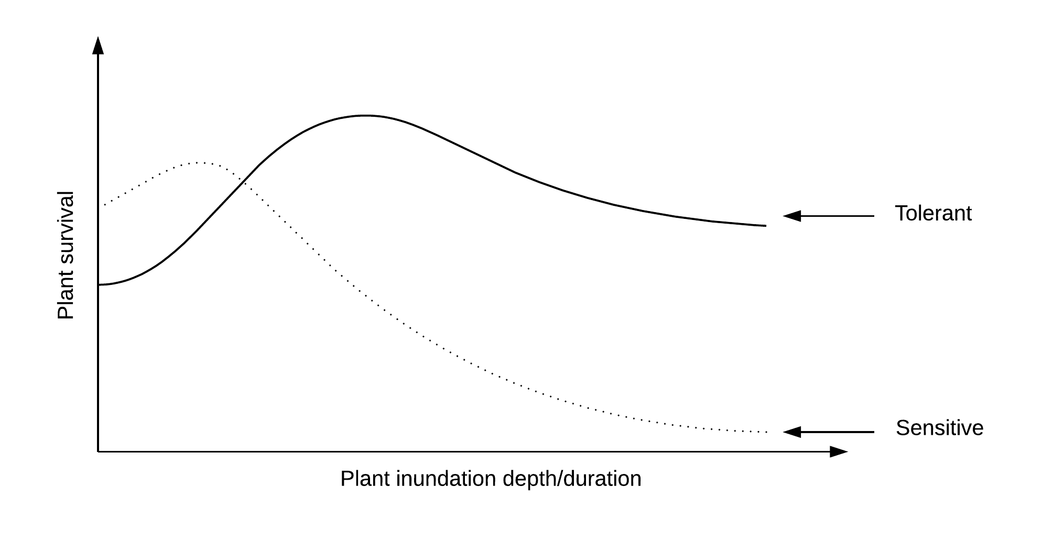Figure A: Conceptual model for vegetation survival with increasing depth and duration of inundation.

On a similar note, when considering soil moisture levels, it is expected that increasing soil moisture levels will result in increased plant survival, until the point that soils become waterlogged, in which case sensitive species (e.g. terrestrial species) will suffer (Figure B).

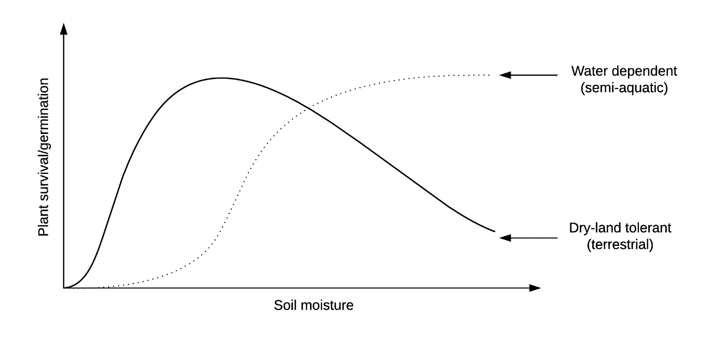

Figure B: Conceptual model for vegetation survival and germination with increasing soil moisture.

In another instance, as salinity, turbidity and velocity increase, it is expected that all plants will have decreased survival, but that more tolerant species will be better able to withstand the conditions than sensitive species (Figure C).

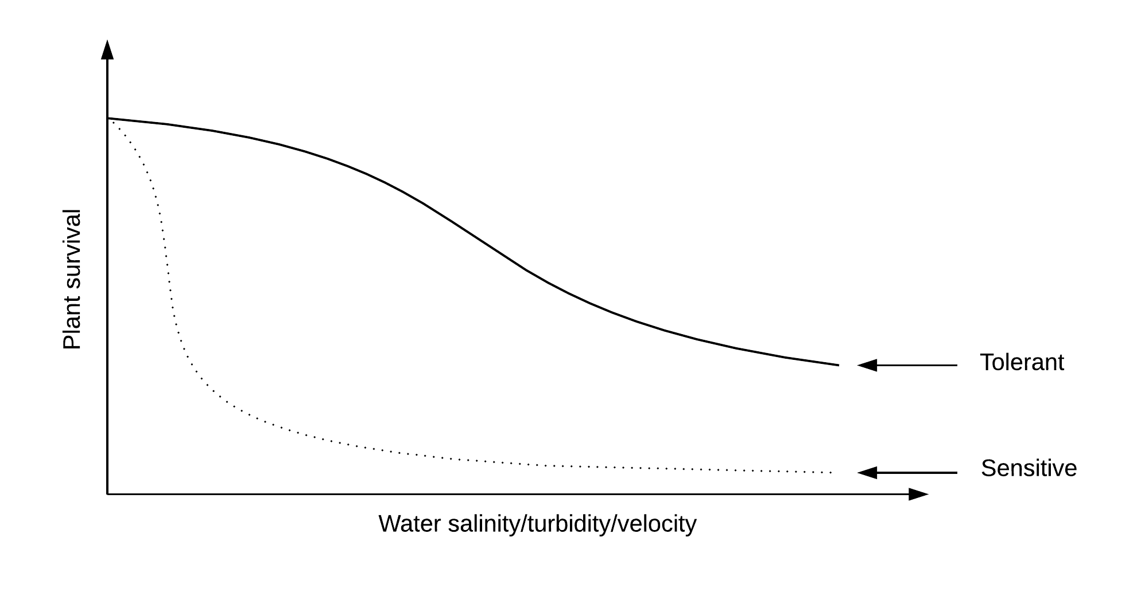

Figure C. Conceptual model for vegetation survival with increasing salinity, turbidity and velocity.

In most instances, a combination of variables will influence vegetation response. Large discharges are more likely to be faster flowing, hence more turbid, and result in a greater depth and duration of inundation. Each of these variables can be detrimental to vegetation health when above a tolerable threshold (Figure D). Salinity of instream water will generally decrease with flow additions as fresher water flushes out still/slow flowing water with accumulated salts from soils and evaporation.

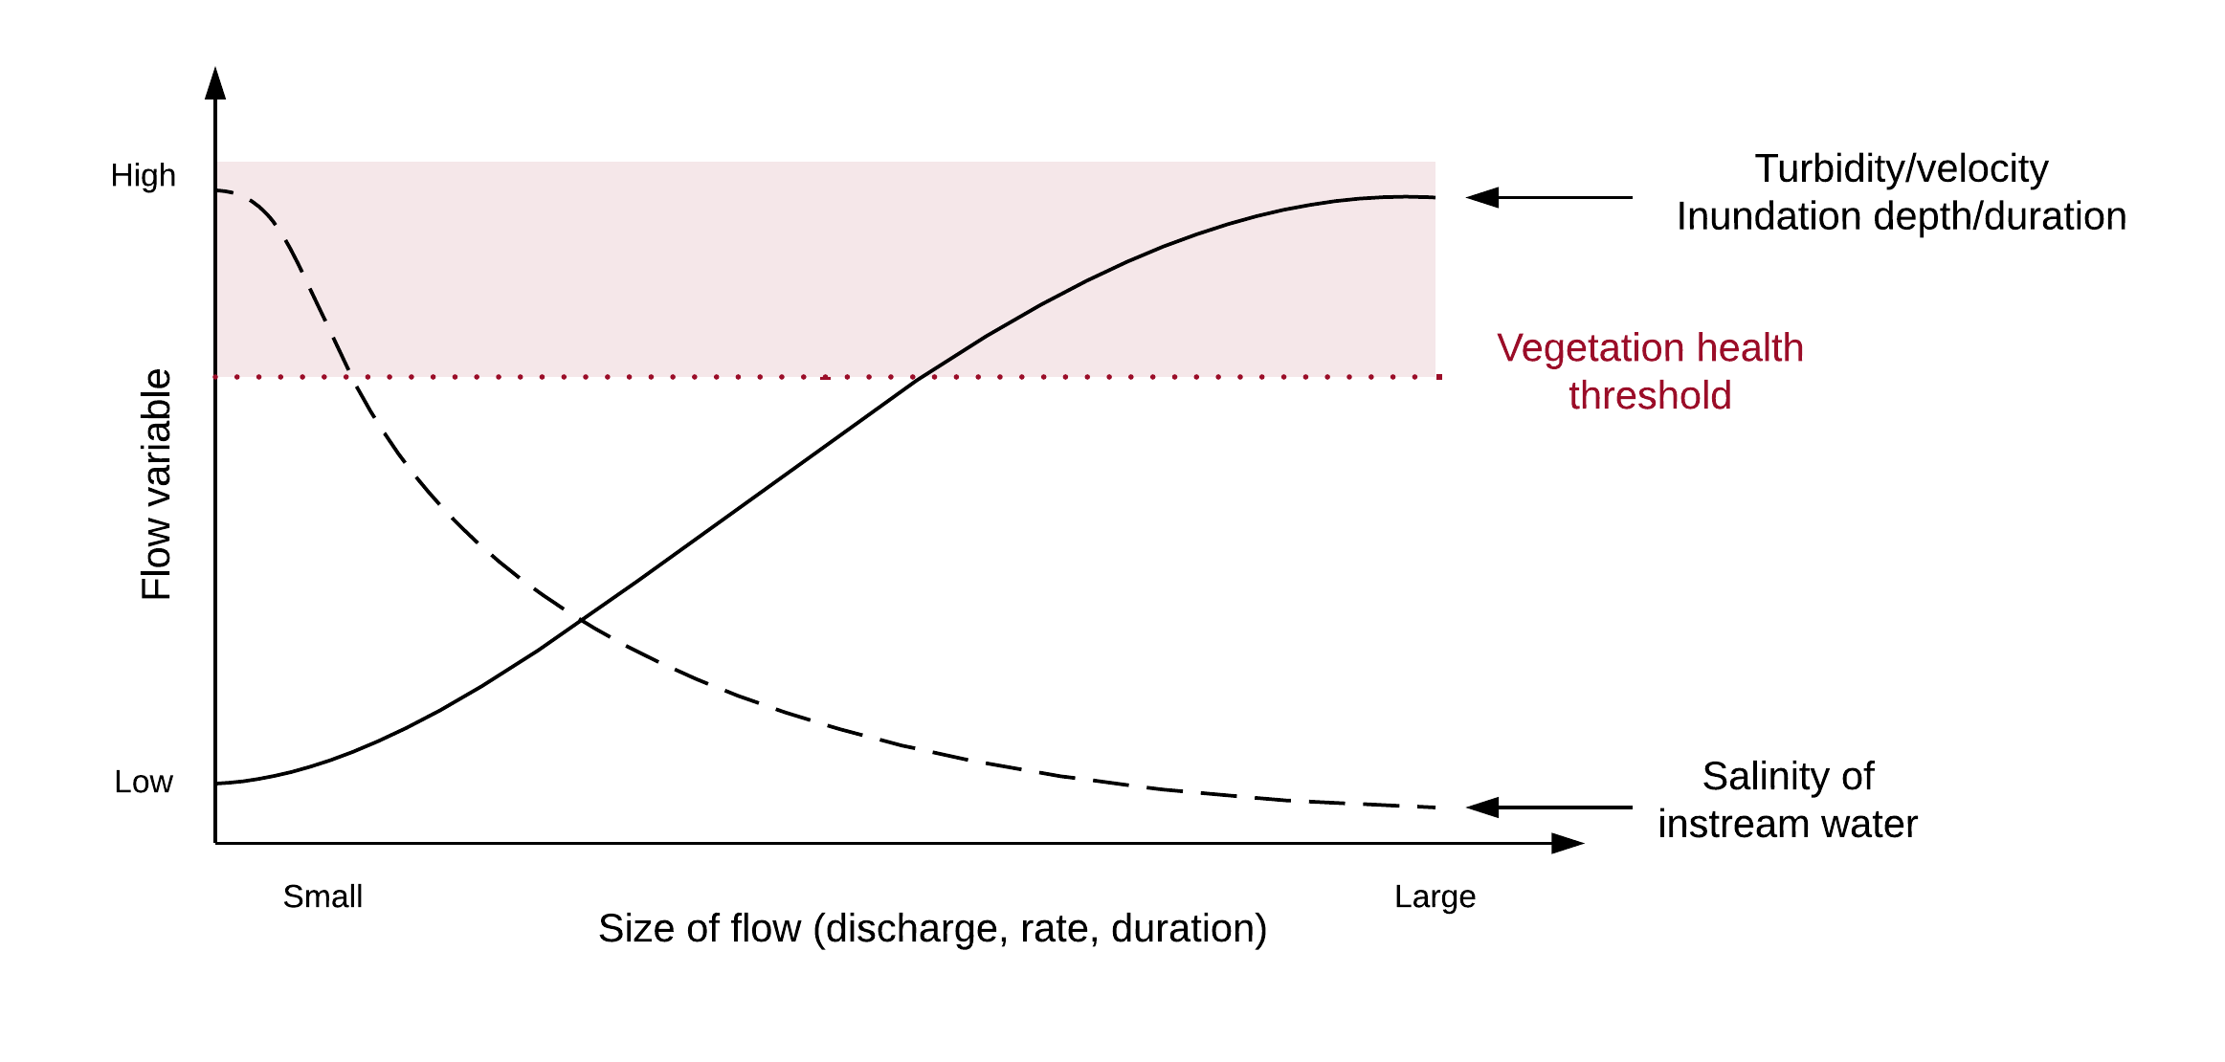Figure D: Conceptual model for vegetation survival under a combination of conditions.

**References**

Catford, J.A., Morris, W.K., Vesk, P.A., Gippel, C.J. & Downes, B.J. (2014) Species and environmental characteristics point to flow regulation and drought as drivers of riparian plant invasion. Diversity and Distributions, 20, 1084–1096.

Greet, J., Cousens, R. D., & Webb, J. A. (2012). Flow regulation affects temporal patterns of riverine plant seed dispersal: potential implications for plant recruitment. Freshwater Biology, 57(12), 2568-2579.

Greet, J., Cousens, R. D., & Webb, J. A. (2013). More exotic and fewer native plant species: riverine vegetation patterns associated with altered seasonal flow patterns. River Research and Applications, 29(6), 686-706.

Laliberté, E., Wells, J.A., DeClerck, F., Metcalfe, D.J., Catterall, C.P., Queiroz, C., Aubin, I., Bonser, S.P., Ding, Y., Fraterrigo, J.M., McNamara, S., Morgan, J.W., Merlos, D.S., Vesk, P.A. & Mayfield, M.M. (2010) Land-use intensification reduces functional redundancy and response diversity in plant communities. Ecology Letters, 13, 76‒86.

Merritt, D.M., Scott, M.L., Poff, N.L., Auble, G.T. & Lytle, D.A. (2010) Theory, methods and tools for determining environmental flows for riparian vegetation: riparian vegetation-flow response guilds. Freshwater Biology, 55, 206‒225.

Miller, K.A., Webb, J.A., de Little, S.C. and Stewardson, M.J. (2013). Environmental flows can reduce the encroachment of terrestrial vegetation into river channels: a systematic literature review. Environmental Management, 52, 1202-1212.

Poff, N. L. and Zimmerman, J. K. H. (2010), Ecological responses to altered flow regimes: a literature review to inform the science and management of environmental flows. Freshwater Biology, 55: 194–205.

Webb, J.A., Little, S.C., Miller, K.A., Stewardson, M.J., Rutherfurd, I.D., Sharpe, A.K., Patulny, L. and Poff, N.L. (2015). A general approach to predicting ecological responses to environmental flows: making best use of the literature, expert knowledge, and monitoring data. River Research and Applications, 31(4), pp.505-514.

# Appendix 9: Vegetation monitoring objectives and potential evaluation questions for each river system

| **CMA** | **River** | **Questions** | **Priority** | **Submerged/**  **Semi-emergent** | **Amphibious** | **Sedges/Rushes**  **/Reed** | **Trees & Shrubs** | **Non-flow constraints of vegetation response to flow** | **Practical Constraints on Monitoring** |
| --- | --- | --- | --- | --- | --- | --- | --- | --- | --- |
| Corangamite | Moorabool River | Maintain or increase* cover/size of existing stands | HIGH | Y |  |  |  | Carp, Steep banks |  |
| Corangamite | Moorabool River | Increase recruitment of woody trees & shrubs | HIGH |  |  |  | Y | Livestock grazing |  |
| Glenelg Hopkins | Glenelg River | Maintain or increase number of species | HIGH |  |  |  | Y |  |  |
| Goulburn Broken | Broken & Nine Mile-R4 | Increase spatial extent along the river length | HIGH | Y | Y | Y |  |  |  |
| Goulburn Broken | Goulburn River | Maintain/increase cover/size of existing stands | HIGH |  | Y |  |  |  | Steep banks |
| Goulburn Broken | Goulburn River | Increase spatial extent along the river length | HIGH |  | Y | Y |  |  | Steep banks |
| North Central | Campaspe River | Increase spatial extent along the river length | HIGH | Y |  | Y |  | Carp |  |
| North Central | Loddon River: Upper/Middle/Lower | Increase spatial extent along the river length | HIGH | Y |  | Y |  | Carp | Steep banks |
| North Central | Loddon River:  Upper/Middle/ Lower | Increase recruitment of woody trees& shrubs | HIGH |  |  |  | Y | Livestock grazing | Steep banks |
| North Central | Loddon River: Upper/Middle/Lower | Increase spatial extent along the river length | HIGH |  |  |  | Y | Livestock grazing |  |
| West Gippsland | LaTrobe River Estuary | Maintain/increase cover/size of existing stands | HIGH |  |  | Y |  | Salinity |  |
| West Gippsland | Macalister River | Increase spatial extent along the river length | HIGH | Y |  |  |  | Turbidity, Carp | Deep/turbidity water |
| Wimmera | Wimmera River-R3 | Maintain or increase cover/size of existing stands | HIGH | Y |  | Y |  | Turbidity, Salinity | Steep banks, Deep/turbid water |
| Wimmera | Wimmera River-R4 | Increase spatial extent along the river length | HIGH | Y |  |  |  | Carp | Steep banks |
| Wimmera | Wimmera River-R4 | Maintain/increase cover/size of existing stands | HIGH |  |  |  | Y |  |  |
| Glenelg Hopkins | Glenelg River | Maintain or increase cover/size of existing stands | MEDIUM | Y |  |  |  | Livestock grazing |  |
| North Central | Campaspe River | Maintain/increase cover/size of existing stands | MEDIUM | Y |  | Y |  | Salinity/Turbidity |  |
| North Central | Campaspe River | Increase recruitment of woody trees& shrubs | MEDIUM |  |  |  | Y |  |  |
| West Gippsland | Macalister | Increase spatial extent along the river length | MEDIUM |  |  | Y |  | Livestock grazing | Steep banks |
| West Gippsland | Macalister | Maintain or increase cover/size of existing stands | MEDIUM |  |  | Y |  |  |  |
| West Gippsland | Macalister | Maintain/increase cover/size of existing stands | MEDIUM |  |  |  | Y | Livestock grazing | Steep banks |
| West Gippsland | Macalister | Increase recruitment of woody trees& shrubs | MEDIUM |  |  |  | Y |  |  |
| Wimmera | Wimmera River R4 | Increase recruitment of woody trees& shrubs | MEDIUM |  |  |  | Y | Livestock grazing |  |
| Wimmera | Yarriambiack Creek | Maintain or increase cover/size of existing stands | MEDIUM |  |  |  | Y |  |  |
| Corangamite | Barwon | Increase spatial extent along the river length | LOW |  |  |  |  |  |  |
| West Gippsland | LaTrobe River Estuary | Increase recruitment of woody trees & shrubs | LOW |  |  |  |  | Salinity |  |

NB: The term ‘maintain or increase’ refers to an objective to ‘at least maintain, and preferably increase’.

# Appendix10: Summarised vegetation objectives for each river system

Information derived from 2016-17Seasonal Watering Plan, Environmental Water Management Plans, and discussions with CMA staff and scientists.

Where qualitative targets are expressed in objectives they are indicated in the table by the following codes: M = maintain; ↑ = increase, improve or restore;↓ = reduce, P = protect. Vegetation objectives are described in different levels of detail and are represented by the following abbreviations: A= abundance (representing either spatial extent, cover, growth, presence); D = diversity; C= condition; H= health; S = structure; R = recruitment. Where objectives relate to a single taxon the name is given in the cell. ↑* indicates that the objective was general in nature (i.e. restore or improve).

|  | **Instream** | | | **Fringing** | | | **Bank** | |
| --- | --- | --- | --- | --- | --- | --- | --- | --- |
| **Floating** | **Submerged** | **Semi-emergent** | **Not specified** | **Herbs** | **Emergent** | **Trees-shrubs** | **Riparian** |
| **Goulburn Broken** |  |  |  |  |  |  |  |  |
| Broken and Nine Mile - R4 | ↓(*Azolla)* |  |  |  |  |  |  |  |
| Broken River R1 |  |  |  | M |  | M |  |  |
| Broken River R2 |  | ↑* |  |  |  | ↑* |  |  |
| Broken River R3 |  | ↑* |  |  |  | ↑* |  |  |
| Goulburn River |  |  |  |  | ↑(A) ↑ (D) | ↑* | ↑* | ↑* |
| **Mallee** |  |  |  |  |  |  |  |  |
| Lock 15 |  |  |  |  |  |  |  | ↑* |
| Murrumbidgee Junction |  |  |  |  |  |  | ↑ (H) |  |
| Wimmera Mallee pipelines |  |  |  |  |  |  | M (H) |  |
| Yarriambiack Creek(Mallee) |  |  |  |  |  |  | ↑ M |  |
|  |  |  |  |  |  |  |  |  |
| **Glenelg Hopkins** |  |  |  |  |  |  |  |  |
| Glenelg River |  |  | ↑* |  |  | M |  |  |
| **North Central** |  |  |  |  |  |  |  |  |
| Avoca River |  |  |  |  |  |  |  | ↑(S); ↑(D) |
| Birch Creek Reach 1 & 2 |  | ↓ (*Elodea)* | ↑(A) ↑ (D) |  |  | ↑ (A) ↑(D) | ↑* |  |
| Birch Creek Reach 3 |  |  | M |  |  | M |  |  |
| Campaspe River |  |  | ↑ or M (A) |  |  | ↑ (A) | M & ↑ (R) |  |
| Coliban River |  |  | ↑(A) ↑ (D) |  |  | ↑(A) ↑ (D) | M & ↑ (R) | ↑* |
| Duck Creek North & South |  |  | ↑ (A) |  |  | ↑ A | M &  ↑ (H) |  |
| Gunbower Creek |  |  |  |  |  |  |  | ↑(A) ↑(D) |
| Loddon River - Lower |  |  | ↑ (A) ↑ (D) |  |  | ↑(A); ↑ (D) | M & ↑ (R) |  |
| Loddon River - Middle |  |  | ↑ (A) |  |  | ↑(A) ↑ (D) | M adults, ↑ (R) |  |
| Loddon River - Upper |  |  |  | ↑ (A) |  | ↑(A) ↑ (D) | M adults ↑ (R) |  |
| Red gum Swamp & Emu creek |  |  |  |  |  |  | M & ↑ (H) |  |
| **North East** |  |  |  |  |  |  |  |  |
| Kiewa River |  |  |  |  |  |  |  | M (sig EVC) |
| Mitta Mitta River |  |  |  |  |  |  |  | M (sig EVC) |
| **Wimmera** |  |  |  |  |  |  |  |  |
| Bungallally Creek |  |  |  |  |  |  |  | P & ↑ |
| Burnt Creek: lower |  |  |  |  |  |  |  | P & ↑ |
| Burnt Creek: upper |  |  | ↑* |  |  |  |  | P & ↑ |
|  |  |  |  |  |  |  |  |  |
| **Wimmera cont.** |  |  |  |  |  |  |  |  |
| MacKenzie River R2 |  | M (A) M (D) |  |  |  | M (A) M (D) |  | P & ↑ |
| MacKenzie River R3 |  |  |  |  |  |  | M (C) ↑ (R) |  |
| Mount William Creek |  | M (A) ↑ (D) |  |  |  | (M) A (M) D |  | P & ↑ |
| Richardson River NCCMA |  |  |  |  |  |  |  | ↑(S) ↑(D) |
| Wimmera River R1 |  |  | M |  |  | M |  | P & ↑ |
| Wimmera River R2 |  |  |  |  |  |  |  | P & ↑ |
| Wimmera River R3 |  |  | M |  |  | M |  | P & ↑ |
| Wimmera River R4 |  |  | M |  |  | M |  | P & ↑ |
| Yarriambiack Creek |  |  |  |  |  |  |  | P & ↑ |
| **West Gippsland** |  |  |  |  |  |  |  |  |
| LaTrobe River |  |  |  | ↑* |  | ↑* |  |  |
| LaTrobe River Estuary |  |  |  |  |  | M | M |  |
| Thompson |  |  |  |  |  | ↑(A) |  |  |
| Macalister |  | ↑(A) | ↑(A) |  |  | ↑(A) |  |  |
| **East Gippsland** |  |  |  |  |  |  |  |  |
| Snowy (NSW) |  |  |  |  |  |  |  | ↓ Tea-tree |

# Appendix 11: Proposed complementary vegetation research questions

Summary of CMA responses to proposed complementary vegetation research questions for VFEMAP Stage 6.

|  |  |
| --- | --- |
| **Complementary Research Questions** | **CMA responses** |
| R1. Does livestock exclusion improve responses of vegetation to flow delivery? | Livestock are identified as potential constraint on vegetation responses to flow in seven of the ten rivers receiving EW including the Moorabool, Loddon, Glenelg, Macalister, Thompson, LaTrobe and Wimmera Rivers although the presence of livestock is site dependant within these rivers. |
| R2. Does the availability of plant propagules in the aerial or soil seed bank limit re-establishment of vegetation? | *North Central:* This question has been asked many times in relation to the Campaspe River’s instream and fringing vegetation. Is a lack of seeds or propagules preventing recovery in the system?  *West Gippsland CMA*: Listed as an additional monitoring question for submerged/in-stream vegetation communities in the Macalister River |
| R3. Does the availability of water dispersed seeds at suitable sites limit the re-establishing of vegetation? | *West Gippsland CMA*: Listed as an additional monitoring question for submerged/in-stream vegetation communities in the Macalister River |
| R3. Does bank/bed condition prevent the re-establishment of vegetation? | *North Central:* Also include substrates – clays vs fine gravels sands as limited factors for vegetation reestablishment |
| R4. Does water quality limit responses of in-stream vegetation to flow delivery? | *West Gippsland CMA*: Listed as additional monitoring questions for submerged/in-stream vegetation communities in the Macalister River and for *Phragmites* in the LaTrobe Estuary |
| R5. Do carp limit responses of in-stream vegetation to flow delivery? | All these questions are of value if we want to evaluate how complementary management actions may help restore missing vegetation types in the lower Loddon & Campaspe Rivers |
| Additional research questions | Do freshes at different times/seasons increase the risk of spreading weeds in the Goulburn River (e.g. freshes in summer compared to spring or autumn) (GBCMA) |
| Does soil moisture play an important role in vegetation establishment and maintenance in the Goulburn River (GBCMA) |
| What drives development of *Azolla* blooms and management in the Broken Creek (GBCMA) |