|  |
| --- |
| Riverine Rehabilitation Decision Support Tool  Helping managers rehabilitate instream habitat |
| Project Overview |

**Background**

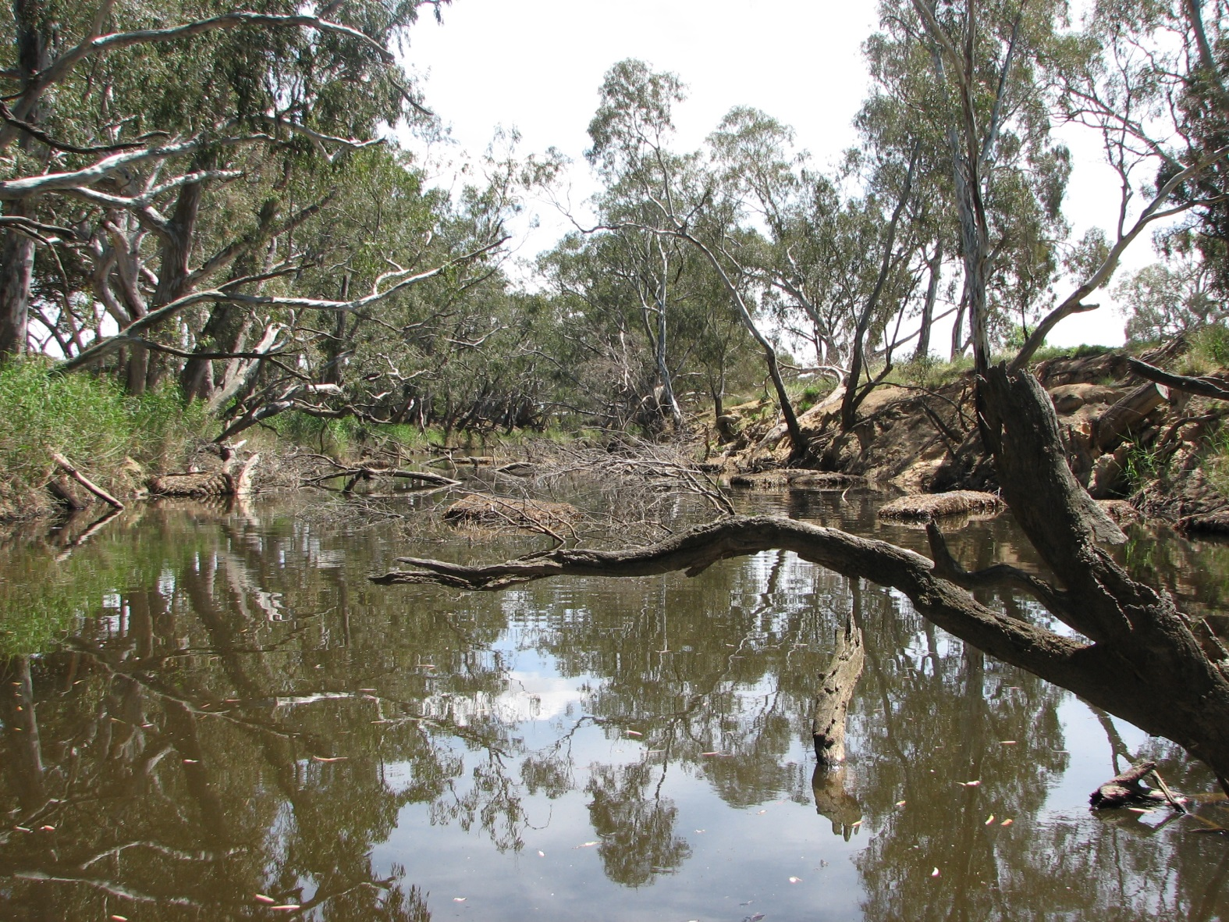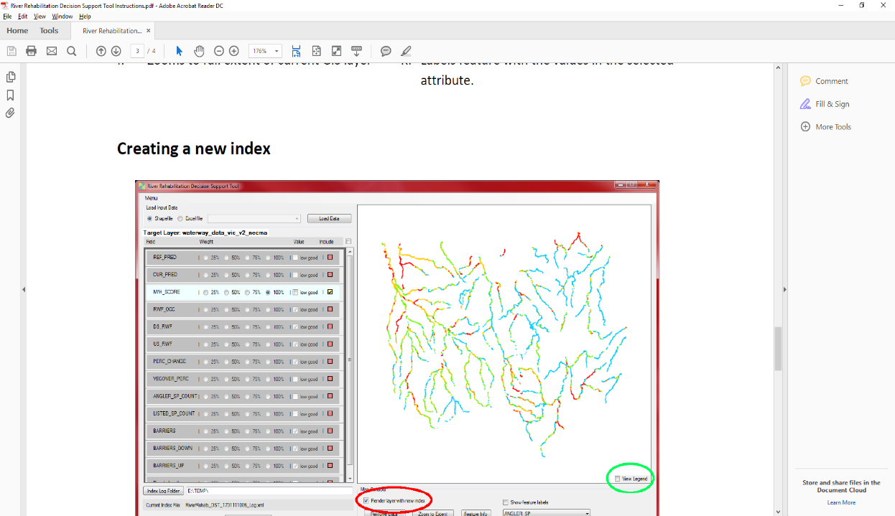

In the past, some believed that instream woody habitat (IWH) increased risks of flooding and erosion and hampered river navigation. This led to riparian clearing and the removal of large quantities of IWH in rivers throughout the world. In Australia, IWH was still being removed until the late 1980s. In Victoria, it is estimated that on average IWH volumes were 41% lower than in pre-European times, with 30% of river reaches assessed to have reductions of >80%1,2. Such losses have caused increased flow velocities, channel enlargement, bed degradation and loss of important aquatic habitats. This has contributed to declines in river productivity and the health of aquatic ecosystems, including native fish.

It is now recognised that IWH plays an important role in critical geomorphological processes and ecological functioning within rivers. Thus, waterway restoration programs commonly re-establish riparian vegetation (a future source of IWH) and install instream habitat structures, to simulate natural conditions and ultimately restore native fish populations.

* 1. **The Victorian Instream Habitat Project**
  2. A Victorian statewide instream habitat research project, funded by the Department of Environment, Land, Water and Planning (DELWP), began in 2011. This long-term project assessed the importance of IWH for fish and riverine processes, mapped existing IWH statewide, and developed a fish monitoring protocol for reaches subject to IWH improvement. This work has greatly improved our ability to understand the benefit of IWH to fish in Victoria.
  3. **Helping managers rehabilitate IWH**

Given the finite resources available for waterway restoration, waterway managers need support to select appropriate priority sites to rehabilitate and protect instream habitat. Statewide spatial data was collated with parameters which can be used to help guide waterway managers in making decisions about instream habitat rehabilitation. These metrics include:

* Riparian attributes (which influence natural rates of IWH input)
* Aquatic fauna occupancy (which relates directly to IWH rehabilitation objectives)
* Hydrology, and
* Barriers (which prevent transfer of fauna and organic material)

The barrier metrics are to be incorporated in the future.

* 1. **A Decision Support Tool for Riverine Rehabilitation**

A GIS independent decision support tool (RiverRehab DST) was developed to help waterway managers identify suitable reaches for instream habitat additions or protection, using a set of parameters. This tool developed a ‘suitability score’ that comprised Index of Stream Condition (ISC) reach parameters. These parameters can be modified depending upon the particular objectives and priorities managers may have for different sites.

* 1. **Approach**

It was identified that to increase the usability of the tool, it would have to be independent of commercial GIS software. Waterway managers were consulted to determine their preferences for a geographical user interface (GUI) for the tool. Consideration was also given to further spatial information that could be incorporated into the tool, such as AVIRA (Aquatic Value Identification and Risk Assessment) metrics. A draft version of the tool was developed, tested by stakeholders, then revised. User instructions were also developed.

* 1. **How it works**

The RiverRehab DST uses selected attributes from a supplied shapefile to calculate a habitat ‘suitability’ index. The index results are displayed in a simple GIS window, showin a colour gradient of the index values for the river reaches. The GIS window allows the user to zoom and scroll as well as investigate the attributes of features. The final shapefile can also be used in other GIS platforms.

The results can help broadly identify reaches that may benefit from rehabilitation (lower scores) depending on the attributes and weights selected.

* 1. **Outputs**

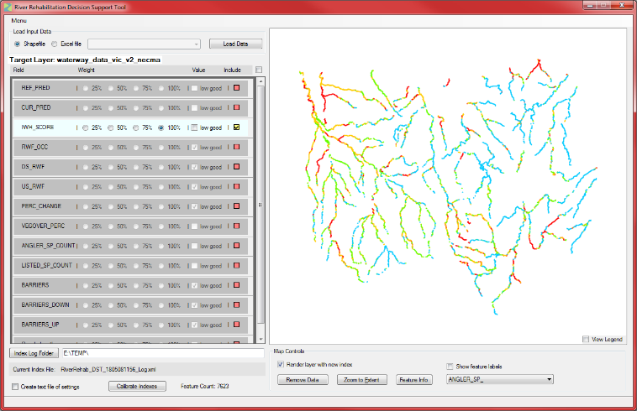A decision support tool for management of riverine rehabilitation.

A user guide which outlines the installation and operation instructions for users.

|  |  |
| --- | --- |
| © The State of Victoria Department of Environment, Land, Water and Planning 2018  LogoThis work is licensed under a Creative Commons Attribution 4.0 International licence. You are free to re-use the work under that licence, on the condition that you credit the State of Victoria as author. The licence does not apply to any images, photographs or branding, including the Victorian Coat of Arms, the Victorian Government logo and the Department of Environment, Land, Water and Planning (DELWP) logo. To view a copy of this licence, visit http://creativecommons.org/licenses/by/4.0/  ISBN 978-1-76077-293-2 (print), 978-1-76077-294-9 (pdf/online/MS word)  Disclaimer  This publication may be of assistance to you but the State of Victoria and its employees do not guarantee that the publication is without flaw of any kind or is wholly appropriate for your particular purposes and therefore disclaims all liability for any error, loss or other consequence which may arise from you relying on any information in this publication. | Accessibility  If you would like to receive this publication in an alternative format, please telephone the DELWP Customer Service Centre on 136186, email [customer.service@delwp.vic.gov.au](mailto:customer.service@delwp.vic.gov.au), or via the National Relay Service on 133 677 [www.relayservice.com.au](http://www.relayservice.com.au). This document is also available on the internet at [www.ari.vic.gov.au/research/rivers-and-estuaries/victorian-instream-habitat-assessment](http://www.ari.vic.gov.au/research/rivers-and-estuaries/victorian-instream-habitat-assessment) |

* 1. **What’s next?**

This tool has the ability to incorporate more attributes which can increase its complexity and value to managers in identifying appropriate priority sites to rehabilitate and protect instream habitat.

* 1. **Contact**

To obtain the RiverRehab DST or for further information contact: [Adrian.Kitchingman@delwp.vic.gov.au](mailto:Adrian.Kitchingman@delwp.vic.gov.au) or Zeb.Tonkin@delwp.vic.gov.au

* 1. **References**

1[Tonkin, Z. et al.](http://onlinelibrary.wiley.com/doi/10.1002/rra.3002/full) (2016) Asessing the distribution and changes of instream woody habitat in south eastern Australian rivers. River Research and Applications 32(7): 1576-1586.

2 [Kitchingman, A. et al.](http://www.publish.csiro.au/MF/pdf/MF15246) (2015) Predicting natural instream woody habitat loads across large river networks. Marine and Freshwater Research 67: 1844-1852.

**Figure 1: RiverRehab DST, showing input attribute selection and values, and mapping with colour gradient**