|  |
| --- |
| Revegetation in farm landscapes  6. Recommendations for regional and farm planning |

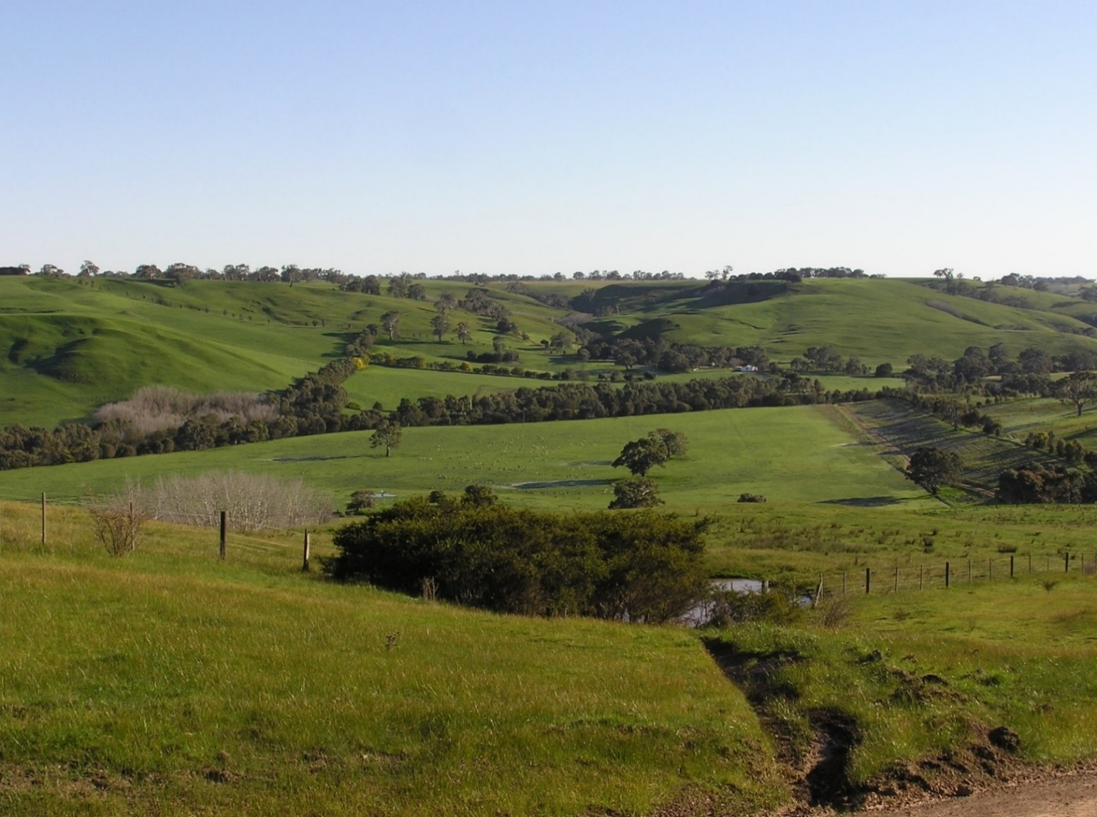

Results from a large, landscape-scale study of birds in revegetation plantings and remmant vegetation in the Glenelg Hopkins region, Victoria, has provided many insights into the value of revegetation for wildlife. Key findings are contained in previous factsheets in this series. Here, we summarise key messages relevant to planning for revegetation and restoration at both regional and farm scales, in this and other regions.

**Key messages for regional planning**

**Benefits for native wildlife**

* Revegetation *restores wildlife* to otherwise-cleared rural landscapes. It facilitates the return of many bird species to landscapes from which they have been lost due to clearing of native vegetation. This is true even for woodland birds, a group of particular conservation concern due to their decline in rural environments. Plantings provide value for other animals too, including reptiles, mammals and insects.
* Plantings are used by most woodland birds in the region – at least for foraging and shelter. Over 80% of woodland bird species recorded in this study were detected in revegetation.
* The value of revegetation habitats *changes with time*, as trees and shrubs grow and mature. By 2019, revegetated landscapes with plantings 14-52 years old, supported similar numbers of species to those in landscapes with an equivalent cover of native vegetation (i.e. revegetation has restored what was lost as native vegetation was removed).
* Revegetation provides *complementary* habitat to remnant native vegetation, by supporting different bird communities.
* Revegetation is an effective investment for nature conservation in rural landscapes. It is largely a ‘one-off’ (rather than annual) commitment, and its value lasts for decades. It can also be undertaken incrementally such that, over time, rural landscapes are transformed.

**Landscape and regional planning**

* Greatest value will result from co-ordinated planning at the regional and local scales, to ensure revegetation complements and enhances existing land-uses. For example, revegetation along creeklines throughout a region can enhance both the amount of habitat and its connectivity for animal species.

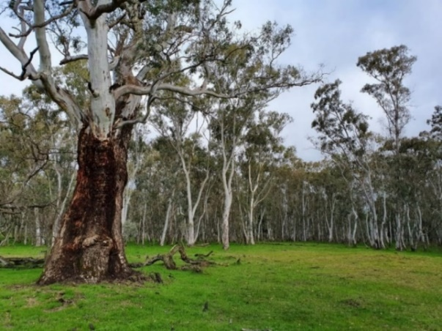

**Mature River Red Gum *Eucalyptus camaldulensis* surrounded by natural, dense regrowth.**

* The *collective actions* of groups of landholders and conservation organisations are critical because, by working together, there is greater capacity to increase the cover and connectivity of vegetation at broad scales.
* Plan for *changes through time*: revegetation takes decades to mature and the complexity of habitat it provides for wildlife increases through time.
* Give priority to the protection of remnant native vegetation in rural landscapes. Remnants provide important habitat and resources for native species: it retains elements of the original ecosystem (e.g. soil biota, fungi, understorey species); and it also enhances the value of revegetation by promoting richer bird assemblages in nearby plantings.
* Retaining scattered trees through farmland is highly beneficial. These trees are often centuries-old and provide habitat in their own right, as well as helping animals move through the landscape. The presence of scattered trees increases the value of both remnant vegetation and revegetation for birds. Rural landscapes with a greater cover of scattered trees support more woodland bird species.

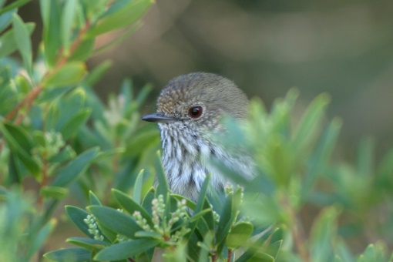

**Superb Fairy-wren *Malurus cyaneus* and Brown Thornbill *Acanthiza pusilla* are woodland bird species frequently recorded in revegetation.**

**Key messages for management at the farm scale**

**Making a wider contribution**

* By revegetating and restoring habitats on farms, landholders make a wider contribution to the landscape, with benefits beyond their immediate farm. Each planting adds to the overall amount of vegetation in the landscape and, collectively, plantings increase conservation outcomes and provide value to the wider community.
* Revegetation along streams provides local and wider downstream benefits. These areas are productive habitats for wildlife, act as natural corridors through the landscape and also protect aquatic habitats and water quality.
* Protecting and retaining *existing remnants* of native vegetation (patches, individual mature trees) on farm properties provides crucial habitats for wildlife and enhances the value of nearby revegetation plantings.

|  |  |
| --- | --- |
| © The State of Victoria Department of Environment, Land, Water and Planning 2020  LogoThis work is licensed under a Creative Commons Attribution 4.0 International licence. You are free to re-use the work under that licence, on the condition that you credit the State of Victoria as author. The licence does not apply to any images, photographs or branding, including the Victorian Coat of Arms, the Victorian Government logo and the Department of Environment, Land, Water and Planning (DELWP) logo. To view a copy of this licence, visit http://creativecommons.org/licenses/by/4.0/  ISBN 978-1-76105-257-6 (pdf/online/MS word)  Disclaimer  This publication may be of assistance to you but the State of Victoria and its employees do not guarantee that the publication is without flaw of any kind or is wholly appropriate for your particular purposes and therefore disclaims all liability for any error, loss or other consequence which may arise from you relying on any information in this publication. | Accessibility  If you would like to receive this publication in an alternative format, please telephone the DELWP Customer Service Centre on 136186, email [customer.service@delwp.vic.gov.au](mailto:customer.service@delwp.vic.gov.au), or via the National Relay Service on 133 677 [www.relayservice.com.au](http://www.relayservice.com.au). This document is also available on the internet at https://www.ari.vic.gov.au/research/ |

* Retaining scattered trees in farm paddocks adds to the value for wildlife of the overall landscape (not just the particular paddock). Fencing will protect these trees, and replacing them as they fall will ensure scattered trees are a feature of paddocks in future. As branches fall, these logs can be moved into revegetatedion areas to provide important habitat for animals.

**What, where and how to plant**

* Revegetation plantings occur in a range of forms (e.g. shelterbelts, creekline plantings, woodlots) and all can benefit conservation. Even small plantings have value, by providing resources for animals at local scales, and adding to vegetation cover at broader scales.
* The value of individual plantings for wildlife can be increased by:  
  - including a greater range of tree/shrub species  
  - planting revegetation nearby, or connected with,   
   other patches of vegetation  
  - fencing to protect plantings from grazing

- adding logs from nearby paddocks  
- planting around existing mature trees.

* The value of revegetation for wildlife increases rapidly in the first 10-20 years, ensuring a relatively quick return on effort. Plantings also represent a long-term conservation investment, as they facilitate the return of species to farm landscapes over longer time-frames. Plantings will provide an even wider range of resources for animals as they develop habitat features such as a large branches and canopies, tree hollows, logs and a complex vegetation structure.

## Further information

Angie Haslem [A.Haslem@latrobe.edu.au](mailto:A.Haslem@latrobe.edu.au)

[research.ari@delwp.vic.gov.au](mailto:research.ari@delwp.vic.gov.au) [**ari.vic.gov.au**](https://www.ari.vic.gov.au/)

## Acknowledgements

This project was funded with support of the Victorian Government as part of the Biodiversity On-ground Action Adaptive Learning project, undertaken as a collaboration between Arthur Rylah Institute and La Trobe University.

**Prepared by:** Angie Haslem, Andrew Bennett, Rohan Clarke, Alex Maisey, Greg Holland (July 2020)

**Photo credits:** Rohan Clark, Meghan Lindsay, Alex Maisey.